

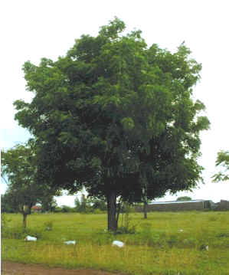
The Neem Tree
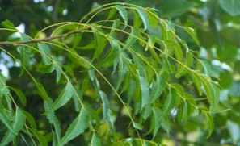
Leaves of the Neem help in the treatment of neuromuscular pains and neutralise free radicals
The Neem tree (Azadirachta indica A. Juss.) has been known as the wonder tree for centuries in the Indian subcontinent. It has become important in the global context today because it offers answers to the major concerns facing mankind.
The history of the Neem tree is inextricably linked to the history of the Indian way of life. Although the antiquity of Neem is shrouded in the mists of time, this evergreen robust looking tree has long been cherished as a symbol of health in the country of its origin. It has, for a very long time, been a friend and protector of the Indian villager. Brihat Samhita, an ancient Hindu treatise, contains a chapter of verses on plant medicines. It contains recommendations for specific trees to be planted in the vicinity of one’s house. Neem was highly recommended.
The Tree
Neem is a medium sized to large tree characterised by its short straight trunk, furrowed dark brown to grey bark, and dense rounded crowns of pinnate leaves. Native to India, Neem is widely planted and naturalised in semiarid areas throughout Asia and Africa. Neem is an evergreen of the tropics and sub-tropics. It belongs to the family Meliaccae and is a cousin of the Chinaberry. With an extensive and deep root system, the hardy Neem can grow luxuriantly even in marginal and leached soils, and thrives up to an elevation of 1500m. The Neem flowers profusely between February and May. The honey-scented white flowers, found in clusters, are a good source of nectar for bees. Neem fruits are green drupes which turn golden yellow on ripening in the months of June, July and August, in India. The kernels have about 45% oil. The termite resistant Neem timber is used as a building material, and in making furniture and farm implements. The bark yields tannin and gum. The amber hued gum is used as a dye in textiles and in traditional medicines.
Medical Properties
The medical properties of Neem have been known to Indians since time immemorial. The earliest Sanskrit medical writings refer to the benefits of Neem’s fruits, seeds, oil, leaves, roots and bark. Each has been used in the Indian Ayurvedic and Unani systems of medicines, and is now being used in the manufacture of modern day medicinals, cosmetics, toiletries and pharmaceuticals.
Neem fruits, seeds, oil, leaves, bark and roots have such uses as general antiseptics, antimicrobials, treatment of urinary disorders, diarrhoea, fever and bronchitis, skin diseases, septic sores, infected burns, hypertension and inflammatory diseases. This is mainly due to the chemical constituents which enable Neem to protect itself from a multitude of pests by a substantial number of pesticidal ingredients. Its main chemical composition is a blend of 3 to 4 related compounds along with over 20 lesser ones, which are equally as active. The general class of these compounds is triterpenes and within this category, the most effective are the limonoids, which are abundant in Neem oil. At least nine limonoids are effective in inhibiting insect growth, especially some of the most deadly varieties found in human health and agriculture worldwide. Of these limonoids, azadirachitin has been found to be the main ingredient for fighting insects and pests, being up to 90% effective in most instances. It repels and disrupts the life cycle, however does not kill immediately, but is nonetheless one of the most effective growth and feeding deterrents ever examined. Meliantriol is another feeding inhibitor which prevents locusts chewing, and has therefore been in traditional use in India for crop protection. Nimbin and nimbidin, also found in Neem, have anti-viral properties and these have been effective in inhibiting fungal growth on humans and animals. Gedunin, a lesser limonoid, is effective in treating malaria through teas and infusion of the leaves.
Fungicides
Neem has proved effective against certain fungi that infect the human body. Such fungi are an increasing problem and have been difficult to control by synthetic fungicides. For example, in one laboratory study, conducted by Khan and Wassilew – 1987, Neem preparations showed toxicity to cultures of 14 common fungi, including members of the following genera:
• Trichophyton – an ‘athlete’s foot’ fungus that infects hair, skin and nails;
• Epidermophyton – a ‘ringworm’ that invades both skin and nails of the feet;
• Microsporum – a ‘ringworm’ that invades hair, skin and (rarely) nails;
• Trichosporon – a fungus of the intestinal tract;
• Geotrichum – a yeast like fungus that causes infections of the bronchi, lungs and mucous membranes;
• Candida – a yeast-like fungus that is part of the normal flora but can get out of control, leading to lesions in mouth (thrush), vagina, skin, hands and lungs.
Components of the Neem tree and their uses
Bark
The bark is cool, bitter, astringent, acrid and refrigerant. It is useful in tiredness, cough, fever, loss of appetite, worm infestations. It heals wounds and is also used in vomiting, skin diseases and excessive thirst. Twigs have been used as a ‘toothbrush’ and for dental care, since antiquity. Neem toothpaste has been on sale in the US and Germany for some time, and is now available here.
Leaves
According to Ayurveda, Neem leaves help in the treatment of Vatik disorders (neuromuscular pains). Neem leaves are also reported to remove toxins, purify blood and prevent damage caused by free radicals in the body by neutralising them.
A paste made with leaves is used in India for the cure of chicken pox, smallpox and warts. A poultice is effective for boils, ulcers and eczema.
Fruits
Neem fruits are bitter, purgative, antihemorrhodial and anthelmintic (vermifuge) in nature.
Flowers
The flowers are used in vitiated conditions of pitta (balancing of the body heat) and kapha (cough formation). They are astringent, anthelmintic and non toxic.
Seeds
Neem seeds are also described as anthelmintic, antileprotic (cures or prevents leprosy) and antipoisonous. Seeds, along with leaves and dry Neem cake, are an active ingredient in mosquito coils.
Oil
Neem oil, derived from crushing the seeds, is antidermatonic, a powerful vermifuge and is bitter in taste. It has a wide spectrum of action and is highly medicinal in nature. As an oil used in aromatherapy, it has been effective in the treatment of head lice in children, especially where tea tree has failed to clear up the condition. This was particularly noticeable on an outbreak of head lice, two years ago, at a school local to my practice, where I treated several children. Those with blonde to reddish hair had their head lice condition cleared up much quicker with Neem oil applied at a 3% dilution to a shampoo base, than with tea tree.
Specific uses of Neem
Skin Conditions
Neem has an almost magical effect on chronic skin conditions that fail to respond to conventional treatments. Acne, psoriasis, eczema, and ringworm are conditions that are effectively treated by a Neem preparation.
Hair and Nails
Scalp conditions like dandruff, scaling and even hair loss improve with Neem products. Yellow or brittle nails, caused by the presence of yeast or fungi, are normalised by the use of Neem.
Teeth and Gums
Neem mouth rinse is very effective in the treatment of infections, tooth decay, bleeding and sore gums. A mouthwash, using Neem oil, has been used at my
practice for the treatment of mouth ulcers.
Fungi, Parasites and Viruses
Stringent laboratory condition tests have proved the efficacy of Neem in destroying fungi, parasites and viruses without killing off beneficial intestinal flora. It is very effective in the treatment of Athletes’ Foot, thrush, candida infestations and herpes.
Diabetes
Neem has been found to reduce insulin requirements by up to 50% for diabetics, without altering blood glucose levels.
Heart and Blood
A recent study showed that a Neem treatment lowered high cholesterol levels. It has also been tested, with good results, for other heart conditions.
Insects
Neem is a very effective insect repellent, without being toxic to pets and humans.
AIDS and Cancer
Tests are currently being carried out, with encouraging results. During the course of the freedom movement in India, led by Mahatma Gandhi, there was an upsurge of the ‘Swadeshi’ or nationalistic sentiment. This led to a move to encourage ‘Swadeshi’ science. Neem research in India was part of this movement. Pioneering work on the possible commercial use of Neem oil and cake was done by the Indian Institute of Science in Bangalore during the 1920s.
Mahatma Gandhi kept the tradition of Neem alive, and is known to have been a firm believer in the goodness of Neem. Dr Ekaid informed Gandhi that laboratory experiments revealed that Neem leaves contain more nutritious elements than any other similar vegetation that has been subjected to chemical analysis earlier. A Neem leaf chutney was a part of Gandhi’s everyday diet. A nutraceutical tea, now being manufactured, would surely have been Gandhi’s favourite beverage.
Physico-composition of Fresh Neem Leaves: Neem Tea and its Uses
Tender leaves, along with black pepper, are effective in intestinal helminthiasis (parasitic infections).
An aqueous extract of tender leaves has been found to possess antiviral properties against vaccinia (viral disease in cattle), variola (smallpox), fowl pox and New Castle diseases.
Fresh mature leaves, along with the seeds of Psoralea corglifolia and Cicer arietinum are effective in leucoderma.
Studies on plasma clotting time using Russell’s viper venom have proved that the leaf extract contains a clotting inhibitor, justifying its use in the treatment of poisonous bites.
Animal-based experiments have shown that total extract of Neem leaves is a potent hepatoprotective agent.
Water extract of Neem leaves shows significant antiulcer activity and reduction in severity of gastric damage, and prevents most cell degranulation and mucus depletion.
The phosphate buffer, ether and alcoholic extracts of the leaves inhibit the activity of the micro-organism Micrococcus pyrogenes var. aureus. The essential oil possesses anti-bacterial activity. It inhibits the growth of Mycobacterium tuberculosis, Salmonella paratyphi, Salmonelbtyphi, Vibrio cholera Pacini and Klebsiella pneumonia (Schroter) Trevisan (organisms which cause typhoid, cholera and pneumonia.
Chewing fresh Neem leaves acts as a sedative and relaxant.
The Future with Neem
Poverty
Today’s exploding growth in human population is seriously depleting the world’s natural reserves and economic resources. Unless the run-away human population growth rate is slowed down, there would be little hope for raising everyone out of poverty in the developing world. Besides educational constraints, the non-availability of inexpensive methods of contraception, which do not cause trauma or aesthetic, cultural, and religious sensitivities of people, limit the success of birth regulation programmes. However, recent findings indicate that some Neem derivatives may serve as affordable and widely available contraceptives. A recent controlled study in the Indian army proved the efficacy of Neem as a contraceptive.
According to a recent report by the Washington based International Food Policy Research Institute, by 2020, the world will be an even more unfair place than it is at present, with food surpluses in the industrialised world and with chronic instability and food shortages in the south, particularly in African countries.
The US Academy of Sciences currently attaches very high importance to the Neem tree. The United Nations declared Neem as the “Tree of the 21st Century”.
Bioactivity
Search for environmentally safe pesticides received an impetus in early 1960s following the publication of Silent Spring by Rachel Carson in 1962. It was around this period that Indian scientists reported the feeding deterrent property of Neem seed kernel suspension against desert locust. Subsequently, several bioactive ingredients were isolated from various parts of the tree, more notable being the isolation of meliantriol and azadirachtin. These findings aroused world-wide interest in the bioactivity of the Neem tree.
The Neem seems to be a virtual designer tree – tailor-made for combating the serious problems confronting mankind today. The information being generated on it in the modern format of science continues to confirm all the ancient claims. Its mammalian safety and environmental friendliness reports are highly encouraging. Its bioactivity spectrum against the harmful organisms is ever increasing.
Neem is now widely used in America in fields ranging from pharmaceutical, health and beauty, pet care, pesticides and insecticides, and agriculture, while health and beauty and pharmaceutical products are available in Austria and Germany.
Neem products are also available in the UK and a nutraceutical tea is the newest product to come on the market.
A key advantage to using Neem, as opposed to some medical treatments and other herbs, is its compliance with the first tenet of the Hippocratic Oath taken by all physicians: “First, cause no harm.” Over thousands of years, Neem has been used by hundreds of millions of people and no hazards have been documented for normal dosages. Only at very high levels may Neem be toxic, something each of us understands can be true of anything taken internally.

Neem
Latin name: Azadiracta indica
Local Name: Neem, Nim
Parts Used: Leaves and Fruits
Introduction:
The Neem tree has been known as the wonder tree for centuries in the Indian subcontinent. Neem has become important in the global context today for its variety of medicinal uses.
Remedies For:
Neem extract which have Nimbinin, nimbandiol as active constituents, alcoholic extract of the leaves was found to possess a significant blood sugar lowering effect, which are very useful against diabetes.
Neem is used in Dermatitis Eczema, Acne, Bacterial, Fungal infections and other skin disorders. It has demonstrated its effectiveness as a powerful antibiotic. Neem also has shown antiviral, anti-fungal and anti-bacterial properties. It helps support a strong immune system and is used in cases of inflammatory skin conditions. Traditionally Neem has been used for skin and blood purifying conditions.
Perhaps Neem's most touted advantage is the effect it has upon the skin. Preparations from the leaves or oils of the tree are used as general antiseptics. Due to Neem's antibacterial properties, it is effective in fighting most epidermal dysfunction such as acne, psoriasis, and eczema. Ancient ayurvedic practitioners believed high sugar levels in the body caused skin disease; Neem's bitter quality was said to counteract the sweetness.
Traditionally, Indians bathed in Neem leaves steeped in hot water. Since there has never been a report of the topical application of Neem causing an adverse side effect, this is a common procedure to cure skin ailments or allergic reactions.
Neem also may provide antiviral treatment for smallpox, chicken pox and warts--especially when applied directly to the skin. Its effectiveness is due in part to its ability to inhibit a virus from multiplying and spreading.
Neem produces pain-relieving, anti-inflammatory and fever-reducing compounds that can aid in the healing of cuts, burns, sprains, earaches, and headaches, as well as fevers. Several studies of Neem extracts in suppressing malaria have been conducted, all supporting its use in treatment.

Our Neem Products:
Neem Powder(Extract)-Neem powder is very effective for protecting crops from a wide range of pests. Neem powder can also be used as a soil treatment for controlling nematodes, especially in nurseries. We produce some of the best quality Neem Powder(Extracts) at extremely competitive prices.
Neem Oil-Neem Oil is used to protect plants and crops against pests. It is effective against insecticide-resistant pests, highly environmentally compatible, non-toxic to mammals and birds, and does not affect beneficial insects. Neem Oil is ideal for integrated pest management programs. We supply one of the best quality Neem Oil available.
Neem Cake-Neem Cake is the residue obtained from pure neem seed kernels which have been crushed to extract the oil. This cake is an excellent organic fertilizer with high N-P-K values. Neem Cake is an excellent organic fertilizer. The high azadirachtin content in Plasma Neem Cake protects crops against parasite nematodes and enriches the soil.

A PRODUCT OF NATURE’S LABORATORY
ALL NATURAL, BIODEGRADABLE & ORGANIC
Wood for:  Implements  Shade  Honey  Soil texture  Forage  Storage of grains | Oil for:  Lubrication  Fisheries  Pesticide  Manure  Mulching  Denitrification

 | 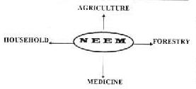
  Pest Repellent
  Food Preservative
  Fuel
  Pesticide
  Oil for
  Illumination
  Soap
  Eco-System
  Mulching
  Improvement of soil
  Timber
  Fuel
  Wind breaker
  Raw Material

Antipathogen  Immuno-modulater  Antidiabetic  Anticancerous  Antiulcerogenic  Contraceptive  CNS effect  Diuretic | Antihepatotoxic  Antimalarial  Anti-inflammatory  Wound Healing  Anthelmintic  Sedative  Skin diseases  Cardio-vascular

NEEM TREES IN INDIA:
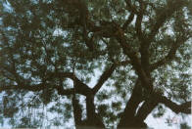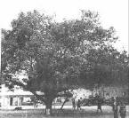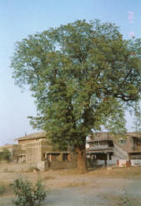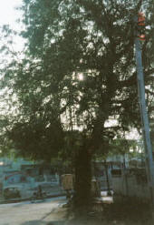
There is a myth that one has to use synthetic fertilizers and synthetic insecticides and pesticides otherwise you can have following. And there is a good reason for it. Synthetic fertilizers and synthetic insecticides is a trillion dollar industry and a million jobs. For next 5 to 10 years they will capitalize on following scare tactic.
MYTH: Scare tactic of manufacturers’ of synthetic insecticides and fertilizers.
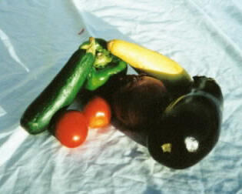  This is grown by synthetic fertilizer, synthetic insecticide and genetically modified seeds. | 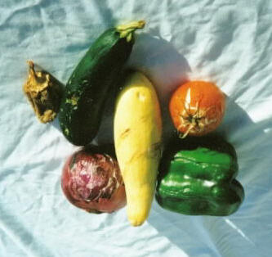  This is organically grown product.
ORGANIC CROPS:
Following is the organic crop. It was grown in Panguitch, UT (altitude of >6850 feet, October thru April the ground is frozen, 80% times humidity is below 40%, zillion rocks per acre of wide range of sizes, etc.). What did I do ? Lots of cow manure mixed with Neem Oil Cake (in 1 to 1 ratio), watered 2 to 3 times a week and applied 3 times (in 4 months) 2% Neem oil emulsion.
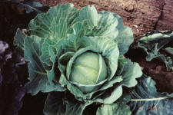 | 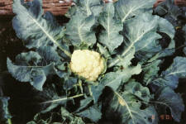 | 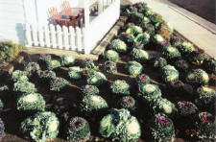
NEEM FRUITS, FLOWERS & LEAVES:
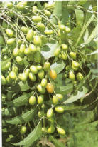 | 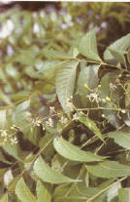
NEEM BASED SOAP AND TOOTH PASTE: US Department of Agriculture / Agriculture Research services – “In India Neem ingredients are found in many consumer goods. Neem oil for instance, has a major ingredient in soaps for at least 50 years. Its antiseptic properties have been used to particular advantage in the manufacture of special medicated soaps and tooth pastes. In addition, pharmaceutical preparations – emulsions, ointments, poultices, and liniments, as well as cosmetics such as creams, lotions shampoos, hair tonics, and gargles – have been prepared.”
People using NEEM sticks as disposable toothbrushes are commonly seen in rural regions of South Asia and Africa (for centuries). Research has found that Neem twigs contain antiseptic ingredients and they are able to maintain healthy teeth and gums.
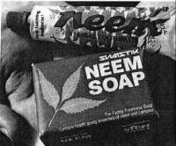 | 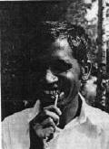

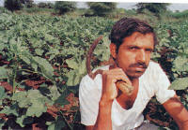  BACK TO NATURE: Ramji Borkar of Meta-Umri uses neem pesticides. | 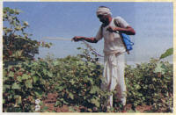  NATURAL ALTERNATIVE: A farmer spraying neem pesticides on cotton.

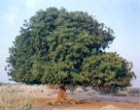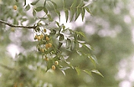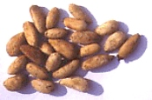
The Neem tree - Azadirachta Indica - is an evergreen, native to India, that grows up to 60 ft high. It is found in the tropical dry deciduous/evergreen and thorny forests and drier parts of Uttar Pradesh, Haryana, Punjab, Himachal Pradesh, Orissa, Andhra Pradesh, Kerala, Karnataka, and Tamil Nadu. It also grows in Indonesia, Sri Lanka, Myanmar, Pakistan, Japan and tropical regions of Australia and America. Ancient Indian texts refer to Neem as Sarva Roga Nivarini, "the curer of all ailments."
To generations of Indians neem was known to provide protection from disease - therefore protecting and planting Neem was not only considered a sacred duty - but it was encouraged by religious sanction. Environmentally, Neem has a reputation as a natural air purifier, exhaling out oxygen and keeping the oxygen level in the atmosphere balanced. Neem's ability to withstand extreme heat and water pollution is well known. It also helps to improve fertility of the soil and to rehabilitate degraded wastelands. The Neem tree can also play a vital role in controlling soil erosion, salination and preventing floods. But Neem is far more than a tough tree that grows vigorously in difficult sites. Among its many benefits, the one that is most unusual and immediately practical is the control of farm and household pests. Some entomologists now believe that Neem has such remarkable powers for controlling insects that it will usher in a new era in safe, natural pesticides.
The medicinal properties of Neem have been described in ancient Indian medical texts (4000 B.C.) such as the Atharva Veda, Ghrhyasutras and the Sutragranthas. The sanskrit name, nimba, is a derivative of the term nimbati syasthyamdadati - meaning 'to give good health'. Literally, every part of the tree has a use. The products of the Neem tree are known to be anti-bacterial, anti-fungal and anti-parasitic. The leaf and bark are used in teas and medicinal preparations.

NEEM (Azadirachta indica)
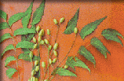
Neem is a fascinating tree, found on every Island in Fiji. For centuries, the Islanders have used various parts of the tree.
The neem tree is a fast growing (up to twenty feet in three years) tropical evergreen related to mahogany. Outdoors, in locations where temperatures don't drop much below freezing, it may reach up to 50 feet tall. It will grow where rainfall is as little as 18 inches per year and thrives in areas that experience extreme heat of up to 120 degrees F. They are reported to live for up to 200 years.
The tree is often covered in these delicate flowers in the early summer. The semi-sweet, olive-sized fruit are a favorite of children in Africa. The seed inside is rich in oil with tremendous medicinal and botanical properties. The oil is easily obtained by pressing the kernels in screw juicer. A neem ,ptree generally begins bearing fruit at three to five years old, and can produce up to 110 lbs. of fruit annually when mature.
Here in Fiji the neem tree is known as the "Village pharmacy". The medicinal and cosmetic properties attributed to neem are so numerous that they invoke disbelief! Neem twigs for cleaning teeth.
Neem cream for healing skin disorders.
Neem leaf juice taken as a tonic,
Neem Pest Control: leaves are placed in beds, books, grain bins and cupboards, to keep away insects.
Medicinally it is effective as analgesic, especially for earaches and headaches. It is also effective in controlling diabetes Various parts of the plant for treatment of ailments like fever, infections and other complaints.
Neem leaf extract substantially increases the state of oxidation in red blood cells.
'Fresh and Wild' sell:
Neem bark powder
The bark is also used in several herbal cosmetic, health, and hygiene product, and its anti inflammatory and antiseptic properties have been well researched. The bark is washed dried and pounded to produce a powder.
Neem Leaf Granules
Neem leaves are thoroughly washed to remove impurities, leaves are dried and granulated in a procedure resembling the processing of tea leave. 'Fresh and Wild' leaf granules are used in several herbal cosmetic preparations, especially facial packs. Researchers have documented treatment of sores and facial pimples by localized application of neem leaves.
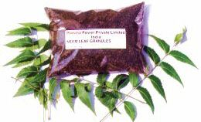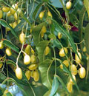
Neem leaves and fruit

