ANCIENT HINDU SAGES BY R.HARISHANKAR
MANDAVYA
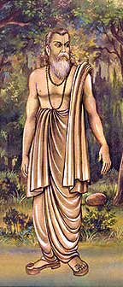
INTRODUCTION
Mandavya was an ancient sage, was once wrongly punished by the king believing him to be a thief, since, some robbers were hidden their stolen articles near his hermitage when he was in deep meditation, and he was wrongly assumed to have stolen the goods. He checked with Lord Yama about his karmic deeds. Yama told that he had given the punishment since he had tortured small insects in his childhood. Mandavya cursed Lord Yama Dharma, since acts done by him in his child hood would not attract such a severe punishment, and said that he will be born in the mortal world. Due to that, Lord Dharma was born as Vidura, the wise minister and the half- brother of the blind King Druthrashtra. He lived in a dharmic path throughout his life, and also given various teachings to the kauravas in order to correct them.
PIPPALADA
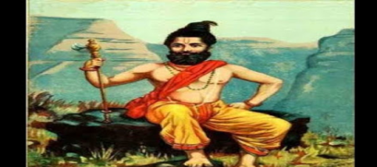
INTRODUCTION
Pippalada was an ancient sage and he had written the Prashna Upanishad. He was the son of pious sage Dadhichi, who donated his bones to the demigods in order to make the divine weapon “Vajrayutha” for Indra’s use. He contains great knowledge in vedas and other divine texts and hindu scriptures. Since he lost both of his parents, he was taken care of by Dadhichi's sister, Dadhimati. After he came to know about the reason of his parent’s death, he performed a heavy penance on Lord Shiva in order to kill Lord Indra and other demi gods in the heaven. Shiva pacified Pippalada and asked him not to show enmity with the divine demi gods, since his parents were died based on their fate, and there is no use in punishing the demi gods. After hearing the words of Lord Shiva, Pippalada was calmed down and thereafter became a great rishi. Once he has also defeated Lord Shani, and asked him not to give troubles to the young people.
UTTANKA
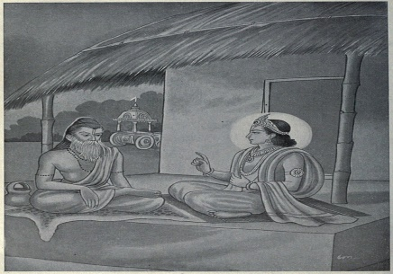
INTRODUCTION
Utanka, is a rishi who was once lived in the Maru desert as per the great epic Mahabharata. Uttanka is the disciple of Gautama. He is a great scholar and contains good knowledge in vedic subjects and was an expert in all kinds of art and contains wisdom, courage and spiritual powers. Uttanka has once met Lord Krishna, and asked about the wellness of the pandavas and kauravas. Krishna told that due to their bad actions, kauravas were killed in the kurukshetra war, and pandavas were ruling their region. On hearing this Uttanka has got angry with Lord Krishna and decided to curse him, for not correcting the wrong behaviour of the kauravas. Then Lord Krishna took his true form and gave his “VISHWAROOPA DARSHAN” and also blessed him with a boon that would quench his thirst whenever he remembered him. The sage realised his mistake and asked Lord Krishna to pardon him.
VISHRAVA
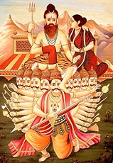
INTRODUCTION
Vishrava was the son of Pulatsya and the grandson of Brahma, and is described as a powerful rishi in the ancient texts. He was very good at meditation and got great spiritual powers through that. Rishi Bharadwaja, was pleased by his good acts, and he married his daughter Ilavida, to him. Through that marriage, they had a son, Lord Kubera, the God of Wealth.
On hearing about his supreme powers, the demon Sumali, and his wife, Ketumati decided to get married their daughter Kaikesi with the Rishi. Through their marriage they had Ravana, Vibhishana, Kumbakarna and a daughter, Shurpanakha. After some time, he left his wife Kaikasi and joined with his first wife Illavida, since Ravana had insulted him as well as his first wife’s son Kubera, and given various troubles to him.
MUDGAL
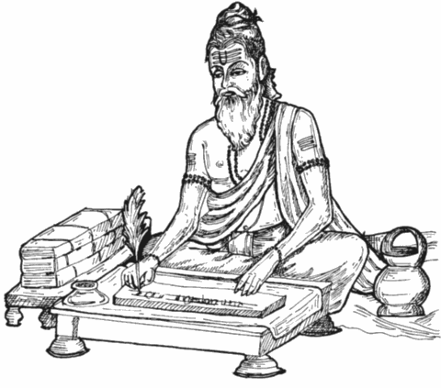
INTRODUCTION
Rishi Mudgal, is one of the Rajarshi in Hinduism. He was a Kshatriya king, but due to his severe penances, he attained great powers and became a famous Rishi. He wrote the Mudgala Purana. In his Purana, he praises about Lord Ganesha, and the way of doing pujas and homams to Lord Ganapati. He got very patience and never hated others, and also never cursed others, even if someone had caused harm to him. He was a pious sage. Once, Rishi Mudgal was the king of the Punjab. He is known as Rajarishi similar to the great sage Viswamitra. His name was mentioned in several ancient puranas and sacred hindu texts. His sons were lived as Rajpurohitas( Chief priests of the king). His wife was a pious and a noble lady Nalayani, who served him as a dutiful wife and showed her full attention on him and she acts as an example for others. In her next birth, she took birth as draupadi and married the pandavas. And she is also an avatar of Mata Parvati and her various temples are located all over India.
RISHYASRINGA
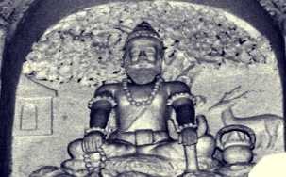
INTRODUCTION
Rishyasringa was a boy born with the horns of a deer and his father was the Vibhandak Rishi, and his mother was Urvashi, a celestial woman. According to legend, his father Vibhandak Rishi was attracted with Urvasi, who was sent by Lord Indra in order to disturb his penance. And after having an affair with her, Rishyasringa was born to them. After the birth of Rishyasringa, his mother Urvasi didn’t cared him and went to the heavens. Due to that, his father Vibhandak Rishi had himself raised him in the forest at his hermitage without showing him the outside world. He was not aware of females and lived in a lonely manner. Once, the kingdom of Anga suffers from severe drought and famine. The King Romapada, was told that this can be solved only by a Brahmin bachelor person. On hearing that Rishyasringa had performed ceremonies, and due to that there was a heavy rain, and he married the princess of that kingdom and lived happily.
WILLYESH RISHI
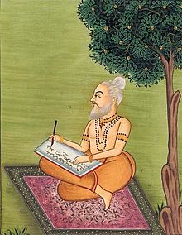
INTRODUCTION
Willyesh Rishi was one of the great rishis and his greatness is mentioned in the Puranas. Willyesh Brahmins are the descendent of Willyesh Rishi and belonged to Hindu Brahmin communities, living in Haryana, Punjab, Rajastan and UP. Willyesh Brahmins were considered as very famous for their knowledge and wisdom and they are also expert in Vedic learning. He was also an expert in all kinds of arts. Sage Willyesh was a renowned scholar of Ayurveda and he also cured the various diseases of the people during the ancient times. He is considered as a great guru, and treated everyone with respect and will never get angry on anyone, and also provided food and free medicines to the poor patients. Similar to Rishi Charaka, he is also famous in doing operations successfully during the ancient times. He is considered as a Master of Ayurveda, and apart from that he is very good at yoga and meditation, and shared his knowledge with others.
YAGNAVALKYA
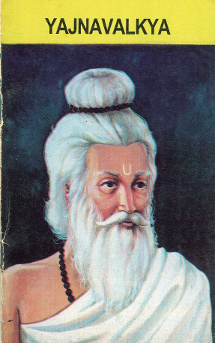
INTRODUCTION
Yajnavalkya was an ancient sage. He is mentioned in the hindu scriptures and in the Upanishads, and it is believed that he lived in Bihar during the 8th century BC. Yajnavalkya is considered as one of the great rishis and helped the people towards attaining spiritual knowledge. He had written the great texts such as Yajnavalkya Smriti, Yoga Yajnavalkya, Vriddha Yajnavalkya, and Brihad Yajnavalkya and also some small texts. He encouraged the participation of women in Vedic studies, and he encouraged the two woman philosophers, Gargi Vachaknavi and Maitreyi and taught them vedic studies. It is stated that, he had two wives Maitreyi and Katyayani. His name is derived from the word Yajna, fire rituals. He is also contributed his works in the Shukla Yajurveda, the Shatapatha Brahmana, the Brihadaranyaka Upanishad. He is also mentioned in the Mahabharata and the Puranas, and also in Jainism texts. He was also good at yoga and meditation. He shared his knowledge with his disciples, and guided them properly.
GURU MALLESHWARA
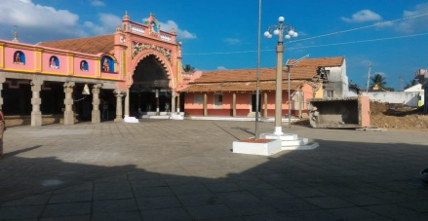
INTRODUCTION
Gurumalleshwara was a 19th-century Veerashaiva Lingayat saint and the Teacher of Shakti Vishishtadvaita. He was born in Karnataka and lived in Mysore and was performed meditation on Lord Shiva at a Mutt in Mysore. After some time, he started a movement through his teachings and also found a new Veerashaiva Mutt in Karnataka. He is considered as an avatar of Lord Nandi and each and every Lingayat family at mysore will have pictures of him at their homes. His Mutt in Devanuru, is considered as a sect of Shri Srishailam Veerashaiva Mutt and he had received the sainthood directly from Bhagawan Renukacharya. He has also performed many miracles like turning the water into ghee, and removed the dreaded physical and mental diseases of the people. His devotees are worshipping him as their own Guru and are living with full of prosperity in their life, due to his blessings.
KARNI MATA
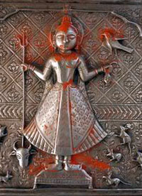
INTRODUCTION
Karni Mata (1387 –1538) was a female sage and she is known as Shri Karniji, and she is worshiped as the incarnation Mata Durga by her followers. She is an official deity of the royal families of Jodhpur and Bikaner. She lived a saintly life and spent with full of devotion during her entire lifetime. The most famous of her temples is in Rajasthan, and was created following her disappearance from her home. The temple is famous for its white rats, which are treated as sacred and given protection in the temple. Another temple dedicated to her during her lifetime contains the footprint to symbolize her visit to that place. Her temples are situated in Mathania, Udaipur and Alwar. She was married with Depoji Charan and she was not interested in living a normal life, and arranged her husband to get married with her younger sister. After some time, she travelled to many holy places with her followers, and finally attained salvation and she is considered as a powerful goddess by the people.

