EIGHT AVATARS OF LORD VINAYAKA
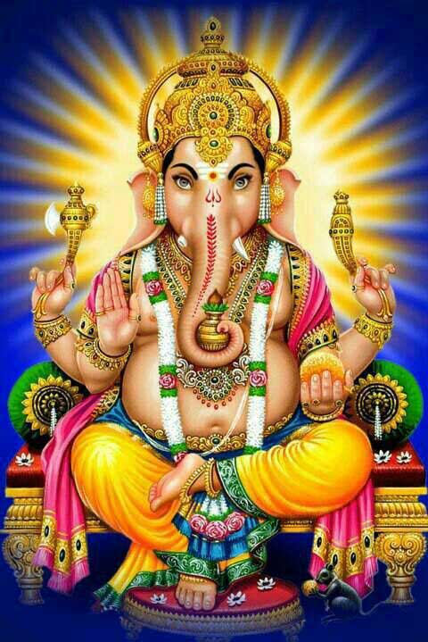

Lord Vinayaka also called as Ganapathi and Ganesa, as we know, is the first god in Hinduism. Due to destroy the evil forces, he took several avatars. All these avatars were taken to destroy the demons and to safeguard the divine devas.The details of his various avatars are explained as below:-

1.Ekdant Avatar
Lord Ganapathy took this avatar in order to destroy the Demon Madasura in order to safeguard the divine devas from the clutches of Madasura.

2.Vakratunda
Lord Ganesa took this avatar to destroy the Demon Matsrasur. He got a boon from Siva, that he will not be destroyed by any living creatures in this world and after then started harassing the devas. Hence he was destroyed by Lord Vinayaka.

3. Gajanana
This avatar was taken in order to defeat Demon Lobhasur. Knowing about Lord Ganesa’s power, the demon surrendered to lord Ganesa without commencing a war.

4. Lambodar
When Lord Vishnu took the form of Mohini during the churning of ocean, Lord Shiva got attracted and followed her, due to the result Krodashur was born. With the blessings of Sun God, he got enough powers, and then he started attacking the devas. And as per the request of the devas, Lord Ganapathy took the avatar of Lambodar and attacked him and pacified the devas.

5. Mahodar
When Lord Muruga killed Tarakasur, Sage Sukracharya has created a demon ‘ Mohasur’. He attacked devas and tried to kill the devas. Lord Ganapathy took the avatar of Mahodar and eliminated Mohasur.

6. Vikat
This avatar for taken for destroying the demon Kamasur.

7.Vighnaraj
In this Avatar, Lord Vinayaka defeated the asura mam who was born from mountains.

8.Dhumravarna
This avatar was taken to defeat the demon ahamkarasur.

CONCLUSION
Those who read the above eight avatars of Lord Vinayaka mainly during Sankatahara Chathurthi and Vinayaka Chathurthi, will definitely be blessed by Lord Vinayaka, and will attain all the prospects and peacefulness in their life.
Let us chant ‘OM SREE VINAYAKA NAMAHA’, ‘OM SREE GANESAYA NAMAHA’, ‘OM SREE GANAPATHIYE NAMAHA’.
WRITTEN BY
R.HARISHANKAR

