BHAKTI TEXTS WRITTEN BY R.HARISHANKAR
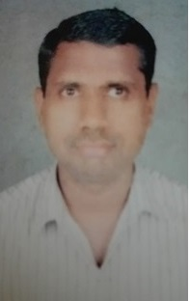
RAMAYANA
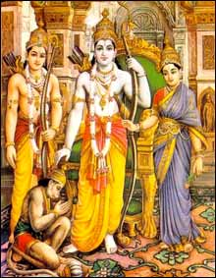
INTRODUCTION
Ramayana is a major epic in Hinduism and it is considered as a sacred text, which tells the greatness and holiness of Lord Rama, an avatar of Lord Vishnu. It also tells the respect he has shown to his father, king Dasaratha and obeys his orders and went to the forest. He acts as an example for others with regard to his Guru Bhakti, love and affection towards his father, mother and wife. And his good characteristics like honesty, dedication and sincerity was mentioned in the epic Ramayana.
Maharshi Valmiki, had written the life story of Lord Rama and the various incidents happening in his life, also known as “VALMIKI RAMAYANA”. The details about his birth, marriage with Sita, his fourteen-year exile to the forest, the kidnapping of his wife by Ravana, the great king of Lanka, fighting and winning a war with him, and becoming the king of Ayodhya, and ruling his kingdom for thousands of years were mentioned in a detailed manner.
The Ramayana is one of the popular ancient epics in india. It also tells us about the greatness of Lord Hanuman in helping rama to rescue Mata Sita from the Demon king Ravana, and also tells his great “RAMA BHAKTI”, and his frequent chanting of the Rama Mantra “JAI SREE RAM”.
MAHABHARATA
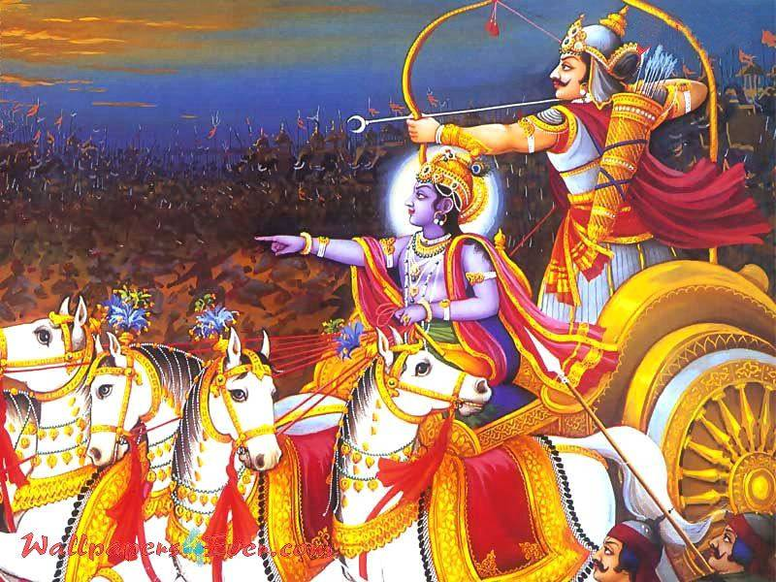
INTRODUCTION
The Mahabharata is one of the great epics similar to Ramayana. It tells us the enmity between two groups of cousins, the pandavas and the kauravas, which led to the Kurukshetra War. It also contains devotional and useful information, which we can follow it in this today’s world. Through the epic, Mahabharata, we can learn the lesson of not fighting with any one and especially with our relatives, which will lead to a greater destruction in our life. Sage Vyasa had written the great epic Mahabharata. It is believed that this great epic was written before 5000+ years.
It is believed that it was Ganesha who wrote down the great epic Mahabharata with the assistance of Sage Vyasa.
After the end of the Mahabharata war, Lord Krishna has left his avatar and went to Vaikunta, and Kali Yuga was formed, since then lot of problems are occurring to the people, and the earth god, is getting troubled through the evil effects of “KALI PURUSHA”.
The great epic Mahabharata was also telecasted in the private TV network channels in hindi, and it has also dubbed in various other indian languages.
BHAGAVATA PURANA
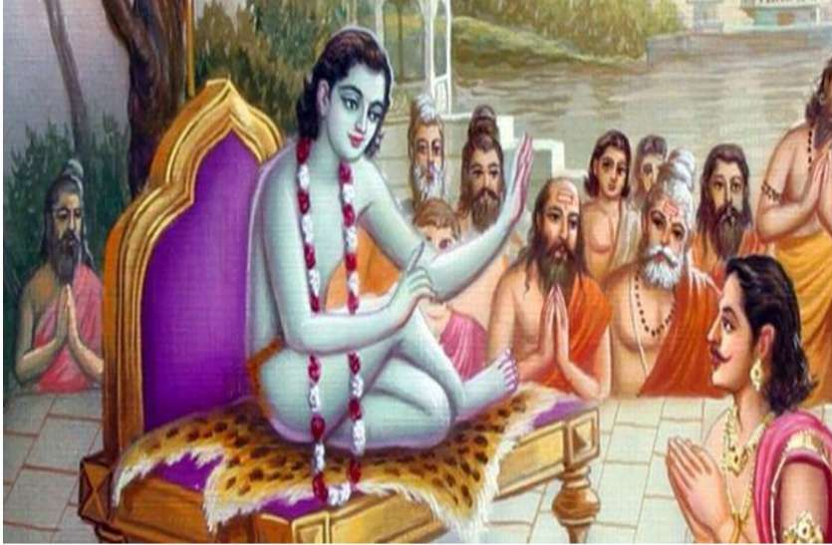
INTRODUCTION
The Bhagavata Purana also known as Srimad Bhagavatam is one of the eighteen ancient puranas.
It tells the greatness of Lord Krishna and as the main source of energy to all the living beings in the earth and also in the heaven. It also tells the miracles performed by him in the childhood and at his young age. It tells the various good characteristic features of Lord Krishna like giving SALVATION even to the demons when they were tried to kill him, which was beyond our imagination. It also mentions the relationship between him with that of Gopikas, and explains the relationship as similar to the love between the mother and the child. It was narrated by the great sage Sukha to king parikshat, who was supposed to die within a few days through snake bite, from the date of hearing this mahapuran. After hearing the puran from Shuka, Parikshat got enlightenment and sat in deep meditation. He also didn’t get any pain even while the snake king takshaka had bitten him. After his death, he attained the SWARKA LOKA.
BHAGAVAD GITA
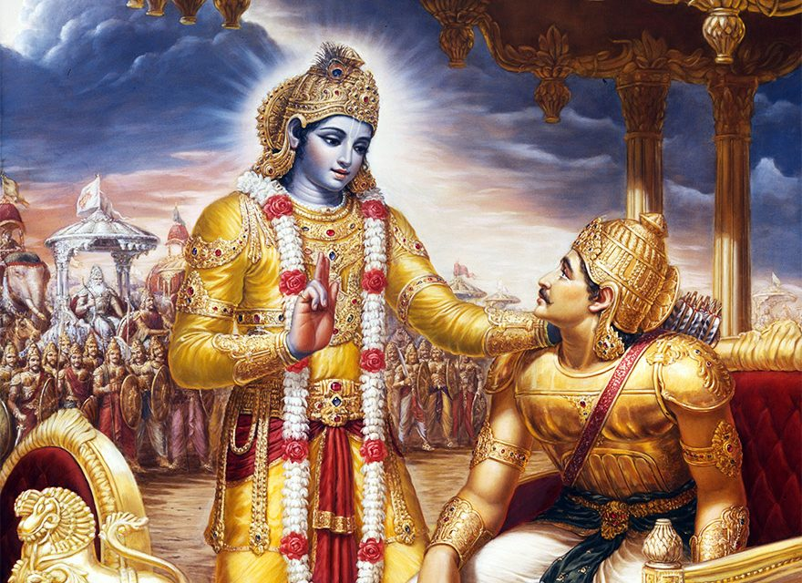
INTRODUCTION
The Bhagavad Gita referred to as the Gita, is a great scripture that is a part of the Hindu epic Mahabharata.
The Gita is formed during the conversation between Pandava prince Arjuna and Lord Krishna during the battle field of Kurukshetra. Arjuna felt it was bad to fight with his relatives, since it will result in lot of deaths and gives troubles to other side of warriors. At one point of time, he showed his disinterest in fighting and kept his bow and arrow in the earth. During that time, Lord Krishna conveys certain messages to him, and tells him about the truth of the divinity and showed his full form of Viswaroopa, and asked him to fight with his enemies, in order to reduce weight of the earth, by killing the warriors in the battle field. The discourse given by Krishna constitutes the Holy Bhagavad Gita.
MAIN TEACHINGS OF BHAGAVAT GITA
1. Know the world which is impermanent and unreal, and think everything is controlled by the god.
2. Know about yourself, by realising the inner spirit within you, and that is living within you. And your soul will not die, it will be a permanent one, and will take various re-births based on your karmic deeds.
3. Keep your mind as stable and ignore the worldly attachments, and don’t enjoy too much of pleasures and comforts in this life, since that will not last too long.
4. Have enough knowledge about god, and find the difference between truth and untruth, good and bad, god and devil, fair and unfair and act accordingly.
5. Try to believe that everything is happening in this world based on the karmic effects of the human beings.
6. Accept god as the basis for living a peaceful life. Surrender to him completely and offer him everything that you have, and he will give more than 100 times greater than that of your offering to him.
7. Be pure in mind and body and experience the true love for God and control your mind and involve yourself in deep meditation on god and chant his mantras and names and involve in deep bhakti on him.
VEDAS
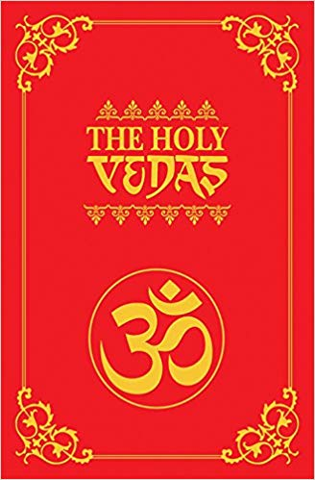
INTRODUCTION
The Vedas are a large body of religious texts. It contains the oldest scriptures of Hinduism. Vedas are considered as sacred by ancient sages and the vedic texts have been more carefully preserved since ancient times. Vedas are very important for Brahmin people. It is considered as very sacred in ancient times. Without uttering the hymns of vedas, a hindu ceremony cannot be performed. It must be chanted correctly. Vedas were created by Lord Brahma, and in his hands he is holding vedic books. Vyasa is the compiler of the Vedas. There are four Vedas, the Rigveda, the Yajurveda, the Samaveda and the Atharvaveda. The Vedas are among the oldest sacred texts.
Of these, the first three were the principal vedas. Reciting hymns in praise of the gods (Rigveda), performing sacrifices (Yajurveda), and chanting songs (Samaveda). The Rigveda is the oldest work. Lot of vedic details are missing, since they were written in palm leaves. Some important leaflets are still preserved.
UPANISHADS
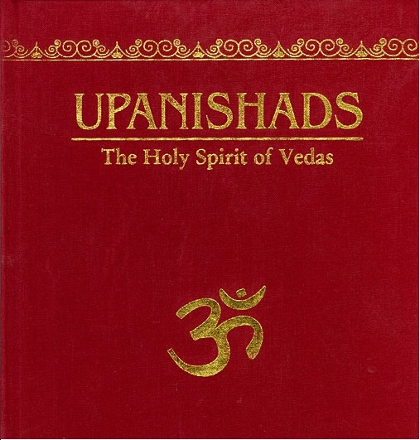
INTRODUCTION
The Upanishads are a part of the Vedas, and are ancient texts contains spiritual details of Hinduism, which were also found in Buddhism and Jainism Texts. Among the various holy texts, the Upanishads occupies an important role towards spreading the spiritual ideas of Hinduism. The Upanishads are also known as Vedanta. Along with the Bhagavad Gita and the ancient puranas, the Upanishads are a main source of divine energy, which helps in establishing a holy path for the mankind.
The main Upanishads are found in various hindu sacred texts, and the new Upanishads were composed during the modern period.
Brihadaranyaka Upanishad contains the, "knowledge of the self", and the "knowledge of Brahma". The Brhadaranyaka and the Chandogya are the two earliest Upanishads. The Prasna and the Mandukya are also popular upanishads.
DEVI BHAGAVATA PURANA
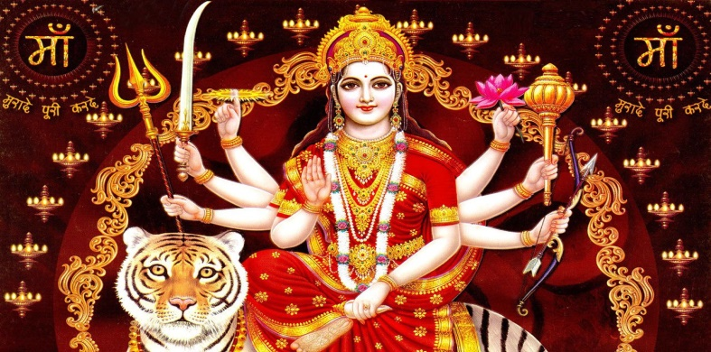
INTRODUCTION
The Devi Bhagavata Purana also known as the Shrimad Devi Bhagvatam is a purana and contains the importance and greatness of Mata Parvati.
In this purana, Shakti is considered as the principal creator of the universe and she only preserves and destroys the entire universe. It is believed that the purana was written several thousands of years ago. This text is attributed to the great sage Veda Vyasa.
The Devi-Bhagavata Purana is an important and historic Shakta Bhakti text. It contains the details about Mata Parvati and her various incarnations like Durga, Kali, Chamundi etc. Mata Parvati had taken various avatars, in order to protect the universe from the evil forces. Her avatar is mainly created for destroying the demons, who had given lot of troubles to the sages, people in the earth and to the demi gods in the heaven. She took various avatars and destroyed the bad ones, and maintained peace and prosperity in the entire universe. Her holiness and kindness cannot be explained fully. She is the divine and affectionate mother, who is there to remove our problems and to reduce our sins. Her importance and greatness is mentioned in the Devi Bhagavatham.
GANESHA PURANA
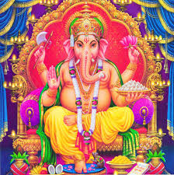
INTRODUCTION
The Ganesha Purana (is a Sanskrit text that deals with Lord Ganesha). It is a sub purana that contains the importance of Lord Ganesha.
The Ganesha Purana is an important text particularly for Ganapatyas who consider Lord Ganesha as their primary deity. In this purana, Lord Ganesha is mentioned as the main deity and is considered as the chief among other gods, since he is worshipped as the first god. It also tells the miracles performed by ganesha and the blessings he had given to his sincere devotees like sage purushundi, vallalan etc. He is the one who is having the entire universe in his stomach, and he controls the entire universe by his great supreme powers, and is an endless god.
Through his grace, the trimurties and tridevis are able to perform their task in a proper manner. He is also considered as an obstacle remover, and worshipped for getting good fortunes in our life.
Being the first god, he cannot be ignored in our daily life. By reading Ganesa purana, our mind and body will get relaxed and can live a disease free and a tension free life.
SKANDA PURANA
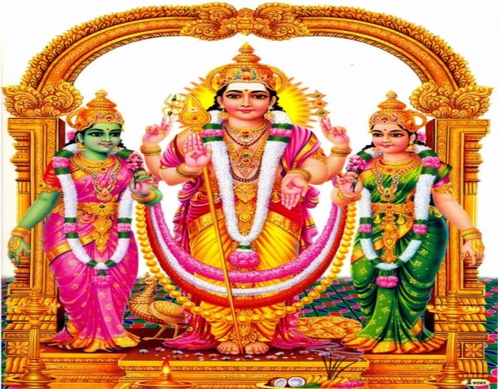
INTRODUCTION
The Skanda Purana is one among the hindu puranas, and it contains the importance and the greatness of Lord Muruga. This text would have written thousands of years back.
This Mahapurana, is attributed to the sage Vyasa.
In this purana, Lord Muruga is considered as a main deity and all other gods are considered as next to him. He is the one who creates, protects and destroys the entire universe. The details about his birth, fighting with demons and marrying Valli and Deivanai are also available in this puranic book. People belonging to Kaumaram sect will worship Lord Muruga as the main god. He is the god who relieves us from sins and safeguards us in this kali yuga. This purana also mentions about the incidents happened in his life at Kailasa, regarding imprisonment of Lord Brahma and doing his creation and playfully fighting with his elder brother ganesa for getting a mango fruit. By worshipping Lord Muruga, our sins committed in the previous births would be removed and we will get good results in our life.
SHIVA PURANA
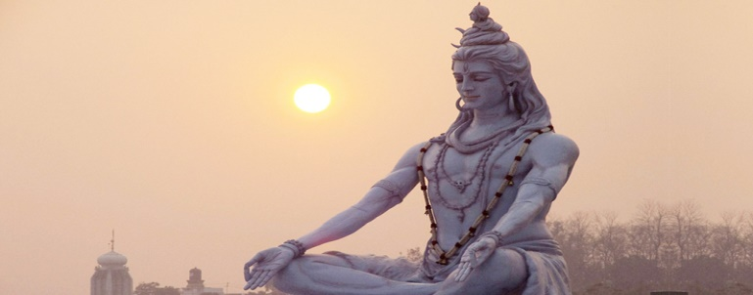
INTRODUCTION
The Shiva Maha Purana is one among the eighteen puranas, and explains the importance and greatness of Lord Shiva. It tells about the details of Lord Shiva and Mata Parvati.
It was written by Romaharshana, a disciple of Vyasa. The Shiva Purana, is a living text, which is available for a long period of time. The Shiva Purana contains shiva’s features and his relationship with other gods, pilgrimages, short stories and bhakti path etc.
The text contains details about Vishnu and Brahma, and the avatars of Vishnu. The text deals with bhakti and yoga. It also considers shiva as the main deity and all other deities are functioning under his control, and obeying his orders and instructions. Apart from Lord Shiva, all other gods are considered only as demi gods.
VISHNU PURANA
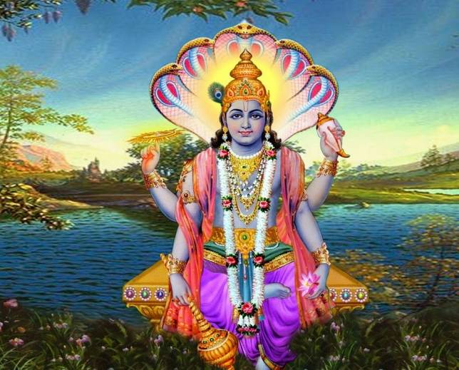
INTRODUCTION
The Vishnu Purana (is one of the eighteen Mahapuranas, and an ancient text of Hinduism. It is an important vaishnavite text, which covers the details about Lord Vishnu and his various avatars, the miracles performed in various avatars, and tells about bhakti, knowledge and meditation.
It also praises Brahma and Shiva and that they are doing their work only through the grace of Lord Vishnu. Vishnu Purana, is written by Sage Veda Vyasa. In Vishnu Purana, the upper seven and the lower seven world’s details are also mentioned. It also cautions us not to commit sins and to enter in the hell, instead of that, it tells us to do good activities and chant vishnu’s names and to read his story, and also to share it to others.
It also contains many short stories, and tells the kindness of Lord Vishnu shown to his sincere devotees. It also tells about vaikunta, the divine abode of Lord Vishnu, who is seated in a snake bed along with various sages like tumburu and narada and demi gods, who were singing songs on him.
GARUDA PURANA
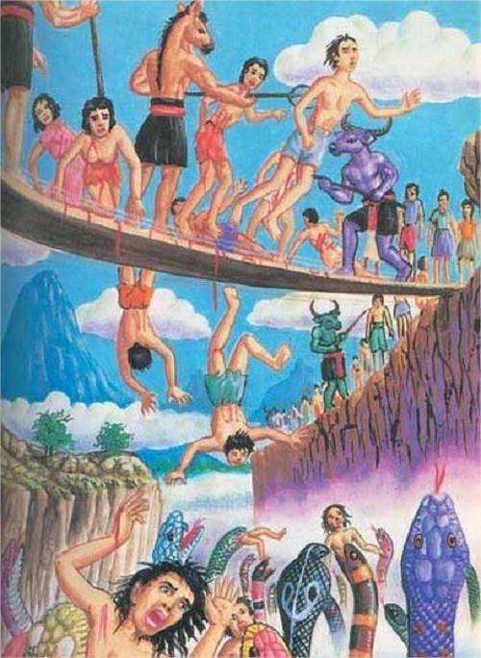
INTRODUCTION
Garuda Purana is the conversation between Lord Vishnu and his Vehicle Lord Garuda. Lord Garuda is asking some questions related to the life after death, and the suffering of the people based on their karmic deeds. For that Lord Vishnu explains in a detailed manner, about the different types of hell that are situated in the underworld, and the different types of punishment given for wrong doers. He also explains the rituals to be followed for a person after his death, by his sons, in order to satisfy the soul to reach the divine world.
He also tells that those people, who spent their life in the earth by doing good things to others, and also by chanting the names of Lord Vishnu, will reach “VAIKUNDA” and can remain there permanently. In order to reach the divine world, people must do good karmic deeds, and must live a noble and a sin free life. Lord Garuda listens to his master’s explanations and got satisfied with his divine words.
HINDU SCRIPTURES
INTRODUCTION
Hindu Scriptures contains all the sacred texts such as puranas, Ramayana, Mahabharata, vedas, Upanishads, bhagavat gita and the hindu mythology (Ithikasas). All these form a part of hindu literature. By reading these divine texts, we will get a good knowledge in Hinduism, hindu gods, goddesses, rishis and saints. It will also help us to live a noble life. We will get punya by reading the sacred texts, and all the benefits would be derived by reading these holy books. We can go through several web sites which tell the greatness of Hinduism, and also contains several short stories related to hindu mythology. It is must for every hindu, to read and recollect all the things contained in the books, in order to get relieved from our sins and also can get liberated from our birth cycle. Hence let us make the habit of reading holy books and be blessed.
WRITTEN BY
R.HARISHANKAR

