DEVOTIONAL ARTICLES BY R.HARISHANKAR
Lord Vinayaka
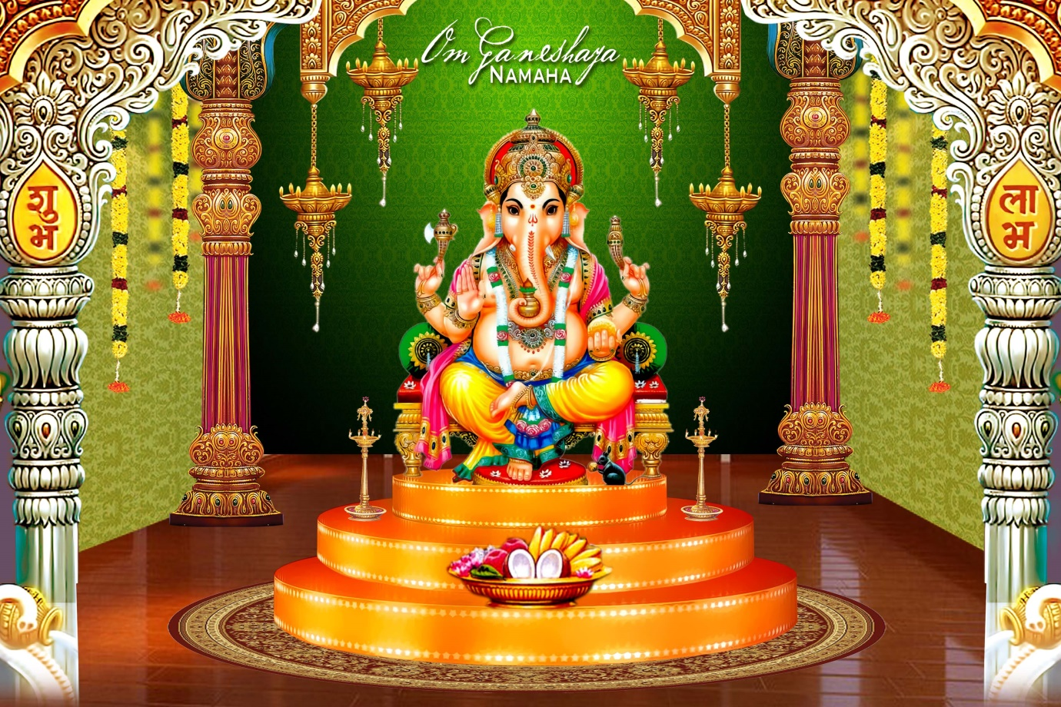
Shuklambaradharam Vishnum
Shashivarnam Chaturbhujam
Prasanna vadanam dhyayet
Sarva vighno (u) pa shantaye.
Lord Vinayaka (Ganesha) is one of the five prime hindu deities. He is the son of Lord Shiva and Goddess Parvati and the brother of Lord Kartikeya (Skanda / Subramaniya / Muruga). He was born of Parvati's body elements. The idols and temples of Lord Vinayaka are found all over the world. In the South Indian villages there are many temples exclusively for the worship of Vinayaka but there is no village where he does not exist. He is considered as the first God to be worshiped.

The worship of Vinayaka is not only popular among the Hindus, but also among Jains and Buddhists. Ganapati worship is popular in far eastern countries like Indochina, Cambodia, Japan and other adjacent countries. Ganapathi Homam / Pooja is a precondition for the performance of any religious function.

Lord Muruga
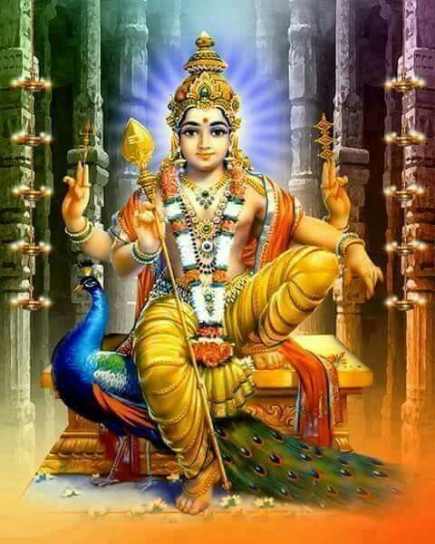

Lord Muruga is heralded in Hinduism in several names including Skanda, Karthikeya, Subrahmanya, Shanmukha, Shaktidhara, Kumara and many others. The iconography of Lord Muruga is represented with six faces and twelve hands with the five faces depicting the five elements of nature and he sixth face referring to the spirit that activates all of them.
Hindu god forms are rather symbols of what they teach humans. Each of the god forms is based on a lofty philosophy that drives home several spiritual truths and moral values. The two wives of Lord Murugan are also rather symbols that teach humans the ultimate purpose of human life. The two wives of Lord Muruga namely Valli and Devasena refer to icha shakti and kriya shakti, meaning the power of will and power of action respectively, while Lord Muruga represents Gnana Shakti or the power of wisdom.
In her earlier birth, Valli was the daughter of Lord Vishnu and she undertook a severe penance to get married to Lord Murugan. Devasena was in her previous birth the daughter of Indra, the king of gods, who too did an austere penance to get wedded to Lord Murugan.

Lord Ayyappa
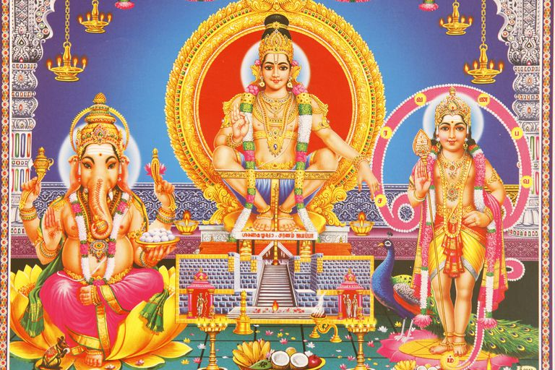

The Pandya dynasty, which was ousted by Thirumala Naicker the ruler of the Pandya Empire spanning Madurai, Thiruveneli and Ramanathapuram resided in places such as Valliyur, Tenkasi, Shengottah and Sivagiri. King Rakashekhra, which was the foster-father of Lord Ayyappa belong to this dynasty.
LORD AYYAPPA WAS THE SON OF VISHNU & SHIVA
Lord Ayyappa is a very popular Hindu deity, which is mainly worshipped in South India. He is also spelt as Ayyappa. It is believed that he was born out of the union between Lord Shiva and the mythical Mohini, who is also regarded as an avatar of Lord Vishnu. Therefore, Ayyappa is also called as ‘ Hariharan Puthiran’ which means the son of both Hari or Vishnu and ‘ Haran’ or Shiva.

Lord Shiva
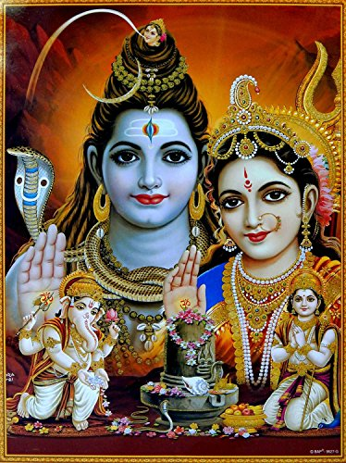

Shiva (Sanskrit: Auspicious One) is one of the main deities of Hinduism that is worshipped as the paramount lord by the Shaivaite sects of India.
In Hinduism, Lord Shiva is regarded as the representation of the Supreme Being. He is known as the third element in the Hindu Trinity (Trimurti), the other two members being Lord Brahma - the creator and Lord Vishnu - the protector. Shiva is the destructive form of the Almighty. As the cycle of destruction and recreation is always in a circle, Shiva’s primary responsibility is maintaining the life cycle. Scholars say, as the Mahakaal, Shiva destroys and dissolves everything into nothingness but as Shankara, he also reproduces that which has been destroyed and dissolved. His symbol of Lingam or the phallus represents this reproductive power.

Lord Vishnu
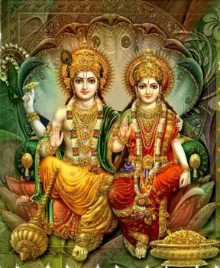
Vishnu is a Hindu god, the Supreme God of Vaishnavism (one of the three principal denominations of Hinduism) and one of the three supreme deities (Trimurti) of Hinduism. He is also known as Narayana and Hari. As one of the five primary forms of God in the Smarta tradition, he is conceived as “the Preserver or the Protector” within the Trimurti, the Hindu Trinity of the divinity.
Vishnu is one of the most important gods in the Hindu pantheon and, along with Brahma and Shiva, is considered a member of the holy trinity (trimurti) of Hinduism. He is the most important god of Vaishnavism, the largest Hindu sect. Indeed, to illustrate Vishnu’s superior status, Brahma is, in some accounts, considered to have been born from a lotus flower which grew from Vishnu’s naval. A complex character, Vishnu is the Preserver and guardian of men (Narayana), he protects the order of things (dharma) and, when necessary, he appears on earth in various incarnations or avatars to fight demons and fierce creatures and so maintain cosmic harmony.
Vishnu represents Sattvaguna and is the centripetal force as it were, responsible for sustenance, protection and maintenance of the created universe.

Lord Brahma
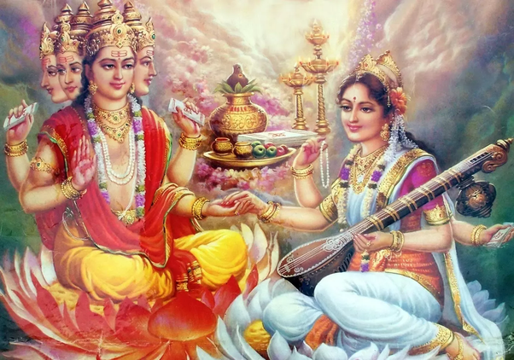

Brahma is the Hindu Creator god. He is also known as the Grandfather and as a later equivalent of Prajapati, the primeval first god. In early Hindu sources such as the Mahabharata, Brahma is supreme in the triad of great Hindu gods which includes Shiva and Vishnu.
Brahma, due to his elevated status, is less involved in picturesque myths where gods take on human form and character, but is rather a generally abstract or metaphysical ideal of a great god. In later Puranas (Hindu epics) Brahma is no longer worshipped and other gods are assigned his myths, even if he always maintains his status as the Creator god. Brahma's epithet is ekahamsa, the One Swan. His vahanam ('vehicle') is a peacock, swan or goose. He is still honoured today with an annual ceremony at the pilgrimage site of Pushkar in Rajasthan, India and he remains a popular figure in South-east Asia, especially in Thailand and Bali.

Goddess Parvathi
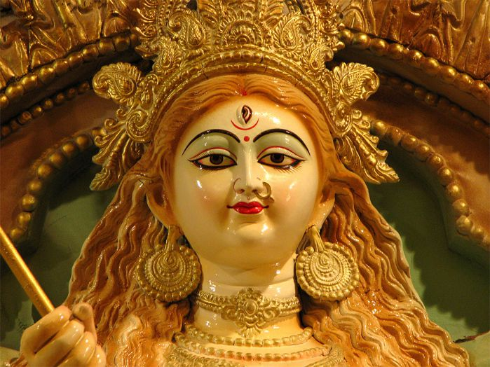

Parvati is the gentle and nurturing aspect of Hindu goddess Shakti. She is the Hindu goddess of love, fertility and devotion. Also, She is the mother goddess in Hinduism and source of power and beauty. She is the perfect incarnation of Adi Para Sakthi. She has many attributes and aspects, each of her aspects is expressed with a different name, giving her over 108 names in regional Hindu mythologies of India. Along with Lakshmi (goddess of wealth and prosperity) and Saraswati (goddess of knowledge and learning), she forms the trinity of Hindu goddesses same as god trinity of Shiva Vishnu and Brahma.
Parvata is one of the Sanskrit words for “mountain”; “Parvati” derives her name from being the daughter of king Himavan (also called Himavat, Parvat) and mother Mena. King Parvat is considered lord of the mountains and the personification of the Himalayas; Parvati implies “she of the mountain”.

Goddess Lakshmi
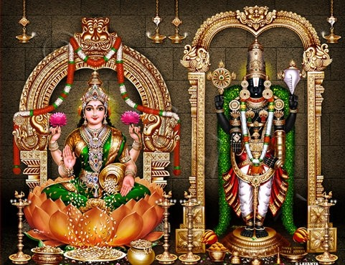
Goddess Lakshmi or Mahalakshmi is the consort of Mahavishnu, the Preserver. She is the resplendent goddess of wealth and prosperity who provides the beings with all kinds of material abundance. She is a protector as well as bestower. She bestows upon deserving people according to their past karma and degrees of devotion. She also protects from ill health and adversity.
Hence, in Hinduism, worship of Lakshmi is considered a suitable remedy for the alleviation of suffering. Her regular worship, chanting of her names, remembering her believed to bring good and luck and prosperity to people. Wealth plays an important role in the preservation of life upon earth. Hence, as the goddess of wealth, Lakshmi rightfully fulfills her duties as the nourisher, preserver and provider.

Goddess Saraswathi
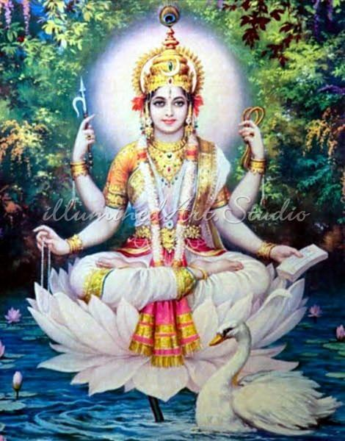
Saraswati, goddess of knowledge and the arts, embodies the wisdom of Devi. She is the river of consciousness that enlivens creation; she is the dawn-goddess whose rays dispel the darkness of ignorance. Without her there is only chaos and confusion. To realize her one must go beyond the pleasures of the senses and rejoice in the serenity of the spirit.
Saraswati wears neither jewels or paints herself with bright colors. The white sari she adorns reflects her essential purity, her rejection of all that is base and materialistic.
She transcends the cravings of the flesh and rejoices in the powers of the mind as the patron of pure wisdom. She embodies all that is pure and sublime in Nature.

Lord Indra
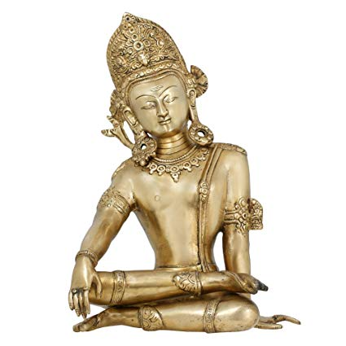

In Hinduism , there are around infinite numbers of Gods and Goddess excluding Three Trinity Deity,Lord Shiva , Lord Vishnu , and Lord Brahma . Among these gods, Lord Indra is considered as theKing of Gods and the ruler of Heavens. Lord Indra is known as Sakra in Vedas and is the Deva who holds the power of Rain and thunderstorms . Being the Deva of Rain and Thunderstorms , Lord Indra wields the Lightning Thunderbolt which is known as Vajra in Hindu scriptures . Lord Indra is depicted riding on the celestial White Elephant called Airavata . Airavata Elephant is known as Vahana of Lord Indra and there are Vahana of all the gods.
Lord Indra is believed to be the son of Dyaus and Goddess Savasi and Indra is believed to be resided on Mount Meru that lies in the heaven. Lord Indra is called by many names Hindu Religion such as “Vrsan The Mighty ”, “ Vrtrahan, Slayer of Vrtra ”, “ Devapati, lord of Devas ” and so on. He was known as National God for Arya Tribe. It is believed that Lord Indra protects Aryas and blessed with Military Aristocracy and the Kshatriyas Warriors. Lord Indra became one of the important figures in Hinduism, Vedic religion , and Buddhism especially Chinese Buddhism , Chan Tradition .

Goddess Indrani
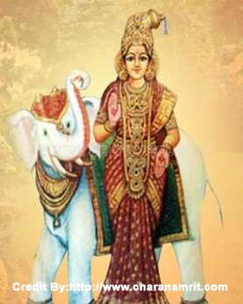

Indrani, as the name suggests, is the consort and queen of Indra, the Lord of the Devas and the God of thunder and lightning. She is a divinity referred to in the holy Vedas. Rig Veda, the ancient text speaks highly about her great beauty. Indrani is also known by many other names, Shachi being the most famous of them. Shachi is said to denote Shakthi, the power and Indrani is considered a powerful divine being. She is also called by the names Aindri, Mahendri, Pulomaja and Poulomi.

Significance of Indrani
Indrani is portrayed as a woman of incomparable beauty, whose charm virtually no one could resist. With everyone longing intensely for her, she became an object of jealousy and heartburn for many and hence, she has come to be regarded as the Goddess of Jealousy and wrath. Her exquisite eyes too have come in for special praise. Contrary to many other Goddesses, she has an independent character of her own. Also, unlike many godly consorts, who take their names from those of their husbands, like Varuni from Varuna, Saranya from Surya etc., it is Indra, who is often referred to as ShachiPathi, the Lord or husband of Shachi or as ShachiVat, Shachi’s possessor. Indrani, the ‘endless beauty’, was very dear to Indra indeed. She also mothered many children like Jayanta, Jayanthi, Midhusa, Nilambara etc. Chitragupta, the well-known and feared aide of Lord Yama, who is said to keep a meticulous record of our good and bad actions, is also her son only.

Guru Raghavendra Swamy
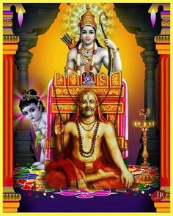

Hundreds of years ago, saints and sages used to perform tough penance and attained wisdom, blessings from God and their life’s motive was to preach devotion towards the Almighty and help people in understanding the true meaning of life. This is why saints were highly respected and some saints were even deemed as God’s incarnation. One such saint who lived during the 16th century and was considered God by many people owing to his several miraculous blessings and work was God Sri Raghavendra Swamy.
Born with the name Sri Venkata Natha in the town of Bhuvanagiri in Tamil Nadu, Sri Raghavendra Swamy was a famous Madhwa saint, philosopher and advocated the Dwaita philosophy. Since he was an ardent devotee of Lord Vishnu or Sri Venkateshwara, he was also called Venkatacharya. After completing his initial education, Sri Venkat Natha was admitted in a matha or temple in Kumbakonam. He was then married to Sarasvati Bai and had a son named Lakshminarayanacharya. Having studied under the expert guidance of Sudheendra Theertha in Kumbakonam, he emerged as a talented scholar. It was in 1614 that he took sanyasa and was given the name Raghavendra Theertha. He is said to have established a Brindavana at Mantralayam where he took Samadhi, located presently in Andhra Pradesh, which is now a popular pilgrimage destination.
In his quest of attaining higher spiritual plane, Sri Raghavendra Swamy never let his life’s struggles deter his faith in the Lord. He never demanded any money for teaching Sanskrit and vedic texts to children nor for his welfare services and this is the reason why he and his family endured a life of poverty. He was bestowed a long divine life that was full of miracles and had healing powers for the welfare of humanity. His miracles are so enormous that people even today chant two powerful lines of his stotra –
“Poojyaya Raghavendraya Sathya Dharma Ratha Yacha
Bajatham Kalpavrukshaya Namatham Kamadenuve.”
This hymn means that the worship of Sri Raghavendra Swamy who is a living example of truth and righteousness (sathya and dharma) blesses with whatever blessing one desires such the Kalpavruksha (the celestial tree) and Kamadhenu (the celestial cow). It is believed that chanting this hymn for several times a day with concentration and sacred mind can eliminate all kinds of ills and problems in life.

Shirdi Sai Baba
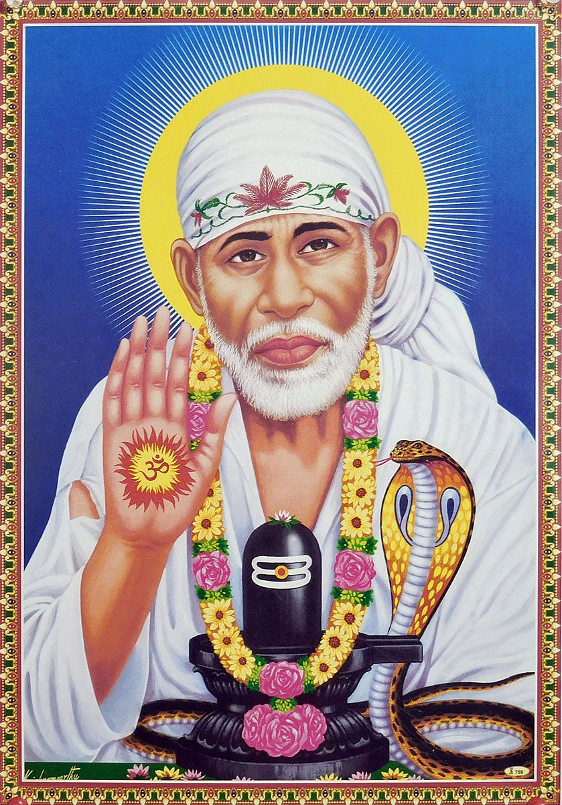
Sai Baba of Shirdi, also known as Shirdi Sai Baba, was an Indian spiritual master who is regarded by his devotees as a saint, a fakir, a satguru and an incarnation (avatar) of Lord Shiva and Dattatreya. He is revered by both his Hindu and Muslim devotees during, as well as after his lifetime.
Saibaba is now revered as incarnation of Sri Dattatreya and considered as Saguna Brahma. He is attributed to be the creator, sustainer and destroyer of this universe by his devotees. He is decorated with jewels and all forms of Hindu vedic deities as he is believed by his followers to be the supreme God.
According to accounts from his life, he preached the importance of realization of the self and criticized love towards perishable things. His teachings concentrate on a moral code of love, forgiveness, helping others, charity, contentment, inner peace and devotion to the God and guru. He stressed the importance of surrender to the true Satguru, who, having trod the path to divine consciousness, will lead the disciple through the jungle of spiritual training.
Sai Baba also condemned distinction based on religion or caste. It remains unclear if he was a Muslim or a Hindu. This, however, was of no consequence to Sai Baba. His teaching combined elements of Hinduism and Islam: he gave the Hindu name Dwarakamayi to the mosque in which he lived, practised both Hindu and Muslim rituals, taught using words and figures that drew from both traditions and took samadhi in Shirdi. One of his well-known epigrams, Allah Malik (God is King) and Sabka Malik Ek (Everyone's Master is One), is associated with both Hinduism and Islam. He is also known to have said Look to me, and I shall look to you.

Ramakrishna Paramahamsa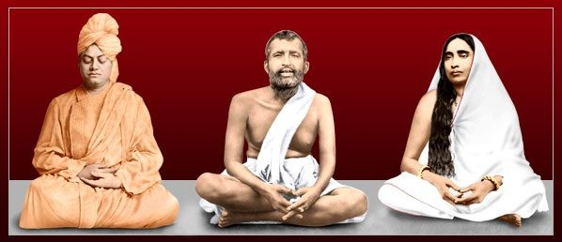
Ramakrishna Paramahansa 18 February 1836 – 16 August 1886), born Gadadhar Chatterjee or Gadadhar Chattopadhyay,was an Indian Hindu mystic and saint in 19th century Bengal. Ramakrishna experienced spiritual ecstasies from a young age, and was influenced by several religious traditions, including devotion toward the goddess Kali, Tantra (shakta), Vaishnava (bhakti), and Advaita Vedanta. Reverence and admiration for him among Bengali elites led to the formation of the Ramakrishna Mission by his chief disciple Swami Vivekananda.
Ramakrishna Paramahamsa is a great divine personality who attains the inner bliss of god. He is a supreme one, who eliminates the ill effects of the bad karma of his true devotees.
Written by
R.HARISHANKAR

