DISCIPLES OF LORD BUDDHA
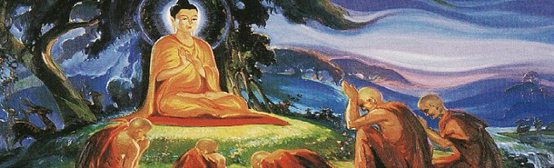
INTRODUCTION
Lord Buddha was born before 2500 years ago in Lumbini at Nepal. He was born as a prince, and after getting married and having a son, he got depressed in his life, by seeing certain incidents in his life, such as a dead man, an old man and a person suffering from disease. Due to that, he wanted to adopt Sainthood in order to get himself liberated from the chain of life cycle. He lived a saintly life, by taking alms and without enjoying any comforts and luxuries in his life. It is also believed that through his yogic powers, he went to the divine places of the gods. In order to spread his teachings and to popularize his Buddhism religion, he has got ten main disciples, and through them, the religion of Buddhism was flourished in many foreign countries and also in india.
The Ten Main Disciples of Lord Buddha are:
- Sariputra
Sariputra, was one of the main disciples of Lord Buddha. He attained Nirvana and got great Wisdom and spiritual powers. He was considered as a great master for teaching all the subjects. He was praised by his guru Lord Buddha as an able scholar and contains good grasping power in all the subjects.
- Moggallana
Mogallana was also another chief disciple of Lord Buddha. He contains great supernatural powers. He preached the teachings of Lord Buddha among the people in a simplistic manner. Since he possessed great spiritual powers, he used it for the welfare of the people.
- Mahakasyapa
Mahakasyapa was known for living in the way of a perfect Buddhist monk and adopting his master’s teachings in a well versed manner. After Lord Buddha, he became the leadership of Sangha. He preached the teachings and sutras of Buddha. He is also called as the “father of sangha”.
- Subhuti
Subhuti was also a great disciple of Lord Buddha, and followed his instructions in propagating the religion, and lived a holistic life. He is also mentioned in Buddhists texts.
- Purna
Purna was a very disciplined and obedient disciple of Buddha and was very good in giving lectures about the doctrines of buddhism. Purna was very much interested towards the spreading of Buddhism among the common people, and took planned steps for flourishing the religion. He also acted as a mediator between the people and Lord Buddha.
- Katyayana
Katyayana, also known as Mahakatyayana was one of the important Disciples of Gautama Buddha. He spread the Dharma, and was thorough with the principles of Buddhism and he was a great teacher and gives fine lectures, in order to attract the gathering, and to spread the religion among others.

- Anuradha
Anuradha was a relative of Buddha. He served Buddha in a dedicated manner similar to his close and important disciple Ananda. He was the foremost disciple of Buddha and thoroughly learnt the Buddhist scriptures. He was the master of all arts and contains great wisdom, courage and boldness. He was a great follower of Buddhism and considered as one of the most important disciple of Lord Buddha.
- Upali
Upali was serving as a barber before he joined Buddha. He was interested in adopting Buddhism. Hence, he left his job and became the disciple of Buddha. Even though, Upali was born in the lowest class, Lord Buddha wilfully accepted him as his chief disciple, and asked him to spread the philosophies of Buddhism.
- Rahula
Rahula was the son of Buddha. Due to that, he got great attachment with his father-guru Lord Buddha. He became a monk at his younger age and got enlightenment at his teenage. He was regarded as the gentle and soft spoken person among all other disciples.
- Ananda
Ananda was the cousin of Lord Buddha and became the disciple of Lord Buddha towards attaining nirvana. He served his master in proper manner and personally looked after him for a long period of time. He was considered as the holiest disciple among the other disciples of Lord Buddha.
WRITTEN BY
R.HARISHANKAR

