ABHINAVA VIDYATHIRTHA
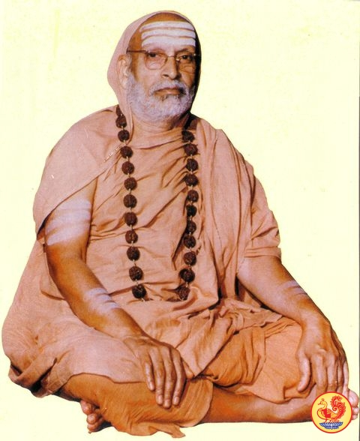
INTRODUCTION
Abhinava Vidyatirtha (1917-1989) was the 35th Jagadguru of the Sringeri Sharada Peetham. His birth name was Srinivasa Sastri.
He was born in Bangalore.
At the age of 14, he was given Sanyasa by Sri Chandrashekhara Bharati.
Sri Abhinava Vidyatirtha Mahaswami was well versed in Vedas and Yoga.
He was an eminent scholar and a master in hindu sacred texts.
In the year 1954, Sri Abhinava Vidya Tirtha took charge as the Shankaracharya of the Sringeri Math.
He occupied a major role in the functioning of the Math. He renovated several shrines in the Sharada temple, constructed a guest house and established a school. He had done puja regularly to Goddess Sharadambigai.
He appointed his successor in 1974 and gave him the Holy title Sri Bharathi Teertha Mahaswami.
He died on 1989.
Sri Vidyateertha foundation was established in order to honour him, and a scholarship programme was also established in his name.
IMPORTANCE
During his period, he has travelled to all parts of india, and cultivated the bhakti among the people. He visited several holy shrines in india. He also made several spiritual discussions, and won in several debates during his period. He also clarified the doubts of his devotees with regard to spiritual matters, and helped them to attain the spiritual path.
He mingled with the people in a good manner and solved their problems. He advises the people to spare some time for devotion on god. It is also known from several old age devotees, that by seeing his glittering face, the devotees will forget their worries and worship him with bhakti.
Let us pray to the great saint and be blessed.
“OM SREE ABHINAVA VIDYATHIRTHA SWAMIGALE NAMAHA”
“OM SREE SARADAMBIGAIYE NAMAHA”
WRITTEN BY
R.HARISHANKAR

ABHINAVAGUPTA
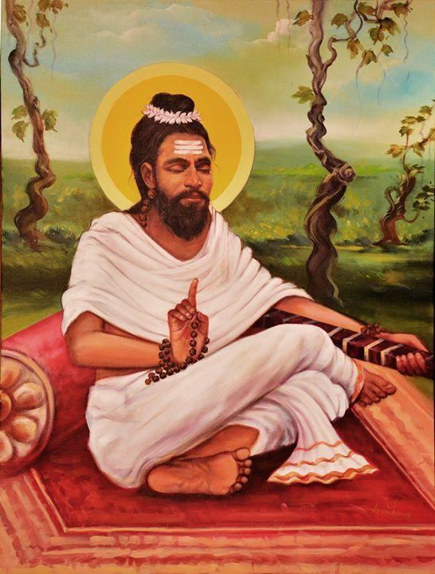
INTRODUCTION
Abhinavagupta (950–1016AD) was a famous Saint from Kashmir. He was also a great musician and poet.
LIFE
He was born in Kashmir and studied under the guidance of holy gurus. His great work Tantraloka, was based on Shaivism, and was widely accepted by the followers of Shaivism.
His works also include devotional songs, and writings on yoga and meditation.
He was considered as an "Intelligent scholar and a pious saint" by the people.
His father was his first teacher, and taught him the literature. Sambhunatha was his most beloved guru, and he learnt all the devotional subjects from him, and has become a great scholar through his guidance.
Ramadeva was his disciple who has served him with much care, and devoted to scriptural study.
He travelled all over Kashmir and participated in several debates and won in the debates.
SPIRITUAL WORKS
- Tantrasara
- Paratrisika
- Paryantapancasika
- Rahasyapancadasika
- Laghvi prakriya
- Devistotravivarana
- Paramarthasara
Abhinavagupta has also composed a number of devotional poems.
He was a holy and a popular saint of India, who has sung many songs in praise of Lord Shiva.

He was against in enjoying worldly comforts and luxuries. He has donated all the money which he had received from the wealthy people to the poor. According to his famous saying that ACCEPTING MONEY AND SPENDING IT LAVISHLY IS NOT ALLOWABLE IN THE LIFE OF THE SAINTS, SINCE IT IS AGAINST THE SPIRITUAL PATH.

He lived a simple life. He spent most of his time in his life in doing meditation, spreading the spirituality and worshipping Lord Shiva.

Let us worship him and be blessed.
“OM SREE ABHINAVAGUPTARE NAMAHA”
“OM NAMAH SHIVAYA”
WRITTEN BY
R.HARISHANKAR

ADISESHA
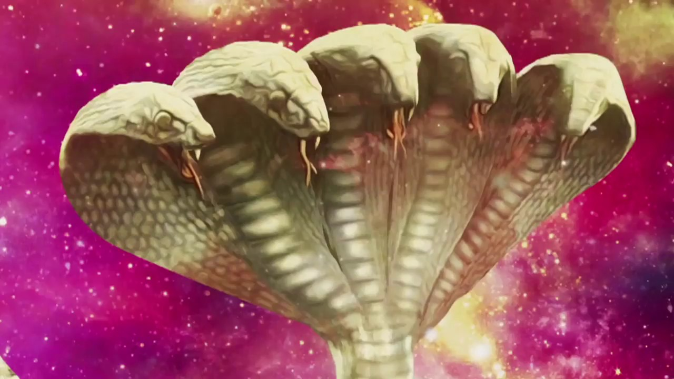
INTRODUCTION
Adisesha is known as the King of Nagas as mentioned in the ancient puranas. Sesha is holding the entire universe in his body and is chanting the names of the Lord Vishnu from his mouth. He is considered as a very noble and a pious god. He is also called by various names such as Anandalvan, Seshanaga, Anantasesha and Ananta. Lord Vishnu’s divine bed is Adisesha. Sesha is considered as a humble divine attendant of Lord Vishnu and also contains the features of Lord Vishnu. He has taken two avatars as Lakshmana and as Balarama and served Lord Rama and Lord Krishna in a proper manner.
He is the thousand headed serpent and contains great power and energy through the grace of Lord Vishnu.
As per the ancient texts,sesha was the son of Rishi Kashyapa and his wife Mata Kadru.
Sesha has done severe penance in several holy places including Himalayas. Through his severe penance, he was granted the boon of becoming the divine bed for Lord Vishnu at his abode Vaikunta. He is also controlling the entire universe through his great supreme power.
In Bhagavat Gita, Lord Krishna tells to Arjuna, “That among the serpants, I am the powerful adisesha”. Which means his greatness was told by the Lord himself. He is considered as the supreme manifestation of Lord Vishnu. Through his name, Lord Vishnu is popularly called as “ANANDA PADMANABHASWAMY” and is worshipped widely in Trivandrum, Kerala. Several temples of Ananda Padmanabhaswamy are found all over india.
IMPORTANCE
Several songs in praise of adisesha are played through speaker in the Vishnu temples during the tamil month of puratasi (September and October). By chanting the names of Adisesha and by reciting his slokas and his glories will definitely cleanse our mind and body, and suffering from poisonous fever or from any dreaded disease will be immediately cured. Being the avatar of Lord Vishnu, he will definitely take us to the right path. He was a very ancient god, who was an ardent devotee of Lord Vishnu. His body holds Lord Vishnu, whereas his mind always thinks about him. His greatness was also mentioned in several puranic texts. He is considered as similar to Lord Vishnu, and all the pujas performed to Lord Vishnu, will also reach him. People who suffer from sarpa dosha can worship him at Ananda Padmanabha swamy temples, and can perform various naga pujas to the serpent deity. Just by thinking about him from our mind will itself bring better prospects in our life.
He expects a true bhakti from us, and will reside in the hearts of all the Vishnu devotees, and bless them for a prosperous life.
It is advisable to chant his name along with the name of Lord Vishnu and be blessed.
“OM SREE ANANTHANE NAMAHA”
“OM NAMO NARAYANAYA NAMAHA”
WRITTEN BY
R.HARISHANKAR

ALAVANDAR
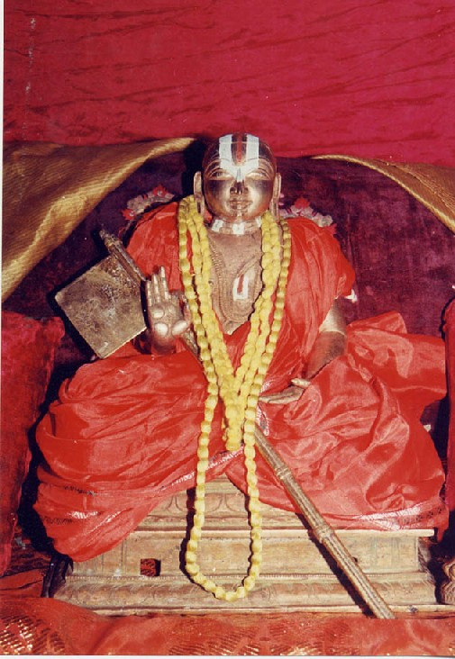
INTRODUCTION
Yamunacharya was a great vaishnava saint in Srirangam, Tamil Nadu, India. He was also known as Alavandar. He was the guru of Sri Ramanuja. He was born in 10th century AD and his grandfather was Nathamuni. Nathamuni was a great scholar and widely respected by the people for his good knowledge in all the subjects.
Alavandar was the disciple of Manakkal Nambi and learned all the divine subjects from him. He won in several debates with many great scholars, and was widely praised by the scholars and people of all regions for his great knowledge in all the subjects.
After his death, for some time, his son took charge of the Srirangam Temple, till ramanuja took possession as the chief of Srirangam Temple.
He composed commentaries on Tiruvaymozhi, Upanishads, and Bhagavad Gita.
IMPORTANT WORKS
- Chathusloki
- Narayana Stotraratnam
- Siddhitrayam
- Agama Pramanya
- Maha Purusha Nirnayam
- Gitartha Sangraha
- Nityam
- Mayavada Khandanam
IMPORTANCE
He was a great saint of srirangam, who has done his services to Sri Ranganathar in a proper manner, and the Lord himself was very much satisfied with his services. He was liked by all the people of srirangam, and especially by Sri Ramanuja, for his good qualities and for his sincere bhakti on Lord Ranganathar. He guided the people to the proper path and insisted them to worship Lord Vishnu and to chant his glories, in order to get rid of sins, and from the problems. He also cured several diseases of the people, and relieved them from mental illness, and removed the negative thoughts of the people, and made them to think about Lord Vishnu. During his administration at the Ranganatha Swamy Temple, he has done temple pujas in a proper manner, and also well maintained the temple. He also conducted several divine discourses and was listened by the people, and appreciated for his simple and attractive speech.
He was a kind, noble and a humble saint, who never got angry and showed love and affection to everyone, and never hated anybody. He also taught all the subjects to his disciples in a simplified manner, in order to easily understandable by them.
Let us worship the great saint and be blessed.
“OM SREE ALAVANDARE NAMAHA”
“OM SREE RAMANUJAYA NAMAHA”
“OM NAMO NARAYANAYA NAMAHA”
WRITTEN BY
R.HARISHANKAR
ANASUYA DEVI
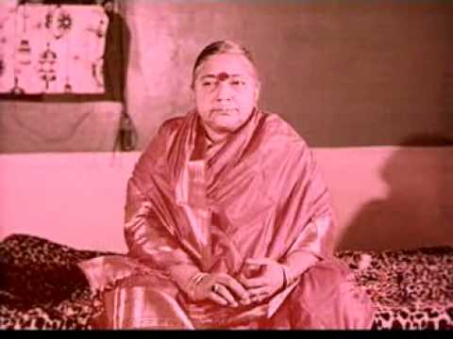
INTRODUCTION
Anasuya Devi (1923–1985), was fondly called as Amma, was a spiritual guru from Andhra pradesh.
LIFE
Anasuya Devi was born in a village at Guntur District, Andhra Pradesh. She got married during the year 1936, and had three children. She started a food grain bank in order to help the poor and needy.
She founded Annapurnalayam at her village in the year 1958, in order to serve free vegetarian food for all the visitors. She established a Sanskrit school in the year 1966. She was very kind to others, and treated all the people as equal irrespective of caste, creed and religion.
Amma died in the year 1985, at the age of 62.
A temple Anasuyeswaralayam was built in the year 1987.
IMPORTANCE
She was a sincere devotee of goddess shakthi and dedicated her life on her. She was well respected by her devotees. She was very pious and a gentle lady, who doesn’t find out any fault on others, and considered all the people as holy and respected everybody, whether good or bad.
According to her, all the people are good, since they are the children of god, and she was against caste discrimination. She provided free food to all the visitors at Andhra Pradesh, and attended them in a pleasing manner.
She looked after her household activities properly, in addition to devoting of god and doing other charitable activities. Though now she is not alive, her contribution made to the people cannot be forgotten.
Let us worship this great spiritual guru and be blessed.
“OM MATA ANASUYA DEVIYE NAMAHA”
“OM SAKTHI PARA SAKTHI”
WRITTEN BY
R.HARISHANKAR
ATTHI VARADAR
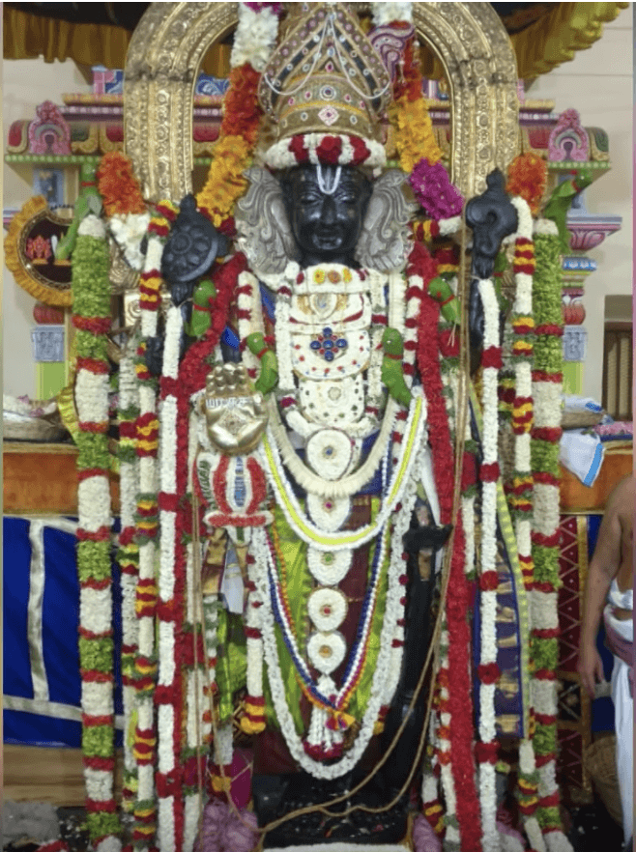
INTRODUCTION
Lord Atthi Varadaraja Perumal is another form of Lord Vishnu, and it is the deity of the Varadaraja Perumal temple in Kancheepuram. Since the idol is made out of fig tree (Atthi), it is called as Atthi Varadar. The deity is kept in an underground area, inside the temple tank and is taken out for worship for 48 days, only once in 40 years.
The holy idol is kept in the mantapam of the temple for 48 days for the worship of the devotees, and there are two different worships done during this period.
Worship the Lord in standing posture, and Worship the Lord in sleeping posture.
The idol will be kept in sleeping posture during the first 24 days of worship.
The shrine dedicated to Lord Vishnu, is one of the Divya Desam shrines and believed to have been visited by the 12 Great Azhwars, and sung in praise of him.
Sri Ramanuja, the great vaishnavite saint was the ardent devotee of Lord Varadaraja.
IMPORTANCE
Recently (In the year July – August 2019), atthi varadar took out from the temple tank and gave darshan to lot of devotees. Many people visited the temple and had a glimpse of the divine lord with much joy and enthusiasm, and huge crowd were there during the entire period of 48 days. Devotees visits atthi varadar, in order to get his divine darshan and to get relieved from their problems, to attain peacefulness and prosperity in their life.
His appearance looks very beautiful. He wears golden ornaments, and dressed in pattu vastram(Silk Dhoti), and adorned with flower garlands. He contains Sangu and Chakra in his hands with a smiling face, and blesses us.
We will have to wait for our next darshan of Lord Atthi Varadar only after 40 years. But if we have sincere bhakti on him, we can be able to see him again in our dream, and get fulfilled our wishes. He expects only a pure bhakti from us and nothing more else.
Let us chant his glory and be blessed.
“OM SREE ATTHI VARADARE NAMAHA”
WRITTEN BY
R.HARISHANKAR

BABRUVAHANA
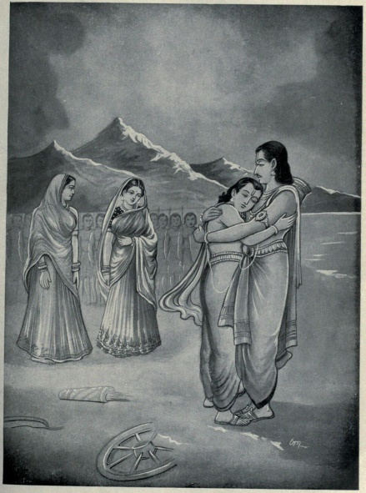
INTRODUCTION
Babruvahana is a character in the Mahabharata. He was the son of Arjuna and Chitrangada. Babruvahana was lived with his grandfather and also ruled the kingdom of Manipura with his grandfather. He recognized Arjuna as his father only at a later stage in his life.
Once when Arjuna went to Manipura in search of the sacrificial horse of the Aswamedha, Babruvahana had captured the horse and killed arjuna without knowing that he was his father. But later he obtained a gem from his step mother uloopi and through that Arjuna’s life was restored.
Babruvahana was praised for his valour and strength and for efficient handling of the divine weapons.
IMPORTANCE
Babruvahana was the great son of Arjuna and also a good expert in all kinds of arts. He was also the devotee of Lord Krishna, and sought the divine blessings from him. In Mahabharatha, his appearance was mentioned as similar to that of Arjuna, with a glowing face and a handsome appearance.
He was brought up by his mother and grand-father, since arjuna left him at his younger age, and joined with his brothers. He also contains the features of Arjuna and got a good experience in archery. He got the capacity to defeat his father arjuna and to kill him. He never afraid about anything and was a brave and an honest person. He was also a spiritual person, and got the habit of worshipping god regularly.
Let us worship this great son of Arjuna and be blessed.
“OM SREE BABRUVAHANARE NAMAHA”
“OM SREE ARJUNAYA NAMAHA”
WRITTEN BY
R.HARISHANKAR
BHAGAWAN NITYANANDA
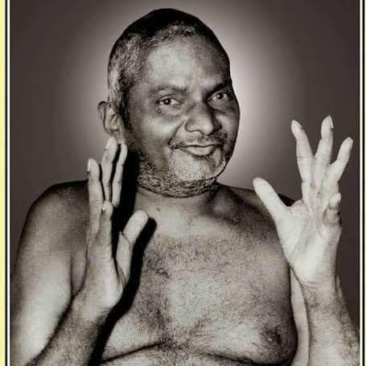
INTRODUCTION
Bhagawan Nityananda (1897–1961) was an Indian Saint. His teachings were published in leading magazines. Nityananda was born in Kerala. His birth name was Raman.

LIFE
He was adopted by a Nair couple and they properly took care of him.
Even at his younger age, Bhagwan Nityananda attained advanced spiritual state, and was enlightened by the god, and got spiritual energy and attained great power through meditation and yoga.
Nityananda became a wandering yogi, and spent most of his time in yogic studies and went to Himalayas and other religious places for getting divine bliss.
Though he was not a highly educated person, he was aware of all the vedas and other spiritual texts, and got the capacity to give lectures on various topics of Hinduism.
Nityananda was popular in curing the diseases of the people through his yogic power. He constructed an ashram near Kanhangad, Kerala state.
He was also popular in doing miracles for doing good things. Nityananda started a school, and provided food and clothing to the school children.
He gave lot of devotional teachings. And he also explained the importance of worshipping the god and asked the people to make regular visit to the temples, and also to provide charitable activities to the poor, and to help others in case of need.
In 1936, he stayed in a hut in the village of Ganeshpuri, nearby the shiva temple. And later he constructed an ashram in that place.
He died in the year 1961 at the age of 63. His samadhi is located in Ganeshpuri.
Though he is not alive now, but his teachings will make us to feel his presence even today.

IMPORTANCE
He was a great siddha purusha, saint and a yogi who never thought about himself, and always done goodness to others through his great power.
He controlled his senses at his younger age itself, and fully realized the god within the inner soul, and became a worshipful saint. He was a pious, noble and a soft spoken saint.
Let us worship him and be blessed.
“OM SREE BHAGAWAN NITYANANDARE NAMAHA”
WRITTEN BY
R.HARISHANKAR

BHARADWAJA
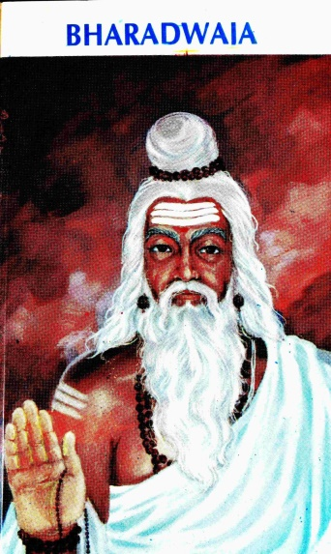
INTRODUCTION
Bharadwaja, was one of the famous Vedic sages in India, and who was a great scholar and a master of all vedas,puranas and upanishads.He was the son of Brahaspati and Mamata. His wife was susheela. And his children were
Dronacharya, Garga, Ilavida and Katyayani.
He was the grandfather of Asvathama, a great warrior of Mahabharata, who is also one among the seven CHIRANJEEVIS and is still living in this earth, by worshipping Lord Shiva.

IMPORTANCE
Bharadwaja is also mentioned in several ancient texts. He is also known as the "Father of Ayurvedic Medicine".
He is one of the Saptarishis.
Brahmins belonging to Bharadwaja gotra were the descendents of Sage Bharadwaja.
Bharadwaja has contributed a lot of sacred texts, some of them are as follows:-
- Some portions of Dhanur-veda.
- Bharadvaj samhita.
- Bharadvaj srautasutra and grhyasutra.
- Some portions of Ayurveda.
- Charaka Samhita.
- Niti sastra.
- Bharadwaja siksa.
According to the Mahabharata, Bharadwaja trained his son Drona in the use of weapons.
In the epic Ramayana, Rama, Sita and Lakshmana visited Rishi Bharadwaja at his ashram.

CONCLUSION
He was a great rishi, who has contributed a lot in the ayurvedic medicinal field. He has worried about the health condition of the people in the earth and has rendered such a noble act. According to him, spirituality can be attained by a person, only if he is in a good health condition. He also advices the people to worship the god in an easy manner like chanting frequently the names of god. In his book, he has mentioned the details of ayurvedic herbs in a simplified manner. He is living in Saptarishi Mandala with his wife Susheela by doing penance. Let us worship this great rishi and his wife and be blessed.
“OM SREE RISHI BHARADWAJARE NAMAHA”
“OM MATA SUSHEELA NAMAHA”
WRITTEN BY
R.HARISHANKAR

BHRIGU
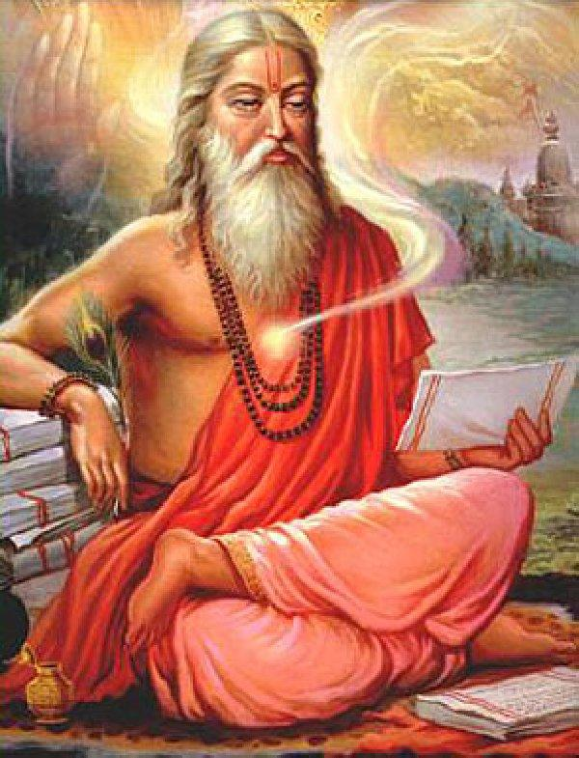
INTRODUCTION
Maharishi Bhrigu was one of the Prajapatis created by Lord Brahma. And it is believed that he was born in the present day Uttar Pradesh. He is the author of Bhrigu Samhita. Bhrigu is considered to be the best son of Lord Brahma, since he was born from the mind of Lord Brahma. And he is having the spiritual knowledge and power similar to that of his father Lord Brahma.

IMPORTANCE
Bhrigu lived in an ashram at the present day Rajasthan in India, and led a very simple life. Bhrigu had made important contributions to Manusmriti. His wives were Khyati, Puloma and Kavyamata.
His children are:-
- Dhata
- Vidhata
- Shukra
- Chyavana
- Bhargavi
Bhrigu is also mentioned in several hindu puranas. He is also mentioned in Mahabharatha. He was also praised by several rishis about his greatness.
An Ashram for Bhrigu is located in Kanchipuram District, Tamil nadu.
Since, Bhrigu Maharishi wants to test and to find the best one among the three gods,brahma,Vishnu and shiva, he went to vaikunta, and since Lord Vishnu was asleep in his vaikunta, he kicked him at his chest with his feet. But later he realized his mistake, when he was forgiven by Lord Vishnu and was warmly welcomed by him.
CONCLUSION
Bhrigu Maharishi was a great sage, who got the ability to test the greatness of the gods. His ego was removed by Lord Vishnu, through his gentle approach on Bhrigu. He was a great scholar in all the vedic subjects, and was referred in many ancient epics. Let us worship Bhrigu Maharishi and be blessed.
“OM SREE BHRIGU MAHARISHIYE NAMAHA”
“OM NAMO NARAYANA”
WRITTEN BY
R.HARISHANKAR

BHRINGI
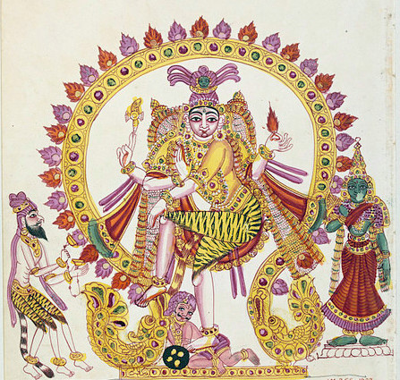
INTRODUCTION
According to Holy texts, Bhringi was a great rishi, and an ardent devotee of Lord Shiva. It is believed that he was very much devoted to Lord Shiva and only worships him and would not worship Mata Parvathi.
Once the great rishi Bhringi went to Mount Kailasa and circumambulated Lord Shiva. Goddess Parvati has asked him to worship her and to circumambulate her also.
But Bhringi was refused doing that, and he concentrated his attention only on worshipping Lord Shiva. And he took the shape of a bee and again circumambulated only on Lord Shiva. Due to his act, Mata Parvati has got very angry with him and punished him to lose all the flesh and blood from his body.
Due to the curse, he has lost all his energy from his body and fell down, and then he realized his mistake, and came to know that both shiva and parvati are one and the same, and prayed to both of them and asked Mata Parvati to forgive him, and he apologised for his mistake. They blessed him and he had granted one more leg in order to balance himself.
IMPORTANCE
Bhringi was a very ancient sage and a great scholar in all the subjects, including vedas, Upanishads and other divine scriptures. He was very good in doing severe penance, and got great spiritual energy through that. His name is also mentioned in several ancient texts, and mentions him that he was a great shiva devotee.
It is believed that he lived for more than 1000 years, and had done severe penance on Lord Shiva and Goddess Parvathi towards neglecting to worship Mata Parvati, and also to reduce his sins towards his wrong act.
He was a great sage who has got the habit of welcoming his guests to his ashram and to give them food and water, to treat them with much care and respect, and to discuss with them about the greatness of Lord Shiva and Mata Parvati. He was also admired by the other great sages and was praised by them about his hospitality.
Hence from this incident, we came to know that we have to worship shiva and parvati together in order to get better results in our life.
Let us worship this great Rishi and be blessed.
“OM NAMAH SHIVAYA”
“OM SAKTHI PARA SAKTHI”
“OM SREE BHRINGI MUNIVARE NAMAHA”
WRITTEN BY
R.HARISHANKAR

CHAITANYA MAHAPRABHU
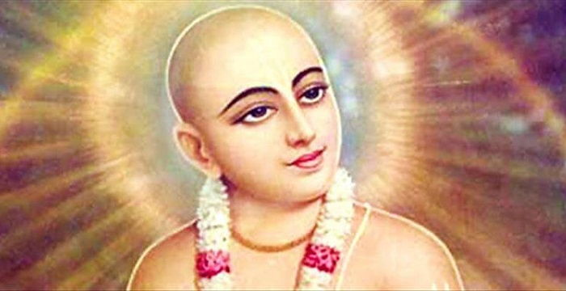
INTRODUCTION
Chaitanya Mahaprabhu(1486–1534), was a Hindu saint, and the chief of the Vaishnava Vedanta school in Hinduism. His birth name was Vishvambhar Mishra. He was born on West Bengal. He is considered as an incarnation of Lord Krishna.
He has asked his devotees to chant 'Hare Rama Hare Krishna mantra' in order to get liberated from birth cycle. His birthday is celebrated as Gaura-purnima.
While Chaitanya was travelling to gaya, he met the great saint Ishvara Puri, and through him he became a great devotee of Lord Krishna and began to chant the Gopala Krishna mantra repeatedly. He returned to Bengal and soon he became the leader of the Vaishnava group.
After some years he left Bengal and became a Sanyasi by Swami Kesava Bharati, and he travelled all over india by frequently chanting the names of Lord Krishna.
TEACHINGS
- Krishna is the Supreme god.
- Always concentrate your attention on Lord Krishna by chanting his divine names,even while doing your work, so that you can do your work properly through the grace of Lord Krishna.
- Love others and show mercy on others.
- Don’t always think about material objects, for that will not come with us. Think about the divine god.
- Feed food to the poor people. Lord Krishna has narrated in the Bhagavat Gita about the importance of providing annadanam.
- Always have peace of mind by worshipping god and keeping him in our mind.
- Move towards the bhakti path in order to reach the heaven.
- Love Krishna and in return you will be loved by Krishna.
- Don’t cause injury to others, and help others in times of need.
10. Visit the temples regularly and offer worship.

IMPORTANCE
He took the avatar in order to give proper guidance to us in this kali yuga. He was inspired by the people through his simplistic approach in explaining about god, and in giving lectures. He lived a pious life and done many miracles to his devotees. He has protected his devotees from several problems in their life, and cured their diseases and showed a good path to them.
DEATH
He left his body and reached the divine abode of Lord Vishnu at the age of 48, at Puri.
CONCLUSION
A great saint and an avatar of Lord Krishna will always be remembered for his famous Hare Rama Hare Krishna song.
Let us worship Lord Rama and Lord Krishna and be blessed.

“OM SREE CHAITANYA MAHAPRABHUVE NAMAHA”
“JAI SREE RAM”
“JAI KRISHNA”

WRITTEN BY

R.HARISHANKAR

CHANAKYA
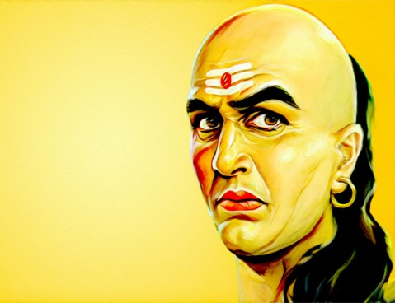
INTRODUCTION
Chanakya (2nd century BC) was an ancient Indian guru, contains great wisdom, knowledge and specialized in all the subjects. He is also known as Kautilya, who was the author of the Arthashastra.
Chanakya was the guru for the Mauryan emperor Chandragupta and helped him to establish the kingdom, and to rule it properly. Chanakya was the chief advisor to the great emperor Chandragupta and his son Bindusara.
Chanakya’s name was mentioned in Buddhist and Jainism texts. And he was regarded as a great Guru and a philosopher, and also appreciated for his administrative capacity.
He was specialized in ancient Vedas, Upanishads and sacred texts and also a master in all kinds of art, and got the capacity to work as an advisor to the emperor.
WORKS
- Arthashastra
- Chanakya Niti
The Arthashastra was written on the basis of political aspects, which has to be followed by a ruler for running his kingdom successfully, including financial position, relation with other rulers, welfare activities to be carried out to the people and the strength of the soldiers needed in case of war etc. The text also describes the duties to be followed by a ruler. Chanakya Niti is a collection of a set of principles based on various shastras.
Chanakya is regarded as a great thinker, religious reformer, famous politician, wise person and a social reformer of the ancient india.
The diplomatic enclave in New Delhi and Chanakya circle in mysore has been named after him.
Several tamil plays were screened by the famous drama and cinema artists based on the life and teachings of chanakya, and it was well appreciated by the audiences.
IMPORTANCE
He was a famous scholar and a wise man, has helped the great king Chandragupta towards successfully ruling his kingdom. Through his noble advice, he has ruled his kingdom in a proper manner, and he had not suffered from the problems of enemy invasion through the help of Chanakya.
Through his talent and efficiency, he made the kingdom of chadragupta to prosper. He also gave good advices to him, and was well appreciated by the people and also by several other kings.
Though he had lived several thousands of years back, still he is remembered by the people for his thorough knowledge in all the fields, and an expert administrator.
Let us worship the great guru and be blessed.
“OM SREE CHANAKYARE NAMAHA”
WRITTEN BY
R.HARISHANKAR

DEVAPI
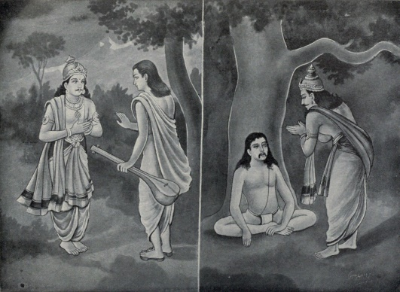
INTRODUCTION
Devapi is an immortal sage. According to the ancient texts, he was the eldest son of the King of Hastinapura. He was a pious and a good prince but since he was affected with leprosy, his younger brother Shantanu was declared as the king of Hastinapura. Shantanu ruled his kingdom in an efficient manner. And all the people in his region were very much satisfied with his golden rule. Later Devapi left the kingdom of hastinapura, and did severe penance in the forest.
Due to the request of his brother king shantanu, devapi served as a priest for some time in the kingdom of hastinapura and conducted a yagna for the prosperity of the kingdom, and again he went to the forest and continued his penance and lived a saintly life.
His importance is mentioned in vedas, puranas, and in Mahabharata, and was mentioned as a great man with divine power which he acquired through constant meditation.
He was also the elder brother of King Bahlika, who was the ruler of the Bahlika region.
IMPORTANCE
He and his brother bahlika are noble persons, who never interested in enjoying worldly comforts and they spent their life in doing good things to the people and by worshipping the god. Bahlika was well appreciated towards showing kindness to his region’s people and for donating the wealth to the poor. He ruled his kingdom in a proper manner. He was a worshipful person, who never done any bad acts during his period. Since he was asked by the kauravas to help them in the kurukshetra war, he agreed and joined with kauravas and fought against pandavas and was finally killed by Bheema. He was a great devotee of Lord Krishna.
Devapi was not interested in occupying the kings throne and hence left his kingdom and done severe penance which lasted for several years, and finally he was granted the boon of becoming as immortal till the end of this Kali Yuga, and will be the great king in the next krita yuga.
All the three brothers shantanu,devapi and bahliga were very much expert in all the vedic subjects and in ancient scriptures. They are also specialised in all kinds of art, and expert in handling all kinds of weapons. Devapi also gifted all of his riches to the poor and the needy and asked his brothers shantanu and bahliga to do good things to the people, and also to worship the god in a proper manner. In course of time, he also got relieved from his leprosy and became a healthiest person.
Let us pray to him and be blessed.
“OM SREE DEVAPIYE NAMAHA”
“OM SREE BAHLIGARE NAMAHA”
“OM SREE SANTHANU MAHARAJAVE NAMAHA”
WRITTEN BY
R.HARISHANKAR

DHRISHTADYUMNA
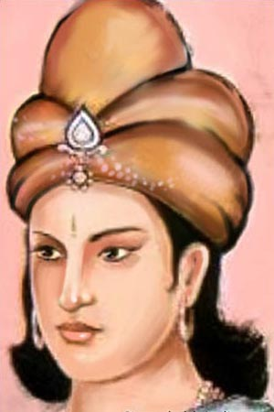
INTRODUCTION
Dhrishtadyumna, was the son of Drupada, the Panchala king, and brother of Draupadi. And he and his sister draupadi were born in the sacrificial fire. He was the chief of the Pandava army during the Kurukshetra War. Dhrishtadyumna killed Drona, the guru of pandavas and kauravas, during the time of his meditation.
Drupada performed a yagna in order to create a son from the yagna fire, in order to kill Guru Drona, who had taken half of his kingdom. Since Dhrishtadyumna was created in order to kill Guru Drona, he killed him. He was told to do so by the pandavas.
He is also considered as an incarnation of Lord Agni Dev, since he was born from fire. His sister Draupati is also considered as an avatar of Mata Parvati Devi, and worshipped by the people as Panchali Amman and Draupathi Amman, and several temples are dedicated for her in tamilnadu.
It is believed that in his previous birth, he was born as ekalavya, and he has given his right hand thumb to Guru Drona as Guru Dakshina.
He got great knowledge in handling weapons and also contains knowledge in divine subjects.
He was the student of Drona, and he learned various types of arts from him.
He was a great swordsman and killed six great warriors including guru drona. He was also a very good archer, and fought well and stood at the pandavas side and helped them in the kurukshetra war.
He was killed by drona’s son Ashwathama during the kurukshetra war.

IMPORTANCE
Being the avatar of Lord Agni, he contains great power, and can destroy anybody through his great knowledge in handling powerful weapons. He was a kind hearted king, who had done lot of charitable activities to the people of his panchala region, and acted in a kind manner to them. He was a pious and a noble man, who took Krishna as his mentor and acted as per his advice, and was blessed by him. He also contains super natural powers, and used it during the Kurukshetra war.
Let us worship the great warrior and be blessed.
“OM SREE DHRISHTADYUMNAYA NAMAHA”
“OM SREE PANCHALI AMMANE NAMAHA”
“OM SREE KRISHNA BHAGAWANE NAMAHA”
WRITTEN BY
R.HARISHANKAR

GAGANGIRI MAHARAJ
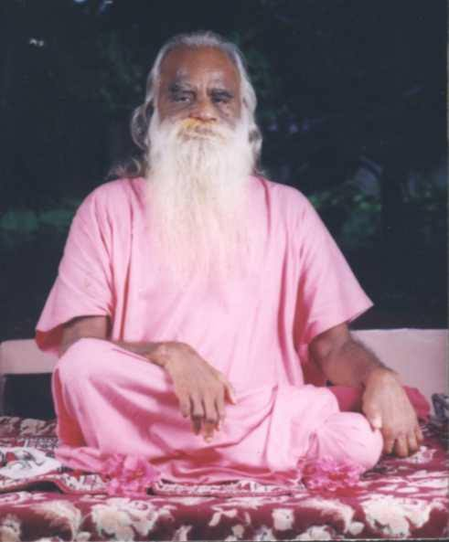
INTRODUCTION
Shri Gagangiri Maharaj was a pious saint and belongs to the Nath Sampradaya. His birth name was Shripad Patankar.

LIFE
Shri Gagangiri Maharaj was born at a village in Patan district of Maharashtra. At his younger age, he left his home and became a saint.
After becoming a saint, he learnt yoga and meditation. He visited many holy places including Himachal Pradesh and Badrinath and worshipped Lord Shiva and Lord Vishnu. He stayed in the cave at Gagangiri and did severe penance.
Since, more people were benefited by his teachings they started worshipping him, including political persons of india.
Maharaj also asked the youngsters to spread spirituality among the masses.
He established his ashrams in Khopoli and Gaganbawda. He has a huge number of devotees in all parts of india, including business man, poor and the rich people. He never differentiated between rich and poor, and treated all of them as equal.
Maharaj took Samadhi in the year 2008 at his Khopoli Ashram.
IMPORTANCE
He was a great saint, who was highly praised by the people for his good speech on spirituality and for his simplicity. He never enjoyed any comforts and luxuries, and lead a holy life. He had done many social welfare activities at his ashram such as giving clothes, providing shelter to the poor, providing food to the poor and needy, and also moved with the poor people in a kind manner.
He taught yoga and meditation to all class of people, in order to lead a healthy and a peaceful life. He also given spiritual lectures on gods, and asked the people to worship the gods regularly and to chant their names.
Let us worship him and be blessed.
“OM SREE GAGANGIRI MAHARAJ NAMAHA”
WRITTEN BY
R.HARISHANKAR

GAJANAN MAHARAJ
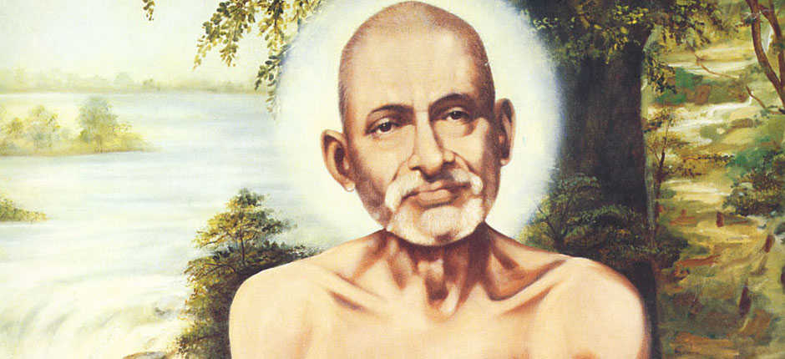
INTRODUCTION
Gajanan Maharaj was an Indian guru belonged to Maharashtra, and he is regarded as an incarnation of Lord Ganesha. He has first appeared in Shegaon, Mahatashtra in the form of a young man, during the year 1878. He has attained Samadhi on 1910. His detailed life history can be known from the sacred book “SHRI GAJANAN MAHARAJ CHARITRA”.
IMPORTANCE
Shree Gajanan Maharaj has travelled to many holy places, and he also visited Lord Trimbakeshwar Shiva Temple at Nashik. It is also believed, that Shree Gajanan Maharaj has appeared in the form of Pandhurang and as Saint Ramdas for his sincere devotees.
In his lifetime, he has performed many miracles such as giving a new life to his devotees, lighting the lamp without fire, curing the dreaded diseases of the devotees, and solving several problems in the life of his devotees and giving peace to mind for many people by looking them kindly and by blessing them. He was well known in yoga and meditation apart from all other forms of art. He was a great scholar and got a very good knowledge in vedas and hindu scriptures.
Shree Gajanan Maharaj took Samadhi on 1910. His earthly remains were buried and a temple in his name was built on his Samadhi at Shegaon. The holy existence of his soul in the Samadhi Temple blesses his devotees, and gives all the prosperity in their life.
In the presence of Gajanan Maharaj, Shri Sant Gajanan Maharaj Sansthan, was formed on 1908.
CONCLUSION
A great avatar of Lord Vinayaka,and a great human personality, who lived a simple and a noble life, and blessed all of his devotees and made them well in their life. In his Samadhi he blesses and helps the devotees during their difficult times. During his lifetime, he removed the ego of his devotees, and transformed them into good natured. Let us pray to him and chant his name with pure devotion in mind and be blessed.
“OM SREE GANESAYA NAMAHA”
“OM SREE GAJANAN MAHARAJAVE NAMAHA”
WRITTEN BY
R.HARISHANKAR

GANGA
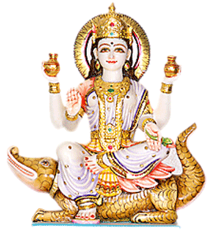
INTRODUCTION
Ganga is the river Ganges and she is considered as a sacred and holy mother. It is believed that bathing in river ganges will cleanse us and will remove our sins and will lead to the path of MOKSHA. It is also believed that all the diseases will be cured by drinking the holy water of ganges.
In the bank of river ganges, several holy temples are situated, which include Kashi temple, Kali temple,Vishnu temple and Hanuman temple.
Ganga is described as the goddess who gives good fortunes in our life, and the Ganges River has been considered as the holiest among all the rivers by Hindus. River Ganges is worshipped as Ganga Mata. She looks very beautiful with a smiling face, and with a golden body. She contains the features of Mata Parvati Devi. The importance of ganges river is mentioned in Vedas and in various divine texts.
She was also the wife of the Kuru king Shantanu, and their son was Pithamaka Bhishma, and it is considered that her vehicle is Crocodile
Through the great king Bhageeratha, she came down to earth from Kailasa, and still clearing our sins and blessing us with her divine power.
Ancestor’s last rites are performed here, in order to make their souls satisfied, and also they can travel easily to the respective worlds, based on their karmic deeds.
While coming down to the earth, she destroyed the the meditation of Jahnu rishi. He got angry and drank up the waters of river ganges. Due to her prayers, Jahnu released her from his ears. Hence she got the name as Jahnavi.
Ganga Jayanti is celebrated mostly by the north indians on Saptami of Vaishakh month's shukla paksha of every year. Ganga Mata is also worshipped during the Navaratri festival as goddess Mata Durga.

IMPORTANCE
It is believed that by applying the water of the ganges river on our head, our all problems will be solved, and in due course, we will attain SALVATION. She is believed to be the saviour of all the living beings in the earth, and by worshipping her, especially at the banks of river ganges will yield good results, and we can forget our worries and problems by seeing the divine mother with our eyes.
She was brought down to the earth, in order to protect us from this Kaliyuga, and we can wash out our sins with her. She also gives courage, wisdom, boldness, confidence and good knowledge in all the subjects, and will make our life to run easily in this today’s tough world.
Ganga Aarti is famous which will be held on the banks of river ganges in the holy city of haridwar. Lot of people will have a glimpse on her, and will burn various lamps and place it in the river, as a prayer to her. Daily thousands of people will gather in haridwar and worship her with much devotion in their mind.
She is also having various temples in all parts of india. She is worshipped as Gangaiamman in south india. There is a famous GANGADEESWARAR TEMPLE in purasawakkam,Chennai. It is believed that king bhageerath prayed to Lord Shiva at this place only.
Her importance cannot be explained in words. It is advisable to worship Goddess Ganga at Ganga Devi Temple, Haridwar and to visit the river ganges at least once in our life time.
Let us chant her glory and pray to her and be blessed.
“OM SREE GANGA MATAVE NAMAHA”
“OM SREE BHAGEERATHARE NAMAHA”
“OM NAMAH SHIVAYA”
WRITTEN BY
R.HARISHANKAR

GNANANDA GIRI
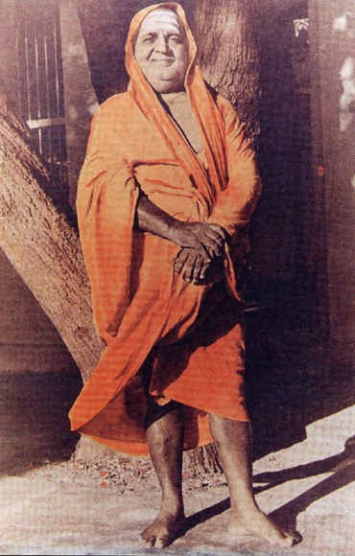
INTRODUCTION
Gnanananda (19th century) was an Indian saint, also called as Swami Sri Gnanananda Giri. He was one of the Chief Pontiffs of the Jyotir Math, Uttarakhand.
Gnanananda is a great guru and Indian philosopher. He had a number of disciples including Vidyananda, Triveni and Haridas. His birth name was subramanyam.
LIFE
He was born in a village at Karnataka to a Brahmin family. He left his home at young age due to his interest in spirituality.
Sivaratna Giri Swami was his guru and named him as Sri Gnanananda Giri. Gnananda spent many years at the Himalayas and made deep penance. He travelled all around India and also went to Nepal, Burma and Sri Lanka.
Gnanananda established ashrams in Salem and at Siddhalingamadam.
Gnanananda built temples for the Hindu deities in Tapovanam,Tirukovilur.
IMPORTANCE
He advocated his devotees to do meditation and prayer. He was well versed in doing bhajans, and he announced to his devotees that doing Hari Bhajans was the easiest way to attain "Moksha".
He was the guru of Sri Haridas Giri Swamigal, and asked him to spread the importance of Namasankeetanam(Chanting the holy names of Lord Hari) among the masses. Haridas also visited several holy places in india to spread the importance of singing god's praises as instructed by his guru. Haridas Giri established Samajams in various countries. He was an obedient disciple of Sri Gnananda and considered him as equivalent to god, and served to him in a proper manner.
He was a humble and a noble saint who took care of his devotees in an affectionate manner. He has provided annadanam in his ashram to his devotees. He was a kind hearted sage and was a great preacher and has given many religious lectures and asked the people to worship the god by uttering his holy names in order to easily attain SALVATION.
Let us pray to him and be blessed.
“OM SREE GNANANDA GIRI SWAMIGALE NAMAHA”
“OM SREE HARIDAS GIRI SWAMIGALE NAMAHA”
“OM NAMO NARAYANAYA NAMAHA”
WRITTEN BY
R.HARISHANKAR

GOPALA BHATTA GOSWAMI
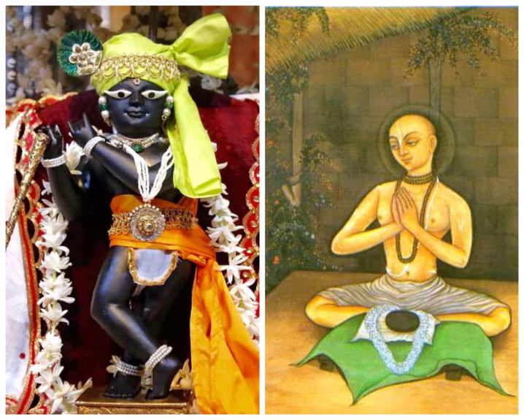
INTRODUCTION
Gopala Bhatta Goswami (1503–1578) was one of the main disciples of Sri Chaitanya Mahaprabhu. He was the prominent person in establishing the Gaudiya tradition through his spiritual speech.
LIFE
He was born in a Brahmin family in srirangam. Gopala bhatta goswami was a great devotee of Lord Vishnu.
He met Shri Chaitanya Mahaprabhu and served him for several months. He realized that Chaitanya was an avatar of Lord Krishna.
Gopal Bhatta took spiritual guidance from his uncle Prabhodananda Sarasvati.
After the death of his parents, he travelled to Vrindavana, and met the great saints and Krishna devotees, Rupa and Sanatana and stayed with them.
As per the instructions given by Sree Chaitanya Mahaprabhu, he helped Rupa and Sanatana to complete the Vaishnava literature written by them.
Gopala Bhatta established the Radha Raman Temple in Vrindavan in 1542, and his samadhi is present within the temple complex.
IMPORTANCE
He interacted with the followers of Krishna and formed a new bhakti cult (Spreading the importance of lord Krishna) and spread it among the masses. He also spread the “RAMA” and “KRISHNA” mantras through his followers. He has done many social welfare activities during his life time. He was a fond disciple of Chaitanya Mahaprabhu.
During his life time, he made many preaching among the followers of Lord Krishna and explained the glory of Lord Krishna to them in a detailed manner. Devotees assembled with much enthusiasm to listen to his speeches. He was considered as a great preacher by Lord Chaitanya Mahaprabhu.
He sung in praise of Lord Krishna, and was always involved in deep thoughts of Lord Krishna.
Let us worship him and be blessed.
“JAI SREE GOPALA BHATTA GOSWAMIYE NAMAHA”
“JAI KRISHNA”
WRITTEN BY
R.HARISHANKAR

GULABRAO MAHARAJ
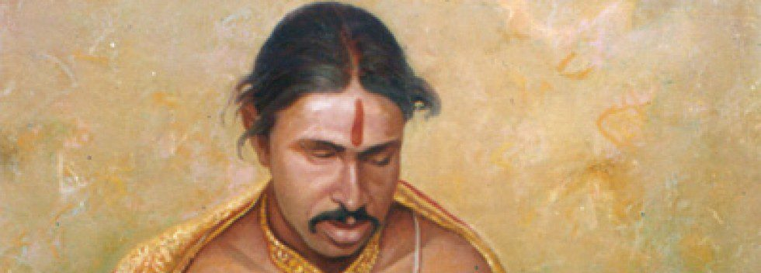
INTRODUCTION
Gulabrao Maharaj (1881–1915) was a blind Hindu saint from Maharashtra, India. He has written many devotional articles within a short period. His birth name was Gulab Gundoji Mohod.
LIFE
Gulabrao Maharaj was born in a village near Amravati,Maharashtra. After the death of his mother, he was brought up by his grandmother.
He was the disciple of Shri Dhyaneshwar Maharaj and has become a great saint through his blessings.
Though he was a blind man, he has got great knowledge in devotional texts and contains extraordinary intelligence and extraordinary memory and good writing skills.
He has done deep meditation at his younger age and was found in a deep Samadhi stage.
He was an expert in writing poems at the age of sixteen. He was married, and even after that, he was involved in spiritual matters and doing meditation.
Though he was from a lower caste, he got many Brahmin disciples. He was aware of the vedas and even without reading the vedas, he got the knowledge through his self-realization.
IMPORTANCE
He has respected the learned scholars and discussed with them on various topics of Hinduism.
He has won several times in religious debates, which was held between him and pundits regarding the sciences.
He was an ardent devotee of Lord Krishna, and always praises him with his superb songs and dedicated his life towards worshipping him.
Saint Gulabrao Maharaj has become more popular after his Samadhi. His disciples are known to be the great saints. He still guides the people even after his death by his holy writings.
CONCLUSION
A great devotee of Lord Krishna, who possess high spiritual knowledge, was well known for his great intelligence and learning ability. He was respected by everyone and treated in a proper manner. He was a kind and soft natured person and does not hurt anybody by his words. He treated all the other people as the avatars of Lord Krishna, and given proper respect to them. He mesmerised the people through his pleasing smile and by his divine talks. He asked the people to think about Lord Krishna and to concentrate him with pure bhakti within their short life span period, in order to prevent the occurrence of re-births.
Let us worship this great saint and be blessed.
“OM SREE GULABRAO MAHARAJ NAMAHA”
“JAI KRISHNA”
WRITTEN BY
R.HARISHANKAR
GURU NANAK
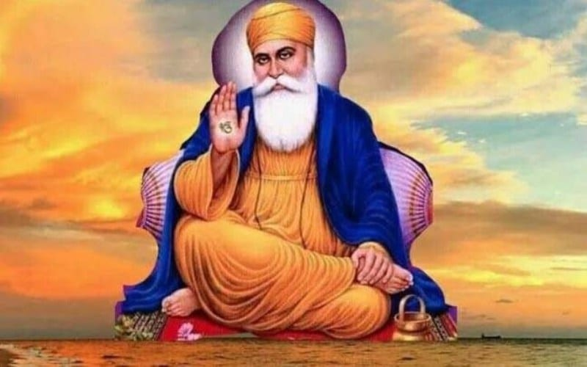
INTRODUCTION
Guru Nanak (1469–1539) was the founder of Sikhism and he was the first amongst the ten Sikh Gurus. His birth day is celebrated during October–November.
Guru Nanak has travelled all over the world and spread the message of one God Principle, and states that there is one god, who lives in all of his creations.
LIFE
Guru Nanak was born in Pakistan. His father has worked as an accountant in a village in pakistan. He had one sister, and after her marriage, he lived with them. During the year 1487, Guru Nanak was married to Mata Sulakkhani, in the town of Batala. And they had two sons.
Guru Nanak's teachings can be found in the holy book Guru Granth Sahib.
The three main teachings of Guru Nanak are as follows:
- Helping others in times of need.
- Honest living, without any fraud, and earning money through hard work.
- Chanting the names of god permanently in order to control the weaknesses of the human personality.
Guru Nanak travelled extensively during his lifetime. He visited several foreign countries in order to spread his teachings.
After appointing his successor, Guru Nanak died on 1539 in Kartarpur, at the age of 70.
The Guru Gobind Sahib is sincerely worshipped by the followers of Sikhism, and he is considered as the final guru of Sikhism.
IMPORTANCE
Guru Nanak was a great person who mainly advocates the principle of helping others, and to live an honest life. Sikhism is a popular religion in india. Saint Guru Nanak was a great personality who lived a modest life and helped others. He was a pious and a noble person, and helped the people by guiding them to the spiritual path.
CONCLUSION
The great saint, Sri Guru Nanak who was the founder of the wonderful religion, SIKHISM, is still guiding us through his teachings. His great teachings are apart from the point of religious perspective. The SIKHS are very great, gentle, affectionate and bold people, and they are living their life peacefully through the blessings of GURU NANAK JI. Let us pray for the wellbeing of the entire people in the world to the great SAINT GURU NANAK JI and let us chant his name and be blessed.
“JAI GURU NANAK JI JAI”
WRITTEN BY
R.HARISHANKAR

KALYAN SWAMI
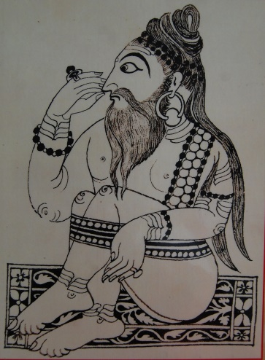
INTRODUCTION
Kalyan Swami (1636–1714) was a sincere disciple of Shree Samarth Ramdas and they were united together with regard to the devotion of Lord Rama.
LIFE
He was born at Kohlapur,Maharashtra a famous pilgrimage site of Goddess Mahalakshmi. His birth name was Ambaji. After his father attained sainthood at Kashi, he and his mother were lived in their relative’s home.
At a younger age, he travelled to many places and had been conducted various religious discourses in order to lead the society to the right path. He also visited many holy temples situated in india. His discourses were attracted by a huge number of his followers.
After some time, he has become the disciple of Shree Samarth Ramdas.
From a young age, he was the chief disciple of Sri Samarth Ramadas, who was a famous saint of Maharashtra. Although he was tested by his guru in many situations, he never failed and has become the closest disciple of Samarth.
IMPORTANCE
He was a great scholar and an expert in all devotional texts and also well known in yoga and meditation.
He was a kind hearted saint and treated all of his devotees in a proper manner, and gave them his blessings, and also removed their sins through the grace of Lord Rama. He cured many dreaded diseases of his devotees, and also given them peace of mind.
DISCIPLES
- Mudgal Swami
- Jagannath Swami
- Keshav Swami
- Ramjibova Baramatikar
- Haribova Bhoomkar
- Purushottam Swami
- Ramajiboova
FAMOUS WRITINGS
- Soliv Sukh
- Mahavakya Panchikaran
- Dhruv Aakhyan
- Rukmini Swayamvar
DEATH
Kalyan Swami died in 1714 in Osmanabad.
The Samadhi temple of Shree Kalyan Swami was constructed in Osmanabad.
CONCLUSION
He was a great devotee of Lord Rama and an obedient disciple of his guru Sri Samarth Ramadas. His teachings were well understood by everyone and he was the main person in promoting the importance of worshipping Lord Rama and chanting his Mantra. He was also a sincere devotee of Lord Hanuman, and wants to become like him with regard to Rama Bhakti. Let us pray to him and be blessed.
“OM SREE KALYAN SWAMIYE NAMAHA”
“JAI SREE RAM”
“JAI HANUMAN”
WRITTEN BY
R.HARISHANKAR

LAHIRI MAHASAYA
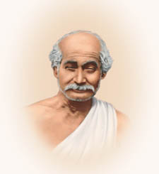
INTRODUCTION
Shyama Charan Lahiri (1828 –1895), also known as Lahiri Mahasaya, was an Indian yogi, guru and a disciple of Mahavatar Babaji. He taught Kriya Yoga to others, when he learned it from Mahavatar Babaji in 1861. Lahiri Mahasaya was also the guru of Swami Sri Yukteswar Giri. He taught the kriya yoga to others and developed spirituality and spread it to others. He lived in Varanasi.
LIFE
Lahiri was born into a Brahmin family in the year 1828 in Nadia district,west bengal. He was interested in doing meditation at his younger age. After some time his family moved to Varanasi, and he has spent his rest of his life in Varanasi.
He studied all the languages, along with Vedas. In 1846, he was married and had two sons, and three daughters. Without leaving his family life, he continued working in a company as an accountant and also concentrated his attention on yoga and spirituality.
Lahiri Mahasaya died on 1895 in Varanasi. Though he left his physical body, he is still remembered for his teachings and for sharing the yoga techniques to others.
IMPORTANT DISCIPLES
1. Panchanan Bhattacharya
2. Yukteswar Giri
3. Pranabananda
4. Keshavananda Brahmachari
5. Bhupendranath Sanyal
6. Bhaskarananda Saraswati
7. Balananda Brahmachari of Deogarh
8. Iswari Narayan Sinha
IMPORTANCE
He taught kriya yoga to all class of people, without distinguishing them with respect to caste, creed, gender, community or religion.
He wants the human’s problems to be solved through learning and practising kriya yoga, and all of them must live their life happily.
According to him, kriya yoga is the medicine for all sorts of diseases. And he asked his followers to do it frequently.
He also asked his followers to solve their problems through meditation.
He wants everyone to live an honest life and through an honest earning.
Lahiri frequently taught the Bhagavad Gita to his followers.
CONCLUSION
A great guru and a spiritual master had opened our eyes through his yoga concepts. He used simple techniques for practising the Kriya yoga and taught it to the people very patiently and took much care of them, in learning the yoga. He was a humble scholar who never hurts anybody through his words, and asked his followers to avoid tension and to observe patience in their life. He wants all class of people to be treated as equal and they should be given proper rights in the society.
He also wants everyone to practise kriya yoga, in order to keep fit and to live happily for ever.
He wants women to be treated with much respect and men must treat women in a proper manner and they also should be given equal rights similar to that of men in the society.
Let us worship this great yogi and be blessed.
“OM SREE LAHIRI MAHASAYA NAMAHA”
WRITTEN BY
R.HARISHANKAR

LAKSHMANA
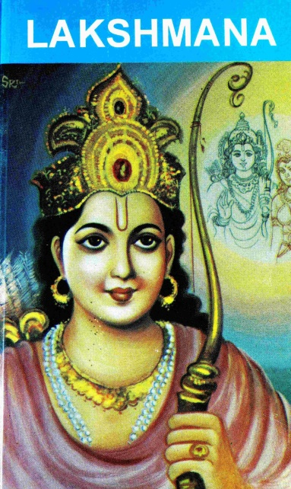
INTRODUCTION
Lakshmana is the younger brother of Rama and also his companion as per the epic Ramayana.
Lakshmana is the twin brother of Shatrughna. He is regarded as the avatar of ADHISESHA, the divine serpent bed of Lord Vishnu.
LIFE
Lakshmana and his brother Shatrughna were born in Ayodhya to Sumitra and King Dasharatha during Treta Yuga. Lakshmana also accompanied Rama towards killing the demons at Mithila as per the instructions given by the sage visvamitra. Lakshmana married Sita's younger sister Urmila. And they had two sons. During the 14 years period of exile, Lakshmana left his wife Urmila and his children and joined with Rama.
He served Lord Rama and Mata Sita with much care and attention during the period of exile. He played an important role during the Ramayana war.
He also tried to protect Sita from the danger, by drawing the lakshman rekha(a line drawn by lakshmana which sita must not cross), when he went out in search of the golden deer, which sita wants to get it captured.
During the Ramayana war, he killed Indrajit who was one of the sons of Ravana.
After Rama was seated in the throne of Ayodhya, when he was a given an offer of becoming the crown prince, he refused the offer, and asked Bharata to be made as the crown prince.
Lakshmana also safe guarded Mata Sita in the forests from animals, and asked sage Valmiki to take care of her in his ashram.
Lakshmana is a holy man who served with loyalty and affection to his elder brother throughout in his life. He never thought about his own comforts, but always thought about Lord Rama and assisted him in his entire life.
IMPORTANCE
He is a great avatar who served with utmost devotion and love to his elder brother Lord Rama. We can’t imagine such a great person in this today’s world. He was a dedicated brother and acted as a servant to Lord Rama who surrenders his entire mind and body towards doing service for him. He was also loved by the people of ayodhya for his kindness showed towards them, and for serving his brother in a proper manner.
He is a pious and a good natured person, who contains good knowledge in all the divine scriptures and also a master in all kinds of art. He contains wisdom, courage, boldness and spiritual power.
Though he was not punished, he went along with rama during the period of exile and looked after him and mata sita in a proper manner. The sincerity which he had shown to Rama and Sita cannot be forgotten by us.
Let us worship him and be blessed.
“JAI SREE RAM”
“JAI SREE LAKSHMAN”
“JAI MATA SITA”
WRITTEN BY
R.HARISHANKAR

LORD KALKI
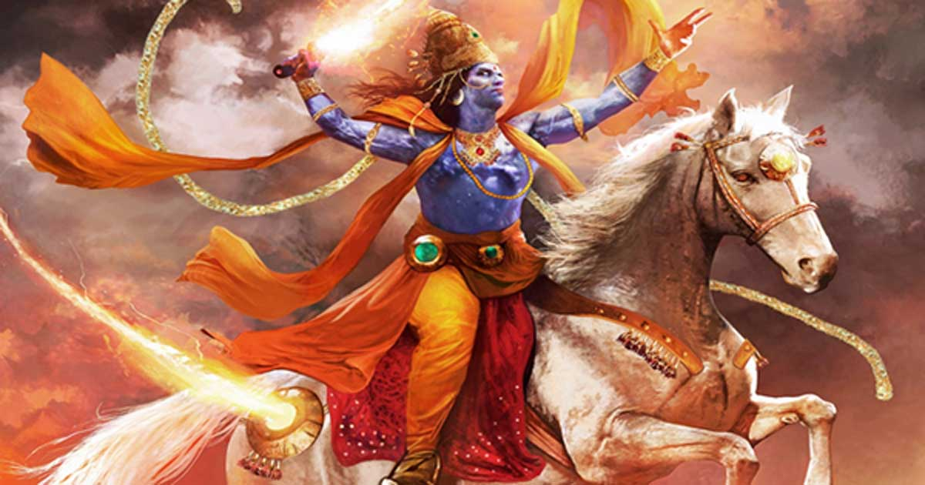
INTRODUCTION
Kalki, is the tenth avatar of Lord Vishnu who will appear at the end of Kali Yuga. It is stated that Kaliyuga consists of 432000 years. Out of that, approximately 5400 years have been passed. Hence the remaining 426600 years are there for kaliyuga to get completed. It is believed that Lord Kalki will appear in this earth only after the completion of 426600 years and will punish the evil forces and protect the good ones.
IMPORTANCE
He is described in the Puranas as the avatar who appears by riding a holy white horse with a shining sword. Kalki is also found in Buddhist texts.
In the great epic Mahabharata also there is a mention about the Kalki avatar. He is described as the great person, and appears at the end of the Kali Yuga. He is described as a Brahmin warrior in the Puranas.
Kalki avatar will be born in Shambala village, and the place of the village is now not known, but it is stated, that it will be somewhere in India, and it will be known only at the time of emergence of Kalki bhagavan.
Lord Kalki will take birth as the son of a Holy Brahmin and will live a simple life. It is also told that he will learn the vedas from Lord Parasurama. Parasurama will be a teacher to Lord Kalki. Lord Kalki will also be a great devotee of Lord Shiva, and will get great powers by worshipping him. He will get the divine horse and a sword by worshipping Lord Shiva. Through that, he will destroy the evil ones, and safeguard the good people. The tenth avatar of Vishnu is seen as the form before deluge (Pralaya). He is mentioned in Mahabharata, and in various divine texts, and he is known to be similar to that of Lord Parashurama, who kills unrighteous kings.
CONCLUSION
Kalki bhagavan is another form of Lord Vishnu, always protects his sincere devotees, and save them from bad persons. He is a highly knowledgeable person. Let us pray to Lord Kalki Bhagavan and be blessed.
“OM SREE KALKI BHAGAVANE NAMAHA”
WRITTEN BY
R.HARISHANKAR

LORD MAHAVIRA
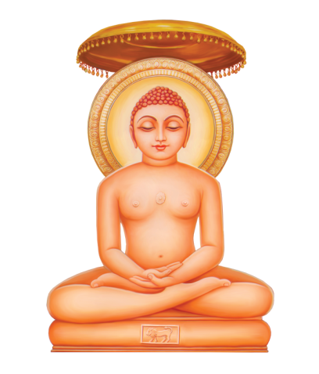
INTRODUCTION
Mahavira, also known as Vardhamana, was the twenty fourth tirthankara. He was a great jain monk who had left all the worldly pleasures, and acts as an example for others to follow his footsteps and principles, and he was greatly worshipped by the jain people. It is believed that while he was born, he was also blessed by the divine gods in the heaven, including Lord Indra.
LIFE
He was born on 599 BC in the present day bihar in a royal family. His father’s name was Siddhartha and his mother’s name was Trishala. He left home at the age of 30 in search for spiritual enlightenment, and for becoming a saint. Mahavira had performed severe penance for 12 years, and after that he attained the spiritual enlightenment in his life. It is believed by the jain people, that he had attained moksha after his departure from the earth.
His main teachings for attaining spiritual liberation are:
- Truth
- Chastity
- Non violence
- Non stealing
- Non attachment to worldly objects
Mahavira is usually depicted in a sitting posture, and his birthday is celebrated as Mahavir Jayanthi by the jain people in a grand manner, and they will give offerings to the poor and do lot of charity work on that day, in order to celebrate the birthday of their great Saint, and the saviour to the entire world.
Mahavir Jayanthi will usually be celebrated in the month of March or April of every year.
Mahavira was considered as the last Tirthankara.
According to the Svetambara, he travelled throughout India to teach the jain philosophy amongst the people, and was widely praised by the people through his teachings and through his kind and simple approach. He was worshipped by the kings in all parts of india, and was properly honoured and praised by them. He was attracted by large number of people to listen to his teachings and to get blessings from him. It is believed that, people got peace of mind and relieved from their mental and physical problems by seeing his shining face itself. He was such a charm and attractive looking person, who never cause any harm to others, and always aimed at doing good things to others in his entire life.
FAMOUS DISCIPLES
- Agnibhuti
- Vayubhuti
- Akampita
- Arya Vyakta
- Sudharman
- Manditaputra
- Mauryaputra
- Acalabhraataa
- Metraya
He attained Nirvana at the age of 72 in bihar.
He is worshipped by the jain people as a great religious leader, guru and god.
TEMPLES
- Jal Mandir in Pawapuri
- Shri Mahavirji in Rajasthan
- Mahavira Jain temple in Osian
- Trilokyanatha Temple in kancheepuram
- Brahma Jinalaya in Lakkundi
- Sankighatta, Karnataka
- Muchhal Mahavir Temple in Rajasthan
- Bhandavapur Jain Tirth
- Dimapur Jain Temple
IMPORTANCE
He was a great avatar purusha (Great Divine Incarnation of God) who took birth in this earth in order to relieve us from the sins, and to move to the correct path. During his period, through his teachings, he made the people to live a happy and a noble life. He taught many good principles which are still helpful to the man kind. He has controlled his senses and has become a great spiritual master. In the present life scenario, we can’t imagine such a great person like him.
He had donated all the things which he possessed to others, including his cloth. We should also cultivate the habit of worshipping him by keeping utmost faith on him. Let us try to follow his principles and teachings and lead a happy, prosperous and a sin free life.
Let us chant his name and be blessed.
“OM SREE BHAGAVAN MAHAVIRAYA NAMAHA”
WRITTEN BY
R.HARISHANKAR

MANASA DEVI
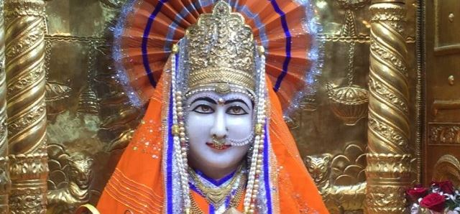
INTRODUCTION
Manasa Devi, is a goddess of snakes, worshipped mainly in north India, for getting recovered from problems caused due to snakebite and also will bless the childless couple and give them children.
Her husband’s name is Jagatkaru, a great rishi, and their son’s name is Astika, a great serpent deity. The great Astika has freed his ancestors from the hell by performing rituals to them, and through his act, his anscestors were attained a permanent place in the heaven.
She is considered as the daughter of Shiva and Parvati and sister of the great serpent king Vasuki.
Manasa is very kind towards her devotees, even for those people who do know much about her, through her kind attitude, she will make them to worship her, in order to give all the prosperity in their life. She is also called by various names such as Nagathamman, Nagalakshmi and Nageswari, and is worshipped by the south Indians.
Manasa Devi is also mentioned in Vedas and various sacred texts, and her importance is also mentioned in the texts.
She is also considered to be the daughter of the great sage Kashyapa and Kadru.
She is the "remover of poison” from our body and also from our mind, and will make us to be sin free persons, and will give peace of mind, good luck, removal of various dreaded diseases from our body, and finally will give SALVATION to us, provided if we worship her sincerely and faithfully, always keeping about her thoughts in our mind.
She is the main deity of snakes and reptiles.
She worshipped Lord Krishna and got great divine powers.
Manasa Devi is worshiped in a grand manner on Naga Panchami festival.
FAMOUS TEMPLES DEDICATED TO MATA MANASA DEVI
1.Manasa Devi Temple, Andhra Pradesh. Here Mata Manasa is worshipped as Mukkamala in West Godavari, Andhra Pradesh.
2.Manasa Devi Temple, Nellore , Andhra Pradesh
3.Manasa Devi Temple, Srikakulam , Andhra Pradesh
4.Manasa Devi Temple, Dornipadu, Kurnool , Andhra Pradesh
5.Manasa Devi Temple, kadapa , Andhra Pradesh
6.Manasa Devi Temple, Kurnool, Andhra Pradesh
7.Manasa Devi Temple, Vadluru, West Godavari , Andhra Pradesh
IMPORTANCE
She is a great goddess who acts as an affectionate mother to her sincere devotees. By worshipping her, we can get immediate relief from all sorts of problems, and will be able to live our life in a proper manner. In tamilnadu, she is worshipped in the name of NAGATHAMMAN, and it is better to do milk abhishekam to her during Tuesdays, Fridays and Sundays, in order to get better results in our life. If possible we can do all other types of abhishekhams also in order to get the blessings from the divine mother. We can chant various slokas meant for her, and recite her names repeatedly, and we will get more spiritual energy in our mind, and in our body, and will be able to run our life successfully.
Let us worship her with utmost devotion in our mind and be blessed.
“OM SREE MATA MANASA DEVIYE NAMAHA”
“OM SREE NAGATHAMMANE NAMAHA”
“OM SAKTHI PARA SAKTHI”
WRITTEN BY
R.HARISHANKAR

MUKTANAND SWAMI
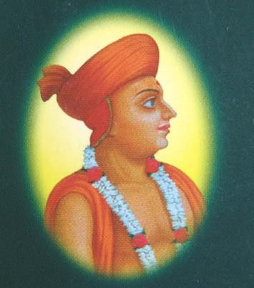
INTRODUCTION
Muktanand Swami (1758-1830) was a famous saint of the Swaminarayan Sampraday. His birth name was Mukund Das. He is considered as an avatar of the great “DEVA RISHI NARADA”
LIFE
He was born in a village in Gujarat in the year 1758.
Mukund Das learned Vedas, scriptures and other devotional texts at his younger age itself. And he was also expert in music, dance and interested in singing songs on Lord Krishna.
Muktanand Swami was the main disciple of Sri Ramanand Swami, and learnt all the divine subjects from him.
He was also interested in doing Satsang and bhajans, and done it regularly during his life time.
He was the favourite friend and devotee of Sri Swaminarayan and he was interested in writing lot of divine poems mainly based on the importance of Lord Krishna.
Muktanand Swami was also the friend of Sahajanand Swami and respected him as his Guru.
He left his physical body and reached the divine abode of Lord Narayana during the year 1830.
DIVINE WORKS
- Dharmabayanam
- Panchratna
- Vivek Chintamani
- Udhav Gita
- Satsangh Shiromani
- Sati Gita
- Shiksapatri Basha
- Shreevasudevavtarchintamani
- Mukundbhavli
IMPORTANCE
He was a great scholar of the Swami Narayan sect and considered as a holy saint by his devotees. During his period, he has done lot of welfare activities to the people, and performed many devotional concerts and spread the bhakti cult among the people. He also provided food to the devotees, and removed the sins of his devotees.
He gave peace of mind to the people, and asked them to chant the glory of Lord Krishna repeatedly during their life time. He insisted the people to lead a holy life and to remove their bad habits, and to visit the temples in order to get the divine bliss of the god.
His name and fame was spread across the masses, and people were very much interested in listening to his spiritual discourses on Lord Krishna. He blessed all of his devotees, and prayed to Lord Krishna for the prosperity of his devotees. By listening to his lectures, the worries and sufferings of the people were vanished. And they lead a very happy and a peaceful life.
Let us worship the great saint and be blessed.
“OM SREE MUKTANAND SWAMI MAHARAJ NAMAHA”
“JAI SWAMINARAYAN”
WRITTEN BY
R.HARISHANKAR

NACHIKETA
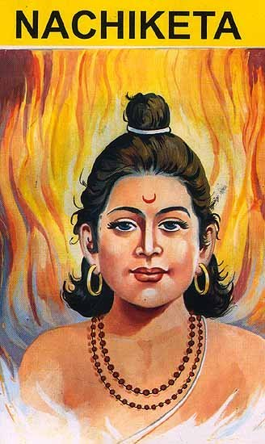
INTRODUCTION
Nachiketa was the son of the sage Vajashravas and was very spiritual in nature similar to that of his father. He has got cleared his doubts with the god of Death, Yama. Nachiketa is noted for his deep interest in devotion to god and was interested to attain the path of moksha. He is also mentioned in the rigveda, and also in other ancient hindu sacred texts, and tells the details about his conversation with Lord Yama.
Once he noticed his father had donated only old and sick cows to the Brahmins, and asked his father to donate him also, since he was also the property of the father.His father has got angry with him, and said that he will give to him in the hands of Lord Yama.
Hence Nachiketa went to Lord Yama’s place, but since yama was unavailable at that place, he waited there for few days without taking food and water. After few days, Yama arrived to his place and told to Nachiketa, to ask three boons from him. Nachiketa first asked for peace of mind for his father and well as for himself. Next, Nachiketa learned the details of various homams. For his third boon, He wanted to about the life after death.
Lord Yama’s quotes are as follows:-
- One should realize himself through his soul, which only can lead him to the path of heaven.
- Only our body will get destroyed and not our soul.
- We will not get moksha only by reading divine books.
- We should know the difference between our soul and our body, and must act accordingly.
- Proper understanding the Self only will relieve us from the cycle of rebirths.
- Realize the self by filling the thoughts of god in your mind.
- Through the thoughts of god, definitely you can reach the path of heaven.
After knowing about the details from Yama, Nachiketa has attained MOKSHA. Nachiketa was considered as one of the most famous person in Hinduism, and he was praised by Swami Vivekananda and appreciated for his boldness and wisdom.
IMPORTANCE
He was a brave person, who met Yama directly at his place itself and asked his doubts. Through him, we have understood the meaning of self-realisation, and also the importance behind it. He was also praised by the divine gods in heaven for his courage and wisdom. He also learnt all the divine scriptures at his younger age itself, and was a very active person. He also occupies in the place of child devotees like Bhakta Prahalada, Dhuruva and Markandeya.
Let us worship the great divine child and be blessed.
“OM SREE NACHIKETARE NAMAHA”
“OM SREE YAMA DHARMARAJAVE NAMAHA”
WRITTEN BY
R.HARISHANKAR
NAKULA
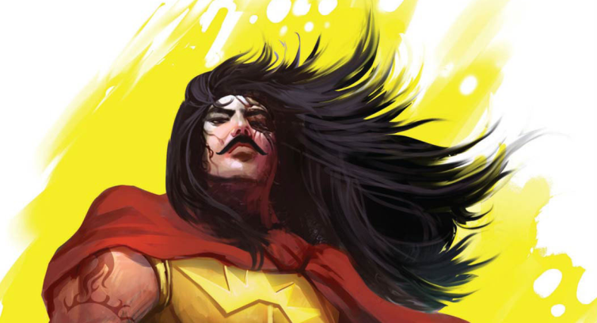
INTRODUCTION
As per Mahabharata, Nakula was the one of the five Pandava brothers. Nakula and Sahadeva were twin brothers born to Mata Madri, through the great divine physicians, the Ashwini Kumaras. Both of them were married with Draupati, and they had children from her.
Both Nakula and Sahadeva were very handsome and good natured persons, and they were very pious and noble persons. Both of them were brave warriors in the battle field. Nakula was an expert in the art of training the horses, while Sahadeva was an expert in handling of sword, and got the capacity to defeat his enemies with his sword.
Nakula killed the kings Kshemankara, Mahamaha, and Suratha through his great knowledge in handling of weapons.
During the period of pandava’s exile, Nakula worked as a horse-trainer.
Nakula also knows the art of treating all the diseases of the horses. He was also a skilled rider of chariots.
Both Nakula and Sakadeva contained good knowledge in Ayurveda, since they were the sons of the divine physicians Ashwini Kumaras.
Both Nakula and Sakadeva were skilled in all kinds of arts, and both of them were experts in handling various types of weapons in the battle field, and they helped a lot in the battle field of Kurukshetra.
IMPORTANCE
Nakula and Shakadeva are inseparable twins and both of them lived in a friendly manner. During the period of pandava’s exile, they showed their love and affection towards all other brothers, and convinced them in case of difficult situation faced by the other pandavas.
Both of them were very kind and gentle, and were loved by everybody. Both of them looked healthy, since they are the sons of the divine physicians.
They showed their bhakti towards Lord Krishna and considered him as their friend, philosopher, guide and god. Through the affection showed by Lord Krishna, they got peace of mind and able to live their life in a proper manner.
Let us worship the divine twins and be blessed.
“OM SREE NAKULAYA NAMAHA”
“OM SREE SAGADEVAYA NAMAHA”
“OM SREE ASHWINI DEVAYA NAMAHA”
WRITTEN BY
R.HARISHANKAR

NEEM KAROLI BABA
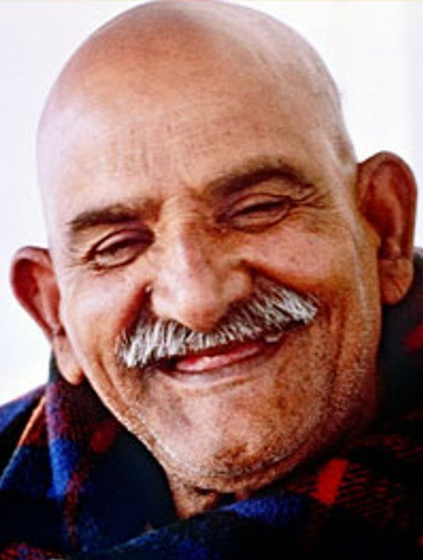
INTRODUCTION
Neem Karoli Baba (1900-1973) was a Hindu guru, and a devotee of Lord Hanuman. His famous disciples are Ram Dass, Bhagavan Das and Krishna Das. His ashrams are situated in Vrindavan, Rishikesh, Neem Karoli village in Uttar Pradesh, and in USA. His birth name was Lakshmi Narayan Sharma.
LIFE
He was born in a village at Firozabad district, Uttar Pradesh, India, in a Brahmin family. At his younger age he became a saint. And later as per the wish of his father he married, and got three children.
He left his home in 1958. Thereafter he wandered throughout india and went to many holy places and met many saints and discussed with them about spirituality.
His ashrams are situated at Vrindavan and at Kainchi.
The Kainchi Dham ashram was built in the year 1964 which contains Hanuman temple.
He died at the age of 73.
Subsequently, his samadhi shrine was constructed at Vrindavan ashram, which also contains some of his personal belongings.
IMPORTANCE
He was a great yoga master and an expert in meditation, and had done many charitable activities to the poor and needy such as providing food grains to them, helping for education, providing clothes and building shelters.
He was interested in chanting the mantras of Lord Rama and Lord Hanuman. He was a dedicated devotee of Lord Hanuman, and conducted regular puja and bhajans in his ashram. He asked his followers to involve in doing puja and to show utmost faith on god.
He was against caste discrimination and respected all the people as equal and considered all the people as the children of god.
He insisted the people to do good things to others, to act honestly and never to cheat others and asked them to work hard in order to earn money. He also asked the people to respect the elders and to take care of their parents.
He also cured the diseases of his devotees and gave them mental satisfaction.
Let us worship this great saint and be blessed.
“OM SREE NEEM KAROLI BABA NAMAHA”
“JAI SREE RAM”
“JAI HANUMAN”
WRITTEN BY
R.HARISHANKAR

PARAMAHANSA YOGANANDA
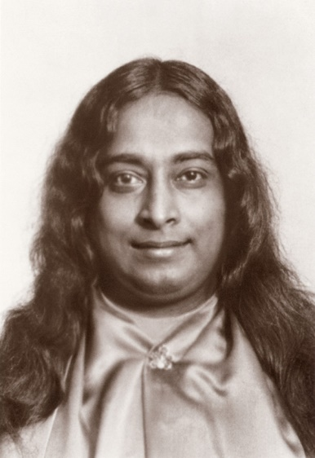
INTRODUCTION
Paramahansa Yogananda (1893 –1952) was a great yogi and guru, attracted by his followers through his teachings on meditation and Yoga. He was the author of the book ‘The Autobiography of a Yogi’.
LIFE
Yogananda was born in Gorakhpur, Uttar Pradesh, India, to a Hindu family. During his younger age itself, he met many great sages and saints and discussed with them about spirituality.
After finishing his schooling, for some time he left home and joined an Hermitage in Varanasi.
In 1915, he became a saint and known as Swami Yogananda Giri. In 1917, Yogananda started a school for boys for imparting spiritual education for them.
In 1920, Yogananda went to USA towards giving lectures in spirituality, which was attracted by thousands of people.
He also met Mahatma Gandhi.
He was given the title Parmahansa by his Guru, Sri Yukteswar on account of his highest spiritual knowledge.
He has described in his book, that once he has seen Lord Krishna directly and received his blessings.
He went to America for conducting spiritual meetings amongst the people on 1952. While he was addressing the meeting, suddenly he died due to heart failure. His followers believe that he reached in a stage of Samadhi, and is still blessing us with his divine power.
HIS FAMOUS LECTURES ARE AS FOLLOWS:-
- Temples are the place of worship. We should visit temples frequently and to worship the god, and to keep him in our heart.
- We should realize our inner spiritual energy, and must think that god is always living with us.
- Spirituality is a must in order to overcome from physical and mental diseases.
- We have to think highly, in order to reach the top level in our life.
- Do good things to others, and never speak badly about others.
- All the religion teaches the same principles such as worshipping god with good faith, and working hard for earning for our livelihood, and not to cheat others and to live honestly, and always showing mercy on others.
- We have to involve ourselves in doing social welfare activities such as providing food, clothing and housing facility to the poor etc.
IMPORTANCE
He also taught Yoga concepts to the people for self-realization purpose. He asked to do meditation in order to purify our mind, and to avoid concentrating on unnecessary activities.
He was a great saint and taught the basics of living the life in a proper manner. He was a learned man and contains all good qualities. It is believed that he once met Maha Avatar Babaji at Himalayas in a cave, and received his blessings.
He served his Guru Sri Yukteswar in a good manner and received his blessings and divine power. He has reduced the sufferings of the people through his spiritual lectures and helped them to attain spiritual energy.
Let us worship him and be blessed.
“OM SREE PARAMAHANSA YOGANANDARE NAMAHA”
WRITTEN BY
R.HARISHANKAR

RAVIDAS
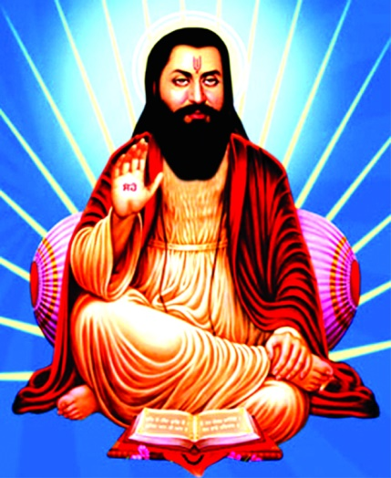
INTRODUCTION
Ravidas(1450-1520) was a Hindu Saint, famous poet and a spiritual guru who was worshipped in the North India. He was born in a village near Varanasi.
LIFE
He was born in a family who were considered as untouchables. It is believed that Ravidas was one of the disciples of the great saint Sri Ramananda.
He met Guru Nanak, the founder of Sikhism and his devotional songs were included in Guru Granth Sahib.
He spent most of his time in devotion at the banks of river Ganga. And also he interacted with large number of saints and discussed about the matters related to spirituality with them.
IMPORTANCE
He was admired by the higher sects of people and praised his knowledge. He travelled all over India and spread the bhakti spirit among the people. He worshipped god without any form. According to him, god has no form and shape, and he contains great power.
Ravidas is known as a saint and was respected by his followers. He is considered as a great guru by his devotees. He was talented in writing devotional poems and was a great scholar. He was against caste discrimination. According to him, all are equal before god, and everyone must respect each other and live together in a friendly manner. And he further says, we are all the servants of the god, and we should think only about god, god only and nothing else. Why we should worry unnecessarily about unwanted things, if god is near to us. Keep pure devotion on god, and that is enough to do our work properly.
CONCLUSION
Ravidas is a great devotee of Lord Vishnu, and has written magnificent poems in praise of him. He was respected by all class of people, the rich and the poor, educated and the uneducated and followed his principles. Let us worship him and be blessed.
JAI RAVIDASJI JAI
WRITTEN BY
R.HARISHANKAR

RISHI KAPILA
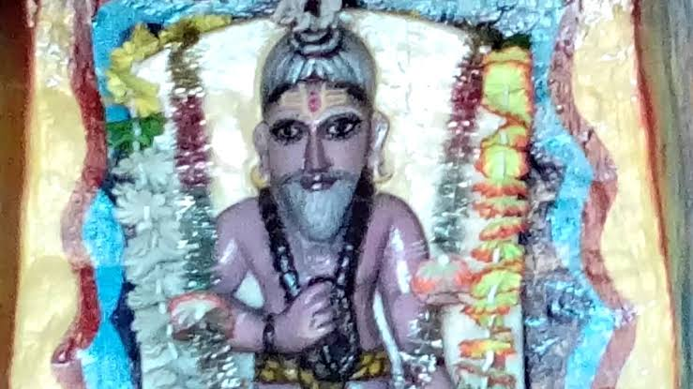
INTRODUCTION
Kapila is a vedic rishi who was mentioned in Rig Veda and Yajur Veda. He is also considered to be an incarnation of Lord Vishnu. Kapila was the son of the great rishi Kardama and his wife Devahuti. His importance is also mentioned in Buddhism and Jainism texts. Kapila was considered as one of the seven great sages along with Sanaka, Sananda, Sanatana, Asuri, Vodhu and Pancasikha.
According to Brahma Purana, when King Sagara's 60,000 sons were looking for their Ashvamedha horse at the place of kapila, and they disturbed Kapila while he was sleeping. He had woken up and burnt Sagara's sons to ashes. He got such a great divine power.
DEVOTIONAL WORKS
- Manvadi Shraddha
- Drstantara Yoga
- Kapilanyayabhasa
- Kapila Purana
- Kapila Samhita
- Kapilasutra
- Kapila Stotra
- Kapila Smriti
9. Kapilopanishad
10. Kapila Gita
11. Kapila Pancharatra
12. Vagbhatta
13. Nischalakara
14. Ayurvedadipika.
15. Kavindracharya
16. Ashtangahradaya
17. Sarvadarsanasamgraha
TEACHINGS
- Control your mind through involving yourself in spiritual thoughts.
- Always think about god, and chant his glory, and worship him with utmost faith and keep bhakti on him.
- Never blame on god, for your problems, since everything is happening in your life, based on your karma only.
- God has created human beings, only for protecting them, and making them to live happily. He will never unnecessarily give problems in your life.
- Always think several times, before starting a work, and pray to god, then you can do it properly.
- Respect your parents and your guru, and offer your prayers to them, then your life will prosper.
- Earn money only by honest means, and don’t cheat others, and don’t give any troubles to others. Help others in case of need.
IMPORTANCE
He has got great spiritual powers, and was always in meditative state, and contains great powers similar to that of Lord Vishnu. He took avatar in order to establish the path of dharma in this world, and also to share his writings to the entire world. He always insisted the people to follow the path of dharma, and to do goodness to others. He was a noble and pious saint, who always chants the glory of Lord Vishnu, and worships him.
Let us pray to him and be blessed.
“OM SREE RISHI KAPILARE NAMAHA”
WRITTEN BY
R.HARISHANKAR
RISHI ANGIRAS
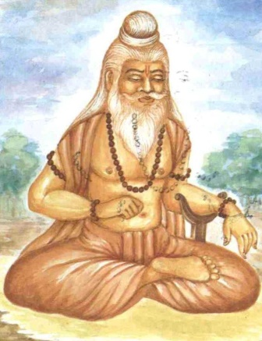
INTRODUCTION
Angiras is a powerful rishi in Hinduism. He is mentioned in vedas as a great rishi, and contains divine knowledge. He is also considered to be one among the Saptarishis. He is the son of Lord Brahma and he had three children. As per ancient vedas, he is also considered to be a great singer, who sings in praise of the Trimurtis: Brahma, Vishnu and Shiva. His name is also mentioned in Buddhist texts. He is also considered as one of the prajapatis, similar to that of Lord Daksha.
IMPORTANCE
He has got many divine qualities through his severe penance. Due to his penance, he attained the state of “Brahmarshi”. He had introduced many Vedic Mantras to this world. He was the author of many Vedic Hymns and mantras and he had introduced fire-worship, conducting homams in the hindu rituals, in order to please the divine gods in the heaven.
Though he contained lot of powers through his meditation, he was very kind and gentle and shared his vedic knowledge to others. He asked the people to worship god through chanting various mantras and praise him through singing divine songs, in order to please him, and to get prosperity in the life.
He was a very ancient rishi who was also present during the time of churning of ocean for getting the divine nectar from the ocean, and also during the vamana avatar of Lord Vishnu. He is the worshipper of all the three gods, and doesn’t find any difference between them.
It is also believed that he had chanted the mantras of gods for more than millions of times, and through that, he had got great spiritual power. He also advises us to sincerely worship the god, in order to achieve goodness in our life. He was a noble and a pious rishi, who lived a simple life.
It is also believed, that he is still living in the saptharishi mandala and doing penance.
Let us worship this great “RISHI” and be blessed.
“OM SREE ANGIRASA MAHARISHIYE NAMAHA”
WRITTEN BY
R.HARISHANKAR
RISHI ATREYA
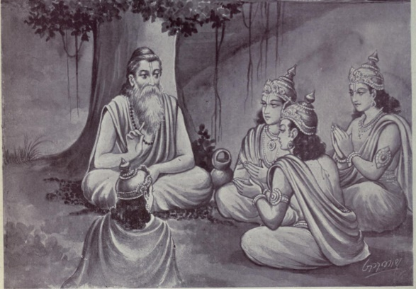
INTRODUCTION
Atreya Rishi was a descendant of Sage Atri and his importance are described in the ancient Puranas. He was born in takshashila, gandhara in the present day Pakistan.
Sage Atreya was a great physician of Ayurveda and he wrote the famous book Bhela Samhita on 6th century BC. He worked as a physician for several kings, and was well appreciated for his talent in curing dreaded diseases through his divine ayurvedic medicine. He also served as a physician of King Nagnajita of Gandhara Kingdom, during the dwapara yuga. He was also the author of Charakasamhita, a text on ayurveda. He taught his knowledge in Ayurveda to six of his disciples. All of them contained great knowledge in Ayurveda as well as in all other fields.
The names are as follows:
DISCIPLES
- Agnivesha
- Bhela
- Jatukarna
- Parashara
- Harita
- Ksharapani
IMPORTANCE
He was an ancient sage and a great physician in ayurvedic. Through his medicine, he has cured all types of diseases to all types of people. He doesn’t distinguish between rich and poor, good and bad, with regard to curing the diseases. His works are more valuable to the people and is a great treasure for the ayurveda physicians. He also shared his knowledge in Ayurveda to the divine demi gods. From ancient texts, it is believed that he was lived for more than 1000 years.
Apart from the field of Ayurveda, he also specialized in all other forms of art and is a great expert in astrology. He correctly tells the fortune of the past, present and future of the people, through his great spiritual knowledge. He was also interested in doing meditation and yoga, and also a great yoga master.
He got great knowledge in Vedas, Upanishads and ancient texts and also highly interested in spirituality and worshipping the divine gods.
Brahmin’s who belongs to atreya gothram are considered as the descendants of Atreya Maharishi.
Let us worship the great rishi and be blessed.
“OM SREE ATREYA MAHARISHIYE NAMAHA”
WRITTEN BY
R.HARISHANKAR

RISHI GARGA
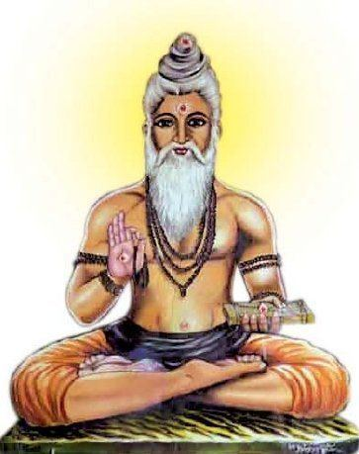
INTRODUCTION
Rishi Garga was one of the most ancient sage and also a great contributor to the field of Ayurveda, and also an expert in astrology.
He was the Author of Garga Samhita and Garga Hora which contains the details of astrology.

LIFE
Garga was the son of the great rishi Bharadwaja and Suseela. Garga also had two sisters named Ilavida and Katyayani.
Garga was lived during the period of Lord Krishna and he was the reputed priest for the Yadu dynasty. He only named the new born divine babies as Balarama and Krishna in the house of Nandagopal and Yashoda. He also told to Nanda about the importance of the divine babies and asked him to take care of them, and to be protected from the demons.
His ashram is situated in almora district, uttarakhand.
IMPORTANCE
He was a great sage and a master in all kinds of art. He was well versed in Vedas, Upanishads and Divine texts. It is believed that he had lived for several thousands of years, and also lived during the dwapara yuga, and served Lord Krishna and Lord Balarama.
He was a great fortune teller, and was awarded by the kings for his talent in astrology. Though he was a scholar, he was a humble and a noble sage, who never find any fault with others. During his lifetime, he never cursed anybody and he never harmed others.
He was interested in doing severe penance, and has obtained great yogic power through that. He never interested in any material comforts in this earth, but concentrated his attention only on god. He ate only simple food, and always chants the glory of the god. He contains pure heart. It is also believed that through the use of ayurvedic medicines, he has cured the diseases of the people during his period.
Let us worship this great rishi and be blessed.
“OM SREE GARGA MUNIVARE NAMAHA”
WRITTEN BY
R.HARISHANKAR

RUPA GOSWAMI
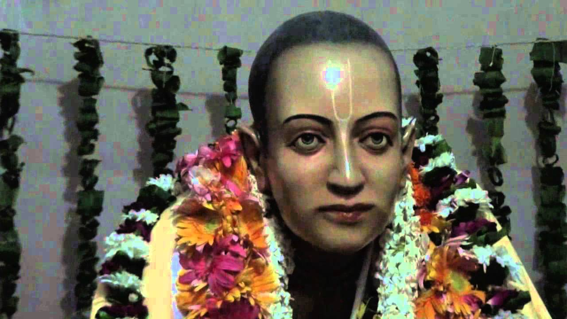
INTRODUCTION
Rupa-Goswami (1489–1564) was a Guru, poet and preacher of the Gaudiya Vaishnava tradition. He was associated with Chaitanya Mahaprabhu.
LIFE
Rupa Goswami was born in Bangladesh. Rupa Goswami spent his childhood in Bangladesh and for some time he worked under a muslim king. He studied the divine texts from the famous scholar Sarvabhauma Bhattacharya. He also studied Sanskrit under his guidance.
After getting the blessings of Sri Chaitanya Mahaprabhu, he joined with him. At the banks of the River Ganges, Sri Chaitanya explained about the details of Gaudiya Vaishnavism to him.
As per the instructions of Sri Chaitanya Mahaprabhu, Rupa Goswami went to Vrindavan and spread the importance of Vaishnavism.
Rupa Goswami departed from this world in 1564 AD, and his samadhi is located in the Radha-Damodara temple in Vrindavana.
Rupa Goswami is considered to be the incarnation of Rupa Manjuri, a cowherd lived during dwapara yuga and who physically served Mata Radha and Sri Krishna in a pleasing manner, and received their blessings.
He was a great writer and a music composer, who sang songs in praise of Lord Krishna, and was admired by his devotees.
DEVOTIONAL WORKS
- Bhakti-rasamrta-sindhu
- Ujjvala-nilamani
- Laghu-bhagavatamrta
- Vidagdhamadhava
- Lalitamadhava
- Stavamala
- Danakelikaumudi
- Sri Radha-krishna-ganoddesa-dipika
- Mathura-mahatmya
IMPORTANCE
He was the main person in spreading the consciousness of Lord Krishna throughout india. He was a great devotee of Lord Krishna and was a disciple of Chaitanya Mahaprabhu. He took the avatar for the benefit of the human beings and for removing the sins of the devotees.
He also worried about the sufferings of the people in Kali Yuga and explained the importance of devotion to them. He asked the people to praise Lord Krishna and to chant his holy mantras in order to get relieved from the birth cycle. His teachings are based on implementing the faith of Lord Krishna to the people.
Let us worship him and be blessed.
“OM SREE RUPA GOSWAMIYE NAMAHA”
“OM SREE CHAITANYA MAHAPRABHUVE NAMAHA”
“JAI KRISHNA”
WRITTEN BY
R.HARISHANKAR
SAINT RAMPRASAD SEN
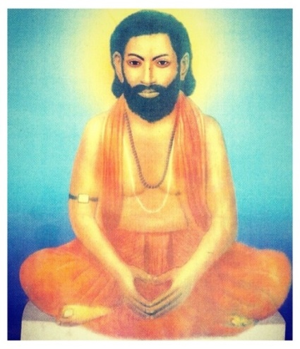
INTRODUCTION
Saint Ramprasad Sen(1723–1775) was a Hindu poet and a great saint of Bengal. His devotional poems on goddess kali are still popular in Bengal.
LIFE
Ramprasad was born in a village on the banks of the Ganges near Kolkata, into a Brahmin family. He devoted his entire attention in writing poems from an early age. He was sincerely devoted to Mother Kali and often sung in praise of her. He has got the darshan of Kali, and he was very much impressed on kali, and always thought about her day and night.
Ramprasad's literary works include
- Vidyasundar
- Kali-kirtana
- Krishna-kirtana
- Shaktigiti
Ramprasad devoted most of his time towards writing devotional poems on Kali mata. After his father’s death, Ramprasad moved to Kolkata and worked as an accountant in a private firm. But instead of doing accounts work, he has written devotional songs on Kali. But his employer took pity on him, and he has asked him to return to his village, and to continue composing songs to Kali, and he continued paying his salary.
After returning to his village, Ramprasad spent most of his time in doing meditation and praying to Kali, and writing poems. He became a disciple of Krishnananda Agamavagisha, a great yogi. Ramprasad became well known for his devotional songs, and he became the court poet of Raja Krishnachandra of Nadia.
Once he got a vision of goddess Annapurna of Varanasi. He is regarded as the famous person of the bhakti movement in Bengal. Ramprasad's songs are known as Ramprasadi. His poems were very popular during his lifetime.
IMPORTANCE
His devotional songs on Kali are very simple and written with pure devotion on kali. His songs were well accepted by various classes of people, and he was even admired by other religious people for his good songs.
He was praised by the Great Saint Ramakrishna Paramahamsa, and he sang his songs and regarded him as a great poet. Paramhansa Yogananda was also attracted with the devotional songs of Ramprasad. Sister Nivedita, the disciple of Swami Vivekananda regarded him as a great scholar and a highly knowledgeable person with spiritual energy.
In Bengal, Ramprasad's songs are recited by most of the devotees of kali even today.

CONCLUSION
Ramprasad was a great kali devotee, who has spent most of his time in writing devotional poems. He was a humble and honest man, who lived a saintly life, and taught the path of devotion to others. He made his followers to become the sincere devotees of Kali. He never allowed luxuries and comforts in his life. Though he was granted lot of wealth by the rich people, he never accepted it, and he lived a simple and a pious life. Let us worship the great “KALI DEVOTEE” and chant his name and be blessed.
“JAI KALI MAA”
“JAI KALI BHAKT RAMPRASAD JAI”
WRITTEN BY
R.HARISHANKAR

SAMBA
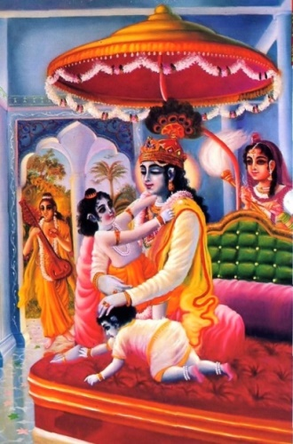
INTRODUCTION
Samba was the son of Lord Krishna, and Jambavati. His grandfather was the great “JAMBAVAN”, the bear king, who lived in treta yuga and also in dwapara yuga. In the ancient times, people were also worshipped the sons of Lord Krishna.
Samba was born due to the severe penance of Lord Krishna on Lord Shiva. He contains the features of Lord Shiva, and at his younger age itself, he learnt the various forms of art, along with divine scriptures and the handling of powerful weapons by the great scholars, and also by his father Lord Krishna. He resembled with Lord Krishna with regard to his mischievous activities made during his childhood. He was attracted by his playful activities and was loved by the entire people of Dwaraka. He has got many brothers and sisters. He was married to Lakshmana, the daughter of duryodana.
According to puranas, samba was suffered from leprosy due to the curse of sage Durvasa, since he misbehaved with him. After some time he got cured from the disease by worshipping Lord Surya. As per the curse of Gandhari, at the end of dwapara yuga, all the yadavas were destroyed by attacking one another, and their dynasty comes to an end, and Krishna and Balarama also departed from this earth and merged with Lord Vishnu.
IMPORTANCE
He was the loving son of Lord Krishna and Mata Jambavati. He got talents at his early age itself, and also contains all the divine qualities as that of Lord Krishna. He was also blessed by his grand- father JAMBAVAN, and he looked very handsome and attractive. The dwaraka people were much liked him for his kindness shown on them, and for his good activities.
Let us pray to the great son of Lord Krishna, and be blessed.
“OM SREE SAMBAYA NAMAHA”
“OM SREE KRISHNAYA NAMAHA”
“OM MATA JAMBAVATHIYE NAMAHA”
WRITTEN BY
R.HARISHANKAR
SHREEDHAR SWAMI
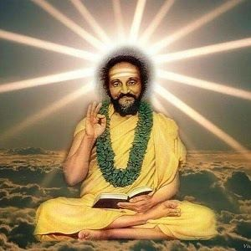
INTRODUCTION
Sri Shreedhar Swami (1908–1973) was a famous Hindu saint and a poet. He was an ardent devotee of Lord Rama, and a disciple of Samarth Ramdas.
LIFE
Sri Shreedhar Swami was born in a Brahmin family in the year 1908 in Karnataka. He had lost his father at his younger age, and his family was taken care by his mother and brother. He was interested in spirituality at a younger age.
He was a great devotee of Lord Rama, and will frequently chant his name from his younger age itself. It is also told that, once he went for his school exams without studying properly, and by the grace of Lord Rama, he had got good marks in the exams.
After some time, his mother and brother were also died, and after their death, he went to Gulbarga and lived with his aunt and continued his education there. After finishing his education, he met Samarth Ramadas at Sajjangad, Maharashtra and sought spiritual knowledge from him and became a saint.
As per his guru’s instructions he went all over india and spread the importance of Sanatan Dharma.
He also explained the importance of vedas and hindu scriptures to the people through his speeches. He built an ashram at Varadapura,Karnataka.
He attained samadhi in the year 1973 at his ashram at Karnataka.
He wrote several spiritual books in Marathi, Kannada and English.
SPIRITUAL WORKS
- Nirupam
- Moksha Sandesh

IMPORTANCE
He was a great disciple of Samarth ramadas, and an expert in yoga, meditation, vedas and hindu scriptures.
He also solved the problems of the people and removed their diseases and also healed the people suffered from black magic and mental problems. He reduced the sins of his devotees by asking them to frequently chant “RAMA MANTRA”, “SREE RAM”, “JAYA RAM”,“JAYA JAYA RAM”
Let us worship the great saint and be blessed.
“OM SREE SREEDHAR SWAMIGALE NAMAHA”
“JAI SREE RAM”
WRITTEN BY
R.HARISHANKAR

SOHAM SWAMI
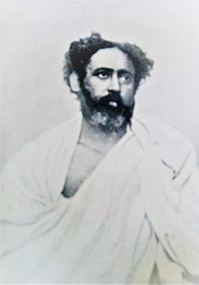
INTRODUCTION
Soham Swami (1858-1918) was a Hindu saint from India. He was the disciple of the Advaita Scholar Tibbetibaba. Tibbetibaba was a great spiritual saint of India. His birth name was Shyama Kanta Bandopadhyay.
LIFE
Soham Swami was born in a small village in a brahmin family at Bikrampur district,West Bengal in the year 1858. And at his younger age itself, he was interested in doing yoga and meditation and also contains great physical energy and strength.
His father worked as a record keeper in the district court in Tripura. He studied in west Bengal, and was an intelligent boy, and able to grasp all the subjects without much difficulty, and also marked as number one in the sports.
In 1899, he left home and became a saint. His guru was Tibbetibaba, and he renamed him as ″SOHAM SWAMI″.
Soham Swami constructed an ashram in uttarakhand. His disciple was Niralamba swami.
He followed the spiritual path of Advaita.
In the year 1918, Soham Swami died in his hermitage at Bhawali. His samadhi is located at Palitpur, Burdwan, India.
DEVOTIONAL WRITINGS
- Soham Geeta
- Soham Tattva
- Soham Samhita
- Common Sense
- Truth
- Shambuka Badh Kavya,
- Bhagabat Geetar Shamolochana

IMPORTANCE
He was a great saint and also a body builder contains physical and spiritual powers. He asked his devotees to keep their body tight and fit in order to protect them from their enemies and also to eliminate the diseases. He was an honest and straight forward person. He never hated anybody during his life, and had spoken to everyone in a kind manner, and interacted with his followers in a pleasing manner. He insisted his followers to do yoga, meditation, regular exercise and worshipping god regularly. He also cured the mental and physical diseases of his followers, through his spiritual powers, and also done many charitable activities, including providing food to the poor and the needy.
Let us worship this great yogi and be blessed.
“OM SREE SOHAM SWAMIYE NAMAHA”
WRITTEN BY
R.HARISHANKAR

SWAMI PRANAVANANDA
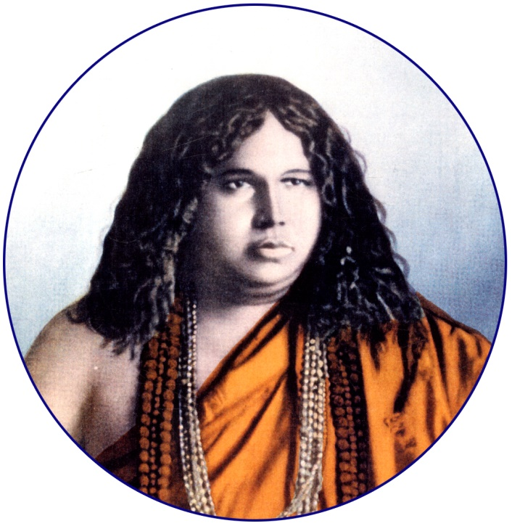
INTRODUCTION
Swami Pranavananda(1896–1941) was a Hindu saint, and also the founder of Bharat Sevashram Sangha. He is remembered for the upliftment of the Hindu society at the highest level in the entire world. He was considered as one of the famous spiritual leaders of India. His principles are mainly based on universal love, showing sympathy for all, humanity and respecting each other, and attaining high level of spirituality through devotion and meditation.
LIFE
He was born in Bangladesh. And he was born through the blessings of Lord Shiva. He was very sincere in his studies and performed well in the school. He was an expert in yoga and meditation and was a great scholar.
He never married and become a saint due to his sincere devotion on Lord Shiva, and also to flourish the hindu religion in all parts of the world.
FAMOUS TEACHINGS
- Working hard is not only important for running a person’s livelihood, but also at least he has to do some sort of help to others.
- Don’t be greedy, since it will swallow your life.
- Devotion is very important to live a good life
- Always follow the path of saints, and learn their teachings, since it will be helpful to you throughout your life.
- Avoid getting tensed, since nothing is going to be changed by getting tension.
- Feel free to talk with others in case of necessity, and at the same time, don’t talk too much to others.
- Always show courtesy on all living beings, since they are also like you.
- Respect your parents and elders.
- Forgive the person who has caused harm to you. You will be properly rewarded in the court of God.
IMPORTANCE
He untiringly worked hard for the welfare of the poor, and also was keen in providing the basic amenities to the poor and the needy.
He was a great devotee of Lord Shiva and spent his time towards doing meditation and yoga. He also solved the problems of his devotees and reduced their sins, and cured their diseases.
Let us pray to him and be blessed.
“OM SWAMI PRANAVANANDARE NAMAHA”
“OM NAMAH SHIVAYA”
WRITTEN BY
R.HARISHANKAR

SWARUPANANDA
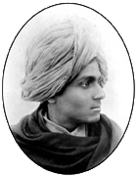
INTRODUCTION
Swarupananda (1871–1906) was a disciple of Swami Vivekananda and the president of the Advaita Ashrama, situated at Uttarakhand. His birth name was Ajay Hari Bannerjee.
LIFE
He was born in Kolkata, in a Brahmin family. He was very much interested in spirituality at a younger age. He had started a school for teaching of Indian scriptures. Swarupananda served as the editor of Prabuddha Bharata, a devotional magazine.
After meeting Swami Vivekanda, he has become a saint in the year 1898.
Sister Nivedita also had become a main disciple of Swami Vivekananda along with Swarupananda at Belur.
Swarupananda became the president of the Mayavati ashrama,Uttarakhand.
Death
He died in nainital in the year 1906.
IMPORTANCE
Swarupananda was very much interested towards the upliftment of the poor people in the region. He established schools and a charitable dispensary and also arranged Hindi and English teachers to teach to the tribal employees of the Ashram. He travelled to several parts of india and visited many holy temples.
He worked tirelessly for the welfare of the people and towards spreading the spiritual knowledge among all classes of people, poor and rich, educated and uneducated.
He followed the principles of swami Vivekananda and implemented it by his teachings to his followers. He was a great saint, and treated all the people as equal, and was against caste discrimination, and his teachings are mainly based on spirituality and social responsibility, and to treat all the people in a proper manner without any discrimination with regard to caste, gender and religion.
He worked among the youngsters to spread the message of Vivekananda. He translated the holy book Bhagavit Gita to English.
Let us worship him and be blessed.
“OM SREE SWAMY SWARUPANANDAYA NAMAHA”
“OM SWAMI VIVEKANANDAYA NAMAHA”
WRITTEN BY
R.HARISHANKAR

TAPTI
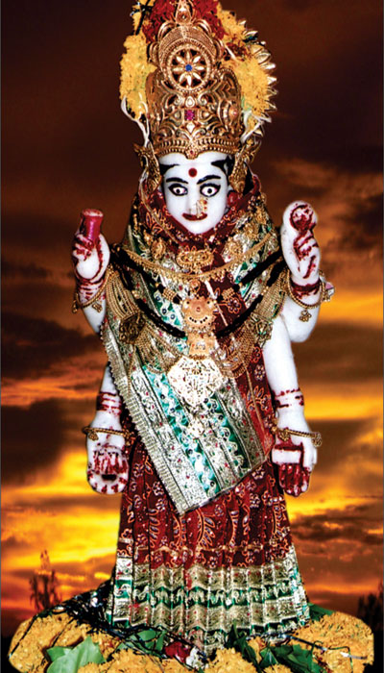
INTRODUCTION
Tapti is the goddess of river Tapti, and she is the daughter of Surya and Chaya. Her siblings are Yama, Yamuna, Bhadra, Shanidev and Ashwin Kumaras. Her husband name is Samvarna and their son name is Kuru, the founder of the kuru dynasty.
She is mentioned in Mahabharata and Bhagavatam and also in various divine texts, and her importance is also mentioned.
As per the Hindu texts, Tapti contains great knowledge in various subjects and looks attractive and contains a very good behaviour, and also contains soft and gentle nature.
Tapti is a river in india between the Godavari and the narmada rivers. It covers the indian state of Madhya Pradesh, Maharashtra and Gujarat.
There is a famous temple dedicated to Mata Tapti at betul, Madhya Pradesh. Devotees are visiting from all parts of india, to have a glimpse of their divine mother. Daily temple rituals will take place, and the goddess will be decorated with flowers and ornaments, and fulfil the wishes of her devotees. By taking bath in the river tapti will clears our sins, and will become holy. She is worshipped as a goddess since ancient times. Her vehicle is Fish.
The famous mantra for Mata tapti is:
“OM SURYAPUTRY MAA TAPTI DEVIYE NAMAHA”
IMPORTANCE
She is the sister of river Yamuna and both are very holy rivers. She is mainly worshipped for getting relieved from water related diseases like cough, cold, diabetes and also cures various other dreaded diseases. Being the daughter of the Sun God, she looks very bright and calm. She contains all the good qualities and is a worshipful mother. Many sages and saints were praised her glory and worshipped her for getting relieved from birth cycle.
Various demi gods also worships her for her great spiritual power, and she also contains the features of Mata Parvati.
Let us worship the great divine mother and be blessed.
“OM SREE MATA TAPTI DEVIYE NAMAHA”
WRITTEN BY
R.HARISHANAKR

THIRUKACHI NAMBIGAL
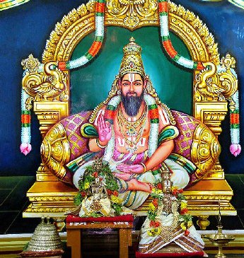
INTRODUCTION
Thirukachi Nambigal is a great devotee of Sree Varadharaja Perumal at Kancheepuram. He was born at Poonamallee. He was also a friend and a guru to Sri Ramanuja. He has lived 1000 years ago. It is believed that he will used to converse with Lord Varadaraja about divine matters as a regular practice. Every year, his birth day will be celebrated at the Poonamallee SRI THIRUKACHI NAMABIGAL VARADARAJA PERUMAL temple with much delight and persuasion.
He will used to do various services to Kanchi Sri Varadaraja Perumal on a daily basis, like plucking flowers for the temple puja, bringing fruits and milk for doing abhishekham to Lord Perumal. Through that, he got the grace of Lord Varadaraja and got the opportunity of conversing with the Lord. When he was sick, the Lord himself had approached him to his place in order to perform his duties to him.
As per the divine instructions of the Lord Varadaraja Swamigal, Nambhigal worked for Thirukostiyur Nambi for some time as a Cart man. Since it is believed during that period, that only by serving to the god’s ardent devotees, one can attain MOKSHA.
Arulmigu Sri Thirukkachchi Nambigal and Varadaraja Perumal Koil is situated in Poonamalle, and it is dedicated to Sri Thirukachi Nambigal, since it is the birth place for him. The temple is an ancient one, and it is more than 1000 years old.
The main deities are Ranganathan of Srirangam, Venkateswara of Tirupati and Varadaraja Perumal of Kancheepuram. Thayar is Pushpavalli.
IMPORTANCE
He was an ardent devotee of the Lord Varadaraja, and he cleared the problems of the people, and also relieved them from their physical and mental problems. He has asked them to chant the narayana mantra,”OM NAMO NARAYANAYA NAMAHA” in order to get relieved from the sins and also to attain MOKSHA. He was a very kind, pious and a humble saint, who guided Sri Ramanuja and cleared his doubts with regard to devotional matters. He also guided the common people to devote them to the spiritual path and to worship Lord Narayana regularly, in order to get all the prosperity in their life.
He is regarded as a great saint by the vaishnavites, and they are worshipping him with much love and devotion in their mind. By worshipping him we will get peace of mind, free from sins, diseases, mental problems, and unwanted, evil and suicidal thoughts will be erased from our mind.
Let us praise his glory and be blessed.
“OM SREE THIRUKACHI NAMBIGALE NAMAHA”
“OM SREE RAMANUJAYA NAMAHA”
“OM NAMO NARAYANAYA NAMAHA”
WRITTEN BY
R.HARISHANKAR
TRAILANGA SWAMY
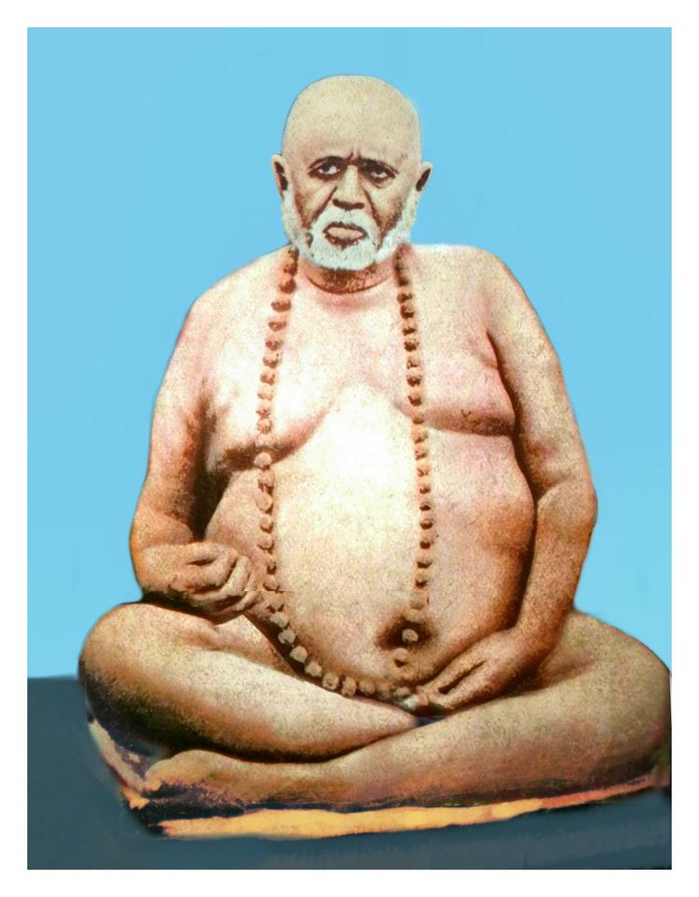
INTRODUCTION
Trailanga Swami was a Hindu saint who lived in Varanasi, India. It is believed that he lived for more than 200 years. He is considered as an incarnation of Lord Shiva. His birth name was shivarama.
LIFE
He was born at Vizianagaram District in Andhra Pradesh.
His parents were ardent devotees of Lord Shiva. After the death of his father in 1647, Sivarama carried out Kali worship in the nearby Kali temple.
After several years of Kali worship, he became a great yogi and he met his Guru Bhagirathananda Saraswati, in 1679 in Punjab, and became a saint and was known as Swami Ganapati Saraswati in 1685. He settled in Varanasi in 1737. After some time, due to his spiritualistic life, he came to be known as Trailanga Swami.
He lived at different places in varanasi. He was also roamed in the streets with naked body. Large number of people were attracted by his yogic powers, and become his devotees. He met many saints including Vivekananda, Lahiri Mahasaya and Swami Abhedananda and discussed spiritual matters with them.
He ate only small quantity of food, and in some occasions, he didn’t take food and water for several days.
On many occasions, he was tested by many people, and finally realized his holiness and asked for apology from him.

DEATH
He died in the year 1887. And according to his devotees, he is still alive and blessing his devotees in a divine form.

TEACHINGS
- Always keep your mind pure, and don’t allow unnecessary thoughts to enter into your mind.
- Don’t be greedy and don’t be a miser. Spent some portion of your money to the poor.
- All the incidents happening in your life, is based on your past karma only. We can’t change the fate, but can pray to the god, for getting peace of mind.
- Worship Lord Shiva and Shakti, you will be blessed by them.
- Don’t curse others, and don’t give any troubles to others. Do good things to others.
- Don’t blame on god, for your sufferings. Nothing is going to be changed by blaming god, instead you pray to him sincerely, and definitely some good change will take place in your life.
- Don’t get too much attachment to the wordly objects, since they will perish in course of time. Show your deep attachment on god, and it will last for ever.
- Show mercy on all the living creatures, since they are all the creations of the god.
- Control your senses and do meditation on god, it will help you to run your life smoothly.
IMPORTANCE
He was a great avatar of Shiva, and led a simple and a noble life. He lived a long life, in order to safeguard the people. During his period, he has removed the sins of the people, and cured the mental and physical problems of the people.
He was a calm and a gentle saint, who never spoken any harsh words over others.
He has also got good knowledge in vedic subjects and was specialized in yoga and meditation.
Let us worship this great saint and be blessed.
“OM SREE TRAILANGA SWAMIGALE NAMAHA”
“OM NAMAH SHIVAYA”
WRITTEN BY
R.HARISHANKAR

VAISHNO DEVI
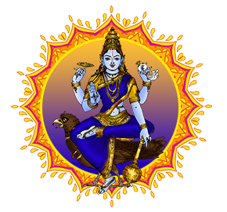
INTRODUCTION
Vaishno Devi, also known as Vaishnavi, is the incarnation of Mata Parvati. Vaishno Devi Mandir is a famous temple dedicated to Goddess Vaishnavi and is located in Kashmir.
Lakhs of devotees are visiting the Holy Shrine of Mata Vaishno Devi every year in Kashmir.
She was formed through the union of the Tridevis, Parvati,Lakshmi and Saraswati.
After destroying several demons, she incarnated as a human with the name of Vaishnavi, in order to maintain peace in the earth.
At his younger age itself, she was very much devoted to Lord Vishnu, and wanted to marry him.
Lord Vishnu appeared before her and granted her the boon that during his kalki avatar at the end of kaliyuga, he would marry her and asked her to wait for him on the trikuta mountain and to bless her devotees, which is located in the present day Kashmir, and her temple is also situated in trikuta mountain ranges.
IMPORTANT TEMPLES
- Vaishnavi temple in Bangalore
- Vaishnavi temple in Gulbarga
- Vaishnavi temple in Jaipur
- Vaishnavi temple in Delhi
- Vaishnavi temple in Chennai
- Vaishnavi temple in Haridwar
- Vaishnavi temple in Andhra Pradesh
IMPORTANCE
She contains great power and energy of the gods and goddess and is worshipped mainly in North India, and also in some parts of south india. She is worshipped as “VAISHNAVI” in south india. She is the mother for the entire universe, and she cures all the diseases related to mental and physical and also protects them from evil forces.
She is also considered as a powerful deity, who will come along with us in all walks of our life. We have to perform puja and abhishekham to her, and to chant her mantras and names, in order to live a happy and peaceful life.
Let us worship the great goddess and be blessed.
“OM MATA VAISHNO DEVIYE NAMAHA”
WRITTEN BY
R.HARISHANKAR

VASHISHTA
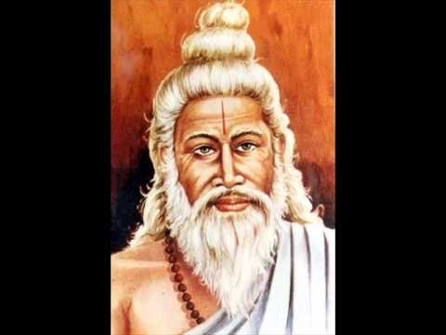
INTRODUCTION
Vashishta is one of ancient Vedic rishis. He is also one of the Saptarishis. Vashishta is the main contributor of Rigveda. He is mentioned in Rigvedic texts and also in other Vedic texts. IMPORTANCE
He is attributed to the literary works which are as follows:-
- Yoga Vashishta
- Vashishtha Samhita
- Agni Purana – Partial Contribution
- Vishnu Purana – Partial Contribution
- Vashishta dharmasutra
He has got the possession of the divine wish fulfilling cows Kamadhenu and Nandini her child, from Swarkaloka.
He is regarded as a scholar and he was married to Arundhati. According to ancient texts, it is believed that, several thousands of years ago, Vashishta has lived on the banks of The Holy River Ganga.
Vashishta is well-known for his relationship with Vishwamitra. Once, the great king Vishwamitra tried to steal Sage Vashishta’s divine cow. Through his great spiritual powers, Sage Vashishta has defeated Vishwamitra's army and sons. Later Vishwamitra undertook severe penances for several thousands of years and became a Brahmarishi. After that, both of them were became friends, and he was praised as Brahmarishi from the mouth of Sage Vashishta.
Main Disciples
- Manu
- Nahusha,
- Rantideva
- Bhishma.
- Samvarta

Temples Dedicated to Sage Vashista
- Ashram in Guwahati, India.
- Vashishta Temple in Himachal Pradesh.
- Vashishta Cave, on the banks of Ganges at Shivpuri
- Arundhati Cave on the banks of Ganges at Shivpuri
There is also a separate shrine for Guru Vashishta at Sree Dharmasastha Temple in Arattupuzha village in Thrissur district of Kerala.
CONCLUSION
Sage Vashishta who was a great rishi, was well-educated in various divine texts including vedas and puranas and a wise man, who is a master in all the subjects, and also a guru to many great kings and scholars. He is residing in Saptharishi Mandala along with her wife Arunthathi, and doing penance on god. Let us worship this great Maharishi and be blessed.
“OM SREE VASHISHTA MAHARISHIYE NAMAHA”
“OM SREE MATA ARUNDATHIYE NAMAHA”
WRITTEN BY
R.HARISHANKAR

VIJAYA DASA
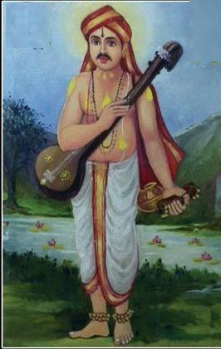
INTRODUCTION
Vijaya Dasa(1682–1755), was a great saint from Karnataka, India. He spread the importance of the philosophy of Madhwacharya across South India through his devotional songs.
LIFE
Vijaya Dasa was born in a Brahmin family in Karnataka. At a younger age, he went to varanasi and studied Sanskrit. He became a scholar in varanasi. Through the divine grace of Sri Purandara Dasa, he has become a famous saint and he was called as Vijaya Dasaru, and he occupied an important role in spreading Dvaita teachings.
IMPORTANCE
Through his great divine compositions, he was regarded as a great scholar among all the people. And he was well versed in Kannada literature.
He performed many miracles in the life of his devotees and made them to live happily. He has turned the uneducated person into an educated person, cured the diseases of the people, spreading the bhakti movement of Lord Narayana. According to him, only due to the divine grace of Lord Narayana, he has performed the miracles in the life of his devotees. He is considered as the spiritual heir of the Great Saint Purandara Dasa, and also considered as an incarnation of Bhrigu Maharishi.
He practiced the habit of singing devotional songs, and chanting of god’s name amongst the people. According to him, the impossible can be made into a possible, by chanting the glory of God’s name, and to get deeply attached with him. He was the main saint in spreading the importance of Lord Narayana through his famous compositions, which was developed and sung by him.

CONCLUSION
A great and a kind hearted saint, who took birth for the welfare of the people, and for spreading the importance of “HARI BHAKTI” among the masses. During his period, he solved the problems of the people, and turned their sorrow into joy. He has given them health, wealth and happiness in their life. Let us worship this great saint and chant his name and be blessed for ever.

“OM SREE VIJAYA DASARUVE NAMAHA”
“OM NAMO NARAYANAYA NAMAHA”

WRITTEN BY

R.HARISHANKAR

VINDYAVASINI
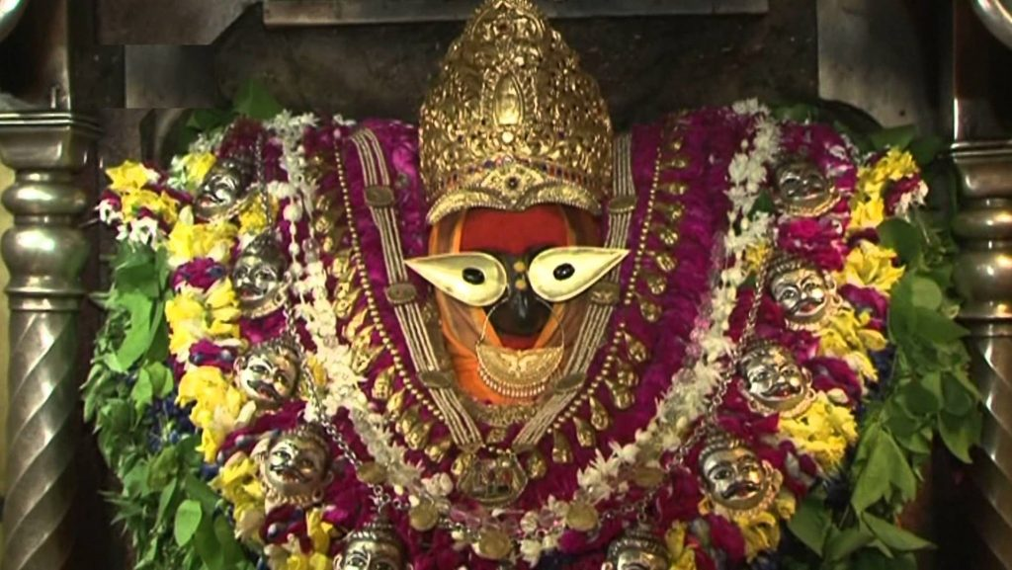
INTRODUCTION
Vindyavasini is one of the various names of the goddess Durga. She gets the name of Vindyavasini, since she resides in Vindyachal. Her temple is located at Vindyachal, on the banks of river Ganges, in Uttar Pradesh. According to various puranas, it was stated that goddess durga took the avatar of Vindyavasini in order to kill the demon Mahishasura.
Another famous temple is located in Bandla, Himachal Pradesh also called Bandla Mata Temple. It is surrounded with full of natural beauty and vegetation and it attracts a large number of devotees from all parts of india, in order to get the blessings from the divine holy mother “MAA VINDYAVASINI DEVI”.
As per the instruction of Lord Vishnu, Vasudev had replaced Krishna with the girl child of Yashoda. When Kamsa tried to kill the girl child, she escaped from Kamsa and turned into the form of Durga Devi and informed him that the killer of kamsa was already born at Mathura. After that, she has chosen to reside in the Vindhyachal mountains and her temple is located at that place.
She has chosen the place, since the place was very calm and a holy place with full of beauty.
The temple is also one of the Shakti Peethas of India. She is also called as Kajala devi. She is the divine incarnation of goddess durga.
During Navarathiri festival, large number of people will visit the temple, and offer their prayers to the goddess, and they will also do abhishekam and various pujas to the goddess in order to get her blessings.
There is also a temple of Goddess Saraswati and Goddess Kali nearby the vindyachal temple.
One temple dedicated to Mata Vindyavasini is located in Nepal.
IMPORTANCE
She is a very powerful goddess and was worshipped by her devotees throughout the year. She gives all the good fortunes, removes the sins and reduces the ill effects caused by the planets, and also cures the diseases of the devotees.
By reciting the mantra of Vindyavasini, we will get better results in our life, and attain happiness and all prosperity in our life.
She has taken the avatar of Vindyavasini in order to safeguard us from the evil effects of KALI YUGA. By worshipping her, we will get physical and mental relaxation in our mind and body, and will be able to move towards the spiritual path. We will be blessed by her and we will be start doing right things in our life.
Let us visit the holy temple of the goddess at Vindyachal at least once in our life time and be blessed.
“OM SREE VINDYAVASINI DEVIYE NAMAHA”
WRITTEN BY
R.HARISHANKAR

YAMUNA
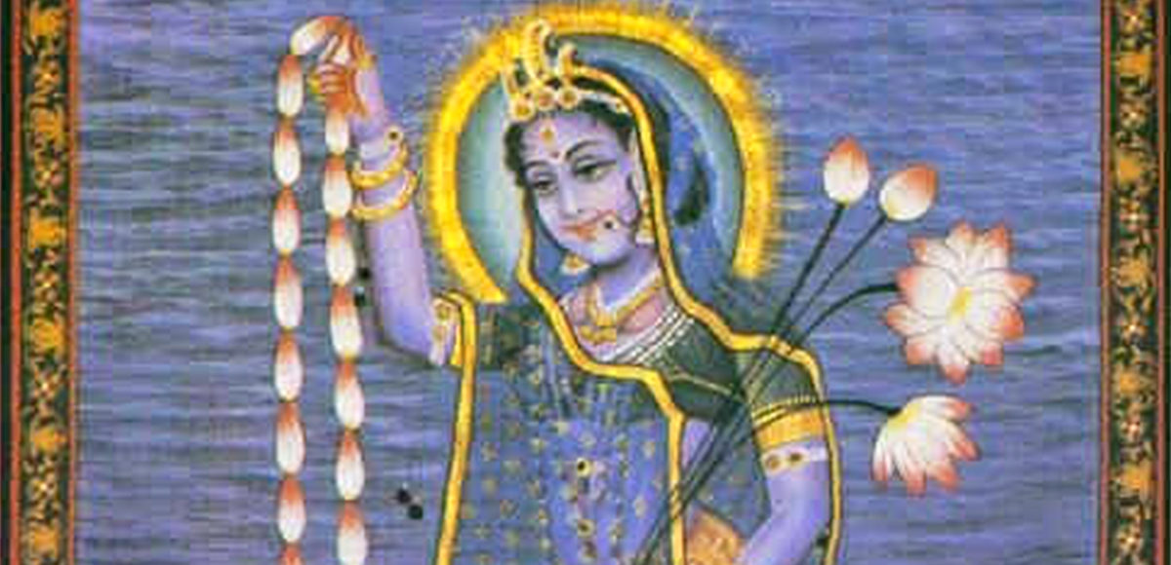
INTRODUCTION
Yamuna is the holiest river of Hinduism. The river is worshipped as Goddess Yamuna. She is also referred in vedas and divine scriptures, and her importance is also mentioned in the divine texts. She is also called as Yami, since she is the sister of Lord Yama.
She is the daughter of the sun god, Surya and Saranyu. Her brothers are Yama, Shanidev and Ashwin Kumaras, the divine physicians. And her sisters are Tapti and Badhra. Bathing in River Yamuna will remove our sins, and there is no need to afraid about our death and also our death will naturally occur, without any major sufferings, since she is the sister of Lord Yama Dharmaraj and Ashwin Kumaras.
She looks very beautiful with a charming face and contains a divine look. She welcomes all of her devotees to her place, and removes their physical and mental sufferings through her divine grace.
She is also a sincere devotee of Lord Krishna and Lord Balarama, and Krishna has spent his childhood days on the banks of river Yamuna, and she became very calm through the divine touch of Lord Krishna.
Yamunotri is the place of Goddess Yamuna, and it is situated in Uttarakhand, and a temple is also dedicated to her. Lot of devotees from all parts of india visit this temple, and get the blessings of the holy divine mother. It is advisable to stay at least for two days in this place, in order to attend all the pujas performed at the Yamuna Temple.
Being the daughter of Lord Surya, she contains great spiritual power, and was worshipped for getting better prosperity in our life. She will clear our karmas and protect us from the clutches of “KALI PURUSHA”, and make us to live happily and peacefully. We can chant the slokas meant for Yamuna and recite her various names frequently with much devotion in our mind, for getting better results in our life.
Let us worship the divine mother and be blessed.
“OM SREE YAMUNA DEVIYE NAMAHA”
WRITTEN BY
R.HARISHANKAR

YOGASWAMI
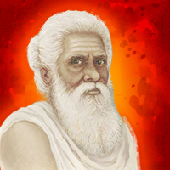
INTRODUCTION
Yogaswami(1872–1964) was a Hindu Saint, who was praised by the people of other religions also, for showing his kindness among the people, and for undertaking several social welfare activities. He was the Acharya of the Nandinatha Sampradaya's Kailasa Parampara. Yogaswami was the disciple of Satguru Chellappaswami, and he has become a saint through his guidance.

LIFE
Yogaswami was born in Jaffna, in Sri Lanka. His birth name was Sadasivan. He was a strict bachelor and has done meditation and studied the hindu scriptures at his younger age itself.
He was the admirer of Swami Vivekananda towards his religious speech.
Yogaswami travelled all over india and visted Chidambaram temple in Tamilnadu and also visited Kashi Viswanathar Temple at Kasi. He also met Ramanamaharishi at his Ashram at Tiruvannamalai.
Yogaswami passed at the age of 91 in Srilanka. All the people at Srilanka paid their last tributes to him.
A temple was constructed in his native place at Srilanka for the worship of the people.
IMPORTANCE
He followed the principles of great saints and siddhas and lived a saintly life. He was very simple and a straight forward person. His teachings are mainly based on doing good things to others, providing food to the poor and the needy, doing meditation and yoga, and realising the god within oneself.
Yogaswami has written many spiritual poems and songs, which was widely accepted and admired by the people of Srilanka. During his period, he was considered as a “GEM” and a “HOLY PERSON” among the people. He was well appreciated for his writing skills, and for his great knowledge in hindu religious texts, and for his courage and wisdom.
IMPORTANT DISCIPLES
- Markandu Swamy
- Sellathurai Swamy
- Santha Swamy
- Srikhantha
CONCLUSION
Sri Yogaswami who lived a pious life will always be remembered by the people for his famous poems and songs. His poems were written in a simple manner and were able to understand by anybody without much difficulty. He was a great Shiva Devotee, who always worships Lord Shiva and prayed to him for the welfare of the people.
He removed the difficulties of the people through his spiritual power.
He was worshipped by the people due to his divine power and for his good poems and teachings.
Let us worship him and be blessed.
“OM SREE YOGASWAMIYE NAMAHA”
“OM NAMAH SHIVAYA”
WRITTEN BY
R.HARISHANKAR

IDAIKKADAR
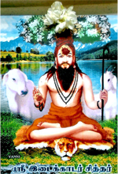
INTRODUCTION
Siddhar Idaikkadar was a great expert in the field of astrology and his writings on astrology are very useful for today’s astrologers. He was also an expert in the field of siddha. He is believed to have lived during the 3rd century BC, and he belongs to Yadava Community, and is very fond of worshipping Lord Krishna from his childhood, and praises him by singing songs on him.
He is one of the famous Siddhar among the 18 Siddhas. He was born in Idaikadu, hence he was named as idaikadar. He lived as shepherd and used to sing songs on Lord Shiva, while doing his work.
In his younger age itself, he realized the inner energy in his soul, and found that god is residing within himself. He was also a great master in yoga and meditation. He was appreciated by Bogar. He served as a disciple to Bogar and learned various subjects from him.
He also awakened the kundalini shakthi from him, and got the spiritual energy through that.
By seeing the sufferings of the people, he asked the people to leave the worldly pleasures and concentrate on bhakti in order to attain the siddhi.
He spent most of his life by helping the people in Thiruvannamalai region and attained jeeva samathi in Thiruvannamalai. He was also an ardent worshipper of Lord Arunachala.
His most important contributions are:
- Arrangement of Navagraha in temples in a proper manner.
- Introduction of Kayakalpa Medicine
He was praised by the people, since people were believed that he contained the power of Lord Shiva and Krishna.
He frequently utters the shiva mantra “Om nama shivaaya!” and asked the people to repeatedly chant it in order to remove the burdens in their life.
FAMOUS WORKS
- Idaikadar Gnyana Soothram 70
- Idaikadar Kanida Nool
IMPORTANCE
He was a great siddha who contained yogic powers, and through his power, people were treated him as god, and worshipped him. During his period, he has done lot of good things to the people. He cured various dreaded diseases of the people, and cleared their mind, by removing bad thoughts in their mind, and guided them to the spiritual path through his great divine powers.
Let us worship the great siddha and be blessed.
“OM SREE IDAIKKADARE NAMAHA”
“OM NAMAH SHIVAYA”
WRITTEN BY
R.HARISHANKAR

KARUVURAR
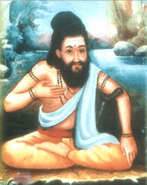
INTRODUCTION
Karuvurar Siddhar was born in Karur in Tamil nadu hence he was called as Karuvurar. It is believed that he was born thousand years ago.
Karuvurar was born in the family of Viswakarma community. His parents were doing sculpture work, by sculpting divine god’s sculptures. His parents were devotees of Lord Shiva, and they daily provided food to shiva devotees in a whole heartedly manner.
He learnt the subjects from various famous gurus, and got great knowledge by serving as a disciple to Sri Kamala Muni, and learnt the concepts of siddha from Bogar.
For some time, he also engaged in the business of doing sculpture work, and developed various god’s idol through his expert knowledge in the art of sculpting the divine idols.
Apart from his knowledge in other divine subjects, he also got great interest in doing yoga and meditation.
It is believed that he also sculpted some idols for the Brahadeeswarar Temple, Thanjavur, and was widely praised for his great work. Siddhar Karuvurar performed many miracles and safeguarded the people from various ailments.
He attained samathi in Sri Kalyana Pasupatheeswarar temple in Karur.
FAMOUS WORKS
- Vaatha kaaviyam
- Vaithiyam
- Yoga gnanam
- Pala thirattu
- Gurunool soothira
- Poorana gnanam
- Meisurukkam
- Sivagnana petham
- karppa vithi

IMPORTANCE
He was a great siddha who got good knowledge in various fields. During his period, he has done many wonders in the life of the people, and made them to lead a sin free life. Through his writings, the entire universe was benefitted. He got the skills through the divine grace of Lord Shiva.
He was loved by all the people, and was appreciated for his talents. He took care of his devotees in a proper manner, and taught the divine knowledge to them. He helped them to attain the spiritual energy through meditation and prayers.
By praying to him, we will get all the prosperity in our life, and after our death we will attain “SALVATION”.
Let us worship the great siddha and be blessed.
“OM SREE KARUVURARE NAMAHA”
“OM NAMAH SHIVAYA”
“OM SAKTHI PARA SAKTHI”
WRITTEN BY
R.HARISHANKAR
KONGANAR
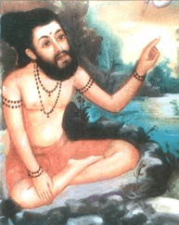
INTRODUCTION
Sri Konganar was believed to have been born during the 5th century BC, and is the disciple of Boganathar, and he is one among the 18 great siddhars. He was appreciated as the best student by Bogar himself. He was born in Erode in a goldsmith family. His main works include in the field of medicine, yoga and philosophy. He left home at his younger age in order to seek spiritualism. He got knowledge in various fields through the guidance of his guru Bogar and became a knowledgeable person. He is a great worshipper of Lord Shiva.
He was very good in doing yoga and meditation and specialized in all kinds of arts and a great scholar in all spiritual subjects.
Sri Konganar is a kind hearted Guru. He has got large number of disciples and he taught all the subjects to them with much affection and care.

Once he changed an iron into gold piece, and gifted it to his siddhar friend sivavakiyar’s wife, since sivavakiyar has gone outside. After his return to his home, his wife had narrated the incident, he immediately thrown out the gold piece into the well. He is such a great Siddha Purusha.
His Guru Boga has made his contributions in various fields.
After living a long life, he entered jeeva samathi at Thirupathi in Andhra Pradesh, nearby the Temple Complex of Lord Venkateswara.
IMPORTANCE
He shared his knowledge to his disciples, and asked them to help the common people. He also cured several health related problems of the people, and guided them in the spiritual path and told them about the greatness of Lord Shiva and asked them to worship him sincerely in order to attain all the prospects in their life.
Let us worship this great siddhar and be blessed.
“OM SREE KONGANARE NAMAHA”
“OM NAMAH SHIVAYA”
WRITTEN BY
R.HARISHANKAR

KUTHAMBAI
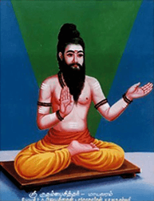
INTRODUCTION
He is one among the siddhas, and born in the Yadava community, and was greatly devoted to Lord Krishna from his childhood. He was a great siddha physician and contains an expert knowledge in the concepts of siddha medicine, and rendered great works on siddha. He learned the Siddha Science at his younger age itself from various scholars and siddhas.
He was interested to journey in the path of Siddhas and moved towards the spiritual path. His teachings are highly valuable for the entire universe. His songs are highly praised by the people, which mainly based on the yogic path.
He attained samathi at Mayiladuthurai in Tamil Nadu.
IMPORTANCE
From his childhood days, instead of playing with other boys, he concentrated his attention on praying to Lord Krishna and Shiva, and was deeply involved in meditation on them. He was highly praised for his great contributions in the field of siddha medicine. Siddha physicians are highly benefitted through his great works on siddha medicine.
He also removed the difficulties of the people, and made them to walk in the correct path. He was also well versed in all the divine subjects and contains good knowledge, wisdom, courage, boldness and devotion towards god.
During his life time, he moved with his followers and with the common people in a lovable manner. He never finds any fault with others, and always treated the people as the god’s creations, and respected everyone in a proper manner. He also cured the diseases of the people and cleared their sins and invoked them in the bhakti path. He removed the bad habits of the people, and encouraged them to develop good habits, by doing constant worship on god. He has done many miracles in the life of his devotees.
Let us worship him and be blessed.
“OM SREE KUTHAMBAI SIDDHARE NAMAHA”
“OM NAMAH SHIVAYA”
“OM SAKTHI PARASAKTHI”
WRITTEN BY
R.HARISHANKAR

MACHAMUNI
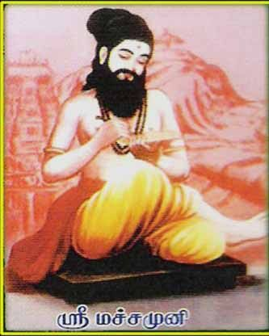
INTRODUCTION
Machamuni Siddhar is an ancient siddhar and is famous for his popular works.
He was born with the blessings of Lord Shiva and contains great bhakti and fully devoted on Lord Shiva. He was brought up by Sri Pinnakeesar and learned various subjects from him.
He took the guidance of the great sage Kakapujandar, and attained yogic powers through him.
Similar to other siddhas, he awakened his kundalini energy in order to understand the inner self and to attain great powers.
After several years of meditation, he got great spiritual energy and rendered his works in the field of Siddha medicine system.
He was also specialized in doing meditation for a long period.
He donated his entire wealth for the welfare of the poor people.
His disciple was korakkar and korakkar learned all the subjects from Machamuni.
He attained jeeva samathi in Thiruparankundram in Tamil nadu.
FAMOUS WORKS
- Meignanam
- Sothidam
- Thirumanthiram
- Perunool kaaviyam
- Vagaaram
- Yogam
- Vaithiyam
- Vethaantham
- Gnanam

IMPORTANCE
Machamuni was a great siddha who contains spiritual and yogic powers, and helped the people through his powers. He has done lot of social welfare activities, and gave all of his belongings for the welfare of the poor. He was not interested in enjoying worldly pleasures and concentrated his entire attention only on spirituality. Through his great power, he has reduced the sins of his devotees, solved their problems, removed their physical and mental diseases and made them to lead a happy life.
Let us worship him and be blessed.
“OM SREE MACHAMUNIYE NAMAHA”
“OM NAMAH SHIVAYA”
WRITTEN BY
R.HARISHANKAR

PULIPANI SIDDHAR
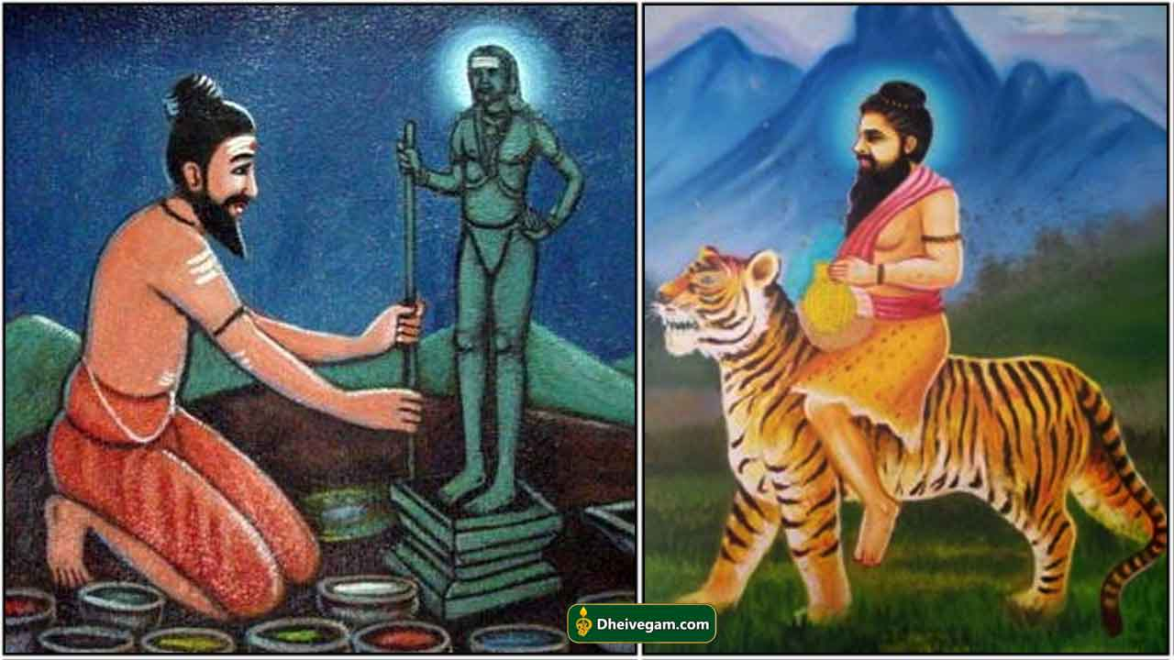
INTRODUCTION
Pulipani Siddhar is an ancient siddhar and is the disciple of Bogar. He is a staunch devotee of Lord Shiva.
Bogar installed Lord Murugan’s Navabashana idol at the Palani Hill, and daily he performed milk and panchamirtham abhishekham to the idol of Lord Murugan. After some time, his disciple Pulipani siddhar performed puja for Lord Murugan, since his guru Bogar went into a samadhi stage.
He got knowledge in vedic subjects and also an expert in all kinds of arts. He is very much interested in spirituality, and also chants the glory of Lord Shiva.
After getting the darshan of Lord Nataraja he concentrated his entire attention on devoting Lord Shiva. He worshipped Lord Siva with ‘Vilva’ leaves. He got a pair of Tiger’s paws as a boon, in order to climb the Vilva tree and for plucking the leaves for the shiva puja.
Pulipani performed yogic meditation towards Lord Siva. He has gained the status of Siddhar, through the divine grace of Lord Shiva.
IMPORTANCE
- By sincerely praying to Pulipani Siddhar, all sorts of dreaded diseases and mental disorders will be removed.
- We will get self confidence in our mind, and will be able to do our work properly.
- We can attain health, wealth and happiness in our life.
- Enemy related problems will be solved.
- We will get peace of mind.
- Unmarried people will be married soon, and they will be blessed with good children.
- We can attain spiritual energy in our mind.
- We will have a bright future.
- Bad, negative and suicidal thoughts will be removed from our mind.
Thus by worshipping Pulipani siddhar, we will get the above benefits in our life, and also after our departure from the earth, we can get SALVATION.
Let us praise his glory and be blessed.
“OM SREE PULIPANI SIDDHARE NAMAHA”
“OM NAMAH SHIVAYA”
WRITTEN BY
R.HARISHANKAR

RAMADEVAR
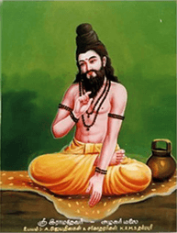
INTRODUCTION
Ramadevar is a great siddhar who occupies an important place in the Siddha Field. He was born in a Brahmin family. His guru is the great Siddhar Pulasthiyar. He attained great spiritual powers through meditation and performed many miracles.
From his younger age, he was an ardent devotee of Lord Siva and Goddess Shakthi. He lived in Nagapattinam. He regularly done pooja to Shiva Linga and worshiped the Lord daily through flowers and vilva(Bel patra) leaves and chanted shiva mantra.
He was well known for his great contribution to the Siddha Science.
He awakened his kundalini energy, and got great powers and helped the people by curing their diseases, and also relieved them from mental disorders. He performed many miracles and was praised by the people.
He attained Jeeva Samadhi at Alagar Malai in Madurai.
FAMOUS WORKS
- Sivayogam
- Vaithiya kaaviyam
- Vaithiya sinthaamani
- Sunnam
- Sunnakaandam urai
- Logaenthoora vaatha kaaviyam
- Panchamitram thandagam
- Vaithiya kalladam
- Vaithiyam 300
IMPORTANCE
He was a great siddha purusha, who used his yogic powers for the benefit of the people. He was an expert in yoga and meditation, and also a master in all forms of art and contains thorough knowledge in divine scriptures. He contains great powers through constant meditation and through his sincere devotion on the god.
Let us worship this great siddha and be blessed.
“OM SREE RAMADEVARA NAMAHA”
“OM NAMAH SHIVAYA”
“OM MATA PARVATHI DEVIYE NAMAHA”
WRITTEN BY
R.HARISHANKAR

RISHI PATANJALI
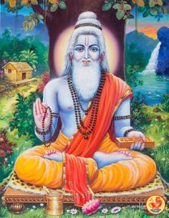
INTRODUCTION
Patanjali was a sage, siddha and a yoga guru in Hinduism, and he had written large number of sanskrit devotional texts, Ayurveda texts and yoga texts.
LIFE
He is considered to have been lived during the 2nd century BC.
He is also one among the 18 siddhars belonged to the shaiva tradition, and he is popularly worshipped by the shaivite sect of people, and he is considered as an incarnation of Lord Shiva, and contains all the features of Lord Shiva.
It is believed that he would have been lived for more than 1000 years, and attained great spiritual power through the divine grace of Lord Shiva.
He has attained Samadhi through his yogic powers at the Brahmapureeswarar Temple located at Tirupattur, Tamil Nadu, India.
Jeeva Samadhi of sage Patanjali, can be seen in Brahmapureeswarar Temple.
In the Yoga tradition, Patanjali is a popular name.
Patanjali studied Yoga from Lord Nandhi Deva.
Patanjali also writes the texts in a simple manner.
LITEREARY WORKS
- Mahabhasya
- Patanjalatantra
- Yogaratnakara
- Padarthavihnana
- Carakavarttika
- Yogaratnasamuccaya
- Cakradatta bhasya

IMPORTANCE
He is a great sage who contains knowledge in all fields. Though he was an expert scholar in various fields, he was specialized in yoga and meditation. He was also a great ayurveda physician and contains good knowledge in Ayurveda, and it is believed that he had treated several people from various diseases through his ayurvedic medicine. He also contained spiritual powers and yogic power through constant meditation. He is a great worshipper of Lord Shiva, Mata Parvati and Nandi deva. He worried about the physical sufferings of the people in the world, and introduced his medicine, several thousands of years before, through his books. It is also believed that during his period, he has seen directly the divine appearance of Lord Shiva, and he was blessed by Lord Shiva. He has got the power to meditate for several years and he attained siddhi (SALVATION) through that.
He is a great sage who lived by taking very little food and water and concentrated his entire attention on devoting Lord Shiva. He was apart from normal people, and considered as a great yogi. He is still living with us through his great divine books.
Let us worship this great sage and be blessed.
“OM SREE PATANJALI RISHIYE NAMAHA”
“OM NAMAH SHIVAYA”
WRITTEN BY
R.HARISHANKAR
SATTAIMUNI
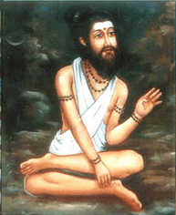
INTRODUCTION
Sattaimuni Siddhar was born in Srilanka and he lived by taking alms nearby a temple, in order to run his family. Even though he was a poor person, he was interested in the welfare of the people.
Sattaimuni Siddhar occupies a main place for his great works.
Due to the various health sufferings of the people, he made an extensive research in siddha and written medical related texts for the benefit of the mankind.
He left his family at his younger age, in order to seek spiritualism and to gain knowledge in siddha.
He was the disciple of Siddhar Agathiyar and Bogar, and learned many important subjects from them. He got the capacity to grasp the subjects quickly, and he was well appreciated for his talents by his gurus.
Being a sincere devotee of lord Shiva, it is believed, that since he was not having sufficient clothes to wear, once Lord Shiva himself appeared before him and presented him some good clothes to wear.
He was the guru of Pambatti Siddhar and Sundaranar Siddhar and he taught all the subjects to them.
He wrote the concepts of siddha secrets in a simplified manner.
Sattaimuni Siddhar is expert in Siddha medicine, and also in other fields.
After living a long life, he attained samadhi in sree rangam thiruchi.
IMPORTANCE
He was a great siddhar who was very much worried about the sufferings of the people from various diseases, and introduced new concepts in siddha medicine field through his great works. He was well versed in all divine texts, and also an expert in all forms of arts. Though he contained a great knowledge in all the subjects, he never got pride and remained as calm and a polite person throughout in his life.
Let us worship this great siddhar and be blessed.
“OM SREE SATTAIMUNI SIDDHARE NAMAHA”
“OM NAMAH SHIVAYA”
WRITTEN BY
R.HARISHANKAR

SIVAVAKKIYAR
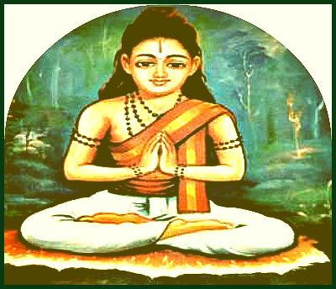
INTRODUCTION
Sivavakkiyar is one among 18 Siddhas and considered as a person who was against caste discrimination. He belonged to the family of gold smiths, and his parents were sincerely devoted to Lord Shiva. It is believed that he lived thousand years ago.
Sivavakkiyar Siddhar was born by reciting Lord Shiva’s holy name. Hence he was called by the name Sivavakkiyar. His parents were insisted him to become a great siddha, and hence he met the siddhas to learn various subjects from them.
He was an expert in Siddha medicine, Yoga and meditation.
Since Sivavakkiyar Siddhar was a great poet, he wrote lot of devotional songs on Lord Shiva.
He got the spiritual energy by worshipping goddess sakthi.
He was against caste, creed, gender and religion. He treated all the people as equal and respected everybody.
He asked the people to chant the glory of god, and by reciting his mantra and name, in order to attain spiritual enlightenment. He went to kasi and learnt vedas and other divine scriptures.
He attained Siddhi at kumbakonam. Pujas are performed regularly on Full Moon Day. Those who pray to him with sincere devotion in mind, are blessed with good health and wealth, and also give peacefulness in life. Praying him on Mondays will give good results in our life. By worshipping him all the evil effects of the Nava Grahas will be cleared immediately, and we can attain all the prosperity in our life. All problems related to black magic, mental disorder, suffering from unwanted, negative and suicidal thoughts will be removed from our mind, if we worship him and chant his name sincerely as a daily practice.
IMPORTANCE
He was a great siddha, and cured the diseases of the people through his siddha medicines. He also invoked his followers to the spiritual path and asked them to worship Lord Shiva regularly, in order attain MUKTHI. He asked the people to realize the god from their own soul, since god is dwelling in everyone’s soul.
He solved various problems of the people through his spiritual energy. He was praised and admired by the people for his good behaviour and for containing great yogic powers.
It is believed that he chanted shiva mantra for several millions of times during his life time.
Let us worship this great siddha and be blessed.
“OM SREE SIVA VAAKIYARE NAMAHA”
“OM NAMAH SHIVAYA”
“OM SAKTHI PARA SAKTHI”
WRITTEN BY
R.HARISHANKAR
THERAIYAR
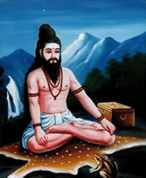
INTRODUCTION
Theraiyar is one of the 18 Siddhas. He has written lot of texts which are very useful to the mankind. His guru is Dharmasoumini. He learnt all the subjects from him, and was an expert in the field of Ayurveda and siddha, and rendered his writings on that.
FAMOUS TEXTS
- Pattartha Guna Chintamani
- Maniwenbha Medicine
- Theraiyar Venba
- Theraiyar Maruthuva Bharatham
- Theraiyar Kappiyam
- Theraiyar Paadal Thirattu
- Theraiyar Tharu
- Theran Yamaga Venba
- Theran Thaila Varkka Churukkam
- Anuboga vaidya Deva Ragasiyam
He is also a disciple of Agastiyar, and learned all the divine subjects from him, and also was blessed by him. It is believed that he lived several thousands of years ago.
He is an expert in all kinds of arts, and a scholar in all the subjects and he discovered many new effective medicines and wrote various texts on that.

He has written a very famous text known as Theraiyar karisal-300, which contains the details of preparation of various siddha medicines, which are very useful for the siddha physicians in this today’s world.

He is said to have attained Samadhi in Toranamalai,Tenkasi.
IMPORTANCE
His contribution towards the siddha and ayurveda field cannot be explained in words.
He was also praised by the great woman saint Avvaiyar for his great works.
He got talent in all the languages.
Since he removed the insect therai from a person’s head, he is called as theraiyar.
He was considered as a siddha physician and treated lot of people.
He consumed rare herbs, in order to live a long life, to provide proper service to the people.
His works are very useful to the modern rough and tough life, and through his new invention of medicines, lot of people are benefitted.
Let us worship the great siddhar and be blessed.
“OM SREE SIDDHA MAMUNI THERAIYARE NAMAHA”
WRITTEN BY
R.HARISHANKAR

