AKRURA
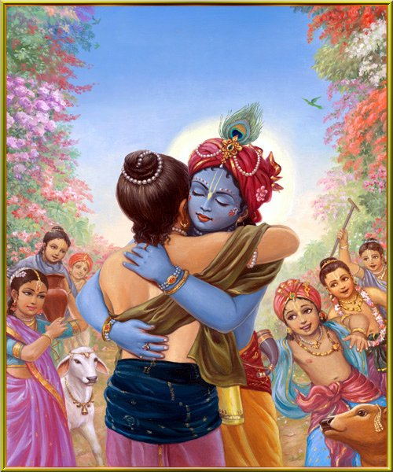
INTRODUCTION
Akrura was a chief of the Yadavas. The life of Akrura can be known from ancient Puranas.
LIFE
Akrura was the son of Svaphalka and Gandini, and he was born during the dwapara yuga in Madura, in the yadava community approximately 5500 years back.
Akrura was married to Sutanu, and they had two sons. Kamsa ruled Mathura. He wanted to kill Lord Krishna and Lord Balarama, since he heard a divine voice from the sky that he would be killed by Krishna. Akrura informed Krishna about Kamsa’s plan to kill Krishna, and advised him to kill Kamsa.
Akrura was considered as an uncle of Lord Krishna but he respects and worshipped him as a god. He is mentioned in the Hindu scriptures as an ardent devotee of Lord Krishna.
Akrura was also present during the wedding function of Draupadi, and was present at the time of Krishna’s marriage with Subhadra. He also attended the marriage function of Abhimanyu.
Akrura helped Krishna towards fighting with Jarasandha, and won in the battle.
Akrura Ghat is the famous ghats at Vrindavan, Mathura district. In this place, Lord Krishna and Balarama gave darshan in the forms of Lord Vishnu and Adhisesha to Akrura. Akrura Ghat is considered as a very holy place, and we can wash out our sins by taking a bath in this ghat.
In Gopi Nath temple, all the three images of Krishna, Balarama and Akrura are found.
IMPORTANCE
The relationship between Akrura and Krishna is that of between a devotee and a god. He treated Lord Krishna in a kind manner and worshipped him from his heart. He humbly served to Lord Krishna and Balarama, and won their hearts.
He was considered to be the chief among the yadavas, and he respected his yadava people, and provided all the benefits to them. He lived a simple life, and roamed in madhura, played with yadavas and also with Krishna and balarama and spent his life happily.
From his younger age, he was interested in spirituality and he contains wisdom, courage, patience and boldness. He was an expert in all forms of art, and also contains knowledge about the divine subjects. He was properly guided by Lord Krishna, and lived a noble life. He along with other yadavas never suffered from any physical or mental diseases or from any other problems, due to the divine grace of Lord Krishna and Lord Balarama.
Let us worship this great devotee of Lord Krishna and be blessed.
“OM SREE AKRURARE NAMAHA”
“OM SREE KRISHNAYA NAMAHA”
“OM SREE BALARAMAYA NAMAHA”
WRITTEN BY
R.HARISHANKAR

ARJUNA
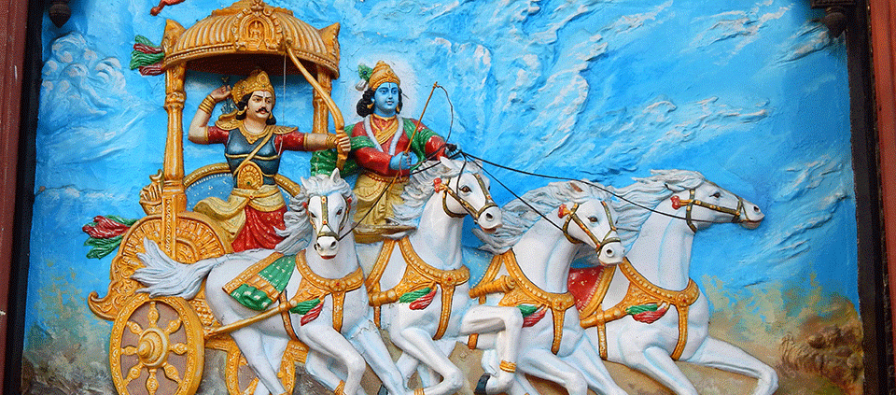
INTRODUCTION
Arjuna was a main character in Mahabharatha. He was the son of Kunti Devi and Lord Indra. He occupied a main place in winning the battle in Kurukshetra war with Kauravas. He was born in dwapara yuga.

IMPORTANCE
Arjuna was a very brave and bold warrior. He was the friend of Lord Krishna. Lord Krishna narrated the Bhagavat Gita to him, during the Kurukshetra war. In his previous birth he was the great rishi named as ”NARA” who undertook severe penance with another rishi called as “NARAYANA”. The rishi “NARAYANA” in his next birth took the avatar as Lord Krishna. Lord Krishna acted as a friend, philosopher, guide and a god to Arjuna. He has given many useful suggestions and teachings to him, which was very much effective to him.

Arjuna has seen the “VISWAROOPA” dharshan of Lord Krishna at the time of Kurukshetra war. He was talented in all kinds of art, and a great warrior in the battle field. He respected all the elders and treated them with much care and attention.

Without the help of Arjuna, the pandavas cannot win in the battle with kauravas. Arjuna was a great valour, and a master in archery. He was able to shoot the arrow even from a long distance, and make it to reach it to the correct direction.

He was married to draupathi, and also after some time, he married subhadra, and they had one son known as Abimanyu. Like his father, Abimanyu was also a great warrior and a master in all kinds of art. Abimanya was killed in the battle by the kauravas.

CONCLUSION
Arjuna was a great scholar and a noble man, who took the avatar for serving to Lord Krishna. He was the son of Lord Indra, and he went to swarkalok for seeing his father Lord Indra. With the help of Lord Krishna, he lived a peaceful life. He was safeguarded by Krishna, and has become a great man after listening to his teachings. He has given proper respect to his brother “YUDHISHTRA” even after they left their palace, and went to the forest. Let us worship the great and the humble King Arjuna, and chant his name and live happily for ever.

“OM SREE ARJUNAYA NAMAHA”
“OM SREE KRISHNA, MUKUNDA, MURARI”

WRITTEN BY
R.HARISHANKAR

ASWATHAMA
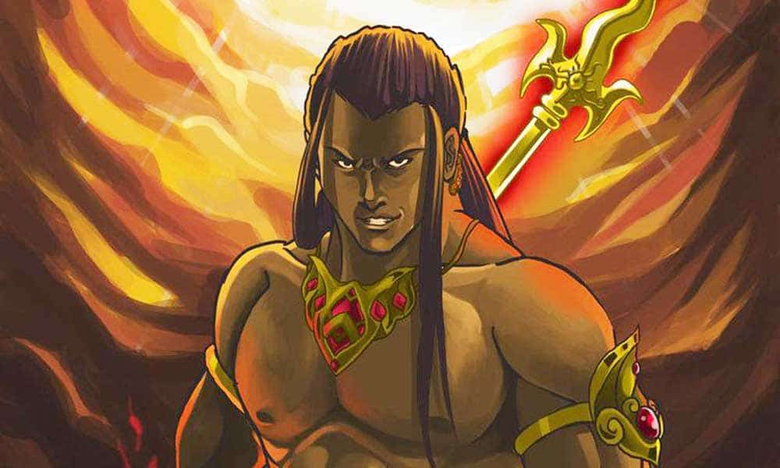
INTRODUCTION
Aswathama is the son of Guru Drona and kripi and the grandson of the Rishi Bharadwaja. He was born due to the divine grace of Lord Shiva. He fought on the Kaurava side against the Pandavas in the Kurukshetra War. Ashwathama,is a famous character in the great epic Mahabharatha.
IMPORTANCE
Aswathama and his uncle (mother’s brother) Kripa, were chiranjeevis and will live in this earth till the end of kaliyuga. Kripa was also a great warrior, a scholar and an expert in all forms of art. He is a humble and a brave man, who also lived a simple life with much devotion on Lord shiva.
His father, Dronacharya has lived a simple life without much wealth. He was a noble and pious man, who never interested in enjoying comforts and luxuries in his life.
Dronacharya became the guru of the Pandavas and Kauravas in Hastinapur. And he also trained his son Aswathama in several arts.
Aswathama took charge as army general and he has participated in the Kauravas side in the Kurukshetra War.
Aswathama was born with a gem in his forehead which gives him great power.
Aswathama is a great warrior in the battle field.
After the death of Drona, Aswathama was planned to attack the pandavas with Narayanastra.
But the pandavas were left unharmed due to the grace of Lord Krishna. After that Ashwathama, killed the pandavas sons and the soldiers of the pandavas army.
Aswathama still not satisfied with the death of pandavas sons, directed the brahmastra weapon towards the womb of Uttara, who was the wife of Arjuna’s son Abimanyu. And the child was later saved by Lord Krishna, and he was the great king Parikshit. After pandavas, he ruled Hastinapur in a proper manner, and was loved by his people.
Due to the advice of sage vyasa, Aswathama has surrendered the gem on his forehead to Pandavas for his forgiveness. And due to the bad deeds of Aswathama, Lord Krishna has cursed him to suffer from several health problems, and to roam from all around the world without the help of anyone for a long period.
CONCLUSION
Aswathama, though had commited lot of mistakes from his side in the Kurukshetra war, still he is remembered for his braveness, and for his sincere devotion on Lord Shiva. He also contains the features of Lord Shiva. It is also believed that he is still worshipping Lord Shiva in this earth, and chanting his names with sincere devotion. He was blessed by Lord Shiva, and he is also a great scholar, and a master in all kinds of art.
Let us worship him, and chant his name with sincere devotion, and be blessed.
“OM SREE ASWATHAMARE NAMAHA”
“OM NAMA SHIVAYA”
“JAI KRISHNA”
WRITTEN BY
R.HARISHANKAR

AVATARS OF GODDESS DURGA DEVI
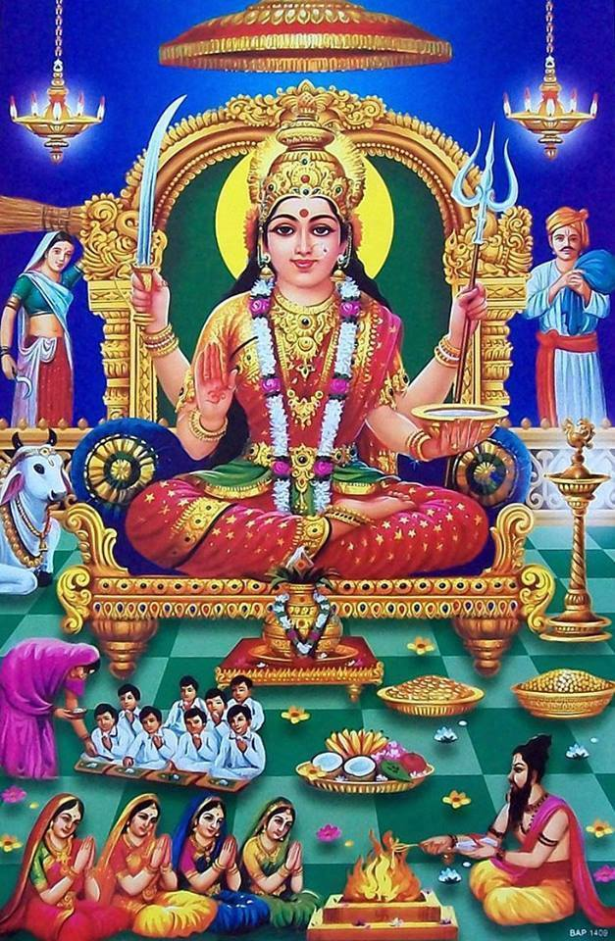
- Shailaputri
Shailaputri is an avatar of Goddess Durga, who was born to the Himalayan King Parvath Raj. The name shailaputri means, the daughter of the mountain king. She is also known by various names such as Bhavani, Parvati or Hemavati, the daughter of Himavat - the king of the Himalayas. Shailaputri is worshipped on the first day of Navrathri festival. By worshipping her on the first day of Navratri festival, we will get great goodness in our life.
- Brahmacharini
It is another name of Goddess Durga. The goddess is worshipped on the second day of Navratri. The goddess Brahmacharini wears white clothes, a japa mala and Kamandal in her hand. By worshipping her on the second day of navrathri festival, we can control our mind and senses, and we will get peace of mind, and can perform our activities much effectively and efficiently.
- Chandraghanta
Chandraghanta is the third form of Goddess Durga. Her name Chandra-Ghanta, means her face looks bright and glitters as that of moon rays. Her worship takes place on the third day of Navaratri. She is believed to give all the prospects to the people with her grace. By worshipping her on the third day of navrathri festival, all mental and physical problems will be solved, and we will become happy with sufficient wealth.
- Kushmanda
Kushmanda is a Hindu goddess, believed to have created this entire universe with her divine smile. She is the fourth form of Durga. Kushmanda is worshiped on the fourth day of the festival of Navratri, and she gives sound health and wealth and happiness in our life, if we sincerely worship her during the fourth day of Navratri.

- Skandamata
Skandamata is the fifth form of Hindu Goddess Durga. Her worship takes place on the fifth day of Navaratri.
Skandamata is four-armed and rides on a lion. Lord Skanda can be seen in her lap. She possesses four arms. She holds her son Skanda in her lap. She is white in colour, and seated on the lotus. So, she is also called Goddess with a lotus-seat. Her vehicle is the lion. If we worship on the fifth day of navrathri, we will get great blessings from her as well as from his son Skanda, and can live a happy and a stress free life.

- Katyayini
Katyayani is the sixth form amongst Navadurga worshipped during the Navratri celebrations. And she is worshipped during the sixth day of Navrathri. She is associated with goddess Bhadrakali and Chandika, and traditionally she is associated with the red colour. Skanda Purana mentions that she was created for killing the demon, Mahishasura. If we sincerely worship her on the sixth day of navrathri festival, we can win our enemies and can become more bold and brave.

- Kaalratri
Kalaratri is the seventh form of the Goddess Durga. Kalaratri include Kali, Mahakali, Bhadrakali, Bhairavi, Mrityu, Rudrani, Chamunda, Chandi and Durga.
If we worship her sincerely on the seventh day of Navrathri, we can achieve all the prosperities in our life, and can become a famous and a great person in this world.

- Mahagauri
Mahagauri is the eighth manifestation of goddess Durga. Mahagauri is worshipped on the eighth day of Navratri. Goddess Mahagauri is the giver of all necessities to her devotees. If we worship her on the eighth day of navrathri festival, we can get rid of severe mental related problems. Lack of energy in our body and general worries, problems from our enemies can be solved by her. Mahagauri has four arms.

9.Siddhidhatri
Siddhidhatri is the ninth form of the Goddess Durga. She is worshipped on the ninth day of Navaratri. If we worship her on the ninth day of navrathri festival, she will fulfil our wishes and gives various boons to us. According to Vedic scriptures, Lord Shiva has attained all the siddhis by worshiping this Goddess.
CONCLUSION
By worshipping the nine forms of Goddess parvathi during navrathri festival, we can get the divine blessings from her, and our needs will get satisfied through her. Let us chant her name and be blessed.
“OM SREE NAVADURGAIYE NAMAHA”
“OM NAMAH SHIVAYA”
“OM SREE GANESAYA NAMAHA”
“OM MURUGA”
WRITTEN BY
R.HARISHANKAR

EIGHT MAIN AVATARS OF LORD SHIVA

Introduction
Before going through the avatars of Lord Shiva, According to me, most of the people are not that much familiar about all the avatars of Lord Shiva. Hence it is important to write about the avatars of Lord Shiva. Most of them would have studied the avatars of Lord Vishnu. In many temples, several paintings are inscribed depicting the avatars of Lord Vishnu in Vishnu Temples. Similar to that, I have seen in one old and ancient temple, Arulmigu Kachaleeswarar Temple at Armenian Street, Parrys,Chennai – 600 001. Beautiful framed pictures are affixed inside the walls of the temple mentioning about the avatars of Lord Shiva in that temple. It is a must to visit that temple, so that we can get the glimpse about the avatars of Lord Shiva by seeing the pictures.

Here I have mentioned eight main avatars of Lord Shiva, which he took in various circumstances. It is a must to read the importance of these avatars, since it will purify our mind and also our health will turn good and several positive vibrations will occur by reading the avatars of Lord Shiva.
1.Krisnadarshan avatar
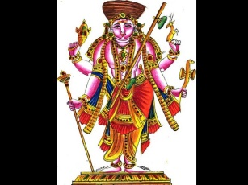

This avatar of Lord Shiva symbolizes and highlights the importance of yagna and other religious practices. This avatar of Lord Shiva told the importance of yagna and asked the people to follow it to lead a happy and healthy living. He has asked to do yagna to get rain and for the wellness of the country. He insisted that by doing yagna, crops will grow properly and will yield good results.

King Nabhag
King Nabhag was born in the nineth geneology of Shradhadeva who himself was a descendant of Ikshavaku. Nabhag was the grandfather of Ambareesh. During his childhood Nabhag left his home for 'gurukula to get education. In his absence his brothers got the wealth of the kingdom distributed among themselves.
When Nabhag returned home after the completion of his education, he demanded his share of wealth from his brothers. His brothers told him that they had forgotten to fix his share as he was absent at the time when wealth was being distributed. They advised him to go and meet their father.
Nabhag went to his father and made the same request. His father advised him to go to sage Angiras who was trying to accomplish a yagya, but was not being able to accomplish it because of his attachment.
"Go and try to eliminate his attachment by your discourses. This way sage Angiras on being pleased with you would give all the wealth which remains after the completion of the yagya." said his father.
Nabhag did the same. He went to the place where sage Angiras was performing his yagya. He preached sage Angiras on the virtues of Religiousness. As a result he became free from all sorts of attachments and the yagya was successfully accomplished.
Sage Angiras was very pleased by Nabhag's knowledge of religion. He gave all the remaining wealth of the yagya to Nabhag. Just then lord Shiva arrived there in his incarnation of Krishna darshan and tried to prevent sage Angiras from donating the wealth to Nabhag, instead he staked his own claim.
Nabhag told lord Shiva that, since the wealth was given to him by sage Angiras himself, it naturally belonged to him. Lord Shiva then sent Nabhag to his father Shradhadev to know about his opinion. Nabhag went to Shradha deva who revealed to him that the person who was staking his claims on the wealth was none other then lord Shiva. He also told him that whatever remained after the accomplishment of the yagya belongs to lord Shiva only.
Nabhag was now satisfied. He went back to lord Shiva and narrated everything what his father had said. He then eulogized and worshipped lord Shiva. Lord Shiva blessed him which helped Nabhag to attain salvation.

OM SREE KRISHNADARSHANE NAMAHA

2.Avdhooth avatar
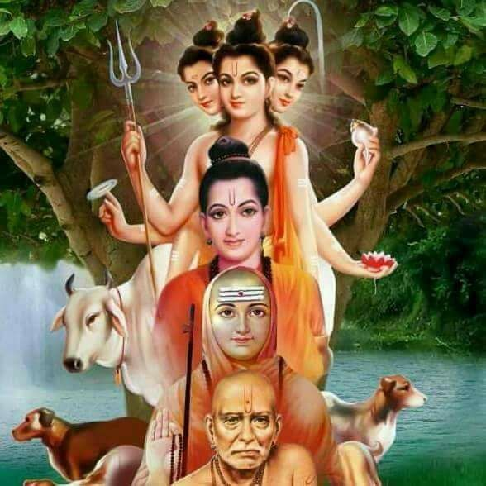

In this incarnation Lord Shiva destroyed the ego of Lord Indira and asked him to live a life without ego.
Lord Shiva took as an Avadooth only for the sake of changing the behaviour of Lord Indra into a good one.
OM SREE AVADOOTHAYE NAMAHA

3.Bhikshuwarya avatar
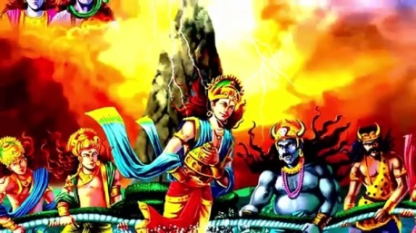

Although in the Hindu Trinity, Lord Shiva is regarded as the destroyer, but he is also said to be the protector of life. This incarnation is a depiction of Lord Shiva as the protector of the universe. Here it is said, he is the one who is protecting the humans and giving them all necessities in their life.
OM SREE BHIKSHUWARYARE NAMAHA
4.Sureshwar avatar
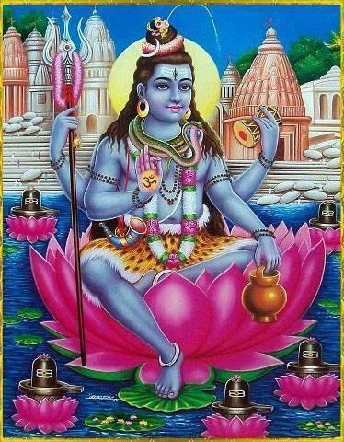

This avatar of Lord Shiva depicts love towards the devotees of Lord Indra. This form of Lord Shiva represents the love and care of him towards his devotees.
OM SREE SURESHWARARE NAMAHA

5.Keerat avatar
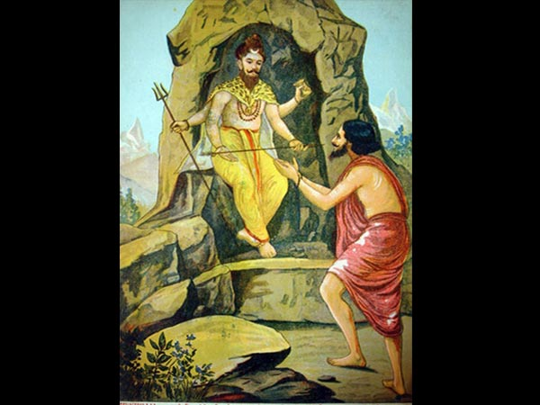

In this avatar, Lord Shiva descended in the form of a hunter or Keerat while Arjuna was meditating. Duryodhan had sent a demon named Mooka to kill Arjuna. Mooka had disguised himself as a boar. Arjuna was engrossed in his meditation, when suddenly his concentration got disturbed by a loud noise. He opened his eyes and saw Mooka He and the Keerat struck the boar at the same time with arrows. A fight broke between the Keerat and Arjuna as to who struck the boar first. Arjuna challenged Lord Shiva in the form of a hunter.
He tested his valour and removed his ego, and then he gifted pasupastra, which he used it in Gurukshetra war and won in the war.
OM SREE KEERATARE NAMAHA

6.Suntantarka avatar
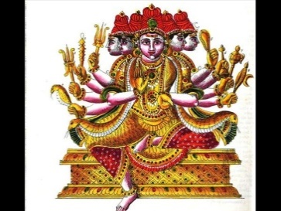

Lord Shiva appeared in this avatar to marry Goddess Parvati by seeking permission from her father Himalaya – The mountain king.
OM SREE SUNTANTARKAVE NAMAHA

7.Brahmachari avatar
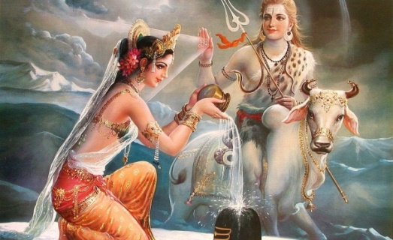

After Goddess Parvati sacrificed herself during her father’s yagna, she took rebirth in Himalayas’ house. She worshipped Lord Shiva for years so that he could be her husband again. Lord Shiva appeared in this incarnation to take Goddess test Parvati.

OM SREE BRAHMACHARYARE NAMAHA

8.Yaksha avatar
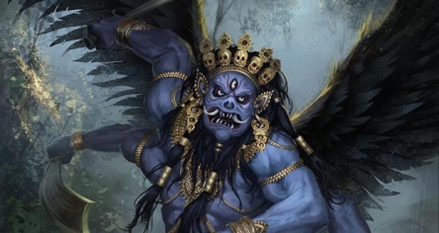

To remove ego and self-pride from the minds of many gods, Lord Shiva took this form. This avatar shows that whoever may be, they should not act in a wrongful manner and should show kindness among others.
During the time when ocean was being churned first of all poison appeared from it. The deities were very terrified to see the tremendous heat it generated. They went to lord Shiva and requested to protect them from the heat of that poison. Lord Shiva drank all the poison but did not let it pass down his throat.
After the poison, Nectar appeared from the ocean, which was drunk by the deities. The demons too wanted to drink the nectar, so a tremendous battle ensued between them and the deities. The deities became victorious in this battle because they had become immortal due to the effect of the Nectar. This victory made the deities very arrogant.
Lord Shiva was very concerned about their arrogant nature. He went to them in the guise of a Yaksha. He asked as to what was it that had made them so arrogant. The deities replied that their arrogance stemmed from victory over the demons. Lord Shiva who was disguised as Yaksha replied- "Your pride is based on false notion, because you did not achieve victory due to somebody's grace and blessing."
The deities disagreed with him. Lord Shiva then asked them to cut the grass if they considered themselves so mighty. He then kept a grass leaf in front of them. Each of the deities tried to cut that grass with their respective weapons but remained unsuccessful in their attempts. They were all amazed. Suddenly a heavenly voice was heard which said that the Yaksha was none other than Lord Shiva himself. The deities realized their mistakes. They apologized to lord Shiva. After vanquishing the false pride of the deities lord Shiva disappeared.
OM SREE YAKSHAYA NAMAHA

CONCLUSION
By reading the above avatars, we will be knowing the greatness and kindness of Lord Shiva who took these avatars for the sake of human beings. Let us pray to him and seek his blessings to lead a good life.
OM NAMASHIVAYA NAMAHA.

WRITTEN BY
R.HARISHANKAR

Three Avatars of Lord Shiva

Introduction
Before going through the avatars of Lord Shiva, According to me, most of the people are not that much familiar about all the avatars of Lord Shiva. Hence it is important to write about the avatars of Lord Shiva. Most of them would have studied the avatars of Lord Vishnu. In many temples, several paintings are inscribed depicting the avatars of Lord Vishnu in Vishnu Temples. Similar to that, I have seen in one old and ancient temple, Arulmigu Kachaleeswarar Temple at Armenian Street, Parrys,Chennai – 600 001. Beautiful framed pictures are affixed inside the walls of the temple mentioning about the avatars of Lord Shiva in that temple. It is a must to visit that temple, so that we can get the glimpse about the avatars of Lord Shiva by seeing the pictures.

Here I have mentioned three avatars of Lord Shiva, which he took in various circumstances. It is a must to read the importance of these avatars, since it will purify our mind and also our health will turn good and several positive vibrations will occur by reading the avatars of Lord Shiva.
THREE AVATARS OF LORD SHIVA

1.Rishi Durvasa
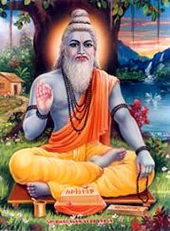
This form of Lord Shiva is famous for its short temper and anger. One such Maharishi was the Durvasa Rishi, who was known for his anger. The incarnation came into existence to maintain peace and harmony on earth. Rishi Durvasa was said to be the incarnation of Shiva, but where Bhole Shankar is considered to be very easy to please, it was probably the most difficult task to please Rishi Durvas. There was one thing in Shiva and Durvas that it was almost impossible for both of them to escape from the flames of anger.Many stories related to the anger of Rishi Durvas are present in our mythological history, when one's acts or misadventures made him angry so much that he had to lose his temper.
KING AMBREESH AND SUDARSHANA CHAKRA

Once, King Ambreesh decided to keep Ekadashi fast. This fast is so powerful that Devendra is shaken by its power. For not being able to finish his fast, Ambareesh asked Durvasa Rishi to go to him. As soon as the time of fast opening came closer, Durvasa Rishi also reached the palace of Ambareesh. He told Ambareesh that he would come back soon after bathing. Ambarish waited too long for Rishi Durvas, but after a long period, when Durvasa Rishi did not come back from the bath, then Ambarish took care of the gods and offered them a sacrifice and took away some of them for Durvas.. After the time of opening the fast, Durvas returned He became very angry to see that in his absence, the king opened his fast.Having come in the passion of anger, he composed a demonstration of the demon, and directed him to attack Ambrish. To save his life, Ambareesh ordered the striking Sudarshan Chakra. Due to Sudarshan Chakra, the action demonstration was killed at the same time. After the execution of the act, Sudarshan Chakra began pursuing the goddess Rishi. To save his life, Rishi Durvas started running around, but wherever he went Sudarshan Chakra came behind him. He came to Indra to save his life. Indra, showing his inability, sent him to Brahma. Brahma asked him Shiva and Shiva to go to Vishnu. Eventually, he reached Vishnu. Vishnu told him that the control of Sudarshan Chakra is near Ambareesh, so he must go to Ambrish. After defeating, Durvas approached Ambrish and asked to stop Sudarshan Chakra. The king accepted the prayer of the sage and finally saved the life of the king of Durvas by stopping the Sudarshan Chakra. It is as easy as annoying Rishi Durvas to make them happy or maybe even more difficult.
KUNTI DEVI’S SERVICE TO DURVAS
The mother of Pandavas, Kunti, had succeeded in pleasing Rishi Durvas with his service.. Pleased with the service of Kunti, Rishi Durvas told him such a mantra with the help of which he could get the son Ratna by meditating on the Gods. Pandavas were born with the help of this mantra.
ATRI MAHARISHI
Once Atri, the manasputra of Lord Brahma went for penance to the banks of river Nivindhya. He commenced his penance and it resulted into a massive fire that spread to all the three worlds. Seeing this devastation, Lord Brahma, Vishnu and Shiva blessed Atri. Later Lord Brahma, Vishnu and Shiva were reincarnated as the moon, Dutt and Durvasa. Apart from his anger, he is a very gentle and noble soul who bless his devotees and satisfy all the desires of his devotees. He will follow his rituals in a proper manner and will do constant meditation.
OM RISHI DURVASAYA NAMAHA

2.Rishabh avatar
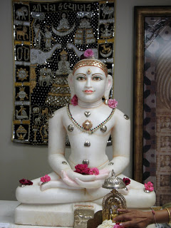

Rishabh is a naked ascetic. This fact is conformed by all Jain literature and Hindu Puranas. This naked tradition of ascetics in Jainism is known as Digambar Tradition. On the other hand Lord Shiva is also Digambar. Digambar is not only one of his designation names, but he was actually a naked God. That is why the seals of naked yogis found in excavation of Indus valley civilization are claimed by Shaivites and Jains, being of Shiv or Rishabh.

Once the ocean was churned and a large vessel containing nectar was emerged out of the ocean. A huge battle was fought between the demons and the divine deities over this vessel of nectar. To distract the attention of demons, Lord Vishnu created numerous beauties. While the demons took these beauties to the ‘Patal Lok’ with them, the deities drank all the nectar. This angered the demons and they tried to kill the divine deities. To save their lives, Lord Vishnu went to Patal Lok and killed them all. Although he killed the demons but he was left mesmerized by the beauties there. The union of Lord Vishnu with the beauties resulted in many children. To save these children, Lord Shiva went to Patal Lok in the form of an Ox – Rishabh.
OM SREE RISHAB DEVAYA NAMAHA

3.Yathinaath Avatar
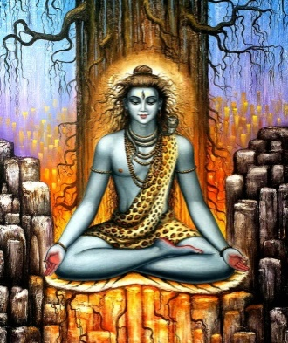

This form of Lord Shiva is a personification of pleasant behaviour towards guests.

Yati’ means a sannyasi (ascetic) and ‘Nath’ means master. So this form of Shiva could largely relate to the master of ascetics.
Also the use of word ‘Nath’ is made in the context of ascetics of the ‘Nath’ sect historically popular for hatha yoga and miracles. Among these the Shiva is considered as Adinath or the initiator of the tradition. Thereafter Gorakshnath, who is also called as ‘Yati’ is also considered to be an incarnation of Shiva himself. So perhaps ‘Yatinath’ refers to him.
Gorakshnath has been mentioned in various traditional stories as an ascetic who could see the past, present and future and travel anywhere in no time.
So in short Yatinath might refer to a Nath sect ascetic Gorakshnath.

There is a story about Yatinaath which goes like this:
“There was once a tribal named Aahuk. He and his wife were ardent devotees of Lord Shiva. One day Lord Shiva visited them in the form of Yatinath. Since they had a very small hut which could accommodate only two people, Aahuk decided to sleep outside and let the guest sleep in. Unfortunately Aahuk was killed by a wild animal at night. In the morning, finding Aahuk dead, his wife decided to kill herself. Then Lord Shiva appeared in His real form and blessed her with a boon that she and her husband will be reborn as Nala and Damayanti and Lord Shiva will unite them.”
OM SREE YATHINATHAVE NAMAHA

CONCLUSION
By reading the above avatars, we will be knowing the greatness and kindness of Lord Shiva who took these avatars for the sake of human beings. Let us pray to him and seek his blessings to lead a good life.
OM NAMASHIVAYA NAMAHA.

WRITTEN BY
R.HARISHANKAR

EIGHT AVATARS OF LORD VINAYAKA
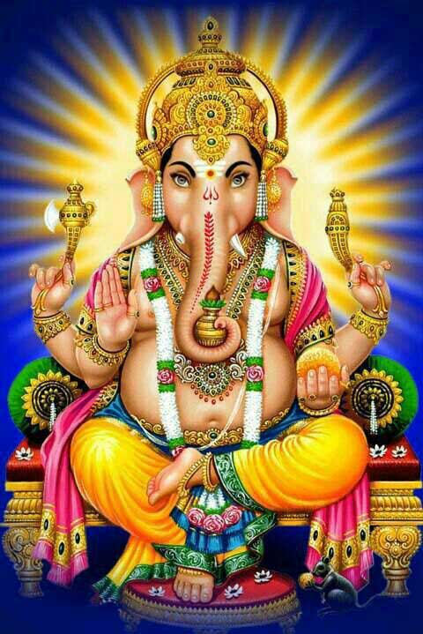

Lord Vinayaka also called as Ganapathi and Ganesa, as we know, is the first god in Hinduism. Due to destroy the evil forces, he took several avatars. All these avatars were taken to destroy the demons and to safeguard the divine devas.The details of his various avatars are explained as below:-

1.Ekdant Avatar
Lord Ganapathy took this avatar in order to destroy the Demon Madasura in order to safeguard the divine devas from the clutches of Madasura.

2.Vakratunda
Lord Ganesa took this avatar to destroy the Demon Matsrasur. He got a boon from Siva, that he will not be destroyed by any living creatures in this world and after then started harassing the devas. Hence he was destroyed by Lord Vinayaka.

3. Gajanana
This avatar was taken in order to defeat Demon Lobhasur. Knowing about Lord Ganesa’s power, the demon surrendered to lord Ganesa without commencing a war.

4. Lambodar
When Lord Vishnu took the form of Mohini during the churning of ocean, Lord Shiva got attracted and followed her, due to the result Krodashur was born. With the blessings of Sun God, he got enough powers, and then he started attacking the devas. And as per the request of the devas, Lord Ganapathy took the avatar of Lambodar and attacked him and pacified the devas.

5. Mahodar
When Lord Muruga killed Tarakasur, Sage Sukracharya has created a demon ‘ Mohasur’. He attacked devas and tried to kill the devas. Lord Ganapathy took the avatar of Mahodar and eliminated Mohasur.

6. Vikat
This avatar for taken for destroying the demon Kamasur.

7.Vighnaraj
In this Avatar, Lord Vinayaka defeated the asura mam who was born from mountains.

8.Dhumravarna
This avatar was taken to defeat the demon ahamkarasur.

CONCLUSION
Those who read the above eight avatars of Lord Vinayaka mainly during Sankatahara Chathurthi and Vinayaka Chathurthi, will definitely be blessed by Lord Vinayaka, and will attain all the prospects and peacefulness in their life.
Let us chant ‘OM SREE VINAYAKA NAMAHA’, ‘OM SREE GANESAYA NAMAHA’, ‘OM SREE GANAPATHIYE NAMAHA’.
WRITTEN BY
R.HARISHANKAR

BHARATA
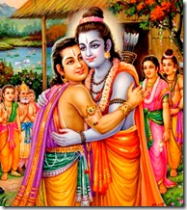
INTRODUCTION
Bharata is the brother of Lord Rama as per the great epic Ramayana. Bharata was a great person who followed the path of dharma throughout in his life.
According to the epics, Bharata is considered to be the incarnation of Shanka, a divine emblem of Lord Vishnu.
LIFE
Bharata was born to the king of Ayodhya, Dasharatha and his second wife, Queen Kaikeyi. He was married to Mandavi, and had two sons - Taksha and Pushkala.
During the period of Rama’s exile, he served as the king of Ayodhya. After knowing the reason, that through the act of his mother Kaikeyi, his brother Lord Ram was exiled, he was very sad and got angry with his mother. He also tried to bring Rama back to Ayodhya. Instead of sitting on the throne, he brought the holy foot wear of Lord Ram and placed them on the throne, and then ruled the kingdom of Ayodhya for the period of 14 years, through the blessings of rama. And after rama’s return to ayodhya, and Rama becoming the king of ayodhya, he was given the offer of crown prince. He served Lord Rama throughout his 11,000 years of GOLDEN rule of Ayodhya. After the completion of Rama's rule, he merged with Lord Vishnu along with his brothers.
IMPORTANCE
He was a kind and an affectionate brother to Lord Rama, and always wants to do favours to him. He also served as an affectionate servant to Lord Rama. During the period of exile, he always worried about him, and properly ruled the kingdom of ayodhya by keeping rama in his mind. His entire body and soul was attached to the service of Lord Rama, and he completely surrendered at his feet, as an affectionate brother.
During his rule, everybody was happy and he provided all the facilities to the people of ayodhya and took care of them properly. Nobody was suffered from any health related or mental related problems, and everyone lived a long life. He has not received any complaints from his people. People were treated his rule as a “GOLDEN RULE”, and admired him with much happiness.
Let us worship this great avatar and be blessed.
“JAI SREE RAM”
“JAI SREE BHARATH”
WRITTEN BY
R.HARISHANKAR

BHEEMA
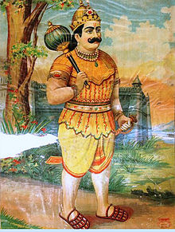
INTRODUCTION
Bheema was an important character in Mahabharatha. He played a major role in the Kurukshetra battle field, and helped his brothers, the pandavas towards winning in the battle. He was the son of Kunti devi and the wind god, Vayu Bhagavan.
IMPORTANCE
He has got great powers when he went to naga lok. He drank the divine drink in nagalok, and got the power of thousands of elephants. He was also married to Draupathi, and again married Idumbi, a demoness and through her, “GHATOTKACHA” was born. Similar to his father, ghatotkacha was a powerful person and possessed magic powers. He helped the pandavas in the Kurukshetra battle and was killed by Karna through his powerful weapon.
He has given respect to all his brothers, as well as to his mother, Kunti devi. He was a master in all arts, and an expert in weight lifting and boxing.
He took the advice of Lord Krishna, and acted accordingly. Similar to his father, vayu bhagavan, he has got great powers. He concentrated his entire attention in the battle field, and showed his efficiency and destroyed many kauravas in the gurukshetra battle field.
CONCLUSION
Bheema was a great person, who cannot be defeated by anyone. He was a great friend to Lord Krishna, and he served him in an affectionate manner. He was also present at the time of Lord Krishna’s Viswaroopa Darshan. He is regarded as an AMSA (features) of Lord Vayu, and contains the power similar to that of Lord Hanuman, who was also the son of Lord Vayu Bhagavan. Let us worship him with sincere bhakti and be blessed. Let us chant his holy name and live peacefully with good health, wealth and all the prosperities in our life.
“OM SREE BHEEMASENARE NAMAHA”
“OM SREE KRISHNAYA NAMAHA”
“OM SREE VAYU BHAGAVANE NAMAHA”
WRITTEN BY
R.HARISHANKAR

BHISHMA
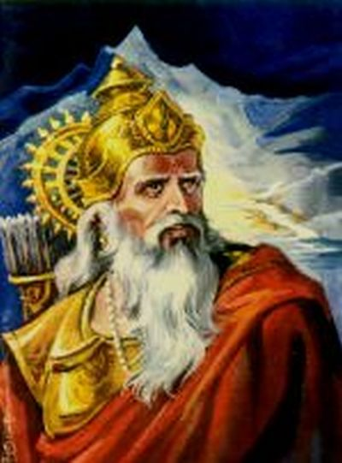
INTRODUCTION
Bhishma was the main character in Mahabharatha, and he was well known for observing celibacy throughout his life. He was the son of Shantanu and goddess Ganga. His birth name was Devavratha, and he lived in the dwapara yuga.
His other names are as follows:-
- Devavrata
- Gangaputra
- Shantanava
- Pitamaha
- Mahamahima
Once King Shantanu saw Ganga Devi (River Ganges) and wanted her to marry him. They married, and she later gave birth to seven sons. But she drowned all the seven childs. When Ganga was about to drown the eighth son, Shantanu, stopped Ganga devi from doing it. Finally, Ganga explained to King Shantanu about the curse given to the eight vasus by the sage vashishta, when they tried to steal his cow. Since the seven other vasus did not commit big mistakes, they were released from the curse by Ganga by drowning them in the river. However the eighth child Bhishma, was cursed to live a long life.
After Devavrata was born, his mother Ganga took him to different places, where he was trained by many great sages such as Brihaspati,Shukracharya and Markandeya.
Devavratha, became known as Bhishma, after he took the oath of observing celibacy till the end of his life, due to his father’s marriage with the fisherwoman Satyavathi, and the promise made by him to Satyavathi’s father, that he would never marry and occupy the kingdom’s throne.
In the great battle at Kurukshetra, Bhishma was on the side of the Kauravas. Finally he was laid down by Arjuna’s arrows. After a few days, he was died.

IMPORTANCE
Bhishma was a great valour and a strong personality, who was very generous to both the kauravas and the pandavas. Though he was at the side of kauravas, he respected pandavas, and worshipped Lord Krishna. He was a great scholar, a good archer, and a master in all forms of art.
CONCLUSION
Bhishma who was the one among the eight vasus (Divine Deva), in his previous birth, was a great man, who maintained his promise in observing celibacy till his death, for the sake of his father. He was a clever and a good person, who was always interested in doing good things to the people, and was the son of “GANGA DEVI”. Let him bless us and give all the prosperities in our life.
“OM SREE BHISHMAYA NAMAHA”
“OM NAMO BHAGAVATHE VASUDEVAYA NAMAHA”
“OM SREE GANGA DEVIYE NAMAHA”
WRITTEN BY
R.HARISHANKAR

BODHIDHARMA
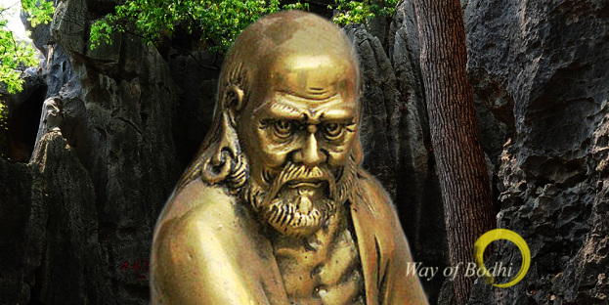
INTRODUCTION
Bodhidharma was a Buddhist monk who lived during the 5th century. He is considered to be the main person who had spread the principles of buddhism to China. He well trained the buddhist monks of Shaolin Monastery in the art of kungfu.
He was an expert in all kinds of martial arts.
In Japan, he was called as Daruma.
LIFE
According to Chinese sources, Bodhidharma came from india to china. He was the third son of a popular Indian king.
Bodhidharma's teachings are mainly based on the teachings of Lord Buddha. He also contains the features of Lord Buddha, and mainly focussed his attention on doing meditation and teaching martial arts to his chinese disciples.
Bodhidharma, died at the banks of the Luo River,China, where he was buried by his disciple in a cave.
FAMOUS QUOTES
- No one can reach the top without the help of the guru.
- Pacify your mind by doing meditation.
- Follow the principles of Buddhism, and act accordingly.
- Apply your mind, before starting any new task, and think several times, before doing the work.
- Learning martial arts will give confidence in your life and can be protected from your enemies.
- Don’t cause any harm to others, always keep your mind pure and calm.
- Always go through the path of righteousness.
- Do good things to others, since it will bring happiness to us.
- Try to avoid too much of worldly pleasures in the life, since it will not last long in your life.
IMPORTANCE
He was a great spiritual master, who was expert in all kinds of art, and also a great yogi, contains spiritual powers. He is still remembered for his good teachings and for living a noble life in this world. He was a pious and a humble scholar who treated everyone with great respect and does not differentiated anyone with regard to caste, gender and religion. He shared his great knowledge to others without any pride in his mind. He is also regarded as a divine incarnation of Lord Buddha, through his great spiritual knowledge, super natural power, wisdom, courage and boldness.
Let us worship this great man and be blessed.
“OM SREE BODHIDHARMARE NAMAHA”
“BUDDHAM SHARANAM GACCHAMI”
WRITTEN BY
R.HARISHANKAR

GAUTAMA BUDDHA
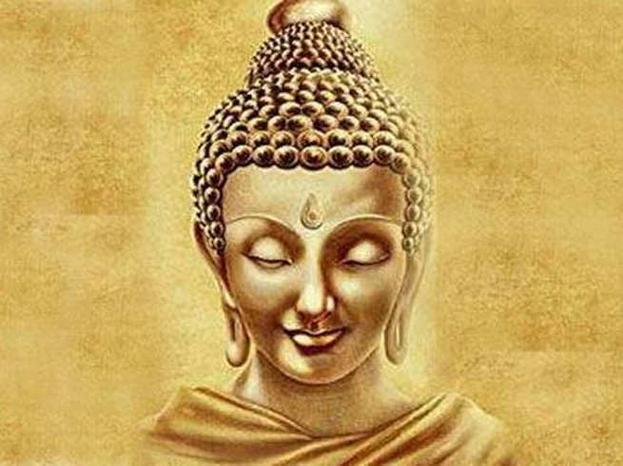
INTRODUCTION
Siddhartha (480-563BC) also called as Gautama Buddha, was a monk, teacher and religious leader and he was the founder of Buddhism. He is believed to have lived in India.
Gautama is the main person in Buddhism. Gautama was born into the Shakya clan. It is believed that, Gautama was born in Nepal, and lived in Kapilavastu.
According to Buddhist tradition, he obtained his enlightenment in Bodh Gaya, gave his first lecture in Sarnath, and died in Kushinagar,Uttar Pradesh.
LIFE
Gautama was born to a Hindu family, the son of Suddhodana and Mayadevi. Suddhodana was the ruler of Kapilavastu.
Buddha's Birthday is called Buddha Purnima and it is celebrated widely in Nepal and India, as he is believed to have been born on a full moon day.
At the time of his birth, several scholars have declared that he will become a great saint.
Since his mother has died a few days after delivering him,siddhartha was brought up by his mother's younger sister, Maha Pajapati.
When he reached the age of 16, he was married to Yasodhara. And they had a son named Rahula.
At the age of 29, Siddhartha left his palace for seeking enlightenment and to become a monk.
Gautama initially went to the present day Bihar and began his saintly life by begging for food in the street.
After some time Buddha is said to have travelled in Uttar Pradesh, and taught the philosophies of Buddhism to all kinds of people like rich and poor, good and bad.
IMPORTANCE
He was a very kind and a noble saint, who never find fault with others. He treated all the persons as alike and never differentiated them with respect to their caste,creed or religion. He lived a simple life, and had his food by begging. He never thought about his physical body, and thought only about the spiritual enlightenment. Through his teachings, many people have adopted Buddhism, and the religion has been spread all over the world, due to its significance. He is worshipped widely in some parts of India, Nepal and in some Asian countries. He also gives his teachings in a simplified manner, which has attracted his followers. He is also considered to be an Avatar of Lord Vishnu.
His main ten disciples are:-
1. Sariputta
2. Maudgalyayana
3. Mahakasyapa
4. Ananda
5. Anuruddha
6. Upali
7. Subhoti
8. Rahula
9. Mahakaccana
10. Punna
CONCLUSION
Lord Gautama Buddha was a very great saint and he has left all his comforts at a younger age and went in search for spirituality. He has founded a very good and great religion, which teaches the ahimsa, that is not giving harm to other living creatures. He also tells stories to the people during his religious meetings with the people, and also told the ways to eliminate our karma by reducing the worldly pleasures in our life. According to his famous saying, “Even when our body cannot be healed, but our soul can be healed”. This can be obtained by doing good things to others, meditating for getting calmness in our mind, and not doing any harm to others, and to follow the principles of Buddhism.
Let us live our life happily and peacefully, based on the teachings of Lord Buddha. Let us chant his name and be blessed.
“OM SREE GAUTHAMA BUDDHARE NAMAHA”
“OM NAMO NARAYANA”
WRITTEN BY
R.HARISHANKAR
GHATOTKACHA
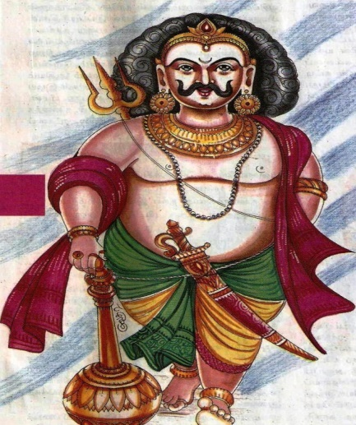
INTRODUCTION
Ghatotkacha is an important character in the Mahabharata. Ghatotkacha was the son of Bhima and Hidimbi.
IMPORTANCE
Ghatotkacha was a gigantic and powerful person with great strength, and he possessed a good knowledge in magic. Ghatotkacha fought and killed many demons. He has got the capacity to win any one, and contains the strength equivalent to that of several thousands of elephants and lions.
Kurukshetra
During the Kurukshetra war, Ghatotkacha fought in favour of pandavas. He used his magical powers, and created a great damage to the Kaurava’s army.
A great fight took place between Karna and Ghatotkacha. Karna invoked the celestial weapon given by Lord Indra towards Ghatotkacha and killed him.
Temples
1.Ghatotkacha Temple in Champawat, Uttrakhand
2.Ghatotkacha Temple in Manali, Himachal Pradesh.
CONCLUSION
A great son of Bhima, and also a great warrior who fought in favour of pandavas, and left his life for them, and also a fearless person. Though he possessed all the abilities, he was killed by karna using a power weapon. After his death, he went to heaven. Let us pray to the great Ghatotkacha and get the blessings from him.
“OM SREE GHATOTKACHAYA NAMAHA”
WRITTEN BY
R.HARISHANKAR

JAMBAVAN
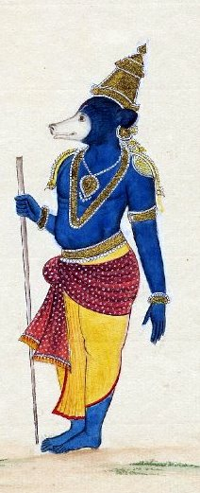
INTRODUCTION
Jambavan is a character popularly found in Ramyana. He is regarded as the King of Bears, and is having the power equivalent to that of lakhs of elephants and lions, and the capacity to win anyone. He is created specially by Lord Brahma for serving Sri Rama. He is known as Riksharaj(King of Bears).
IMPORTANCE
Jambavan was present in various yugas and was present at the time of churning of the ocean, and was present when Vamana has acquired the three worlds from Mahabali.
Jambavan in his previous life was the King of the Himalayas, who had incarnated as a bear in order to serve Lord Rama. He received a boon from Lord Rama that he would have a long life, and have the strength of ten million lions and elephants. According to Ramayana, Jambavan helped Rama during his fight with Ravana. He made Hanuman to realize his efficiency and capabilities, and asked him to fly across the ocean to search in Lanka for Sita Mata. According to Mahabharata, Krishna came to Jambavan’s cave in search of a gem, and they both of them fought with each other, and finally Jambavan realized that Lord Krishna was none other than his almighty Sri Rama. He then felt very sorry for fighting with Krishna, and apologized to him, and handed over him the gem, and also married his daughter Jambavathi to Lord Krishna.
Jambavan, is considered to be the one who has been present in both Ram and Krishna avatars. After the end of dwapara yuga, he left from earth and went to Satyalok(Lord Brahma’s abode).

CONCLUSION
Jambavan who was the mighty bear king, was very great, handsome and contains good qualities. He never disturbed any one unnecessarily. Only when a person comes to fight with him, he will fight with him. He was a gentle, noble and affectionate bear, who respects elders and obey their commands. He was a great warrior and will defeat any one. He was the son of Lord Brahma, and contains the powers equivalent to that of Lord Brahma. Let us pray to this great divine bear, and let him fulfil our needs and wishes. He is still hearing our prayers from Satyalok. He is carefully analysing our day to day problems and is solving them meticulously. But we should have pure bhakti with him.He is the saviour for us in this Kali yuga. Let us chant his mantra and be blessed.
“OM SREE JAMBAVANE NAMAHA”
“JAI SREE RAM”
WRITTEN BY
R.HARISHANKAR

JANAKA
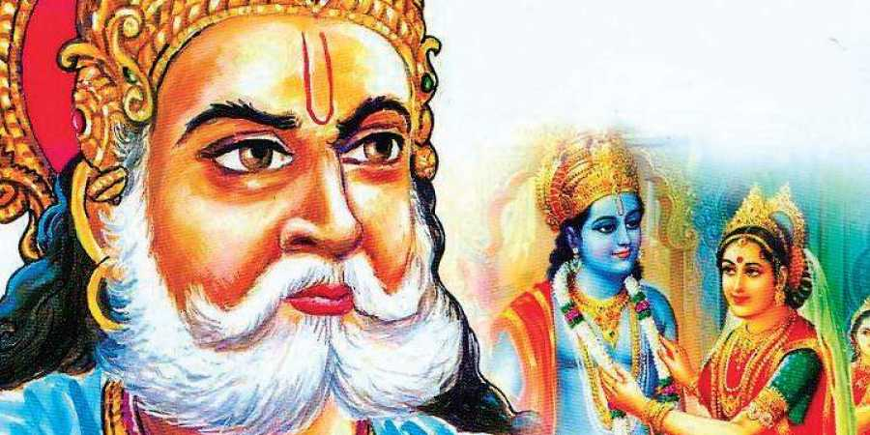
INTRODUCTION
Janaka was an ancient king of Videha. His father name was Hroshhoroma and his brother name was Kushadhwaja. King Nimi was the first ruler of the Videha kingdom. Janaka’s daughters are Sita and Urmila.
Janaka was a non-attachment person towards material objects. He was interested in listening spiritual discourses and considered that showing bhakti to the god is the main thing. He interacted with many holy sages and it can be found in ancient texts. His kingdom was located near Himalayas.
He married his daughter sita to Lord Rama, and another daughter urmila to Lord Lakshmana, belonged to Ayodhya.

IMPORTANCE
His importance was mentioned in ancient hindu scriptures, and about his kindness shown to his people was also mentioned. He treated all the people as equal and given all the riches in their life. During his period, no one was starved from hunger due to lack of food, everyone had lived a disease free and a sin free life. No one had given any complaints about their king’s rule.
Everyone was occupied with some kind of work, and fully concentrated their attention on that work, and done it properly. No thefts were there. No one was worried about thieves, since everyone has got enough money and food, in order to run their life properly. Everyone has acted honestly, and doesn’t find any fault with others.
Though he was the ruler of the kingdom, he took only simple food, and doesn’t enjoyed any comforts and luxuries in his life. He lived a saintly life, and dedicated his entire attention towards worshipping the god, and taking care of his people properly.
During his period, no enemy invasion was there. He treated with kindness and moved with all other kings in a proper manner. He was well respected by his people, and by all other kings, and by the entire world.
He was also a learned man and got thorough knowledge in vedas and other devotional texts, and also a master in all kinds of art.
He was a pious man, who also contains wisdom, knowledge, courage and boldness.
Let us worship this great king and noble sage “JANAKA”, and be blessed.
“OM SREE JANAKA MAHARAJARE NAMAHA”
“JAI SREE RAM”
“OM SREE SITA DEVIYE NAMAHA”
WRITTEN BY
R.HARISHANKAR

JATAYU
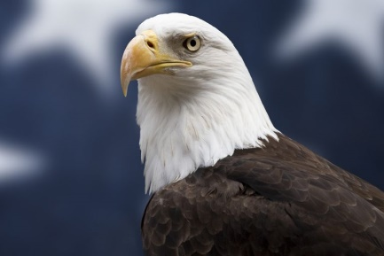
INTRODUCTION
In Ramayana, Jatayu is mentioned as a divine bird, and he was the old friend of King Dasharatha.
IMPORTANCE
According to Ramayana, when Jatayu fought with Ravana to safeguard Sita mata from Ravana, he was killed by Ravana.
When Rama and Lakshmana met the dying Jatayu during their search for Sita, he informs Rama and Lakshmana about the fight between him and Ravana and tells them that he had gone to south. Lord Rama blessed Jatayu and he has done the final rites for him and also he has given SALVATION (MOKSHA) to him.
Once Jatayu and his brother Sampati, tried to fly higher. Sampati saved his brother Jatayu from the hot flames. Due to that, Sampati got injured and lost his wings. Once while meeting Lord Rama and knowing about him, he chanted Rama’s name for three times, and immediately he regained his feathers again and was able to fly.
According to ancient legend, it is believed that Jatayu fell on the rocks in Chadayamngalam, Kerala and also Lepakshi in Andhra Pradesh is also attributed to the place where Jatayu fell after being wounded by Ravana, and Ramarkal Mettu is the place where the last rites of Jatayu was performed by Lord Rama.
CONCLUSION
A divine bird and also a great warrior, who has helped Rama to locate the place of sita. He was a very good bird, and also spent his entire life in doing good things only. Let us pray to “SREE JADAYU” and chant ram mantra and be blessed.
“OM SREE PAKSHIRAJA JADAYUVE NAMAHA”
“JAI SREE RAM”
WRITTEN BY
R.HARISHANKAR

KABIR DAS
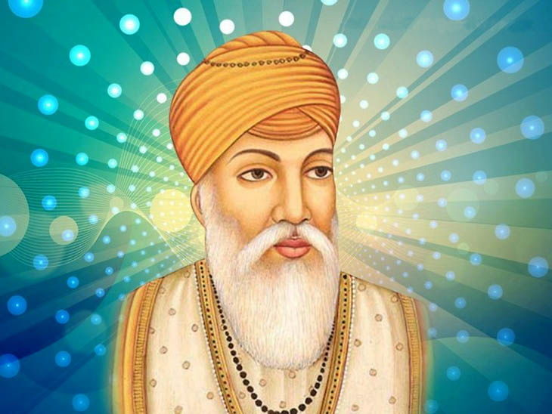
INTRODUCTION
Kabir Das (1440–1518) was a poet and saint, whose writings, influenced Hinduism's Bhakti movement. His writings were found in Guru Granth Sahib. He was born on Varanasi.
Kabir was raised by a Muslim family.
Kabir was the disciple of the Saint Swami Ramananda in Varanasi.
Kabir never married and led a bachelor’s life.
Kabir's family is believed to have lived in Varanasi.
Famous works
- Kabir Bijak
- Kabir Parachai
- Sakhi Granth
- Adi Granth
- Kabir Granthawali
He has written lot of poems which are still famous.
According to Saint Kabir, Ram and Rahim are one and the same, and there is no difference between them. According to his saying:
- Don’t differentiate gods, for they are living in the hearts of all the living creatures in the world.
- Have peace in the mind by showing mercy on everyone.
- All the religions preach only to do good things in the life. They all teach the correct principles to be followed in our life.
- Apply your mind on god, so that you can be happy, and don’t pay more attention on worldly comforts.
- Always do charity to the poor and needy, so that god will get satisfied.
IMPORTANCE
Saint Kabir Das has lived a noble life and his teachings were widely accepted by the hindus and muslims. He was well appreciated for his great poems by the great kings and the common people. He was declared as a universal guru among his followers. He is well known for his Ram Bhakti, and he considers himself as his great devotee, and sung in praise of Lord Sriram.
DEATH
He died at the age of 78 in Maghar, Uttar Pradesh.
CONCLUSION
The great saint who has won thousands of hearts through his great compositions is still living with us through his poems. Let us worship him and be blessed.
“JAI KABIRDAS”
WRITTEN BY
R.HARISHANKAR

KARNA
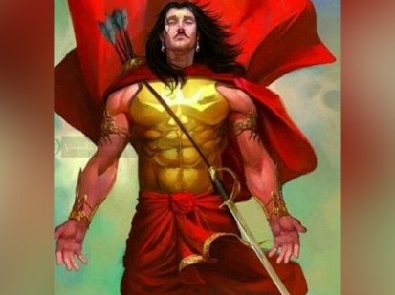
INTRODUCTION
Karna , is one of the major characters in the Hindu epic Mahabharata. He is the son of Surya and princess Kunti devi. Kunti devi who delivered karna at an younger age and in an unmarried state, leaves him in ganges river by putting him in a basket.Then he was adopted and raised by his foster parents named Radha and Adhiratha Nandana, who was the charioteer of the king Dhritarashtra. Karna then becomes a loyal friend of Duryodhana. He is appointed as the king of Anga (Bengal) by Duryodhana. Karna joins the Duryodhana side of the Mahabharata war. He aim was to kill Arjuna, but he dies in the battle field while fighting with Arjuna during the Kurushetra war. After his death, his soul reached the heavenly abode of surya loka, and he permanently stayed there with his father,Lord Surya Bhagavan.

IMPORTANCE
Karna was known for his charity. He is the one, who never rejects any one who come to him for alms. He was well versed in marital arts, and a reputed soldier in the battle field. With the grace of his father surya, he gained an healthy life. He never suffered from diseases and poverty. He lead a happy life through the blessings of the sun god. He was an able scholar, and an expert in several kinds of arts. Even after knowing that death will occur to him when he gifts his earrings, he gifted his earrings to Lord Indra. He was such a noble soul ,a generous and a kind hearted man who lived by doing charity throughout in his life. Generally, whenever a person gifts money to another, the receiver of the money will praise him as “KARNA MAHARAJA” and “KARNA VALLAL”. He has earned such a name and fame even after several thousands of years.
CONCLUSION
Karna who was a great
Philanthropist and a noble man, is in surya loka. He possess great good qualities and he is having the power equivalent to that of his father, Lord Surya. Through his good karmas, he is living in the divine abode of surya loka. Even now, he is having the power to fulfil our needs and wishes, and to give a blessed life. If we worship him sincerely with pure bhakti, he will give us the necessities in our life with good health, wealth and happiness. Let us pray to him and chant his holy name.
“OM SREE KARNA MAHARAJAVE NAMAHA”
“OM SREE SURYA BHAGAVANE NAMAHA”
WRITTEN BY
R.HARISHANKAR

KING PARIKSHIT
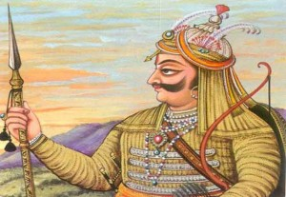
INTRODUCTION
Pariksit was a Kuru king who was supposed to have ruled his kingdom during 9th century BC. He played a major role in the development of the Kuru dynasty. He was the son of the great warrior Abhimanyu.
He was the successor of his greatuncle Yudhishthira to the throne of Hastinapur.
HISTORY
Parikshit mentioned in the Atharvaveda as a great Kuru king, who ruled his kingdom in a proper manner, and all the people lived happily in his kingdom. He is mentioned as a universal king.His son was Janamejayan.
He was cursed by a Brahmana, and due to that he was killed by the Naga king, Takshaka, the then ruler of Taxila.
According to the Bhagavata Purana , Ashwatthama planned to kill King Parikshit through the powerful Brahmastra,while he was in his mother's (Uttara) womb, as a revenge against the Pandavas for killing his father in the Kurukshetra war. Lord Krishna calmed her, and protected the child in the womb from the deadly weapon and thus saved his life.
On hearing about this incident, Parikshit's son Janamejaya planned to kill Takshaka, and he starts the Sarpamedha Yajna, through which he wants to end the life of all the snakes in the world. But Takshaka was saved by Astika Muni, and as a result he was not killed in the yajna.
IMPORTANCE
Parikshit ruled his kingdom in a very good manner. His son “SRI JANAMEJAYA” also took part in the affairs of the kingdom along with him. During his period, no people in his kingdom has suffered from poverty,illness and mental problems. His period was a “GOLDEN RULE” for his people.
CONCLUSION
Parikshit, who was a great king and also a warrior, was a gem among the kings during his period. He provided all the basic amenities to his people. No one has complained about their problems. They lived in a peaceful manner. Let us pray to this great king and worship him and be blessed.
“OM SREE PARIKSHIT MAHARAJAVE NAMAHA”
“OM SREE JANAMEJAYA MAHARAJAVE NAMAHA”
“OM NAMO BHAGAVATHE VASUDEVAYA NAMAHA”
WRITTEN BY
R.HARISHANKAR

LORD BALARAMA
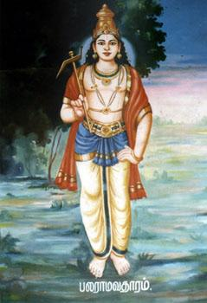
INTRODUCTION
Balarama is a Hindu god and the elder brother of Krishna. He is also known as Baladeva, Balabhadra, Haladhara and Halayudha. Lord Balarama is considered to be an avatar of Lord Vishnu. He is also regarded as an incarnation of Adisesha.
Importance
Balarama was the son of Vasudeva. He was born on Raksha Bandhan. His weapon is the plough.
As per the Hindu traditions, Balarama has been a farmer's deity. He is always described with Lord Krishna. Balarama supports Krishna in form and spirit. Balarama's association with Krishna makes him the protector and supporter of dharma.

Life
Balarama spent his childhood as a cow herder with his brother Krishna. Both of them killed several asuras who tried to kill them. Balarama and Krishna studied under sage Sandipani at Ujjain. He married Revati, the daughter of King Kakudmi.
Balarama is the celebrated plougher.
Death
In the Bhagavata Purana, it is described that after the destruction of the Yadu dynasty and witnessing the disappearance of Lord Krishna, he sat down in a meditative state and departed from this world.
Temples
1.Nenmini Balarama Temple, Kerala.
2.Aluva Srikrishna Balarama Temple, Kerala.
3.Mazhoor Balarama Temple, Kannur district, Kerala.
4. Puri Jegannath Temple, Odisha.
5. Baladevji Temple, Kendrapara.
6.Ananta Vasudeva Temple,Odisha
7.RevtiBaladevji Mandir, Jetalpur, Gujarat
8.Shri Daau Ji Mandir, Vill- Banchari, Haryana
9.Kathmandu temples, Nepal
10.Shri Dauji Mandir, Mainpuri, (U.P.)
CONCLUSION
Lord Balarama, whose name itself indicates his strength, will save us from this kali yuga, by diverting our attention on god. And let him make us to do good karma and to think positively. Let him clear all our karmas, free us from our sins and diseases and give SALVATION to us. Being the brother of the great Krishna, he will definitely protect us from all sorts of problems, which we are facing in our day to day life, and lead us to a good path. Let us chant the holy names of Lord Krishna and Lord Balarama.
“OM SREE BALADEVARE NAMAHA”
“OM NAMO BHAGAVATE VASUDEVAYA”
WRITTEN BY
R.HARISHANKAR

LORD DATTATREYA
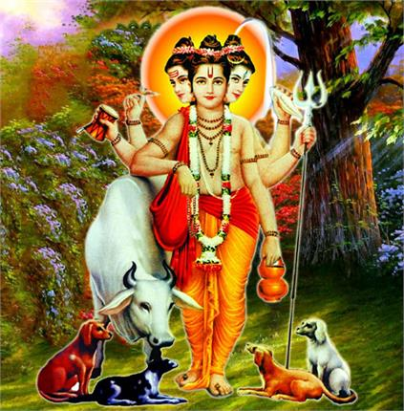
INTRODUCTION
Dattatreya, Datta or Dattaguru, is a Guru and a saint in Hinduism. In India and Nepal, he is considered as a god. In some parts of India, he is considered to be an incarnation of Brahma, Vishnu and Shiva, collectively known as Trimurti.
The most important text Avadhuta Gita is attributed to Sri Dattatreya. An annual festival called Datta Jayanti is celebrated during November/December of every year in India.
LIFE
According to the Puranas, he was born in north India to Anusuya and Atri. They are believed to be lived in Maharashtra. He is described in the Mahabharata, as a sage with very good knowledge, and considered as an Avatar of Lord Vishnu.
AVATARS
Guru Sri Datta took 16 avatars, which are as follows:
1.Yogiraj
2.Atrivarad
3.Dattatreya
4.Kala Agnishaman
5.Yogijan Vallabh
6.Lila Vishwambar
7.Siddharaj
8.Dnyanasagar
9.Vishwambharavdhoot
10.Mayamuktavadhoot
11.Mayayuktavadhoot
12.Adiguru
13.Shiva Guru Dattatreya
14.Devdeveshwar
15.Digambar
16.Sri Krishna Shyam Kamalnayan
TEMPLES
Lot of Datta temples exists in Maharashtra and in several parts of India and in Nepal. The list of temples are as follows:-
1.Temple of Lord Dattatreya in Devgad of Ahmednagar district.
2.Temple of lord Dattatreya, at the village of Pathari, Gujarat.
3.Lord Dattreya in Pulgaon in Wardha district in the Indian state of Maharashtra on the bank of the Wardha River.
4.Dattatreya temple in Bhaktapur, Nepal.
5.Shri Dattatreya Temple (Datta Bardi), Hadgaon, Nanded, Maharashtra
6.Chandannath Temple - Jumla, Nepal
7.Sri Dattatreya temple – Gulbarga, Karnataka.
8.Sripada Srivallabha temple – Pitapuram, Andhra Pradesh.
9.Datta Mandir Narasoba Wadi, Maharshtra
10.Shri Datta Mandir – Garudeshwar, Gujarat
11.Shri Datta Mandir – Nareshwar, Gujarat
12.Sri Kalagnishamana Datta – Mysuru, Karnataka
13.Sri Datta Mandir – Hingoli, Maharashtra
14.Sri Yogiraja Vallabha Datta – Prodduturu, Andhra Pradesh
15.Sri Yogiraja Vallabha Datta – Bangalore, Karnataka
16.Sri Gnana Sagara Datta – Anantapur, Andhra Pradesh
17.Sri Syama Kamala Lochana Datta – Vijayawada, Andhra Pradesh
18.Sri Atrivarada Datta – Machalipattanam, Andhra Pradesh
19.Sri Sivaroopa Datta – Jayalakshmipuram, Andhra Pradesh
20.Sri Jagadguru Datta – Guntur, Andhra Pradesh
21.Sri Adiguru Datta – Chennai, Tamil Nadu
22.Sri Digambara Datta – Rishikesh, Uttarakand
23.Sri Viswambara Avadhoota Datta – Akiveedu, Andhra Pradesh
24.Sri Deva Deva Datta – Nuzivedu, Andhra Pradesh
25.Sri Avadhoota Datta – Hyderabad, Telangana
26.Sri Digambara Datta – Gandigunta, Andhra Pradesh
27.Sri Siddaraja datta – Cochin, Kerala
28.Sri Mayamukta Avadhoota Datta – Acharapakkam, Tamil Nadu
29.Sri Leela Viswambarava Datta – Surat, Gujarat
30.Sri Kshetra Narada Gadde – Raichur, Karnataka
31.Shri Dattatreya Temple, Bijalpur, Indore, M.P.
32.Shri Dattatreya Temple – Dharwad, Karnataka
33.Shri Datta Mandir Sansthan Ruibhar,Osmanabad Maharashtra
34.Shree datta mandir pulgaon.dist wardha maharshtra
35.Datta mandir gangapur, Maharshtra
36.Datta mandir salaquin
37.Shripad shrivallabh datta mandir, karnja dist, amravti, maharstra.

CONCLUSION
Dattatreya, who is the union of three gods, Brahma,Vishnu and Shiva and who is having divine power and spiritual knowledge, and also a yogi, will give pleasantness and happiness in our life. Let him remove all the evils in our life, and show us the correct path. Let him lit a lamp in our life, and show us the way to live a sin free life. Let him protect and safeguard us from our enemies, and give a prosperous and a healthy life. Let him give us SALVATION at the end of our life. Let us praise his glory and chant his name continuously for ever.
“OM SREE DATTA BHAGAVANE NAMAHA”
WRITTEN BY
R.HARISHANKAR

LORD KRISHNA
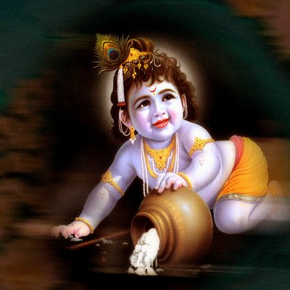

Lord Krishna is a friend, philosopher, a guide and a god to everyone. The great sage Narayana took the avatar as Lord Krishna alongwith the great sage Nara who took the avatar as Arjuna.
Both of them meditated deeply in the Naimisharanya forest for several thousands of years and then took the avatar as Lord Krishna and the Great Warrior Arjuna in Dwapar Yuga. Lord Krishna even as a child, has done many miracles and protected the yadava community. His divine beauty cannot be described in full. The way he steals the butter and cheese from the Yadavas which was described in Srimad Bhagavatha was very much sensational and heart filling with full of joy.

Lord Krishna cannot be known fully. Only by reading his divine text Bhagavatham and by praying him continuously, we could know him to some extent. He is a slave to our Pure Bhakti. Only by keeping constant Bhakti on him, we can fulfil our needs and desires. We should totally surrender on to the LOTUS FEET of Lord Krishna.
Lord Krishna’s popular temples are situated at Dwaraka,Orrisa,Guruvayur and in Udipi. Even in western countries also, Lord Krishna’s temple is there. He has given the way of leading a sin free life in BHAGAVAT GITA which is an important scripture for the hindus. Even though he is a Bhagawan,he respected elders and sought their blessings also.
He has shown mercy for the demons also, those who tried to kill him and offered MOKSHA to them. He lead a complete life and ruled his kingdom very efficiently and effectively. He saved his friends from the clutches of Demons by killing them.
Usually he is surrounded by GOPIKAS, who were his true devotees and will always see him as a God. He acted as a guide to the Pandavas during the time of their distress and saved Draupathi from Duchadana. Though he was a relative and a friend of pandavas, he has not changed their fate, since they have to suffer for their sins, but supported them and finally helped them towards conquering their kingdom.

Whoever calls the name KRISHNA KRISHNA and ask for his help, he will immediately present there and readily help them. The only thing he expects from us is pure bhakti on him. He respected his childhood friend Sudhama and removed his poverty. He was a humble and noble to everyone. He respected all the people and shown kindness to everyone.

Lot of songs are there for Lord Krishna. Songs in all languages are available. Bhagavatham and Bhagavat Gita are the two main Hindu epics. Sree Krishna Jayanthi is celebrated widely all over India and also in Western countries by the Indians. Various food items like seedai, murukku and thattai will be prepared using pure cow’s butter and will be presented in front of Lord Krishna’s Idol. Small childrens will be decorated as Krishna and will be participating in their school function.

Generally, if a child looks beautiful, we will say a word as you are good looking like ‘Bala Krishna’! Similar to Rama Mantra, chanting Lord Krishna’s Mantra repeatedly for several lakhs of times will make us to enter into the HEAVEN.

JAI KRISHNA, JAI GOPALA, JAI GOVINDA NAMO NAMAHA
WRITTEN BY
R.HARISHANKAR

LORD KURMA
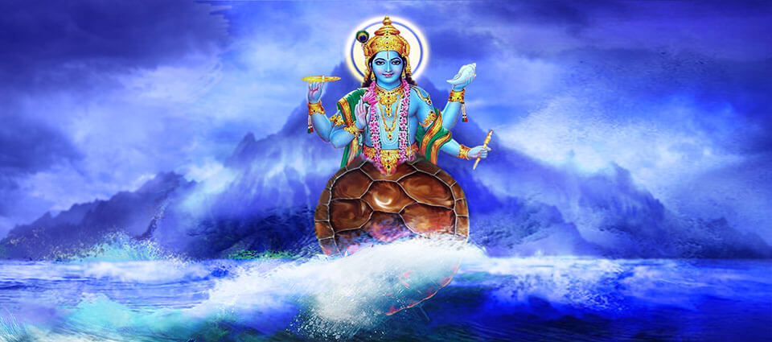
INTRODUCTION
Kurma is the great Avatar of Lord Vishnu. Kurma appears at the time of Churning of the ocean. He appears in the form of a divine tortoise.
The Kurma avatar appears in Ancient Vedic texts, and he is a popular avatar among the vaishnavites.
Once, sage Durvasa cursed the Devas (demi gods) to lose their powers because they did not respect him. In order to regain their power, the demi gods decided to churn the cosmic ocean of milk to get the divine drink (AMIRTHA). For churning the ocean of milk, they have used Mount Mandara, Serpent Vasuki and Lord Kurma.
The Demons took the divine drink, and Lord Vishnu manifested himself as the beautiful Mohini and mesmerized the Demons, and then he distributed the divine drink to the Devas. The Devas after drinking the divine drink, had regained their powers, and defeated the demons easily.
Temples for Lord Kurmanathar
Kurma Temple in Chittoor District of Andhra Pradesh
Sri Kurmam Temple in Srikakulam District of Andhra Pradesh
Kurmanathar Temple in Chitradurga District of Karnataka
Kurma Swamy Temple in Hooghly district of West Bengal
IMPORTANCE
Lord Vishnu has taken this avatar mainly to give the divine power to devas by generating divine drink (AMIRTHA) from the ocean. Through this avatar, he has protected devas. Hence he was praised and worshipped by the demi gods.

CONCLUSION
Lord Kurma is a great avatar of Lord Vishnu, who takes this avatar for restoring devas to their original power, and also to defeat the demons. Let us pray to Lord Kurma and be blessed.
“OM SREE KURMANATHASWAMIYE NAMAHA”
WRITTEN BY
R.HARISHANKAR

LORD MATSYA
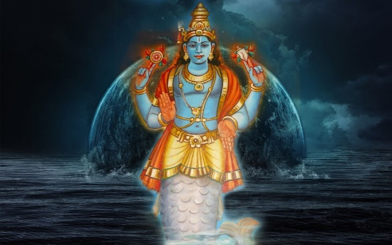
INTRODUCTION
Matsya is the fish avatar of Lord Vishnu. This avatar is mentioned in Vedic texts, puranas, bhagavatam and in the great epic Mahabharatha.

Once when Manu, who was the son of Lord Brahma, and also one of his first and foremost creation, was performing religious rituals on the banks of the Cherivi River, Andhra Pradesh. At that time a little fish asked for its protection. When Manu places the fish in the small bottle, it grows rapidly in size and again he put the fish into a tank, and then to the holy Ganges River, and finally to the ocean.

The great Matsya who was in the form of fish has advised Manu to carry with him the Rishis with sufficient food grains in a ship, on the day of the expected deluge (PRALAYAM). Manu ties the ship to the fish and then drove the ship to the Himalayas. The fish then reveals himself as Lord Vishnu and gives the power of creation to Manu.
TEMPLES FOR LORD MATSYA
- Shankhodara temple in Bet Dwarka
- VedanarayanaTemple in Nagalapuram
- Matsya Narayana Temple in Bangalore

IMPORTANCE
Lord Vishnu has taken this avatar several lakhs of years before. He has taken care of Manu and the great rishis, and protected them from the deluge.
CONCLUSION
Lord Matsya who has safeguarded the holy beings and took care of them, will also protect us throughout our life, if we sincerely worship him with pure bhakti. He is expecting the sincere faith and devotion on him and nothing more else. Even if we offer few flowers and worship him with true bhakti, he will readily accepts it and bless us. Let us worship Lord Matsya and be blessed.
“OM SREE MATSYA MAHA VISHNUVE NAMAHA”
WRITTEN BY
R.HARISHANKAR
LORD NARASIMHA
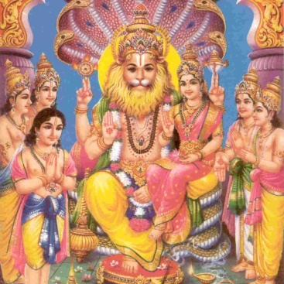
INTRODUCTION
Narasimha is an avatar of Lord Vishnu, who incarnates in order to protect Dharma, and to protect the earth and heaven from the Demon King Hiranyakashipu, and for saving the child devotee Bhakt Prahalad, from the clutches of Hiranyakasipu.
IMPORTANCE
During Krita Yuga, there was a demon king known as Hiranyakasipu who has got various boons from Lord Brahma through his severe penance, and has become a more powerful demon king, and he has ordered the devas, demons, and other living beings in the earth and heaven to worship him. All the living beings, were suffered by his cruel acts, and prayed to Lord Vishnu to safeguard them from Hiranyakasipu. Lord Vishnu took Narasimha avatar and destroyed Hiranyakasipu. Bhakt Prahalad was the son of Hiranyakasipu, but was an ardent devotee of Lord Vishnu. After killing Hiranyakasipu, Narasimha has made Prahalad as the king for that region.
Narasimha is the 'Great Protector' who protects his devotees from their enemies.
He is referred in various puranas, and his importance is clearly mentioned.
Narasimha is also mentioned in the great epic Mahabharatha.
There are many famous temples dedicated to Lord Narasimha. Some of them are as follows:-
- Mangalagiri Temple, Andhra Pradesh
- Yadagiri gutta Temple, Telangana
- Dharmapuri Temple, Telangana
- Singaperumal Koil Temple, Chengalpattu
- Yoga Narasimha Temple, Sholinghur
- Sri Malayadri Temple, Andhra Pradesh
- Sri Narasimha Swamy Temple,Kottayam,Kerala

Narasimha Jayanthi festival will be celebrated widely in Narasimha temples, and in Vishnu temples, which will occur during May month of every year. Various abhishekams will be taken place on that auspicious day, and Lord Narasimha deity will be decorated with flowers and garlands.
CONCLUSION
Lord Narasimha, has taken the avatar for removing the evil forces from this earth and for protecting the good ones. He is worshipped mainly for removing our sins in our life, and for removing several health related problems, problems due to black magic, mental related problems, enemy related problems etc. Let us worship Lord Narasimha and be blessed.
“OM SREE NARASIMHAYA NAMAHA”
“OM SREE LAKSHMI DEVIYE NAMAHA”
“OM SREE BHAKTA PRAHALADARE NAMAHA”
WRITTEN BY
R.HARISHANKAR

LORD PARASURAMA
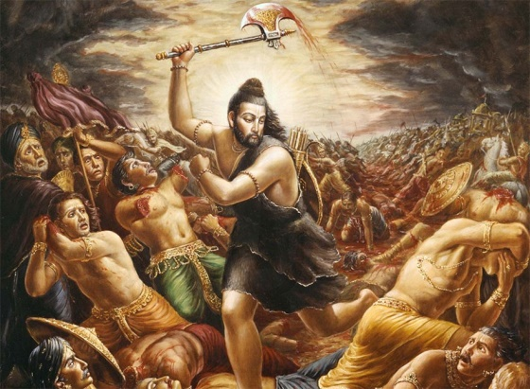
INTRODUCTION
Parashurama was the avatar of Lord Vishnu. He is known to be the most sincere devotee of Lord Shiva. He has controlled the power of Kshatriya, who began to abuse their power, and cause problems to the ordinary people and tortured them.
LIFE
According to Hindu legends, Parashurama was the son of sage Jamadagni and his wife Renuka, and his birthplace is believed to be in Uttar Pradesh. They had a celestial wish fulfilling cow. A king named Kartaviryajuna had stolen their cow. When Parashurama learns about this crime, he fought and kills the king, and he returned with the holy cow. Sage Jamadagni has asked him to visit various holy temples, in order to eliminate the sin caused by killing the king. After Parashurama returns from pilgrimage, he was known that his father was killed by the warriors. Parashurama kills many warriors and finally, he had thrown all his weapons and takes up meditation.
IMPORTANCE
Lord Parasurama was very affectionate towards his mother, father and his brothers. He never married and remained as a bachelor.
It is mentioned in various epics, that when parasurama threw his axe into the sea, the land of Kerala arose.
According to holy texts, it is mentioned that, he kills his own mother, in order to obey his father’s orders since his father claims that she had committed a sin by having bad thoughts after seeing a Kandarva, while filling up the water in the vessel. Parasurama had regained his mother’s life through the boon given by his father.
He is also mentioned in the great epic Mahabharata, in which he acts as a teacher to Bhishma, Drona and Karna with regard to teaching arts related with handling various weapons at the battlefield.
It is believed that Parashurama is still living in the Mahendra Mountains, odisha and doing penance, since he is considered as one among the seven chiranjeevis.
The region of Konkan is also considered to be the Parashurama Kshetra.
Every year, during winter season, several thousands of pilgrims are visiting the Parshuram Kund in Arunachal Pradesh, and have a dip in the kund, in order to get relieved from their sins.
Sree Parasurama Swami Temple is located in Thiruvallam,Kerala. It is the only temple in Kerala dedicated to Lord Parasurama.
CONCLUSION
Lord Parasurama, is an avatar of Lord Vishnu and also a chiranjeevi is living in the earth, and doing penance for the wellbeing of the entire universe. Let us worship this great Vishnu Avatar, and be blessed.
“OM SREE PARASURAMARE NAMAHA”
“OM SREE MATA RENUGA PARAMESWAREYE NAMAHA”
WRITTEN BY
R.HARISHANKAR
LORD RAMA
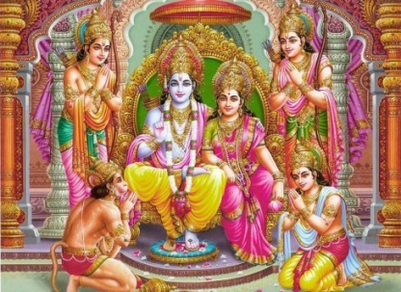
INTRODUCTION
Lord Rama is an important god in Hinduism. He was born in Treta Yuga. He was the king of Ayodhya, and ruled several thousands of years along with his brothers in a proper manner.
LIFE
Rama was born in the month Chaitrai (March–April), which is celebrated in India as Ram Navami. Rama was born to Kaushalya and Dasharatha in Ayodhya. His brothers were Lakshmana, Bharata, and Shatrughna. He was married to Sita. He suffered several hardships in his life. Once he went to forest, through the plan made by his step mother Kaikeyi. And at another time, his wife sita was kidnapped by the demon Lanka King Ravana. Later, he rescued his wife sita, with the help of the Vanara king, Sugriva and his army, and with the great help of Lord Hanuman. The entire life story of Rama, Sita and their companions discusses the duties, rights and responsibilities of an individual. His sons were Lava and Kusa. The epic Ramayana was written by the Great Rishi “VALMIKI”, and based on that, it was written again by the great tamil poet Kambar, and also by several scholars. And later, it was translated in many languages. Lord Rama is very famous among Vaishnavites. He is the main person of the great epic Ramayana. Lord Rama was also mentioned in Jainism and Buddhism texts.
IMPORTANCE
The importance of Rama can be said in a broad manner. By uttering his name itself, will reduce our sins, and give many beneficial results to us. Lord Hanuman has gained much power, through Lord Rama’s mantra. It is a common practice among hindus, to write Lord Rama’s mantra (SRI RAMAJAYAM and JAI SREE RAM) in a note book, and also by chanting it several times. Even in several hindu texts, there was a mention made about the importance of uttering RAMA MANTRA. It is also known that the great saints like Sri Bhadrachala Ramadas, Guru Raghavendra Swamy and Saint Thiyagaraja were devoted their life towards worshipping Lord Rama.
CONCLUSION
Let us worship Lord Rama and chant his mantra “JAI SREE RAM”, and be blessed.
WRITTEN BY
R.HARISHANKAR
LORD VAMANA
INTRODUCTION
Vamana was born to Aditi and Kashyapa, the great Rishi couples, and he was an avatar of Lord Vishnu. Lord Vishnu was incarnated as Vamana in Treta Yuga, in order to keep the position of Lord Indra in power as the Ruler of Heavens, and to maintain the other devas in their power at their Swarkaloka, and to send King Mahabali to Pathala Loka.
IMPORTANCE
According to Hindu texts, once the great king Mahabali, who is also the grandson of Bhakt Prahalad was performed a ceremony in order to gain more power, and also to become the king of heavens. Lord Vishnu appears at this ceremony as Vamana, and asked to gift three feet of land to him. Lord Vamana through his power has enlarged his shape, covering the entire world and also the divine worlds. In one step he covers the earth, in another the heavens, and for the third, Mahabali offers his head on which Vamana steps, sending the demon king to the Patala (netherworld).
Vamana avatar is mentioned in Rigveda and also in puranas, and praises the glory of Lord Vishnu. Lord Vamana is also known as Trivikrama.
Bhagwan Vishnu was incarnated as vamana in the present day Bihar, India. Vamaneshwar Shiva Temple is present in bihar, and Lord Vamana deity is also present in the temple.

ONAM FESTIVAL

King mahabali before going to the Pathala (netherworld), was granted a boon by Lord Vamana, that he can visit the land, which he was previously ruled, which is considered to be the present day kerala, on every ONAM Festival, and can bless the people.

TEMPLES
1. Vamana temple at Marhia, Jabalpur
2. Vamana temple in Maharashtra
3. ThrikkakaraTemple, Kerala
4. Ulagalantha Perumal Temple, in Kanchipuram
5. Vamana Temple, Khajuraho, Madhya Pradesh
6. Ulagalantha Perumal Temple, Tirukoyilur
7. Kazheesirama Vinnagaram in Sirkazhi, Tamil Nadu
CONCLUSION
Lord Vishnu as Vamana has shown his power by taking a gigantic shape covering the entire universe, and also the divine worlds. With this incident, we can know about his power, and he is having the capacity to maintain all the worlds under his control. It is also believed, that after this Kaliyuga, he will make King Mahabali as the ruler of Heavens, and grant him the position of “DEVENDRA”. From this incident, we can also knew, that the god will fulfil our wishes at the correct time. But we have to wait patiently for that time. He knows everything about us, and will give prosperity in our life. Let us worship this great VAMANA and be blessed.
“OM SREE VAMANARE NAMAHA”
“OM SREE MAHABALI CHAKRAVARTHIYE NAMAHA”
“OM SREE BHAKTA PRAHALADARE NAMO NAMAHA”
WRITTEN BY
R.HARISHANKAR

LORD VARAHA
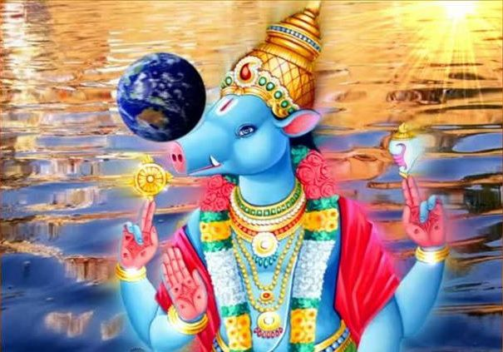
INTRODUCTION
Varaha is the avatar of Lord Vishnu who takes the form of a boar to rescue goddess earth from the ocean. Earth god, BhuDevi was thrown into the ocean by the demon king Hiranyaksha, who was the brother of Hiranyakasipu. Lord Vishnu fought with Hiranyaksha, and destroyed him. This is a very important avatar, since Lord Vishnu has safeguarded the earth, by bringing it from the ocean, thereby restoring her place in the universe. He has taken this avatar in the first yuga, that is in SATYA YUGA also known as KRITA YUGA.

IMPORTANCE
Varaha appears, with a boar's head and human body.
Varaha is a major deity of Sri Vaishnavites.
The word Varaha is found in Rigveda.
Varaha avatar is taken mainly to destroy the demon king Hiranyaksha, who has given lot of troubles to the people in the earth and heaven. Several rishis and demi gods were very much suffered from him. Since he has got lot of powers with him through his penance, no one was able to defeat and destroy him.
FAMOUS TEMPLES DEDICATED FOR LORD VARAHA
- Varaha Temple at Mathura
- Varaha Cave Temple in Mahabalipuram
- Sri Varahaswami Temple in Tirumala, Andhra Pradesh
- BhuvarahaswamiTemple in Srimushnam
- Lakhmi Varaha Temple, in Karnataka
- Varaha Temple, in Kerala
- Lakshmi Varaha Temple in rajasthan

CONCLUSION
Lord Varaha was a great avatar of Lord Vishnu, who protects the entire universe by destroying the demon king Hiranyaksha. He is worshipped widely all over india. Varaha Jayanthi is celebrated all over india. During that day, devotees perform bhajans and observe fasts in order to please Lord Varaha. Let us pray to Lord Varahaswami and be blessed.
“OM SREE VARAHASWAMIYE NAMAHA”
“OM SREE MATA BHOOMA DEVIYE NAMAHA”
WRITTEN BY
R.HARISHANKAR

MAGARDWAJA
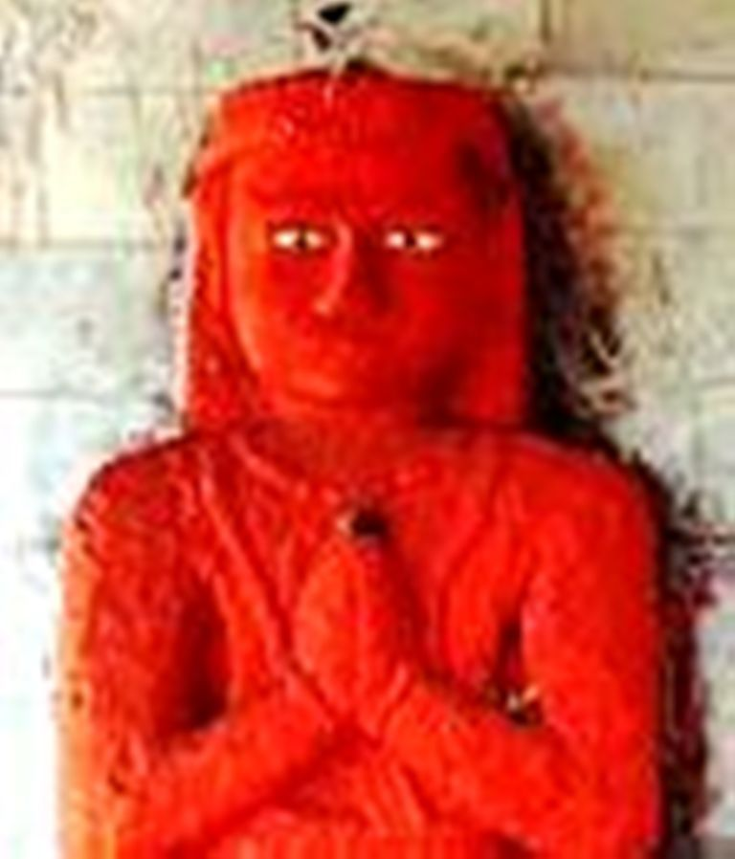
INTRODUCTION
Magardhwaja is considered to be the son of Lord Hanuman, and he was mentioned in some ancient texts.

LIFE
After Hanuman burnt lanka and took bath in the sea, his sweat fell into the mouth of a Giant Fish. Due to that incident, Makardhwaja was born.
The fish was caught by people of Patala Loka, the nether-world. Markardhwaja was found alive when the fish was cut and opened, and hence he was named as Makardhwaja.
By seeing his great strength, he was given the job of guarding the kingdom of Patala Loka.
Hanuman fought with his son in the Patala Loka and defeated him in order to safe guard Lord Rama and Lakshmana from the demon king Athiravana and to rescue them from the Patala Loka. However he blessed his son and declared him as the king of patala, after killing Athiravana.

TEMPLES
1. Odadar village, Gujarat
2. Hanuman-Dandi,Dwaraka
3. Chinchawan, Maharashtra
4. Karahiya, Madhya Pradesh
5. Balaji Makardhwaja Temple, Rajastan

IMPORTANCE
He was a brave and a knowledgeable person, who was the son of the mighty Hanuman. Though he was the son of Hanuman, he fought with him for the sake of his master Athiravana, and purposefully defeated by him, in order to do his duty as well as to help his father in his task of saving Lord Rama and Lord Lakshmana from his master Athiravana.
He is worshipped for getting great energy, strength, boldness, wisdom and courage.
He contains all the features as that of his father Lord Hanuman, and readily responds to our prayers, and fulfils our wishes and gives us all the prosperity in our life. He will throw out our enemies, and give us a peaceful and a happy life.
Worshipping him is equivalent to that of worshipping Lord Hanuman, since both of them are one and the same.
It is advisable to worship him whenever we worship Lord Hanuman, in order to get good results in our life.
Let us worship him and be blessed.
“OM SREE MAGARDWAJAYA NAMAHA”
“JAI HANUMAN”
“JAI SREERAM”
WRITTEN BY
R.HARISHANKAR

PRADYUMNA
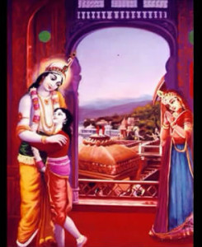
INTRODUCTION
Pradyumna was the son of Lord Krishna and Rukmini. Pradyumna was an incarnation of Kamadeva, the god of love.
LIFE
Pradyumna was born in Dvaraka during dwapara yuga. Once, Kamdev was burnt by Shiva when he disturbed Lord Shiva's meditation. Later Lord Shiva blessed his wife Rati and told that in his next birth Kamdev will be born as the son of Lord Krishna and Rati will marry him.
According to the boon, he was born to Lord Krishna and Mata Rumani. But when he was a child, he was kidnapped by the demon Sambara and he was thrown into the sea, and subsequently he was swallowed by a fish, and when the fish was cut and opened, he was brought to the demon sambara’s place. There he was took care by a maid in Sambara's palace. When Pradyumna grew up, he fought with the demon Sambara and killed him using a powerful divine weapon. Soon he went back to his palace and stayed with his father Krishna and was very much liked by the people of Dvaraka, due to his good qualities.
Later he married Princess Mayavati, the incarnation of Kamadeva’s wife Rati, and the daughter of his uncle, Rukmi.
His son Aniruddha married to Usha (daughter of Banasura and granddaughter of Mahabali, and also the great granddaughter of Bhakt Prahalad).
He along with his family lived their life in a proper manner, and at the end of dwapara yuga, and before the beginning of kali yuga, all the yadavas including pradyumna and Lord Krishna’s lives come to an end.
After his death, he merged with Kamadeva, and started doing his work in the heaven, and his wife also merged with rati devi and both of them are living in the heaven (INDRA LOKA) in a pleasant manner.
IMPORTANCE
Being a divine avatar of Kama Deva, he looks attractive and contains all the good qualities of his father Lord Krishna, and was liked by everyone. He was a soft natured person, who treated the people of dwaraka in a kind manner, and respected the elders.
He also contains the knowledge of divine scriptures and also mastered in all forms of art, and was trained by Lord Krishna with regard to the proper administration of the kingdom.
He contains all the qualities as that of Lord Krishna, and also his appearance was similar to that of Lord Krishna.
Let us worship the divine avatars and be blessed.
“OM SREE PRADYUMNAYA NAMAHA”
“OM SREE KRISHNAYA NAMAHA”
WRITTEN BY
R.HARISHANKAR

SATRUGHNA
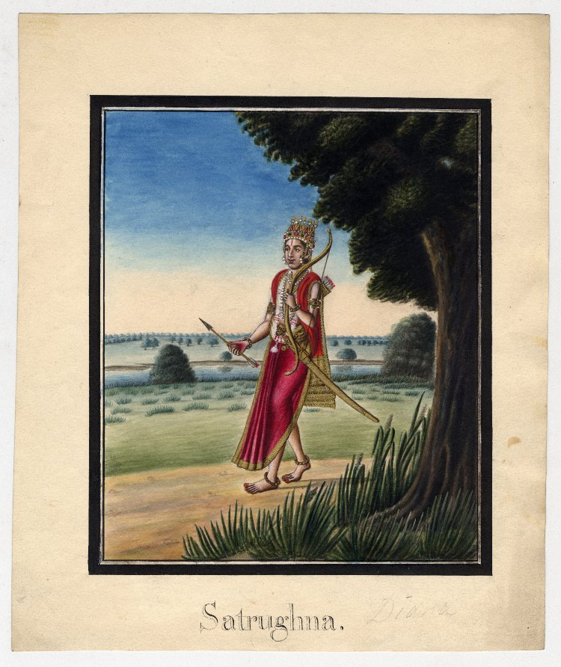
INTRODUCTION
Satrughna was the youngest brother of Lord Rama according to the epic Ramayana. He was also the brother of Lakshmana and Bharata.
Satrughna was considered to be an incarnation of Sudarshana chakra, a divine weapon of Lord Vishnu.
Satrughna was the son of the king of Ayodhya, Dasharatha and Queen Sumitra. Satrughna was married to Shrutakirti, and they had two sons.
Although Bharata was designated as the king of Ayodhya during Rama's exile, Satrughna took care of the administration of the entire kingdom, and ruled the kingdom in a proper manner.
Satrughna tried to kill Manthara, maid of kaikeyi, since she was the main person who was responsible for rama’s exile. But he was prevented by Bharatha from killing her.
He is celebrated for killing of Lavanasura, the demon King of Mathura, who had committed lot of sinful activities. After Lavanasura's death, Rama crowned him as the King of Mathura.
After Rama ruled Ayodhya for 11,000 years in a proper manner, he walked into the Sarayu River and merged with Lord Vishnu along with his brothers.

TEMPLES
- Satrughna Temple in Thrissur District of Kerala
- Satrughna Temple at Rishikesh
- Satrughna Temple Mathura, UP
IMPORTANCE
He was a loving brother of Lord Rama, who was very affectionate with him. During Rama’s exile, he had done his daily duties only after chanting his name. He was honest, pious and a straight forward person, who always followed the path of dharma, and lived his life in a good manner, and he affectionately treated the people of Ayodhya.
Let us worship the great “SATRUGHNA” and be blessed.
“OM SREE SATRUGHNAYA NAMAHA”
“JAI SREE RAM”
WRITTEN BY
R.HARISHANKAR

ABHIMANYU
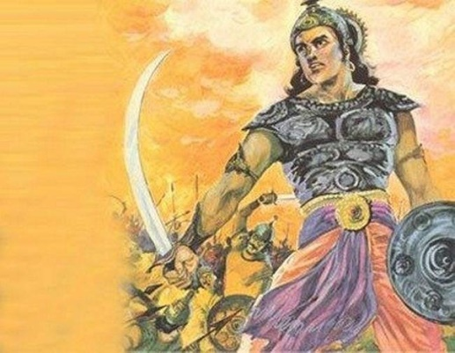
INTRODUCTION
Abhimanyu was a famous character in Mahabharata.Abhimanyu was the incarnation of Lord Chandra’s son. Abhimanyu was married to Princess Uttara. Abhimanyu was very much loved by the pandavas. At the age of sixteen, in the Kurukshethra war, Abhimanyu was killed in the battle by the kauravas.
His various names are as follows:-
- Arjuna Putra
- Subhadranandan
- Soubhadri
- Chandra Putra
- Krishna Shishya
- Rudra dhari

IMPORTANCE
Abhimanyu was a great warrior, and possessed very good knowledge in all the subjects. He was a master in all kinds of art. He was a brave and a humble person, who contains all the good qualities, since he mingled with Lord Krishna, and considered him as his Guru. Being the son of Arjuna, he never afraid about anything, and was a wise man.
CONCLUSION
Abhimanyu was a great person, who respects the elders, and showed courtesy to all the people. He was a kind hearted person, and a devotee of Lord Krishna. At a younger age itself, Lord Krishna guided him properly, and taught many good things, which are essential for the life. He was a great scholar. Being an incarnation of Lord Chandra’s son, his appearance was very good. By worshipping him, we can satisfy Lord Chandra, and we can get the divine grace from him. Let us pray to this great divine warrior, and be blessed.

“OM SREE ABHIMANYUVE NAMAHA”
“OM NAMO BHAGAVATHE VASUDEVAYA NAMAHA”
WRITTEN BY
R.HARISHANKAR

UDDHAVA
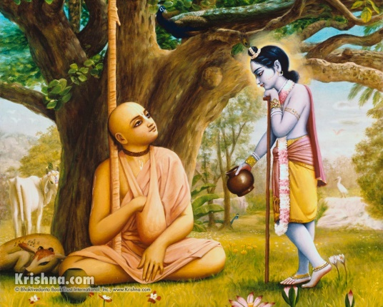
INTRODUCTION
Uddhava is the friend of Lord Krishna. He was taught yoga and bhakti directly by Krishna. The discussions made between him, and Krishna is known as Uddhava Gita which is similar to that of Bhagavad Gita. Uddhava was a devotee and a dear friend of Krishna.
Uddhava realized the bhakti of gopikas on Lord Krishna was very great, and the relationship between them is similar to that of the God and his devotees.
And the bhakti spirit of gopikas cannot be measured by anyone and also cannot be imagined. He then realized that he also cannot compete with them with regard to their bhakti on Lord Krishna.
Lord Krishna’s famous teachings to Uddhava are as follows:-
- One should not be attached with deep love with anyone, since nothing is going to be permanent.
- Everything will perish in due course of time. Hence always keep love on me and worship me, I will award you suitably based on your true love and bhakti on me. Trust me, that is enough to live your life peacefully.
- Only if you realize me and my importance, you can be free from your birth cycle. Or otherwise you will have to permanently stay on this earth and have to suffer from miseries and sorrows and it will never come to an end at any time. Hence show your intense bhakti on me then I will release you from this life cycle, and help you to attain the divine bliss of god, and to reach the heavenly abode of Vaikunta.
- Always chant my names and praise me with full bhakti, I will never leave you alone, and I will accompany with you, wherever you go.
- Never forget me. Always remember me then you will be saved from the clutches of Kali Purusha.
- Bhakti is the only way to eliminate the sufferings in life.
- I am residing in everyone’s heart. But the main thing is that you must realize that I am living in your heart.
Uddhava was very much astonished to see Lord Krishna was shot on his left foot by a hunter’s poisoned arrow, and then he was consoled by Lord Krishna.
Udhwa is a village in Jharkhand which was named in honour of the saint Uddhava, a friend of Lord Krishna. And It is believed that Uddhava had lived in the village of Udhwa during dwapara yuga.
IMPORTANCE
Uddhava was a friend of Lord Krishna, and his appearance also resembles him. According to him, Krishna was his friend, philosopher, guide and god. He was guided directly by Lord Krishna and took him to the spiritual path.
He was a great devotee of Lord Krishna, and finds his appearance on every object. During his period, he followed Lord Krishna’s teachings, and obeyed his orders and acted accordingly. He considers Lord Krishna as a divine avatar, and given him proper respect.
He was a learned scholar and a spiritual guru, who lived a saintly life, and also helped others in realizing the importance of Krishna, and chanted his names throughout his life with utmost faith and devotion on him, and got the divine grace of Lord Krishna.
Let us worship the great saint and be blessed.
“OM SREE UDDHAVARE NAMAHA”
“JAI KRISHNA”
WRITTEN BY
R.HARISHANKAR

VAKULA DEVI
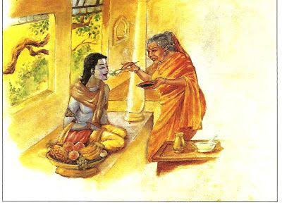
INTRODUCTION
Vakula Devi is the foster mother of Lord Venkateswara. Yasoda who was the foster mother of Lord Krishna in the dwapara yuga was again taken birth as Vakula Maligai in this kali yuga, in order to serve Lord Venkateswara.
A Temple in her name was built about several hundreds of years ago near the Tirumala hills. This temple was constructed in order to fulfil the wishes of the divine mother of Lord Venkateswara.
It is also traditionally followed from several years that the bhogh before being offered to Lord Venkateswara would first be offered to his mother Vakula Maligai, in order to test by her the quality of the food items, and whether it can be offered to his son Lord Venkateswara.
After Lord Vishnu came to the earth from his abode vaikunta, he stayed in an ant-hill for some time by doing penance. After some time he approached Vakula Devi and accepted her as his foster mother.
Vakula Devi, also recognized that the person approached her was none other than her child “KRISHNA” in his previous birth, and took care of him properly.
IMPORTANCE
Though she was not rich, she had given shelter and food to Lord Srinivasan. And also both of them were showed their affection and lived a peaceful life. After some time, she arranged for a marriage between Padmavathi, daughter of Akasa Raja and to his son Srinivasan.
She asked her son to keep a permanent place for her near to him. According to her wish, even still now, she is watching the cooking process of the food items which is being offered to Lord Venkateswara as Neividiyam (Bhog). She is still residing near Tirumala at her temple, and having the darshan of Lord Venkateswara regularly.
The bondage between her and Lord Venkateswara cannot be explained in words. Such a great love and affection is there between them.
Let us worship the divine mother and be blessed.
“OM SREE VAKULA DEVI ANNAIYE NAMAHA”
“OM SREE VENKATESWARAYA NAMAHA”
“OM SREE PADMAVATHI THAYARE NAMAHA”
WRITTEN BY
R.HARISHANKAR
VIBISHANA
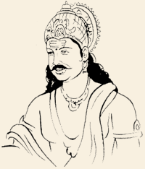
INTRODUCTION
Vibhishana was the brother of Ravana, the king of Lanka as per Ramayana. Vibhishana was the youngest son of Kaikesi and Sage Vishrava.

IMPORTANCE
Even though he was a Rakshasa, Vibhishana was of a noble character and advised Ravana, to return sita to her husband Rama. When Ravana did not listen to his advice, Vibhishana left Ravana and joined in Rama's army. Later, when Rama defeated Ravana, Rama crowned Vibhishana as the king of Lanka and he returned to Ayodhya.
Vibhishana had a pure mind and a pure heart. From his childhood, he was meditating the name of the Lord. Even when asking for a boon to Brahma, he asked him to give the boon of staying permanently in Lord’s feet and worshipping him. This prayer was fulfilled and he served Rama, who was a divine avatar.

Because of Vibhishana’s advice, Lord Rama was able to succeed in the lanka war, and he killed Ravana. After becoming the king of Lanka, Vibishana has changed his rule to the path of Dharma.
When Rama was about to leave Ayodhya at the end of his reign, he asked Vibhishana to stay on earth, and to guide the people to the path of Dharma. Hence, Vibhishana is considered as one of the seven Chiranjeevis.
Srirangam
During the coronation of Rama, Vibishana was presented with the idol of Sri Ranga Vimana. While he was carrying the idol to his kingdom of Sri Lanka, he took rest for some time, by placing the idol on the banks of river cauvery. After some time, he tried to lift the Vimana, but it could not be lifted. Lord vishnu appeared to him and said that he desired to stay as Ranganatha in the place, which is now called as Srirangam.
CONCLUSION
King Vibhishana who was of a noble character, and who helped rama in defeating ravana during the war. He was one of the seven chiranjeevis, and is still living in this earth. He is considered as a great devotee of Lord Rama. Let him bless us and guide us in the correct path, and give us all the necessities in our life.
“OM SREE VIHISHANAYA NAMAHA”
“JAI SREE RAM”
WRITTEN BY
R.HARISHANKAR

VIDURA
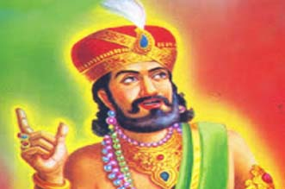
INTRODUCTION
Vidura is one of the main characters in the Mahabharata, and he was the prime minister of the Kuru dynasty, and also the uncle of Pandavas and Kauravas.
IMPORTANCE
Vidura was the son of sage Vyasa. Vidura was an adviser to the Pandavas, and safeguarded them from death on several occasions, which was plotted by Duryodhana.
Vidura protested against the insult caused to Draupadi in the Kaurava court. Vidura sided with dharma and the Pandavas during the Kurukshetra war.
According to Krishna, Vidura was considered as an avatar of Lord Yama Dharma. Krishna respected Vidura’s knowledge and for his devotion towards the welfare of the people.
When Krishna visited Hastinapura as a peace messenger of the Pandavas, he stayed at the home of Vidura, since Krishna knew Vidura will properly look after him in his palace.
In protest against the Kurukshetra War, Vidura resigned from the post of minister.
Vidura in his old age,went to the forests as a saint with his half-brother Dhritarashtra and his sisters-in-law Gandhari and Kunti. Before his death, he gave his power to Yudhishtra, saying that both of them were the incarnations of Lord Yama Dharmaraj.
Vidura-niti, is considered as the best among those who are following the path of dharma.
Vidura is known to be a person of truth, wisdom,courage,knowledge,impartial judgement and dharma. He is considered as the holy man in the great epic Mahabharata.
CONCLUSION
Vidura, who was an incarnation of yama dharma has spent his entire life in the path of dharma. He protected pandavas, and advised them properly, and asked them to follow the path of dharma. He was a noble man and respected everybody. Let us pray to the great Vidura, and seek his blessings, and live happily and peacefully for ever.
“OM SREE VIDURAYA NAMAHA”
WRITTEN BY
R.HARISHANKAR

YUDHISHTHIRA
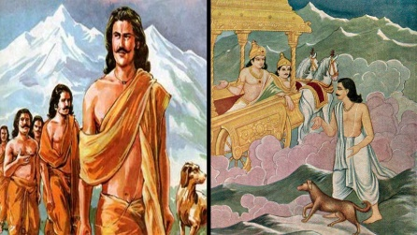
INTRODUCTION
Yudhishthira was the son of Kunti Devi and was the AMSA (features) of Lord Yama Dharma. He was the eldest son among all the pandavas. After his departure from the earth, he went to heaven.
IMPORTANCE
Yudhishthira was a great person who contains pure sense of mind. He always tries to win a person’s heart by making an offering to him. His wife was draupathi. Though, he was cunningly cheated by the Kauravas in the dice game, and went to the forest, he remained a noble person.
He was guided by Lord Krishna with regard to ruling his country, after he won in the kurukshetra battle. He loved his mother, his brothers and his wife, and he took care of his people in a proper manner. During his regime, all the people in his kingdom were never suffered from any problems related with health, wealth and mental diseases.
He provided a golden rule and he treated all the people as same and respected them well. He never considered him as a king, and acted politely to his servants and to his relatives. He never tell any lies, or acted in a wrong manner. Even nowadays also, when a person acts honestly and showed kindness to others, he will be called as “DHARMA RAJAVE”, it means even now the people are recalling King Yudhishtra, and keeping the honest person in his place.
CONCLUSION
King Yudhisthira, was well versed in art, and possessed good knowledge in vedas and other religious texts. He was also mastered in archery and a great warrior, who also fought well in the Kurukshektra along with his brothers. He always stood in the side of righteousness. He was a great personality who was remembered by the people even today. He is well known for his kindness, charity and a pleasant behaviour. Let us worship this great “DHARMA RAJA” and be blessed.
“OM SREE YUDHISHTHIRARE NAMAHA”
“OM SREE YAMA DHARMARAJAVE NAMAHA”
“OM SREE KRISHNA BHAGAVANE NAMAHA”
WRITTEN BY
R.HARISHANKAR
YUYUTSU
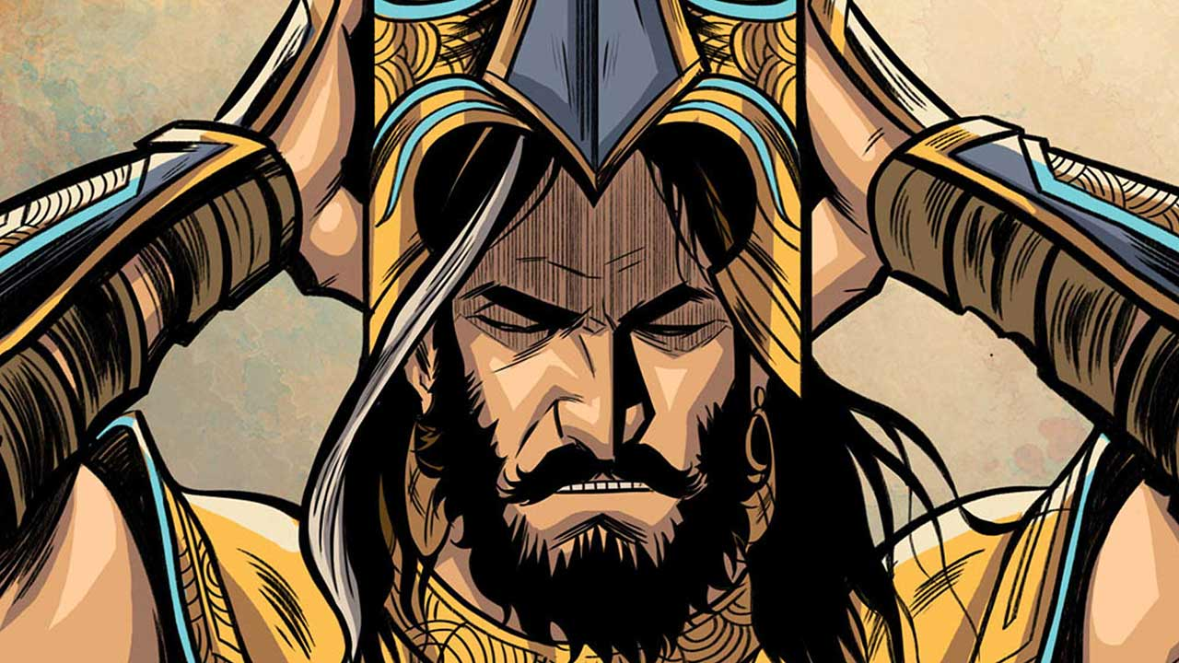
INTRODUCTION
Yuyutsu as per the great epic Mahabharata, was the son of Dhritarashtra and his wife Gandhari's maid. He was the only son of Dhritarashtra who survived in the Kurukshetra war, after the death of all other kauravas.
He was also called by various other names such as Dhartarastra and Vaishyaputra.

LIFE
Yuyutsu was a great warrior, who has chosen the path of righteousness even though he was the half-brother to duryodana and other kauravas. He was away from his family bonds in order to live a noble life.
Yuyutsu also saved the life of pandavas by his prior intimation about Duryodhana's plot to kill the pandavas. He also advised duryodana to follow the right path, but he was refused to do so.
During the battle of Kurukshetra War between Kauravas and Pandavas, Yuyutsu fought the battle on the side of the Pandavas. And he was survived in the war.
Before his departure from this world, Yudhishthira gave him the charge of helping King Parikshit towards ruling his kingdom in a proper manner.
IMPORTANCE
He was a talented scholar and a master in all kinds of art. He lived an honest life, and took Lord Krishna as his mentor and followed his teachings and became a noble man.
He had advised his half-brothers to have friendship with pandavas, but they have not accepted his wishes and finally destroyed in the kurukshetra war.
He was a noble, simple and a pious man, who was not interested in leading a luxury life, and lived a good life, by chanting the god’s names and doing his duties properly.
He was a humble friend of pandavas and looked after them in a proper manner.
Let us worship this great warrior and be blessed.
“OM SREE YUYUTSUVE NAMAHA”
“JAI KRISHNA”
WRITTEN BY
R.HARISHANKAR

