DIVINE DETAILS BY R.HARISHANKAR
VARASIDDHI VINAYAGAR TEMPLE, BESANT NAGAR
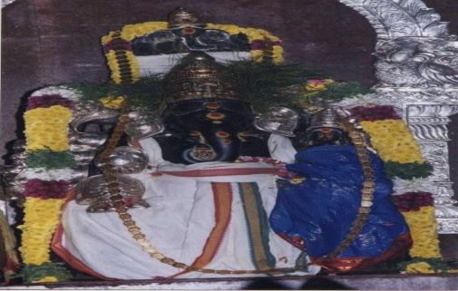
INTRODUCTION
The Varasiddhi Vinayakar Temple in Besant Nagar, Chennai, is a famous Vinayaka temple located nearby the Besant Nagar Beach. The temple provides free food to the poor and conducts regular pujas.
The first Kumbabhishekam of the temple was held in April, 1979. The Temple conducts music programs during Vinayakar Chathurthi festival and also permits other organizations to conduct programs in the temple auditorium. It is considered as a sacred temple, and Lord Vinayaka bestows various boons to his devotees, and hence called as Vara Siddhi Vinayaka, which means giving boons and fulfilling the wishes of the devotees. By visiting this temple, we will get peace of mind and a great sense of satisfaction, which we will not find it anywhere else, since Lord Vinayaka is considered as the first god, and who was worshipped first before worshipping other gods.
WRITTEN BY
R.HARISHANKAR
KATYAYANI
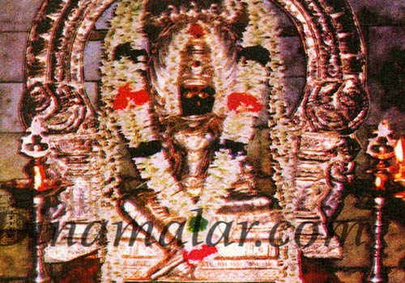
INTRODUCTION
Katyayani is one of the forms of Navadurga and worshipped during mainly during Navratri. She is also considered as an avatar of Mata Paravati, and is considered as the affectionate sister of Lord Krishna.
She is called by various names such as Bhadrakali and Chandika, and also appears similar to Mata Devi Durga.
Katyayani Temples are situated throughout India, and the most important one is situated in Bihar. Temples of Ram, Lakshman and Ma Janaki are located nearby the temple. During Mondays, Tuesdays and Fridays, large number of devotees would come to this temple, to visit and worship the holy Mata. She was brought up by Rishi Katyayan. Hence, it is believed that she is called as Katyayani. She is relieving her devotees from sins and gives them sound mind and good health.
WRITTEN BY
R.HARISHANKAR
SUN GOD TEMPLE, ARASAVALLI
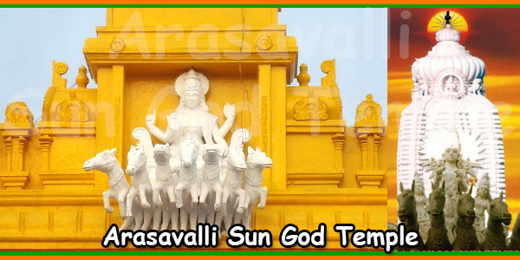
INTRODUCTION
Arasavalli Sun Temple is situated at Arasavalli Village in Andhra Pradesh, and it is a 7th century temple. It is built by the Kalinga Emperor, the great king Sri Devendra Varma. It is a popular temple, and lot of devotees are visiting this temple from all over the world. This temple is an ancient temple, and is good in architecture and art work. It is a famous temple, next to Konark Sun Temple, and is worshipped by the people, for getting relieved from their diseases and for getting bright eye sight. Here Sun God blesses us and gives all the prosperity to us. Rathasaptami festival is celebrated in a grand manner in this temple. It is advisable for those, who are suffering from severe dreaded diseases to visit and worship Lord Surya Narayana, who is protecting us through his sun rays, and can get relieved from their various ailments and can live their life peacefully and happily without any major sufferings in their life.
WRITTEN BY
R.HARISHANKAR
AHOBILAM TEMPLE
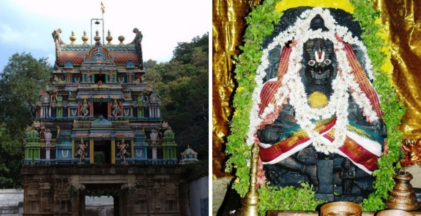
INTRODUCTION
Ahobilam is a holy site and is located in the Nallamala forests of Kurnool district in Andhra Pradesh. It is surrounded by several mountain hills and the place looks very attractive. The temple consists of nine shrines of Lord Narasimha. There is also a famous Prahalada Varadhan temple in the bottom of the mountain. Lot of devotees from all parts of India, as well as from foreign countries are visiting this holy shrine of Lord Narasimha, and getting his divine blessings. Ahobilam is the sacred place where the Lord Narasimha killed the great demon king Hiranyakasipu in this place. Lord Garuda also got the divine darshan of Narasimha after performing severe meditation on him. It is believed that by worshipping this ancient and famous temple of Narasimha, all sorts of health related problems will be solved, and we will get great spiritual energy in our mind and body, and our day to day sufferings would come to an end. Let us try to visit this temple, at least once in a year, and get the divine vision of the Lord, and also can enjoy the natural beauty at this place.
WRITTEN BY
R.HARISHANKAR
UPPILIAPPAN TEMPLE
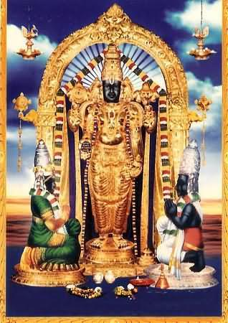
INTRODUCTION
Uppiliappan Temple, is a temple dedicated to Lord Vishnu, located in Kumbakonam of Tamil Nadu. The temple is praised in the Divya Prabandham, a sacred vaishnavite text. It is one of the 108 Divya Desams dedicated to Lord Vishnu. Here Lord Vishnu is worshiped as Uppiliappan and Mata Lakshmi as Bhumi Devi.The temple is believed to have been constructed by the Chola Kings during the 8th century AD, and after wards renovated by the great Thanjavur Nayaks. Uppiliappan is believed to have given darshan for sage Markandeya , Mata Bhoomadevi, Lord Brahma and Lord Shiva. The temple follows six daily rituals and three yearly festivals. The chariot festival, is grandly celebrated during March–April, is the most famous one. Here Naivedyam for the Lord is offered without adding salt and distributed it to the devotees. By consuming the holy Prasad, all of our mental and physical diseases will be removed from our body, and we will get spiritual energy.
WRITTEN BY
R.HARISHANKAR
RAVISHWARAR TEMPLE
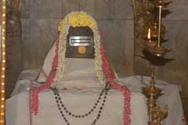
INTRODUCTION
Ravishwarar Temple is a famous Shiva temple built during Chola's period. It is located at Murthy Iyengar Street, Vyasarpadi. Vyasarpadi is situated nearby Perambur. The lord Shiva is named as Ravishwarar. It is said that the lord is worshiped by the Sun God. Once, the Sun god also took bath in the temple tank to get rid of his Bhramaharti Dosham. Mata Parvati Devi shrine is also available in this temple. The Sun god shrine is also located inside the temple. After worshiping lord Shiva, the Sun god must be worshipped. The temple has three sacred trees. Lots of people visit this temple on Sundays to get rid of various diseases and mental problems. The God is considered as powerful, and worshipped by hundreds of devotees during festival days. Here free food is offered daily to a minimum of 50 people. The place is easily accessible from various parts of the city through various modes of transport. By worshipping Lord Shiva and Lord Surya, we can get all the prosperities in our life.
WRITTEN BY
R.HARISHANKAR
SARABESWARAR TEMPLE
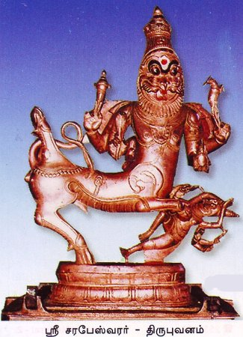
INTRODUCTION
The Sarabeshwarar Temple is a Hindu temple dedicated to Lord Shiva. It is situated in Thirubuvanam. Shiva is worshipped as "Lord Kampaheswarar ". As per ancient legend, Shiva is believed to have assumed the form of Saraba, to pacify Lord Narasimha. The temple is good in architecture. And the looks of the temple is similar to the Big Temple at Thanjavur, Airavatesvara Temple at Darasuram and Gangaikonda Cholapuram temples. There is a separate shrine for Sarabeswarar in the temple. The temple was built by the Chola king during the 13th century.
It is believed that by worshipping Lord Sarabeswara in this temple, our entire past birth sins would be wiped out, and we will get good positive thoughts in our mind, and our various diseases also will be cured. Let us try to visit this temple, at least once in a year, and be blessed.
WRITTEN BY
R.HARISHANKAR
KACHALEESWARAR TEMPLE
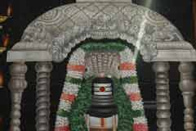
INTRODUCTION
The Kachchaleswarar Temple is a shiva temple located in Armenian Street, Parrys, chennai. It was constructed in the year 1725, and was one of the popular temples since the times of the ancient Madras City. The temple is similar to the Kachaaleshwarar temple at Kancheepuram. Here Lord Shiva is worshipped in the name of Kachaaleshwarar and Mata Parvati is worshipped in the name of Soundaraambikai. The first consecration ceremony was performed during the year 1728, and thereafter during the years: 1962, 1984 and1989. It is located in the main place of the Chennai, and surrounded by banks and business houses. It is a holy temple, where Avatars of Lord Shiva were depicted in the walls of the temple, and it will be pleasant experience by looking at that divine pictures. Chennai people can visit this temple, since lot of transportation facilities are available to reach this holy temple. Shiva Ratri and Thiruvadirai festivals are grandly celebrated and daily annadanam is offered for a minimum of 50 people. Let us visit this holy place, and be blessed.
WRITTEN BY
R.HARISHANKAR
CHENNAKESAVA PERUMAL TEMPLE
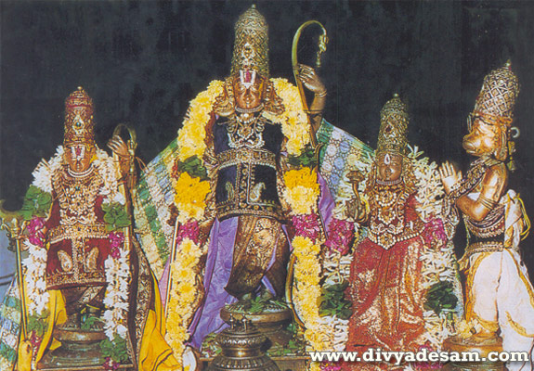
INTRODUCTION
Chennakesava Perumal Temple is a Hindu temple situated in the George Town, Chennai. It is dedicated to Lord Chenna Kesava Perumal, a form of Lord Vishnu. Chenna Malleeswarar Temple is situated nearby the Vishnu Temple. They are twin temples. Chenna pattanam is believed to have been named after the Chenna Kesava Perumal Temple. It is believed that during the 18th century, this temple has been constructed. Lot of devotees would visit these two temples, especially during the festival days. And the temple management is providing free food to a minimum of 50 people in both the temples. Both these temples are big temples, and a must to visit place, in order to get relieved from our various problems which we are facing day to day, in this Kali Yuga. Shaivites and Vaishnatives can come together and worship the deities and be blessed.
WRITTEN BY
R.HARISHANKAR
EKAMBARESWARAR TEMPLE
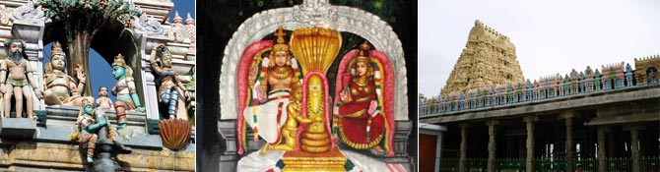
INTRODUCTION
Ekambareswarar Temple is a Shiva Temple, located in Kanchipuram. It is one of the Pancha Bhoota Stalas, Prithvi. Lord Shiva is worshiped as Prithvi lingam. Mata Parvati is worshipped as Gowridevi Amman. The greatness of the temple was praised in the 7th century sacred work, the Tevaram, written by the great nayanars and classified as Paadal Petra Sthalam. The temple is one of the largest in India. The temple has numerous shrines, and also contains many halls.
The temple follows six daily rituals from 5:30 a.m. to 10 p.m., and twelve yearly festivals are celebrated in this temple. Panguni Uthiram festival is celebrated during the period: March - April and is considered as the main festival of this temple. The temple attracts large number of tourists from all over the world.
It is believed, that Mata Parvati worshipped Lord Shiva in the form of a Prithivi Lingam in this place.
Here free food is served in the noon to a minimum of 50 persons on a daily basis.
WRITTEN BY
R.HARISHANKAR
THIRUVALANGADU TEMPLE
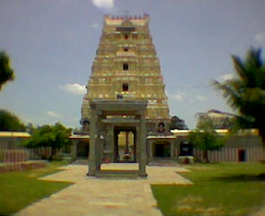
INTRODUCTION
This temple was built by the Chola Kings during the 12th century AD and is regarded as a sacred temple. According to the ancient Legend, once when Lord Shiva was deeply involved in cosmic dance, the jewels from his feet were fell into the earth and scattered in 5 places. Thiruvalangadu is one among them. It is considered as one among the 275 famous Shaivite temples. The temple is good in its architecture. The chief deity of the temple is known as "Vadaranyeswarar" and the Mata Parvati is called as, "Vandarkuzhali Amman". The temple tree is a large banyan tree. The great Karaikkal Ammaiyar visited this place and worshipped Lord Shiva.
Shivraathri and Thiruvadirai are the two important festivals which are celebrated in a grand manner in this temple, and lot of devotees from all parts of tamil nadu are visiting this holy temple, to have the glimpse of the divine father and mother. By visiting and worshipping the deities in this temple, we can get all the prosperities in our life.
WRITTEN BY
R.HARISHANKAR
SRI RAJARAJESWARAR TEMPLE,VEMULAWADA
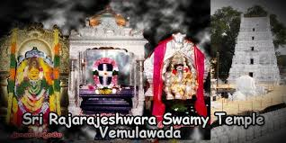
INTRODUCTION
Sri Raja Rajeshwara Temple is one of the most famous Shiva temples in Telangana.
Here Lord Shiva is worshipped in the form of Raja Rajeshwara Swami. The Chief deity of the temple is Sri Raja Rajeswara Swamy appears along with Mata Sri Raja Rajeswari Devi. Vemulawada Raja rajeswara temple is situated near Karimnagar. Lot of pilgrims are visiting this holy temple during festivals and weekends. Pilgrims will used to take bath in Dharma Gundam, before worshipping the deities since the holy water in this temple tank contains medicinal properties. During Maha shivarathiri and Thiruvadhirai festivals, lot of devotees would visit this temple in order to get the darshan of the divine god and goddess. Here free food is offered to more than 100 people on a daily basis, which is considered as a tasty and delicious food by the devotees.
WRITTEN BY
R.HARISHANKAR
DHANVANTRI TEMPLE
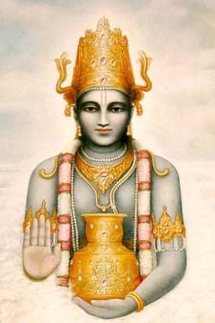
INTRODUCTION
Sri Dhanvantri Bhagavan Temple is situated in a village of Wallajapet of Vellore District of Tamil Nadu. The temple is administered by Sri Dhanvantri Arogya Peedam, and the temple is more than 500 years old.
The other shrines of the temple are Lord Vinayaka, Mahishasuramardhini, Vaastu Bhagavan, Indra, Agni, Vayu, Varuna and Kubera. Here dhanvantri homam is conducted in order to relieve the diseases of the devotees.
Lot of people from various parts of tamil nadu are visiting this sacred temple in order to get relieved from their health issues and problems related to mental disorders are also cured by consuming the temple prasadam. Hence it is advisable for us to visit this holy temple, in order to get a healthy body with a sound mind.
WRITTEN BY
R.HARISHANKAR
BHOJARAJAN
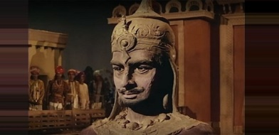
INTRODUCTION
King Bhojarajan was a great king who once ruled Ujjain, after the great king Vikramaditya, and treated all of his people in a kind manner. He was the successor of Vikramaditya, and ruled for several years in a well versed manner. He has given a golden rule, and no one has suffered from any problems during his reign. He was also a great Kali Devotee similar to Sri Vikramaditya. He has also heard about the greatness of Vikramaditya, through the golden statues, which spoke about the importance of Vikramaditya, who also contains the features of Lord Vishnu. As per the advice of the golden statues, which are also considered as divine deities, he ruled the kingdom of Ujjain in a prosperous manner. All the people in his kingdom were lived happily, without any sufferings in their life, and praised their king and compared him similar to the great king Vikramaditya and gave proper respect to him. He was also praised by the sages, holy people and by the divine gods in the heaven. After his death, he has attained SALVATION.
WRITTEN BY
R.HARISHANKAR
NAVAGRAHA TEMPLES AT KUMBAKONAM
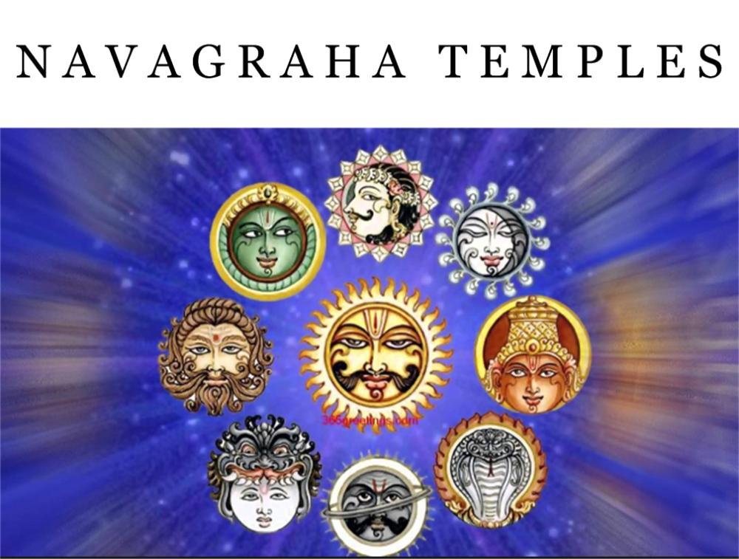
INTRODUCTION
Navagrahas are occupying the main place in our life. We are able to live in this world, through their grace only. Apart from the main gods, Navagrahas are considered as demi gods, and are even worshipped by the great rishis, sages and saints. In order to get prosperity and to get rid from our problems, it is advisable to visit and worship the nine temples, also called as Navagraha temples, situated nearby the Kumbakonam area. The details of the nine temples are as follows:

- Suriyanar Koil
Temple History
The temple is believed to be the place where all Navagrahas also called as Nine Planets were cursed by Lord Brahma and got back their power and strength due to the blessings of Lord Shiva, and permanently stayed at this place in order to bless the devotees who worship them at this place. The Sun god is worshipped as a main deity in this temple.
Significance
In this temple, separate shrines for all the nine planetary deities are found. This temple is an ancient temple which was built by the Chola king. Lord Surya blesses us with his consorts Mata Saranyu and Mata Chayadevi. The idol of Sri Suryanarayanaswamy is found in a lying posture inside the sanctum of the temple. The other eight Navagrahas are seen facing Lord Surya. Suriyanar Temple also embodies the shrines of Kasi Vishwanath, Visalakshi and Brihaspati. The Kol Theertha Vinayakar shrine is a prominent sculpture inside the temple.
By worshipping this temple, along with our family, all sorts of diseases will be removed from our body, especially skin related diseases, and we will get great strength in our mind and body and get peace and prosperity throughout our life. The planets are believed to influence the horoscope computed based on time of one's birth and subsequently influence the course of life.
2. Thingaloor also called as Chandranar Temple or Kailasanathar Temple
History
As per legend, Lord Chandra, had married 27 daughters of Lord Daksha, were considered as the divine stars shining in the sky. Since he showed his love and affection only on the Rohini Star, all other wives of Lord chandra, complained to their father, the great Daksha, and due to that he cursed Lord Chandra, to lose all of his powers. In order to regain his powers, Lord Chandra is believed to have worshiped Kailasanathar at this place and got restored with all his powers.
Significance
The temple is famous for first feeding of rice to infant children. Problems due to Chandra dosha will be removed by worshipping this temple. Since Chandra is the controller of our minds, by worshipping Lord Shiva and Chandra in this temple, our mind related problems, such as mental tensions, worries, and psychiatric problems will be solved. Hence it is advisable to visit and worship this temple especially during Mondays, and can have the darshan of Shiva and Chandra and can get all the prosperities in our life.
3. Vaitheeswaran Kovil
History
This temple was an ancient temple and built by the ancient kings, in order to get relieve from diseases. Shiva is worshipped as Vaidyanathar which means "God of healing" and it is believed that regular prayers to Vaitheeswaran can cure several dreaded diseases. It is one of the nine Navagraha temples and is associated with the planet Mars also called as Angaraka. The holy waters of the temple tank, is believed to cure all diseases of the devotees.
Significance
The temple is revered by Tevaram hymns of saint poets Thirunavukkarasar and sambandar belonging to the 7th century. The village is also famous for Naadi astrology in Tamil. The temple is praised Tamil saint poets and is also classified as a Paadal Petra Sthalam (temple revered by the nayanars). Thirunavukkarasar compares Lord Shiva to luminous objects - a flame, a pearl, a diamond and pure gold. He also indicates wasting lot of days not worshipping Shiva at this temple.
4. Tiruvenkaadu Swetharanyeswarar Temple
History
This temple was worshipped by Budhan and got great powers through the grace of Lord Shiva. Shiva took the fierce form of Aghoramoorthy to kill the demon Maruttuvan. Lord Shiva is worshipped in the name of Swetharanyeswarar in this Temple.
This temple is dedicated to Lord Shiva and to the Planet Mercury – Budhan, and it is one of the 9 Navagraha stalams. Tiruvenkadu is considered similar to the holy Benares and is located near Kumbakonam. Nearby Shiva temples include Keezhtirukkattuppalli, Tiruvalampuram, Tiruchaaikaadu and Pallavaneeswaram.
Significance
By worshipping this temple and praying to Lord Shiva and Budan, all of our problems would come to an end, and we will get better prospects in our life. This temple is worshipped by great sages and saints, and the Lord Shiva is showering his grace to his sincere devotees. Thiruvenkadu Temple is surrounded by pancha prakarams. Here the Lord is consecrated in his forms as Aghoramurthi and Nataraja. The Nataraja image holds seven instruments and weapons, namely, Vetalam, Khadgam, Udukku, Mani, Kedayam, Kapalam and Trisulam.
There are three theerthams called as Agni Theertham, Surya Theertham and Chandra Theertham which are said to have been created out of the three drops which fell from Lord Shiva’s eyes when he was dancing. The sthala vrikshams are also three in number – Vilvam, Vadaval and Konrai.
5. Apatsahayesvarar Temple
History
It is a famous temple dedicated to Lord Shiva located in the village of Alangudi of Tiruvarur district, Tamil Nadu, which was built by the Chola Kings. Shiva is worshipped as Apathsahyesvarar. And Mata Parvati is worshipped here as Elavarkuzhali. It is believed that Lord Shiva after consuming the Hala Hala Visham stayed at this place for some time. The main deity is praised in the 7th century Tamil work Tevaram and classified as Paadal Petra Sthalam. It is a famous stalam of Lord Guru Bhagawan.
Significance
Alangudi is the holy temple of Jupiter and a divine place where one could worship Jupiter (Lord Guru Brahaspati Bhagawan). This sacred shrine of Jupiter is renowned for its tri-glories, i.e. Moorthy (The Presiding Deity), sthalam (Place of divinity) and theertham (The Holy Water). Lakhs of people throng his place, particularly on the day of Jupiter’s transit to the next sign to solicit Jupiter’s protection from afflictions. Lord Jupiter’s benign look (Drishti) can shower a lot of blessings from him. He is Deva guru. He is also known as Brihaspathi, due to his excellence in education and fine arts, possessing supreme intelligence.

6. Agniswarar Temple
History
It is a Hindu temple in the village of Kanjanur, 18 kilometres north-east of Kumbakonam. The presiding deity is Sukra (Venus). However, the main idol in the temple is that of "Agniswarar" or Shiva. The temple was built by Chola Kings. Lord Siva blessed Parasara Rishi here with cosmic dance. Lord Shiva and Parvati in Kanjanur are worshipped as Agneeswarar and Karpagavalli Amman. Lord Shiva Himself is worshipped as Sukran and therefore the absence of a separate shrine for the Navagraha, Sukra.
Significance
Unlike other Navagraha temples, the main deity, Agneeswarar in the form of lingam depicts Lord Sukra. A special feature of the Linga of Agneeeswarar is that it absorbs all the oil poured on it during the process of Abishekam. By visiting this holy temple, all of our problems will come to an end, and we will get great pleasantness in our mind, and will be relieved from mental tensions and worries.
7. History of Sri Saneeswara Bagwan Temple and Sri Darbharanyeswara Temple
History
In Thanjavur District the ancient temple of Sri Darbharanyeswara is situated. This temple was visited by the Saint Tirugnana Sambandar Thirunavukkarasu and Sundarar and sung songs on Lord Shiva. This temple houses a separate shrine for Lord Saturn also known as Shani Bhagavan. The presiding deity is Dharbaranyeswarar and is believed to have been made of dharba grass. The tradition is to worship Shani before entering the inner sanctum of Lord Siva.
Significance
Lot of devotees are visiting the temple for relief from the effects Saturn in their life. They take an oil bath in the Nalatheertham, offer prayers to Kalitheertha Vinayaka, break coconuts and worship Baghwan Sani the planet Saturn.
Those afflicted by the adverse effects of Saturn get a relief after praying to the Saturn in the Darbaranyeswarar temple. They also come here for repentance from sins, curing of diseases, getting oratory skills. They pray to Darbaranyeswarar for peaceful marriage alliances. Above all they get total mental peace.
Thirunallar is also known as an important pilgrimage spot of Lord Saturn. The Saturn Shrine is always crowded. As he is the Lord of Makara (Capricorn) and Kumba houses in the Zodiac, their idols also find a place in the shrine. There is also a Golden Crow, the vehicle of Saturn in the shrine.
8. Tirunageswaram Naganathar Temple
History
It also known as Rahu Stalam is a Hindu temple dedicated to the deity Shiva, located in Tirunageswaram. Here Lord Rahu is said to have worshipped Lord Shiva and got great powers through that. It is significant to the Hindu sect of Saivism as one of the temples associated with the nine planet elements, the Navagraha Stalas, and specifically Rahu. Shiva is worshiped as Naganathar, and is represented by the lingam. His consort Parvati is depicted as Piraisoodi Amman. The presiding deity is revered in the 7th century Tamil Saiva canonical work, the Tevaram, written by Tamil saint poets known as the nayanars and classified as Paadal Petra Sthalam.
Significance
As per Hindu belief, people troubled by Sarpa-dosha or Malefic effects Rahu-Kethu seek a relief by offering prayers in this temple. By visiting this temple sarpa doshams will be eliminated, and we will get good prospects in our life.
We can see that the idol of Rahu during Rahukaalam with milk turning to blue colour in this temple is considered to be a miracle and attracts devotees from distant places.
As per Hindu belief, people troubled by Sarpa-dosha or Malefic effects Rahu-Kethu seek a relief by offering prayers
9. Naganatha Swamy Temple or Kethu Sthalam
History
It is a Hindu temple in the village of Keezhaperumpallam, 2 kilometres from Poompuhar. The presiding deity is Ketu, a shadow planet. However, the main idol in the temple is that of "Naganatha Swamy" or Shiva.
According to history, Keezhperumpallam was famous as Vanagiri. Kethu and Rahu, popular as ‘Chaaya Grahangal’, associate with the legend of the churning of the milky ocean. When Devas and Asuras churned the ocean of milk with Manthira Mountain as churning stick and snake Vasuki as the rope, the amirtham emerged.
An asura who disguised himself as a Deva consumed it. Hence, Lord Narayana hit the asura on the head with the spoon in his hand. Then the cut off head fell on the ground. As the asura had consumed amirtham, his head and body continued to live.
Also, the head portion of the asura attached itself to a snake body and became Rahu Bhagavan. The body portion fell in Pothigai mountain region and a Brahmin preserved it. The asura body attacked the head of snake to become Kethu.
Significance
The center icon of the temple Kethu is a shadow planet. Also number 7 is the number denoting Ketu God. Further, Ketu God here has a divine posture with a five-head serpent as his head and folded hands worshiping Lord Shiva (Lord Naganatha swamy).
Devotees also believe that they will get rid of Naga dhosham, Kethu dhosham, and form issues of marriage by worshiping in this temple. According to astrology, Ketu’s effects are that of similar to Mars but this is only one way of describing the malefic effect and power of Ketu.
Ketu can be more destructive if it is inauspiciously positioned in the horoscope. Ketu destroys the potency of the planet with which it is conjunct, making the planet behave in an uncontrollable manner. All days are special in the Ketu temple at Keezhaperumpallam.
Rahu and Ketu were the twins and universe planets than other planets. Lord Ketu is red in colour and has decorations of red lilly flower and red dresses. The effect of Ketu will create hindrance in one’s effort, poverty, enemy, ill health, devil spirits, loss of property, loss of face etc.
WRITTEN BY
R.HARISHANKAR

PUJYA SRI GURU DEVAR
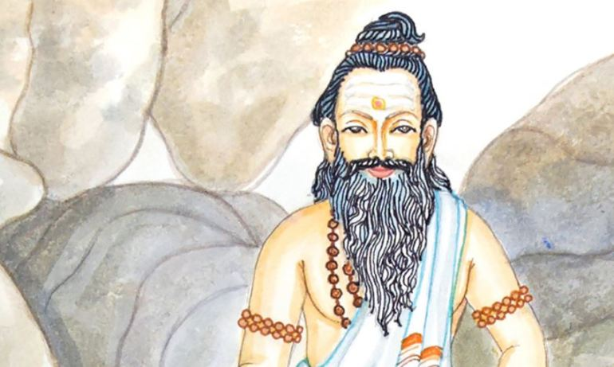
INTRODUCTION
During the 19th century there lived a great saint, in a village at Maharashtra, who was later known as Pujya Sri Guru Devar. He is an incarnation of Lord Shiva, and for his sincere devotees, he has appeared in the form of Lord Shiva. His details are not known to many people, since he doesn’t want his details to be disclosed among others. In one old Tamil book, his details were mentioned, and I got to know about him through that. He got married to a pious and a worshipful lady named as Sridevi, who is also considered to be an incarnation of Mata Parvati Devi. And they had sons and daughters. Even at the time of his daughter’s death, he didn’t prevent her from dying, and thought that the act is the desire of the god. But he has done many miracles in the life of his sincere devotees. Once he has saved a devotee from black magic, which was kept by his enemies, due to his promotion in the higher post in the Central Government. He tied a Raksha in his hand, and throughout his life, he was protected by that Raksha. Once, he tried to safeguard the life of his devotee’s wife by asking her to recite the name of Lord Shiva or his name. But due to her bad luck, she didn’t think about it seriously and not chanted the mantra, and due to that, suddenly due to fire accident, she was died. Due to that Gurudev has become very angry with the Fire God, Lord Agni Dev, and decided to punish him. But at that time, Lord Vinayaka appeared in the form of white elephant with the divine Amirtha pot in his trunk, and circumambulated Sri Gurudev, and made him to realise that everything is happening based on the fate, and there is no need to punish Lord Agnidev, and disappeared from that place. Then he has become pacified, due to the appearance of Lord Vinayaka in the form of elephant. But after her death, due to the grace of Sri Puja Sri Gurudevar, she has attained SALVATION.
Usually he will used to dwell only in the forest along with his wife and children. And he didn’t get any problem from the animals living in the forest. They will used to circumambulate and sit in front of them without giving any disturbance to them. He has got such great spiritual powers.
Once he has participated in a puja performed by his devotee, and suddenly, the devotee’s mother has called his son and said secretly, that the Guru while performing Puja has turned in the form of Lord Shiva, with snakes in his neck and wearing the tiger skin, and having a trisool in his hand. After the performance of the puja, the devotee has asked about this matter to Gurudev. And Gurudev said that his mother was a pious and a noble woman and due to that she has got his darshan in the form of Lord Shiva.
He also removed the diseases from the devotee’s body, removed black magic, and insisted them to chant the Shiva Mantra “OM NAMAH SHIVAYA” on a continuous basis, in order to get all the prospects in their life. He also changed the bad hearted souls into good ones, and made them to worship the god, and also shown his true form, and blessed them.
After his death, he has merged with Lord Shiva.
Let us worship the holy saint and be blessed.
“OM SREE PUJYA SRI GURUDEVARE NAMAHA”
“OM NAMAH SHIVAYA”
“OM SAKTHI PARASAKTHI”
WRITTEN BY
R.HARISHANKAR

SANGUKARNAR
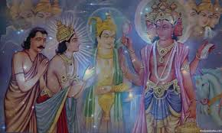
INTRODUCTION
During the Krita Yuga, in the Brahma Lok, among the several devas, there lived a noble deva, whose name is SANGUKARNAR. His main job is to come to the earth and pluck the fragrant flowers, and take it to the Brahma Loka, and give it to Lord Brahma Dev for performing puja to Lord Vishnu. Once, he got delayed to return to the Brahma Loka, and due to that the Puja was not performed in the stipulated time by Lord Brahma. And hence, he was cursed by Brahma to be born into the family of demons, in the earth.
Sri Sangukarna Dev was very much worried, and asked Brahma to apologize him. But Brahma has said, that the curse given by him cannot be changed even by himself, and the birth would be taken by him due to good reasons only, and he will be born as Bhakt Prahalad, and acts as an example for others, with regard to deep devotion on the god.
Due to that, in the Krita yuga, Sangukarnar was born as Bhakt Prahalad, and due to the blessings of Lord Narasimha, after the death of his father Hiranyakasipu, he ruled over the entire earth in a prosperous manner. And in the Dwarapa Yuga, Sangukarnar has again taken birth as the great king Bahlika, brother of King Santhanu, and ruled the Bahlika kingdom in a well versed manner.
And in the Kali Yuga, he again took birth as Vyasaraja, a great Madhwa saint during the period: 1460-1539, and he has constructed hundreds of Hanuman temples, and also served as Rajaguru to the Vijayanagar king, the great Krishnadevaraya and also for some time, served as the chief priest in the Venkateswara Temple, Tirumala, and done many miracles in the life of his devotees. And again in his next birth he was born as Venkatanatha during the year: 1595, who was later known as Sri Raghavendra Tirtha, and attained Jeeva Samadhi during the year: 1671. It is believed that till the age of 700 years he would live in this earth at his Jeeva Samadhi situated at Mantralayam, Kurnool District, Andhra Pradesh. He is doing deep meditation in his Samadhi by chanting Rama Mantra, without stopping even for a second, and blessing his devotees in a remarkable manner. And it is believed that after 300+ odd years, he will be relieved from his curse and he would leave this earth, and reach the Brahma Loka also called as Satya Loka, and will do his regular activity by helping Lord Brahma in his Vishnu puja activities.
It is also believed that similar to Lord Rama, he will take his sincere devotees along with him, to the Satya Loka, or leave them in other holy Lokas such as Swarka Loka, the heaven or Vitala Loka, the underworld, where the grandson of Bhakta Prahalad, the great king Mahabali is ruling over that Loka in a prosperous manner.
Let us worship the great Sangukarnar and be blessed.
“OM SREE SANGUKARNA DEVARE NAMAHA”
“OM SREE RAGHAVENDRAYA NAMAHA”
“JAI SREE RAM”
WRITTEN BY
R.HARISHANKAR
SRI CHINNIAH
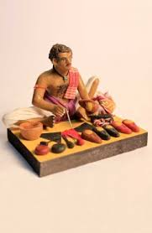
INTRODUCTION
Several centuries back, Chinniah, a Harijan Cobbler lived in a village near Tirupati. He was doing his profession of stitching the slippers and shoes for his customers and maintained his family through that income. Due to his past birth karma, he has suffered from severe paralysis.
One day while he was doing his profession, he saw a group of devotees who were on the way to the holy Tirumala, in order to worship the great Lord Sri Venkateswara. And he learned from them, that the Lord Venkateswara would remove the sins of his sincere devotees, and relieve them from their diseases, and would give great prosperities in their life. After hearing the pleasant words, from them, Chinnaiah prayed to the Lord, to cure his disease in order to maintain his family without any difficulties.
Due to his sincere prayers, gradually he has got relieved from his disease, and has become a healthier person. And he decided to stitch a nice pair of slippers for the Lord Venkateswara. Due to his prayers, The Lord appeared at his house, and made footprints on the flour spread in his house and disappeared. The next day, Chinnaiah saw this, and got very happy, and started doing his work, and very soon he has stitched a new pair of costly slippers to the Lord. And he took it to Tirumala. But the temple authorities didn’t permit him inside the temple, and they hit him hardly.
Due to that Chinnaiah fell down on the ground and got fainted. That night the Lord gave his divine darshan and relieved him from his wounds by touching his lotus hands on to his body, and accepted his slippers. On seeing this incident, the temple guards have asked him to apologise them, and took him to the temple. And the slippers were placed at the entrance of the hills and puja is performing daily. His statue is located at Alipiri, and the pilgrims are worshipping the great selfless devotee, Sri Chinniah. After his death, he has reached the holy abode of Lord Vishnu, the Vaikunda.
From this incident, we can know that god is not seeing a devotee’s caste or community, and he is seeing only his faith and bhakti on him. Lord Venkateswara is dwelling in the Tirumala, and showering his grace on the devotees, and removing all their problems, diseases and difficulties from their life. Lord Vishnu, who took the form of Sri Venkateswara is residing at Tirumala, only for our sake, in order to do goodness and to give peace and prosperity and all sorts of benefits to us.
Let us worship the great saint and the great Lord and be blessed.
“OM SRI BHAKTA CHINNIAH NAMAHA”
“OM SRI VENKATESWARAYA NAMAHA”
“OM SRI ALUMELU MANGAMMAVE NAMAHA”
WRITTEN BY
R.HARISHANKAR

SRI GOVINDARAO – GREAT DEVOTEE OF LORD VENKATESWARA
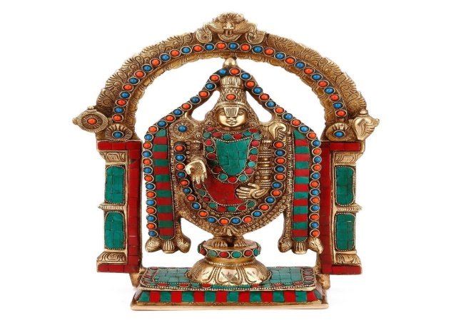
INTRODUCTION
Once there lived Sri Govinda Rao in a small village near Tirumala Tirupati Temple. He and his family were ardent devotees of Lord Venkateswara.
His main profession was making paintings on Lord Venkateswara, and selling it to the nearby merchants at a cheaper price, since he is doing the work as a service to the Lord Venkateswara. All of his family members were used to do puja to the Lord and offer neivedyam(Holy Prasad) to the god, and after the performance of the puja, they will distribute it to the participants of the puja, and to the neighbours. They will also worship the god in his temple on every Saturday, and have their morning breakfast, only after getting the darshan of Lord Venkateswara.
They also have cattle sheds at their home, and used to feed the cows properly with grass, vegetables, fruits and other cow fodder items. They also have the habit of offering free food to the poor people at their home during Saturdays. Additionally, Govind Rao’s wife used to prepare various food items with sweets and distribute it to the devotees of Lord Ventakeswara at the temple hills.
Once, one of his cows was missing. The cowherd boy has informed to him that he was unable to trace it. Immediately, Govinda Rao himself decided to search the cow, and at the night, he took a torch light and left his home.
He searched in lot of places near the holy mountains ranges of Tirumala, but could not find it. Suddenly, he fell down in a small pit at that dark midnight. He was very afraid and chanted the mantra “OM NAMO VENKATESAYA NAMAHA”, but no one was available in that place. Suddenly, he heard a voice, and he looked at that location, and to his surprise, he saw a beautiful tall young person, with a smiling face, and he helped Rao to safely come out from the pit. As soon as he was safely rescued by the great man, he bowed his head and thanked him. Suddenly the young man disappeared from that place, who was none other than our great Lord Sri Venkateswara.
He was very much delighted and thanked the lord for giving an opportunity to have his divine darshan. Very soon, he has traced his cow also, which was grazing in the nearby grass field, and he took it along with his home, and narrated the entire incident to all of his family members, with much joy and enthusiasm. He also shared the incident to the village people, and they also praised his bhakti on the god and praised the god, for showering his grace on to his sincere devotee.
Hence let us have great devotion on Lord Venkateswara, in order to get a blessed life.
“OM NAMO VENKATESAYA NAMAHA”
WRITTEN BY
R.HARISHANKAR

LORD INDRA
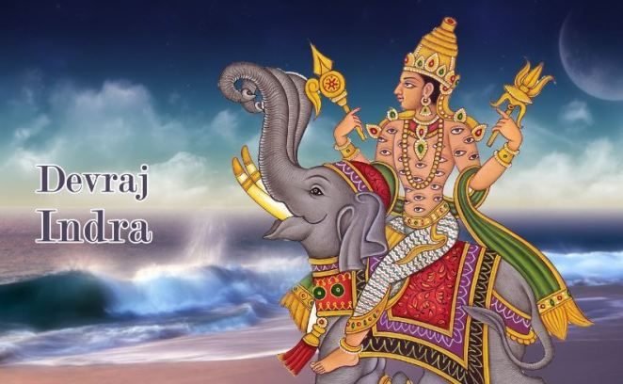
INTRODUCTION
Indra is a Vedic deity in Hinduism, and the king of the heaven. He is the son of Kashyapa and Aditi. He was mentioned in Rig veda, and described him as a most efficient warrior, and a learned scholar who contains valuable powers, and having the capacity to fight with asuras. He is guided by his guru “BRAHASPATI”.
IMPORTANCE
His wife’s name was Indrani. He rides an elephant called Iravatha, and having son and daughter, called as Jayantha and Jayanthi.
He is the god of the heavens and rains. He has got a great name in killing Vritrasura, the most fierceful asura through his Vajrayudha, and is surrounded by several crores of divine devas, who always sing in praise of him. Several rishis and saints also praised his glory and respected him. He was a great valour in the battle field, especially while fighting with the asuras. He looks very charm and gentle in nature.
He never unnecessarily fought with the asuras. Only if the asuras, gives any trouble, in that situation, he fought with them. He was a polite and a humble person. But it is also stated, that in certain situations, for keeping his position permanently, he has given some troubles for those who do severe penance on god. In order to safeguard his position, he has given some problems to those rishis who were in deep meditation.
But in general, he was a great person, and was the leader of devas, and controls the entire universe by his powers. Though, he was controlled by the Trimurthis, he acts freely for taking any decisions on waging war between asuras. Apart from this, he is a very good demi god, and is a clever person. He is interested in having pleasures like drinking divine drink, and listening to the dance of apsaras.
CONCLUSION
Devraj Indra, who was a great person, and the controller of heaven, may give us all the prosperities in our life, and help us to reach his divine place “HEAVEN” after our departure from earth. Let us pray to him, and be blessed.
“OM SREE DEVRAJ INDRANE NAMAHA”
WRITTEN BY
R.HARISHANKAR
LORD AGNI
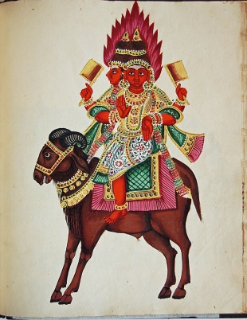
INTRODUCTION
Agni is the fire god, and considered as the Vedic god of Hinduism. He is also the guardian deity of the southeast direction. He is the son of Aditi and Kashyaba. His wife name is Svaha Devi.
IMPORTANCE
Agni is a major god along with Indra and Chandra. All the offerings of the homams will be made only through him. He resides in the agniloka. His name is mentioned in ancient Upanishads, puranas,vedas and in ancient divine texts. By conducting homams, and by chanting the names of various gods and divine devas, the fire god, carries all these powerful mantras to the respective places of the gods, and give us the benefits. His power is great and cannot be underestimated. He is very gentle and humble. He can be able to burn the entire universe into ashes, but always obeys the orders of the gods like Indra, Shiva,Brahma and Vishnu. He is mainly controlled by Lord Indra.
CONCLUSION
Lord Agni, the fire god, let us burn our bad thoughts and bad karma into ashes, and make us bright and pure. He is the god, who is present in all the temple rituals, and can be visibly seen by us in our naked eyes. His name is found in the texts of Buddhism and Jainism also. Without fire, we can’t do anything. Agni acts as the life force for a healthy body, and we are able to digest the food only with the help of Agni which is present in our body.
His image can be seen in some Hindu temples, and in Prithyanga Devi temple, Sholinganallur, a separate statue of Lord Agni is erected. In Arunachaleswarar Temple, the Shiva linga represents the element fire and is called as Agni Lingam. Fire plays an important role in celebrating Karthigai deepam festival. Various lamps are lit in every house of the devotees with much joy. Deepavali festival is also celebrated by the childrens with much interest by bursting crackers by using fire only. And our DAILY food is cooked only with the help for fire. Hence without the use of fire, we can’t sustain in this world. It is also one of the Panchabootha. Hence, let us worship “THE GREAT FIRE GOD” and be blessed.
“OM SREE AGNI BHAGAVANE NAMAHA”
WRITTEN BY
R.HARISHANKAR

LORD VAYU
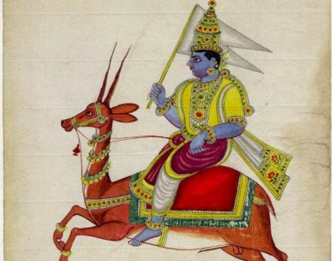
INTRODUCTION
Vayu is a Hindu deity, the wind god, and the father of Hanuman and Bheema. He is controlled by Lord Indra, the god of heavens. And he is a sincere devotee of Lord Vishnu.
IMPORTANCE
He was the father of Lord Hanuman in Tretha yuka, and has done a great service to Lord Rama. He was the father of Bheema in Dwapara yuka, and has done a great service to Lord Krishna. In Kaliyuga, he again incarnated as Madhwacharya to do service for the great Rishi Vedavyasa, and it is believed that still he is doing his divine service to Sree Vedavyasa in Bhadrikashram.
Lord Vayu contains a lot of important features. He is the base for all the living beings in the earth. Without his help, no one can survive in this world. Even by possession of his great power, he was a humble and a gentle demi god, who always worships Lord Vishnu and keep chanting his various names for ever. He is also been controlled by Lord Indra, and he acts as an assistant to him. He has to follow his instructions, and to act accordingly. Once Lord Hanuman in his childhood, tries to catch the sun god thinking that it was a fruit. By seeing his action, Lord Indra hit him with his powerful weapon Vajrayudha. Lord Hanuman could not withstand the power of the weapon, and he immediately fell on the ground and was laid in an unconscious state. By seeing his son’s condition, Lord Vayu, stopped his air circulation among the human and divine beings in the earth and heaven, and everyone was suffered by this act. After some time, the gods pacified vayu, and regained hanuman to his normal position, and offered many great boons to him. Lord Vayu became happy and again he circulated his air movement all over the heaven and the earth. With this incident, we can realize his great supreme powers.

CONCLUSION
We can’t live if we stop our breath. We are able to live only because of the Lord Vayu, who helps us for breathing in this world. Let us worship this great demi god Lord Vayu Bhagavan and be blessed.
“OM SREE VAYUDEVARE NAMAHA”
“JAI SREE RAM”
WRITTEN BY
R.HARISHANKAR

LORD VEERABAHU
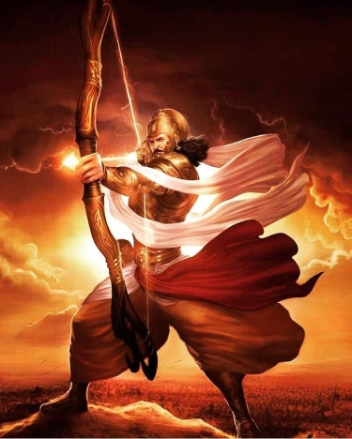
INTRODUCTION
Veerabahu is the Army Chief of Lord Muruga. Lord Muruga is the son of Lord Shiva and Goddess Parvathi. Through the power of Goddess Parvathi, nine soldiers were born to help Lord Muruga in the battle field. Among the nine commanders, Veerabaahu is the main commander of Lord Muruga’s army.
IMPORTANCE
Veerabahu acted as a mediator between Lord Muruga and the Asura King soorapadman. Veerabahu has advised soorapadman to avoid the war, and asked him to act in a friendly manner with Lord Muruga. But soorapadman arrogantly behaved with Veerabahu, and started the war with Lord Muruga. Veerabahu occupied an important role in winning the battle with soorapadman.

CONCLUSION
Veerabahu an army chief of Muruga, after winning the battle with Soorapadman, was given a permanent place in the abode of Lord Muruga. In most of the Murugan temples, a separate shrine will be there for Veerabahu. He was born from the supreme power of Maa parvathi, hence he is having all the good qualities like wisdom,courage,kindness and boldness.
He is sincerely listening to the problems of the de votees, and informing it to Lord Muruga. He removes the diseases of the devotees, and gives happiness in their life. He will be very much satisfied with those murugan devotees, who took kavadi and vel piercing in their body. He will take care of those devotees, who sincerely worship Lord Muruga. Based on their good and bad deeds, he will give the result. If a devotee cries for any help and call his name, he will be present there, and give his immense help. Let us worship this great Veerabahu, and let us chant his name and be blessed.
“OM SREE VEERABAHUVE NAMAHA”
“OM MURUGA VEL MURUGA”
WRITTEN BY
R.HARISHANKAR
SANATH KUMARAS
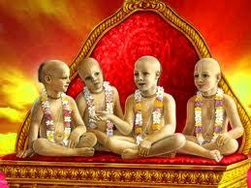
INTRODUCTION
The Sanath Kumaras are four rishis named Sanaka, Sanatana, Sanandana, and Sanatkumara. They are described as the first creations of Brahma. The four Kumaras were strict Brahmacharis(Observance of celibacy). They wander all around the entire universe. All the four brothers were talented in Vedas. They were learned Brahmins, and they were the sons of Lord Brahma. The Bhagavata Purana mentions them as an avatar of Vishnu.
IMPORTANCE
The four Kumaras learnt the Vedas at a younger age, and they became great Rishis. The Kumaras remained in the form of children due to their spiritual power. The four Kumaras are said to reside in Jana Loka. They repeatedly chant Lord Vishnu’s names and sing the glory of Lord Vishnu. Narada was regarded as the disciple of Sanath Kumaras.
According to sanath kumaras, Vishnu is the only refuge to all and he only grants MOKSHA to his devotees. His worship frees the people from their sins.
Once, the four Kumaras went to Vaikunta. And when they reached the main gate of Vaikunta, they were stopped by the Dwarapalakas, Jaya and Vijaya. The four kumaras were then got angered by their act, and punished them to take birth as demons for three consecutive births. The two guards were then born on earth, as Hiranyakashipu and Hiranyaksha in the Krita Yuga.
During the Treta Yuga, they were born as Ravana and Kumbhakarna and defeated by Lord Rama.
And in Dwapara Yuga, they were born as Sishupala and Dantavakra during the time of Lord Krishna.

CONCLUSION
The discourses given by Sanat Kumaras were found in Mahabharatha and Srimath Bhagavatha. According to them, Vishnu is everything in life. Without Lord Vishnu, we can’t sustain in this world. They further tell that when we continuously chants the name of Lord Vishnu, undoubtedly will reach the holy abode of Lord Vishnu. Lord Vishnu controls this entire universe. No one can live without the help of Lord Vishnu. Always think about Lord Vishnu to reach his abode, and to touch his lotus feet. Let us worship these four great maharishis, with sincere devotion and purity in our mind and be blessed.
Let us chant their names and live happily for ever.
“OM SREE SANAKAYA NAMAHA”
“OM SREE SANATANAYA NAMAHA”
“OM SREE SANANDANAYA NAMAHA”
“OM SREE SANAT KUMARAYA NAMAHA”
“OM NAMO NARAYANAYA NAMAHA”
WRITTEN BY
R.HARISHANKAR
GOPALA DASA
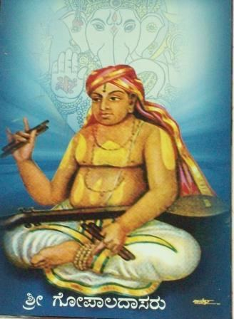
INTRODUCTION
Gopala Dasa (1721–1769), was a famous saint belonging to the Madhva tradition. He preached the Dvaita philosophy of Madhvacharya in South India through his various devotional songs.
LIFE
Gopala Dasa birth name was "Bhaganna". He was born in a village at Karnataka. He became a disciple of Vijaya Dasa, and was a great composer of devotional songs. He is well known in various kinds of arts. He composed bhakti songs in praise of the Lord Vishnu.
IMPORTANCE
Once Jagannatha Dasa, was invited by Madhva Philosopher Vijaya Dasa to dine with him. Jagannatha Dasa who was a great scholar in sanskrit, avoided taking food with him and lied him that he is having stomach pain. Soon Jaganatha Dasa actually began to suffer from stomach pain. Jagannatha Dasa was relieved from stomach pain by Gopala Dasa, who was also a great saint following the philosophy of Madhva. Gopala dasa soon realized his mistake and become a great Madhva saint, and preached the philosophies of Madhvacharya throughout the country.
CONCLUSION
Gopala Dasa, who was a great saint, and an ardent devotee of Lord Hari, was the main person in spreading the madhva philosophy among the masses. He has cured the diseases of his devotees, and spread the importance of devotion among the masses. He relieved the sins of his devotees through his sincere worship on Lord Hari. During his period, his devotees were gathered in group to attend his divine concerts. They have deeply involved in HARI BHAKTI through his devotional songs. Let us worship this great devotee of Lord Hari and chant his name and be blessed.
“OM SREE GOPALA DASARE NAMAHA”
“OM NAMO NARAYANAYA NAMAHA”

WRITTEN BY
R.HARISHANKAR

JAGANNATHA DASA
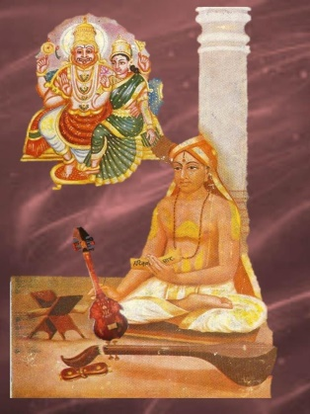
INTRODUCTION
Jagannatha Dasa (1728–1809), was born in Karnataka state, was a famous saint in india. He was also a great scholar in Sanskrit.
His birth name was Srinivasacharya. He wrote several devotional songs in praise of Lord Hari. His work Harikathamritasara, was considered as a popular divine work, and it was praised by the “HARI BHAKTAS”, as if the Original Divine Fluid (Amirtham) was flown into their ears, and it was well accepted by the people. He concentrated his entire time on the devotion of Lord Hari, and on composing various divine songs in praise of Lord Hari.

LIFE
During the period of Jagannatha Dasa, Hari Bhakti movement was invoked among the people in full swing. And mainly it was inculcated on the holy town of Mantralayam, which was the holy abode of the great saint Guru Raghavendra, who is in Jeeva Samadhi, and showering his grace to his devotees, and doing miracles in their life.
Jagannatha Dasa, who was once avoided to dine with Vijaya Dasa, was severely developed with stomach pain, and then he visited Gopala Dasa and was cured by him. Jagannatha Dasa became a disciple of Gopala Dasa, and began to compose songs in praise of Lord Vishnu.
IMPORTANCE
He was a great scholar and talented in all arts. He was a spiritual guru, and acted as a guide to his devotees. He shows the right path to his devotees by asking them to concentrate their entire attention only towards “LORD HARI” and not on other worldly pleasures. He advised his followers to sincerely worship Lord Hari to enter into the path of “SALVATION”. He strongly advocated the spiritual path among his followers.
CONCLUSION
Sri Jagannatha Dasaru who was popular in composing divine songs on Lord Hari, and also a great saint, occupied a key role towards spreading the devotion among the people. He taught the principles of Hinduism in a simple manner, which can be easily followed by the common people. Let us worship this great saint with pure bhakti in mind, and chant his name and be blessed.
“OM SREE JAGANNATHA DASARUVE NAMAHA”
“OM NAMO NARAYANA”
WRITTEN BY
R.HARISHANKAR

VIJAYA DASA
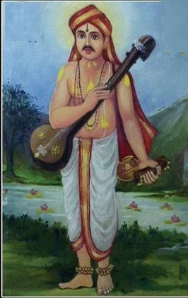
INTRODUCTION
Vijaya Dasa(1682–1755), was a great saint from Karnataka, India. He spread the importance of the philosophy of Madhwacharya across South India through his devotional songs.
LIFE
Vijaya Dasa was born in a Brahmin family in Karnataka. At a younger age, he went to varanasi and studied Sanskrit. He became a scholar in varanasi. Through the divine grace of Sri Purandara Dasa, he has become a famous saint and he was called as Vijaya Dasaru, and he occupied an important role in spreading Dvaita teachings.
IMPORTANCE
Through his great divine compositions, he was regarded as a great scholar among all the people. And he was well versed in Kannada literature.
He performed many miracles in the life of his devotees and made them to live happily. He has turned the uneducated person into an educated person, cured the diseases of the people, spreading the bhakti movement of Lord Narayana. According to him, only due to the divine grace of Lord Narayana, he has performed the miracles in the life of his devotees. He is considered as the spiritual heir of the Great Saint Purandara Dasa, and also considered as an incarnation of Bhrigu Maharishi.
He practiced the habit of singing devotional songs, and chanting of god’s name amongst the people. According to him, the impossible can be made into a possible, by chanting the glory of God’s name, and to get deeply attached with him. He was the main saint in spreading the importance of Lord Narayana through his famous compositions, which was developed and sung by him.

CONCLUSION
A great and a kind hearted saint, who took birth for the welfare of the people, and for spreading the importance of “HARI BHAKTI” among the masses. During his period, he solved the problems of the people, and turned their sorrow into joy. He has given them health, wealth and happiness in their life. Let us worship this great saint and chant his name and be blessed for ever.

“OM SREE VIJAYA DASARUVE NAMAHA”
“OM NAMO NARAYANAYA NAMAHA”

WRITTEN BY

R.HARISHANKAR

Avatars of Lord Shiva
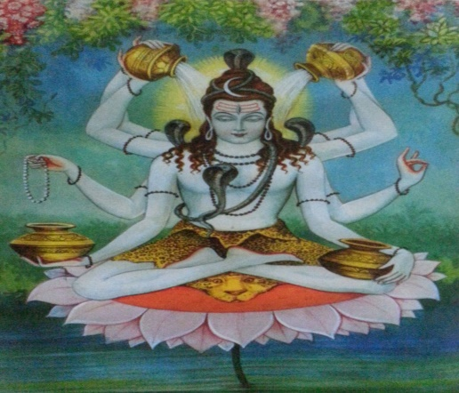
Introduction
Before going through the avatars of Lord Shiva, According to me, most of the people are not aware about all the avatars of Lord Shiva. Hence it is important to write about the avatars of Lord Shiva. Most of them would have studied the avatars of Lord Vishnu. In many temples, several paintings are inscribed depicting the avatars of Lord Vishnu in Vishnu Temples. Similar to that, I have seen in one old and ancient temple, Arulmigu Kachaleeswarar Temple at Armenian Street, Parrys,Chennai – 600 001. Beautiful framed pictures are affixed inside the walls of the temple mentioning about the avatars of Lord Shiva in that temple. It is a must to visit that temple, so that we can get the glimpse about the avatars of Lord Shiva by seeing the pictures.

Here I have mentioned twelve avatars of Lord Shiva, which he took in various circumstances. It is a must to read the importance of these avatars, since it will purify our mind and also our health will turn good and several positive vibrations will occur by reading the avatars of Lord Shiva.

1.Rishi Durvasa
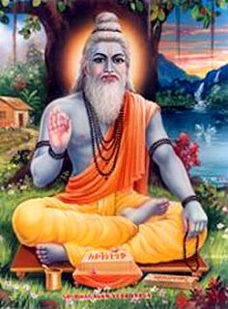
This form of Lord Shiva is famous for its short temper and anger. The incarnation came into existence to maintain peace and harmony on earth. Once Atri, the manasputra of Lord Brahma went for penance to the banks of river Nivindhya. He commenced his penance and it resulted into a massive fire that spread to all the three worlds. Seeing this devastation, Lord Brahma, Vishnu and Shiva blessed Atri. Later Lord Brahma, Vishnu and Shiva were reincarnated as the moon, Dutt and Durvasa. Apart from his anger, he is a very gentle person, and blesses his devotees, and would satisfy all the desires of them. He would follow his rituals in a proper manner and will do constant meditation.
OM RISHI DURVASAYA NAMAHA
2.Hanuman
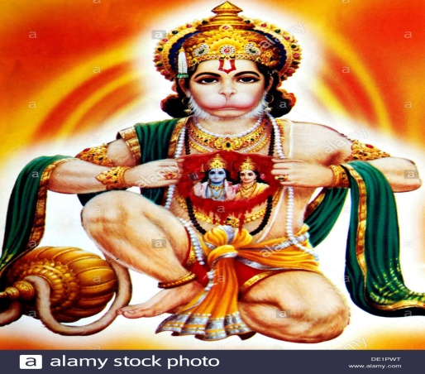

The beloved Lord Hanuman is also one of the incarnations of Lord Siva. He has been created specifically for serving Sree Rama and to show the importance of Bhakti among human beings. He is a Chiranjeevi and is still living in the earth in Kailash Mansarovar by chanting Rama Mantra. He has got super natural powers and he has done many wonders during Tretha Yuga and even still he is listening to our prayers and fulfilling our needs and wishes. By listening to his Hanuman Chalisa, our health condition will be improved and mind will get puried and we will get happiness in our life.
JAI SREERAM. JAI HANUMAN

3.Rishabh avatar
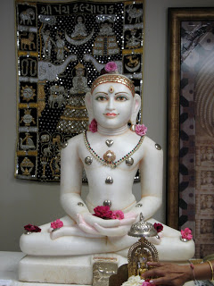
Once the ocean was churned and a large vessel containing nectar was emerged out of the ocean. A huge battle was fought between the demons and the divine deities over this vessel of nectar. To distract the attention of demons, Lord Vishnu created numerous beauties. While the demons took these beauties to the ‘Patal Lok’ with them, the deities drank all the nectar. This angered the demons and they tried to kill the divine deities. To save their lives, Lord Vishnu went to Patal Lok and killed them all. Although he killed the demons but he was left mesmerized by the beauties there. The union of Lord Vishnu with the beauties resulted in many children. To save these children, Lord Shiva went to Patal Lok in the form of an Ox – Rishabh.
OM SREE RISHAB DEVAYA NAMAHA

4.Yathinaath Avatar
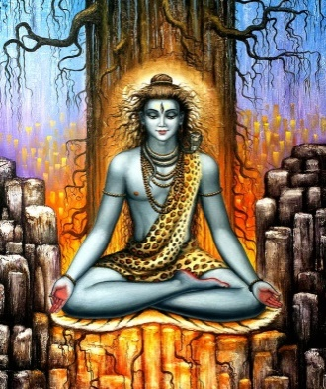
This form of Lord Shiva is a personification of pleasant behaviour towards guests.
There is a story about Yatinaath which goes like this:
“There was once a tribal named Aahuk. He and his wife were ardent devotees of Lord Shiva. One day Lord Shiva visited them in the form of Yatinath. Since they had a very small hut which could accommodate only two people, Aahuk decided to sleep outside and let the guest sleep in. Unfortunately Aahuk was killed by a wild animal at night. In the morning, finding Aahuk dead, his wife decided to kill herself. Then Lord Shiva appeared in His real form and blessed her with a boon that she and her husband will be reborn as Nala and Damayanti and Lord Shiva will unite them.”
OM SREE YATHINATHAVE NAMAHA

5.Krisnadarshan avatar
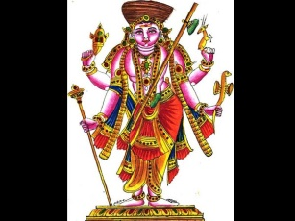

This avatar of Lord Shiva symbolizes and highlights the importance of yagna and other religious practices. This avatar of Lord Shiva told the importance of yagna and asked the people to follow it to lead a happy and healthy living. He has asked to do yagna to get rain and for the wellness of the country. He insisted that by doing yagna, crops will grow properly and will yield good results.
OM SREE KRISHNADARSHANE NAMAHA
6.Avdhooth avatar
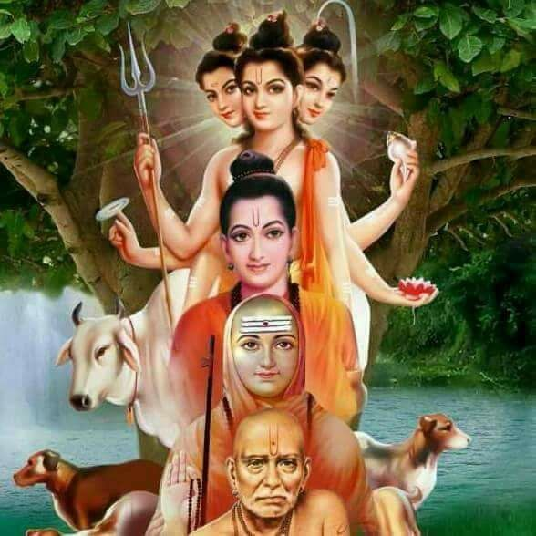

In this incarnation Lord Shiva destroyed the ego of Lord Indira and asked him to live a life without ego.
OM SREE AVADOOTHAYE NAMAHA

7.Bhikshuwarya avatar
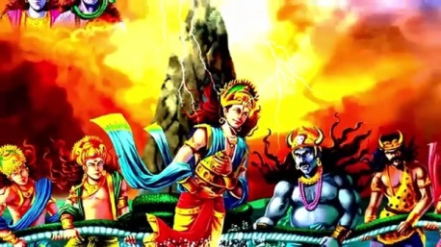

Although in the Hindu Trinity, Lord Shiva is regarded as the destroyer, but he is also said to be the protector of life. This incarnation is a depiction of Lord Shiva as the protector of the universe. Here it is said, he is the one who is protecting the humans and giving them all necessities in their life.
OM SREE BHIKSHUWARYARE NAMAHA
8.Sureshwar avatar
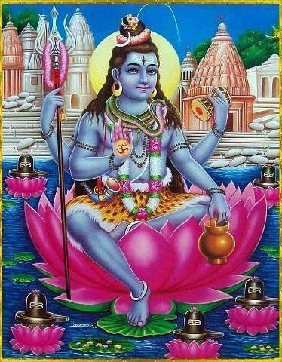

This avatar of Lord Shiva depicts love towards the devotees of Lord Indra. This form of Lord Shiva represents the love and care of him towards his devotees.
OM SREE SURESHWARARE NAMAHA

9.Keerat avatar
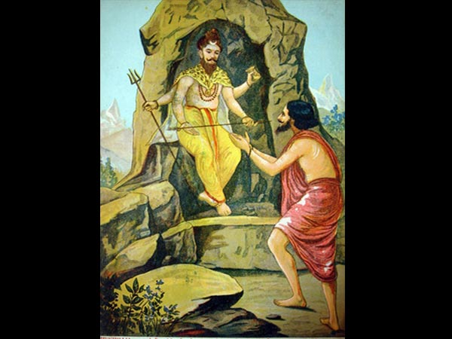

Once, Arjuna performed penance to please Lord Shiva. In this avatar Lord Shiva appeared as a Keerat(Hunter) to test Arjuna and his principles. He tested his valour and removed his ego, and then he gifted pasupastra, which he used it in Gurukshetra war and won in the war.
OM SREE KEERATARE NAMAHA

10.Suntantarka avatar
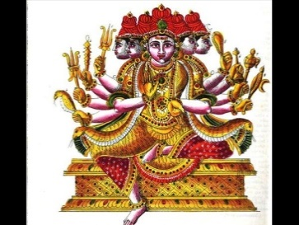

Lord Shiva appeared in this avatar to marry Goddess Parvati by seeking permission from her father Himalaya – The mountain king.
OM SREE SUNTANTARKAVE NAMAHA
11.Brahmachari avatar
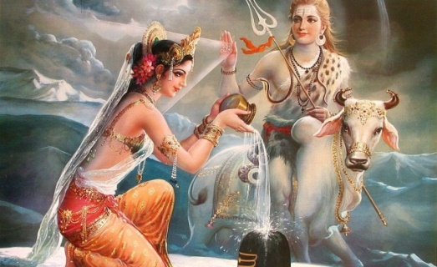

After Goddess Parvati sacrificed herself during her father’s yagna, she took rebirth in Himalayas’ house. She worshipped Lord Shiva for years so that he could be her husband again. Lord Shiva appeared in this incarnation to take Goddess test Parvati.
OM SREE BRAHMACHARYARE NAMAHA
12.Yaksha avatar
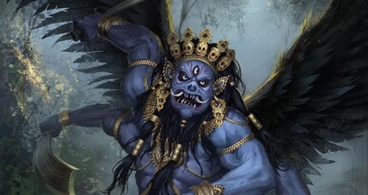

To remove ego and self-pride from the minds of many gods, Lord Shiva took this form. This avatar shows that whoever may be, they should not act in a wrongful manner and should show kindness among others.
OM SREE YAKSHAYA NAMAHA
CONCLUSION
By reading the above avatars, we would know the greatness and kindness of Lord Shiva who took these avatars for the sake of human beings. Let us pray to him and seek his blessings to lead a good life.
OM NAMAH SHIVAYA
WRITTEN BY
R.HARISHAN KAR
BHAIRAVI
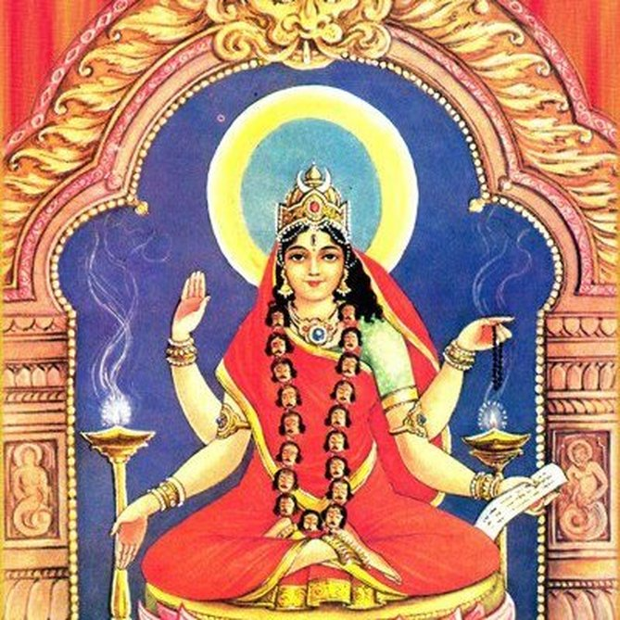
INTRODUCTION
Bhairavi is a Hindu goddess and is one among the Mahavidyas. She is the consort of the shiva avatar Kala Bhairava.
Bhairavi appears to be in fierce form and also called as Tripurabhairavi. She contains four hands and blesses us in her right hand. She is the protector of the entire universe and safeguards us from all sorts of natural calamities, evil forces and from our enemies.
By reciting the shloka meant for her, we can get rid of all the evil effects and also will realize more energy in our mind and body. We will also get spiritual energy by continuously worshipping her and chanting her various names. Mainly she removes the fear from our minds during the time of our death, and will help us to move towards the spiritual path during our life. She wears red garments and we can offer red saree to her deity in the temples meant for her.
Tripura Sundari and Tripura Bhairavi are closely related with each other, and give us better prospects in our life by worshipping them. Bhairavi is none other than our Mata Parvati, and she loves her children and guides them in all walks of their life. The only thing is that, we must sincerely worship her with utmost faith and devotion in our mind.
IMPORTANCE
Bhairavi controls the bad changes taking place in our life. And though she doesn’t change our fate, but she makes ourselves to adjust to live in this KALIYUGA, by giving more courage and confidence in our mind. She also will reduce the level of our sufferings, and remove our sins. She is the affectionate mother for us, and will try to reduce our problems, and make us to concentrate ourselves on good activities. Being the consort of Kalabhairava, by worshipping Kalabhairava in the shiva temples, she will become happy and will give us a happy and a prosperous life. She also relieves us from several dreaded diseases and gives more strength to our mind and to our body.
Bhairavi temple in Brahmapur, Siddha Bhairavi temple in odhisha, Linga Bhairavi temple in salem are the famous temples dedicated to the goddess Bhairavi.
By donating food, clothes, educating the poor children and providing shelter to the poor, will immensely satisfy her, and showers her grace on us. She can be worshipped by visiting her temples, or otherwise we can worship her with her laminated or framed photo in our puja room, and can offer flowers and fruits and can prepare some sundal (CHICKPEAS) and offer her as naivedyam (Holy Prasad - Food offering), and after the puja, we can distribute the Prasad to the people. It is advisable to chant the shiva panchakshara mantra “OM NAMAH SHIVAYA” and to chant “OM MAA TRIPURA BHARAVI DEVIYE NAMAHA” on a daily basis.
Let us pray to the divine holy mother and be blessed.
“OM SREE KALA BHAIRAVA SAMETA SREE KALA BHAIRAVIYE NAMAHA”
“OM NAMAH SHIVAYA”
“OM SAKTHI PARASAKTHI”
WRITTEN BY
R.HARISHANKAR

SOHAM SWAMI
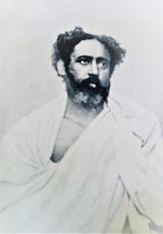
INTRODUCTION
Soham Swami (1858-1918) was a Hindu saint from India. He was the disciple of the Advaita Scholar Tibbetibaba. Tibbetibaba was a great spiritual saint of India. His birth name was Shyama Kanta Bandopadhyay.
LIFE
Soham Swami was born in a small village in a brahmin family at Bikrampur district,West Bengal in the year 1858. And at his younger age itself, he was interested in doing yoga and meditation and also contains great physical energy and strength.
His father worked as a record keeper in the district court in Tripura. He studied in west Bengal, and was an intelligent boy, and able to grasp all the subjects without much difficulty, and also marked as number one in the sports.
In 1899, he left home and became a saint. His guru was Tibbetibaba, and he renamed him as ″SOHAM SWAMI″.
Soham Swami constructed an ashram in uttarakhand. His disciple was Niralamba swami.
He followed the spiritual path of Advaita.
In the year 1918, Soham Swami died in his hermitage at Bhawali. His samadhi is located at Palitpur, Burdwan, India.
DEVOTIONAL WRITINGS
- Soham Geeta
- Soham Tattva
- Soham Samhita
- Common Sense
- Truth
- Shambuka Badh Kavya,
- Bhagabat Geetar Shamolochana

IMPORTANCE
He was a great saint and also a body builder contains physical and spiritual powers. He asked his devotees to keep their body tight and fit in order to protect them from their enemies and also to eliminate the diseases. He was an honest and straight forward person. He never hated anybody during his life, and had spoken to everyone in a kind manner, and interacted with his followers in a pleasing manner. He insisted his followers to do yoga, meditation, regular exercise and worshipping god regularly. He also cured the mental and physical diseases of his followers, through his spiritual powers, and also done many charitable activities, including providing food to the poor and the needy.
Let us worship this great yogi and be blessed.
“OM SREE SOHAM SWAMIYE NAMAHA”
WRITTEN BY
R.HARISHANKAR

EZHUTHACHAN
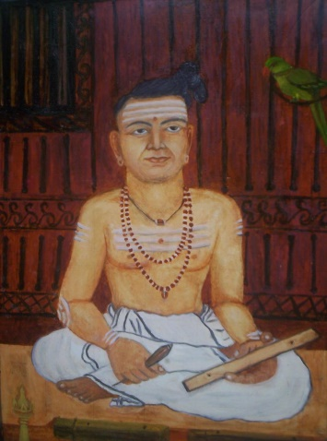
INTRODUCTION
Ezhuthachan(1495-1575) was a Malayalam saint and a poet. He is also known as the father of Malayalam language.
LIFE
Ezhuthachan was born in Trikkandiyoor. At a younger age, he became a saint and travelled throughout southern India, and settled finally at Palakkad.
He has contributed a lot towards Malayalam language. He translated, the Ramayana and Mahabharata, to Malayalam in a very simple manner, so that even a common man will be able to read it. He got great skills in writings poems and was a great scholar in Malayalam.
IMPORTANCE
Ezhuthachan strongly invoked the Bhakti movement in Kerala. In his name, literary honour awards are presented by the Kerala government, and it is known as the "Ezhuthachan Puraskaram".
Narayana Pattathiri who was the author of Narayaneeyam, was a friend of Ezhuthachan, and it is said that Ezhuthachan has helped Pattathiri in writing his famous text Narayaneeyam, and he has asked him to write his text by beginning with Matsya avatara(Fish avatar of Lord Vishnu), and then to proceed the remaining avatars of Lord Vishnu, and after that explaining the childhood glorious deeds of Lord Krishna in a detailed and attractive manner.

CONCLUSION
Ezhuthachan was a great poet, and a devotee of both Lord Vishnu and Shiva. He treated both of the gods as one and the same. He has chosen the path of spirituality, and attained a great success in his life. Let us worship this great poet and be blessed.
“OM SREE EZHUTHACHANE NAMAHA”
WRITTEN BY
R.HARISHANKAR

SATYAKAMA JABALA
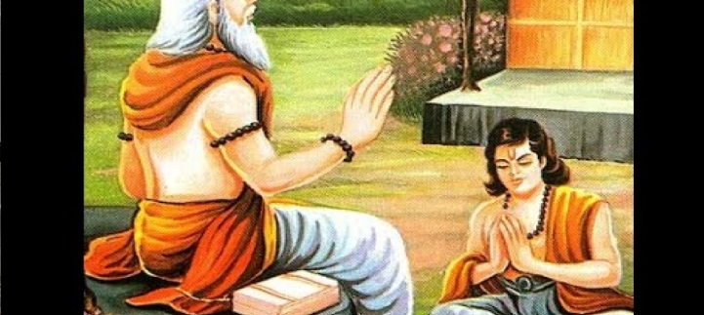
INTRODUCTION
Satyakama Jabala was a pious boy, who has later become a holy sage, and he was mentioned in the sacred text, the Chandogya Upanishad. Once when he asked the name of his father, his mother was unable to tell, since due to the family condition, she had chosen a wrong path. But Jabala, was a very active and an intelligent boy, who went to the sage Haridrumata Gautama, to learn education from him. And he told about his true condition. The sage was convinced with the boy's honesty and accepts him as a student in his school.
As per the advice of his guru, he got knowledge from the divine demi gods and he returns to his teacher and humbly learns the remaining portion of his education. A great Upanishad named as “Jabala Upanishad” was written by him.
Jabala has become a famous sage, and was well accepted by the other sages, due to his vast ocean of knowledge and for his great spiritual powers.
IMPORTANCE
Due to bad fate, though his mother went in a wrong path, he was a good person, and learned all the divine subjects from his guru, and he corrected his mother also, and turned her into a noble and a worshipful woman. After becoming a great sage, through his yogic powers, he helped lot of people, and washed out their sins, and took them into the spiritual path. His greatness and importance cannot be described in full, since he contains full of good features. He was also good at meditation and yoga and shared his knowledge with others. He conducted devotional lectures to the people, and made them to realize their spiritual energy, and asked them to chant the holy mantras on god.
Let us worship the great sage and be blessed.
“OM SREE SATYAKAMA JABALA MAHARISHIYE NAMAHA”
WRITTEN BY
R.HARISHANKAR
INDIAN FESTIVALS
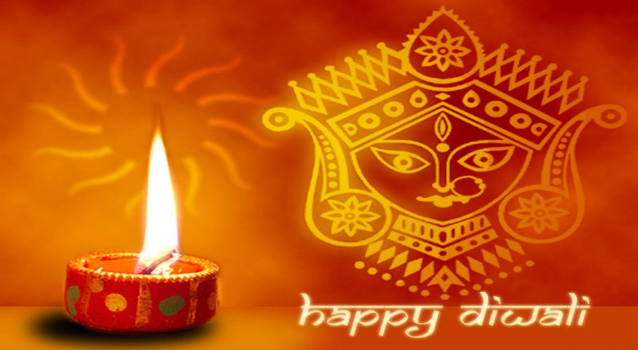
INTRODUCTION
In India, the celebrations of fairs and festivals are considered as an enjoyment for all the people, especially the children.
Indians from various religious groups celebrate their respective festivals with much joy and enthusiasm and they will offer prayers to the gods and worship them for their prosperity.
There are a large number of Hindu religious festivals celebrated throughout the world. Hindus living in foreign countries also celebrate the festivals as if they are celebrating in their home town. They will not forget their Indian culture, and celebrate it as a token of paying respect to the god.
Most important festivals widely celebrated by the Indians throughout the world, are: Diwali, pongal, Navratri, Vinayaka Chaturthi, Krishna Jayanti, Maha Shiv ratri, Hanuman Jayanti and Ram Navami.
- Holi Festival is mainly celebrated by the north Indians. It is celebrated in order to mark the killing of Holika by Prahalad, the demoness aunt of Bhakt Prahalad. It is a festival for destroying the evil. It is a celebrated for more than a week. During this festival, people throw coloured water on each other in a joyful mood.
- Diwali is the festival of lights. Diwali is also a festival celebrated similar to the people celebrating the Christmas festival in the foreign countries.
- Durga Puja: Durga, is also worshipped as Amba or Jagdamba, Annapurna, Bhairavi, and in many other forms by the Indian people, during the Navratri festival days.
- Chhat Puja (Festival dedicated to the Sun God also known as Surya Bhagawan). Chhath is mainly celebrated in Bihar but is also celebrated in other states by the north indian temple. It is a festival dedicated to the Sun God for fulfilling wishes and getting relieved from various diseases, since sun god is capable of relieving us from our various diseases, and gives us peace and prosperity in our life.
- Ratha Yatra: Rath Yatra is the festival related with Puri Jagannath.It is the most important festival of Bengalis and Odias and celebrated in Odhisha in honour of Lord Krishna Bhagawan.
- Raksha Bandhan: Raksha Bandhan is a festival mainly celebrated by the north Indians in order to show their bondage of love between the brothers and sisters.
- Thai Pongal: Pongal is one of the most popular harvest festivals of Tamil Nadu. It will be celebrated on January 14th or 15th of every year, along with the successive Mattupongal and Kaanum Pongal festivals. People will cook pongal in their homes, and offer it to the sun god, and eat it with the company of their friends and relatives.
- Onam: Onam is the harvest festival of Kerala. Onam is traditionally a Hindu festival celebrated in Kerala, in order to welcome their great king Mahabali, who once ruled kerala, and was very much liked by his people for his golden rule, and now living in the pathala loka, the netherworld. Keralites will prepare sumptuous food in order to welcome their beloved king Mahabali at their home on the onam festival day, and will share their delicious food with others, and nowadays, many people are donating food to orphanages and old age homes on onam festival day considering it as a charitable activity.
- Vasant Panchami: Vasant Panchami is celebrated for getting the blessings of Mata Saraswati, the education goddess.
- Thaipusam: Thaipusam is a Hindu festival celebrated mostly by the Tamil people. The festival marks the occasion when Parvati gave Murugan a spear in order to destroy the demon Soorapadman.
- Maha Shivaratri: Maha Shivaratri is celebrated by the devotees of Lord Shiva and used to offer bilva leaves to him. It will be celebrated during February – March. Devotees would observe fasting on that day, and chant various slokas and mantras of Lord Shiva. They will visit to the nearby shiva temples, and some of them will stay in the temple for the entire night, in order to watch all the pujas of Lord Shiva.
- Rama Navami: Rama Navami is celebrated as the birth day of Lord Rama. It is celebrated during April – May, and people would visit to the Ram temples and Vishnu temples, and pay their respects to the god. By chanting the rama mantra “JAI SREE RAM” along with “JAI HANUMAN” will bring all the prosperity in our life.
- Gudi Padwa: Gudhi Padwa is celebrated as New Year Day by Marathis, Konkanis and Sindhis. According to the ancient Brahma Purana, it is believed that during this day Lord Brahma had first created the world.
- Ugadi: Ugadi is a New Year day for kannadigas and telugu people.
- Vishu: Vishu is a Hindu festival celebrated in Kerala. It usually falls on 14th April of every year.
- Tamil New Year: The Tamil New Year is celebrated mostly by the Tamil people and it usually falls on 14th April of every year.
- Hanuman Jayanti: Hanuman Jayanti is celebrated as the birth day of Lord Hanuman. By worshipping Lord Rama and Hanuman on this day, we get great physical and mental strength and can attain all the prosperity in our life.
- Guru Purnima: Guru Purnima is the festival where devotees would offer prayers to their guru. It is also celebrated as the birth of Sage Veda Vyasa. In Raghavendra and Sai Baba temples, lot of devotees would worship their beloved gurus and get their divine blessings.
- Mahalakshmi Vrata: Mahalakshmi Vrata is a puja performed by married Hindu women for the well-being of their husband, and also for getting good fortunes in their life.
- Krishna Janmaashtami: Krishna Janmaashtami is celebrated as the birth day of Lord Krishna. During this day, devotees would visit Vishnu or Krishna temples and offer prayers to the god, and also prepare various of hot snacks and offer it to Krishna, and have it along with their neighbours.
- Radhastami: Radhastami is celebrated mainly in Northern India as the birth day of Mata Radha, consort of lord Krishna.
- Ganesh Chaturthi: Ganesh Chaturthi is celebrated as the birth day of Lord Ganesha. It is celebrated by all the hindus, and worship the divine god, by buying a clay statue of god at their nearby pavement shops. It is the most important festival in Maharashta.
- Kartik Poornima: A main festival is celebrated in Varanasi and it is celebrated by Lord Murugan Devotees, and shiva devotees.
- Skanda Sashti: Skanda Sashti festival will be celebrated during October–November of every year. It is one of the important festivals of Lord Muruga and it is celebrated as a victory of Muruga against the Demons.
- Karthikai Deepam: Karthikai Deepam is the festival of lights and mostly celebrated by Tamil Hindus on the full moon day of Karthikai month on November-December.
- Kumbh Mela: The Kumbh Mela, is mainly celebrated in north india, and lot of people would visit the holy place of Haridwar and offer their prayers to the sacred river ganga and to Lord Shiva and Mata Parvati.
- Godavari Pushkaram: Godavari Pushkaram is the celebration of festival of the river Godavari. It occurs once in every 12 years. The river Godavari took birth at triambakeswar of Nasik. It flow through various regions of Telangana and Andhra Pradesh.

- Naga Panchami: Naga Panchami is a worship of snake gods, and celebrated throughout india and in Nepal. In north india, people will visit the shrine of Mansa Devi, haridwar and offer their prayers to the serpant goddess, who is also the sister of the great serpant king Vasuki.
CONCLUSION:
Thus Hindu festivals are celebrated with much joy and interest by the Hindu people in India and also by people from all over the world. Though certain changes are there towards celebrating Hindu festivals in ancient times and in current trend, the joy of celebration remains the same. The bhakti spirit of the people also will never change.
CELEBRATION OF FESTIVALS OCCURS HAPPILY ACROSS THE WORLD AND PEOPLES ARE CELEBRATING THE FESTIVALS WITH MUCH JOY AND INTEREST, AND THAT TOO, MAINLY CHILDRENS WHO ARE IN THEIR BELOW 10’S.
DEVELOPED BY
R.HARISHANKAR

LORD VINAYAGA
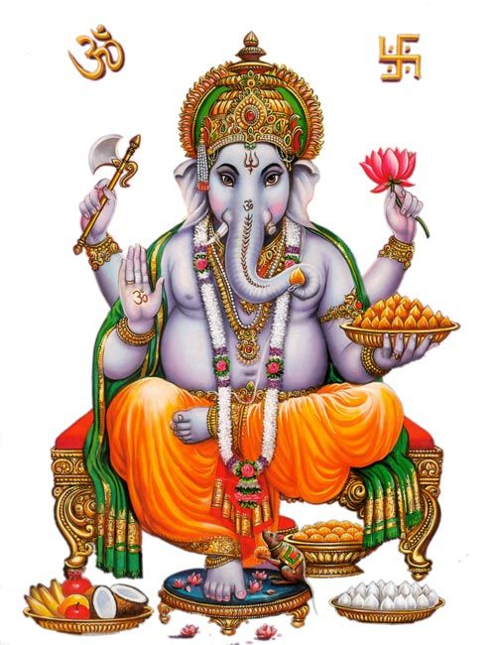
Lord Vinayaga is the first god in the hindu tradition. Every hindu worship lord vinayaka as an obstacle remover and people will worship him daily before doing their daily routines.
Lord Vinayaka is the symbol of Wisdom and Faith. He is regarded as the god of gods. Lord Ganesh Temple is situated in almost all parts of India. Even under a tree, he will be available. He cannot be ignored when we start a new venture or any other new engagement.
My mother Mrs.R.Saraswathi has written Sri Vinayaka Puranam alongwith Muruga Puranam(Two Parts) for Prema Presuram,Rangarajapuram,Kodambakkam,Chennai during 1960’s. Still now that books are available in all leading book shops. Several times she has been safeguarded by Lord Ganesha from various accidents and ill health.
Vinayaka Chaturthi is celebrated in all parts of India with much joy and interest. Idols of vinayaka will be found all over the streets on the occasion of Ganesh Chaturthi.
It is mentioned in our puranas, that even divine gods worship lord vinayaga before doing any new activity. Such a kind of importance is given for Lord Ganapathi. Since he emerged from Goddess Parvathi, he possess the sakthi element. That is, protecting and safeguarding the people and removing the evil elements in their life.
Almost in all Shiva and Vishnu temples, Lord vinayaga’s idol will be there. Abhishekam and Archanai will be done with much speciality. He is also called as Aingaran, five hands including his thumbikai. Aingarathane, Anaimugane is the most popular song of Lord Vinayaka which will be sung during Vinayaka Chathurthi in temples.
Lord Vinayaka’s statue will be there is almost all hindu temples. In some Raghavendra Mutts and Sai Baba Temple also, in the entrance, Lord Vinayaka Idol will be there. People can perform pooja to Lord Ganapathi without much strain. By offering Arukampul itself while performing archanai, he will be satisfied and will fulfil our needs and wants.
If we worship him with pure bhakti, he will be readily available to come to our house and will partake with our neiveidiyams and bless us.
Lord Ganesha’s history is described in many puranas. He was blessed and got various boons and also got the first god position from the divine gods.
He is the elder brother of Lord Muruga, and described as a playful boy during his childhoold, similar to that of Lord Krishna. He is very fond of Mothagams. It is advisable to prepare Mothagams during every Sankatahara chathurthi ( which comes once in a month) and to offer to Lord Ganapathi as Neiveidiyam along with various flowers and Arukampul. If we face any problem and call him, instantly he will be available and clear our problems. His vahana is Mushika.
In Hindu trinity, he is praised by various sages as remover of obstacles, bring luck to people, fulfilment of needs and wishes of people and finally giving salvation.
He is praised with various slokams. Women sage and poet Avvaiyar has written songs on him. Hence it is advisable for each and every person to worship Lord Ganapathy, before doing any work and also before worshiping any other god.

His famous temples are situated in Chitoor District- Kanipakkam Vinayaka temple and also in Mumbai –Ganeshji Temple and Karnataka – Idagunji Vinayaka Devaru, Trichy – Malaikottai Temple. Almost in all temples, free food is being offered as prasadam for about 100 to 200 devotees.
OM SREE GANESAYA NAMAHA

WRITTEN BY
R.HARISHANKAR

LORD MURUGA
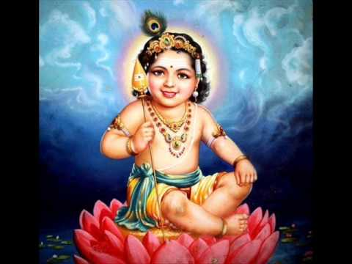
INTRODUCTION
Lord Muruga, also known as kanda,kadamba,kathirvela,senthilandava and karthikeya, and also by various names, is the second son of Lord Shiva and Parvathi. He was born from the third eye spark of Lord Shiva. He was a great warrior in the battle field. He fought with several asuras and defeated them. He was married with Valli and Deivanai, both of them are two activating forces of the entire world.
TEMPLES
Many temples are dedicated to Lord Muruga, the main among them are arupadai veedus, six houses(temples) of Lord Muruga in six locations. They are Tirutani, Tiruparankundram, Palamudhir cholai, Tiruchendur, Palani and Swami malai. All the six temples are located in tamil nadu. Apart from Arupadai Veedus, Maruda Malai Murugan is very famous which is situated nearby Coimbatore city. In Chennai,Vadapalani andavar temple,kundrathur murugan temple, kandakottam temple in rasappa chetty street,park town and Thiruporur murugan temple are considered as famous temples. In most of the tamil nadu temples, free annadanam is offered to devotees in the afternoon.
Several temples are there in foreign countries also like Malaysia,srilanka and singapore. One main temple is situated at Malaysia which is called as Pathu malai murugan temple(Batu caves). Every year, during thai poosam, several devotees will take various kavadi and vel piercing on face and body will be done by the devotees. This shows their strong faith on Lord Muruga.
He is regarded as a god for tamil.
Kanda Puranam is a famous work, which shows the importance of Lord Muruga.
FESTIVALS
The main important festivals for Lord Muruga is Skanda Shasti, Tamil New Year Day, Thai Poosam, Karthikai Deepam and Panguni Uthiram. During these festivals, special abhishekam will be done by the devotees to lord muruga in murugan temples, such as milk,honey,ghee,fruits,paneer and coconut water.
WORSHIP
Several saints were worshipped and praised the glory of Lord Muruga. The important among them are, Arunagiri nathar, Bogar, Kirupananda variyar and Avvaiyar. They have sung several songs praising the glory of Lord Muruga.
Murugan worship was prevailing from ancient history. Several kings worshipped Lord muruga and offered their land for constructing several murugan temples, and also they have donated several ornaments to Lord Muruga.
CONCLUSION
Lord Muruga who is an amsa and the son of Lord Shiva, is a great god, and answers the prayers of his devotees. He accepts our offerings and grant various boons to us. He gives us courage and boldness to face difficulties in our life. He removes all the evil effects of the planetary position of his devotees. Those who observe fasting on Shasti, will get immediate relief from their sufferings and problems in their life. Let us chant his holy name and be blessed in our life.
“OM MURUGA VADIVEL MURUGA”
WRITTEN BY
R.HARISHANKAR

LORD AYYAPPAN
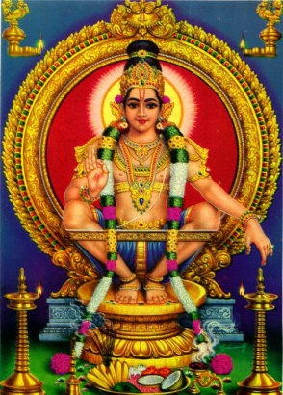
INTRODUCTION
Ayyappan is the Hindu god, and is the most popular god in Kerala. Ayyappan is called by various names such as Hariharaputra, Manikanta and Dharma Shasta.
According to the Hindu tradition, he was born with the powers of Shiva and Vishnu to defeat the demoness Mahishi. Ayyappan was born from the power of Shiva and Vishnu’s mohini avatar.
The famous Ayyappan shrine is at Sabarimala, Kerala. The shrine receives millions of pilgrims every year in late December and early January. The most famous festival is Makaravilakku (Makara Sankranti), observed during winter season. Free annadanam will be offered to all the devotees during their visit to sabarimala.
Life
Once the king of Pantalam Rajashekhara found a baby boy in a forest, and he carried the baby to his kingdom, and he named him as Manikantha(Ayyappan).
Ayyappan brings tigress milk for the sake of the queen by riding on a tiger, but after doing so Ayyappan left the kingdom, and becomes a yogi and lived in the mountain(SABARIMALA).
Temples
Sabarimala is the most famous temple in Kerala. Other important temples are:-
1.Kulathupuzha Sastha Temple
2.Aryankavu Sastha Temple
3.Achankovil Sree Dharmasastha Temple
4.Erumely Sree Dharmasastha Temple
5.Ponnambalamedu Temple.

IMPORTANCE
Lord Ayyappan’s worship is prevailing from several thousands of years. Going to sabarimala is different from going to other temples. For going to sabarimala, We have to observe fasting for one mandalam (48 days) and to take only vegetarian food. Smoking and drinking is totally prohibited. We should get up early in the morning, and do puja to ayyappan, and to visit nearby temples. Daily we must take bath. It is better to observe fasting in the night or otherwise, we should take only tiffen items. During that fasting period, we should not think about unnecessary things, and our mind must concentrate only on Lord Ayyappan and to chant his mantras and his name. We should get irumudi( Coconut filled with ghee) from the guruswamy(senior ayyappa devotee), and to take it throughout the mountain of sabarimala and to worship Lord Ayyappa.
If we strictly follow all the procedures which has to be adopted for going to Sabarimala, we will definitely get Lord Ayyappan’s blessings and our needs and wishes will get fulfilled through his grace.
CONCLUSION
Lord Ayyappa, being the son of Shiva and Vishnu, contains the powers equivalent to that of Lord Shiva and Lord Vishnu. Lord Ayyappa Deity in sabarimala shows a abaya mudra(blessing) pose. He will relieve us from our sins, and help us to live our life happily and peacefully, and will give SALVATION at the end of our life based on our true bhakti. Let us pray to him and be blessed.
“OM SWAMIYE SARANAM AYYAPPA”
WRITTEN BY
R.HARISHANKAR

LORD HANUMAN
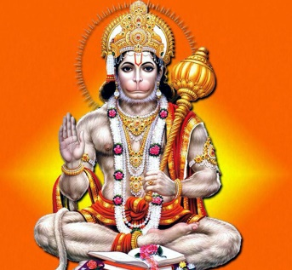
Lord Hanuman is said to have taken birth during Treta Yuga. He is well known for his bravery, generosity and humble nature. Everyone knows about his Rama Bhakti and through that, he has done several super natural works. He is the main person in the epic “RAMAYANA”. All the authors of Ramayana, praises his valour, courage and strength. He is an avatar of Lord Shiva, and is the son of Lord Vayu(Wind God). Because of his great help, Rama has succeeded in the war between him and Ravana, and was able to get back Sita Mata from Ravana.
Even in his childhood, he tried to pick the sun god, thinking him as a fruit. This shows his great powers. He was blessed by the divine gods, and they have granted him several boons. His importance is described in the stotra “HANUMAN CHALISA”. Generally, Hanuman Jayanthi and Rama Navami are the most important festivals celebrated in Hanuman temples.
Lot of temples are dedicated to Lord hanuman all over india. In tamilnadu, namakkal anjaneyar and nanganallur anjaneyar temples are famous temples, and in this temples, during hanuman jayanthi, hanuman statue will be garlanded with Vada Malai, and vennai kappu is also done there.
Lord Hanuman was entirely devoted to Lord Rama. He is considered as a bachelor and is still living in the Himalayas, by chanting Rama Mantra. Till the end of kali yuga, he will be in earth, and will bless all of his devotees, and give them a good life, health and all prosperity in their life. According to ancient puranas, hanuman will be the next brahma after kali yuga, and will do creation work.
It is very easy to please hanuman, by uttering the Rama Mantra. Whenever religious discourses on Ramayana takes place, he will be immediately present in that place and will hear the discourse. He took the Panchamukha avatar and appeared to Guru Raghavendra in Panchamukhi, which is situated nearby mantralayam.
Several songs and mantras are there in praise of Lord Hanuman. In medias also they have shown the character of Hanuman and his importance in Ramayana.
He was specially created by Lord Brahma to serve Lord Rama in the Treta Yuga. Though he possessed a great power and strength, he will use it in case of necessity only, and for good purpose only. His bhakti with Lord Rama cannot be described in words. Whenever he hears the name of “LORD RAMA” , tears will flow down from his eyes, and will dance with full of happiness. Let us pray to this humble and noble god, and chant Rama mantra repeatedly for ever.
“JAI HANUMAN”
“JAI SREE RAM”
WRITTEN BY
R.HARISHANKAR

TRIMURTHI
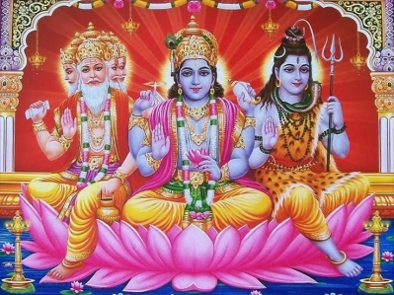
INTRODUCTION
The Trimurti are the three main gods in Hinduism who performs the three main functions of creation, protection, and destruction and are allocated to Brahma the creator, Vishnu the protector, and Shiva the destroyer. Dattatreya avatar is the incarnation of Trimurti. The concept of Trimurti is also present in the ancient puranas.
Temples
The Temples that are dedicated to Trimurti can be seen as follows:-
1.Baroli Trimurti Temple
2.Elephanta Caves
3.Mithrananthapuram Trimurti Temple
4.Prambanan Trimurti Temple
5.Savadi Trimurti Temple
6.Thripaya Trimurti Temple

Sauram
The Saura sect worships only Surya as the supreme personality. They consider Surya as the three main gods Brahma,Vishnu and Shiva. Some Sauras worship either Vishnu or Brahma or Shiva, and others exclusively worship Surya alone.
Shaivism
According to shaivites, Shiva performs the five main actions. According to them, Brahma, Vishnu and Rudra are the forms of Shiva. To Shaivites, Shiva is the only God who performs all the actions, and protects the universe. Shaivites believe that Lord Shiva is the Supreme God.
Shaktism
The feminine goddesses are called Tridevi:-Mahasarasvati (Creator), Mahalaxmi (Preserver), and Mahakali (Destroyer). According to the followers of Shaktism, they consider that tridevi are the main goddesses and they worship only them.

Kaumaram
The kaumaram sect of people will worship only Lord Muruga, and they consider him as a supreme god among other gods. Some of them worship other gods like Shiva,Vishnu,Brahma and Surya. While many of them worship only Lord Muruga.
Smartism
Smartism emphasis on a group of five deities rather than just a single deity which are Ganesha, Vishnu, Brahma, Devi and Shiva. Sankaracharya later added Kartikeya to these five, making six total.
Vaishnavism
Vaishnavism generally does not acknowledge the Trimurti concept, but they believe in avataras of Vishnu like Buddha, Rama, Krishna, etc. They also believe that Shiva and Brahma both are forms of Vishnu.
CONCLUSION
The Trimurti worship can vary among different sects, and by different groups of people. But all of them contains divine powers. Instead of differentiating from one another, let us sincerely worship all the trimurti and tridevi(Lakshmi,Saraswathi,Parvathi) and Lord Vinayaka,Muruga,Ayyappan and the sun god(who is giving us daily energy and helps us in surviving in this world), and also all other devas like Indra,Varuna,Vayu,Agni,Yama,Nirudhi,Aswini Devas,guardian gods and goddess, saints,rishis,rishi pathini’s(wives of rishis),demi gods and goddess, and all other 33 crore divine devas in heaven. Let us pray sincerely to all the divine gods and goddess for our well being, and for the well-being of the entire world. Let us chant the mantra “OM” and be blessed and live happily for ever.
WRITTEN BY
R.HARISHANKAR

SUSWANI MATA
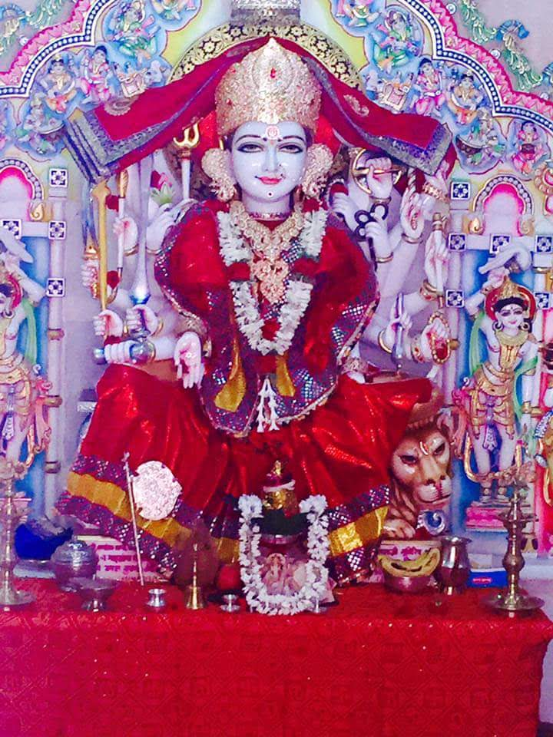
INTRODUCTION
Suswani Mata is regarded as an avatar of Parvati Mata and worshipped by Jain and Hindu community devotees.
Her main temple is located at Morkhana in Bikaner district of Rajasthan. The temple was constructed in 12th century AD. There is an ancient Shiva Temple situated nearby the main temple. She is worshipped as Kuladevi by many families in rajasthan.
The Suswani Devi temple is constructed out of marble stones and various statues of other gods are also found inside the temple premises.
Suswani Mata was born to Jain couples in 1219. She looks very beautiful. Due to her beauty, the nawab of Nagaur fell in love with her. He expressed his wish to her parents. But her parents were rejected his proposal. This made nawab to get angry with them and imprisoned her parents. Mata Suswani prayed to Lord Shiva and sought for his help.
In her dream, Lord Shiva appeared and blessed her. The next day morning, she came out from her home and started going to a shiva temple. The nawab also followed her. While nearing the temple, the earth was opened and she went inside the earth and disappeared and merged with Lord Shiva. The nawab felt ashamed for his act and returned from that place and also freed her parents from the prison.
Due to the instructions given by Mata Suswani to one of her relatives in his dream to construct a temple for her, her temple was built after her departure from the earth. It was later renovated and reconstructed and now the temple structure looks very good. Visiting her main shrine would definitely fetch good results in our life. Let us try to visit her holy temple at least once in our life time and can have the blessings of the divine mother.
TEMPLES
- Suswani Mataji temple in Nagaur,Rajasthan
- Ma Suswani Mandir in Jodhpur, Rajasthan
- Suswani Devi temple in West Bengal
- Suswani temple in Villupuram,Tamil nadu
- Suswani Mataji temple in West Bengal
- Suswani temple in Karnataka
- Suswani temple in Maharashtra
IMPORTANCE
By worshipping Mataji in her temples, would give us all the prospects in our life and we will have a bright future in our life. We can also chant her name “OM SREE SUSWANI MATAJI NAMAHA” and get her blessings. She is the divine protector of the entire universe. Our all sufferings would turn into happiness, and our various health related problems would be relieved through the greatness of the divine mother. By worshipping her with sincere faith, we would get better prospects in our life.
Let us worship the divine mother and be blessed.
“OM SREE SUSWANI MATAJI NAMAHA”
“OM NAMAH SHIVAYA”
WRITTEN BY
R.HARISHANKAR

LORD KUBERA
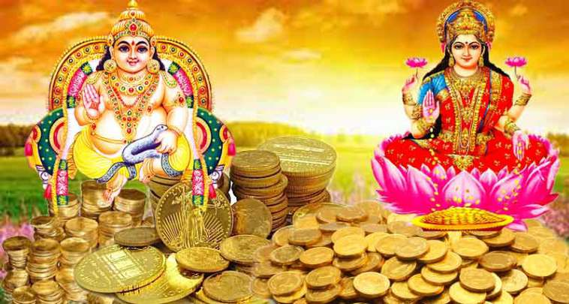
INTRODUCTION
Kubera is the Lord of Wealth and the king of Yakshas as per Hinduism. He is the son of Vishrava and Illavida. His wife name is Bhadra. And his children are Nalakuvara and Manibhadra. He is regarded as the protector of the entire world.
IMPORTANCE
Kubera was known to be as one of the powerful god as per Puranas. Previously he was the ruler of Lanka, and afterwards when he was defeated by Ravana in treta Yuga, he left Lanka and settled in Alakapuri and he is the king of that region. Kubera was praised in the Buddhism and Jainism texts. Kubera is described as the person containing "wealth, prosperity, glory", and gives it to us, when we worship him sincerely and faithfully.
Kubera was worshipped for giving good fortune as well as the giver of all the benefits in our life. Lord Kubera is the ruler of Yakshas, and his palace and his region is similar to that of Lord Indra’s ‘SWARKA LOKA’. His palace is well decorated with gold and diamonds, and fully installed with golden marbles. His glory was well praised by Narada and Tumburu, the divine sages. He is ruling his kingdom in a very generous manner, and treats all as equal.
In Venkateswara Mahathmiyam, It was stated that Lord Kubera has given a loan amount to Lord Srinivasa for performing his marriage with goddess Padmavathi. And it is told that Lord Srinivasa in Tirumala is receiving huge donations from devotees and repaying his debt to Lord Kubera. From this incident we can know the greatness and importance of Lord Kubera. He has lent money to the God himself. Mostly he is worshipped along with goddess mahalakshmi. There is one famous temple dedicated to Lord Kubera which is situated in Kuberan Koil, Anna Main Rd, Rathinamangalam, Tamil Nadu 600127.
CONCLUSION
Lord Kubera, the god of wealth and happiness, must be worshipped by us on a daily basis. We should sincerely devote him, in order to obtain all the prosperities in our life. Let us chant his name and be blessed.
“OM SREE KUBERAYA NAMAHA”
WRITTEN BY
R.HARISHANKAR

LORD VARUNA
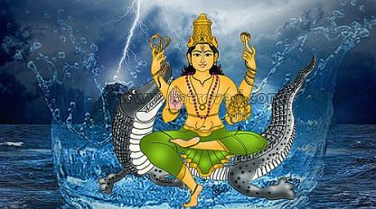
INTRODUCTION
Varuna is a Hindu deity related with the seas. He is found in the Vedic literature of Hinduism. He is the god of sea and rain. He is under the control of Lord Indra. He receives the instructions given by Lord Indra, and will do according to his favour.
In the Hindu Puranas, Varuna is the god of oceans,and his vehicle is a Makara(Sea creature), and his weapon is a rope loop. He is regarded as the guardian deity of the western direction. He is also regarded as the father of the great sage Vasishta.

IMPORTANCE
According to Rigveda, Varuna is considered as the protector of moral law. He is mentioned in many epics, and was praised by holy sages for his superior powers.
In Yajurveda, Varuna is said to be an AMSA of Lord Vishnu, it means Varuna contains the feature of Lord Vishnu. He is also considered as the main deity of physicians. His importance is mentioned in detail in various Upanishads.
In Ramayana,Lord Rama tried to cross the sea for going to Lanka, in search of his wife sita. For crossing the ocean, he sought the help of Lord Varuna. But Varuna doesn’t respond to his prayers and kept silent. Rama got angry with him and tried to punish him through his arrows. After that, Lord Varuna responded and promised Lord Rama, that he will help him for crossing the ocean, and further promised him, that the bridge will not get sink into the water.

CONCLUSION
Varuna is a great god, and is the giver of rain. In hindu temples, Varuna homam will be conducted in order to get the required rain during the rainy season. Lord Varuna is also prayed for getting relieved from water related diseases like common cold, diabetes,illness caused towards consuming bad water, and also cures all other types of dreaded diseases also. But the main thing is, we have to worship him with pure devotion in our mind with full concentration on him, and by chanting his name for several thousands of times. Let us pray to Lord Varuna and be blessed. Let us chant his name, and live peacefully for ever.
“OM SREE VARUNAYA NAMAHA”
“OM SREE INDRAYA NAMAHA”
“OM SREE VISHNUVE NAMAHA”
WRITTEN BY
R.HARISHANKAR

LORD YAMA
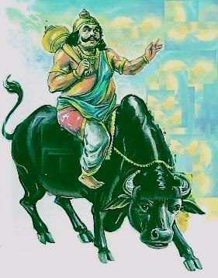
INTRODUCTION
Yama or Yama Dharma raja is the god of death. He is the son of Surya and Saranyu. His sisters are Yamuna, tapti and Bhadra, and his brother is Lord Shani Dev. By the divine grace of Lord Shiva, he became the ruler of the departed souls, and is called as the "Lord of the Pitrus".
IMPORTANCE
Lord Yamadev who was also called as dharma raja or dharma prabhu will take our souls to his place, and do his justice as per our Karmic deeds, and it is believed that persons who has done good karma will be sent to heaven, and persons who has done bad karma will be sent to hell, and will be severely punished by his attendants. He will never award injustice to the true devotees of god, and those who frequently chant the names of god, and they will be allowed to go to the suitable divine places as per their good karma. It is advisable for those who are suffering from dreaded diseases and mind related problems to do “MAHA MRITYUNJAYA HOMAM” for restoring good health, and for living a longer life without any worries in their life.
Lord Yama is also praised in Buddhism, and he is worshipped in Srilanka in the name of Dharmapala. It is also believed that the great Vidura and Yudhishtra of Mahabharatha were the incarnations of Yamadharmaraj.
In Himachal Pradesh, there is a temple dedicated to Lord Yama known as “DHARMESHVAR MAHADEV TEMPLE”. Devotees will visit this temple and offers their worship to Lord Yama Dev for maintaining a good health and for a long and peaceful life.
Lord Yamadharmaraj maintains the track of records of human beings good and bad deeds with the help of “SREE CHITHRA GUPTA”. He is a divine accountant and verifies the good and bad things done by us in this earth, and will make the correct calculations and keep it in record and show it to Lord Yamadharmaraj. They will be given the correct justice by Lord Yama as per their deeds.
There is also a famous temple for Chitragupta in Kanchipuram, and he is worshipped by a large number of devotees, especially during “CHITRA POURNAMI FESTIVAL” which falls during the English month of April.
CONCLUSION
Yama and Chitragupta are worshipped widely all over India. There is no need to get afraid of them, if we have not committed any greater sins to others. Both of them are worshipped mainly for removing our sins to some extent, and to lead a healthy and to live a sustainable life. It is advisable for those who visit Arunachaleswarar Temple at Tiruvannamalai, to worship Lord Chitragupta shirine situated inside the temple. Let us worship them and be blessed.
“OM SREE YAMADHARMA RAJAVE NAMAHA”
“OM SREE CHITRAGUPTARE NAMAHA”
“OM SREE ARUNACHALESWARAYA NAMAHA”
WRITTEN BY
R.HARISHANKAR

DURGA DEVI
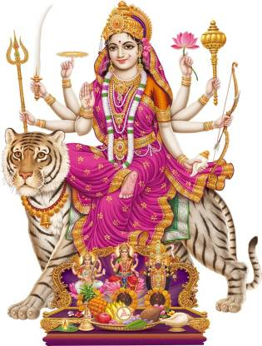
INTRODUCTION
Durga also known as Adi Parashakti, is an incarnation of Mata Parvati Devi. She is the warrior goddess, who destroys the evils and safeguards the innocent ones, and maintains peace and prosperity in the world. Durga Devi shows motherly affection to her devotees, and blesses them and helps them to reach the spiritual world.
Durga Devi’s vehicle is a fierce tiger, and she carries various weapons on her hands and in one hand, she blesses us. She appears in the form of a beautiful lady, and wears ornaments in her neck, and she contains the powers of Saraswati, Lakshmi and Parvati and is also a form of Kali Devi, who incarnated towards killing the demons, and safeguards the demi gods in the heaven. Her nine aspects are called as Navadurga.
She is the main deity in the Shaktism and her greatness, kindness and importance was mentioned in Devi Mahatmya, a great puranic text of Parvati Devi. Durga devi is worshipped throughout India, Bangladesh and Nepal, and she is specially worshipped during the Navratri festival, and Durga puja would be performed in Durga Temples.
By reciting her slokas and going to her temples, and performing puja in the temple as well as in our home will bring better prospects in our life. Durga, is mentioned in ancient epics, in puranas and in Mahabharata.
She killed the demon king Mahishasura, and also had given SALVATION to him. She is such a merciful, kind and affectionate mother!
The day of Durga's victory over the destroying of the demons is celebrated as Vijayadashami. She is also mentioned in the Buddhist, Jainism and Sikhism texts.
FAMOUS TEMPLES
- Kanaka Durga Temple in Vijayawada.
- Kanaka Durga Temple in Chennai.
- Maa Durga Mandir, Kolkata, West Bengal.
- Shri Durga Mata Mandir, New Delhi.
- Durga Mata Mandir, Bengaluru, Karnataka.
- Shri Durga Devi Temple, Kozhikode, Kerala
- Shri Durga Devi Temple, Ernakulam, Kerala.
- Shri Durga Mata Mandir, Mumbai, Maharashtra.
- Durga Mata Temple, Jaipur, Rajasthan.
IMPORTANCE
By worshipping Durga Mata, we will get great energy in our mind and in our body and can reach the top of the ladder in our life. It is advisable to worship her in the temples meant for her, and perform puja and abhishekham to her and can offers flowers, fruits and food items as naivedyam. She can be worshipped even from our heart, and she knows our each and every calling, even without calling her name. She got the power to understand the things stored in our mind, and will sufficiently do favours to us.
Let us worship the holy mother and be blessed.
“OM SREE DURGA DEVIYE NAMAHA”
“OM NAMAH SHIVAYA”
WRITTEN BY
R.HARISHANKAR

BHUVANESHWARI DEVI
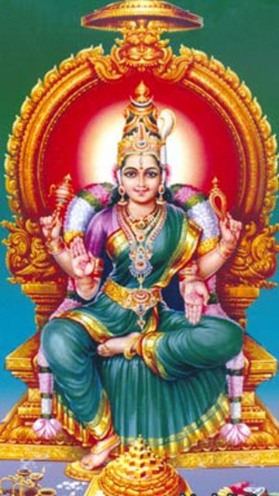
INTRODUCTION
Bhuvaneshwari Devi is one among the Mahavidyas and an avatar of Parvati Devi and is formed to protect the universe through her supreme powers.
She is also known as Adi Parashakti and is considered as the "Holy mother of the entire universe”.
She is red in colour. And wore red ornaments, flower garlands, and she blesses us with a smile on her face, and informs us that we will be protected by her. She was the consort of Trayambaka Bhairava, a form of Lord Shiva, and their glory are praised by the divine demi gods. The Divine Couple are seated in a golden throne, and are being worshipped by many Great Sages.
Bhuvaneshvari enlightens her devotees with her kindness, and fulfils our needs and desires. She is the giver of great boons, and will lead us to the path of heaven.
She is considered as the supreme goddess and contains the power equivalent to that of Lord Brahma, Lord Vishnu and Lord Shiva. She had created many worlds, like Satyalok, Swarkalok and the earth.
There are several famous temples dedicated to goddess Bhuvaneshwari throughout India. The following are the list of her temples:
- Bhuvaneshwari Temple in Nainativu of Northern Sri Lanka.
- Bhuvaneshwari temple in Bhubaneswar at Odisha.
- Bhuvaneshwari Temple in Hatkhola, Chandannagar.
- Bhuvaneshwari Temple in Pudukkottai, Tamil Nadu.
- Mata Bhuvaneshwari devi Temple at Gunja, Gujarat.
- Bhuvaneshwari Devi Temple at Gondal in Gujarat.
- Bhuvaneshwari Amma temple in Calicut, Kerala.
- Bhubaneshwari Devi Temple in Jamshedpur.
- Bhubaneshwari Devi Temple in Sangli district of Maharashtra.
IMPORTANCE
By worshipping Mata Bhuvaneshwari Devi, we will get supreme powers and can concentrate our attention on devotional matters. By chanting her mantras, fresh spiritual energy will be passed into our body and our inner wounds in our mind and body will be healed. She can be worshipped by chanting various slokams meant for her and by reciting her various names, or otherwise we can simply recite her name “OM MATA BHUVANESWARI DEVIYE NAMAHA”, and can get better results in our life.
Similar to other hindu deities, she can be worshipped by offering flowers, fruits and by breaking coconut. She can also be decorated with flower garlands, and we can do milk and honey abhishekham to her idol. Being the holy mother, she will forgive our sins and give good concentration and grasping power and helps us to reach the spiritual ladder. She expects the true bhakti from us and nothing more else.
Let us sincerely pray to her and be blessed.
“OM SREE BHUVANESWARI DEVIYE NAMAHA”
“OM NAMAH SHIVAYA”
WRITTEN BY
R.HARISHANKAR

