DIVINE DOCS BY R.HARISHANKAR
AKHA BHAGAT
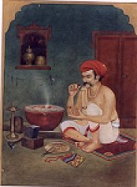
INTRODUCTION
Akha Bhagat (1615-1674), also known as Akha Rahiyadas was a great Saint and Gujarati poet who wrote lot of divine texts. He was specialised for writing the poems in a simplified manner. He was an ardent devotee of Lord Krishna.
He was a goldsmith and lived in Ahmedabad. He was a disciple of Saint Gokulnath, and through his guidance, he has spread the Krishna Bhakti spirit among the masses.
WORKS
- Panchikarana
- Gurushishyasamvada
- Akhe-gita
- Chittavichar Samvada
- Santona Lakshano
- Anubhav Bindu
- Avasthanirupan
- Kaivalya Gita
Though he was a goldsmith by profession, he was good at meditation and yoga. Through his spiritual powers, he has helped the people by reducing the sufferings in their life, and cultivated the habit of worshipping Lord Krishna regularly. He also conducted religious discourses among the people, and explained them about the importance of praying to the god, in order to get relieved from their sins, problems and from diseases.
Lot of people were got attracted with his spiritual speech, and become ardent devotees of Lord Krishna. His teachings are very famous among the people. Some of them are as follows:
TEACHINGS
- Worship the god and then do your duty, and completely surrender to him, and then he would do wonders in your life.
- Believe that god exists all over the world, and he is dwelling with you also.
- Always be kind and polite over others, and move with everyone in a friendly manner.
- Try to chant the Krishna Mantra frequently in order to get all the prosperity in your life.
- No one is there to help you in this world, except the god.
- Provide sufficient help to the poor and the needy, and give them food, clothing and shelter, and educate the poor children.
- Life would become more difficult if you show enmity over others, and you cannot even able to sleep or eat properly.
- Don’t keep on thinking about your physical body, regularly do yoga and meditate on the god, then your mind and body would be relaxed and become stronger.
- Frequently visit the temples and offer pujas to the god to please him.
Let us worship the great saint and be blessed.
“OM SRI AKHA BHAGAT SWAMIGALE NAMAHA”
“JAI KRISHNA”
“JAI RADHE MA”
WRITTEN BY
R.HARISHANKAR
ARUNDHATI
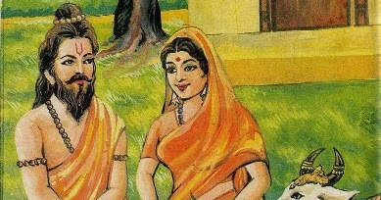
INTRODUCTION
Arundhati is the wife of the sage Vashistha, and she is considered to be living in the Saptharishi Mandala, along with her husband Vashistha. We can see the rishi couples in the form of stars in the sky. She is considered as a pious woman with regard to chasteness and holiness. Her importance is mentioned in ancient puranas and other holy texts. She is considered as the “MARVELLOUS GEM AMONG THE WOMEN”, and considers as a worshipful women. It is advisable for the newly married ladies, to worship Mata Arundhati, in order to get her blessings and to gain all the prosperities in their life. In the Hindu culture, several traditions are centred on Arundhati during the marriage function.
Arundhati also met Sita and Rama as mentioned in the Ramayana, and blessed the divine couples. As per ancient texts, she was considered as the daughter of Rishi Kardama and Devahuti. She was a dutiful wife and served her husband with much care and attention. She had a son named Shakti and daughter named Suyagya.
Due to the couples divine powers they had adopted the divine cow Kamadhenu as their daughter. Mata Kamadhenu would give all the necessities in the life. But the holy couples were utilized her only for the general well-being of the people, and not enjoyed any comforts and luxuries through the divine cow. Mata Arundhati contains supreme powers, and through that she would be able to burn the evil ones, and protect the good ones.
She is also worshipped as the holy mother Mata Parvati, and contains the aspect of Mata Parvati. It is a must for us to worship the divine couples, who are the divine mother and father of the entire universe, in order to get their blessings.
Let us worship Mata Arudhati and be blessed.
“OM SRI VASHISHTARE NAMAHA”
“OM MATA ARUNDATIYE NAMAHA”
“OM NAMAH SHIVAYA”
WRITTEN BY
R.HARISHANKAR

BHAKTA KURMADAS
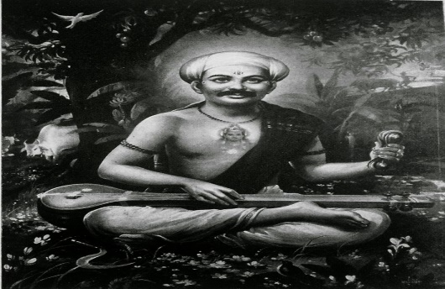
INTRODUCTION
Sri Kurmadas was born in a village at Maharashtra. He was born without having limbs in his hands and legs. Since from his childhood, he was an ardent devotee of Lord Vital. Once he got an opportunity to listen to the discourse on Lord Vital and was very much interested to reach the holy place, and to worship his beloved Pandurangan. He expressed his desire to the villagers, but they felt that it would be very difficult for him to reach Pandharpur, since he was a handicap person, and also pandharpur was far away from their village. But somehow he managed to go to Pandhari and started rolling over the roads, and due to that his body was fully wounded.
He then met a rich man, who gave proper food, and took along with him to Pandharpur. They reached a village called Bahula. By then, his body was totally wounded. He was unable to move from that place.
He then stayed back at Bahula and shared his worries to the rich man, and he was depressed very much towards the difficulty which he faces in reaching Pandharpur. Immediately Lord Krishna revealed his true form and gave his darshan, and gently touched his body through his lotus hands, and immediately his handicap has been removed from his body and he has become a healthier person.
Kurmadas was very much delighted, and ask the Lord to stay in the village Bahula itself, and to bless his devotees. Immediately the Lord has been changed in the form of Idol, and a small shrine has been constructed in that place. Even today, Bahula is considered equivalent to Pandharpur.
Afterwards, even without learning, due to the grace of Lord Vital, he has got sufficient knowledge in all the divine texts, and composed several songs in praise of Lord Krishna, and sung in the Pandharpur temple. After his death, he has attained SALVATION.
Let us worship the great saint and be blessed.
“OM SRI BHAKTA KURMADAS NAMAHA”
“JAI JAI VITALA VITALA PANDURANGA VITALA”
“JAI RUKMANI MATA NAMAHA”
WRITTEN BY
R.HARISHANKAR

BODHALA BAWA-DEVOTEE OF PANDURANGA
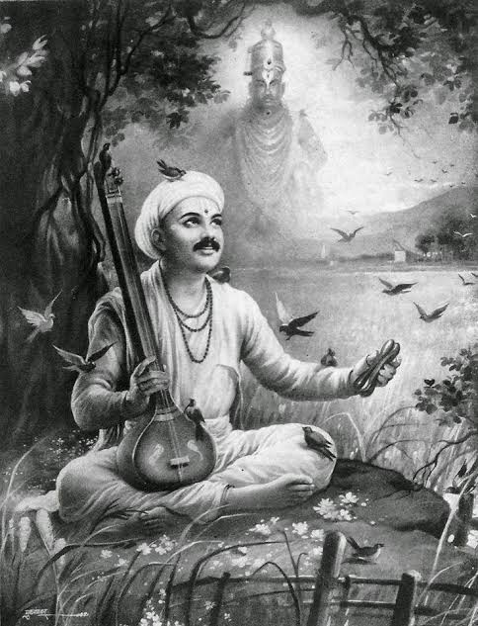
INTRODUCTION
Once there lived a holy person Sri Bodhala Bawa in a small village at Maharashtra, and he was a small merchant, and an ardent devotee of Lord Vital of Pandharpur. He would visit regularly on every Ekadasi to Pandharipur and would have the darshan of Lord Vital at Pandharpur temple. In Ekadasi he and his wife would observe fasting, and take bath in the river chandrabaga, and then worship Lord Vital at the temple, and would stay in the temple during the night, and the next day dwadasi morning, he would offer food to at least two devotees at Pandharpur. For several years, he was doing this as a practice.
One day after observing fasting in the Ekadasi and after having darshan of Lord Vital in the temple, the next day morning, they searched for the devotees to offer them food. But that day, a rich man was arranged for a grand feast at his home, and everybody went to his home, for having the feast. So no one was there to take the simple food prepared by the wife of Bodhala Bawa.
After some time, an old man along with his wife, approached them and asked for some food. Bawa has become very happy, and immediately he asked his wife to serve the cooked food. The old couples were eagerly finished the nice meals served by the pious couple, and blessed them and immediately vanished from that place.
The blessed couple immediately could realize that the old couple were none other than their beloved Vital and Rukmani, and joyful tears were fell down from their eyes, and worshipped the god at the temple, and finished their food, and went home. In due course of time, due to their sincere devotion on Lord Vital, after their death, they attained SALVATION.
Let us worship the holy couples and be blessed.
“OM SRI BODHALA BAWA JI NAMAHA”
“JAI VITAL MAHARAJ KI JAI”
“JAI RUKMANI MATA NAMO NAMAHA”
WRITTEN BY
R.HARISHANKAR

CHILE MAHARAJ
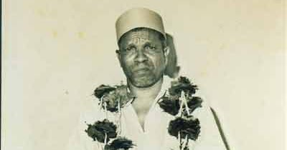
INTRODUCTION
Shri Chile Maharaj was born in the year 1922 in a village near Panhala Fort, Maharashtra. Shri Chile Maharaj spent his childhood at Paijarwadi, Jeur and Kolhapur, due to his father’s business activities. In his Childhood, he visited the holy places like Bhairavanath Temple, Masai Temple and Siddheshwar Temple.
Sadguru Chile Maharaj met Shri Siddheshwar Maharaj and Patil Maharaj, and they were considered as his gurus.
He was a kind hearted saint, and considered as an incarnation of Lord Datta. He would clear the doubts of the devotees in a simple manner. And tells to them, “that everything is happening to the people, based on their own karmic deeds, whether it is good or bad, and we cannot escape from it. But if a person finds a suitable guru, he will be healed, based on his past birth sins. Even if a person, commits lot of sins in the past births, and reaches a right guru, to some extent his sins would be washed out, and he will be cleansed through the spiritual powers of the guru”. In this case we can take the example of the famous saints like Ramakrishna Paramahamsa, Shirdi Saibaba and Guru Raghavendra Swamy etc.
The shrine of ‘Parampujya Sadguru Chile Maharaj’ is situated at the holy place of Paijarwadi. Even still now, lot of devotees are visiting this holy place and paying their respects to the golden guru. The Holy Paijarwad is located on Kolhapur.
In this shrine, food is offered to the devotees in a pleasing manner.
IMPORTANCE
He cleared the problems of the devotees by blessing them in his hands, and touching their heads, and worshipping the god, and removing their sins, and getting them healed. He was a kind hearted and a noble guru, who loves everybody, and was praised by the people for his simplistic approach and kind attitude over others.
Let us worship the great guru and be blessed.
“OM SRI CHILE MAHARAJ NAMAHA”
WRITTEN BY
R.HARISHANKAR

DEVASENA
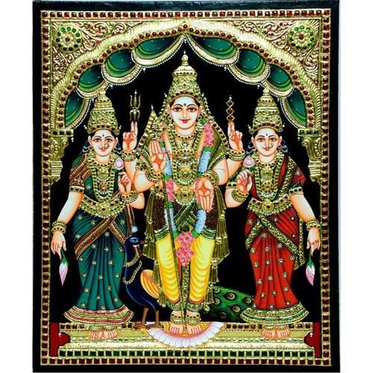
INTRODUCTION
Devasena is the mother goddess and the consort of Lord Muruga. She is also known as Devayanai. Devasena is believed to be the daughter of Lord Indra, the chief of the demi gods. She got married with Lord Muruga in the Tirupparankunram, which is later constructed as Murugan Temple.
According to ancient texts, Devasena was believed to be the daughter of Lord Vishnu in her previous birth. She performed penance on Lord Muruga, and due to that Lord Indra adopts her as his daughter and marries her to Lord Muruga. Muruga also helped Indra in defeating the demons in several battles. In most of the South-Indian temples, Lord Muruga is depicted with both of his consorts, Valli and Devasena.
Devasena do not have independent temples dedicated to her. She is worshipped along with Lord Muruga in the temples. She is considered as a Shakti aspect and contains great powers. By worshipping her along with Lord Murugan, we would get better prospects in our life.
Let us worship the divine mother and be blessed.
“OM SRI MATA DEVASENA NAMAHA”
“OM MURUGA”
WRITTEN BY
R.HARISHANKAR

DHANURDASA - DISCIPLE OF RAMANUJA
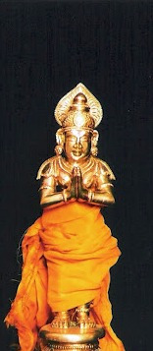
INTRODUCTION
Sri Villidasan also called as Dhanurdasa was an important disciple of Swamy Ramanuja. Actually he was a body builder and a strong man. His attitude was changed by Sri Ramanuja, and he has become a pious saint. Though he belonged to lower caste, he was liked by Sri Ramanuja for his sincere devotion and faith on him and with Lord Vishnu. Both he and his wife were very pious couples, and dedicated their entire attention on the guru and the god.
He was noticed by Sri Ramanuja when he was walking nearby the Srirangam Temple. Ramunuja found him sharing his love and affection with his wife Ponnachi in a different manner. He was holding an umbrella to protect her from the sunrays, and watching her face. His activity was disliked by lot of people who were passing that way.
Sri Ramanuja has called him, and took him along with him to the temple, and made him to see the face of Lord Ranganatha. Through the grace of the divine saint Sri Ramanuja, he has got enlightenment on seeing the divine form of Ranganatha, and immediately he and his wife were become his ardent devotees, and stayed in the house provided by Sri Ramanuja, and served his guru in a well versed manner.
The other disciples, doesn’t like the affection shown by Sri Ramanuja to Sri Villidasan, since he has belonged to a lower caste. Once they have asked about this to their guru also. Due to that Sri Ramanuja wants to prove his true bhakti on him and decided to test him.
He has asked his disciples to go to his house at the night and to remove the jewels of his wife, and to bring it to him. At that time, Villidasan was not there in his house. The disciples obeyed their master’s instructions, and went to his house, and slowly started removing the jewels from the body of Ponnachi. They removed half of the jewels from her body, and she realized their activity and wants them to take the remaining jewels also hence she slightly moved her body, in order to take the remaining jewels easily by them.
But the disciples thought that she has wake up from the sleep, and leaved that place with half of her belongings, and went to their guru’s place and narrated the entire incidents.
The next day Villidasan hurriedly reached his guru’s place and fell at his feet, and narrated the incident and asked his guru’s disciples to take the remaining part of the jewels of his wife. On hearing his words, the disciples were ashamed for their act, and realized his good behaviour and his true bhakti he has kept on his guru. Sri Ramanuja looked at his disciples with a meaningful smile. Afterwards, the disciples of Ramanuja were started moving with him in a cordial manner.
Let us worship the great saint and be blessed.
“OM SRI DHANURDASARE NAMAHA”
“OM SRI RAMANUJAYA NAMAHA”
“OM NAMO NARAYANAYA NAMAHA”
WRITTEN BY
R.HARISHANKAR
GARGI
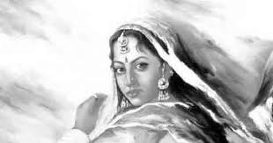
INTRODUCTION
Gargi Vachaknavi was a woman saint. She was mentioned in the Vedas and was also known as Brahmavadini, a knowledgeable person. She got supreme powers, and can travel to any world. She also participated in a debate with the great sage Yajnavalkya and asked him about certain spiritual questions, and got clarified her doubts with him. She has written some portions of texts in the Rigveda. She observed celibacy throughout her life, and considered as a holy and a worshipful woman saint.
She was the daughter of sage Vachaknu. From her younger age itself she has shown deep interest in Hindu scriptures and was very much interested in spirituality. She was won in several debates with great scholars. She was also good at meditation, and it is believed that through that, after her death, she has attained SALVATION.
Gargi was honoured as one of the Nine Gems in the court of King Janaka of Mithila, the father of Mata Sita.
Let us worship the pious saint Gargi and be blessed.
“OM SRI GARGI ANNAIYE NAMAHA”
WRITTEN BY
R.HARISHANKAR

GHOSHA
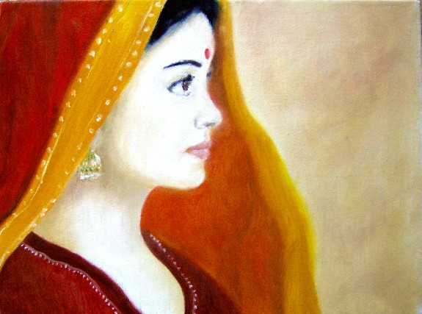
INTRODUCTION
Ghosha was an ancient woman rishi and considered as a most pious and a noble lady. She was well-versed in Vedas and other divine texts, and a master in all kinds of arts. From her younger age itself, she was devoted to Lord Shiva. For some time, she has suffered from skin disease due to her previous birth karma.
But after praying to the divine physicians Ashvini Kumars, she got relieved from her disease and restored her normal health. And after some time, she got married and had a son. She was a noble woman and helped the people by solving their problems through her spiritual powers.
She was the daughter of the great Rishi Kakshivat. After attaining old age, she went to the forest and performed severe penance on Lord Shiva, and due to that, she has attained the holy abode of Lord Shiva, Kailasa, and become one of the attendants of Mata Parvati.
Let the worship the noble rishi and be blessed.
“OM SRI MATA GHOSHA NAMAHA”
“OM NAMAH SHIVAYA”
“OM SRI PARVATI MATA NAMAHA”
WRITTEN BY
R.HARISHANKAR

GOPABAI
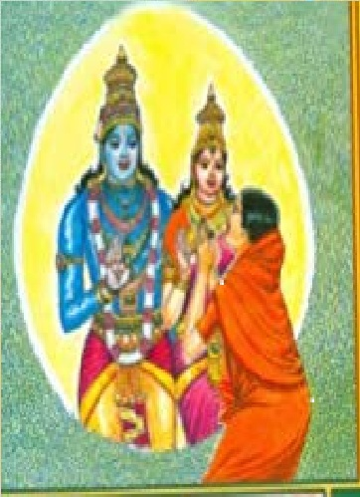
INTRODUCTION
Gopa Bai was a pious lady who was born and brought up at a village in Maharashtra before few hundred years back, and she belonged to goldsmith community. She was well known for writing and singing songs on Lord Vital of Phardharpur. She has devoted her entire life towards keeping bhakti on the Lord. She also invoked the bhakti spirit among the people, and asked them to chant the glorious names of Lord Vital, in order to attain all the prosperities in their life.
She left her family, and lived in Pandharpur by constructing a small ashram and welcomed the devotees of vital and offered them food and water. She was safeguarded several times by Lord Vital, and once she has got the darshan of Lord Vital and Mata Rukmani at her Ashram, and after that, she got great spiritual powers, and used the powers to heal the people from diseases, and removed their obstacles in their life, and asked them to chant the Vitala Mantra “JAI JAI VITALA VITALA PANDURANGA VITALA” on a daily basis. It is believed that after her death, she has attained SALVATION and merged with Lord Vital.
Her poems mainly focuses on Lord Vital only and she frequently ask him to take her to his abode, in order to escape from the clutches of the birth cycle.
Some contents from the poems are as follows:
- Hey Vital mahaprabhu, you are my saviour, without you, no one is there to help me, please take me to your place, and don’t make me to again take birth in this difficult world, please show mercy on me.
- You are the wire puller of the entire universe, without your help, nobody can survive in this world. Let me chant your mantras frequently and make myself to live peacefully.
- You are showing kindness even to small tiny creatures, but you are not showing your motherly affection on me.
- I want to make your presence always at my place, till my death.
- You are showing courtesy even to the arrogant demons, and making them to reach the heaven and you are a kind hearted god.
- All the demi gods and gods are under your control. You are the master of the entire universe. Let me enjoy myself under your company.
- Please embrace me like a mother, and give me a divine warmth feeling.
- By touching your lotus feet in the body of the people, their entire sins would be removed, and their mind and body would be cleansed, and they would become pure.
- Hey Gopala! I want to see your childhood plays at Vrindavan, and I want to get great happiness over that.
Let us worship the divine saint and be blessed.
“OM SRI GOPABAI NAMAHA”
“JAI VITALA”
“JAI MATA RUKMANI”
WRITTEN BY
R.HARISHANKAR
HARALAYYA AND KALYANAMMA
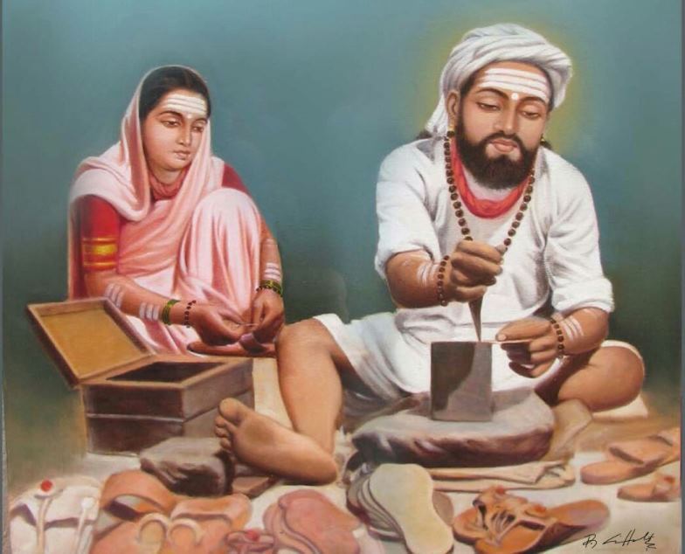
INTRODUCTION
Sri Haralayya(12th century) belonged to a family of lower class community, lived with his wife Kalyanamma in Kalyana town, Karnataka, and his profession was making slippers and shoes. He and his wife were ardent devotees of Lord Shiva, and used to chant the Shiva mantra “OM NAMAH SHIVAYA” on a daily basis, and perform a simple puja at their home, and then only they would have their morning breakfast. He has got such a great bhakti on Lord Shiva. His wife was a pious, humble and a calm lady and a dutiful wife, who looked after her husband in a proper manner, and supported her husband throughout her life.
Once the great saint and the Saviour Sri Basavanna came to Sri Haralayya’s house and ate food in his house. Sri Haralayya happily offered him with delicious food cooked by his wife, and asked him to take rest for some time in his home. He also made a nice slipper for the great saint Basavanna and offered to him with great respect.
Haralayya was against caste discrimination, and he fought for their caste’s own rights, but didn’t succeed during that time. Though he was teased by the upper class people, he didn’t hate and fight with them. He was such a kind hearted person, who loves everybody, and treats others with great respect.
He also performed marriage with a Brahmin girl to his son, but soon, they were punished to death by the king. This act caused deep depression in the minds of Haralayya and his wife, and they went on deep meditation on Lord Shiva, and got great spiritual powers through that. Through that powers, they started helping the people, and removed their miseries and sorrows in their life, and cured their diseases, and gave them happiness and peacefulness in their life.
He insisted the people not to see the lower class people by way of caste, but by way of human beings, and according to him, all are equal before god, and everyone must be treated with great respect and given equal rights. Though he was a cobbler, he contains good knowledge in all the subjects, by hearing the religious discourses conducted by the scholars in the temples. He will used to watch their discourses with keen interest by standing outside the temples. His bhakti on the god is unimaginable. He didn’t scold the god, for his bad fate, and for being taken birth in a lower caste, but he and his wife has got utmost faith and devotion on Lord Shiva, and after their death, both of them were attained SALVATION.
Let us worship the great Shiva devotees and divine couples Sri Harlayya and Kalayanamma and be blessed.
“OM SRI HARALAYYA NAMAHA”
“OM MATA KALYANAMMA NAMAHA”
“OM NAMA SHIVAYA”
WRITTEN BY
R.HARISHANKAR

HARICHAND THAKUR
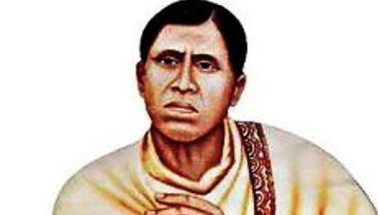
INTRODUCTION
Harichand Thakur (1812-1878), was a social welfare activist and fought for the welfare of the lower class community people. He was against caste discrimination. He was the founder of the Matua sect of Hinduism.
He was born in the year 1812 in a farmer’s family in the village of Bangladesh and he was a great devotee of Lord Krishna, and also written several songs in praise of Lord Krishna. He would visit the pandharpur, brindavan and puri once in a year, and would worship Lord Krishna with utmost faith and devotion in his mind.
He was also considered as a great saint, and contains all the good features like providing food, clothes and arranging shelters for the poor people, and also he used to offer food to the devotees of Lord Krishna at his home.
He mainly fought for the rights of the lower class community people towards education and social upliftment. He also raised his voice for the well-being of the women, and wants them to be equally treated similar to men.
Thakur was married to Shanti Mata and they had two sons. He died at Orakandi in 1878.
He also preached among the people about the equal treatment of people in the society. He delivered lectures in India as well as in foreign countries, and spread the bhakti spirit among the people. He expressed his feeling in the form of poems which contains in the form of spiritual as well as of social nature.
Some excerpts from his poems are as follows:
- Don’t separate people through caste. All are equal before god.
- God is not asking us to differentiate us in the name of castes, only the people are doing like that.
- Our human body is made out of blood, skin, flesh, bones and nerves, and everyone’s body contains only these. Then why there is need to differentiate ourselves in the name of caste?
- Lord Krishna is treating every one as equal, and not differentiating his devotees in the form of castes.
- We are living a short life in this earth, and hence why there is a need of community clash in this society.
- Our merits and demerits can be judged only through our noble activities, and not by way of caste discrimination.
- Only the god is the master for the entire Universe, worship him always and get his divine blessings from the heaven.
- Other living beings like birds and animals are not finding any difference between them and they are living together.
- Our every actions, are watched by the god, hence it is advisable to do good deeds in order to satisfy the divine gods in the heaven.
Let us worship the great man and be blessed.
“JAI HARICHAND THAKUR”
“JAI KRISHNA”
“JAI RUKMANI MATA”
WRITTEN BY
R.HARISHANKAR
KAKKAIYAA
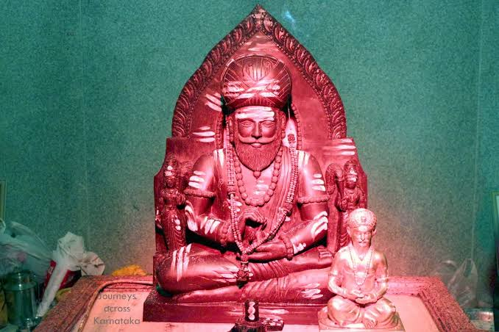
INTRODUCTION
Kakkayya (12th century) was born in a village at Madhya pradesh, and after some time shifted his place to Karnataka, and was a close associate of Sri Basavanna and Chenna Basavanna. He belonged to Dohara caste, which is considered as lower class community during his period, and his profession was polishing the leather. He has written lot of poems in praise of Lord Shiva, and also expresses his feeling towards caste discrimination, and fought for the rights of Lower class people. He died during a community clash in Belgaum district at Karnataka.
He became an active member of the Anubhava Mantapa. He worked with Basavanna for forming a casteless society.
Basavanna regarded him as his own father, and maintained good relations with him.
His poems contain lot of questions raised by him to Lord Shiva, and asked him to safeguard the lower class people from the upper class people. He also wants to remove the difficulties of the people, and ask them to worship Lord Shiva, in order to get rid of worries and tensions.
Excerpts from his poems
- Oh Lord Shiva, please help me to find a solution to form a casteless society.
- You are containing lot of powers please help us by using your power to remove the sufferings of the people in the earth.
- You are the universal father, without your help, we cannot do anything, please protect us in our daily life.
- You are showering your grace on the devotees without seeing their caste, but why the people are doing so?
- Oh Lord! Please protect us from our enemies, and remove the evil spirits from our body.
- You have to remove the bad thoughts in our mind, and must give better fortunes in our life.
- Oh Lord, the great Shiva, please come down to this earth, and change the behaviour of the evil minded people.
- Please help me to frequently chant your mantra, and make me to remember you always.
- Please provide food to all the living beings in the earth, and don’t make them to suffer.
Let us worship the great saint and be blessed.
“OM SRI KAKKAIYAAVE NAMAHA”
“OM NAMAH SHIVAYA”
“OM SAKTHI PARASAKTHI”
WRITTEN BY
R.HARISHANKAR

KALAVATI MATA
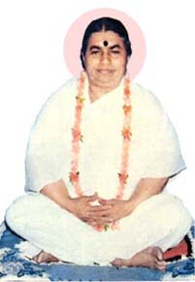
INTRODUCTION
Kalavati (1908-1978) was a female saint and a great devotee of Lord Krishna. She was the founder of Shri Harimandir, at Belgaum, Karnataka, in order to spread the “KRISHNA BHAKTI SPIRIT” among the masses. She has inculcated the Bhakti in the hearts of millions of people, thus by the way of bringing Joy and Hope in their lives.
She was born in a noble family of Karwar at Karnataka in the year 1908. She was born to her parents, after they performed several pujas to Lord Shiva. Her birth name was Rukmabai. Since from her childhood, she was a wonderful girl, and respected everybody, and didn’t show any displeasure over others. She had contained pleasing manners and attracted everybody by her soft speech. She also studied well and got good marks in all the subjects, and was well versed in all the regional languages.
During her younger age, she went on religious temple tours along with her parents, and got very much attracted over that. She got melodious voice and sings beautiful songs on Lord Krishna in the temples. During her childhood, she will used to play with the idols of Lord Krishna, and interestingly do that along with her friends. She will used to feed butter to the child Krishna, and perform puja to him, and offer the holy Prasad among her friends, and finally completes it with singing songs and prayers.
At her younger age, she met the great saint Swami Purnananda Saraswati. And he taught the divine texts and she grasped it quickly. And at her later age, she has conducted religious discourses on the topics like Ramayan and Bhagawatham etc. Her guru gifted her, an idol of Lord Krishna, and she worshipped it throughout her life. She was also called as Param Pujya Aai or the Holy Mother by her devotees.
After getting married, the young couple met the great Saint "Sri Siddharudha Swami" at Hubli, and got his blessings. And the saint asked her to chant the Shiva Mantra “OM NAMAH SHIVAYA” regularly to attain all kinds of prosperity in her life.
She was a humble and a calm lady who showed great attention to her in laws, and took care of them properly. She acted as a dutiful wife to her husband, and treated him as equivalent to the God, and showed great respects to him. In her free time, she will used to worship the deities, and also provided the cooked food to the poor, after getting permission from her husband.
She was blessed with two children, but lost her husband at her teenage. She donated most of the wealth to the poor and for charitable activities. She stayed at her Guru's ashram in Hubli. And she was treated by her guru and showed great attention to her like her own father. Her sons were brought up by her mother at Gokarna.
She ate only a little food, and concentrated her entire attention towards devoting to the god, and didn’t make any bad thoughts to enter into her mind. She also done severe meditation on Lord Shiva, and through that, she has got more spiritual powers, and become a bold and a strong woman. She didn’t make any unnecessary conversation with others, and for most of the time, she maintained strict silence. Her Guru was very much pleased with her activities and showed much affection on her.
She was named as 'Kalavati Devi' by her guru. She also given spiritual discourses on Lord Krishna, and explained the importance of reading the great epic Srimad Bhagawatham, which explains the childhood plays and miracles of Lord Krishna. She also written several devotional books and published it.
Through the grace of her guru, she has attained enlightenment, the eternal bliss of the god. After some time, her guru has died, and after that she spent her life on doing spiritual activities, and conducting religious discourses on the gods and goddesses.
She built an Ashram called ' Shri Harimandiram ' at belgaum, Karnataka, from the piece of land gifted to her by her well-wisher. She has conducted regular bhajans and performed pujas at her ashram, and would distribute the holy Prasad among the devotees and to the poor people, and through that, she has healed many diseased people, and removed their sins, and made them to walk properly in their life.
She died in the year 1978. A samadhi was constructed at the ashram. Even today lot of devotees are visiting and worshipping the holy mother at her shrine, and receives her blessings.
Let us worship the divine mother and be blessed.
“OM SRI KALAVATI MATAJI NAMAHA”
“JAI KRISHNA”
“OM NAMAH SHIVAYA”
WRITTEN BY
R.HARISHANKAR
LOPAMUDRA
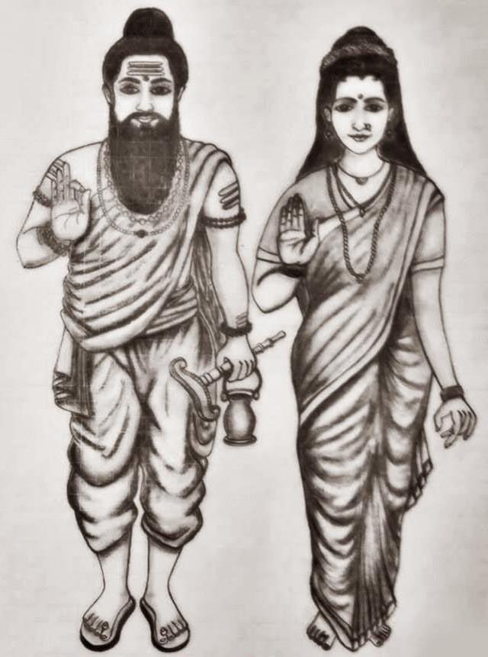
INTRODUCTION
Lopamudra was a female rishi and the wife of the sage Agastya who is believed to have lived before several thousands of years and she was mentioned in Rig Veda, and her importance is also mentioned in that. She has helped her husband to peacefully perform penance in the ashram, and remained as a dutiful wife, and looked after him properly.
She used to collect the fruits and vegetables from the forest, and kindly offer it to her husband sage Agastya. She was considered as a pious and a chaste woman, and contained very good qualities. According to legend, Lopamudra was created by sage Agastya, and later married her.
She also spread the importance of reciting the Lalita Sahasranama Sloka among the people, and inculcated the bhakti spirit into them. She was also considered as an aspect of Mata Parvati, and was a great devotee of Lord Shiva and Parvati, similar to her husband sage agastya.
It is believed that she is still living in the Saptharishi Mandala, along with Rishi Agastya, and doing penance on Shiva and Parvati.
Let us worship the divine couples and be blessed.
“OM SRI AGASTIYA MAMUNIYE NAMAHA”
“OM ANNAI LOPAMUDRA NAMAHA”
“OM NAMAH SHIVAYA”
WRITTEN BY
R.HARISHANKAR

LORD DAKSHINAMURTHY
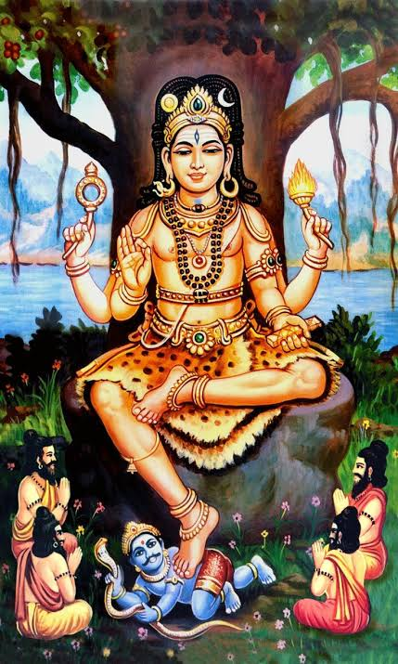
INTRODUCTION
Guru Dhakshinamurthy is a divine form of Lord Shiva and is the universal guru. He is worshipped as the god of knowledge and the giver of all the boons to us. He is the god of yoga and meditation. Apart from worshipping several other Guru’s like Ramakrishna, Raghavendra Swamy and Shirdi Sai Baba, Dakshinamurthy must also be worshipped as a holy guru, and must be specifically worshipped on Thursdays by offering chickpeas as neivedyam (Holy Prasad) to him.
He is a supreme teacher who gives good knowledge, wisdom and Salvation to his sincere devotees. In most of the Shiva temples, a separate shrine for Lord Dakshinamurthy would be there. He usually found in the temple with four arms. He is depicted seated under a banyan tree, facing the south, and blessing the sages surrounded by him. Dakshinamurthy sits in the yogic posture by performing meditation. Various forms of Dakshinamurthy idols can be found in the temples, like Veenadhara Dakshinamurthy and Rishabharooda Dakshinamurthy.
During Guru Purnima festival, Dakshinamurthy would be specially worshipped by adorning various flower garlands and garland of chickpeas. By worshipping him on this day, we would get all kinds of prosperity in our life, and we would have a blessed life.
There are only a few temples where Dakshinamurthy is worshipped as the main deity.
- Dakshinamurthy in Mahakaleshwar at Ujjain.
- Sree Dakshinamurthy Temple at Malappuram District, Kerala.
- Ettumanoor Mahadevar Temple in Kerala, where the Shivalingam is worshipped as Dakshinamurthy.
- Dakshinamurthy Temple at Alangudi, Kumbakonam, Tamil Nadu
- Sree Dakshinamurthy Temple at Sivagangai District, Tamil Nadu.
- Dhakshinamurthy temple at Thiruvotriyur, Chennai.
- Dakshnimurthy temple in Poonthottam village in Thiruvarur, Tamil Nadu.
- Dakshinamurthy temple at Vellave in Kerala.
- Sree Dakshinamurthy temple in Alappuzha District, Kerala.
Apart from the above famous temples dedicated to Lord Dakshinamurthy, in foreign countries also dalshinamurthy temples are found like Mauritius and USA.
Dakshinamurthy Gayatri Mantra
Om Vrishabha-dhvajaaya Vidmahe
Ghruni-Hasthaaya Dheemahi
Thanno Dakshinamoorthy Prachodayaath.
IMPORTANCE
By worshipping the divine guru, we would be relieved from our sins, diseases, mental problems and would get good prospects in our life. Hence it is advisable to worship the great guru by visiting the Shiva temples, and chanting various mantras and doing puja and abhishekham to the idol of Lord Dakshinamurthy and be blessed.
“OM SRI GURU DAKSHINAMURTHIYE NAMAHA”
“OM NAMAH SHIVAYA”
“OM SAKTHI PARASAKTHI”
WRITTEN BY
R.HARISHANKAR

MADARA CHENNIAH
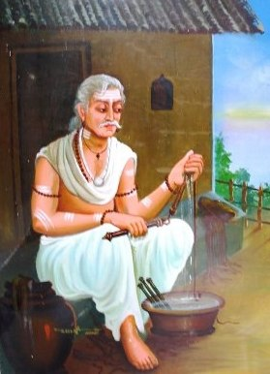
INTRODUCTION
Madara Chenniah (12th century) was belonged to Madiga Caste and was an ardent devotee of Lord Shiva, and he lived during the period of the great Saint Basavanna, and he was considered to be older than him. He participated in the religious discussions held at Anubhava Mantapa established by Basavanna at Kalyana, Karnataka.
He was born and brought up at a village in Tamil Nadu, and visited the Anubhava Mantapa in order to share his religious knowledge with others. His main occupation was making slippers and selling it at the cheaper price to the devotees of Lord Shiva. He used to offer food as Prasad to Lord Shiva with pure devotion, and the Lord would accept it without any hesitation. Due to his sincere devotion on the Lord, he was well respected by the Chola kings and also by the people of that region. His name and fame spread all over the region and he was considered as a great Shaivite saint. He also helped the people by hearing their problems patiently and telling suitable solutions to tackle it. He used to pray to the god for the well-being of the people. Through his sincere prayers on Lord Shiva, lot of people were relieved from their diseases, and lead a happy life.
He will used to chant the “OM NAMAH SHIVAYA” mantra continuously and also asked others to do so, in order to get relieved from their sufferings and problems in their life. He was against caste discrimination, and used to express his feeling in the form of poems. He would question that “according to god all are equal and then why these people are distinguishing themselves as higher and lower class people”. Though he didn’t educated properly, his poems were written in a classical manner. Throughout his life time, he spent his time in doing Shiva pujas at his home, conducting religious discourses on Lord Shiva and doing his profession of stitching slippers. He also provided free food to the devotees of Lord Shiva at his home. Through his noble service, lot of people were become ardent devotees of Lord Shiva, and lived a peaceful and a happy life.
Let us worship the holy person and be blessed.
“OM SRI MADARA CHENNIAH NAMAHA”
“OM NAMAH SHIVAYA”
“OM SAKTHI PARASAKTHI”
WRITTEN BY
R.HARISHANKAR

MADIVALA MACHAYA
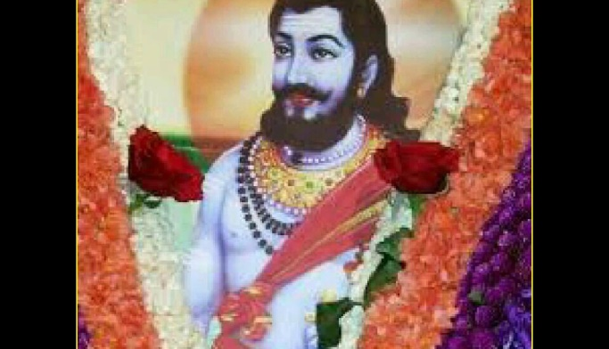
INTRODUCTION
Madivala Machaya was born in Devarahipparagi in Bijapur district into the Washermen’s family, and a great devotee of Lord Shiva. He was considered as a supreme incarnation of Lord Virabhadra and contains great valour, strength and courage. He would exclusively wash only the clothes of Shiva devotees, and consider them as an aspect of Lord Shiva. He would never get afraid of any one, and even he didn’t wash the clothes of the local region king. Due to that, he was attacked by the king’s elephant, and he has pierced that animal into pieces, and then he applied the sacred ash on the pieces, and brought back the life of the elephant. By seeing his great powers, the king has showed his great respect and rewarded him with lot of wealth. But he donated all the riches to the poor people. He was such a good person, who never interested in earning money, but showing love and affection over others, and worshipping his favourite god Shiva.
He was a close friend of the great saint Sri Basavanna, and both of them were discussed about spiritual matters. Sri Basavanna has praised him for his good acts and spiritual powers.
He was against caste discrimination and considered all of the human beings as the divine incarnations, and everyone must be treated with great respect. He also performed many miracles such as making a stone bull to eat a sugarcane, and removing the leprosy from the body of the leper, and made him to smile and walk cheerfully in the streets.
He has written several poems in praise of Lord Shiva, and also asked the people to worship Lord Shiva, instead of spending time on doing other unnecessary activities like thinking about other women, consuming liquor and gambling. He insisted the people to chant the “OM NAMAH SHIVAYA MANTRA” continuously in order to erase the bad thoughts from their mind and to make their mind to be filled up with full of spiritual energy. He was praised by the kings and the common people for his talents, and respected him and treated properly.
His tomb is found in Karimane near the town of Murugod in Belgaum district, Karnataka.
TEACHINGS
- Don’t hurt others by using bad words.
- Be polite and kind with others.
- Think about Shiva and Shiva only, and then you can attain easily the Shiva Loka.
- Give respect to females, and treat them as your own mother and sister, and realize them that they are all the divine incarnations of Mata Parvati.
- Treat your parents with great respect and provide them with all the necessities in their life, and take care of them properly.
- Lord Shiva is always there to help you, provided if you call his name, and beg for his mercy.
- Living life in this earth is easy only, provided you should control your mind and senses, and show your attention on doing service to the god and to all the living beings in the earth.
- Avoid laziness, since it will kill you, and you will never be happy throughout in your life.
- Realize that you are created by the god for a special purpose only and act favourable to the god.
Let us worship the great saint and be blessed.
“OM SRI MADIVALA MACHAYA NAMAHA”
“OM NAMAH SHIVAYA”
“OM SAKTHI PARASAKTHI”
WRITTEN BY
R.HARISHANKAR

MATA AHALYABAI
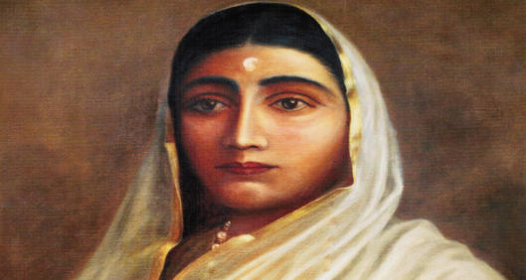
INTRODUCTION
Maharani Ahilyabai Holkar (1725–1795) was the Queen of the Malwa kingdom, India. Mata Ahilyabai was born in the village in Ahmednagar, Maharashtra. She moved the capital near the Narmada River, since she was very religious and an ardent devotee of Lord Shiva. From her childhood, she used to offer prayers to Lord Shiva, and performed puja at her home and in the Shiva Temples. She was well educated and learnt the Hindu Scriptures and mastered in handling deadly weapons. She was also good at meditation.
Her husband was killed in a battle in 1754. After that she has become the queen of the Malwa kingdom. She was a great warrior, and ruled the kingdom in a well versed manner. She would listen to the problems of the people, and solved them immediately. She developed the region of Indore from a small village to a developed city. She encouraged music and literature. She has ruled the Malwa Kingdom in a most efficient and eminent manner.
She has done lot of charitable activities for the welfare of the people. She also constructed several education centres and Dharmashalas throughout the region. She showed motherly affection towards the people, and has given a golden role. The people in her kingdom were admired for ruling the kingdom in a prosperous manner, and paid great respects to her.
Rani Ahilyabai has built lot of Hindu temples, and she has written lot of spiritual books. She got married her daughter to a brave and a good natured soldier, without seeing his status.
After her death, it is believed that due to her good nature and pious character, she has attained SALVATION.
A film titled Devi Ahilya Bai was produced in the year 2002 in order to recognise her worthy service to the people. Universities, parks and airport were also founded with her name.
Let us worship the holy mother and be blessed.
“OM SRI MATA AHALYABAI NAMAHA”
WRITTEN BY
R.HARISHANKAR

MATA ANUSUYA
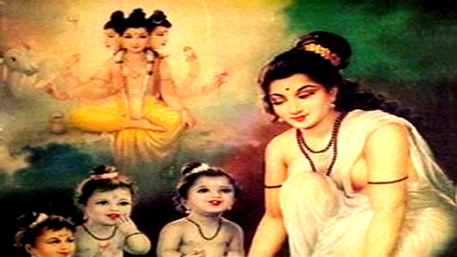
INTRODUCTION
Mata Anusuya was the wife of the Rishi Atri, and was considered as a holy woman with regard to chasteness. She was mentioned in ancient puranas and her importance was praised in the earth and in the heaven. She was a dutiful wife, and done her service to her husband in a pleasing manner. She will used to take her food only after her husband finishes his food. Due to her pathi bhakti, she has got great supreme powers.
Once the trimurties were decided to test her holiness, and transformed themselves in the form of sages, and went to the house of Anusuya. They were eagerly welcomed by the rishi couples, and they were willing to provide them with good food. But they insisted Mata Anusuya to serve them food without wearing any clothes. On hearing that, the holy mother, didn’t get shocked, but sprayed some holy water from the kamadala of rishi Atri and turned them into babies and served food to them.
The Tridevis were very much worried about the condition of their husband’s and went to the hermitage of Rishi Atri and requested Mata Anusuya to change their divine husband’s into their original form. On hearing their request, Mata Anusuya worshipped Rishi Atri, and once again sprinkled the holy water from the Kamadala, and restored them to their original form. The trimurties and tridevis were very much satisfied about her holiness and kindness, and blessed the rishi couples. The Trimurties have done this act in order to show her greatness and holiness to the entire universe. The trimurties were created a divine son with their powers, and named him as “DATTATREYA” and asked the rishi couples to look after him.
The young Dattatreya worshipped the Trimurties, Tridevis and their adopted parents and lived with them in a peaceful manner. Later on Datta went on meditation and done several miracles in the life of his devotees and he has taken several avatars in this kaliyuga, and is still safeguarding the devotees from their problems.
Let us worship the great divine woman and be blessed.
“OM RISHI ATRIYE NAMAHA”
“OM MATA ANUSUYAVE NAMAHA”
“OM SRI DATTATREYARE NAMAHA”
WRITTEN BY
R.HARISHANKAR

MATA AVADAYAKKAL
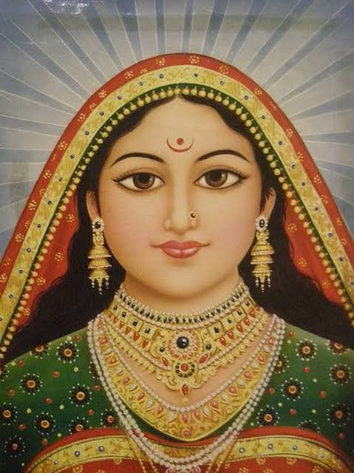
INTRODUCTION
Avadayakkal (18th Century) was a pious woman saint and a humble lady who lived her life for the sake of the people, and done many welfare activities for the people along with deep meditation on Lord Shiva and Mata Parvati.
She was born in a Brahmin family and she was interested in spirituality from her younger age itself. She will used to visit Shiva temples frequently and perform meditation and puja to the lord, and also studied well.
She was an expert in Hindu scriptures, Vedas, Upanishads and other holy texts. She was considered as an incarnation of Mata Parvati. She was married at her teenage, and the very first day of marriage itself, her husband was died due to snake bite. After that, for several years she has suffered a lot in her in laws house. She didn’t offered proper food, and used to do all kinds of house hold chores and become very weak and tired due to her activities.
By god’s grace, one day she got an opportunity to visit the great saint Sri Sadasiva Brahmendral, and she seek shelter at his ashram. The holy saint, welcomed her, and offered a place at his ashram. But his disciples were not interested to keep her at their guru’s ashram, and they started giving troubles to her. But Avadayakkal had tolerated all of their bad acts, and started worshipping Lord Shiva. In course of time, the disciples realized her greatness and gave proper respect to her.
She has performed several miracles in the life of her devotees, like removing their sins and diseases from their body, and inculcated the bhakti spirit into them, and giving them spiritual discourses on Lord Shiva, and properly guided them in all walks of their life. She also provided food to the poor people at her guru’s ashram. Due to her kindness showered upon them, the people in the region, were worshipped her and treated with great respect, and considered her as a divine lady.
After her death, she reached Kailasa, and become an attendant of Mata Parvati.
Let us worship the great saint and be blessed.
“OM SRI MATA AVADAYAKKAL NAMAHA”
“OM NAMAH SHIVAYA”
“OM SAKTHI PARASAKTHI”
WRITTEN BY
R.HARISHANKAR

MATA VASUKI
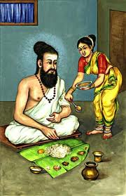
INTRODUCTION
Vasuki was an excellent and noble woman who was mentioned in the ancient texts. She was considered as very chaste and pious woman, and she can be compared equivalent to the holy siddhas, and contains great spiritual powers, for being served as a dutiful wife to the great saint and poet Sri Thiruvalluvar.
She was born in Kaviripakkam, to a farmer’s family. From her childhood itself, she has shown great respect to the elders, and was a great devotee of Lord Shiva. Several times, she was tested by her husband Valluvar, and she has succeeded in the tests. Even due to the request of Valluvar, she cooked the raw sand and turned it into boiled rice, due to her holiness. She was such a powerful woman. The respect she has shown to her husband cannot be described in words. Without asking any question, she would obey her husband’s instructions, and till her death, she has followed like that. With respect to her holiness, kindness and gentleness, we can compare her with the divine goddess Mata Adi Parasakthi. It is also believed that she contains the features of Mata Parvati. She acts as an example for others.
In ancient times, people would give advice to the newly married girl to live like Vasuki and to perform the domestic duties, and to take care of her husband in a proper manner similar to Vasuki.
Arulmigu Vasuki Amman Temple is dedicated to Mata Vasuki and it is situated in Vairavanpatti, Sivaganga district, Tamil nadu.
Once, the great Siddhar Konganar visited her house for taking alms. But Vasuki made him to wait for some time in the outside of her house, since she was serving food to her husband, valluvar. After some time, she came with food, and asked Konganar to accept it. But Konganar has become very angry with her, and decided to curse her. Mata Vasuki laughed at him and said “I am not a crane to burn me into ashes”. On hearing the words, the siddhar was shocked and ask her to forgive him, and praised for her spiritual powers, and had the food given by her and left her home.
Konganar before visiting Vasuki’s house was doing penance under a tree, and at that time a crane has dropped its saliva into the head of the siddhar, and due to that, the siddhar has angrily looked at the crane and due to his great yogic powers, the crane was burnt into ashes. No one was aware of this incident, but Mata Vasuki knows that, since she was a dutiful wife to her husband tiruvalluvar, and also contains very good qualities.
Let us worship Mata Vasuki and be blessed.
“OM SRI TIRUVALLUVARE NAMAHA”
“OM SRI MATA VASUKIYE NAMAHA”
“OM NAMAH SHIVAYA”
WRITTEN BY
R.HARISHANKAR

SIDDHI BUDDHI
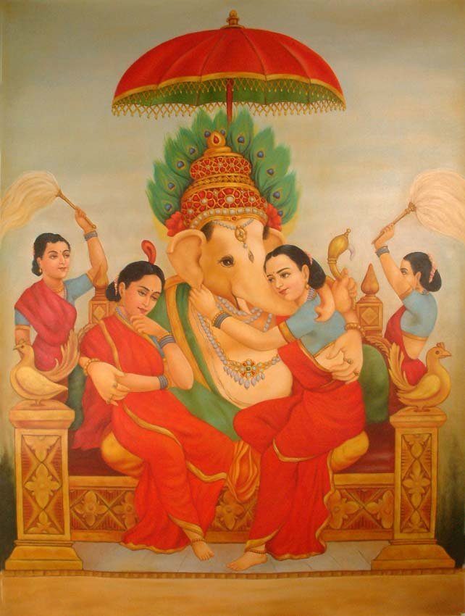
INTRODUCTION
Siddhi and Buddhi are considered as the two consorts of Lord Ganesha. There are believed to have been created by Lord Brahma for the specific purpose of marrying them to Lord Ganesha. According to ancient puranas, Once Lord Ganesha wants to get married a girl containing the qualities of his mother Parvati Devi. Since no matching girl was found similar to Parvati, Lord Brahma decided to create two holy girls, in order to get them married to Lord Ganesha.
Brahma used his entire powers, and created two lovely girls and named them as Siddhi who gives enlightenment and Buddhi who gives cleverness. They are worshipped along with Lord Ganesha, and found in lot of temples. Some important temples are as follows:
- Siddhi Buddhi Vinayakar Temple at Raja Annamalaipuram, Chennai.
- Siddhi Buddhi Vinayakar Temple at Saidapet, Chennai.
- Sri Siddhi Buddhi Vinayakar Temple at Poonamalee, Chennai.
- Siddhi Buddhi Vinayakar Temple at Kundrathur.
Siddhi Buddhi are worshipped for getting better prospects in our life, to remove the obstacles in our life, to live a disease free life and to get relieved from all sorts of problems in our life.
They are mentioned in the Ganesha Purana and various other puranas and they are depicted as seated in both sides of Lord Ganesha, and embracing their beloved husband. The Ganesha Temple at Morgaon is the popular temple, and here Lord Ganesha is worshipped along with his two consorts Siddhi and Buddhi. It is believed that the divine couples are having two sons Kshema who gives prosperity, born to Siddhi, and Labha who gives income, born to Buddhi. Mata Santhoshi is considered to be the daughter of Lord Ganesha and she satisfies all of our wishes, and gives wisdom, knowledge, courage and boldness.
Let us worship the divine family and be blessed.
“OM SRI SIDDHI BUDDHI VINAYAKA NAMO NAMAHA”
WRITTEN BY
R.HARISHANKAR

SRI RAUL MAHARAJ
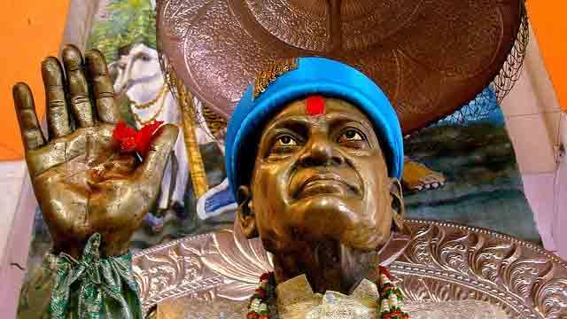
INTRODUCTION
Raul Maharaj was born in a small village of Sindhudurg district in Maharashtra, was considered as an incarnation of Lord Dattatreya. He was a great devotee of Lord Datta from his childhood, and used to visit and worship the temple of Datta regularly. He would meditate for several hours in his home and also studied well and finished his basic education by securing good marks in all the subjects. He would perform pujas at his home as well as in the Datta Mandir, and invite his friends to join in the puja, and asks them to chant the holy mantra “OM SRI DATTATREYARE NAMAHA”.
He learned the devotional texts, and also learned the regional languages from a famous scholar. He was a master in yoga and meditation, and got great spiritual powers through his severe meditation on Lord Datta.
During his period, he has provided food to the poor, and also financially helped them. He also removed the health issues and various other problems of the people, and pacified their mind by conducting religious lectures.
A shrine is erected at the place of his burial at Pinguli, Maharashtra, and till now lot of devotees are visiting and worshipping this holy place. And it is believed that he is still safeguarding his sincere devotees and solving their problems through his grace.
TEACHINGS
- Don’t always think about yourself, think about others also, and help them in case of necessity.
- Observe strict patience, calmness and don’t be arrogant over others.
- You are responsible for your own actions, and you cannot blame anybody else.
- Work is worship. Work hard and pray to the god, and spare some money for donating it to a noble cause.
- Believe that god can be able to change a person’s destiny based on his true bhakti on the god.
- Avoid unnecessary tensions by doing yoga and meditation and also by going to the temples.
- Don’t be lazy in your younger age, or otherwise you would have to suffer at your older age.
- Consider others as your friends and relatives and always be kind over others.
- Provide food to all the living beings in this world, and show mercy even to the small tiny insects, and don’t hurt them.
Let us worship the great saint and be blessed.
“OM SRI RAUL MAHARAJ JI NAMAHA”
“JAI DATTATREYA”
WRITTEN BY
R.HARISHANKAR

VALLALAN – ARDENT DEVOTEE OF LORD VINAYAKA
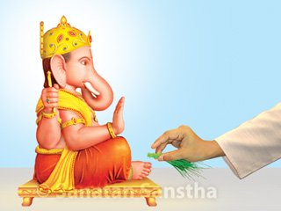
INTRODUCTION
Several centuries back, there lived a pious Brahmin boy along with his family at a village in Tamil Nadu. His name was Vallalan. He was mentioned in the Vinayaka Purana. He was an ardent devotee of Lord Vinayaka, and used to offer regular prayers to him at his home, and in the temples. Though he has studied well, his father was not pleased with his performance in the studies, and put more pressure on him, with regard to his studies.
The young Vallalan after finishing his school, daily would take his friends at the Vinayaka Idol which was seated under a fig tree. He would collect flowers from the nearby flower gardens, and also gather the fruits which were fallen out from the trees, and use it for performing the puja for Vinayaka idol. His father was not aware of that. One day, while his father was passing by that side, he suddenly saw his son performing the puja to the idol of Vinayaka. He got very angry with his son, and hit him hardly with a stick. The young boy was injured and got fainted and fell down on the floor. Even after that, his father could not control his angriness, and started hitting him hardly again and again with the stick. Due to that, he was very much wounded and laid in an unconscious state.
After some time, his father, has went home, and narrated the entire incident to his wife. She was very much upset, and went to the temple of Vinayaka, and given first aid to her son, and took him to a village physician. After some time, Vallalan got relieved from his pains, and become normal. But his father could not raise his hands, and the bones of his right hand were broken automatically. He realized his mistake, and asked his son to apologize him, and also prayed to Lord Vinayaka.
The young vallalan also felt pity on his father, and asked him to chant the ganesa mantra “OM SRI VINAYAKAYA NAMAHA”, his father has chanted the mantra, and miraculously his bone got attached, and he was healed through the help of his son the great Vinayaka Devotee Sri Vallalan. Then the entire family were become sincere devotees of Lord Vinayaka. After his death, he reached the divine abode of Lord Vinayaka, the Ganesha Loka.
Let us praise the glory of Vallalan and be blessed.
“OM SRI VALLALANE NAMAHA”
“OM SRI VINAYAKAYA NAMAHA”
WRITTEN BY
R.HARISHANKAR

VALLI
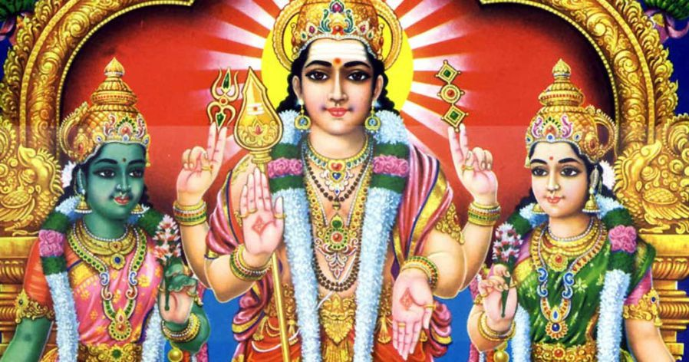
INTRODUCTION
Valli is a goddess and the consort of Lord Muruga. Valli was born as the daughter of Lord Vishnu in her previous birth with the name Sundaravalli.
She was the adopted daughter of Nambi Rajan, the tribal leader of the Mountain kingdom. She was a sincere devotee of Lord Muruga from her childhood itself. Valli used to pray to Muruga with great devotion, and wants him to be her consort. Once, while she was protecting the crops from the birds, she met Lord Murugan in the form of a hunter, an old man, and finally revealed his true form.
After some time, Lord Muruga has transformed into a young man, and started talking with Valli. At that time, Valli’s father Nambirajan and his followers were arrived at that place, and without recognising the young man as Lord Muruga, they fought with him, and all of them were killed in the hands of Lord Muruga, but due to the request of Valli, they were brought back alive, and Lord Murugan took his true form and blessed the tribesmen, and the chief performed marriage to Valli and Murugan.
The place where these incidents were occurred is known as Vallimalai and it is located in Vellore District of Tamil Nadu. After their wedding, Murugan and Valli, moved to Thiruthani, Tamil Nadu, and blessing their devotees in a wonderful manner.
Let us worship Mata Valli and be blessed.
“OM SRI VALLI ANNAIYE NAMAHA”
“OM MURUGA VEL MURUGA”
WRITTEN BY
R.HARISHANKAR

VENKATA DESAI – SINCERE DEVOTEE OF GURU RAGHAVENDRA
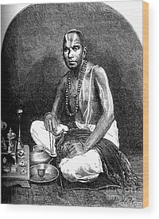
INTRODUCTION
Venkata Desai (16th century) was the landlord in the Kiritakiri Village, Karnataka, and belonged to an orthodox family. He was the chief person in the village, and lived along with his wife and his small child. He lived during the time of Guru Raghavendra, and was a great devotee of him. He was a pious and a noble scholar who was thorough in all the sacred texts, and lived an honest life, by regularly doing pujas, homams and abhishekhams at his home as well as in the temples of Lord Vishnu, and lived peacefully with sufficient wealth.
Once, during his yatra, Guru Raghavendra visited his village. Desai eagerly welcomed the great guru to his home. Guru has accepted his request and visited his home, to perform the Moolarama Puja, which is a very famous puja, and the Moola Rama deity was worshipped by Lord Brahma himself in his Brahma Lok.
The entire village was decorated with flowers, and mango leaves, and it was looked like a festive season. Desai was preparing lot of food items at his home, by employing lot of cooks, in order to serve to the participants of the puja and to the village people. Most of the village people gathered in the house of Sri Venkata Desai, and they were eagerly watching the Moola Rama Puja. Desai and his wife were also watching it with much pleasantness in their mind. At that time, their little child suddenly fell into the big cooking vessel, which contains mango rasam, and the child was died due to fire burns.
At the end of the puja, the couples were searched for their child, and found him into the cooking vessel, and was very much depressed. And after some time, they brought their son in presence of Guru Raghavendra, and whispered. Immediately the great guru sprinkled the water from his kamadala into the face of the dead child. After a few seconds, the child was brought back alive. The desai family and the village people were very happy, and Venkata Desai had gifted several lands to the divine saint, and got blessings from him.
Let us worship the great man Venkata Desai and be blessed.
“OM SRI VENKATA DESAI NAMAHA”
“OM SRI GURU RAGHAVENDRAYA NAMAHA”
“OM SRI MOOLA RAMA DEVARUVE NAMAHA”
WRITTEN BY
R.HARISHANKAR

VILVAMANGALAM SWAMIGAL – GREAT DEVOTEE OF LORD GURUVAYURAPPAN
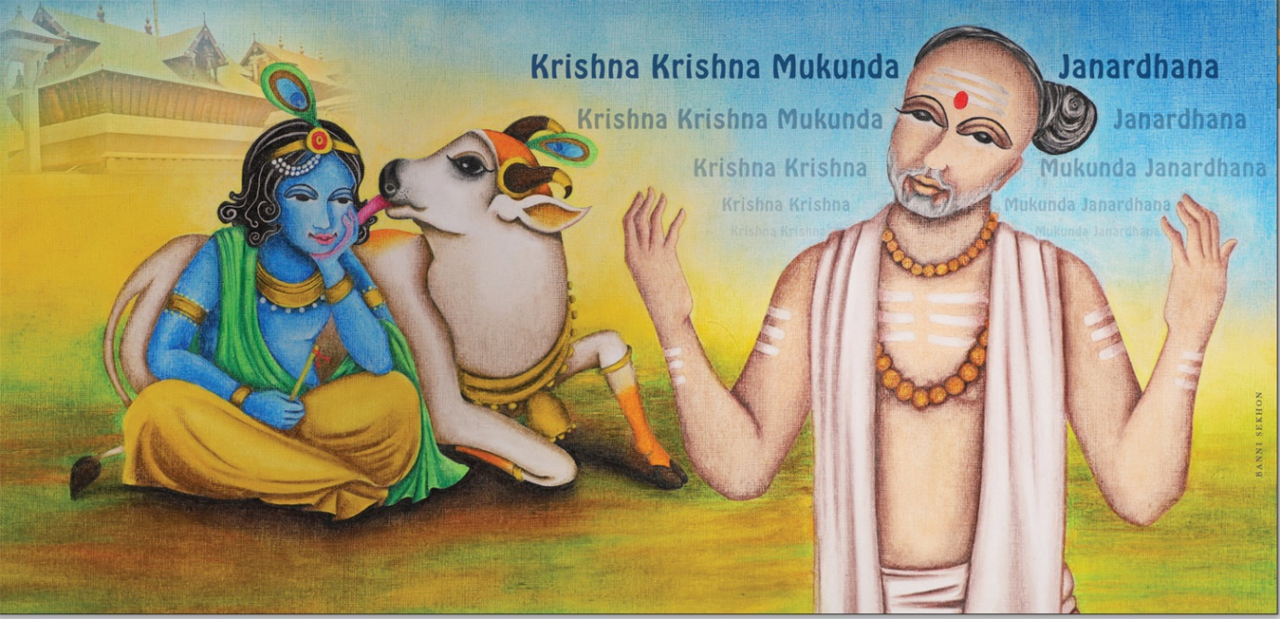
INTRODUCTION
Sri Vilvamangalam Swamigal (1268-1369) was a great saint, poet and a devotee of Lord Guruvayurappan, a form of Lord Krishna. He was born in a village in Trichur District at Kerala. He has written many devotional poems in praise of Lord Krishna, and sung in front of the Guruvayurappan deity at his famous temple in Kerala. Sri Krishna Karnamrutam was the famous work rendered by the great saint. Though he belonged to shaivite sect, he was a great devotee of Lord Krishna similar to Narayana Bhattadhiri and Poonthanam Namboodri. He was a great scholar who has studied all the hindu scriptures and used to perform lectures in Bhagavatham among the people. He has also travelled to many holy places and visited the famous shrines in Dwaraka, Puri and Badrinath.
It is believed that he has got the divine appearance of Lord Krishna in the form of a small boy, and he performed mischievous acts, while he was doing puja to Lord Krishna at his home. He will used to apply the sandal paste kept for puja in his body, and ate the butter kept in the puja room, and used to wear the garland from the idol of Krishna. Initially, the great saint doesn’t know that the boy was none other than his holy Krishna, and he scolded the boy for his mischievous acts, but after some time, he felt a smell of great divine fragrance from the body of the little boy. The boy suddenly disappeared from that place. After a long search, he found the boy at Ananthankadu, and there Lord Krishna has given his darshan to him in the form of Anantha Sayana Moorti. Swami prayed to the Lord to pardon him. After some time a Temple was constructed in that place.
The Ananthankadu Nagaraja Temple still exists near the Padmanabhaswamy Temple. The Samadhi of the Vilva Mangala Swamigal exists to the west of the Padmanabha Temple. A Krishna Temple was built over the Samadhi. This Temple is known as “Vilwamangalam Sri Krishna Temple”.
FAMOUS WORKS
- Sree Krishna Karnamrutam
- Sreechinham
- Purushakaaram
- Abhinava-Kausthubha-Maala
- Dakshinaamoorthy-Sthavam
- Kaalavadha Kaavyam
- Durgaasthuthi
- Baalakrishna Sthothram
- Baalagopaala Sthuthy
IMPORTANCE
He was a great saint who has got the darshan of Lord Krishna several times in his life. He also helped the people, by asking them to chant the Krishna mantra, “OM NAMO BHAGAVATE VASUDEVAYA NAMAHA”, and gave the Holy Prasad to the sick and the sinful people, and relieved them from their diseases and sins. He spread the Krishna Bhakti Spirit throughout Kerala through his great poems, and gave religious discourses in a simple manner and insisted the people to worship Lord Krishna regularly.
Let us worship the great saint and be blessed.
“OM SRI VILVA MANGALA SWAMIGALE NAMAHA”
“JAI KRISHNA”
“OM NAMAH SHIVAYA”
WRITTEN BY
R.HARISHANKAR

