DIVINE TEXTS BY R.HARISHANKAR
ACHARYA KANAD
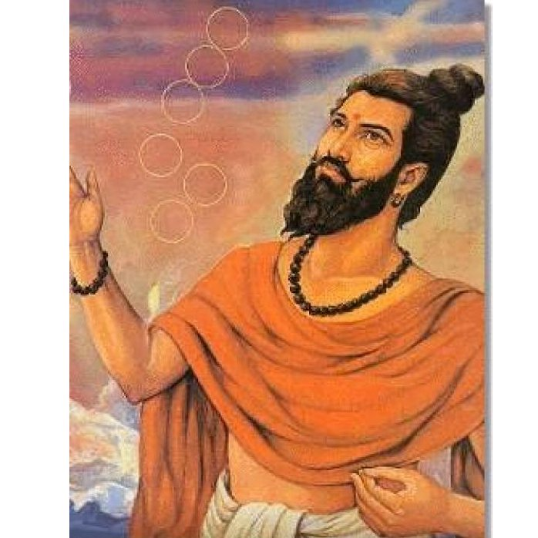
INTRODUCTION
Acharya Kanad was considered as the father of atomic theory. It is believed that he would have lived before 2600 years ago. He is also a great sage, who had done severe penance on Lord Shiva and achieved the spiritual energy and spiritual power. His birth name was Kashyap.
LIFE
Acharya Kanad was born near Dwaraka, Gujarat, India. He was the son of the great sage Ulka.
Even at his younger age itself, Kashyap was interested in learning about new things in his life. He also travelled to many holy places like Prayaga, dwaraka, puri, kasi and badrinath, and worshipped the gods. He was a sincere devotee of Mata Ganga and considered her as his own mother. Through her grace, he had attained great divine powers. During his childhood, he was also interested in counting stars in the sky, though it is a very difficult task, he will used to do it due to his great interest on space and science.
He also had got the habit of collecting rice from the rich people in order provide food to the poor devotees at the banks of the holy river ganges. Kanad in due course of time had got great interest in researching and inventing new things. Due to that, he was called by the people as “Acharya Kanad”.
He was very much interested in learning science and the discovery about atomic energy. According to Acharya Kanad, atoms are minute objects that are considered as indestructible. He founded the Vaisheshika School of philosophy to teach the subjects related to science to his followers. He also wrote a book called “Vaisheshik Darshan”. He was recognized as the best among the sages of the ancient times.
TEACHINGS
- Collection of many small particles will make into a whole big object.
- Spirituality is a must for understanding the subjects related to science.
- Every invention of a new thing must be used only for good and productive purpose.
- The invention must benefit the people and also the entire region.
- Anything can be achieved in this world by hard work and sincerity.
- Before inventing a new product, proper understanding about the subject is a must.
- Learning science is not a difficult task.
- Concentration is must for doing any kind of activity.
- Strict discipline must be observed while doing any kind of work.
IMPORTANCE
Apart from his interest in science and new inventions, he is a great sage and was a great scholar who had mastered in divine scriptures and also an expert in all kinds of art. Though he lived before thousands of years ago, his interest in the field of science and technology can never be forgotten in today’s world. Even big scientists and scholars are appreciating his sincere interest in the field of science and about his new inventions.
Let us worship the great sage and be blessed.
“OM SREE ACHARYA KANAD NAMAHA”
WRITTEN BY
R.HARISHANKAR

ALAMPUR JOGULAMBA TEMPLE
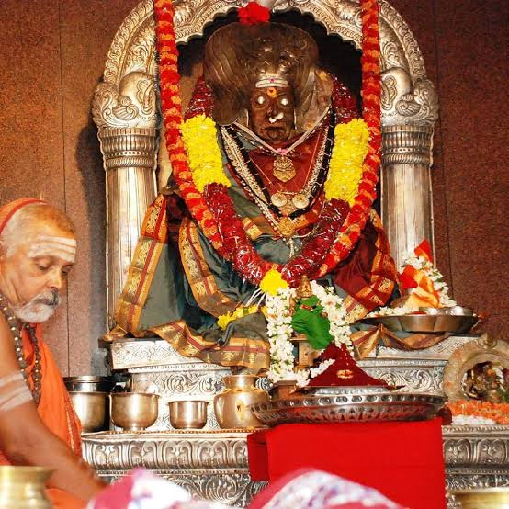
INTRODUCTION
Jogulamba temple is situated in Alampur in the state of Telangana. This temple is dedicated to goddess Jogulamba Devi and Lord Balabrahmeshwara. The temple will be kept opened between 7.00 AM and 8.30 PM. This temple is considered as one of the Shakti Peethas.
Here Goddess Jogulamba looks in a fierce form, and she grants salvation to her sincere devotees. According to legend, once there lived a great saint in 6th century who was known as Rasa Siddha and he had got the power to convert any metal into gold. And through his great powers, the temples were formed. They are as follows:
- Swarga Brahma Temple
- Padma Brahma Temple
- Vishva Brahma Temple
- Arka Brahma Temple
- Bala Brahma Temple
- Garuda Brahma Temple
- Taraka Brahma Temple
- Kumara Brahma Temple
- Vira Brahma Temple
The Jogulamba temple stands for its great art work and sculpture. It is believed that Lord Brahma had performed a great penance in Alampur for several thousands of years, and got the powers of creation. Hence, the deity is known as Brahmeswara and the goddess as Jogulamba, a divine form of mother Parvathi.
IMPORTANCE
She is our divine mother, who protects us from all sorts of problems and difficulties. We can visit her temple and get her blessings at least once in a year. Every year during Navratri festival days, the god and the goddess would be decorated with flowers and flower garlands and special pujas and abhishekhams will be conducted in the temple. She gives all the prosperity in our life and protects us throughout our life, and finally will give SALVATION to us.
Pooja Details
Pooja on Normal days:
Pooja Timings: 7.30 am – 4.00 pm
During Karthika masam:
Pooja Timings: 6.30 am – 5.00 pm
Rudrabhishekham will be performed for about 45 minutes. The devotees can pay the ticket cost for doing abhishekham to the deities or they can bring with them items like milk, curd, honey, fruits, ghee, vibhuthi for performing abhishekham to the deities.
By performing abhishekham to the deities, all the evil and negative thoughts will be removed from our mind, and we will get peace and prosperity in our life.
Let us worship the divine father and mother and be blessed.
“OM SREE JOGULAMBIGAIYE NAMAHA”
“OM SREE BALABRAHMESWARARE NAMAHA”
“OM NAMAH SHIVAYA”
WRITTEN BY
R.HARISHANKAR

BAGALAMUKHI DEVI
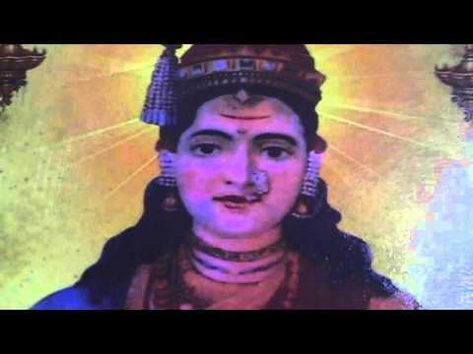
INTRODUCTION
"Bagalamukhi" Devi is one of the mahavidyas, and she clears the confusion in the minds of her devotees and gives great spiritual power. The Devi has 108 names and she is generally known as Pitambari Mata and worshipped by the people in North India, and the goddess complexion is golden colour. Her vehicle is Bagula bird, a kind of divine bird, similar to that of Lord Garuda. Hence she is called as Bagalamukhi Devi.
Temples dedicated to Bagalamukhi are located at Assam, Karnataka, Madhya pradesh, Himachal Pradesh, Kanchipuram district, Tirunelveli district of Tamil nadu and also in Nepal.
She is also called as "Kalyani". And she contains the features of Devi Durga. Worshipping Bagalamukhi Devi and Durga Devi will yield better results in our life. We can perform pujas to Mata Bagalamukhi Devi, by placing her picture in our puja room, and can offer fruits, flowers and coconuts and chant her various names and recite her mantras. Performing pujas on Tuesdays and Fridays will bring good fortunes in our life. Several people have experienced very good results in their life after performing pujas to Mata Bagalamukhi Devi. She has the power to extract all the negative thoughts in our mind, and will fill up with good spiritual thoughts in our mind. By sincerely praying to her, our mind will get refreshed and we will feel like as if we are living in the divine world. We should trust on her with utmost faith and devotion in our mind.
In the First yuga, also called as Krita Yuga or Satya Yuga, a great storm was formed and destroyed the universe. The Divine gods meditated Mata Durga on the banks of Haridra Sarovar. Pleased with the prayers of the divine gods, Mata Durga appeared in front of them and through her powers she created Bagalamukhi. Bagalamukhi pacified the storm, and thus making the normal functioning of the universe.
Once, Mata Bagalamukhi, killed a powerful demon. Being dying, the demon prayed to the goddess that he has to be worshipped by the people along with her. And the goddess Bagalamukhi granted the boon to him. Bagalamukhi is worshipped for giving peace of mind and for providing all sorts of prosperity in our life. She removes the black magic, and gives more strength, courage and boldness in our life. She will come with us in our daily life and will guide us in all aspects of our life.
IMPORTANCE
By regularly reciting ‘Bagalamukhi stotram’, our anger will be removed. And our enemy will become our friend, a poor person will become a rich person, various health related problems will be recovered and sins committed in previous births will be removed and we will get good results in our life.
Let us worship the great divine mother and be blessed.
“OM MATA BAGALAMUKHI DEVIYE NAMAHA”
“OM DURGA DEVIYE NAMAHA”
“OM NAMAH SHIVAYA”
WRITTEN BY
R.HARISHANKAR

BANASURA
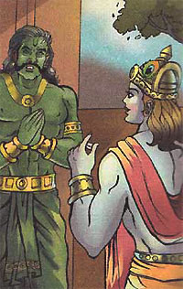
INTRODUCTION
Banasura was a thousand-armed Asura king, and the son of Bali, and the great grand-son of Bhakt Prahalad. Banasura is believed to have ruled the present-day Assam. Banasura, a great demon king, once ruled over a large kingdom. He was a brave and a courageous ruler who never got afraid of any one. Even the devas and the asuras were given proper respect and honoured him. Banasura was a great shiva devotee. He used to worship a Rasalingam which was given to him by Vishvakarma. He used his thousand arms to play the Mridanga when Shiva was performing the dance. Due to the boon given by Lord Shiva, Shiva protects his entire kingdom. Due to that, he got pride and considered himself as the powerful person.
He got a daughter and her name was Usha. One day, Usha dreamt of Aniruddha, the grandson of Lord Krishna and fell in love with him. Her friend Chitralekha was an efficient artist and helped her friend Usha to identify the young man by drawing various pictures. Chitralekha, through her supernatural powers, took Aniruddha from the palace of Krishna and brought him to Usha. Due to that a fight between Krishna and Banasura had taken place. Banasura was defeated by Lord Krishna. And Banasura apologized to Lord Krishna and married his daughter to Lord Krishna’s grand- son, Aniruddha.
Banasura's story has been mentioned in Mahabharata and Bhagavata Purana.
IMPORTANCE
He was a great shiva devotee, and after his death, he attained the abode of Lord Shiva, Kailasa and become one of his attendants. He is praised for his wisdom, courage, braveness and knowledge.
Let us worship the great shiva devotee and the great grand-son of Bhakt Prahalad and be blessed.
“OM SREE BANASURARE NAMAHA”
“OM SREE BHAKTA PRAHALADAYA NAMAHA”
“OM NAMAH SHIVAYA”
WRITTEN BY
R.HARISHANKAR

BAYAJABAI
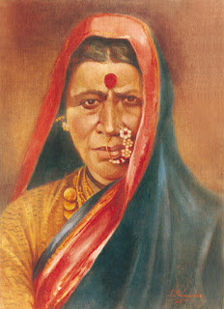
INTRODUCTION
Bayajabai also called fondly as Bayaja Maa became a resident of Shirdi after she married Sree Ganapath Patil. She was a sincere and a dutiful wife and she also provided food to all the guests and other living creatures like dogs, cats and birds, especially to crows. She only first saw “SAI BABA” when he was meditating under a neem tree. From then onwards, she started serving him by showing her affection and bhakti on him. She will used to serve Baba with great care. She was very affectionate towards Saibaba and considered him as her own brother. Without offering food to baba, she would never eat food. She showed such a love and affection on Baba. She realized his divine powers, and considered him as a divine avatar. Baba will used to take food from her house regularly. He will used to call fondly as “BAYAJA MAA”, and immediately after hearing baba’s voice, Bayaja Maa would serve good food with motherly affection. She will also prepare special food items for him. Baba was very much pleased with her great service and regularly used to take food from her hands. She also treated him with great respect and with full of devotion in her mind.
Baba once saved the life of Bayaja Ma’s husband from the death god “YAMA”, and he also safe guarded her son Tatya from ill health and from several accidents. Her son tatya also loved saibaba and called him as uncle. Their entire family were very much devoted with SAIBABA.
She will used to regularly praise about baba and tell about his greatness and holiness to her husband and son and also to his disciples. She continued her dedicated service of serving food to baba until her death. The house of Bayaja Maa is located nearby “Sai Kutir”.

IMPORTANCE
Even though she got her own family, she liked baba for his simplicity and kindness. She had realized that he was not an ordinary human, but an incarnation of god. We cannot imagine doing such a great and good service to the worshipful saint in this today’s fast changing world.
Let us praise her for her dedicated service to “SREE SAI BABA” and be blessed.
“OM MATA BAYAJABAI NAMAHA”
“JAI SAI RAM”
WRITTEN BY
R.HARISHANKAR

BRAHMA TEMPLE, PUSHKAR
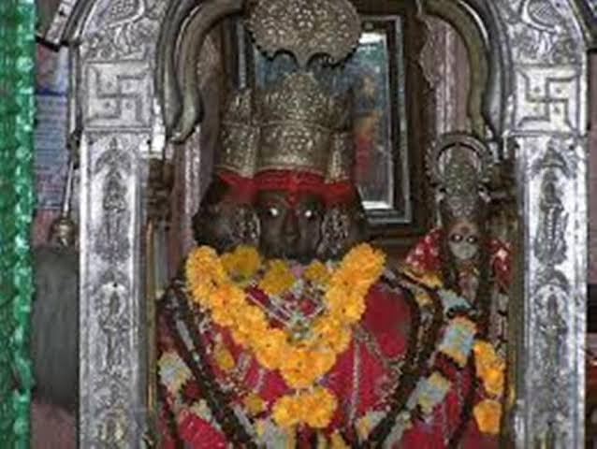
INTRODUCTION
Lord Brahma is the father of the entire creation. Though he is the creator, he got only few temples, due to the curse given by Rishi Brihu during the previous Dwapara Yuga. His famous temple is situated at Pushkar in Rajasthan. The temple is the most popular temple among his few other temples.
The temple was believed to have been built during the 14th century, and later it was renovated and reconstructed several times. The temple is made out of fine marble stones. The temple’s main deity is Lord Brahma with his consort Mata Gayatri. The temple is administered by a certain sect of priest. Every year during Kartik Poornima festival, large numbers of pilgrims would visit the temple and worship Lord Brahma, after taking their bath in the sacred Pushkar Lake.
The temple is believed to have been built by the great sage Vishwamitra, and it is believed that Lord Brahma himself had preferred to stay in this temple in order to bless his devotees.
His four arms hold the mala, the divine vedas, the holy grass and the sacred water pot. Lord Brahma‘s vehicle is the hamsa. The temple is visited by lot of pilgrims and also by saints, after taking a bath in the Lake Pushkar.
The temple is open for worship between 6:30 am and 8:30 pm and three types of aratis are held in the temple.
Brahma's two consorts Savitri and Gayatri also have separate temples built for them in Pushkar. The Atpateshwar temple is situated nearby the main temple which was built by the instructions of Lord Brahma in order to worship Lord Shiva permanently from his temple.
IMPORTANCE
Being the creator of the entire universe, by sincerely worshipping Lord Brahma in this temple, our bad fate also will get slightly changed, since he is only putting our fate on our head. We will be brightened in our life, and enjoy the spiritual bliss through the grace of the divine father Lord Brahma. And our entire problems would be vanished after having the glimpse of the Lord and bathing in the sacred pushkar lake. We can also do several pujas and perform abhishekhams at this temple to Lord Brahma and his consorts. It is a must to visit Mata Savatri and Gayatri temples also after visiting his main temple. After finishing worship in the temples, we have to definitely worship Lord Shiva at his Atpateshwar Temple. Let us try to visit this holy temple of Lord Brahma once in every year during the pushkar festival period.
Let us worship the divine creator and the universal father Lord Brahma and be blessed.
“OM SREE BRAHMA DEVARE NAMAHA”
“OM MATA SARASWATHI DEVIYE NAMAHA”
“OM MATA GAYATRI DEVIYE NAMAHA”
WRITTEN BY
R.HARISHANKAR

BRAHMAPUREESWARAR TEMPLE
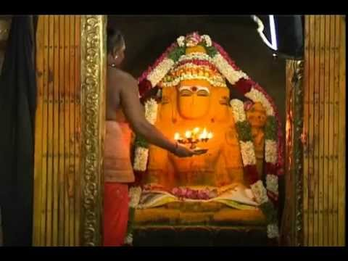
INTRODUCTION
The Brahmapureeswarar Temple is situated in Thirupattur. It is believed that by visiting this temple our fate can by changed by the blessings of Lord Brahma.
Once Lord Brahma has got pride that he was the ultimate Creator of the entire Universe. Lord Brahma thought that he has got more powers than Lord Shiva.
Due to his pride, Lord Shiva destroyed Lord Brahma’s Fifth Head, and also he got cursed from Lord Shiva, and due to that he had lost his creative powers.
In order to get relieved from the curse, Lord Brahma went on a pilgrimage of Lord Shiva Temples.
During his travel, Lord Brahma visited this temple and performed severe penance on Lord Shiva and worshipped him.
Due to his severe penance, Lord shiva appeared in front of him and liberated him from his curse. Lord Shiva also had given the power of creation to Lord Brahma.
Due to the blessings of Lord Shiva, Lord Brahma had got a separate shrine at this temple. He also advised Lord Brahma that the fate of those devotees who visits this temple should be rewritten.
Hence by worshipping Lord Brahma, Lord Shiva and Mata Parvati at this temple, we can expect a good change in our life.
The main deities are Lord Shiva who is in the form of Lord Brahmapureeswarar and Mata Parvati Devi in the form of Brahma Sampath Gowri. Lord Brahma’s idol can be found here in the form of doing penance. Jeeva Samadhi of the great siddhar Patanjali, is also found in this temple.
There are 12 Shiv Lingams found in this temple which were installed and worshipped by Lord Brahma.
A sacred pond was named as Brahma Theertham, since Lord Brahma fetched water from this pond, for performing puja to Lord Shiva.
SHRINES IN THE TEMPLE
- Sri Brahmapureeswarar Main Deity
- Sri Pazhamalai Nathar
- Sri Pathala Eswarar
- Sri Thayumanavar
- Sri Manduga Nathar
- Sri Ekambareswarar
- Sri Arunachaleswarar
- Sri Kailasa Nathar
- Sri Jambukeshwarar
- Sri Kalathi Nathar
- Sri Sabthagereswarar
- Sri Sudharaneswarar
IMPORTANCE
By worshipping Lord Brahma, Lord Shiva and Mata Parvati in this temple, we can get rid from our sins committed in our past births, and can get great spiritual energy, physical and mental strength. Wherever we go, the divine gods and goddess will follow us like our shadow, and be with us in our every moment of life. Our wishes will be fulfilled and we will become a happiest person in the world for ever.
Let us chant the glory of the gods and goddesses and be blessed.
“OM SREE BRAHMADEVARE NAMAHA”
“OM NAMAH SHIVAYA”
“OM SAKTHI PARASAKTHI”
WRITTEN BY
R.HARISHANKAR

CHOWDESHWARI DEVI
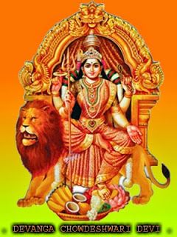
INTRODUCTION
Sri Chowdeshwari Devi is an incarnation of Mata Parvati. Her other names are Banashankari and Soodambika. She is the Kula Devi of the Devanga sect of people.
According to ancient puranas, Sage Devala, was the chief of the Devanga community. He contains the features of Lord Shiva and was born in the earth in order to introduce the professions of making clothes and weaving for the benefit of the people. Once, Devala was attacked by fierce demons. Devala prayed to Mata Shakti to protect him. Shakti appeared in front of him and killed the demons. After killing the demons, Mata Shakti was awarded the name Chowdeshwari Devi and she advised Devala to worship her during every Amavasya.
Devala went to Himalayas and wove new clothes and given them to the divine gods in the heaven and to the people in the earth. He married Lord Surya’s sister, and also married Lord Aadhi shesha's daughter.
Devanga people worship Mata Parvati in the form of Chowdeshwari Amman. People of Tamil Nadu, Karnataka and Kerala worship Chowdeshwari amman with sincere devotion in their mind. Nepali Devanga people worship her in the form of Komalangi Devi.

FESTIVALS
- Devanga new year
- Chaitra Suddha Panchami
- Ashadha Amavasya
- Devanga Janivara
- Jagajathara Dhoddabba
- Sankranti
- Diwali
- Janmastami
- Ramnavami

TEMPLES
1. Sri Ramalinga Sowdeshwari Amman at Hampi, Karnataka
2. Mata Sowdeswari Devi temple in Dharapuram
3. Sowdeswari Amman temples in Tamil Nadu
4. Sowdeswari Amman temples in Karnataka
5. Sowdeswari Amman temple in Kerala
6. Komalangi Devi temple in Nepal
IMPORTANCE
Mata Choudeshwari Amman will destroy the evil forces which occupies in our mind and body, and make us into a good and knowledgeable person. By sincerely worshipping her, she will act as a care taker and an affectionate mother, and we can tell our problems to her. Whatever problems we have, she will know that, and give proper remedy to us in a suitable time.
We have to wait for our bad karmas to get lost. Then through the grace of Mata Chowdeshwari, our life will blossom like a lotus flower. Being the holy and kind mother, she is having the capacity to slightly change our fate also, and gives us all the prospects in our life. She will remove our diseases and mind related problems and come with us in our every moment of life.
Let us worship the divine mother and chant her glory.
“OM SREE MATA CHOWDESHWARI DEVIYE NAMAHA”
“OM NAMAH SHIVAYA”
WRITTEN BY
R.HARISHANKAR

GAYASURA
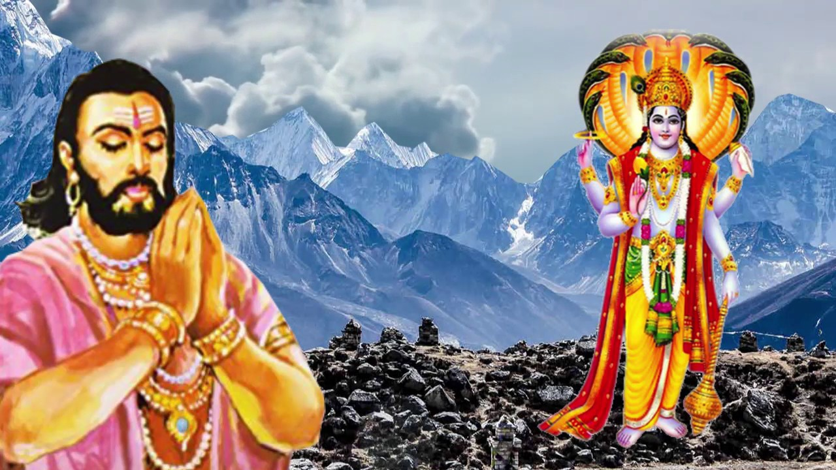
INTRODUCTION
Tripurasura, the father of Gayasura, was a great devotee of Lord Vishnu. After his death, his son, Gayasura, became the king, and he was also a devotee of Lord Vishnu. He performed severe penance on Lord Vishnu and attained the boon of immortality: not to be killed by any one and at any time. After getting such a great boon, Gayasura tortured everybody through his great powers.
He finally fought with Lord Vishnu, and due to his great powers, Vishnu was also defeated by Gayasura. Gayasura was very happy by defeating the god himself by his great powers and he had again tortured all the living beings in the earth and heaven.
Everyone in the earth and heaven were suffered and approached Lord Vishnu to use his tricks, and to relieve the people from their difficulties. Lord Vishnu went to the place of Gayasura and asked him to give a boon for him. Gayasura also agreed to it. Vishnu has asked him to be turned into a stone.
Before turning into the form of a stone, he has asked the god to fulfil his wishes. He has asked to put the two feet of the lord in his heart. And he has asked to grant salvation for those devotees who had the Lord’s feet in their hearts. And finally he has asked that if even a single person having the Lord’s feet in his heart fails to get salvation, he will again become a living man.
Lord Vishnu granted all the boons to him. From this incident, it can be known that god had liberated all of his devotees who have got the opportunity to place the Lord’s feet in their hearts, and didn’t give an opportunity for gayasura to again become a living man. Still now his statue is present in the Kukkuteswara Swamy temple at pithapuram, East Godavari district, Andhra Pradesh. It is a very ancient and a holy temple. Here free annadanam is provided for more than 100 people on a daily basis. Daily lot of devotees from all parts of india are coming here to have the glimpse of the Lord Kukkuteswara Swamy and Gayasura. And it is holy place for doing ancestors rituals and to get relieved from the curses of the ancestors.
IMPORTANCE OF WORSHIP
From this incident, we can know, that god will never allow his sincere devotees to take rebirth again in this difficult world. He will never withdraw his promise given to Gayasura. Hence let us make the practice of keeping the thoughts of god in our mind, and realize him from our inner soul in order to attain SALVATION.
Though gayasura has turned into a stone, it is believed, that he is still worshipping his beloved god Vishnu and chanting his mantras and names from his inner soul.
Let us worship the great gayasura and Lord Vishnu and be blessed.
“OM SREE GAYASURAYA NAMAHA”
“OM NAMO NARAYANAYA NAMAHA”
WRITTEN BY
R.HARISHANKAR

HARISIDDHI
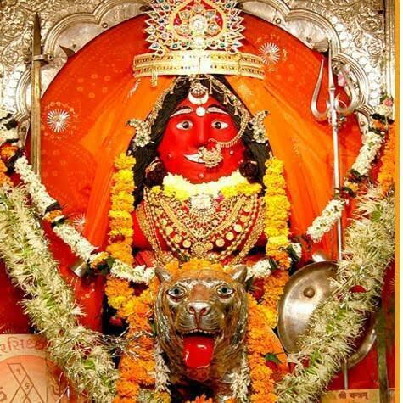
INTRODUCTION
Harsidhhi is a famous goddess mostly worshipped in Gujarat, Madhya Pradesh and Maharashtra. She is the incarnation of the divine mother Mata Parvati. She is also known as Harsidh Bhavani Devi.
She is worshiped as Kula devi by Brahmin, Jain and other community people in the northern states of India. She is also sincerely worshiped by fishermen of Gujarat, since she is considered as the guardian of ships while travelling in the sea.
Harshidhhi Mata Temple is located at Gandhvi village, near Dwarka. It is believed that Lord Krishna had worshiped Mata Harsidhhi and attained great powers. The original temple was constructed by Lord Krishna. Krishna prayed to Mata Harsidhhi and defeated the demons. After he won in the battle with the demons, he constructed the temple. She is also considered as the kula devi of the Yadavas.
According to legend, once, a sea traveller Jagadu prayed to Mata Harsidhhi to save his ship from storm. And as per the wish of the goddess, he sacrificed buffaloes and finally was willing to sacrifice his own life along with his family. Due to his sincere devotion, Mata Harsidhhi appeared before him and granted the boon of safeguarding his ship from floods and storm and also given him sufficient wealth and all prosperities in his life.
There is another popular temple located at Ujjain, which was built by the great Kali devotee King Vikramaditya. Her other temples are located in Rajpipla, Ladol, Palaj, Indore, Dwaraka and Kutch.
IMPORTANCE
She protects the travellers of ships and safeguards them from sea creatures, winds and storm. She also protects them in case of breakage of ships. She is the holy mother, who cannot be ignored not only while travelling through ships, but also in our daily life journey, whether it may be at our office, home or any-where else. Even for moving a single step forward, we need her help. Without the help of the divine mother, Harsidhhi, we cannot do anything. Hence let us worship her with full of devotion in our mind and be blessed.
“OM SREE HARSIDHHI DEVIYE NAMAHA”
“OM NAMAH SHIVAYA”
WRITTEN BY
R.HARISHANKAR

IMPORTANT AVATARS OF PARVATI DEVI
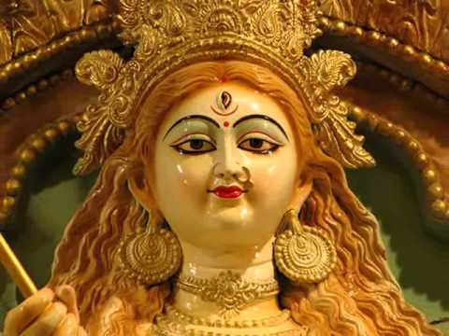
- Ishvari is the female form of Lord Shiva. She is the incarnation of Mata Parvati Devi. She is the sakthi element, who protects the entire universe along with Lord Shiva. She is worshipped in various names. She can be worshipped by reciting her various names and chanting her slokas.
- Adi Parashakti is considered as the supreme goddess in the Shaktism sect. She is also called by names such as "Adi Shakti", "Maha Shakti", and “Maha Gauri”. According to Devi-Bhagavata Purana, she is the main activating force and she only creates, protects and destroys the entire universe.
- Akilandeswari is one of the main forms of Mata Parvati. The famous temple of Akilandeswari is situated at Thiruvanaikoil. She is also worshipped as Meenakshi, Kamakshi and Vishalakshi.
- Jaganmata means the mother of the entire universe and she is considered to be an avatar of Parvati Devi. Jaganmata is another form of Bhuvaneshvari Devi and contains temples in tamil nadu. Her other names are Vishveshwari and Lokeshwari.
- Kolaramma is the main deity for the people of of Kolar in Karnataka. The Kolaramma temple is an ancient temple and built by the Chola kings. Mata Parvathi is worshipped as Kolaramma by the people of Kolar. The kings of Mysore were regularly visited this temple to get the divine blessings of Mata Kolaramma, and done many charitable activities in this temple like providing food to the poor devotees. They also arranged to conduct regular pujas and abhishekhams to the goddess. The temple statues are very beautiful and the temple looks very neat and clean and was well administered by the temple authorities.
- Sati is the daughter of Lord Daksha, and she was later married to Lord Shiva. Once she went to the yagna conducted by his father daksha. Her father didn’t like her due to her marriage with Lord Shiva, and hence insulted her. Mata Sati self-immolated herself, through her divine power, and her body fell down in several parts of the world. Her 51 parts which fell in different places are called as 51 Shakti Peetas.
- Paranasabari Devi is worshipped for getting rid from several dreaded diseases, and also gives mental energy along with spiritual energy. She also throws out our enemies, and gives permanent protection to our problems.
- Rudrani is the consort of Lord Rudra. She is considered as a supreme manifestation of Mata Parvati. Rudrani contains the powers of Lord Rudra and she is also called as Maheshwari and Uma Maheshwari.
- Saibini is goddess worshipped by the people of Goa, India. She is none other than our divine mother parvati, who protects the universe from harmful activities and gives proper solution to the problems caused due to natural calamities like earth quake, storm, tsunami, drought and famine. And gives food, clothing and shelter to the poor people.
Let us worship the holy avatars of Mata Parvati and be blessed.
“OM SREE PARVATI DEVIYE NAMAHA”
“OM NAMAH SHIVAYA”
WRITTEN BY
R.HARISHANKAR

KALI PURUSH
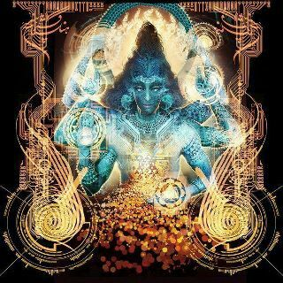
INTRODUCTION
According to Hindu religion, Kali is the god of the Kali Yuga who gives lot of sufferings to the people. After the end of Kaliyuga, he will be destroyed by Lord Kalki Bhagawan, the divine avatar of Lord Vishnu. As per puranas, Kaliyuga will come to an end only after 4,26,000 plus years. Till such time, we have to suffer from the clutches of “KALI PURUSHA”. As per the Kalki Purana, he is described as a powerful demon and he is the main source of all the evil things happening in our life. Through his evil influence, the great king Nala placed dice game with his brother and lost all of his riches and was exiled from his kingdom and went to the forest along with his wife Damayanti.
It is also believed that the pandavas were exiled from their country and suffered in the forest for several years due to the evil influence of Kali Purush.
At the beginning of Kali Yuga, Kali asked king Parikshit to give permission to enter into his kingdom. The king allowed him five places to reside: gambling, alcohol consumption, prostitution, animal slaughter and gold. Due to the evil influence of Kali, Parikshit asked for water to the sage Shamika. Since the sage was in deep meditation, he didn’t answer to the king. King parikshit had got angry with him and he took a dead snake and put it in the neck of the sage. After some time, the sage’s son Shringin, cursed the king to die of snake bite.
KALI PURUSH looks ugly with a terrible black coloured body with a large mouth and contains gigantic shape.
As per Vedavyasa, by regularly reading the ancient puranas and Bhagavatham, we can escape from the ill effects of Kali purush.
As per the Bhagavata Purana, the day when Lord Krishna left this earth, Kali, immediately entered into the world, and from then onwards he created lot of troubles and confusions in the minds of the people.
During this Kali yuga, dharma will not be there. And the earth goddess will be standing in one leg. Most of the people’s mind will get diverted and they will try to do unwanted things due to the evil influence of KALI PURUSHA.
As per the ancient puranas, Lord Brahma is the grandfather of Kali. Since this yuga is known as kali yuga, he has created kali and sent him to dwell in the hearts of the people in the earth.
BHAKTI PATH AND CHARITY
By adopting the bhakti path, and doing charity works, we can reduce the ill effects caused by Kali. We can recite the god’s names frequently and even while doing our regular routine work. By keep on chanting the mantras and names of gods and goddesses, Kali purusha will find it difficult to enter into our body and to give troubles to us.
Apart from Nama Japam, we can also do lot of charitable works like giving food, providing clothes and arranging shelters for the poor people, and can educate the orphans and poor children. We can also do lot of pujas, abhishekhams and homams in the temples and can reduce the sufferings given by the Kali Purusha. We have to give respect to the elderly people and to our parents and generally we should move softly with other people, and should not get angry over others, even when they create any problems for us. Our sufferings would come to an end once we get the mercy and blessings from the gods.
Let us do good things in our life and be blessed.
“OM SREE VINAYAGAYA NAMAHA”
“OM NAMO NARAYANAYA NAMAHA”
“OM NAMAH SHIVAYA”
“OM SAKTHI PARASAKTHI”
WRITTEN BY
R.HARISHANKAR

KALYANA VENKATESWARA TEMPLE
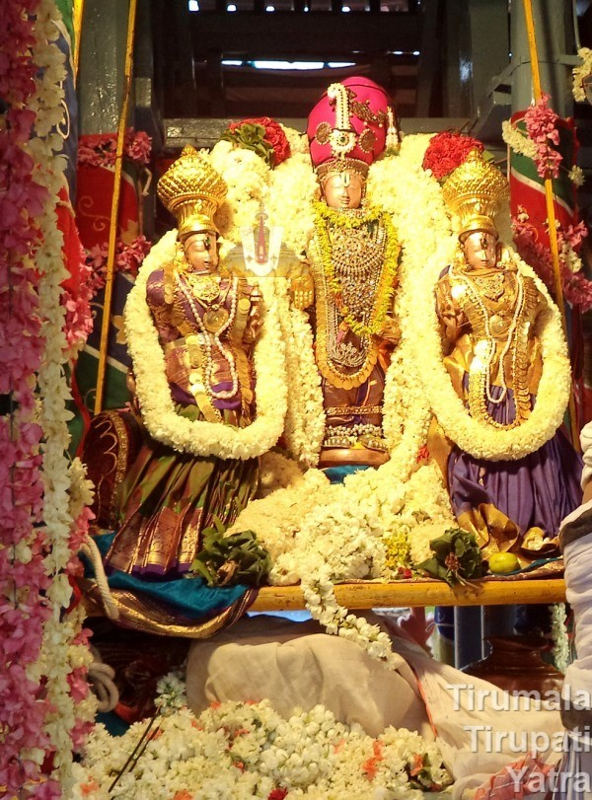
INTRODUCTION
Sri Kalyana Venkateswaraswamy Temple is located at Narayanavanam, in Chittoor District of Andhra Pradesh. The Temple is dedicated to Lord Kalyana Venkateswara, an aspect of Lord Vishnu. The temple is situated near puttur. According to legend, it is believed that Lord Venkateswara married Padmavati at this place and then went to Tirumala.
Narayanavanam was then ruled by the great King Akasaraja. Akasaraja conducted the marriage of his daughter Padmavati, at this holy place.
The temple was established in the year 1541 AD, and it is also believed that the temple was established before thousands of years ago. And it was renovated and reconstructed several times. The main gopuram was constructed by the king Sri Krishna Deva Raya. The second gopuram was constructed by the king Sri Veera Narasimha. Nearby the temple, temples of vinayaka, veerabadhra, shiva, and parvati are also found.
The temple is being administered by Tirumala Tirupati Devasthanams. The temple timings are: From 6.00 A.M to 8.00 P.M.

Poojas and Festivals
Daily poojas are performed in this temple, and during the tamil month of margazhi, lot of devotees would throng in this temple, to have the glimpse of the god and the goddess. Annual Brahmotsavam is grandly celebrated in this temple.
IMPORTANCE
It is believed that those unmarried people, who worship the divine deities in this temple, will soon get married and will have a blessed life. They will also be blessed with good children and get all the prosperity in their life. Their life will blossom like a lotus flower and reach the upper level in their life. Lord Venkateswara being the living god of Tirumala, will grant immense benefit to his devotees, and will never make them to suffer in their life, and always make them to live happier in their life.
Let us worship Lord Venkateswara and Mata Padmavati and be blessed.
“OM NAMO VENKATESAYA NAMAHA”
“OM SREE PADMAVATHI THAYARE NAMAHA”
WRITTEN BY
R.HARISHANKAR

KING NALA
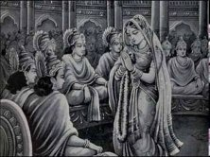
INTRODUCTION
Nala, is the king of Nishadha Kingdom and the son of Veerasena. Nala is skilled in dealing with horses and was an expert in cooking. He was married to princess Damayanti, and their details were mentioned in the Mahabharata. He was suffered by the influence of “KALI PURUSHA”. He was also the author of the cookery book, Pakadarpanam.
Once all the demi gods were willing to marry Damayanti due to her good qualities and good appearance. But she ignored the demi gods and chosen Nala as her husband. On hearing about this, “KALI PURUSHA”, was got angered and punished Damayanti by giving lot of problems to her.
Due to the evil influence of “KALI PURUSHA”, Nala played dice game with his brother and lost all of his wealth and went to the forest along with his wife Damayanti. While Damayanti was sleeping in the forest, Nala, due to the evil influence of Kali, left her alone and went from that place.
In the forest, he saved the great snake god “KARKOTAKA” from a fire. Karkotaka through his magic powers transformed Nala into a dwarf and named him Bahuka and asked him to serve the King Rituparna of Ayodhya. He also gave Nala a magic garment that would restore him to his original form. Nala went to King Rituparna and served him as both charioteer and cook. Meanwhile, Damayanti searched for her husband Nala and reached her father's kingdom. She tried to find out her husband by declaring a handsome reward for those who knew his whereabouts.
After some time “KALI PURUSHA” came out from Nala’s body, and blessed him and also asked him to go to his father-in-law’s kingdom. Nala in the form of Bahuka took his original form and met his wife Damayanti and both of them were very happy on seeing each other.
Due to the blessings of “KALI PURUSHA”, Nala has once again played dice game with his brother and restored all of his wealth and regained his kingdom. He has also forgave his brother and asked him to reside with him. Nala and Damayanti were reunited and lived happily thereafter.
Due to the boon giving by “KALI PURUSHA”, that whoever read Nala’s story would not be severely affected from the clutches of “KALI PURUSHA”.
Nala and Damayanti had lived with their two children for a long period of time and after their death, they went to heaven and they are still living in the heaven with the blessings of Lord Indra Bhagawan.
Let us worship the holy royal couples and be blessed.
“OM SREE NALA MAHARAJAVE NAMAHA”
“OM MATA DAMAYANTI DEVIYE NAMAHA”
“OM SREE INDRA BHAGAWANE NAMAHA”
WRITTEN BY
R.HARISHANKAR

MAHALASA DEVI
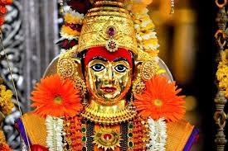
INTRODUCTION
Mahalasa Devi is a holy divine goddess. She is worshipped in two different forms. In one form, she is worshipped as Mohini, the female avatar of Lord Vishnu and is called as Mahalasa Narayani. Mahalasa Devi is also worshipped as the consort of Lord Khandoba, an incarnation of Lord Shiva, and is considered as an incarnation of Mata parvati.
Mahasala Mata’s main temples are situated in Goa and worshipped by the people in the form of Mahalasa Narayani and a temple dedicated to her in Nevasa is worshipped by the people as Mahalasa Devi, wife of Kandoba, which is considered as her birthplace. She is worshipped as a Kuladevi by the people of the region.
Mahalasa has got four hands, carrying weapons in three hands and blesses us in her right hand.
According to a famous legend, Mahalasa was born as the daughter of a merchant in Nevasa, Maharashtra. After some time, Mahalasa was married to Lord Khandoba on Pausha Pournima, and got merged with the god. Even today an annual festival is celebrated in a grand manner to honour the supreme god and the goddess at Pali in rajasthan on Pausha Pournima.
Mahalasa is also worshipped as a village deity. Mahalasa is mostly worshipped along with her consort Lord Khandoba.
TEMPLES
Temples dedicated to the holy goddess is situated in the following places of worship:
- Verna
- Kumta
- Mudgeri
- Kundapura
- Basruru
- Shirva
- Mangaluru
- Kasargod
- Malpe
Her temples are also situated in Karnataka, Kerala, Gujarat, Rajasthan and Gokarna.
IMPORTANCE
Parvati being the holy mother to the entire universe takes different forms in order to worship her in different names and in different places, for the benefit of her devotees for giving peace and prosperity in their life. Though she is worshipped in different names, she is a Shakti devi and will protect her devotees by whatever name we worship.
We can worship goddess Mahalasa Devi along with Lord Kandoba in order to attain all the goodness in our life. They will remove our sins, diseases and all sorts of problems in our life. They will protect us in this earth, as well as after our death, they will help us to reach heaven. The most important thing we must remember is that we must have to worship them with utmost faith and sincere devotion in our mind.
Let us praise the glory of the god and the goddess and be blessed.
“OM MATA MAHALASA DEVIYE NAMAHA”
“OM SREE KHANDOBA SWAMIYE NAMAHA”
“OM NAMAH SHIVAYA”
WRITTEN BY
R.HARISHANKAR
MAHALSAPATHI
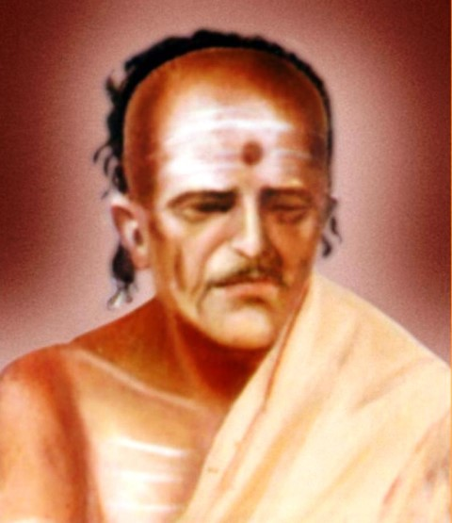
INTRODUCTION
Mahalsapathi was the priest of Lord Khandoba temple of Shirdi village. His full name was Mahalsapathi Chimnaji Nagare. His native place was shirdi. From his teenage itself, he was not interested in enjoying worldly pleasures, and he was a great devotee of Lord Khandoba and wants to attain SALVATION after his death. Though he was not fully educated, he was a great scholar and possessed good knowledge in divine scriptures. He wants to free himself from repeated birth cycles. He got a meagre income from the offerings of the devotees and he owned a small house without any basic facilities. But he had great faith on Lord Khandoba and performed pujas to him with much devotion and faith without thinking about his poverty. He also offered food to the poor devotees at the Khandoba temple, at his own cost, even though he was a poor person. He also respected the people belonging to different religions and he treats them with much love and affection, when they visit his village. Due to the grace of Lord Kandoba, he had got a good relationship with Sai Baba for a long period of time. Once, Mahalsapathi, while performing puja to Khandoba, noticed Baba's presence in Shirdi and, welcomed him by uttering the words, ‘Aao Sai’, means “WELCOME SAI”, even without knowing anything about him. He was such a great person. We cannot imagine such a holy and a pious person in this today’s fast changing modern world.
Mahalsapathi initially considered that baba was a mad man. But after some time by seeing his divine powers, Mahalsapathi respected and served Baba with much pleasure and enjoyment in his mind.
Mahalsapathi took charge of taking custody of baba’s body in the year 1886 for three consecutive days, till baba’s soul returns to his body from the divine world. Till such time, Mahalsapathi kept Baba's body on his own knee, even without taking proper food and didn’t sleep for three days. Thus, he rendered a noble service to the great saint “SAI BABA”.
Mahalsapathi was blessed with a male child in the year 1897 due to the blessings of sai baba.
He served baba with much love and affection. When Baba passed away in 1918, he had fasted for several days. After the MAHASAMADHI of baba, he lived only for four years. He had died in the year 1922.
Baba insisted Mahalsapathi to travel to holy places. Mahalsapathi had travelled to many holy places and visited the shrines of the gods for several months and returned to shirdi.
Mahalsapathi’s house is located from the Chavadi to Darga. At his house, the following sacred articles given by Baba are kept for public view:
- Baba’s Kafni.
- Baba’s Danda.
- Baba’s Udi.
- Three Silver Rupee Coins.
- Baba’s Padukas.

IMPORTANCE
An honest and a good priest and a great devotee of Sai baba had lived in shirdi by doing only good things in his life. He was a born devotee of Lord KANDOBA. It is believed that through the grace of LORD KHANDOBA and SAI BABA, he would have attained the holy abode of Lord Shiva, THE KAILASH. He never hated anybody and he never caused any harm to others. He was also a great ram devotee. Even at his death bed, he chanted “JAI SREE RAM” and breathed his last.
Let us worship the holy, humble and the pious man and be blessed.
“JAI SREE MAHALSAPATHI”
“JAI SREE KHANDOBA”
“JAI SAI RAM”
WRITTEN BY
R.HARISHANKAR

MANDA
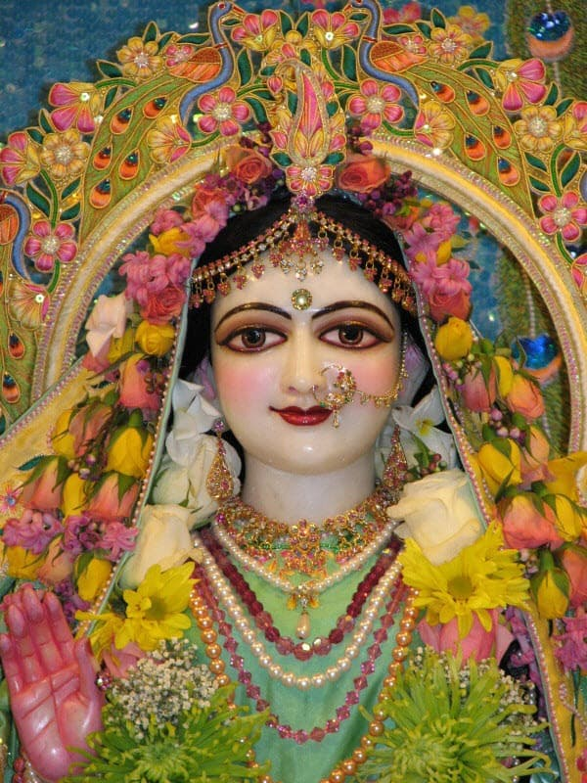
INTRODUCTION
Manda also called as Dhamini is the consort of Lord Shani and mother of Gulikan. She is a Gandharva princess and she is the goddess of art and the worshipper of Mata Saraswati Devi. Her expert in dance cannot be compared with anyone in the entire universe. She is the daughter of the Kantharva King Chitraratha and Queen Divyanka.
She got a divine appearance with attractive and smiling face. She is considered as the most beautiful woman among the divine goddesses in the heaven. She is a good natured goddess and contains the features of Mata Saraswati. She is talented in all kinds of art, and contains great skills in dancing field.
As per ancient legend, even after marrying Manda, lord shani used to remain meditating Lord Shiva. He didn’t even speak to his wife properly. This made his wife Manda to get angry with him and she cursed him to remain his sight looking always downward. However, after some time, Lord Shani got liberated from this curse.

TEMPLES OF MANDA’S SON GULIKAN
There are some popular Gulikan Temples in Kerala, India:
- Gulikan Temple, pullur
- Gulikan Temple, Kaarilikkandiyil
- Gulikan Kavu, Sree Thirunelly
- Gulikan Temple, Kunhichadukkam
- Sree Gulikan Devasthanam,Peralam
- Gulikan Kshethram, Naithallur Thalachilllon

IMPORTANCE
Chanting the names of Manda Devi and visting the temples of Gulikan will please Lord Shani and will give his immediate blessings on us, and to some extent relieve us from our sins. Hence it is better to chant her names along with the name of Lord Shani Bhagawan in order to get good prospects in our life. As an affectionate mother, she will always show her love and affection on us, and will completely change our life path and make us to walk in the spiritual path. She will also remove our diseases from our mind and body, and make us to always feel comfortable and safe in our life.
Let us chant the names of Mata Manda and be blessed.
“OM SREE MANDA DEVIYE NAMAHA”
“OM SREE GULIKANE NAMAHA”
“JAI SHANI DEV”
WRITTEN BY
R.HARISHANKAR

MARIAMMAN
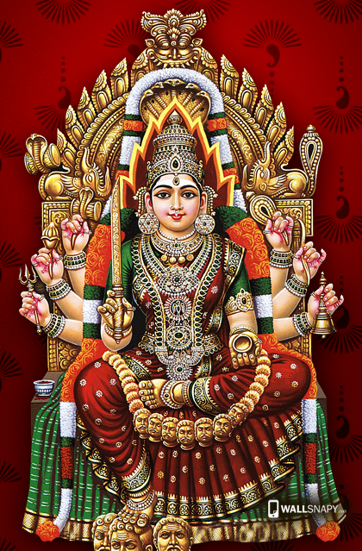
INTRODUCTION
Mariamman also known as Mariamma and Thandu Mariamman is a holy goddess of rain and mainly worshipped as a popular deity in tamil nadu. Mariamman is also associated with Mata Parvati and contains the features of Kali Devi. Festivals for Mariammam are grandly celebrated in the tamil month of "Aadi" which is known as "Aadi Thiruvizha". She is usually worshipped for curing diseases like poxes, stomach problems and all types of dreaded diseases. She will also relieve us from mental disorders and gives us great strength and energy in order to sustain in our life.
Maariamman is also worshipped as Village deity and pujas are performed to her mostly by non-Brahmin priests. In case of Samayapuram Maariyamman temple, Pujas would be performed to amman by Brahmin priests.
Mariamman has been worshipped as a great goddess since ancient times. She is also called as “DURGA DEVI” and “SITHALA DEVI” in the north india.
She would be offered with items such as pongal and koozh during the festive season. Along with that, important rituals like fire walking, mouth piercing and homams also takes place in her temples.
Samayapuram Temple is a famous temple dedicated to Mariamman, situated near Trichy. Festivals would be grandly celebrated by the devotees during April and July – August month.
Draupadi, the wife of Pandavas, is an incarnation of Marriamman. Many temples are dedicated to her throughout tamil nadu, which is called as Panchaliamman temple and Draupadiamman temple. Among her various temples, one popular small temple is situated in Arumbakkam, near koyambedu. Here Chittirai and Aadi festivals would be celebrated in a grand manner by her devotees, and the temple authorities also offer annadanam to the devotees during festival season. Mata
“VASUKU AMMAI”, the wife of the divine poet “SRI THIRUVALLUVAR” is also considered as another aspect of Maariamman who has relieved the people in her village from small pox and from several other dreaded diseases. Maariamman is also called as Muthu Maariamman, since she relieves the people from small pox, chicken pox and also brings rain in the drought regions. She is also considered as another aspect of “RENUKA DEVI”, mother of Lord Parasurama and worshipped as Renuka Devi Amman in some parts of south india.
Mariamman is also believed to be the protector of the villages and the towns and cities, and she also acts as a guardian deity. Mariamman looks young, wears red dress and contains a bright appearance with a glittering face. She also gives a blessing posture in her right hand, and in other hands she holds weapons to destroy the evil forces from the world.
Mariamman is the Kula Devi for many families in the Thanjavur district of Tamil Nadu.
TEMPLES
- Punainallur Mariamman Temple, near Thanjavur.
- Salem Kottai Sri Periya Mariamman temple
- Erode Mariamman temple
- Karur Mariamman temple
- Mariamman temple in Theni
- Thiruverkadu Amman temple
- Sivakasi Mariamman temple
- Vellore Mariamman temple
- Putthu Marriamman temple in Velacherry, Chennai.
MARIAMMAN TEMPLES OUTSIDE INDIA
1. Mariamman temple, matunga
2. Mariamman Koil, Pilakool
3. Mariamman Temple, Bangkok
4. Mariamman Temple, Pretoria
5. Sri Mahamariamman Temple, Kuala Lumpur
6. Sri Mariamman Temple, Medan
7. Sri Mahamariamman Temple, Penang
8. Sri Mariamman Temple, Singapore
9. Matale Sri Muthumariyamman Temple, Matale-Sri Lanka
IMPORTANCE
Mata Mariamman has got many temples all over the world. She is praised for her timely help and for curing the dreaded diseases within a short period of time. She is our beloved mother, who cannot be ignored by us in order to live a peaceful and happy life.
Let us visit her temples, and pray to her with sincere faith and devotion and be blessed.
“OM SREE MARIAMMAN THAYE NAMAHA”
“OM NAMAH SHIVAYA”
WRITTEN BY
R.HARISHANKAR

MARUNDEESWARAR TEMPLE
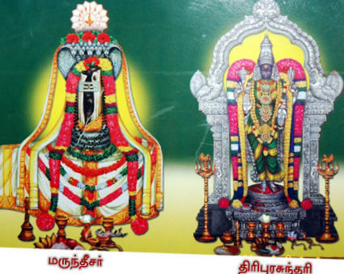
INTRODUCTION
Marundeeswarar Temple is a temple dedicated to Lord Shiva, situated in Thiruvanmiyur, Chennai. It is one of the Paadal Petra Sthalams and the great nayanar saints Appar and Tirugnana Sambandar have sung about the importance of this temple. The temple has been reconstructed and renovated by the Chola kings during the 11th century. The Marundeeswarar temple is considered as a place of worship for the people with dreaded diseases, and many people have shared their experiences about the holiness of the temple, and their relief from various diseases after visiting this temple.
The temple follows six daily rituals from 5:30 a.m. to 10 p.m. and twelve yearly festivals. The latest consecration of the temple was performed during the year 2008.
It is said that sage Valmiki, worshiped Lord Shiva in the temple. Hence this place was called as Thiruvalmikiyur, which in due course pronounced as Thiruvanmiyur. There is also a small shrine for the great sage “VALMIKI” near the temple. It is believed that Markandeyar, Lord Brahma and the divine wish fulfilling cow “Mata Kamadhenu” worshipped Lord Shiva in this temple.
The main deities of this temple are Lord Marundeeswarar and Thirupura Sundari Amman. The temple also has smaller shrines for Ganesha and Murugan. The samadhi of Pamban Swamigal is also found near the temple. Daily free food is offered to more than 100 devotees in this temple by the temple management.
IMPORTANCE
By visiting the temple and worshipping Lord Marundeeswarar and Thirupura Sundari amman, we would get the following benefits in our life:
- Relief from prolonged illness.
- Cure from several dreaded diseases.
- Mental disorders will be removed.
- Mental stress, confusion and bad thoughts will be eliminated.
- We will get good spiritual energy.
- Peace of mind.
- Good health.
- Prosperity.
- Increase in wealth.
By worshipping Lord Shiva, we would get the above benefits in our life, and apart from that, we will get salvation also. Hence let us visit this temple at least once in a month and be blessed.
“OM SREE GANESAYA NAMAHA”
“OM SREE SHIVAYA NAMAHA”
“OM SREE PARVATHI DEVIYE NAMAHA”
WRITTEN BY
R.HARISHANKAR

MATA RADHA
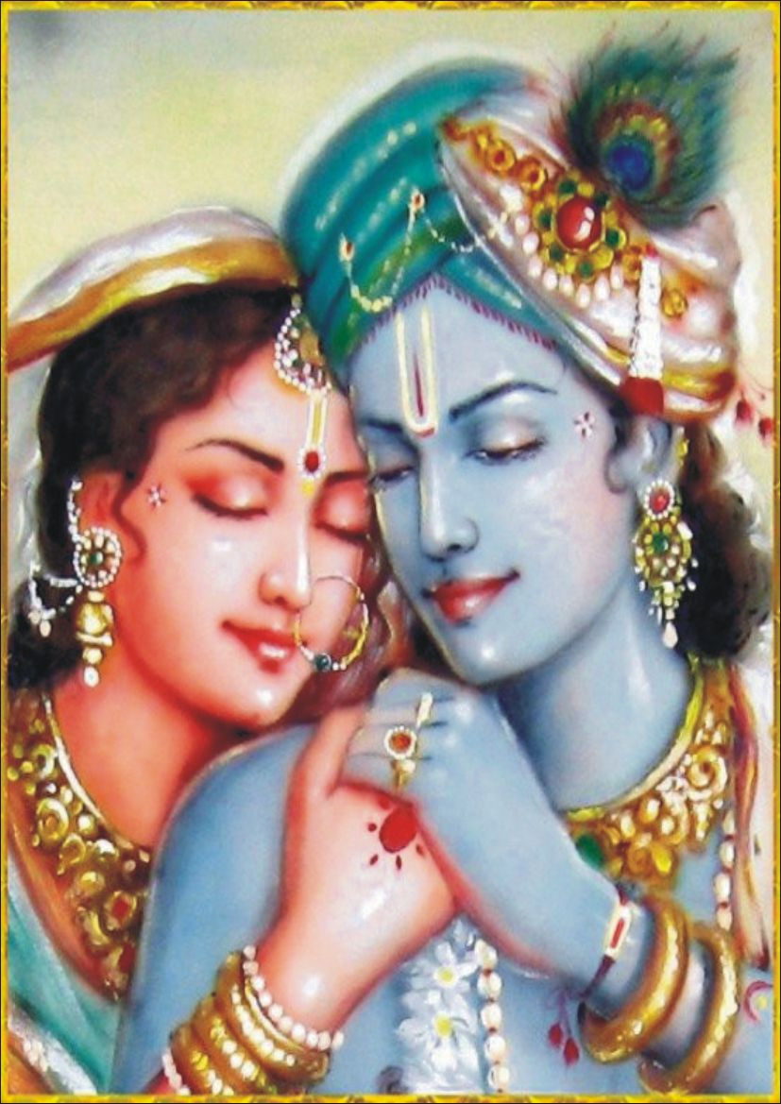
INTRODUCTION
Radha also called as Radhika, Radharani, and Radhe, is a popular goddess and worshipped along with Lord Krishna throughout the world. She is regarded as the consort of Lord Krishna. Radharani is an avatar of Goddess Lakshmi. She is the head of the milkmaids. And her birthday is celebrated as Radhastami.
She kept selfless love and surrendered at the lotus feet of Lord Krishna. Several vaishnavite saints were praised her glory and considered her as the supreme goddess. People in india, generally will keep names for their male child as Radhakrishnan and female child as Radha. Radha is worshipped mostly by the north indians.
By taking Mata Radharani as an example who surrenders her aatma(soul) to the god Krishna, similarly, we can also practice to develop such kind of devotion, in order to attain SALVATION after our death. The leelas performed by Radha and Krishna were known as RASALEELA. And the leelas performed by Lord Krishna with the Gopikas doesn’t mean any human bondage between them, but the enjoyment given by the divine avatar to the divine souls, and their main attachment only related with their heart, similar to the mother touching her child with care and affection. As per the comments given by the GOPIKAS, through the divine touch of Lord Krishna, they felt a sense of spiritual satisfaction, and joy was spread all over their body, and they realized that were united with the god.
Radha and Krishna are the main characters as per the Article “Gita Govinda” written by Jayadeva Gosvami.
Swami Haridas also considered Radha as the ardent devotee of Lord Krishna. She is considered as Krishna's spiritual power, and the acting force of Lord Krishna. Her entire thoughts were only about Lord Krishna and she didn’t concentrate much on other worldly matters.
TEMPLES
- Radha Temple in Barsana in Mathura District.
- The Radhavallabh Temple, Vrindavan.
- Sri Radha Mandir in Delhi.
- Shree Radha Rani Temple at Austin, Texas, USA.
IMPORTANCE
By worshipping Ma Radha we can get the divine grace of Lord Krishna. And she will show her motherly affection towards us and safeguards us throughout our life. She will also lead us to the path of heaven. She removes the entire sorrows from our mind and makes us to live a happy and a tension free life. She will also remove the diseases from our body and give us spiritual energy and make us to live peacefully in our life.
Let us worship Mata Radha and Krishna and be blessed.
“OM SREE RADHARANIYE NAMAHA”
“OM SREE KRISHNAYA NAMAHA”
“OM NAMO NARAYANA”
WRITTEN BY
R.HARISHANKAR
MATA RENUKA DEVI
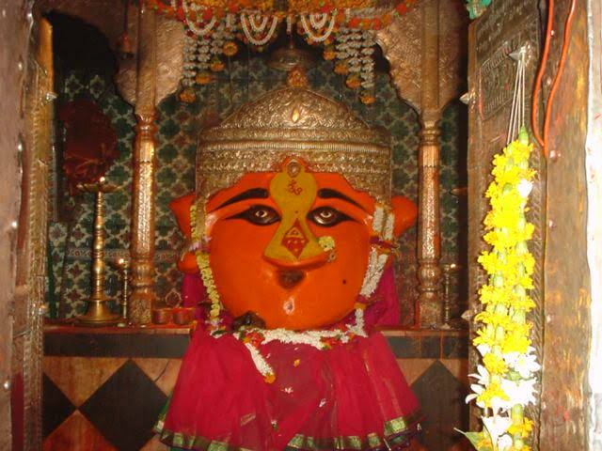
INTRODUCTION
Goddess Renuka is worshipped as Yellamma in Karnataka, Andhra Pradesh, Maharashtra and Tamil Nadu. She is also worshipped as Manchalamman in Mantralayam. Goddess Renuka is the incarnation of Mata Parvati and is our affectionate mother Goddess and her name and type of worship changes from place to place.
According to the Legends, Renuka was the wife of Sage Jamadagni, and since he had suspected her of infidelity, he asked Parashurama to remove her head. Lord Parashurama agreed to his father’s wish, and removed his mother head. And Lord Parashurama asked his father to give him a boon to bring back his mother. Thus Renuka, the mother of Lord Parashurama, was brought back to life.
Goddess Renuka is the Mother Goddess and gives courage, boldness, braveness and wisdom to her devotees. She also worshipped for curing diseases and for protecting the belongings of the people.
In Mahur, Maharashtra, a famous Renuka Mata Temple is situated. Lot of devotees from all parts of india would worship her during the festival of Vijayadashami.
Once, the king Sahasrarjun killed Renuka, in order to grab the Sacred Kamdhenu cow. When Lord Parshuram knew about it, he got very much angry with the king, and he immediately killed the king, and performed the last rites of his mother in Mahur under Lord Dattatreya's guidance. Due to the affection on his mother, she had given darshan to him in the Mahur mountain ranges and from then onwards she is protecting the entire world.
There are also other temples situated in Mahur like Rishi Jamadagni Temple, Lord Parshuram Temple and Kali Temple.
The three important temples: Renuka Mata Temple, Lord Dattatreya Temple and Anusaya Mata Temple are built on three mountain ranges. Mahur is surrounded by jungles and it is a best pilgrimage centre, which is surrounded with full of greenery and natural beauty.
It is believed that Renuka Mata head was removed by Lord Parasurama in this place. The temple is considered as one of the Shakti Peethas.
IMPORTANCE
By worshipping Mata Renuka Devi, we would be relieved from our sins committed in our previous births, and will get more spiritual energy and her blessings will make us to lead a spiritual life. She can be worshipped by chanting her name “OM SREE RENUKA DEVIYE NAMAHA” along with chanting her son’s name “OM SREE PARASURAMARE NAMAHA”.
By reciting her various names and by chanting her slokas, we would get all the prosperity in our life. All of our health related problems will come to an end and we would have a blessed and a sin free life. Our holy mother will always be with us at our every moment of life. Let us try to visit her temples at least once in a year and be blessed.
“OM NAMAH SHIVAYA”
“OM SAKTHI PARASAKTHI”
WRITTEN BY
R.HARISHANKAR
MATA SAVITRI
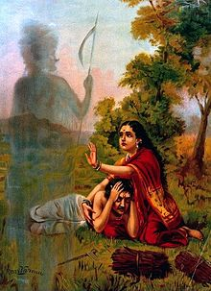
INTRODUCTION
The king of Madra Kingdom, Asvapati, lives with his consort Malavi. He prayed to sun god for having a child. Due to the blessings of Lord Surya, a girl child was born, and she was named as Savitri. Savitri looks very beautiful and after attaining the marriage age, she went on a pilgrimage in search of marrying a suitable person, and finds Satyavan, the son of a blind king of Salwa Kingdom, who lost everything including his eyesight, and lives in forest with his wife and son.
Sage Narada announces to Savitri and to his father that Satyavan will die after one year. But Savitri replied to the sage narada, that since she had already decided, she would prefer to marry him only.
Savitri and Satyavan are married, and she lived in forest with her new parents-in-law and husband, and looked after them in a proper manner.
Few days before the date of death of Satyavan, Savitri takes a vow of fasting in order to save the life of her husband.
In the morning of Satyavan’s predicted death, Savitri went with her husband into the forest. While going inside the forest, suddently Satyavan had got fainted. Lord Yama arrived and taken the soul of Satyavan. Savitri followed Yama and worshipped and praised him by her kind words. Due to her praise, Lord yama agreed to offer boon to her. She asked for eyesight and restoration of the kingdom for her father-in-law, and then to bless her with children through her husband Satyavan. Due to her purity and holiness, Yama grants life to Satyavan and blesses both of them to live a long life, and also gave boon for getting the eye sight of her father in law and restores his kingdom.
Savitri tells the story to her parents-in-law, husband, and to the great sages in the forest. Her father-in-law has got back his eye sight and become the king of his kingdom. Everyone has praised for her holiness and appreciated her efforts for saving her husband from the clutches of the death god Yama.
In North India, every year, married women would observe Savitri Vrata on the Amavasya day in the month of Jyestha. This is performed for the well-being of their husbands. It is believed that Savitri had got her husband back on the first day of the Tamil month Panguni. Hence, this day is celebrated as Karadayan Nonbu in Tamil Nadu. On this day, married women wear yellow robes and pray to Hindu goddesses for the well-being of their husbands.
IMPORTANCE
Mata Savitri is our holy mother, and acts as an example for others. Through her holiness and sincerity, she got back the life of her husband from Lord Yama. She contains such great good qualities. We can also worship her as Mata Parvati Devi for our well-being, and chant her mantra “OM SREE SAVITRI DEVIYE NAMAHA”. It is also believed that she has attained heaven after her death along with her husband satyavan and happily living there. It is also told, that she is the worshipper of Lord Shiva and Mata Parvati. Through their blessings, and through her good nature, she got all the prosperity in her life.
Let us worship the holy mother Savitri on the day of “KARADAIYAN NONBU” and be blessed.
“OM SREE MATA SAVITRIYE NAMAHA”
“OM NAMAH SHIVAYA”
“OM SREE MATA PARVATI DEVIYE NAMAHA”
WRITTEN BY
R.HARISHANKAR

MEENAKSHI AMMAN
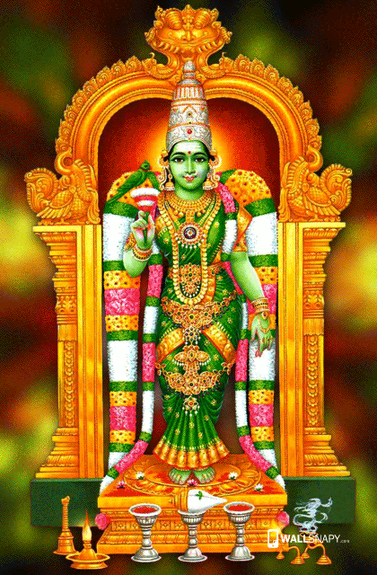
INTRODUCTION
Goddess Parvati Devi had taken the avatar of Meenakshi at the beginning of the Kali Yuga, that is before 5000 and odd years. She came out from a sacrificial fire as a small child. She was brought up by the Pandiyan King, Malayadwaja and his wife Kanchanamalai. She was born from the sacrificial fire, due to the prayers of the pandiyan couple. Her parents were sincere devotees of Lord Shiva, and through their great bhakti, they were blessed to have goddess parvati itself as their child.
The Pandiyan King named her as Meenakshi and took care of her properly and she studied the basic education and was an expert in all kinds of arts and was skilled in handling with powerful weapons. After some time, the pandiyan king crowned her as the princess of Madurai and she ruled the city of Madurai in a proper manner. She captured almost the entire region of the world and went to Indralok and defeated Lord Indra and captured the Swarkalok also. After some time, she went to Mount Kailash in order to capture it. But on seeing the sight of Lord Shiva, she felt shy on her act, and asked him to pardon her. Lord Shiva was very happy on seeing Meenakshi and they got married in Madurai.
It is believed that the wedding was attended by all the gods, goddesses, demi gods, saints and also by the devotees of Lord Shiva and Parvati. Since Mata Parvati herself had assumed the form of Meenakshi, Lord Vishnu, Parvati’s brother, handed her over to Lord Shiva. Even today, the wedding ceremony is celebrated every year as ‘Chithirai Thiruvizha’ which is also known as ‘Tirukalyanam’.
MEENAKSHI TEMPLE
The famous Meenakshi Amman temple is situated in Madurai, and the great temple was built by Kulashekara Pandiyan king before some thousands of years. The temple is dedicated to Meenakshi and Sundareswarar.
Meenakshi Amman Temple is one of the ancient temples in India. It is situated in Madurai and the temple has historical significance. It is believed that Lord Shiva had taken the form of Sundareswarar (the good looking one) and married Parvati (Meenakshi) at the site where the temple is currently located. The temple was renovated in the later years after it was built. Meenakshi Amman Temple was declared as one of the wonders of India with regard to its architecture and historical monuments. Daily thousands of devotees are visiting this temple to have a glimpse of their divine father and mother. During the annual ‘Tirukalyanam Festival,’ millions of devotees would visit this temple to participate in the festival. The temple is well-maintained by the temple authorities and free annadanam is also daily provided in this temple for hundreds of devotees. And apart from annadanam they are also conducting several social welfare activities like providing help to the orphaned children and free marriages are performed in the temple for the benefit of people belonging to scheduled castes, schedules tribes and Back ward classes.
IMPORTANCE
By worshipping this temple, people will get more braveness, boldness, courage, wisdom and knowledge. Goddess Meenakshi blesses her devotees and gives all sorts of prosperity in their life. It is mainly advisable for ladies to visit and worship in this temple before their marriage in order to get their good life partner and also to live with great courage, good physique and with spiritual energy in their mind. Mata Meenakshi will never leave her devotees to go from this temple with empty handed. She will give good health, wealth and with her divine blessings, devotee’s life will blossom like a flower. Hence it is advisable for the devotees to go to this temple at least once in a year and can get the blessings of Lord Shiva and Parvati.
Let us worship the divine couples and be blessed.
“OM SREE MEENAKSHI THAYE NAMAHA”
“OM SREE SUNDARESWARAR THANTHAIYE NAMAHA”
“OM NAMAH SHIVAYA”
WRITTEN BY
R.HARISHANKAR

MEYKANDAR
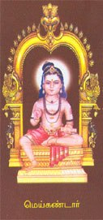
INTRODUCTION
Meykandar (13th century AD) also known as Meykanda Devar, was a great shaiva saint and scholar. He had rendered a famous devotional work called as Siva Jnana Bodham which tells the importance of the shaivism sect and features the greatness of Lord Shiva. His birth name was Swethavana Perumal.
LIFE
Meykandar was born in Cuddalore District, Tamil Nadu. He was born after his parent’s deep penance on Lord Shiva at Thiruvenkadu Siva Temple. He was brought up by his uncle at Thiruvennainallur. He learnt the basic education and the hindu scriptures. At his childhood itself, he was very much attracted in spirituality and became an ardent devotee of Lord Shiva. One day he met Rishi Paranjyoti, and become his disciple and from then onwards he was called as “MEYKANDAR”.
Through his guru Paranjyoti, he had acquired spiritual knowledge and become a great spiritual mentor. Due to his great spiritual knowledge, his family guru, had become his disciple. His family guru was later known as Arulnandi Sivan, and he also composed various sacred texts on shaivism. Meykandar’s several disciples were written sacred texts on the shaiva siddhantha philosophy.
"Meykandar Sampradaya" is a famous sampradaya which was flourished during his time. It tells the importance of shaivism sect. He is worshipped in the Karur Shiva temple, along with Sundarar.
IMPORTANCE
Meykandar was a spiritual guru and considered as equivalent to nayanar saints. He was a great devotee of Lord Shiva and spent his life by doing temple services and also provided food and clothes to the devotees of Lord Shiva. He chanted the Namashivaya mantra on a daily basis and lived a saintly life. He also gave spiritual bliss to the devotees of Lord Shiva. Many people were benefitted by reading his sacred texts and by listening to his lectures.
Let us worship the great saint and be blessed.
“OM SREE MEYKANDARE NAMAHA”
“OM NAMAH SHIVAYA”
“OM SAKTHI PARA SAKTHI”
WRITTEN BY
R.HARISHANKAR

MODESHWARI DEVI
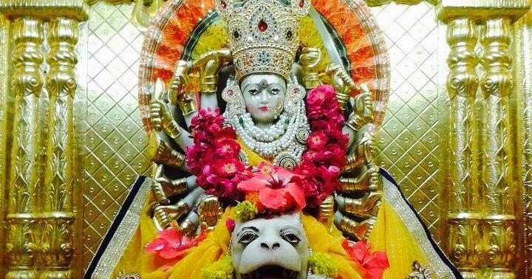
INTRODUCTION
Modheshwari Devi is an incarnation of Mata Parvati. She is the main deity of the Modh community of Gujarat.
Once there lived a fierce demon Karnat who disturbed the Brahmins and all other caste of people while doing their daily prayers and also disturbed the demi gods in the heaven. Due to that, all the demi gods and the people in the earth approached Mata Parvati. On hearing about their sufferings, she got angry and created a Shakti devi who is known as Modheshwarimata. Mata Modheshwari has got eighteen arms, containing weapons in each hand, and appears in fierce form. She destroyed the demon Karnat and saved the demi gods in the heaven, and the people in the earth.
She is the worshipped by the modh sect of people in Gujarat and they worship Modeshwari mata as their kula devata.

TEMPLES
- Modeshwari Mata temple in Modhera.
- Modeshwari Devi temple in Patan.
- Modeshwari temple in Ahmedabad.
- Ma Modeshwari temple in Bhavnagar.
- Sri Modeshwari Ma temple in Bhuj.
- Jai Modeshwari temple kin Ujjain.
- Modeshwari Ma temple in Vadodara
- Modeshwari temple in Bharuch.
- Modeshwari temple in Sinhore.
IMPORTANCE
Ma Modeshwari is mostly worshipped by the people of North India. She is a holy mother who protected the universe from the demon, and killed him. She will never tolerate the sufferings of the living beings and immediately will take action to remove their sufferings. She also relieved the physical and mental diseases of her devotees, and took them to the spiritual path and made them to get peacefulness and happiness and to attain prosperity in their life. Let us try to visit at least one of her temples in our life time and be blessed.
“OM MATA MODESHWARI DEVIYE NAMAHA”
“OM NAMAH SHIVAYA”
WRITTEN BY
R.HARISHANKAR

MUTHUSWAMY DIKSHITAR
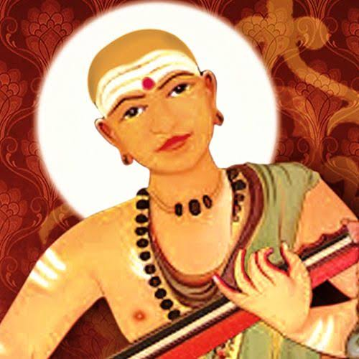
INTRODUCTION
Muthuswami Dikshitar (1775–1835) was a great poet, singer, veena player, and a great composer of Carnatic Music. His compositions are highly praised for their detailed descriptions of Hindu gods and temples. His compositions are popular and even today it is sung in classical concerts of Carnatic music. He is also appreciated for his divine music similar to the great musicians Shyama and Thyagaraja. He is considered as one among the three musical doyens. His compositions were developed mainly in Sanskrit.
LIFE
Muthuswami Dikshitar was born in Tiruvarur. He learnt the vedas, music and the divine scriptures. He spent his childhood in Manali, Chennai and after some time, a saint named Chidambaranatha Yogi took him under his custody and went to Varanasi. There he was taught basic education, music and yoga. After the death of his guardian, Dikshitar returned from Benares and resided at Tiruttani near Murugan temple.
Due to the grace of Lord Tituttani Murugan, he became a master in music and was able to compose lot of divine songs. His career in music started in full swing and it lasts till his death.
He was an ardent devotee of Lord Muruga and praised his glory and sung devotional songs on him. He also visited and composed music and played veena in the temples at Kanchi, Tiruvannamalai and Chidambaram.
He was also a regular visitor of Tiruvarur temple and worshipped Lord Thyagaraja and composed many divine songs on him. Muthuswami Dikshitar died in the year 1835 at Ettayapuram. A samadhi was constructed at Ettayapuram in his memory and lot of people and musicians visits his samadhi. Muthuswami Dikshitar's brothers were also very famous musicians.
IMPORTANCE
He was an ardent devotee of Lord Shiva and Muruga and spent his life towards composing and singing songs on them. He was also a noble and a pious man and he had done several pujas in Tirutani Murugan temple and Thyagaraja swamy temple. He also provided food to the poor and educated the poor children. His greatness cannot be described in full. He was a great musician and was admired by the visitors of his music concerts.
Mostly he performed music in temples with great dedication and devotion on god. He was blessed by the gods and regarded as a born musician.
Let us worship the great musician and be blessed.
“OM SREE MUTHUSWAMI DIKSHITARE NAMAHA”
“OM SREE TIRUTHANI MURUGANE NAMAHA”
“OM SREE THYAGARAJA SWAMIGALE NAMAHA”
WRITTEN BY
R.HARISHANKAR

MYLAPORE SAIBABA TEMPLE
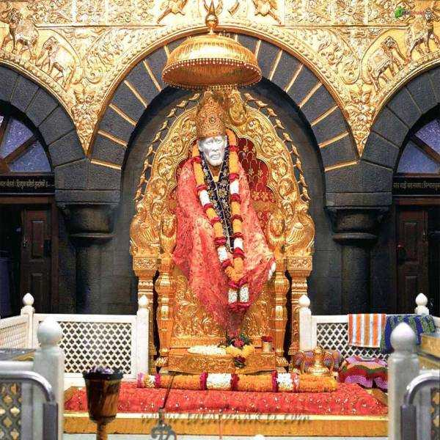
INTRODUCTION
The Holy Sainath temple is situated at Mylapore, Chennai. This temple was fully constructed during the year 1952 with the great efforts of Sri Narasimha Swamiji, who was an ardent devotee of Sai Baba. He lived a simple and a saintly life and dedicated his entire life towards doing service to Sri Shirdi Baba. He got the divine blessings of Baba, and through his grace, he founded this temple. He had written lot of articles on Sai baba.
Every day thousands of devotees are visiting this temple, to get the divine grace of Baba. It is well developed and maintained properly by the temple authorities. Many devotees have also shared their miraculous experiences that they have got in their life after visiting this holy temple of baba. In this temple, holy fire will be lighted continuously. Devotees are permitted to touch the baba’s statue and can offer flowers and clothes to him. His statue was made out of white marble. It is a very good temple and by visiting this temple, one can feel some sort of peacefulness and mental satisfaction than ever before. The temple would be fully crowded during Thursdays and on Guru Poornima and Vijayadasami days.
Sri Narashimma Swamiji’s Shrine is also found in this temple.
Temple timings: Morning 5:00 A.M. to 1:00 P.M. Evening 4:00 P.M. to 9:00 P.M.
Address :
Sri Sai Baba Temple,
51B, VC Garden Street, Alamelu Mangapuram, Mylapore, Chennai – 600 004.
Sai Baba is one of the divine gurus who had done good activities throughout in his life. And people from any religion can visit and worship Saibaba at this temple. Here quran and bible are also read on once in every week.
IMPORTANCE
This temple is also called as southern shirdi for its great attraction among the devotees and towards the increase in the number of devotees in this temple. Here free food is offered on every day and on Thursdays, large number of people will gather at this temple, to have the holy Prasad of Sainath. Those people who visit mylapore area to worship Lord Shiva and Sri Ramakrishna in the Kapaleeswarar Temple and Ramakrishna mutt respectively can visit this temple, since it is situated nearby the two temples.
By praying to Sainathar, our problems and sufferings would reduce to a certain level and in due course of time, based on our karmic deeds, we would get good position in our life and our sufferings also would be removed from our life. Since he is also considered as an incarnation of Lord Dattatreya, and contains the features of Lord Shiva, he has got super natural powers enough to protect and save us from this difficult world. Hence it is a must for us to visit the holy temple of saibaba on Thursdays, or otherwise for those people who don’t have time on Thursdays, can visit him on Sundays and can get his divine blessings.
Let us chant the names of Saibaba and be blessed.
“JAI SAINATH MAHARAJ KI JAI”
“OM NAMAH SHIVAYA”
“JAI SREE RAM”
WRITTEN BY
R.HARISHANKAR

NALLATHANGAL
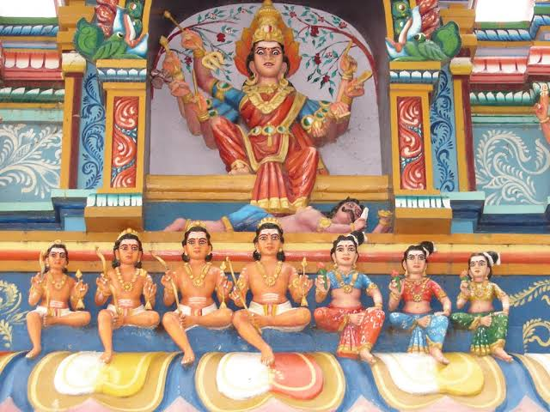
INTRODUCTION
Nallathangal history is based on the sufferings faced by Nallathangal in her life and she is popularly worshipped by the people of Tamil Nadu. It is believed that she is still living in her temple and blessing her devotees. She had committed suicide by falling into the well along with her seven children due to starvation. On knowing about the incident, her affectionate brother has also committed suicide by falling into the same well.
Nallathangal is worshiped as a village deity. The temple is situated at Vatrayiruppu near Srivilliputtur.

LIFE
Once, the noble couples Ramalinga Sethupathi and Indrani ruled the village Vatrayiruppu. They got two children. They lost their parents when they were young. However, Nallada Thambi, took care of her younger sister in a proper manner and married her to Kaziraja, a small ruler of the Sivaganga district.

She lived a happy married life for some time with her husband and her seven children. After some time, severe famine was occurred in her place for several years and there was no rain. Many people were died without taking proper food. Due to that, she came to her brother’s village with her seven children.

Since her brother had gone for attending his duties, her brother’s wife ill-treated her and didn’t provide food for Nallathangal and to her seven children. Nallathangal was very much depressed by her act and committed suicide along with her children. And after some time her brother was also committed suicide. After death, she became a goddess and is still blessing her sincere devotees and giving them all sorts of prosperities in their life.

Nallathangal Temple
Nallathangal temple is located in the town of Archanapuram, Vatrayiruppu near Srivilliputtur. Archanapuram is located near green fields.

FUNCTIONS
Aadi, Ani and Thai Pongal Festival is celebrated here every year. Lot of devotees from tamil nadu would visit this place to worship the holy mother along with her children.
IMPORTANCE
It is a must to visit this temple for unmarried and married people. Those who are unmarried will get married soon and those who are married will remain steady in their marriage life without any problems and quarrels in their life, and they will also get good children. She will remove the fear from the minds of her devotees, and makes them to live bravely in their life. She also removes several dreaded diseases and mental disorders of her devotees and gives them good fortunes in their life.
Let us worship the holy mother MA NALLATHANGAL and be blessed.
“OM SREE NALLATHANGAL THAYE NAMAHA”
“OM NAMAH SHIVAYA”
“OM SAKTHI PARASAKTHI”
WRITTEN BY
R.HARISHANKAR

NEELA
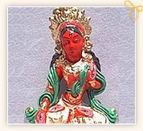
INTRODUCTION
Neela is known as Neelima and is the consort of Lord Shani. She is the goddess of Sapphire. She has got great powers and gives her powers to Lord Shani dev for disclosing his duties in a proper manner.
In Hindu mythology, it is believed that she firstly misunderstood shani and became Shani's enemy. But, due to the pleasing acts of Lord Shani, she realised her mistake, and became his consort and gave all of her powers to Lord Shanidev.
She is worshipped as the consort of Lord Shani, and she is the giver of boons to us. By worshipping her, we would get the blessings of all the divine lords in the heaven.
IMPORTANCE
Though there are no separate temples dedicated to her, she can be worshipped along with Lord Shani Dev. In some shani dev temples, her idol would be worshipped along with Lord Shani dev. She was created from the spiritual powers of Lord Shiva, and hence she also contains the powers of Lord Shiva. In the famous shani mantra, her name would also be recited.
“OM NILANJANA SAMABHASAM RAVI PUTRAM YAMAGRAJAM CHAYA MARTANDA SAMHUBHUTAM TAMA NAMAMI SHANESCHARAM”
By reciting this powerful shani stotra, we can please the entire family of Lord Shani Dev, and can get their blessings also.
Let us praise Mata Neela and be blessed.
“OM SREE MATA NEELA DEVIYE NAMAHA”
“OM SREE SANEESWARAYA NAMAHA”
WRITTEN BY
R.HARISHANKAR
NIRRTI DEVI
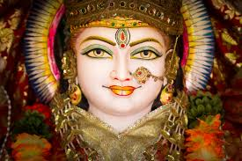
INTRODUCTION
Nirrti is considered as the goddess of miseries and sorrows, one of the guardians of southwest directions. She is also considered as an incarnation of Mata Parvati, and was mentioned in Rigveda and in other famous sacred hindu texts. She is also mentioned as living in the kingdom of the dead. She wears black dress and golden ornaments and contains bright look with charming face. The divine crow is her vehicle.
According to ancient puranas, she was born after the birth of Goddess Lakshmi, the goddess of wealth. So Nirrti is the elder sister of Lakshmi. Lakshmi presides on wealth, whereas Nirrti presides on sorrows. She is the ultimate giver of all the miseries and sorrows based on our bad karmic deeds. By worshipping her with pure devotion, our sorrows will be reduced to certain extent in our life. Being the avatar of Mata Parvati, she acts as an affectionate mother to us, and always tries to shower her divine blessings on us.
Though there are no notable temples dedicated to her, we can worship her by reciting her slokas and chanting her various names.
By worshipping her with utmost faith, we can get the following benefits:
- Relief from miseries and sorrows
- Avoidance of unnatural death
- Relaxation in mind and body
- Unwanted, bad and suicidal thoughts will be removed from our mind
- Death fear will not occur
- Enemies will become our dear friends
- Improvement in career path
- Will get good respect in the society
- Life will become peaceful and prosperous
Hence by worshipping Mata Nirrti Devi, we would get the above mentioned benefits in our life. It is always advisable to chant her glory and praise her with pure bhakti in our mind.
Let us worship the holy divine mother and be blessed.
“OM SREE MATA NIRRTI DEVIYE NAMAHA”
WRITTEN BY
R.HARISHANKAR
PAVHARI BABA
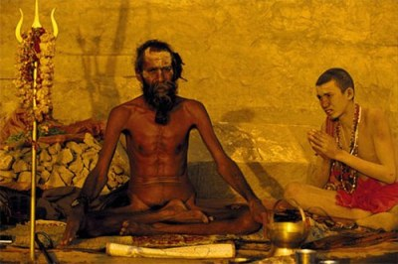
INTRODUCTION
Pavhari Baba was a great Hindu Saint who was born near Varanasi in a Brahmin family. He was born in a village at Jaunpur District in a Brahmin family. In his young age, he studied in ghazipur under his uncle’s guidance. After completing his education, he went on a pilgrimage to many holy places and performed yoga and meditation. He is a great devotee of Lord Shiva and Lord Vishnu. He would frequently chant the “RAM NAAM” and insists his followers to do it, and also he had explained the greatness of chanting the ram mantra, and the benefits that can be achieved by reciting the mantra continuously.
After finishing his holy journey, he returned to ghazipur and built an ashram for him, and done meditation and Yoga for several years. He was a very kind hearted man. According to one incident, once a thief had entered into his ashram and tried to take some valuables which were kept inside his house. On seeing this, the great baba, approached him and he himself gave all the things in his house and asked him to go safely to his place. He was such a pious and a humble person, which cannot be seen in this today’s world. Due to his kindness, the thief had become a sincere follower of Pavhari Baba.
In the year 1890, Swami Vivekananda visited him at ghazipur. He praised Baba for his simplicity, kindness and for his great meditative powers. And he further says that he has met a divine soul and discussed with him about spiritual matters. Vivekananda once delivered a lecture about the holiness of baba, which was later published in the form of a book.
He was a strict bachelor and observed it throughout in his life. During his life time, he will used to have only a small quantity of food, and sometimes would take only one meal in a day. Even for some days, he didn’t consume any food, but consumed only the air as his food.
He was a master in teaching Hindu philosophy to others and spread the importance of Hinduism across the region. He also became a disciple of a saint and learnt the essence of hindu scriptures.
Pavhari Baba was considered that god is the main master and we are all his slaves. He will used to frequently tell to his followers as “LISTEN HOLY PEOPLE. HAVE BHAKTI ON GOD, AND GOD IS THE ONLY PROTECTOR IN THIS WORLD. HAVE FAITH AND WORSHIP HIM WITH FULL OF DEDICATION AND DEVOTION IN MIND, AFTER ALL WE ARE ALL THE SERVANTS AND SLAVES OF THE GOD. AND WE HAVE BEEN BORN IN THIS WORLD TO PROVIDE SERVICE TO HIM”
He was very much interested in feeding food to the poor and to the hungry animals and birds. He will used to treat even his enemies as messengers of god, and believed that by way of getting troubles from them they are reducing his past birth sins.
He got the great power to transform a wicked soul into a good soul.
It is believed that at the age of 100, he had committed suicide by burning himself in fire. He died during the year 1898. It is considered that he had attained SALVATION after his death.
IMPORTANCE
Though now he is not alive, his teachings and his kindness and holiness can never be forgotten by the people who study his life history. Throughout his life, he never cause any harm to others, and lived a saintly life. He was not interested in enjoying worldly comforts and luxuries but concentrated his attention only on doing meditation, chanting the names of the gods and goddesses and praying for the well-being of the entire UNIVERSE. It is also believed that through his spiritual powers, he had cured the mental and physical diseases of his devotees and invoked them into the spiritual path.
Let us worship the great saint and be blessed.
“OM SREE PAVHARI BABAVE NAMAHA”
“JAI SREE RAM”
“OM NAMAH SHIVAYA”
WRITTEN BY
R.HARISHANKAR

PERIYACHI AMMAN
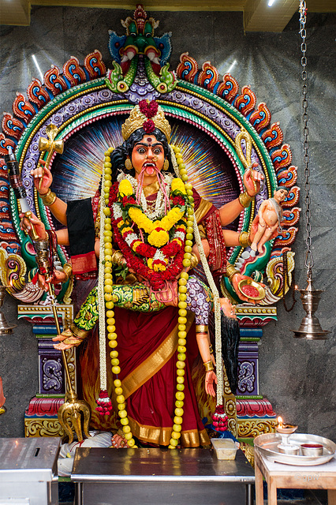
INTRODUCTION
Periyachi is a ferocious aspect of Mata Parvati. She is also called as Periyachi Amman and she is also an incarnation of goddess Kali. Periyachi is considered as the protector of children and is worshipped for safe pregnancy and for good children. Periyachi is popularly worshipped in Singapore and Malaysia. Once, there ruled a pandiyan king Vallalarajan, who had harassed his region’s people and given lot of troubles to them by laying heavy tax, increase in the price of food products, heavy punishment for even small mistakes.
Since he had suffered from several doshams, due to an astrologer’s advice, he doesn’t want his child to be born, by touching the earth. Then the king appointed a care taker for his queen with the name Periyachi during the conceiving time. She completed the safe delivery of the child and held it up before it touches the earth. For her great service, the pious woman, Periyachi demanded money for her service, but the King scolded her and doesn’t want to make payment to her. Immediately the divine mother Periyachi was transformed into Devi Durga, and she killed the king using her hands and weapons.
Periyachi contains a ferocious appearance. She holds various weapons in her hands. She took the terrible appearance in order to safeguard the people from the evil spirits and from their enemies. She is also worshipped as a kula devi by many people.
Periyachi, was the consort of Jada-Muneeswaran, a form of Lord Muneeswaran, who had taken the divine form in order to punish the cruel and bad people in the earth. She is considered as a guardian of children.
Tuesdays and Fridays are considered as the most important days to worship Periyachi and Muneeswaran. She is mainly worshipped in the tamil month of Thai and Aadi.
SHRINES OF PERIYACHI AMMAN
- Sri Veeramakaliamman Temple, Thanjavur
- Sri Veeramakaliamman Temple, Pudukkotai
- Sri Mariamman Temple, Singapore.
- Sri Maha Mariamman Temple, Kepong.
- Devi Sri Periyachi Amman Temple, Penang.
IMPORTANCE
She appears in a fearsome form only to protect her innocent devotees from their enemies and to teach the lesson for the bad people. She always safeguards her sincere devotees, and will not allow them to suffer from problems. She is a merciful and an affectionate mother, who gives all sorts of prosperity to us, and will remove the unnecessary fear from our mind. She is also the remover of dreaded diseases and mental disorders, and gives peacefulness and happiness throughout in our life.
We can worship her by going to her temples and by chanting the mantra “OM SREE PERIYACHI AMMANE NAMAHA” in order to get good results in our life.
“OM SAKTHI PARASAKTHI”
“OM NAMAH SHIVAYA”
WRITTEN BY
R.HARISHANKAR

PRATYANGIRA DEVI
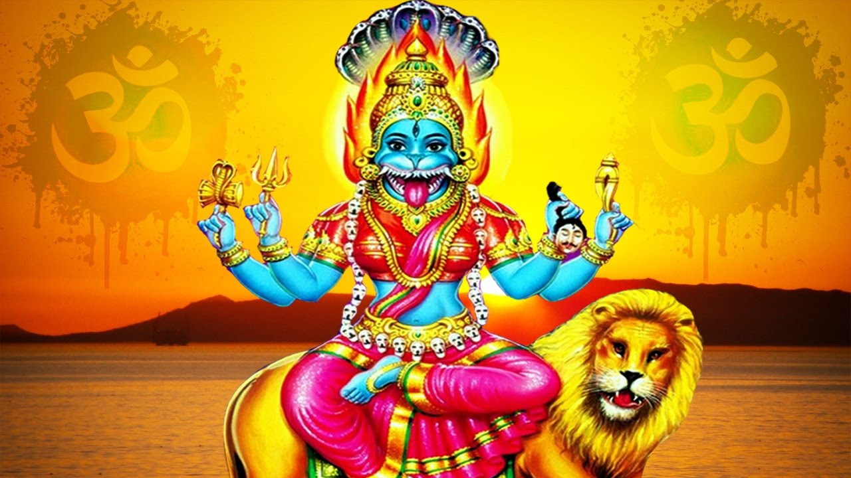
INTRODUCTION
Pratyangira Devi is an avatar of Parvati Devi. She is also a form of Adi Parashakti and is the consort of Sharabeswarar, a form of Lord Shiva, who took the avatar to pacify Lord Narasimha. She contains lion’s face and human body and contains the combined power of Lord Vishnu, Lord Shiva and Goddess Shakti. She was created in order to protect the good ones from the evil forces. Pratyangira is also worshipped as Kali and Narasimhi by the devotees. According to the ancient Vedas, she is mentioned as the lion goddess with great protective and destructive powers.
Lord Narasimha, even after killing the demon King Hiranyakashipu was remained in anger and fiercely roared. In order to control him, Lord Shiva took the form of Sharabeswarar, and controlled his anger. At that time, with the powers of Lord Shiva and Lord Narasimha, Mata Pratyangira was formed and appeared in front of them.
IMPORTANCE
By worshipping devi Pratyangira, we can get rid of problems from black magic, and also will get a healthy mind and a healthy body. Our mind will be peaceful, and the power of Devi Pratyangira will force us to do good things in our life. There are some important temples dedicated to her.
FAMOUS TEMPLES
- Sri Pratyangira Devi Temple, Sholinganallur,Chennai.
- Sri Pratyangira Devi Temple, Ayyavadi in Thanjavur.
- Mahapratyangiri Devi Temple, Kumbakonam
- Sri Pratyangira Devi Temple, Turahalli, Bangalore.
- Sri Maha Pratyangira Devi Peetam, Kodambakkam.
- Pratyangira Devi Temple, Venkata Palem, Andhra Pradesh.
- Pratyangira Devi Temple, Sastha Mangalam, Trivandrum, Kerala.

In temples of south India, She is also worshipped as Atharvana Bhadrakali, since she is the goddess of the Atharvana Veda. Her homams are very famous, and by doing that, we can get relieved from various health related problems and enemy related problems will also be solved immediately.
Pratyangira is considered as one of the warrior goddess and Pratyangira gives confidence and success to her devotees. Pratyangira is also mentioned in Ramayana. Pratyangira must be worshipped with sincere devotion, dedication and faith. Pratyangira can be worshipped and pujas can be done to her through the guidance of hindu priests.
She is mainly worshipped for destroying the evil forces. Doing Pratyangira Devi Homam (Havan) during Amavasya will yield good results in our life.
She will be pleased by the act of doing annadanam on Tuesdays and Fridays, and offers good boons to us. Apart from annadanam, we can also donate clothes to the roadside beggars, and to the poor people. If possible, we can help the poor people by constructing small shelters, in order to live their safely and peacefully. Whatever good acts done by us, will be pleased by the divine mother “MATA PRITYANGIRA DEVI” and will come with us in our everyday life, and will follow us like our shadow.
Let us worship the great divine mother and be blessed.
“OM SREE PRATYANGIRA DEVIYE NAMAHA”
“OM NAMAH SHIVAYA”
WRITTEN BY
R.HARISHANKAR

RAGHUVARYA THEERTHA
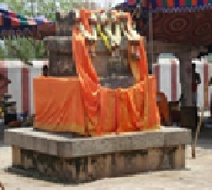
INTRODUCTION
Raghuvarya Tirtha was a great saint and he was the pontiff of Shri Uttaradi Mutt for the period: 1502 to 1557. He was the disciple of Sri Raghunatha Theertha, and he was his successor. Sri Raghuvarya Tirtha taught the famous work Nyayasudha to his disciples in a simple manner. He was the guru of Sri Raghothama Theertha, an aspect of Lord Nirudi Dev. He was a great devotee of Lord Sri Rama and worshipped his idol with much bhakti. He had spread the bhakti cult throughout the south india, and many people were become his ardent followers, due to his simplicity and spirituality. His disciples also admired him for his wisdom, courage and kindness.
Once, Sri Raghuvarya Tirtha met Sri Chaitanya Mahaprabhu in Udupi and discussed about Madhwa philosophy, and also about spiritual matters. Chaitanya, who was a divine avatar of Lord Krishna, blessed him and given spiritual powers to him.
Due to his great spiritual powers, once, the river Bhimarathi gave way to Sri Raghuvarya Tirtha to reach the other side of the river.
He attained samadhi at Anegundi, which is also known as Navabrindavana.

WORKS
- Raghupariksa
- A commentary on Prameyaratnamalika
- Krishnastuti
IMPORTANCE
He was an expert in vedas, Upanishads and all divine texts. He treated all of his devotees in an equal manner without differentiating them with regard to their caste and community. He was a kind, humble and a noble saint, who was an ardent devotee of Lord Ram and also a devotee of his guru Sree Madhwacharya. Through his great powers, he had blessed all of his followers and devotees and given them peace of mind, good health with sufficient wealth and removed their diseases and given them peace of mind.
Let us worship the great saint and be blessed.
“OM SREE RAGHUVARYA THEERTHARE NAMAHA”
“JAI SREE RAM”
WRITTEN BY
R.HARISHANKAR

REVANTA
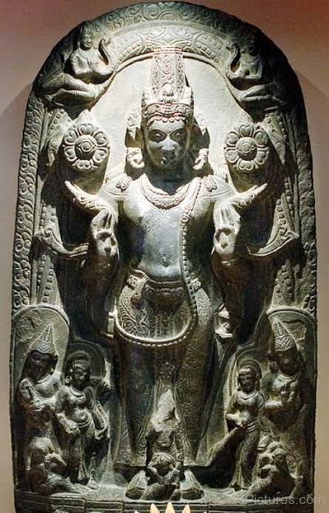
INTRODUCTION
Revanta or Raivata is the son of Lord Surya, and his wife Saranyu. Revanta is chief of the Guhyakas in the Himalayas. His Images are found in various temples and mostly worshipped by some sects of north Indians since ancient times. He is similar to yakshas and was worshipped for getting strength in mind and body. Being the son of Lord Surya, he is capable of giving good health and blesses us for a happy and prosperous life. His images are found in ancient Surya and Vishnu temples. There is an ancient temple dedicated to him in Madhya pradesh, and he is worshipped as the main deity in that temple.
Revanta is the brother of Shani dev, Ashwin kumaras,Yama dev, Yamuna, Tapti and Bhadra.
He is also mentioned in Markandeya Purana and Kalika Purana and describes his valour and strength. Though there is not much temples dedicated to him, he can be worshipped by chanting the stotra “OM SREE SURYA PUTRA REVANTAYA NAMAHA”.
By worshipping him we would get the following benefits in our life:
BENEFITS
- Proper eye light and relief from eye related diseases.
- Relief from skin related diseases.
- We would get great knowledge, wisdom and the ability to do all sorts of work.
- Relief from mental and physical problems.
- Relief from unnecessary confusions and tensions in life.
- Good grasping capacity.
- Free from enemies.
- Relief from planetary ill effects.
- Permanent peace of mind.
Let us worship the great GOD REVANTA, and be blessed.
“OM SREE REVANTAYA NAMAHA”
“OM SREE SURYA DEVAYA NAMAHA”
WRITTEN BY
R.HARISHANKAR

RISHI CHARAKA
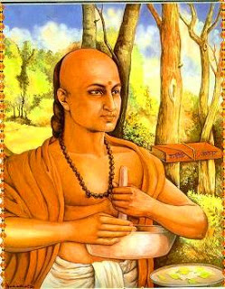
INTRODUCTION
Charaka (3rd century BC) was one of the great physician and inventor of new medical system of Ayurveda, and healed many people from their various health related problems. He is the author of the Charaka Samhita. Charaka was lived in Jalandhar in the present day Punjab. He is considered as the father of the “INDIAN AYURVEDIC MEDICINE”. It is believed that Charaka had studied at the University of Taxila in Punjab and also practised his profession in punjab.
He was a great and a noble man, who will used to wander from place to place and if he finds any sick person, he immediately give his medicines for getting him cured from his ailment. According to him, all types of diseases can be cured only with the help of AYURVEDIC MEDICINES, but the only way is that the patient must have to give his full cooperation and follow certain food practices, and must also have to be a god fearing person. According to him, by worshipping god and by properly taking ayurvedic medicines, one can get cured from all of his ailments. He also tells that diseases can be prevented by doing regular exercise, yoga, meditation and by regularly worshipping the god.
He was a great physician, who would first study all the factors which leads to a person’s disease, and then only would prescribe the treatment. Many people were benefitted by his treatment and lived happily for a long period of time.
Charaka had also contributed in the field of yoga, varma, phycology and physiotherapy. Charaka is considered as the foremost physician to improve the immunity levels of the people, and to control the various diseases of the people. He also asked the people to be in a jovial mood and to take their life as easy. And asked them to control their mental sufferings and worries, and instead of that, he insisted them to worship the god and to seek his help, by chanting his name and by frequently visiting the temples.
Charaka had completely studied the anatomy of the human body. He also accepted that our cause for worries is due to our bad karma. But he has got more confidence on his ayurvedic medicines. His famous book “CHARAKA SAMHITA” is considered as a very useful book in the ayurvedic field.
IMPORTANCE
Though he was treated as a physician, he was actually considered as a great “RISHI” who had taken birth in this earth, in order to relieve the people from their sickness and to make them to concentrate their attention more on bhakti path. He is a selfless physician who lived a pious and a noble life throughout his life period. He lived only for the welfare of the people, and done meditation on the god for raising the standard of living of the people, and also to reduce the physical and mental sufferings of the people. In this today’s modern era of world, we cannot expect such kind of person who had lived only for the welfare of others.
Let us worship the great physician and yogi and be blessed.
“OM SREE RISHI CHARAKARE NAMAHA”
“OM NAMAH SHIVAYA”
“OM SAKTHI PARASAKTHI”
WRITTEN BY
R.HARISHANKAR

RISHI KUTSA
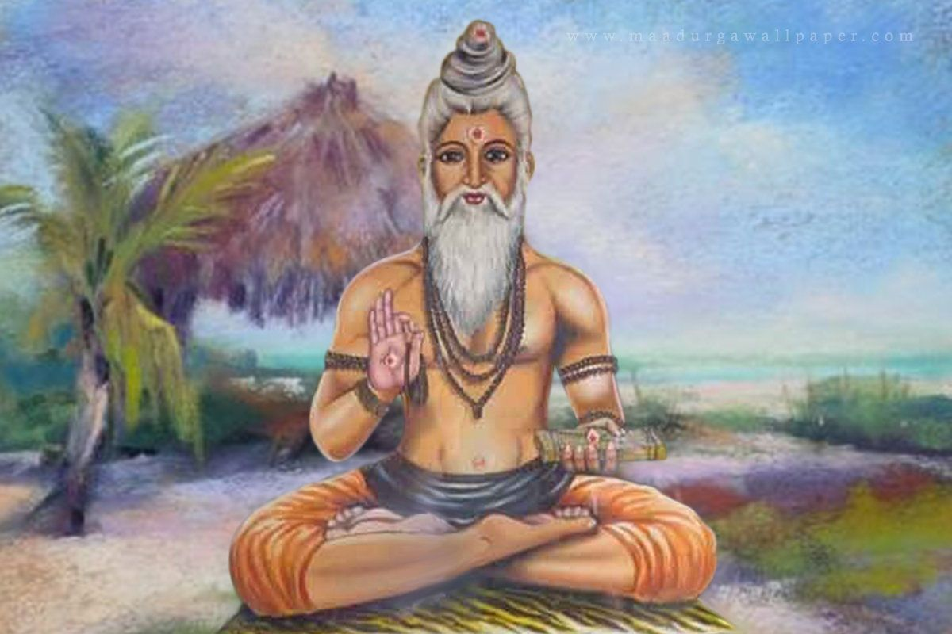
INTRODUCTION
Kutsa Maharishi is one among the Saptarishis of this Yuga. Maharishi Kutsa is a humble and a soft spoken person. Like other rishis, he will never get angry and curse others. His speciality is his patience. Whoever disturbs him from his meditation or from his regular activities, he will not punish or curse them, but instead with a smiling face, he will ask the reason for them in disturbing him. With his sweet words and gentle nature, nobody will act as his enemy. They will appreciate him for his kindness and praise him for his high meditative power. It is also said that several sukthas in the Rudram, were penned by Maharishi Kutsa. It is also stated that Kutsa Maharishi explained the ways for attaining the glory of the god and to reach the path of heaven.
The name of Kutsa is mentioned in all the four Vedas and his greatness is also mentioned in the Vedas. Kutsa and Indra are very close friends and both of them have similar appearance. Once, Indra helped in defeating the enemies of Kutsa’s father.
From then onwards, Kutsa became a best friend of Lord Indra.
As mentioned in Rig Veda, Lord Indra also saved Rishi Kutsa when he fell into a deep well.
Maharishi Kutsa has also introduced several mantras in order to chant them as a daily routine for the benefit of the vedic people.
IMPORTANCE
Though he is not well known similar to other maharishis, he is mentioned in detail in the sacred hindu texts. Mainly he resides in the swarka loka along with Lord Indra and also acts as a friend and an advisor to him. Similar to Guru Brahaspati, he was also a great scholar in all the vedas, Upanishads and puranas. He had contributed a lot in developing mantras, and composed several texts for the benefit of the people. He was also emphasised the importance of worshipping god and doing charity related activities in his sacred texts. Being the near and the dear friend of Lord Indra, by worshipping him sincerely with utmost devotion in our mind, will definitely lead us to the path of Indra Loka after our death.
Let us worship the holy maharishi and be blessed.
“OM SREE RISHI KUTSAYA NAMAHA”
“OM SREE INDRAYA NAMAHA”
“OM MATA INDRANI DEVIYE NAMAHA”
WRITTEN BY
R.HARISHANKAR

RISHI SUSHRUTA
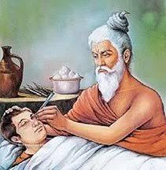
INTRODUCTION
Sushruta, was an ancient Indian physician and the author of Susruta-saṃhita. According to the great epic Mahabharata, he was the son of the great Rishi Vishvamitra. He is declared as the "Father of surgery", and he was a celebrated physician who was very much praised for practising his noble profession throughout the WORLD.
The Sushruta Samhita is the principle text of Ayurveda. It is believed that he would have lived in the holy city of “VARANASI” before several thousands of years back. And a statue was dedicated in honour of Rishi Sushruta at Haridwar.
The Susruta-saṃhita, contains the details of remedial medicines which must be used in case of prolonged illness, and also contains the details of medicines for removing several dreaded diseases and mental illness. The text mentions the various surgical techniques that should to be followed for eye, ear, nose, heart, lungs and all parts of the body.
He also advocates the principles of yoga and meditation. And he insists us to do regular exercise and yoga along with deep meditation. He also asked us to chant the names of gods and to practice it regularly, and asked us to eat proper digestive food items. He had prescribed certain medicines for increasing our immunity levels, in order to run our life without much difficulty. He insists to do pranayama for asthma patients, and to worship Lord Varuna Deva for getting rid of water related diseases like common cold, sinusitis, tonsillitis, tuberculosis and diabetes. And he asked us to worship Lord Vayu Deva for getting rid of problems from indigestion, asthma, lung infections and heart related diseases, since we are able to breathe properly and living in this world only through his grace.
He asked us to worship Lord Agni Dev for getting relieved from fire burns, ulcer and various stomach related problems. According to him, Lord Adhisesha, the divine bed of Lord Vishnu must be worshipped for getting relieved from various poisonous diseases and dreaded diseases like cancer etc. Apart from worshipping these divine demi gods, we can worship our favourite saints, gods and goddesses based on our own interest and dedication to the respective saints, gods and goddesses.
IMPORTANCE
He is also considered as an avatar of Lord Dhanvantri, an ayurvedic god. He had contributed a lot in the medical field. Apart from providing service to the patients, he also provided free food to the guests, and performed meditation for the well-being of the entire UNIVERSE. He had done a very great noble service to the entire mankind, and due to his service he was praised by the people in the earth, and by the gods, goddesses and by the demi gods in the heaven.
Let us worship the great divine physician and be blessed.
“OM SREE RISHI SUSHRUTAYA NAMAHA”
“OM NAMAH SHIVAYA”
“OM SAKTHI PARASAKTHI”
WRITTEN BY
R.HARISHANKAR

SELLIAMMAN
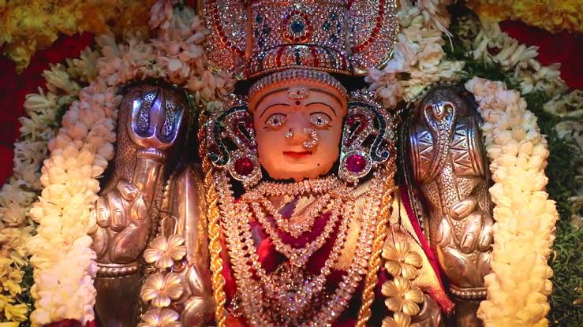
INTRODUCTION
Selliamman also called as chelliamman is a famous goddess worshipped mainly by the south Indians, and is considered as an aspect of Mata Chamundi. Selliamman temples are situated throughout tamil nadu. Among her several temples, Temple at Vellore is a famous temple, which is worshipped by thousands of devotees on a daily basis. This temple is situated nearby the new Vellore bus stand. Inside the temple, the idols of all the Saptha Mathrikas are also found. Goddess Selli Amman is the main deity in this temple. Many devotees have got benefitted by worshipping this amman. Selliamman temple situated in Peravallur, Chennai – 600 082 is also a famous temple, and lot of devotees would regularly visit this temple on Tuesdays, Fridays and Sundays. And during Aadi month, pongal and koozh offering will be made by the devotees in this temple.
According to a famous legend, once there lived two affectionate brothers: Bommi and Dhimmi from Karnataka, they left their native place due to the ill treatment given by their relatives and reached Vellore. After settling in vellore, they regularly visited the Selli Amman temple and they worshipped Mata Chamundi (Tamil people worship her as Chelli amman) who was also their Kula Deivam (family goddess). They also saved the village people from thieves due to the power given to them by Chamundi. The other villagers realized the powers of the goddess and treated the two brothers with much respect. The temple is open from 6 Am to 8 PM.
There is also another temple named as Kattu Chelli Amman temple which is situated inside the forest at Sengarai, Tamil Nadu 601202. Once she also safeguarded a british soldier from snake bite and also made him to realize that she is a divine goddess. She also cured her devotees from several dreaded diseases and from mental disorders.
The temple is open from 6 Am to 6 Pm. Tuesdays Thursdays and Fridays are important days at the temple and large number of devotees from the nearby areas would visit this temple. In the tamil month of Chittirai and Aadi, amman will be decorated with various flowers and pongal, koozh and fruits would be offered as naivedyam to her, and later on it will be distributed to the devotees. Childless couples will visit this temple and are blessed with good children. Unmarried people also regularly visit this temple and soon they will get married with the divine grace of the holy mother.
IMPORTANCE
She is also worshipped for getting relieved from various health related and mind related problems and we can quickly recover from that. She also removes the black magic, removes the enemy related problems, and always follows us in our every moment of our life, if we worship her sincerely and faithfully.
Let us worship the divine mother and be blessed.
“OM SREE SELLIAMMAN THAYE NAMAHA”
“OM NAMAH SHIVAYA”
WRITTEN BY
R.HARISHANKAR

SHACHI DEVI
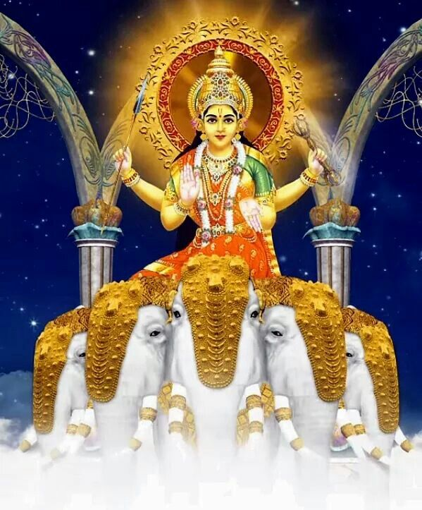
INTRODUCTION
Shachi Devi also called as Indrani is the consort of the heaven king Lord Indra, and is the goddess of beauty. She is the daughter of the Demon Puloman. She is one among the seven mother goddesses. She is described as a beautiful worshipful goddess and contains pleasing manners. She is the mother of Jayanta, Jayanti, Devasena, and Chitragupta.
She also contains the powers equivalent to that of her husband Lord Indra and having The Great Elephant Iravatha, as her Vehicle. Grand puja would be performed to Goddess Indrani during the Navratri Festival.
She is also mentioned in several vedic texts, and her importance and glory is mentioned in Hindu Scriptures, and it is believed that she will welcome the holy sages and the good ones to the heaven with great respect and takes them to her hushand Lord Indra. She contains all the good qualities similar to that of Mata Parvati, Lakshmi and Saraswati. She shows great mercy to the living beings in the earth, and reduces the sufferings of her sincere devotees. It is also believed that with her blessings and permission only, one can enter into the heaven and enjoy all the comforts. She also gives great respect to her husband Lord Indra, and consoles him whenever war occurs between devas and demons. In general, we can say that she cannot be compared with any other ordinary women in the entire universe. She also protects her devotees from their enemies, and gives them all sorts of happiness and peacefulness in their life.
IMPORTANCE
She shows great compassion on the living beings in the earth, and especially in this difficult period of “KALI YUGA”, and makes them to relieve from their sins and helps them to enter into the path of heaven. She is also considered as a Shakti element, and contains the features of Mata Parvati Devi. Though she enjoys the heavenly comforts, still as a “UNIVERSAL MOTHER”, gives her helpful hands and lift us when we are thrown out by our enemies. By worshipping Indrani, we will get the blessings of Lord Indra and all the divine devas in the heaven.
Though there are no independent temples dedicated to her for worship, there is a famous temple known as “SRI INDRANI PANCHADURGA PARAMESHWARI TEMPLE” situated at Udupi, Karnataka. Here Goddess Indrani is worshipped in the form of Devi Durga.
By worshipping the divine mother and by doing puja and homam to her at our home by placing her framed picture, in course of time, based on our good karmic deeds, we will get a chance to reside at Indraloka and can enjoy all the pleasures and live happily.
She is also the destroyer of our sorrows and the giver of happiness. And she removes the mental and physical illness from our mind and body. She gives peacefulness and happiness and everlasting bliss to us.
Let us worship the divine mother and be blessed.
“OM SREE INDRAYA NAMAHA”
“OM SREE INDRANIYE NAMAHA”
WRITTEN BY
R.HARISHANKAR
SHAKAMBHARI
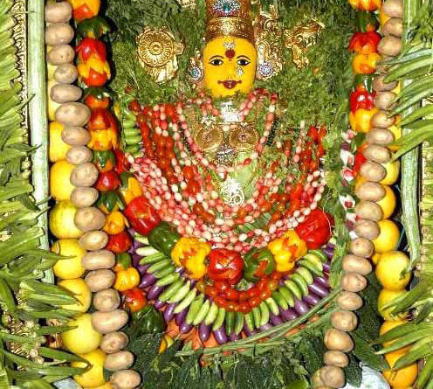
INTRODUCTION
Shakambhari is an incarnation of Mata Parvati, and is our holy mother. She accepts any Vegetarian Item as the Prasad. Usually in her temples, she would be decorated with various flowers, fruits and vegetables. It is also believed that during the times of drought and famine, Parvati Mata would incarnate as Shakambhari and gives food to the hungry. She is also called as “SARVA LOKA MATA” (UNIVERSAL MOTHER) and worshipped in several names. Her Shakti peeth is situated in Rajasthan and Uttar Pradesh. She is also popularly mentioned in several Puranas.
Once there lived a powerful demon named Durgamasur, and he was very arrogant. He didn’t like the vedic sages chanting the mantras of the gods. He wanted to stop this act. Hence, he went to the Himalayas and performed severe penance on Lord Brahma. Brahma appeared before him and was willing to offer the boon. The demon had asked Brahma to give him all the Vedas. Lord Brahma had given the four vedas to the demon and then disappeared.
From that time, the great sages and the vedic pandits didn’t do their daily rituals, fire sacrifices, and other rites and were become lazy. After some time, the demon fought with the divine devas and made them to vacate from the heaven.
All the divine devas, sages and the holy people went to Himalayas and worshipped Mata Parvati to show mercy on them. Parvati took the form of Shakambhari and after a long battle she killed him, and took the four vedas and handed over it to Lord Brahma. Due to that, the sages and the vedic people were able to chant the mantras and do homams and pujas on gods and goddesses.
TEMPLES
- Ma Shakambari temple at Sakarai in Rajasthan.
- Shakambari Mata temple at Jharkhand.
- Mata Shakambari Devi temple in koltata.
- Shakambari temple in Uttar Pradesh.
- Shakambari temple in Odhisha.
- Shakambari Mata temple in Badami.
- Shakambari Temple in Cuttack.
- Shakambari temple in Aurangabad.
- Shakambari temple in Pune.
Every year in Durga Temple at Vijayawada, goddess Durga would be decorated with vegetables and fruits for three days and worshipped as Shakambari Devi.
Various Pujas would be performed in Shakambhari Devi temples during Navaratri festival days.
IMPORTANCE
Goddess Shakambhari Devi is a god of vegetation and agriculture. By worshipping her, there would be a good harvest in the agriculture sector. She is the kind mother, who will used to provide food to the people, whenever in case of need. Through her blessings only, nowadays free food is offered in most of the temples throughout india. She is the affectionate mother who offers boons to her sincere devotees and blesses them.
Let us worship the kind mother and be blessed.
“OM SREE SHAKAMBHARI DEVIYE NAMAHA”
“OM NAMAH SHIVAYA”
WRITTEN BY
R.HARISHANKAR

SHAKUNTHALA
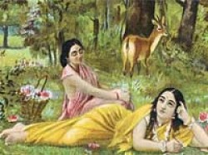
INTRODUCTION
According to Mahabharata, Shakunthala is the wife of Dushyanta and the mother of the great king Bharata. Poet Kalidasa has also written a text on the life history of Mata Shakunthala.
Rishi Kanva found her in the forest as a baby, and he took her to his ashram and looked after her in a proper manner.
Once King Dushyanta saw the beautiful Shakuntala and both of them were fell in love with each other and got married as per Gandharva marriage system. Dushyanta gave his personal royal ring to Shakuntala and invited her to his palace.
Shakuntala dreamt about her husband and due to that once when Sage Durvasa visited to Sage Kanva’s ashram, she didn’t attended to him properly. Due to her act, the rishi cursed Shakuntala, saying that the person she was dreaming of would forget about her altogether. After getting the proper explanation from Sakunthala, the rishi slightly changed his curse saying that the person who had forgotten Shakuntala would remember her again when she show to him the ring which he gave it to her.
Shakuntala, after some time went on searching for Dushyanta with the ring. But while doing some personal activities, the ring slipped off from her finger and she didn’t know about it at that time.
After arriving at the palace of the king, due to the curse of rishi durvasa, her husband did not recognize her. With great grief in her mind she returned to the ashram of rishi kanva with her son. Her son Bharata was brave and strong enough to open the mouth of the tigers and lions and to count their teeth.
Meanwhile, a fisherman found the royal ring in the belly of a fish and he took the ring to the palace. On seeing his ring, Dushyanta got the memories of Shakunthala in his mind. He immediately went to rishi kanva’s ashram, and took his wife Shakunthala and his son Bharatha to his palace and crowned his wife shakunthala as the queen and his son Bharata as the prince for his region.

IMPORTANCE
Mata Shakunthala is a pious and a noble lady who took care of her husband and son in a proper manner. She acted as a dutiful wife for her husband and she gave proper suggestions to Dushyanta to rule his kingdom in a proper manner. All the people were pleased by her act, and greatly respected her for showing great kindness on them.
After living for many years, the royal couple went to the abode of Lord Indra, Swarka Loka, and it is believed that they are still living in the heaven with the blessings of Lord Indra.
Let us worship the great royal couple and be blessed.
“OM SREE DUSYANTHA MAHARAJAVE NAMAHA”
“OM MATA SHAKUNTHALA DEVIYE NAMAHA”
“OM SREE BHARATA RAJAVE NAMAHA”
WRITTEN BY
R.HARISHANKAR

SHAMA
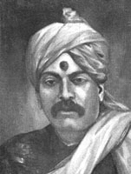
INTRODUCTION
Madhav Rao Deshpande also called as Shama was one of the baba’s most sincere devotees, and acted like his personal attendant. Their relationship can be compared to that of Lord Krishna and Arjuna.
He was born on Margashirsh Shudda Panchmi day on 6th December 1880 to a Brahmin family from Nimon. He came to Shirdi at his childhood along with his parents and permanently stayed in shirdi till his death. He was educated in Shirdi and became a teacher in a school. Baba only named Mahdav Rao as "Shama" and used to call him as ““HEY SHAMA COME COME” with love and affection. Shama realized baba’s superior powers and become his ardent devotee and disciple. Baba will used to frequently tell to shama that both of them were related from several past births. Shama had also learnt Ayurveda by reading various books and given free medicines by mixing baba’s udi (sacred powder) to the poor sick patients. He also charged a very nominal charge for other patients. Many people from different places visited him and consumed his medicines and they were all cured miraculously through the blessings of “SAIRAM”.
Shama used to call Baba as a "Divine man" and also took liberties with him. He will affectionately ask baba whether he had taken proper food and whether he had satisfied with that food. And he will ask him to give his Prasad “UDI” to him for mixing it with his medicines. He moved with him in a friendly manner.
And he also respected him, and treated him as a holy messenger of god, and considered him as his own elderly relative.
Once, Baba presented to shama a “VISHNU SAHASRANAM BOOK”. He also asked Shama to read the book regularly. Shama followed his instructions and read the book regularly till his death.
Once, Baba cured Shama from his eye infection. And he also showed him the Trilok and the Trimurties through his super natural powers. Baba gave to shama spiritual religious books as gifts to him and asked him to travel to holy places. Shama visited many holy places like Kashi, Char Dham and Puri.
Shama did not perform special pujas to Baba. But, he kept great faith in Baba. He will used to chant the sai mantra “JAI SAI RAM” regularly till his death.
In the year 1944, Shama fell sick and died and merged with SAIBABA.
Shama's house is situated between Dwarakamai and the Bazaar. His house is considered as very sacred and some of the books given by baba are still found in his house. One statue of Ganapati which was given by Baba is also found in his puja room.
IMPORTANCE
Shama had got an opportunity to live with sadguru sainath for such a long period of time. Throughout his life period, he served him with affection and showed sincere devotion on him. Though he had taken certain privileges from him, he never disobeyed him. Whatever instructions baba gives, he immediately follows it without any hesitation. He got such a great GURU BHAKTI. We cannot imagine such a great devotee in this today’s rough and tough world.
Let us worship the great man of shirdi and be blessed.
“OM SREE SHAMA PRABHUVE NAMAHA”
“JAI SAIRAM”
WRITTEN BY
R.HARISHANKAR

SHIVADOOTI
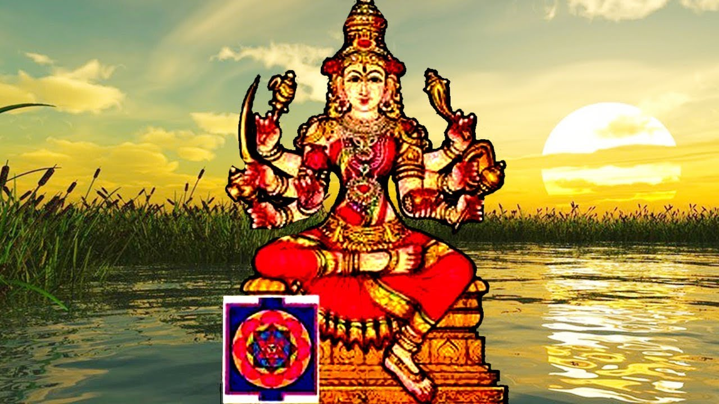
INTRODUCTION
Shivadooti is a divine avatar of Mother Parvati. Once, the divine devas and the living beings in the earth were suffered from the clutches of the powerful demons Shumba and Nishumba. All of them went to the Himalayan mountain ranges and worshipped Mata Paravati. Due to their sincere devotion Mata Parvati took the form of Goddess Shivadooti and fought with Shumbha and Nishumbha and destroyed them through her great powers. Goddess Shivadooti fought against Adharma and maintained peace and prosperity in the universe.
According to ancient Puranas, Shivadooti contains red coloured body with a beautiful appearance and a smiling face which glitters like millions of stars in the sky.
IMPORTANCE
By worshipping the holy mother Shivadooti, we would get the following benefits in our life:
- Free from enemies
- Good health
- Peace of mind
- Sufficient wealth
- Happy marriage life
- Good children
- Good fortunes in our life
- Name and fame
- SALVATION after our death
By worshipping Ma Shivadooti, we would get the above mentioned benefits. In general term, she would give all kinds of prosperity in our life. Though there are no notable temples dedicated to her, worshipping her in the temples of Mata Parvati and Mata Durga is sufficient. We can place a picture of Mata Shivadooti and recite the mantra: “OM SREE SHIVADOOTI DEVIYE NAMAHA”. We can worship her by offering fruits, flowers and pulses as naivedyam (HOLY PRASAD) and can distribute it among the devotees.
Let us chant the glory of the goddess and be blessed.
“OM SREE MATA SHIVADOOTIYE NAMAHA”
“OM NAMAH SHIVAYA”
WRITTEN BY
R.HARISHANKAR

SHYAMA SASTRI
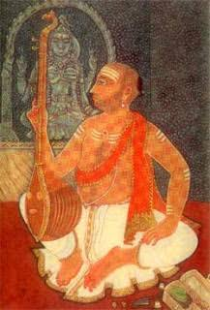
INTRODUCTION
Shyama Sastri (1762–1827) was a great musician and a divine composer of Carnatic music. He was senior to the two divine composers Tyagaraja and Muthuswami Dikshitar.
Shyama Shastri was born in a Brahmin family in Tiruvarur. He learnt the vedas, Upanishads and divine scriptures at his younger age. He learnt music under a famous musician of Thanjavur.
His compositions are well known due to his great proficiency on the music. He got the blessings of goddess saraswati, and he became a very clever and a knowledgeable person. He was a great devotee of Mata Kamakshi Amman and worshipped her with great devotion and regularly visits her temple, and performed various pujas to her.
He composed kirthanas in Telugu as well as in Tamil. Most of his compositions tell about the greatness of goddess Kamakshi. He got a very good voice and sings melodiously during his period.
Shyama Shastri died in Thanjavur in 1827 and attained the Lotus feet of the divine mother “KAMAKSHI”. One of his two sons Subbaraya was well versed in singing songs on “KAMAKSHI” and also a great composer of divine songs. He was trained by Tyagaraja, who is also a divine composer of Carnatic music.
Shyama Shastri had many disciples, and most of his disciples were trained under his supervision and they become celebrated musicians.
IMPORTANCE
Shyama Sastri, though he was a family man, he lived a saintly life, and dedicated his entire life towards writing songs on KAMAKSHI AMMAN and singing in front of her temple and also in several musical concerts. He was also a worshipper of Tumburu and Narada, since both of them were good musicians. His entire thoughts were involved in music and thinking about the greatness and kindness of KAMAKSHI. Let us worship the divine musician and be blessed.
“OM SREE SHYAMA SASTRIGALE NAMAHA”
“OM SREE KAMAKSHI AMMANE NAMAHA”
“OM NAMAH SHIVAYA”
WRITTEN BY
R.HARISHANKAR

SITARAMDAS OMKARNATH
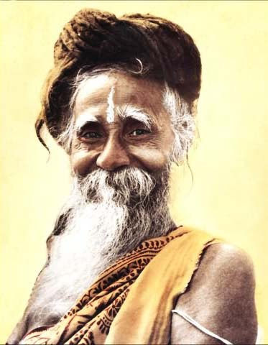
INTRODUCTION
Sitaramdas Omkarnath (1892–1982) was an Indian saint from Bengal. He invoked the bhakti path among his devotees throughout the world, and also preaches the importance of chanting Ram Nam. He is considered as a pious and a holy man among his followers and his devotees. Sitaramdas Omkarnath had written many books related to Hindu scriptures, and constructed temples and ashrams throughout india, and also founded a spiritual organisation and through that, he had cultivated the bhakti spirit among the people. He contains great knowledge, wisdom, courage and braveness and was a good scholar in vedas and hindu religious texts.
LIFE
Sitaramdas Omkarnath was born in a village in the district of Hooghly, West Bengal, in the year 1892. His original name was Probodh Chandra Chattopadhyay and was born in a Brahmin family and after finishing his education, he started his own practice as an ayurvedic physician in his native village. His family deity is Lord Krishna. He was a sincere devotee of Lord Ram, and will used to have his daily food, after chanting ram naam japam for atleast 1000 times in a day.
Omkarnath had his basic education in a village school but after some time he left that school and he studied under Sri Guru Yogeswar. Once in his younger age, he got the divine darshan of Lord Shiva and Mata Parvati. He was also a worshipper of Mata Kali, and got spiritual powers through her grace.
His Guru had given him the popular name, Omkarnath and after some time, he came to be known as Sitaramdas Omkarnath. He will used to do meditation in a cave at Ramashram, Dumurdaha, Hooghly, by chanting the gods and goddess names.
His thoughts were full of reciting Ram Nam and he practiced the habit among his fellow villagers. He also renovated and repaired the temples and provided shelters for the poor, given proper food to the poor, given education to the poor children, distributed clothes the poor villagers, and also helped the marriage of their daughters. Lakhs of devotees were become the followers of Sitaram, due to his kindness and for his selfless service to the mankind. Sitaram was respected by the great spiritual gurus like Anandamayi Ma, Dalai Lama, Swami Chidananda and others.
Omkarnath died in the 1982. And for some time, his body was kept at Sri Ramashram, Dumurdaha for public homage.
TEACHINGS
- Have faith in god, without god’s help, we cannot do anything in our life.
- Try to recite Ram Nam japam as many times as possible.
- Offer regular prayers and worship the gods and goddess in their temples.
- Show kindness and respect everybody, since every living being are considered as an aspect of the divine god.
- Do meditation and yoga. That will help you to keep your mind and body energetic.
- Don’t worry about life after death. Every- thing is already determined by the god. Based on that it will happen.
- Don’t save too much money, try to distribute it to the welfare of the poor.
- Have faith on your religion, and worship the god, since all the religions teaches only good things to us.
- Don’t blame on god for your sufferings. Instead of that, worship the god and pray to reduce your sufferings. Definitely your prayers will get answered.
IMPORTANCE
He has also done lot of miracles in the life of his devotees. He had made the bed ridden people to cheerfully walk in the streets and interact with others, cured the cancer, leprosy and mental disorder patients, and given them a new life, and made them to stand them on their own legs, without expecting anybody’s help.
He also concentrated in doing help to the poor female villagers. He made them to actively get engaged in doing small chores of activity at his ashram, and provided wholesome food to them along with their children. He also showed much kindness to the animals and birds, and regularly fed them with milk, biscuits and food grains.
Let us worship the great saint and be blessed.
“OM SREE SITARAMDAS OMKARNATH JI NAMAHA”
“JAI SREE RAM”
“OM NAMAH SHIVAYA”
WRITTEN BY
R.HARISHANKAR

SITHALAPAKKAM RAGHAVENDRA SWAMY TEMPLE
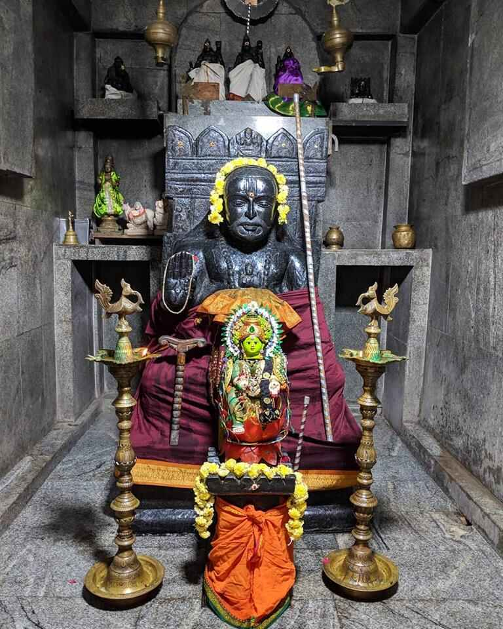
INTRODUCTION
As per the words of Guru Raghavendra Swamy, many mutts are being formed all around the world. Out of his several temples, there is a famous temple situated at Sithalapakkam, which is located in Plot No. 364, Sri Raghavendra Swamy Koil Main Street, T.N.H.B. Quarters, Medavakkam - Mambakkam Main Road, SITHALAPAKAM, Chennai – 600126.
It is also one of the Mritika Brindavan. This temple is managed by Sri.Arun Raghavendrar, who is also the priest of the temple. The temple was also consecrated (KUMBABISHEKHAM) in a well versed manner to enlighten the Holy Brindavan.

In this temple, more than 10 types of Abhishekhams are done to Sri Raghavendrar and to other deities in the temple. Devotees can do abhishekhams and can get the blessings of the deities. This is also considered as a “GURU PARIHARA STALAM”. Here navagraha shrine, Anjaneyar Shrine, Bhairavar Shrine and Vinayakar Shrines are found inside the temple. Here Guru Raghavendra Swamy is considered as the main deity and special pujas and abhishekhams would be done to him on Thursdays.

Homams are also done in order to get rid from the negative effects of the planets and also to gain peace and prosperity in life. By worshipping the shrines in this temple, all our miseries and sorrows would come to an end, and our enemies would run away from our sight, and we would have a blessed life.

Lot of sevas like Pallaku Seva, Pushpa seva, Vastra seva and Oonjal seva is performed in this temple. Devotees can pay the prescribed amount and perform all or any of these sevas and can get the blessings of the divine guru and gods.

Here free annadanam is offered on every Thursdays to the devotees. Devotees can also offer food grains to the temple. The food offered would be very tasty, and by consuming the food, we will get relieved from our several health related problems.

During the annual aradhana festival, lot of devotees would participate in the function and worship the guru and the gods, and have their delicious food which will be served in a pleasant manner by the temple staffs.

Let us visit this Guru’s temple at least once in a month and be blessed.

“OM SREE GURU RAGHAVENDRAYA NAMAHA”

“JAI SREE RAM”

“JAI HANUMAN”

WRITTEN BY

R.HARISHANKAR

SREE BASKARACHARYA
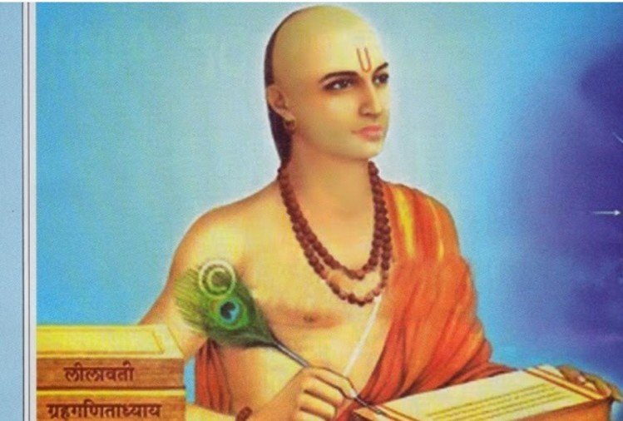
INTRODUCTION
Bhaskaracharya (1114–1185) was an Indian mathematician and astronomer. He was born in Bijapur in Karnataka. He had contributed a lot towards new inventions in the field of mathematics and astronomy. He had written a text known as Siddhanta Shiromani and is considered as a famous work. He also wrote another great work Karanaa Kautuhala.
He had discovered the principles of differential calculus and its application to the field of astronomy. Bhaskara had laid some of the good principles of differential calculus. He was also honoured by the Indian Space Research Organisation (ISRO) in the year 1981 by launching the satellite and they have named it as Bhaskara II satellite.
LIFE
He was born in Karnataka. Bhaskara was occupied a chief position at the astronomical centre at Ujjain. He lived in Maharashtra.
His father Mahesvara was a great mathematician, astronomer and also an astrologer. He died at the age of 71.
His famous astronomy works are as follows:
- Lilavati
- Bijaganita
- Grahaganita
He had made a major contribution in the field of Mathematics in the following subjects:
- Arithmetic
- Algebra
- Trigonometry
- Calculus
IMPORTANCE
He was a great scholar and also a great sage who had invented new concepts in mathematics and astronomy. He was also good at yoga and meditation. And he was a master in divine scriptures and an expert in all forms of art. He was an ardent devotee of Lord Krishna and used to chant his name repeatedly. His great contribution to the field of mathematics and astronomy can never be forgotten by today’s people, and he is considered as a divine scholar.
Let us worship the great scholar and saint and be blessed.
“OM SREE BASKARACHARYARE NAMAHA”
WRITTEN BY
R.HARISHANKAR

SREE GURU SANGHA
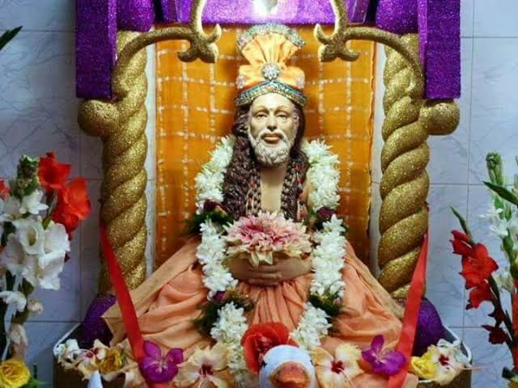
INTRODUCTION
Sree Guru Sangha was a great siddha purusha and a saint who was born before 1400 years. He got many sincere disciples who were followed all of his instructions and spread the bhakti path throughout india.
LIFE
Sree Sangha was born in north india, to a pious family, and he had studied his basic education and was an expert in vedas, puranas and Upanishads. He was not interested in family life. Hence he had constructed an ashram at the banks of river tapti and lived his life by taking alms and teaching the divine scriptures to his disciples and also given spiritual discourses to the people. From his younger age itself, he was an ardent devotee of Lord Krishna. Whenever he got time, he will used to fly to Pandarpur by his spiritual powers in order to worship Lord Krishna. Though he had got good knowledge in all the subjects, and though he was an expert in all kinds of art, he didn’t get peace of mind.
Once he heard a divine voice, and the voice had ordered him to visit Saint Dyaneshwar in Alandi at Pune, Maharashtra. Sree Sangha created a tiger and went to the place of Dyaneshwar. Dyaneshwar was a small boy then. He was sitting along with his siblings in the bottom of a banyan tree, and welcomed the holy saint. Sri Sangha who was an old man, bowed in front of the young Sree Dyaneshwar for his simplicity and for his pure bhakti on god. And Dyaneshwar had advised him to become the disciple of his sister Muktabai, who was also an ardent devotee of Lord Krishna.
Sangha Dev had agreed and he became the disciple of young Muktabai and wilfully learnt the divine matters from her and pursued great knowledge and wisdom. He left his pride and become a man of simplicity. He stayed there for some time, and after wards left that place and went to his ashram and continued his regular work and attained SALVATION after his death.
IMPORTANCE
Sree Sangha also performed miracles to many of his devotees. Once he brought back to life of a widow’s husband, he removed the leprosy of a poor man, he also given eye sight to lot of people, and cured several diseases of the people. It is believed that he had got the divine darshan of Lord Krishna for several times, during his life time.
His famous teachings are as follows:
- Think, Think, Think. Always think about Lord Krishna and chant his holy names and mantras.
- Visit the holy shrines of Lord Krishna and get his blessings.
- Always be kind with others, and provide proper help to the poor and the old people, by giving them food, clothing and shelter.
- Concentrate your mind on useful and spiritual activities. Don’t allow you mind to become a dust bin. Try to clean it immediately and fill up your mind with full of spiritual matters only.
- Never hurt anybody through your words or by physical means, since god is dwelling in everyone’s heart.
- Don’t curse god for your problems. God knows everything, and in course of time, he will make you happier by removing your problems.
- Don’t get too much attached with worldly matters, since that will not last too long.
- Always think yourself as the servant and slave of the god. And repeatedly chant the names of god. By doing that, you can reach a higher level in your life.
- Give respect to everybody, and treat your parents as equivalent to gods and goddesses. Then your life will always be happy.
Through his powers and teachings, he was praised by the people and kings, and they had awarded lot of wealth to him. But, he had donated all the wealth for the welfare of the poor people. He lived throughout his life by doing service to the mankind and to the god.
Let us worship the great saint and be blessed.
“OM SREE GURU SANGHA DEVARE NAMAHA”
“JAI KRISHNA”
WRITTEN BY
R.HARISHANKAR

SRI ANNAMALAYAR MAHATMYAM
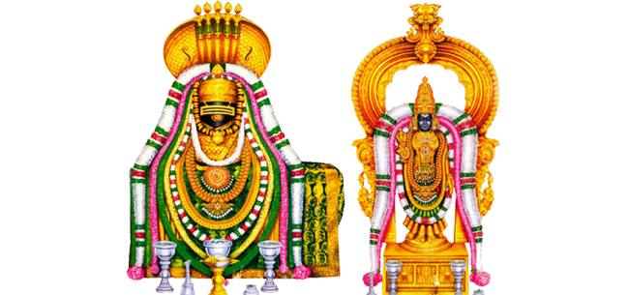
INTRODUCTION
Arunachaleswara Temple, also called as Annamalaiyar Temple, is a Hindu temple of Lord Shiva, located at Arunachala hill in the town of Thiruvannamalai in Tamil Nadu. It is one of the Pancha Bhoota Stalas, and Lord Shiva is worshipped as an element of fire in this temple. Shiva is worshiped as Arunachaleswara or Annamalaiyar, and he is worshipped in the form of Agni lingam. Mata Parvati is known as Unnamalai Amman. The importance of Annamalayar was mentioned in the famous text Tevaram.
The temple is one of the largest temples in India. The temple opens from 5:30 a.m. to 10 p.m., and celebrates several festivals. The Karthigai Deepam festival is celebrated in a grand manner in this temple. Girivalam is very famous among the devotees, and they will circumambulate the arunachala hill especially during full moon days. And Chitra Pournami festival is a famous festival for the devotees and thousands of devotees will make their girivalam during that day.
According to ancient puranas Mata Parvati, once playfully closed the eyes of Lord Shiva at Mount Kailash. Due to her act, the entire universe was surrounded with full of darkness for several years. In order to maintain the universe to its normal form, Mata Parvati performed penance at the Arunachala hills, and Lord shiva appeared before her and she merged with Lord Shiva.
According to another famous legend, when Vishnu and Brahma challenged that they are the superior gods among the other gods, Lord Shiva appeared in the form a flame, and challenged them to find his original form. Brahma took the form of a swan, and flew to the sky to see the top of the flame, while Vishnu became the boar Varaha, and sought its base. Neither Brahma nor Vishnu could find his original form, and while Vishnu accepted his defeat, Brahma had lied and told that he had seen Lord Shiva’s original form. Due to his act, Lord Shiva cursed Lord Brahma that he would never have any temples on the earth.
Sambandar, Appar and Manickavasagar praises the glory of the temple, and written about it in their sacred texts.
The place is also called as Mukthi Sthalam and saints like Seshadri Swamigal and Ramana Maharishi were lived in this Tiruvannamalai.
IMPORTANCE
By visiting the holy temple of Arunachaleswara, we can get SALVATION after our death. Our sins would be gradually reduced and we would get spiritual energy and attain more physical and mental strength in our body and in mind. In this holy temple, the temple management is providing annadanam daily at 12.00 noon to about 300 devotees per day. Lot of devotees are getting benefited through that.
In the girivalam path, lot of temples are there, like Raghavendraswamy temple, hanuman temple, Vishnu, Amman temples etc. Ashta linga temples are also situated in the girivalam path, and ashrams for Ramana Maharishi, Seshadri swamigal and Yogi Ramsurat kumar is found in the girivalam path. By doing girivalam, our mind will get relaxed from tensions and we will forget outselves from worries and will feel more pleasant and happy, and also we will get the grace of Lord Shiva. Hence let us try to develop the habit of visiting Lord Arunachaleswarar at least once in a year, and get the divine blessings from him.
Let us chant the names of Lord Shiva and be blessed.
“OM SREE ANNAMALAYARE NAMAHA”
“OM SREE UNNAMALAYAMMANE NAMAHA”
WRITTEN BY
R.HARISHANKAR

SRI PARAMASIVENDRA SARASWATI
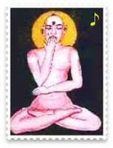
INTRODUCTION
The Head of Shri Kanchi Kamakoti Peetam Sri Paramasivendra Saraswati Swamy’s temple is situated in Tiruvenkadu. He was the 57th pontiff of the Kanchi Mutt. The Acharya attained salvation in Tiruvenkadu on Sukla Dasami during the year 1586 AD. The place Tiruvenkadu is very famous, since the great shaivite nayanar Thirugnanasambandar was born in Tiruvenkadu. Inside the temple complex, there are shrines of Lord Vinayaka, Muruga, Kala Bhairavar, Lord Surya and Shri Dakshinamurthy. His birth name was Sivaramakrishna.
He was born on the banks of the river Pampa. And his father’s name was Parameshwara. From his younger age itself, he was mastered in all the hindu scriptures and learnt all forms of art. He was expert in all regional languages. He was a humble, noble and a kind hearted saint, who has done lot of charitable activities during his period. He provided free food to the poor people and to the devotees of Lord Shiva and also educated the poor children. He was the Guru of the famous saint Sree Sadasiva Brahmendra, who was also the author of the Gururatna malika and he was also a great Brahma Gnani. His disciple Sadasiva Brahmendra was very obedient with his guru, and he had done all sorts of services to him. And due to his great guru bhakti, he will used to carry the foot wear of his Guru on his head. In this today’s modern world, we cannot imagine such a kind of great “DISCIPLINED DISCIPLE”.
TEACHINGS
- Have faith in god and worship him, otherwise nothing is possible in this earth. Think yourself as a slave to the god, since we are all the servants of the god.
- Our only way to escape from the clutches of Kali purusha is to have sincere devotion on god.
- God is having the capacity to change our fate also, based on our sincere bhakti.
- Always be patience and obedience over others.
- Control your senses through worshipping god.
- Give respect to everybody in this world.
- Provide food to all the living beings in the earth.
- Chant the names and the mantras of god as a regular practice and develop the habit of going to temples and worshipping god.
- Don’t be miser and don’t be greedy. Don’t save too much of money. Since we are going to live only for a short span of life. Nothing is going to come with us after our death, and only our good karmic deeds will come along with us.
His teachings were attracted by the people and many of them were become his followers.
IMPORTANCE
Paramasivendra Saraswati contains great spiritual powers and performed miracles. He also cured several dreaded diseases and relieved the mental illness of his devotees. He was a great shiva devotee and used to regularly worship Lord Sattanathar at Sirgazhi. Daily he will used to perform pujas to the god and also adorned the god with flowers and will used to perform abhishekhams. Through his great powers, he has reduced the sufferings of his followers and his sincere devotees and made them to live their life peacefully and happily. He also invoked them into the spiritual path.
Let us worship the divine guru and be blessed.
“OM SRI PARAMASIVENDRA SARASWATI SWAMIGALE NAMAHA”
“OM SRI SADASIVA BRAHMENDRARE NAMAHA”
“OM NAMAH SHIVAYA”
WRITTEN BY
R.HARISHANKAR

SRI SRINIVASA MAHATMYAM
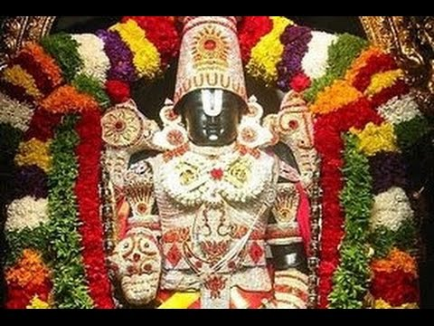
INTRODUCTION
Lord Venkateswara also known by various names as Srinivasa, Balaji, Venkatachalapati and Govinda is a divine form of Lord Vishnu. Lord Venkateswara is the main deity of Tirumala Venkateswara Temple situated in Tirupati, Andhra Pradesh. Lakhs of devotees are visiting daily to the Tirumala Temple to have a glimpse of their dear god, and to get his blessings.
In Tirumala, TTD Devasthanams are conducting lot of social welfare schemes for the benefit of the devotees and to the poor people, like providing free food to the devotees, education to children, veda patasala, hospitals, go-samrakshana etc. The TTD is investing the money received from the devotees in Fixed Deposits and utilizing only the interest portion for performing social welfare schemes. Lot of poor students and poor people were got benefited by these schemes.
Every day lot of devotees are donating lakhs of rupees at the Tirumala Venkateswara Temple at Tirupati, Andhra Pradesh. According the famous legend once the sages gathered in one holy place and decided to perform rituals to the gods. The sages asked Bhrigu, to test the goodness among the gods. Bhrigu went to divine worlds and met Indra, Brahma and Shiva and found that they are not competent. Afterwards, bhrigu went to Vaikunta, the abode of Lord Vishnu. At that time, Vishnu didn’t attend him and was in yoga nithra. Seeing his action, bhrigu got very angry and kicked him at his chest with his feet. Since Mata Lakshmi permanently resides in the heart of Lord Vishnu, she could not tolerate the actions of bhrigu maharishi and left vaikunta and went to the Kolapur city for performing penance. Lord Vishnu pacified Bhrigu maharishi and pressed the feet of Bhrigu maharishi gently through his lotus hands. Bhrigu got very much admired with the actions of Lord Vishnu, and asked him to apologise him for his anger with him and went to the holy place where all the other sages were gathered and informed them that Lord Vishnu is the competent person and the rituals can be dedicated to him.
Since goddess Lakshmi has left him, Lord Vishnu went to the earth for searching Goddess Lakshmi. Since, he was unable to find her, he settled on Seshachalam hills inside an anthill. Lord Shiva and Lord Brahma incarnated as a cow and a calf respectively and were took care by a shepherd of Chola kingdom in the Seshachalam hills. The cow and calf, everyday used to give their milk in the anthill to reduce the thirst of Lord Vishnu. The Chola king became suspicious. The next day the king went along with the shepherd and got angry with the divine animals and attacked the animals. But on behalf of the animals, Lord Vishnu accepted the attack and got wounded on his forehead. The king and the shepherd were very much worried about their cruel act and both of them were surrendered at the Lord's lotus feet. Lord Srinivasa had given the king a boon that he would marry his daughter. After some time, Srinivasa went to the home of Mata Vakula Devi and took shelter in her home, who was the foster mother Yashoda of Lord Krishna.
In the next birth, the Chola king was taken birth as Akash Raj and his daughter is Padmavathi. Lord Srinivasa met Padmavati and after certain period of time both of them got married in presence of divine sages, gods and the people in the earth.
It is believed that, during his marriage with Padmavathi, in order to meet the marriage expenses, Lord Vishnu took a large loan from Kubera, and still now through our donations like our hair and wealth he is repaying the debt to Lord Kubera. It is also believed, that Lord Srinivasa would reside at Tirumala till the end of this kaliyuga and will bless his devotees.
IMPORTANCE
Going to Tirumala and worshipping the god is a regular practice which was prevailing for several thousands of years. Lot of devotees are visiting the holy mountain in order to put their burdens on to the feet of the god. The god also doesn’t cheat them, and providing his grace at the appropriate time, based on their karmic deeds. The only thing is that, we must have utmost faith on him and worship him with entire devotion in our mind. Definitely in course of time, he will fulfil our wishes and gives peace and prosperity in our life. It is advisable for us to visit the holy place of Tirumala at least once in a year, and to seek the divine blessings of the great Lord Balaji.
Let us chant the glory of the god and be blessed.
“OM NAMO VENKATESAYA NAMAHA”
“OM SREE PADMAVATHI THAYARE NAMAHA”
“OM SREE VAKULA DEVIYE NAMAHA”
WRITTEN BY
R.HARISHANKAR

SUSWANI MATA
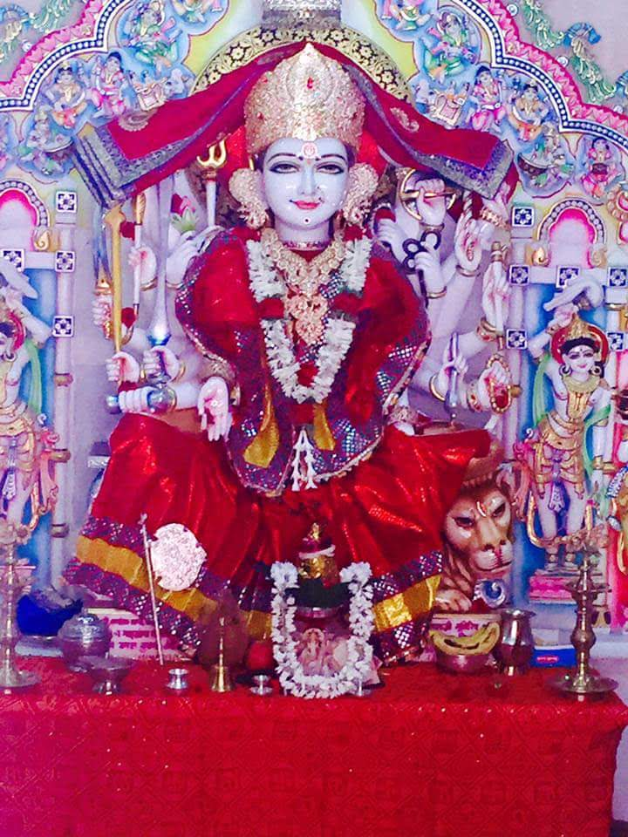
INTRODUCTION
Suswani Mata is regarded as an avatar of Parvati Mata and worshipped by Jain and Hindu community devotees.
Her main temple is located at Morkhana in Bikaner district of Rajasthan. The temple was constructed in 12th century AD. There is an ancient Shiva Temple situated nearby the main temple. She is worshipped as Kuladevi by many families in rajasthan.
The Suswani Devi temple is constructed out of marble stones and various statues of other gods are also found inside the temple premises.
Suswani Mata was born to Jain couples in 1219. She looks very beautiful. Due to her beauty, the nawab of Nagaur fell in love with her. He expressed his wish to her parents. But her parents were rejected his proposal. This made nawab to get angry with them and imprisoned her parents. Mata Suswani prayed to Lord Shiva and sought for his help.
In her dream, Lord Shiva appeared and blessed her. The next day morning, she came out from her home and started going to a shiva temple. The nawab also followed her. While nearing the temple, the earth was opened and she went inside the earth and disappeared and merged with Lord Shiva. The nawab felt ashamed for his act and returned from that place and also freed her parents from the prison.
Due to the instructions given by Mata Suswani to one of her relatives in his dream to construct a temple for her, her temple was built after her departure from the earth. It was later renovated and reconstructed and now the temple structure looks very good. Visiting her main shrine would definitely fetch good results in our life. Let us try to visit her holy temple at least once in our life time and can have the blessings of the divine mother.
TEMPLES
- Suswani Mataji temple in Nagaur,Rajasthan
- Ma Suswani Mandir in Jodhpur, Rajasthan
- Suswani Devi temple in West Bengal
- Suswani temple in Villupuram,Tamil nadu
- Suswani Mataji temple in West Bengal
- Suswani temple in Karnataka
- Suswani temple in Maharashtra
IMPORTANCE
By worshipping Mataji in her temples, would give us all the prospects in our life and we will have a bright future in our life. We can also chant her name “OM SREE SUSWANI MATAJI NAMAHA” and get her blessings. She is the divine protector of the entire universe. Our all sufferings would turn into happiness, and our various health related problems would be relieved through the greatness of the divine mother. By worshipping her with sincere faith, we would get better prospects in our life.
Let us worship the divine mother and be blessed.
“OM SREE SUSWANI MATAJI NAMAHA”
“OM NAMAH SHIVAYA”
WRITTEN BY
R.HARISHANKAR

SWARCHALA DEVI
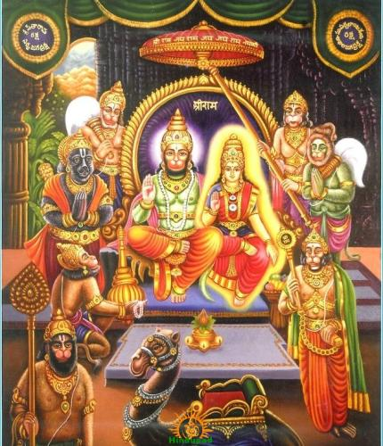
INTRODUCTION
According to ancient legends, Lord Hanuman was studied under Surya Bhagwan and he was his obedient disciple and mastered in all the divine subjects. Though he was an expert in vedas and other studies, since Lord Hanuman was a bachelor, he could not study the holy Vyakarnas for which he has to obtain the status of a married man. In order to study the vyakarnas, Surya Bhagawan had created a beautiful lady from his supreme powers, and named her as Swarchala Devi, and given all the powers to her and married her to Lord Hanuman.
Lord Surya asked him to marry his daughter Swarchala as a GURU DAKSHINA to him.
Lord Surya had given the boon to Hanuman that he would still be a Bachelor even after marriage. And his marriage is only for the welfare of the Universe and it would not affect his celibacy. Since Lord Hanuman is going to be a Brahma in the next Yuga, Swarchala would occupy the place of Goddess Saraswathi. Hanuman obeyed his Guru’s wishes and he got married to Swarchala on JYESTHA SUDDHA DASAMI.
IMPORTANCE
Being the wife of Lord Hanuman, Mata Swarchala Devi will give all prospects in our life and remove the problems from our life. Being the daughter of the Sun God, she will show us the way of spiritual path, makes our life to be brighter and helps us to live a disease free life. In general, she will protect us from obstacles and removes the thorns from our path and clears our mind, and makes us to live a peaceful and a happy life.
Let us worship Mata Swarchala Devi and be blessed.
“OM SREE SWARCHALA DEVIYE NAMAHA”
“OM SREE RAMA BHAKTA HANUMANE NAMAHA”
“OM SREE SURYA BHAGAWANE NAMAHA”
WRITTEN BY
R.HARISHANKAR

TARA DEVI
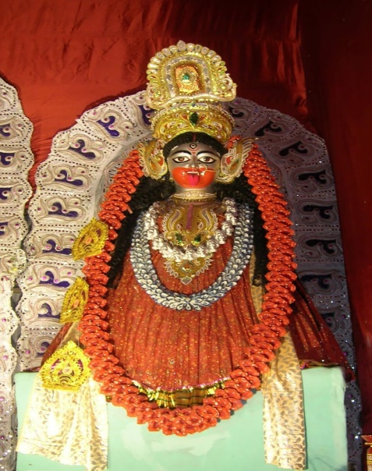
INTRODUCTION
Tara Devi is one among the Mahavidyas and she is a form of Durga Devi, and contains great powers. She is referred in the sacred text Adbhuta Ramayana, and she is also mentioned in the Buddhist texts.
According to Adbhuta Ramayana, when Kali kills a great demon, all the divine gods assembled before her and chanted her with divine songs. She was pleased by the praises of the divine gods, and she has become calm and transformed in the form of Tara Devi.
Tara had also assumed the form of Goddess Shodashi for maintaining the dharma and peace in the world. She was created for the ultimate purpose of safeguarding the innocent people from the attacks of cruel people. She always gives boldness and courage to the innocent and unhealthy devotees, and helps them to improve their physical and mental condition. By reciting her various slokas, we will get great wisdom, knowledge, braveness, strong mind and strong body. Unnecessary fear and tension will be removed from our mind, and our mind and body will be shaped in a proper manner. She was the creator of the entire nature, and helps the farmers in their farming activities and makes the crops to grow well and to get good food grains for the consumption of the people. Mata Kali and Tara are considered as one and the same.
Tara has eight forms:
- Ekajata
- Ugratara
- Mahogra
- Kameshwari
- Chamunda
- Nilasaraswati
- Vajra
- Bhadrakali
Tara shows motherly affection to her sincere devotees and gives peace and all sorts of prosperity in their life. Her famous temple is situated in west Bengal. Her ardent devotee Bama Khepa used to worship her with sincere dedication in this temple. He had got her divine appearance also. He worshipped her as his own mother, and done pujas in the temple. He lived during the period: 1837-1911.
Another famous Temple for Tara Devi is situated in Shimla. It is a famous tourist destination also. Lot of devotees from all parts of india will visit this temple, especially during Navrathri festival days. Grand puja celebration would be done in this temple for all the nine days of the festival.
IMPORTANCE
She is the divine mother parvati, who took the form of Tara Devi, in order to guide us in the proper path. Her presence will always be with us, provided if we worship her with faith and devotion in our mind. By offering flowers and fruits and reciting her slokas, she will get satisfied and makes us to live happily and peacefully without any problems in our life.
Let us chant the glory of the goddess and be blessed.
“OM SREE TARA DEVIYE NAMAHA”
“OM NAMAH SHIVAYA”
WRITTEN BY
R.HARISHANKAR

THIRUMANANCHERI TEMPLE
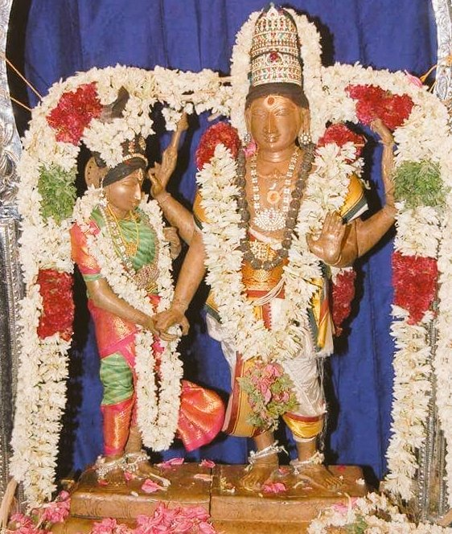
INTRODUCTION
Thirumancheri temple is famous for marriage related activities. Those who do not get married or if their marriage gets delayed due to any reason, if they visit this temple, and pray to the deities, surely they will get their marriage finished quickly due to the grace of Lord Shiva and Parvati.
According to legend, once parvati tells her wish to Lord Shiva that she wants to have a wedding with the Lord in the earth. Parvathi then left Kailasa and lived as the daughter of the great sage Sree Bharata. After some time, Sage Bharata contacted Lord Shiva to get married with Parvati.
Here the bridegroom Lord Udhvaganathar also known as Kalyanasundarar and Goddess Kokilambal got married in this place before several thousands of years.
The temple attracts large number of crowds especially on Fridays. Since Fridays are considered as an auspicious day. Unmarried males and females must visit this temple and offer flower garlands and perform pujas and abhishekhams to the god and the goddess. After their prayer gets answered, again they have to come here for thanking the divine deities.
This temple was visited by Thirugnanasambandar, Thirunavukkarasar and Sundarar and they sung in praise of Lord Shiva.
This temple is located 6 Kms from Kutthalam. Thirumanancheri is one of the important temples of Lord Shiva. This temple is constructed by Chola Queen Sembiyanmadevi.
It is a holy place where the wedding of the divine deities took place.
OTHER DEITIES IN THIS TEMPLE
- Durgai Amman
- Raghu Bhagavan
- Lord Vinayaka
- Natarajar
- Appar
- Sundarar
- Sambandar
- Manickavasagar
- Vishnu
- Lakshmi
- Bharatha Maharishi
- Saneeswarar
- Rudravaneswarar
- Rudravaneswari
Poojas and Festivals
- Daily Pooja
- Weekly Poojas
- Monthly Poojas
- Annual Poojas
During Navarathiri, Vijayadasami, Karthigai and Aruda Dharshanam, Temple Festivals takes place. Every year during Tamil month 'Chithirai' Thirukkalyanam Festival will be celebrated in a grand manner.

IMPORTANCE
By visiting this temple, and praying to the divine father and mother, definitely we will get a blessed and a good married life. If we have utmost faith and dedication on Lord Shiva and Parvati, then immediately our prayers will be answered and our life will go smoothly. Since nowadays lot of misunderstandings occurs between the couples, it is advisable for them to visit this temple and worship the deities. After praying in this temple, they will get peace of mind and ego will be removed from their mind, and they will live in a cooperative manner adjusting with each other. They will also get good children through the blessings of Lord Shiva and Shakti, and their life will be flawless and peaceful.
Let us worship the divine god and goddess and be blessed.
“OM SREE SHIVAYA NAMAHA”
“OM SREE PARVATHI ANNAIYE NAMAHA”
WRITTEN BY
R.HARISHANKAR

TRISHANKU
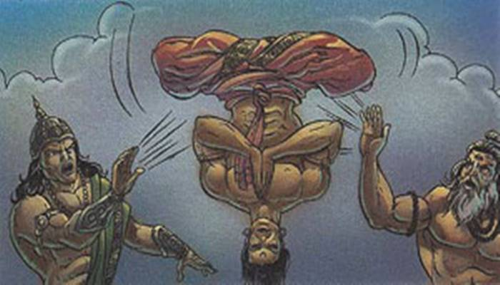
INTRODUCTION
Trishanku is a king who lived in Treta Yuga and belonged to Ishvaku dynasty. The story of Trishanku was mentioned in Ramayana. Those people, who are unable to make a decision properly, will be called as “TRISHANKU”. The great king Trishanku is still living in the heaven created by Viswamitra.
He was an ancestor of Lord Rama. After ruling properly the kingdom for several years, his father crowned his son Trishanku and made him as the king of Ayodhya and left to the forest for performing penance. Trishanku was interested in going to heaven with his physical body. He approached sage Vasishta, but he refused towards sending him to heaven with his physical body. After some time, he approached sage Viswamitra for sending him to heaven with his physical body. Viswamitra, accepted Trishanku's request and agreed to perform the necessary rites to raise Trishanku to the heavens with his physical body.
The rituals began and with the great powers of the sage, Trishanku started going to heaven. Upon his arrival in heaven, the Devas led by Indra, refused to permit Trishanku to enter, and sent him out. Trishanku began falling back to earth.
Vishwamitra become very angry and he used his powers to prevent Trishanku's fall, causing trishanku to stay in the middle of the sky.
Trishanku prayed Vishwamitra for help and this time, the great sage viswamitra started creating of a new heaven in the sky. As the new heaven was created, the sage asked Trishanku to live peacefully in the heaven. Vishwamitra declared him as the Indra of the new heaven that he had created. Due to his act, the devas were frightened and asked him to withdraw him from his act. They explained to Viswamithra that they only wished to prevent the unnatural act of someone entering heaven with his physical body.
Viswamitra accepted the request of the devas, and told to them that the new heaven shall be called as Trishanku's heaven and he shall not supersede the command of Indra, and he will reside upside down in his heaven.
IMPORTANCE
Though he lived in the new heaven in the manner of upside down, he was previously ruled his kingdom in a well-versed manner and respected his people and done many charity works. He was liked by his people, and the people were lived very happily and peacefully without any problems in their life. Since he had taken an unnatural task of entering into the heaven through his human body, he had suffered a lot and lived in the “TRISHANKU HEAVEN” in the upside down manner. But after some time, due to his son Harichandra’s noble activities, it is believed that he regained his normal position and living peacefully in his own heaven.
Let us worship the great king and be blessed.
“OM SREE TRISHANKU MAHARAJAVE NAMAHA”
“OM SREE VISWAMITRA MAHARISHIYE NAMAHA”
“JAI SREE RAM”
WRITTEN BY
R.HARISHANKAR

VIROCHANA
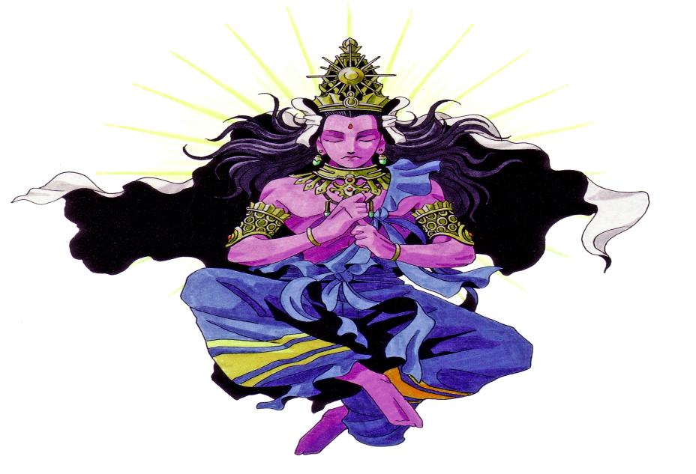
INTRODUCTION
Virochana was the noble and pious son of Bhakta Prahalad. He was also a great Vishnu devotee similar to his father. He learnt all the sacred texts at his younger age itself. Though he was born in the family of daityas, he was a humble and a good king, who took the advice of his father and ruled his kingdom in a proper manner. His teachings are very famous. And some of them are as follows:
- Believe in one god, and that is Lord Vishnu.
- Always think and worship Lord Narayana, for getting good prospects in life.
- Be generous and kind to others.
- Don’t be arrogant and adamant over others. After all we are all the slaves of Lord Narayana, and he only has got the commanding power over others.
- If necessary for the purpose of doing goodness to others, we can sacrifice our life also.
- Only by chanting the names and the glory of Lord Vishnu, we can get SALVATION after our death.
- Lord Vishnu is the one who creates, protects and destroys the entire universe.
- We should not disturb others unnecessarily.
- We should always live in the path of “DHARMA” and be righteousness throughout our life.
King Virochana’s teachings were based on the teachings of his father Bhakta Prahalad. His teachings were very popular since ancient times. Once he won Swarkalok, the divine abode of Lord Indra. But Lord Indra appeared in the form of a pious Brahmin and asked Virochana to fulfil his wish. Virochana was happily agreed without knowing the problem behind that. Lord Indra in the form of Brahmin asked his life as a boon from him. Immediately the great king Virochana severed his own head with his knife and gave his head to Lord Indra and immediately collapsed and died. He is such a great person for being born as the son of the great “BHAKTA PRAHALAD”. We cannot imagine such a human sacrifice in this today’s world.
IMPORTANCE
King Virochana was such a kind and a noble person, who lived in a good manner throughout his life. During his regime, he took care of his people in a proper manner, and opened free food centres in many parts of his region for the benefit of the travellers from other places. He also constructed resting places all over his region for the travellers. His name and fame spread across the world, and it reached heaven also. For some time, he also captured and ruled Swarka Lok. His act was disliked by Lord Indra and he killed him in a cunning manner. Though he has died several lakhs of years ago, his own human sacrifice will never be forgotten by the people in the earth and by the gods and demi gods in the heaven, and by the living beings in the entire UNIVERSE.
Let us worship the great king “VIROCHANA” and be blessed.
“OM SREE VIROCHANA MAHARAJARE NAMAHA”
“OM SREE BHAKTA PRAHALADARE NAMAHA”
“OM NAMO NARAYANAYA NAMAHA”
WRITTEN BY
R.HARISHANKAR

KADUTHA SWAMY
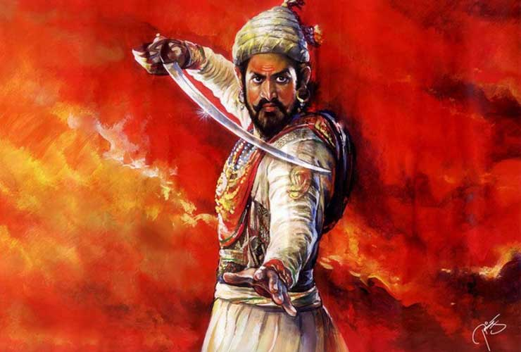
INTRODUCTION
In the Sabarimala Ayyappa temple, there is a deity of Kaduthaswamy who acts as a guardian for Lord Ayyappa and also helps the devotees to get the divine vision of Lord Ayyappa, and also protects the devotees from thieves, ill health and gives great mental strength to visit the holy temple and to worship the great god Ayyappa.
According to legend, Kadutha was a great warrior and helped the Pandalam king to defeat the enemies. When Kadutha came to the sabarimala temple, he doesn’t want to leave from that place, since he was very much attached to Ayyappa and still he is staying with Lord Ayyappa in the sabarimala temple and blessing us. He is also considered as an attendant of Lord Ayyappa.
Kaduthaswamy spent most of his time during the childhood days of Lord Ayyappa, and went along with him like a shadow and safeguarded the lord from the evil forces. He is a sincere and an obedient servant of Lord Ayyappa, who had got a great opportunity to serve the Lord himself. It is believed that due to his good deeds committed in past births, he has attained a place in the heart of Lord Ayyappa and always stays with him.
IMPORTANCE
Similar to Vavar, he was a close confidential person of Lord Ayyappa who lived before thousand years ago, and permanently settled in the shrine of the Lord. He is also worshipped similar to Vavar and Manja Mata, and by worshipping him, Lord Ayyappa will be very much pleased. He is having the capability and power to tell our problems to Lord Ayyappa and to give a remedial solution for our problems.
Hence let us worship the Great Kadutha Swamy along with Ayyappa Swamy and be blessed.
“OM SREE KADUTHA SWAMIYE NAMAHA”
“OM SREE AYYAPPA SWAMIYE NAMAHA”
“OM NAMO NARAYANAYA NAMAHA”
WRITTEN BY
R.HARISHANKAR

KRISHNANANDA AGAMAVAGISHA
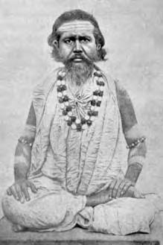
INTRODUCTION
Krishnananda Agamavagisha also called as Krishnananda Moitra was a Brahmin of Nadia, West Bengal and he was a great scholar and good in doing tantric acts, yoga and meditation. He lived during the 16th century AD. He is the author of the "Tantrasara", and also written several texts on Hinduism, yoga, bhakti and meditation.

LIFE
Krishnananda Agamavagisha was born in 1650 at west Bengal into a pious Brahmin family, and his father’s name was Acharya Mahesha. He had one brother and four sons. All the entire family members were worshippers of Lord Krishna. He will used to do puja regularly at his home, and perform abhishekhams to the god and the goddess and used to worship Kali Mata temple at his native place. He introduced the Kali Puja worship in his village, and still now the puja is performed in the kali temple of west Bengal as per his guidelines. He was also the guru of the great Kali devotee Sri Ramprasad Sen.
After doing divine service for several years in the earth, he left his body at Mallarpur, Birbhum, and reached the divine world.
TEACHINGS
- Have faith in Ma Kali. She will definitely do wonders in your life.
- Never lose hope and never feel bad about you. Have enough mental strength and courage in your mind.
- Try to read divine books regularly. By doing that, you will get peace of mind.
- Don’t be afraid of anything. Fear is the main enemy in our life, and it has to be removed from our mind.
- Nothing can be made possible without the blessings of the god.
- Show love and affection to everybody, so that you will also get the same from them.
- Chant the mantras of the god, and make it as a practice on a daily basis.
- Bhakti is the main thing to be followed in this difficult “KALI YUGA”, or otherwise we will have to face up lot of troubles in our daily life.
- Our life is fully filled up with miseries and sorrows only. We have to try to eliminate it by doing good things to others.
IMPORTANCE
He had dedicated his entire life towards doing good things to the people, worshipping the god, doing pujas and removing the sufferings of the people through his spiritual powers. He had got name and fame within a short period of time. But he lived a simple life, and given the money received as donations, to the welfare of the people. He didn’t keep anything for his own purpose. Lot of devotees were benefitted by worshipping him. He was praised by the people and by his devotees. It is believed that once he had got the holy darshan of “KALI MA”, and got her divine blessings and received great spiritual power.
Let us worship the holy saint and be blessed.
“OM SREE KRISHNANANDARE NAMAHA”
WRITTEN BY
R.HARISHANKAR
MAALIKAPURATHAMMA
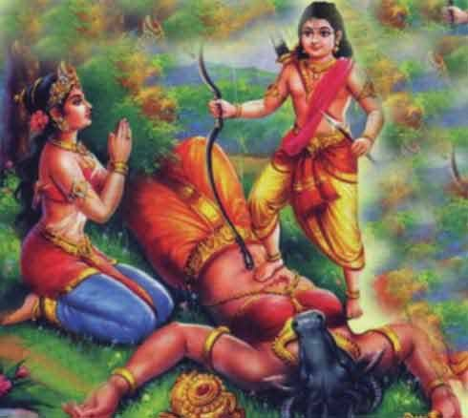
INTRODUCTION
Maalikapurathamma is the goddess who is worshipped at a shrine in Sabarimala Ayyappa Temple. It is a must for the Ayyappa devotees to worship Mata Maalikapurathamma Temple after having darshan of Sabarimala Ayyappa Temple. Malikappurathamma is also called as Mancha matha.
Maalikapurathamma is the sister of Mahishasura, and she is a buffalo-headed demoness. She was killed by Lord Ayyappa, and then she was transformed into a beautiful woman. She wanted to marry Ayyappa, but since Lord Ayyappa was a strict bachelor, instead of marrying her, he asked her to permanently reside near his temple in Sabarimala and to bless his devotees. In course of time, her temple was known as Maalikapurathamma Temple.

Malikappurathamma temple
Malikapuram Temple is situated on a small hill nearby Sabarimala. According to legend, Malikapuram temple is the place where she met Lord Ayyappa.
The temple of Amma, is also considered as sacred similar to Lord Ayyappan, and is located near to the main shrine of Lord Ayyappa. She is also believed to be an aspect of Mata Parvati, and contains her features. She is fondly called as “AMMA” and worshipped by the devotees with much love and affection on her. She shows motherly affection and provides all sorts of goodness to us and will bless us to get a permanent place in the heaven. She holds a Changu, Chakram and Abhya Mudra.
Coconuts, saffron powder, jaggery, silk clothes and turmeric powder are offered to Malikapurathamma.
IMPORTANCE
She is a divine mother who will take us to the spiritual path and make us to feel comfortable in our life. Being the Shakti aspect, she also contains the divine powers of Lord Ayyappa and whoever visits her shrine, she will kindly look at them, and shower her grace. By worshipping her, we will get courage, physical and mental strength, wisdom and peacefulness in our life.
Let us worship the holy mother and be blessed.
“OM SREE MAALIKAPURATHAMMAVE NAMAHA”
“OM SWAMIYE SARANAM AYYAPPA”
“OM NAMAH SHIVAYA”
WRITTEN BY
R.HARISHANKAR

NAVA VEERAS
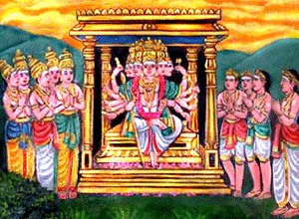
INTRODUCTION
Nava Veeras are the nine great soldiers and the brave divine attendants of Lord Muruga. They were born from Nava Shakthis, who were born out of the powers of Mata Parvati. They are also considered as an incarnation of Mata Parvati.
The sons of Navashakthis are known as Nava Veerar's. The Nava veeras are:
1. Veerabahu Thevar is the army chief of Lord Muruga and helped Muruga during his fight with Surapadhman and his brothers.
2. Veera Kesari is a courageous person and roars like a lion during the time of the war with devas and aruras, and is a great divine helper of Lord Muruga.
3. Veera Mahendra is a powerful person, who strictly obeys his master muruga’s instructions, and helped Lord Indra during his fight with the demons, and he contains powers similar to Lord Indra.
4. Veera Maheswara is a great warrior and contains the powers of Lord Shiva and Shakti and waits for his master’s instructions, and carries his task with much ease and destroys the forces of the enemies.
5. Veera Purandhara is the destroyer of the places of enemies, and gives great victory to the demi gods during their fight with the demons.
6. Veera Rakkadha is a humble servant of Lord Muruga and helped him during the battle of devas and asuras, and also protected the demi gods from the demons.
7. Veera Marthanda is another warrior and divine servant of Lord Muruga, who is capable of defeating the enemy forces within a few seconds of time.
8. Veera Anthaka is a most confidential and a loyal servant of Lord Muruga, who always used to praise the glory of the lord by chanting his various names, and will immediately follow the instructions given by Lord Muruga.
9. Veeradheera is a great warrior who had made a major contribution in the battle between muruga and surapadhma and destroyed the army forces of Surapadhma.
IMPORTANCE
By reciting the names, and studying the details of the Nava Veeras of Lord Muruga, we will get boldness, wisdom and courage and can get great mental and spiritual energy. Since they contain great divine powers, we can worship by chanting their names and our prayers will be fulfilled through their grace. They also have got the powers to pass on our prayers to Lord Muruga and to find a remedial solution for us.
Let us worship the divine army of Lord Muruga and be blessed.
“OM SREE MURUGAYA NAMAHA”
“OM SREE NAVA VEERARA NAMAHA”
“OM SREE NAVA SAKTHI ANNAIYE NAMAHA”
WRITTEN BY
R.HARISHANKAR
SAINT DURBALNATH
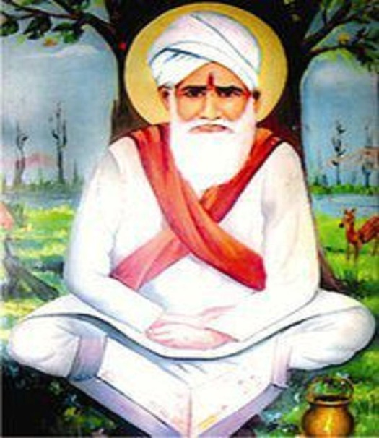
INTRODUCTION
Saint Durbalnath was a nineteenth century Hindu saint. His birth name was "Bichgaav" , and he was born in Alwar district in Rajasthan. Durbalnath ji is worshipped as a "kula guru" by the Khatik community people. He has got many temples throughout india, but the main temple is located at dausa district in Rajasthan. Every year a grand festival is celebrated on Kartik purnima at his temple.
Though he was born from a lower caste family, he was born into a pious and a noble family. His guru was Shri Garibnath Ji. He was against caste discrimination. He had studied his basic education under his guru, and he was also an expert in all kinds of art, and was interested in spirituality from his younger age. He will used to play with his friends using god’s toy idols. He will used to decorate the idols with flowers and flower garlands. He will also buy fruits and snack items from the shops and offer it as a naivedyam (HOLY PRASAD) to the idol, and distribute it among his friends with much joy and happiness in his mind. He also got the habit of chanting the names of the gods and the goddesses repeatedly and practiced it till his life time.
TEACHINGS
- Keep your surroundings and your body always clean.
- Control your senses by chanting the glory of the god.
- Respect your father and mother.
- Be polite and straight forward. Don’t argue for simple matters.
- Do some kind of social welfare activity, since it will give greater punya to your soul.
- Don’t be rude and crude with others.
- Consider your neighbours children as your own children and take care of them properly, when your neighbours are away from their home.
- Realize the god from your inner soul.
- Provide food to all the living beings in the earth, and always be kind with others.
IMPORTANCE
He was a great saint, who always thought about the welfare of others, and lived a saintly life throughout his life. Still his devotees are worshipping him, through his good nature. He had got a deep knowledge in spirituality. It is also believed that he had got the divine darshan of the gods for several times during his life time. His teachings were widely accepted by the people and they were become his sincere devotees and followers. He also solved the problems of the people through his spiritual touch and gave them strength in their mind and body. Through his divine touch, many of his devotees were relieved from their diseases and attained good physique.
Let us chant the glory of Sree Durbalnath and be blessed.
“JAI SREE DURBALNATH MAHARAJ KI JAI”
WRITTEN BY
R.HARISHANKAR
SAINT KUMARASWAMIJI
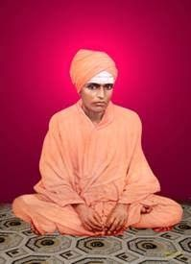
INTRODUCTION
Kumaraswamiji of Hanagal (1867– 1930) was a great saint and the founder of the “Veerashaiva Mahasabha”.
Shri Kumaraswamiji was born in a village of Haveri district, Karnataka into a pious family. His birth name was Halayya. He was a clever person, and he was interested in spiritual matters at his young age itself. He was completed devoted with god and spent his time towards going to temples and doing meditation.
He was the disciple of Siddaroodha Swamiji of Siddaroodha Math in Hubli. He learnt the divine scriptures from him, and he spent several years in doing meditation in the caves located at mysore. After some time, he returned to his native village for spreading the bhakti among the people. He died at the age of 63, and it is believed that after his death, he had attained “SALVATION” due to his good deeds which he had done throughout in his life.

SERVICES
- Establishment of annadana mandapam for providing food to the poor.
- Establishment of Shivayoga Mandira.
- Establishment of Goshala.
- Donated clothes to the poor people
- Provided shelters for the benefit of the poor people.
- Establishment centre for spiritual training and education.
- Helped in providing occupation for the poor unemployed people and the widows.
- Conducted regular spiritual classes and invoked the bhakti spirit among the people.
- Trained the people in yoga and meditation.
TEACHINGS
- Compulsorily have the habit of worshipping god and chant his names on a daily basis.
- Never hate others and never show angriness over others, such kind of activities doesn’t liked by the god.
- Always be patience in doing your work, do your work with full of concentration.
- Physical and mental strength can only be attained by doing yoga and exercise regularly.
- Don’t worry for small, small things, since you may have to face many big problems in your long phase of life.
- Don’t underestimate others, since each and every person would have some kind of speciality with them.
- Provide wholesome food to the poor people and attend to them properly with your kind words.
- Nothing is going to last in this world, expect your own good karmas. Hence always do good activities to please the divine god.
- Try to educated the under privileged children, and make them to shine in their life. Their parent’s blessings will help you to come up in your life.

IMPORTANCE
Apart from the above mentioned services, saint kumaraswamiji had also helped the people towards relieving from their diseases, mental problems and enemy related problems through his spiritual power. Everyone had liked him for his kind approach and lot of people were become his followers. He also conducted regular spiritual lectures and advised the people to follow the bhakti path towards running easily their life in this difficult period of “KALI YUGA”.
Let us worship the great saint and be blessed.
“OM SREE KUMARASWAMIJIYE NAMAHA”
“OM NAMAH SHIVAYA”
“OM ADHI PARASAKTHI THAYE NAMAHA”
WRITTEN BY
R.HARISHANKAR

SRI VAVAR SWAMY
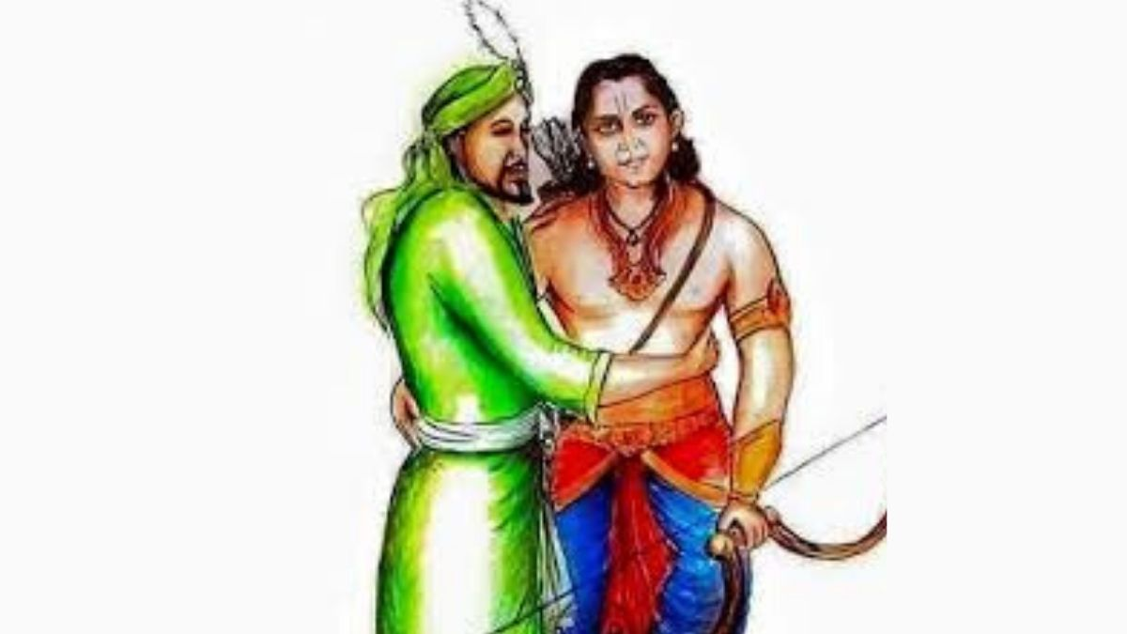
INTRODUCTION
Vavar also called as Vavaraswami is considered as a friend of Lord Ayyappa. The shrine of Sri Vavaraswami is located at Sabarimala, and his mosque is also situated at Erumely. His shrine and mosque shows us the great friendly relationship between the hindu and muslim. In this Ayyappa temple, devotees of all castes and religions are considered as equal and treated with great respect.
According to legend, Vavar was a great warrior who lived in Kerala and once he had a fierce fight with Lord Ayyappa, but he was defeated. Due to the kind words and on seeing the divine face and getting the divine touch of Lord Ayyappa, he was attracted with Ayyappa and Vavar became a friend as well as an attendant of Lord Ayyappa and helped him with regard to his personal activities. Vavar became a sincere devotee of Lord Ayyappa and he was known as Vavar swami. Still the sword which he had used for fighting with Lord Ayyappa is found in his shrine. Due to the instructions of Lord Ayyappa, Pandala King had constructed a beautiful mosque for Vavar at Erumely in Kottayam District.
In the shrine of vavar, instead of idol, a carved stone slab is worshipped as the deity of Vavar. Silk clothes are used to cover the deity. The offering made to Vavar is black pepper. A Muslim priest still performs the rituals even today at his shrine.
IMPORTANCE
Though he belonged to a different religion, in general all the religions cultivate the habit of doing good things to others and their teachings are also based on worshipping the god regularly, either in the form of an object or formless. Being the guardian and friend of Lord Ayyappa, by worshipping Sri Vavarswamy, we would get all the prosperity in our life, and reach the upper level in our career. Since, he had occupied the divine status, by worshipping him, all of our problems and sufferings will be relieved by sincerely praying to him.
Let us worship Vavar Swamy and Ayyappa Swamy and be blessed.
“OM SREE VAVAR SWAMIYE NAMAHA”
“OM SREE AYYAPPA SWAMIYE NAMAHA”
“OM SREE PANDALA MAHARAJAVE NAMAHA”
WRITTEN BY
R.HARISHANKAR

YADAVACHARYA
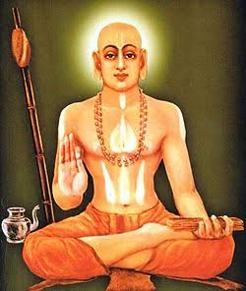
INTRODUCTION
Yadavacharya(1580-1630) was a great saint of the Dwaita Sect. He is the follower of Uttaradi Mutt and the disciple of Vedesa Bhiksu.
His birth name was Yadupati, and he was born in Kannada Brahmin family in a village at Belgaum district. His father name is Yadappayya.
WORKS
- Commentary on Tattva Samkhyana.
- Commentary on Tattvoddyota.
- Commentary on Nyayasudha.
- Commentaries on the Bhagavata.
- Commentary of Yamakabharata.
- Commentary on Sadachara Smriti.
He got good knowledge in all the subjects and was an expert in vedas, Upanishads and puranas. He was a great scholar and a master in all kinds of art. From his childhood, he has concentrated his attention only on spiritual matters, and was distinct from other children. Instead of playing with the children, he will used to chant the names of the gods, perform puja at his home, and used to visit the temple regularly. He got the divine knowledge through the grace of Mata Saraswati. It is believed that he had got the darshan of Sree Rama and Sree Krishna in his dream, and they have directed him to travel in the spiritual path.
IMPORTANCE
He showed great respect with everyone and treated everyone as equal and contains a kind approach towards others. He also spread the philosophy of Guru Madhwa throughout the region. He got the habit of doing charitable services like providing food to the poor, and provided timely help to others.
Through his great powers, he removed the difficulties of the people, and made them to breathe easily in this world. He also won in the debates, and was praised by several scholars. Similar to Guru Raghavendra, he was also a kind and a blessed person and was keen in doing service to the god and to the mankind. He was good in meditation and yoga and also took only simple food and observed fasting on certain auspicious days. His greatness cannot be described in full. He is such a good and a noble person, who got the opportunity of serving the god.
Let us worship the divine saint and be blessed.
“OM SREE YADAVACHARYARE NAMAHA”
WRITTEN BY
R.HARISHANKAR

VISHUDDHANANDA PARAMAHANSA
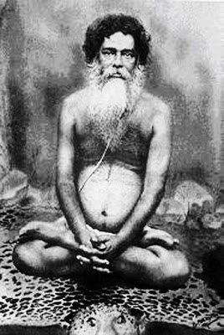
INTRODUCTION
Vishuddhananda Paramahansa (1853–1937) popularly known as Baba was a great saint. He got great yogic powers and through that, he had removed the sufferings of the people, and cured their physical and mental illness. Once he met Paramhansa Yogananda, and discussed about spiritual matters with him. His birth name was Bholanath Chattopadhaya.
LIFE
He was born in the year 1853 in a village in Bardhaman district in West Bengal. He was a great Saint and contains great devotional qualities. He learnt the basic education under his guru and he never disobeyed his Guru's instruction. He started a spiritual training school in Tibet, and taught the importance of worshipping the god, the divine scriptures along with yoga and meditation. He was also a sakthi devotee, and got spiritual powers by worshipping her. He was not interested in living a normal life. His aim is to achieve the glory of the god, by doing meditation and doing good things to the people. He dedicated his entire life on devoting the god. He died during the year 1937 and attained SALVATION.
TEACHINGS
- Do your daily worship and pray for the wellness of the entire universe.
- Put your burdens on to the feet of the god, he will take care of you.
- Spirituality is a must to reach the top stage in the life.
- Give respect to your elders, teachers, parents and everybody, and always have a smile on your face.
- Don’t be arrogant and harsh over others. Show your kindness even to your enemies.
- Don’t get tensed and don’t lose patience. Troubles and sufferings are common to each and every person depending on their own karma.
- Try to learn more good things in your life, and teach it to others also.
- Believe that god is dwelling within you, and realize the inner spirituality in your soul.
- Pray to the god and beg him to save from the difficulties and problems which everybody is facing in this “KALIYUGA”, and ask him to show the path of heaven.
IMPORTANCE
Through his kind approach, lot of people were regularly used to attend his lectures and got benefitted from that. He filled up spiritual energy in the mind and in the body of his devotees, and made them to do good activities in their life. He also asked the devotees to chant the “RAMA MANTRA” on a regular basis in order to attain “SALVATION”, after our death. Most of the devotees were followed his instructions and become his sincere disciples.
Let us worship the great saint and be blessed.
“OM SREE VISHUDDHANANDA PARAMAHANSA MAHARAJ KI JAI”
WRITTEN BY
R.HARISHANKAR
BHAGAT DHANNA
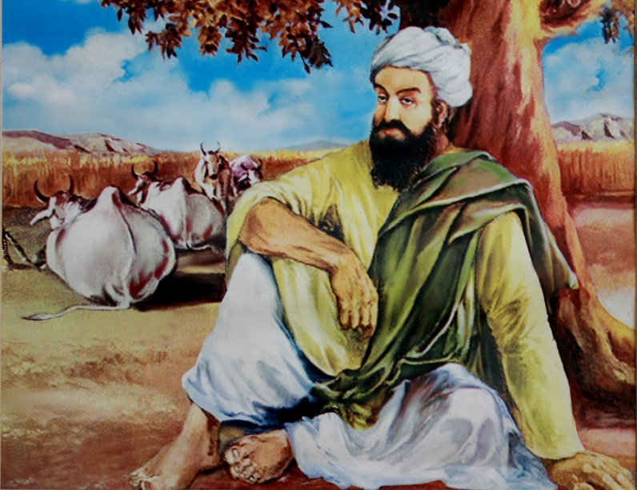
INTRODUCTION
Dhanna Bhagat was born in the year 1415 and he was a great poet and a Krishna devotee who will used to compose beautiful songs and sing in praise of Lord Krishna.
LIFE
He was born in the village in the Tonk district of Rajasthan in a hindu family.
He was the founder of the Krishna Swami Samaj in the state of rajasthan and spread the bhakti spirit on Lord Krishna throughout the region. Through his great bhakti, he got spiritual powers. It is believed that once he got the divine darshan of Lord Krishna and Mata Rukmani and was blessed by them.
There are lot of interesting stories about the divine powers of Dhanna Bhagat. Once he served food to hundreds of saints using only a small quantity of rice. Through his great powers, the food grains started increasing enough to feed the 100 saints. He also converted the vegetables into precious stones and distributed it to the poor people. He cured the leprosy of a person, and changed him into a healthier person. Though he contains great power, he didn’t get pride, and used his powers only for doing useful service to the people.
He also helped in renovating and repairing the ancient hindu temples, and made proper arrangements for conducting regular puja activities. Throughout his life, he provided a dedicated service to the people and to the divine god.
In 1974, a Punjabi movie was produced in honour of him. The film was named as “Bhagat Dhanna Jatt”, and Sri Dara Singh Ji, was acted in the lead role.

IMPORTANCE
He was a kind and a noble man, who lived a simple life and was a cowherd by occupation. He will used to give his cow’s milk to the temples for doing abhiskhekham to the deities. He also removed the diseases and sufferings of the people through his spiritual power. He was praised by the common people and by the kings for his great powers.
Let us worship the great saint and be blessed.
“OM SREE BHAGAT DHANNA NAMAHA”
“JAI KRISHNA”
WRITTEN BY
R.HARISHANKAR

GANAPATHY MUNI
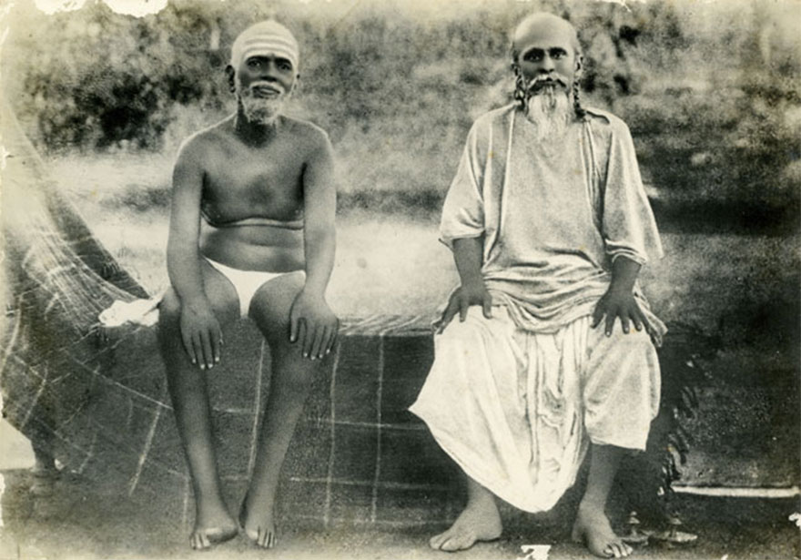
INTRODUCTION
Ganapati Muni (1878–1936), was a disciple and devotee of Sri Ramana Maharshi. His birth name was Ganapathi Sastry.
Ganapati Muni was born in a village in Andhra Pradesh in the year 1878. He had studied well and learned the basic education along with the divine scriptures like Vedas, Upanishads and Puranas. At his teenage, he was very much interested in spirituality and left his home and went on pilgrimage to holy places like dwaraka, puri and rameswaram and performed severe meditation on god. At Varanasi, he well studied sanskrit language and got the title 'Kavyakantha'. From then onwards, he is also known as “KAVYAKANTHA GANAPATHI SASTRI”. He went to many places and reached Tiruvannamalai in the year 1903 to worship Lord Shiva and Parvati in the Arunachaleswarar temple and performed meditation on the girivalam path. He met Ramana Maharshi, and got his blessings and accepted him as his spiritual guru. After staying there for several years, he got a teacher job in Vellore in the year 1904. His wrote a divine text "Uma Sahasram," which contains the greatness of Mata Parvati. He also wrote another text “MAHAVIDYADI SUTRAS”. He also met Sri Aurobindo in the year 1928. And he left his physical body at Kharagpur in the year 1936.
IMPORTANCE
Similar to Bhagavan Ramana Maharishi, he also got great spiritual powers through his severe meditation on Lord Shiva. He also helped the devotees by invoking them in the bhakti path, and held various religious discourses and taught the importance of worshipping the god, and also guided them in solving their problems and asked them to chant the names of Lord Shiva, in order to get relieved from the problems.
Let us worship Sri Ganapathi Muni and be blessed.
“OM SREE GANAPATHI MUNIYE NAMAHA”
“OM SREE RAMANA MAHARISHIYE NAMAHA”
“OM NAMAH SHIVAYA”
WRITTEN BY
R.HARISHANKAR

VETHATHIRI MAHARISHI
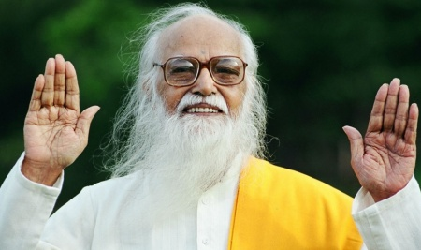
INTRODUCTION
Shri Vethathiri Maharishi (1911–2006) was specialised in different fields like spirituality, science and Ayurveda. He was also the founder of the World Community Service Center. His Theory of Universal Magnetism provides a clue towards knowing about the concepts of the evolution of atoms. He provided several methods for World Peace. He presented a blueprint at United Nations for World Peace.
He founded lot of yoga centres and meditation centres throughout the world and wrote several books on yoga. He also taught yoga to several people, including foreigners.
LIFE
Shri Vethathiri Maharishi was born in 1911 in Guduvancheri, into a weaver’s family. He established several business houses. He got enlightenment at the age of thirty-five. After some time he closed his business ventures and devoted himself fully to spiritual service. However, he remained as a householder. He also visited several foreign countries for spreading the spirituality across the world. He also treated several patients through his ayurvedic medicines and they were got relieved from their various health related problems.
Shri Vethathiri Maharishi wrote lot of philosophical poems. He had written more than 75 books and done the service till his death. Vethathiri Maharishi died in the year 2006 in Coimbatore.
TEACHINGS
- God is love. Hence love all the livings beings in the earth, including the tiny insects.
- Have faith in god and worship him regularly.
- Do yoga and meditation as a daily practice.
- Study well at your younger age, then there is no need to worry about you at your older age.
- Develop reading habit. Start learning the religious texts at your younger age itself. That will help you to overcome many hurdles in your life.
- Live a disciplined and an honest life.
- Respect your parents and everybody in the world.
- Don’t show too much affection on others. Instead of that, show your affection on god.
- Help others by giving proper food and making the necessary facilities for them.
IMPORTANCE
Sri Vedatri Maharishi was a great man, who had dedicated his life for upbringing the society. He had also done lot of social welfare activities. He got interest in spirituality, and worshipped the god on a regular basis. He wrote several useful books which are beneficial to the mankind in this today’s world. Though now he is not alive, his name and fame will never diminish, and it will remain forever.
Let us praise the great man and be blessed.
“OM SREE VETHATHIRI MAHARISHIYE NAMAHA”
WRITTEN BY
R.HARISHANKAR
BRAHMANANDA SARASWATI
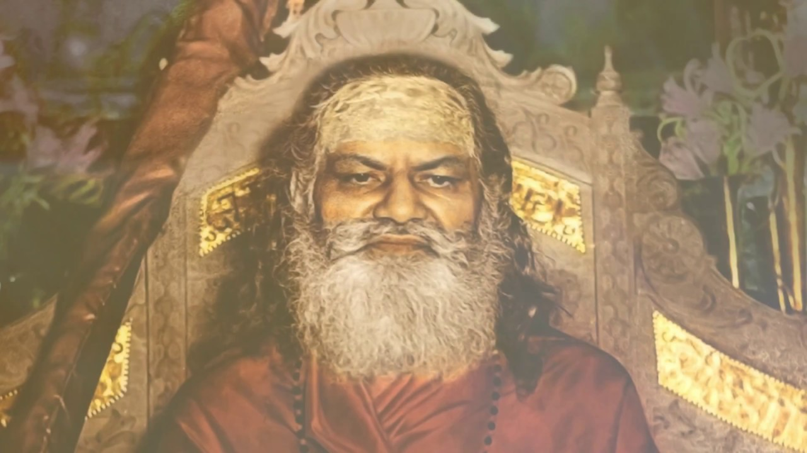
INTRODUCTION
Swami Brahmananda Saraswati (1868–1953) was the Pontiff of the Jyotir Math in India. His birth name was Rajaram. He was born into a Brahmin family, and he left home at his younger age towards interest in spirituality. After some time, he became a disciple of Svami Krishnananda Sarasvati. He has become a holy saint and the Chief of the Jyotir Math in 1941. He was called as Maha Yogi Raj and as Guru Dev by his disciples and devotees.
Some of his disciples were
1. Swami Shantanand Saraswati.
2. Maharishi Mahesh Yogi.
3. Svami Swarupananda Sarasvati.
4. Swami Karpatri.
He made Swami Shantanand as his successor before his death in the year 1953.
LIFE
He was born into a priest community in the village near Ayodhya in Uttar Pradesh. He was interested in spirituality and his family guru has also suggested his parents to allow him to the spiritual journey, since he was a blessed divine child. He went to the Holy Himalayas and Haridwar and Rishikesh. After some time he met Svami Krishnananda Sarasvati. And he was given the name of Brahma Chaitanya Brahmacari by his guru. And with his guru’s permission, he temporarily stayed in a cave and began his meditation, and after some time he joined his guru with his ashram, and started doing spiritual activities.
He constructed a building for Jyotir Math. He spent most of his time as a pious saint and travelled throughout india, for spreading the spiritualism among the people.
TEACHINGS
- Try to love others and think every-one as your friend, then there will be no enemy for you.
- Cultivate the bhakti spirit and pass it on to others.
- God is the main master for you and you are his servant, give proper respect to your master, since we are all the slaves and servants of the god.
- Behave with others in a pleasing manner, and have an attitude of showing kindness with others.
- Don’t feel yourself as insecure. God is the best security for you. He will guide you, protect you and teaches the right things to you.
- Control your thoughts by doing yoga and meditation, and by going to temples and worshipping the gods and the goddesses. Or otherwise, bad and unwanted thoughts will easily enter into your mind, and your life will get spoiled.
- Don’t worry about past things in your life. Think about the present and the future life only.
- Try to do charitable activities like providing food and giving necessary things to the poor people, and also educate the poor children and help in the marriage of the poor girls.
- Respect the aged people and give respect to your parents. Don’t leave them alone, and take care of them properly.
IMPORTANCE
Through his efficient teachings, more and more people were got attracted and become his followers. He also removed the problems in the life of his devotees and made them to reach the spiritual path. Throughout his life, he had concentrated his attention only on doing good things to others. He also removed the physical and mental diseases of his devotees through his spiritual powers.
Let us worship the great saint and be blessed.
“OM SREE BRAHMANANDA SARASWATIYE NAMAHA”
WRITTEN BY
R.HARISHANKAR

