BHAVAJI
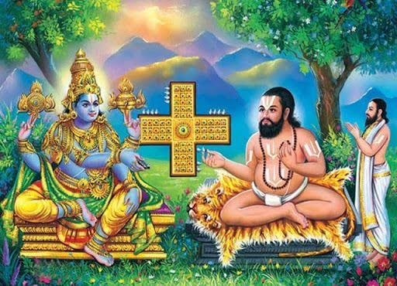
INTRODUCTION
Hathiram Bhavaji (15th century) was a saint of North India, and also an ardent devotee of Lord Rama and Lord Venkateswara, also called as Lord Balaji.
LIFE
Hathiram was born in Himachal Pradesh, North India. At his younger age, his family shifted to a village at Punjab. And after some time, he visited Tirumala, and after getting attracted by the beauty of Lord Venkateswara, he constructed an ashram nearby the temple, and stayed there permanently.
IMPORTANCE
It is believed that he had got the opportunity to play dice game with Lord Balaji. One day, after playing the dice game with him, Lord Balaji left one of his ornaments in Bhavaji's ashram.
Since one of the ornaments of the deity of Lord Venkateswara was missing, he was caught and house arrested by the temple guards presuming him to be the thief.
The king had ordered bavaji to eat a bunch of sugarcane within a day in order to test him, and also ordered his guards to watch him properly. At that night, when everybody was sleeping, an elephant appeared in bhavaji’s ashram, and ate the bunch of sugarcane completely and disappeared.
After knowing about that incident, the king was astonished and realized the true bhakti of Bhavaji on Lord, since the Lord Himself had appeared as an elephant to safe guard his devotee. And then the king asked bhavaji to forgive him.
There is a mutt in dedication of Sri Hathiramji, which is known as Hathiramji Mutt at Tirumala.
He was a great saint, who was a sincere devotee of Venkateswara, and worshipped him by keeping him in his heart.
Due to his great bhakti, Lord Balaji himself appeared and spent his time with him.
He was a pious saint, who lived with the pure thoughts on Lord Balaji, and lived peacefully.
Though he was a poor man, the god accepts his bhakti and wilfully appeared before him. From this incident, we can know that the Lord is not seeing our wealth position and blessing us, he considers only our pure bhakti, and nothing more else.
Even if we offer some flowers or basil leaves (Tulsi), he will readily accepts it and offer his blessings on us. But we should sincerely have faith with him and put our burdens on his shoulders, and worships him properly. Rest of the things will be taken care of by him.
Let us worship the great saint Bhavaji and be blessed.
“OM SREE BHAVAJIYE NAMAHA”
“OM SREE VENKATESWARAYA NAMAHA”
WRITTEN BY
R.HARISHANKAR

MAHARISHI UPAMANYU
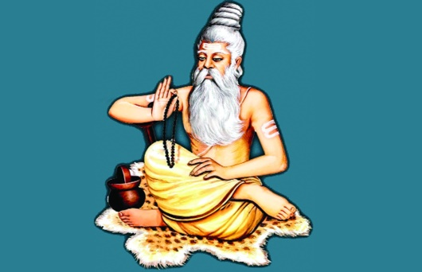
INTRODUCTION
The life of the great sage Upamanyu was told by Vaayudeva in Shiva Maha Purana.
Upamanyu was a devotee of Lord Shiva, and made severe penance and obtained Ksheera ramalingeswara in his childhood.
LIFE
Upamanyu is the son of Ugradanta and was very poor and instead of giving him milk, his mother used to give the child, powder mixed with water. Upamanya after going to his uncle’s house and drank the cow’s milk, he insisted his mother to give him the same.
His mother has asked him to do penance on Lord Shiva and to get fulfilled his wishes.

She described the greatness of Shiva mantra and blessed her child and taught him the great Shiva panchakshari - Na Ma Shi Va Ya.Then upamanyu went to himalayas and built a small temple and worshipped Lord Shiva in the form of Paardhiva linga(Shiva linga made of mud).

By pleased with the severe penance of Upamanyu, Lord Shiva showed himself as Ksheeraramalingeswara, and showed the child the ocean of milk, ocean of ghee, Sea of immortality and also tasty food.
Upamanyu was very happy on seeing his Lord Shiva and Paarvathi, and worshipped them with happiness.Then Lord shiva assigned him with the leadership to all of his shivaganas. Goddess Parvathi blessed him with a boon of being young throughout his life. Lord Shiva blessed the child with immortality.
Upamanyu has asked Lord Shiva to stay with him and to protect him throughout his life.
Lord Shiva was very happy and he stayed there as Ksheeraramalingeswara with Parvathi, and this place is called Ksheerapuri and now known as Palakollu.
IMPORTANCE
Upamanyu is still answering to the prayers of his devotees. Even after getting immortality, he is still doing penance, for the benefit of this world. He is protecting us from evil forces, through his spiritual powers. His greatness cannot be explained in full. He is such a noble and kind hearted sage.
CONCLUSION
Upamanyu Maharishi is still doing meditation and prayers for the sake of the people, and especially for those who are suffering from severe problems in this Kali Yuga in this earth. He is such a kind and humble sage, and who was always thinking about doing good to the people, and to make them to live happily. Let us pray to the great Maharishi ‘UPAMANYU’ and get fulfilled our needs and desires.
‘OM SHREE MAHARISHI UPAMANYUVE NAMAHE’
‘OM NAMA SHIVAYA’
‘OM SAKTHI PARASAKTHI’
WRITTEN BY
R.HARISHANKAR
MEERA BAI
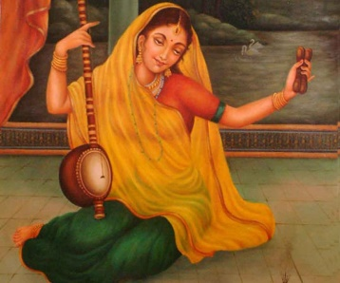
INTRODUCTION
Meera, also known as Meera Bai or Mirabai (1498–1547) was a great poet and an ardent devotee of Lord Krishna.
LIFE
Meera was born into a Rajput royal family in Rajasthan, India. Most legends mention her devotion to Lord Krishna, and she was hated by her in-laws for her religious devotion.
Though Meera bai has written lot of poems in praise of Lord Krishna, only few of her poems were preserved. These poems are commonly known as bhajans.
According to ancient records, it is known that Meera unwillingly married Bhoj Raj, the crown prince of Mewar, in 1516. Her husband was died in 1521.
Due to the dislike of her bhakti with Lord Krishna, her in-laws tried to kill her several times by poisoning, but she was not harmed due to the grace of Lord Krishna.
Mira Bai left the kingdom of Mewar, and went on pilgrimages. In her last years, Meera lived in Dwarka or Vrindavan, where legends state she miraculously disappeared by merging into an idol of Krishna in 1547.
WRITINGS
Most of Meera's poems are dedicated to Lord Krishna. A number of compositions by Meera Bai continue to be sung even today, mostly as bhajans. She was very much remembered by the people for her pure bhakti on Lord Krishna.
CONCLUSION
Meera bai, was the one, who was harmed by many people, due to her sincere devotion on Lord Krishna. But she was not injured by that. Her Bhakti is equivalent to that of bhakti of Sri Bhakta Prahalada, Dhuruva and Markandeya. If we develop bhakti on god like her, we can also merge with god, and attain the eternal bliss, and can escape from the birth cycle. In this kali yuga, devotion to god is the only way to escape ourselves from the problems, which we are facing in our every day life. NAMA japam is the most important thing and it has to be done routinely. With that, we can find many good changes in our life, like relief from sickness, attaining good health and wealth, and all the prosperities in our life. Let us chant the holy name of the great Saint Meera Bai and Lord Krishna and be blessed and live happily for ever.
“OM SREE BHAKTA MEERAVE NAMAHA”
“JAI KRISHNA,JAI GOVINDA,JAI GOPALA, MURARI”
WRITTEN BY
R.HARISHANKAR

Sree Bhakta Prahalada Mahathmiyam

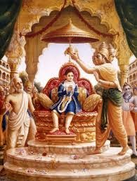
Bhatha Prahalada, was the son of Demon King Hiranyakashibu. Lord Narasimha killed Hiranyakashibu and made Prahalada as the king of the region. Bhakta Prahalada was an ardent devotee of Lord Hari. He has preached the greatness of Lord Hari along with his fellow students. He has lived a life with much holiness, pure bhakti and kindness among his people.
During his regime, he has daily offered Annadanam to more than 1000 people. He is the Avatar of Divine Personality – Sangukarna Devar. Sangukarna Devar was serving Lord Brahma in Satyalok during Krita Yoga. Once due to his mistake, he was cursed by Lord Brahma and took the avatar as Bhakt Prahalad. His next avatars are Pahlika Raja, Vyasa Raja and Guru Raghavendra Swamy.
It can be seen in Raghavendra Mutts, that the Urchava Vigraham is Prahaladar. Bhakta Prahalada was praised by Divine gods like Indra ,for the efficient handling of his kingdom.
OM SREE BHAKTA PRAHALADAYA NAMAHA.
OM SREE NARASIMHAYA NAMAHA
WRITTEN BY
R.HARISHANKAR

Sree Bhakta Dhuruva Mahathmiyam
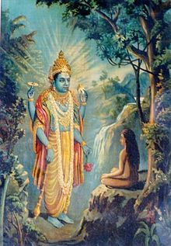
Dhuruva was born to the king Uthanapadha. He was the son of his first wife. The king Uthanapadha was very much attracted to his second wife and was not shown much interest with Dhuruva. Depressed by this unfavourable act, Dhuruva went to the forest and meditated Lord Hari. After several years, Lord Hari appeared and granted him a boon to become a GREAT STAR – DHURUVA.
Dhuruva then went to his palace and being received by his father and mother with much joy and he was crowned after his father. After completing his good goden rule, he attained the Star Position. Even now we can see one Bright star shining in the sky. That is Bhakt Dhuruva.
Dhuruva due to his bhati, has attained the position of the Star. He will not be conquered by any one. Even in Maha Pralayam, there will be no disturbance for him and he will be shining in the sky for ever. He is fulfilling the wishes of his devotees even now.
OM BHAKTA DHURUVAYA NAMAHA
OM NAMO NARAYANAYA NAMAHA
WRITTEN BY
R.HARISHANKAR

Sree Markandeya Maharishi Mahathmiyam
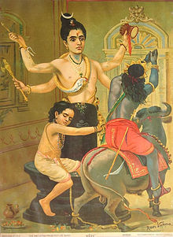
Sage Mirukandu has no child and performed severe penance for several years. Lord Shiva granted him the boon and then Markandeya was born. He was supposed to live only upto the age of 16. After knowing this, young Markandeya left his parents and went to the forest and created a shivalingam on soil on his own and performed deep meditation on Lord Shiva.
After his time in the earth is over, Lord Yama approached him and tried to put the rope on his neck but suddenly it was strucked with Shivalingam. Lord Shiva angrily emerged from the Shivalingam and burnt Lord Yama into ashes. Due to the prayers of divine gods, he gave the life for lord yama. And Lord Shiva granted Markandeya the boon for becoming Chiranjeevi – Always 16 and there is no end for his life. He always remain constant. Such a pure Bhakti he observed.
Markandeya returned to his place and narrated the detail to his parents. His parents were very happy and worshipped lord shiva for returning their child’s life.
Even today, Markandeya Maharishi is alive and fulfils the wishes of his devotees.
OM SREE MARKANDEYA MAHARISHIYE NAMAHA
OM NAMAH SHIVAYA
WRITTEN BY
R.HARISHANKAR

SHABARI
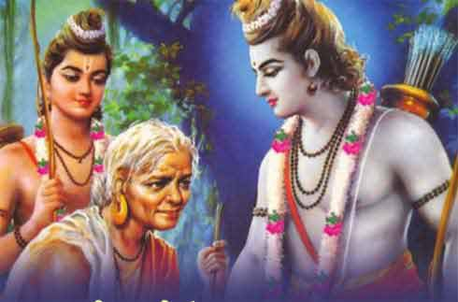
INTRODUCTION
Shabari is an old woman saint mentioned in Ramayana. She was an ardent devotee of Lord Rama and received his blessings.
LIFE
Shabari lived in a remote village. She was very spiritual even at his younger age, and lived an honest and noble life.
In course of time, she met Sage Matanga near the Mountain Rishyamukha and served him as a disciple with much attention and care. Pleased by her service,Matanga asked her to wait for getting Lord Rama’s darshan.
She patiently waited at her ashram for getting the darshan of Lord Rama.
One day, according to her wish, Rama went to Shabari's ashram and tasted the fruits which she kindly gave it to him, and blessed her.

IMPORTANCE
The place where Rama had given darshan to her was known as “SABARI MALAI”, where Lord Ayyappa’s famous temple is situated.
It is also believed that several lakhs of years before, Lord Ayyappa in the form of “DHARMA SASTHA” was done meditation in this place.
It is also believed that Shabari had the darshan of Dharma Sastha also.
She was a very pious and noble lady who walked in the path of dharma and spent her time by chanting god’s names and doing meditation.
She spent all the time in chanting Rama mantra, and finally got his darshan. She never expected anything from him, but only accepted his blessings as the boon.
Throughout her life, she lived a saintly life, and had simple food, and always concentrated her attention on god.
Through her great devotion on Lord Rama, after her death, she attained the divine abode of Lord Vishnu, “THE VAIKUNDA”.
Let us worship her and be blessed.
“OM SREE SHABARI ANNAIYE NAMAHA”
“JAI SREE RAM”
WRITTEN BY
R.HARISHANKAR

