ABIRAMI PATTAR
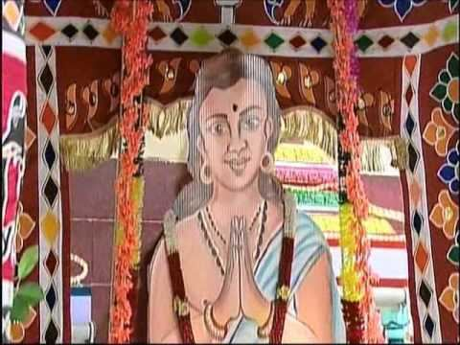
INTRODUCTION
Abirami Pattar was a 18th century Hindu saint from Tamil Nadu. His birth name was Subramaniya Iyer. He is the author of Abhirami Anthadhi.
LIFE
Subramaniya Iyer was born in the village of Thirukadaiyur. Amritaghateswarar-Abirami Temple is situated at Thirukkadaiyur. Subramaniya Iyer was a staunch devotee of goddess Abirami from his childhood days.
IMPORTANCE
Once, the King of that place visited the Amritaghateswarar temple, and he approached Subramaniya Iyer, who was the priest of that temple, and asked him whether that day was amavasya or pournami. Actually that day was Amavasya, but due to the great devotion on the goddess, Subramaniya Iyer could not see anything before him, but only the vision of the goddess was appearing before his eyes, and he wrongly answered that day was pournami. The king has given the time till night, and warned him, that he will kill him, if the full moon did not appear on the sky in the night.
Subramaniya Iyer has written 79 hymns in praise of Goddess Abhirami, and goddess manifested before him, and threw her earring over the sky, and it was shining in the sky. Subramaniya Iyer with much joy, has composed 21 more verses in praise of the Goddess.
The king realized his mistake and immediately revoked his punishment, and also granted the title of “Abirami Pattar” to Subramaniya Iyer.
CONCLUSION
He developed a great devotion to goddess Abirami by meditating in the temple, and singing her praises. We should also develop the same bhakti similar to that of Abirami pattar, and invoke it to other devotees also. Through his great bhakti, he has changed the uncertain into certain. This has happened because of his unselfish bhakti on the goddess. Let us learn from him, the essence of bhakti he has applied to the goddess, and we also have to cultivate ourselves, the habit of going to temples frequently, and worship the gods and the goddesses. We should do the worship as a regular exercise. If once our wishes are fulfilled, we should not forget about god, and after then, we should apply more bhakti and faith on god.
Let us pray to the great Abirami Pattar and to goddess Abirami for our life and be blessed.
“OM SREE ABIRAMI PATTARE NAMAHA”
“OM SREE ABIRAMI THAYE NAMAHA”
WRITTEN BY
R.HARISHANKAR

APPAIYA DIKSHITAR
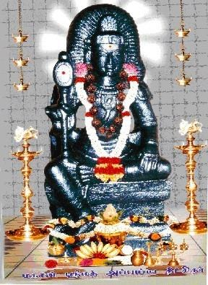
INTRODUCTION
Appayya Dikshitar(1520–1593),was a great devotee of Lord Shiva, and he performed several yajnas for the welfare of the people, and cultivated the devotion of Lord Shiva among the people. His birth name was Vinayaka Subramanian.

LIFE
Appayya Dikshitar was born in a village in Tiruvannamalai district. Appayya studied the Vedas, Upanishads and the Hindu scriptures under his Guru, Rama Kavi. He was an expert in vedas, and was a learned scholar and a master in all kinds of art.
Dikshitar travelled throughout the country, and won in several debates with learned scholars. He was patronized by the kings of Vellore, Tanjore and Vijayanagara. He established Shaivism all over the country.
IMPORTANCE
Dikshitar was very good in yoga. He taught the yoga concepts among his followers. His works were based mainly on Vedanta, Shiva Advaita and devotional poetry.
He has cured the diseases of the people through his divine power, and he was good in meditation. He preached the philosophies of Shaiva Siddantha and that was widely accepted by the people. He tried his level best to reach the bhakti spirit of Lord Shiva among the masses. He never afraid of anything and constantly worships and meditates on Lord Shiva. Through his preaching on Lord Shiva, many people have got the knowledge about shaivism and followed it with full interest. He was a soft spoken and a humble scholar, who treats all the people as equal.
CONCLUSION
Appaiya Dikshitar has miraculously saved many people from their problems, and removed their sins through his great power. He has taken birth in this earth for spreading the devotion of Lord Shiva among the masses, and for taking care of the people in a proper manner, and to move them to the right path. Let us worship this great saint and be blessed.
“OM SREE APPAYYA DIKSHITARE NAMAHA”
“OM NAMAH SHIVAYA”
WRITTEN BY
R.HARISHANKAR

ARAVINDAR
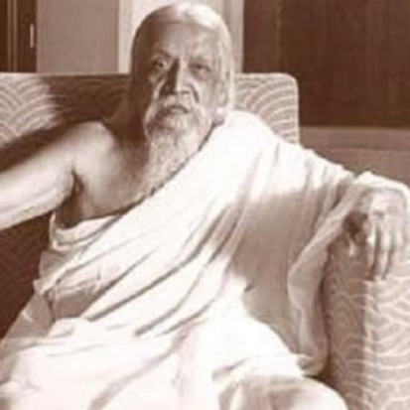
INTRODUCTION
Sri Aravindar (1872 –1950) also called as Aurobindo, was an Indian Yogi. He was a spiritual reformer, mainly focussing his attention towards human progress and spiritual evolution.
Education
Aurobindo studied at Cambridge, England. He was convicted and imprisoned for writing articles against British rule in India.
During his stay in Pondicherry, He believed in spiritual realisation. In 1926, with "Divine Mother",Mira he founded the Sri Aurobindo Ashram.

LIFE
Aurobindo Ghose was born in Calcutta in a Bengali Kayastha family.
Young Aurobindo was brought up speaking english, since his father believed British culture to be superior.
In Baroda, Aurobindo joined the state service in 1893.
He started taking an active interest in the politics, and participated in india’s independence activity movement. He established contact with Lokmanya Tilak and Sister Nivedita.

Spirituality
In Pondicherry, Sri Aurobindo dedicated himself to Spirituality. His publications were as follows:-
1.The Life Divine,
2.The Synthesis of Yoga,
3.Essays on The Gita,
4.The Secret of The Veda,
5.Hymns to the Mystic Fire,
6.The Upanishads,
7.The Renaissance in India, War and Self-determination,
8.The Human Cycle,
9.The Ideal of Human Unity and
10.The Future Poetry
He started the Sri Aurobindo Ashram in 1926.
Annai Mirra and Aravindar
Sri Aurobindo's close spiritual collaborator, Mirra, who was also fondly known as ‘The Mother’ by her devotees. She was a French national, and she went to Pondicherry and settled there in 1920. Sri Aurobindo considered her as his spiritual successor. When Aurobindo died in 1950, she took charge of the ashram, and continued the spiritual work. Even now, lot of people are worshipping her as their own god, and offering flowers to her, and distributing chocolates and sweets to devotees as prasadam.
Death
Sri Aurobindo died on 5 December 1950. Lot of people attended his funeral to see his body. Several political leaders praised him for his contribution to Yoga, and for the independence movement. National and international newspapers commemorated his death.
CONCLUSION
Sri Aurobindo, who was a great freedom fighter and a spiritual reformer, was a great noble man who has done only good things in his life. He never felt disappointed for any activity. He was firm in taking decisions, and he will take only right decisions in his life. He was very much attached to Swami Vivekananda, and through his grace, he life has turned him to lead a spiritual life. Let us Pray to the Great Aurobindo for our well being and for the well being of the nation and be blessed.
“OM SREE ARAVINDARE NAMAHA”
“OM ANNAI MIRRAVE NAMAHA”
WRITTEN BY
R.HARISHANKAR

ARUNAGIRINATHAR
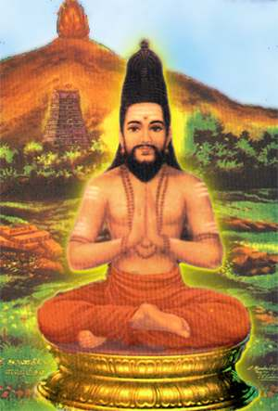
INTRODUCTION
Arunagirinathar was a great saint, a staunch devotee of Muruga, and a divine poet, who lived during the 15th century in Tamil Nadu. His important spiritual writing was the tamil poem Thiruppugazh, which was written in praise of Lord Murugan.
In Thiruppugazh, his devotion to Lord Muruga has been shown meticulously.
Thiruppugazh is one of the great devotional works of ancient literature, which was widely read by the tamil loving people, and by the devotees of Lord Muruga. It is a general saying that, those who sing Thiruppugazh, their mouth will become sweet. It means “WE CAN FEEL A VERY GOOD DIVINE SENSE WHILE SINGING THIRUPPUGAZH”.
LIFE
Arunagiri was born during the 15th century in Thiruvannamalai, Tamil Nadu. After his father’s death, he was brought up by his mother and sister. According to legends, Arunagiri was attracted to the wordly pleasures, and after some time he realized his mistakes, and decided to end up his life in the Vallala Maharaja Gopuram located at the Annamalaiyar Temple,Thiruvannamalai. But Lord Murugan appeared before him and prevented him from committing suicide, and showed him the spiritual path, and invoked him to create devotional songs for the benefit of the people. He was also known as Gopurathilayanar, since he was saved by Lord Muruga from the Vallala Maharaja Gopuram.
Spiritual Compositions By Arunagirinathar
1.Thiruppugazh
2.Thiruvaguppu
3.Kandar Alangaram
4.Kandar Anubhuti
5.Kandar Andhaadhi
6.Vel Viruttham
7.Mayil Viruttham
8.Seval Viruttham
9.Thiru Elukutrirukkai
CONCLUSION
Arunagirinathar was a great saint and an exceptional devotee of Lord Muruga. His devotion and dedication to Lord Muruga cannot be explained fully. He was such an ardent devotee of Lord Muruga. He is still residing in the hearts of Murugan devotees, and is guiding them in a proper manner. Let us worship Sri Arunagirinathar, and receive his blessings, as well as the blessings of Lord Muruga, and live happily for ever.
“OM SREE ARUNAGIRINATHARE NAMAHA”
“OM MURUGA”,”VEL MURUGA”, “VADIVEL MURUGA”
WRITTEN BY
R.HARISHANKAR

AVVAIYAR
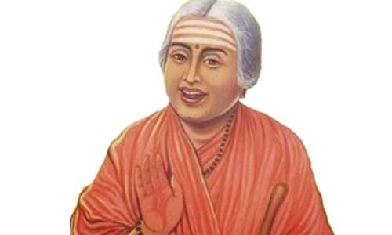
INTRODUCTION
Avvaiyar lived during the 3rd century BC, and is said to have maintained good relationships with the Tamil kings.
IMPORTANCE
She has written some verses in poems like Natrinai, Kuruntokai, Akananuru and Purananuru. According to ancient texts, she was a court poet of the kings of the Tamil Nadu. She has travelled to several places and composed several songs. Most of her songs were in praise of the kings, and also relates to proper governance of the country.
Avvaiyar has helped the kings in avoiding war between them, and she has acted as a mediator in this respect. She was welcomed by all the rulers of the state, and she was praised for her knowledge in writings poems. Usually in pictures, she will be depicted as an old lady carrying a stick with full of brightness on her face. She was very much devoted to the gods, and has seen the original form of gods through her devotion towards god.
Avvai Vizha is conducted in the Avvaiyar Temple situated at Kanyakumari District, Tamil nadu.
CONCLUSION
Avvaiyar was a poet who contains great wisdom, knowledge, courage and affection towards others. She has worried about the sufferings of the people, particularly farmers, and she has sung for relaxing the farmers. Whenever she travels to a particular region, she will compose songs and sing in front of the kings, and among the common people. She has not differentiated between rich and poor, good and bad. She has showed the same respect to a king and to a common man. Let us praise her, and chant her name, and be blessed.
“OM SREE TAMIL PULAVAR AVVAIYARE NAMAHA”
WRITTEN BY
R.HARISHANKAR

AYYA VAIKUNDA SWAMIGAL
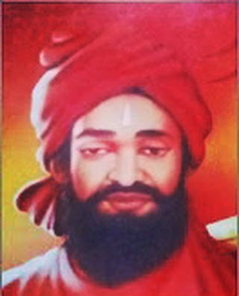
INTRODUCTION
Lord Ayya Vaikundar (1809–1851), is believed to be an incarnation of Lord Vishnu, also called as Narayana Pandaram, and worked for the welfare of poor people in Travancore.
It is said that Lord Vishnu used the body of Lord Krishna, for the incarnation of Lord Ayya Vaikundar, which was kept in Parvatha Ucchi Malai, after the completion of the Lord Krishna Avatar.
IMPORTANCE
Muthukutty(Ayya’s birth name) was born in 1809 at Poovandanthope in the Kanyakumari District. Muthukutty was a sincere devotee of Lord Vishnu.

Lord Ayya Vaikundar has five disciples. According to ancient history, the Pandavas took birth in this kailiyuga to serve as disciples for Vaikundar. Vaikundar cured several diseases of the people.
Once The Travancore king Swathi thirunal arrested Vaikundar in 1838, due to his controversial remarks against the king, and after few months, he was released by the king, after knowing about his greatness.
AYYAVAZHI
It was believed that he has entered Vaikundam in the year 1851, and his body was kept in a tomb and, around that, a temple was later built. Even today his devotees are visiting this site, and performing the rituals. His life and works remain as the foundation of the Ayyavazhi. The main temple of the Ayyavazhi religion is located in the Village of Swamithope in tamil nadu.
CONCLUSION
Ayya Vaikundar was a great saint and an avatar of Lord Vishnu. Through his special powers, he has done lot of miracles in the life of his devotees. He has cured diseases and solved the problems of his devotees. Let us worship Lord Ayya with pure bhakti and chant his name and be blessed.
“OM SREE AYYA VAIKUNDARE NAMAHA”
“OM NAMO NARAYANA”
WRITTEN BY
R.HARISHANKAR

BODHENDRA SARASWATHI
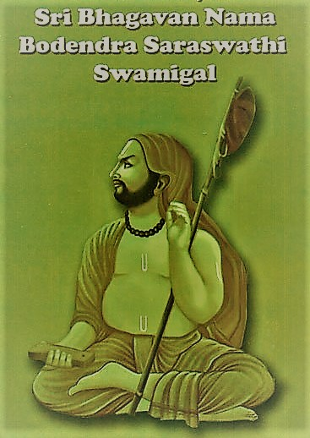
INTRODUCTION
Bodhendra Saraswathi(1610-1692)was a Hindu pontiff and the Jagathguru of the Kanchi mutt, Kanchipuram, Tamil Nadu, India. He also lived in Govindapuram. His birth name was purushotaman.

LIFE
Bodhendra was born at Kanchipuram in the year 1610.
Sri Viswakendra Saraswati of Kanchi Mutt asked his parents to give him to the mutt. And they wilfully gave him to the Mutt. He was a master in all spiritual texts and contains wisdom, courage and boldness at his younger age itself. He chanted Rama nama for more than one lakh times every day.
He served well as the head of kanchi mutt and was pleased by his acts by the devotees.
He attained samadhi at Govindapuram,Thanjavur district in the year 1692 AD.
The Samadhi of Bodhendra Saraswathi is well maintained by the Kanchi mutt.

TEACHINGS
- Always utter Rama Nama in order to live peacefully in this earth, and also to attain MOKSHA after death.
- Everyone must adopt spirituality in their life, in order to succeed in their life.
- Daily chant at least few thousands of Rama Nama Japam.
- Rama is the main person who gives all sorts of happiness to us and we can attain the eternal bliss only through worshipping him.
- By chanting Rama Nama, we can control our senses and avoid negativity, bad and suicidal thoughts in our mind, and can get fresh spiritual energy in our body.
- Our heart will get purified by doing Rama Nama Japam.
- We can develop good habits by uttering Rama Nama throughout in our life.
- It is the easiest way to attain the spiritual enlightenment of god.
- Several physical and mental diseases can be controlled and cured by repeatedly uttering Rama Nama.
IMPORTANCE
He was a great scholar and a devotee of Lord Rama and Lord Hanuman. He guides us in the spiritual path, and clears our soul and protects us from several problems. He was born in this earth in order to lead us to the spiritual path and to attain the eternal bliss of the god.
Though he was not alive, his teachings will always be remembered by us and will act as a guide to us. During his life time, he conducted many devotional lectures and was attracted by his followers. He was also a regular reader of Ramayan and was specialized in preaching it among his followers. He was a kind hearted saint, who always give respect to others sentiments and feelings and move with everyone in a cordial manner.
We also have to follow him with regard to his bhakti on Lord Rama, and to try to attain peacefulness in our life, and to attain SALVATION after our death. Even though it is a difficult task, we should try to our level best with regard to devoting Lord Rama and by chanting the mantras “JAI SRI RAM” and “SREE RAM JAYA RAM, JAYA, JAYA RAM” sincerely and with utmost faith in our mind.
Let us worship him and be blessed.
“OM SREE BODHENDRA SARASWATHI SWAMIGALE NAMAHA”
WRITTEN BY
R.HARISHANKAR

CHINMAYANANDA SARASWATI
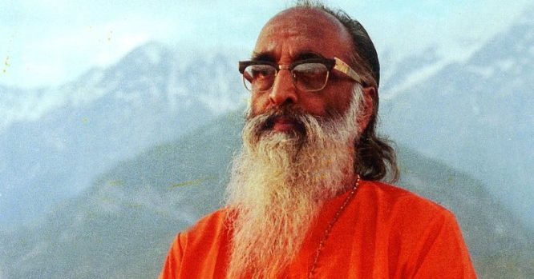
INTRODUCTION
Swami Chinmayananda Saraswati (1916 –1993) was a Hindu saint and the founder of Chinmaya Mission, whose aim was to spread the knowledge of Vedanta amongst the people. His birth name was Balakrishna Menon.
Chinmayananda was a master in teaching hindu scriptures. Chinmaya Mission program was started by him in 1953. It is a spiritual and charitable organization that contains several branches in india and also in foreign countries. He has written various books on spirituality.
LIFE
Swami Chinmayananda, was born in Kerala, India in 1916.He completed his formal schooling in Kerala. And he has completed his graduation and post-graduation in Lucknow University,Uttar Pradesh.
He has also studied under Tapovan Maharaj of Uttarkashi, Uttarakhand.
For some time, he worked as a journalist in a leading newspaper.
He visited the great sage, Sri Ramana Maharshi at Ramanashram. And he was inspired by his devotion to Lord Arunachaleswarar. And he received blessings from him.
He was inspired by the teachings of Swami Sivananda, and he has become a saint in the year 1949, through the guidance of Sivananda, and from then onwards he was called as Swami Chinmayananda Saraswati.
With the blessings of Swami Sivananda, He spread the concepts of Vedanta to the masses.
Chinmayananda has given famous divine lectures in many places of india, as well as in other countries, and travelled all around the world to spread the importance of vedas and hindu religion.
He died on 3 August 1993. A mahasamadhi shrine has been built in Himachal Pradesh.
Chinmayananda established ashrams,schools,provided medical facilities to the poor and written and published many spiritual books.
He was granted awards by indian government, in recognition of his spiritual service to the entire nation.
IMPORTANCE
He was a great preacher and a social reformer and was very interested in doing public service. He has concentrated his attention towards uplifting the hindu religion and to convey his teachings amongst the people. He has given lectures in foreign universities and has spoken about the importance of spirituality. He was also served as a president in Vishwa Hindu Parishad for some time. He was a kind hearted and a noble saint, who was well known by the entire people of the world, due to his good teachings. Let us worship him and be blessed.
“OM SWAMI CHINMAYANANDA SARASWATIYE NAMAHA”
WRITTEN BY
R.HARISHANKAR
KAMBAR
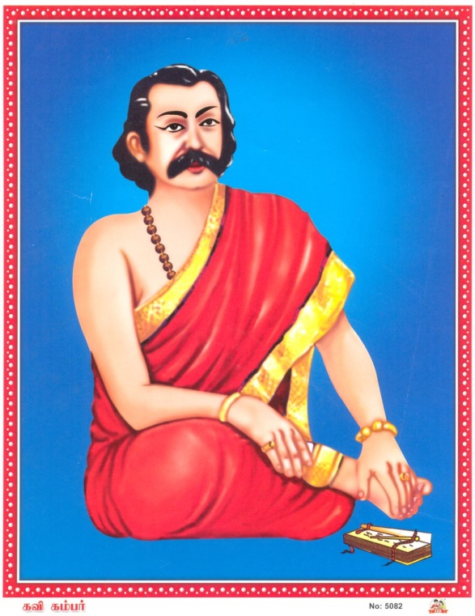
INTRODUCTION
Kambar (1180-1250 AD) was a Tamil poet and the author of Kamba Ramayanam.
LIFE
Kambar was brought up by a farmer in Tamil Nadu. He was honoured by the Great Chola King with the title Kavi Chakravarty. He was a great scholar, and was an expert in tamil and Sanskrit languages.
SPIRITUAL WORKS
- Kamba Ramayanam
- Saraswati Anthati
- Sadagopar Anthathi
- Silaiezhupathu
- Thirukkai Vazakkam
- Erezhupathu
- Kangai Puranam
IMPORTANCE
Kambar has written the kamba ramayanam in a simplified manner. It contains almost all the details that were contained in Valmiki Ramayana. Kambar has written the ramayanam in his own style, but without additing or deleting any contents from the original version of the ramayanam. It is a great epic, and it was praised by all the kings, and by the common people. He was honoured by the kings for his great contribution to Hinduism.
Kamba Ramayana was first delivered in Sri Ranganathaswamy Temple, Srirangam.
In praise of Kambar, there is a popular saying, “that even the mill in his house would sing “("Kambar veettuk kattuththariyum kavipadum")
"Kamba Sutram" is a phrase used by Tamil people in their day-to-day activity.
Whenever a person finds it difficult to understand a particular subject, he will tell that there is some sort of “KAMBA SUTRAM” behind it.
The manner of penning poems by him is magnificent. Within a short period of time, he will be able to write a number of poems.
CONCLUSION
Kambar was also a great devotee of Lord Shiva, Goddess Saraswathi along with other gods. He was an admirer of hinduism. He was well versed in all ancient vedas, puranas and other divine religious texts. He also lived a noble life and respected others. Let us worship this great “DIVINE POET” and seek his blessings, for getting good knowledge in all the subjects similar to him. Let us praise his name and be blessed.
“OM SREE KAVI CHAKRAVARTHY KAMBARE NAMAHA”
“JAI SREE RAM”
WRITTEN BY
R.HARISHANKAR

KIRUPANANDHA VARIYAR
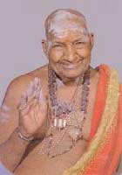

INTRODUCTION
Kirupanandha Variyar(1906-1993) was a Great Spiritual Saint from Tamil nadu, India. Variyar Swamigal, was born in Kangeyanallur in Vellore City in the state of Tamil Nadu.
IMPORTANCE
He was a staunch Murugan devotee, who renovated several hindu temples across tamil nadu. He is very famous for giving hindu puranic discourses.
He helped in spreading Hinduism, and cultivated bhakti among the people by his speech, and was fully involved in his motive. He is considered as the main person towards spreading the Kaumaram cult of Lord Murugan.
He spread the Murugan worship among the masses, by giving spiritual discourses on Lord Muruga. He is considered to be the 64th nayanmar by his devotees.

Variyar Swamigal received the Isai Perarignar award from the Tamil Isai Sangam of Tamil Nadu.
Generally his religious discourses will be made only with well talented musicians.

CONCLUSION
He spent most of his life, in giving discourses of hindu gods, especially on Lord Muruga, and it was well accepted by the people. People will eagerly assemble in crowd to participate in his religious discourses. They were very much interested in listening and hearing to his discourses. The manner, in which he presents his discourses, was attracted by the people. Let us pray to this great Muruga devotee, and to Lord Muruga, and seek their blessings.
“OM SREE THIRUMURUGA KIRUPANANDHA VARIYAR SWAMIGALE NAMAHA”
“OM MURUGA”
WRITTEN BY
R.HARISHANKAR

KUMARAGURUPARAR
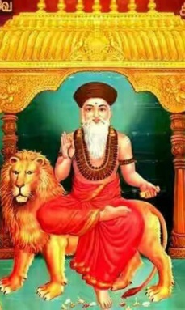
INTRODUCTION
Kumaraguruparar (17th century AD), was a poet and Shaivite saint, who associated with the Dharmapuram Adheenam.
LIFE
Kumaraguruparar was born in Thoothukudi district. He was blessed with Lord Muruga, and he sung in praise of Lord Murugan. He has also written songs in praise of Madurai Meenakshi Amman. After some time, he joined the Dharmapuram mutt, and studied Saiva Siddhanta. He was born due to the divine grace of Lord Muruga of Tiruchendur.
Kumaraguruparar left his house, and went to Madurai, and he was welcomed by the king Tirumalai Nayakkar in Madurai. He composed and sung in praise of Goddess Meenakshi. He was greatly honoured and given respect at Madurai.
Then he went to Tiruvarur, where he sung in praise of Lord Thyagarajar.
From Tiruvarur, Kumaraguruparar went to Dharmapuram, and he met Desikar. Desikar agreed to be the guru of Kumaraguruparar, and Kumaraguruparar, with the advice of his Guru Desikar, stayed at Thillai, and worshipped Lord Shiva for some time, and then he went to the northern part of the country, to spread the principles of shaivism.
IMPORTANCE
Kumaraguruparar renovated the abode of Kedhar Eashwara. In his mutt, he preached the Shaivite philosophy among the people. He spent the money received from the devotees, towards the spiritual development of the people of Kasi.
SPIRITUAL WRITINGS
1.Sakalakalavalli Maalai
2.Muthukumaraswami Pillai Tamil
3.Tiruvarur Nanmani Malai
4.Madurai Kalambakam and
5.Meenakshi Pillai Tamil
6.Sivakami Ammai Irattai Mani Malai
7.Chidhambara Cheyyul Kovai
CONCLUSION
Kumarakuruparar, who was a great shaivite saint and a poet, has contributed a lot towards spreading the importance of the principles of shaivism. He was a knowledgeable man, who contains great spiritual powers. He is the one, who is capable of removing the sins of his devotees, through his divine powers. Let us worship this great guru and be blessed and live happily for ever.
“OM SREE KUMARAKURUPARARE NAMAHA”
“OM MURUGA VEL MURUGA”
“OM NAMAH SHIVAYA”
WRITTEN BY
R.HARISHANKAR

KUNDRAKUDI ADIGALAR
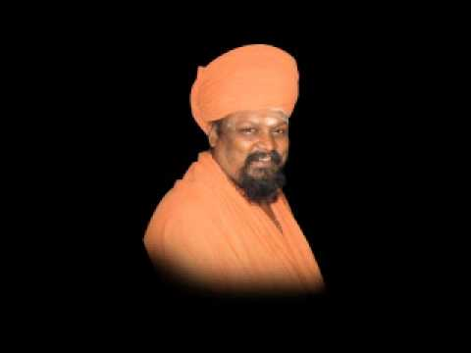
INTRODUCTION
Kundrakudi Adigalar (1925 - 1995) was born in a small village, in Nagapattinam district, Tamil nadu. His birth name was Aranganathan. He was a great devotee of Lord Muruga.
IMPORTANCE
He was against untouchability from his childhood, and he has shown humanism to everybody, without seeing their caste, creed or religion. He was a kind and a great person.
He was working as an accountant in the Dharmapura Adheenam. After some time the chief of the Adheenam, has made him as a Sanyasi with the name “Kandasami Thambiran”.
He has performed many religious services. He was then given the nickname "Arunachala Desika Paramacharya Swamigal".
On 1949 , he was crowned as the prince of Kundrakudi Adheenam. From then onwards, he became known as “THAVA THIRU KUNDRAKUDI ADIGALAR”.
He spread Hinduism across the globe. He insisted in worshipping god, in order to get relieved from problems. He has given several speeches in connection with worship of god, and the importance of hindu religion. He was a great saint and possessed spiritual powers. People were admired with his knowledge and spiritual power. He developed a sense of satisfaction through his speech. His speech attracts lot of crowd, and his speech was simple and straight forward in nature. His speech mainly relies on development of the nation, spirituality and helping to the poor people.
TRAVEL
He had visited many foreign countries. His travels made him as a cultural ambassador for Tamil Nadu. He cultivated spirituality and growth for the welfare of the tamil people, living in foreign countries. Once while visiting to Russia, he developed a scheme called as “KUNDRAKUDI VILLAGE SCHEME”, and it was a very popular scheme.

MAGAZINES
He has written many books and also published magazines like Manimozhi, Tamilagam and Arulosai.
SPIRITUAL WRITINGS
1.Appar Virundhu
2.Appar, Sundarar and Manickavasagar
3.Thiruvasagathen
4.Tamil amudhu
5.Hindu Literary works
6.In the foot steps of Nayanmars
7.Tiruvalluvar

CONCLUSION
Kundrakudi Adigalar who was a great murugan devotee and a pious saint, was not only created spirituality among the people, but also has rendered religious and social services. His services were made him popular among the masses. He was worshipped and welcomed by everyone. Due to his saintly approach, he became a celebrated person. Let us worship him and Lord Muruga, and chant their names, and be blessed.
“OM SREE KUNDRAKUDI ADIGALARE NAMAHA”
“OM MURUGA VEL MURUGA”
WRITTEN BY
R.HARISHANKAR

MANICKAVASAGAR
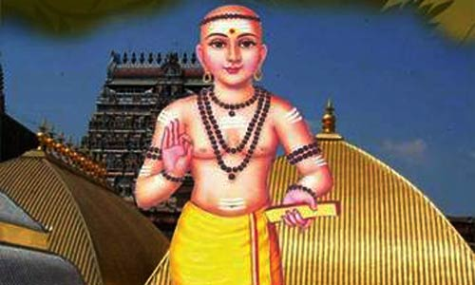
INTRODUCTION
Manickavasagar was a 9th-century Tamil poet and he has written poems in praise of Lord Shiva which is known as Tiruvasakam. And he has also written Tiruvenbavai. He is said to have lived at Chidambaram in Tamil Nadu.
LIFE
He worked as a minister to the Pandiyan king and he lived in Madurai. He was a great saivite saint in Southern India.
Manickavasagar is said to have born in Vadhavoor, near Madurai. His father was a temple priest.
Once the king of Pandiyan dynasty had selected Manickavasagar, and gave him huge amount to purchase horses. But he utilized the money, and built the temple of Shiva in Tirupperunturai. First the king felt anger with Manickavasagar, and after that, Lord Shiva made him to realize his mistake. Then the king immediately gave up his throne, and attained mukthi at the feet of Lord Shiva.
IMPORTANCE
He attained mukthi at the chidambaram temple due to his great devotion on Lord Shiva. Manikkavacakar has won in the debates with Buddhists at Chidambaram. His festival is celebrated in the Tamil month of Aani. Manickavasagar visited temples in various parts of Tamil nadu. Tiruvembavai is sung across the temples in Tamil Nadu during the Tamil month of Margazhi.
CONCLUSION
He was a great saint, and attained mukthi due to his sincere devotion on Lord Shiva. Let us pray to him and be blessed.

“OM SREE MANICKAVASAGARE NAMAHA”
“OM NAMAH SHIVAYA”
WRITTEN BY
R.HARISHANKAR

NAKEERAR
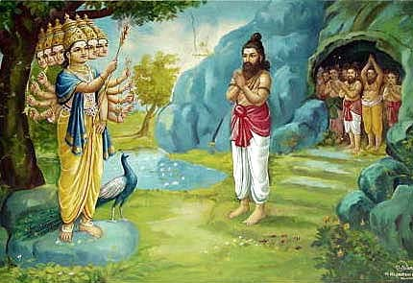
INTRODUCTION
Nakeerar was a famous Tamil poet who lived before two thousand years. He wrote several Tamil poems.
IMPORTANCE
Nakeerar was a famous poet and the author of the famous poem known as “Tiru Muruka Aatruppadai”, which was written by him in praise of Lord Muruga. He was a great scholar and a great devotee of Lord Shiva and Goddess Parvathi. Many kings and the common people were very fond of his poems, and all of them respected and honoured him for his great knowledge.

INTERACTION WITH LORD SHIVA
Once a pandiyan king announced a price money, for the writers of the best poem. A poor poet prayed to Lord shiva for winning in the competition, and Lord Shiva came in the form of a poet and gave a best poem to him. The poor poet met the king and read his poem. The king was very much pleased with his poem, and decided to gift him gold coins. But the royal poet, nakeerar stopped the king from giving the gold coins to the poet, and further told that the poem contains lot of mistakes.
The poor poet met Lord Shiva who was also in the form of a poet, and told to him about the incident in a worrying manner. Lord Shiva himself took the form of a poet, and approached the royal court, and asked nakeerar to point out the mistake in his poem, and opened his third eye, but Nakeerar couldn’t with stand the heat and prayed to him. But yet he suffered from the burns caused by the fire emitted from the third eye. Lord Siva advised him to do a penance to recover from it.
While he was doing penance, he was caught by a demoness, and he was thrown into a cave prison along with other prisoners. The other prisoners were crying for saving their lives.
Nakeerar comforted them, and told that he would pray to Lord Muruga, and he would help them. Nakeerar sang a poem in praise of Lord Muruga. Then by the grace of Lord Muruga, the demoness also got released from a curse which turned her into a demoness. After that all the prisoners were released, and the poem became a popular one.
CONCLUSION
Nakeerar was a famous poet and also a soft natured person, who was still living in the hearts of the tamilians, and all of his admirers. He is well known for his bravery. He was brave enough to find fault with Lord Shiva’s poem. Though the way he behaved is not well and good, but the courage which he has got is well appreciated by the people. Let us pray to this great poet to reduce our problems in our life, and be blessed.
“OM SREE NAKEERARE NAMAHA”
“OM NAMAH SHIVAYA”
WRITTEN BY
R.HARISHANKAR

OTTAKOOTHAR
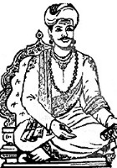
INTRODUCTION
Ottakoothar (12th century AD) was a popular court poet of Chola kings, and he wrote poems in praise of Chola kings.
His memorial is situated in Kumbakonam, nearby Airavatesvara Temple.
According to ancient texts, he has become a great poet after he was blessed by goddess Saraswati in Koothanur.

FAMOUS LITERARY WORKS
- Kulottunga Cholan Pillai Tamil
- Eetiyelupattu
- Eluppelupattu
IMPORTANCE
Once, he was requested by his sengunthar community people to compose a work in honour of them. For that, Ottakoothar has asked them to sacrifice the 1008 lives of their first born sons. Accordingly, they have sacrificed their first born sons. The poet then wrote, Eetiyelupattu, in praise of the past history of the chief of Sengunthar and the soldiers. He later wrote another poem called Eluppelupattu in order to regain the dead members to life. When he sang the poem, the heads of the dead persons have attached to their bodies, and the dead became alive once again. The poet thus came to be known as OttaKoothan, since due to his great power he made the heads attached to the bodies.

CONCLUSION
Ottakoothar was a great poet, who got good knowledge, courage and wisdom, which he acquired through the divine grace of Goddess saraswathi. He possessed spiritual power, and he was a sincere devotee of Goddess Saraswathi. Let us chant his name and be blessed.
“OM SREE TAMIL PULAVAR OTTAKOOTHARE NAMAHA”
“OM SREE SARASWATHI THAYE NAMAHA”
WRITTEN BY
R.HARISHANKAR

PAMBAN SWAMIGAL
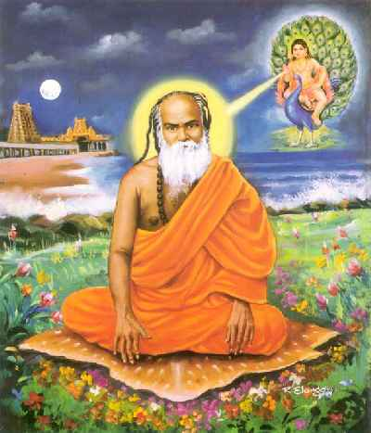
INTRODUCTION
Pamban Gurudasa Swamigal, who is also known as Pamban Swamigal, was a great saint and a poet. He was an ardent devotee of Lord Muruga.
LIFE
Pamban Swamigal was born on 1850, to a Saivite family at Rameswaram. His birth name was Appavu, but later became known as Pamban Swamigal.
Even at a younger age, he was interested in writing poems in praise of Lord Muruga, and he has written many poems on Lord Muruga. He was also a devotee of the great saint Arunagiri Nathar, and he considered him as his guru.

BHAKTI
He was got married in the year 1878. Even after getting married, Pamban Swami lived a life of a saint. He took charge of his family business and done it successfully, through the divine grace of Lord Muruga. He and his family was cured from several health related problems, by applying Lord Muruga’s sacred ash(Vibudi) on their body. Pamban Swami also took only simple food, and also took only one meal in a day.
DEVOTIONAL WRITINGS
In 1891, Pamban Swami wrote Shanmuga Kavacham, for the sake of Lord Murugan's devotees, in order to protect them from physical and mental problems, and also to protect them from their enemies. If we recite it with pure bhakti on Lord Muruga, then we will get several positive results in our life.
Also Pamban Swami has written Panchamrita Varnam in praise of Lord Muruga.
He has written a poem called as Tiruvorumalai Komagan.

IMPORTANCE
Once while he was at Kanchipuram, Lord Muruga appeared in the form of an young man, and took him to Kumarakottam Murugan Temple.
Once, Pamban Swami has got upadesam (Divine chant), directly from Lord Muruga who appeared to him in the form of Palani Andi.
In 1895, Pamban Swami took sanyasa, and left his village. He went to George Town at Chennai, and there he was welcomed by an old lady, and she provided him with food and accommodation, as per the instructions of Lord Muruga, which was given to her in her dream. And Pamban Swamigal has accepted her invitation, and stayed there for some time.
DEATH
He was died in the year 1929. Before his death, he told his followers to have strong faith on Lord Muruga, and to worship him with pure bhakti.
CONCLUSION
A great saint and a Muruga devotee, who has spent his life in devoting lord muruga, and sung his praises, and spread the bhakti of Lord Muruga to the people. He was a gentle and a soft spoken person, who contains spiritual powers. Let us pray to him with sincere devotion and chant his name and Lord Muruga’s name and be blessed.
“OM SREE PAMBAN SWAMIGALE NAMAHA”
“OM SREE PALANI ANDAVARE NAMAHA”
WRITTEN BY
R.HARISHANKAR

PANDRIMALAI SWAMIGAL
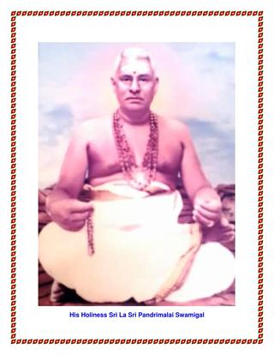
INTRODUCTION
Pandrimalai Swamigal(1906-1986) was born in Pandrimalai, a small village in kodaikanal,Tamil nadu. His birth name was Ramasamy.

LIFE
Even at a younger age, he was declared as a Siddha Purusha, and he has attained athma gnana(Self Realization). He was interested in spirituality, and he was a great devotee of Lord Muruga. After serving for some time as a panchayat president in pandrimalai, he dedicated himself completely to the path of spirituality, and also to the service of humanity, by serving to the poor and needy people.

IMPORTANCE
Swamigal himself declares that, serving to the humanity is important for everyone to do in this world. He further says, that in order to attain the glory of god, first we must try to respect each other, and human values must be well respected. He didn’t consider himself as a god or a saint. He always tells, that he is the servant of the god, and he comes here for doing service to the people.
Very soon, his teachings were attracted by the people, and also they got relieved from their physical and mental problems through his divine grace. He went to several foreign countries like Malaysia, Singapore and Sri Lanka, and has given spiritual teachings among the people. He constructed Hindu temples in Mauritius, New York and South Africa.
His main teaching is to realize the god, and to develop pure bhakti towards god. He further tells us to seek the guidance of spiritual guru, and to control our senses and to avoid anger, and other bad things in our life.
He asked the people to chant Lord Shiva’s holy mantra “OM NA MA SI VA YA” in order to attain spirituality in their life. And his ashram is situated at Nungambakkam,Chennai.

CONCLUSION
A great philosopher and a saint who has attained the glory of god. He has done a lot of miracles in the life of his devotees. Being a great Muruga devotee, he spent most of his life in spiritual path, and also concentrated his attention on “HUMANITY” towards the people.
He was a great speaker, who covers all the important topics related to bhakti and humanity. He was respected by everyone through his spiritual enlightenment. Let us pray to him with pure bhakti and be blessed.
“OM SREE PANDRIMALAI SWAMIGALE NAMAHA”
“OM NA MA SI VA YA”
WRITTEN BY
R.HARISHANKAR

PANTH MAHARAJ
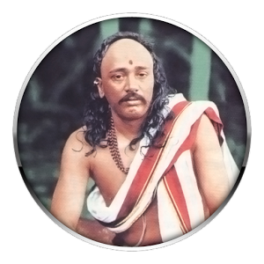
INTRODUCTION
Pant Maharaj (1855–1905), was a Hindu guru born in Belgaum, Karnataka and is considered to be an incarnation of Lord Dattatreya. His birth name was Ramachandra Kulkarni.
LIFE
He was born in a Brahmin family on 1855 on Krishna Janmashtami. He was a great saint, taught the teachings of Lord Dattatreya to the people and asked them to help others. His guru was balmukund, and he learned all the vedas and other devotional texts from him.
Once, he met Swami Vivekananda, and they discussed about spiritual matters.
His ashram and temple is located in Belgaum.
The temple contains personal materials used by him. Every year thousands of devotees visit his ashram from various parts of india for participating in the three days festival conducted every year during the month of October.
DEVOTIONAL WRITINGS
- Datta Prem Lahari
- Premtaran
- Atmajyoti
- Prembhet
IMPORTANCE
He was a great guru, saint and a yogi and contains yogic powers. He was the main person towards spreading the bhakti of Lord Dattatreya amongst the masses. He was a great scholar and a spiritual leader, who was well versed in yoga, meditation and was a master in all kinds of art. He took the human form in order to guide us and to protect us from the problems, which we are facing in our daily life. He also safeguards us from our enemies and will come with us wherever we go, if we sincerely worship him. He is our saviour, who removes our sins and gives us SALVATION. Being an avatar of Lord Dattatreya, he contains spiritual powers, and always relieves us from various physical and mental diseases.
Let us chant his name and be blessed.
“OM SREE PANTH MAHARAJ NAMAHA”
“OM SREE DATTATREYARE NAMAHA”
WRITTEN BY
R.HARISHANKAR

PARANJOTHI MUNIVAR
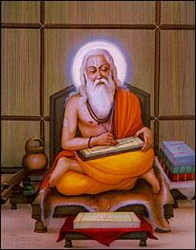
INTRODUCTION
Paranjothi Munivar, was born on 7th century AD. He was also known as Siruthondar Nayanmar, who was the army chief of the Pallava king Narasimavarman I. In course of time, Paranjothi left his job, and became a Sanyasi. LIFE
Paranjothi, was born in a village in Nagapattinam district, Tamil Nadu. Paranjothi, was specialized in various marital arts, and went to to Kanchipuram and learned tamil literature and the principles of Shaivism.

IMPORTANCE
Paranjothi was won in the battle between Narasimavarman, and the Chalukya king, Pulakeshin.
During the battle field, Paranjothi was worshipping Lord Ganesha for his victory in the battle. After his victory in the battle field, he took the statue of Vatapi Ganapathy to his birthplace Tiruchenkattankudi. Still now the statue is kept in the temple in Tiruchenkattankudi in Nagapattinam district, Tamil Nadu. “VATAPI GANAPATHY” is a famous form of Lord Ganesha, who is widely worshipped by the people, especially by the people of tamil nadu from ancient times, for their success in their life.
After winning in the battle, his mind has changed, and he moved towards the spiritual path, and became a great Saivite saint with the name as “SIRUTHONDAR”. He is one among the 63 Saivite Nayanmars.

CONCLUSION
Paranjothi was a great shiva devotee, and since he has become one of the nayanmars, he is living in the divine abode of Lord Shiva, the Kailasa. He is serving Lord Shiva in the kailasa, along with other nayanmars and shiva ganas with pure bhakti. Let him bless us, and make us a devotee of Lord Shiva. Being an ardent devotee of Lord Shiva, let him shower his grace on us, and show us the path of spirituality. Let us pray to this great saint, and be blessed.
“OM SREE SIRUTHONDA NAYANMARE NAMAHA”
“OM NAMAH SHIVAYA”
WRITTEN BY
R.HARISHANKAR

POLUR VITOBA SWAMIGAL
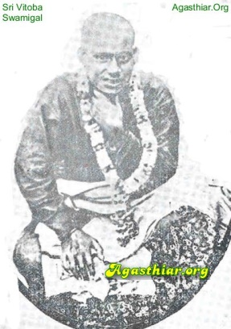
INTRODUCTION
Vitoba Swamigal was born during 19th century AD at Chennai, and he belongs to the Langar Caste, those who take tailoring as their main occupation. He was devoted to the god from his childhood.
IMPORTANCE
Even at a younger age, he will used to sit in a mutt, built by his father, and chant god’s names. Even after he got admitted in the school, he will sit silently and chant god’s names. He has thrown out from the school at the age of 14, and after that, he began wandering all over the streets, but with full of bhakti towards god on his mind. After some time, he left his place and came to polur. There he was provided with food by a pious lady.
He will not take proper food. He will ask people to get water and nose powder for him. Sometimes, he will drink drainage water also. He treated all the food and drinks as alike. He has not differentiated between good and bad food. He was a great Yogi.
MIRACLES
He has cured the diseases of his devotees. Those who suffered from stomach ache and from severe chronic diseases, were got the blessings of Vitoba swamigal, and got relieved from their health problems. He observed strict silence, and replied to his devotees only through actions. Sri Vithoba Swamigal’s Maha Samadhi is located at Polur, 34 kms from Thiruvannamalai.
CONCLUSION
Swami Vitoba, was a great saint who has reached the divine world after his departure from this world. He was a great person, who took care of his devotees, and made them to enter into the path of spirituality. He is still answering to our prayers from the divine world. Let us worship him with sincere devotion, and chant his name and be blessed.
“OM SREE VITOBA SWAMIGALE NAMAHA”
WRITTEN BY
R.HARISHANKAR
RAMALINGA SWAMIGAL
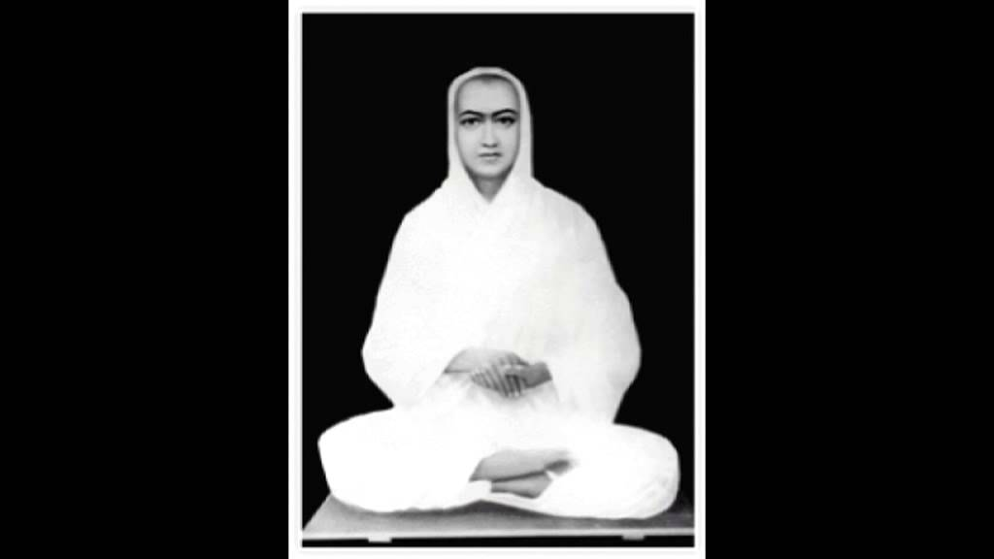

Ramalinga Swamigal(5 October 1823 – 30 January 1874) also called as Ramalinga Adigal and Vallalar was born at Marudur near Chidambaram on 1823 and was one of the most popular tamil saint and also one of the greatest poet. He was the founder of Sathya Gnana Sabha which was opened on 1872. His main principle is : By doing service to living beings, we can attain moksha(Salvation).This Sabha is not a temple and here no fruits and flowers are offered and blessings are not given. Here all types of people are allowed without any difference in caste, but except meat eating people. They are allowed to worship only from the outside of the temple. According to him, God is one and he was worried very much about caste discrimination. After his father’s death, he and his family settled at Ponneri for some time and then they again relocated to Seven Wells,Chennai.

He was very much attracted with providing annadanam and started an annadan choultry on 1867. Free food offered to all the people in this Dharma Sala.. On the inaugural day he lit the fire of the stone stove, with a declaration that the fire be ever alive and the needy shall be fed forever. Even now, annadanam is provided in this Dharma Sala and provision like rice, dhall,sugar etc are provided by the devotees. Thousands of people are benefited by this Dharma Sala. Those who are below 12 years or those who are above 72 years alone are expected to enter Gnana sabai and to do poojas. The oil lamp lit by him is kept burning.The land for the facility was donated by kind, generous people and those registered documents are available for seeing by the visitors. The free facility continues its service till the present time. Ramalinga disliked people eating non vegetarian food.:His main place is in Vadalur, but his followers are there all over the world.

He has got lot of talents. He was a publisher,Siddha Doctor, Founder of Dharma Sala, Writer, Preacher etc. During his period, he understood that all the religions truth is one and same only and started Sanmarkam. He is against casteism. He considers all are one and there should not be any difference between castes and all should be treated as equal and must be given equal justice.
He has written several books, and Thiruvarutpa Songs. He is against non vegetarian. He strictly insisted on eating vegetarian food by the people. His popular saying is: ‘Whenever I find a crop in drought condition, I also suffered similar to that crop’. He went to Chennai Kanda Kottam, Kandasamy Temple and there he spent lot of his time. The locality where he lived, has been renamed in his name as ‘Vallalar Nagar’.
In several temples, his statue has been installed. He was a poet as well a musician and composed several songs. It was on Thai Poosam in 1874, he was disappeared from his locked room and merged with light. He is the one who transformed his physical body into a body made of light. During his life time, he visited Kandasamy Temple, Kandakottam,Thituthani Murugan temple, Thiruvottiyur Vadiyudaiyamman temple and Chidambaram Natarajar temple.The Chief Minister of Tamil Nadu released postage stamps depicting Ramalingam on 17 August 2007.
WRITTEN BY
R.HARISHANKAR

RAMANA MAHARISHI
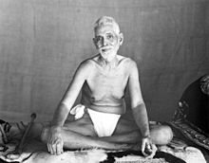
INTRODUCTION
Ramana Maharishi (1879 –1950) was an Indian sage. His original name was Venkataraman, but he is popularly known by the name Bhagavan Sri Ramana Maharishi.
BIRTH
He was born in Tiruchuli, Tamil Nadu, India. At the age of 16, he identified with Shiva. After some time, he went to Tiruvannamalai, where he became a sanyasi, and remained there for the rest of his life.
He was soon attracted by the devotees who regarded him as an avatar. Ramana Maharshi recommended bhakti and self realization for his devotees.

Life
After arriving in Tiruvannamalai, Maharishi went to the temple of Arunachaleswara and deeply meditated in the temple. Seshadri Swamigal, a popular saint of Tiruvannamalai, protected him.
Sri Ramanasramam
From 1922 to 1950, Ramana lived in Sri Ramanasramam.
In Sri Ramanasramam a library, hospital, post-office and many other facilities were formed.
Sri Ramana led a simple life. Ramana was very active in Ashram activities such as cooking and stitching leaf plates.
Death
He died on 14 April 1950 at 8:47 p.m. At the same time a star was seen in the sky. It shows that he has merged with Lord Arunachala.
Importance
Ramana Maharshi is regarded by many as a divine avatar. He was a famous person, and attracted many devotees.
Some of Ramana Maharshi's devotees regarded him to be as Dakshinamurthy(A Form of Lord Shiva).
Spiritual Teachings
Ramana Maharshi provided spiritual teachings by giving darshan, and sitting silently together with devotees and visitors, but also by answering the questions raised by those who sought him out.
Spiritual Writings
1.Akshara Mana Malai
2.Navamani Malai.
3.Arunachala Patikam.
4.Arunachala Ashtakam
5.Arunachala Pancharatna
6.Ramana Puranam.
7.Ekatma Panchakam.
CONCLUSION
Sri Ramana Maharishi, a great saint of Tiruvannamalai, and also a great devotee of Lord Shiva, gives us liberation(MOKSHA). Many number of people are visiting his ashram at tiruvannamalai, which is situated in the Girivalam path. We can observe a deep silence inside his ashram. Many foreigners are staying there and worshipping him for getting peace of mind. We can get a great pleasure and a relief in our mind and freedom from tensions and problems in our daily activities. It is a must to visit his ashram at Tiruvannamalai, and to get peace of mind and be blessed. Let us chant his holy name and be happy for ever.
“OM SREE BHAGAWAN RAMANA MAHARISHIYE NAMAHA”
“OM SREE ARUNACHALESWARARE NAMAHA”
“OM NAMAH SHIVAYA”
WRITTEN BY
R.HARISHANKAR

SACHIDANANDENDRA
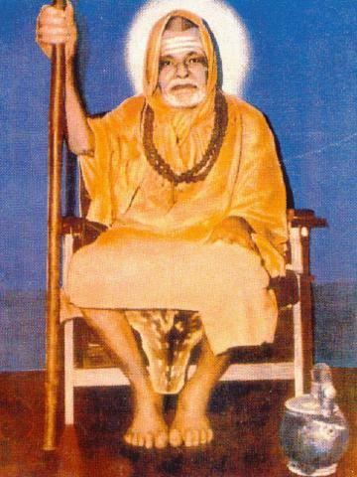
INTRODUCTION
Sri Satchidanandendra Saraswati (1880 –1975) was the founder of the Adhyatma Prakasha Karyalaya in Karnataka, India. He was a great scholar of Advaitha Philosophy. His birth name was Sri Yellambalase Subbarao.
LIFE
He was the master of Advaita Vedanta. He worked as a school teacher in Karnataka. He had written several articles on the Vedanta in various languages. Satchidanandendra Swamiji had written many books, and he dedicated his life in seeking spirituality, and spreading it to others.
At his younger age itself he was interested towards studying ancient scriptures. He learnt Vedas from Virupaksha Shastri.
In 1920 he founded the organisation Adhyatma Prakasha Karyalaya, which is functioning even now.
He was initiated into saint hood in 1948. As a saint, he lived a very noble life at his ashram in Karnataka.
He died at the age of 95 at Karnataka.

SPIRITUAL WORKS
1. Adhyatma Yoga
2. Avasthatraya
3. Sankara's Sutra-Bhashya
4. Suddha-Sankara-Prakriya-Bhaskara
5. The Heart of Sri Samkara
6. Sankara Siddhanta
7. The Vision of Atman

IMPORTANCE
He was a great guru and saint who was very fond of vedas, puranas and Upanishads and taught it among his followers. He published various spiritual books and given spiritual lectures and also done lot of charitable activities to the poor people. He also preached the importance of worshipping the god amongst the people, and asked the people to do meditation and worship god frequently in order to avoid bad and negative thoughts and to cultivate good habits and to live a proper life. He lived a good life and acts as an example for others. He was also a kind hearted person and never hated others, and also provided food at his ashram for the poor people, and developed the reading habit of the people, by circulating his books to the people.
Let us worship the great saint and be blessed.
“OM SREE SACHIDANANDENDRA SWAMIGALE NAMAHA”
WRITTEN BY
R.HARISHANKAR

SADASIVA BRAHMENDRA
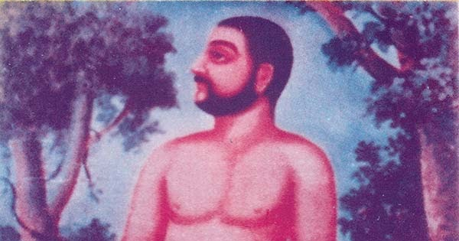
INTRODUCTION
Sadasiva Brahmendra(18th century) was a saint who lived near Kumbakonam, Tamil Nadu. He composed many devotional songs. His birth name was Sivaramakrishna.

LIFE
Sadasiva was born into a Brahmin family at Tiruvisainallur. He was married at the age of 17. He learnt the vedic education at his village.
At his younger age, he was not interested in family life and, he took sanyasa. He was a wandering saint in search for athma gnana in the form of naked or semi-naked. He performed many miracles in the lives of the people.
He was tested by many people and finally they got realized by his divine power and asked him to forgive them.
He installed the deity Punnainallur Mariamman near Thanjavur, he installed the Hanuman idol in the Prasanna Venkateswara temple in Thanjavur and he also installed the idol of Lord Vinayaka at the Thirunageshwaram temple at Kumbakonam.
His samadhis are situated at the following places:
1. Nerur
2. Manamadurai
3. Puri
4. Kashi
5. Karachi
DEVOTIONAL WORKS
- Brahmasutra-vrtti
- Yoga-sudhakara
- Siddhanta-kalpa-valli
- Advaita-rasa-manjari
- Atmanusandhanam
- Atmavidya-vilasa
- Shiva-manasa-puja
- Dakshinamurtty Dhyanam
- Swapnoditam
He also wrote several Carnatic songs to spread the devotion amongst the common people. His compositions are very popular.
Some of these are:
- Ananda Purna Bodhoham
- Bhajare Gopalam
- Bhajare Raghuviram
- Bhajare Yadunatham
- Brahmaivaham
- Bruhi Mukundethi
- Chetah Sreeramam
IMPORTANCE
He was a great saint who never thought about himself and his physical appearance. He travelled to holy temples and installed many idols of god. He attained the great status of “ATHMA GNANI”, that means, he had realized the god within self. He had done many miracles in the life of his devotees. Cured the diseases, illness, removed the black magic, given peaceful life and prosperity to all of his sincere followers.
By seeing his face itself, people will get liberated from their sins. He was such a great saint who contains charming and bright face and glitters like a star. Those who seek protection from their enemies, and pray to him, will be definitely blessed by him and they will be protected for ever. He is also worshipped to get relieved from all other problems in the life and also to attain SALVATION.
Let us worship him and be blessed.
“OM SREE SADASIVA BRAHMENDRARE NAMAHA”
WRITTEN BY
R.HARISHANKAR

CHANDRASHEKARENDRA SARASWATI SWAMIGAL
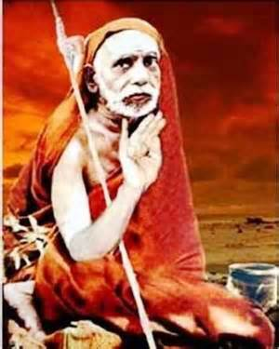
INTRODUCTION
Shri Chandrashekarendra Saraswati Swamigal (1894–1994),also known as the Sage of Kanchi or Mahaperiyava was the 68th Jagadguru of the Kanchi Kamakoti Peetham.
Life
Mahaperiyava was born and brought up in Villupuram, South Arcot District. His birth name was Swaminathan. His family belongs to Smartha Brahmin sect. His father has worked as a teacher, and swaminathan was well versed with the Vedas. Swaminathan took charge of the Kanchi Kamakoti Pitham on 13 February 1907, as the sixty eighth Acharya with the Sanyasa name Chandrashekarendra Saraswati. He was well versed with the Vedas, puranas, hindu texts and literature. He studied at kumbakonam and subsequently at Mahendramangalam. He was interested in various fields of art. He returned to Kumbakonam in 1914, and occupied his seat as an active sanyasi.
Spiritual Contributions
He travelled all over india, and spread his spiritual knowledge among the people. People belonged to other religions also became his devotees. Mahaperiyava dedicated his life in the worship of Kamakshi Amman in Shri Kamakshi Amman temple. He advised his followers and devotees to chant and write the holy name “RAMA”, in order to remove the bad karmas of the people. Devotees from all parts of india, were impressed by the way of his teachings and worshipped him. His speeches were aimed at invoking spirituality among the common people.
Religious Discourses
He travelled across the country and gave religious discourses. His discourses made the whole nation to enter into the path of spirituality. He was the key person in spreading the sanatana dharma throughout the country.

Books
1.Hindu Dharma
2.The Vedas
3.Voice of the Guru
4.Saundaryalahari
5.Voice of God
CONCLUSION
Maha Periyava as we fondly call him, though left us from his physical body, is still living with us in our hearts. His books and spiritual discourses will help many of his devotees to lead towards spiritual path, and to live in a proper manner. He was a great and a noble saint, who was free from sins. He has lived a pious life by devoting Lord Shiva and Goddess Kamakshi Amman.We can pray to him sincerely and attain his divine blessings.
“OM SREE MAHA PERIYAVALE NAMAHA”
“OM NAMAH SHIVAYA”
WRITTEN BY
R.HARISHANKAR
SAINT PATTINATHAR
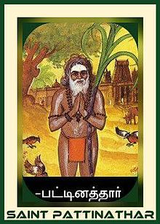
INTRODUCTION
Saint Pattinathar was born in 14th century as Thiruvengadar at Kaveripoompattinam. He belongs to a wealthy merchant family, and he was doing his family business, before attaining sainthood.
IMPORTANCE OF THE DIVINE SAINT
After reaching a certain age, he took up his family business, and once his father has sent him with goods through ship for doing business. But, Pattinathar just brought back sacks full of paddy husks. The angry father was very much disappointed with him, and locked him in a room and went to the harbour and threw the husks out. He was very much astonished to see that they were all gold. Immediately he went home to see his son. He was not in the locked room. He was disappeared from the room, and before disappearing, he gave to his mother a small box and asked her to give it to his father. In the box there was a palm-leaf manuscript, and a needle without an eyelet. On the script, the following words were printed:
"Not even an eyeless needle will accompany us in the final journey of life."
Pattinathar realized the god, and left everything – his wife, his wealth and his child. He was wearing a small piece of cloth. He sang many spiritual songs for the people towards leading them to spirituality. He sang about the human life which suits to the common man. He insisted not to be attached to the body and other pleasures in the world, since everything will get perished in course of time, and asked the people to keep on thinking about god and to surrender at his feet.
Pattinathar worshiped Shiva at the Srikalahasti temple. The Pattinathar Samadhi is a very famous one and also is a landmark which is located in Tiruvottiyur.

An idol for Pattinathar is found inside the temple of Nandrudayaan Vinayagar temple located at trichy.Bharthari was a King of Ujjain and he later became a disciple of Pattinathar and got mukthi (Salvation) in Kalahasthi temple.
CONCLUSION
Saint Pattinathar who was not attached to the worldly pleasures, and who left everything and he was a great shiva devotee. Through his life and from his teachings, we can know that nothing is going to come with us after we leave our body. Hence true devotion with god is the most important one. We should concentrate our attention on god by continuously chanting his mantra in order to attain SALVATION similar to that of Saint Pattinathar. Let us worship him with sincere devotion and chant his holy name and be blessed.
OM SREE PATTINATHADIGALE NAMAHA
OM NAMAH SHIVAYA
WRITTEN BY
R.HARISHANKAR

SEKKIZHAR
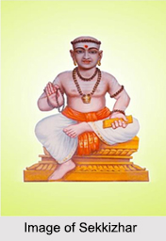
INTRODUCTION
Sekkizhar was a saint and he has written the Periya Puranam which contains the life stories of the sixty-three Nayanmars, who are the devotees of Lord Shiva. His birth name was Arulmozhithevan.
LIFE
King Kulothunga Chola II appointed him as his Prime Minister, on account of his knowledge in all subjects. Sekkizhar anniversary festival is celebrated every year in the month of Vaigasi on his star Poosam.
IMPORTANCE
Sekkizhar was a great saint and a stauch devotee of Lord Shiva. His Periya Puranam was accepted by Lord Shiva. He himself is considered as equivalent to that of Nayanmars, since he contains great devotion on Lord Shiva. He has cultivated the habit of chanting shiva mantra among the shiva devotees. He took keen interest in developing the Shaivism tradition among the people. He was a great poet who received many gifts from the kings, in praise of his great knowledge in composing poems.
TEMPLES
1. Kundrathur Sekkizhar Temple
2. The Devakottai Nagara Sivan Kovil,Sivagangai district in Tamil Nadu. Here urchava moorthy is Sekkizhar.
CONCLUSION
Sekkizhar, who was a great scholar, and a noble man who lived a spiritual life, and gifted us the history of “63 Nayanmars”. Let us worship this great saint, and seek his blessings, and be blessed.
“OM SREE SEKKIZHARE NAMAHA”
“OM NAMAH SHIVAYA”
WRITTEN BY
R.HARISHANKAR
SESHADRI SWAMIGAL
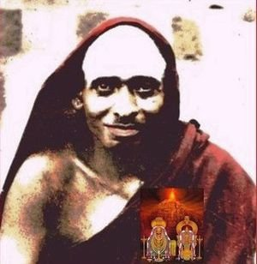
INTRODUCTION
Seshadri Swamigal was born on January 22, 1870 at Kanchipuram. Even as a child, he has done miracles. Once Seshadri wants to purchase an idol of Lord Krishna from a shop, and asked his mother to buy it.The trader gave the idol to the child for free of cost. Then the next day the trader approached Seshadri and his mother, and told them that, since seshadri has touched his statues, all the 1,000 statues had been sold in one day. All the people praised the boy and gave him the name as "Thanga Kai" (Golden Hand) Seshadri.
At the age of 14, his father has died and after some years, his mother has also died. Then Seshadri's uncle took charge of Seshadri and the younger brother Narasimha Josiar and brought them to his place.

Life and Teachings
At the age of 19, he met Sri Balaji Swamigal, and he made Seshadri as sanyasi. After that, Seshadri started to travel to Tamil Nadu and finally reached at Tiruvannamalai.
His teachings are based on emphasising the glory of Arunachala. According to him, Tiruvannamalai is a sacred place for liberation, and he asserts that the people can attain salvation by merely thinking about the glory of Arunachala.
Sri Seshadri Swami was a great worshipper of Lord Shiva and Goddess Shakti. Many times, he sat in the state of Samadhi form, without thinking about his own body.
Miracles
He has done lot of miracles in the life of his devotees. He cured the leprosy of a devotee who suffered from that disease for a long time, and she has been separated from her husband due to that disease. He has removed the ghost from his devotees body, and made her to live a normal life. Through him, many devotees have got their promotions in their job, and were blessed with a good life. Sometimes he will hit his devotees and reduce their bad karma. He was the prophet for his devotees who knows the past, present and future life of his devotees. He was an omnipresent saint according to his devotees. His devotees has seen him in different places at the same time.
Seshadri Swamigal and Ramana Maharshi
Seshadri took care of Ramana Maharshi on his arrival to Tiruvannamalai. Sri Seshadri has protected Ramana Maharishi, and he cleansed Ramana's wounds, and revealed Ramana as a saint to the world.
Ashram
The Seshadri Swamigal Ashram is located in Tiruvannamalai girivalam path.
Death
Sri Seshadri Swamigal died on January 4, 1929.
CONCLUSION
Sri Seshadri Swamigal though not existing physically in this world, still hears the voices of the devotees from his Ashram, and removes the problems and difficulties in the life of his devotees. Being a great saint, and who has done many miracles, is still doing lot of miracles in the life of his sincere devotees. We should have faith with him and pray him with pure bhakti. Let us chant his holy name and pray to Lord Arunachala and be blessed.
“OM SREE SESHADRI SWAMIGALE NAMAHA”
“OM SREE ARUNACHALESWARAYA NAMAHA”
“OM NAMAH SHIVAYA”
WRITTEN BY
R.HARISHANKAR

THAYUMANAVAR
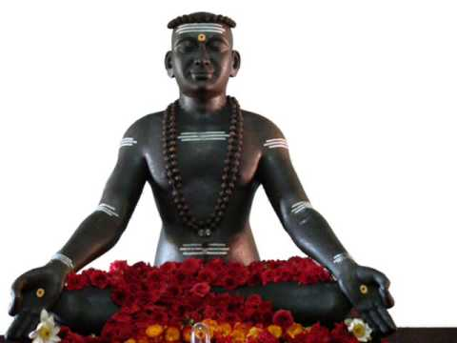

INTRODUCTION
Thayumanavar (1705–1744), was a spiritual philosopher and a saint from Tamil Nadu, India. Thayumanavar formulated the philosophy of Saiva Siddhanta. He wrote several Spiritual Tamil texts. His poems were written based on the philosophy of Hinduism.

IMPORTANCE
Thayumanavar focussed his teaching on controlling the physical senses, and concentrate our attention towards god by doing meditation. According to him, controlling human’s mind is very difficult, and he further says that can be achieved only by constant practice towards chanting god’s name and doing meditation.

SPIRITUAL SONGS
Thayumanavar was a great scholar, and was a minister to the King of Trichy. After attaining the path of spirituality, he left his job, and began spreading Lord Shiva worship. His songs were written based on pure bhakti towards god, and once we read the songs written by him, our mind will get filled with joy, and we will get peace of mind, and will be relieved from tensions. He is asking us to love others and to see everything through love.
CONCLUSION
Saint Thayumanavar, who was a soft spoken, and a humble person, lived a pious life. He devoted his attention towards bhakti, and cultivated it to others also. He never interested in enjoying comforts and luxuries. He only enjoys the comfort of singing the glory of Lord Shiva, and practiced it throughout in his life. Through his devotional songs, people were get relieved from their sins, and took spiritual path. Let us pray to this holy saint and to Lord Shiva, and be blessed for ever in our life.
“OM SREE THAYUMANA SWAMIGALE NAMAHA”
“OM NAMAH SHIVAYA”
WRITTEN BY
R.HARISHANKAR

THIRUVALLUVAR
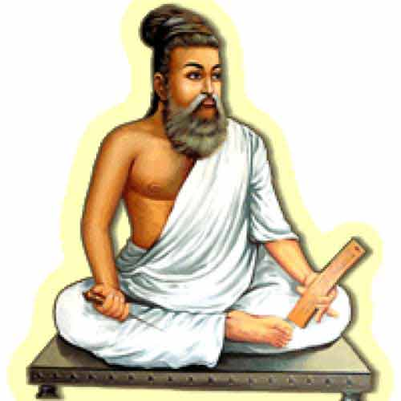
INTRODUCTION
Thiruvalluvar, commonly known as Valluvar, was a popular Tamil poet. He is best known for writing the great text Thirukkuṛaḷ.
LIFE
He is believed to have lived in Madurai, and later in the town of Mylapore, and it is believed that he would have lived during 4th century BC.
He is believed to have been born in the caste of vellalar, since he mentions the importance of agriculture in his work.
His wife name was Vasuki. And she was a very good, pious and a noble lady who took very much attention towards serving her husband Thiruvalluvar. She was an incomparable woman who possessed all the good qualities, and lived a pleasant life by being a dutiful wife for her husband. She acts as an example for others.
According to ancient texts, Valluvar was left as a new-born child, nearby a Shiva temple at Mylapore. It is believed that he was raised by a Velalan couple. Valluvar and Vasuki earned a living by weaving clothes. Valluvar submitted his great work “THIRUKURAL” at the Pandiyan King's court at Madurai. And it was well accepted by the king, and by his ministers, and by the great scholars of his court.
In memory of Thiruvalluvar, Valluvar Kottam was constructed in Chennai in 1976. There is also a 133-foot tall statue of Valluvar erected at Kanyakumari.
IMPORTANCE
Thirukural acts as a guide to the entire world. It tells the way to live in the society, the things to do and not to do, and shows the importance of good things, and tells to avoid bad things in our life. If we follow the verses of Thirukural, our life will become easier, and we can run our life in a proper manner. It is a great treasure for the entire world, and it acts as a Holy book for all the religions and can be read by any one, since the contents are very short, very much simplified and easy to read.
CONCLUSION
Thiruvalluvar who was believed to have lived before thousands of years, is still living with us through his great work “THIRUKURAL”. He is considered as a divine poet and also a holy saint. He has gifted us the holy treasure thirukural, which was praised and well accepted by the people. Let us pray to this great poet and be blessed.
“OM SREE DEIVA PULAVAR THIRUVALLUVARE NAMAHA”
“OM SREE VASUKI THAYE NAMAHA”
WRITTEN BY
R.HARISHANKAR

THYAGARAJA
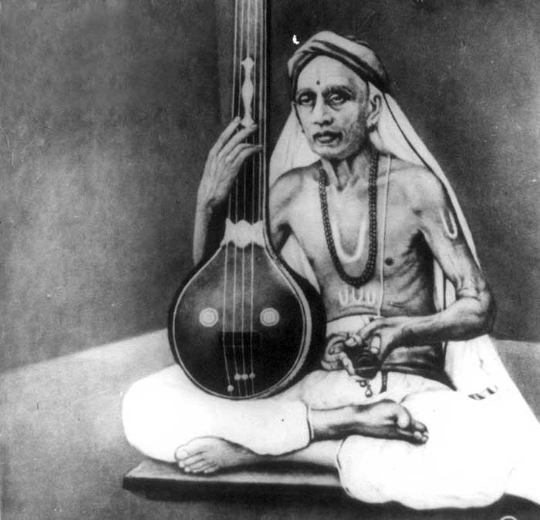
INTRODUCTION
Thyagaraja (1767–1847), was a popular composer of Carnatic music, and he has contributed a lot towards the development of Carnatic music. Thyagaraja composed thousands of devotional songs, mostly in Telugu, and in praise of Lord Rama.
LIFE
His birth name was Kakarla Thyagabrahmam and he was born in Tiruvarur. He is a famous musician and dedicated his entire life towards singing songs in praise of Lord Rama.
Thyagaraja has undergone musical training at an early age under Sonti Venkata Ramanayya, a great music scholar, and was praised by him for his great knowledge in music.
He lived in Thiruvaiyaru, and he travelled to Tirumala and Kanchipuram to visit the holy temples of Lord Vishnu and Lord Shiva. It is also believed that once he had a vision of Sage Narada, and was blessed by him.
Thyagaraja died at the age of 79 at Thiruvaiyaru.
Thyagaraja Aradhana, is held every year at Thiruvaiyaru in the months of January to February towards honouring him. Several Carnatic musicians from all over the world participate in the event and will perform by singings songs in praise of Lord Rama. Lot of people will gather at that place and will hear the devotional songs with much devotion, joy and interest.
FAMOUS SONGS OF SRI THYARARAJA
- Saamajavaragamana
- Aadamodigaladhe
- Raaju vedale
- Ninne nammi naanura
- Nagumomu kanaleni
FAMOUS MUSICAL DRAMA
- Prahalada Bhakti Vijayam
- Nauka Charitam
IMPORTANCE
A great musical composer and also a great human being has lived a saintly life and dedicated his life towards spirituality. His songs are well appreciated by the musical people and sung even today. He lived a simple life and he didn’t served as a musician in the court of kings, and he was not interested in enjoying comforts and luxuries. He lived a very pious and noble life and prayed to the god for the welfare of the people.
CONCLUSION
Saint Thyagaraja who was a staunch devotee of Lord Rama will help us to succeed in our path towards spirituality, and he is still living with us through his devotional songs. Let us worship this great “RAMA BHAKTA SRI THYARARAJA” and be blessed.
“OM SREE THYAGARAJA SWAMIGALE NAMAHA”
“JAI SREE RAM”
“JAI HANUMAN”
WRITTEN BY
R.HARISHANKAR
VISHVAKSENA
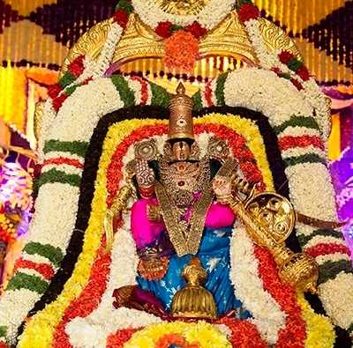
INTRODUCTION
Vishvaksena is the ARMY CHIEF of the Hindu god Vishnu. Vishvaksena is worshipped before performing any rituals, according to Vaishnavism tradition. Vishnu temple festivals will begin after worshipping him. The name of his wife is Sutravati.
IMPORTANCE
In Mahabharatha and Srimad Bhagavatam, the name of Lord Vishvaksena is mentioned in several places of the texts. He is described as a great valour and controls the army, gives great strength to those who worship him, and mainly gives courage, boldness and good health and wealth. He is the one who protects his devotees from their enemies. It is advisable to those, who are suffering from their enemies, to worship Lord Vishvakshena with good faith, and to get rid of their problems. BLACK magic, bad mantric and tantric problems, and all negativity of thoughts will be removed by chanting his name repeatedly, and to worship him regularly, especially it is better recommended for those persons, who do not have enough strength and courage in their mind and body.
He is regarded as an AMSA (Aspect) of Lord Vishnu. He is regarded as a divine servant of Lord Vishnu.
He is believed to protect his devotees from their problems. Similar to that of Lord Vinayaka, Vishvakshena is first worshipped by the Vaishnavites before starting any new work.
It is believed that Lord Vishvakshena is protecting the entire world through his army.
WORSHIP
At the following important temples, Lord Vishvaksena plays an important role in the temple festivals:-
1. Venkateswara Temple, Tirumala
2. Srirangam temple, Trichy
3. Varadharaja Perumal Temple, Kanchipuram
4. Sri Bhudevi Sametha Sri Venkateswara Swamy Temple in Krishna District,Andhra Pradesh.
CONCLUSION
Lord Vishvaksena is none other than Lord Vishnu himself. By worshipping him, we will get all sorts of benefits in this world, and also can attain SALVATION after our death. Let us praise his glory and be blessed.
“OM SREE VISHVAKSENARE NAMAHA”
“OM NAMO NARAYANAYA NAMAHA”
WRITTEN BY
R.HARISHANKAR

YOGI RAMSURATKUMAR
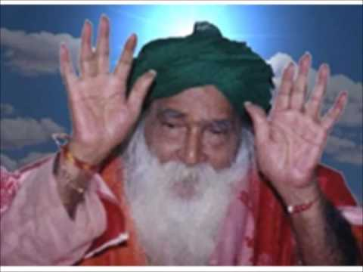
INTRODUCTION
Yogi Ramsuratkumar (1918–2001) was an Indian saint. He was fondly referred to as "Visiri samiyar" who usually keeps visiri in his hand, and bless his devotees. He has lived in Tiruvannamalai, after becoming a saint. Tiruvannamalai is famous for big and small temples. Spiritual seekers will visit here from all over the world to seek the divine blessings, and to get peace of mind.
LIFE
Yogi Ramsuratkumar was born in a village in Uttar Pradesh. In his childhood, in his home town, he met many saints, and received their blessings.
He met both Sri Aurobindo and Ramana Maharishi, and received blessings from both of them.

He went to Tiruvannamalai in 1959 from his native place. Swamiji lived in a small house near the AnnamalaiyarTemple. From there, he was blessing his devotees, since for the devotees who outnumber, the Yogi Ramsuratkumar Ashram was constructed at Tiruvannamalai.
CONCLUSION
Yogi has led a very simple life and welcomed all of his devotees, and took care of them in a pleasing manner. He has concentrated his attention on pure bhakti towards god. He asked his devotees to utter god’s name, and then to do their work. He has also done many miracles in the life of his devotees. He was a great devotee of Lord Arunachaleswara of Tiruvannamalai. He was also a devotee of Lord Rama. Let us pray to this humble and kind hearted yogi, and seek his blessings.
“OM SREE YOGIYE NAMAHA”
“OM SREE ANNAMALAYARE NAMAHA”
WRITTEN BY
R.HARISHANKAR

