FAMOUS HINDU TEMPLES IN FOREIGN COUNTRIES
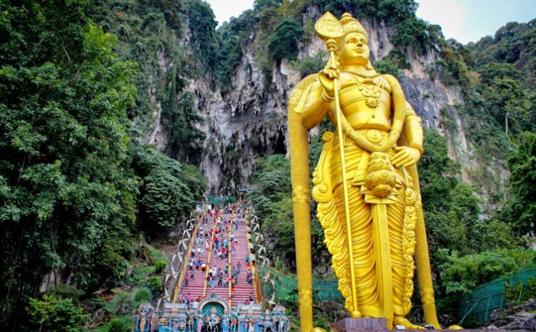
INTRODUCTION
- Angkor Wat temple in Cambodia is dedicated to Lord Vishnu. This religious monument is the largest monument in the world and has become a symbol of Cambodia. This temple attracts lot of foreign tourists from across the globe, due to his attractive features and its holistic nature.
- Prambanan Temple of Indonesia is dedicated to the Hindu Trimurti, Brahma, Vishnu and Shiva and considered as one of the biggest Hindu temple in Southeast Asia. The temple attracts large number of visitors from around the world. Here temple rituals are performed as per hindu traditions and customs and proper puja services are performing here regularly.
- Sri Durga Temple in Australia is the largest Durga Mata temple, in Melbourne. The temple is visited by large number of tourists in order to get relieved from their sins and to get the blessings of the holy mother “MA DURGAMAA”.
- Sri Venkateswara Temple, Durga Temple and Murugan Temple are the popular and important Hindu temples in Australia. The temples are well constructed with marble stones, and it attracts large number of tourists.
- Tanah Lot Temple at Bali is one of seven sea temples around the Balinese coast. The temple is a famous tourist place in the island of Bali.
- Pashupatinath Temple in Kathmandu is the most holy temple of Lord Shiva. The temple is dedicated to Pashupatinath, an incarnation of the Hindu god Shiva and located on the banks of the River Bagmati. People who go for a trip to Kailash Mansarovar Yatra will usually visit this temple, in order to get the blessings of Lord Pashupatinathar.
- Sagar Shiv Mandir is the most famous place of worship for Hindus in Mauritius, and attracts lot of tourists due to its great features.
- Dhakeshwari Temple of Dhaka, bangladesh and is one of the Shakti Peethas. Dhakeshwari Temple is the most important Parvati Mata Temple for worship in Bangladesh.
- Shri Kali Temple in Myanmar is known for its good architecture and it is maintained by the Indian community people. Nathlaung Kyaung Temple is another famous Hindu temple dedicated to Lord Vishnu in Burma.
- Sri Siva Subramaniya Temple is the largest Hindu Temple in Fiji. The temple is dedicated to Lord Murugan and attracts large numbers of devotees, especially during hindu festival days.
- Pura Besakih temple of Indonesia is the largest temple in Bali. The temple is located in the village of Besakih near Mount Agung. It is a most beautiful and well maintained temple, and attracts a large number of devotees.
- Erawan Shrine in Bangkok is dedicated to Lord Brahma, situated nearby Grand Hyatt Erawan Hotel. The temple is considered as one of the most famous temple of Lord Brahma in the world.
- Nallur Kandaswamy Temple in the Jaffna district of Sri Lanka is dedicated to Lord Murugan. The temple is one of the most significant Hindu temples in Sri Lanka. During thai pusam and Tamil new year days, lot of devotees would throng to this temple, to worship Lord Muruga.
- Tividale Tirupathy Balaji Temple is dedicated to Shri Venkateswara Balaji and one of the largest temples in Europe. The temple is designed in the manner of the Tirumala Tirupati, located at West Midlands of England.
- BAPS Shri Swaminarayan Mandir in London is the popular Hindu temple in Britain. The temple was constructed and maintained by the Hindu community people and it is the largest Hindu temple.
- BAPS Shri Swaminarayan Mandir in Toronto is one of the most popular Swaminarayan temple in the world, built by the BAPS Swaminarayan Sanstha.
- The Swaminarayan Akshardham in New Jersey is the largest Swaminarayan Mandir in America. The temple was built by the BAPS Swaminarayan Sanstha, and also contains the details of hindu culture.
- Radha Madhav Temple in Austin is the oldest Hindu Temple in Texas. The temple is the most popular temple in Austin and also one of the biggest Hindu temples in the United States of America.
- Arulmigu Sri Rajakaliamman Glass Temple is the major tourist attraction of Malaysia. The temple attracts large number of tourists due to its significance.
- Shiva and Krishna Mandir are dedicated to Lord Shiva and Krishna in Dubai. It is worshipped by the tourists and also by the hindus nearby the locality, and perform regular pujas in this temple.
- Madhya Kailash Temple in Midrand of South Africa is dedicated to Lord Shiva. It contains lot of attractive features and looks attractive and was neatly maintained by the temple authority.
- Hinglaj Mata Temple in the Lasbela district of Balochistan is one of the Shakti Peethas and it is the most famous Hindu temple in Pakistan. Lot of hindus from nearby areas are visiting this temple on a daily basis, apart from the tourists.
- Kailashnath Mahadev Temple is located near Kathmandu on the border of the Bhaktapur. Kailashnath Mahadev Statue is the tallest statue of Lord Shiva in the world. It attracts large number of crowd due to its unique feature.
- Dattatreya Temple and Hanuman Statue at Carapichaima is the more famous Hindu site in Trinidad. Here Hanuman statue is considered as the largest statue outside India.
- Batu Cave Temple and Lord Murugan Statue is one of the most popular Hindu shrines outside India. The temple is dedicated to Lord Murugan and contains the tallest statue of Lord Murugan in the world. Lot of devotees from nearby areas as well as from india would visit this temple, especially on thai poosam, Tamil new year, Skanda shasti and will take kavadi and piece their mouth and body with the holy vel, apart from doing various abhishekhams to the tamil god Lord Muruga peruman.
WRITTEN BY
R.HARISHANKAR

