FAMOUS INDIAN KINGS AND QUEENS
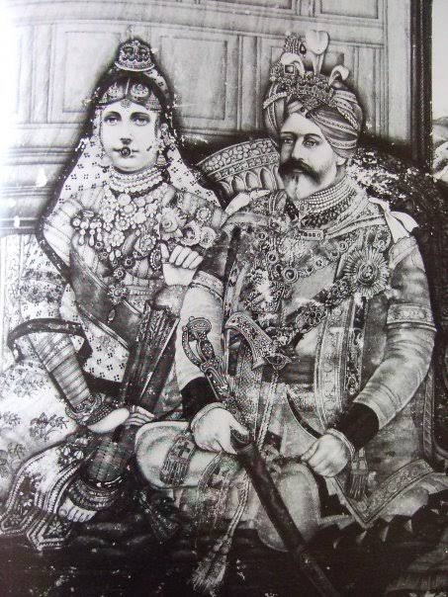
1. Ajatasatru (512-461 BCE)
Haryanka Emperor
Ajatasatru was the son of the great king Bimbisara, one of the earliest rulers of the ancient kingdom of Magadha in north-east India. Bimbisara became head of the Haryanka dynasty in 543 BCE, and contains great powers in handling weapons and was a master in all kinds of art. Ajatasatru was considered as a great king and was treated with respect by his people.
2. Chandragupta Maurya (340-298 BCE)
Mauryan Emperor
Chandragupta Maurya is influential for his founding of the Mauryan Empire. He had extended his kingdom under the guidance of his advisor, Chanakya, and ruled his region in a very efficient and an eminent manner.
3. Ashoka (304-232 BCE)
Mauryan Emperor
The grandson of Chandragupta, Ashoka was one of India’s greatest emperors, who ruled the Maurya dynasty with an empire that spread almost across the entire world. After making the war with the several kings, and after finding the deaths of lakhs of soldiers in the battle field, he had changed his mind, and converted to Buddhism, he vowed never to take any one’s life, and lived in a pious and a noble manner. He had constructed many Buddhist monasteries and treated the Buddhist monks with much respect and provided all the necessary facilities to them.
4. Samudragupta (315-380)
Gupta Emperor
Samudragupta was a great leader of the Gupta dynasty from 335-375. He defeated many kings, and expanded his region. By the time of his death, he was a very big emperor. He nicely ruled his kingdom and provided all the facilities to the people and his rule was referred to as “the Golden Age of India”.
5. Pulakesi II (610-642)
Chalukya King
In the 6th Century, Pulakesi came to the throne as a boy, with his uncle Mangalesa serving as his guardian. After some time, he was ascended to the throne under the name Pulakesi. Soon after, he went to war with rebellious forces within the empire, fighting with the Kings Govinda and Appayika at the Bhima River in southern India. He was defeated by Mahendravarman’s son, and was killed by him.
6. Raja Raja Chola I (947-1014)
Chola King
When Rajaraja came to power, the kingdom faced opposition from the Pandya and Chera kingdoms in India, and the Sinhala in Sri Lanka. Somehow he managed to destroy the ancient Sinhalese capital, Anuradhapura. Raja Raja then conquered Gangapadi in 999, and the kingdom of Vengi in the south, and expanded the Chola kingdom. He built the Brihadeeswara Shiva Temple at Thanjavur, and it is considered as one of the most famous temple with regard to its art and architecture and the big statue of Lord Nandikeswarar was attractively sculpted by famous sculptures, and it is regarded as a great monument in the indian heritage.
7. Krishnadevaraya (1471-1529)
Vijayanagara Emperor
The Vijayanagara Empire of southern India reached its greatest extent under the auspices of Krishnadevaraya, the third ruler of the Tuluva dynasty. He was a great scholar and a clever person, who had done lot of good services to his people. He defeated the Sultans of the Deccan region in 1509. He also respected the saints, and honoured them. His Rajaguru was Sri Vyasaraja, a great madhwa saint and a Vishnu devotee, who once saved him from the clutches of the death god, Yama through his spiritual powers. His rule is considered as a “GOLDEN RULE” by the people.
8. Karikala was a Tamil Chola king who ruled southern India. He had conquered almost the entire india up to the Himalayas. He is recognised as the greatest of the Early Cholas.
His period is also considered as a golden rule for the people, and given much respect to knowledge, worship and wisdom.
9. Lakshmibai, the Rani of Jhansi (1828 –1858), was the queen in Jhansi district in Uttar Pradesh, India. She was considered as one of brave lady who lived a noble life till her death.
She was born in Varanasi into a Marathi Karhade Brahmin family. She was named Manikarnika Tambe. She was educated in all fields, and was a master in arts. She had given a good service to the people during her regime.
10. Rani Mangammal was a queen in the Madurai Nayak kingdom during the period 1689—1704. She was an able administrator and laid roads and avenues, and constructed temples, tanks and choultries for public benefit. She is also known for talents and superior powers.
Mangammal was the daughter of Tupakula Lingama Nayaka, a general of Madurai ruler Chokkanatha Nayak (1659–1682). She was the wife of the king Chokkanatha Nayak, and after his death in 1682, she has become the queen for Madurai, and she ruled the kingdom in a pleasing manner and listened to the problems of the people and showed motherly affection on them. Her rule is also considered as a “GOLDEN RULE” for the people.
11. Rani Velu Nachiyar (1730–1796) was a queen of Sivaganga from 1780–1790. She was fought against the british rule in India. She is known by Tamils as Veeramangai. Velu Nachiyar was the princess of Ramanathapuram and the only child of her parents of the Ramnad kingdom.
Nachiyar was trained in all kinds of arts and was a great scholar. She married the king of Sivagangai, and they had a daughter.
12. Harsha (590–647AD), also known as Harshavardhana, was an Indian emperor who ruled North India from 606 to 647 AD. He was the son of Prabhakarvardhana. Due to his efficiency, his Empire had vastly expanded. He also ruled his kingdom in a well-versed manner, and treated everyone with respect, and provided lot of benefits to his people.
13. Chhatrapati Shivaji Maharaj
Chhatrapati Shivaji Maharaj(1630-1680) was a great king of Maratha Empire. In 1674, he was crowned as the emperor at Raigad.
Over the course of his life, Chhatrapati Shivaji Maharaj fought with the Mughal Empire, as well as with European colonial powers. Shivaji's military forces built forts, and formed a Maratha navy. Shivaji established well-structured administrative organisations. He promoted the usage of Marathi and Sanskrit, and respected Marathi and Sanskrit scholars and highly rewarded them.
He was known for his spirituality and towards his devotion with Mata Bhavani, who was worshipped as his family deity. He believed that due to the blessings of Ma Bhavani, he was able to win in the war, and able to give a golden rule to his people. Till his death, he used to pray Ma Bhavani on a daily basis, and visits her temple regularly.
14. King Bhakt Prahalad
The exact date of birth was unknown, since he was considered as a mythological king. But lot of evidence is there, that he ruled almost the entire world, including India, and his grandson was the great king “MAHABALI” and he ruled the kingdom of Kerala, and his annual visit to Kerala is celebrated as “ONAM FESTIVAL”.
He got the blessings of Lord Narasimha, and expanded his kingdom, almost the surface of the entire earth. Due to his good qualities and high spiritual powers, he ruled his kingdom in a well-versed manner, and treated all of his people in a kind manner, and also constructed lot of annadana choultries for the welfare of the poor people. During his period, no one has suffered from poverty, and no has reported any complaints. All the people were lived happily by chanting the glory of Lord Hari: “OM NAMO VASUDEVAYA NAMAHA”. No one has attained unnatural death, suffered from sickness, suffered from mental tensions and worries, due to the divine presence of their great king “BHAKT PRAHALAD”.
It is believed that he would have ruled the entire earth before several thousands of years ago, and he would have ruled for a minimum period of a million years, with the grace of Lord Narasimha.
DEVELOPED BY
R.HARISHANKAR

