GREAT RISHIS BY R.HARISHANKAR
AGNIVESA
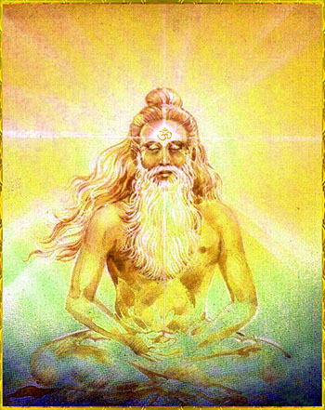
INTRODUCTION
Agnivesha was an ancient vedic rishi and a famous author on ayurveda. He was the disciple of Punarvasu Atreya. He has written Agnivesha Samhita, based on his guru’s teachings. But after some time, most of the scripts written by him in palm leaves were lost and only a few chapters were available. It is very useful in ayurvedic field for formulating various medicines which are useful for curing several dreaded diseases like cancer, leprosy and mental ailments etc.
His greatness and knowledge was mentioned by Rishi Charaka in the Charaka Samhita. He was considered as a divine physician and he was a devotee of Lord Dhanvantri, a form of Lord Vishnu and a divine physician. He insists the people to use the medicines along with the spiritual energy in order to cure the diseases. For that, he is asking us to worship the god regularly and chant his mantras and names in order to live a disease free life. And he further tells that for curing mental diseases, only medicines will not heal a person’s mental state, but he must have to frequently worship the god, and praise his glory in order to get relieved from his mental related problems.
He was also good at meditation and yoga, and through his severe meditation on the god, he has got great spiritual powers, and was considered as one of the “GEM” in the Ayurvedic Field.
Let us worship the great rishi and be blessed.
“OM SREE AGNIVESAYA NAMAHA”
“OM NAMAH SHIVAYA”
WRITTEN BY
R.HARISHANKAR

ASTIKA
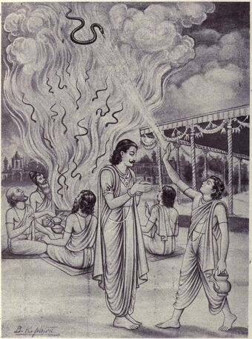
INTRODUCTION
Astika was an ancient rishi, and he was a son of Rishi Jaratkaru and the serpent goddess Mata Manasa Devi, who is also a sister of the great serpent king Vasuki. He also saved the life of the serpant king Takshaka, when king Janamejaya performed a snake sacrifice, to avenge for the death of his father Parikshit due to the snake bite of Takshaka. He stopped the king from doing such a sinful act, and further told to him, that his father Parikshit was bitten by Takshaka due to his fate, and there was no enmity between them. On hearing the words from the mouth of the holy sage Astika, King Janamejaya was pacified and stopped doing the snake sacrifice. That day was Shukla Paksha Panchami in Shravan and is since celebrated as the festival of Nag Panchami.
He is also a vedic scholar and was thorough in all religious texts and puranas. Being the son of the holy mother, MA MANASA DEVI, who is having popular mandirs in north india, he was very kind and affectionate with others. He lived a noble life, and after peacefully living for many years, he attained moksha and went to the abode of Lord Indra Dev, and lived happily there.
IMPORTANCE
By worshipping Rishi Astika, we can get the blessings of his mother, Manasa Devi, and mainly our poisonous diseases will get relieved, and also we will not suffer from snake bites, and get good prospects in our life.
Let us worship the great Astika Rishi and be blessed.
“OM SREE ASKTIKA MAHARISHIYE NAMAHA”
“OM RISHI JARATKARUVE NAMAHA”
“OM MA MANASA DEVIYE NAMAHA”
WRITTEN BY
R.HARISHANKAR

ATHARVAN
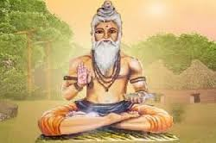
INTRODUCTION
Atharvan was a Vedic sage of Hinduism and he had written the Atharvaveda along with Rishi Angiras. He is the first person who conducted the fire sacrifice also known as yagna. He is considered famous similar to the seven rishis, popularly known as Saptarishis. Atharvan was married Shanti, daughter of the pious Kardama rishi, and had a great sage Dadhichi as a son, who had given his bones for making the divine weapon ”VAJRAYUTHA” for giving it to Lord Indra. According to holy ancient texts, he was eldest son and the mind born son of Lord Brahma. His teachings are very popular since ancient times. They are as follows:
FAMOUS TEACHINGS
- Make yourself involved with spirituality, and do only good things in your life.
- Perform homams and do pujas to deities in order to attain good fortunes in your life.
- Always chant the mantras and the names of the god.
- Don’t think about your future, since your future is already predicted.
- Consider all of them as equal, and give respect to everyone.
- Act honestly and don’t cheat others.
- Learn the ancient texts in order to relax your mind, and also to get more spiritual energy for your mind.
- Always be active, and work hard for proper earning.
- Consider yourself as the obedient servant of the god, and keep faith and devotion on him
IMPORTANCE
He lived a noble life and lived for the welfare of others and he has become very popular for writing the Atharvaveda. Throughout his life, he spent most of his time, in devoting to the god, doing meditation and yoga and lived a peaceful life.
Let us worship the great “ATHARVAN RISHI” and be blessed.
WRITTEN BY
R.HARISHANKAR

AURVA
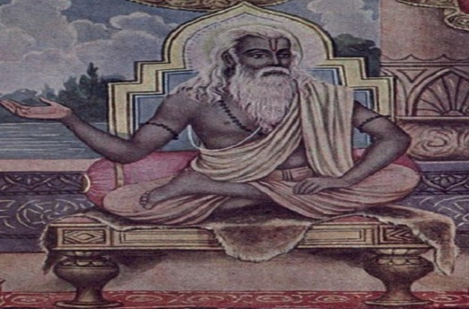
INTRODUCTION
Aurva is known to be an angry sage, who was the descendent of Rishi Bhrigu. He was the grandson of Vatsa, and his descendants Gothram was Srivatsa. His son was Richika Maharishi and Richika’s son was Jamadagni.
According to the Mahabharata, once there lived a noble king named Kritavirya, who had donated most of his wealth to the sages. But after his death, his descendants were suffered from poverty and went to the sages and asked them for help. But the sages were refused to give their wealth to them. Due to that, the kings were become angry and killed the sages. Miraculously, one child was escaped from the hands of the kings, and that child was later known as Aurva Rishi.
Though he was considered as an angry person, who got enmity with the kings, since all of his ancestors were killed by them, but he was good at devotion, and doing meditation and helping the common people. Through his powers, he had relieved the people from their diseases and removed their sufferings and made them to live peacefully and happily.
Let us worship the divine rishi “AURVA” and be blessed.
WRITTEN BY
R.HARISHANKAR

AVATSARA
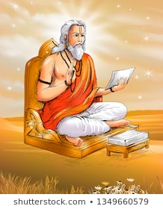
INTRODUCTION
Avatsara was an ancient Rishi and his name and importance was mentioned in the Rig Veda and Yajur Veda. He was a great scholar in vedas, Upanishads and hindu puranas, and also a master in all kinds of arts.
Avatsara had contributed some portions in the Rig veda and praised about the demi gods such as Agni, Varuna, Vayu, Indra, Surya and Chandra and also praised the great gods and goddesses such as Vishnu, Shakti and Shiva.
Avatsara was the son of Rishi Kashyap, and he is good at meditation and earned lot of powers through that. He also shared his wisdom and knowledge with others, and taught the divine scriptures to his disciples at his ashram. He has also written songs on Vishnu and Shiva and sung in praise of them. He preached the importance of worship among the people and got great name and fame through that.
Let us praise the holy sage and be blessed.
“OM SREE AVATSARAYA NAMAHA”
“OM NAMAH SHIVAYA”
“OM NAMO NARAYANAYA NAMAHA”
WRITTEN BY
R.HARISHANKAR

GURU MALLESHWARA
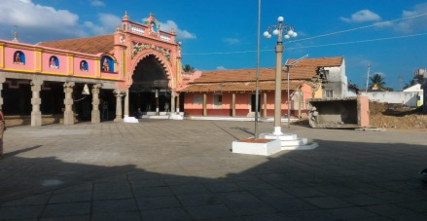
INTRODUCTION
Gurumalleshwara was a 19th-century Veerashaiva Lingayat saint and the Teacher of Shakti Vishishtadvaita. He was born in Karnataka and lived in Mysore and was performed meditation on Lord Shiva at a Mutt in Mysore. After some time, he started a movement through his teachings and also found a new Veerashaiva Mutt in Karnataka. He is considered as an avatar of Lord Nandi and each and every Lingayat family at mysore will have pictures of him at their homes. His Mutt in Devanuru, is considered as a sect of Shri Srishailam Veerashaiva Mutt and he had received the sainthood directly from Bhagawan Renukacharya. He has also performed many miracles like turning the water into ghee, and removed the dreaded physical and mental diseases of the people. His devotees are worshipping him as their own Guru and are living with full of prosperity in their life, due to his blessings.
WRITTEN BY
R.HARISHANKAR

JAHNU
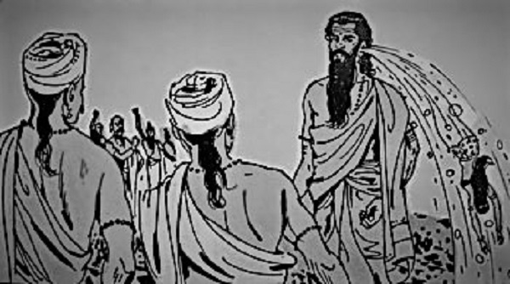
INTRODUCTION
Rishi Jahnu was an ancient vedic sage and contains great powers due to his penance. He was an ancestor of Vishwamitra. He was also mentioned in various sacred hindu texts, and considered as a pious and a holy age.
Once, King Bhagiratha had performed penance on Lord Shiva, in order to send the souls of his ancestors to the heaven. Due to the severe penance of the king Bhagiratha, Lord Shiva had released Mata Ganga from his head, and the sacred water of River Ganga began to flow in Jahnu's fields and his penance was also disturbed. Due to that, Rishi Janhu has got angry with the divine river and through his spiritual powers, he punished her by drinking the waters of Ganga. On seeing this incident, the Divine Gods prayed to the Rishi to release the Ganges from his body, so that she could give salvation to the souls of the ancestors of Bhagiratha. Jahnu accepted their wish, and he released the Ganges from his ear. From then onwards, she is also called as Jahnavi, meaning "Daughter of Jahnu", since she was released from the body of Sage Jahnu.
Let us worship the great sage and be blessed.
“OM SREE JAHNU MAHARISHIYE NAMAHA”
“OM MATA GANGA DEVIYE NAMAHA”
“OM NAMAH SHIVAYA”
WRITTEN BY
R.HARISHANKAR

JAIMINI
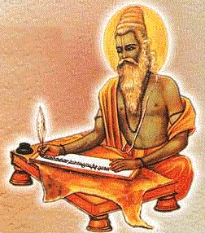
INTRODUCTION
Jaimini was an ancient rishi and a philosopher. He was a disciple of sage Veda Vyasa, the son of Parashara. He was taught Samaveda by his guru Veda Vyasa, along with other spiritual education. He is the author of the Mimamsa Sutras and Jaimini Sutras. He is believed to have been lived during the 4th century BC. He was a great scholar in vedas, shastras, devotional texts and a master in all kinds of arts.
Jaimini was also the disciple of Badarayana, a great sage and a Hindu philosopher, and the author of Brahma Sutras. Both of them were involved in deep spirituality, yet they differ in certain aspects like, while Badarayana emphasizes on knowledge, Jaimini emphasizes on rituals. He was also a friend of Sage Markandeya and frequently used to interact with him about devotional matters.
IMPORTANCE
He is an ancient sage, who was involved in deep meditation, and got great spiritual powers. He used his powers to protect the mankind from diseases and prevents them from problems in their life. He also taught yoga and meditation and shared his spiritual knowledge with his disciples. Being the disciple of the great veda vyasa, he was considered as an efficient and talented person, who lived a pious and a noble life throughout in his life. He was also a devotee of Lord Krishna and got his blessings as well as his Guru Veda Vyasa’s blessings.
Let us worship the great rishi and be blessed.
“OM SREE RISHI JAIMINIYE NAMAHA”
“JAI KRISHNA”
“OM SREE VEDA VYASARE NAMAHA”
WRITTEN BY
R.HARISHANKAR
KACHA
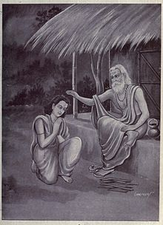
INTRODUCTION
Kacha was an ancient sage and the son of Deva Guru Brihaspati. He is also mentioned in various puranas and in Mahabharata. He was known for learning all the divine scriptures from his father as well as from the demon guru Sri Sukracharya.
Once Kacha met Sukracharya and become the disciple of Sukracharya, to learn the secret of the Mrita Sanjivini mantra in order to bring back the lives of the demi gods again who have lost their lives during their battle with various demons. Kacha also impressed his guru’s daughter Devayani, who falls in love with him.
On knowing about the incidents, the demons tried to kill Kacha for several times, since he cunningly approached their guru for knowing the secret of the Sanjeevini Mantra. But sukracharya brought back the life of kacha, with the help of the mantra. After learning the mantra, when Kacha was decided to go back to Deva loka, Devayani expresses her love for him and asks him to marry her. Kacha tells her that being the daughter of guru, it is not good to marry her, since he consider his guru sukracharya as equivalent to his father as per the Hindu Dharma. On hearing the words from him, Devayani got angry with him and she cursed that he will forget the Mrityu Sanjivini Mantra whenever he tries to use the mantra.
Since his attempt to use the mantra was failed, he returned to Deva Lok and narrated the entire incident to his father, Brahaspati. He calmed down his son, and asked him to get more divine powers by doing meditation on Lord Shiva. He obeyed his father’s instructions, and performed severe penance on Lord Shiva, and got great spiritual powers through that.
Let us worship the great Kacha and be blessed.
“OM SREE KACHAYA NAMAHA”
“OM SREE KACHALEESWARARE NAMAHA”
“OM NAMAH SHIVAYA”
WRITTEN BY
R.HARISHANKAR

KARNI MATA
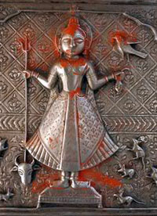
INTRODUCTION
Karni Mata (1387 –1538) was a female sage and she is known as Shri Karniji, and she is worshiped as the incarnation Mata Durga by her followers. She is an official deity of the royal families of Jodhpur and Bikaner. She lived a saintly life and spent with full of devotion during her entire lifetime. The most famous of her temples is in Rajasthan, and was created following her disappearance from her home. The temple is famous for its white rats, which are treated as sacred and given protection in the temple. Another temple dedicated to her during her lifetime contains the footprint to symbolize her visit to that place. Her temples are situated in Mathania, Udaipur and Alwar. She was married with Depoji Charan and she was not interested in living a normal life, and arranged her husband to get married with her younger sister. After some time, she travelled to many holy places with her followers, and finally attained salvation and she is considered as a powerful goddess by the people.
WRITTEN BY
R.HARISHANKAR

MANDAVYA
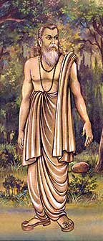
INTRODUCTION
Mandavya was an ancient sage, was once wrongly punished by the king believing him to be a thief, since, some robbers were hidden their stolen articles near his hermitage when he was in deep meditation, and he was wrongly assumed to have stolen the goods. He checked with Lord Yama about his karmic deeds. Yama told that he had given the punishment since he had tortured small insects in his childhood. Mandavya cursed Lord Yama Dharma, since acts done by him in his child hood would not attract such a severe punishment, and said that he will be born in the mortal world. Due to that, Lord Dharma was born as Vidura, the wise minister and the half- brother of the blind King Druthrashtra. He lived in a dharmic path throughout his life, and also given various teachings to the kauravas in order to correct them.
WRITTEN BY
R.HARISHANKAR

MUDGAL
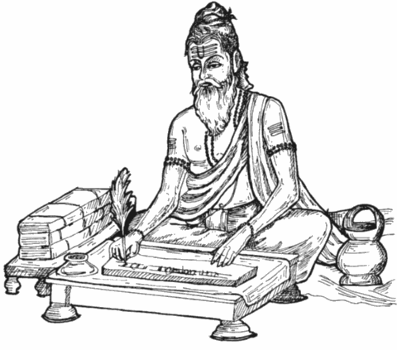
INTRODUCTION
Rishi Mudgal, is one of the Rajarshi in Hinduism. He was a Kshatriya king, but due to his severe penances, he attained great powers and became a famous Rishi. He wrote the Mudgala Purana. In his Purana, he praises about Lord Ganesha, and the way of doing pujas and homams to Lord Ganapati. He got very patience and never hated others, and also never cursed others, even if someone had caused harm to him. He was a pious sage. Once, Rishi Mudgal was the king of the Punjab. He is known as Rajarishi similar to the great sage Viswamitra. His name was mentioned in several ancient puranas and sacred hindu texts. His sons were lived as Rajpurohitas( Chief priests of the king). His wife was a pious and a noble lady Nalayani, who served him as a dutiful wife and showed her full attention on him and she acts as an example for others. In her next birth, she took birth as draupadi and married the pandavas. And she is also an avatar of Mata Parvati and her various temples are located all over India.
WRITTEN BY
R.HARISHANKAR

PIPPALADA
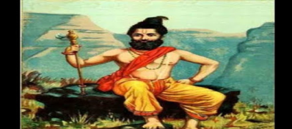
INTRODUCTION
Pippalada was an ancient sage and he had written the Prashna Upanishad. He was the son of pious sage Dadhichi, who donated his bones to the demigods in order to make the divine weapon “Vajrayutha” for Indra’s use. He contains great knowledge in vedas and other divine texts and hindu scriptures. Since he lost both of his parents, he was taken care of by Dadhichi's sister, Dadhimati. After he came to know about the reason of his parent’s death, he performed a heavy penance on Lord Shiva in order to kill Lord Indra and other demi gods in the heaven. Shiva pacified Pippalada and asked him not to show enmity with the divine demi gods, since his parents were died based on their fate, and there is no use in punishing the demi gods. After hearing the words of Lord Shiva, Pippalada was calmed down and thereafter became a great rishi. Once he has also defeated Lord Shani, and asked him not to give troubles to the young people.
WRITTEN BY
R.HARISHANKAR

RENUKACHARYA
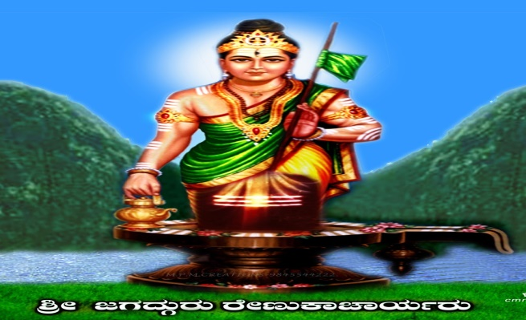
INTRODUCTION
Renukacharya was one of the five great saints who took the avatar in the Kali Yuga to propagate Virasaivism. He travelled throughout india to teach and to give lectures on Virasaivism.
He contains the features of Lord Shiva, and believed to have been born through the grace of Lord Someswara. Sri Someswara Temple is an ancient temple dedicated to Lord Shiva located in Kolanupaka village in Nalgonda District, telangana.
This temple is also called as Thousand Lingas Temple. The temple was constructed during the 12th century by Kakatiya Kings. Here Lord Shiva is worshipped in human form.
According to ancient texts, he is said to have been born during the Treta Yuga, and he was the teacher of the great sage Agastya. He has consecrated several lakhs of lingas for the worship of the Lanka King Vibhishana.
He established the Rambhapuri maṭha. And his descendants of Virasaivas contain the Renuka gotra.
Being the divine incarnation of Lord Shiva, during his period, he had given several lectures on Lord Shiva to the people, and spread the Shaivism sect among the people. He also cured the diseases of the people, and removed the problems and the sins of the devotees by making them to hear about the glory of Lord Shiva and asked them to chant the Shiva mantra “OM NAMAH SHIVAYA” on a continuous basis.
Let us worship the holy saint and be blessed.
“OM SREE RENUKACHARYARE NAMAHA”
“OM NAMAH SHIVAYA”
WRITTEN BY
R.HARISHANKAR

RISHI ARUNI
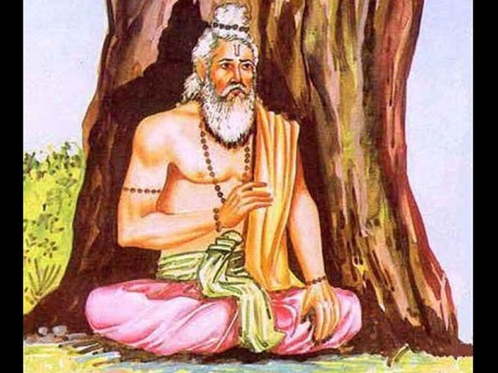
INTRODUCTION
Aruni (8th century BC), is an ancient sage of Hinduism. He is mentioned in many devotional texts, and his philosophical teachings are considered famous similar to the teachings contained in the Brihadaranyaka Upanishad and Chandogya Upanishad. He was a spiritual guru, and attracted students from all over the world. One of his disciples was the great sage Yajnavalkya, and his greatness and importance was mentioned in ancient texts. He contains good knowledge in vedas and ancient sacred texts.
He explained in detail to his disciples, questions related to soul and body, and the realization of the god from the inner soul, and also taught about the spiritual world, and the greatness of the divine gods.
He also clarified the doubts of his son Svetaketu, about the spiritual details, and made him to realize the god by asking him to do meditation on god.
WORKS
- Arunisruti
- Aruni Upanishad
TEACHINGS
- Keep asking questions then only your knowledge will get improved.
- Don’t be lazy and always be active.
- Don’t depend on any one. Depend only on yourself, since no one is going to help you always.
- Think several times, before starting a new work.
- Don’t keep too much of worries with you, since it will eat your life.
- Always be good natured and well manned, and have faith on god.
- Don’t think that you are only suffering in this world. Think about others also. And it is only in your hands to turn your sufferings into happiness.
- Don’t list your needs and wants to the god. He knows everything about you, and at the appropriate time, he will fulfil your wishes.
- Think that you are living peacefully and happily, only due to the grace of god, and worship him for that.
IMPORTANCE
His teachings were accepted and admired by the kings and the common people, and they were eagerly attended his lectures, in order to change themselves and to live in a better manner. He told the essence of bhakti and about worship of god, and insists the people to spend some of their valuable time in worshipping the god, in order to reduce their sufferings, and to attain all the prosperity in their life.
Let us worship the holy sage and be blessed.
“OM SREE ARUNI MAHARISHIYE NAMAHA”
WRITTEN BY
R.HARISHANKAR

RISHYASRINGA
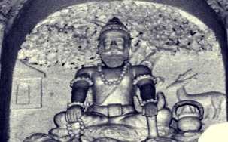
INTRODUCTION
Rishyasringa was a boy born with the horns of a deer and his father was the Vibhandak Rishi, and his mother was Urvashi, a celestial woman. According to legend, his father Vibhandak Rishi was attracted with Urvasi, who was sent by Lord Indra in order to disturb his penance. And after having an affair with her, Rishyasringa was born to them. After the birth of Rishyasringa, his mother Urvasi didn’t cared him and went to the heavens. Due to that, his father Vibhandak Rishi had himself raised him in the forest at his hermitage without showing him the outside world. He was not aware of females and lived in a lonely manner. Once, the kingdom of Anga suffers from severe drought and famine. The King Romapada, was told that this can be solved only by a Brahmin bachelor person. On hearing that Rishyasringa had performed ceremonies, and due to that there was a heavy rain, and he married the princess of that kingdom and lived happily.
WRITTEN BY
R.HARISHANKAR

SANDIPANI
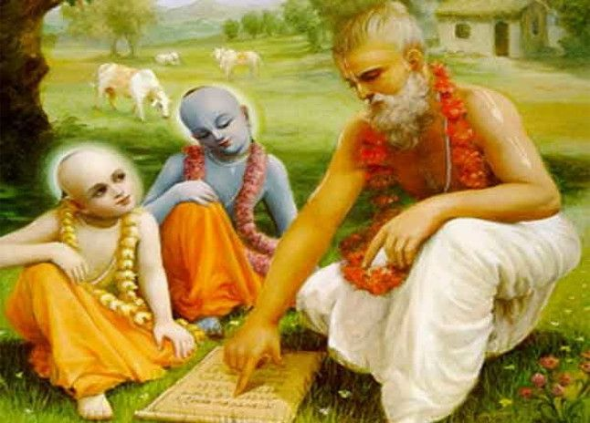
INTRODUCTION
Sandipani Rishi was a holy saint and the guru of Lord Sri Krishna and Balarama. Sandipani was lived in the present day Ujjain, Madhya Pradesh at his Ashram. He was a humble and a great scholar who got sufficient knowledge in vedas and ancient scriptures, and he lived during the previous Dwapara Yuga, approximately before 5000 years back.
He taught the basic education along with the scriptures to Lord Krishna and Balarama, and they studied well through his guidance. He also taught them in a simple manner, in order to grasp the subjects quickly by them. The Brahmin Boy Sudama also joined with them and studied properly, who was also later known as “KUSELA”. Sandipani who already knows about the powers of Krishna and Balarama, had asked the divine children to rescue his child from the ocean at Prabhasa, near the present day Gujarat. The two brothers travelled to Prabhasa, and found that their Guru’s son had been kidnapped by the demon named Sankhasura, and rescued the child from him after killing him. They also got the divine darshan of Lord Vishnu and Ma Lakshmi at that place, and they blessed the divine children.
They took the child of Sandipani from the ocean and handed over him to his father Sandipani. He was very much happy on seeing his son again, and blessed Lord Krishna and Balarama, and he praised them for their divine powers.
IMPORTANCE
He was a holy and pious rishi who has got the opportunity to teach lessons to the divine children. He was also an able scholar and a kind hearted person, who will used to provide food at his ashram for his students, including Krishna, Sudhama and Balarama. He will used to patiently teach the lessons, and will never get angry with his students, even if they are poor in studies. He is such a good, kind and a noble hearted teacher.
Let us worship the great sage and scholar and be blessed.
“OM SREE SANDIPANI MUNIVARE NAMAHA”
“JAI KRISHNA”
“JAI BALARAMA”
WRITTEN BY
R.HARISHANKAR

SATYAKAMA JABALA
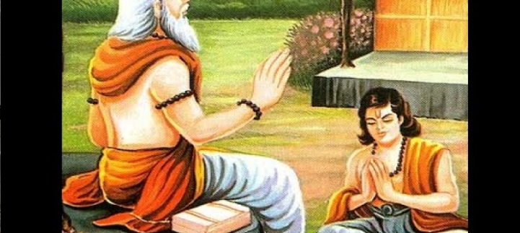
INTRODUCTION
Satyakama Jabala was a pious boy, who has later become a holy sage, and he was mentioned in the sacred text, the Chandogya Upanishad. Once when he asked the name of his father, his mother was unable to tell, since due to the family condition, she had chosen a wrong path. But Jabala, was a very active and an intelligent boy, who went to the sage Haridrumata Gautama, to learn education from him. And he told about his true condition. The sage was convinced with the boy's honesty and accepts him as a student in his school.
As per the advice of his guru, he got knowledge from the divine demi gods and he returns to his teacher and humbly learns the remaining portion of his education. A great Upanishad named as “Jabala Upanishad” was written by him.
Jabala has become a famous sage, and was well accepted by the other sages, due to his vast ocean of knowledge and for his great spiritual powers.
IMPORTANCE
Due to bad fate, though his mother went in a wrong path, he was a good person, and learned all the divine subjects from his guru, and he corrected his mother also, and turned her into a noble and a worshipful woman. After becoming a great sage, through his yogic powers, he helped lot of people, and washed out their sins, and took them into the spiritual path. His greatness and importance cannot be described in full, since he contains full of good features. He was also good at meditation and yoga and shared his knowledge with others. He conducted devotional lectures to the people, and made them to realize their spiritual energy, and asked them to chant the holy mantras on god.
Let us worship the great sage and be blessed.
“OM SREE SATYAKAMA JABALA MAHARISHIYE NAMAHA”
WRITTEN BY
R.HARISHANKAR
SHANDILYA
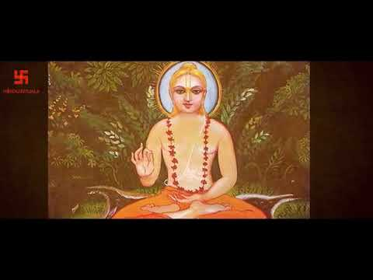
INTRODUCTION
Shandilya was the name of a popular rishi. Those who are having the Sandilya gotra, are the descendants of Sri Shandilya Maharishi. Most of the people belonging to West Bengal, Assam, Maharashtra, Punjab and Gujarat are considered as the descendants of Shandilya.
He was a son of the sage Asita and grandson of the rishi Kashyapa. He was the disciple of Vaatsya rishi. He also trained in vedas under the great rishis: Kaushika, Gautama Maharishi and Kushri. His disciples were Kaundinya, Agnivesa, and Bharadwaj. He has composed the famous Shandilya Upanishad. According to the Bhagavata Purana, he has cleared certain spiritual doubts of King Parikshit of Hastinapura during the previous dwapara yuga.
He lived at his Ashram in the Sarada forest, at a village in the present day Kashmir. The goddess Sarada, a form of Mata Parvati, is said to have given her divine appearance to him, due to his severe penance on her, and blessed him and gave him more spiritual powers. There is also a temple dedicated for Mata Sharada in that place.
IMPORTANCE
He contains great spiritual powers, and through that, he has helped lot of common people, by relieving them from their physical and mental diseases, and given them more confidence and courage. He was also good at yoga and meditation, and shared his spiritual knowledge with others. He was a good, and a kind hearted person, who also provided food to the poor people, during the drought season. He has lived for the welfare of the people, and done good things to them throughout in his life, and after his death, he reached heaven, and happily living there.
Let us worship the great rishi Shandilya and be blessed.
“OM SREE SHANDILYA MAHARISHIYE NAMAHA”
“OM SREE SARADAMBIGAIYE NAMAHA”
“OM NAMO NARAYANAYA NAMAHA”
WRITTEN BY
R.HARISHANKAR

SHRAVAN
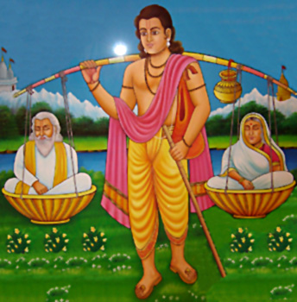
INTRODUCTION
Shravan is a holy person who was mentioned in Ramayana. Shravan was lived along with his parents, and he was a young boy, and his parents lived a saintly life by devoting their entire attention on god. Since they were blind and also have become old, they wanted their son to take them to holy pilgrimages. Since they were poor, the kind hearted Shravan, who was a dutiful son, carried his parents by placing them in a basket, and he carried the basket in his shoulder while on their pilgrimage.
Once, the then-Prince of Ayodhya, Dasharatha was hunting in a forest, which is located in the present day Uttar Pradesh, and he accidently hits Shravan through his arrow, thinking him to be an animal. On his death bed, Shravan requested Dasharatha to tell the incidents. Dasaratha went to his parents and told them about the incident, and they were very much shocked about the death of their dear and lovely son, and they cursed dasharatha also to suffer the same pain which they had faced. And due to that, King Dasharatha was very much worried and collapsed and finally died, when his beloved son Rama had exiled from Ayodhya and went to the forest.
At Mukhed in Maharashtra, there is a Temple dedicated to the great Shravana. Even now, lot of people in the nearby areas are visiting the holy shrine and worshipping him, and getting their wishes fulfilled.
IMPORTANCE
The pious boy shravan, was a very kind hearted person, who took care of his aged parents in a proper manner, and also who carried them in his shoulders for taking them to the holy temples. In this present day life, we cannot imagine such a kind of boy, who was considered as a divine human, and his character was similar to that of Bhakt Prahalada, who was also worshipped and gave more respect to his father, even when his father “Hiranyakasipu” disliked him for his “Narayana bhakti” and punished him several times.
Let us worship the great Shravan and be blessed.
“JAI SHRAVAN”
‘JAI BHAKT PRAHALAD”
“JAI SREERAM”
WRITTEN BY
R.HARISHANKAR

UTTANKA
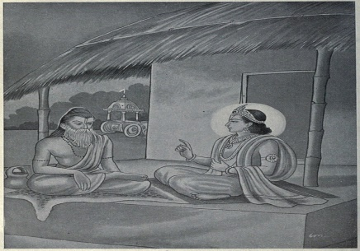
INTRODUCTION
Uttanka, is a rishi who was once lived in the Maru desert as per the great epic Mahabharata. Uttanka is the disciple of Gautama. He is a great scholar and contains good knowledge in vedic subjects and was an expert in all kinds of art and contains wisdom, courage and spiritual powers. Uttanka has once met Lord Krishna, and asked about the wellness of the pandavas and kauravas. Krishna told that due to their bad actions, kauravas were killed in the kurukshetra war, and pandavas were ruling their region. On hearing this Uttanka has got angry with Lord Krishna and decided to curse him, for not correcting the wrong behaviour of the kauravas. Then Lord Krishna took his true form and gave his “VISHWAROOPA DARSHAN” and also blessed him with a boon that would quench his thirst whenever he remembered him. The sage realised his mistake and asked Lord Krishna to pardon him.
WRITTEN BY
R.HARISHANKAR

VAISAMPAYANA
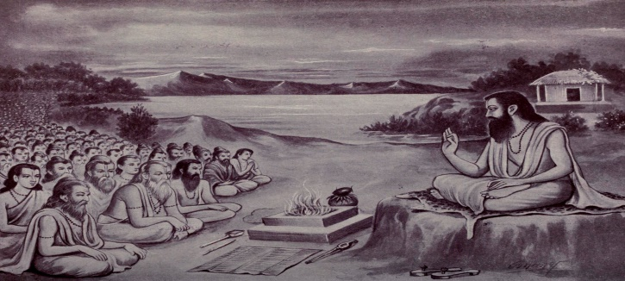
INTRODUCTION
Vaishampayana was the preacher of the Mahabharata. He was an ancient sage and also the master of the Krishna Yajur-Veda. He is also mentioned in lot of sacred hindu texts, and his importance is also mentioned in the divine texts. He learnt all the subjects from Rishi Vyasa and he served as a sincere and honest disciple to him. From his guru, he learnt the Mahabharata, and started propagating it to others. He also shared his divine knowledge with other holy men and the great rishis.
He also helped his guru in his daily activities, and learned all the vedas thoroughly under him. He contained great spiritual powers through meditation and invoked the bhakti spirit among the people, and also made them towards getting attracted with the god, by telling the importance of Lord Krishna, and about his greatness, kindness and supreme powers. It is believed that he would have lived before 5000 years back.
Let us worship the holy saint and be blessed.
“OM SREE VAISAMPAYANARE NAMAHA”
“OM SREE VEDA VYASARE NAMAHA”
“OM NAMO BHAGAVATHE VASUDEVAYA NAMAHA”
WRITTEN BY
R.HARISHANKAR

VISHRAVA
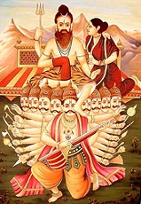
INTRODUCTION
Vishrava was the son of Pulatsya and the grandson of Brahma, and is described as a powerful rishi in the ancient texts. He was very good at meditation and got great spiritual powers through that. Rishi Bharadwaja, was pleased by his good acts, and he married his daughter Ilavida, to him. Through that marriage, they had a son, Lord Kubera, the God of Wealth.
On hearing about his supreme powers, the demon Sumali, and his wife, Ketumati decided to get married their daughter Kaikesi with the Rishi. Through their marriage they had Ravana, Vibhishana, Kumbakarna and a daughter, Shurpanakha. After some time, he left his wife Kaikasi and joined with his first wife Illavida, since Ravana had insulted him as well as his first wife’s son Kubera, and given various troubles to him.
WRITTEN BY
R.HARISHANKAR

WILLYESH RISHI
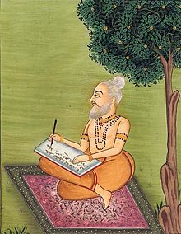
INTRODUCTION
Willyesh Rishi was one of the great rishis and his greatness is mentioned in the Puranas. Willyesh Brahmins are the descendent of Willyesh Rishi and belonged to Hindu Brahmin communities, living in Haryana, Punjab, Rajastan and UP. Willyesh Brahmins were considered as very famous for their knowledge and wisdom and they are also expert in Vedic learning. He was also an expert in all kinds of arts. Sage Willyesh was a renowned scholar of Ayurveda and he also cured the various diseases of the people during the ancient times. He is considered as a great guru, and treated everyone with respect and will never get angry on anyone, and also provided food and free medicines to the poor patients. Similar to Rishi Charaka, he is also famous in doing operations successfully during the ancient times. He is considered as a Master of Ayurveda, and apart from that he is very good at yoga and meditation, and shared his knowledge with others.
WRITTEN BY
R.HARISHANKAR

YAGNAVALKYA
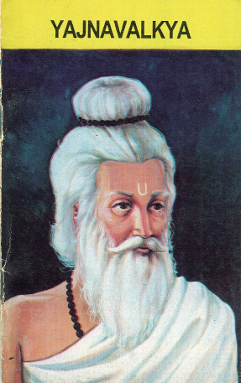
INTRODUCTION
Yajnavalkya was an ancient sage. He is mentioned in the hindu scriptures and in the Upanishads, and it is believed that he lived in Bihar during the 8th century BC. Yajnavalkya is considered as one of the great rishis and helped the people towards attaining spiritual knowledge. He had written the great texts such as Yajnavalkya Smriti, Yoga Yajnavalkya, Vriddha Yajnavalkya, and Brihad Yajnavalkya and also some small texts. He encouraged the participation of women in Vedic studies, and he encouraged the two woman philosophers, Gargi Vachaknavi and Maitreyi and taught them vedic studies. It is stated that, he had two wives Maitreyi and Katyayani. His name is derived from the word Yajna, fire rituals. He is also contributed his works in the Shukla Yajurveda, the Shatapatha Brahmana, the Brihadaranyaka Upanishad. He is also mentioned in the Mahabharata and the Puranas, and also in Jainism texts. He was also good at yoga and meditation. He shared his knowledge with his disciples, and guided them properly.
WRITTEN BY
R.HARISHANKAR

