HINDU DEVOTIONAL DETAILS – R.HARISHANKAR
AMSHUMA DEVA
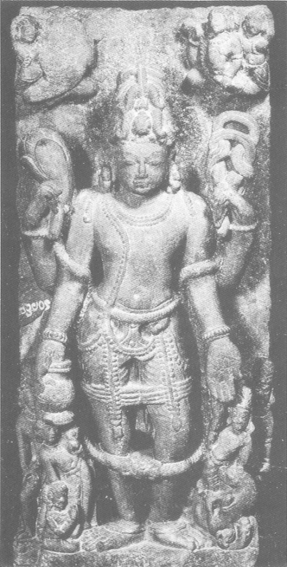
INTRODUCTION
Amshuma Deva is one of the twelve Adityas. He was the son of Mata Aditi and Rishi Kashyapa. He is considered to be an incarnation of Lord Surya.
Amshuma does his duties along with the Wind god, Lord Vayu Bhagavan in a proper manner. Amshuman has got a golden chariot driven by seven horses, and they have formed while churning of the divine ocean.
Amshuma contains divine powers, and his greatness and importance was mentioned in ancient Puranas, Vedas and other holy texts. His sculpture is found in some ancient Hindu temples. He has to be worshipped for getting good health and good mental strength. He can be worshipped along with Lord Vayu Bhagawan and Lord Surya Bhagawan. Amshuma Deva was controlled by Lord Indra, and discharges his duties given to him in an efficient manner. He is a great demi god, who would listen to our prayers, and fulfils our wishes based on our pure bhakti on him.
Let us worship Lord Amshuma Deva and be blessed.
“OM SRI AMSHUMA DEVARE NAMAHA”
“OM SRI VAYU BHAGAWANE NAMAHA”
“OM SRI INDRA BHAGAWANE NAMAHA”
WRITTEN BY
R.HARISHANKAR

ANIRUDDHA
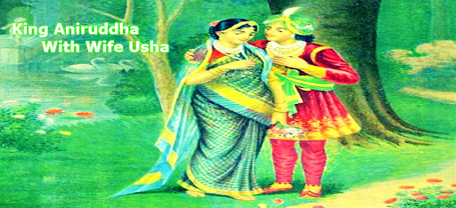
INTRODUCTION
Aniruddha was the son of Pradyumna and the grandson of Lord Krishna, who lived during the previous dwapara yuga, approximately 5,500 years ago. He is considered as an incarnation of Lord Vishnu. Aniruddha was a noble and kind person, and looks very handsome similar to that of his grandfather Lord Krishna.
Once Aniruddha had an affair with a Demon princess named Usha, who was the daughter of the great Shiva Devotee Sri Banasura, who was the son of Mahabali and the great grandson of Sri Bhakt Prahalad. Banasura ruled Assam in a well-versed manner, which was known as Sonitapura in the previous yuga. Since Banasura disliked Aniruddha’s affair with his daughter Usha, he had imprisoned Aniruddha. Later Lord Krishna fought with Banasura and succeeded in the battle, and then Banasura had realised his mistake, and married his daughter Usha with Aniruddha, and they happily lived together for many years with the blessings of Lord Krishna. After the end of their life, both of them went to the abode of Lord Vishnu, the Vaikunta.
His father-in-law Banasura had become one of the divine attendants of Lord Shiva, after his death.
Let us worship the divine avatars and be blessed.
“OM SRI ANIRUDDHAYA NAMAHA”
“OM SRI BHAKTA PRAHALADAYA NAMAHA”
“JAI KRISHNA”
WRITTEN BY
R.HARISHANKAR

ANNA NAGAR AYYAPPAN TEMPLE
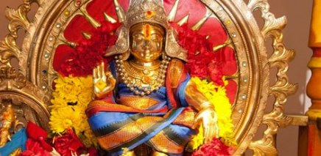
INTRODUCTION
Anna Nagar Ayyappan Temple is dedicated to Lord Ayyappan in Chennai. In the year 1979, the temple construction was started and the kumbabishekam and consecration of the idol were performed in the year 1984 by the temple management. In this temple separate shrines for Lord Ganesha, Muruga, Mata Durga, Navagraha and Sri Anjenaya were also found. In the year 2005, gold coating work of dwajasthambam was made. The temple is situated near the Anna Tower also known as Visveswarayya Tower.
There is an auditorium, for conducting various spiritual programmes, musical concerts and religious discourses. Pujas are performed by Kerala namboodiris. Mahaganapathy homam and the Mritunjaya homam, are the most popular homans performed at this temple. Mandala Puja is celebrated during the month of December. Lot of charitable activities are done at this temple. Daily free food is delivered in the morning to the nearest orphanages through a vehicle. Lot of puja schemes, Annadanam and permanent endowment schemes are available in this temple. Interested devotees can visit the temple office and can get the relevant details:
Address: C-45, 2nd Avenue Road opposite KHM Hospital, Near Anna Tower, Chennai, Tamil Nadu 600040
Let us visit and worship the great Lord Ayyappa and be blessed.
“OM SRI KANNI MOOLA GANAPATHIYE NAMAHA”
“OM SWAMIYE SARANAM AYYAPPA”
“OM NAMAH SHIVAYA”
WRITTEN BY
R.HARISHANKAR

APSARAS
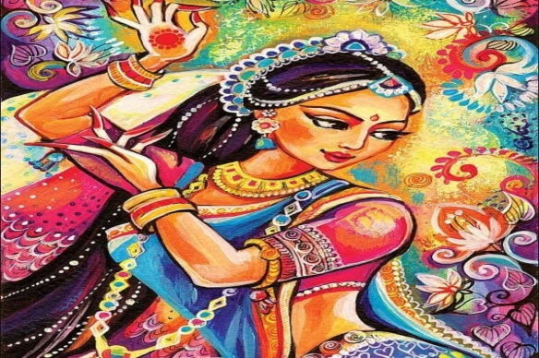
INTRODUCTION
Apsaras are considered as celestial dancers who reside in the Indra Loka. They are specialized in diversified fields of arts like sculpting, dancing, and painting and are treated as the most respectable women in the Swarka Loka.
The most famous among the Apsaras are Urvasi, Menaka, Rambha and Tilottama. Apsaras are very beautiful and excellent in dancing, and they are controlled by Lord Indra Bhagawan. Some Apsaras are married to Gandharvas, who are good at music and singing songs. Generally Apsaras would dance in the Indra Lok, in order to please their master Lord Indra.
They would sometimes be sent by Lord Indra to the earth in order to attract great sages and the kings in order to disturb their meditation, and in order to safeguard Lord Indra’s position in the heaven. Apsaras contain super natural powers, and they could go anywhere and at any time. They are considered as very pure and holy, and they intentionally would never give problems to others, but since they have to follow the orders of Lord Indra, sometimes they have to change their nature.
They are mentioned in Bhagavata Purana, Vedas, Mahabharata, and in other ancient puranas, and their features were mentioned in that. In general, according to humans, they are considered as worshipful deities, and we have to worship them along with Lord Indra, in order to get all kinds of prosperities in our life.
Let us worship Apsaras and be blessed.
“OM MATA APSARA DEVATA NAMAHA”
“OM SRI INDRA BHAGAWANE NAMAHA”
“OM NAMO NARAYANAYA NAMAHA”
WRITTEN BY
R.HARISHANKAR

ARYAMBA - HOLY MOTHER OF SRI ADISHANKARA
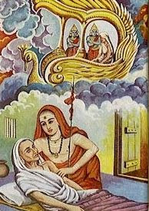
INTRODUCTION
Aryamba(8th century AD) was the holy mother of Sri Adisankara, and she was born in a Brahmin family, and at her younger age she got married with a pious Brahmin scholar Shivaguru, and had one son, who was later famously known as Jagadguru Sri Adisankaracharya. Sankara’s father was died at his childhood, and he was brought up by his mother in a proper manner. At his younger age itself, he has performed miracles like changing the course of the river for the sake of his mother, and removing the illness of a Shiva Devotee, and making the impure persons to become pure etc.
Sri Sankara had learned all the divine subjects and was well versed in Vedas, Shastras and other Holy scriptures. At his younger age itself, Sri Sankara felt the need to become a saint, for the wellness of the mankind, but his affectionate mother Aryamba, doesn’t wants to separate herself from her only son. But Sri Shankara had got permission from his mother, to become a saint, when a crocodile had tried to kill him. Aryamba doesn’t know any other way, and hence she has given permission to her son to become a saint.
Due to his spiritual powers, he arrived to his birth place Kaladi and visited his mother at her death bed, and consoled her and chanted Lord Shiva’s holy mantras on her ears, and gently rubbed the body of his mother in his hands. Due to that, his mother was freed from her sins, and has attained SALVATION.
Let us worship the holy mother Aryamba and be blessed.
“OM MATA ARYAMBA NAMAHA”
“OM SRI ADISANKARARE NAMAHA”
“JAI SHIVA SAKTHI”
WRITTEN BY
R.HARISHANKAR

ASAMANJA
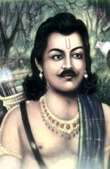
INTRODUCTION
Prince Asamanja was the son of King Sagara and Queen Sumati. As per ancient texts, it is believed that he was cruelly acted with the young boys in his region, and used to throw them in the Divine River Sarayu and made them to get drowned in the river. Due to his activities, his father Sagara had exiled him from his palace, and Sagara’s another son Amshuman had become the king of Ayodhya. Amshuman was a great person and a noble scholar, who was liked by the people of Ayodhya for his kindness and gentleness over them, and he ruled the kingdom of Ayodhya in a well versed manner.
Asamanja was actually a good person, and in order to distance himself from the royal family and to become a saint, he had done like that. Then Asamanja revealed his spiritual powers and brought back the life of the drowned boys, and due to that, the people of Ayodhya, and his parents were very happy, and compelled him to stay with them. But Asamanja had hesitated to stay with them, and left Ayodhya, and went to the forest, and built up an ashram, and become a great sage and performed severe meditation on Lord Shiva, and attained SALVATION after his death.
Let us worship the great person and be blessed.
“OM SRI ASAMANJARE NAMAHA”
“OM SRI AMUSHUMANE NAMAHA”
“JAI SRIRAM”
WRITTEN BY
R.HARISHANKAR

AYANAVARAM RAGHAVENDRA SWAMY MUTT
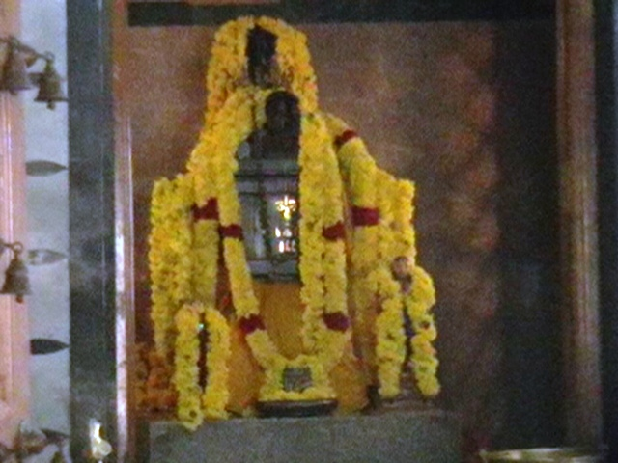
INTRODUCTION
Raghavendra Swamy Mutt is situated at Ayanavaram and it was built during the year 1982, and the temple is located nearby Ayanavaram Bus Terminus. Lot of devotees would visit this Mutt during Thursdays, and other auspicious festival days and lot of miracles were happened in the life of the devotees of Raghavendra after visiting this holy Mutt. The temple is situated in a large area, and a shrine of Lord Vinayaka is also located inside the temple complex. Annual Aradhana festival would be celebrated in a grand manner in this temple, and free food is offered for three days to all the devotees.
Many devotees have experienced lot of changes in their life, and they have also shared it to others. When I was residing in Ayanavaram, I used to visit this temple for several times, and lot of good changes were happened in my life.
Hence let us visit this holy shrine and be blessed.
Temple Address:
Sri Raghavendra Swamy Mutt
No.7, Pananthope Colony,
Ayanavaram,
Chennai – 600 023
Let us worship the great saint and be blessed.
“OM SRI RAGHAVENDRAYA NAMAHA”
“JAI SRIRAM”
“JAI KRISHNA”
WRITTEN BY
R.HARISHANKAR

BABA HARIRAM
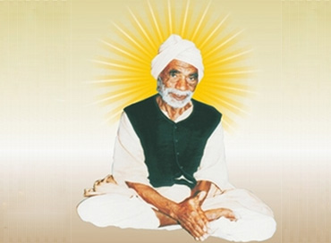
INTRODUCTION
Baba Hariram (1867–1947) was a great saint and lived in Sindh Province of Pakistan. He was a great guru and a spiritual leader, who was a sincere devotee of Lord Srirama, and used to frequently chant the Rama Mantra “JAI SRIRAM”, and also insists others to do so. He was fondly called as Baba, due to his vast knowledge in all the subjects and based on his spiritual teachings. He was the disciple of Baba Kriparam, who also an ardent devotee of Lord Srirama. His follower was Sri Bhagat Wadhuram, an illiterate man who had changed into 'Baba' through the grace of Lord Rama.
Devotees of Baba Hariram are mainly found in Sindh province in Pakistan, and some of the devotees are living in Delhi, Mumbai and Kolkata.
He is considered as a man of simplicity who has controlled his senses, and showed kindness and affection on each and every living being in the world. He says that “Lord Rama is dwelling in each and every living being, and we have to show courtesy on all of his creations, in order to satisfy Lord Sriram”.
DISCIPLES
- Hirdaram
- Ramchand
- Bhauji
- Siyaram
- Mangalram
- Ramsaran
Sant Hariram has done several social welfare activities like providing food to the poor, helping the people by building shelters to them and done valuable service to the poor people during the times of natural calamities.
Let us worship the great saint and be blessed.
“OM SRI BABA HARIRAM NAMAHA”
“JAI SRIRAM”
“JAI SITA MATA”
WRITTEN BY
R.HARISHANKAR

BHAKTA AND BHAGAVAN
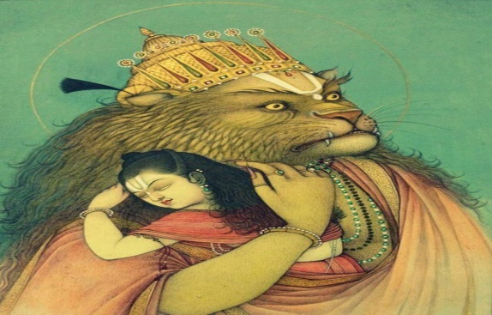
INTRODUCTION
The relationship between a bhakta and the bhagavan is that of a mother and a child. In this picture itself, we can see that Lord Narasimha is gently holding Bhakt prahalad in his hands. God expects only a true devotion from his devotees, and he didn’t expect any rich contribution from them. Bhagavan Krishna tells, “I will be satisfied, even if a true devotee offers me a tulsi leaf, and I would immensely grant boons and fulfil his wishes”.
We can take the example of great devotees like Bhakt Prahalad, Narad, Dhruva and Markandeya. All these devotees were entirely surrendered at the feet of the god, and didn’t expect anything from him and they had expected only their entire dedication on god permanently. Such kind of selfless devotion only is appreciable by the god. Generally god knows when to fulfil the favours of his sincere devotees, even if they didn’t tell their expectations. Generally, he would take away the wealth from them, and make them to show their entire attention on him, in order to give them SALVATION after their death.
We can see from Puranas and other ancient texts that most of the devotees would suffer a lot till they reach the divine world. Why do they? They are getting tested and tested again and again by the god, in order to make them to shine brighter, similar to making of a beautiful sculpture from the stone. In case of the nayanmar saints, most of the nayanmars were very much tested by Lord Shiva, and finally they reached the Kailasa, and still enjoying the eternal bliss in the divine world. Similar to that, we also have to keep our entire attention on god, and whatever difficulty we face, we must never worry about it, and should completely surrender on to his lotus feet.
Let us worship the almighty and be blessed.
“OM SRI VINAYAKAYA NAMAHA”
WRITTEN BY
R.HARISHANKAR

CHILDHOOD PLAYS AND MIRACLES OF LORD KRISHNA
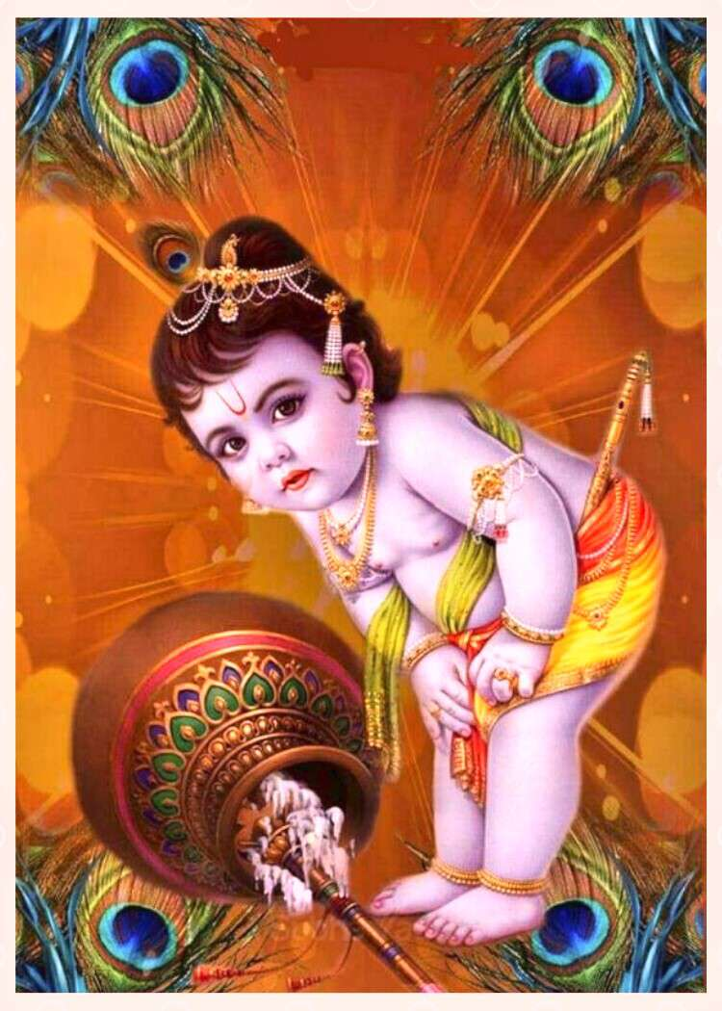
INTRODUCTION
Lord Krishna is the supreme god, and he is the avatar of Lord Vishnu. He was born during the Dwapara Yuga, and done lot of mischievous activities and performed many miracles. He used to steal butter in the neighbour’s house, replace the things in their house, but pretends himself to be an innocent boy. The people in Gokulam have done lot of good karmas, since they witnessed the beautiful playful activities of child Krishna. Whatever act he performs, no one would get angry on him, and instead of that, they would get more affection on him, due to his lovely smile.
Lord Krishna had killed lot of demons very easily, and reduced the burden of the earth goddess, also known as Mata Bhudevi. Both Krishna and Balaram are very good boys and had stolen the hearts of the people in Gokulam. Due to their presence, no one had suffered from illness, mental tension and mental disorders. Every one lived happily with the presence of the divine child Lord Krishna and Balaram. Lord Krishna took the avatar, in order to make the people to move in a right path, and gave good guidance for living a noble life through his famous Bhagavat Gita.
When Vyasa Bhagavan has completed the work of Mahabharata, he still felt some mental uneasiness. Then, sage Narada appeared before him, and asked him to write the epic “BHAGAVATHAM” in order to mention the child hood plays and miracles of Lord Krishna. As per his advice, when Sage Veda Vyasa had completed the work “BHAGAVATHAM”, he got more satisfaction and happiness in his mind, and he gained more spiritual powers.
During the time of Lord Krishna, people loved each other and contained polite behaviour, and they didn’t suffer much in their life. But in this present age of Kali Yuga, a person would be respected only based on his status and wealth and not on his good behaviour. Due to that, let us pray to the great god Vishnu, to send Lord Krishna once more in this earth, in order to make good things to occur in this world.
Let us worship Lord Krishna and be blessed.
“OM SRI KRISHNA BHAGAWANE NAMAHA”
“OM SRI BALADEVARE NAMAHA”
“OM NAMO NARAYANAYA NAMAHA”
WRITTEN BY
R.HARISHANKAR

DAYA BAI
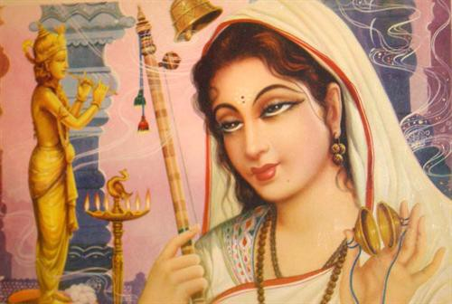
INTRODUCTION
Daya bai (18th century AD) was born in a pious Hindu family at a village in Rajasthan. After hearing the stories of Lord Krishna from her mother, she was devoted to Lord Krishna at her childhood itself. She used to chant the names of Lord Krishna, and visit the nearby temples and perform bhajans and praise his glories and gave lectures on Bhagavatham and Bhagavat Gita. Due to her sincere devotion on the god, she didn’t marry, and dedicated her entire life towards worshipping Krishna.
After attaining teenage, she heard about Swami Charandas and become his disciple. Swami Charan das was a great devotee of Lord Krishna, and gave warm welcome to her at his ashram, and provided proper food, and shelter and looked after her like his own daughter.
In course of time, she become the successor of Charan das and began to spread the bhakti spirit among the people, and done lot of social welfare activities for the benefit of the poor people. She also written a sacred text known as “DAYABODH”, and she died in Bithoor, Uttar Pradesh. It is believed that after her death, she has reached the abode of Lord Vishnu, the Vaikunta.
Let us worship the noble saint and be blessed.
“OM SRI DAYA BAI NAMAHA”
“JAI KRISHNA”
“JAI RUKMANI MATA”
WRITTEN BY
R.HARISHANKAR

DAYA MATA
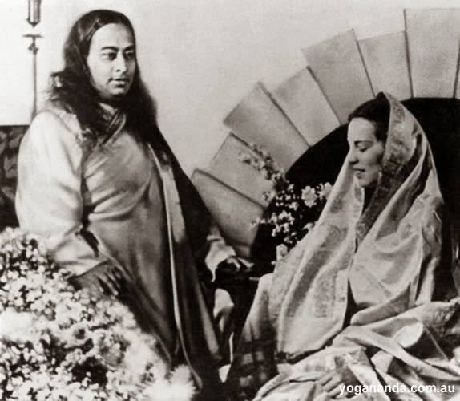
INTRODUCTION
Daya Mata (1914 –2010) was the president of the organization founded by Paramahansa Yogananda. The organization was founded in order to teach Yoga concepts, meditation, developing good behaviour, realization of the god from our soul, Dedication to god, and to spread humanity and kindness among the entire world. Her birth name was Rachel.
She was born in Salt Lake City, Utah, USA to a holy Christian family. And her parents and her ancestors were the devotees of the great Lord Jesus Christ. They have served in a famous church at USA, and dedicated their entire attention on spreading the Christ message among the people.
Daya Mata, being born as a Christian, was very much interested in reading bible and Christ related books in her childhood days. After she met Yogananda at the age of 17, she found a sense of satisfaction with the great Guru Sri Yogananda, and she immediately joined in his ashram. She has attained sainthood under Yogananda and she was named as Daya.
According to her, every human being wants themselves to be loved by others. And she started searching for God. Finally she met a wonderful messenger of god, Sri Paramahansa Yogananda. And she said that she was very much attracted with his good behaviour, and the way he taught things to her was very much liked by her.
She became one of the Yogananda’s main disciples. She considered her guru as her friend, father, guide and god. According to her, Swamy Yogananda was everything to her.
She served as the president of Sri Yogananda Satsanga from 1955 to till her death in 2010, in a wonderful manner.
Her mother, brother and sister also served as Yogananda's assistants for many years, and they accompanied with him in his spiritual tours.
She died in the year 2010, in Los Angeles.
WORKS
- Enter the Quiet Heart
- Finding the Joy Within you
- Only Love
Let us worship the great saint and be blessed.
“JAI DAYA MATA”
“JAI SWAMY YOGANANDA”
WRITTEN BY
R.HARISHANKAR

DIVINE WEAPONS
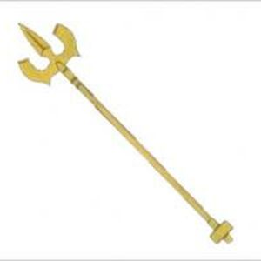
INTRODUCTION
According to Hinduism, Divine weapons forms part of each and every deity. Almost all the Hindu deities holds some weapons in their hands, in order to remove the evil forces from the universe and to safeguard their devotees, and to maintain peace and prosperity in the universe. By possessing the divine weapons, the gods and the demi gods are considered as more powerful and similar to worshipping the gods and goddesses Hindus would worship their divine weapons also. Let us see the details of divine weapons and their use:

Astra | Deity | Effect
Brahmaastra | Brahma | Would destroy the entire universe and considered as the more powerful astra as mentioned in Mahabharata. Parasurama, Bhishma, Drona, Karna and several other warriors possessed the knowledge to invoke this weapon. And this weapon was also used during the battle of Rama and Ravana.
Trishula | Shiva | The Trident of Lord Shiva is the most powerful weapon, and contains the features of Lord Shiva. And it contains the powers of Mata Parvati also.
Gada (mace) | Lord Hanuman | Weapon of Lord Hanuman. And it is used by Hanuman during the battle with Ravana and also Bheema used it during the Kurukshetra war.
Sudarshana Chakra | Vishnu | The most important weapon of Lord Vishnu, which is created by Lord Viswakarma and given by him to Lord Vishnu. It is used by Lord Vishnu at many times during his battle with the demons.
Indraastra | Indra | Possessed by Lord Indra, the god of heavens, and it contains the powers of Lord Indra, and used during the period of war.
Agneyastra | Agni | This weapon belongs to Lord Agni Dev, the god of fire and destroys all the bad elements in the universe. It is used only for productive purpose by him, and especially when he was ordered by his master Lord Indra towards invoking it against his enemies during the battle. It contains fire element.
Varunastra | Varuna | It contains water element. This weapon is mostly used to prevent the Agneyastra.
Nagaastra | The Nagas | This weapon when invoked in the battle field, releases lot of snakes and attacks the enemy forces with their poisonous flames. This weapon was used by Karna against Arjuna in Mahabharata.
Garudastra | Garuda | By invoking this weapon, one can get relieved from the clutches of the Nagaastra. It contains the features of the divine bird and the vehicle of Lord Vishnu, Sri Garuda Bhagavan.
Vayuvyastra | Vayu | By invoking this weapon, the enemy forces would be destroyed by creating severe storm and wind. Arjuna used this weapon against Karna in the battle field. Contains the powers of the great Vayu Bhagavan, the humble servant of Lord Indra and Lord Vishnu.
Suryastra | Surya | Contains the features of Lord Surya. Arjuna used this astra against Shakuni in the Kurukshtra War.
Vajra | Indra | Used by Indra to destroy the demons. Contains the features of Indra Bhagawan.
Narayanastra | Vishnu | Used by Lord Vishnu during the battles.
Kaumodaki | Vishnu | Divine mace of Lord Vishnu. Would destroy the enemy forces within a few seconds.
Sharanga (bow) | Vishnu | The bow of Lord Vishnu, was used by Sri Rama and Sri Krishna.
Nandaka | Vishnu | The sacred divine sword of Lord Vishnu. It was used by Lord Krishna to kill the demons.
Pinaka (bow) | Shiva | Also called as Shiva Dhanush, was the bow of Lord Shiva, which was given to King Janaka, father of Mata Sita, and was broken by Lord Rama during the swayamvara.
Rudra Astra | Shiva | Contains the powers of Lord Shiva. It is very powerful and used only in times of need.
Pashupatastra | Shiva | One of the most powerful weapons of Lord Shiva, and this astra was capable to destroy the entire universe. Arjuna and Rama handled this weapon.
Parashu (axe) | Shiva | The Parashu (axe) was a divine weapon given to Lord Parashurama by Lord Lord Shiva due to his devotion.
Gandiva (bow) | Shiva | Weapon of Arjuna given by Lord Shiva, and used by him during the Kurukshetra battle.
Spear | Muruga | Vel was possessed by Lord Murugan, a War God also known as Vel Murugan, and it was given by his mother Ma Parvati in order to destroy the demon king Surapadman and his forces.
Ankusa | Vinayaka | The Ankusa, a divine weapon used by Lord Vinayaka, and it was used by him during the times of his battles with the demons.
Let us worship the divine weapons and be blessed.
“OM SRI DIVYA ASTRAYA NAMAHA”
“OM SRI VINAYAKAYA NAMAHA”
“OM NAMO NARAYANAYA NAMAHA”
WRITTEN BY
R.HARISHANKAR

FAMILY DEITY AND GUARDIAN DEITY
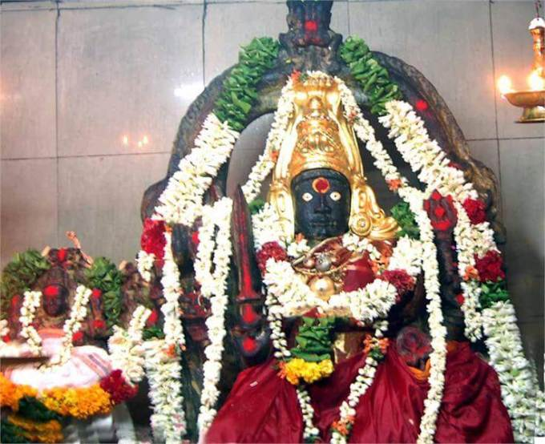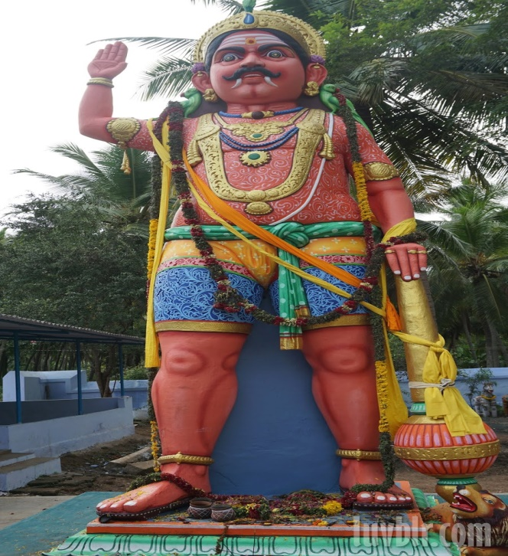
INTRODUCTION
Family deity and Guardian deity are the most important deities whom we have to worship in our everyday life. Family deity also called as Kula Deivam belongs to a person’s ancestral god or goddess and we must personally visit and worship our Kula Deivam’s temple and seek his/her blessings at least once in a year. Those who don’t know their Kula Deivam can worship Mata Angala Parameswari at Melmalayanur located at Tamilnadu. And Malayanur Parameswari can be worshipped by everyone as their Ishta Devata. She is the mother goddess, who shows sympathy on us, and reduces our sufferings and brings happiness and prosperity in our life.
Guardian deity also known as Kaval deivam varies from place to place. Generally Lord Ayyanar can be worshipped by the devotees as the Kaval deivam along with their main kaval deivam. Lord Ayyanar protects us from our enemies and come with us in our each and every step during our entire life time. He will be with us during our difficult times, and removes our tears and brings happiness and peacefulness in our life.
Though some people believe that Lord Ayyanar is a demi god, he is considered as a main god by many people, and contains the features of Lord Dharma Sastha, and he is also believed to be a form of Lord Ayyappa. Ayyappa and Ayyanar are the two avatars of Lord Dharma Sastha, who have taken the avatars, in order to lend their helping hands on us, and to protect us from our enemies. They would give boldness, courage, wisdom, enthusiasm and removes the fear in our minds, and support us, and be with us in our day to day life.
Let us worship Mata Angalamman and Lord Ayyanar and be blessed.
“OM SRI MELMALAYANUR ANGALA PARAMESWARIYE NAMAHA”
“OM SRI AYYANARE NAMAHA”
“OM NAMAH SHIVAYA”
WRITTEN BY
R.HARISHANKAR

GANDHARVAS
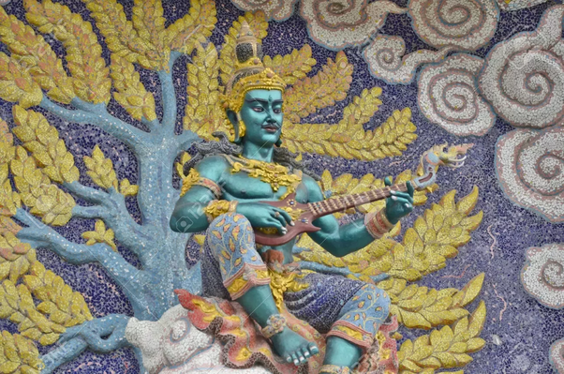
INTRODUCTION
Gandharvas are the celestial musicians and they are mentioned in Hinduism, Buddhism and Jainism texts.
Gandharvas are male demi gods and the consorts of the celestial dancers also called as the Apsaras. They contain feathers and contain an attractive face and a handsome look, and they possess good musical skills. Mostly Gandharvas used to sing in the court of the great god Sri Indradev at Swarkalok.
Gandharvas also acted as a mediator between the gods and humans. According to ancient texts, gandharva marriages would be mostly conducted by the kings during their visit to a different place, and it would be performed without any rituals and mainly with the consent of the groom and the bride, and they would exchange their rings, as a symbol of marriage.
Gandharvas are mentioned in Mahabharata and in ancient texts. Gandharvas are generally considered as the low level demi gods when compared with the Divine Devas in the heaven. There is a separate Loka for them known as Gandharva Loka, and they used to reside in that Loka.
Chitrasena was a Gandharva who was mentioned in Mahabharata. He was the music and dance teacher of Arjuna. The great musician Tumburu is also a gandharva who was very good in composing and singing songs and playing music and contains talents equivalent to Devarishi Narada and used to perform music in the court of Lord Indra and Lord Vishnu.
Let us worship the Gandharvas and be blessed.
“OM SRI GANDHARVAYA NAMAHA”
“OM SRI INDRA BHAGAWANE NAMAHA”
“OM SRI VISHNU BHAGAWANE NAMAHA”
WRITTEN BY
R.HARISHANKAR
GANESH – ARDENT DEVOTEE OF LORD GURUVAYURAPPAN
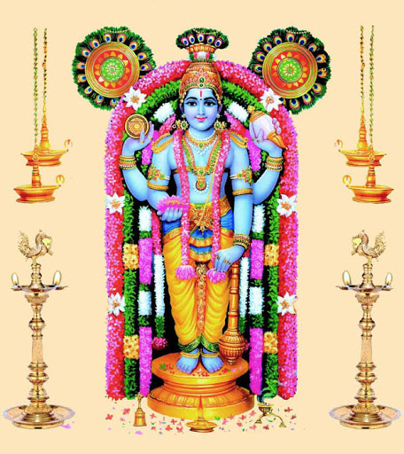
INTRODUCTION
Ganesh was an ardent devotee of Lord Guruvayurappan and he lived in Palakkad Kerala. He was an intelligent boy and secured good marks in his school exams. He was also interested in spiritual matters, and regularly visits temples in his nearby area. Once in a year, during the Krishna Jayanti festival, he used to visit Guruvayur along with his sister and parents and would worship the great Lord Sri Guruvayurappan.
During the first year of his college studies, one day, suddenly he got fainted in the college floor, and remained in an unconscious state for a few hours. The college management informed his condition to his parents, and his parents were admitted him in a nearby hospital. The doctors were diagnosed and found that he is having brain tumour. On hearing this, he and his parents were very much depressed and were disinterested in running their life. Suddenly ganesh got some hope and decided to visit Guruvayurappan along with his family. He went there and prayed to the lord and promised the lord to offer bananas as thulabaram, if he gets relieved from the disease. After few months, he got admitted in the hospital, and the doctors were successfully completed the operation, and within a few days after surgery, he was completely relieved from his disease. As per the promise, he immediately went to Guruvayur along with his family and offered bananas as thulabaram.
This incident was happened during 1960’s.
Let us worship the great god Sri Guruvayurappan and be blessed.
“OM SRI GURUVAYURAPPANE NAMAHA”
WRITTEN BY
R.HARISHANKAR

GAURI MA
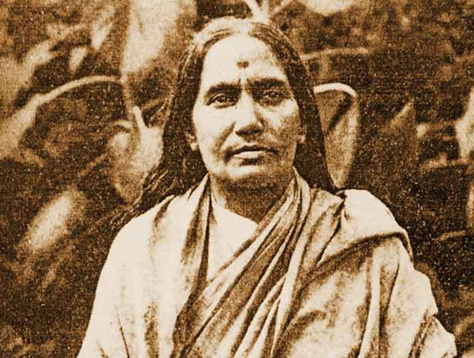
INTRODUCTION
Gauri Ma (1857–1938) was a great disciple of Ramakrishna and Sarada Devi and she was the founder of the Saradeswari Ashram, Kolkata. Her birth name was Mridani.
Gauri Ma was not interested in worldly affairs, and hence she has become a saint, and she was fondly called by Ramakrishna as Gauri Ma.
Gauri Ma was born in Sibpur, Howrah. She developed interest towards spirituality from her younger age itself. She considered herself as the devotee of Lord Krishna, and began to worship him with full of devotion in mind. She used to perform puja to Lord Krishna in the temples and at the Ashram.
After some time, she undertook pilgrimage to various holy Krishna temples throughout India. She got great interest in reading Hindu spiritual texts, and used to do yoga and meditation.
Gauri Ma used to serve in a wonderful manner to Guru Ramakrishna and Mata Sarada Devi, and prepare delicious food for them.
Through the Saradeswari Ashram, she has performed lot of charitable services to the poor village people. She also used to feed cooked food to the poor children by visiting their houses, and taught basic education to them. And she helped in the marriage of the poor village girls by providing financial aid through the donations received from the rich people. Due to her noble service, she was highly praised by Swami Vivekananda, Ramakrishna and Sarada Devi.
She continuously served the society till her death, and she left her physical body in the year 1938.
Let us worship the noble saint and be blessed.
“OM SRI GAURI MA NAMAHA”
“JAI KRISHNA”
WRITTEN BY
R.HARISHANKAR
GNAYIRU SUN GOD TEMPLE
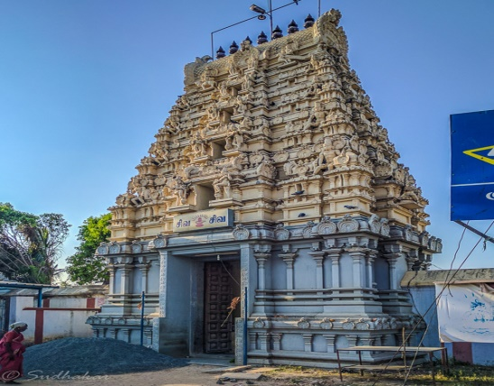
INTRODUCTION
Gnayiru Sun god temple also known as Sri Pushparatheswarar temple is situated at the Gnayiru village and it is considered as one of the sacred navagraha temples located at Chennai and dedicated to Lord Surya Bhagawan and the main deity is Lord Shiva, who is known as Lord Pushparatheswarar. For visiting this temple, bus facility is available from Red hills Bus Terminus and there are no big hotels or lodging facilities near the temple. Those who come from distant places, can have their food, and stay in a lodge at Redhills, and visit this temple either through bus or through auto. This temple had been praised in Periya Puranam. This is one of the ancient temples of Lord Surya Bhagawan.
According to legend, it is believed that once Sun God was cursed by Lord Brahma, and due to that he has lost his brightness, and in order to get relieved from the curse, Lord Suriya performed severe meditation on Lord Shiva at this temple and took bath in the sacred temple tank, and performed puja to Lord Shiva and Mata Parvati, who is called as Mata Swarnambikai.
Due to his severe penance, Lord Shiva appeared along with Swarnambikai and blessed him and relieved him from his curse.
Apart from the main shrine of Pushparatheswarar, there is a separate shrine for Mata Swarnambigai and also a separate shrine for Lord Sun. It is advisable to visit this sacred temple during Sundays, in order to get favourable results in our life. By visiting and worshipping the deities at this temple, all of our diseases would be removed from our body, and we would get good energy, and get all kinds of prosperities in our life.
Temple opens from 7.00am–12.30pm and 4.30pm-8.30pm
Contact: Sun God Temple, Arumandai Gnayiru Road, Gnayiru Gramam,
Sholavaram, Chennai.
Let us visit and worship this ancient temple and be blessed.
“OM SRI SURYA BHAGAWANE NAMAHA”
“OM NAMAH SHIVAYA”
“OM SREE SAKTHI DEVIYE NAMAHA”
WRITTEN BY
R.HARISHANKAR

GODS, GODDESSES, SAINTS AND HOLY RIVERS
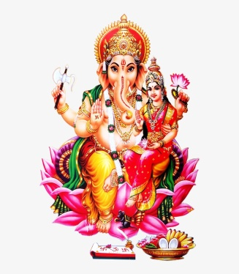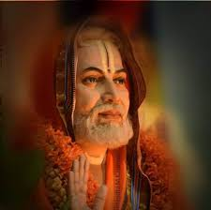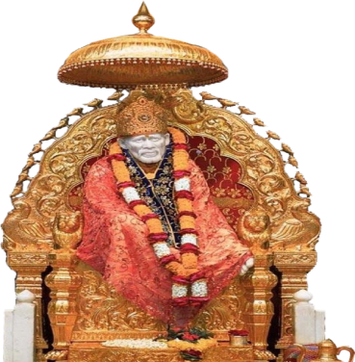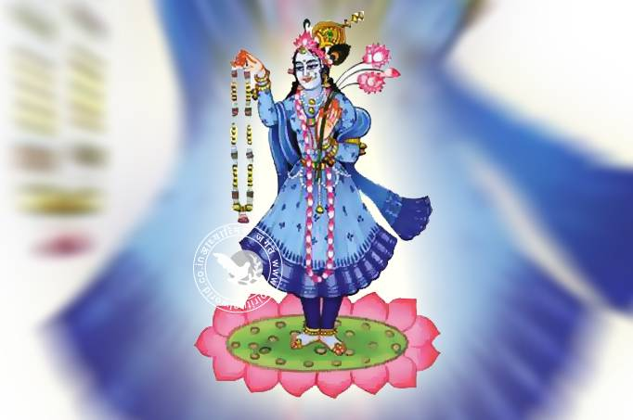
INTRODUCTION
In Hinduism, why do we have lot of gods, goddesses, saints and worshipful river goddesses? The main thing is to concentrate our attention on devotional matters, and not on other unnecessary activities, and people are worshipping their favourite gods and goddesses based on their dedication. In general, all the deities are considered as holy and whoever we worships, it reaches one formless supreme power, and through that only, lot of divine deities were formed.
Saints are created in order to reduce the sufferings of the people, and people would have some kind of relief, and they would think that someone is ready to protect us, in case of all situations as well as in case of emergency needs. Generally saints would recommend our needs to the gods, and make our needs fulfilled at the appropriate time. Great saints like Raghavendra and Shirdi Baba were incarnated in this earth only for doing goodness to us. Instead of directly worshipping the divine deities, we have to first worship the saints, who are our immediate saviours, and then we can worship the deities. Since god himself is asking us to reach him only through our appropriate spiritual guru.
Next to the deities and saints, holy rivers like Ganges, Godavari, Yamuna, Tapti, Kaveri and Thungabadra etc, plays a major part in removing our sins and gives all prosperities in our life. It is not possible for us to directly visit each and every river and to worship the great river goddesses. Instead of that, we can chant their names and their slokas, and keep a framed picture in our home, and can do puja to them, in order to get favourable results in our life. We can also watch the greatness of the holy rivers in internet, and by reading devotional books related to them.
Hence, let us worship the great deities, saints and holy river goddesses and be blessed.
“OM SRI VINAYAKAYA NAMAHA”
“OM SRI RAGHAVENDRAYA NAMAHA”
“OM SRI GANGA MATA NAMAHA”
WRITTEN BY
R.HARISHANKAR

GOKULAKRISHNAN – STAUNCH DEVOTEE OF GURU RAGHAVENDRA
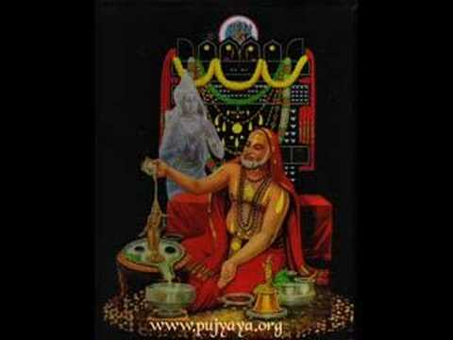
INTRODUCTION
Gokulakrishnan was a staunch devotee of Guru Raghavendra swamy and he was born in the year 1971 in a Brahmin family at Triplicane. From his childhood itself, he was a devotee of Guru Raghavendra, and would frequently visit the Triplicane Raghavendra Mutt on thursdays. He has completed his schooling in a school at Triplicane and later on he has finished his B.Com and M.Com degree also through the grace of Raghavendra. He was not good at studies but somehow he had managed to complete his education.
Since Gokulakrishnan was not healthy, he had struggled a lot towards working in private companies. He had suffered from many health issues like Sinus, Asthma, frequent fever, cold and cough. Even after taking proper treatment in big hospitals, he didn’t get cured. Due to that, he had changed many companies. This resulted in depression in his mind, and he used to frequently scold his parents. His parents were maintained patience, since he was their only son.
During the year 2005, he planned to go for an interview on a Thursday morning. At that time, he didn’t purchase mobile phone. He went to Triplicane Mutt and prayed to the Guru, and tried to attend the interview at Avadi. Suddenly, he heard a voice, and it informed him to go to his home immediately. He got surprised and immediately he went home and there he saw his father as a dead body. He has expired just a few minutes ago before his arrival. He was very much shocked, and he was amazed about the kindness of the guru, who had conveyed him about the death of father, and after that he became a staunch devotee of Guru Raghavendra. Similar to that, Guru has performed lot of miracles in his life, and still now he is surviving in this world only through the grace of the divine guru.
Let us worship the great guru Sri Raghavendra and be blessed.
“OM SRI RAGHAVENDRAYA NAMAHA”
“JAI SRI RAM”
“JAI HANUMAN”
WRITTEN BY
R.HARISHANKAR

GOPAL – ARDENT DEVOTEE OF SHIRDI SAIBABA
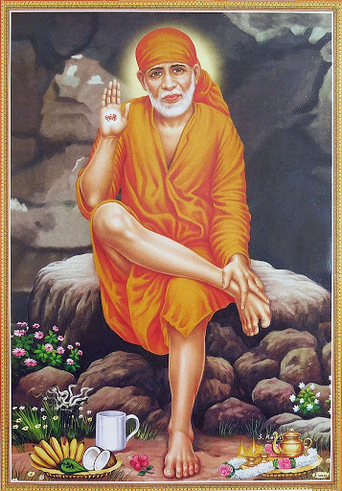
INTRODUCTION
Gopal (20th century) was born in a village at Mumbai and he was an ardent devotee of Sri Sainath from his younger age itself. He used to visit Shirdi on every year during the Guru Purnima festival, and have the darshan of Sairam. He was very good at studies, and his father had worked in a private company and his mother was a house wife. He was the only son for his parents. He has completed his law degree and become a professional lawyer. He used to contribute a share of his income for the welfare of poor and also would donate huge sums during his visits to Shirdi.
One Sunday, after having his morning breakfast, the food he ate didn’t get digested, and he started vomiting. First he and his parents were thought it was an ordinary problem, and he took some medicines. But the problem continued for several days. And he got tested and got admitted in a famous hospital at Mumbai. But nothing has changed his health condition, and day by day his conditioned was worsened. Immediately he got an idea to go for a trip to Shirdi and went along with his family. He ate the holy food at the Sai Prasadalaya, and to his surprise, it got digested. He stayed for several days, and continuously had his food in the Sai Temple, and he could able to have his food without any digestive problems.
He and his parents thanked Sainath for the mercy shown on him and informed the incident to the temple management and presented a lump sum as donation to the temple authorities, and left shirdi and reached his hometown. After reaching Mumbai, he narrated the incident to everyone and everyone was delighted and praised the glory of Sainath.
Let us worship Sainath and be blessed.
“OM SRI SAINATH MAHARAJ KI JAI”
WRITTEN BY
R.HARISHANKAR

GOPALER MA
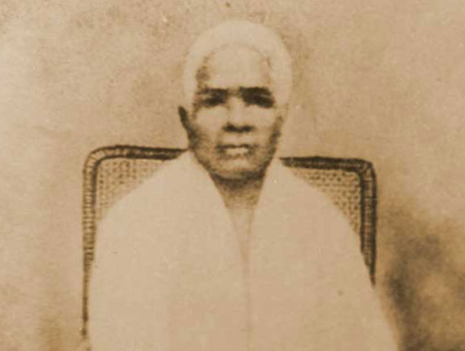
INTRODUCTION
Gopaler Ma (1822 –1906) was a devotee and disciple of Sri Ramakrishna. Her birth name was Aghoremani Devi, but she came to be known as Gopaler Ma due to her sincere devotion on Lord Krishna and to her Guru Ramakrishna. She was an ardent devotee of Lord Krishna, and Sri Ramakrishna was very much impressed with her with regard to her devotion. She was a close friend of Swami Vivekananda and Sister Nivedita.
Aghoremani Devi was born in a Brahmin family in the year 1822 in a village at Kolkata. She got married at her younger age, and became a widow at her teenage. She stayed along with her brother who was serving as a priest in the Krishna temple at Kamarhati. She lived a simple life, and used to perform meditation and chants the holy names of Lord Krishna. She used to do temple services, and though she was poor, she used to provide simple food to the poor devotees at the temple. She also travelled to the holy places of Lord Krishna like Mathura, Vrindavan and Puri.
She met Sri Ramakrishna in the year 1884 at the Dakshineswar temple and was very much impressed with him. She realized that Sri Ramakrishna was none other than her beloved Krishna and began to worship him with devotion, and at the same she was also considered Ramakrishna as baby Krishna and used to feed food to him in her own hands. It is believed that once, Sri Ramakrishna had appeared in the form of child Krishna by playing flute.
Gopaler Ma maintained strong relationship with Sri Ramakrishna and Mata Sri Sarada Devi. She also actively participated in the affairs of the Rama Krishna Mission, and done spiritual service till the end of her life.
Let us worship the holy mother and be blessed.
“OM SRI GOPALER MA NAMAHA”
“JAI KRISHNA”
WRITTEN BY
R.HARISHANKAR
GREATNESS OF BHAKTA DHURUVA
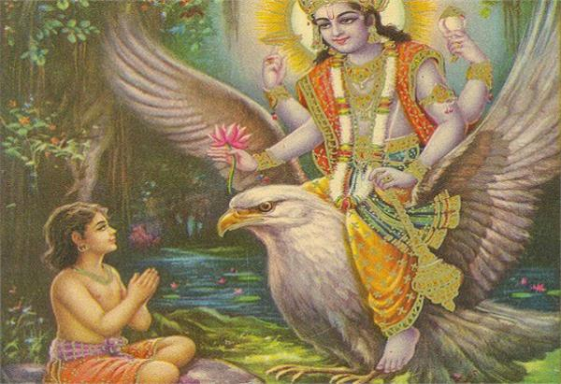
INTRODUCTION
Dhuruva is a pious boy and due to his sincere meditation on Lord Vishnu, he has become a king after his father, and finally become a great DHRUVA star and controlling the sun, moon, stars and the planets through his great powers. This was made possible only because of his true devotion on Lord Vishnu.
According to the legend, his father was Uttanapada and his mother was Suniti. Since his father had shown more attention to his new queen’s son, he was ignored, and he and his mother were not properly treated by his father. Hence due to that, he had performed severe penance and got great boons from Lord Vishnu. After completing his penance, he went to his palace, and due to the grace of Lord Vishnu, his father has changed his mind, and showed more love and affection on Dhuruva. He has become a king and ruled his kingdom properly by treating the people as his own sons, and gave much respect to them. Everyone loved him, and appreciated him for giving a GOLDEN RULE. After ruling the kingdom for several years, he and his mother have become stars, and still living in the Dhuruva Mandala, a star world containing all sorts of luxuries, and they would be permanently residing in the Loka even during the time of MAHAPRALAYAM, a great disaster to the entire universe, and there is no end for them.
Let us worship the great Dhuruva and be blessed.
“OM SRI DHURUVA MAHARAJARE NAMAHA”
“OM MATA SUNITIYE NAMAHA”
“OM NAMO NARAYANAYA NAMAHA”
WRITTEN BY
R.HARISHANKAR

GREATNESS OF BHAKTA MARKANDEYA
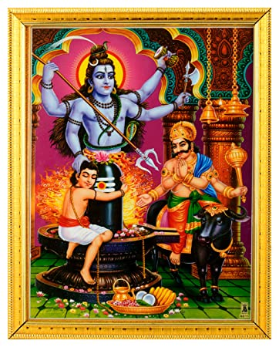
INTRODUCTION
Markandeya was the son of Rishi Mrikandu, and was born with very good features. Similar to his father, he used to worship Lord Shiva at the Ashram and perform pujas and abhishekhams to the Shiva Lingam. According to legend, when he was nearing to lose his life by Lord Yama, he was safeguarded by Lord Shiva, and he has become a Chiranjeevi in this earth. He appears in the form of a boy, and looks like a full moon, and contains great spiritual powers.
He had shared his spiritual knowledge with various rishis and discussed spiritual matters with them. Once he had conversed with Lord Nandhi Bhagawan, and came to know the greatness of Lord Shiva. He also got the divine darshan of Lord Vishnu, and once when Mata Lakshmi took birth in the earth, Rishi Markandeya affectionately brought up her in a good manner, and got married to Lord Vishnu. Through that, he has become father-in-law of the Lord himself. Through the divine grace of Lord Shiva, he would permanently live in this world even during the entire destruction of the universe, and meditates on god, and would do goodness to his sincere devotees. It is believed that now, he is living in the Rishi Mandala, and performing severe meditation on Lord Shiva.
Let us worship the great rishi and be blessed.
“OM SRI MARKANDEYA MAHARISHIYE NAMAHA”
“OM NAMAH SHIVAYA”
“OM NAMO NARAYANAYA NAMAHA”
WRITTEN BY
R.HARISHANKAR

GURUJI VARADHARAJANAR
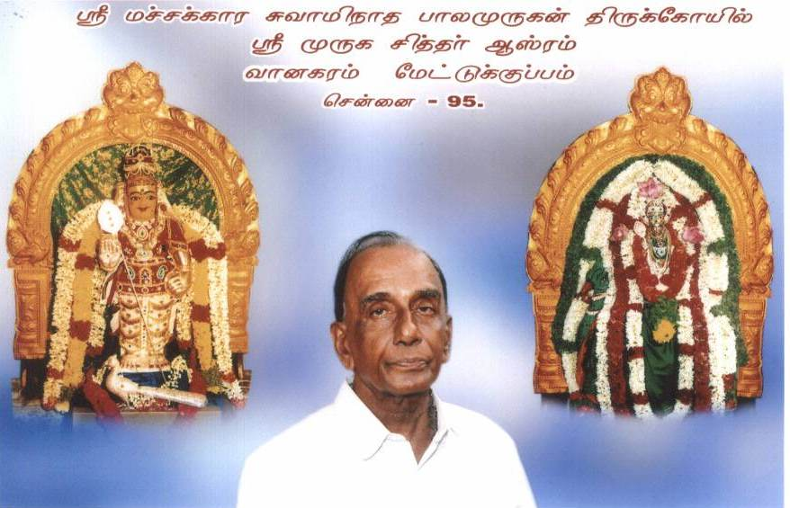
INTRODUCTION
A. R. Varadharajanar is a doctor by profession, and a staunch devotee of Lord Muruga. At his younger age, he stayed at Kodambakkam, and used to visit the Vadapalani murugan temple. But after losing his daughter, he had lost interest in living, and stopped worshipping the god and doing puja.
Due to that, few siddhars were appeared in person, and asked him to continue doing puja to Lord Murugan, and as per their instructions, he began to perform puja to Lord Muruga, and helped the devotees by removing the troubles in their life, through the grace of Lord Muruga. He provides Annadhanam to the visitors of the siddhar peedam.
Guruji conducts puja to the samadhis of the Siddhars Saints at the Siddhar Peedam, and provides annadanam to the devotees. Grand Pujas are performed at the Murugan temple at Vanagaram on auspicious festival days. Lot of devotees from all parts of Tamil Nadu visit the divine shrine in order to find remedy to their sufferings and sorrows.
Let us visit the divine shrine and be blessed.
“OM MURUGA”
WRITTEN BY
R.HARISHANKAR

HEAVEN AND HELL
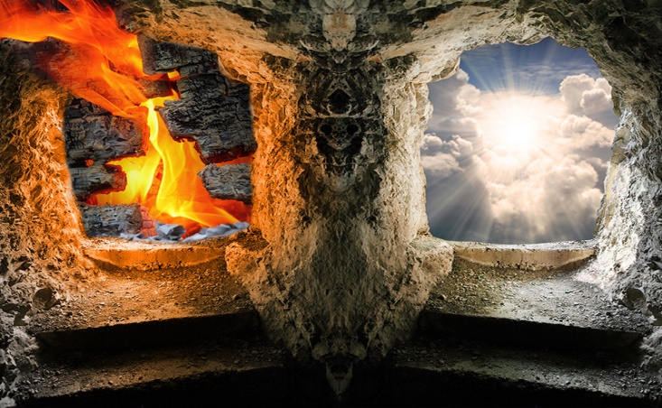
INTRODUCTION
Heaven and Hell is the term used in almost all the religions. In a nutshell, those who do good things in their life would go to heaven, and those who commits bad things in their life would go to hell. But our fate is already predetermined by the god, and it cannot be changed even to a little extent. Whatever sufferings we have to face, we must, and there is no other way to escape from that. Daily we are reading in the newspapers that lot of people dies due to accidents, murders and suicides. All these are happening, due to our fate, and due to our bad karmic deeds done in our past lives.
In general, god is creating us in different forms and each and every-one is suffering from some problems in their life. Some may suffer to a large extent others may suffer to a small extent in their life. He creates us in different types, and putting different types of fate on us. Even god cannot escape from the sufferings. Example Lord Rama, had suffered a lot, even though, he has got the powers to change his fate.
Lord Krishna also had left his physical body, after a poisonous arrow invoked on his leg accidently by a hunter, and he wilfully accepted his fate. But god doesn’t create us for giving only sufferings to us. And he cannot be present with us physically and explain the plus and minus of our activities, since according to him, it would disturb the very purpose of creation itself.
The only thing we have to do in our life is to accept our sufferings in a relaxed manner, and to spend our life by worshipping god regularly by chanting his various names. And gradually our problems would be reduced, and we would feel better, and in course of time, our problems also would come to an end.
The concept of creation is to create the living beings differently and to make them to act independently without the interference of the god. But we should keep the divine faith in our soul, and must follow the path of righteousness.
Let us worship Lord Krishna and be blessed.
“OM SRI KRISHNA BHAGAWANE NAMAHA”
WRITTEN BY
R.HARISHANKAR

HOLY BROTHERS OF BHAKT PRAHALAD
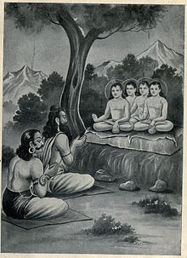
INTRODUCTION
Most of the people are not aware of the brothers of Bhakt Prahalad. According to ancient Puranas, similar to Bhakt Prahalad, his brothers, Anuhladan, Hladan and Samhladan contains the characteristics of their brother, and they also become the great devotees of Lord Vishnu, after the death of their father Hiranyakashipu.
After Prahalad had become a king his mother Kayadu, and his brothers were supported him, towards ruling the kingdom in a noble manner. All the three brothers were the residents of Swarka Loka in their previous birth, and due to a curse, they have born as the brothers of the holy Prahalad. Throughout their life, they didn’t fight with their brother Prahalad, and showed great affection on him. They also got married, and had sons, and lived a pious life. They also regularly preached the importance of worshipping Lord Vishnu among the people, along with their brother Bhakt Prahalad. After their death, they have relieved from their curse and reached the abode of Lord Indra, the Swarka Loka.
Let us worship the holy brothers and be blessed.
“OM SRI ANUHLADANE NAMAHA”
“OM SRI HLADANE NAMAHA”
“OM SRI SAMHLADANE NAMAHA”
“OM SRI BHAKTA PRAHALADARE NAMAHA”
WRITTEN BY
R.HARISHANKAR

IMPORTANCE AND MIRACLES PERFORMED BY LORD RAMA DURING THE EXILE PERIOD
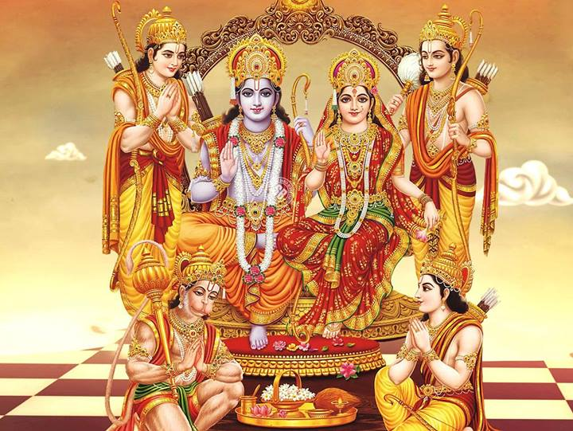
INTRODUCTION
Lord Rama is the great avatar of Lord Vishnu and he was born during the Treta Yuga. He was praised for his great attachment with his father Dasaratha, and for living his life in a righteousness manner. He didn’t show his anger with others, and even to Ravana, and initially he requested him to safely return his wife Sita, and during the time of building the bridge, he patiently waited for getting the approval of the Ocean god, Sri Varuna Dev, and since he didn’t appear before him even after waiting for several days, he got angry and tried to shot up arrows in the ocean. He is such a humble and a kind avatar, who had taken all of his Ayodhya people along with him, when he went to Vaikunta.
During the period of 14 years of exile, he performed many miracles and he killed many fierce demons with a single arrow, and he removed the curse of Mata Ahalya, consort of Rishi Gouthama, since she has become a stone, and she was brought back to her normal form, due to the grace of Lord Rama. He also gave SALVATION to the eagle king Jatayu who had lost his life when he fought with Ravana, in order to safeguard Mata Sita from Ravana.
He restored the wings of the noble eagle Sambati, brother of Jatayu, who had lost his wings, when he tried to reach the top of the sky along with his brother Jatayu. He met Mata Sabari and had her humble offering and blessed her and gave SALVATION to her. Similarly he went to the forest with the help of the boat man Guhan, and accepted his humble prayers, and blessed and gave SALVATION to him, and met sage Sutikshama, who was an ardent devotee of Lord Rama, and the disciple of Sage Agastya, and blessed him.
Let us worship the great Lord Srirama and be blessed.
“OM SRI RAMACHANDRA MURTHIYE NAMAHA”
“JAI HANUMAN”
“OM SRI RAGHAVENDRAYA NAMAHA”
WRITTEN BY
R.HARISHANKAR

IMPORTANT TEACHINGS OF SAINTS
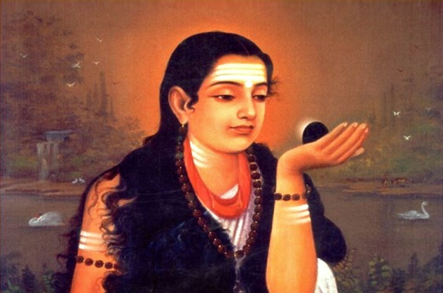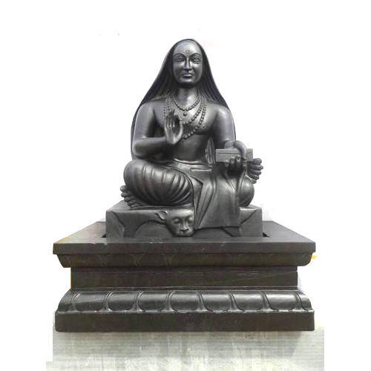
INTRODUCTION
In our country, due to the grace of the god, lot of saints were lived and still living. They taught us the ways of living a noble life, and the do’s and don’ts in our life. We must follow their teachings in our life, in order to live a sin free and a blessed life. Lot of male and female saints taught us the basic things which must be followed in our life. They insist us to get the ever-lasting pleasure by worshipping the deities. Let us come across some of their famous divine teachings and be blessed.
TEACHINGS
- Joy and sadness is in your hands only. You have to choose the right path in order to be happy.
- Believe in god, and worship him by chanting his innumerable names, and you would get the eternal bliss through the grace of god.
- Don’t think you are the master. God is the master for the entire universe and we are all his attendants.
- Think that god is always present near you, and watching all of your activities. He always shows kindness on you, but at the same time, if you commit any sins, he would give the suitable punishment for you.
- All the religion teachings only good things. Don’t differentiate people based on their religion, and show respect and affection on each and every people.
- Status, money and body attraction would never come always in your life. Things may change. Only true love, courtesy, humbleness, gentleness and kindness would give you proper reward in this birth, as well as in your next birth.
- Don’t worry for the lost moments in your life. Anyway you cannot get it again. Think about present and future and act accordingly.
- Respect your parents, and take care of them properly, then there is no need to worry about yourself.
- Always act honestly and never try to earn money by cheating others.
Let us follow the above nine great teachings in our life, and let us live happily in our life forever.
“OM SRI VINAYAKARE NAMAHA”
“OM MATA AKKA MAHADEVIYE NAMAHA”
“OM SRI RAGHAVENDRAYA NAMAHA”
WRITTEN BY
R.HARISHANKAR

JAYANTA
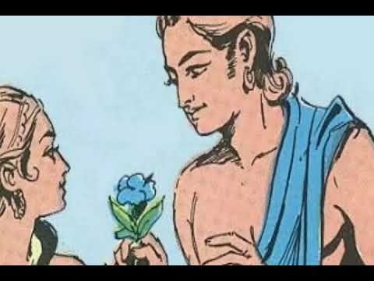
INTRODUCTION
Jayanta is the son of Lord Indra and Mata Indrani. He is considered as the prince of the Swarka Loka. His sister is Jayanti, and he is mentioned in various Hindu divine texts. He also fought with various demons to support his father Indra. He is a pious and a kind Demi god, but since he had enjoyed lot of pleasures in the swarka loka, once, it is believed that during Rama’s exile, he took the form of a crow and disturbed Mata Sita. After that he got punished by Lord Rama and lost sight in one of his eyes and after performing puja to Lord Shiva he had regained his eye sight. From that day onwards, he had changed his mind, and concentrated his attention on worshipping the trimurities and tridevis and gave much respect to rishis, rishi pathnies and to all the females, and didn’t cause any harm to others.
Jayanta was considered as a love god, similar to Kama Deva, and he can be worshipped along with Kama Deva especially by the newly wedded people, and can chant his holy mantra: OM SRI INDRA PUTRA JAYANTANE NAMAHA”, for getting all sorts of prosperities in their life, and he would help to maintain proper understanding between the couples, and would prevent from frequent fights and divorces etc. By worshipping Sri Jayanta, we would get the blessings of Lord Indra and Mata Indrani also.
Let us worship the great demi god Sri Jayanta and be blessed.
“OM SRI JAYANTANE NAMAHA”
“OM SRI INDRA BHAGAWANE NAMAHA”
“OM SRI INDRANI THAYE NAMAHA”
WRITTEN BY
R.HARISHANKAR

JIMUTHAVAHANA
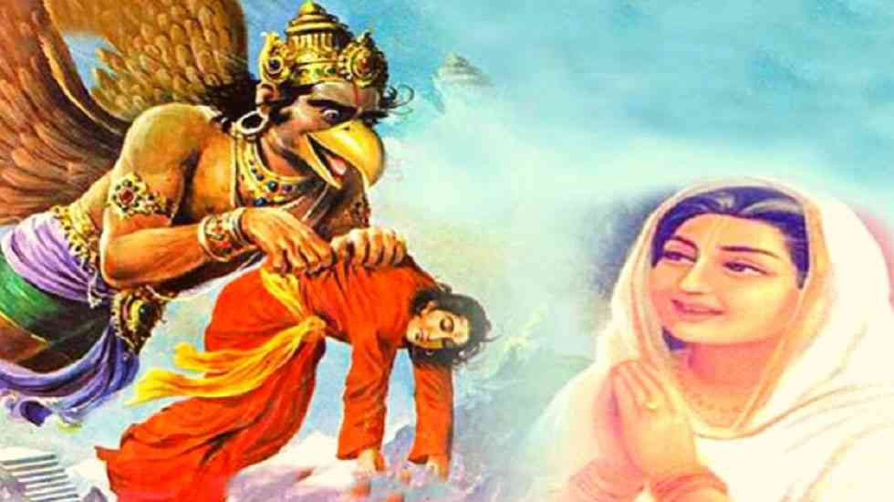
INTRODUCTION
Prince Jimutavahana who lived some thousands of years ago in India, was a great person, and since he didn’t want to fight with his cruel relatives, he gave his kingdom and his entire belongings to them, and left his family and settled down in a village nearby a forest along with his parents and his dutiful wife. He was considered as a holy incarnation of Lord Vishnu. Once when he was staying in an ashram along with his family, he heard the cries of a Naga Lady.
He approached her and asked for the reason. The lady wept sorrowfully and told, that “Garuda is considering snakes (Nagas) as his enemy for a long period of time, and that in their village, daily every person, must self-sacrifice themselves to Garuda, who was the vehicle of Lord Vishnu, and today is the turn for my only lovely son to self-sacrifice himself to Lord Garuda”.
On hearing the incident from the Naga Lady, Jimuthavahana got pity on her and decided to save her Naga son. Jimuthavahana had dressed himself in the form of the naga boy and went near Garuda. Garuda got very happy and slowly began to tear him into pieces and ate his flesh with much joy. But he noticed that the great Jimuthavahana, didn’t shown any signs of worries, and he remained in a happy state even when his body was damaged. Garuda got very much surprised and asked him about his details. Then Jimuthavahana had narrated the incidents in his life. On hearing the incidents from him, Garuda was very much ashamed and worshipped him and realized that he is none other than his master’s incarnation and regained his body into normal form and from then onwards he stopped eating serpents.
From this incident we can understand, that the messengers of god are very kind on all the living beings in the earth, and they would even self-sacrifice their lives for safeguarding the living beings.
Let us worship the holy prince, the great Jimuthavahana and be blessed.
“OM SRI JIMUTHAVAHANARE NAMAHA”
“OM SRI GARUDA BHAGAVANE NAMAHA”
“OM NAMO NARAYANAYA NAMAHA”
WRITTEN BY
R.HARISHANKAR
JITAMITRA TEERTHA
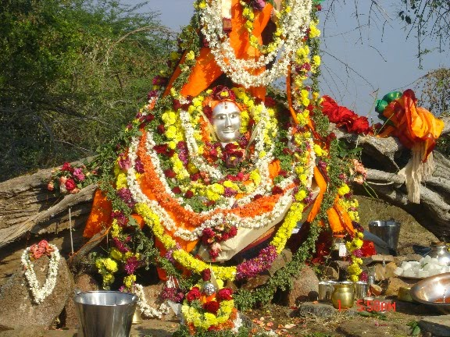
INTRODUCTION
Jatamitra (14th century AD) who was earlier known as Anantappa had served as a pontiff of Sri Vibudentra Tirtha mutt in a well versed manner. His predecessor was Sri Vibudendra Tirtha and his Successor was Sri Raghunanda Tirtha. He was considered as an incarnation of Lord Rudra, a form of Lord Shiva. After serving the mutt for some period, he had disappeared in a holy tree at Shivapura, Shahapur Taluk in Gulbarga District. It is believed that he is still meditating there in the divine form and blessing his devotees.
Anantappa, at his younger age, had lost his parents and was looked after by her widowed elder sister. He used to assist his sister in the paddy fields and cultivated crops.
Once, Sri Vibudendra Tirtharu, met him and stayed in his house for a few days and done Moola Rama Dev pooja at his house in a pleasing manner. And he gave a Narasimha idol to Anantappa and asked him to perform puja to the deity regularly and went on to travel to holy places. The young boy used to give the holy Prasad directly to the mouth of narasimha’s deity and miraculously the deity also would eat his food.
After some time, Sri Vibudendra Tirtharu visited his house, and on knowing about the miraculous incident of eating the Prasad directly by Lord Narasimha, he was very much convinced with the boy, and made him as his disciple, and Sri Anantappa had become a saint with the new name “SRI JITAMITRA TEERTHA” and Jitamitra Tirtharu became the pontiff of Sri Vibudendra Tirtha Mutt. And during the year 1493, he suddenly disappeared in the holy tree at Gulbarga District, Karnataka.
Still now lot of devotees are worshipping the holy tree and getting his blessings.
Let us worship the great Guru Sri Jitamitra and be blessed.
“OM SRI JITAMITRA TEERTHARE NAMAHA”
“JAI SRI RAM”
“JAI SRI RUDRA DEVA”
WRITTEN BY
R.HARISHANKAR

KANTIMATHI - HOLY MOTHER OF SRI RAMANUJACHARYA
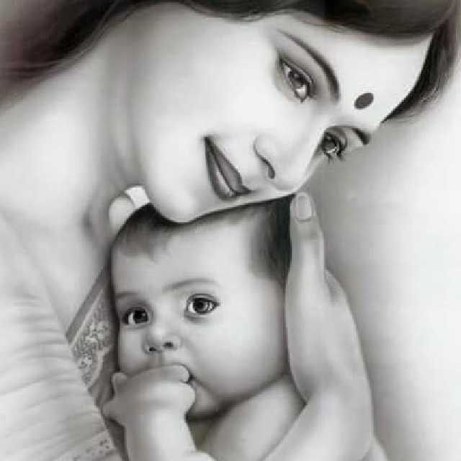
INTRODUCTION
Kantimathi (11th century AD) was the holy mother of Sri Ramanuja, and at her teenage, she got married to Sri Kesava Somayaji, a pious Brahmin scholar, and lived in Srperumbudur, and had one noble son, who was the great Vaishnative saint Sri Ramanuja and his birth name was Ilaya Perumal.
Due to her past births good karmic deeds, she gave birth to Sri Ramanuja, who was considered as the divine avatar of Adisesha, the divine serpent bed of Lord Vishnu. She was a good house wife and properly looked after her family, and attended the pujas and homams in the Vishnu temples, and lived a pure life. She taught good manners to her son Ramanuja and invoked the “VISHNU BHAKTI SPIRIT” to her son at his younger age itself. She used to treat everyone as alike similar to her divine son Sri Ramanuja, and got great bhakti on Lord Vishnu, and used to observe fasting during Ekadasi days. After living a holistic life for many years, she has attained the Lotus feet of Lord Vishnu.
Let us worship the divine mother and be blessed.
“OM MATA KANTIMATHI NAMAHA”
“JAI RAMANUJA”
“OM SRI LAKSHMI NARAYANARE NAMAHA”
WRITTEN BY
R.HARISHANKAR

KATAS RAJ TEMPLES
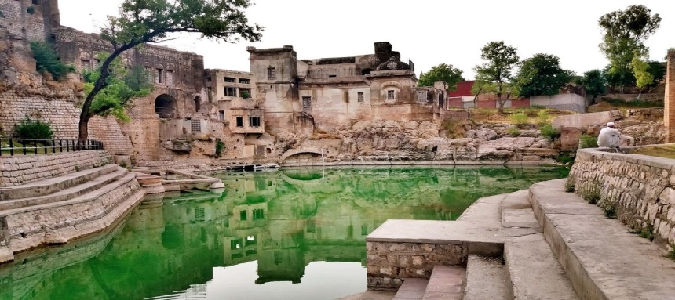
INTRODUCTION
The Katas Raj Temples is a complex of several Hindu temples and contains a holy tank named Katas which is considered as sacred by the Hindus, and it is believed that by drinking the water in the holy tank would cure all kinds of diseases and removes our sins. The temple complex is situated in Punjab, Pakistan. The temple tank is considered as the teardrops of Lord Shiva, after he wandered in the earth after the death of Mata Sati. The importance of this temple is mentioned in Mahabharata.
The great Guru Nanak had visited the Katas Raj Temples. This temple is not maintained properly, and currently some minority Hindus are looking after this holy place, and have done some maintenance work at their own cost. Only minority Hindus living in the nearby areas are visiting this popular temple. However during Shivrathri festival day, hundreds of Hindu pilgrims from Pakistan and India would visit this lovely shrine in order to get the blessings of the great Lord “SRI MAHADEV”. In the temple complex, Lord Rama, Hanuman and Shiva temples are found. It is an ancient temple, and it is believed that this temple would have been built by the Pandavas, since they have frequently visited this place during their exile.
Let us worship Lord Shiva, Rama and Hanuman and be blessed.
“OM SRI SHIVAYA NAMAHA”
“JAI SRI RAM”
“JAI HANUMAN”
WRITTEN BY
R.HARISHANKAR

KING AJA
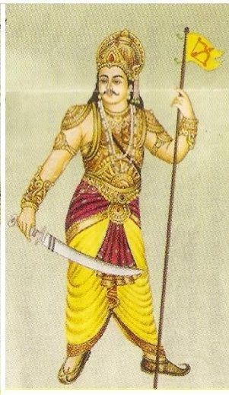
INTRODUCTION
King Aja was the ancient king of the Solar Dynasty, and the worshipper of Lord Surya. He was born in the Treta Yuga, and he was good at handling weapons and was a great scholar and an expert in all kinds of arts. He was the son of king Raghu , who was considered as a great emperor of the Ikshvaku dynasty, and his grandfather was the noble king Dileepa. He ruled the kingdom of Ayodhya in a well-versed manner. His wife was Indumati, who was a chaste and a worshipful queen, and his son was Dasharatha, father of Lord Rama.
Indumati in her previous birth was an apsara in the Indra Loka. Since as per the instructions of Lord Indra, she disturbed the penance of the great Sage Trinabindu, and he cursed her to take birth in the earth. Due to that, she was born as the Vidarbha Kingdom Princess and got married with king Aja. After some time, Indumati had got relieved from her curse, and went back to the Indra Lok. King Aja could not tolerate her absence, and died shortly. And after his death, it is believed that he had attained SALVATION.
After the death of Aja and Indumati, child Dasarata was taken care of by his relatives, and after he attained teenage, he was crowned as the king of Ayodhya.
Let us worship the great king Aja and be blessed.
“OM SRI AJA MAHARAJAVE NAMAHA”
“JAI SRIRAM”
“JAI MATA SITA”
WRITTEN BY
R.HARISHANKAR

KING HARITA
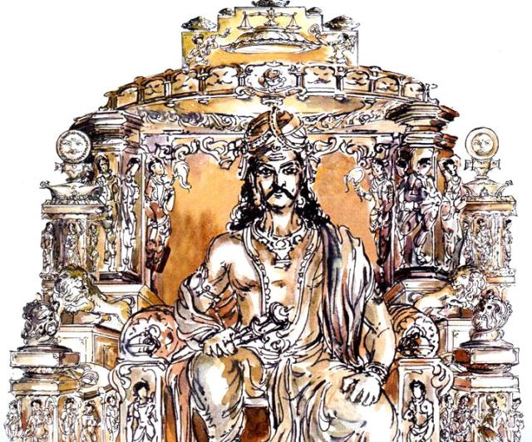
INTRODUCTION
Harita was an ancient king of the Suryavansha dynasty, and those who have Harita gotra are considered as his descendants. After the death of his father, he became the ruler of Ayodhya.
Harita was the grandson of king Ambareesha, and he was the ancestor of Lord Rama. Due to the blessings of Adikesava Perumal, a form of Lord Vishnu, he has become a pure Brahmin, and contains the qualities of Brahmin as well as Kshatriya. Those Brahmins, who belongs to the Harita gotra, would contain boldness, courage and wisdom, and king Harita is considered as their protector.
King Harita was a good ruler, and treated his people with kindness and considered them as his own relatives, and provided all the necessary benefits to them. No one had suffered from any kind of problems during his golden rule.
King Harita had renovated the Adikesava Perumal temple at Sriperumbudur and he got great boons from Lord Adikesava Perumal. After his death, he went to the abode of Lord Indra, and still peacefully lives in the Indra Lok, without any sufferings.
Let us worship the noble king and be blessed.
“OM SRI HARITA MAHARAJAVE NAMAHA”
“JAI SRIRAM”
“JAI MATA SITA”
WRITTEN BY
R.HARISHANKAR

KING MANDATA
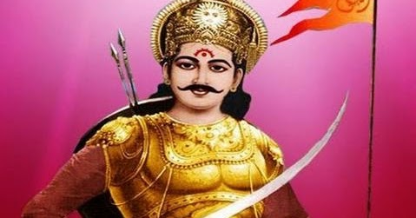
INTRODUCTION
Mandhata was an Ikshvaku king and the son of Yuvanashva. He got married with Bindumati, daughter of Yadava king Shashabindu. And he had three sons, and he is well known for his charitable activities, and he had maintained strict law and order in his kingdom. He was mentioned in Rig Veda and Mahabharata.
King Yuvanashva of Ayodhya once while hunting in the forest, felt thirst and drank sacred water which was kept by a sage for his wife, without knowing about its reaction. Hence he had become pregnant, and soon he delivered a beautiful baby boy, and he was given divine nectar by Lord Indra itself, and the boy was known as the great king Mandata.
Mandata contain good knowledge in Vedas and obtained divine knowledge from Guru Brahaspati. He was good at archery, and considered as a great warrior king.
Due to his great powers, he has become the king of the entire earth. He ruled his kingdom in a good manner, and all the people in his region were happily lived and praised for his kindness and goodness.
He made lot of fire sacrifices and pleased the divine gods. He was a great devotee of Shiva-Sakti. Once he defeated Ravana in the battle.
During a battle with the great warrior Lavana, he was killed.
Let us worship the great king Mandata and be blessed.
“OM SRI MANDATA MAHARAJAVE NAMAHA”
“JAI SRIRAM”
“JAI MATA SITA”
WRITTEN BY
R.HARISHANKAR

KING SAGARA
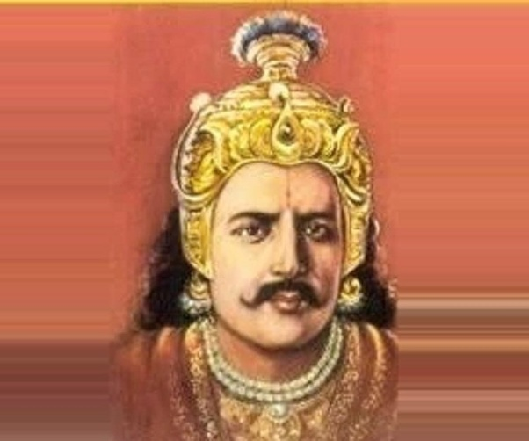
INTRODUCTION
According to ancient legend, Sagara is a famous king of the Suryavansha dynasty and ruled the Vidarbha region, which is the present day Nagpur, Maharashtra and he was mentioned in ancient texts and in Mahabharata. He ruled his kingdom in a proper manner, and gave a golden rule during his period. Lord Rama and the great king Sri Harichandra were born in the Suryavansha dynasty.
Once, King Sagara performed a Horse Yagna in order to increase his powers. After knowing about it, Lord Indra had stolen the horse and he tied the horse at the ashram of Kapila, who was in deep penance. King Sagar’s sons were searched and found the horse at Sri Kapila Bhagavan’s ashram. And they thought he had stolen it, and prepared to attack the sage. Kapila opened his eyes, and fire formed from his eyes and all the sons of Sagara were immediately burnt into ashes. Later on their descendant, Bhagiratha prayed to Mata Ganga and brought her into the earth, and by spraying the holy water of river ganges in the ashes, his forefathers were reached to the heaven.
Let us worship the great king Sagara and be blessed.
“OM SRI SAGARA MAHARAJAVE NAMAHA”
“JAI SRIRAM”
“JAI GANGA MA”
WRITTEN BY
R.HARISHANKAR

KING SURASENA
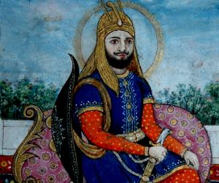
INTRODUCTION
As per Vinayaka Purana, during the Treta Yuga, there lived a noble king whose name was Surasena. He was very good and behaved kindly with his people. He was an ardent devotee of Lord Vinayaka and used to perform pujas in the temples and in his palace and offer Mothakams to the First god. Due to his devotion on the Lord, his name and fame was spread, and everyone in his kingdom and from other states began to praise his bhakti.
After ruling several years in a prosperous manner, one day a pushpaka vimana was arrived at his palace and the divine attendants of Lord Vinayaka were asked him to get seated in the holy Vimana in order to take the king to the Ganesa Loka. The king requested them to accept his people also, since he had considered his people as his own children, and the divine attendants were also accepted his proposal. But some people couldn’t get inside the vimana due to their bad karmic deeds. However the great king chanted the holy mantras of Lord Vinayaka, and gave them the divine Prasad Mothak to them. After consuming the holy Prasad, they were able to get inside the Vimana, and their appearance was also changed, and they become divine persons. By this way, the great king Surasena went to the Ganesa Loka along with his family, relatives and the people.
In this today’s world, we can’t even imagine such a kind of selfless person like Sri Surasena, who wants everyone to get Salvation and to enjoy the eternal bliss in the divine world.
Let us worship the great king Surasena and be blessed.
“OM SRI SURASENARE NAMAHA”
“OM SRI VINAYAKAYA NAMAHA”
WRITTEN BY
R.HARISHANKAR

KINNARAS AND KIMBURUDAS
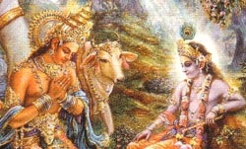
INTRODUCTION
Kinnaras and Kimburudas are the celestial musicians and they lives in the Gandharva Loka. They are considered as minor deities and are the lower level demi gods. Though they live in Gandharva Loka, they are controlled by the Gandharvas and Devas in the heaven. Kinnaras and Kimburudas are very much devoted with Lord Vishnu, and used to sing songs on him. They also got the powers to visit the divine worlds, and contain attractive looks. They possess good qualities and gives great respect to the demi gods in the heaven. They have entirely dedicated their lives on worshipping Lord Vishnu, and used to praise his glory.
Sometimes, they used to sing songs in praise of Lord Indra also. They didn’t contain any bad habits and they used to frequently meditate on Lord Vishnu. Their age may vary from person to person depending on their features. Some may live even for a yuga, depending on their characteristics. They used to marry apsaras, also called as celestial dancers, and enjoy comforts and luxuries only to a limited level.
Let us worship Kinnaras and Kimburudas and be blessed.
“OM SRI KINNARAYA, KIMBURUDAYA NAMAHA”
“OM SRI INDRAYA NAMAHA”
“OM NAMO NARAYANAYA NAMAHA”
WRITTEN BY
R.HARISHANKAR

KODI SWAMIGAL
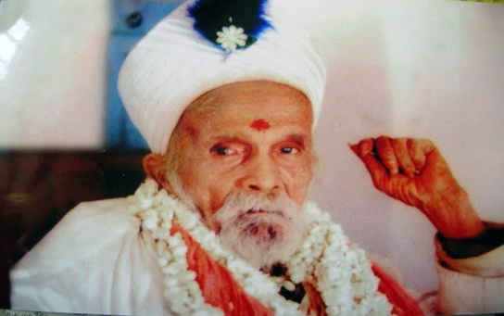
INTRODUCTION
According to his devotee’s experiences, it is believed that Sri Kodi Swami was lived for a few hundred years, and attained Mahasamadhi in the year 1993. He was considered as a holy saint and was greatly respected by his devotees and by other saints and received blessings from him.
After living in several places, the great saint had finally settled himself at the house of a devotee in a small village near Pollachi in Coimbatore. He used to have a little food and sleep only for a short time. Mostly he would do meditation in his room, and maintained silence, and didn’t give any disturbance to others. Throughout his life, he was healthy and got great spiritual energy.
Lot of experiences were shared by the devotees of this Great Saint. Once he safeguarded a devotee from a road accident, by gently touching his hands. He also removed the diseases of the people by mixing the Kumkum powder with water and made them to drink it. He asked his devotees to visit the temples frequently and to worship the deities, in order to get permanent protection in their life. He is an ardent devotee of Durga Devi, and used to perform pujas in the house of his devotees. According to him, everything was decided by the god already, and we have to adjust ourselves to live in this rough and tough world by chanting the mantras of the gods and goddesses.
It is believed that even after his death he still answers to the prayers of his sincere devotees, and comes with them in every walk of their life.
Let us worship the great saint and be blessed.
“OM SRI KODI SWAMIGALE NAMAHA”
“OM NAMAH SHIVAYA”
“OM MATA PARVATI DEVIYE NAMAHA”
WRITTEN BY
R.HARISHANKAR

KUDAI SWAMIGAL
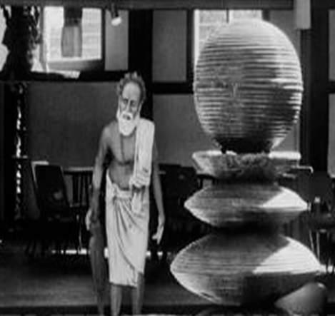
INTRODUCTION
Kudai Swamigal was a great siddha who was born to a pious family in Kumarakottam in the year 1897. His birth name was Kanthaiya Swamigal and initially done agricultural work in his farm lands. He lived in Srilanka and he was the disciple of Sri Mahadeva Swamigal. After the death of his wife, he got frustrated and become a saint. He lived a simple and a noble life. He used to carry an umbrella, in order to protect himself from the sun and from the rain and he used to wear only simple clothes and lived his life by taking alms. He used to remain in a Samadhi state for several hours and even for several days without taking food.
He contains great supernatural powers and considered as a great yogi. Occasionally he used to visit some shops and stay there for some time, and before the end of the day almost the entire goods in the shops would be sold. He knows the past, present and future occurrences in the life of his devotees, and based on that, he would give suitable suggestions to them liking doing special puja in their homes, and to offer food to the poor people.
He rarely spoke and always chants god’s names. He has done many miracles in the life of his devotees like safeguarding a devotee from the snake bite, curing the leprosy of a devotee, protected his devotees from accidents, removed the illness and dullness of the devotees, and gave much physical and mental strength to them. He was highly respected by the devotees for his great spiritual powers.
He attained samadhi in the year 1978, and it is believed that he still blesses the devotees from his Samadhi.
Let us worship the great saint and be blessed.
“OM SRI KUDAI SWAMIGALE NAMAHA”
“OM NAMAH SHIVAYA”
“JAI MATA PARVATI”
WRITTEN BY
R.HARISHANKAR
LAVA KUSHA
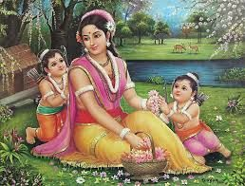
INTRODUCTION
According to the great epic Ramayana, Lava and his twin brother Kusha, were the children of Rama and Sita. Lava and Kusha looks attractive in their appearance similar to their parents.
Lava and Kusha belongs to the Ikshvaku clan and lived during the Treta Yuga. Lava was elder brother and Kusha was younger.
According to the Ramayana, Sita was banished from the kingdom of Ayodhya by Rama due to the rumours made by the people of his kingdom about Mata Sita, since she was under the custody of Ravan for several years in Srilanka.
She took refuge in the ashram of Sage Valmiki located on the banks of the River Tamsa. Lava and Kusha were born at the ashram and were well educated and trained in all kinds of arts under the guidance of Sage Valmiki. They also learned the story of Rama.
After some time when Sita was very much depressed about her condition, she went inside the earth, since she was the incarnation of the earth goddess Bhudevi. Rama then learnt that Lava and Kusha were his children, and brought them to his kingdom, and took care of them properly.
Lava and Kusha became rulers after their father Rama and also founded the cities of Lavapuri( the present day Lahore) and Kasur respectively. There is a temple dedicated to Lava in Lahore.
Let us worship the divine sons of Rama and be blessed.
“OM SRI LAVA, KUSHA NAMAHA”
“JAI SRI RAM”
“JAI MATA SITA”
WRITTEN BY
R.HARISHANKAR

LORD CHITRAGUPTA
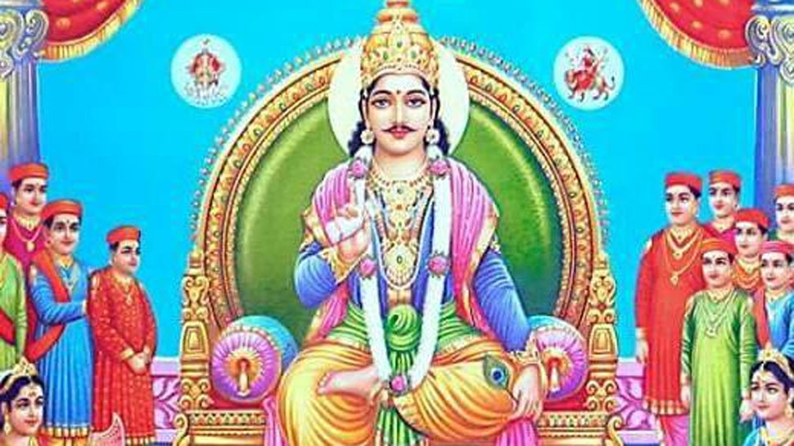
INTRODUCTION
Lord Chitragupta is a divine accountant who maintains complete records of activities of human beings in the earth and punishes or rewards them according to their Karmas. He is assisting Lord Yama Dharmaraja, and does his duties in a righteousness manner. Chitragupta is the son of Lord Brahma and he is worshipped in India and in Nepal. It is also believed that he was created from the picture drawn by Mata Parvati, and gave life to the picture, and since he was created from the picture, he came to be known as Lord Chitra Gupta.
Chitra Gupta is carefully watching our each and every activity and gives the correct judgement. According to legend, it is also said, that Lord Indra and Indrani were took care of him in the Indralok during his childhood.
He was mainly created to reduce the burden of Lord Yama Dharma. Once the death god has faced lot of difficulties in making the correct calculations of the human beings Karma, and as a result, he reported his problem to Lord Maheshwar. The great Lord got mercy on Yama and created Chitra Gupta through his powers. By birth itself, Lord Chitra Gupta has got great powers. He was a clever and an efficient person, who was able to execute the toughest task of making calculations of human beings actions, and sending them to heaven or hell, based on their karmic deeds.
He is executing his task by keep chanting Lord Shiva’s mantra, and through his blessings he was successfully carrying out his duties for several lakhs of years. It is beneficial for us to worship Lord Chitra Gupta temple in Kanchipuram, in order to reduce our sufferings in our life. There is also a separate shrine for Lord Chitra gupta in the Arunachaleswara Temple, and he is seated along with his consort.
There are also some temples dedicated to Chitra Gupta in the following places:
- Telangana
- Jharkhand
- Bihar
- Madhya Pradesh
- Rajasthan
- Uttar Pradesh
- Lucknow
- Mumbai
- Nepal
Let us worship the great Lord Sri Chitragupta Maharaj and be blessed.
“OM SRI CHITRAGUPTARE NAMAHA”
“OM SRI YAMADHARMA RAJARE NAMAHA”
“OM NAMAH SHIVAYA”
WRITTEN BY
R.HARISHANKAR

LORD ISANYA
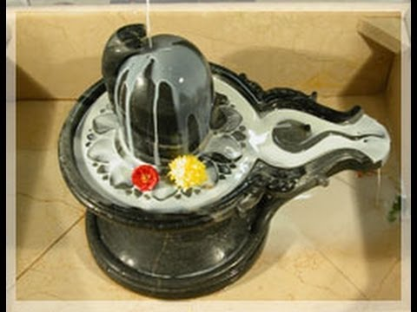
INTRODUCTION
Lord Isanya is a form of Lord Shiva, and contains his features. He is the god of North-East Direction. He is the Rudra Deva and contains Trisool and wears snakes and his body is covered with sacred ash and contains a divine look. He is the god, who removes the evil spirits from our mind and body, and from his sacred ash we can understand, that one day or other day, our body would be burnt into ashes and nothing is going to come with us after our death.
The shrine of the Isanya Lingam is situated near the girivalam path and the cremation ground, and attracts large number of devotees regularly. People believe that by worshipping the great lord Isanya, their entire problems would be burnt into ashes, and they would get more peacefulness and happiness in their life. Whenever we have a chance to visit Tiruvannamalai, let us do girivalam, and visit all the ashta lingams which include Isanya Lingam also. It is believed that by worshipping Lord Isanya, death related worries would never takes place in our mind, and we would get a peaceful death without suffering from any ailments.
Let us worship the great Lord Isanya and be blessed.
“OM SRI ISANYARE NAMAHA”
“OM NAMAH SHIVAYA”
“OM SRI PARVATI ANNAIYE NAMAHA”
WRITTEN BY
R.HARISHANKAR

LORD SHIVA AND MATA KALI
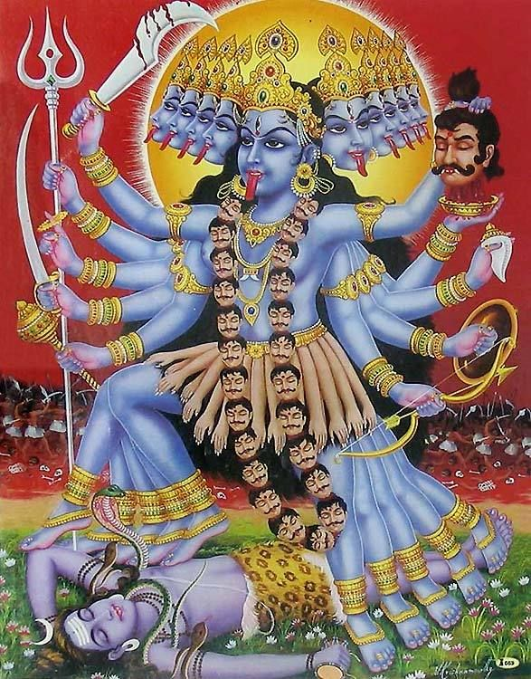
INTRODUCTION
Once, the entire universe was suffered from the clutches of the powerful demons. The demons got various boons from the gods by doing penance and tried to rule the earth and heaven. Among the fierce demons, Raktabija was the cruel one, and he used to disturb the sages from doing fire sacrifices and spoil their penances by causing lot of problems to them. He got great boons from Lord Brahma, and began to attack Lord Indra.
Due to that, the demi gods and the sages began to worship Mata Shakti and praised her glories, in order to protect them from the demon Raktabija.
Mata Shakti took the form of Kali Devi, and the battle between Raktabija and Kali Devi took place. And finally Kali Devi destroyed the demon, and drank his blood and began to dance with a loud laughter.
Mata Kali didn’t stop dancing, and due to that, the divine gods approached Lord Shiva in order to pacify her. Shiva went in front of Kali and asked her to stop the dance, in order to safeguard the universe. But she didn’t listen to the words of Lord Shiva, and began to dance and dance and finally Lord Shiva lay down at her feet, and finally Kali Devi realized her mistake, and she asked apology to Shiva and become very calm.
Let us worship the divine couples and be blessed.
“OM SRI SHIVAYA NAMAHA”
“OM MATA KALI DEVIYE NAMAHA”
WRITTEN BY
R.HARISHANKAR

MAHA ANANDA SIDDHAR
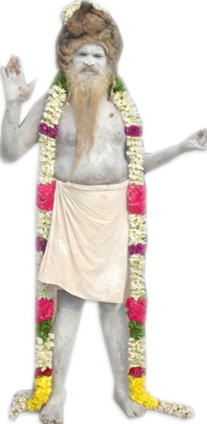
INTRODUCTION
Maha Ananda Siddha was born in Dharmapuri district in the year 1930. Initially he was selling sacred ash, kumkum powder and turmeric powder. After some time, he undertook renovation work in Tamil Nadu Temples with great pleasure. He also fed the poor people with sumptuous meals along with sweets and fruits at Bharadhwajeeswarar temple of Kalahasthi in Andhra Pradesh. He was very good at meditation and yoga.
His divine service was pleased by Lord Siva and appeared before him and commanded him to live in the hilly forest and to perform deep penance on him, and then disappeared. Ananda Siddhar obeyed the orders of the Lord and settled down in a hilly region in Andhra Pradesh and started meditating on Lord Shiva for several weeks without having food and water. Due to that, he has got great powers, and utilized the powers towards removing the difficulties of the people who are facing a tough situation in this Kali Yuga. He insisted his followers to chant the “OM NAMAH SHIVAYA” mantra continuously in order to get rid from their sins, and to live a pleasant and prosperous life.
It is believed that he still lives in a cave in Andhra Pradesh and performing penance on Lord Shiva.
Let us worship the great saint and be blessed.
“OM SRI MAHA ANANDA SIDDHARE NAMAHA”
“OM NAMAH SHIVAYA”
“OM SRI PARVATI ANNAIYE NAMAHA”
WRITTEN BY
R.HARISHANKAR

MAHAYOGI AYYA
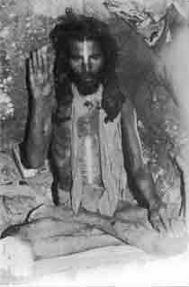
INTRODUCTION
Mahayogi Ayya( 19th century) was born in a village at Kanyakumari, and was very pious and holy at his younger age itself. Due to his spiritual thirst, at his teenage he came to Thiruvannamalai and sat down in a cave and done severe meditation for several years without having proper food and sleep. He was a disciple of Swami Ayya Vaikundar, an incarnation of Lord Vishnu, and he followed the footsteps of his guru. Similar to his guru, he also contained great spiritual powers, and healed the diseases of his devotees, and made them to realize their inner soul, and insisted them to do meditation and yoga.
He used to take only a small quantity of food which was offered by his disciples. In course of time, Ayya used have just a cup of milk in a day.
After some time, due to his greatness, he was visited by large number of people at the cave. He used to offer the sacred ash of Lord Shiva, and asked the people to chant the “OM NAMAH SHIVAYA” mantra and asked them to drink it after mixing it with water. By drinking the holy water, people were got relieved from their sins, diseases and mental illness. Gradually his name and fame has spread, and people began coming searching for him from faraway places also.
Ayya was against caste discrimination and equally treated everyone, and showed much affection and love on the people.
Let us worship the great saint and be blessed.
“OM SRI MAHAYOGI AYYA NAMAHA”
“OM SRI AYYA VAIKUNDARE NAMAHA”
“OM NAMAH SHIVAYA”
WRITTEN BY
R.HARISHANKAR

MAHORKADA VINAYAGAR
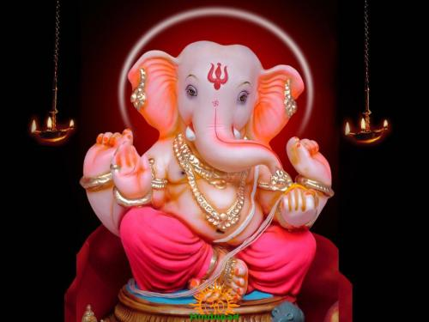
INTRODUCTION
According to Vinayaka Purana, Mahorkada Vinayagar was born as the son of Rishi Kashyapa and his consort Mata Adithi during the Treta Yuga. He was mainly born to kill the cruel demons, since they have got lot of boons from Lord Shiva, and they could not be defeated by anybody, except by Lord Ganesha. He destroyed Doomakethu, Sindhoorasura, Durmugan and many other demons, in order to protect the demi gods in the heaven, to protect the people in the earth and to maintain peace and prosperity in the entire universe.
During his avatar as Mahorkada, he performed childhood plays similar to Lord Krishna and he also performed many miracles, and used to steal and eat lot of Mothakams prepared by his mother Adhithi. Once while he was eating food at his father Kashyapa’s ashram along with Kasirajan, the then king of Kasi, apart from the regular food items, some more items were found in his plantain leaf. Kasirajan had enquired about it to Lord Mahorkada, and he replied that his great devotee Purushundi had offered some sweets and fruits to him at his ashram, and due to his sincere devotion, he had accepted his offering.
Once he has shown his full form (Viswaroopa Darshan) to Lord Indra, in order to destroy his ego. He also mingled with other ashram boys and used to play games with them in the streets. Mahorkada also used to frequently visit the houses of his neighbours and used to eat the food items in their house. Everyone in the region liked the divine boy Mahorkada, and they have forgotten their sorrows and lived peacefully by having the darshan of Lord Mahorkada.
Let us worship the great god Sri Mahorkada and be blessed.
“OM SRI MAHORKADA VINAYAGARE NAMAHA”
WRITTEN BY
R.HARISHANKAR
MAITREYE
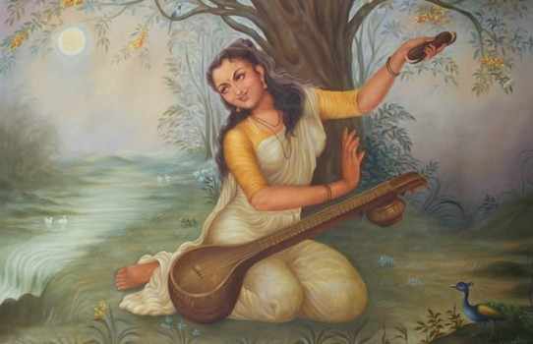
INTRODUCTION
Maitreyi (8th century BC) was a saint and a philosopher who lived in ancient India. She was mentioned in the Vedas and Upanishads, and her importance is also mentioned in the great texts. She is believed to be the consort of the great Rishi Yajnavalkya. But some ancient texts mentions that Maitreyi had never married. Whatever may be, she is a pious and a chaste woman who contains good knowledge in divine subjects, and considered as a great woman rishi.
She had frequently discussed about the soul and the body of the human beings with Sri Yajnavalkya in the Brihadaranyaka Upanishad. According to their dialogue, love is the main thing and it must be expressed by each and every living being in the earth, and an Atma can become a Paramatma, only through constant meditation and doing good things to others. She used to frequently clear her doubts with the great sages and scholars. Mata Maitreye is a great scholar in Advaita philosophy, and she is an ardent devotee of Lord Shiva, and used to regularly perform Puja to the Shiva Lingam at her Ashram. She was a great poet, and used to sing songs in the Shiva temples and was a good natured woman. Her father had served as a minister in the ancient king’s court, and contains great knowledge in all the subjects.
Maitreyi, was considered as a brave women of ancient India, and acts as an example for others. A college in New Delhi is named as the Maitreyi Vedic College, in order to honour the great scholar and saint.
Let us worship Mata Maitreye and be blessed.
“OM SRI MAITREYE ANNAIYE NAMAHA”
“OM NAMAH SHIVAYA”
WRITTEN BY
R.HARISHANKAR

MANDODARI IN RAMAYANA
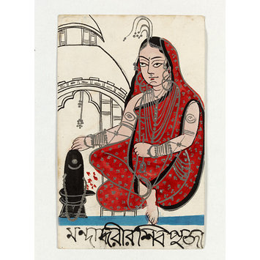
INTRODUCTION
Mandodari was the consort of Lanka king Ravana, and she was very beautiful, pious, and a chaste woman. It is believed that in her previous birth, she was a celestial dancer, and due to a curse, she was born as Mandodari.
Mandodari was the daughter of Mayasura, the King of the demons and she was born during the Treta Yuga. Mandodari had two sons: Meghanada and Akshayakumara. Eventhough, she was the wife of Ravana, she was a noble woman who repeatedly argued with her husband Ravana to relieve Sita and to send her to her native place. But Ravana didn’t listens to her advice, and done the cruel act of keeping Mata Sita under his custody till his death.
Mandodari was an ardent devotee of Lord Shiva, and used to perform puja to the Shiva Lingam at the palace of Ravana along with him. It is believed that after her death, she has become one of the divine attendants of Mata Parvati at Mount Kailash.
Let us worship Mata Mandodari and be blessed.
“OM SRI MANDODARI DEVIYE NAMAHA”
“JAI SRI RAM”
WRITTEN BY
R.HARISHANKAR

MANKANA – ARDENT DEVOTEE OF LORD GANESA
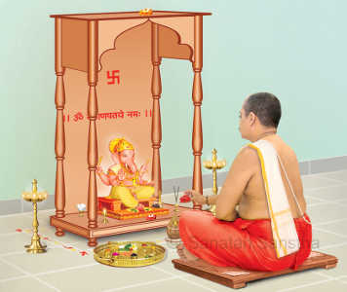
INTRODUCTION
According to Hindu Legend, Several thousands of years back, there lived a pious person in Varanasi whose name was Mankana, and he was a barber by profession, and he was a great devotee of Lord Ganesa. Once, Kasi was ruled by the King Divodasa. Since the king Divodasa doesn’t worship Lord Shiva, and since he disliked the Brahmins performing the Vedic rituals, Lord Shiva got angry with him and wanted to destroy the city of Kasi with the help of his son Lord Ganesa.
Lord Ganesa came to Kasi and gave his divine darshan to his ardent devotee Sri Mankana, and asked him to construct a temple on the outskirts of Kasi. Mankana constructed the holy temple and Lord Ganesa in the temple was called as Nikumbhamandira. Lot of Devotees visited the divine shrine of Ganesa and got their prayers fulfilled. But even after praying to the god, the King was not blessed to have a son. Due to that, he got very angry with Lord Ganesa, and he destroyed the temple. Lord Ganesa could not bear the act of the king and cursed that the city of Kasi would become in a dilapidated state. Thus the great Lord Shiva’s wish was fulfilled.
From this story we can understand, that if god makes a plan and acts accordingly, he would definitely succeed it through his great spiritual powers, since everything is created by the god, and he is the ultimate master and the creator of the entire universe, and we are all his slaves and servants.
Let us always bow our head before the great god Lord Shiva and be blessed.
“OM SRI MANKANA PRABHUVE NAMAHA”
“OM SRI VINAYAKAYA NAMAHA”
“OM NAMAH SHIVAYA”
WRITTEN BY
R.HARISHANKAR

MANOMOHAN MITTRA – FAMOUS DISCIPLE OF SRI RAMAKRISHNA
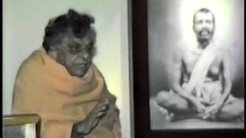
INTRODUCTION
Manomohan Mittra (1851–1903) is one of the famous disciples of Bhagavan Sri Ramakrishna Paramahamsa.
Manomohan was born in the year 1851 at a village in West Bengal. His father was a doctor, and an ardent devotee of Lord Shiva, and his mother was also a disciplined and a calm housewife and got sincere devotion on Shiva-Sakti, and used to spend her free time in the temples. He followed the foot-steps of his parents, and developed the bhakti spirit and worshipped the deities in the temples.
Once he had a nice dream, and in that dream, a holy saint appeared before him, and chanted the glories of Mata Kali in his ears, and disappeared. Manomohan had understood that the saint was none other than Sri Ramakrishna, since he had already read about the holiness of Sri Ramakrishna in the magazines like Indian Mirror and other newspapers. Hence he visited the great saint at Dakshineswar.
He met the great saint and discussed various spiritual matters, and peacefully returned to his hometown. After that, once in a month, he used to visit Sri Ramakrishna and received his blessings.
Manomohan's sister was married to Rakhal Chandra Ghosh, who was later known as Swami Brahmananda, an ardent devotee and disciple of Sri Ramakrishna.
After serving the great saint for some years, he had permanently taken rest in the lotus feet of Mata Kali Devi.
Let us worship the divine saint and be blessed.
“OM SRI MANOMOHAN MITTRARE NAMAHA”
“JAI RAMAKRISHNA”
“JAI MATA SARADA”
WRITTEN BY
R.HARISHANKAR
MARAGATHAM – HOLY MOTHER OF SWAMI SESHADRI
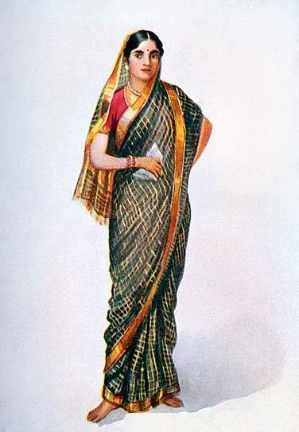
INTRODUCTION
Maragatham (19th century) was a pious woman who was born and brought up at a village in Kanchipuram District. At her younger age, she got married with Sri Varadarajan, who was a great scholar and an expert in astrology. He was a nice person, and lived his life, by taking astrology as his main profession. Both of the couples were very good at doing puja to the god, and offering food to the guests.
Maragatham treated her husband equivalent to god, and gave him good respect. She would get up early in the morning, fetch up water in the well, and assist her husband for doing puja at their home, and used to provide food to the poor people, and to the visiting guests with a smiling face. Then she used to offer food to her husband and then only she would have her food.
In course of time, she gave birth to a divine baby, and named him as “SESHADRI”. Seshadri was a divine child, and contains the features of Lord Shiva. He has performed miracles at his childhood himself. Though he has studied well, he didn’t get interested in worldly affairs and keep on doing meditation on the god.
This act made his parents to get worried about him, and they tried their level best to correct him, but there was no use. At his younger age his father has died, and he and his mother shifted their place to her father’s home at a village in Kanchipuram.
After her husband’s death, she lived a saintly life, and had only little food, and keep on doing puja and meditating the god. In course of time, she has become weak and lost her energy and could not tolerate the death of her husband, and finally blessed her son Seshadri, and died at his younger age. It is believed that after her death, she has attained SALVATION.
Let us worship the divine mother and be blessed.
“OM SRI MARAGATHAM ANNAIYE NAMAHA”
“OM SRI SESHADRI SWAMIGALE NAMAHA”
“OM NAMAH SHIVAYA”
WRITTEN BY
R.HARISHANKAR

MATA NARMADA
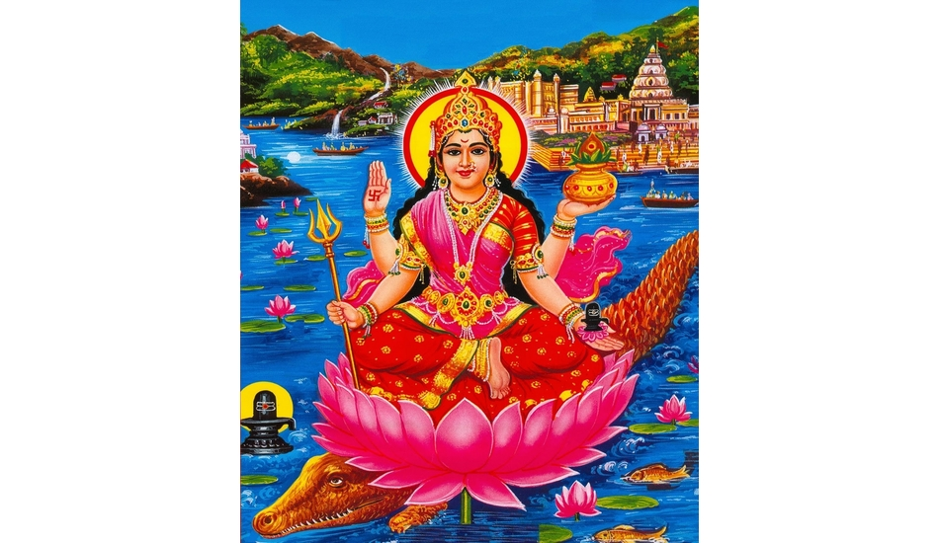
INTRODUCTION
Narmada River is the holiest river and can be considered equivalent with River Ganga. River Narmada, Ganga, Yamuna, Godavari and Cauvery are the holiest rivers, and they are specially created in this earth for doing goodness to their devotees. They are formed through the grace of the Trimurties, in order to cleanse our sins and to make us to live a sin free life.
According to legend, it is believed that Mata Ganga itself takes a holy bath in the great river Narmada in order to make herself, pure and holy.
Once while Lord Shiva was meditating for a long time, his sweat was formed into a river, and that river is called as Narmada. And she is considered as the holy daughter of Lord Shiva.
Since, she is the daughter of Shiva, she protects us from snake bites, and removes the sufferings in our life, and gives peacefulness, prosperity and happiness to us. Her master is Lord Varuna Dev, who showers his grace on to her, and gives strength and power to her in order to discharge her duties properly.
Her vehicle is a crocodile, and she is considered as a very pious and a kind goddess, who forgives our sins, and prays for our well-being to Lord Shiva, and blesses us and gives various boons to us.
Let us worship the holy river Mata Narmada and be blessed.
“OM SRI NAMADAI THAYE NAMAHA”
“OM NAMAH SHIVAYA”
“OM SRI VARUNA DEVARE NAMAHA”
WRITTEN BY
R.HARISHANKAR

MATA PADMAVATHI
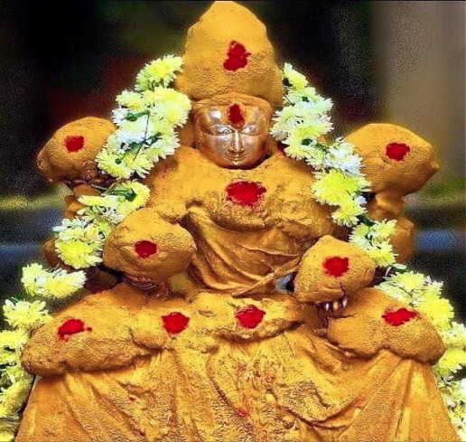
INTRODUCTION
Padmavathi also known as Alamelu manga is the consort of Lord Sri Venkateswara and an avatar of Mata Lakshmi Devi. The famous Temple of Padmavathi is situated at Tiruchanur, near Tirupati. According to legend, those who prefer to travel to Tirumala, must first visit and worship the shrine of Mata Padmavathi at Tiruchanur, and to offer their prayers and then only they can proceed to Tirumala Venkateswara Temple.
Padmavathi is the mother goddess who showers her grace on her sincere devotees and gives immense benefits to them and bless them with all sorts of prosperities in their life. Several Azhwar saints were praised her beauty and glory and composed and sung several songs on her. She is the favourite consort of Sri Venkateswara and she protects her devotees from all sorts of problems in their life. According to legend, it is believed that still now, every night, Lord Venkateswara of Tirumala, is visiting Tiruchanur and staying with his consort Mata Padmavathi for some time, and then return backs to Tirumala.
Sri Annamacharya, who was an ardent devotee of Padmavathi, sung several songs in praise of her. And several times, he got her divine appearance and received blessings from her.
Let us worship the great goddess and be blessed.
“OM SRI PADAMAVATHI THAYARE NAMAHA”
“OM NAMO VENKATESWARAYA NAMAHA”
WRITTEN BY
R.HARISHANKAR

MATA SITA
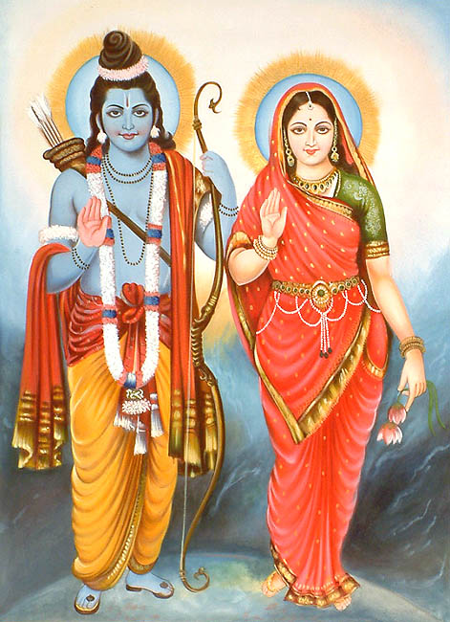
INTRODUCTION
Sita is the main character and is the most pious and holy woman as per Ramayana. She is considered as the incarnation of the earth goddess, Bhumi Devi and was adopted by King Janaka of Videha and his wife, Queen Sunaina.
She has a younger sister, Urmila, and the female cousins Mandavi and Shrutakirti. Sita is well-known for her dedication, wisdom, knowledge, kindness, self-sacrifice, courage and purity.
Sita chooses Rama, the prince of Ayodhya as her husband in a swayamvara, where Rama proves his valour and married her. After the swayamvara, she went along with her husband to his kingdom, but later she accompanied her husband Rama, along with her brother-in-law Lakshmana, in his exile. While in exile, in the Dandaka forest she was kidnapped by Ravana, the Demon king of Lanka. She is imprisoned in Lanka until she was rescued by Rama. After the war, Sita entered into the fire in order to prove her chastity and purity before she is accepted by Rama.
After proving her purity, Rama and Sita returned to Ayodhya, where they are crowned as king and queen. After a few months, Sita becomes pregnant, and due to the gossip made by a person of his region, Rama sends Sita away on exile. Then she takes shelter in sage Valmiki's ashram. After few years, she handed over her sons to Lord Rama, and went inside the earth and stayed with her mother, the earth god, since she doesn’t want to further suffer any-more in this world.
Let us worship the holy mother and be blessed.
“OM MATA SITA DEVIYE NAMAHA”
“JAI SRI RAM”
WRITTEN BY
R.HARISHANKAR

MATA VELLAYI
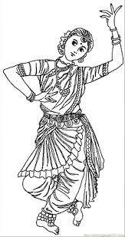
INTRODUCTION
Among the several gopurams in the Ranganathaswamy Temple, Srirangam, there is a white gopuram which attracts special attention and it is called as the Vellayi Gopuram, and it is located at the entrance of the Srirangam Temple. Srirangam Temple is dedicated to Lord Vishnu.
Vellayi was a dancer who wilfully sacrificed her life to protect the idol of the temple. In the year 1323, the army of Sultans invaded Sri Ranganathaswamy Temple and they looted diamond jewels and golden ornaments. But the main idol was hidden from the eyes of the Sultanate forces. Due to that, the Sultan has become very angry and killed thousands of the local people in and around Srirangam.
The great Vaishnavite Acharya, Sri Pillailokacharya had safely kept the idol at Madurai. In order to protect the idol, Dancer Vellayi danced for several hours and cunningly took the soldiers towards the top of the gopuram. And she pushed the Sultan from the Gopuram, and he died. Immediately she also committed suicide by chanting the name of Lord Sri Ranganatha.
After some time, Vijayanagar Chief Sri Kempanna, defeated the Sultanate forces and drove them out from that place. He immediately named the tower as Vellayi Gopuram in order to respect and honour her great sacrifice.
Let us worship the great devotee of Lord Ranganatha and be blessed.
“OM MATA VELLAYI NAMAHA”
“OM NAMO NARAYANAYA NAMAHA”
“OM MATA LAKSHMI DEVIYE NAMAHA”
WRITTEN BY
R.HARISHANKAR

MATANGA MAHARISHI
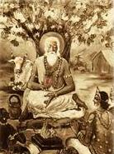
INTRODUCTION
Matanga Maharishi was born in the Treta Yuga, and he was mentioned in Ramayana. Lord Rama and Mata Sita visited the ashram of Matanga Maharishi near the Mountain Rishyamukha.
He was the sincere devotee of Shiva and Parvati, and due to that Mata Parvati had taken birth in the earth as his daughter and she was called as Matangi.
He also got great boons from Lord Shiva, and he wishes the prosperity of the people in the earth. He got many disciples and taught them Vedas and divine scriptures and through his guidance, his disciples were become great sages. He is considered as one among the ancient rishis, and contains good features. He would never get angry and never hate others. He used to think only about the goodness of the entire universe, and lived a pious life.
It is believed that due to his good karmic deeds, after the end of his life, he went to the abode of Lord Brahma, the Satyaloka.
Let us worship the great rishi and be blessed.
“OM SRI MATANGA MAHARISHIYE NAMAHA”
“OM SRI MATANGI MATA NAMAHA”
“OM NAMAH SHIVAYA”
WRITTEN BY
R.HARISHANKAR

MIRACLE OF LORD VENKATESWARA
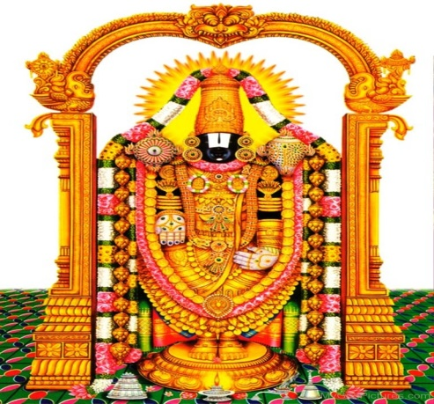
INTRODUCTION
Viswanathan (20th century) was born in a poor Brahmin family in Bangalore, Karnataka. By birth itself, he was not mentally stable, and used to depend on others for doing his regular activities. His father had worked as a priest in a nearby Hanuman temple, and got only meagre income. With the small earnings, he took care of his wife and his son Viswanathan. His father provided proper treatment to him by borrowing money from others, but nothing had made him to become perfect.
One day, a friend of Viswanathan’s father visited their house, and learned about his history, and asked them to go to Tirumala, in order to get the blessings of Lord Venkateswara. He also took his family along with him, by arranging a car at his own cost. After reaching the temple, they had a nice darshan. They stayed there for two days, and returned to Bangalore.
His father’s friend went to his home at Chennai. After the return, there was some slight change in the activity of Viswanathan. He began to slowly talk and walk, and was able to utter Father and Mother from his mouth. His parents were got delighted and made sincere worship to Lord Venkateswara. They also fed the Tirupati laddus to him, and chanted the mantra of Lord Venkateswara, “OM NAMO VENKATESAYA NAMAHA” continuously. To their surprise, within a few months, the child Viswanathan was completely relieved from his problem and become a normal child. Everyone was surprised on seeing the changes happened to the boy. His parents were very much happy and from then onwards, every year during the month of Purattasi, they would visit tirupati and put their offerings in the hundial to thank the great lord for giving a great change in their son’s life.
Let us worship the great Lord Sri Venkateswara and be blessed.
“OM NAMO VENKATESAYA NAMAHA”
“OM SRI ALAMELU THAYE NAMAHA”
WRITTEN BY
R.HARISHANKAR

MITRA
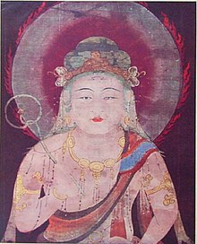
INTRODUCTION
Mitra is a chief deity who was mentioned in the Rigveda, and he is considered as the god of faithfulness, honesty, friendship, contracts and meetings. He is considered as one among the Adityas, and he is the son of Rishi Kashyapa and Aditi. He also gets his share of oblation from the fire sacrifices similar to other Adityas.
He acts as a witness during marriages, business contracts and confidential meetings. Those who try to cheat others would be severally punished by Lord Mitra, since he is present anywhere and everywhere. Those who start new business, those who do contract business, and those who are going to get married, can worship Lord Mitra, in order to get the desired results in their task.
He is controlled by Lord Indra, and properly discharges his duties. Generally, he punishes the people who make false promises, grabbing another person’s property by making false documents, cheating the girls by making false love promises etc.
People who go for an interview can worship Lord Mitra in order to get their desired job.
Let us worship the great demi god Sri Mitra Bhagawan and be blessed.
“OM SRI MITRAYA NAMAHA”
“OM SRI INDRAYA NAMAHA”
WRITTEN BY
R.HARISHANKAR

MOOKUPODI SIDDHAR
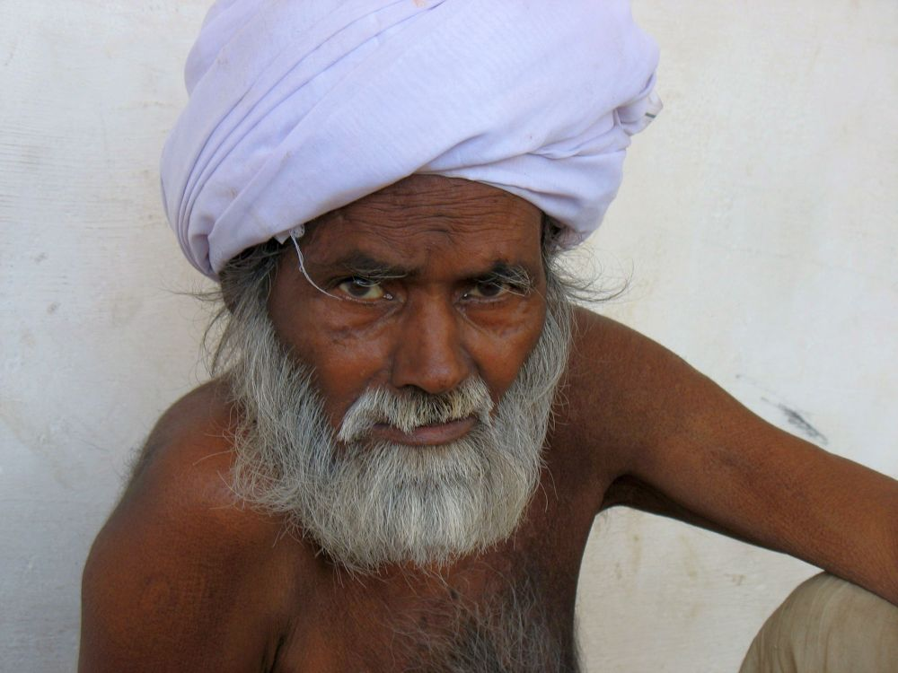
INTRODUCTION
Mookupodi Siddhar also called as Mookupodi Swamigal was born in a village at Salem in the Gounder community and his birth name was Mottaiyan. He worked in a local temple as a priest and served Lord Veerabhadra in a pleasing manner. He used to decorate the deity with beautiful garlands and done puja regularly.
At his teenage he got married to a pious girl, and soon gave birth to a male child and named him as Periyasamy. After his son’s birth, he left his home, and visited many holy places and worshipped the gods and goddesses and attained spiritual power. After a long journey, he settled down at Tiruvannamalai and lived in various temples at Tiruvannamalai.
He used to apply the snuff in his nose, and hence he was known as Mookupodi Swami. He used to correctly predict the climatic conditions, and foretells the future of his devotees. Due to that, his name and fame has got spread, and people began to come from various parts of Tamil Nadu in order to receive his blessings. He used to talk occasionally and always remain silent. Sometimes, he used scold the people, and beat them with his stick, which he used to hold always in his hand. But whatever he does, his devotees would consider it as his blessings only, and never gets angry over him. He breathed his last in the year 2018.
Let us worship the great saint and be blessed.
“OM SRI MOOKUPODI SIDDHARE NAMAHA”
“OM NAMAH SHIVAYA”
“OM SRI SAKTHI DEVIYE NAMAHA”
WRITTEN BY
R.HARISHANKAR

MOUNA SWAMIGAL
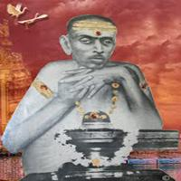
INTRODUCTION
Mouna Swamigal (19th century) was a great saint who lived in Kumbakonam, and done lot of goodness to his followers, and according to his name he maintained perfect silence throughout his life. He was born in a pious family at Thirubhuvanam, and studied well and quickly grasped the divine subjects. At his teenage, he left his family and came to Kumbakonam and performed meditation on Lord Shiva.
After some time, through the help of his devotees, he constructed a small ashram for himself, and spent his time by performing puja to the Shiva lingam and sitting down in a Samadhi state for long hours. He used to have only little quantity of food, and sometimes performed meditation for several days even without having food. He was praised by Kanchi Swami Sri Chandrasekarendra Saraswati Swamigal, and he considered him as a great siddha purusha. Even though he remained silent in his life, he used to murmur the slokas of Lord Shiva and blesses his devotees with a smiling face.
He attained Mahasamadhi in Kumbakonam in the year 1899, and even today, lot of people visits his holy place and perform pujas and worships him with great devotion, and he is fulfilling the prayers of his devotees, and blessing them to attain all sorts of prosperity in their life.
Let us worship the great saint and be blessed.
“OM SRI MOUNA SWAMIGALE NAMAHA”
“OM NAMAH SHIVAYA”
WRITTEN BY
R.HARISHANKAR

MUKKALA MUNIVAR
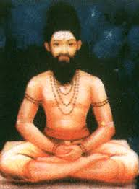
INTRODUCTION
According to Vinayaka Purana, Mukkala Munivar is an ancient sage who lived during the Treta Yuga. He was an ardent devotee of Lord Vinayaka, and lived in an Ashram at the banks of the Holy River Ganges. During his period, there lived a king in Varanasi whose name was Sukrasena. He was a noble king and treated his region’s people as his own relatives, and provided all sorts of benefits to them. His queen was Swarnambika, and she was a pious and a chaste woman. They had one child and his name was Rajasena. The child was born without eye sight and suffered from leprosy. Due to that the king got angry with the queen and his son, and sent them to the forest.
The queen was very much worried about her fate and lived in a small hut in the forest. She used to pluck the fruits from the trees and offer it to her son and she would also take a portion of the food. Once due to the grace of Lord Vinayaka, she met Sri Mukkala Munivar, who was an ardent devotee of Lord Vinayaga. He patiently listen her story and fell pity on her and asked her to do Puja for Lord Ganesa for 48 days by chanting the ganapathy mantra and by adorning the deity of Vinayaka with Vanni leaves and Arukampul.
The noble queen had done like that. In the 49th day morning, the child had got his vision, and his appearance was changed and he has become a handsome person. The queen happily worshipped Lord Vinayaka and Mukkala Munivar and went back to her palace. The king also welcomed the queen and his son, and from then onwards, they become ardent devotees of Lord Vinayaka. He also built many temples for Ganesa and after their death the entire family went to the Ganesa Loka. This was happened mainly because of the guidance given by the great Mukkala Munivar to the queen.
Let us worship the great sage and be blessed.
“OM SRI VINAYAKARE NAMAHA”
“OM SRI MUKKALA MUNIVARE NAMAHA”
WRITTEN BY
R.HARISHANKAR

MUTHU SATTANATHAR
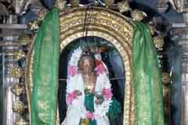
INTRODUCTION
Muthu Sattanathar is a form of Lord Shiva and he is the incarnation of Sri Kalabhairava. His famous temple is situated in Sirkazhi, Tamil Nadu. And apart from the shrine of Sri Sattanathar, Lord Shiva is worshipped as Thoniappar and Mata Parvati is worshipped as Periyanayaki in this temple. Six daily rituals are observed in this temple, and Thiruvadhirai and Shivarathiri are the most important festivals celebrated in this temple.
Thevaram was sung in this temple by the Shaivite saints, and it is one of the most ancient temples in tamil nadu. During his childhood, Sambandar was fed with the divine milk by Mata Parvathi on the banks of the temple tank.
By worshipping Lord Muthu Sattanathar in this holy temple, legal case problems would be solved, since Sattanathar is considered as the Lord of justice. The great saint Sri Arunagiri Nathar had visited this temple and sung in praise of Lord Muruga.
Since Sattanathar is the avatar of Kala Bhairava, he would give good mental and physical strength and protect us from our enemies, and removes our worries and tensions and gives all sorts of prosperities in our life.
Let us worship the great Lord Sri Muthu Sattanathar and be blessed.
“OM SRI MUTHU SATTANATHARE NAMAHA”
“OM NAMAH SHIVAYA”
“OM MATA PARVATI DEVIYE NAMAHA”
WRITTEN BY
R.HARISHANKAR

NAGAMANI ADIGALAR
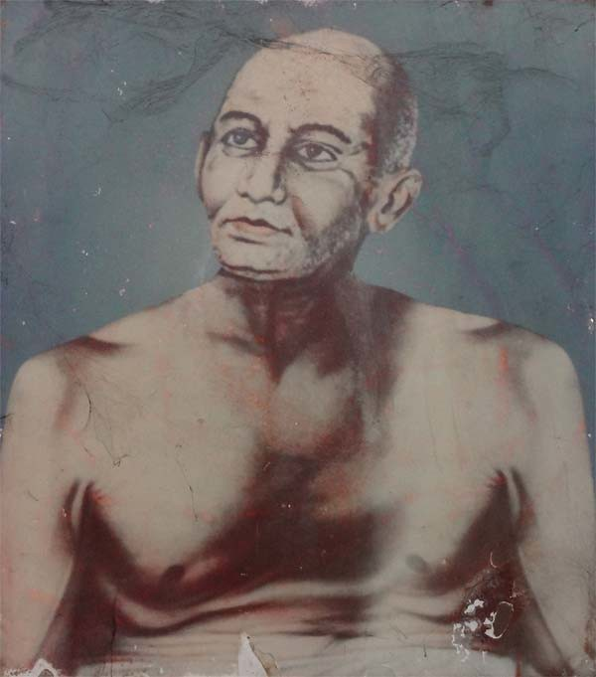
INTRODUCTION
Nagamani Adigalar(19th century AD) was born in Mylapore. From his younger age itself, he was deeply involved in spirituality. He was expert in all the regional languages, and he worked in different professions such as doctor, teacher and scholar, and preached various holy texts among the people like the life history of the 63 Nayanmar saints, Thirumurugadru Padai and Devaram.
He used to give free medicines as well as the sacred ash of Lord Shiva, and cured the diseases of the devotees, and asked them to provide free food to a minimum of 100 poor people on a monthly basis. He lived a noble life and done spiritual as well as social service and attained Jeeva Samadhi in the year 1946 at Perungudi, Chennai.
Kumbabishekham for his Samadhi shrine was performed in the year 1994, and every year annual guru puja would be done on the month of Avani during Pournami.
Let us worship the great Nagamani Adigal and be blessed.
“OM SRI NAGAMANI ADIGALARE NAMAHA”
“OM NAMAH SHIVAYA”
“OM SRI PARVATI ANNAIYE NAMAHA”
WRITTEN BY
R.HARISHANKAR

NAGAS
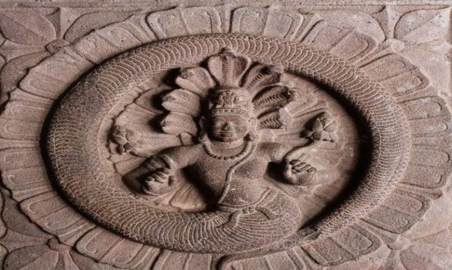
INTRODUCTION
Nagas are mentioned in Hinduism, Buddhism and Jainism texts and they are considered as divine deities and reside in the Patala Loka. They contain great powers, and can take any form at any time. They are also related with gods and goddess like Nagathamman, Nagalingeswarar and Ananta Padmanabha swamy etc. Among the Nagas, Adisesha had become a divine serpent bed of Lord Vishnu, and Vasuki had become the ornament and was adorned by Lord Shiva in his neck, and Lord Vinayaka also used to wear a divine naga as an ornament in his stomach.
Mata Manasa Devi, the Snake goddess and the healer of several dreaded diseases is worshipped by the people all over the world, and lot of temples are dedicated to her throughout India, and she is considered as the mother goddess. Similar to that, Takshaka and Karkotaka are the holiest snakes and lives in the nether world, and they give us all kinds of prosperities and relieve us from diseases and problems.
According to legend, lot of divine gods and demi gods were visited the Naga Kingdom and admired the beauty of the Loka. Naga Lok can be compared equivalent to Indra Lok and contains all the riches. Serpent people, who lives in the Naga Kingdom contains a shining look, healthy body and lives for a long period of time. Those who visit Naga Lok would be welcomed by the Nagini’s, the female forms of Nagas in a pleasant manner. They contain beautiful face, and wear all kinds of precious ornaments, and glitters like a sun.
Once, the great Vishnu Devotee Sri Bhakt Prahalad had visited the Patala Loka, and he was welcomed in a grand manner by the Naga kings and queens. He was given precious gifts and ornaments, and Nagas were praised his glory and his greatness. Bhakt Prahalad was a noble king, and he has controlled his senses, and didn’t enjoy any luxuries and pleasures. His entire attention is only on devoting Lord Vishnu and praising his glories, and due to that, he didn’t accepted the gifts given by them, and after staying for some time in the Naga Loka, he went back to his kingdom.
Let us worship the great Nagas and be blessed.
“OM SRI SESHA BHAGAWANE NAMAHA”
“OM NAMO NARAYANAYA NAMAHA”
“JAI SRI BHAKT PRAHALAD”
WRITTEN BY
R.HARISHANKAR

NARASIMHA JOSIAR - AFFECTIONATE BROTHER OF SESHADRI SWAMIGAL
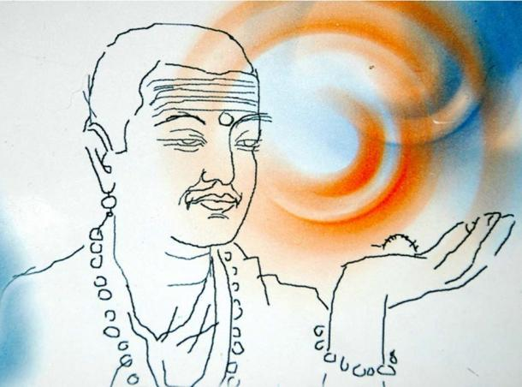
INTRODUCTION
Narasimha Josiar(19th century AD) was the younger brother of Sri Seshadri Swamigal, and he was very affectionate with his elder brother Sri Swamigal. He was very intelligent and mischievous at his childhood, and he was born in Kancheepuram District into a pious Brahmin family, to the holy couple Maragatham and Sri Varadarajar. He was interested in spiritual aspects from his younger age itself, and used to visit the Shiva and Vishnu Temples, and perform meditation.
At his teenage, after his parent’s death, he went to his uncle’s house along with Seshadri Swamigal. His uncle was a famous astrologer, and Narasimha Josiar had learnt all aspects of astrology and become a famous astrologer. After his brother Seshadri had become a saint, he used to visit him at Tiruvannamalai, and spend some time with him. He used to carry with him lot of eatables for his brother and affectionately served him till his death.
Let us worship the divine brothers and be blessed.
“OM SWAMY NARASIMHA JOSIARE NAMAHA”
“OM SRI SESHADRI SWAMIGALE NAMAHA”
“OM SHIVA SAKTHI NAMAHA”
WRITTEN BY
R.HARISHANKAR

NIDHIVAN KRISHNA TEMPLE
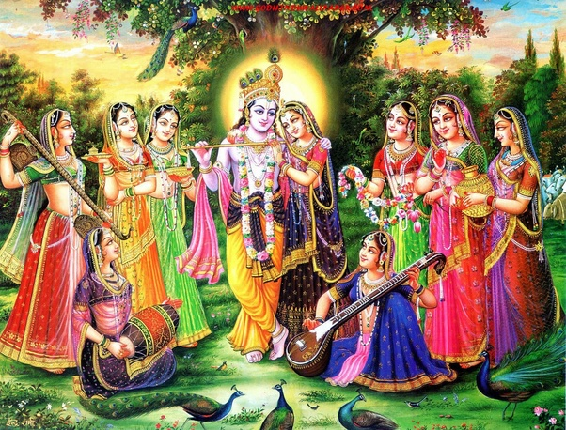
INTRODUCTION
Nidhivan Temple in Vrindavan, is situated near Mathura, and it believed that even today, in this temple, daily night Lord Krishna is visiting here, and dancing with Mata Radha and with other Gopikas, who are in the form of trees, would be changed into Gopikas, once Lord Krishna arrives at this place. And they would be again changed into trees during the next day morning. No people are allowed to visit this temple after 5 pm. According to the belief of the local villagers, those who try to visit this holy place after 5 pm either would become mad or would lose their eyes.
Nidhivan Temple is covered with full of natural beauty and in the Nidhivan temple, a beautiful statue of Lord Krishna and Mata Radha is found. According to the local villagers, lot of proofs are available in this temple regarding the visit of Lord Krishna during the nights. Inside the temple a bed is also kept for Radha and Krishna to take rest.
The temple closes at 5 PM every day.
The people of Nidhivan are the ardent devotees of Lord Krishna and Mata Radha.
Let us once visit the ancient temple of Radhe Krishna and be blessed.
“OM SRI KRISHNA BHAGAWANE NAMAHA”
“OM MATA RADHA RANIYE NAMAHA”
WRITTEN BY
R.HARISHANKAR

ODUKATHUR SWAMIGAL
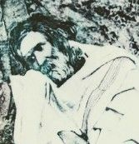
INTRODUCTION
Sri Odukathur Swamigal(19th century) was born in a pious Naidu’s family in the North Arcot District. He was born after performing many pujas and observing fasts by his parents. His birth name was Seshiah.
Seshiah, even at his childhood, showed no interest in worldly matters, and concentrated his attention on doing Shiva Puja and performing meditation. At his younger age itself, he left his home in search of spirituality and wandered throughout South India.
He visited many holy temples and worshipped the deities and finally settled at Odukathur, a village in Vellore. And due to that he was called as Odukathur Swamigal. He observed silence and frequently meditates on the god. His name and fame was spread and lot of people visited him in order to get relieved from their problems. He used to be in a deep Samadhi state for many days at his ashram and rarely consumes food.
He has rescued the people from their death beds, and made them to freely walk. He attained Mahasamadhi in Ulsoor, bangalore in the year 1915. Even now large number of devotees are coming to his Samadhi Shrine and worshipping him, and getting great blessings from him.
Let us worship the holy saint and be blessed.
“OM SRI ODUKATHUR SWAMIGALE NAMAHA”
“OM NAMAH SHIVAYA”
“OM DEVI PARAMESWARIYE NAMAHA”
WRITTEN BY
R.HARISHANKAR

PALANI – AN ARDENT DEVOTEE OF LORD MURUGA
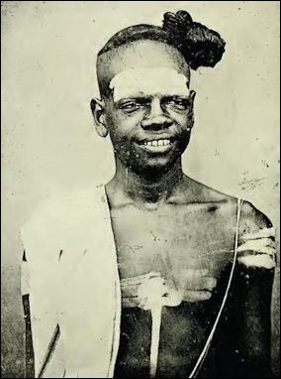
INTRODUCTION
Before hundred years, there lived a pious Brahmin scholar in a village at Tamilnadu whose name was Palani, and he worked as an assistant priest in the nearby Murugan Temple. He used to assist the chief priest in discharging his day to day duties. He will used to do Abhishekham and Puja to Lord Muruga and used to lit Agarbathies and champhor and would distribute the temple Prasad to the devotees after the completion of the puja.
The Chief priest used to offer bananas to Lord Muruga in large numbers during Thaipoosam festival day. One Thaipoosam day, he found some bananas were missing from the temple. He immediately asked Palani about the disappearance of the bananas. Palani got shivered and in a low voice he told that due to hungriness he had eaten half a dozen bananas and began to weep. The Chief priest got very angry with him and began to beat him with a stick till he gets fainted in the floor. Palani cried and stayed the entire night in the temple and left home in the next day early morning.
In the next day morning, when the chief priest opened the shrine of Lord Muruga, he found that there are lot of scars and wounds in the face of Lord Muruga. Immediately he realized that it was happened due to the punishment he had given it to his assistant, and immediately he called his assistant Palani from his home, and asked apology, and praised him for his sincere devotion on Lord Muruga, and gave rich food items to him. On hearing about the incident, the devotees and the people in the nearby villages approached Palani and began to praise him for his pure bhakti on Lord Muruga.
Let us worship the great Muruga devotee and be blessed.
“OM SRI PALANI NAMAHA”
“OM MURUGA”
WRITTEN BY
R.HARISHANKAR
PANCIKA
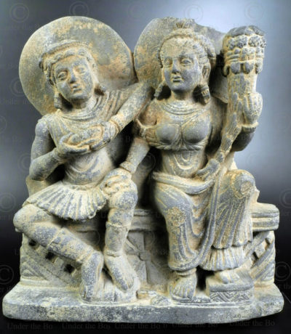
INTRODUCTION
Pancika is a yaksha and his consort is Hariti, and they had hundreds of children.
According to the legend, Pancika was the army general of Lord Kubera, the god of wealth, and enjoys great powers by controlling the Yaksha army. He fought with several powerful warriors and won in the battles.
Pancika appears along with his consort Hariti by keeping a bag of jewels in his hand. They were mentioned in Buddhist texts. He appears similar to his master Lord Kubera, and he is also believed to be the god of wealth. It is suggested to worship Lord Pancika and Mata Hariti while worshipping Kubera and his consort Mata Bhadra, in order to get all sorts of prosperities in the earth, and also we would get a chance to live in the Yaksha world, which is situated near the Himalayas, for a long period of time.
Pancika is an able warrior and contains super natural powers. He is the giver of boons to those who worships him sincerely. It is believed that he stills lives in the Yaksha Loka, and enjoys all sorts of comforts and luxuries, and gives his immense blessings to his sincere devotees.
Let us worship Lord Pancika and Mata Hariti and be blessed.
“OM SRI PANCIKARE NAMAHA”
“OM MATA HARITI NAMAHA”
“OM SRI KUBERAYA NAMAHA”
WRITTEN BY
R.HARISHANKAR

PARANJOTHI BABA
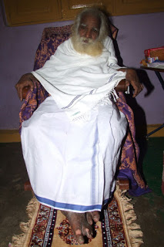
INTRODUCTION
Sri Paranjothi Baba was a great saint who lived in a small room near Vadapalani Murugan Temple. He contains great spiritual powers, and healed many of his devotees by giving the holy medicinal oil. He was an ardent devotee of Lord Muruga from his childhood itself, and used to chant the Kanda Shasti Kavasam in front of the Murugan Temples. He has controlled his senses and never gets angry over others.
He has insisted the people to worship Lord Muruga in order to successfully run their lives. He also conducted religious discourses in the Murugan Temples, and sung the songs of Thirupugazh and Thirumurugatrupadai. He spent most of his time in the Vadapalani Murugan Temple, and used to perform meditation on Lord Muruga, and through that he got great powers, and used the powers for removing the sufferings of the people.
He has attained Jeeva Samadhi during the year 2011 in his small room near Vadapalani Temple, and it is believed that he still blesses his sincere devotees from that room where he stays for a long period.
Let us worship the great saint and be blessed.
“OM SRI PARANJOTHI BABAVE NAMAHA”
“OM MURUGA VEL MURUGA”
“OM NAMAH SHIVAYA”
WRITTEN BY
R.HARISHANKAR

PARJANYA
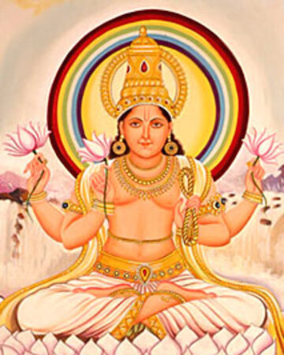
INTRODUCTION
Parjanya is a deity of rain, thunder, lightning and he also fertilizes the earth. He is controlled by Lord Indra, and discharges his duties along with him, since Lord Indra is also considered as the rain god. He suitably rewards the writers and poets and he is an enemy for those who eat non vegetarian food. His name is mentioned in various Hindu sacred texts, and he is considered as one among the Adityas. His parents are Aditi and Kashyapa.
We can make continuous prayers to Lord Indra, Lord Varuna, Mata Bhudevi and Parjanya in order to get sufficient rain, and to get proper cultivation of food crops in the earth.
Parjanya is also mentioned in Buddhist texts. He is the king of the minor gods and he has got a noble daughter named Kokanada, who was considered as very sacred and a chaste woman.
Let us worship Lord Parjanya and be blessed.
“OM SRI PARJANYARE NAMAHA”
“OM SRI INDRA DEVAYA NAMAHA”
“OM MATA KOKANADA NAMAHA”
WRITTEN BY
R.HARISHANKAR

PISHARADI
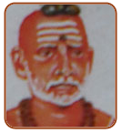
INTRODUCTION
Pisharadi (1550-1621) was born in Trikkandiyur, Kerala, and he was a great writer, reader, astrologer and an ardent devotee of Lord Guruvayurappan. He also helped his student Sri Narayana Bhattathiri towards composing the devotional poem Sri Narayaneeyam.
WORKS
- Pravesaka
- Karanottama
- Uparagakriyakrama
- Sphutanirnaya
- Chayastaka
- Uparagavimsati
- Rasigolasphutaniti
- Venvarohavyakhya
- Horasaroccaya

Pisharadi played a vital role in bringing up his student Sri Bhattathiri in a good manner, and asked him to worship Lord Guruvayurappan at Guruvayur, in order to gain more knowledge and discipline. Bhattathiri obeyed the orders of his guru, and went to Guruvayur and written the great divine text Narayaneeyam with the guidance of his guru Sri Pisharadi. After the completion of Narayaneeyam, Bhattathiri had got relieved from his diseases, and become a strong man.
Pisharadi was a noble scholar and contains great bhakti on Lord Krishna. He taught the essence of Hindu sacred texts to many students, and they have become great scholars and ardent devotees of Lord Krishna. The day on which Bhattathiri dedicated his sacred work Narayaneeyam to Sri Guruvayurappan is celebrated as "Narayaneeyam Day" every year at Guruvayur in a grand manner.
Let us worship Sri Pisharadi and be blessed.
“OM SRI PISHARADIYE NAMAHA”
“JAI KRISHNA”
WRITTEN BY
R.HARISHANKAR
PITRU TARPANAM
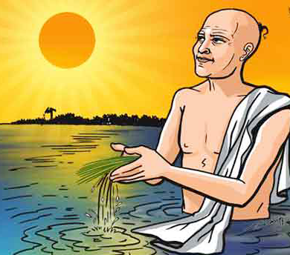
INTRODUCTION
Tarpanam is a type of Vedic practice and it is an offering made to the divine deities by chanting divine mantras. Tilatarpanam means offering made by a person to his deceased father / mother and to the Pitrus (Departed souls of our ancestors) using water and sesame seeds during the annual death ceremony or on Amavasya and other related days.
Tilatarpanam can be done in auspicious temples like Rameswaran, Srisailam, Kasi and Triyambakeshwar Temple, in order to remove our Pitru Doshams.
Tilatarpanam is made in favour of gods, demi gods, rishis, and to our fore fathers.
The main reason for doing Tilatarpanam is to relieve the sins of our fore fathers, and to make them to attain the divine world, and also by way of Tarpanam, we are offering food to them, who would be in hunger, and waiting for our food with anxiety, and if we doesn’t do tilatarpanam, our ancestors souls would get disappointed and they would curse us. Hence it is always suggested to do tilatarpanam to our father and mother after their death in a proper manner. Mainly it is suggested to do Tilatarpanam during Mahalaya Amavasya.
Let us worship Lord Vinayaka and be blessed.
“OM SRI VARASIDDHI VINAYAKARE NAMAHA”
WRITTEN BY
R.HARISHANKAR

PRAYER TO GOD
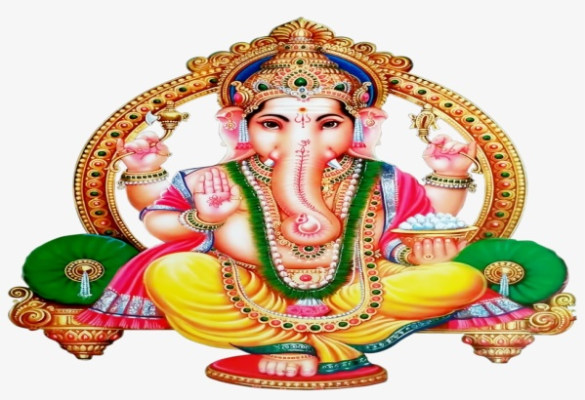
INTRODUCTION
We are the human beings born in this earth, and everyone is suffering from some kind of problems, and some may suffer from big problems, other may suffer from small problems. No human beings are entirely living happily in this world. Is there is any solution for that? Yes! Solution is there and it is within our reach only! But we are not realising the cause of problems and the reason for our sufferings, and we are scolding on god for our sufferings. Actually that is not the way for getting solution to our problems.
Daily we are spending lot of time on reading newspapers, unnecessary gossips and listening to music, dance, cinema and drama. But are we really pray to the god in a whole heartedly manner? And are we thanking him for living a peaceful life? Are we thanking him for having a good health and wealth? Are we doing it? No? Really we are not doing? We are praying just for name sake, and urgently hurrying up doing our duties, which we consider it as the main thing, rather than spending some time and patiently praying to the god. Then how we can get solutions for our problems?
Hence from today onwards, let us allocate some time for devoting to god, and doing puja and praising his glories and chanting the slokas and his various names. Apart from engaging in other activities like sports, entertainment and chatting with others, we can spend some time for thanking god, so that, very soon, we would experience a great change in our life, and we would become more peaceful than ever before. Devotion is not based on religion. People belonging to different religions, can worship their respective gods, and prayers only would make our life to prosper and so that we can get spiritual enlightenment in our life, and can attain SALVATION after our death.
Hence, let us worship the great almighty and be blessed.
“OM SRI VIGNESWARAYA NAMAHA”
WRITTEN BY
R.HARISHANKAR

PRINCE UTTAR
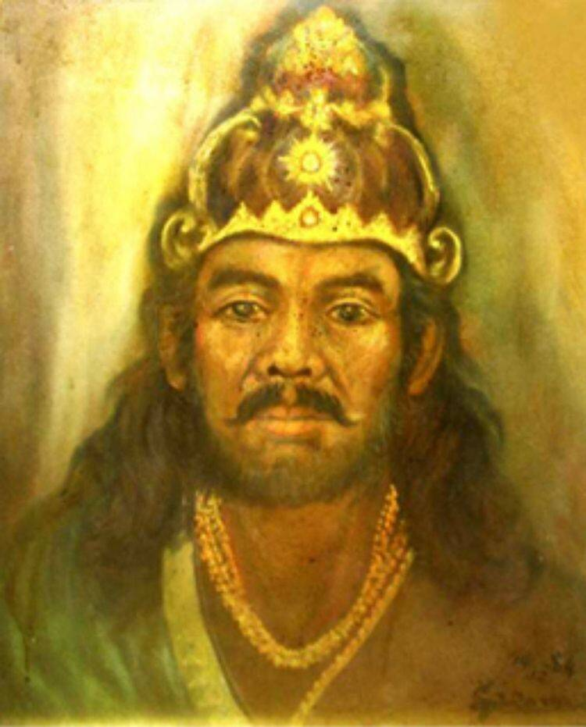
INTRODUCTION
According to Mahabharata, Uttar was the crowned prince of Matsya Kingdom and the son of King Virata. Pandavas spent one year in their kingdom during their exile. His sister Uttara was got married to Abhimanyu, son of Arjuna.
When Duryodhana tried to attack the Matsya Kingdom, Uttar takes the help of his sister's dancing teacher, Brihannala, who was actually Arjuna, who took the form of a dancer, in order to spend his exile period, without disclosing his original identity. He served as the Charioteer of Uttar and then he had shown his true identity in order to disclose his power to Uttar, and fought on behalf of him and succeeded in the war and defeated Duryodhana and drove him out along with the entire Hastinapura army. During the Kurukshetra war, Uttar fought with the Kauravas and supported Pandavas. But the great Uttar was killed in the battle by Shalya.
Prince Uttar was a pious man and after his death, he went to the Swarka Lok and living happily there by enjoying all sorts of comforts and luxuries and become a demi god in the heaven.
Let us worship Sri Uttar and be blessed.
“OM SRI UTTARARE NAMAHA”
“JAI ARJUNA”
“JAI KRISHNA”
WRITTEN BY
R.HARISHANKAR

PURUSHOTAMMA TEERTHA
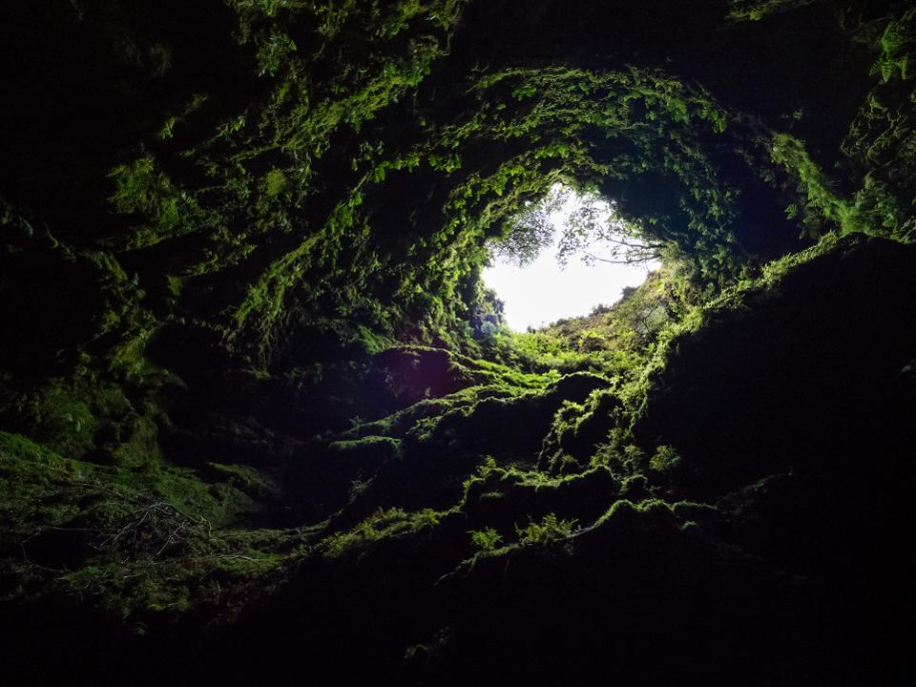
INTRODUCTION
Sri Purushotamma Teertha was a great madhwa saint who lived during the 15th century. His guru was Sri Jayadhwaja Teertha and his disciple was Sri Brahmanya Teertha. It is believed that during the year 1460, he entered alive in a cave near Abbur, Karnataka, similar to his guru Sri Madhwacharya who was disappeared inside the flowers, and settled down at Bhadrikashram and still serving Guru Sri Vyasa Bhagavan in a wonderful manner.
He was a great saint and a sincere devotee of Lord Srirama and Srikrishna. He used to perform puja to the deities in a proper manner, and distribute the holy Prasad to the devotees without seeing their caste, creed or community. It is believed that still now he is blessing the devotees from the cave, and he is still performing meditation on Lord Rama inside the cave without disclosing his identity.
Let us worship the great saint and be blessed.
“OM SRI PURUSHOTAMMA TEERTHARE NAMAHA”
“OM SRI MADHWACHARYARE NAMAHA”
“JAI SRI RAM”
WRITTEN BY
R.HARISHANKAR

RADHA KRISHNA SWAMIJI
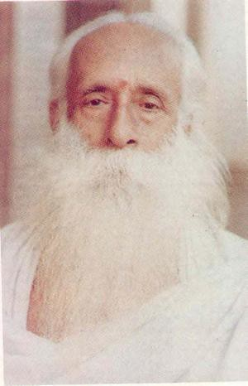
INTRODUCTION
Sri Radhakrishna Swamiji was born in a village in Trichy in a pious Brahmin – Iyer family during the year 1906. Since from his childhood days, he developed bhakti on god and used to do meditation and puja, and at his younger age, he also met many saints and visited temples throughout Trichy.
The Kanchi Swamigal was attracted with the young boy, and made him to stay along with him for some days. He also meditated in the caves and got the divine appearance of Lord Dattatreya.
He was an ardent devotee of Guru Raghavendra, Sadashiva Brahmendra, Shirdi Sai Baba and Lord Krishna. He also met Ramana Maharshi and Seshadri Swamigal at Thiruvannamalai, and received blessings from them.
In the year 1942, he met Sri Narasimha Swamiji, an ardent devotee and follower of Shirdi Baba and became the spiritual heir of Sri Narasimha Swamiji.
Though he got married to a noble lady, he was disinterested in marriage life, and after spending several years in the family life, suddenly he has left his family and become a saint. He was a good reader and also a writer, and read all the divine books, and got great knowledge. He actively participated in the office of the All India Sai Samaj and assisted Sri Narasimha Swamiji and become his personal assistant.
He insisted the Sai devotees to recite the holy names of Lord Vishnu in order to relieve from their sins and also to get out from the chain of birth cycle. After pleasantly doing Sai service for many years, he died in the year 1980.
Though now he is not physically available, he is still blessing us from the heaven.
Let us worship the great saint and Sai devotee and be blessed.
“OM SRI RADHA KRISHNA SWAMIJI NAMAHA”
“OM SRI SAINATH NAMAHA”
“JAI SRIRAM”
WRITTEN BY
R.HARISHANKAR

RAM CHANDRA DATTA – DISCIPLE OF RAMAKRISHNA
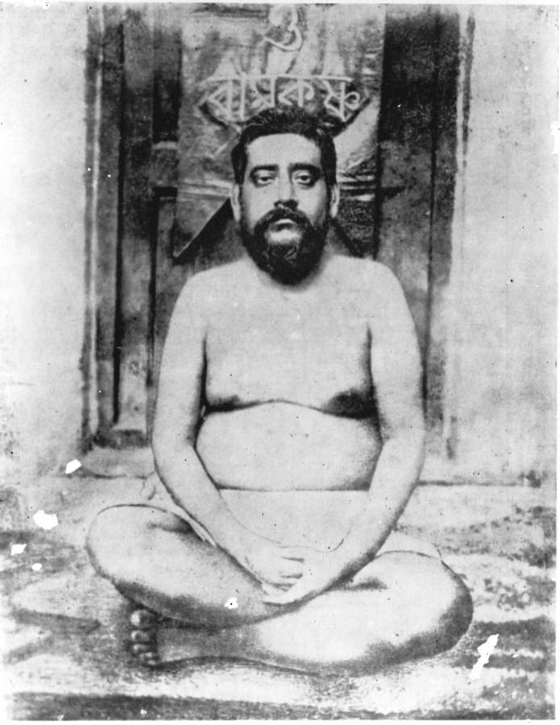
INTRODUCTION
Ram Chandra Datta (1851-1899) was a disciple of Ramakrishna and a well-versed writer of spiritual books. Datta was a close friend of Swami Vivekananda.
Datta was born in the year 1851 in Kolkata. His parents were ardent devotees of Lord Krishna, and his mother has died at his childhood, and hence he was brought up by Mata Bhubaneshwari Devi, who was a relative, and the mother of Swami Vivekananda, and she took care of him in a kind manner, and treated him as her own child. Young Datta become a devotee of Lord Krishna, and used to visit the Krishna temples and perform meditation at his younger age itself. He was a strict vegetarian and didn’t eat non vegetarian food till the end of his life.
At his teenage he got married with a noble girl, and Swami Vivekananda stood by his side, and he was the well-wisher of Datta. For some time, he served in the government department, and done his job in an active manner and he also worked in foreign countries, and got good name through his sincerity, honesty and hard work.
In the year 1879, he visited Sri Ramakrishna at Dakshineshwar and from then onwards he became a true disciple of Ramakrishna and considered him as an incarnation of god, and spread the message of Ramakrishna through his devotional lectures throughout India.
He sincerely served Ramakrishna, and through that he got great mental satisfaction, and he also used to converse with others mentioning about the greatness and the good qualities of Swami Vivekananda.
He built a temple for Ramakrishna and conveyed spiritual lectures in the temple, and explained his life history in the public gathering, and also wrote books on the life history of Rama Krishna.
He died in the year 1899 due to various health issues.
Let us worship the pure saint and be blessed.
“OM SRI RAM CHANDRA DATTA NAMAHA”
“JAI VIVEKANANDA”
“JAI SRIRAM”
WRITTEN BY
R.HARISHANKAR

RAMANATHAN – ARDENT DEVOTEE OF GURU RAGHAVENDRA
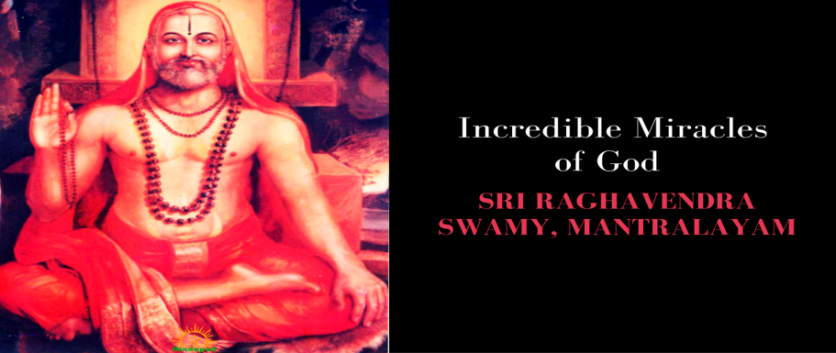
INTRODUCTION
Once there lived in Trichy a pious devotee of Guru Raghavendra whose name was Ramanathan, and he was a businessman, and he belonged to Hindu Mudaliar Community. Regularly during thursday’s he used to visit the Raghavendra Mutt at Srirangam, and worship Raghavendra Swamigal and Lord Sriranganathar at the Srirangam temple. He got married and had two sons, and the entire family were the believers of Sri Swamigal.
He was doing export business, exporting of food stuffs to other foreign countries. Once he had exported cardamom to Singapore through ship, and he stayed in a hotel at Singapore for a few days. One day night, he had experienced severe chest pain and suffered from severe heart attack. He could not even able to get up from the bed. He had realised that he is at the end of his life. Knowing that, with the severe pain in the chest, he started chanting the mantra
“OM SRI RAGHAVENDRAYA NAMAHA” for countless number of times. When he was almost nearing the death, suddenly a saint who was dressed in a saffron cloth entered his room, and gently pressed his chest in his hands, and left away from that room. He was astonished, and he found himself, that slowly he was recovering from his chest pain. That entire night he was doing meditation on Guru Raghavendra, and after waking up in the morning, he narrated the incident to the hotel management, and after the completion of his work, he returned to Trichy, and explained the entire incident to his wife and children.
After a week, he went along with his family to Mantralayam, and offered prayers to the holy saint, and donated few lakhs of rupees to the annadanam scheme to the temple management. He also narrated the incident to the pontiff of the Raghavendra Mutt, Mantralayam in a joyful manner, and after staying there for a few days he left Mantralayam and reached Trichy. From then onwards, every year during the Aradhana celebration days of Guru Raghavendra, he used to visit Mantralayam along with his family and used to donate sufficient money to the annadanam scheme in the temple office.
Let us worship the great saint Sri Guru Raghavendra and be blessed.
“OM SRI RAGHAVENDRAYA NAMAHA”
“JAI SRI RAM”
“JAI KRISHNA”
WRITTEN BY
R.HARISHANKAR

RISHI KANVA
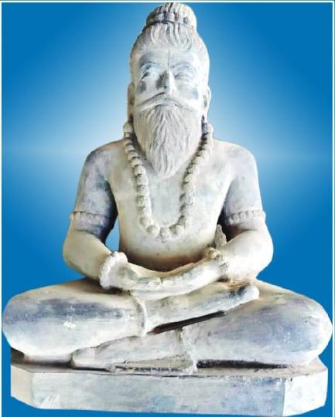
INTRODUCTION
Kanva Maharishi was an ancient rishi and he was born in the Treta yuga, and his importance were mentioned in Rig Veda. He has also written a portion of text in Yajur Veda. He was the foster father of Shakuntala, who was the consort of Dushyanta. Rishi Kanva found Shakuntala in the forest as a child, since her mother Menaka left her in the forest, nearby his ashram. He took care of the baby and brought up her in a proper manner. He is the devotee of the Trimurties, Brahma, Vishnu and Shiva.

Kanva was a very holy and a noble person, who was very good at doing penance. He was mentioned in Mahabharata and Ramayana. Kanva was a great scholar and an expert in all kinds of arts. He lived a simple life and lived his life by eating only fruits and vegetables, and never utilized his spiritual powers for doing wrong activities.
It is believed that now he is living in the Maharishi Mandala and performing penance on Lord Shiva.
Let us worship the holy rishi and be blessed.
“OM SRI KANVA MAHARISHIYE NAMAHA”
“OM TRIDEVAYA NAMAHA”
WRITTEN BY
R.HARISHANKAR

RISHI MAITREYA
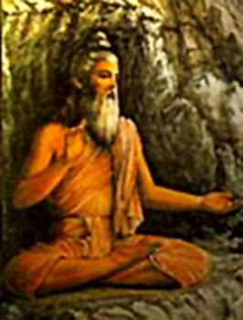
INTRODUCTION
Maitreya was a great sage and he was mentioned in the Mahabharata. It is believed that he was one of the Vedic Rishis and also contains the features of Lord Brahma. During the Dwapara Yuga, he visited Hastinapur and advised Duryodhana to treat the Pandavas in a proper manner, and to give the share of ruling the kingdom to Pandavas, since Duryodana drove the pandavas out from his kingdom, after winning in the dice game, and pandavas went on exile to the forest.
But, Duryodhana disrespected the sage, and due to that the sage cursed him to lose his life in the hands of Bhima during the kurukshetra war. The curse which he gave was truly happened in case of Duryodana, and he died in the hands of Bheema during the battle.
Let us worship the great rishi and be blessed.
“OM SRI RISHI MAITREYARE NAMAHA”
“JAI SRI KRISHNA”
“JAI RUKMANI MATA”
WRITTEN BY
R.HARISHANKAR

RUKMANI
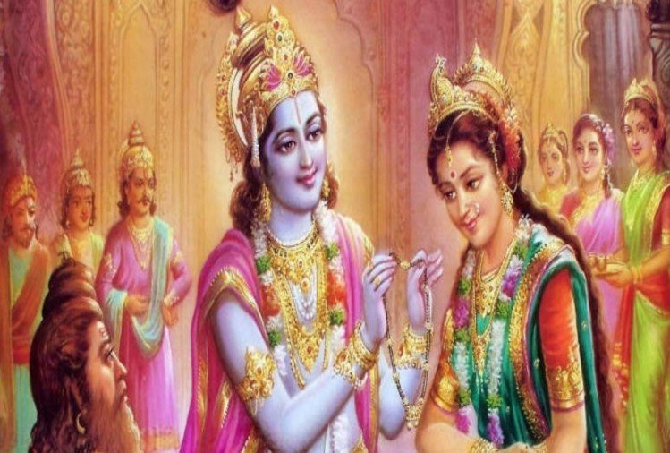
INTRODUCTION
Rukmani was the princess of Vidarbha and she was born in the holy city of Haridwar, and she is the consort of Lord Krishna. Due to the dislike with Krishna, her brother Rukmi arranged her marriage with Sishupala. But Lord Krishna fought with the kings and got married with Rukmani. She was mentioned in Bhagavata Purana, and was considered as a divine incarnation of Mata Lakshmi.
Due to her marriage with Lord Krishna, Dwaraka’s citizens were happy, and they celebrated their marriage as a festival in their homes. Everybody prepared various sweets and savouries and offered it to their great master Krishna and Rukmani, and received their blessings.
Once Mata Rukmini welcomed Lord Krishna’s childhood friend Sri Sudama with much respect, and offered him delicious food. She is worshipped as Rukhumai, the consort of Vithoba (an incarnation of Krishna) in Pandharpur, Maharashtra. She is the mother of ten children and among those Pradyumna was considered as the crown prince of Dwaraka.
After the end of Krishna avatar, Rukmini along with his other consorts were entered into the pyre and attained VAIKUNTA.
Let us worship the holy mother and be blessed.
“OM SRI RUKMANI ANNAIYE NAMAHA”
“JAI KRISHNA”
WRITTEN BY
R.HARISHANKAR

SAANGU SIDDHA SWAMIGAL
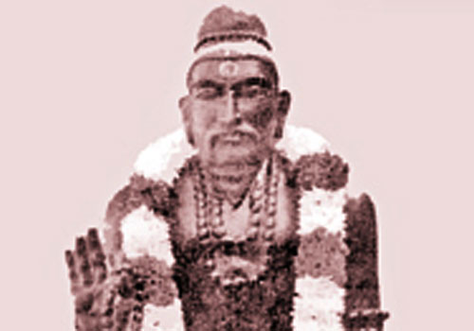
INTRODUCTION
Saangu Siddha Swamigal had attained Jeeva Samadhi in the year 1900 at Thirugnanasambandar madam, Guindy. Nearby his Samadhi Shrine, Sri Kollapuri Swamigal Samadhi and Sri Ezhumalai Swamigal Samadhi are also found.
Saangu Siddha Swamigal was an ardent Shiva devotee and dedicated his entire life towards worshipping Shiva-Parvati, and done many social service activities with the donations received from the rich people like providing food, making shelters for the poor people, and performed marriages to the poor girls. He didn’t keep any money for his own purpose, but utilized the money received from his devotees towards doing good things to others.
Apart from doing social services, he also removed the diseases of the people, by giving curd rice and tamarind rice as Prasad to the devotees after offering it to Lord Shiva, and devotees were got relieved from their diseases after consuming the holy Prasad. He insisted the devotees to spend more time towards concentrating their attention on Lord Shiva and made them to chant the Shiva Mantra: “OM NAMAH SHIVAYA”
Let us worship the great saint and be blessed.
“OM SRI SAANGU SIDDHA SWAMIGALE NAMAHA”
“OM NAMAH SHIVAYA”
“OM MATA SATHI DEVIYE NAMAHA”
WRITTEN BY
R.HARISHANKAR

SAGE SUTIKSHANA
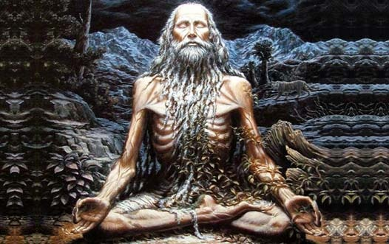
INTRODUCTION
Sage Sutikshna was a disciple of Sage Agastya, and he has learned all the divine subjects under his guidance. After finishing his education, he decided to grant Guru Dakshina to his Guru Agastya, and asked his wishes. Sage Agastya had demanded him to bring Rama before him in order to discuss with Lord Rama. But that time, Lord Rama didn’t take his avatar in this earth. But the great disciple didn’t think all about these. He had constructed an ashram in the forest, and started meditating by chanting the Rama Mantra “JAI SRIRAM”. He didn’t take any food and keep on chanting the Rama Mantra for several years, and due to that, he has become very weak, and he looked very thin.
Finally one day, Lord Rama came to the forest during his exile period. He met Sutikshna and both of them embraced each other. Afterwards, Sutikshna had told to Lord Rama to meet his Guru Sage Agastya, and both of them met each other, and they gave several boons to the great sage Sutikshana.
It is believed that Sage Sutikshna’s ashram is located in the present day Uttar Pradesh, and he is considered to be the true disciple of Sage Agastya.
Let us worship the great sage and be blessed.

“OM SRI SUTIKSHANARE NAMAHA”
“OM SRI AGASTYA MAHARISHIYE NAMAHA”
“JAI SRI RAM”
WRITTEN BY
R.HARISHANKAR

SAHAJO BAI
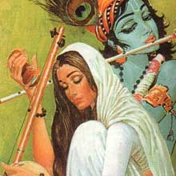
INTRODUCTION
Sahajo Bai (1725-1805) was born in a pious Hindu family in a village at Delhi. She got married at a younger age, and her husband was died immediately after marrying her. Due to that, she had lost interest in family life, and preferred to become a saint and become a disciple of Saint Charandas, and concentrated her entire attention towards devoting on Lord Krishna, and forgets about everything in the world. She got great knowledge from her guru, and learnt all the divine scriptures. She died on 1805 in Vrindavan, and reached Vaikunta.
TEACHINGS
- Believe in Lord Krishna, and put your entire burdens in his lotus feet, and peacefully do your duties.
- Lord Krishna is everywhere and he resides in each and every living being. He is the creator, protector and the destroyer.
- Chant the glories of Lord Krishna, and read the Bhagavatham and Bhagavat Gita, in order to get enlightenment in life.
- Krishna is the only medicine for our diseases, and by worshipping him frequently, and by consuming his divine Prasad, all the dreaded diseases would run away from our body.
- Don’t waste even a single moment without chanting Lord Krishna’s names.
- Don’t show too much attention on earning money, since it would never come with you after your death, and do some kind of charity activity with your surplus money.
- Don’t commit sins and don’t suffer in your life.
- Don’t think about unnecessary and unwanted things and waste your time, instead of that, meditate on Lord Krishna, and gain more spiritual power through that.
- Show mercy on all the living beings in the earth, and provide food to the people, animals, birds and insects.
Let us worship the holy saint and be blessed.
“OM SRI SAHAJO BAI NAMAHA”
“JAI KRISHNA”
“JAI BALRAM”
WRITTEN BY
R.HARISHANKAR

SAINT KAMBALISWAMY
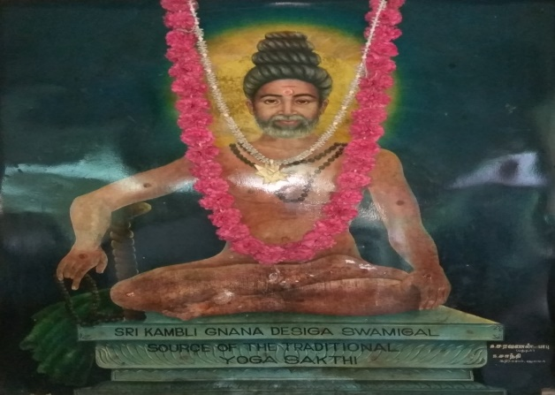
INTRODUCTION
Saint Kambaliswamy(19th century AD) also known as Kambli Gnana Desiga Swamigal was a great yogi who lived before 150 years, and lived in the present day Thattanchavady, Pondicherry. He has observed strict silence during his life time, and he is also known as Mouna Swamigal. He used to give sacred ash and distribute the holy Prasad to the devotees. He was good at yoga and meditation and trained his devotees in the yoga field. Sri Kambaliswamigal used to take Jala Samadhi in the lake as a regular practice, and used to meditate on Lord Shiva for long hours. He used to take only simple food, and lived a simplistic and holistic life.
Sri Kambaliswamigal had done many miracles in the life of his devotees, and cured the diseases of the people, and he made the dumb and deaf to talk and hear, and he made the blind to read and write, and the lame to walk, like that, he had performed lot of good things in the life of his sincere devotees. He was also a good writer and composed many songs and sung in praise of Lord Shiva and Lord Muruga in the temples.
He attained Maha Samadhi in the new moon day in the month of Marghazi in 1873 at his ashram at Pondicherry.
Let us worship the great saint and be blessed.
“OM SRI KAMBALISWAMIGALE NAMAHA”
“OM NAMAH SHIVAYA”
“JAI BHAVANI MATA”
WRITTEN BY
R.HARISHANKAR

SANDHANANDA SWAMIGAL
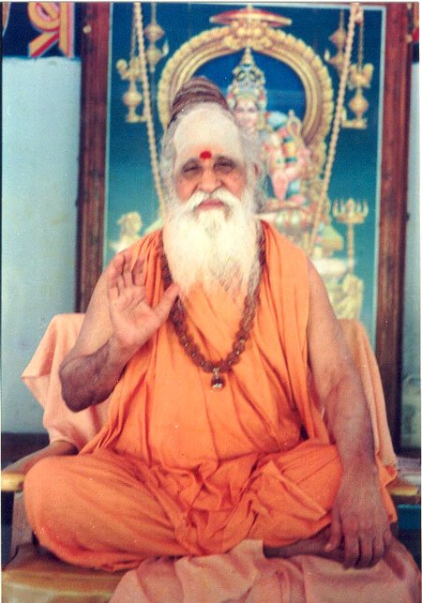
INTRODUCTION
Sandhananda Swamigal was born in a pious Brahmin family in a village near Madurai. He became the disciple of Sri Mayandi Swamigal and learnt Divine scriptures under his guidance. He has done meditation and attained great powers through that. He took sainthood at a village near Salem from Swayam Prakasha Brahmendra Saraswathy Swamigal and from then onwards, he was called as Sathguru Sandhananda Swamigal.
He settled in Puthukkottai, and constructed Shiva and Sakthi temples and introduced various puja schemes in the temples. He also provided annadanam to the devotees in the temple complex and also done various charitable activities like educating the poor children, building shelters for the poor people, providing financial aid for poor girl’s marriages etc.
He attained Samadhi in the year 2002, and his Samadhi Shrine is located in Salem Skandasramam. And the address of the shrine is as follows:
Sri Skandasramam,
Udayapatti, Salem – 636 140.
Let us worship the great saint and be blessed.
“OM SRI SANDHANANDA SWAMIGALE NAMAHA”
“OM NAMAH SHIVAYA”
“OM SRI PARVATI DEVIYE NAMAHA”
WRITTEN BY
R.HARISHANKAR

SANT PATALU
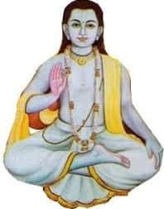

INTRODUCTION
Sant Patalu (19th century) was born in Faizabad in a pious Hindu family, and he was an ardent devotee of Lord Srirama. He has completed his basic education at his childhood. From his younger age itself, he used to worship Lord Ram in the temple, and offer flowers and lit lamps and adorn him with flower garlands in a simple manner. After attaining teenage, he left his home, and for some time wandered in the nearby villages by taking alms and lived a simple life.
After some time, he met the great saint Sri Bhikhadas, and learnt the Hindu scriptures and become a great saint. He travelled throughout India and worshipped the deities in the holy temples, and got great spiritual power through that. Finally, he settled down at Ayodhya and set up an Ashram, and began to do meditation and gave lectures on Ramayan to the devotees of Rama. His famous disciple was Hulasadas. He relieved the body related and mind related diseases of the people and invoked them into the “SREE RAMA BHAKTI PATH”. He insisted the people to chant the Rama Mantra, “JAI SRIRAM” regularly. He used to chant Rama Mantra for a minimum of 1000 times on a daily basis. Once he got the divine darshan of Rama, and received blessings from him. With the money received from the donations, he used to provide food to the poor people, and took care of them properly.
There is a Samadhi of Sant Patalu in Ramkot near Ayodhya. Still now, lot of devotees are visiting the holy Samadhi shrine and getting his blessings.
Let us worship the great saint Sri Patalu and be blessed.
“OM SRI SWAMY PATALU NAMAHA”
“JAI SRI RAM”
“JAI MATA SITA”
WRITTEN BY
R.HARISHANKAR
SASHTI VIRATHAM
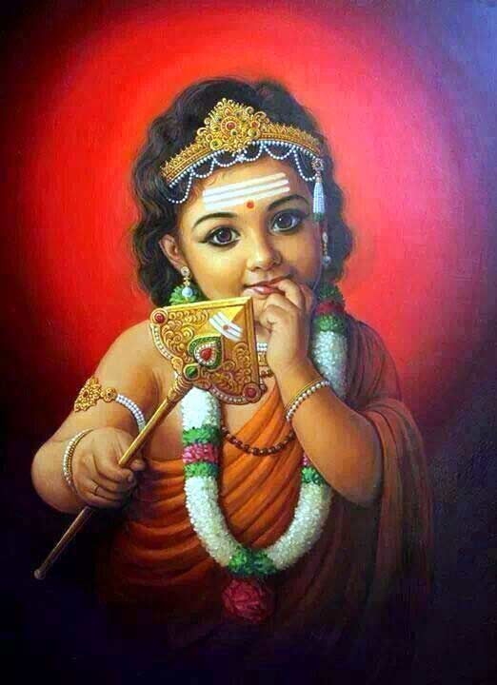
INTRODUCTION
Sashti Viratham would be observed by the devotees of Lord Muruga, and usually it would be observed by the childless couples for getting child for them. This fasting would be observed either by the husband or by the wife, or in some cases both of them would observe the fasting, in order to get a blessed child. This fasting can be done either on the Annual Kanda Sashti day, or on the monthly Sashti days, depending on their convenience. It is suggested to observe fasting on all the Sashti days, in order to get better results in their life.
Apart from child birth, Sashti Vrata is followed by the devotees for getting all other sorts of benefits also. We can observe the fasting either in the temple or in our house itself. During the fasting days, we have to eat only simple food like milk and fruits, or otherwise we can observe fasting on the entire Sashti day only by having water, and it all depends on our devotion with the god, and control in our mind and body. We can chant the Kanda Sashti Kavasam during the fasting day, in order to get positive results in our life. Even we can observe fasting without for any particular reason in order to get the divine grace of Lord Muruga.
Let us worship Lord Muruga and chant his name and be blessed.
“OM MURUGA VEL MURUGA”
WRITTEN BY
R.HARISHANKAR

SATYABAMA
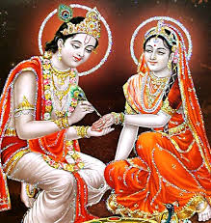
INTRODUCTION
Satyabama is the consort of Lord Krishna. She is believed to be an incarnation of Bhu Devi, the Goddess of Earth. She helped Lord Krishna in killing the demon king Narakasura. She also brought the divine wish fulfilling tree Kalpavriksha from the heaven with the help of Lord Krishna.
Satyabama was the daughter of Yadava King Satrajit. And due to some issues he disliked Lord Krishna. But after some time, he realized the greatness of Lord Krishna, and willingly offered his daughter to Krishna. Satyabama was a close friend of Mata Draupadi.
After the death of Krishna, Satyabama has left her physical body, and reached the divine abode of Vaikunta. Satyabama was a calm woman and maintained patience throughout her life, since she was the avatar of Bhu Devi. She acted as a dutiful wife of Lord Krishna, and sincerely served him throughout her life.
Let us worship the divine mother Mata Satyabama and be blessed.
“OM SRI SATYABAMA ANNAIYE NAMAHA”
“JAI KRISHNA”
WRITTEN BY
R.HARISHANKAR

SATYAKI
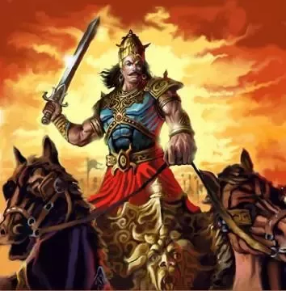
INTRODUCTION
Satyaki was a great Yadava warrior and an ardent devotee of Lord Krishna. He was the adopted son of Satyaka. Satyaki fought from the side of Pandavas in the Kurukshetra War. He went along with Lord Krishna for meeting Duryodhana during peace talks, in order to avoid the war between the Pandavas and Kauravas. He also had seen Lord Krishna's Vishwaroopa form, when Lord Krishna takes the form, in order to show his supreme powers to Duryodhana. During the Kurukshetra war, Satyaki was the army chief of the Pandava army.
He was the disciple of Arjuna and learned the skills of handling weapons, and he also trained under drona, and got great knowledge in archery. During the war, Satyaki kills the great warrior Somadatta and also helped Bhima to kill the noble King Bahlika, a person who had followed the path of righteousness throughout his life.
Satyaki is a great Ayurvedic physician, and also recovered the injured Pandava warriors by giving proper medicines to them.
Due to the curse given by Mata Gandhari, the great Satyaki and the Yadavas were entirely destroyed at the end of the Dwapara yuga, and Lord Krishna and Lord Balarama were left their physical body and attained Vaikunta.
After the death of Satyaki, he went to the abode of Lord Indra, the Swarka Loka and still happily living there.
Let us worship the great warrior and the Sri Krishna Devotee Sri Satyaki and be blessed.
“OM SRI SATYAKIYE NAMAHA”
“JAI SRIKRISHNA”
“JAI SRIBALARAM”
WRITTEN BY
R.HARISHANKAR
SHIVA GANA BRINGI
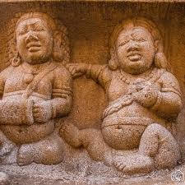
INTRODUCTION
Bringi is said to be a Shiva Gana, who is living in the Shiva Lok, the Himalayas, along with Lord Shiva and Mata Parvati, and with other divine attendants of Lord Shiva. According to legend, Bringi had obtained the position in the Shiva Loka, due to his severe penance on Lord Shiva in the earth during the first Krita Yuga. He was considered as one of the main attendants of Lord Shiva, similar to Lord Nandhi and Lord Chandikeswara. He greatly respects the divine couple, and considers Shiva-Parvati as his divine father and mother.
According to legend, he was present along with Lord Shiva, when Shiva consumed the Halahala poison, in order to safeguard the earth and heaven from destruction. And according to ancient Puranas, he would be residing in Mount Kailash permanently, and would do sincere service to Shiva-Parvati and used to chant the Shiva mantra “OM NAMA SHIVAYA” continuously and looks always cheerful and happy. He also used to play the drums when Lord Shiva dances.
Let us worship the divine Shiva Gana and be blessed.
“OM SRI SHIVA GANA BRINGIYE NAMAHA”
“OM SHIVA SAKTHI NAMO NAMAHA”
“OM SRI VIGNESWARAYA NAMAHA”
WRITTEN BY
R.HARISHANKAR

SIDDHAR BALASUBRAMANIYA SWAMIGAL
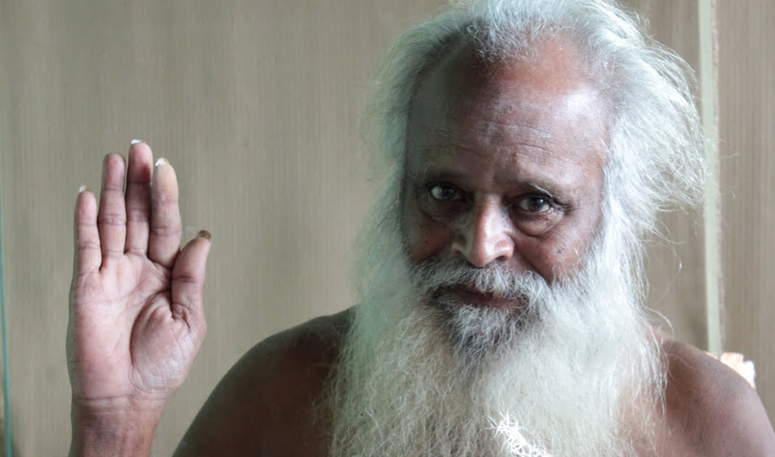
INTRODUCTION
Sri Balasubramaniya Swamigal was born in the year 1937 in Karur into a pious Mudaliar Family. He was taken to nearby temples by his mother at his younger age itself, and made him to be a staunch Shiva Bhakta. His affectionate mother and his sisters were died at his younger age. But, since he was deeply involved in spirituality, somehow he has changed his mind, and concentrated his attention on doing service to Lord Shiva. He will used to regularly visit Lord Pasupatheeswarar and perform puja and abhishekham to the Shiva Lingam.
He is residing in a small house near the Pasupadeeswarar Temple and blessing his devotees in a wonderful manner. Many devotees shared their pleasant memories spent with him. Through his powers, he has done many miracles in the life of his devotees. He used to affectionately welcome his devotees to his house and enquire about their well-being and give them Lord Shiva’s sacred ash as Holy Prasad to them. Lot of devotees were got relieved from their problems and happily living their life.
Let us worship the great siddhar and be blessed.
“OM SRI SIDDHAR BALASUBRAMANIYA SWAMIGALE NAMAHA”
“OM NAMAH SHIVAYA”
“OM SAKTHI PARASAKTHI”
WRITTEN BY
R.HARISHANKAR

SIDDHAR SRIVASTAV GURUJI

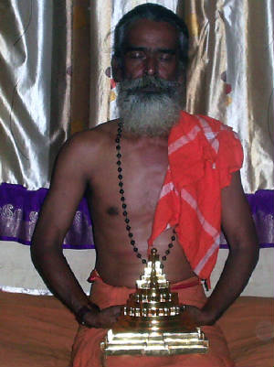
INTRODUCTION
Siddhar Srivastav Guruji was one among the living siddhars who could remove the human problems through his spiritual powers. He was born and brought up in Coimbatore. After completing his basic education, he has concentrated his attention on spirituality.
He used to visit the Vellingiri mountains and used to sit in deep meditation. He spread the bhakti spirit among the tribes in the Vellingiri mountains, and insisted them to worship the god by chanting his holy names. His spiritual guru was Sudalai Muthu Pillai. He is a sincere devotee of Lord Shiva, and used to chant his holy names and got great divine powers through that. After some time, he has become popular in the Coimbatore locality and rendered his helping hand to the sufferers.
Now he is residing at Chennai and blessing his devotees. Devotees from all parts of India and even from abroad are coming to him, in order to get spiritual enlightenment.
Let us worship the great siddhar and be blessed.
“OM SRI SRIVASTAV GURUJI NAMAHA”
“OM NAMAH SHIVAYA”
“JAI BHAVANI MATA”
WRITTEN BY
R.HARISHANKAR

SIDDHAR SWAMIGAL
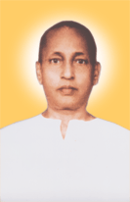
INTRODUCTION
Sri Siddhar Swamigal was born in the year 1904 to a pious Hindu Shaivite family in Kumbakonam. His birth name was Narayanaswamy. His parents and ancestors were ardent devotees of Lord Shiva, and used to perform puja and milk abhishekam and adorn flowers regularly to the Shiva lingam. He was married at his younger age itself, and had two children. His grandfather had become a saint, and used to do penance on Lord Shiva at his ashram. Swami also developed the habit of doing penance from his grandfather.
In course of time, due to his constant meditation on Lord Shiva, he has got more spiritual powers, and healed the diseases of the people. He protected the devotees from dangerous accidents, murders and from black magic. Once he removed the leprosy of a person by rubbing the sacred ash on his body. He removed the evil spirits from the body of the devotees, and removed the evil thoughts from the minds of the devotees.
He wholeheartedly provided food to all the devotees at his ashram, and through his powers, he used to generate food from an empty vessel and distribute it to thousands of poor devotees. He insisted the people to chant the “NAMAH SHIVAYA” mantra continuously in order to remove the problems in their life. He also used to give discourses on Shiva puranam, story of 63 nayanmar saints, Thevaram and Thiruvasagam.
He died in the year 1964 at his Omkara Ashram in Myladuthurai, Nagapattinam District, tamil nadu.
Let us worship the great swamigal and be blessed.
“OM SRI SIDDHAR MAHASWAMIGALE NAMAHA”
“OM NAMAH SHIVAYA”
“JAI PARASAKTHI”
WRITTEN BY
R.HARISHANKAR

SIDDHAR YOGEESHWARAR
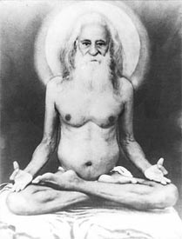
INTRODUCTION
Siddha Purusha Sri Yogeeshwarar was born during the year 1865, in a village at Tamil Nadu. From his childhood itself, he was deeply involved in spirituality. At his younger age, he visited Kanchi Sri Ekambareeshwarar temple, and performed meditation on Lord Shiva in the temple premises for several days, and got great enlightenment through that. He was also good at doing yoga, and taught the concepts of yoga to the people. Yogeeshwar has travelled to many foreign countries, and gave various spiritual discourses among the people.
At his teenage, he got married with a pious and a noble lady and she served him wholeheartedly.
Shri Yogeeshwar had done various kinds of business and earned lot of money through that. But he donated most of the wealth to the poor people, and kept only a small portion for himself and his family. He used to offer food to the poor people, animals, birds, and even to insects. He was such a kind hearted person.
After some years, his wife was dead, and he distributed all the belongings of himself and her wife to his poor relatives, and he built a small hut at Vyasarpadi at Chennai and started doing meditation. And again, some years later, Yogeeshwar moved to Cuddappah in Andhra Pradesh and set up an ashram and wrote various devotional books and published it with the donations received from the noble donors. At his final stage of life, he built an ashram for himself at Bangalore, and done spiritual as well as social welfare activities.
He entered in the state of Samadhi in the year 1957, at his Ashram in Bangalore.
Let us worship the great saint and be blessed.
“OM SRI SIDDHAR YOGEESHWARARE NAMAHA”
“OM NAMAH SHIVAYA”
“OM SRI PARVATI ANNAIYE NAMAHA”
WRITTEN BY
R.HARISHANKAR

SIDDHARS
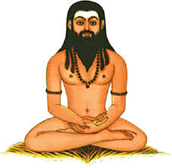
INTRODUCTION
Siddhars are considered as divine people, who had attained spiritual powers through constant meditation, and the greatness of siddhars was mentioned in ancient Tamil texts. The famous ones are the 18 siddhars, and apart from them, even now lot of siddhars are living all over India, and blesses us. And most of them reside in the hilly mountain ranges, and they contain good knowledge in devotional subjects, and they are the devotees of Lord Shiva, and some Siddhars worships other gods and goddesses also. Sage Agastya is a famous siddhar, and an incarnation of Lord Shiva, and rendered lot of good service for the welfare of the mankind.
Siddhars are considered as great saints and they are specialised in Ayurvedic and Siddha field. They have written divine poems on Lord Shiva, Lord Muruga and Lord Vishnu in Tamil in the "Palm leaf manuscripts". These are still preserved by some people and kept under safe custody. They have mentioned certain types of medicines to cure various dreaded diseases in the palm leaves. They have also cured lot of people using Varmam, a kind of hard touch, through which people would find immediate remedy from their pains in their body.
Some Siddhars are still living in Mountain Sathuragiri, in a divine form, and would give their appearance to the true devotees of Lord Shiva. Siddhars contains great powers, and they can take any form or can become invisible from our eyes. They have controlled their senses, and dedicated themselves on worshipping and meditating on the gods and goddesses. They live for a long span of life, and the great Nayanmar saint and siddhar Sri Thirumoolar had lived for a period of 3,000 years in order to spread the “SHIVA BHAKTI SPIRIT” among the masses.
Let us worship Lord Shiva and be blessed.
“OM SRI SHIVAYA NAMAHA”
WRITTEN BY
R.HARISHANKAR

SISTER NIVEDITA
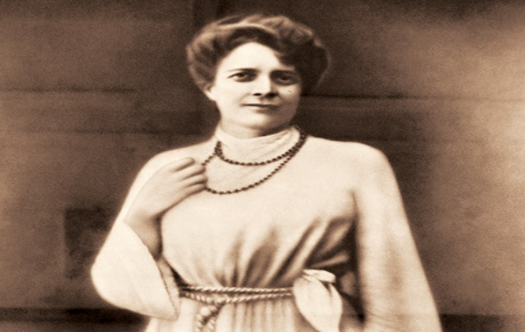
INTRODUCTION
Sister Nivedita (1867–1911) was a spiritual writer, social activist and the beloved disciple of Swami Vivekananda. She spent her childhood days in Ireland. From her younger age itself, she learned the motto that doing service to mankind is the major service to God. Her birth name was Margaret. She worked as a school teacher for some time, and she met Swami Vivekananda in London and travelled to Kolkata in the year 1898, and become a saint under Swami Vivekananda with the name Nivedita. She also written spiritual books and delivered spiritual messages in front of public gathering.
After becoming a saint, she opened a school for teaching subjects to the poor children and also done many welfare activities like taking care of poor patients and providing food to them as per the advice of his guru Swami Vivekananda. Nivedita also helped towards forming Ramakrishna Mission. She was very fond of Mata Sarada Devi, consort of Ramakrishna, and used to discuss spiritual matters and also clarified her doubts with her regarding spiritual aspects. She died in the year 1911 in Darjeeling. Her memorial is located near the Victoria Falls in Darjeeling.
Let us worship the great saint and be blessed.
“JAI SWAMY VIVEKANANDA”
“JAI SISTER NIVEDITA”
WRITTEN BY
R.HARISHANKAR

SRI NARASIMHA SWAMIJI
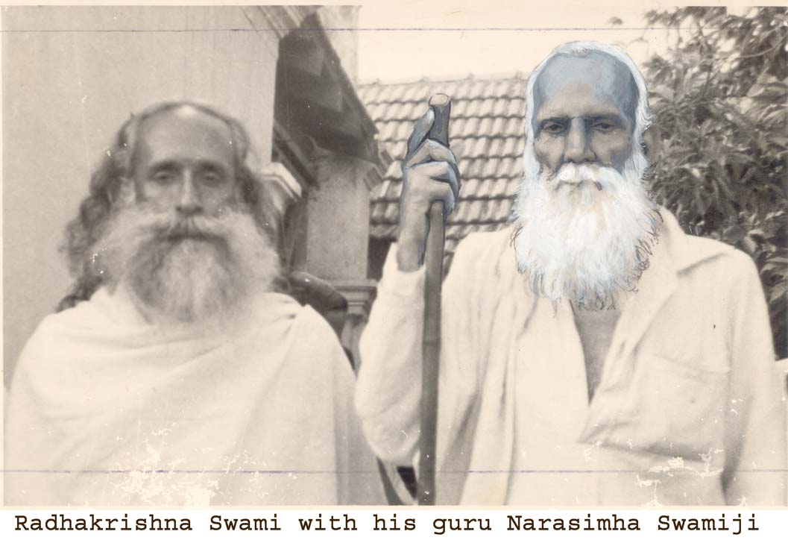
INTRODUCTION
Sri Narasimha Swamiji, was born in the year 1874 in a Brahmin family at Coimbatore in Tamil Nadu. His birth name was Narasimha.
Sri Narasimha Swamiji was an intelligent child, and quickly grasped the subjects, and become a leading boy in the school. After completing his law degree, he became a noble lawyer and handled cases of poor people, and also done many social service activities like providing food packets and giving new dresses to the roadside beggars etc.
Once, in his dream, Sri Shirdi Baba had invited him to Shirdi to have his darshan. He went to Shirdi and became an ardent devotee of Sainath, and began to spread the message of Sai Baba and about the greatness of Sai Baba throughout India. Very soon, he got name and fame due to his sincere devotion on Baba. He wrote lot of books mentioning the miracles performed by Sai in the life of his devotees.
Sri Narasimha Swamiji fully dedicated his life towards worshipping Sai and doing spiritual as well as social service.
He got married at his teenage, and took care of his family properly. He also renovated the ancient temples at his own cost, and performed puja services in the temples. He met Guru Ramana at Thiruvannamalai and got great spiritual energy, and he also visited holy temples throughout India and got divine blessings. He met the direct disciples of Saibaba at Shirdi and interacted with them and conversed with them about the holiness of Sainath. He used to give Sainath’s Udi, sacred ash, to the Sai devotees, and due to that, lot of devotees were got relieved from their ailments. He published a monthly spiritual magazine in order to spread the importance of Saibaba among the people in various languages.
After doing selfless service to the society, Sri Swamiji had attained SALVATION in the year 1956.
Let us worship the great Sai devotee and be blessed.
“OM SRI NARASIMHA SWAMIJI NAMAHA”
“JAI SAINATH”
“JAI SRIRAM”
WRITTEN BY
R.HARISHANKAR

SRI RAGHUPATHI TEERTHA
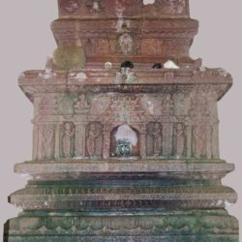
INTRODUCTION
Shri Raghupati Teertha was a great Madhwa saint and served as the pontiff of the Palimar Mutt, Udupi, Karnataka, for a period of 17 years, under the lineage of Shri Hrishikesha Teertha. He was an ardent devotee of Lord Rama and was well appreciated by many scholars for his great works. He also won in the debates held with great scholars. He got good knowledge in all the subjects, and an expert in all kinds of arts and well-versed in ancient Vedas and Hindu Scriptures.
He was a kind hearted saint who used to conduct divine lectures, in order to spread the bhakti spirit among the people. He used to give the Holy Prasad to all the devotees in a pleasing manner, and relieved the diseases of the devotees through his spiritual powers.
He underwent lot of tours during the final stage of his life and in the year 1588 A.D, he had attained Brindavana at Haridwar.
Let us worship the noble saint and be blessed.
“OM SRI RAGHUPATHI TEERTHARE NAMAHA”
“JAI SRIRAM”
“JAI SRIKRISHNA”
WRITTEN BY
R.HARISHANKAR

SRI RAJENDRA TEERTHA
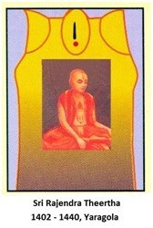
INTRODUCTION
Rajendra Teertha (14th century AD) was the pontiff of the Yargola Mutt, Karnataka. Sri Rajendra Tirtha was the disciple of Sri Vidyadhiraj, and he learnt the knowledge of Vedas, Shastras and other divine subjects from him. Once, his guru Vidyadhiraja Tirtha was very sick, and hence he had appointed his disciple Kavindra Tirtha to become the pontiff of the Mutt, since during that time, Sri Rajendra Teertha undertook holy pilgrimages.
Rajendra Tirtha after returned from his journey became the pontiff of the Vyasaraya Mutt. He had preached all over India and explained about the importance of Dvaita philosophy throughout India.
Sri Rajendra Teertha had many disciples and among them Vishnudasacharya was his main disciple. Rajendra Teertha wrote many devotional works during his period, and was praised by the people for his vast knowledge in all the subjects. Rajendra Teertha Samadhi is situated at Yargola at Karnataka, and now the Samadhi structure was damaged.
Let us worship the great saint and be blessed.
“OM SRI RAJENDRA TEERTHARE NAMAHA”
“JAI SRIRAM”
“OM SRI MADHWACHARYARE NAMAHA”
WRITTEN BY
R.HARISHANKAR

SRI SAKKARAI AMMA
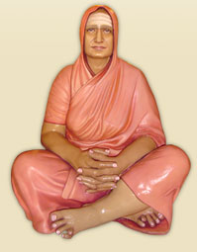
INTRODUCTION
Anandamba was born in the year 1854 in a village near Polur into a pious Brahmin family. Her father was serving as a priest in the famous Bruhannayaki Temple, and young Anandamba used to sit inside the temple by chanting the stotras of Amman and Lord Shiva and would perform deep meditation on Lord Shiva. At her younger age, she got married to Sri Sambasiva and after she attained puberty, she moved to her in laws house at Pudupet, Chennai. Her husband was serving as the temple manager in the Komaleeswarar Temple, Pudupet, and Andamba would frequently visits the temple after finishing her household works.
Due to bad habits, her husband had died at his younger age, and she had become a widow at her teenage itself. Then she went to her hometown at Polur and stayed with his father and brother. After some time, she met a saint with the name Nakshatra Gunamba, and become her disciple and learned all the spiritual aspects from her. Due to that her name had been changed to Sakkarai Amma. After spending several years at Polur, she went to Chennai and visited Marundeeswarar Temple, Tiruvanmiyur, and she had attained Samadhi nearby the temple during the year 1901.
During her life time as a saint, she possessed great magical powers, and few persons witnessed her flying in the sky like a bird, and she also treated the diseases of the devotees by applying kumkum on their forehead, and used to give the sacred ash of Lord Shiva to her devotees. And due to that, they got relieved from their diseases. Throughout her life, she dedicated her attention on Shiva and doing noble service to the people.
Let us worship the great Sakkarai Amma and be blessed.
“OM SRI SAKKARAI AMMALE NAMAHA”
“OM NAMAH SHIVAYA”
“OM SRI SAKTHI DEVIYE NAMAHA”
WRITTEN BY
R.HARISHANKAR

SRI SATYAPRAJNA TEERTHA
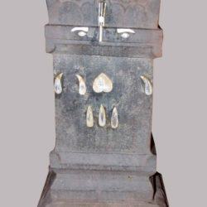
INTRODUCTION
Shri Satyaprajna Teertha was the Madhwa saint who served as the pontiff of Shri Uttaradi Mutt from 1942 to 1945. His birth name was Shri Pandurangi Jayacharya.
Before attaining sainthood, for some years, he served as the manager of the Uttaradi Mutt. He learnt all the Vedic subjects from his guru and was considered as a great scholar.
During the year 1942, he built Brindavana in Pandharapur for his guru Shri Satyadhyana Teertha and performed annadanam in a massive scale. He was considered as a kind hearted saint and used to provide annadanam and would distribute the Abhishekha Prasad to the devotees, in an affectionate manner. He wants everyone to live happily and he used to pray to Lord Rama for the wellbeing of all the living beings in the universe. He used to advice the devotees to do regular puja at their homes and to chant the Rama Mantra “JAI SRIRAM” on a daily basis, in order to come out from the sufferings and sorrows in their life.
His successor was Sri Satyabhijna Teertha, and Sri Satyaprajna Teertha had attained Jeevasamadhi in 1945 in Atkur on the banks of river Krishna.
Let us worship Sri Satyaprajna Teertha and be blessed.
“OM SRI SATYAPRAJNA TEERTHARE NAMAHA”
“JAI SRI RAM”
WRITTEN BY
R.HARISHANKAR

SRI THENGAI SWAMIGAL
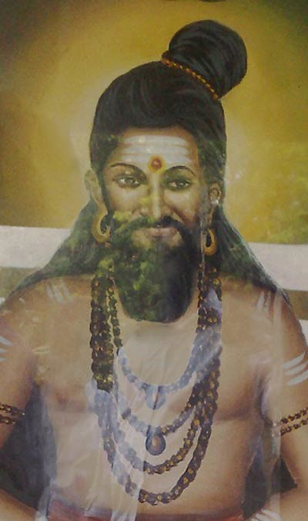
INTRODUCTION
Thengai Swamigal (20th century AD) was a great saint and his Jeeva Samadhi temple is situated in Pondicherry. Swamigal was a great devotee of Shiva-Sakthi, and used to do regular pujas at his Ashram. During his period, for solving their problems, devotees would come with a coconut along with them, and give to Swamy. Swamy would break the coconut into two pieces, and one piece he would keep it, and another piece he would return it to them, and the devotees used to worship the coconut piece in their puja room. After doing that, all of the problems of the devotees were vanished, and they got good health, wealth and attained all kinds of prosperities in the earth.
His jeeva Samadhi is situated near Villianur Railway Station, Pondicherry. Childless couples would be blessed with a noble child, through his grace. Lot of devotees were found great relief in their life, and lot of diseases of the devotees were cured by vising the holy shrine of the great swamigal.
Hence, let us once, visit the Samadhi shrine of Sri Thengai Swamigal and be blessed.
“OM SRI THENGAI SWAMIGALE NAMAHA”
“OM NAMAH SHIVAYA”
“OM SRI MANAKULA VINAYAGARE NAMAHA”
WRITTEN BY
R.HARISHANKAR

SRI UPENDRA TEERTHA
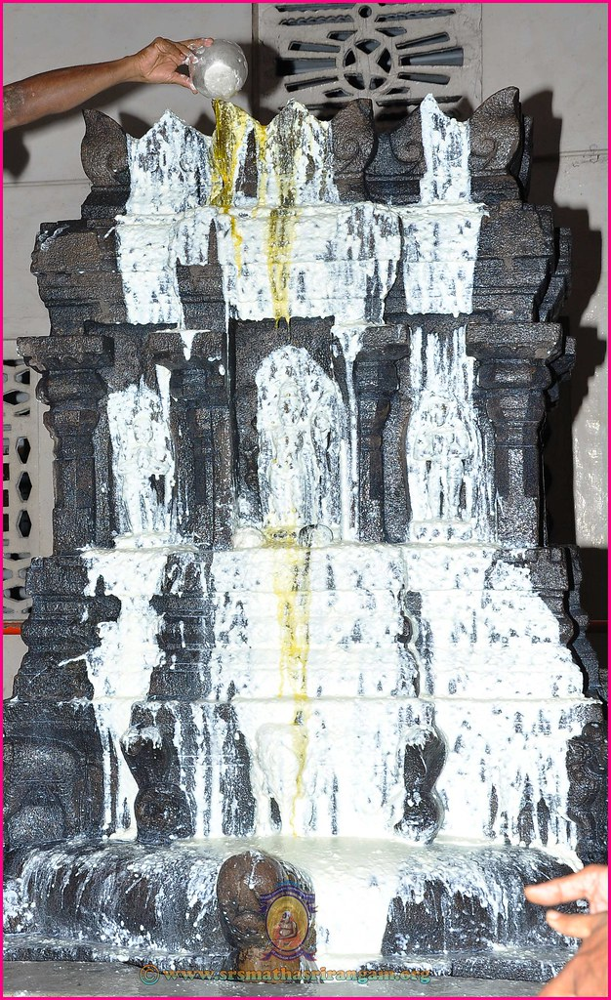
INTRODUCTION
Sri Upendra Tirtha (12th century) was the disciple of Sri Madhvacharya, and the pontiff of the Puthige Mutt at Udupi. He was the sincere devotee of Lord Vittala, and daily used to do puja to the deity which was given by his Guru Sri Madhvacharya.
Upendra Tirtha had performed many miracles during his period similar to his guru Sri Madhwacharya. Once, while he was crossing the Holy River Ganges, some Muslim soldiers tried to attack him, but he didn’t get angry and smiled at them. On seeing his shining face, the soldiers were changed their mind, and asked him to apologize them and went back to their place. Similar to that, once he was surrounded by lot of thieves and they tried to kill him, but Sri Upendra Swamy raised his hands and blessed them. Due to that, the thieves were become calm, and they also become his followers. After spending many years in divine service, he attained Samadhi at Udupi.
Let us worship the great saint and be blessed.
“OM SRI UPENDRA TEERTHARE NAMAHA”
“JAI SRIRAM”
“JAI KRISHNA”
WRITTEN BY
R.HARISHANKAR

SRI VEDANTHA SWAMIGAL
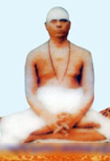
INTRODUCTION
Vedanta Swami was born in the year 1892 in a village in Pondicherry. His birth name was Thandavarayan. He has studied well in his younger age, learned the basics of Hindu Scriptures, and also learnt the regional languages.

For some time, he worked in a private job and afterwards, he has lost interest in doing the monotonous work, and left his job and also his house. For some time, he wandered in the streets by taking alms, and then, he undertook a long pilgrimage to south Indian temples and worshipped the divine deities and due to that, he has got great cheerfulness in his mind, and decided to spend his rest of his life towards spreading spirituality among others. He used to sung the Thiruvasagam and Thayumanavar songs in front of the temples.
He used to conduct religious discourses in the temples and explains the various topics on Puranas in a simplified manner to the people. He lived a pious life, and blessed his devotees and removed the fear from their minds, and made them to shine in the world through his spiritual powers.
Let us worship the great saint and be blessed.
“OM SRI VEDANTHA SWAMIGALE NAMAHA”
“OM NAMAH SHIVAYA”
“OM SAKTHI PARASAKTHI”
WRITTEN BY
R.HARISHANKAR

SRI VIDYAPATHI TEERTHA
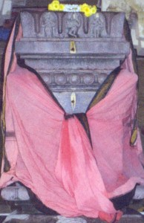
INTRODUCTION
Sri Vidyapathi Teertha(18th century) served as a pontiff in Sri Vyasaraja Mutt at Kumbakonam during the period:1788-1798. His Guru was Sri Vidyanatha Teertha, and his successor was Sri Vidyavallabha Teertha. He attained Jeeva Samadhi at Kumbakonam, during the year 1798. He was an ardent devotee of Lord Srirama and Hanuman. He was a great scholar and an expert in all the regional languages.
He also served sincerely in the Vyasaraja mutt, and performed Puja to Rama, Narasimha, Hanuman and Sri Vyasaraja in an amazing manner. After the performance of puja, he would distribute the sacred rice to the devotees, and used to provide annadanam during the festival days like Ramanavami, Hanuman Jayanthi, Sri Vyasaraja Jayanti, Krishna Jayanthi etc.
He would patiently hear the problems of the devotees and gave suitable suggestions to them. He also conducted divine lectures on Ramayan, Bhagavatham and Bhagavat Gita and asked the devotees to chant the Sri rama mantra continuously. Throughout his life, he has concentrated his attention only on devotional matters, and ignored the rest of the things in his life. He lived a holistic life, and contains great wisdom, bhakti, courage and boldness.
Let us worship the holy saint and be blessed.
“OM SRI VIDYAPATHI TEERTHARE NAMAHA”
“OM SRI VYASARAJARE NAMAHA”
“JAI SRI RAM”
WRITTEN BY
R.HARISHANKAR

SRIRAM – ARDENT DEVOTEE OF GURU RAGHAVENDRA
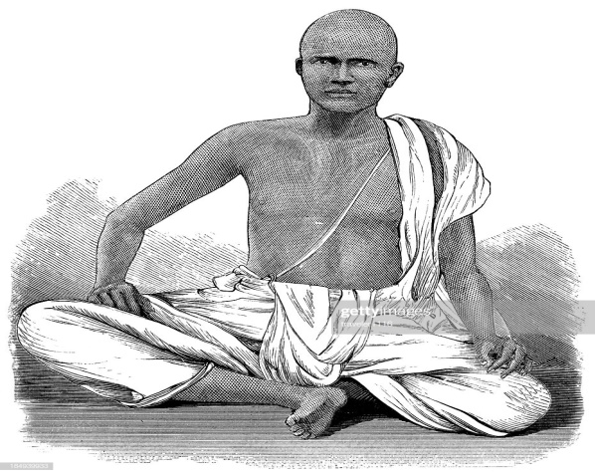
INTRODUCTION
Sriram belongs to Brahmin community, who lived during the 20th century. He served as a Brahmin priest at a small Krishna temple in a village in Karnataka. He was an ardent devotee of Guru Raghavendra. After attaining teenage he got married to a pious girl, and soon he had one son. After becoming a family man, since he has previously served as a sales executive in a company, and since he has to support his aged parents, his wife and child, he applied and got a sales executive job in a company at Japan.
Somehow, he utilized his entire savings and collected money from his neighbours and reached Japan in the night. The place he reached was very dark and a lonely area. He doesn’t know the Japanese language, and he was also not fluent in English. He was very afraid and began to chant the mantra of Guru Raghavendra: “OM SRI RAGHAVENDRAYA NAMAHA” in a loud voice, and got fainted in the floor.
In the next day morning, he found himself in his company’s guest house, and he was very much surprised, and enquired about the people in the company. One of the company staff told to him that “in the night, he was taken by an old saint in a car, and his look was very impressive. He didn’t speak anything, but he has taken the appointment order from the bag of Sriram and showed it to the security staff, and immediately left from that place”.
On hearing the words of the company staff, Sriram was unable to express his feelings, and joyful tears were flown from his eyes, and he narrated the entire incident to the company staff in english. The staff conveyed the matter to the entire company people, and finally to the boss, and everyone was surprised and praised the greatness of Guru Raghavendra.
Let us worship the great saint Sri Raghavendra and be blessed.
“OM SRI RAGHAVENDRAYA NAMAHA”
“JAI SRIRAM”
WRITTEN BY
R.HARISHANKAR

SUBRAMANIAN – ARDENT DEVOTEE OF LORD AYYAPPA
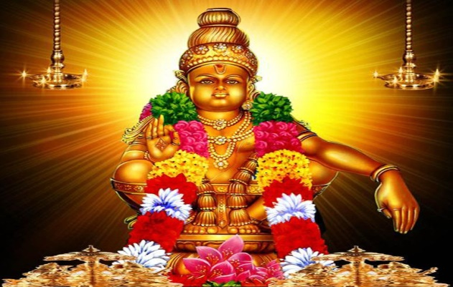
INTRODUCTION
Subramanian was a college lecturer in Chennai, and he was born in an orthodox Brahmin family. He has completed his M.Com and finished M.Phil also. He was an ardent devotee of Lord Ayyappa and every year used to visit the Sabarimala temple during the Mandala season.
He served in the college for a few years, and got good name through his good teaching. This was caused jealous among the other lecturers, and they made a plan to send him out, and one of the lecturers had kept his money purse in the bag of Subramanian, and started calling others and informed them that his purse was stolen by someone. Soon all of them were gathered, and began to check the bags of all the college lecturers and students.
Subramanian was not aware about the incident and he calmly watched the happenings. While some of his rivals check his bag, they found lot of Ayyappan photos inside his bag, and they couldn’t trace the purse. And to their surprise the purse was finally found from the owner’s bag. His rivals were got disappointed and when they open the purse, in that, a small written slip was there, and in that it was mentioned as “SWAMIYE SARANAM AYYAPPA”. After that they got ashamed and asked apology to Subramanian, and his rivals were also become his friends and also they become sincere devotees of Lord Ayyappa.
Let us worship the great Lord Ayyappa and be blessed.
“OM SWAMIYE SARANAM AYYAPPA”
WRITTEN BY
R.HARISHANKAR
SUKRATHINDRA TEERTHA
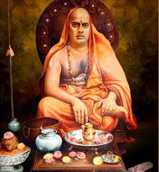
INTRODUCTION
Sukrathindra Thirta (1897–1949) was the pontiff of the Kashi Math. He was a noble scholar and was well educated in ancient Upanishads, vedas and puranas. He was very clever at his childhood itself, and used to sing songs in praise of Lord Krishna at the nearby temples.
Sukrathindra Thirtha became the chief of Kashi Math in 1914 after his guru has attained Mahasamadhi in Mumbai. During his period, he had performed Puja to the deities at the mutt in a good manner, and provided wholesome meals to the devotees, and gave them the sacred rice (Akshadai), and blessed them in a whole heartedly manner. He would listen patiently to the problems of the devotees, and gave them proper advices, and asked them to regularly chant the god’s names, in order to clear their sins. He trained a noble person and given him responsibilities of the Mutt in the year 1945 and named him as Sudhindra Thirtha.
Sri Sukrathindra Thirtha had attained Mahasamadhi in the year 1949 at Kochi.
Let us worship the great saint and be blessed.
“OM SRI SUKRATHINDRA TEERTHA SWAMIGALE NAMAHA”
“JAI SRI RAM”
“JAI KRISHNA”
WRITTEN BY
R.HARISHANKAR

SUNDARAM – ARDENT DEVOTEE OF LORD MURUGA
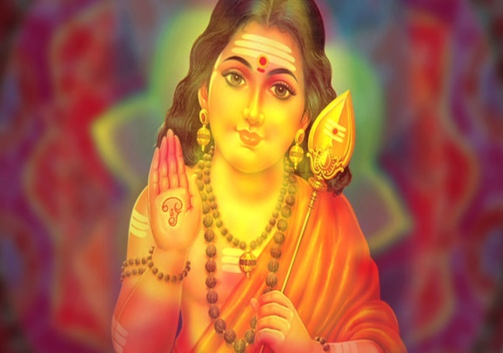
INTRODUCTION
Sundaram was a Vedic scholar and served as a freelance Purohit and he stayed at Thiruvallur. He used to visit his client’s houses and perform rituals such as Grihapravesam, Amavasai Tharpanam and Thevasam. He also used to perform marriages to his clients at the Mandaps. He used to charge only a nominal fee, and due to that, he got large number of clients. Generally while performing purohit service, he will used to take only Tiffen items and coffee and would not take lunch, since it was his habit.
One day, he went to a famous astrologer’s house in Ambattur, and performed rituals for the astrologer’s father, and as usual he ate only tiffen and had coffee. The astrologer started compelling him, but he hesitated. Finally the astrologer chanted some mantras and sprayed water on him. Due to that, Sundaram had finished his lunch without any hesitation, and left from that place. The next day morning, when he woke up, he was unable to speak, and he informed the matter to his parents and his wife by writing his problem in a piece of paper. When the family went to the astrologer’s house, they have informed that the astrologer went on a foreign trip and that he would return only after few months.
Everyone was shocked and they didn’t find any way to solve the matter. Finally they prayed to their Kuladeivam Thiruthani Murugan to cure his problems, and performed Viratham by his wife. After few days, they went to Thiruthani and prayed to Lord Muruga. To their surprise, Sundaram was shouting with full of joy in front of the main shrine of Lord Muruga. Everyone in the temple had enquired about the reason for shouting. He explained that, while he was praying to Lord Muruga, suddenly he saw the face of real god Muruga, and he blessed him, and it lasted only for a few seconds. On hearing that, his family and everyone in the temple was very happy and began to praise the grace of Lord Muruga, and Sundaram performed annadanam to 100 devotees at his own cost and returned to Thiruvallur.
Let us worship the great god Lord Muruga and be blessed.
“OM MURUGA VADIVEL MURUGA”
WRITTEN BY
R.HARISHANKAR

SWAMI SAMAIYA
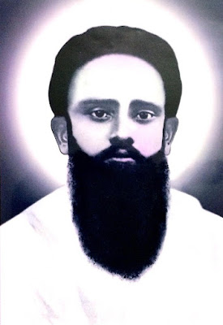
INTRODUCTION
Swami Samaiya was born in the year 1892 at Coimbatore. Though he got married and got an employment in a private firm, he left his job and his family and become a disciple of Swami Sivananda Paramahamsar. He used to meditate on Lord Shiva and got spiritual enlightenment.
Once he was teased by the British soldiers, and immediately through his powers, he made them to stand like statues for some time, and then regained them to their normal state. After realising their mistake the British general apologised to him. He also removed the sufferings of the people and asked them to chant the mantras of god in order to get relieved from their sins and problems in their life. He lived a simple and a holy life and spent his entire time towards doing good things to others and worshipping and meditating on god.
He attained Jeeva samadhi in the year 1937 and his Jeeva Samadhi is situated at his native place in Coimbatore.
Let us worship the great saint and be blessed.
“OM SRI SWAMI SAMAIYAVE NAMAHA”
“OM NAMAH SHIVAYA”
“OM SRI PARAMESWARI THAYE NAMAHA”
WRITTEN BY
R.HARISHANKAR

SWAMI SUNDARANAND
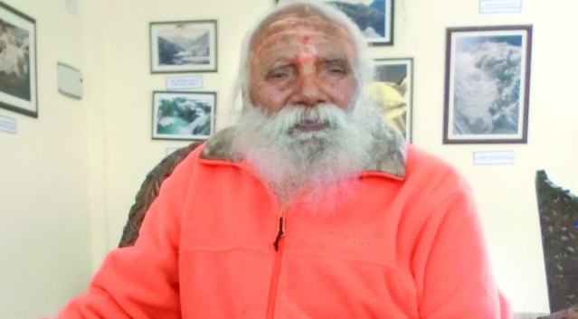
INTRODUCTION
Swami Sundaranand was born in the year 1926 at a village in Nellore, Andhra Pradesh. He is a great Yogi and a multifaceted personality who gave various spiritual lectures in India.
Swami Sundaranand was a disciple of the great yogi Sri Swami Tapovan Maharaj and learned yoga and Hindu Scriptures from him. He has become a saint and lived with his guru in the Gangotri in a small Ashram and performed severe penance on Lord Shiva, and due to that, he has got great spiritual powers. He got large number of followers, and they worshipped him as their spiritual guru.
He is a sincere devotee of Mata Ganga and insisted the people and his devotees to protect the River Ganges from pollution, in order to show our true love and affection towards the Holy Mata River Ganges.
Swami Sundaranand has written a book about Mountain Himalaya and the Holy River Ganges. He has climbed Mountain Himalaya and reached the peak. He also done many social welfare activities like providing food to the wandering sadhus and animals, and found god in every living being. He has rendered selfless service to the people, and got a good name among the people. He used to frequently worship Lord Kashi Vishwanath in the Kashi Temple and perform puja and abhishekham to the Shiva lingam.
Let us worship the holy saint and be blessed.
“OM SRI SWAMI SUNDARANAND NAMAHA”
“JAI GANGA MA”
“OM NAMAH SHIVAYA”
WRITTEN BY
R.HARISHANKAR

SWAMI TURIYANANDA - DISCIPLE OF RAMAKRISHNA
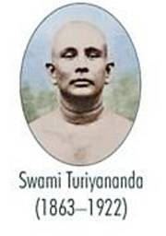
INTRODUCTION
Swami Turiyananda also called as Hari nath and Hari Maharaj due to his sincere devotion on god Hari, and he was the popular disciple of Ramakrishna. He was a close associate of Swami Vivekananda, and due to his request, he went to foreign countries, and preached the holiness of Hinduism among the people. He established Ashrams in foreign countries, and spread the bhakti spirit among the masses.
Turiyananda was born in a pious Bengali Brahmin Orthodox family in Kolkata in the year 1863. He lost his parents at his young age and he was brought up by his brother. He successfully completed his studies, and studied holy texts like the Bhagavad Gita, Bhagavatham, Puranas and Vedas.
Harinath met Ramakrishna at his younger age, and used to visit the Dakshineswar temple frequently. Due to the saying of Sri Ramakrishna he began to see all the women in the form of the Divine Mother Kali Devi, and gave great respect to them. Ramakrishna got high opinion on him and frequently praises his good nature.
He also used to interact with Swami Vivekananda about spiritual matters, and spend lot of hours in doing meditation. He went to foreign countries along with Swami Vivekananda and gave his full support to him. At his final stage of life, he served in the Ramakrishna Mission Sevashram in Varanasi, and died in the year 1922.
Let us worship the great saint and be blessed.
“OM SRI TURIYANANDARE NAMAHA”
“OM SWAMI VIVEKANANDARE NAMAHA”
“JAI KRISHNA”
WRITTEN BY
R.HARISHANKAR
SWAMI VIRAJANANDA - DISCIPLE OF SWAMY VIVEKANANDA
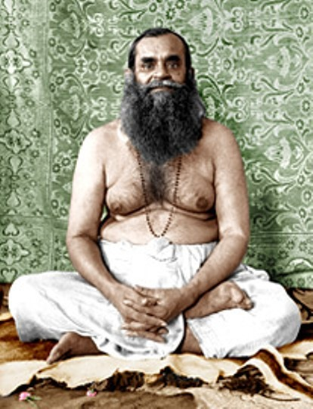
INTRODUCTION
Swami Virajananda (1873–1951) was a disciple of Swami Vivekananda. He was born in Kolkata in a pious Hindu family, and in the year 1897, he has attained sainthood under Swami Vivekananda. Apart from basic education, he got good knowledge in Hindu sacred texts, and familiar in regional languages. Through his friend Sri Vimalananda, he got interested to work with Swami Vivekananda and joined as a disciple under him, and he is considered as a true disciple of Swami Vivekananda.
Virajananda published a monthly magazine known as Prabuddha Bharata. He also actively published the important Works of Swami Vivekananda. He served as the president of the Advaita Ashrama at Mayavati, and after some time, he became the President of the Ramakrishna Mission. He also founded spiritual schools, for initiating the students in the spiritual path. He undertook holy pilgrimages and eagerly served Swami Vivekananda as his personal attendant.
Virajananda had done lot of social welfare activities through the guidance of his guru Sri Vivekananda.
He attained Mahasamadhi in the year 1951.
FAMOUS WORKS
- The Life of Swami Vivekananda.
- Towards the Supreme Goal.
- Strive to attain God.
- The Story of an Epoch.
- Great Works of Swami Vivekananda.
Let us worship the great saint and be blessed.
“OM SRI SWAMI VIRAJANANDARE NAMAHA”
“OM SWAMI VIVEKANANDARE NAMAHA”
“JAI SRIRAM”
WRITTEN BY
R.HARISHANKAR

SWAMI VIVEKANANDA
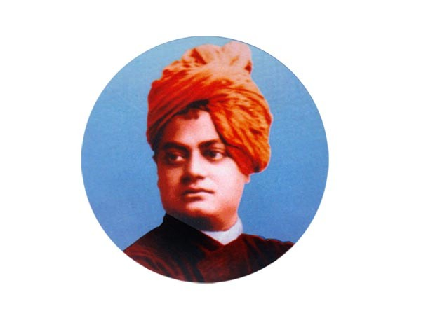
INTRODUCTION
Swami Vivekananda (1863–1902) was a Saint, and the main disciple of Sri Ramakrishna. He has introduced our Hindu Philosophies to the Western country people and also conducted spiritual lectures in foreign countries. Lot of foreign people were admired and praised for his good speech. He was the one who used the words “BROTHERS AND SISTERS” before beginning his speech. Lot of people were got attracted through his holistic and simplistic approach. His birth name was Narendranath.
Vivekananda founded the Ramakrishna Math and the Ramakrishna Mission. He was born into an orthodox Bengali family of Kolkata, and he was moved towards spirituality from his younger age itself. He was properly guided by his guru, Ramakrishna, and he learnt the divine teachings from him. He has rendered lot of social welfare activities and spiritual services. After Ramakrishna's death, Vivekananda travelled throughout India, and spread the importance of Hinduism.
He was a great devotee of Lord Shiva, and performed severe penance on Kanyakumari Amman in Kanyakumari District in a rock for several days and got the divine darshan of Mata Kanyakumari. The rock which he sat and performed penance, is now famously known as the “VIVEKANANDA ROCK”, and it attracts large number of tourists.
He mainly targeted the youngsters and gave various teachings for their welfare. His lectures are very famous and mainly the lecture which he delivered in Chicago was attracted by several thousands of foreigners and they have recorded his discourse in audio form. He asks the people to act busily in their lives, and to remove the laziness in their minds, and asks us to maintain good health and to gain more mental energy, courage and wisdom by doing meditation and by worshipping the god and serving to the spiritual guru.
Let us worship the great saint and be blessed.
“OM SRI SWAMI VIVEKANANDARE NAMAHA”
WRITTEN BY
R.HARISHANKAR

SWARNALATA DEVI - MOTHER OF SRI AUROBINDO
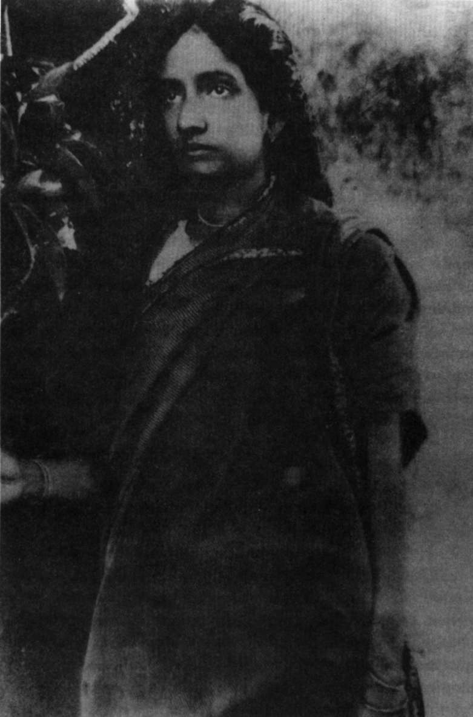
INTRODUCTION
Swarnalata Devi (19th century AD) was the holy mother of Sri Aurobindo. She was born in a Hindu Bengali family at Kolkata, West Bengal, and her father was Sri Rajnarayan Bose, who was a participant in the Brahmo Samaj, and she was very clever from her younger age itself. She got married at her teenage to a famous doctor Sri Krishna Dhun ghose, and they had five children, and among them, Sri Aurobindo had become a great saint and social reformer.
She served as a dutiful wife to her husband and an affectionate mother to her children. She got great interest in doing social welfare activities, and done many good things through the help of Brahmo Samaj. All the entire family members were the active participants of the Brahmo Samaj. She was against caste discrimination and also fought for the women rights, and delivered speeches for bringing improvement in the life of women. Similar to her son Aurobindo, she lived a noble life and served the society in a proper manner.
Let us worship the divine mother and be blessed.
“JAI MATA SWARNALATA DEVI”
WRITTEN BY
R.HARISHANKAR

TANSEN
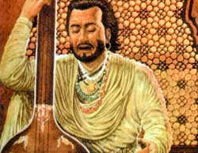
INTRODUCTION
Tansen (1500–1586), also known as Ramtanu, was an important person in Hindustani classical music. He used to burn the temple lamps automatically, by singing melodious songs using Deepak raga, and also he brought rain after singing the glories of the rain gods, Lord Varuna and Lord Indra. He was born in a Hindu family, and he learned various subjects in the present day Madhya Pradesh. He was the musician in the court of the Hindu king Sri Raja Ramchandra Singh and he used to mesmerize the court with his great musical talents.
After some time, due to his name and fame, he has joined in the court of the Mughal Emperor Akbar and rendered a marvellous musical performance. Once, he also removed the sickness of King Akbar by singing a melodious song on Lord Shiva.
Akbar considered him as a GEM and a Divine Musical Composer. His music was widely appreciated by the people and he was praised for his great talents.
He sang songs in praise of Lord Vinayaka, Vishnu, Shiva and other Hindu deities. It is believed that once, he has got the divine appearance of Narada and Tumburu and received blessings from them, and through that he has become more skilled in his field.
He also written various slokas in praise of gods, and was a sincere devotee of Lord Sri Rama. After getting married with Akbar’s daughter, he has embraced Islam. And though he has converted into a Muslim, he maintained his bhakti on Hindu gods, and used to frequently sing songs on them.
Let us worship the great musician Tansen and be blessed.
“OM SRI TANSEN MAHAPRABHU NAMAHA”
“JAI SRI RAM”
“OM NAMAH SHIVAYA”
WRITTEN BY
R.HARISHANKAR

THADHIMUGAN IN RAMAYANA
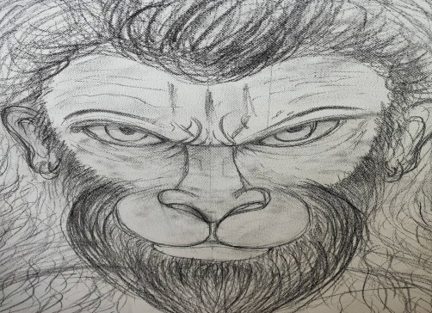
INTRODUCTION
Thadhimugan was a great Vanara, who contains noble characteristics, and considered as a GEM among the Vanaras, similar to Lord Hanuman. He was mentioned in the great epic Ramayana as the uncle of Sukriva and also guards his beautiful garden with his monkey army. Similar to other Vanaras, he is considered to be an incarnation of a celestial Gandharva, and was a great devotee of Lord Vishnu. He came to know about Lord Rama from Sugriva, and from then onwards, he become a sincere devotee of Lord Rama, and he considered Lord Rama as the supreme avatar of Lord Vishnu, and began to worship him.
During the time of battle between Rama and Ravana, he also participated in the army of Vanaras, and helped in building the bridge also. Lord Rama also showed friendship with him and gave his blessings.
After the end of his life, he regained his Gandharva form, and went back to Gandharva Loka, and began to compose and sing songs on Lord Rama in the Gandharva Loka.
Let us worship the great Vanara and be blessed.
“OM SRI THADHIMUGANE NAMAHA”
“JAI SRIRAM”
“JAI MATA SITA”
WRITTEN BY
R.HARISHANKAR

THE HOLY ELEPHANT GAJENDRA
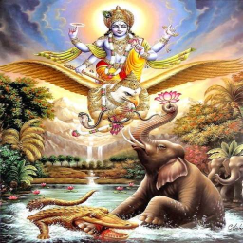
INTRODUCTION
The details about Sri Gajendra, the holy elephant were mentioned in Bhagavata Purana. This story tells us that how the great Lord Sri Vishnu Bhagavan is coming down to the earth from Vaikunta to safeguard his sincere devotees during their difficult times. According to Bhagavatam, Lord Vishnu come down to earth and protected Gajendra, the elephant, and saved it from the clutches of the Crocodile, and through the blessings of the Lord, Gajendra had attained MOKSHA. Then, Lord Vishnu also gave Moksha to the crocodile also. This story was told by Sri Suka to king Parikshit.
It is believed that the incident was happened in Mangalagiri, Andhra Pradesh. There is an ancient temple at Kapisthalam, Tamil Nadu and it is known as Sri Gajendra Varadha Temple, and it was built in order to mark the wonderful incident, and to show the greatness of Lord Vishnu.
Similar to this incident, whenever we suffers from any problem, we must immediately chant the mantra “OM NAMO NARAYANAYA NAMAHA”, and immediately the god would reply to our urgent call and make his presence in front of us in some other form, and remove our problems. The only thing is that we must have pure bhakti on him.
Let us worship the merciful god Sri Vishnu Bhagavan and be blessed.
“OM SRI GAJENDRARE NAMAHA”
“OM NAMO NARAYANAYA NAMAHA”
“OM SRI LAKSHIMI DEVIYE NAMAHA”
WRITTEN BY
R.HARISHANKAR

TVASHTHA
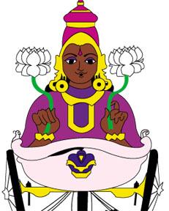
INTRODUCTION
According to ancient Vedas, Tvashtha is the god of art and fashion. He is also considered as an incarnation of Lord Vishvakarma. In Yajurveda and in the Rigveda, his characteristics were mentioned. Like Viswakarma, he is also considered as the maker of divine weapons for the gods and demi gods.
His importance was mentioned in the great epic Mahabharata, and he is considered as the son of Sukracharya, and in some texts, he was mentioned as the son of Kashyapa and Aditi. His son was Vritra, and his daughter was Saranyu, consort of Lord Surya, and their sons are Yama and Yami.
It is said that he also helps in the creation of new world after the completion of a Yuga with the help of Lord Viswakarma.
People in art field, fashion designers and architects can worship Lord Tvashtha in order to shine in their respective career path.
He also gives all sorts of prosperities to his sincere devotees, and blossom their life like a lotus flower.
Let us worship Lord Tvashtha and be blessed.
“OM SRI TVASHTHA NAMAHA”
“OM SRI VISWAKARMARE NAMAHA”
WRITTEN BY
R.HARISHANKAR

UGRASENA
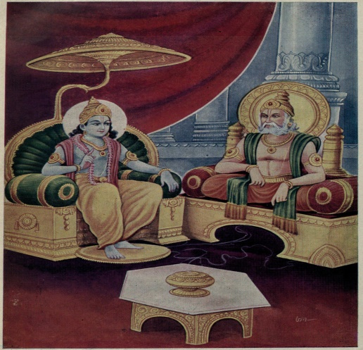
INTRODUCTION
Ugrasena was the king of Mathura, and Lord Krishna was the grandson of Ugrasena. Krishna's father, Vasudeva was the Yadava King, and Vasudeva was the son-in-law of Ugrasena. Ugrasena regained his kingdom from his cruel son Kamsa, after Kamsa was killed by Lord Krishna. According to ancient legend, Ugrasena was the son of Ahuka, and he was a nice king, who had treated his people as his own family and provided all sorts of benefits to them.
Once, Lord Krishna had asked for the Syamantaka jewellery from Satyajit, who was a yadava king, on behalf of Ugrasena, in order to prosper the kingdom of Mathura. But Satyajit had refused to give the precious jewel to Ugrasena. Later due to Lord Krishna’s spiritual powers, the kingdom of Madura was prospered. People in his region were lived happily and peacefully without any sufferings in their life. No one was suffered from poverty, sickness or any other kind of problems in their life. He ruled his kingdom in a well-versed manner, and after his death, he went to the abode of Lord Indra, the swarka loka.
Let us worship the great king Sri Ugrasena and be blessed.
“OM SRI UGRASENARE NAMAHA”
“JAI KRISHNA”
WRITTEN BY
R.HARISHANKAR

URMILA IN RAMAYANA
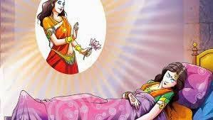
INTRODUCTION
Urmila is a noble princess who lived during Treta Yuga. And her holiness was mentioned in Ramayana. She was praised for her chastity and purity. She was the daughter of King Janaka of Mithila and the sister of Sita. She was the dutiful wife of Lakshman and they got two sons.
When Lakshman went to forest along with Ram and Sita, Lakshman didn’t sleep for 14 years in order to look after his brother and Mata Sita in a proper manner. Instead of that, Urmila slept on behalf of her husband Lakshman during day time also. In total, in a day, she has slept for more than 16 hours, and during the remaining time, she took care of her in-laws in a nice manner. This was made possible after praying to Mata Nidhra Devi, the sleep goddess. Urmila was well known for her great sacrifice done for her beloved husband, and due to that, she is still praised by the people.
In Rajasthan, there is a temple dedicated to Lakshman and Urmila. The temple was constructed during 19th century AD by the king Balwant Singh of Bharatpur and he was an ardent devotee of Lord Rama.
Let us worship Mata Urmila and be blessed.
“OM MATA URMILA NAMAHA”
“JAI LAKSHMAN”
“JAI SRI RAM”
WRITTEN BY
R.HARISHANKAR

URVASHI
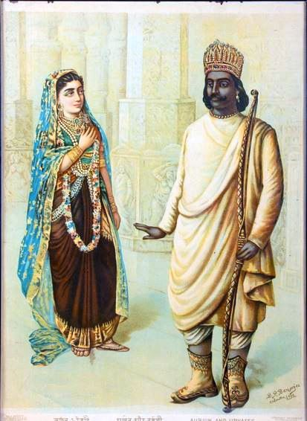
INTRODUCTION
Urvashi is a celestial dancer and residing in heaven, and discharging her duties according to the instructions given by her master Lord Indra. Her name is mentioned in Vedic texts and in Mahabharata and was considered as the most beautiful dancer among the divine dancers in the Indra Loka.
She contains all the good qualities, and considered as the most obedient attendant of Lord Indra. She also welcomes the visitors of the Indra Loka with a smiling face, and provides necessary facilities to them. She is a great devotee of Trimurties, and got more divine powers through them.
Once she united with the great sage Sri Vibhandak, and gave birth to Rishyasringa. She became the wife of king Pururavas, the son of the great Planet Budha Bhagavan. She looks very youthful and charming, and contains bright and shining face.
It is believed that she was created through the powers of the great sages Nara and Narayana, and later gifted by them to Lord Indra, and from then onwards she occupies the role of celestial dancer in the court of Lord Indra in Indra Loka.
Let us worship the divine dancer and be blessed.
“OM MATA URVASHI DEVIYE NAMAHA”
“OM SRI INDRA BHAGAVANE NAMAHA”
WRITTEN BY
R.HARISHANKAR

VAISHNAVA CHARAN DAS BABAJI
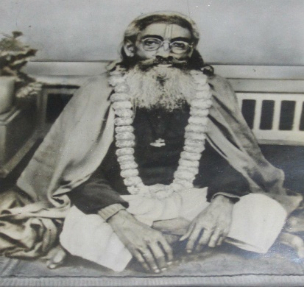
INTRODUCTION
Vaishnava Charan Das Babaji (19th century) was a great saint and the author of “Srimad Bhagavad Sastra”. He was a great disciple of Ram Das Babaji and served him in a proper manner at Pathabari Ashram in Baranagar, Kolkata. Sri Vaishnava Charan Das Babaji was well versed in Vedanta, Sanskrit and contains great knowledge in Hindu Scriptures. He has done lot of spiritual service at the Pathabari Ashram by conducting religious discourses on Bhagavatham, Bhagavat Gita and Ramayan. He was an ardent devotee of Lord Krishna, and invoked the spirit of chanting Krishna’s names in the minds of the people. He used to distribute Lord Krishna’s Prasad to the devotees at his ashram after the performance of puja. He also published a spiritual magazine at his ashram.
His famous disciple was Srimad Madhavananda Das Babaji who was also a well-educated scholar and contains good knowledge in Hindu religious texts. Similar to his guru, he was specialised in Sanskrit language and taught it to others. He used to conduct bhajans on Lord Krishna, and delivered the message of Lord Krishna in a simplistic manner. Both Vaishnava charan and his disciple madhavanadha were great religious figures and played a major role in propagating the lectures on Lord Krishna amongst the people.
WORKS
- Paramartha Katha
- Srimad Bhagavata Tatvatarangini
- Sidhanta Ratnam
IMPORTANCE
Sri Vaishnava Babaji has changed the bad people into good ones through his divine powers. He controlled his senses and become a holy saint. He got very good qualities and considers everyone as the incarnations of Lord Krishna. He removed various problems from the life of his devotees and showed great kindness on them. He never scolded or showed angriness over others. He was greatly honoured by his followers and considers him as their great guru.
Let us worship the holy saint and be blessed.
“OM SRI VAISHNAVA CHARAN DAS BABAJI NAMAHA”
“OM SRI MADHAVANAND DAS BABAJI NAMAHA”
“JAI KRISHNA”
WRITTEN BY
R.HARISHANKAR

VALLALA MAHARAJA
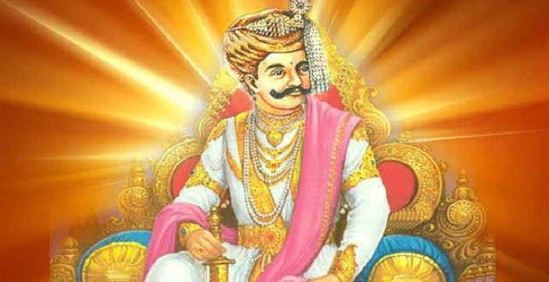
INTRODUCTION
The great King Vallala (14th century) ruled over the Thiruvannamalai region. He had two wives, but he did not have a child. Due to that he has offered food to lakhs of people on a daily basis. He renovated the temple of Lord Arunachaleswara and built a huge tower in Arunachaleswarar Temple called Vallala Maharaja Gopuram. Even now we can find this Gopuram in the Arunachaleswarar Temple.
In order to prove his holiness to the world, Lord Shiva decided to test him, and transformed himself in the form of a Shaivite saint and went to the king’s palace, and asked him to find a dancer woman, who can give company to him. But the king could not find anyone, since all the dancers were already got engaged with others.
Hence, as per the wish of his wife, Sallammadevi, the King had decided to offer her to the Saint. As soon as the queen touched him, he transformed into a child. She took the child to the King. But immediately, the divine child disappeared from the hands of the great king. Due to that, the king felt very sad, but Lord Shiva appeared before the royal couple, and blessed them and said that after his death, he himself would do his final rites. Even today after 600 years, on every Masi Makha, on the death anniversary of the King, Lord Arunachala himself performs the annual rites for the King!
Let us worship the holy king and be blessed.
“OM SRI VALLALA MAHARAJAVE NAMAHA”
“OM NAMAH SHIVAYA NAMAHA”
WRITTEN BY
R.HARISHANKAR

VARIOUS YUGAS
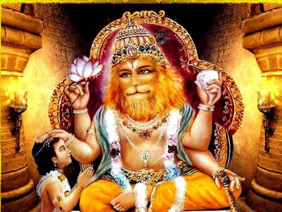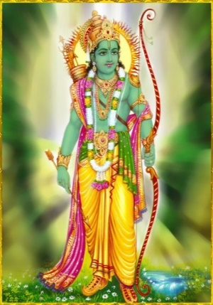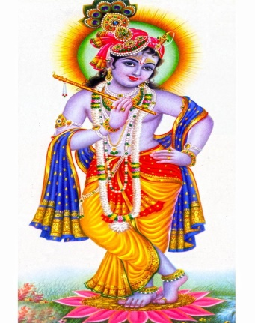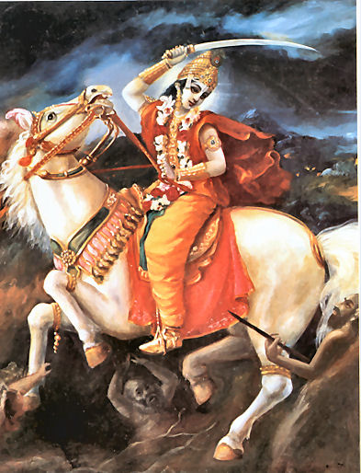
INTRODUCTION
Yuga in Hinduism consists of four. As per ancient Hindu texts, the First Yuga is the Krita Yuga, second one is Treta Yuga, third one is Dvapara Yuga and the fourth and the present yuga is Kali Yuga, in which we are living now. Kali Yuga had started approximately before 5000 years.
Types of Yuga
Satya Yuga also called as Krita Yuga is considered as the golden yuga and the first yuga. In the Krita yuga, truth, kindness and faith exists all over the world. Everyone behaved with others in a gentle manner. There were no quarrels, misunderstandings, unnecessary fights and selfishness. Everyone lived happily for many years without any difficulty. All of them possessed sufficient wealth, and food crops were grown properly in all the seasons. All the men were considered as holy, pure and perfect, and women were very pure and chaste. All of them contained good health and lived for a long period of time. During the Krita Yuga, the great Vishnu Devotee, Bhakt Prahalad had ruled almost the entire earth in a prosperous manner. All the people were praised his glories and gave much respect to him and began to chant the mantras: “OM SRI PRAHALADA MAHARAJA NAMAHA” and “OM NAMO NARAYANAYA NAMAHA”.
Treta yuga is the second Yuga and this yuga also is considered as the best yuga. But compared with Krita Yuga, slight changes were there in this yuga. Small fights were made by the people, and kings were interested in expanding their territory by fighting with other kings, and bad habits also formed among the people like anger, lust, anxiety, depression and tension. But after Lord Rama was born, the bad changes were controlled to a certain extent, and people began to control their senses and lived their life in a disciplined manner. But compared with Krita yuga, treta yuga is not that much good, since jealousy and enmity was occupied in the minds of most of the people.
Dvapara Yuga is the third Yuga and in this yuga, people become addicted towards bad habits like drinking wine and enjoying lot of comforts and luxuries. Diseases also spread among the people. Unnecessary quarrels took place among the people. Bad habits like lust, anger and greedy were commonly found in almost all the people, and they couldn’t control their senses. People lived a life span for a minimum of 120 years. Till Krishna lived in the Dwaraka, due to his grace, bad activities were controlled to a certain extent, and people were lived in a moderate manner. But as soon as Lord Krishna had left his physical body, people began to suffer from lot of problems.
Kali Yuga is the fourth yuga and the present yuga. In this yuga, People commits lot of sins, and think only about themselves, and never take care of their relatives or their own parents. There will not be true love and affection between most of the couples, and for name sake only they will live with each other. Lot of divorces and marriage breaks will be there, and illegal sexual relationships also will be there. And love between men and women would be mainly based on body attraction, and not on attraction between two souls. Rich people would dominate the poor, and asked them to do extra work. At the end of the Kali yuga, in most of the work places, employees would be treated like slaves, and would be given extra work without paying extra money. Whoever raises their voice would be immediately thrown out from their jobs, and no courtesy, kindness or mercy will be there in the minds of the most of the employers. In general no good habits will there with most of the people in this Kali Yuga. It is believed that, Lord Kalki Bhagavan would take the avatar and come to this earth after 4 lakhs and odd years, and would destroy the evils and protect the good ones and maintain peace and prosperity in the earth. And after some time, he would destroy the entire earth, and again Krita Yuga would be born.
Period of each Yugas:
Satya Yuga = 4800 × 360 = 1,728,000 years
Treta Yuga = 3600 × 360 = 1,296,000 years
Dvapara Yuga = 2400 × 360 = 864,000 years
Kali Yuga = 1200 × 360 = 432,000 years

CONCLUSION
Let us try to live in a righteousness manner, and sing the glory of Lord Krishna and be blessed.
“OM SRI KRISHNA BHAGAVANE NAMAHA”
“OM SRIRAMACHANDRA PRABHUVE NAMAHA”
“JAI BHAKT PRAHALAD”
WRITTEN BY
R.HARISHANKAR

VARUNI
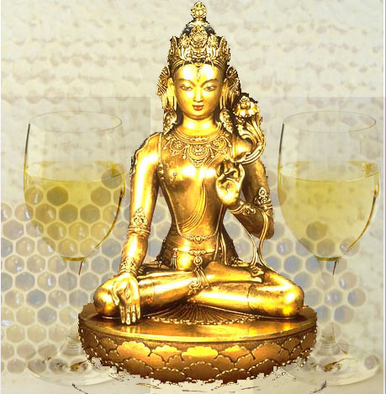
INTRODUCTION
Varuni, also known as Jaladevi, is the consort of Lord Varuna, and she is the goddess of wine. In some Hindu temple sculptures, Varuni is found along with Varuna. She is described in the Vedas and Hindu Sacred texts. She is also considered as an incarnation of Mata Lakshmi.
According to the legend, Varuni was formed during the churning of the divine ocean, and got married to Varuna. She is considered as a Yogini. She resides in the Varuna Loka, which is situated in the bottom of the ocean. Both of them are controlled by Lord Indra Bhagawan.
Varuni acts as a dutiful wife for her husband Lord Varuna, and obeys his commands, and gives more respect to him. It is always suggested to worship her along with Lord Varuna, in order to get good health, wealth and can attain all sorts of prosperities in our life. Generally she is worshipped along with Varuna for getting relieved from water related diseases like cough, cold, diabetes, kidney and lung diseases. She also helps us to get proper rain during drought times.
There is one Varuna Dev temple in Karachi at Pakistan, and it is considered as the only temple dedicated to Lord Varuna and Mata Varuni Devi. Since, it is difficult to visit Pakistan and to worship the deities, it is suggested to worship the divine couples by placing their picture in our puja room, and can chant the following mantras:
Om Jaladevara Namaha, Om Sri Varunadevaya Namaha
Om Jaldeviyay Namaha, Om Varuniye Namaha
Om Sri Indra Bhagawane Namaha
Let us worship the divine father and mother and be blessed.
“OM SRI VARUNA DEVARE NAMAHA”
“OM MATA VARUNIYE NAMAHA”
“OM NAMO NARAYANAYA NAMAHA”
WRITTEN BY
R.HARISHANKAR
VEDAVATI - HOLY MOTHER OF SRI MADVACHARYA
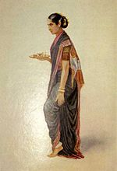
INTRODUCTION
Vedavati was the holy mother of the great Madhwacharya, whose birth name was Vasudeva, and her consort name was Naddantillaya. The couples were lived at a village in Karnataka. She was a noble woman and got great attachment on her son Vasudeva. The parents were performed Upanayana to Vasudeva at his younger age itself, and he had become a great saint at his teenage.
Sri Vasudeva was an avatar of Lord Vayu Deva and after he attained sainthood, his parents gave birth to another son Subhaktiman, who was known as Vishnu Tirtha at a later stage, and they also gave birth to a daughter. Sri Vishnu Tirtha also became a saint after his parent’s death.
Vedavati contains very good qualities, and used to tell bhakti stories to her son Vasudeva at his younger age. She used to take Vasudeva along with her to the temples, and worship the deities with full of bhakti in mind, and she also humbly invite the guests to her home, and offer wholesome food to them. Till her death, she showed great love and affection with her son Vasudeva, and after her death, she has attained the lotus feet of LORD VISHNU.
Let the praise the divine mother and be blessed.
“OM MATA VEDAVATI NAMAHA”
“OM SRI MADHWACHARYARE NAMAHA”
“JAI KRISHNA”
WRITTEN BY
R.HARISHANKAR

VELLORE GOLDEN TEMPLE
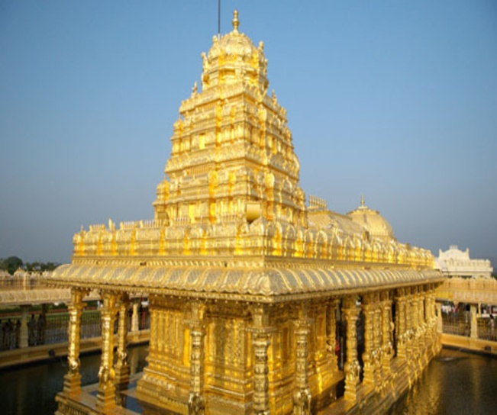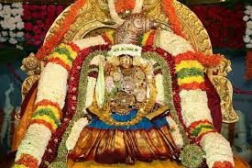
INTRODUCTION
The famous golden temple of Mata Lakshmi Devi is situated in Vellore in Tamil Nadu. The consecration ceremony of the temple was held during the year 2007 and devotees from all parts of India were participated in this grand event. This temple was made out of pure gold similar to the Golden Temple at Amritsar.
Here goddess Lakshmi is known as Sri Lakshmi Narayani, the divine consort of Lord Narayana. The temple was constructed by Sri Narayani Peetam through the blessings of the great male spiritual guru who was affectionately called by the devotees as 'Narayani Amma'. And Narayani Amma is performing daily puja activities in a proper manner, and blesses the devotees and affectionately smiles at them and gives suitable suggestions for removing the problems of the devotees. Many devotees have shared their joyful experiences with the great guru Sri Narayani Amma, and lot of people were got relieved from their sufferings and sorrows through his grace.
In this temple, free food is provided to all the devotees daily in the noon in a pleasing manner.
A hospital is situated near the Sripuram Golden temple and it is maintained by 'Sri Narayani Peedam' Charitable Trust. And lot of people are getting benefitted through that.
Let us visit the golden temple and worship the divine guru “AMMA” and Mata Lakshmi Devi and be blessed.
“OM SRI NARAYANI AMMAVE NAMAHA”
“OM NAMO NARAYANAYA NAMAHA”
“OM SRI LAKSHMI DEVIYE NAMAHA”
WRITTEN BY
R.HARISHANKAR

VENKATAMBA – AFFECTIONATE SISTER OF GURU RAGHAVENDRA
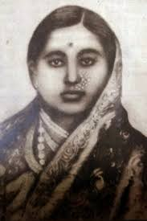
INTRODUCTION
Venkatamba(16th century AD) was the affectionate sister of Venkatanatha, who was known as Guru Raghavendra after becoming a saint, and she and her husband Sri Lakshminarasimhacharya played a vital role towards upbringing Venkatanatha in a proper manner at his younger age. After the death of her father Sri Timmanacharya and mother Smt.Gopikamba, she invited her brother Venkatanatha to Madurai and took care of him properly, and her husband Lakshminarasimha, a great scholar, had taught all the divine subjects to Venkatanatha.
Venkatamba used to take Venkatanatha to the nearby temples, and invoked the bhakti spirit to her brother. She used to tell divine stories to him, and never used to scold her brother, and till her death, she was very kind with him.
They treated him as their affectionate son, and due to their kindness, Sri Venkatanatha had somewhat consoled himself from the worries caused due to the death of his parents.
Venkatamba arranged for the marriage to his brother Venkatanatha to a pious girl Saraswati, and gave all the necessary support to the couple. After some time, Venkatanatha went to Kumbakonam and due to the wishes of the great saint Sri Sudhindra Tirtha, he has become a great saint, and known as Sri Raghavendra Swamy, and attained Jeeva Samadhi at Mantralayam and till today he is showering his grace on his devotees from the holy shrine.
Let us worship the holy brother and sister and be blessed.
“OM MATA VENKATAMBA NAMAHA”
“OM SRI RAGHAVENDRAYA NAMAHA”
“JAI SRIRAM”
WRITTEN BY
R.HARISHANKAR
VENUGOPALA SWAMIGAL
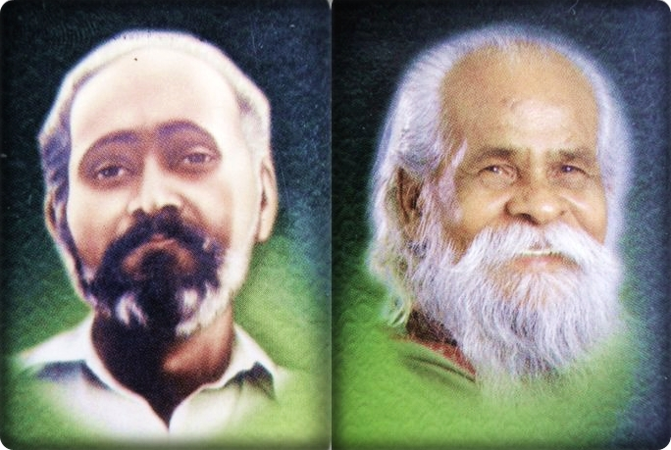
INTRODUCTION
Sri Venugopala swamigal (20th century) was born in a poor Hindu family at a village in Srivilliputhur. After finishing his schooling, he worked as a labourer in a company and got married at his teenage. His guru was Sri Eashwar, and once when his wife was suffered from severe illness, due to the grace of his guru Sri Eashwar, she got relieved from fever, and the couples were become ardent devotees of Sri Eashwar.
His guru Sri Eashwar had taken him to several holy places throughout India, and they visited the divine deities in the temples. Both them had performed several social services as well as services to the god. After rendering selfless service, Sri Eashwar had attained Samadhi at Erode, and an Ashram was built in that place.
Sri Venugopala Swamigal had attained Samadhi in the year 2002, and his Jeeva Samadhi is located in Rajakilpakkam, East Tambaram.
Let us worship the divine gurus and be blessed.
“OM SRI VENUGOPALA SWAMIGALE NAMAHA”
“OM SRI EASHWAR SWAMIGALE NAMAHA”
“OM NAMAH SHIVAYA”
WRITTEN BY
R.HARISHANKAR

VIDYADARAS
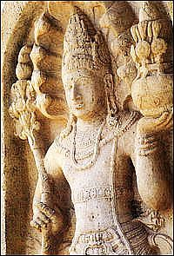
INTRODUCTION
Vidyadaras are considered as the divine demi gods similar to Yakshas, Gandharvas, Kinnaras, Kimburudas and Saranas. They are the ardent devotees of Lord Shiva and lives near the Himalayan Mountain ranges. They are mentioned in various Hindu Puranas, Jain and in Buddhist texts.
Vidyadaras contains super natural powers, and they could fly in the air. Vidyadara couples used to circumambulate Mountain Kailash, and would get great blessings from Lord Shiva. They also enjoy pleasure by dancing, laughing and swimming in the rivers and mostly they do not cause any troubles to the human beings. It is believed that similar to Yakshas, they are also living in the Mountain Gandhamadhana, and they may reside at different mountain ranges, based on their convenience and suitability. They are also mentioned in the Bhagavatam, Ramayana and Mahabharata. They are controlled by Lord Indra, and obey his orders, and follow his instructions. In ancient temple sculptures, they can be found, and they appear either in single form, or along with their consorts.
Vidyadaras can be worshipped for getting good knowledge in all the subjects, and they are very famous in composing music and singing songs. Rishi Narad and Tumburu would frequently visit the place of Vidyadaras, and would sing melodious songs. Vidyadaras also visit Lord Shiva and Mata Parvati in the Mount Kailash and sing songs on them.
Let us worship the holy Vidyadaras and be blessed.
“OM SRI VIDYADARA NAMAHA”
“OM NAMAH SHIVAYA”
“OM NAMO NARAYANAYA NAMAHA”
WRITTEN BY
R.HARISHANKAR
YAKSHAS
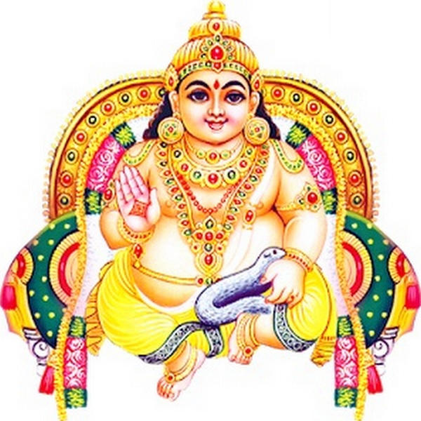
INTRODUCTION
The yakshas are considered similar to demi gods, but sometimes they would do mischievous activities like taking the belongings of the people in the earth, and giving sounds like thunder in order to make them to get afraid of them. But after some time, they would appear in their true form and bless the people. They are worshipful divine demi gods, but they are playful in nature. They are mentioned in Hindu, Jain and Buddhist texts.
The female form of Yakshas, are called as Yakshinis, and they look very attractive and contains a shining appearance, and mostly would not cause any harm to the devotees of Lord Shiva. They are considered as pious, pure and chaste women, who are also considered as incarnations of Mata Parvati Devi.
According to legend, Yakshas are living in the Kandanamada Mountains, which is situated nearby the Himalayas. They are mentioned in great epics like Ramayana and Mahabharata and their importance and greatness is mentioned in that.
According to Hindu, Buddhist and Jain texts, Lord Kubera, the god of wealth and prosperity is considered as the Yaksha King. He is regarded as the god of the North Direction and the protector of the entire world. He has become the ruler of the Yaksha kingdom after performing severe meditation on Lord Brahma, and he obtained more powers and knowledge through his penance. By frequently worshipping him, and chanting his glories and names, we would we get an opportunity to live with him in the “YAKSHA LOKA”.
Kubera can be worshipped along with Mata Lakshmi, in order to get good results in our life.

Sloka of Lord Lakshmi-Kubera
Om Shrim krim Om kuber lakshmi kamla
Devnayae dhan karshinyae swaha
Let us worship the great Kubera and be blessed.
“OM SRI KUBERA BHAGAWANE NAMAHA”
“OM MATA LAKSHMI DEVIYE NAMAHA”
“OM NAMAH SHIVAYA”
WRITTEN BY
R.HARISHANKAR

YASHODA
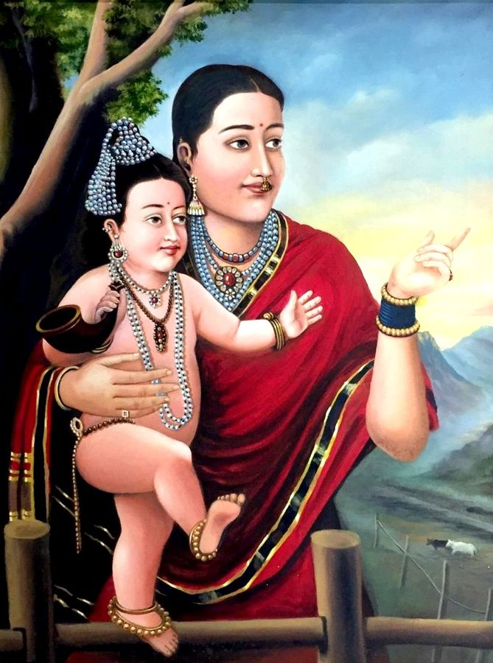
INTRODUCTION
Yashoda is the foster-mother of Lord Krishna and the wife of Nandagopal. She is mentioned in ancient Hindu texts. According to Bhagavata Purana, Krishna was born to Devaki, but he was brought by his father Vasudeva to Gokulam, due to the evil act of Kamsa, and raised by Yashoda and Nandagopal.
Yashoda is a kind hearted woman who has brought up Lord Krishna in a good manner. She also treated her neighbour’s children as her own children, and showed love and affection on each and every one.
She got the opportunity to see the childhood plays and miracles of Lord Krishna, and got mesmerised through his playful acts. Yashoda has done many good karmic deeds in her previous births, and hence she got Krishna as her lovely son.
She also praised for her great love and affection she had with Lord Krishna.
Yasoda also played an important role in raising Balarama (the son of Rohini) and sister Subhadra.
She also gave birth to Yoga Maya, but when Kamsa tried to kill Yogamaya, she assumed her real form and stayed in Vindhya hills as Vindhyavasini Devi.
She has taken birth as Vakula Devi, the foster mother of Lord Venkateswara in this Kali Yuga.
Let us worship the holy mother and be blessed.
“OM SRI YASHODA ANNAIYE NAMAHA”
“JAI KRISHNA”
WRITTEN BY
R.HARISHANKAR

