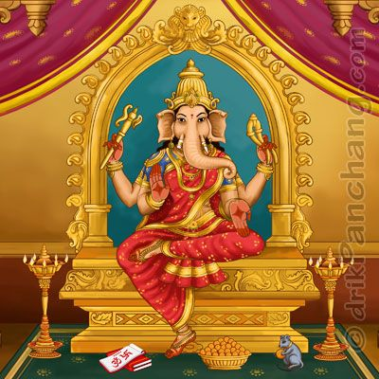Vinayaki

Vinayaki is an elephant-headed Hindu goddess. Her mythology and iconography are not clearly defined. Little is told about her in Hindu scriptures and very few images of this deity exist.
Due to her elephantine features, the goddess is generally associated with the elephant-headed god of wisdom, Ganesha. She does not have a consistent name and is known by various names, Stri Ganesha ("female Ganesha"]), Vainayaki, Gajananā ("elephant-faced"), Vighneshvari ("Mistress of obstacles") and Ganeshani, all of them being feminine forms of Ganesha's epithets Vinayaka, Gajanana, Vighneshvara and Ganesha itself. These identifications have resulted in her being assumed as the shakti - feminine form of Ganesha.
Vinayaki is sometimes also seen as the part of the sixty-four yoginis or the matrika goddesses. However, scholar Krishan believes that Vinayakis in early elephant-headed matrikas, the Brahmnaical shakti of Ganesha, and the Tantric yogini are three distinct goddesses.
In the Jain and Buddhist traditions, Vinayaki is an independent goddess. In Buddhist works, she is called Ganapatihridaya ("heart of Ganesha").

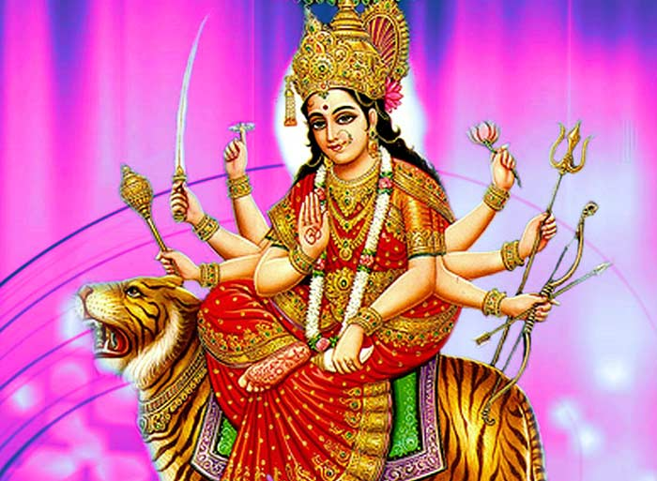

Durga

Durga, also identified as Adi Parashakti, Devī, Shakti, Bhavani, Parvati, Amba and by numerous other names, is a principal and popular form of Hindu goddess. She is the warrior goddess, whose mythology centers around combating evils and demonic forces that threaten peace, prosperity and dharma of the good. She is the fierce form of the protective mother goddess, willing to unleash her anger against wrong, violence for liberation and destruction to empower creation.
Durga is depicted in the Hindu pantheon as a goddess riding a lion or tiger, with many arms each carrying a weapon, often defeating Mahishasura (lit. buffalo demon). She appears in Indian texts as the wife of god Shiva, as another form of Parvati or mother goddess.
She is a central deity in Shaktism tradition of Hinduism, where she is equated with the concept of ultimate reality called Brahman. One of the most important texts of Shaktism is Devi Mahatmya, also called as Durgā Saptashatī, which celebrates Durga as the Goddess, declaring her as the Supreme Being and the creator of the universe. Estimated to have been composed between 400 and 600 CE, this text is considered by Shakta Hindus to be as important scripture as the Bhagavad Gita. She has a significant following all over India, Bangladesh and Nepal, particularly in its eastern states such as West Bengal, Odisha, Jharkhand, Assam and Bihar. Durga is revered after spring and autumn harvests, specially during the festival of Navratri.

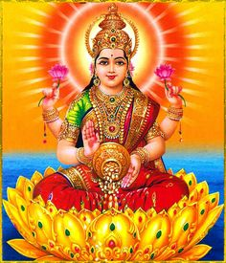

Lakshmi

Lakshmi or Laxmi, is the Hindu goddess of wealth, fortune and prosperity. She is the wife and shakti (energy) of Vishnu, one of the principal deities of Hinduism and the Supreme Being in the Vaishnavism Tradition. Lakshmi is also an important deity in Jainism and found in Jain temples. Lakshmi has also been a goddess of abundance and fortune for Buddhists, and was represented on the oldest surviving stupas and cave temples of Buddhism. In Buddhist sects of Tibet, Nepal and south east Asia, goddess Vasudhara mirrors the characteristics and attributes of the Hindu goddess Lakshmi with minor iconographic differences.
Lakshmi is also called Sri or Thirumagal because she is endowed with six auspicious and divine qualities, or gunas, and is the divine strength of Vishnu. In Hindu religion, she was born from the churning of the primordial ocean (Samudra manthan) and she chose Vishnu as her eternal consort. Kamadeva is son of vishnu and lakshmi. When Vishnu descended on the Earth as the avatars Ramaand Krishna, Lakshmi descended as his respective consort. In the ancient scriptures of India, all women are declared to be embodiments of Lakshmi. The marriage and relationship between Lakshmi and Vishnu as wife and husband is the paradigm for rituals and ceremonies for the bride and groom in Hindu weddings. Lakshmi is considered another aspect of the same supreme goddess principle in the Shaktism tradition of Hinduism.
Lakshmi is depicted in Indian art as an elegantly dressed, prosperity-showering golden-coloured woman with an owl as her vehicle, signifying the importance of economic activity in maintenance of life, her ability to move, work and prevail in confusing darkness. She typically stands or sits like a yogin on a lotus pedestal and holds lotus in her hand, a symbolism for fortune, self-knowledge and spiritual liberation. Her iconography shows her with four hands, which represent the four goals of human life considered important to the Hindu way of life: dharma, kāma, artha, and moksha. She is often depicted as part of the trinity (Tridevi) consisting of Saraswati, Lakshmi and Parvati.

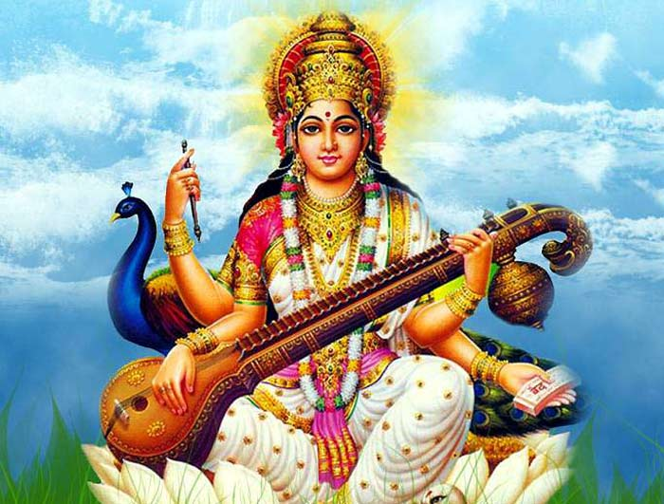

Saraswati

Saraswati is the Hindu goddess of knowledge, music, art, wisdom and learning worshipped throughout Nepal and India. She is a part of the trinity (Tridevi) of Saraswati, Lakshmi and Parvati. All the three forms help the trinity of Brahma, Vishnu and Shiva to create, maintain and regenerate-recycle the Universe respectively. She was mother of the Four Kumaras, Naradaand Daksha.
The earliest known mention of Saraswati as a goddess is in the Rigveda. She has remained significant as a goddess from the Vedic period through modern times of Hindu traditions. Some Hindus celebrate the festival of Vasant Panchami (the fifth day of spring, and also known as Saraswati Puja and Saraswati Jayanti in so many parts of India) in her honour, and mark the day by helping young children learn how to write alphabets on that day. The Goddess is also revered by believers of the Jain religion of west and central India, as well as some Buddhist sects.
Saraswati is also worshipped outside the Indian subcontinent, in nations such as Japan, Vietnam, Indonesia and Myanmar.

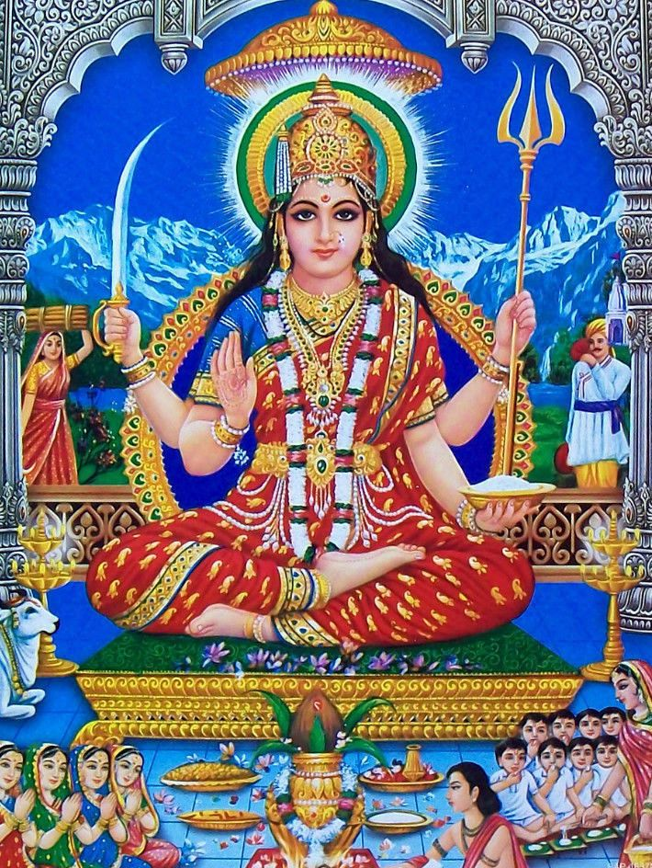

Santoshi Mata

Santoshi Mata or Santoshi Maa is a goddess in the Hindu pantheon of whose veneration throughout Hinduism had only relatively recently commenced. She is venerated as "the Mother of Happiness", the meaning of her name. Santoshi Mata is particularly worshipped by women of India and Nepal. A vrata (ritual fast) called the Santoshi Maa vrata performed by women on 16 consecutive Fridays wins the goddess' favour.
Santoshi Mata started to be worshipped as a goddess in the early 1960s. Her prayer initially spread through word of mouth, vrata-pamphlet literature, and poster art. Her vrata was gaining popularity with North Indian women. However, it was the 1975 Bollywood film Jai Santoshi Maa ("All Hail Mother Santoshi")—narrating the story of the goddess and her ardent devotee Satyavati Vyas—which propelled this then little-known "new" goddess to the heights of devotional fervour. With the rising popularity of the film, Santoshi Mata "entered" the pan-Indian Hindu pantheon and her images and shrines were incorporated in Hindu temples. The film portrayed the goddess to be the daughter of the popular Hindu god Lord Ganesha and hindu goddess Buddhi related her to the Raksha Bandhan festival.

Saptha Kannimar

- Brameshwari
- Gowmari
- Varaghi
- Vaishnavi
- Saamundi
- Maheshwari
- Indhirani

Saints

Avvaiyar

The Avvaiyars was the title of more than one poet who was active during different periods of Tamil literature. The Avvaiyar were some of the most famous and important female poets of the Tamil canon. Abithana Chintamani states that there were three female poets titled Avvaiyar.
Among them, the first Avvaiyar lived during the Sangam period (c. 1st and 2nd century CE) and is said to have had cordial relations with the Tamil chieftains Vēl Pāri and Athiyamān. She wrote 59 poems in the Puṟanāṉūṟu.
Avvaiyar II lived during the period of Kambar and Ottakoothar during the reign of the Chola dynasty in the tenth century. She is often imagined as an old and intelligent lady by Tamil people. She wrote many of the poems that remain very popular even today, and are inculcated in school textbooks in Tamil Nadu. These books include a list of dos and don'ts, useful for daily life, arranged in simple and short sentences.

Karaikkal Ammaiyar

Karaikal Ammaiyar (meaning "the revered mother from Karaikkal"), one of the three women amongst the 63 Nayanmars, is one of the greatest figures of early Tamil literature. She was born at Karaikal, South India, and probably lived during the 6th century. She was a devotee of Shiva.

Karaikal is a maritime trading city in Chola Nadu. Karaikal Ammaiyar, whose original name was Punithavathiyar, was born to Dhanathathanar in a merchant community known as Nattukottai Nagarathar (also Known as Nattukottai Chettiar). She was married to Paramadattan, a wealthy merchant from Nagapattinam.
One day Paramadattan sent two mangoes to his house. Punithavathy kept them safely so that she could serve her husband with them at meal-time. In the meantime, a Shiva yogi appeared before her. He was hungry and completely exhausted. Punithavathy worshipped him and offered him bhiksha. She had nothing to give him, except the mangoes. She gave one to the guest.
At midday Paramadattan came to the house. The wife served him with one mango. He liked it, and asked for the other. She was upset as she had already given the other mango to the Siva yogi. She appealed to the Lord for help. When she finished her prayer, mysteriously a mango fell on the palm of her hand. She gave it her husband. He tasted it. It was exceptionally sweet. He asked her to tell him from where she got it, as he was quite sure it was not the mango he had sent.
Punithavathy told him the whole truth. Paramadattan, however, would not believe this and challenged her to produce another. She prayed again to the Lord. Another mango appeared on her palm. She gave it to him. But, at once it disappeared from his hand. He was astounded. He understood the greatness of his wife. He felt that it would be a great sin to continue living with her as her husband. On the pretext of going to a foreign country for trade, he sailed with a ship load of goods. On return, he established himself in a big city in the Pandyan kingdom. He married a merchant girl and lived happily. He had a daughter by her and he named her Punithavathy, after his first wife.
Meanwhile, Punithavathiyar's relatives came to know of her husband's whereabouts and took Karaikkal Ammaiyar also there in a palanquin. When Paramadattan heard that Punithavathy was coming to see him, he, with his second wife and child, went forward, and fell at Punithavathy's feet. When the people demanded an explanation, he revealed that he regarded her, not as his wife, but as a Goddess. Punithavathy understood his mental condition, and prayed to the Lord, "In that case, Oh Lord, deprive me of the present physical charm and let me have a demoniacal form."
Her prayer was immediately granted and her charming body was transformed into a skeleton.
Then she went on a pilgrimage to the mount Kailash. Feeling that it would be a great sin to place her foot on those sacred grounds, she made the last part of the journey on her head.
Lord Shiva called her as "Ammaiyae", meaning mother.

Mangayarkkarasiyar

Mangayarkkarasiyar (Tamil:மங்கையர்க்கரசியார்) was one of the 63 Nayanmars or holy Saivite saints who are revered in South India. She is one among the only three women who attained this distinction. Her devotion to Lord Shiva is recounted in the hagiographic poem Periyapuranam compiled by Sekkizhar as well as in the Tiruthhthondar Thogai written by the poet-saint Sundarar.

Mangayarkkarasiyar was born as a Chola princess in Pazhayarai. Her real name was Maani. She married the Pandyan Dynasty King Koon Pandiyan who ruled Madurai. She came to be known as "Mangayarkkarasiyar" (meaning queen of the women in Tamil) on account of being an ideal Queen who commanded great respect and admiration among her subjects.

Devotion to Lord Shiva
She was an ardent devotee of Lord Shiva and remained a staunch Shaivite in her country which was becoming increasingly influenced by Jainism. Her husband, the Pandyan Kinghad converted to Jainism and this worried her a lot. The King became a Jain fanatic and even forbade her to wear Thiruneeru on her forehead. Hindus suffered persecution and Having converted the king, the Jain monks started to wield greater power in the kingdom. She feared that if left unchecked, the spread of Jainism would wipe out Shaivism entirely from Madurai. Her only solace was the Prime Minister of the kingdom, Kulachirai Nayanar who still remained a staunch Shaivite. The Prime Minister sympathized with the Queen and they were both deeply concerned about the spread of Jainism and the atrocities committed by the Jain monks in Madurai.
The Queen and the Prime Minister were struggling to find a way to get rid of Jainism and bring Shaivism to its prior prominence in the kingdom. But their efforts were in vain because of the King's fanaticism. During this time, she heard news that Appar and Sambandar had committed a miracle in the Vedaranyeswarar Temple by opening and closing the temple doors with their devotional verses. Having failed in all her attempts, the Queen made up her mind to seek the help of Appar and Sambandar. She dispatched the Prime Minister to invite Appar and Sambandar to Madurai.
Appar and Sambandar accepted the Queen's request and came to Madurai. They faced a lot of obstacles from the Jain monks on their way but successfully overcame them. King Koon Pandiyan had been ailing from incurable boils for a long time and also had a hunchback. He got the name Koon Pandiyan because of his hunchback. The Jain monks tried their best to cure the King with their medicines but to little avail. Sambandar cured the king of his boils by singing hymns and applying Thiruneeru on the king's body. The king was also cured of his hunchback and came to be known as Ninra Seer Nedumaara Nayanar ( meaning 'one who stands tall and erect' in Tamil).
Sambandar had earned the King's devotion and the King immediately reconverted to Shaivism. With the King's reconversion, Jainism was wiped out completely and Shaivism regained its prior prominence in the kingdom. For their role in the spread of Shaivism, the Queen, the Prime Minister and the King were each individually included in the list of Nayanmars and their tales were rendered in the hagiographic poem Periyapuranam compiled by Sekkizhar as well as in the Tiruthhthondar Thogai written by the poet-saint Sundarar.

Manasa

Manasā, also Mansā Devi, is an Indian folk goddess of snakes, worshipped mainly in Bengal and other parts of North and northeastern India, chiefly for the prevention and cure of snakebite and also for fertility and prosperity. Manasa is the mother of Astika, sister of Vasuki, king of Nāgas (snakes) and wife of sage Jagatkāru (Jaratkāru). She is also known as Vishahara (the destroyer of poison), Nityā (eternal) and Padmavati.
In the Puranas, sage Kashyapa is her father, Lord Shiva is a father figure to her. Manasa is depicted as being kind to her devotees, but harsh to people who refused to worship her. Denied full godhead by her mixed parentage, Manasa's aim was to fully establish her authority as a goddess and to acquire steadfast human devotees.

Worship

Generally, Manasa is worshiped without an image. A branch of a tree, an earthen pot or an earthen snake image is worshiped as the goddess, though images of Manasa are worshipped too. She is worshiped for protection from and cure of snake bites and infectious diseases like smallpox and chicken pox.
The cult of Manasa is most widespread in Bengal, where she is ritually worshiped in temples. The goddess is widely worshiped in the rainy season, when the snakes are most active. Manasa is also a very important fertility deity, especially among the lower castes, and her blessings are invoked during marriage or for childlessness. She is usually worshiped and mentioned along with Neto, who is called Neta, Netidhopani, Netalasundori, etc. in various parts of Bengal.
In North Bengal, among the Rajbanshis, Manasa (called Bishohora, Bishohori or Padmavati) is one of the most important goddesses, and her thaan (shrine) may be found in the courtyard of almost every agrarian household. Among the lower-caste Hindus of East Bengal (present-day Bangladesh)too, she is worshiped with great pomp.
Manasa is an especially important deity in Bengal for the mercantile castes. This is because Chando of the Manasamangal was the first to initiate her worship, and Behula, the heroine of the Manasamangal was a daughter of the Saha clan (a powerful trading community).
Manasa is also worshiped extensively in Assam, and a kind of Oja-Pali (musical folk theatre) is dedicated entirely to her myth.
Manasa is ceremonially worshiped on Nag Panchami - a festival of snake worship in the Hindu month of Shravan (July–August). Bengali women observe a fast (vrata) on this day and offer milk at snake holes.
In South India people started recently worshipping Goddess Manasa Devi Temple in Mukkamala located in West Godavari, Andhra Pradesh.

Notable temples
Mansa Devi Temple, Haridwar
Mata Mansa Devi Mandir, Panchkula, near Chandigarh.
Mansa Devi Temple, Kandra, Jharkhand

Hindu tradition
Main articles: Urdhva lokas and Patala
according to Hindu cosmology. Universe contains 7 upper and 7 lower planetary systems.
In the Puranas and in the Atharvaveda, there are fourteen worlds, seven higher ones (Vyahrtis) and seven lower ones (Pātālas), viz. bhu, bhuvas, svar, mahas, janas, tapas, and satya above and atala, vitala, sutala, rasātala, talātala, mahātala, pātāla and naraka below.
The concept of a loka or lokas develops in the Vedic literature. Influenced by the special connotations that a word for space might have for a nomadic people, loka in the Veda did not simply mean place or world, but had a positive valuation: it was a place or position of religious or psychological interest with a special value of function of its own.
Hence, inherent in the 'loka' concept in the earliest literature was a double aspect; that is, coexistent with spatiality was a religious or soteriological meaning, which could exist independent of a spatial notion, an 'immaterial' significance. The most common cosmological conception of lokas in the Veda was that of the trailokya or triple world: three worlds consisting of earth, atmosphere or sky, and heaven, making up the universe.
Sl No | Planetary system name
01 | Satya-loka
02 | Tapa-loka
03 | Jana-loka
04 | Mahar-loka
05 | Svar-loka
06 | Bhuvar-loka
07 | Bhu-loka
08 | Atala-loka
09 | Vitala-loka
10 | Sutala-loka
11 | Talatala-loka
12 | Mahatala-loka
13 | Rasatala-loka
14 | Patala-loka

Conclusion:-
By God’s grace, I have completed the details of Hindu Goddess,14 Lokas and saints.
Thanks & Regards,
R.HARISHANKAR

