Angala Parameswari Amman

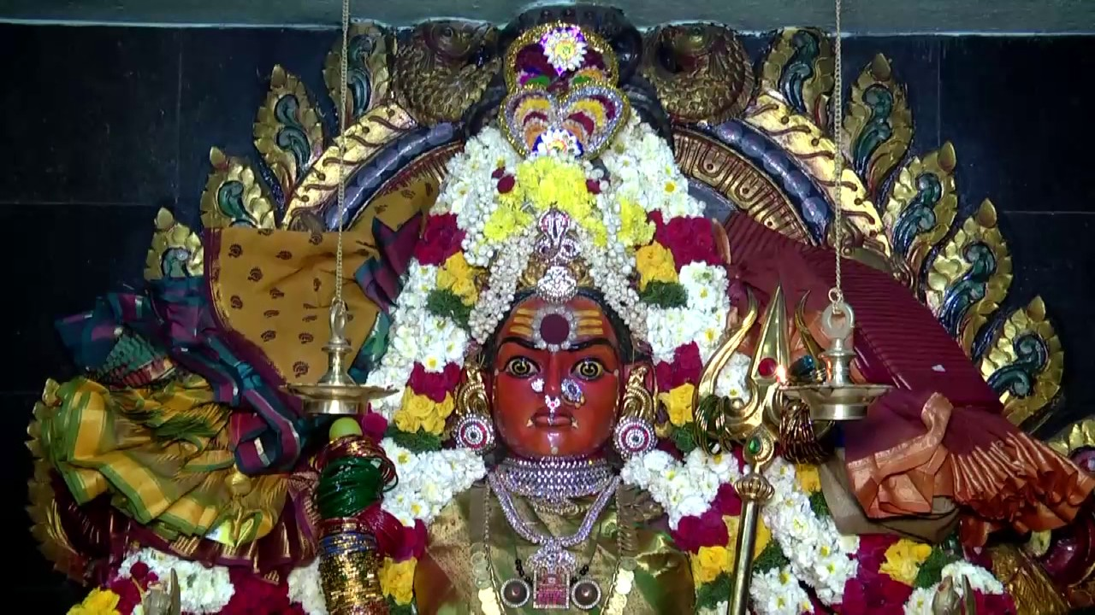

INTRODUCTION
Angala Parameswari Amman or Angalamman (Adhi Sakthi - Meaning - The First form of goddess Parvathi. The Origin is Melmalayanoor.). Most of the Tamil nadu peoples Kula Deivam is Angala Parameswari Amman. My Kula Deivam also is Angala Parameswara Amman Temple which is situated in Keerakara Veedi, Erode -1. It is one of the most important temples in erode. Boarding and Lodging facilities are available nearby the temple. During Sivarathiri Festival and Aadi month festival, lot of people will come to this temple and will do Abhishekham and Archanai. This Amman has done lot of favours to her devotees. Free from sickness, wellness in family, removal of poverty in the family, Giving child to childless people etc. It is a must to visit this Erode temple alongwith other Angalaparameswari Amman temples situated all over tamil nadu.

OTHER NAMES OF ANGALA PARAMESWARI
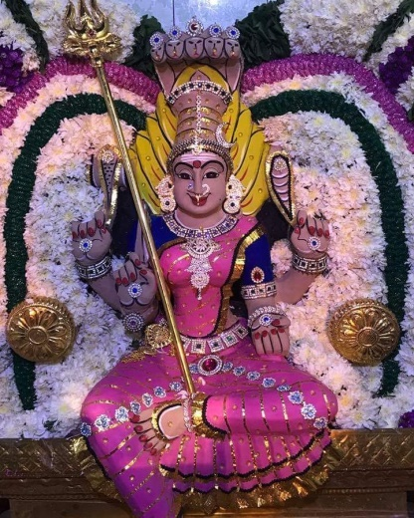
Goddess Ankalamma, or Angalamma, is also known as Ankamma or Angamma, Ankali, Angali, Ankala Parameswari and Angala Parameswari. She is worshipped with these names in Andhra Pradesh, Karnataka and Tamil Nadu.Most people in Tamilnadu keep their name as "Angu" by the influence of the god.
Ankalamma is counted as one of the Matrikas or "Seven Mothers". She is also considered to be a form of goddess Ankali or Kali.
Ankalamma is a non-Vedic deity and, like so many grama devatas, she seems to have originated in a fierce guardian figure. Sacred areas of Ankalamma and traditional Hindu deities are worshipped symbolically to appease the inner destructive impulses in us. Fowl or lamb offerings are made in village annual ceremonies and these are later consumed as food. Ankalamma's shrines are usually located outside of the village in groves of trees. They are usually not proper temples, but very simple stone structures.
The main characteristic of the ritual called Ankamma Kolupu is that a midnight worship (puja) is performed by making a colorful Rangoli with wheat flour, turmeric powder, kumkum, black charcoal powder, etc. During the worship singers recite ballads based on local stories about warrior ancestors (Veeran). The climax comes at the end of the ritual, when the devotees sacrifice a goat and its blood is spilled in order to appease the goddess. Other rituals like the Devara Kolupu or Veerla Kolupu are normally performed on some special occasions by individuals or by the community as a whole.

BIRTH OF ANGALA AMMAN
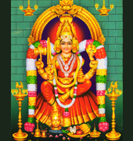
Goddess Mother Parvathi the wife of Lord Shiva took birth on her as hive. The purpose of the birth is to clear Lord Shiva from certain sin and give blessings to all people in kaliyug. The birth took place her before the start of kaliyug. The birth place is Melmalayanoor where the temple is situated. The specialty in this temple is Mother in Angala amman faces north while blessing devotees.
The great dazzling brightest light is mother Sri AngalaPrameshwari was ruling the world even before inhibition started.
Once Shakthi was reborn as Parvati, Brahma performed a yaga to save god and men from two demons known as Sandobi and Sundaran. Through this yagna Thilothamaan apsara came to life. Attracted by the beauty of Thilothama, the demons, and even Brahma, followed her. For her protection she went to Kailash where Brahma also followed. As Brahma also was with five heads, Parvathi mistook him for Shiva and felt at his feet. When Parvathi realized the truth, she was very angry and prayed Shiva that the fifth head of Brahma should be destroyed. So Shiva as "Rudra" removed one head of Brahma so Brahma now with four heads cursed Shiva that his fifth head must be attached to his hand itself and hereafter Shiva must be affected having hunger, having no sleep. So Shiva came to earth and roamed everywhere. When he was hungry he begged and ate, but half of the food he begged was eaten by the fifth head of Brahma: that is, the "Kabala" so Shiva roamed in every graveyard and slept in ashes and that form of Shiva is worshipped as Bhairava in south India.

GOD SHIVA’S RELIEF FROM HIS HUNGER
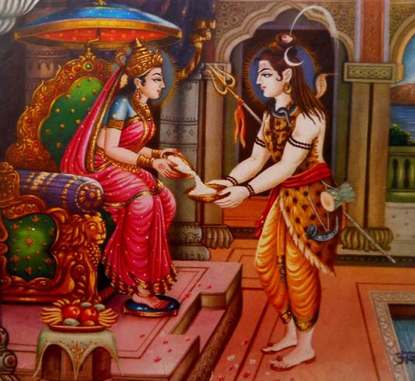
Parvati went to her brother Lord Vishnu and asked for relief for her husband so Lord Vishnu said to Parvati, "My dear sister, go to thandakarunyam graveyard with your husband and make a pond there named "Agni kula theertham" and prepare a tasty food made by Agathi keerai (Humming bird tree leaves) and blood of chicken and serve that food to kabala and then throw the food everywhere in the graveyard. The kabala will come down, leaving Shiva’s hand, to eat the food. Then take your husband to the pond and clean him with that water so that it will not catch your husband’s hand". Parvati did as her brother said: she took her husband to thandakarunyam graveyard and prepared the food, served it to the kabala and then threw it in the graveyard. The kabala came down from Shiva’s hand; meanwhile, Parvati took her husband to the pond and cleaned him. The kabala searched for Shiva’s hand but could not touch him so it attached to Parvati’s hand. So Parvati forgot about this and danced; then she recognised what had happened and become big and destroyed the kabala with her right leg.
The fiercest form (Angara rubam or Agora rubam) which destroyed the kabala when separated from Parvati is called Angalaamman. Parvati told Angalaamman to stay there and give a boon to the people who worship her and she went to Kailayam. However, Shiva was not there. Shiva got relief from Brahma’s curse, but he was too hungry so he went Kasi and there Parvati, incarnated as "Annapoorani Devi", served him food and Shiva ate and got relief from his hunger.
In the Thandakarunyam Angalaamman give boon to the people who worship her the people who had diseases went there and get relief from the diseases she drive away the evil ghosts from the people and people go there and worship her in no moon days (Amavasya) at the midnight of every no moon day Angalamman is decorated and put on a swing (Amavasai Oonjal).
Let us chant the mantra ‘OM SAKTHI PARASAKTHI’ and praise goddess parvathi.
WRITTEN BY
R.HARISHANKAR

ASHOKASUNDARI
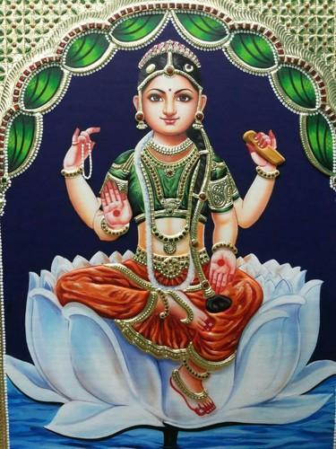
INTRODUCTION
Ashokasundari also called as Bala Tiripura Sundari is a Hindu goddess and the daughter of Shiva and Parvati. And she is the sister of Lord Vinayaka and Murugan. Her details were mentioned in the ancient puranas. The goddess is mostly worshipped by the Sakthi Devotees. Her husband is Nahusha. And her son is Yayati.
Ashokasundari was created from the wish-fulfilling tree Kalpavriksha due to Parvati’s favour. She was a beautiful girl and contains the powers, similar to that of Goddess Parvati.
Ashokasundari looks very attractive and contains charming face, and looks in the form of an adolescent child.
Once she was abducted by the Demon Hunda in order to marry her, and later she was escaped from him.
The great king Nahusha fought with the demon Hunda, and defeated him after a fierce battle and married her. For some time he occupied the throne of Lord Indra and ruled the heaven in a well versed manner. Their son’s name is Yayati, and he is also a great warrior and a noble man, similar to that of his father Nahusha. Both Nahusha and his son Yayati are learned scholars and mastered in all kinds of art, and contain spiritual powers.
IMPORTANCE
Bala Tiripura Sundari was worshipped all over India. She protects her devotees from misfortunes and gives them a bright future. She removes the illness and sorrows from the life of her devotees, and gives good prospects in their life. Several mantras are attributed to her. And lot of temples are dedicated to her.
It is advisable to worship her in order to get relieved from our sins, from various mental and physical diseases, to live a happy life and also to get SALVATION.
She is worshipped by several saints and holy persons and got benefitted from her. She is worshipped mainly with flowers, and doing abhishekham to her idol will also yield good results in our life.
Since she is an incarnation of Goddess parvati, worshipping her is equivalent to that of worshipping goddess parvati.
It is advisable to visit her temples, and to get good results in our life.
Adi sankaracharya worshipped Bala Tiripura Sundari and recited several slokams in praise of her.
Childless couples are advisable to pray goddess tiripura sundari, and to worship her with sincere devotion in order to get the boon of child birth to them.
Let us pray to the divine GODDESS, “DEVI BALA TIRIPURA SUNDARI” and be blessed.
“OM SREE DEVI BALA TIRIPURA SUNDARIYE NAMAHA”
WRITTEN BY
R.HARISHANKAR

DEVI SANTHOSHI MATA
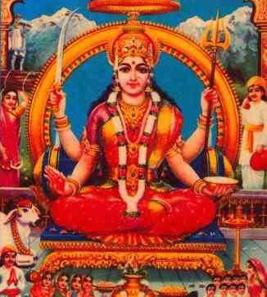
INTRODUCTION
Santoshi Mata is a Hindu goddess. She is described as "the Mother of Satisfaction". Santoshi Mata is particularly worshipped by women of North India and Nepal. Santoshi Mata vrata is mostly performed by women for fulfilling their wishes.
Santoshi Mata vrata was gaining popularity with North Indian women, and nowadays also among South Indian women. Santoshi Mata images and shrines are popular in Hindu temples.
Observance of Fasting
The Santoshi Mata fasting is to be observed on 16 successive Fridays, or until one's wish is fulfilled. The devotee should perform the worship on Santoshi Mata and offer her flowers, and a bowl of raw sugar. The devotee who is performing the puja has to wake up early in the morning, remembering the Goddess. Only one meal must be taken during the fasting day, and devotees must avoid eating sour food, and serving these to others. When the wish is granted, a devotee must then organise a ceremony, where eight boys are to be served as a festive meal.
In this type of worship, the devotee should not do bad things to others. By means of this fasting, one can live happily in their life. This fasting teaches the devotee to spread happiness among others.
Temples
There are temples all over India and abroad where Principal deity is Mata Santoshi.
1. Harinagar,Delhi(NCR)
2. Jai Nagar,Trichy(Tamil Nadu)
3. Chakradharpur(Jharkhand)
4. Lall Sagar,Jodhpur(Rajasthan)
Story of the Vrata
The vrata katha is as follows: An old woman had seven sons. The youngest son was not employed and was very lazy,hence she served him the remaining food of his brother as his daily meal. The wife of the youngest son got to know this and told her husband. Then he left the house in search of a job. He got a job with a merchant and became rich, but forgot about his wife. His wife was insulted by her in-laws, in the absence of her husband. Once, she came to know about the 16-week Santhoshi Mata vrata and performed it. As a result, Santoshi Mata appeared in her husband's dream and informed him of his wife's wish. He immediately returned home, and lived separately with his wife.
CONCLUSION
Observing fast by praying Maa Santhoshi Mata, will definitely yield good results. Even I have heard about this. Nowadays people in Chennai also are observing fast and getting good results. She will definitely answer to our prayers, if we perform the fast with good intention, and with great devotion to the holy mother. Let us pray to the holy mother for our welfare, and chant the name of Maa Santhoshi Mata.
OM MAA SANTHOSHI DEVI NAMAHA.
WRITTEN BY
R.HARISHANKAR

GAYATRI
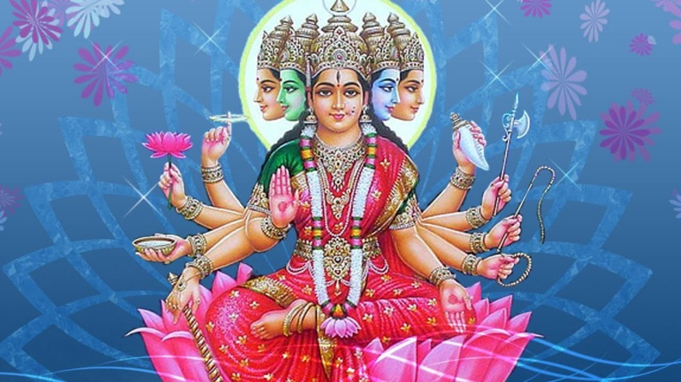
INTRODUCTION
Gayatri is well known for her popular Gayatri Mantra. She is also known as Vedamata.
Gayatri is considered to be the consort of Lord Brahma.
According to ancient puranas, Goddess Gayatri killed the demon Vetrasura, since he had given trouble to the people living in the earth and heaven.
Goddess Gayatri Devi contains the powers of Devi Parvati, and it is also considered that she is the incarnation of Parvati.
Gayatri is worshipped since ancient period. She is mainly worshipped by the learned scholars and the great rishis for getting adequate knowledge in the vedic subjects.
Gayatri exist in 24 female forms. And she contains superior powers, and she is the controller of the entire universe.
1 Adi Shakti
2. Brahmi
3. Vaishnavi
4. Shambhavi
5. Vedamata
6. Devamata
7. Vishvamata
8. Mandakini
9. Ajapa
10. Riddhi
11. Siddhi
12. Rtambhara
13. Savitri
14. Lakshmi
15. Durga
16. Saraswati
17. Kundalini
18. Annupurna
19. Mahamaya
20. Payasvini
21. Pranagni
22. Treyta
23. Bhavani
24. Bhuvaneswari
IMPORTANCE
She is the main source of the Gayatri Mantra. Without uttering this mantra, a proper hindu ceremony will not get completed. She lives in that mantra, and gives us various benefits, if we sincere chant the mantra as a daily practice. This mantra is usually recited by the Brahmins and by some sects of hindus who wears the sacred thread. After the next day of Avani Avittam festival, during the day of Gayatri Japam, it is suggested to utter atleast 1000 times of gayatri mantra.
She gives all sorts of prosperity in our life. And removes the sins committed in the past, and will purify our soul. Being the holy mother of the entire universe, she treats us kindly and softly and will forgive our mistakes and make us to lead a sin free life.
Let us worship the divine mother Gayatri and be blessed.
“OM SREE GAYATRI DEVIYE NAMAHA”
“OM SREE BRAHMA DEVARE NAMAHA”
WRITTEN BY
R.HARISHANKAR

PARVATHI DEVI AMMAN
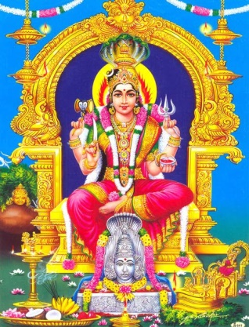
INTRODUCTION
Parvati Devi also known as Amman, and also fondly called by the name “AMMA”, is the Hindu goddess and who contains superior divine strength and power. She is the gentle Hindu goddess, and is one of the most important deities of Hinduism. She is the mother goddess in Hinduism, and has many popular aspects. Along with Lakshmi and Saraswathi, she forms the trinity of Hindu goddesses (Tridevi). Parvati is the wife of the Hindu god Shiva, the sister of God Vishnu and the mother of Lord Vinayaka and Lord Muruga.

WORSHIP
Amman is also worshipped in some places as the "Grama Devata” and puja will be done to her by non-Brahmin priests, or in the case of large temples such as the Samayapuram Maariamman temple, by Brahmin priests also. She is usually taken in procession in a decorated chariot.
Mariamman is a Tamil goddess, whose worship was prevalent from ancient period. She is the main tamil mother goddess, and is popular mainly in the rural areas of Tamil Nadu. In north india, she is worshipped as Shitaladevi and in east india, she is worshipped as Manasa Devi. Generally, large number of Amman temples are scattered all over india, and also in some foreign countries. Angala parameswari Amman is very famous in the villages of tamil nadu, and also is the kula deivam for most of the devotees of tamil nadu. One most popular Angala Parameswari temple is situated at Erode, and this amman is my “KULA DEIVAM” and is very famous for curing the devotees diseases, and giving good results in their life, and also in giving “SALVATION” to her sincere devotees.

In some Amman temples, the worshiping methods are non-vedic, and offerings such as pongal and koozh are also made during the festive season. Rituals such as fire walking(Thee Midhi Thiruvizha) and mouth or nose piercing are also practised.
Aadi is a special month for Amman and she becomes very powerful at this time of the year, and cures all the diseases, and brings great prospects in the life of her devotees. She is mainly known for healing chicken pox and small pox.
Goddess Parvathi Devi, called by various names such as Sathi, Amman, Durga, Bhavani, Bhairavi,Chamundi,Tiripurasundari,Kamakshi,Kamalakshi,Kameswari, Mahishasuramardhini,Chandiga Devi,Varahi Devi,Aadhi Parasakthi,Mariamman, Bhuvaneswari,Parameswari, Kali Devi, Ambal,Annapurna and by many more names. Whatever by name she is called, the result in worshipping Goddess Parvathi Devi will be a favourable one. Based on several traditional stories, in some temples, she was self manifested. There are several followers of shaktism, in which specifically they will worship goddess parvathi alone. They will participate in all the festivals of amman, and visit several temples of the goddess and offer their prayers to her.
Some staunch devotees will visit amman temples through pada yatra, especially during Aadi month.
CONCLUSION
Goddess Parvathi, who grants our wishes and fulfil our dreams, and is the mother(AMMA) for all of us, and for all the living creatures in this world. Let us pray to the divine mother for our well being, and chant her name sincerely and continuously with full of devotion in our mind.
“OM SAKTHI PARA SAKTHI”
WRITTEN BY
R.HARISHANKAR

SHEETALA DEVI
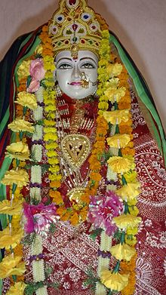
INTRODUCTION
Sheetala Devi is worshiped in many parts of india and also in Nepal, Bangladesh and Pakistan. She is an incarnation of Goddess Durga, and she cures poxes, and all other dreaded diseases.
Once a demon named Jwarasur, started spreading incurable diseases to all the people in the earth, especially among the children. Durga assumed the form of Sheetala Devi, and with her great power, she cured all the people’s diseases.
Lord Bhairav and Durga Mata fought with Jwarasur and killed him with their powerful weapons. They have destroyed the demon, in order to prevent the sufferings of the people, and to make them to live a healthy and peaceful life.
IMPORTANCE
Sheetala Devi was very fair, and looks young in appearance and is considered as an incarnation of Mata Durga.
She is a goddess of curing the diseases and she can give them too, if we neglect her. She is the cause as well as the cure.
Sheetala is the reliever of various diseases and the one who protects from the sufferings of the people. Sheetala is worshiped under different names in various parts of india. Shitala is popularly worshipped by North Indian people.
In Haryana, Kripi (Mother of Ashwathama) is worshiped as Sheetla Devi in Sheetala Mata Mandir Gurgaon.
The puja of Sheetala is performed by both brahmins and non-brahmins. She is mainly worshiped in winter and also worshipped in the day of Sheetala Asthami.
Sheetala is represented as a young and charming god riding a donkey, holding a short broom (to clear the harmful germs which cause various diseases to the people) and a pot containing cold water (to heal the people suffering from various diseases). She is also said to be carrying a bunch of neem leaves, a medicinal herb used to cure various diseases of the people.
TEMPLES
- Sheetala Mata Mandir,Bihar
- Sheetala Mata Mandir,Uttar Pradesh
- Sheetala Dham Mandir,Jaunpur
- Sheetala Mata Mandir,Sonipat
- Sheetala Mata Mandir,Rajasthan
- Sheetala Mata Mandir, Kolkata
- Sheetala Mata Mandir, Himachal Pradesh
- Sheetala Mata Mandir, Assam
- Sheetala Mata Mandir,Gurgaon
10. Sheetala Mata Mandir,Madhya Pradesh

She not only cures the diseases of the people, but also gives all the prosperity in our life. She is the divine mother who protects the entire universe through her magnificent power.
Let us worship her and be blessed.
“OM SREE SHEETALA DEVIYE NAMAHA”
WRITTEN BY
R.HARISHANKAR

THANDU MARIAMMAN
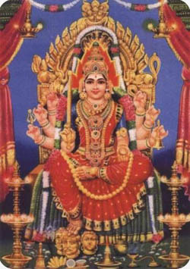
INTRODUCTION
Thandu Mariamman, is a form of Goddess Parvathi, and she is a very powerful Goddess. Though there are many temples for Thandu Mariamman, the main temple is situated at Coimbatore.
HISTORY
This amman temple was established by few of the Tippu sultan’s soldiers in a small manner, before a few hundred years back. One of the Tippu sultan’s soldiers, was an ardent devotee of goddess parvathi. One day in his dream, Amman has appeared and she has shown him the place where she stays, and ask him to build a temple for her. The next day, with great enthusiasm, the particular soldier took the help of the other soldiers, and he visited the place where amman has spotted to him in his dream, and constructed a small temple in the form of a hut to her. In course of time, that small temple was converted into a big temple and it accompanied with several shrines such as Ganapathi,Saraswathi,Dakshinamoorthy, Lakshmi and Durga.
IMPORTANCE
This mariamman cures chicken pox and also cures several other dreaded diseases of her devotees, and also she is considered as the rain god. She gives all prospects in the life of her devotees. One small temple nearby my residence is there for Thandu Mariamman, and it is situated at paper mills road,Perambur, near venus bus stop. Here devotees will gather in large numbers on Tuesdays,Fridays and Sundays and will do puja for amman. During Aadi month, Amman will be decorated and pongal and kuzh will be offered to her. She heals and protects us from all sorts of problems, and acts as a saviour for us. Let us Pray to the great goddess, and chant her nama with pure devotion.
“OM SREE THANDU MARIAMMAVE NAMAHA”
WRITTEN BY
R.HARISHANKAR

THANTHONDRI AMMAN
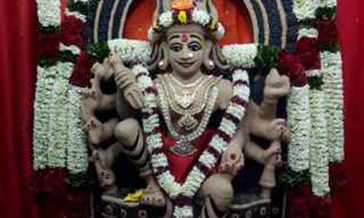
Though there are many small and big temples for Thanthondri Amman, the main temple is located at Gobichettipalayam, Erode District, Tamilnadu-638476. Since this amman was emanated by herself, the name is called as Thanthondri Amman.
Thanthondri Amman worship is popular in tamil nadu, and also among the tamil speaking people in foreign countries also. Devotees believe that by worshipping Thanthondri amman, their problems will be solved immediately. Amman is called by various names, and one among them is Thanthondri Amman. She is considered as the supreme being among all other gods. According to the puranas, Amman is considered as the original creator, observer and destroyer of the whole universe.
Another famous temple is situated nearby my residence at Agaram, Chennai - 600 082, near Perambur loco works. This amman is popular among the parambur locality people. Devotees are visiting this temple mainly for fulfilment of their marriage, long life and to get rid of various health related problems and to bring happiness in their life. Apart from the main shrine of amman, several other shrines for Vinayaka,Muruga,Durga and Navagraham is found inside the temple.
Inside the temple complex, a big Ayyanar statue was installed, which was commonly worshipped by the devotees with great faith, and they believe that by worshipping him, he will give courage and strength to withstand the problems in their life, and they believe that he will safeguard them from their enemies.
Thee Midhi is popular in this temple which will be performed during Aadi month, and live telecast will be there is TV during this thee midhi festival. The most favoured offering is "pongal", cooked mostly in the temple complex and Kuzh will also be offered by the devotees to Amman and will seek the blessings of Amman.

Some important Thanthondri Amman temples are as follows:-
1. Thanthondri Amman Temple No.8/11, Madras Thiruvallur High Rd, Villivakkam, Konnur, Chennai, Tamil Nadu 600049.
2. Thanthondri Amman Temple No.18, Arunachalam St, Chepauk, Triplicane, Chennai, Tamil Nadu 600005.
Let us pray to Thanthondri Amman with pure bhakti, and seek her blessings and chant her holy name.
“OM SREE THANTHONDRI THAYE NAMAHA”
“OM SAKTHI PARASAKTHI”
WRITTEN BY
R.HARISHANKAR

TULASI DEVI
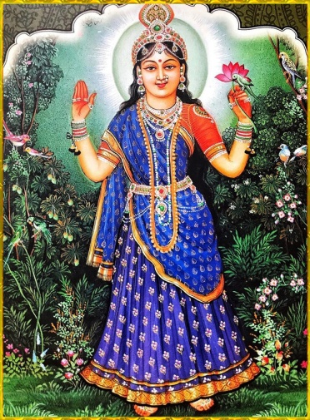
INTRODUCTION
Tulasi is considered as a sacred plant in Hinduism.
Hindus regard it as the manifestation of the goddess Tulasi.
She is the incarnation of Goddess Lakshmi. The offering of tulasi leaves is compulsory in the worship of Lord Vishnu.
Many Hindus have the habit of planting tulasi plants in their home. Tulasi Devi is also known by various names such as Vrinda, Vaishnavi and Haripriya.
Tulasi was married to Jalandhara, a powerful demon. Jalandhara had done lot of bad deeds and gave disturbance to the entire universe. Finally, he was killed by Lord Shiva.
After that, Lord Vishnu appeared before tulasi, and asked her to return to “VAIKUNTA” as Goddess Lakshmi.
It is believed that Gandaki River in Nepal is the AMSHA of Goddess Tulasi, and contained the features of Goddess Tulasi.
IMPORTANCE
Tulasi plant is also regarded as the holiest among all other plants. The Tulasi plant is regarded as a best medicinal herb, and it is used mainly for curing cough and cold, fever and also used as an ayurvedic medicine.
When a person who took care of the Tulasi plant and pours water regularly, will attain the divine abode of VAIKUNTA. And also all the negativity of thoughts will be removed by worshipping Tulasi plant. Good fortunes will occur in the life, and all the problems occurring in our everyday life will be immediately wiped out. Goddess Lakshmi will permanently stay in our house and we will get sufficient wealth in our life.
On 25th December of every year, the festival for tulasi will be celebrated in a grand manner mostly in north india.
Garlands made of tulasi leaves, are adorned to Lord Vishnu and to his avatars, and also to Lord Hanuman.
Wearing Tulasi malas in the neck are considered to be very auspicious. And it will prevent the evil effects occurring to the body.
Hence it is very important to worship goddess tulasi regularly, in order to achieve good results in our life.
Let us praise her glory, and be blessed.
“OM SREE TULASI DEVIYE NAMAHA”
“OM NAMO NARAYANAYA NAMAHA”
WRITTEN BY
R.HARISHANKAR

VINAYAKI DEVI
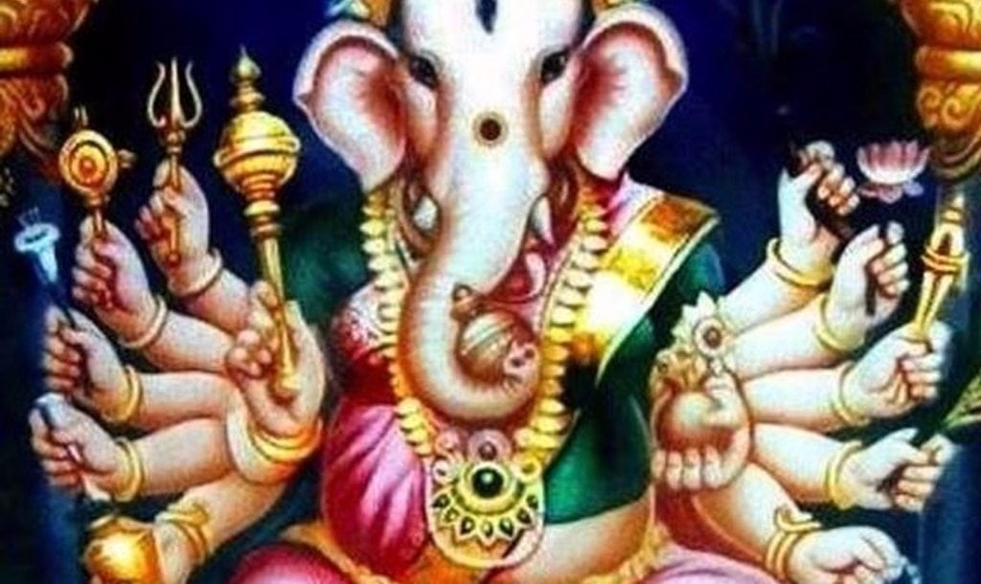
INTRODUCTION
Vinayaki is an elephant-headed Hindu goddess. Her details are not clearly defined. Only few details are available about her in Hindu scriptures and very few images of this deity exist.
The goddess is generally associated with the elephant-headed god of wisdom, Ganesha. She does not have a consistent name and is known by various names such as Vinayaki, Vighneshvari and Ganeshani. Vinayaki is sometimes also seen as the part of the sixty-four yoginis. In the Jain and Buddhist traditions, Vinayaki is an independent goddess.

Puranas
Elephant-headed females appearing in the Puranas are demonesses or cursed goddesses. Vinayaki, not related to Ganesha, also appears in the Puranas. In the Matsya Purana, she is one of the Matrikas, created by the god Shiva to defeat the demon Andhaka. In this connection, she may be considered as a shakti of Shiva, rather than Ganesha. She also figures in a list of shaktis in the Linga Purana.
However, the Devi Purana identifies Gananayaki or Vinayaki as the shakti of Ganesha, based on her elephant head and the capacity to remove obstacles like Ganesha, and includes her as the nineth Matrika. Though generally the number of Matrikas is seven in sculpture, nine Matrikas became popular in eastern India. Apart from the classical seven, Mahalakshmi or Yogeshvari and Ganeshani or Ganesha were added as eighth and ninth Matrika respectively.
Shilparatna describes a female form of Ganesha (Ganapati) called Shakti-Ganapati, who resides in the Vindhyas. The deity has an elephant head and two trunks. Her body is of a young woman, vermilion red in colour and with ten arms. She is pot-bellied and with full breasts and beautiful hips. This icon probably belongs to Shaktism, the Hindu Goddess-worshipping sect. However, this form is also interpreted as a composite of Ganesha and his shakti, due to the presence of the twin trunks.
In a Buddhist text, the goddess is called the siddhi of Vinayaka. She contains many of Lord Ganesha’s characteristics. Like Ganesha, she is the remover of obstacles and has an elephant's head with only one tusk. She is also called the daughter of the god Ishana, an aspect of Shiva.
CONCLUSION
It can be concluded, that Goddess Vinayaki, whether relates to Vinayaka or Parvathi, is a powerful goddess possessing all the features of Lord Vinayaka. She is having the power equivalent to that of Lord Vinayaka. Let us pray to Goddess Vinayaki and be blessed. Let us chant the nama ‘OM SREE VINAYAKIYE NAMAHA’
WRITTEN BY
R.HARISHANKAR

