**LORD VINAYAGA**

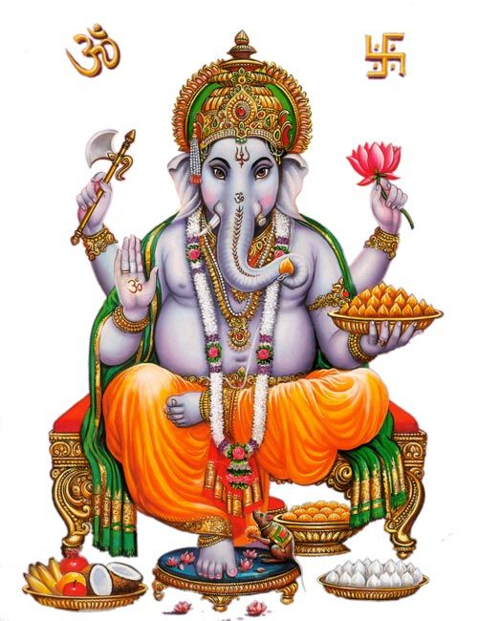

Lord Vinayaga is the first god in the hindu tradition. Every hindu worship lord vinayaka as an obstacle remover and people will worship him daily before doing their daily routines.

Lord Vinayaka is the symbol of Wisdom and Faith. He is regarded as the god of gods. Lord Ganesh Temple is situated in almost all parts of India. Even under a tree, he will be available. He cannot be ignored when we start a new venture or any other new engagement.

My mother Mrs.R.Saraswathi has written Sri Vinayaka Puranam alongwith Muruga Puranam(Two Parts) for Prema Presuram,Rangarajapuram,Kodambakkam,Chennai during 1960’s. Still now that books are available in all leading book shops. Several times she has been safeguarded by Lord Ganesha from various accidents and ill health.

Vinayaka Chaturthi is celebrated in all parts of India with much joy and interest. Idols of vinayaka will be found all over the streets on the occasion of Ganesh Chaturthi.

It is mentioned in our puranas, that even divine gods worship lord vinayaga before doing any new activity. Such a kind of importance is given for Lord Ganapathi. Since he emerged from Goddess Parvathi, he possess the sakthi element. That is, protecting and safeguarding the people and removing the evil elements in their life.

Almost in all Shiva and Vishnu temples, Lord vinayaga’s idol will be there. Abhishekam and Archanai will be done with much speciality. He is also called as Aingaran, five hands including his thumbikai. Aingarathane, Anaimugane is the most popular song of Lord Vinayaka which will be sung during Vinayaka Chathurthi in temples.

Lord Vinayaka’s statue will be there is almost all hindu temples. In some Raghavendra Mutts and Sai Baba Temple also, in the entrance, Lord Vinayaka Idol will be there. People can perform pooja to Lord Ganapathi without much strain. By offering Arukampul itself while performing archanai, he will be satisfied and will fulfil our needs and wants.

If we worship him with pure bhakti, he will be readily available to come to our house and will partake with our neiveidiyams and bless us.

Lord Ganesha’s history is described in many puranas. He was blessed and got various boons and also got the first god position from the divine gods.

He is the elder brother of Lord Muruga, and described as a playful boy during his childhoold, similar to that of Lord Krishna. He is very fond of Mothagams. It is advisable to prepare Mothagams during every Sankatahara chathurthi ( which comes once in a month) and to offer to Lord Ganapathi as Neiveidiyam along with various flowers and Arukampul. If we face any problem and call him, instantly he will be available and clear our problems. His vahana is Mushika.

In Hindu trinity, he is praised by various sages as remover of obstacles and bringing luck to people, fulfilment of needs and wishes of people and finally giving salvation.

He is praised with various slokams. Women sage and poet Avvaiyar has written songs on him. Hence it is advisable for each and every person to worship Lord Ganapathy, before doing any work and also before worshiping any other god.

His famous temples are situated in Chitoor District- Kanipakkam Vinayaka temple and also in Mumbai –Ganeshji Temple and Karnataka – Idagunji Vinayaka Devaru, Trichy – Malaikottai Temple. Almost in all temples, free food is being offered as prasadam for about 100 to 200 devotees.

**OM SREE GANESAYA NAMAHA**

**WRITTEN BY**

**R.HARISHANKAR**

**LORD MURUGA**

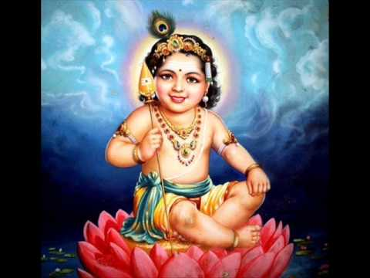

**INTRODUCTION**

Lord Muruga, also known as kanda,kadamba,kathirvela,senthilandava and karthikeya, and also by various names, is the second son of Lord Shiva and Parvathi. He was born from the third eye spark of Lord Shiva. He was a great warrior in the battle field. He fought with several asuras and defeated them. He was married with Valli and Deivanai, both of them are two activating forces of the entire world.

**TEMPLES**

Many temples are dedicated to Lord Muruga, the main among them are arupadai veedus, six houses(temples) of Lord Muruga in six locations. They are Tirutani, Tiruparankundram, Palamudhir cholai, Tiruchendur, Palani and Swami malai. All the six temples are located in tamil nadu. Apart from Arupadai Veedus, Maruda Malai Murugan is very famous which is situated nearby Coimbatore city. In Chennai,Vadapalani andavar temple,kundrathur murugan temple, kandakottam temple in rasappa chetty street,park town and Thiruporur murugan temple are considered as famous temples. In most of the tamil nadu temples, free annadanam is offered to devotees in the afternoon.

Several temples are there in foreign countries also like Malaysia,srilanka and singapore. One main temple is situated at Malaysia which is called as Pathu malai murugan temple(Batu caves). Every year, during thai poosam, several devotees will take various kavadi and vel piercing on face and body will be done by the devotees. This shows their strong faith on Lord Muruga.

He is regarded as a god for tamil.

Kanda Puranam is a famous work, which shows the importance of Lord Muruga.

**FESTIVALS**

The main important festivals for Lord Muruga is Skanda Shasti, Tamil New Year Day, Thai Poosam, Karthikai Deepam and Panguni Uthiram. During these festivals, special abhishekam will be done by the devotees to lord muruga in murugan temples, such as milk,honey,ghee,fruits,paneer and coconut water.

**WORSHIP**

Several saints were worshipped and praised the glory of Lord Muruga. The important among them are, Arunagiri nathar, Bogar, Kirupananda variyar and Avvaiyar. They have sung several songs praising the glory of Lord Muruga.

Murugan worship was prevailing from ancient history. Several kings worshipped Lord muruga and offered their land for constructing several murugan temples, and also they have donated several ornaments to Lord Muruga.

**CONCLUSION**

Lord Muruga who is an amsa and the son of Lord Shiva, is a great god, and answers the prayers of his devotees. He accepts our offerings and grant various boons to us. He gives us courage and boldness to face difficulties in our life. He removes all the evil effects of the planetary position of his devotees. Those who observe fasting on Shasti, will get immediate relief from their sufferings and problems in their life. Let us chant his holy name and be blessed in our life.

**“OM MURUGA VADIVEL MURUGA”**

**WRITTEN BY**

**R.HARISHANKAR**

**LORD AYYAPPAN**

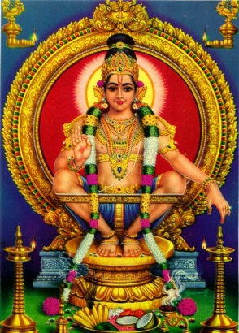

**INTRODUCTION**

**Ayyappan** is the [Hindu](https://en.wikipedia.org/wiki/Hinduism) god, and is the most popular god in [Kerala](https://en.wikipedia.org/wiki/Kerala). Ayyappan is called by various names such as Hariharaputra, Manikanta and Dharma Shasta.

According to the Hindu tradition, he was born with the powers of Shiva and Vishnu to defeat the demoness Mahishi. Ayyappan was born from the power of Shiva and Vishnu’s mohini avatar.

The famous Ayyappan shrine is at [Sabarimala](https://en.wikipedia.org/wiki/Sabarimala" \o "Sabarimala), [Kerala](https://en.wikipedia.org/wiki/Kerala). The shrine receives millions of pilgrims every year in late December and early January.  The most famous festival is Makaravilakku ([Makara Sankranti](https://en.wikipedia.org/wiki/Makara_Sankranti" \o "Makara Sankranti)), observed during winter season. Free annadanam will be offered to all the devotees during their visit to sabarimala.

**Life**

Once the king of Pantalam Rajashekhara found a baby boy in a forest, and he carried the baby to his kingdom, and he named him as Manikantha(Ayyappan).

Ayyappan brings tigress milk for the sake of the queen by riding on a tiger, but after doing so Ayyappan left the kingdom, and becomes a yogi and lived in the mountain(**SABARIMALA**).

**Temples**

Sabarimala is the most famous temple in Kerala. Other important temples are:-

1.[Kulathupuzha Sastha Temple](https://en.wikipedia.org/wiki/Kulathupuzha_Sastha_Temple" \o "Kulathupuzha Sastha Temple)

2.[Aryankavu Sastha Temple](https://en.wikipedia.org/wiki/Aryankavu_Sastha_Temple" \o "Aryankavu Sastha Temple)

3.[Achankovil Sree Dharmasastha Temple](https://en.wikipedia.org/wiki/Achankovil_Sree_Dharmasastha_Temple" \o "Achankovil Sree Dharmasastha Temple)

4.[Erumely Sree Dharmasastha Temple](https://en.wikipedia.org/wiki/Erumely_Sree_Dharmasastha_Temple" \o "Erumely Sree Dharmasastha Temple)

5.[Ponnambalamedu](https://en.wikipedia.org/wiki/Ponnambalamedu" \o "Ponnambalamedu) Temple.

**IMPORTANCE**

Lord Ayyappan’s worship is prevailing from several thousands of years. Going to sabarimala is different from going to other temples. For going to sabarimala, We have to observe fasting for one mandalam (48 days) and to take only vegetarian food. Smoking and drinking is totally prohibited. We should get up early in the morning, and do puja to ayyappan, and to visit nearby temples. Daily we must take bath. It is better to observe fasting in the night or otherwise, we should take only tiffen items. During that fasting period, we should not think about unnecessary things, and our mind must concentrate only on Lord Ayyappan and to chant his mantras and his name. We should get irumudi( Coconut filled with ghee) from the guruswamy(senior ayyappa devotee), and to take it throughout the mountain of sabarimala and to worship Lord Ayyappa.

If we strictly follow all the procedures which has to be adopted for going to Sabarimala, we will definitely get Lord Ayyappan’s blessings and our needs and wishes will get fulfilled through his grace.

**CONCLUSION**

Lord Ayyappa, being the son of Shiva and Vishnu, contains the powers equivalent to that of Lord Shiva and Lord Vishnu. Lord Ayyappa Deity in sabarimala shows a abaya mudra(blessing) pose. He will relieve us from our sins, and help us to live our life happily and peacefully, and will give **SALVATION** at the end of our life based on our true bhakti. Let us pray to him and be blessed.

**“OM SWAMIYE SARANAM AYYAPPA”**

**WRITTEN BY**

**R.HARISHANKAR**

**LORD HANUMAN**

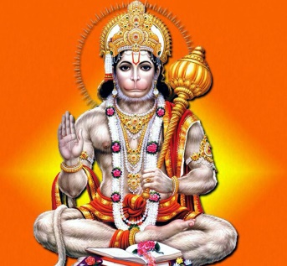

Lord Hanuman is said to have taken birth during Treta Yuga. He is well known for his bravery, generosity and humble nature. Everyone knows about his Rama Bhakti and through that, he has done several super natural works. He is the main person in the epic “**RAMAYANA**”. All the authors of Ramayana, praises his valour, courage and strength. He is an avatar of Lord Shiva, and is the son of Lord Vayu(**Wind God**). Because of his great help, Rama has succeeded in the war between him and Ravana, and was able to get back Sita Mata from Ravana.

Even in his childhood, he tried to pick the sun god, thinking him as a fruit. This shows his great powers. He was blessed by the divine gods, and they have granted him several boons. His importance is described in the stotra “**HANUMAN CHALISA**”. Generally, Hanuman Jayanthi and Rama Navami are the most important festivals celebrated in Hanuman temples.

Lot of temples are dedicated to Lord hanuman all over india. In tamilnadu, namakkal anjaneyar and nanganallur anjaneyar temples are famous temples, and in this temples, during hanuman jayanthi, hanuman statue will be garlanded with Vada Malai, and vennai kappu is also done there.

Lord Hanuman was entirely devoted to Lord Rama. He is considered as a bachelor and is still living in the Himalayas, by chanting Rama Mantra. Till the end of kali yuga, he will be in earth, and will bless all of his devotees, and give them a good life, health and all prosperity in their life. According to ancient puranas, hanuman will be the next brahma after kali yuga, and will do creation work.

It is very easy to please hanuman, by uttering the Rama Mantra. Whenever religious discourses on Ramayana takes place, he will be immediately present in that place and will hear the discourse. He took the Panchamukha avatar and appeared to Guru Raghavendra in Panchamukhi, which is situated nearby mantralayam.

Several songs and mantras are there in praise of Lord Hanuman. In medias also they have shown the character of Hanuman and his importance in Ramayana.

He was specially created by Lord Brahma to serve Lord Rama in the Treta Yuga. Though he possessed a great power and strength, he will use it in case of necessity and for good purpose only. His bhakti with Lord Rama cannot be described in words. Whenever he hears the name of **“LORD RAMA”**, tears will flow down from his eyes, and will dance with full of happiness. Let us pray to this humble and noble god, and chant Rama mantra repeatedly for ever.

**“JAI HANUMAN”**

**“JAI SREE RAM”**

**WRITTEN BY**

**R.HARISHANKAR**

**LORD DHANVANTRI**

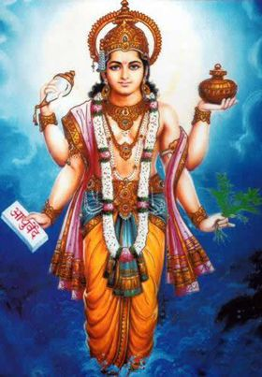

**INTRODUCTION**

**Dhanvantri** is an Ayurvedic god, and worshipped widely all over india as a god of medicine. He has emerged from the Ocean with Amirtha (Divine immortal drink of the devas) on his hand. His birthday is celebrated as Dhanteras all over India, especially by north Indians. This festival will be celebrated before deepavali, and mainly by north indian jewellery shops, who will celebrate it in a grand manner similar to that of Akshaya Tritiya.

**Importance**

Dhanvantri is a divine god and he is considered as an avatar of Lord Vishnu. He is having four hands. He is believed to be the reliever of various diseases of his devotees. Generally, in temples, Dhanvantri homam will be performed by the devotees for attaining good health for them. Several thousands of years before, he is said to have incarnated with the same name **‘DHANVANTRI’** and occupied the court of King Vikramadiya as his minister. He is said to have cured various diseases of his sincere devotees. He is very much praised in the field of Ayurvedic.

**Temples**

**The following temples are dedicated to Lord Dhanvantri:-**

1.Dhanvantri temple at Maharashtra.

2.The [Thottuva Dhanvantri temple](https://en.wikipedia.org/wiki/Thottuva_Dhanwanthari_temple" \o "Thottuva Dhanwanthari temple) in Kerala.

3.In [Sri Srirangam Temple](https://en.wikipedia.org/wiki/Sri_Ranganathaswamy_Temple_(Srirangam)), there is a separate Dhanvantri shrine.

4.Dhanvantri shrine is found in [Varadaraja Perumal Temple](https://en.wikipedia.org/wiki/Varadharaja_Perumal_Temple,_Kanchipuram), [Kanchipuram](https://en.wikipedia.org/wiki/Kanchipuram" \o "Kanchipuram).

5.Nelluvai Dhanvantri Temple, Kerala

6.Sri Dhanvantri Arogya Peedam, Vellore District, Tamilnadu.

7.Sree Dhanvantri Temple, Kottayam, Kerala.

8.Aanakkal Dhanvantri Temple, Thrissur.

9.Sree Dhanvantri Temple, Coimbatore, Tamil Nadu.

10.Sree Dhanvantri Temple, Maruthorvattom, Cherthala, Kerala.

11.Sree Dhanvantri Temple, Alleppey, Kerala.

12.Sree Dhanvantri Temple,Pathanamthitta, Kerala.

13.Shri Aalkkalmanna Dhanvantri Temple is situated at Malappuram District.

14.Sri Murrari Dhanvantri Moorthi Kshetram temple in kollam district.

15.Shri Dhanvantri Temple, Kochi, Kerala.

**CONCLUSION**

Dhanvantri, being a great god of ayurvedic, is very much attracted by his devotees, towards curing their diseases. His worship is there in India for several thousands of years. For running a proper life, we need a good health, and by worshipping him with pure bhakti, we can get a proper health and can do our duties in a proper manner.

Without a proper health, we can’t survive in our life, and we can’t properly work and earn money anywhere in this world. Hence **HEALTH** is **WEALTH**. If we have proper health, we can earn wealth. This can be done by praying sincerely to Lord Dhanvantri. Let us pray to him with sincere devotion, and chant hisname continuously for ever, and be happy with good health and wealth.

**“OM SREE DHANVANTRIYE NAMAHA”**

**WRITTEN BY**

**R.HARISHANKAR**

**LORD VISWAKARMA**

[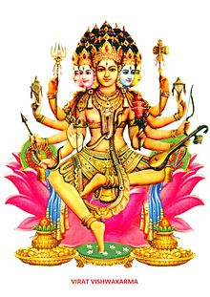](https://en.wikipedia.org/wiki/File:Vishwakarmaa.jpg)

**INTRODUCTION**

**Viswakarma** is the deity with creative power. According to the [vedas](https://en.wikipedia.org/wiki/Rigveda" \o "Rigveda),he is considered to be the divine architect of the entire universe.

Viswakarma created five main Rishis for maintaining **PEACE** in the entire **UNIVERSE**.

1. Sanaga
2. Sanathana
3. Ahabhuna
4. Prathna
5. Suparna

**IMPORTANCE**

Viswakarma is the creator of the chariots and weapons of the gods.

He created the [Vajra](https://en.wikipedia.org/wiki/Vajra" \o "Vajra)yudha for Lord [Indra](https://en.wikipedia.org/wiki/Indra" \o "Indra).

Viswakarma is worshiped by all the Hindu people.

The Viswakarma Puja is celebrated in all parts of [Nepal](https://en.wikipedia.org/wiki/Nepal) and [India](https://en.wikipedia.org/wiki/India) on the month of September of every year.

Viswakarma Jayanthi is celebrated by all industrial houses. His Jayanthi is celebrated on Magha Shukla Trayodashi. Though he is considered as the main creator of the entire universe, some important creations made by him are as follows:-

1. In Satya Yuga, he built Heaven
2. In Treta Yuga, he built Lanka
3. In Dwapara Yuga, he built Dwarka

**CONCLUSION**

Lord Viswakarma is a powerful god, and controls the entire universe. He is considered as the chief among all the other gods. He contains abnormal power and protects from enemies and problems, and gives us a healthy, wealthy and a happy life. He acts as a guardian for all of us. Let us pray to him and chant his name, and be blessed.

**“OM SREE VISWAKARMAVE NAMAHA”**

**WRITTEN BY**

**R.HARISHANKAR**

**TRIMURTHI**

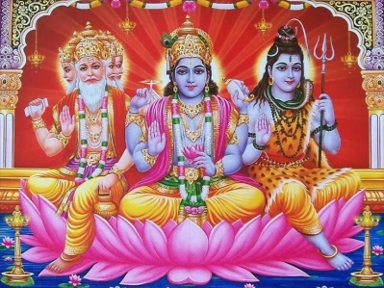

**INTRODUCTION**

The Trimurti are the three main gods in [Hinduism](https://en.wikipedia.org/wiki/Hinduism) who performs the three main functions of [creation](https://en.wikipedia.org/wiki/Creation_ex_nihilo), [protection](https://en.wikipedia.org/wiki/Conservation_(ethic)), and [destruction](https://en.wikipedia.org/wiki/End_time#Hinduism) and are allocated to [Brahma](https://en.wikipedia.org/wiki/Brahma) the creator, [Vishnu](https://en.wikipedia.org/wiki/Vishnu) the protector, and [Shiva](https://en.wikipedia.org/wiki/Shiva) the destroyer. Dattatreya avatar is the incarnation of Trimurti.The concept of Trimurti is also present in the ancient puranas.

**Temples**

The Temples that are dedicated to Trimurti can be seen as follows:-

1.[Baroli Trimurti Temple](https://en.wikipedia.org/wiki/Baroli_Temples" \l "Trimurti_temple" \o "Baroli Temples)

2.[Elephanta Caves](https://en.wikipedia.org/wiki/Elephanta_Caves" \o "Elephanta Caves)

3.[Mithrananthapuram Trimurti Temple](https://en.wikipedia.org/wiki/Mithrananthapuram_Trimurti_Temple" \o "Mithrananthapuram Trimurti Temple)

4.[Prambanan Trimurti Temple](https://en.wikipedia.org/wiki/Prambanan" \o "Prambanan)

5.[Savadi Trimurti Temple](https://en.wikipedia.org/wiki/Western_Chalukya_architecture" \l "Stellate_plans" \o "Western Chalukya architecture)

6.[Thripaya Trimurti Temple](https://en.wikipedia.org/wiki/Thripaya_Trimurti_Temple" \o "Thripaya Trimurti Temple)

**Sauram**

The Saura sect worships only [Surya](https://en.wikipedia.org/wiki/Surya) as the supreme personality. They consider Surya as the three main gods Brahma,Vishnu and Shiva. Some Sauras worship either Vishnu or Brahma or Shiva, and others exclusively worship Surya alone.

**Shaivism**

According to shaivites, Shiva performs the five main actions. According to them, Brahma, Vishnu and Rudra are the forms of Shiva. To Shaivites, Shiva is the only God who performs all the actions, and protects the universe. Shaivites believe that Lord Shiva is the Supreme God.

**Shaktism**

The feminine goddesses are called Tridevi:-[Mahasarasvati (Creator)](https://en.wikipedia.org/wiki/Mahasaraswati" \o "Mahasaraswati), [Mahalaxmi (Preserver)](https://en.wikipedia.org/wiki/Mahalaxmi" \o "Mahalaxmi), and [Mahakali (Destroyer)](https://en.wikipedia.org/wiki/Mahakali" \o "Mahakali). According to the followers of Shaktism, they consider that tridevi are the main goddesses and they worship only them.

**Kaumaram**

The kaumaram sect of people will worship only Lord Muruga, and they consider him as a supreme god among other gods. Some of them worship other gods like Shiva,Vishnu,Brahma and Surya. While many of them worship only Lord Muruga.

**Smartism**

[Smartism](https://en.wikipedia.org/wiki/Smartism) emphasis on a group of five deities rather than just a single deity which are [Ganesha](https://en.wikipedia.org/wiki/Ganesha" \o "Ganesha), [Vishnu](https://en.wikipedia.org/wiki/Vishnu), [Brahma](https://en.wikipedia.org/wiki/Brahma), [Devi](https://en.wikipedia.org/wiki/Devi) and [Shiva](https://en.wikipedia.org/wiki/Shiva). [Sankaracharya](https://en.wikipedia.org/wiki/Adi_Shankara" \o "Adi Shankara) later added [Kartikeya](https://en.wikipedia.org/wiki/Kartikeya" \o "Kartikeya) to these five, making six total.

**Vaishnavism**

[Vaishnavism](https://en.wikipedia.org/wiki/Vaishnavism) generally does not acknowledge the Trimurti concept, but they believe in [avataras](https://en.wikipedia.org/wiki/Avataras" \o "Avataras) of Vishnu like [Buddha](https://en.wikipedia.org/wiki/Buddha), [Rama](https://en.wikipedia.org/wiki/Rama), [Krishna](https://en.wikipedia.org/wiki/Krishna), etc. They also believe that Shiva and Brahma both are forms of Vishnu.

**CONCLUSION**

The Trimurti worship can vary among different sects, and by different groups of people. But all of them contains divine powers. Instead of differentiating from one another, let us sincerely worship all the trimurti and tridevi(Lakshmi,Saraswathi,Parvathi) and Lord Vinayaka,Muruga,Ayyappan and the sun god(who is giving us daily energy and helps us in surviving in this world), and also all other devas like Indra,Varuna,Vayu,Agni,Yama,Nirudhi,Aswini Devas,guardian gods and goddess, saints,rishis,rishi pathini’s(wives of rishis),demi gods and goddess, and all other 33 crore divine devas in heaven. Let us pray sincerely to all the divine gods and goddess for our wellbeing, and for the wellbeing of the entire world. Let us chant the mantra **“OM”** and be blessed and live happily for ever.

**WRITTEN BY**

**R.HARISHANKAR**