COLLECTION OF HINDU SACRED ARTICLES BY R.HARISHANKAR
ADHAR SEN
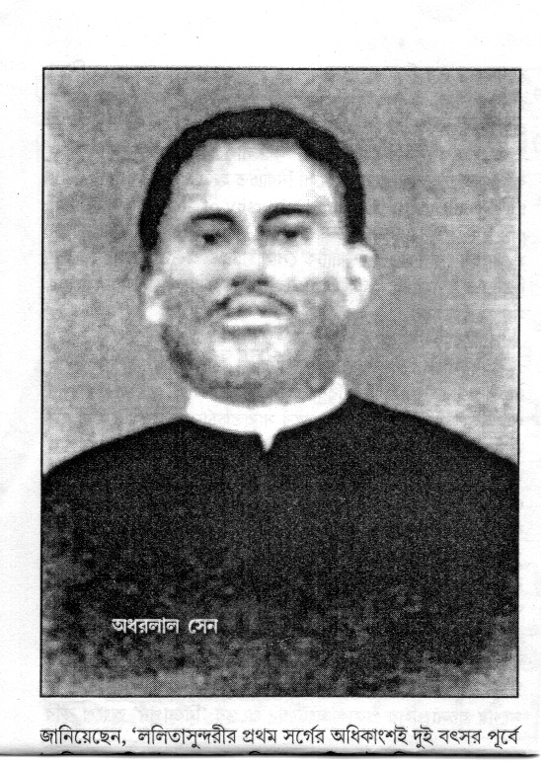
INTRODUCTION
Adhar Lal Sen(19th century AD) was a disciple of Sri Ramakrishna, and he was considered as a Holy Saint of Bengal, and he was also considered as very pious and a kind hearted person, who used to do lot of charity works. After meeting his Guru Sri Ramakrishna, he lived a simple life as per the wishes of his Guru. He lived in Kolkata and worked as a magistrate, and he also served as a professor in the Kolkata University. He was a famous writer and poet, and published lot of his works, and he was an ardent devotee of Mata Kali Devi.
Adhar Sen was born in the year 1855 in Ahiritola, Kolkata to a pious Bengali Hindu family, and he got married at his young age itself. He was a scholar in English literature.
Adhar met Sri Ramakrishna in the year 1883, and he was advised by Ramakrishna, to concentrate his attention on spiritual matters, since Sri Ramakrishna was already aware that Adhar would be alive only for few more years. Sri Ramakrishna used to visit the house of Adhar and attended religious festivals, pujas and devotional songs. He also had feast along with him, and gave his blessings. Adhar also used to frequently visit Dakshineswar and meet Sri Ramakrishna, in order to listen to his teachings, and they would cheerfully discuss about religious matters. Sri Ramakrishna visited Adhar on his death bed in the year 1885 and prayed to Mata Kali to give eternal bliss for the soul of Adhar.
Adhar died in the year 1885 and attained the lotus feet of Mata Kali, due to the grace of his guru Bhagavan Sri Ramakrishna.
Let us worship the great saint and be blessed.
“OM SRI ADHAR MAHAPRABHU KI JAI”
“JAI MATA KALI DEVI”
WRITTEN BY
R.HARISHANKAR
AMMAN SATHYANATHAN
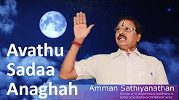
INTRODUCTION
Amman Satyanathan is an ardent devotee of Guru Raghavendra Swamy and he belongs to a pious Brahmin family. He wrote several devotional books and published it, and his books are available at “ARULMIGU AMMAN PATHIPPAGAM”
Address: Old no: 116, New No 16, Thulasinga Perumal Koil St, Triplicane, Chennai, Tamil Nadu 600005. (Opp to Raghavendra Swamy Mutt, Triplicane).
He wrote and published 11 Parts of books, on the importance of Guru Raghavendra Swamigal. Apart from that, books about Vyasaraja, Navabrindavan and many Sloka books are also available at his book shop. He used to travel to various holy temples throughout India, and only after making detailed study about the temples, he would start his writing work.
He had two children, and they used to sing bhakti songs on Guru Raghavendra, and he has constructed Krantalaya – a holy temple for Guru Raghavendra at Thiruvallur under the name: Sri Raghavendra Granthalaya Seva and Educational Charitable Trust.
He also went to foreign countries and spread the RAGHAVENDRA BHAKTI among the people through his divine lectures.
Lot of devotees of Guru Raghavendra are greatly satisfied and got relieved from their problems, after reading his Raghavendra Mahimai – 11 Parts.
Let us praise the holy man.
“OM SRI RAGHAVENDRAYA NAMAHA”
WRITTEN BY
R.HARISHANKAR

ANCIENT AND PRESENT DAY WORLD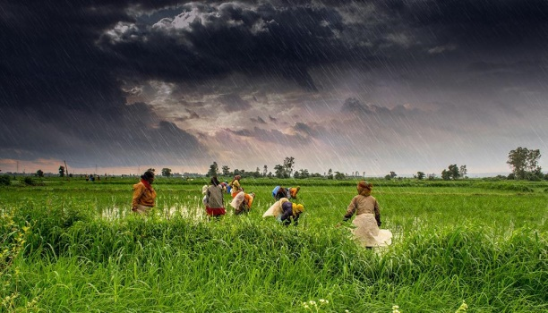
INTRODUCTION
Ancient World dates back to few centuries, which look clean and green, and no pollution prevailed in the world. Streets look clean and neat and food crops grow up properly, and rain is also showered during the rainy seasons, and people didn’t suffer much due to change in the climatic conditions. Most of the agricultural lands would be exclusively used for agriculture purpose only, and they would not be utilized for any other purpose. Joint family system prevailed both in the cities and in the villages. Lot of temples were built, and people were eagerly and regularly went to the temples, and offered their worship to the deities.
Most of the people were concentrated their attention on doing agriculture work, and there was no scarcity of water and food. All the youngsters were given much respect to their family members, and even if they commit any mistake, they would inform it to their family members, and correct themselves. Most of the people didn’t suffer from health related problems, and they lived a long and healthy life. But due to the changing situations in this modern world, people began to lose their patience and peace of mind, and joint family system was almost dropped in the lives of the people. Agriculture lands have been converted into commercial and residential plots, and they have been sold. Only in the villages, agriculture was there, and due to the shortage of water, gradually village people also begin to sell their lands to the real estate people, and they are converting it into plots.
Youngsters are not giving proper respect to the elders, and ignoring their noble words, and getting angry with their advices. Deity worship is also gradually reducing, and people began to lose faith and interest in their religion, due to their diversion in other activities such as going for sight-seeing tours, cinemas, beach and amusement parks etc. Most of the youngsters are concentrating their attention on the mobiles and laptops and playing lot of games, thereby losing their mental energy. We would have heard that sometime before, few people were committed suicide due to playing a certain kind of video game. By seeing all these, the old age people are very much worried, and began to pray to the god, to make necessary changes in the present day modern world.
Let us pray to the almighty to give good thoughts in the minds of the present generation people and to make good changes in the entire world, and let him change the world into a “DISEASE FREE WORLD” at this point of time.
“OM”
WRITTEN BY
R.HARISHANKAR

ARYABHATA
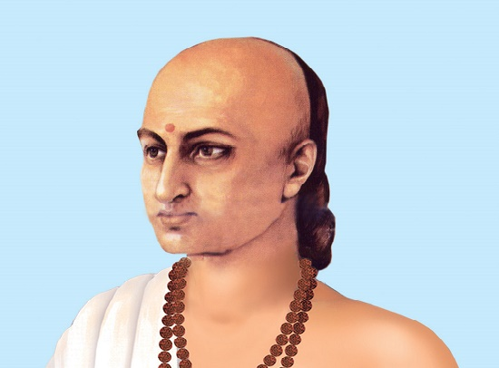
INTRODUCTION
Aryabhata (476AD–550AD) was the ancient mathematician and astronomer and he had rendered a major contribution in the fields of Maths, Physics and Astronomy. His major works include the Aryabhatiya and the Arya-siddhanta. He was born in a pious Brahmin Family, in the present day Patna at Bihar in 476 AD. He was interested in science and spirituality and considered them as his two eyes, and achieved a lot in his profession.
Apart from the science field, he was considered as a great sage, and a devotee of Lord Shiva, and lived a simple and noble life.
Aryabhata was believed to have been served as the professor of the Nalanda University, and he was well versed in Vedas, Puranas, Bhagavatham and other Hindu Scriptures.
Aryabhata has written lot of spiritual, astronomy and Maths books. He was highly respected by the kings, common man and by the scholars due to his talents in the diversified fields. He was given a high recognition, and awarded by the then kings, which is considered equivalent to the present day Doctorate degree. After rendering good service in his fields, he died in the year 550AD.
Let us worship the great person and be blessed.
“OM SRI ARYABHATARE NAMAHA”
“OM NAMAH SHIVAYA”
“OM SRI VINAYAGAYA NAMAHA”
WRITTEN BY
R.HARISHANKAR

ATIBADI JAGANNATHA DAS
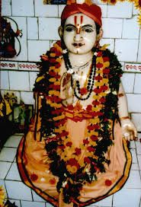
INTRODUCTION
Atibadi Jagannatha Das was born in a village near Puri in the year 1487. He belongs to Kaushiki Gotra, and his parents were ardent devotees of Lord Jagannatha. He used to sing the glories of Krishna in Jagannath temple, Puri, and conducted discourses on Bhagavatham in a remarkable manner, and due to that, he was suitably rewarded by the kings.
One day, while he was singing in the temple, Chaitanya noticed him, and gave him the title of Atibadi, which means very great person. Jagannatha Das was against caste discrimination, and used to recite Bhagavatam in the houses of poor and unhealthy people and made them to attain the glory of Lord Krishna, and through his noble service, the people in the region were praised his kindness and become ardent devotees of Lord Krishna.
He used to mingle with his devotees in a cordial manner, and would not differentiate between men and women. He considered them as the devotees of Lord Krishna, and gave great respect to them.
He also initiated the Queen of the region into spirituality, and explained to her in detail, about the greatness of Hindu Puranas, Gita and Bhagavatham, and also asked her to worship Lord Krishna regularly. He started a Mutt, called Bada Odiya Mutt, and through that, he performed lot of spiritual and social services.
Once, he got the divine darshan of Rishi Narad, and as per his instructions, he translated Srimad Bhagavatam into Odia language. He wrote lot of devotional texts such as Gupta Bhagavat, Tula vina, Sola chapadi, Chari chapadi and Tola bena etc. Jagannatha Das has attained the lotus feet of Lord Krishna in the year 1557. His main disciples were Baliga Das, Uddhava, Ramachandra, Gopinatha and Hari Das.
Let us worship the great saint and be blessed.
“OM SRI ATIBADI JAGANNATHA DAS NAMAHA”
“JAI KRISHNA”
WRITTEN BY
R.HARISHANKAR

BABUJI MAHARAJ
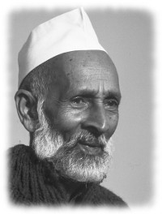
INTRODUCTION
Babuji (1899 -1983) was born in Shahjahanpur, in Uttar Pradesh, in the year 1899, and his birth name was Ram Chandra. He was educated in most of the regional languages by his father, who was a lawyer. Ram Chandra was very keen in reading spiritual books, and concentrated his attention on spirituality. Ram Chandra served as a court clerk in his hometown for many years, and he was married and had children. After the death of his wife, he learned Yoga and meditation, and in the year 1922, he met a great saint whose name was Ram, near his hometown. Through the blessings of his guru Ram, he learned the essence of Hinduism, and developed the habit of reading Holy Scriptures.
Babuji believed that spirituality must be adopted by the people, in order to get rid from their sins and from the sufferings in their life. He loved everyone and taught the importance of worshipping the god, irrespective of caste, creed and religion. Through his good teachings, many people were become his followers, and attained enlightenment. According to him, “We must chant the RAMA NAMA regularly for attaining goodness in our life”. He advised his followers not to worry about their life, since everything is already decided by the god, and to act in a smart way, to remove the thorns in their path. He travelled to many countries and spread the philosophies of Hinduism, and also shared his teachings among the people throughout the country. In 1945, Babuji founded the Shri Ram Chandra Mission for spiritual seekers, and through that mission, he taught yoga to his students and followers, and he has done lot of social services also.
Babuji left his physical body in the year 1983, and he is still remembered for his spiritual advices and for his teachings on yoga to his followers and disciples.
“JAI SRIRAM”
WRITTEN BY
R.HARISHANKAR
BALARAM BOSE
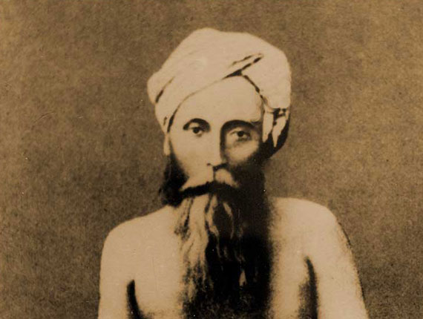
INTRODUCTION
Balaram Bose (1842–1890) was one of the main disciples of Ramakrishna Paramahamsa. He was the son of Radhamohan Bose, and he is mentioned in the text “The Gospel of Sri Ramakrishna”. Ramakrishna and Mata Sarada Devi used to visit his house and attend pujas performed at his house. He has donated most of his wealth for the welfare of poor people, and he also provided food to the hungry people at his house.
Bose was born in an orthodox Vaishnavite family in Kolkata. His grandfather established a Krishna temple in his house and used to invite the neighbours and relatives for participating in Bhajans, and he also used to give the Holy Prasad to the participants of the Puja after the completion of the Puja. His residence is presently known as the Balaram Mandir. Balaram was a spiritual person from his young age, and used to spend his spare time in the nearby temples, and worship the divine deities. Balaram was married to a pious girl who was very cooperative with her husband, and discharged her household duties in a proper manner. Bose met Sri Ramakrishna and he got clarified his doubts on spirituality with him. Sri Ramakrishna considered Balaram Bose as the divine incarnation of Sri Chaitanya Mahaprabhu.
After the death of his Guru Sri Ramakrishna, even though Balaram was not rich, he used to give some money to the disciples of Ramakrishna in the Baranagar Mutt. Mata Sarada Devi also stayed in his house for some time. There is a street in Kolkata which is named after Balaram Bose, is called as Balaram Bose Ghat Road.
Let us worship the great saint and be blessed.
“OM SRI BALARAM BOSE NAMAHA”
“OM SRI RAMAKRISHNAYA NAMAHA”
“OM MATA SARADA DEVIYE NAMAHA”
WRITTEN BY
R.HARISHANKAR
BHAGAT SADANA
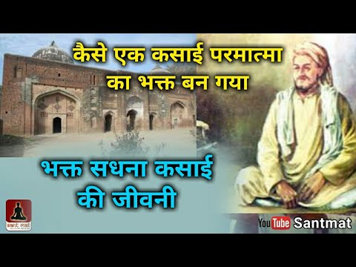
INTRODUCTION
Bhagat Sadana was a great saint and poet and he was also called as Sadana Qasai, and his divine verses were incorporated in the famous Sikh text, Guru Granth Sahib. His devotional poems were admired by great saints and poets, and he was considered as a worshipper of the formless god.
The followers of Bhagat Sadana are called Sadana Panthis. He died at Sirhind in Punjab.
Sadana was born in 1180 AD in a Muslim family in Hyderabad, Sindh province in Pakistan. He undertook the profession of butchery. And though he has done the job of cutting the goats, in general, he was a kind hearted person, and used to discuss with the Hindu Spiritual Saints about spiritual matters, and in course of time, he left his profession, and began to preach the “IMPORTANCE OF LOVE AND AFFECTION” among the people throughout India.
At his teenage, he looked very handsome with a pleasing personality. Once, when he was travelling in North India, a young married lady got attracted with him and began to love him, but he guided her properly and sent to her home, and asked her to live as a dutiful wife to her husband. Though he got the opportunity to have an affair with her, he didn’t do that, since he was a noble man, and at this present scenario, we cannot find such a great person like him.
Based on the above incident, he used to tell to others not to commit a crime or sin, even when they got the opportunity to do so, since everything is being watched by the god, and he is counting our good and bad karmic deeds, and hence asks us to always do good activities and to do selfless service to others. He was such a noble personality, and acts as an example for others.
He also performed many miracles in the life of his devotees, such as removing their sins by touching his holy hands on to their head, and by asking them to do meditation on the formless god.
Bhagat Sadana had preached lectures in Uttar Pradesh, Rajasthan and Punjab areas. At Sirhind, he died, where a mosque was built in his memory and preserved by the Punjab Government. He was praised by the famous Dalit saint Sri Ravidas, who was considered as an AMSA of Lord Surya Bhagavan. He was also praised by the great saints like Kabir, Namdev and by other Varkari Saints, devotees of Lord Panduranga.
TEACHINGS
- Realise the god within your soul, and always be pure and never hate others.
- Show love and affection even to your enemies.
- Control your senses, and don’t enjoy too much of pleasures in your life, since that will put you in hell, after your death.
- Provide help to the needy, and share your wealth with others.
- Believe that god is love, and act accordingly.
- Take care of your family members, and treat your parents properly, and show more attention on them during their old age.
- Always keep thinking on doing goodness to others, and do it immediately whenever your immediate help is needed by anyone.
Let us worship the great saint and be blessed.
“OM SRI BHAGAT SADANA NAMAHA”
WRITTEN BY
R.HARISHANKAR

BHAGATJI MAHARAJ
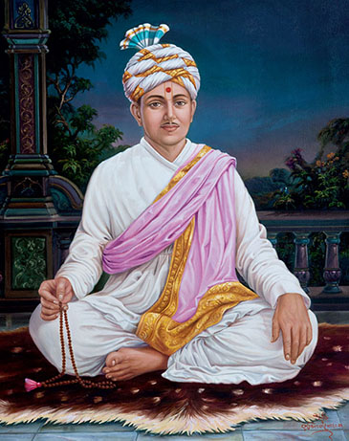
INTRODUCTION
Bhagatji Maharaj (1829–1898), was a devotee of Swaminarayan, and he is regarded as one of the spiritual successors of Sri Swaminarayan. His birth name was Pragji Bhakta.
He performed discourses on explaining the greatness of Swaminarayan, and travelled throughout India and spread the “SWAMINARAYAN AND KRISHNA BHAKTI SPIRIT” among the people. He was against caste discrimination and considered as a very kind spiritual guru. His main disciple was Sri Shastriji Maharaj, who was the founder of the BAPS Swaminarayan Sanstha.
Pragji Bhakta was born in the year 1829 in the family of sewing community. As a young child, he concentrated his entire attention towards devotion and spirituality and used to visit the nearby Laksmi-Narayan mandir and worship the Lord. He insists his friends towards worshipping the God in the temples. His family members were very noble, and used to provide food to the visiting guests at their home.
He was attracted by Sri Gopalanand Swami in Vadtal and Bhagatji Maharaj had considered him as his guru and sincerely served him. After the demise of Gopalanand Swami, he sincerely served Sri Gunatitanand Swami.
Bhagatji Maharaj has appointed Shastriji Maharaj, as his spiritual successor. After rendering spiritual service for many years, Bhagatji Maharaj died in the year 1898.
Let us worship the great saint and be blessed.
“OM SRI BHAGATI MAHARAJ NAMAHA”
“JAI SWAMINARAYAN”
WRITTEN BY
R.HARISHANKAR

BHAKTA SALABEGA
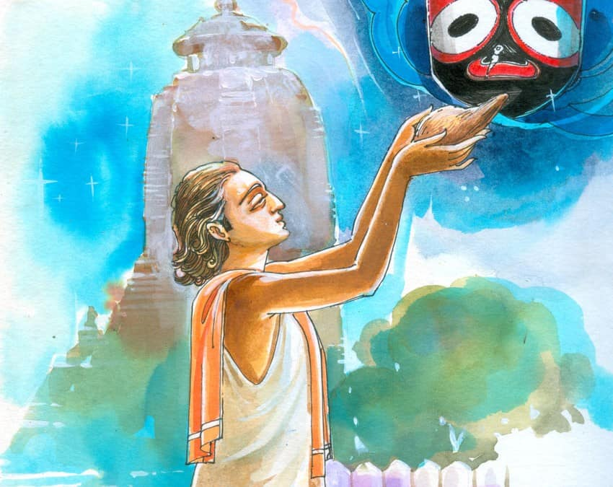
INTRODUCTION
Salabega (16th century AD) was an Odisha poet and a great Saint, who dedicated his entire life towards singing in praise of Lord Jagannath, a form of Lord Krishna.
Salabega occupies a main place among the devotees of Lord Jagannath. He was born in a village in Odisha during the year 1607 AD. His father was a Muslim warrior and his mother was a noble house wife. Salabega also participated in the wars along with his father. Once he was severely wounded in a battle, and when was about to die, he chanted the glorious names of Lord Krishna and immediately he got relieved from his wounds due to the grace of Lord Jagannath Mahaprabhu.
He went to Puri, and though he was not permitted to go inside the temple of Jagannath, he stood outside the temple, and happily chanted the names of Lord Krishna, and then he travelled to Vrindavana and become a saint by reciting the Slokas and Namas of Lord Sri Krishna. After his stay of one year in Vrindavana, he returned to Puri to witness the Rath Yatra festival, and he composed and sung lot of songs in praise of Lord Jagannath. The Samadhi of Salabega is found in Puri near Balagandi. Salabega’s bhajans are still popular among the devotees of Lord Jagannath.
Some of the verses of his songs are as follows:
“OM LORD JAGANNATH, MY LIFE IS GETTING WASTED SIMPLY BY SLEEP AND BY HAVING ANXIETY ON OTHER WORLDLY MATTERS. PLEASE REMOVE THE UNWANTED THOUGHTS FROM MY MEMORY, AND MAKE YOUR PERMANENT PRESENCE IN MY HEART”.
“OUR DEATH HAS ALREADY BEEN FIXED DURING OUR BIRTH ITSELF. THEN WHY WE ARE SHOWING OUR ATTENTION ON WORLDLY PLEASURES, AND PHYSICAL COMFORTS, LET US START CHANTING THE NAMES OF LORD KRISHNA, IN ORDER TO AVOID TAKING REBIRTHS AGAIN AND AGAIN”.
Let us praise the great saint and be blessed.
“OM SRI BHAKTA SALABEGA NAMAHA”
“JAI KRISHNA”
WRITTEN BY
R.HARISHANKAR

BHAKTA SAMVATA
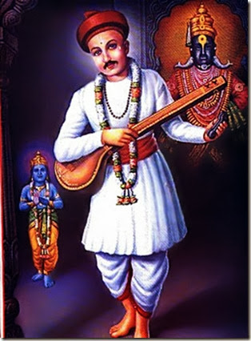
INTRODUCTION
Samvata is a Varkari saint, who lived in a village in Maharashtra before few hundred years. He was a sincere devotee of Lord Vital, a form of Lord Krishna, and used to compose and sing songs on him. He lived his life by cultivating crops in his agricultural lands, and with his meagre income, he would offer food to the poor people. He was devoted with Lord Vital from his younger age itself, and even after getting married, he concentrated his entire attention on Lord Vital. His wife was a chaste and pious woman, who used to help her husband in his daily activities. She also would attend bhajans along with her husband in the vital temple, and sing his glories.
The couples used to visit Lord Vital at Pandharpur once in a year. They would go to Pandharpur by walk, and they didn’t get any difficulty in travelling such a long distance. During their travel, they would have their food in the annadana choultries, and get relaxed themselves in the guest houses. In course of time, due to their old age, they were unable to visit Pandharpur to offer their prayers to Lord Vital, and hence they felt very much worried and prayed to Lord Vital, for their situation. One day night, Lord Vital had appeared in their dream, and asked them to worship the idol of Vital from their home itself, and that would be equivalent to worshipping him in Pandharpur and disappeared. The couples got very happy, and installed a Panduranga deity at their home, and began to worship him by performing pujas, abhishekhams and offering various food items as holy Prasad to him. After their death, due to their sincere bhakti, and due to the grace of Lord Vital, they attained SALVATION.
Let us worship the noble couple and be blessed.
“OM SRI BHAKTA SAMVATA NAMAHA”
“JAI VITAL MAHAPRABHU KI JAI”
“JAI RUKMANI MATA NAMO NAMAHA”
WRITTEN BY
R.HARISHANKAR
BHARATHIYAR
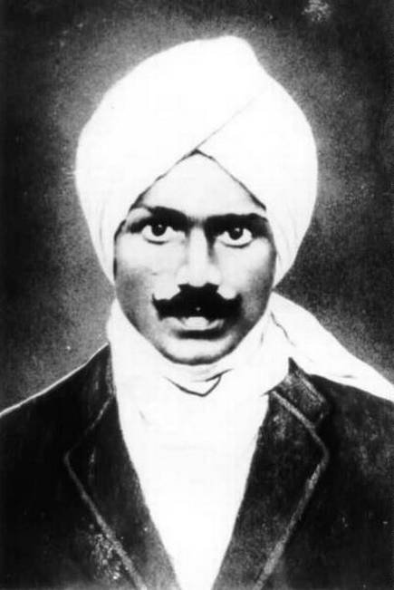
INTRODUCTION
Bharathiyar (1882–1921) was a great personality who was specialized in diversified fields such as writing texts, composing poems, publishing journals and participating in the freedom fighting movement etc. He was an expert in writing Tamil poems, and due to that he had been awarded the title "Mahakavi Bharathi". He lived a simple life, and contains very good features, and though he was an intelligent person, he spent his life in poverty, till the end of his life. He was interested in spirituality, and used to frequently visit the temples and worship the deities. His birth name was Chinnaswami Subramania Bharathi.
He was born in the present day Thoothukudi in the year 1882 in a pious Brahmin family. After completing his education in his native place, he worked under various newspaper agencies. Due to his active participation in the freedom fighting movement, he shifted to Pondicherry, and he lived there until 1918.

Apart from Tamil language, he was an expert in other regional languages also. His songs are highly memorable, and easy to understand, and still praised by the old and new age people, for the meaningful lyrics. His famous lyric is “IF EVEN A SINGLE PERSON STARVES WITHOUT FOOD. COME LET US DESTROY THE ENTIRE WORLD”. ​“தனி ஒரு மனிதனுக்கு உணவில்லை எனில் இந்த ஜகத்தினை அழித்திடுவோம்”.
His other famous lyric is “HEY, DEATH GOD YAMA COME IN FRONT OF ME! I WILL KICK YOU”.
“காலா!உனை நான் சிறு புல்லென மதிக்கிறேன்; என்தன் காலருகே வாடா! சற்றே உனை மிதிக்கிறேன்”.
He met Sister Nivedita, Swami Vivekananda's disciple, and through her insistence, he wrote about the rights of the women in his magazine. He also considered that all the women are the incarnations of Mata Shakti Devi, and gave much respect to them.
He was arrested several times, by the British soldiers, and later got released by them. During the year 1921, while he was visiting the Parthasarathy Temple, Triplicane, he was attacked by the temple elephant, and even after getting admitted in the hospital, after a few months his health condition was worsened, and he died on 11 September 1921. He spent his last years of his life in a house in Triplicane, Chennai. The house was named as Bharati Illam and opened for public view.
Let us praise the great poet.
“JAI SRI SUBRAMANIA BHARATI”
“JAI HIND”
“VANDE MATHARAM”
WRITTEN BY
R.HARISHANKAR

BOON TO DEMONS
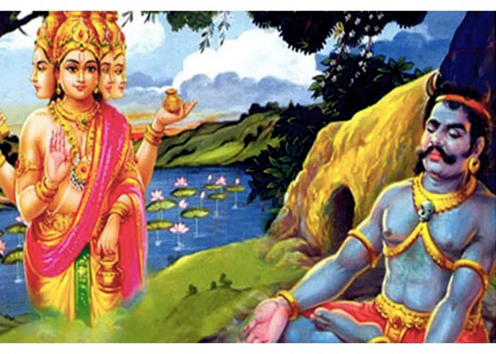
INTRODUCTION
We would have read in the ancient puranas, about the penance of Demons on Lord Brahma, and getting great boons after finishing their penance. But most of the demons have utilized their powers obtained through their boons only for destructive purposes. After getting great powers, through their powerful boons, they began to capture the divine worlds and used to control the demi gods, and lived a comfortable life by drinking wine and enjoying great pleasures in their life. They also disturbed the sages and spoiled their Yagnas. And since they had great powers through their boons, no one could control them. Finally in order to destroy them, the gods or goddesses have to take an avatar to kill them. Why this is happens? Why can’t the gods avoid giving the boons to the demons?
The reason is they could not stop giving boons, since the demons have almost sacrificed their life and performed the penance. The reason for giving the boons to the demons and killing them is mainly due to the changing situations, which prevails even in the divine world. There would be some changes even in the life of the demi gods, since they also cannot remain happier for ever. The divine gatekeepers of Vishnu had incarnated as demons in their three births, and destroyed by Lord Vishnu, and finally they went back to the Vaikunta. All this happens, due to illusion, and even the gods cannot escape from that.
Vishnu was cursed by Sage Bhrigu to lose his wife in an avatar. Similarly Lord Vishnu had incarnated as Rama, and Sita was kidnapped by Ravana, and Ravana was destroyed by Rama. All these things have written already in their fate, and Mata Sita played a major role in destroying Ravana. Life would not be always sweet even for the divine gods, and they also adjusting their life as per the changing circumstances.
Let us worship Lord Rama and be blessed.
“JAI SRIRAM”
WRITTEN BY
R.HARISHANKAR
CHITRA POURNAMI
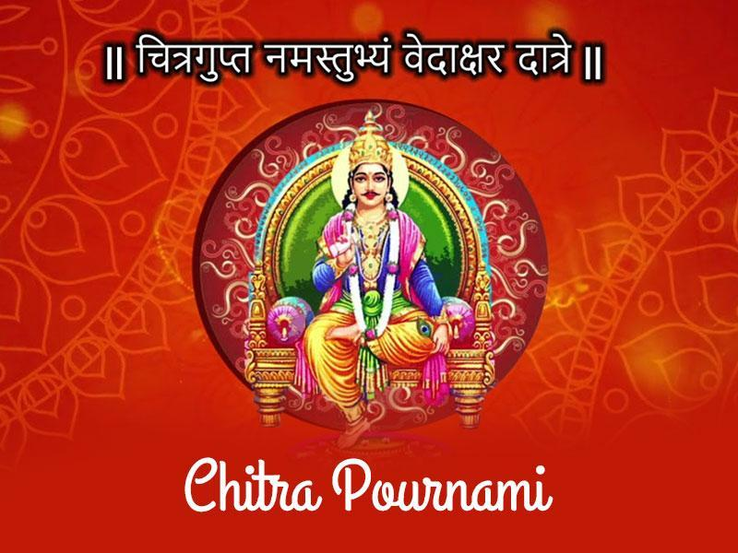
INTRODUCTION
Chitra Pournami is an Indian festival celebrated by Hindus throughout India.
It is observed on the day of the full moon in the month of Chithirai which falls on April or May. The festival is dedicated to Lord Chitragupta, a divine accountant, who is recording the good and bad deeds done by the people and reporting their life accounts to his master Lord Yama, the death god. Chitragupta would forgive the sins of his sincere devotees, and puja is performed on Chitra Pournami by his devotees. On the Chitra Pournami festival day, many devotees would observe fasting and bath in the holy rivers in order to cleanse their sins.
In Thiruvananthapuram, in the temple of Bhagavathi at Pachalloor, grand puja is done during Chitra Pournami. Chitra Gupta temple is also situated in Kanchipuram, and Lord Chitra gupta is found in a separate shrine in the Annamalaiyar temple.
Let us worship Lord Chitra Gupta and be blessed.
“OM SRI CHITRA GUPTAYA NAMAHA”
WRITTEN BY
R.HARISHANKAR

COCKS IN HINDUISM
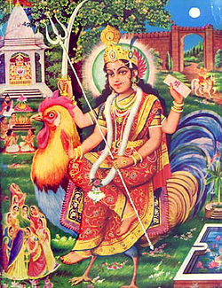
INTRODUCTION
Cocks are worshipful birds, and they are the divine vehicle of Bahuchara Mata, goddess of chastity and fertility, an incarnation of Mata Parvati, who is mostly worshipped by the Gujarati people.
Bahuchara Mata is the mother goddess who helps the women during the times of their pregnancy, and helps them to properly deliver the child, and gives her immense blessings to the mother and the child.
According to Hindu Legend, the cock flag is the Lord Muruga's army flag. Cock is the clever bird, and used to understand the instructions of its masters, and would act accordingly. Cocks are killed for meat, and the system of killing the cocks prevails since ancient times. But it is not advisable to kill the cocks, since it contains the divine aspect of Lord Muruga and Mata Bahuchara. By killing them for meat, would make the divine deities to get angry with us, and would punish us severely. Cocks are not created for killing, and they have to be protected properly.
Let us serve the cocks with food grains and be blessed.
“OM SRI VEL MURUGANE NAMAHA”
“OM SRI BAHUCHARA MATA NAMAHA”
WRITTEN BY
R.HARISHANKAR

DHANRAJ GIRI
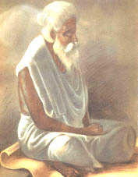
INTRODUCTION
Dhanraj Giri (1811–1901) was a great saint who lived at an ashram in Rishikesh, popularly known as Kailash Ashram. Pilgrims who undertook the Char Dham temples pilgrimage would visit his ashram. He was a famous Saint in North India and was a scholar in Vedas, Upanishads and Hindu Scriptures, and taught it to the students. He also spread the
“SHIVA BHAKTI SPIRIT” among the North Indians, and conducted spiritual discourses on Shiva Puran, Nayanmar Saints and Shaiva Siddhanta among the people. He was praised by the great saint Swami Vivekananda.
He was an ardent devotee of Lord Shiva, and used to chant the Namachivaya Mantra continuously from his young age. In search of divinity, he left his home at his younger age itself, and lived a saintly life.
Swami Vivekananda during his travels to holy places, visited Kailash Ashrama, and discussed with Dhanraj Giri Swamigal about spirituality. Dhanraj Swamigal has done lot of social welfare services to the sick and poor, and healed their diseases through his spiritual powers. He also helped the disciples of Swami Vivekananda during their visit to Rishikesh, and made them to stay along with him for several months. Still today, in the Kailash ashram, Vedanta class are undertaken by his disciples.
Let us worship the great saint and be blessed.
“OM SRI DHANRAJ GIRI SWAMIGALE NAMAHA”
“OM NAMAH SHIVAYA”
“JAI PARAMESWARI MATA”
WRITTEN BY
R.HARISHANKAR

DOGS IN HINDUISM
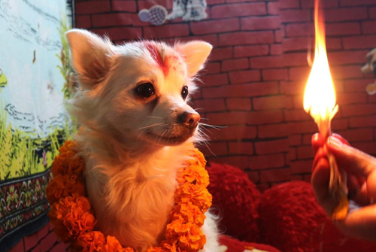
INTRODUCTION
Dogs are worshipped in Hinduism, and they are considered as the vehicle of Lord Kalabhairava, an incarnation of Lord Shiva. Dogs contain very good features and easily attached with anyone, and would serve faithfully to its master. It truthfully and honestly would serve his master, and protects him from dangers, and even would lose its life, for safeguarding its master. It would not easily forget its master, even if they throw it outside their homes. Dogs can be provided with biscuits and dog food, and some people used to offer meat to the dogs.
Some people would keep the dogs as their pets and abandon them after some time. But it is not good on their part, since abandoning a dog is similar to abandoning a child. Since similar to humans, It also would expect the kindness from their masters till their death. Dogs act as a guardian for us and we can take it outside during our morning and evening walks. It would enjoy the pleasant journey in the outside world, and can see his/her fellow dogs, and can funnily whistle at them. In Shiva temples and Kalabhairava temples, we can see the idol of the dog in front of the Kalabhairava shrine. Showing love and affection on the dog would please the great Lord Kalabhairava and he would bestow his grace on to us. Dogs cannot be attacked or killed even if it bites us, since doing such act would make Kalabhairava to get angry and he would punish us severely.
Hence let us try to adopt a dog, and make them as our best friend, and let them become our life long relative.
“OM SRI KALABHAIRAVABHAIRAVI NAMAHA”
WRITTEN BY
R.HARISHANKAR

DONKEYS IN HINDUISM
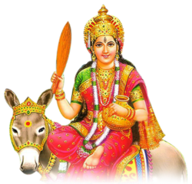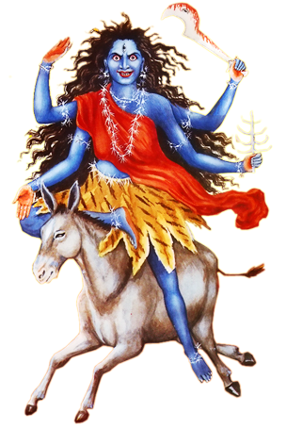
INTRODUCTION
Donkeys are worshipful animals, since they are considered as the divine vehicle of Mata Sheetala and Mata Kalaratri, who are the divine incarnations of Mata Parvati Devi. Donkeys, serves as the faithful servants to their masters, and they would carry heavy load of goods on their back and would obediently follow its master, act as per their instructions, and would discharge their duties in a proper manner. Mostly they would serve under Dhobis also called as Washer men, by helping them in carrying the cloth bags in their backs. It is commonly believed, that by seeing the face of the donkeys, we would get good fortunes in our life.
Even though, they are hard labourers, much respect is not given to them, and people would make them to work tirelessly in the day and the night. Their food items are grasses, vegetables and fruits. We can easily find the donkeys in the villages, and can affectionately serve them with beans, carrots and potatoes, which they frequently consume. By worshipping and taking care of donkeys, Mata Sheetala Devi would bless us. Sheetala Devi is mostly worshipped for getting relieved from all kinds of dreaded diseases and from mind related problems. By providing proper food to the donkeys, we would get good health, and would be free from mental worries and tensions, and can lead a happy life.
Mata Kalaratri also would bless us, and she would relieve us from the problems of black magic, evil eye, evil spirits, Bad omens and from bad thoughts, and gives us good energy and make us to move freely in the world.
Let us worship Mata Kalaratri and Mata Sheetala Devi and be blessed.
“OM MATA KALARATRIYE NAMAHA”
“OM MATA SHEETALA DEVIYE NAMAHA”
“OM NAMAH SHIVAYA”
WRITTEN BY
R.HARISHANKAR
DR.ARUN RAGHAVENDAR
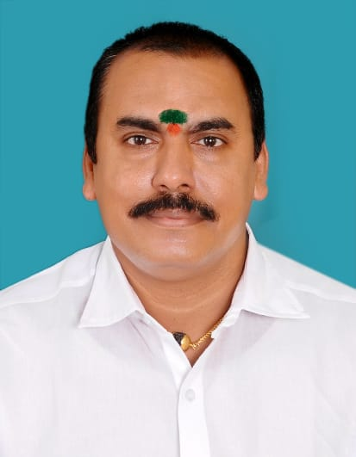
INTRODUCTION
Dr.Arun Raghavendar is a multifaceted personality. He is a Brahmin scholar, and he is serving as a priest and trustee in Raghavendra Swamy Temple, Sithalapakkam and he is a famous Astrologer, Psychologist and a Siddha Doctor. He can be contacted in the below mentioned address.
Head Office
Sri Raghavendra Swamy Temple
#364, TNHB Quarters, Medavakkam - Mambakkam Main Road,
Sithalapakkam, Chennai-600 126.
Branch Office
#848, Annasalai, Saidapet, Chennai - 600 015.
Phone : 89 39 466 099, 044 - 43558182
Dr.Arun Raghavendar is a soft and gentle person, who discharges his duties in an efficient manner. He used to conduct special pujas and homams for the devotees, and relieves their problems. He used to politely move with others, and reduces the sufferings of the devotees through the blessings of Guru Raghavendra Swamigal.
Let us praise the great man.
“OM SRI RAGHAVENDRAYA NAMAHA”
WRITTEN BY
R.HARISHANKAR

ELEPHANT IN HINDUISM
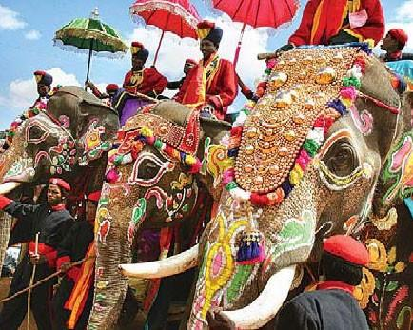
INTRODUCTION
Elephants are considered as holy animals, and they would be found in temples, zoos and forests. Though they are classified as wild animals, in general, they would not harm others. Only if they get some problem in their physical or mental health, they would try to attack others. They are considered as the divine incarnations of Lord Vinayaka, and they are also considered as the descendent of the holy elephant Airavata, who is serving as a divine vehicle of Lord Indra Bhagavan in the Swarka Loka.
White elephants are very sacred, and it is found mainly in Thailand and Burma, and it represents good luck. Temple elephants would be properly tamed, and they are given only strict vegetarian food consists of greens, sugarcane, plants and lot of vegetables and fruits. In Kerala temple festivals, lot of elephants would march and preside over the deities. Some temple elephants would even nod its head, while performing puja and abhishekham to the deities. Elephants living in forests sometimes would get scared with lions and tigers, and would run away from their sight.
Elephants are very favourite animals for small children. They would eagerly watch its appearance, and jump with great joy, and they would offer some money to the temple elephant, and in return, they would get the blessings from the elephant. The sanctity of elephants had been mentioned in various Puranas, Vedas and in other holy texts. It is believed that those who take care of the elephants, and offer food and water to them regularly, after their death, they would reach the Ganesa Loka, or they would live in the Indra Loka, by enjoying all sorts of comforts and pleasures.
According to legend, once an elephant named Gajendra was struck under the clutches of a crocodile, when he was bathing in a lake. Due to heavy pain, it began to worship Lord Vishnu, and plucked a lotus flower from the lake and raised it in the sky, as an act of offering his prayers to him. Immediately the great Lord Vishnu, approached him and relieved him from the clutches of the wild crocodile, and also granted SALVATION to the holy elephant Gajendra.
Let us worship the divine elephant Airavata and the first god Vinayaka and be blessed.
“OM SRI GANESAYA NAMAHA”
“OM SRI AIRAVATARE NAMAHA”
“OM SRI INDRA BHAGAVANE NAMAHA”
WRITTEN BY
R.HARISHANKAR

FLUTE KRISHNA
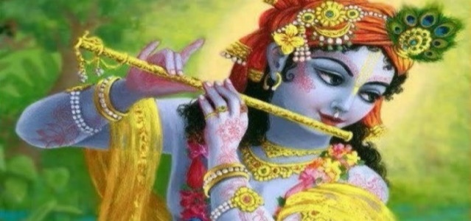
INTRODUCTION
We can generally see in several pictures of Lord Krishna who holds and plays flute in his hands, and gives us the divine music from that. The main reason for playing the flute is to give positive vibration in the minds of all the living beings in the earth, and also to give pleasantness in the minds of the living beings in the earth. From the great epic Srimad Bhagavatham, we can observe that all the living beings in the earth, including the trees, birds, animals, insects and humans were addicted to his divine music, and got mesmerized and they have forgotten their worries, and become cheerful.
The cows were milked properly, trees gave good fruits and vegetables, crops had given good yields, and rain is showered in all the seasons, all these were happened due to the divine grace of Lord Krishna, and through his simple musical instrument flute.
The main purpose of the avatar of Lord Krishna is to do good things to all the living beings in the earth, and to remove the badness from their minds. The flute had acted a main role in removing the sufferings and bringing purity in the minds of the people during the time of Lord Krishna. It is also believed, that even the divine demi gods and the great sages like Nard, Tumburu and Bhakt Prahalad, would assemble in the skies during the time of the divine music of Sri Krishna.
As per legend, it is believed that the divine flute also contains the features of Lord Krishna, and at the time of his departure from the earth, it also took the divine form, and went along with Lord Krishna to the Vaikunta, similar to Lord Rama, who took his divine bow and arrows along with him to the Vaikunta, during the time of his departure from the earth.
Let us worship the great Lord Sri Krishna and be blessed.
“OM SRI KRISHNA BHAGAVANE NAMAHA”
WRITTEN BY
R.HARISHANKAR

GURU BHAKTI
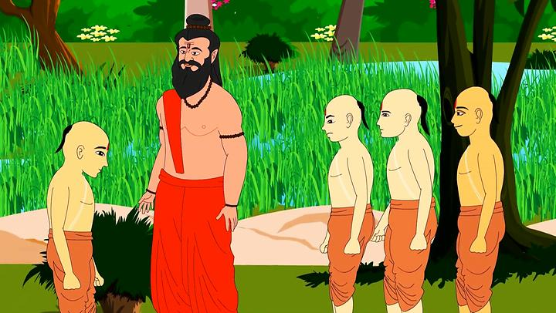
INTRODUCTION
Guru Bhakti is widely followed in ancient India, and we can study about these in various Hindu texts. Even the divine avatars like Rama and Krishna have educated themselves under a guru, and got sanctified. According, to an ancient proverb “GURU BRAHMA GURU VISHNU GURU DEVO MAHESWARA”. It means guru is considered as equivalent to Trimurties and they are the most worshipful persons in the world, next to our father and mother.
We can get goodness in our life, only through our Guru Bhakti, which can be developed by constant practice. Each and every one must have one spiritual guru, to lead a noble and a sinless life. We can worship the great Gurus like Ramakrishna Paramahamsa, Raghavendra and Shridi Baba etc, and can read their spiritual books, and can attain proper guidance through them, and can follow their spiritual path. We cannot develop guru bhakti within a few days. We have to read the life history of various saints, and can follow their teachings. Since their teachings are based on humanity, spirituality and kindness, if we follow it, our mind would get matured, and we would not spend our time on unnecessary activities, and concentrate our attention only on important things in our life.
Hence let us worship our beloved Spiritual Gurus and be blessed.
“OM SRI GURU DATTA BHAGAWANE NAMAHA”
WRITTEN BY
R.HARISHANKAR

GURU JAMBHESHWAR
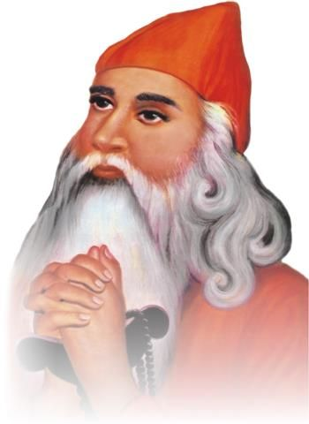
INTRODUCTION
Guru Jambheshwar(1451-1536) also called as Guru Jambhoji, was the founder of the Vishnoi sect, and it is believed that he was an incarnation of Lord Vishnu. According to him, God dwells in everyone’s heart, and we must have to realize him, by showing our sincere devotion and dedication on him. His main teachings are based on protecting the plants and animals and to safeguard them from bad elements. According to him, killing animals and destroying trees are considered as sinful acts, and those who do that, would be severally punished by the god.
Jambheshwar was born in a Rajput family belonged to the Panwar clan in a village in Nagaur district, Rajasthan in 1451. He was the only child for his parents. He was very fond in maintaining cows, and he became a cow herder. At the age of 34, Guru Jambheshwar founded the Vishnoi sect. His teachings are well appreciated by all classes of people and it is known as Shabadwani. He preached for several years, and his teachings are very simple, and he travelled throughout India, and spread his teachings among the people. He mainly founded the sect, in order to protect all the living beings in the earth from cruel killings, and to maintain calm and peace in the world.
His principles are mainly based on promoting animal husbandry, maintaining good health and cleanliness, and worshipping the divine deities regularly. Still now, in Rajasthan and in some parts of North India, devotees of Guru Jambheshwar are strictly following his principles, and worshipping him as their Kula Deva. There is a famous shrine in Bikaner District of Rajasthan for Guru Jambheshwar.
Let us worship the great saint and be blessed.
“OM SRI GURU JAMBHESHWAR NAMAHA”
“OM BHAGAVAN MAHAVISHNU NAMAHA”
“OM MATA LAKSHMI DEVIYE NAMAHA”
WRITTEN BY
R.HARISHANKAR
HOLY RIVER MATA CAUVERY
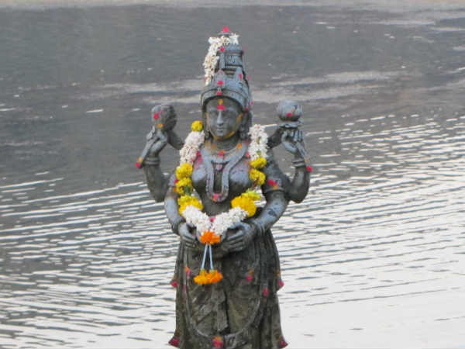
INTRODUCTION
Kaveri or Cauvery is the holy river which flows through the states of Karnataka and Tamil Nadu. Mata Kaveri is considered sacred by the people of South India and they are worshipping her as River goddess. Kaveri is considered similar to River Ganga with regard to her Sanctity. She was the daughter of Lord Brahma and created for a special purpose to give prosperity to the people in the earth.
Once there lived a great King who was known as Kavera, and he performed severe penance on Lord Shiva, in order to get a noble child. Pleased by his sincere devotion, Shiva blessed him with a noble daughter and the king named her as Kaveri and got married her to Sage Agastya, and she was also known as Lopamudra. One day, Sage Agastya turned her in the form of water and put her in his holy pot, and went for bathing in a river by leaving the holy pot in the banks of the river. Meanwhile, Lord Ganesa took the form of a crow and pushed the Holy pot. The water was released from the pot, and Kaveri became a river. Lord Ganesa had done this, in order to help the people to quench their thirst, and due to that Mata Cauvery is providing water for us. River Cauvery is considered as an AMSA of Mata Lopamudra, wife of the great sage Agastya.
Let us worship the holy river Cauvery and be blessed.
“OM SRI CAUVERY ANNAIYE NAMAHA”
“OM SRI RISHI AGASTIYARE NAMAHA”
“OM SRI VINAYAKAYA NAMAHA”
WRITTEN BY
R.HARISHANKAR

IMPORTANCE OF CROW IN HINDUISM
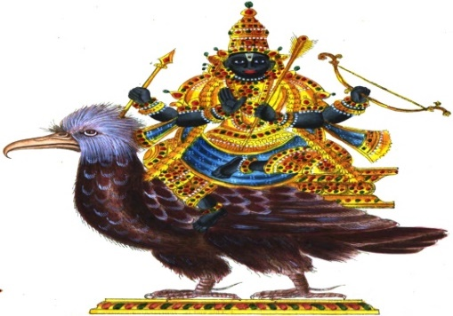
INTRODUCTION
Crows are considered as sacred birds, and crow is the divine vehicle of the justice god Shani Dev. It is believed that during the time of death ceremony and other rituals performed to the departed souls, our ancestors are coming in the form of a crow and taking our food offerings and blessing us. The popularity of the crows was mentioned in ancient epics, and they act as a bridge between us and the dead ancestors, and they help us to honour our ancestors.
We can easily offer the food to the crows in the outside of our home, since there is no need to search for them. Offering food to the crows is a must during the Amavasya days and other auspicious festival days. By offering food to the crows, Lord Shani Bhagavan would be pleased, and would reduce our sufferings to some extent, and extend his helping hand on us during our difficult situations. Crows must not be killed for meat, since crows are not eatable items, and doing that, would cause Pitru dosham and Shani Dosham. We can worship Lord Shani Bhagavan in the Thirunallaru temple and he is seated in the Golden Crow Vahana.
Crows are the blessed ones, and they are also the worshipful birds. We can provide food and water regularly to the crows and worship Lord Shani Bhagavan. It is believed, that the caretakers of the crows, would be blessed by all the divine gods and goddesses, and they would reach the Divine world, after their death.
Hence let us worship Lord Shani Bhagavan and be blessed.
“OM SRI SHANI BHAGAVANE NAMAHA”
WRITTEN BY
R.HARISHANKAR

IMPORTANCE OF HORSE IN HINDUISM
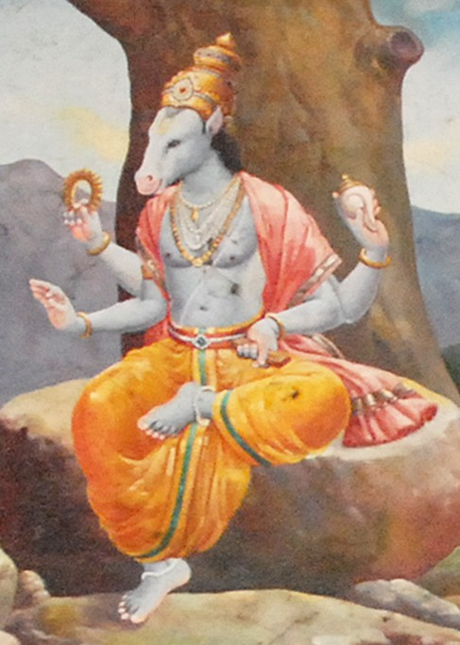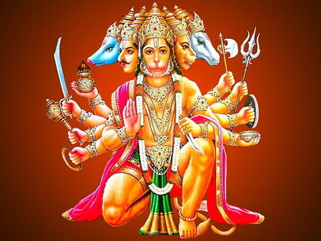
INTRODUCTION
The Hindu tradition gives the horse a very important status, since horses contain great powers and shows loyalty and respects it master. Uchaisravas, a seven headed horse, is the first horse formed during the churning of the divine ocean, and Uchaisravas is considered as the forefather of all the horses. Seven horses are tied in the chariot of Lord Surya Deva, and they are discharging their duties for several millions of years.
Lord Surya Deva’s sons Ashwin Kumaras contains horse heads. Lord Vishnu had taken the Hayagreeva avatar, in order to restore the Vedas from the demons, and after killing them, he handed over the Vedas to his son Lord Brahma Dev, and he contains horse head. In ancient times, while doing Ashwameda Yagna, a holy horse would be used by the kings, for travelling to distant places.
Horses, greatly respects their masters, and do their duties as per the commands given by their masters. But they would disrespect us only when we treat them cruelly. During the wars, the kings would mostly use horses, in order to fight easily with their enemies.
In order to praise the bhakti of Sri Vadirajar, Lord Vishnu used to come in the form of a divine horse and would eat the Holy Prasad, jaggery mixed with pulses from the hands of the great Madhwa saint Sri Vadirajar Swamigal. The great Mahabharata warrior, Ashwathama was given the horse name, since he produced the sound of a horse, during his birth. The divine Gandharva sage Tumburu is having the horse head, and he used to sing melodious songs on Lord Vishnu, and used to wander in the divine worlds, similar to Rishi Narad. Lord Panchamukha Hanuman, among his five heads, he contains horse head also.
Let us worship Lord Hayagreeva and be blessed.
“OM SRI HAYAGREEVARE NAMAHA”
“OM SRI PANCHAMUKHA HANUMANE NAMAHA”
WRITTEN BY
R.HARISHANKAR

IMPORTANCE OF LION AND TIGER IN HINDUISM
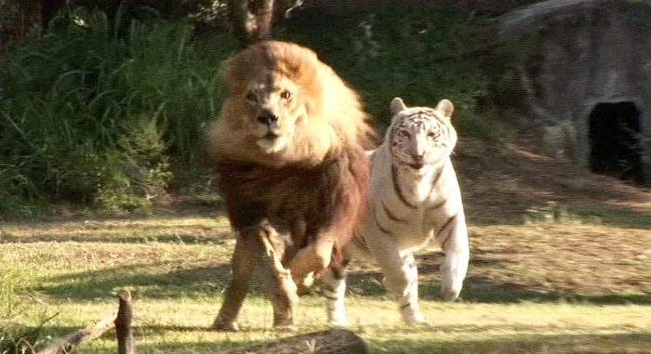
INTRODUCTION
Lions and tigers are wild animals, and they have the capacity to even attack a wild elephant. They are strongly related with Hinduism, and Lord Vishnu took the Narasimha Avatar, with the head of a lion, Mata Parvati is having the lion as her vehicle, and Lion is considered as the king among all the animals in the world. They contain great powers, and live their life by hunting animals such as goats, deer, rabbits, camels and elephants etc. Lions cannot be tamed, and they are treated under the wild animal category only.
Tigers are the powerful animals only next to lion, but sometimes during the fights, tigers may win over lions also, and kill them, but that would happen only rarely. Tigers are also connected with Hindu Mythology, and they are mentioned in Puranas and ancient texts. Mata Durga Devi, an incarnation of Parvati, is seated in a tiger, and Lord Ayyappan had brought the tiger milk from the forest, by riding in a tiger. Tigers mostly would kill the animal and eat the meat, and they have sharp eyes, and are able to catch their prey even during the nights. According to a famous incident in the life of Sri Ayya Vaikunta Swamigal, an incarnation of Lord Vishnu, once he was placed in the cage of a hungry tiger, by the orders of the king. But due to the divinity of the sage, the tiger had bowed its head, and sat peacefully before him, and it didn’t harm the great saint. Tigers are also able to find the sudden changes in the atmosphere like earthquake, storm and cyclone, and would warn us by roaring in a different manner.
In general, both lions and tigers are worshipful animals, and are considered as the divine incarnations of the divine vehicles of Mata Parvati Devi, and let us show our great respect on these lovely animals.
“OM SRI AMBIGAIYE NAMAHA”
“OM SWAMIYE SARANAM AYYAPPA”
WRITTEN BY
R.HARISHANKAR
IMPORTANCE OF RABBITS IN HINDUISM
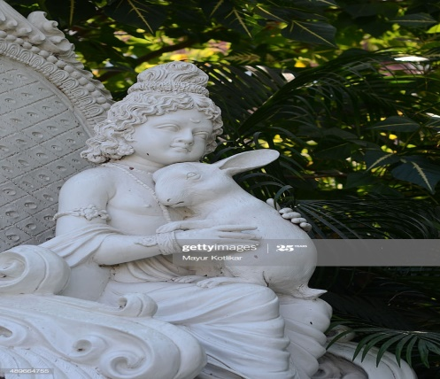
INTRODUCTION
Rabbits are lovely mammals and are considered as worshipful creatures. In the dwapara yuga, Lord Krishna loved rabbits, similar to cows, and showed his great affection on them. Rabbits are mentioned in ancient puranas and in holy texts, and they are considered as the pet animals for most of the sages. They used to wander nearby the ashram of the sages, and used to eat carrots and greens from the forest. Rishi Kanva brought up rabbits and deers, and he greatly loved them. He used to feed vegetables and fruits from his own hands, and made them as the tamed pet animals.
Rabbits living in the forest would appear bigger in size. Though rabbit doesn’t get angry over others, but if anyone disturbs its child, it would become wild and attacks them. Rabbits are also related with Lord Chandra, since if we look at the moon, we can see a rabbit like thing appears inside the moon. Similar to dogs and cats, rabbit also shows faithfulness to its master, and act as a friend to its master, and rabbits are very soft and gentle animals.
But nowadays rabbits are being killed for meat, and most of the people who keep rabbits as pet animals, used to kill them and preparing dishes through their meat. Some people exclusively grow rabbits in their homes for the purpose of converting it into meat items. People also sell the rabbits to star hotels and making lot of money. But doing such kind of act is not advisable, since rabbits are considered as lovely creatures and they must be protected.
Let us worship Lord Krishna and be blessed.
“OM SRI KRISHNA BHAGAVANE NAMAHA”
WRITTEN BY
R.HARISHANKAR

IMPORTANCE OF TORTOISE IN HINDUISM
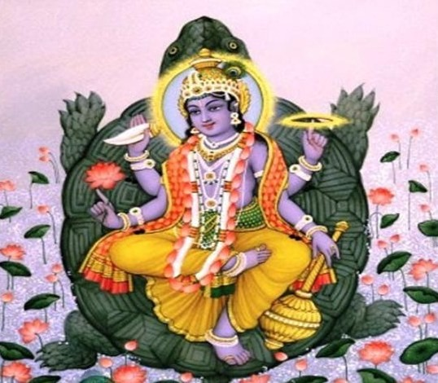
INTRODUCTION
Tortoises are the noble animals, and considered as pious reptiles, next to cow. They didn’t cause any harm to others, and they eat sea foods, and even they eat vegetarian items like Vegetables, pulses and fruits. Since, tortoises are related with the Vishnu’s Kurma Avatar, they are also considered as worshipful and respectable creatures. They would live for more than 100 years, and in India, pet tortoises are not allowed according to the wild life act. But in some foreign countries, people would keep the tortoises as their pets.
In a popular Tamil saying, “As soon as a tortoise enters a home, then immediately, the owner of the home would lose his rights from the possession of the house property”. But in actual, it is not like that, tortoises are very good creatures, and they gives us good luck and best fortunes in our life. They would act in a friendly manner with us, and we can treat them as our own child, and enjoy their small mischievous acts, and can forget our worries, since tortoises contains the features of Lord Kurma Bhagavan, an avatar of Lord Vishnu, and his Srikurmam temple is situated in Srikakulam, Andhra Pradesh.
Let us worship Lord Kurma Bhagavan in the Srikurmam temple, and be blessed.
“OM SRI KURMA BHAGAVANE NAMAHA”
WRITTEN BY
R.HARISHANKAR

IRAVATI
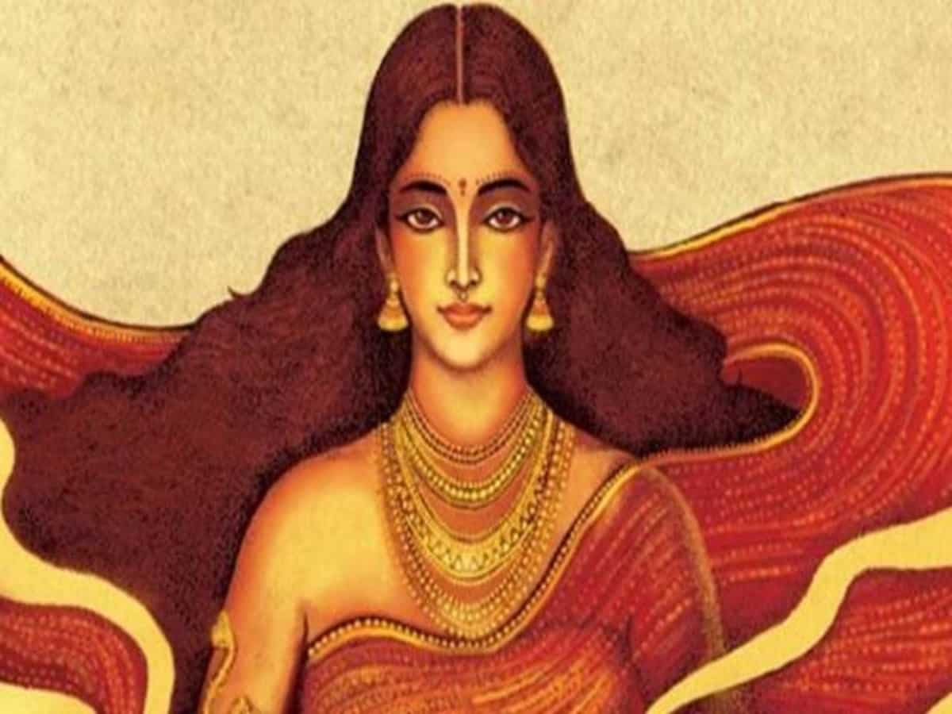
INTRODUCTION
As per the divine epic Sridmad Bhagavatham, King Uttar performed marriage to his daughter Iravati with his sister Uttara’s son King Parikshit, who was the king of Hastinapur. Iravati was considered as a holy and chaste woman, who always stood at the side of her husband Parikshit, and served as a dutiful wife to him. She had heard about the family details of her husband Parikshit, and was very much impressed with the valour of the Pandavas, and got great Bhakti on Lord Krishna.
She also took part in the affairs of the Kingdom, along with her husband Parikshit, and was liked by the people of Hastinapur, and she treated them as her own relatives, and provided all sorts of benefits to them. She contains wisdom, courage and boldness, and she was a considered as a pious lady. She lived a noble life, and after her death, she has attained MUKTI due to her good karmic deeds.
Let us worship the noble woman Iravati and be blessed.
“OM MATA IRAVATIYE NAMAHA”
“OM SRI PARIKSHIT MAHARAJAVE NAMAHA”
“JAI KRISHNA”
WRITTEN BY
R.HARISHANKAR

JACKAL IN HINDUISM
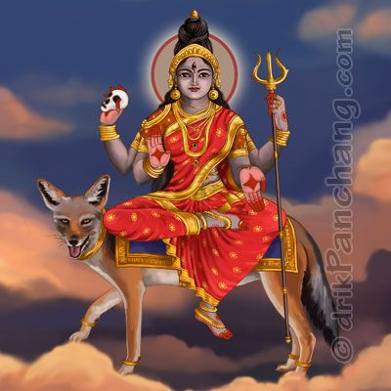
INTRODUCTION
Jackal is considered as the divine vehicle of Mata Chamunda, an incarnation of Mata Parvati Devi. In some pictures, Mata Kali also appears with her divine vehicle jackal. Jackals though are wild animals, but are considered as very clever animals, and they would mostly live in the forest and in burial grounds. As per Shiva Purana, while Lord Shiva roams in the burial grounds, along with his Bootha Ganas, lot of jackals would be present along with him, and they used to protect him. Jackals are also believed to be the divine vehicle of Lord Veerabadra, an avatar of Lord Shiva.
Jackals are mentioned in ancient texts, and they are also considered as an aspect of the Shiva Bootha Ganas. Most of the people will not kill the jackals, since it is one of the protected animals, and also it is living in the forests and in the zoo. But some people in the villages, used to hunt the wild jackals for their teeth and skin, and they would also consume its meat, since jackals meat is considered as good for weak and unhealthy people.
But it is not preferable to eat jackals, since they are considered as holy ones. Whenever we find them in any villages or zoo, we can offer fruits as food items to them. Giving food to the jackals would fetch us the divine blessings of Lord Shiva’s Bootha Ganas.
Let us worship Lord Nandikeswarar who is the immediate controller of the Bootha Ganas of Lord Shiva, and be blessed.
“OM SRI SHIVA BOOTHA GANAYA NAMAHA”
“JAI SHIVSAKTI”
WRITTEN BY
R.HARISHANKAR

JOURNEY TO THE DIVINE WORLDS
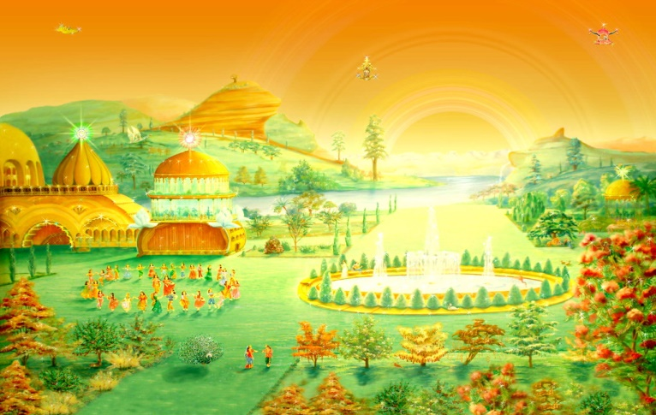
INTRODUCTION
We would have studied in the Puranas and in other Hindu scriptures about the existence of various divine worlds in the upper worlds. The great rishis and devotees like Bhrigu, Narad, Thumburu and Bhakt Prahalad have already visited the Divine Lokas, and worshipped the divine deities. And since they have got bhakti on the gods they are able to do it, and there is no need to get surprise over that. But we are all ordinary mortals, and we could able to show our devotion on god only to a limited extent, since we are concentrating our attention on doing other activities also. And it is also very difficult to visit the divine worlds through our physical body, since no one in the divine world would allow any mortals to enter into their world with their physical body.
Then how can we reach the divine worlds? Is it any other way to go there? Yes. But not now, only, if we perform sincere meditation on god, with or without having a family, and if we sincerely do our duties, and if we ignore the bad things from us like ego, lust, anger and jealously, and if we do lot of good things in our life, like providing food to the poor people, helping in the construction, repair and renovation of temples, construction of schools and houses for the poor people etc.
And we can reach the divine worlds, only after our death, and only after the balance of our bad karmas would become nil, we are allowed to reach the divine places. We can’t go to the divine worlds, by spending money or by way of showing our riches to the divine gods, since that is not liked by the god. Doing good karma doesn’t cost much. But due to laziness and disinterest in doing such things, we are all losing the opportunity to reach the divine places in the upper worlds, like the Heaven, Dhuruva Loka, Satya Loka, Vaikunta, Kubera Loka, Kailasa etc.
Hence let us keep on chanting the names of the god, have sincere faith and devotion on the almighty, do noble activities in our life, avoid doing bad things in our life, and then let us get ready to ride in the divine chariot to reach the divine lokas.
Let us pray to the great Lord Indra Bhagavan and be blessed.
“OM SRI INDRA BHAGAVANE NAMAHA”
“JAI GANESA”
“OM SRI DHURUVA BHAGAVANE NAMAHA”
WRITTEN BY
R.HARISHANKAR

JURAHARESWARAR TEMPLE
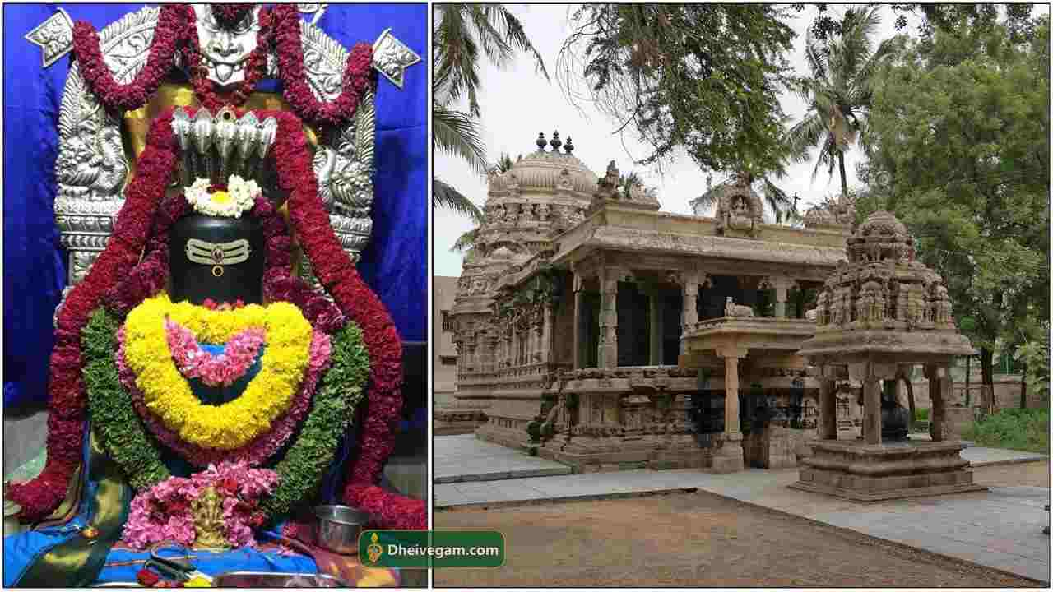
INTRODUCTION
Jurahareswarar Temple is situated in Kancheepuram, and it is more than 2000 years old temple. It is a famous Shiva temple, and it is believed that those who worship the great Lord Shiva at this temple would get relieved from all types of fevers and dreaded diseases. By visiting this temple, we would get great mental satisfaction, great pleasure, and would get more withstanding power.
At this temple, sacred temple tank is also found, and it is known as Jurahareswarar Teertham. It is considered as very holy, and by sprinkling the water in our head and body, our mental worries and tensions would be removed and we would get great peace of mind.
According to ancient Puranas, once a demon named Tharagan had caused several disturbances to the demi gods in the heaven. Due to that, the demi gods went to Kailash and prayed to Lord Shiva. Lord Shiva gave his blessings, and destroyed the demon, and then he stayed at the present place of the temple at Kancheepuram. It is believed that since Lord Shiva had relieved the heat related diseases of the demi gods, he is called as “JURAHARESWARAR”, and the temple was built by Pallava kings during the 8th century AD.
Temple timings: 8 am to 11am and 5 pm to 7 pm.
Hence, let us visit the ancient temple and be blessed.
“OM SRI JURAHARESWARARE NAMAHA”
WRITTEN BY
R.HARISHANKAR

KAVIMANI DESIKA VINAYAKAM PILLAI
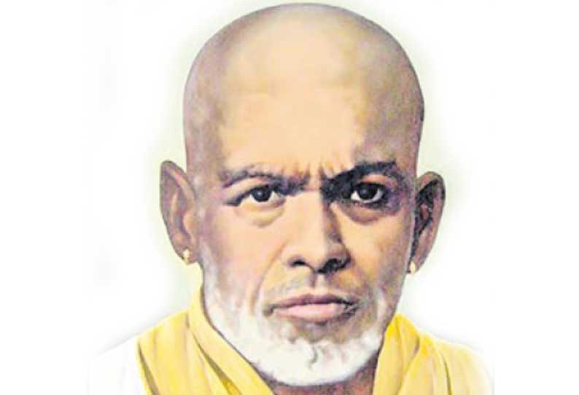
INTRODUCTION
Kavimani Desika Vinayakam Pillai (1876-1954) was a famous poet who lived in Kanyakumari District. He composed lot of devotional songs, and poems.
Desika Vinayakam was born to a pious couple in the year 1876. After finishing his education, he worked as a teacher in a school.
He wrote lot of children books, and has earned a great name among the children. He also translated English spiritual books in Tamil, and also used to tell Bhakti stories to the children during Sundays and in the evenings.
Desika Vinayakam Pillai has served as an assistant at the University of Madras, and he got the title Kavimani at the Pachaiyappan College, Chennai, due to his expertise in writing poems. He was awarded by the kings for his great knowledge in Tamil language.
After serving the society through his valuable texts, he has died in the year 1954.
Let us praise the great poet.
“JAI KAVIMANI DESIYA VINAYAKAM PILLAI”
WRITTEN BY
R.HARISHANKAR

KERALA VARMA
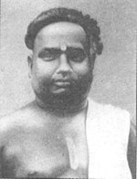
INTRODUCTION
Kerala Varma (January 1879 – June 1919), also called as Mahakavi Pandalam Kerala Varma, was a malayalee poet and a great scholar. He was born at Pandalam, and belonged to the Pandalam Royal Family. He wrote lot of poems and he was the Editor of Malayalam Magazine, Kavana Kaumudi.
Kerala Varma was born at Pandalam in 1879, in a pious family. Kerala Varma learnt Siddha and Ayurveda, and he was a physician also. Kerala Varma married a noble lady in the year 1905, and they had five children. He worked as a poet under Maharaja of Travancore. Kerala Varma died in the year 1919 after suffering from illness. In 1979, a collection of his writings were reprinted and published.
FAMOUS WORKS
- Sreekrishna Sthothram.
- Kesadipada Sathakam.
- Rasavilasambhanam.
- Marthanda Devodayam.
- Vancheesa Sathakam.
- Sreemoola Prakasika.
- Sreemoolaraja Vijayam.
- Saubhadra Niryanam.
- Bheema Prabhavam.
Kerala Varma wrote lot of poems in praise of Mata Parvati and Lord Ayyappa.
Kerala Varma published lot of spiritual books in Malayalam language.
Kerala Varma was very generous and used to feed the poor people, and also participated in social service works.
His poems are very easy to understand even by the layman.
Let us praise the great poet.
“JAI SRI KERALA VARMA”
WRITTEN BY
R.HARISHANKAR
KING BHARATA - SON OF SHAKUNTALA AND DUSHYANTA
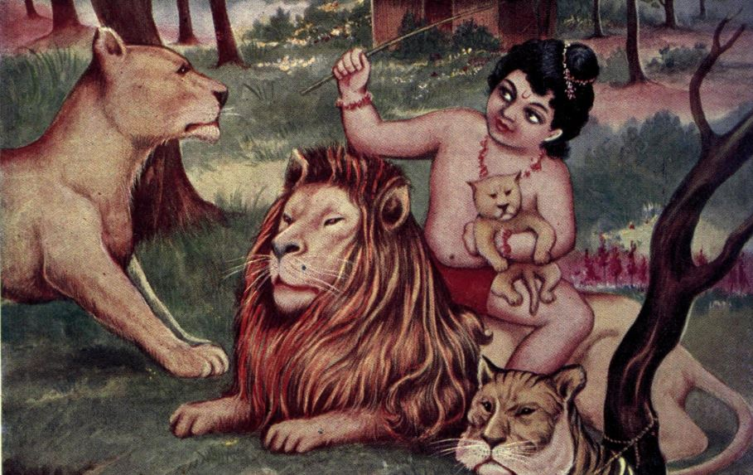
INTRODUCTION
According to the holy Puranas, King Bharata is the ancestor of the Pandavas and the Kauravas and he is a noble king who ruled the present India, also known as Bharat, was derived from his name. Emperor Bharata was considered as the ancient father of India.
He is mentioned in the Rig Veda, as well as in the Mahabharata, and he is the son of Dushyanta and Shakuntala, and he was a great Kshatriya king. The details about his life were mentioned in Kalidasa's works.
Bharata was born in the Ashram of Rishi Kanva, and was brought up by the great rishi Kanva, and by his mother Shakuntala. Bharata was a brave boy and had no fear from his childhood itself. He was very strong, and he would even open the mouth of the tigers and lions and count their teeth. Bharata performed many ritual yagnas (fire sacrifices) and became a great king. Bharata married Sunanda, the daughter of the Kasi King Sarvasena, and had a son named Bhumanyu.
Bharata had ruled his kingdom in a well versed manner, and the people in his kingdom were enjoyed all sorts of comforts in their life, and didn’t get any kinds of problems or mental worries or any other diseases in their life. All of them lived for a long period of time, with full of happiness in their mind. There is a famous saying about the noble ruling of Bharata in the ancient texts.
“THOSE WHO TAKE SHELTER UNDER THE GREAT KING BHARATA, WOULD NEVER GET AFFECTED WITH ANY KIND OF PROBLEMS, AND WOULD LIVE THEIR LIFE WITH FULL OF PEACE AND PROSPERITY”.
After ruling over his kingdom for many years, he crowned his son as the king, and went to the forest, and became a great sage. In his next birth, he was born as a noble saint, and his name was Jata Bharata. He taught spiritual philosophies to the common people, and to the kings, and after his death, he attained the Brahma Loka, and became the divine attendant of Lord Brahma.
Let us worship the great king Bharata and be blessed.
“OM SRI BHARATA MAHARAJARE NAMAHA”
“OM SRI BRAHMA DEVARE NAMAHA”
“JAI KRISHNA”
WRITTEN BY
R.HARISHANKAR

KING DIVODASA
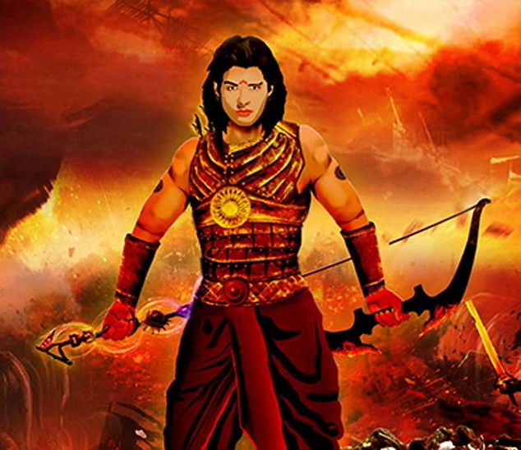
INTRODUCTION
King Divodasa is an ancient king, who was mentioned in the Rigveda, and lived in the Treta Yuga. He was a close associate of Lord Indra, and he helped him towards winning in the battle with the demons. He is also a friend of the Ashvin Devas, since they healed his wounds, after the battles. His father was king Bhimaratha, and he was considered as the grandson of Lord Dhanvantri, who took birth in the earth, in order to heal the people suffering from diseases. His son, Pratardana, is a pious person, and he was mentioned in ancient texts.
He attended the Ashwamedha Sacrifice performed by King Dasharatha of Ayodhya. He was the brother of Queen Sumitra, and was a Brother-in-law of Dasharatha. He was considered as a man of noble thoughts, and used to apply his mind before doing any kind of actions. He was an ardent devotee of Lord Vishnu, and he was the uncle of Lord Rama. He kindly treated his people, and provided necessary facilities to them, to run their life comfortably. He contains wisdom, courage and boldness, and lived a noble life. After his death, he went to the Swarka Loka.
Let us worship the great king and be blessed.
“OM SRI DIVODASARE NAMAHA”
“JAI SRIRAM”
WRITTEN BY
R.HARISHANKAR

KING GAADHI
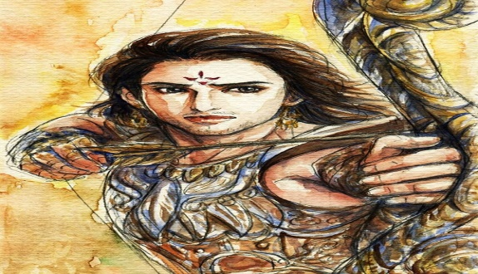
INTRODUCTION
Gaadhi was the son of King Kushanabha. He belonged to the Chandravansha Clan. He was mentioned in ancient sacred texts and in Puranas, and he was described as a great ruler. He was the father of Kaushika, who was later become Brahmarshi Vishvamitra. Kaushika ruled almost the entire earth, and after he was interested in spirituality, he left his kingdom, and became a rishi. Gaadhi had a daughter named Satyavati. Satyavati was married to Rishi Richika.
Gaadi lived a noble life and maintained his kingdom properly. He gave a golden rule, and all the people in his kingdom were lived without any diseases, miseries and sorrows. No one in his kingdom complained about any problem, and everybody lived happily and peacefully. He defeated the kings in other regions, and expanded his kingdom, and established many Annadan Choultries, pilgrims rest places, built temples and done lot of good activities in his life.
After attaining old age, he gave his kingdom in the hands of his son Kaushika, and went to the forest, and performed severe penance, and after his death, he went to the abode of Lord Indra, the Swarka Loka.
Let us worship the great king Gaadhi and be blessed.
“OM SRI GAADHI MAHARAJA NAMAHA”
“OM SRI INDRA BHAGAVANE NAMAHA”
“JAI SRIRAM”
WRITTEN BY
R.HARISHANKAR

KING JANAMEJAYA
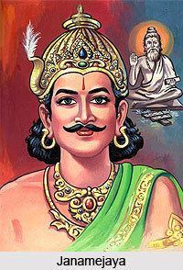
INTRODUCTION
Janamejaya was the king of Hastinapur, and he is believed to have lived before few thousand years. Similar to his father Parikshit, he contains very good qualities, and ruled his kingdom in a well versed manner, and kindly treated his people, and provided all the necessary facilities to them. People were admired and praised him for giving a GOLDEN RULE. He honoured the sages and conducted lot of fire sacrifices, and gave sufficient wealth to the Vedic scholars, and arranged for regular puja activities in the temples. He conquered lot of regions through his bravery, and expanded his kingdom.
He was mentioned in Srimad Bhagavatham and his importance is also mentioned. According to an old saying “Those who lives under the shelter of King Janamejaya need not worry about themselves and their family members, and can live for a long period without any diseases, and have their basic needs fulfilled”. He got such a good name and fame among the people due to his good characteristics.
Janamejaya contains very good features and his charm can be compared with that of Lord Indra. He got married with a noble lady and had children. After knowing about the cause of death of his father Parikshit, who was killed by the great snake king TAKSHAKA, he performed Yagna in order to destroy all the SNAKES in the world. After some time, he stopped doing the snake sacrifice, due to the interference of various Sages and demi gods, and got pacified and maintained good relationship with the Nagas. According to Puranas, after his death, he has attained SALVATION.
Let us praise the glory of the great king, and be blessed.
“OM SRI JANAMEJAYARE NAMAHA”
“JAI KRISHNA”
WRITTEN BY
R.HARISHANKAR
KING PRAVAHANA JAIVELI
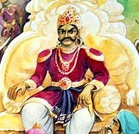
INTRODUCTION
Pravahana Jaivali (7th century AD) was a king of Panchala who was mentioned in the ancient texts, and in Upanishads. He is considered as a pious king and ruled his kingdom in a well-versed manner, and gave a GOLDEN RULE to his people. He is also considered as a holy sage, since he knows lot of devotional matters, and once, he teaches Svetaketu, son of Sage Uddalaka Aruni and explains the process of rebirth, and the ways to come out from the life cycle, and how to lead a successful life by following spiritual path etc. Jaiveli is believed to be a devotee of Lord Vishnu, and devoted his entire attention on the supreme god.
Pravahana Jaivali, who was well-versed in Vedas, Shastras and Upanishads, further tells that the principle of self-sacrifice for the sake of others, is a noble task, and it must be adopted by everyone. He also insists the people to do proper rituals after the death of their parents and ancestors, and it must be completed by providing food to the Brahmin scholars. He asked the people to feed grass, fruits and greens to the cows, in order to get relieved from all sorts of doshams, and from the evil effects of the planetary position etc. He tells to the people, to offer food and water to the living beings in the earth, in order to reach the heaven, the divine abode of Lord Indra Bhagavan.
He also took advice from the great king Janaka, and after successfully ruling over his kingdom for several years, at his old age, he crowned his son as a king, and went to the forest, and constructed an ashram, and had only fruits and cow milk as his daily food, and done severe penance on Lord Vishnu, and in course of time, he has attained MUKTI.
Let us worship the great king and be blessed.
“OM SRI PRAVAHANA JAIVELIYE NAMAHA”
“JAI SRI RAM”
WRITTEN BY
R.HARISHANKAR
KING SHIBI
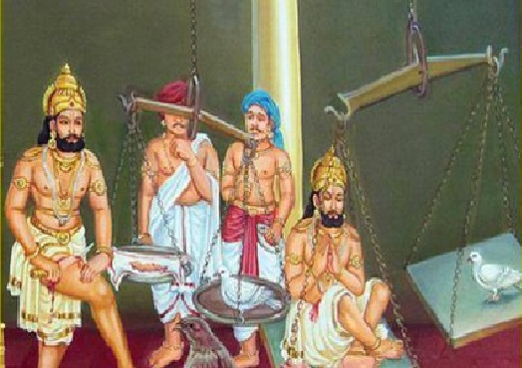
INTRODUCTION
Shibi was the son of King Ushinara, and he was an efficient ruler of the lunar dynasty. King Shibi was praised for his selfless service to the people and for his righteousness. He was highly respected by the people, due to his good features.
Shibi was mentioned in the Hindu Puranas, Mahabharata and in other Hindu Sacred Texts. He is said to be the worshipper of the Sun God, Lord Surya Bhagavan. Shibi visited most of the temples in Tamil nadu and worshipped the divine deities.
Shibi lived during the Treta Yuga. He was well known for his generosity and kindness over others. Due to that, he was praised by the kings in the earth, as well as by the demi gods in the heaven. Once, Lord Indra and Agni Dev wanted to test Shibi, and they took the form of eagle and pigeon respectively and went to the palace of the king.
The pigeon took shelter in the lap of the king, and the eagle has asked the king to offer it to him, in order to eat it. But the king refused and told that he would give some other animals flesh as food for the eagle. But the eagle had hesitated and asked the flesh of the king equivalent to the weight of the pigeon. The king had agreed and kept the pigeon in the weighing machine (THARASU) and he put some of his flesh in the other part of the weighing machine. But the weighing machine was not balanced. Due to that, he himself sat in the weighing machine, and thereafter the weighing machine was balanced.
Immediately, the birds were changed into their true form, and Lord Indra and Agni had recovered his wounds, and gave several boons, and praised him for his noble deed, and went to their respective places. The demi gods in the heaven began to pour flowers on him in order to recognize his great sacrifice for the small bird.
Due to his valour, he had conquered the entire world and performed lot of fire sacrifices, and lived in a prosperous manner for a long period of time. And after his death, due to his good karmas, he has reached the kingdom of heaven.
Let us praise the great king and be blessed.
“OM SRI SHIBI CHAKRAVARTHYE NAMAHA”
“OM SRI AGNI BHAGAVANE NAMAHA”
“OM SRI INDRA BHAGAVANE NAMAHA”
WRITTEN BY
R.HARISHANKAR

KUNCHAN NAMBIAR
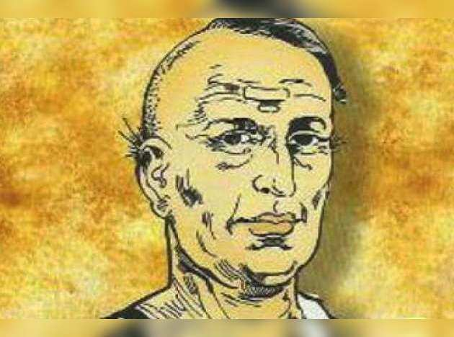
INTRODUCTION
Kunchan Nambiar was a famous Malayalam poet and a devotional writer. He was a multifaceted personality, who was well versed in all kinds of arts. Similar to Ezhuthachan, Bhattari and Poonthanam Namboothiri, Nambiar was very good in penning devotional poems. He is considered as the king of the poets in his period.
Nambiar is believed to have been born in the year 1705 in a village in Palakkad district of Kerala in a pious Malayali family. He got high spirits in training martial arts and was good at education, and studied the great epic “NARAYANEEYAM” at his younger age itself, and became an ardent devotee of Lord Krishna, and he used to sing melodious songs on Lord Krishna in the Guruvayur Temple, and he was highly appreciated by the kings for his talents. He worked in the king’s court of Travancore as a court poet. At the later stage of his life, he went to Ambalapuzha and he died in the year 1770. Kunchan Nambiar is also mastered in all forms of dance arts, and introduced new methods in the dancing field. The Government of Kerala founded Kunjan Nambiar Memorial in Ambalappuzha.
WORKS
1. Syamanthakam
2. Ghoshayathra
3. Kiratham
4. Santhanagopalam
5. Patracharitham
6. Karthaveeryarjunavijayam
7. Bakavadham
8. Hariniswayamvaram
9. Thripuradahanam
Let us praise the glory of the great poet.
“JAI SRI KUNCHAN NAMBIAR”
WRITTEN BY
R.HARISHANKAR
LORD KATTAVARAYAN
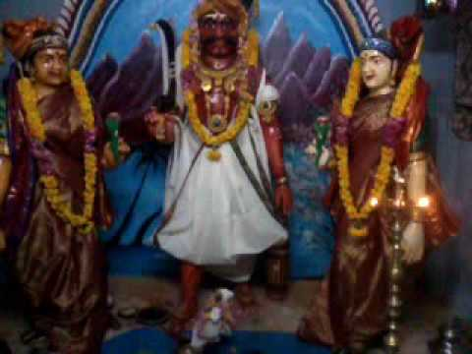
INTRODUCTION
Kattavarayan is considered an aspect of Lord Shiva. When Mata Parvati incarnated in the earth as Kamakshi, he stood near her as a guardian and protected her. Parvati was also guarded by a divine female attendant. When Kattavarayan fell in love with the divine attendant, Mata Parvati had cursed him and her divine attendant to be born as mortals in the earth.
Due to that, Kattavarayan was born in a village near Trichy in the 14th century AD, in a low class family, and he was talented in playing the musical instrument “NADASWARAM”. After hearing his lovely music, one young Brahmin girl named Aryamala, who was the cursed divine attendant of Mata Parvati, fell in love with him, and both of them were married and travelled to a distant place. After knowing his whereabouts, the king of the Trichy city, hanged him, since Kattavarayan was married to an upper class girl. On hearing the death news of her beloved husband, Arya mala was died due to heart attack, and both of them were become guardian deities.
His temple is situated in a village at Trichy, and he appears along with his consorts Onthayee and Aryamala in the main shrine of the temple, and still now large number of devotees are visiting his shrine, and getting his wonderful blessings. In most of the Kamakshi Amman temples, Lord Kattavarayan appears nearby Kamakshi Amman shrine, and guarding the holy mother, and also showering his grace on us.
Let us worship the great guardian guard Sri Kattavarayan and be blessed.
“OM SRI KATTAVARAYANE NAMAHA”
“OM SRI SHIVASAKTHI NAMAHA”
WRITTEN BY
R.HARISHANKAR

MADAN MOHAN MALAVIYA
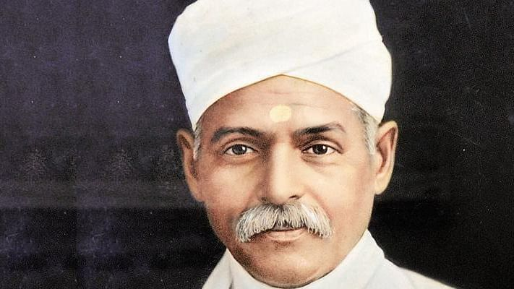
INTRODUCTION
Madan Mohan Malaviya (1861–1946) was a great scholar, spiritual writer and a Krishna Devotee, who participated in the freedom fighting movement and served as the Congress president. He was a holy and a soft spoken person, who has done many social services during his life time.
Malaviya was born in Allahabad, in the year 1861 in a Brahmin family and was well educated and become a Sanskrit Pundit. He also taught Sanskrit to the poor students, and he and his family were provided food to the visiting guests at their home. He was well versed in Vedas and used to recite the Bhagavat Gita, Ramayan and Srimad Bhagavatam.
He also used to write devotional poems on Lord Krishna, and sings his glories meticulously in the Krishna Temples.
He founded the Banaras Hindu University in order to give an opportunity to the poor and the down trodden people to get well educated. Through his selfless help, lot of low class and poor people were studied in diversified fields of courses like arts, commerce, sciences, agriculture and engineering and become well settled in their life.
He also went to South Africa and gave various political as well as religious lectures, and he spread the “KRISHNA BHAKTI SPIRIT” among the South Africans.
He started the English newspaper, The Leader, and published many good articles in his magazine. After his death, he was awarded with Bharat Ratna, in the year 2014.
After rendering many years of social as well as spiritual service, he died during the year 1946.
Let us honour the great man.
“JAI SRI MALAVIYA”
“JAI KRISHNA”
“JAI SRIRAM”
WRITTEN BY
R.HARISHANKAR
MAHATMA GANDHI
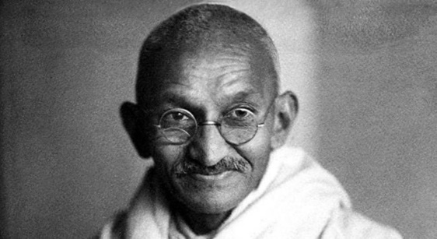
INTRODUCTION
Mohandas Karamchand Gandhi (1869–1948) who was later called as Mahatma Gandhi was a lawyer, freedom fighter and a Ram devotee who lived a pure life, and was considered equivalent to a saint. He was born in Gujarat in the year 1869, and obtained a law degree in London.
After finishing his studies, he went to South Africa for attending a client’s case. After living there for many years, he returned to India. He has become a leader of the Indian National Congress in 1921, and began to fight for the people rights in India, and become a freedom fighter. He was fondly called by the people and by his well-wishers as Bapu.
Though he was a lawyer, he used to wear only simple clothes, and had only simple vegetarian food, and also observed fasting for several days, and used to perform Srirama puja at his home, and frequently chants his mantras and names. He participated in many freedom fighting movements, and he was imprisoned in India. At his younger age, he got married with a noble girl Kasturibai, and she stood at his side throughout her life. For getting freedom for India, he has suffered a lot. After many struggles, through his great help, India has got freedom in the year 15th August 1947.
But he has got enemies through his several actions. Due to that, on 30th January 1948, when Gandhiji was on his way to address a prayer meeting, one Nathuram Godse, a Hindu nationalist, shot at him. And gandhiji was collapsed and died. And it is believed that at the time of his death, he has chanted the Rama Mantra “HEY RAM”, and died. Afterwards, the killer, Godse was executed in the year 1949.
Let us praise Mahatma Gandhiji.
“JAI MAHATMA GANDHIJI”
WRITTEN BY
R.HARISHANKAR
MAHESH PANDIT
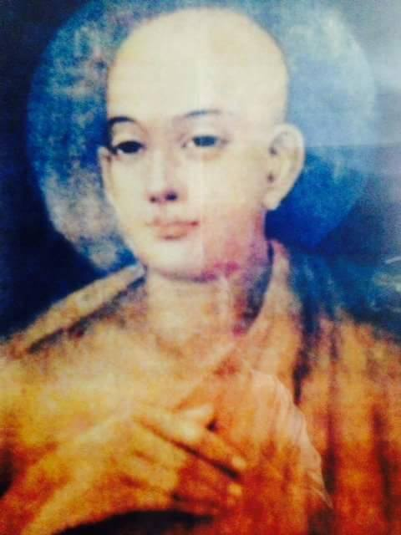
INTRODUCTION
Mahesh Pandit(15th century AD) was a close associate of Sri Nityananda Prabhu, also known as Nitai, and he was considered as a very pious and a kind hearted saint who prayed to Lord Krishna, to grant salvation to all the living beings in the world. He was born in a village in West Bengal in a pious Hindu family. He was very much depressed on seeing the sufferings of the living beings in the earth, and worshipped on their behalf to Lord Krishna. He would chant the divine names of Lord Krishna, and used to joyfully sing and dance in the Krishna temples.
Mahesh Pandit is an incarnation of the cowherd boy Gopala, who was a close friend of Lord Krishna at the Gokulam, during the previous Dwapara Yuga. Mahesh Pandit is considered to be a close friend of both Nityananda Prabhu and Chaitanya Mahaprabhu. He used to share his wonderful feelings on Krishna along with them. His name is also mentioned in Chaitanya Bhagavata. His Samadhi temple is situated in Palpara, West Bengal.
Let us worship the great saint and be blessed.
“OM SRI MAHESH PANDIT NAMAHA”
“JAI KRISHNA”
WRITTEN BY
R.HARISHANKAR

MANIMAN
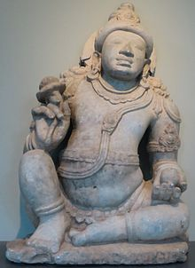
INTRODUCTION
Maniman was a Yaksha, and he was a close friend of Lord Kubera and resides at the Yaksha Loka. He was a friend of Lord Kubera from his childhood, and he maintained a close bondage with him. He was mentioned in divine texts, and his importance and knowledge was also mentioned. He got married and had children. Once playfully he disturbed the penance of a sage, and he was cursed to become a cobra, and after his request, the sage slightly changed his curse, and due to that, during the exile period of the Pandavas, he was killed by Bhima, and got relieved from the curse, and went back to the Yaksha Loka.
He got the powers to visit various worlds and can directly worship the gods and goddesses. According to legend, he used to go along with Kubera to Mount Kailash to visit Shiva Parvati, and would get their blessings. He was talented in all kinds of arts, and used to play Veena and Yazh in a pleasing manner, similar to the Gandharvas, and would praise Lord Kubera and Lord Indra by singing melodious songs on them.
It is believed that he still lives in the Yaksha Loka along with Lord Kubera and leading a happy life.
Let us worship the divine person and be blessed.
“OM SRI MANIMANE NAMAHA”
“OM SRI KUBERAYA NAMAHA”
“OM MATA LAKSHMI DEVIYE NAMAHA”
WRITTEN BY
R.HARISHANKAR

MATA AMBHRINI
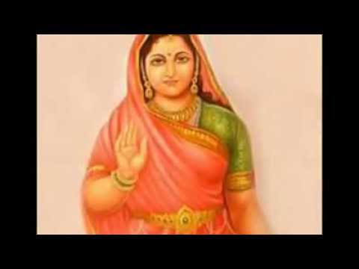
INTRODUCTION
Ambhrini also called as Vak Ambhrini was the daughter of the Rishi Ambhrina. She is a female rishi, and writer of various sacred texts, and she is also mentioned in ancient Vedas, and her greatness is also mentioned.
She is considered as the first and foremost female poet in the world.
Her famous work is called as Vak Sookta, and she is considered as the goddess of poems and literature.
Her poems would tell the beauty of nature, the holy Himalayas, the stunning river Ganges, and the holy rishis, rishi pathnis and many more.
She also sings in praise of Shiva-Parvati, and considered as their great devotee. She used to write beautiful poems within a few minutes, and she has got great talents in penning poems in a remarkable manner.
She was the noted writer of the Vak Sookta which contains a collection of good poems. The Vak Sookta can be read by any one, and it was written in a simple manner, and it praises the beauty, kindness and holiness of the divine mother Parvati.
She was very perfect in taking decisions, and lived a saintly life. After spending her life in a full-fledged manner, she has attained SALVATION.
Let us worship the noble woman saint and be blessed.
“OM MATA AMBHRINI DEVIYE NAMAHA”
“JAI PARVATI PARAMESHWAR NAMAHA”
WRITTEN BY
R.HARISHANKAR

MATA APALA
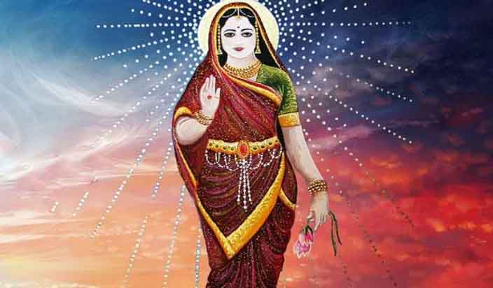
INTRODUCTION
Apala was a noble woman who was mentioned in the ancient Rig Veda. She has got several heath related problems, and due to that, her husband has got separated from her. She was very much worried about the ignorance of her husband, and began to pray to Lord Indra Bhagawan.
After her severe penance, Lord Indra was pleased with her devotion, and gave her a healthy body with an attractive appearance, and considered her as his own daughter. Indra also regained the life of her father, who had lost his life by a demon, and also Indra made her to join with her husband, who was a rishi.
As per the legend, it is believed, that she lived in the Treta yuga, and also met Lord Srirama and Mata Sita, during his exile, and received blessings from them. She is considered as a holy, pure and a chaste woman, who is also considered as an AMSA of Mata Parvati.
After her death, she reached the abode of her foster father Lord Indra, the Indra Loka, and permanently settled there.
Let us worship Mata Apala and be blessed.
“OM MATA APALA NAMAHA”
“OM SRI INDRA BHAGAVANE NAMAHA”
“OM SIVASAKTHI NAMAHA”
WRITTEN BY
R.HARISHANKAR

MATA ARCHI
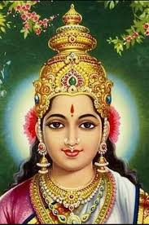
INTRODUCTION
As per the Bhagavatha Purana, Archi was an incarnation of Mata Lakshmi Devi and she was the consort of the great king Prithu, who was considered as an incarnation of Lord Vishnu. She served as a dutiful wife to her husband Prithu, and went along with him to the forest at the final stage of her life, and after the death of her husband, she entered into the funeral pyre of her husband.
King Prithu had got great skills and ruled almost the entire earth through his talents and capabilities. He acted as the near and dear to his country’s people, and behaved with them in a friendly manner. Through his generous rule, mother earth had given all kinds of prosperities to him, and all the food crops were grown properly, and rain was showered in all the seasons, and people were praised his glory and lived a healthy, wealthy and a long life without any difficulties in their life. He also maintained good relationship with all the major rulers, particularly with the Daitya King, Sri Bhakt Prahalad.
Let us praise the divine couple and be blessed.
“OM SRI PRITHU NAMAHA”
“OM MATA ARCHI NAMAHA”
“JAI SRIMAN NARAYANA”
WRITTEN BY
R.HARISHANKAR

MATA KALARATRI
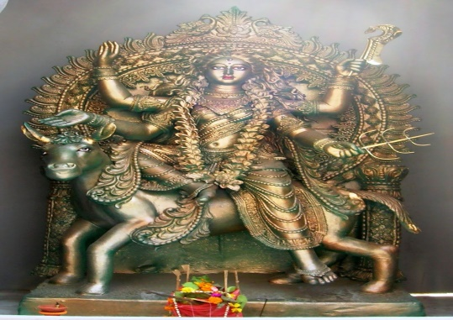
INTRODUCTION
Kalaratri is a form of Mother Durga, and she is mentioned in the Durga Saptashati, in the Markandeya Purana, which contains songs in her praise. Kalaratri is considered similar to Mata Kali, Bhairavi, Chandi and Durga. Kalaratri is also mentioned in the Mahabharata, and she represents the mother of the entire universe.
Kalaratri is mainly worshipped during the Navratri days, and special puja and Abhishekham is performed to her in the temples meant for her. She is the Goddess of destroying the bad ones, and to safeguard the good ones through her supreme powers, and she would dwell in the hearts of the weak and dull persons, and make them to become active. She also is worshipped for getting rid of evil spirits, enemy related problems, black magic and from several dreaded diseases and mental disorders. Ancient Puranic texts, describes Goddess Kalaratri as the guardian goddess, who safeguards the people during the night times from thieves, and removes the fear in the minds of her devotees. She is also worshipped in the form of a chakra, and worshipping the Chakra would give all kinds of prosperities to us.
She was created by Mata Kali and killed the powerful demons Chanda and Munda, in order to save the divine demi gods from their clutches. She looks in a dark form, wears beautiful dresses, and contains a shining and charming face, and her vehicle is a donkey, and contains great energy, and removes the badness from our minds like lust, anger, enmity and fear. She wears a necklace that glitters like the Great Dhurva Star in the sky. She gives the brightness in the life of the devotees, and would change their fate also to some extent, based on their sincere devotion on her.
TEMPLES DEDICATED TO KALARATRI
- Kalratri Temple near Kasi Viswanathar Temple, Varanasi, Uttar Pradesh.
- Kaalratri Temple, Nayagaon, Bihar.
- Kalratri Temple, Vindhyachal, Mirzapur (UP).
Let us worship the divine mother Kalaratri and be blessed.
“OM MATA KALARATRI DEVIYE NAMAHA”
“OM NAMAH SHIVAYA”
“OM MURUGA”
WRITTEN BY
R.HARISHANKAR

MATA KAUSHIKI
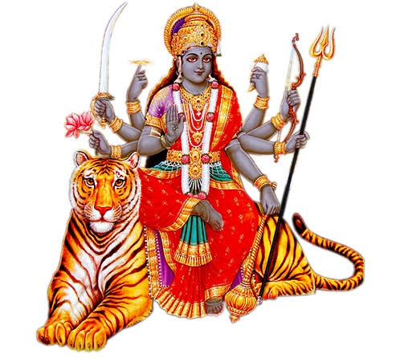
INTRODUCTION
'Kaushiki' is the goddess of education, strength, bravery, beauty, wisdom, courage, chastity, wealth, health and will-power. She was formed from the powers of Mata Parvati Devi. She looks very beautiful and shows kindness to her devotees. She was seated on a tiger, and lot of temples are dedicated to her, and she contains several powerful weapons in her hands.
She is also known as Goddess Ambika as per various Puranas, and showers her grace on her sincere devotees, and she took the avatar mainly to kill the evil minded demons Shumbha and Nishumbha. Her other names are Durga, Ambica, Gowri, Kali, Renuka, Seethala, Bhairavi, Chamundi and Jwala Devi. According to the Devi Mahatmya, her features cannot be completely described, since she contains great powers, and controlling the entire universe, and she was considered as the creator, protector and destroyer, and through her grace only, all the beings in the earth and heaven survive in this universe.
As per ancient legend, Mata Parvati once performed severe meditation to become very beautiful. Due to that, from her body a beautiful goddess was arisen, and she was called as Kaushiki. After that, she went to the Holy Mountain Vindhyas and destroyed the demons, and by destroying them, the demi gods were regained their position and lived happily in the heaven. And they praised Mata Kaushiki with her several names and stotras, and got great powers.
Hence let us worship Mata Kaushiki and be blessed.
“OM SRI VINAYAGAYA NAMAHA”
“OM MATA KAUSHIKIYE NAMAHA”
“OM NAMAH SHIVAYA”
WRITTEN BY
R.HARISHANKAR
MATA KOLARAMMA
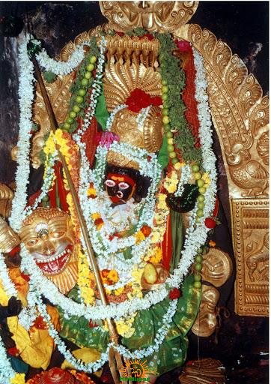
INTRODUCTION
Kolaramma is the divine mother widely worshipped by the people of Kolar in Karnataka, and Kolaramma is the divine incarnation of Mata Parvati Devi. The Kolaramma temple is more than thousand years old and it was built by the Chola kings. Kolaramma is worshipped by the people of Kolar, as their Ishta Devi, Kula Devi and Guardian deity. Lot of Mysore kings were repaired and renovated the ancient Kolaramma temple. The temple is very good in art and architecture, and attracts large number of visitors due to the natural surroundings nearby the temple shrine.
Along with Mata Kolaramma, Mata Chelamma also known as the scorpion goddess is worshipped by the people. People believe that by worshipping Chelamma they would be safeguarded from snake and scorpion bites, and from dreaded viruses. Devotees make their offerings in the hundi kept at the temple inside a pit, and so far, no one has opened the temple hundi and counted the value of the offerings. The Someshwara Temple is a famous Shiva temple which is situated nearby the Kolaramma temple. Special pujas would be performed on Tuesdays and Fridays, and along with that Abhishekham to the deities also would be done.
Saptamatrikas shrine is also located inside the temple premises. The temple is visited by the devotees from all parts of India especially during the months of March and April. The famous Karage Festival is celebrated in favour of Mata Kolaramma during those months.
Lot of devotees have experienced many good changes in their life after visiting this holy temple. People suffering from mental diseases and mental disorders are advised to visit this temple, and to worship Mata Kolaramma and Chellamma, in order to get complete cure from their mental illness.
Let us visit and worship the divine mother.
“OM SRI KOLARAMMAVE NAMAHA”
“OM SRI CHELLAMMAVE NAMAHA”
“OM NAMAH SHIVAYA”
WRITTEN BY
R.HARISHANKAR

MATA NOOKAMBIKA
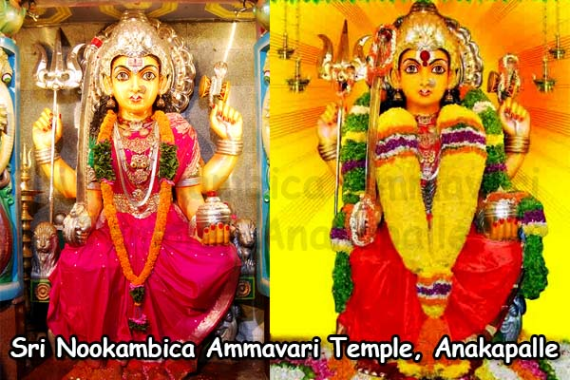
INTRODUCTION
Mata Nookambika is a famous village deity who is having her popular shrine in Anakapalle at Andhra Pradesh.
The main deity of the temple is Mata Nookambika. Sri Appalaraju, a great Shakti devotee built the temple for Mata Nookambika approximately before 450+ years. During Ugadi, thousands of devotees throughout Andhra Pradesh would visit the temple for offering their worship to the divine mother. Amavasya days is famous for worshipping Mata Nookambika. Sri Nookambika Devi is the incarnation of Mata Durga Devi, and the temple was renovated by various kings, and offered their worship to the holy goddess. Daily pujas and Abhishekhams are performed to the divine mother. After the invasion of Mughal kings, for some time, puja was not properly performed at this temple.
But after the defeat of the Mughal rule, and during the period of Hindu Kings, the temple had again attained its glory and got spiritual significance, and puja was also properly performed by the kings. Sunday, Tuesday and Thursday are considered as auspicious days for performing puja and Abhishekham to Mata Nookambika Devi.
Sri Nookambika Ammavari temple is being run by the Endowments Department since 1935. Daily in the noon, free food is offered to the devotees by the temple management. Devotees can donate a sum of Rs.1116 – Rs.100000 and above, in order to participate in the Nitya Annadanam scheme. It is believed that those who worship Mata Nookambika at this temple, would be relieved from their sins, and would get all kinds of prosperities in their life.
Let us once visit this holy temple at Andhra Pradesh and be blessed.
“OM MATA NOOKAMBIKA NAMAHA”
“OM NAMAH SHIVAYA”
WRITTEN BY
R.HARISHANKAR
MATA SARANYU
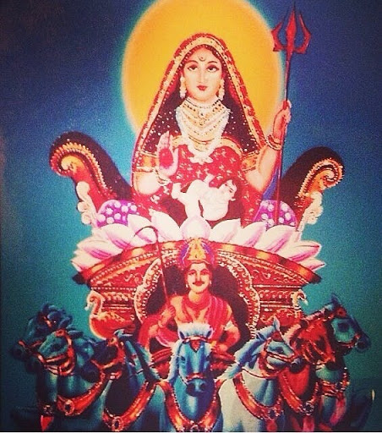
INTRODUCTION
Saranyu is also known as Sanjana and Sandhya is a mother goddess and the daughter of the divine architect, Lord Viswakarma. Saranyu and her sister Chaya are the consorts of Lord Surya Bhagavan.
Children of Mata Saranyu:
- Revanta
- Ashvin Kumaras
- Yama
- Yamuna
Saranyu was mentioned in the ancient Rigveda and was considered as a noble goddess, who showers her grace on to her devotees along with her consort Lord Surya Bhagavan.
Once, she couldn’t bear the heat of Sun god, and hence she created Mata Chaya through her shadow, and went to the earth and performed penance. Initially, Lord Surya was not aware of the incident, and hence he thought that Chaya was his original wife Mata Saranyu, and through their union, the great Judgement God, Lord Shani Dev was born. After some time, Lord Surya got to know about the past incidents, and brought back his consort Saranyu from the earth, and happily living with both of his consorts in the Surya Loka.
Let us worship Mata Saranyu and be blessed.
“OM SRI SURYA BHAGAVANE NAMAHA”
“OM MATA SARANYU NAMAHA”
“OM MATA CHAYA DEVIYE NAMAHA”
WRITTEN BY
R.HARISHANKAR

MATHAJI - SISTER OF BABAJI
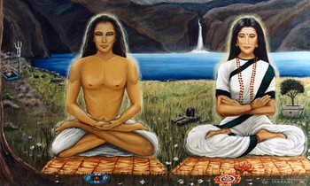
INTRODUCTION
Mataji is considered as the sister of Babaji, and she contains great spiritual powers. Similar to Babaji she lives in a cave in the Himalayan Mountain ranges for more than 2,000 years. The great sage Yogananda was mentioned about Mataji in his famous book “AUTOBIOGRAPHY OF A YOGI”. She is considered as a Shakti aspect, and a great Yogini, and both of them are considered as the divine saviours, who took the avatar in order to introduce the Kriya Yoga concepts and to maintain peace and prosperity in the entire world.
She is believed to have been born in a village in Tamil Nadu and was trained under various siddhars and attained Yogic powers. She is believed to be a great Shiva devotee, similar to the female Shaivite saints like Karaikkal Ammaiyar, Isaignaniyar and Mangayarkarasiyar.
Both of them are considered as the divine child of Shivaparvati, and were sent by them to light the lamps in the lives of their devotees. Mathaji insists her devotees to train in the Kriya Yoga in order to realize the inner self, to attain enlightenment, and to get great spiritual energy in mind and body.
TEACHINGS
- Do frequent meditation on god, and find the good changes in your life.
- Learn the yoga concepts and practice the KRIYA YOGA through a spiritual Yoga Master.
- I am the divine mother to protect you, and don’t worry. Whenever you find face any difficult situation in your life, immediately call me as “MATHAJI” and I will come to rescue you.
- Be good and act kindly with others.
- Through self-control, we can achieve anything in this world.
- Lead a simple and a straight forward life.
- Don’t commit sins in your life.
Let us worship the great Mathaji and be blessed.
“OM SRI BABAJI NAMAHA”
“OM SRI MATHAJI NAMAHA”
“JAI PARVATIPARAMESHWAR”
WRITTEN BY
R.HARISHANKAR

MITRAVINDA IN THE BHAGAVAT PURANA
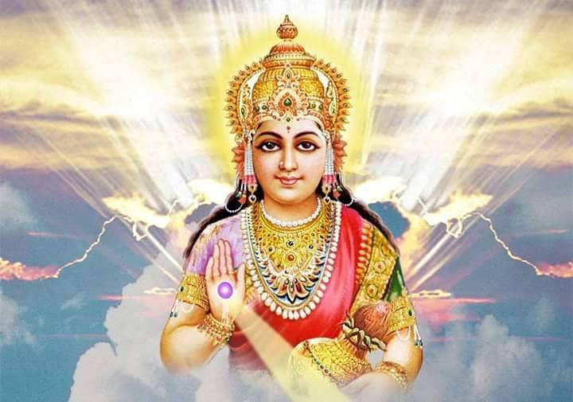
INTRODUCTION
According to the Bhagavata Purana, Mitravinda is one of the holy queens of Lord Krishna, who lived in the Dwapara Yuga, and she was the daughter of the Avanti King Jayasena.
Mitravinda was also mentioned in the Vishnu Purana, and she is considered as an incarnation of Mata Lakshmi Devi. She got married with Lord Krishna in the Swayamvara. But her brothers were doesn’t like her to get married with Krishna, since they wants their sister to get married with Duryodana, and they fought with Krishna and they were defeated by him. Mitravinda and Krishna were sincerely loved with each other, and as per her wishes, Krishna took her to his kingdom of Dwaraka and married her.
Mitravinda was considered as a close friend of Mata Draupadi and whenever she meets her, she would interact with her in a nice manner.
The Bhagavata Purana tells that Mitravinda had ten sons from Lord Krishna. After the death of Lord Krishna it is believed that she has entered into the funeral pyre of Lord Krishna, and self-sacrificed her life.
Let us pray to the divine mother for our well-being and be blessed.
“OM MATA MITRAVINDA DEVIYE NAMAHA”
“JAI KRISHNA”
“JAI BALARAMA”
WRITTEN BY
R.HARISHANKAR

MONGOOSE IN HINDUISM
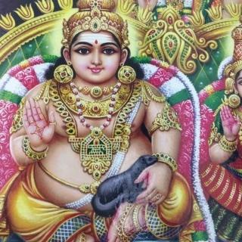
INTRODUCTION
Mongooses are very good mammals, who would be usually found in the forests, and they are considered as the worshipful creatures in Hinduism. Compared with foxes and wolves, Mongooses are very kind animals, and they never harm us. They can be tamed and even brought up in our homes, but according to wild life Act, it is not possible. We can see them only in the zoos, villages and in the dense forests. It is believed that by seeing or holding mongooses in our hands, we would get good fortunes in our life, and also we would become rich, since mongooses are considered as the beloved vehicle of Lord Kubera, and he is usually depicted with a mongoose.
According to one panchatantra story, once there lived a family in a village consisting of the husband, wife and their small child, and they are also having a pet mongoose. Once the wife went to the farm land and after finishing the work, she returned to her home. And at that time, she saw the mongoose which was covered with full of blood in its mouth, was standing in the outside of the home. Mistakenly, she thought that the mongoose had killed her child, and hit the noble animal with a stone and killed it, and afterwards, she hurriedly went inside the home, and found that her child was peacefully sleeping in the cradle, and a poisonous snake was lying dead in a pool of blood. She was very much upset and realized her mistake and prayed to the almighty to forgive her sin. Based on this lovely story, we can see how much loyalty the small creature had shown to its masters, and how affectionate was the gentle animal!
Hence, whenever we have a chance to visit the zoo, after getting the permission from the zoo authorities, let us provide some food items to the mongooses, in order to make its master Kubera to shower his grace on us, and let him gives us good health, wealth and a peace of mind.
“OM SRI LAKSHMI KUBERARE NAMAHA”
WRITTEN BY
R.HARISHANKAR
NAYANMARS AND ALWARS
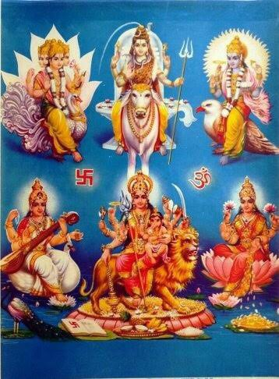
INTRODUCTION
Nayanmars are the shaivite saints who lived a few thousand years ago. They are the ardent devotees of Lord Shiva, and they found Shiva in their each and every body cell, and worshipped him with great bhakti. They crossed many hurdles in their life, and they are tested by Lord Shiva, in order to bring out their purity, and to show their great devotion to the entire universe. Each and every Nayanmar saints are tested in a different manner, and they passed in the divine tests successfully, and finally reached the abode of Lord Shiva, Mount Kailash. The divine texts Thevaram tells the devotion of the Nayanmar saints, and contains the greatness of Lord Shiva. The Nayanmar saints preached the importance of Shaivism among the people, visited holy temples throughout India, and also cleared the sins and diseases of the people through the grace of Lord Shiva.
Similar to them, the 12 Alwars are also suffered a lot during their life time, and had staunch faith on Lord Vishnu during their toughest times. They have praised Lord Vishnu in their holy text “DIVYA PRABANDAM”, and it contains divine songs in praise of Lord Vishnu. Still the songs from “DIVYA PRABANDAM”, is being played in the Vishnu Temples, especially during the Margazhi month which falls on December – January. Alwars though contains divine powers, didn’t utilized it for their own use, and utilized it only for the welfare of the people. They relieved the diseases of the people, invoked the VISHNU BHAKTI SPIRIT among the people, and written several divine texts in praise of Lord Vishnu.
From the life of Nayanmars and Alwars, we have to cultivate the bhakti on the deities, and must adopt it regularly. Though we cannot entirely live like them, at least, by reading their divine texts, we can slowly develop the bhakti spirit on the gods and goddesses. Without the grace of the god, we can’t survive in the present “KALI YUGA”, and let us praise the glories of Brahma, Vishnu and Shiva and be blessed.
“OM”
WRITTEN BY
R.HARISHANKAR

OM SWAMI
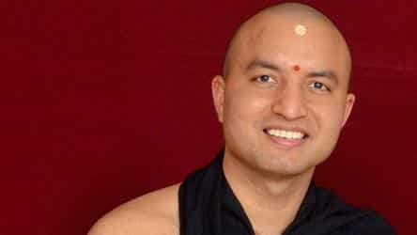
INTRODUCTION
Om Swami is a saint and wrote several books on Yoga, Meditation and Hinduism. His books are written in a modern style, and were very impressive among the youngsters.
Swami was born in North India in the year 1979 in a pious Hindu family. Swami studied Vedic and astrology, and served as an astrologer for a few years. After some time he went to foreign countries for teaching Vedic subjects and yoga to the students. And he also started businesses in various foreign countries, and become a successful businessman.
However, in the year 2010, the great Swami had abandoned his wealth and went to Kashi, and become a saint. He performed severe meditation in the caves of Himalayas for more than a year. During the period of meditation, he took only simple food, and derived great powers through his meditation.
WORKS
- If Truth Be Told
- The Big Questions of Life.
- The Book of Kindness.
- The Heart of Success.
- The Children of Tomorrow.
- The Hidden Power of Gayatri Mantra.
- Mind Full to Mindful.
- A Fistful of Wisdom.
- The Ancient Science of Mantras.
Let us praise the great saint and be blessed.
“OM SWAMI JAI SWAMI”
WRITTEN BY
R.HARISHANKAR

ORPHANAGES AND OLD AGE HOMES
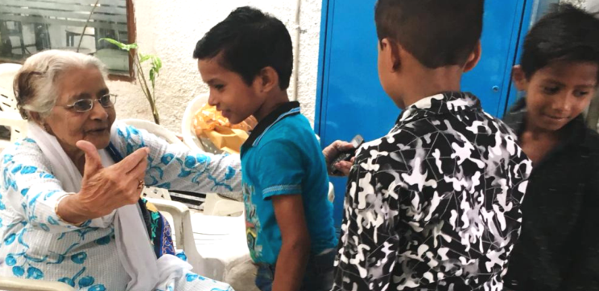
INTRODUCTION
Orphanages would consist of abandoned children, parentless children and children from very poor background. Generally, orphanages would be run by service oriented charitable and non-profit organizations whose motto will be to provide good service to the helpless children. Orphanage institutions mostly run with the donations received from the kind hearted people. Children would be provided with good food, and they will be given proper education also. Regular prayers and meditation would bring some sort of mental peace to the young children, and it will remove the stress from their mind. Some Institutions are helping their children to pursue for higher professional courses like B.E, M.B.B.S etc.
Those who give lot of troubles to their affectionate parents and harming them by verbally and by physically, would be born as an orphan in their next birth, and would not get their parents affection, throughout their life.
Similar to orphanages, lot of elderly people are getting admitted in the old age homes, mainly due to the carelessness of their children. After the children get married, and have their own children, they are losing interest with their parents, and finding them as a burden for them. Slowly they would hurt them by words, and sometimes, they may also attack them physically, and admit their parents in the old age homes. Those children would never think about the future of their parents, but would think about their own pleasure only. The parents will have no other go, expect to stay in the old age homes, and live their lives till their end. The old age people would affectionately interact with the orphaned children, and treat them as their own grandson/granddaughter. The young ones also share their love to their affectionate abandoned grandparents.
The children must think about their parents, and must realize that things may change unfavourably for them also. Similar to them, their children also may admit them in the old age homes, in the future. They also have to face severe consequences in the future for their wrong doing. Since, no one can escape from the watchful eyes of the god.
Let us pray to the almighty to give boldness, courage and wisdom to the abandoned old ones and the young ones.
“OM”
WRITTEN BY
R.HARISHANKAR

PADMA PADAR
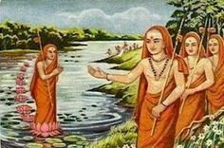
INTRODUCTION
Padma Padar was born before few thousand years in India, in a pious Brahmin family, and he was considered as the main disciple of Sri Adisankara, and he has done lot of service to his Guru. Once when he was drying the clothes in the other bank of the river, he was suddenly called by his Guru. Without thinking about the water in the river, he immediately tried to cross the river. To his surprise, for his each and every step, a lotus flower was formed, and safeguarded him from drowning in the river water, till he reaches the other end of the river. He got such a kind of great Guru Bhakti, which we cannot imagine in this today’s selfish world.
He also participated in the debates with the scholars and won in the debates and got lot of prize money for that, but he distributed it to the poor people. He helped his guru in his spiritual works, and sincerely served as a devotee, disciple and an attendant to his Guru. He went to many holy places along with his guru, and got the divine darshan of the deities. Once when he was in Kasi along with his Guru Sri Adisankara, he got the divine darshan of Shiva-Parvati and Kala Bhairava, and got their blessings. He also helped his guru towards spreading the Advaita Vendanta, and preached the importance of Lord Shiva among the people, and spread the “SHIVA BHAKTI” spirit throughout India. According to him, Lord Shiva is the one, who can protects and safeguards us from all sorts of problems, and he would come with us in our every walk of life, based on our true bhakti on him. He obediently served his master for many years, and after his death, he reached the abode of Lord Shiva, the Kailasa.
Let us worship the great saint and be blessed.
“OM SRI PADMA PADARE NAMAHA”
“OM SRI ADI SANKARARE NAMAHA”
“OM NAMAH SHIVAYA”
WRITTEN BY
R.HARISHANKAR
PARROT IN HINDUISM
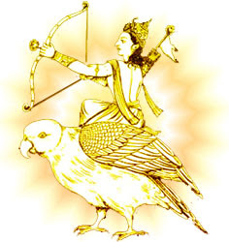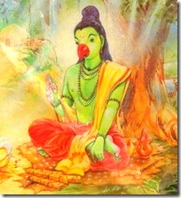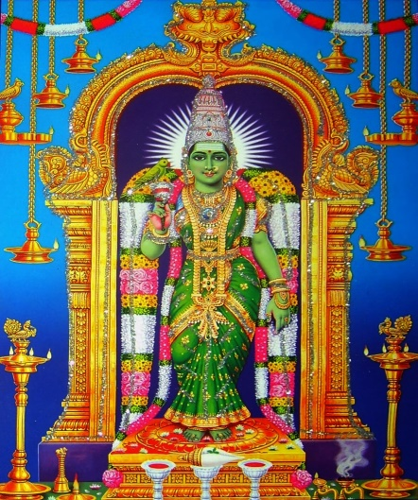
INTRODUCTION
Parrots are lovely birds, and they are strongly associated with Hinduism. Lord Kamadeva also called as Manmadan and his vehicle is a parrot, the great Sukha Maharishi contains parrot head and Mata Meenakshi Amman at Madurai is holding a parrot in her right hand. Parrots are used for astrology purposes also, and generally the road side astrologers would keep it for their business. The main enemy of parrot is cat, and parrots are also attacked by eagles. Parrots contain very good knowledge, and they would repeat our sayings, and contains a good voice and good memory power.
Parrots usually live up to 20 years, and it depends on their living place. It is not advisable to put the parrots in cages, since it always prefers to live independently. Parrots can be found in the gardens of those devotees who worship Mata Meenakshi Devi, and the great Sage Sukha Brahma Maharishi. It can be fed with fruits, nuts and pulses. We can keep some fruits and water in the open terrace of our houses, so that the parrots would come regularly and have its food. By providing food items to the parrots, we would be blessed by the great sages, gods, goddesses and the demi gods in the heaven.
Hence let us try to serve the parrots, and be blessed.
“OM MATA MADURAI MEENAKSHI AMMANE NAMAHA”
“OM SRI SUKHA BRAHMA MAHARISHIYE NAMAHA”
“JAI SRI KAMADEVARE NAMAHA”
WRITTEN BY
R.HARISHANKAR

PEACOCK IN HINDUISM
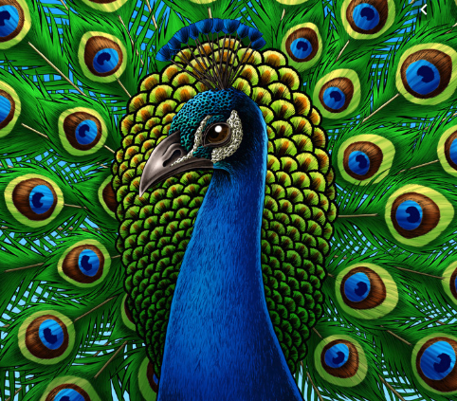
INTRODUCTION
The Peacocks are beautiful birds, and lives in the dense forests, bird sanctuaries and zoo. They are mentioned in Hindu Puranas, Vedas and ancient texts, and peacock is the divine vehicle of Lord Muruga. Peacocks are loveable creatures, who would give best fortunes in our life. By hearing its voice, and by seeing the dance, we would forget our worries and tensions, and we would become cheerful.
Peacock is also considered as the divine vehicle of goddess Lakshmi and Saraswati. It is known as Mayura, and Guru Ramana kept some peacocks at his ashram, and it is believed that, after their death, due to the grace of Guru Ramana, they had attained SALVATION. In Kanda Purana, Lord Muruga defeated the demon Surapadma, only by seating in his vehicle peacock. The holy peacock also destroyed lot of demons through its nose and nails, and brought victory to the great Lord Muruga. Peacocks also considered as worshipful creatures, since they are the blessed ones. In Murugan temples, we can find the idol of Peacock in front of the main shrine.
Hence, whenever we see any peacock, let us provide proper food and water to them, and save them from starvation, and by doing the noble act, we would be blessed by the divine gods in the heaven.
Let us worship Lord Mayura, the divine vehicle of Lord Muruga, and be blessed.
“OM SRI MAYURA NAMAHA”
“OM MURUGA”
WRITTEN BY
R.HARISHANKAR

PIDARI AMMAN
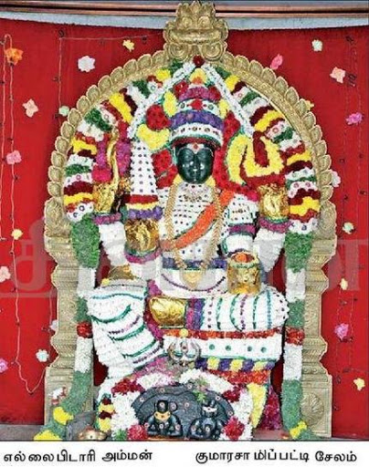
INTRODUCTION
Pidari Amman is a popular deity mostly worshipped by the people of South India. She is said to be the incarnation of Kali, and the deity of Mata Pidari Amman looks attractive, and smiles at us, and gives her immense blessings on us. She holds the trident and weapons in her hands, and blesses us in her right hand. She is the mother goddess who gives immediate relief from several dreaded diseases to the sincere devotees. She removes the evil spirit from our mind, and would cleanse our mind, and gives fresh energy and a new life for us.
Mainly Pidari Amman is worshipped in small villages, and in towns, some big temples are dedicated to her, especially in Salem, where large number of devotees would visit the holy shrine during the Adi month, and offer kuzh and pongal as neivedyam (HOLY PRASAD). She has been worshipped since 8th century AD, and she was worshipped by the Chola Kings, and they built temples for her. She reduces the ill effects of the planetary positions, especially those who suffer from Sani Dosham and Chevvai Dosham. It is advisable to visit the temple of Pidari Amman especially during Tuesdays and Fridays, and can perform Puja and Abhishekham to the divine mother in order to get all kinds of goodness in our life.
Let us worship the holy mother and be blessed.
“OM SRI PIDARI AMMANE NAMAHA”
“OM NAMAH SHIVAYA”
“OM SRI VINAYAGARE NAMAHA”
WRITTEN BY
R.HARISHANKAR

PIG IN HINDUISM
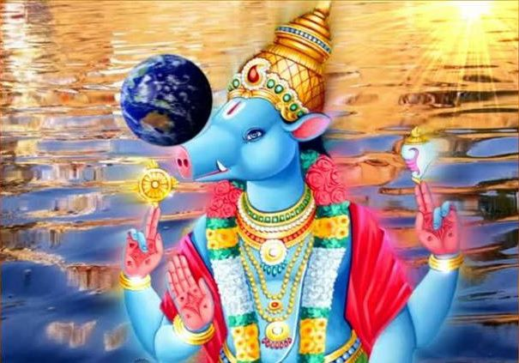
INTRODUCTION
Pigs are worshipful animals according to Hinduism, since pigs contain the features of Lord Varaha, an avatar of Lord Vishnu. Once the demon, Hiranyaksha had thrown the earth into the ocean, and due to that, Lord Vishnu took the Varaha Avatar, and fought with the demon, and brought back the earth from the ocean, and placed the divine earth goddess, Bhudevi into the original position.
Pigs are classified as black and white in colour. Black pigs looks very ugly, and used to eat dirty things, whereas, most of the white pigs are reared by the people in the villages, and used to keep them in their gardens or in pig shelters, and provide them vegetables and fruit wastages as food for them. After they have grown up, they would be killed for the purpose of meat, and it would be consumed by some pork meat lovers. But in general, pigs are not meant for killing for meat, since it resembles the divine avatar “Adi Varaha Perumal”, and having the meat of the white pork, would make the Varaha avatar to get angry on us, and he would punish us severally. Pigs are mentioned in ancient texts, and they are considered as holy and pious. They got great power, and sometimes, they would fight with the wild animals like tiger and lion for safeguarding themselves from their fierce attacks.
Pigs can be provided with food wastages and can be brought up by us with much care and attention. By adopting a pig at our home, would give all kinds of prosperities to us, and our life would become brighter. By showing kindness on pigs, we would get the divine blessings of Mata Bhudevi also. Those who give respect to the pigs, and treat them properly, would be blessed by the divine gods in the heaven.
Let us praise Lord Varaha Bhagavan and Mata Bhudevi and be blessed.
“OM SRI VARAHA SWAMIGALE NAMAHA”
“OM MATA BHUDEVIYE NAMAHA”
WRITTEN BY
R.HARISHANKAR
POLLUTION OF HOLY RIVERS
INTRODUCTION
Holy rivers like Ganga, Yamuna and Godavari are getting polluted day by day. Holy rivers are dwelling in this earth for clearing our sins, and giving goodness to us. But people are not thinking about that, and creating lot of pollution. They are washing the clothes in the banks of the holy rivers, and even some children are using the sacred rivers as toilets. By doing all sort of these things, the river goddesses would get angry with the people, and they would curse them.
The concerned authorities must take necessary actions and must avoid the people from polluting the rivers. Those people who pollute the holy rivers must realize that rivers are not only the water contents, but the great divine goddesses who came down to the earth from the divine worlds, only for serving us. The authorities have to lay down fine amount to those who try to pollute the rivers. Since keep on doing such an activity would result in the entire destruction of the world, since all the holy river goddesses are considered as the divine incarnations of Mata Parvati Devi.
Once, the great King Bhageeratha had performed severe penance and brought down river Ganga to the earth from Mount Kailash, and though he has done such an act for the liberation of his ancestors, the holy river ganga is still providing all sorts of prosperities in our life, and just by chanting her holy names itself, people would get liberated from their sins, and through the sprinkling of Holy water from the river Ganga, people would attain SALVATION. Similar to that Mata Yamuna also cleanse our sins, and removes the death fear from our minds, since she is the affectionate sister of the death god Yama. Mata Narmada contains good features, and bathing in the holy river Narmada would reduce our bad karmic deeds, and make us pure.
Hence let us try to keep the Holy Rivers clean and let us worship the great river goddesses and Lord Varuna Bhagavan and be blessed.
“OM SRI GANGA MATA NAMAHA”
“OM SRI VARUNA BHAGAVANE NAMAHA”
“JAI SADASHIVA”
WRITTEN BY
R.HARISHANKAR

PREM CHANDRA
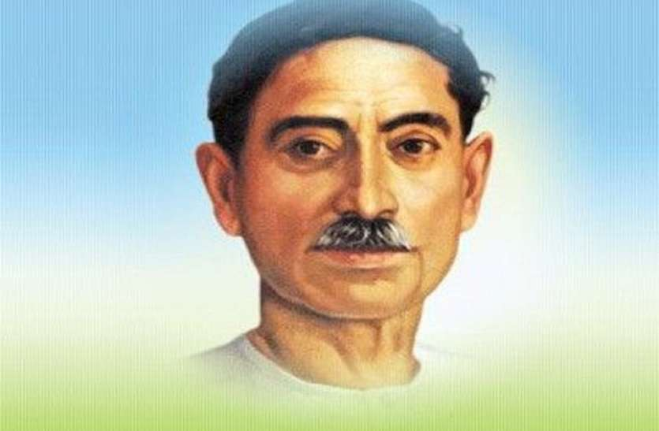
INTRODUCTION
Premchandra (1880–1936), was a famous Hindi writer and considered as one of the leading writers of India. His novels includes Godaan, Karmabhoomi, and Mansarovar, which explains the important of providing food to the cows, and also the importance of visiting and worshipping the holy Mountain Kailash Mansarvar, in order to get relieved from our sins. Apart from these works, he has published lot of short spiritual stories for the benefit of the young children. His birth name was Dhanpat Rai Shrivastava.
He used to write scripts for Drama and wrote famous novels, and he was awarded the title of “THE MAGNIFICIENT WRITER” by the readers. He wrote about social service issues, and insists the readers to actively participate themselves in doing social service works.
He was born in the year 1880 in a village located near Varanasi into a holy Kayastha family, who are the worshippers of Lord Chitra Gupta, the divine accountant of Lord Yama Dev.
After the death of his mother, he was brought up by his stepmother from whom he has not received proper care.
He was married at his teenage, and he was not that much interested in marriage life, due to his great interest in writing books and in spirituality.
Before becoming a great writer, he worked as a teacher in a school and educated the young boys and girls in a proper manner.
After serving the society for many years, he died in the year 1936.
Let us honour the great person.
“JAI SRI PREM CHANDRA”
“JAI KRISHNA”
“JAI SRI RAM”
WRITTEN BY
R.HARISHANKAR

PUSHPADANTA
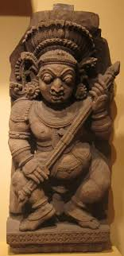
INTRODUCTION
Pushpadanta was considered as one of the Lord Shiva’s chief divine attendants. He attained the position after performing severe penance on Lord Shiva.
Once he served as a temple priest at a Shiva temple in North India. Suddenly, he heard the voice of the divine from the main shrine of the temple, and he hid himself from the eyes of others, and heard the discussion between Lord Shiva and Parvati.

Shiva was telling wonderful stories to Mata Parvati inside the main shrine of the temple, and after hearing the stories, Pushpadanta went back to his home and communicated the incident to his wife and asked her not to disclose the secret to anyone. But his wife Jaya immediately communicated the details to her neighbours, and as a result Shiva and Parvati got very angry with Pushpadanta, and they have cursed him
to become a ghost, and due to that, he took the form of a ghost, and began to wander everywhere. But due to his past birth good karmas, even after taking the form of a ghost, he began to chant the Shiva Mantra “OM NAMAH SHIVAYA” continuously. Due to that, after few years, he got liberated from the curse, and Shiva-Parvati had appeared before him, and changed his form, and took him to the Shiva Loka, and he became a divine attendant of Lord Shiva.
Let us worship the great Shiva Gana and be blessed.
“OM SRI PUSHPADANTARE NAMAHA”
“OM NAMAH SHIVAYA”
“JAI PARASAKTHI ANNAIYE NAMAHA”
WRITTEN BY
R.HARISHANKAR

RANGANATHANANDA
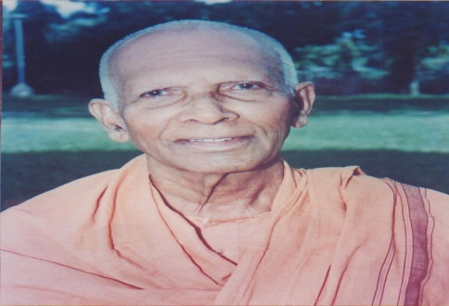
INTRODUCTION
Ranganathananda (1908–2005), was a saint and served as the president of the Ramakrishna Mission. His birth name was Shankaran Kutty.
Ranganathananda was born in the year 1908 in a village near Trichur, in Kerala to a pious Hindu family. He was impressed by the teachings of Swami Vivekananda and joined in the Ramakrishna Mission at Mysore centre. He has become a saint in the year 1933, and he served in the Rangoon and Karachi branches of Ramakrishna Mission.
He performed discourses on the Bhagavad Gita and Bhagavatham, and his discourses were attracted even by big politicians, and praised him for his great knowledge in the Hindu texts. He also gave lectures on Islam and he was widely praised by the Islamic brothers.
He served in various branches of Ramakrishna mission situated throughout India, and spread the “BHAKTI SPIRIT” among the people.
Ranganathananda has received many awards for his great contribution in Hinduism. He also visited foreign countries, and gave divine lectures and explained the goodness of Hinduism and the teachings of Vivekananda and Ramakrishna. He served as a teacher in the Vedic schools and wrote lot of spiritual books, and his books were published, and won the appreciation of thousands of people.
Raganathananda spent his last years in the Ramakrishna Mission at Belur in West Bengal. He died at Kolkata, in the year 2005.
FAMOUS TEACHINGS
- Live your life as per the sayings of the great saints.
- When you live in this world, try to establish your name, and make the people to remember you even after your death.
- If you are an unhealthy person, pray frequently to the god, and one day you would be healed from your health problems.
- Bow your head before the divine master, and thank him every day for giving you a good life.
- Life would not always be smooth. Things will be keep on changing, and try to live in this world, by your noble deeds, and with your sincere faith on god.
- Read the spiritual books and fill up with full of spiritual energy and spiritual thoughts in your mind.
- Nothing can be achieved by simply sitting in your home, and keep on praying to the god, work hard and simultaneously pray to the god for your goodness.
Let us worship the great saint and be blessed.
“OM SRI RANGANATHANANDARE NAMAHA”
“JAI KRISHNA”
WRITTEN BY
R.HARISHANKAR

RAVI SHANKAR
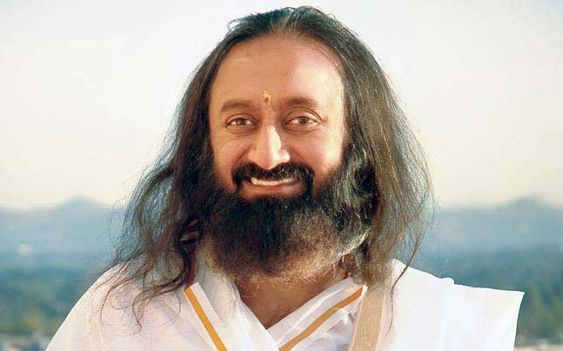
INTRODUCTION
Ravi Shankar is a famous spiritual Guru. He is referred to as Gurudev. He founded the Art of Living Foundation in 1981, in order to provide social support to the people. In 1997, he established a charitable institution for the welfare of the society.
Ravi Shankar was born in the year 1956, in Papanasam, Tamil Nadu, to a pious Hindu family. After finishing his graduation, he spent his time with Sri Maharishi Mahesh Yogi, and helped him in establishing Transcendental Meditation and Ayurveda centres.
In the 1980s, he travelled throughout the world, in order to spread the spirituality among the people. He is good at yoga and meditation.
In the year 1983, he started the Art of Living course in Switzerland, and he also travelled to other foreign countries and taught the ways of living a peaceful life to the people.
According to Sri Ravi Shankar, spirituality is not limited to any one religion or culture, and it is open to all people, and he is against caste discrimination, and he treats all classes of people as alike, and gave much respect to them.
According to him, science and spirituality must be interlinked with each other. His teachings are simple and straight forward in nature, and he used to give various examples from the divine texts, while discussing about spiritual matters.
He visited many foreign nations and inaugurated Art of Living centres.
He received many awards for his wonderful service to the entire world.
WORKS
- Buddha.
- The Wisdom of the Upanishads.
- Narada Bhakti Sutra.
- Hinduism & Islam.
- Patanjali Yoga Sutras.
- Ashtavakra Gita.
- Management Mantras.
Let us praise the talented guru and be blessed.
“JAI GURU RAVI SHANKAR”
WRITTEN BY
R.HARISHANKAR

RISHI AUPAMANYAVA
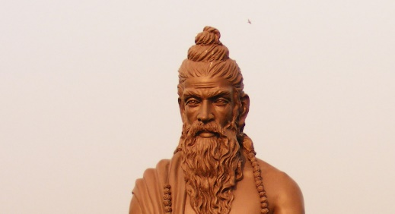
INTRODUCTION
Rishi Aupamanyava is an ancient Vedic scholar and a Rishi, and he was mentioned in the Sama Veda, and he had contributed some portions of texts in the Sama Veda. He is an ardent devotee of Lord Shiva, and used to perform meditation in his Ashram. He wrote lot of devotional texts in palm leaf manuscripts.
He was the descendant of the well-known Upamanyu Maharishi, and considered as a pious and a holy person. Rishi Anandaja was the disciple of Rishi Aupamanyava, and Rishi Madragara was the Guru of Aupamanyava. He had large number of disciples and properly guided them in the spiritual path.
According to the Mahabharata, He appeared along with his descendent Upamanyu, and blessed the Pandavas before the Kurukshetra War, and they also met Lord Krishna, and received his blessings. He lived a meaningful life, and done lot of good things in his life.
Upamanyu is one of the Gotras of the Hindu Brahmins living in some parts of Nepal and Jammu & Kashmir.
Let us worship the great rishi Aupamanyava and be blessed.
“OM SRI AUPAMANYAVA NAMAHA”
“OM SRI UPAMANYUVE NAMAHA”
“JAI KRISHNA”
WRITTEN BY
R.HARISHANKAR

RISHI DEVALA
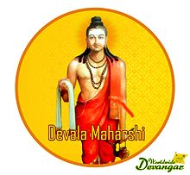
INTRODUCTION
Rishi Devala is one of the ancient rishis. As per the ancient texts, he is compared similar to the great devotees like Prahalada, Dhuruva, Narada and Tumburu with regard to his Bhakti on Mata Chowdeshwari Devi, an incarnation of Mata Parvati Devi. Rishi Devala is the founder of the Devanga community, and he was the first weaver, who weaves clothes for all. Devala is created from the third eye of Lord Shiva, similar to Lord Muruga, to introduce the system of wearing clothes in our body and also for carrying out the weaving activity in the world.
When Devala was returned from the abode of Lord Vishnu after getting the necessary clothes from Lord Vishnu, he was attacked by fierce demons. Devala prayed to Mata Parvati Devi to protect him. Devi Parvati appeared before him, and she killed the demons. Devala worshipped the divine mother, by chanting various slokas. And, Mata Parvati was named as Chowdeshwari Amman, and blessed Rishi Devala. It is believed that Devala went to Himalayan Mountain ranges, and constructed an Ashram, and gave new clothes to the divine deities and to other humans, in order to cover their body. Since Devala had given clothes to the Divine Devas, his community is named as Devanga Community.
He married Suryadev's sister and Aadhi Shesha's daughter. People who follow the Devala sect are known as Devangar. The main god for Devala community is Mata Chowdeshwari Amman, and their spiritual guru is Rishi Devala. His descendants are called as Devanga, and the Devanga community people mostly lives in Southern and Northern parts of India.
Let us worship the holy rishi and the divine mother and be blessed.
“OM SRI RISHI DEVANGARE NAMAHA”
“OM MATA CHOWDESHWARI AMMANE NAMAHA”
“OM NAMAH SHIVAYA”
WRITTEN BY
R.HARISHANKAR

RISHI DIRGHATAMA
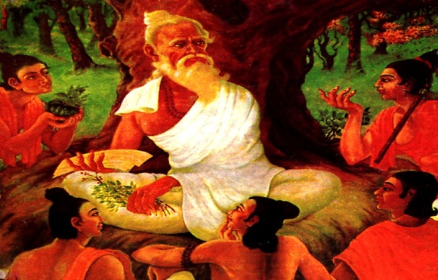
INTRODUCTION
Dirghatama was an ancient sage and was mentioned in the Rig Veda. He was the author of several hyms mentioned in the Rig Veda. And it is believed that by birth, he was blind. He was the descendent of Maharishi Angirasa, and he was the son of Utathya, who was the brother of the Deva Guru Brihispati. He was considered as an ardent devotee of Lord Shiva, and gained lot of spiritual powers, through his constant meditation on Lord Shiva. He was a kind person, and contains very good qualities, and was very much worried about the sufferings of the people in the earth.
He served as a chief priest of King Bharata, who was an able ruler and he was the founder of our country Bharat, also called as India. Pithamaga Bhishma during the Mahabharata war narrates the story of Dirghatama to the Pandavas.
FAMOUS SAYINGS
- Let me remain alive permanently, and let the death god, Yama doesn’t approach me.
- Let me educate many people in Vedic subjects, and make them into bright scholars.
- Let the power gained from my meditation would help me in difficult times.
- Let me make the people in the earth to live a hunger free and disease free life.
- Let everyone in this earth, live their life happily and peacefully.
- Let me share my good karmic deeds, among the sinful people, and let them get relieved from their sorrows.
- Let me spread the Shiva Bhakti among the masses.
- Let me teach good things even to the common people, and make them into blessed ones.
- Let me remove the mental and physical diseases of the people in the earth, and let them live without any troubles in their life.
“OM NAMAH SHIVAYA”
WRITTEN BY
R.HARISHANKAR
RISHI GRITSAMADA
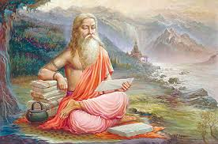
INTRODUCTION
Gritsamada is an ancient rishi, who was mentioned in the Rigveda and his son was Kurma. Gritsamada comes under the lineage of Rishi Bhrigu. He lived at an Ashram in the present day Varanasi, near the banks of the Holy River Mata Ganga, and performed meditation on Lord Vishnu, and attained great powers. He was a great devotee of Lord Vishnu, and his contributions were included in the Rig Veda. He got large number of disciples, and he delivered good teachings to them, which was mentioned in the ancient Puranas. After living a noble life for many years, he went to the Rishi Mandala, and he would be living there till the end of this Kali Yuga.
FAMOUS TEACHINGS
- Moksha can be attained only by proper meditation.
- Lord Vishnu is the Main god, and he is the creator, protector and destroyer, and all the other gods are controlled by him.
- Only by leading a simple and pious life, one can get the glory of the god.
- Always keep thinking about god, and behave with others in a kind manner.
- Don’t kill animals and other living beings in the earth.
- Try to be selfless and don’t be selfish.
- There would be several rebirths in your life, unless you dedicate yourself in the service of the god.
- Don’t enjoy by seeing the wealth around you. Try to achieve the everlasting wealth, by frequently chanting the names of Lord Vishnu.
- Remove the bad habits from within you, like lust, anger and fear, and generate good behaviour.
Let us worship the great Rishi and be blessed.
“OM SRI RISHI GRITSAMADARE NAMAHA”
“OM SRI LAKSHMI NARAYANAYA NAMAHA”
WRITTEN BY
R.HARISHANKAR
RISHI RAIKVA
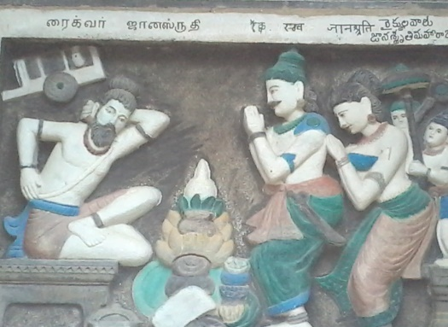
INTRODUCTION
Raikva was a bullock cart driver, and through his dedicated involvement in spirituality, he has become a great rishi, and guided many people in the spiritual path. He was mentioned in Vedas, Upanishads and divine texts. He is considered similar to the great rishis like Bhrigu, Vasishta and Marisi.
He contains very good qualities, than the other rishis, and he used to show kind attitude over others, and used to change the bad ones into good ones, through his mesmerizing speech, and he never hated others. He is considered as a philosopher of ancient Hinduism, and taught the divine knowledge to the great King Janasruti. His teachings to his disciples are very famous, and would act as a guide to the spiritual seekers.
He was praised for his good behaviour even by the animals and birds, and they would describe his importance in their own language. After hearing about his greatness from the creatures, many great kings were become ardent devotees and disciples of Rishi Raikya.
TEACHINGS
- The entire world is controlled by the five Pancha Bhootas, they are, the earth, water, fire, air and sky. And we must worship the Bhudevi, Lord Varuna, Agni Bhagavan, Vayu Devar and Dyaus, the great sky god, for our goodness.
- Consider that all the divine demi gods are equivalent to the supreme gods and goddesses, and they are doing their duties properly, example, Surya Bhagavan, Chandra Bhagavan, Nava grahas and the celestial stars such as Rohini star and Dhuruva star etc. Chant the names of the demi gods also, similar to chanting the names of gods.
- Don’t think you are the powerful person and don’t commit sins. You are surrounded by millions of divine devas who are watching your day to day activities, and reporting it to the respective gods.
Let us worship the great rishi and be blessed.
“OM SRI RISHI RAIKYA NAMAHA”
“OM SRI GANESAYA NAMAHA”
WRITTEN BY
R.HARISHANKAR

RISHI SANKRITI
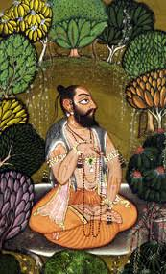
INTRODUCTION
Rishi Sankriti is the founder of the Sankriti Gotra. Sankriti is the grandson of Sage Vashishta, and the son of Sakti Maharishi. He was an ardent devotee of Lord Shiva, and performed severe penance in the Himalayas at his Ashram, and gained superior powers. He was mentioned in ancient Puranas and Upanishads, and Lord Dattatreya had taught the divine subjects to him. Those who are having the Sankriti Gotra are considered as the descendent of Sankriti Maharishi.
TEACHINGS
- Live your life as per the teachings given by the saints.
- Strictly follow the philosophies of Hinduism.
- Do proper services to the people, and help the sick and poor persons.
- God can be seen only by proper bhakti and constant meditation.
- Don’t lose your faith on god, and have the mental strength in order to face any kind of challenges and difficulties in your life.
- Life is not a bed of rose, and you have to work hard to survive in your life.
- Consider all the people as your friends, and behave with them in a gentle manner.
- Be generous, kind and noble towards others.
- Forget about the past things in your life and think only about your present and future life.
Let us worship the great rishi and be blessed.
“OM SRI SANKRITI MAHARISHIYE NAMAHA”
“OM SHIVASAKTHI NAMAHA”
“JAI GANESA”
WRITTEN BY
R.HARISHANKAR

RISHI VARTANTU
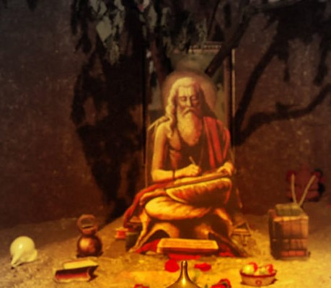
INTRODUCTION
Vartantu was a great rishi who had established a large ashram in Bharuch, Gujarat, for educating the Brahmin students in Vedic subjects. His students were become rishis, and performed penances and reached the divine worlds.
Those who are having Vartantu Gotra, are considered as the descendants of Rishi Vartantu. He was mentioned in Vedas and Puranas, and considered as a noble rishi. He is believed to have been lived before several thousands of years, and lived in the present day Gujarat. He contains good knowledge in Vedic subjects, and contains high spiritual powers. He appeared before the Pandavas, in the forest, during the time of their exile, and consoled them. He also blessed the Pandavas towards winning over the Kauravas during the Kurukshetra battle. He was well known for his teachings, and he was considered as an ardent devotee of Lord Shiva.
FAMOUS QUOTES
- A person who lives a simple life would be a blessed one.
- Read, listen, hear and then teach.
- Forget and forgive.
- Devotion on god only would help in times of difficult situations.
- Never and ever pay evil for evil.
- Praise the glory of the god after all we are all the servants of the god.
- Don’t think you are the doer and achiever. Only god is doing all the activities on your behalf.
- Realize the god within you.
- All the creations made by the god are wonderful.
Let us worship the great rishi and be blessed.
“OM RISHI VARTANTU NAMAHA”
“OM SRI SIVADURGA NAMAHA”
WRITTEN BY
R.HARISHANKAR
RISHI VIBHANDAKA
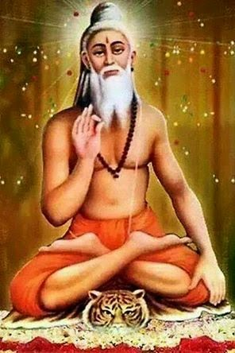
INTRODUCTION
Vibhandak Rishi was a Rishi who comes under Rishi Kashyapa's lineage. His son was Shringi Rishi. Vibhandak was born in the treta yuga, and got good knowledge in Hindu Scriptures. He established an ashram near the Himalayan mountain ranges, and taught Vedic subjects to the students. Along with Vasishta, he also tutored Rama, in Vedic subjects. He was a friend of King Dasaratha, and helped him in discharging his official duties in a proper manner.
He was an ardent devotee of Lord Vishnu, and used the frequently chant the “OM NAMO BHAGAVATHE VASUDEVAYA NAMAHA” mantra. He insists his followers and disciples, to worship Lord Vishnu, in order to attain all sorts of prosperities in their life. He also served as a priest in the palaces of kings, and discharged his duties in a well-versed manner. Through his good advices and suggestions, many kings were praised him, and appreciated his talents. After living for many years, he attained MUKTI.
Let us worship the great rishi and be blessed.
“OM RISHI VIBHANDAKARE NAMAHA”
“OM NAMO NARAYANAYA NAMAHA”
“OM MATA LAKSHMI DEVIYE NAMAHA”
WRITTEN BY
R.HARISHANKAR

ROHIT DAS
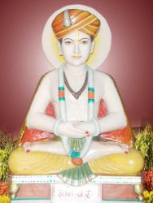
INTRODUCTION
According to ancient legend, Rohit Das was a young sage, who lived in an Ashram situated at the banks of a sacred River. Rohit das, was very much devoted with his parents, and took care of them properly. Due to that, he didn’t get married, and spent most of the time with them. He lived his life, by selling cow’s milk to the people. He was considered as an ardent devotee of Lord Vital, a form of Lord Krishna. He also used to provide food to the poor people, birds and animals, and showed his kindness and gentleness on all the living beings in the earth.
Daily three ugly women would take bath in the river situated nearby his ashram and then would turn into beautiful women. They also would worship Rohit Das, and his parents, and then would return to their respective places.
The beautiful women are none other than the holy Rivers Ganga, Yamuna and Godavari. They are coming to bath in the river situated nearby his ashram, in order to cleanse their sins, since they are getting polluted due to the sins of their devotees. Rohit das was praised by the demi gods in the heaven for his noble deeds, and after his death, he has attained SALVATION.
Let us worship the great person and be blessed.
“OM SRI ROHIT DAS NAMAHA”
“JAI MATA GANGA, YAMUNA, GODAVARI”
“OM NAMAH SHIVAYA”
WRITTEN BY
R.HARISHANKAR

SACRED COW IN HINDUISM
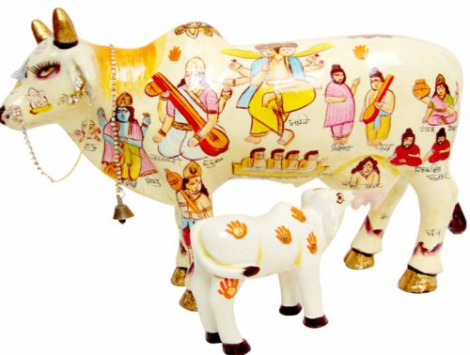
INTRODUCTION
Cow is considered as a very sacred animal in Hinduism, and cows are considered as the incarnations of the divine cow Kamadhenu, who is living in the Swarka Loka, along with her daughter Nandini. Cows are also worshipped as the divine mother Lakshmi Devi, and people would believe that, bringing cows to their homes during the housewarming functions or during the Cow Puja would bring great prosperities in their life. For many years, lot of protests were made against killing the cows for meat. Cows are created by Lord Brahma for doing goodness to the people. Cow products are very helpful for human consumption purpose. Cow urine and Cow dung contains medicinal properties. Cow milk contains rich nutrients, and it strengthens our bones and nerves. During Mattu Pongal festival day, cows and bulls would be properly dressed, and puja would be done to them, and they would be fed with grasses, fruits, greens and cow fodder.
Cows contains good memory power, and they would remember their master, even after a long separation, and it the owners approach and call it by mentioning the name, it would immediately come closer to their master, and would nod its head. Cows, generally doesn’t harm others, and it is a very kind animal, and only in case, if they realize that we are going to harm them, they would try to attack us. Cows are strict vegetarians, and even if we offer non vegetarian food, they would smell the dish and ignore it. Donating cows to temples and cow sheds is a very noble task, and by doing that, all of our previous birth’s sins would immediately vanish. Feeding food to the cows in the temples and cow sheds would heal our diseases, mental as well as physical, and gives good strength to our mind and body.
Hence let us worship the divine cow Kamadhenu, in order to get good prospects in our life.
“OM SRI KAMADHENUVE NAMAHA”
WRITTEN BY
R.HARISHANKAR
SADGURU BEEDKAR MAHARAJ
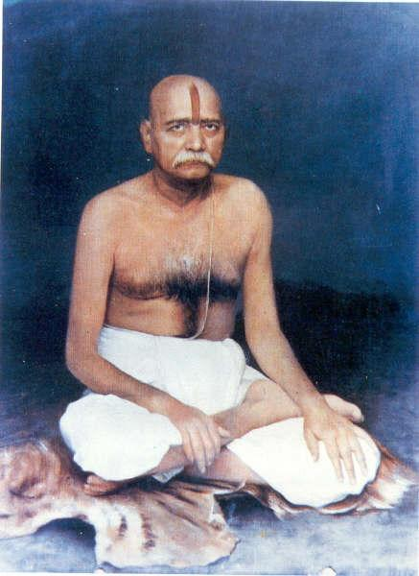
INTRODUCTION
Sadguru Beedkar Maharaj was the disciple of the great saint Shree Akkalkot Maharaj, and through his insistence, he established an Ashram at Pune, towards spreading spiritualism among the people. He is an ardent devotee of Mata Durga, and used to perform Pujas at the temples. His famous disciple was Shree Baba Maharaj Sahasrabuddhe.
Beedkar Maharaj was born in the year 1839 in North India in a Hindu holy family, and his birth name was Ramanand. His father had worked as a government employee under British rule.
At his young age, he lost his father, and he was took care by his noble mother, and she brought up him in a proper manner.
In his childhood, he went on a holy pilgrimage to Pandharpur, and worshipped the great Lord Panduranga. He also visited Mata Saptashrungi Devi at Nasik District, Maharashtra, and the goddess emerged from the idol and gave her immense blessings to Sri Maharaj.
At his teenage, he has entered into the business of valuation of gold and diamond necklaces and earned lot of money through that. But in course of time, he realized that one cannot get pleasure only through material comforts since that will last only for a certain period of time, and began to concentrate his attention on spiritual matters. Once he got the divine darshan of Lord Hanuman, and as per his wishes, he met Shree Swami Samarth of Akkalkot, and become his sincere disciple and devotee.
Shree Beedkar Maharaj propagated the sweetness of Hindu Dharma among his Devotees through his simple teachings, and he strongly insisted his devotees to feed food to the poor and the hungry people, birds and animals, in order to get the grace of the god.
In the year 1913, he attained Mahasamadhi in Pune.
Let us worship the great saint and be blessed.
“OM SRI BEEDKAR MAHARAJ NAMAHA”
“JAI MATA DURGA”
“JAI HANUMAN”
WRITTEN BY
R.HARISHANKAR

SAINT DANDISWAMI
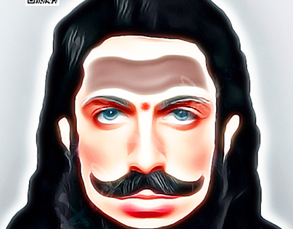
INTRODUCTION
"Dandiswami” was a Hindu Philosopher and a saint, who met the great Alexander near Taxila during the 4th century B.C. When Alexander met some naked saints near the mountain forests, he came to know about their leader Dandiswami, who lived in an Ashram, and he was a great Shiva Devotee.
Alexander then sent his messenger to bring Dandiswami before him. When his messenger met him at his Ashram, Dandiswami had refused to meet his king Alexander, and asked him to meet him at his ashram. Then Alexander went to the forest and met Dandiswami at his Ashram, and they were discussing about the spiritual matters and about the greatness of the almighty. When Alexander was ready to offer him gold and other valuable materials, Dandiswami politely refused, and replied to Alexander, that he is already a blessed soul, and having contact with the divine god, and hence, he doesn’t require any riches in this world. And he asked Alexander to concentrate his attention on devotional matters, instead of conquering the kingdoms, killing lot of soldiers, and committing lot of sins. But Alexander doesn’t listen to his words, and after some time, due to an ailment, he was died. During the time of his death bed, he asked his soldiers, to mention his final saying in the form of writing, and asked them to engrave it in his tomb. The final saying is “I AM THE GREAT KING, ALEXANDER THE GREAT, WHO HAD CONQUERED ALMOST THE ENTIRE WORLD, AND I AM HAVING LOT OF RICHES IN THIS WORLD. BUT AT THE TIME OF MY DEATH, IAM GOING EMPTY HANDED, LET THE VIEWERS MAY SEE MY WRITTEN WORDS, AND LET THEM FOLLOW THE SPIRITUAL PATH”. The details were recorded by the Greeks, and it is still preserved by them.
Hence let us worship the great saint and saviour Dandiswami, and follow the spiritual path and be blessed.
“OM SRI DANDISWAMIGALE NAMAHA”
“OM NAMAH SHIVAYA”
“OM MATA BHUVANESWARI DEVIYE NAMAHA”
WRITTEN BY
R.HARISHANKAR

SAINT SHISHUNALA SHARIF
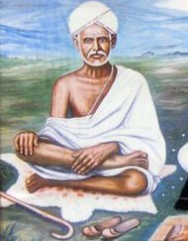
INTRODUCTION
Shishunala Sharif was Saint and a famous poet, and he is considered by the people as the Kabir of Karnataka. His birth name was Muhammad Sharif.
Shishunala Sharif was born in the year 1819 in a pious Muslim family, in a village in Haveri district, Karnataka. His dream was to unite Hinduism and Islam. His father was a devotee of Lord Shiva, and he used to teach him Ramayana, Bhagavatham, Mahabharata, and the teachings of Basavanna.
As a young boy, he used to go to the Shiva temples and performed puja to the Shivalingam, by maintaining a strong Hindu-Muslim relationship.
Govinda Bhatta was a Brahmin scholar, and he used to treat all kinds of religious people as alike, and gave much respect to everybody. He even used to eat food in the house of Christians and Muslims.
One day, Govinda Bhatta came to Shishuvinahala, and he accepted Sharifa, as his disciple and cared him as his own son. He taught all the divine subjects to the young Sharifa, and the little boy eagerly learnt all the subjects quickly.
Most of the Brahmin scholars, doesn’t like, Govinda Bhatta to interact with a Muslim boy, and hence they expressed their objections. One day, Govinda Bhatta to the surprise of everyone in the village put his sacred thread around Sharifa, and hugged him affectionately, and he further said to the Brahmin Scholars, that god doesn’t see the religious differences, only we humans would do! And Immediately, Sharifa, bowed his hands and fell at the Guru’s feet. The Brahmins were realized their mistake.
Once, when his guru Sri Govinda Bhatta, had asked him to hold the food he vomited in his hands, even without thinking for a moment, he immediately drank the vomited food. Sharifa has got such a great GURU BHAKTI and at this present situation we can’t even imagine it.
Shishunala Sharifa left his physical body in the year 1889 AD. His last rites were performed as per the customs of both the religions, and the Quran was recited along with the Hindu Mantras.
A temple was constructed in Shishuvinahala, and the statues of both Govinda Bhatta and Sharifa are installed, and his divine shrine is still visited by both Hindus and Muslims, till today.
Let us worship the great saint and be blessed.
“OM”
WRITTEN BY
R.HARISHANKAR

SANT DEVIDAS
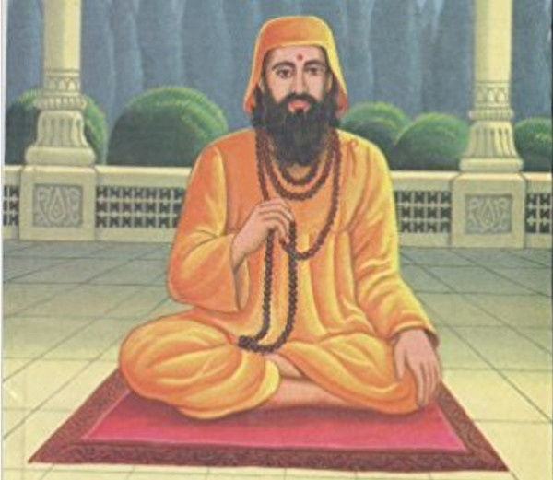
INTRODUCTION
Sant Devidas(1725-1800) was a spiritual guru, and guided lot of people through his teachings. He was born in a village at Gujarat in the year 1725 to a pious family. At his childhood itself, he differed from other children, and spent his time on doing meditation and engaged himself in doing spiritual activities. Initially people were not aware of his powers, but after sometime, due to his kind attitude, and due to the miracles performed by him, everyone in his village began to consider him as a great saint and respected much. He has done goodness to even those people who hated and given troubles to him. He never hated or got angry with others, and he was such a pious and humble saint.
At his teenage, he left his family and started an Ashram at Parab Dham in Gujarat. Lot of people began to visit to his Ashram due to his spiritual powers. He performed lot of miracles in the life of his devotees, such as removing the disease from the body of the devotees, and provided wholesome meals to the poor people with a small quantity of grains. He removed the injuries from the body of the people without applying any medicine in their body. He had done all these miracles, by chanting the Durga Mantra. “OM MATA DURGA DEVIYE NAMAHA”.
He was an ardent devotee of Mata Durga, and once he had the darshan of the Divine mother, and received her noble blessings. He was against caste discrimination, and equally treated all classes of people, and he never differentiated between rich and poor. He attained Samadhi at his Gujarat Ashram at the age of 75 and during the year 1800 AD. Still now lot of devotees believe that he is doing goodness to them, and worships him by visiting his Samadhi Shrine regularly.
Let us worship the great saint and be blessed.
“OM SRI SANT DEVIDAS NAMAHA”
“OM MATA DURGA DEVIYE NAMAHA”
“OM NAMAH SHIVAYA”
WRITTEN BY
R.HARISHANKAR
SARADANANDA
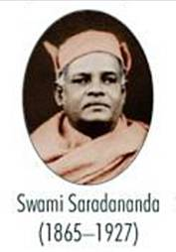
INTRODUCTION
Saradananda (1865–1927) was born in the year 1865, in a Rich Brahmin family in Kolkata, and he was one of the famous disciples of Ramakrishna. He served as a secretary in Ramakrishna Mission, and he published the Bengali magazine Udbodhan, and published the life history of Ramakrishna. His birth name was Sarat Chandra Chakravarty.
His father was doing the business of selling medicines, and for some time, he also took part in his business. His relative Shasi also become a disciple of Ramakrishna and came to be known as Ramakrishnananda.
Sarat Chandra had donated most of his personal belongings to the poor people, and helped the persons who suffered from diseases by providing medical aid to them, and also provided food packets to them. He also became an active member of Brahmo Samaj.
In October 1883, he went along with his relative Shasi to Dakshineswar and met Ramakrishna, and they have got clarified their doubts with regard to the existence of the god with Sri Ramakrishna, and Ramakrishna has asked them to realize the god by themselves through constant meditation and prayers, and due to that, both of them have got the divine darshan of Kali Mata at Dakshineswar Kali Temple.
After finishing his studies, Sarat spent his time in taking care of Ramakrishna, who was suffering from severe illness. After the death of Ramakrishna, he joined the Baranagar Mutt along with his relative Shasi.
Sarat had met Swami Vivekananda, and they became close friends. When Sarat started the Ramakrishna Mission, Vivekananda changed his name into Saradananda, and Sarat had attained sainthood.
Saradananda travelled to many holy temples, and had a nice darshan of the deities. During his travels, sometimes he suffered from tiredness, hungriness and body pain, but he tolerated all the pains, by worshipping his guru Bhagavan Ramakrishna.
Saradananda suffered from various ailments and died in the year 1927.
Let us worship the holy saint and be blessed.
“OM SRI SARADANANDARE NAMAHA”
“OM SRI RAMAKRISHNARE NAMAHA”
“OM SWAMI VIVEKANANDARE NAMAHA”
WRITTEN BY
R.HARISHANKAR

SHAKTI MAHARISHI
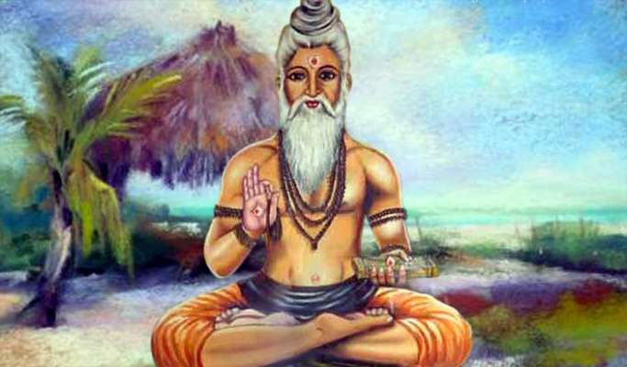
INTRODUCTION
Shakti Maharishi was the son of Vasistha and Arundhati. He was the father of Parasara Maharishi, and he was one of the great Shiva devotees. He was present during the time of Mahabharata war, and gave spiritual advices to the Pandavas, and met Lord Krishna also. He got great powers after performing meditation on Lord Shiva, and he was mentioned in ancient Vedas, Shastras, Puranas and many other holy texts, and he was described as a powerful rishi who contains good courage, boldness and wisdom.
He had large number of disciples, and he taught Vedas and other holy texts to them. He was born in the Treta Yuga, and befriended Lord Rama at Ayodhya. Along with his father Vasistha, he also gave spiritual advices to Rama, and consoled him, during the time of Kidnap of Mata Sita by Ravana. It is believed, that now he is living in the Maharishi Mandala, and performing penance on Lord Shiva.
Let us worship the great rishi and be blessed.
“OM SRI SHAKTI MAHARISHIYE NAMAHA”
“JAI SRIRAM”
“JAI MATA SITA”
WRITTEN BY
R.HARISHANKAR

SHRI GODAVARI MATAJI
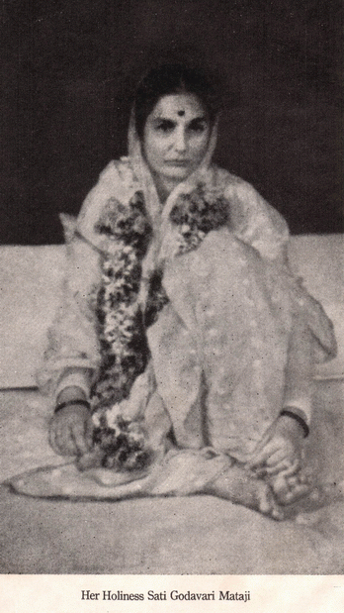
INTRODUCTION
Shri Godavari Mataji was born in the year 1914 at Shegaon, Maharashtra. She was born in an orthodox brahmin family, and at her childhood she got the darshan of Shri Upasani Maharaj, an ardent devotee of Shri Shirdi Saibaba, and asked her to devote her attention on spirituality.
She went to Sakori, at her teenage, and became a saint under Shri Upasani Maharaj and also became his disciple.
Due to that, lot of her friends were also initiated themselves into the spiritual path, and lived a simple and a holy life.
After the death of Shri Upasani Maharaj, Shri Godavari Mataji, had become the head of the Kanya Kumari Sthan Ashram, and continued her spiritual journey.
She also regularly performed Yajnas by chanting the Vedic mantras, with her various female disciples, and also performed yoga and meditation at the Ashram, and apart from that, they also done lot of social welfare activities like providing food, clothes and shelter to the beggars and the homeless people. Mataji went on religious pilgrimages along with her disciples and visited and worshipped the divine deities at the holy temples.
She travelled to foreign countries, and spread the “SAI BHAKTI SPIRIT among the people.
After doing her selfless service for many years, she has attained SALVATION.
Sri Godavari Mataji Annual Anniversary is observed on Krishna Paksha Panchami of Shravan month.
Let us worship the great saint and be blessed.
“OM SRI GODAVARI MATAJI NAMAHA”
“OM SRI UPASNI MAHARAJ NAMAHA”
“JAI SAINATH”
WRITTEN BY
R.HARISHANKAR
SISU ANANTA DAS
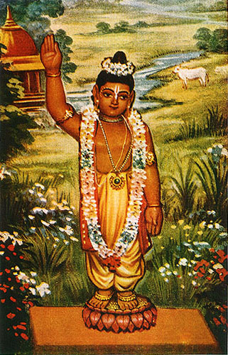
INTRODUCTION
Sisu Ananta Das is an Avatara Purusha, who was born in a village, near Bhubaneswar, Odisha in the year 1488. His parents were ardent devotees of Lord Surya Bhagawan, and through the grace of Sun God, Sisu Ananta Das was born. The entire family would regularly worship the Sun god at the Konark Sun Temple, and offer their prayers, and their Ishta Deva was Sun god.
Once in his dream, Lord Surya Narayana had ordered him to meet Chaitanya Mahaprabhu, a divine incarnation of Lord Krishna. Due to that, he has attained sainthood under Nityananda Prabhu, a close associate of Chaitanya, and an incarnation of Lord Balarama. Sisu Ananta Das resided in Tapovana Ashram, and through his bhakti and meditation on Lord Krishna, he has attained mystic powers.
He used to worship the deity of Lord Jagannatha at his ashram. His main disciples were Barang Das and Hamsa Das. He wrote lot of bhakti texts, and also composed several bhajan songs, and used to sing in the temples. He has written all the texts with much dedication and devotion on Lord Krishna, and it is believed that, Lord Krishna itself appeared before him, and acknowledged his works, appreciated his talents, and blessed him.
Let us worship the great Krishna devotee and be blessed.
“OM SRI SISU ANANTA DAS NAMAHA”
“JAI KRISHNA”
“JAI BALARAMA”
WRITTEN BY
R.HARISHANKAR

SIVAYA SUBRAMUNIYASWAMI
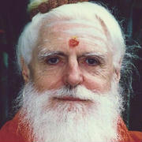
INTRODUCTION
Sivaya Subramuniyaswami (1927–2001), was affectionately called as Gurudeva by his devotees and followers, was born in Oakland, California, and adopted Hinduism and followed Shaivism at his teenage. He was one of the pontiffs of the Nandinatha Sampradaya's Kailasa Parampara and Guru at Kauai's Hindu Monastery on Hawaii's Garden Island, North America.
In the year 1947, he travelled to Sri Lanka and adopted sainthood under the Shiva devotee, Sri Yogaswami of Jaffna, Sri Lanka, who was considered as one of the great Shaivite saints in the present century. He established a Hindu monastery in Kauai, Hawaii, North America, and also stated the spiritual magazine Hinduism Today.
He founded the Sri Subramuniya Ashram in Alaveddy, Srilanka, and performed yagnas and pujas to the Shivalingam, and also done free food service to the devotees of Shiva. He founded a Hindu temple in Mauritius, which attracts large number of devotees from all over the world.
He started his own publication house and published more than 30 books, and he himself wrote lot of spiritual books. He travelled throughout the world, and spread the importance of Shaivism across the globe. He maintained cordial relationship with his Spiritual guru Sri Yogaswami and after his death in the year 1964, he become the head of the Nandinatha Sampradaya's Kailasa Parampara.
He was an ardent devotee of Shiva-Parvati, and worshipped them throughout his life, and he died in the year 2001.
Let us worship the great guru and be blessed.
“OM SRI SIVAYA SUBRAMUNIYASWAMIYE NAMAHA”
“OM NAMAH SHIVAYA”
“OM SAKTI ANNAIYE NAMAHA”
WRITTEN BY
R.HARISHANKAR

SPECIAL CHILDREN
INTRODUCTION
Special children are considered as the sons of the god, and hence they are known as Special children. Throughout their life, they will not commit sins and knowingly they will never harm others, they are innocent, and doesn’t know the things happening around them. Most of the special children contains defect in their mind and body during their birth itself, and they may suffer from autism, mental disorders, brain deficiency and cerebral palsy etc. Their brain would not function properly, and due to that, they could not discharge their routine duties properly, and they may be having defect in their nerves and bones also, and due to that, their nerves and bones would be frequently broken, and cause heavy pain to them.
In general, it is believed, that the special children suffers from their body disorders, due to their past birth sins. At the same time, we cannot avoid such kind of persons, since taking care of the depressed people, is considered as the noble task. Some special children would be having talents in drawing, painting, singing and dancing, and it is based on the proper training given to them. Whenever a special child was born to the parents, the parents must not get upset, and consider their child as one the holiest children in the world, and must be treated with great love and affection.
Though special children cannot be completely relieved from their ailments, but to a certain extent, their sufferings can be reduced, and it can be done by providing proper medicines to them, and taking them to the temples, giving the holy Prasad to them, and make them to regularly worship Lord Child Krishna. A picture of Child Krishna must be kept in the puja room and it must be decorated with flowers, and the parents must ask their special child to regularly perform puja to the divine child. In course of time, the child’s sufferings would be decreased, and gradually it may recover completely from its ailments.
“JAI KRISHNA”
WRITTEN BY
R.HARISHANKAR
SRI ATMANANDA
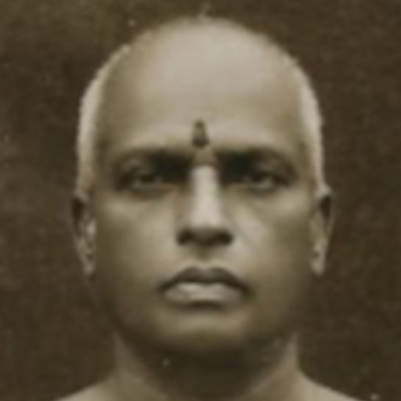
INTRODUCTION
Sri Atmananda (1883–1959) was a spiritual saint. His birth name was Krishna Menon, and he was born in the year 1883 in Peringara at Kerala in a pious Malayalee Menon family. After finishing his studies, he served in government service, and done his job in a perfect manner until the year 1939. He was considered as a best spiritual saint in Kerala during his period. He was an ardent devotee of Lord Krishna, and spread the “KRISHNA BHAKTI SPIRIT” among the people in Kerala. He insisted his followers to worship Lord Krishna, in order to get relieved from their physical and mental diseases. He used to visit Guruvayur Krishna Temple once in a month in order to offer prayers to the great Lord Sri Guruvayurappan.
He met Sri Yogananda and become his disciple and was renamed as Sri Atmananda. He began to teach Yoga and meditation to his devotees, and stayed at his family home itself in Anandavadi on the banks of the holy river Pampa in Malakara, Kerala. He published several spiritual books in Malayalam and in English. His teachings are well accepted by the people, and lot of people become his spiritual followers.
He died at Trivandrum in the year 1959.
After his death, his eldest son Adwayananda continued the spiritual service of his father, and he started a school and was named as Sri Atmananda Memorial School, in the year 1987 in Malakkara.
SPIRITUAL WORKS
- Atma Darshan
- Atma Nirvriti
- Atmaramam
- Atmananda Tattwa Samhita
Let us worship the holy saint and be blessed.
“OM SRI ATMANANDARE NAMAHA”
“JAI KRISHNA”
WRITTEN BY
R.HARISHANKAR
SRI KANNAN SWAMIGAL
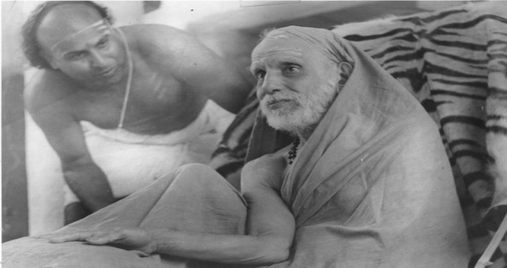
INTRODUCTION
Sri Kannan Swamigal was born in Pondicherry in a pious Iyengar family in the year 1930, and he was a spiritual personality, divine preacher and was a disciple of Kanchi Swamigal. He worked in government service, and retired. He has done lot of spiritual and social services throughout his life time. He got married in the year 1954, and had children. He was against caste discrimination and treated everyone as alike.
He was a Vedic scholar and an expert in English, Tamil and Sanskrit languages. He had performed lot of divine discourses and had large number of followers, and well-wishers, and he had spread the philosophy of Vaishnavism in U.S.A. He taught Vedas and Shastras to the students, and improved their life.
He served in Sri Ramanuja Mission at Srirangam and Ahobila Mutt, Ahobilam, and he also served as a priest in the temples of India and in foreign countries. He used to write lot of spiritual articles and it was published in various magazines. He tried his level best for propagating the importance of VAISHNAVISM and spreading the teachings of “SRI RAMANUJA” among the people.
He died in the year 1999.
Let us praise the great man.
“JAI SRI KANNAN SWAMIGAL”
“OM NAMO NARAYANAYA”
“OM MAHALAKSHMI DEVIYE NAMAHA”
WRITTEN BY
R.HARISHANKAR

SRI SUBHUDENDRA TEERTHA
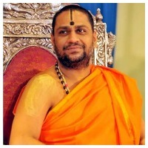
INTRODUCTION
The present pontiff of Mantralayam Sri Raghavendra Swamy Mutt is Sri Subhudendra Teertha. Previously he was serving as the Diwan of the Raghavendra Swamy Mutt, and he has become a saint in the year 2013, and he took charge of the administration of the Mutt in the year 2014 from Sri Suyateendra Teertha, and became his successor. His birth name was Raja S. Pavamanacharya.
He was one of the main preachers of the Advaita Philosophy of Madhwacharya, and he conducted spiritual discourses among the people, and inculcated the “SRI RAGHAVENDRA BHAKTI SPIRIT” into their minds, and he participated in the debates with various learned scholars and won in the debates.
He is a learned pundit and an expert in Vedas, Puranas, Ithikasams and other divine texts. He was born in a pious Madhwa family, and was proficient in regional languages, and was a great devotee of Guru Raghavendra from his young age. Daily he is doing Moola Rama Puja with sincere devotion in mind, and distributing the Holy Prasad after the completion of the Moola Rama Puja. Daily free food is offered to all the devotees in the Mantralayam Mutt in the afternoon and in the night. The food would be served in a pleasing manner, and it would be very delicious, and having the food would cleanse our sins, heals our diseases, and we would get the divine blessings of our holy Guru Sri Raghavendra Swamy.
Sri Subhudendra Teertha’s contribution to the spiritual world is as follows:
- He served as a teacher at Sri Gurusarvabhouma Sanskrit Vidyapeetha, Mantralaya.
- He served as the Editor of various spiritual magazines.
- He used to write articles in the spiritual magazines.
- He served as a Chairman in the Vedic Schools at Mantralayam.
- He helped in Renovation of Ancient Temples.
- He arranged for medical camps for the poor people in and around Mantralayam.
- He also introduced new donation schemes in the Mantralayam temple, in order to raise funds from the public, for doing social services to the society.
Let us worship the great saint of Mantralayam and be blessed.
“OM SRI SUBHUDENDRA TEERTHA SWAMIGALE NAMAHA”
“OM SRI MOOLA RAMA DEVARE NAMAHA”
“OM SRI RAGHAVENDRAYA NAMAHA”
WRITTEN BY
R.HARISHANKAR

SRI SUSHAMEENDRA TEERTHA
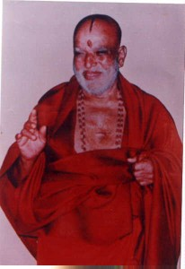
INTRODUCTION
Sri Sushameendra teertha was served as a pontiff in the Mantralayam Sri Raghavendra Swamy Mutt from 1985 to 2009, and he attained Mahasamadhi during the year 2009. He was born in the year 1926 in a pious Madhwa family at Nanjangud. His spiritual guru was Sri Sujayeendra Teertha, and his successor pontiff was Sri Suyateendra Teertha. Sri Sushameendra Tirtharu had performed tireless service to establish the Shakambari Nagar Raghavendra Mutt. He had done renovation works also. His birth name was Suprajnendracharya. He comes under the lineage of Sri Raghavendra Swamy.
He had completed his basic education under his grandfather Sujnanendracharya, and learnt Sanskrit from the scholars of Nanjangud. Swamiji founded Vidyapeetha at Mantralaya, for giving Vedic studies to the Brahmin students. Similarly, he also established schools for giving good education to the children.
He renovated many ancient temples, and introduced puja schemes. He also done lot of welfare activities to the poor, and through his guidance and valuable suggestions, without any interference, even till today, daily thousands of people are fed with delicious meals in Mantralayam. He lived as per the teachings of his guru Madhwacharya, and was a great devotee of Guru Raghavendra Swamigal and Lord Sri Rama. He used to perform puja to Rama with great pleasure.
Throughout his life, he had rendered valuable services, and attained Mahasamadhi in the year 2009, and his Samadhi shrine is situated in the Mantralayam temple itself. Whoever visits Mantralayam temple, would worship this great saint’s Brindavana also, in order to get his divine blessings.
Let us worship the noble saint and be blessed.
“OM SRI SUSHAMEENDRA TEERTHARE NAMAHA”
“JAI SRIRAM”
“JAI GURURAJA”
WRITTEN BY
R.HARISHANKAR

SRI SUYATEENDRA TEERTHA
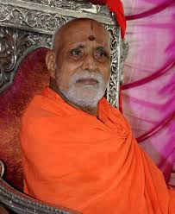
INTRODUCTION
Sri Suyateendra Teertha was the previous pontiff of Mantralaya, and he had attained mahasamadhi in the year 2014 at the age of 80 years. Now his successor Sri Subudendra Teertha is the present pontiff of Mantralayam Sri Raghavendra Swamy Mutt. Sri Suyateendra had done good service to the god and to the people in the Mantralaya Temple during his tenure. He worked hard to rebuild the Mantralayam, after it was struck by the heavy floods of the Tungabhadra River in the year 2009. He was born in Gadag district in Karnataka in a pious Madhwa Brahmin family, and his birth name was Susheelendra Char.
After completing his degree, he became a Sanskrit pundit, before becoming a saint. He also worked as a teacher in a Vedic school in Bangalore, for many years. He was initially appointed as a manager in the Sri Raghavendra Swamy Mutt, Mantralayam in the year 2006, by Sri Sushameendra Teertha. Later, he was appointed as Peetadipathi in the year 2009 and efficiently served in the mutt till his death.
Through his guidance, many halls were built like the dining hall and puja mandapa, and lot of good things were done. He also started various schemes for the benefit of the public in Mantralayam. He used to perfectly do the Moola Rama Puja and would kindly serve the divine Prasad to all the visiting devotees at the puja hall. He ate only simple food, and followed the spiritual path till the end of his life. He was a Rama devotee, and used to chant Rama Mantra regularly from his young age itself.
Let us worship the noble saint and be blessed.
“OM SRI SUYATEENDRA TEERTHA SWAMIGALE NAMAHA”
“OM SRI GURU RAGHAVENDRAYA NAMAHA”
“JAI SRIRAM”
WRITTEN BY
R.HARISHANKAR
SRI VEER TEJA
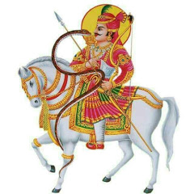
INTRODUCTION
Sri Veer Teja also fondly called as Tejaji is a village deity of people in Rajasthan. He is considered as a DIVINE AMSHA of Lord Shiva, and he is mostly worshipped by the rural people, as their Kula Deva and their Ishta Deva.
Veer Teja was born in the year 1256 AD in Khadnal, Rajasthan in a pious Rajasthani Hindu family, and by birth itself he was considered as a divine child, and used to perform pujas to the Shiva Lingam from his young age itself.
Veer Teja is considered as a brave warrior, who had safeguarded the supressed people, and fought for their rights and highly respected the women, and he was against caste discrimination. He has expressed his divine powers during the times of sufferings of his devotees, and removed the various problems in their life, and still protecting his devotees from his shrine.
Teja had died in the year 1304, during a battle and he relieved the people from poisonous diseases and from snake bites, and considered as a guardian deity for the people.
Even now people in Rajasthan used to see him in the nights, and he rides in a white horse, and dressed in colourful clothes, and protects his devotees from their enemies and thieves.
TEMPLES
- Tejaji Temple at Kharnal
- Tejaji temple at Paner
- Shree Veer Tejaji Samadhi Temple, Sursura
In the year 2011, Postage stamps were released by the Indian Government depicting Tejaji, in order to honour the “MOST PRECIOUS DEITY”.
A Rajasthani movie named as Veer Tejaji was produced during 1980’s, and it received a grand applause from the audience.
Let us worship the great SAVIOUR and be blessed.
“OM SRI VEER TEJA NAMAHA”
“OM NAMAH SHIVAYA”
“JAI MATA MANGALAMBIKA”
WRITTEN BY
R.HARISHANKAR

SUBODHANANDA
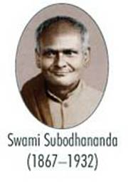
INTRODUCTION
Subodhananda (1867–1932) was a well-known disciple of Ramakrishna, and he was praised for his kindness and generosity. Similar to other disciples of Ramakrishna, he also played a major role in establishing the Ramakrishna Movement in various places. He was appointed in the Belur Mutt in the year 1901, and became an active participant of the Ramakrishna Mission. His birth name was Subodh Chandra Ghosh.
Subodh Chandra Ghosh was born in Kolkata in the year 1867, to a wealthy family, and his father was a great philanthropist, who had renovated many ancient temples, at his own cost. While, he was studying a spiritual book containing the Teachings of Sri Ramakrishna, he was impressed with him, and met him in the Dakshineswar temple. Subodhananda, got to know about the spiritual powers of his Guru Sri Ramakrishna, when he sat in a deep meditation state, and through the grace of his Guru, he attained the spiritual state of mind.
After the death of Ramakrishna, Subodh left his home and joined in the Baranagar Mutt, which was started by Swami Vivekananda. He was given the monastic name “Swami Subodhananda”, by Swami Vivekananda. Subodhananda went to holy pilgrimages like Himalayas, Kedarnath and Badrinath.
He had done many social welfare activities along with Sadananda and Sister Nivedita, and he fed food to many poor people with the money received from the devotees. He was very fond of Vivekananda, and Swami Vivekananda treated him as his own brother. He guided large number of people, and impressed by his spiritual lectures, many devotees were become saints in the Ramakrishna Mutt.
He died in the year 1932.
Let us worship the great saint and be blessed.
“OM SRI SUBODHANANDARE NAMAHA”
“OM SWAMI VIVEKANANDARE NAMAHA”
“JAI KRISHNA”
WRITTEN BY
R.HARISHANKAR

SUKI SIVAM
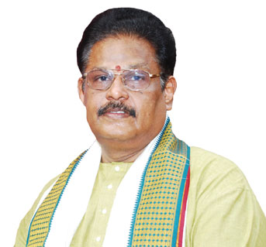
INTRODUCTION
Suki Sivam is a popular speaker, writer and a Tamil Scholar. He used to participate in TV programmes.
He was the Kalaimamani awardee for his contributions towards Tamil and for spreading the bhakti spirit in the minds of the people.
His discourses on Bhakti texts are very simple to understand, and he contains good knowledge in Hindu Divine Texts. He is having interest in social welfare services also, and is considered as a humble and a noble man.
He was the son of the famous writer couple, Kalai Maa Mani Mr.T.N. Suki Subramaniam and Smt. Gomathi Subramaniam, and he was influenced by the speeches of Sri.Thirumuruga Kripananda variyaar and Thavathiru Kundrakudi Adigalaar, and he developed the MURUGA BHAKTI from their divine lectures, and also spread it among the people.
Mr.Suki Sivam is a well-educated person and received lot of awards for his rich contribution in writing Tamil texts.
He has written Motivational books, Literary and religious books and introduced Literary and religious videos.
He is journeying in the spiritual boat, and also making others to sail in it, in order to reach the shore of Heaven.
Let us pray to the almighty to give a good health, wealth, sound mind and a long life to the great person Sri Suki Sivam.
“OM MURUGA”
WRITTEN BY
R.HARISHANKAR

SWAMI ACHALANANDA
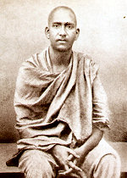
INTRODUCTION
Achalananda (1876-1947), who was also called as Kedar Baba, was a disciple of Swami Vivekananda and the founder of Ramakrishna Mission in Varanasi. Due to his deep interest in the philosophies of Swami Vivekananda, he left his job, and joined under Vivekananda. His birth name was Kedarnath Moulik.
Kedarnath Moulik was born in a Bengali family in the year 1876, and he was educated in Varanasi. Kedarnath was interested in reading lot of spiritual books at his young age, and joined as a disciple of Vivekananda and came to be known as Swami Achalananda.
He maintained friendship with Niranjananda and Kalyanananda, disciples of Vivekananda, and began to start doing social service works along with them in Varanasi. Kedarnath also underwent lot of holy pilgrimages, and gave various spiritual lectures among the people throughout India. Kedarnath went to Jayrambati and met Mata Sarada Devi and he spent a few months along with her. Due to his spiritual service works, his relatives and his father abandoned him. Due to that, Kedarnath left his worldly ties, and invoked himself fully in the bhakti path. He went to Belur Math and spent a few months along with Swami Vivekananda. Vivekananda behaved with him very kindly and treated him as his own brother. Swami Vivekananda lived a pious life, and he didn’t scolded or abused others either by physically or mentally. He was a divine avatar, who took birth in this earth in order to cleanse the minds of the people through his holy spiritual teachings. He even changed the dull persons into intelligent, through his kind attitude and through his spiritual powers, and he never neglected or abandoned any one throughout in his life.
Swami Achalananda had worked in various centres of Ramakrishna Mission, and dedicated his life towards doing service to the god and to the society. He lived a noble life, and was considered as a pure and a dedicated saint.
He died in Benares in the year 1947.
Let us worship the holy saint and be blessed.
“OM SWAMI ACHALANANDARE NAMAHA”
“JAI SRIRAM”
WRITTEN BY
R.HARISHANKAR

SWAMI ANAND
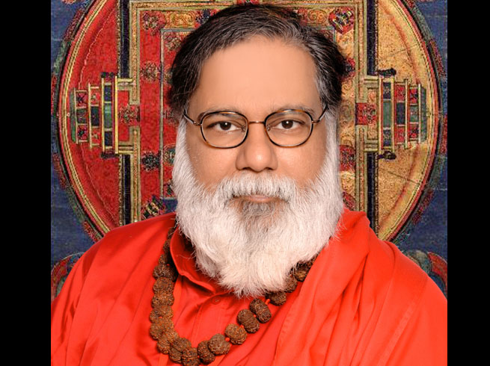
INTRODUCTION
Swami Anand (1887–1976) was a saint, freedom fighter and a well-known Gujarati writer. He met Mahatma Gandhi and wrote wonderful books due to the insistence by Gandhi, and through his help Gandhiji had written his life history, which contains all the important incidents happened in the life of Gandhiji. He wrote lot of spiritual articles like Bhagavat Gita and Bhagavatham and published it.
Swami Anand was born in Himmatlal, Ahmedabad, Gujarat, in the year 1887 at a village in a pious Brahmin family. He was brought up in Mumbai. At his young age, he left his home, and wandered along with various saints. He worked in a political newspaper, and wrote articles on freedom fighters. After some time, he went to Himalayas, and performed severe penance on Lord Shiva.
He also served as Vallabhai Patel's assistant, and he fought for the rights of the women and tribal people, and he was against caste discrimination, and he also worked in his own farm lands, and cultivated food grains. Swami Anand also met Sri Aurobindo and Guru Ramana, and received their divine blessings. He wrote the adventures during his visit to the holy Himalayas, and also explained about the importance of doing meditation in his book, and published it.
He became a saint and he was named as Swami Anandnand and joined in the Ramakrishna Mission.
He died in the year 1976 at Mumbai.
TEACHINGS
- Let us respect our country, and praise and worship our Bharata Mata.
- Hard work alone would provide us our daily bread.
- Learn good books and improve your knowledge.
- Kill the fear in your mind, by doing meditation on god.
- Always be sincere, honest and straight forward, and develop the habit of doing charity works for the benefit of the poor people.
- Chant the names of the god, and always fill up good thoughts in your mind in order to live happily and peacefully.
- Think about the worst sufferers in the world, and don’t get tensed and pressurized for small, small things.
- Be active and maintain patience in your life.
- Be happy with whatever god had given to you, and try to go up in your life ladder through your efficiency.
“JAI SRIRAM”
WRITTEN BY
R.HARISHANKAR

SWAMI ASHOKANANDA
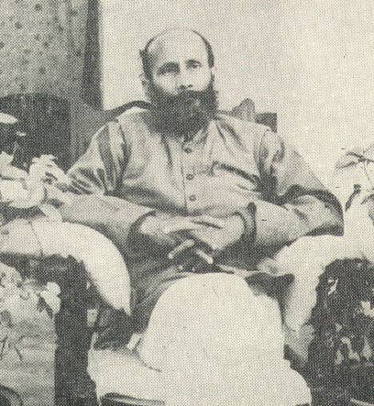

INTRODUCTION
Swami Ashokananda (20th century AD) was a native of Kashmir, and an ardent devotee of Sri Ramakrishna. He stayed in an Ashram at Kashmir, and gave valuable suggestions and teachings to his disciples.
Now his followers have changed the Ashram with modern facilities, and they have built some guest houses near the Ashram, for the stay of visitors, and a small temple is also built for Sri Ramakrishna Paramahamsa, which is located near the beautiful hills covered with full of greenery. The Samadhi of Swami Ashokananda is located near the Ashram.
Ashokananda was a blessed one, who took spirituality as his main path, and adopted good characteristics in his life. According to his followers he is a divine saint and a born genius, who could recollect even his previous birth memories. He used to roam in the Himalayan forests and sometimes in naked form. He has done lot of miracles in the life of his devotees. He predicted the future of the people, and used to suggest them to go in the spiritual path. He had many disciples, and they have explained about the miraculous incidents happened in their life. They have been safeguarded by their Guru from diseases, accidents and from wild animals.
Ashokananda used to regularly visit the Kathleshwar temple, Srinagar, and performed Pujas to the Shivalingam.
Swamiji died in the year 1971 at Srinagar, Kashmir.
SIMPLE TEACHINGS
- If you respect your Guru, it is equivalent to that of respecting the god.
- Your parents are the mortal Brahma for you. Hence, worship them, and treat them properly.
- Follow strict discipline, and live a noble life, based on the teachings of saints and Guru.
- Remove the ego from within you. Then only you would be able to live a comfortable life.
- Treat all the persons in a good manner, irrespective of their status.
- Remove the lust, anger and fear from you, by frequently doing meditation.
- Never and ever show enmity with others.
- Offer prayers to the god regularly, and thank him for giving this good life for you.
- Develop the good habits of courage, wisdom and generosity.
Let us worship the great saint and be blessed.
“OM SWAMI ASHOKANANDARE NAMAHA”
“JAI RAMAKRISHNA”
“JAI MATA SARADA DEVI”
WRITTEN BY
R.HARISHANKAR

SWAMI GOVINDANANDA
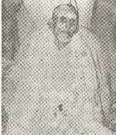
INTRODUCTION
Swami Govindananda (20th century AD) was lived in a small hut in the banks of the river Jhelum at Srinagar, Kashmir. He was a holy person, and used to take only one meal a day. He used to study spiritual books, and practised Yoga, and revealed his Kundalini Shakti. He was a siddha and Ayurveda Physician, who used to cure the diseases of the people with herbs and natural medicines at free of cost.
Once he went to Mount Amarnath, and had the darshan of the Snow Lingam. There he met the great saint Sri Chandanwari Baba and both of them had spiritual conversation. After successfully finishing his journey, Swami Govindananda went to his Srinagar Ashram and stayed for a long period of time. He had done many good things to the people like healing their diseases, hearing their problems, pacifying them in kind words, giving spiritual discourses on Lord Krishna and Rama, and cleansed the minds of the Kashmir people. He used to visit Vrindavan every year, and would have the darshan of Lord Krishna.
Swami Govindananda had attained mahasamadhi in the year 1987 at Kashmir.
HOLY QUOTES OF SWAMIJI:
- Believers of the god are the thinkers, doers and the achievers.
- We can get goodness in our life by our constant prayers to the god.
- Life is very short, utilize it properly by doing good things in your life, or otherwise you will have to suffer in the next birth.
- Be kind, generous, gentle and lenient towards others.
- Live your life in the path of “DHARMA”.
- Don’t fill up your stomach by cheating others.
- Don’t expect sympathy from others, instead of that, seek sympathy from god, and he is ready to fulfil your wishes, since we are all his servants, and he is our supreme master.
- Don’t spend your life only by dreaming, your life is in your hands only, through hard work only you can reach the upper ladder in your career path.
- Fill up with full of good thoughts in your mind.
Let us worship the noble saint, and be blessed.
“OM SWAMI GOVINDANANDARE NAMAHA”
“JAI KRISHNA”
WRITTEN BY
R.HARISHANKAR

SWAMI KALYANANANDA
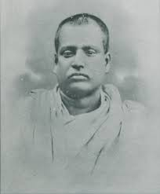
INTRODUCTION
Kalyanananda (1874–1937) was a disciple of Swami Vivekananda, who was the founder of the Ramakrishna Mission at Kankhal, near Haridwar. As a saint, he was kind, generous and humble towards the people, and practiced the Philosophies of Ramakrishna in his life and lived accordingly. He spent many years in Ramakrishna Mission at Kankhal and served the poor and down trodden people with much affection. He also started a hospital for giving treatment to the sick people. His birth name was Dakshinaranjan Guha.
Dakshinaranjan was born in the year 1874 in a village in the present day Bangladesh into a Bengali family. He was interested by the teachings of Swami Vivekananda, and decided to join with him in order to spend a selfless life towards doing service to the society. In 1898, he joined the Belur Mutt, and become a Saint, and was renamed as Kalyanananda. He was a Rama devotee, and used to frequently chant the Rama Mantra, “JAI SRIRAM”.
Kalyanananda travelled to many holy shrines, and visited the divine deities. In Ramakrishna Mission, Benares, he met the disciple of Vivekananda, Swami Achalananda, and together they have done lot of service to the poor people in Benares. In 1901, he returned to Belur Math and met Vivekananda, and through his insistence, he went to the Rishikesh-Haridwar and served the people. He has done lot of social service activities in various centres of Ramakrishna Mission. He was very much praised by Swami Vivekananda for rendering a tireless service to the people.
After serving the society for many years, he died in the year 1937 in Dehra Dun.
Let us worship the great saint and be blessed.
“OM SWAMY KALYANANDARE NAMAHA”
“JAI SRIRAM”
WRITTEN BY
R.HARISHANKAR
SWAMI NANDLAL
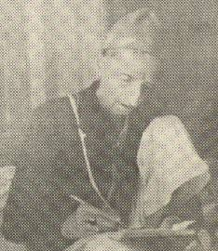
INTRODUCTION
Swami Nandlal (20th century AD) was a spiritual saint of Kashmir, and he hailed from a village near Ganderbal at Srinagar in Kashmir. He was considered as a holy man with lot of spiritual powers, and he was widely attracted by thousands of devotees from all over the world. Some devotees would even visit him from foreign countries in order to get their problems solved by him.
He behaved similar to Sri Shirdi Sai, and used to laugh, cry and sometimes talk unnecessarily. He knows the past, present and future happenings of his devotees, and would act accordingly. In most of the cases, he would solve the problems of the devotees in a remarkable manner. For some big sinners, he would not do anything, and leave it into the hands of god, since he doesn’t want to entirely change the fate of the devotees, since he felt that doing like that is against the wishes of the god. But he would ask them to keep doing KRISHNA NAMA JAPAM, in order to reduce their problems to certain extent.

He was very clean, and used to regularly take bath and apply oil in his head. He also used to advice his devotees to follow cleanliness in their life. He used to have only simple food, and he would ask his devotees to eat the holy Prasad prepared at his Ashram. He used to apply the Sintoor in the foreheads of his devotees, and for Muslim devotees he would not do so. He was an ardent devotee of Lord Krishna, and used to sing songs on him, and asked his devotees to do so.

Nandlal generally used to go by walk to the outside places, and if his devotees compels, he would go by car. Once while he was travelling to Delhi, he came to know that the petrol tank of the taxi became dry and immediately he asked the driver of the car to pour water instead of petrol. The driver also done like that, and the car reached Delhi without any petrol in its tank. He has got such great supreme powers!
Similar to other saints, he would tell to his devotees to realize the god from their soul, and asked them to do meditation regularly. After doing a good service, he attained MUKTI in the year 1973.
Let us worship the great saint and be blessed.
“OM SRI NANDLAL NAMAHA”
“JAI KRISHNA”
WRITTEN BY
R.HARISHANKAR

SWAMI NISCHAYANANDA
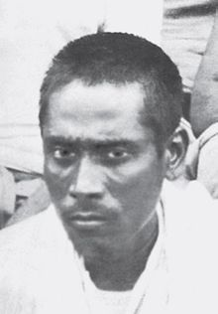
INTRODUCTION
Nischayananda (1865–1934) was a disciple of Swami Vivekananda. He joined with Kalyanananda, and worked in the Ramakrishna Mission, Kankhal. He was inspired by the teachings of Swami Vivekananda and followed his advices. He worked in government service before joining as a disciple of Vivekananda. After Vivekananda's death, he went to Haridwar and began to eagerly work for the service of the poor people in Kankhal. His birth name was Suraj Rao.
After becoming a saint, he also travelled throughout India, and spread the philosophies of Swami Vivekananda. He met the tribal people in the Himalayan region, and provided lot of services to them. Once while he was in Raipur, he met Niranjananda, a direct disciple of Ramakrishna. He also travelled to foreign countries, and delivered lot of religious lectures.
Swami Nischayananda worked as an assistant to Swami Vivekananda, and discharged his duties in a good manner, and he also helped him in writing spiritual books, and discussed with him about spiritual matters, and also clarified his doubts with his guru. He considered that serving to the divine guru would bring happiness in mind, and sincerely served Swami Vivekananda. Tilak once visited Swami Nischayananda in Belur Mutt, and they cheerfully discussed about lot of things including spiritual matters. Guru Dhanraj Giri praised Swami Nischayananda for his wonderful service to the society. Swami Nischayananda died in the year 1934 while doing meditation.
Let us worship the great saint Swami Nischayananda and be blessed.
“OM SWAMY NISCHAYANANDARE NAMAHA”
“JAI KRISHNA”
WRITTEN BY
R.HARISHANKAR
SWAMI PRANABANANDA GIRI
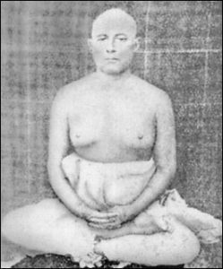
INTRODUCTION
Swamiji was born in a village in the Guptipara district, West Bengal, in a rich Brahmin family. He was an orthodox Brahmin, and used to perform puja to Shiva lingam and other deities by reciting Vedic mantras.
Swamiji contains good behaviour from his childhood. He contains helping tendency, and used to give his own pocket money for the welfare of the poor, and would get scolded by his father. He studied well and got good marks in all the subjects. He lost his mother at his teenage and felt very much worried due to the unbearable loss. After that, he began to wander in the streets and didn’t pay attention to his father, and began to spend his time with his friends.
Due to that, his father had got angry with him, and asked him to leave from the house. Swamiji didn’t get upset, and went to Banaras, and joined in a private company, and spent his salary mainly for the purpose of doing charity works.
At Banaras, he met the great spiritual Guru Sri LahiriMahasaya, and he was trained in Kriya Yoga, under his guidance. After some time, he went to his native place, and got married and had children. After spending few years of married life, he lost interest in family bondage, and left his family, and began to travel to Himalayas, and there he met Mahavatar Babaji, and received his blessings, and met his Guru Lahiri Mahasaya, and joined with him as a disciple, and was deeply involved in doing yoga and meditation. He also got large number of disciples, and he initiated them in practising Kriya Yoga.
After spending many years with his guru, after his death, he has attained MUKTI.
Let us worship the great saint and be blessed.
“OM SRI SWAMI PRANABANANDA GIRIYE NAMAHA”
“JAI MAHAVATAR BABAJI NAMAHA”
WRITTEN BY
R.HARISHANKAR
SWAMI RAMAKRISHNANANDA
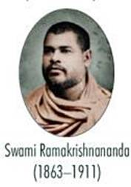
INTRODUCTION
Ramakrishnananda (1863–1911) was one of the chief disciples of Ramakrishna Paramahamsa. He was a celebrated saint, and he is well known for his sincere service to his guru, and he whole heartedly served the Baranagar Mutt for several years. His birth name was Shasi Bhushan.
Shasi was born in the year 1863, and he was interested in worshipping the divine deities in the temples. After finishing his schooling, he went to Kolkata for study purpose, and lived along with his relative Sharat who was later known as Swami Saradananda. While studying in a college at Kolkata, Shasi heard about Ramakrishna and met him in the year 1883, at Dakshineswar and become an ardent devotee of Ramakrishna.
Shasi served Ramakrishna during his last days, when he suffered from illness, and after his guru’s death, he joined the Baranagar Mutt and become a saint, and came to be known as Ramakrishnananda. He started the system of daily performance of puja to the idol of Ramakrishna that is still followed by the Ramakrishna Mission. He also used to provide food to the poor beggars with a loving smile.
He went on pilgrimages and visited the holy places such as Kasi, Badrinath, Kedarnath and Himalayas. As per the instructions of Swami Vivekananda, he started the Ramakrishna Mission branch at Chennai. He travelled throughout India, and spread the “RAMAKRISHNA BHAKTI SPIRIT” among the people. He started various centres of Ramakrishna Mission in Trivandrum, Mysore, Bangalore and Mumbai.
He published books on Ramakrishna and Vivekananda, and he wrote about the life history of Sri Ramanuja, Sri Krishna and Sri Ramakrishna.
He died in the year 1911 and attained MUKTI.
Let us worship the holy saint and be blessed.
“OM SRI RAMAKRISHNANANDARE NAMAHA”
“JAI KRISHNA”
WRITTEN BY
R.HARISHANKAR

SWAMI SARVANAND SARASWATI
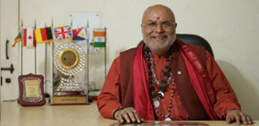
INTRODUCTION
Swami Sarvanand Saraswati is a great saint who has formed lot of welfare organizations for the goodness of the people.
Swamiji started many projects for the welfare of the poor students. He raised the standard of living of the women and poor people, and motivated them in their path. He is a spiritual person, and considered as a great Shiva devotee. He is a post graduate in Arts, and is the founder of Bhajan movement in New Delhi. He used to perform regular bhajans in praise of Lord Krishna Paramathma, with a group of his followers. He is the founder of the Mahashakti Peeth Ashram located at Delhi. The Ashram is started for social and religious purpose. He built the Ashram and the Sarveshwar Temple dedicated to Lord Shiva at 1, Nelson Mandela Road, VasantKunj, New Delhi-110070. In the Ashram, meditation halls, Ayurveda dispensaries, and a spiritual library are available.
His main purpose of establishing organizations is as follows:
- To take care of the mankind in the social, cultural and spiritual fields without any caste or gender discrimination.
- To help the mentally challenged people, by providing sufficient food, and giving proper medical treatment to them.
- To conduct Yoga, meditation and Vedic classes for the welfare of the devotees.
- To open Hospitals and to provide subsidised canteen facilities, for the benefit of the poor people.
- To regularly conduct religious discourses.
- To guide the people in the spiritual path, by publishing various spiritual books on Hinduism.
- To develop the “KRISHNA BHAKTI SPIRIT” among the people.
Let us praise the great saint and be blessed.
“OM SRI SARVANANDARE NAMAHA”
WRITTEN BY
R.HARISHANKAR

SWAMY KASHKAK
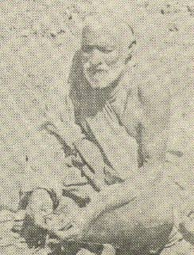
INTRODUCTION
Kashkak (19th century AD) was a spiritual saint and a divine healer, who was well known for his simplicity and generosity, is a native of Manigam, a village near Srinagar. Lot of devotees were felt that by having his mere Darshan alone would bring comfort in their lives. His devotees would include poor as well as rich persons, and people from all caste, community and religion would come to him, for getting relieved from their problems. Meher Baba, a great saint of Pune once visited Kashkak and received blessings and Prasad from him.
Great saints like Nandlal and Swami Lakshman Joo, had the darshan of Swamy Kashkak.
With the grace of his Guru, Narain Bhan, Kashkak had attained enlightenment, and got great powers. But he utilised the powers only for necessary purposes. Devotees, who visit him, would never go empty handed, and their hands would be filled up with his divine Prasad. Once he instantly cured the fractured arm of a devotee. He would mostly remain silent, but occasionally he would talk in a low voice to his well-wishers and devotees.
He would never accept any offerings from his devotees, and even if they forcibly give any money, he would immediately throw it in the Sindh River that flowed nearby.
Kashkak attained Mahasamadhi in the year 1961.
Let us worship the great saint and be blessed.
“OM SWAMY KASHKAK NAMAHA”
WRITTEN BY
R.HARISHANKAR

SWANS IN HINDUISM
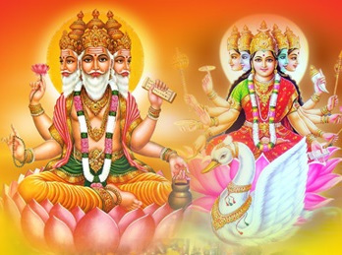
INTRODUCTION
Swans, also called as Hamsa, are considered as pious birds in Hinduism. According to legend, divine swans are believed to live in the Himalayan mountain ranges, and they contain spiritual powers, and they are the worshippers of Shiva and Parvati. In Manasarovar Lake, divine swans used to swim and it is believed that it would appear only in the eyes of the noble people. And by worshipping the swans in the Manasarovar Lake would cleanse our sins, and we would prosper in our life.
Swans are also the divine vehicle of the Creator god Brahma, Gayatri Devi and Mata Saraswati. The divine architect, Lord Viswakarma also has swan as his vehicle. Mata Damayanti used to convey her love messages to Nala through the help of a swan bird. Swans are mentioned in ancient texts, and they are considered as very pure.
Swans would separate water and milk, and drink milk only, similar to that, we also have to differentiate between bad and good things, and ignore the bad things, and must do only good things in our life. Swans would walk very slowly and would eat small insects, fish and crabs. They are not supposed to be killed, since killing of swans would cause angry to Lord Brahma Dev and Mata Saraswati, and they would curse us.
Swans would live in lakes and ponds, and contains a pleasing appearance. They would never give troubles to us, and in fact, makes our mind to get relaxed through their beautiful appearance.
Let us worship Lord Brahma and Mata Saraswati and be blessed.
“OM SRI BRAHMA DEVARE NAMAHA”
“OM MATA SARASWATIYE NAMAHA”
“OM SRI VISWAKARMA NAMAHA”
WRITTEN BY
R.HARISHANKAR

TANDU
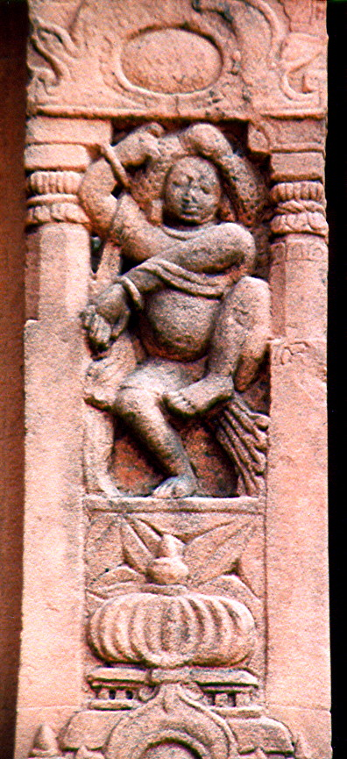
INTRODUCTION
Tandu is considered as one of the divine attendants of Lord Shiva, and he resides in Mount Kailash along with Shiva-Parvati. He has learnt all kinds of arts from the primary divine attendant Lord Nandi Dev, and learnt the art of dance from Lord Shiva. He is said to participate in dance along with Lord Shiva during the time of Pradosham. He is considered as one of the chief demi gods, and permanently settled in the Shiva Loka.
Before several thousands of years, he was born in the earth, as a noble Brahmin scholar, and he contains great bhakti on Lord Shiva, and used to chant the Rudram, Chamakam and performs regular puja and abhishekham to the Shiva Lingam. He used to feed the poor devotees of Lord Shiva, along with his wife, and also financially helped in the marriage of the poor girls. Lord Shiva was satisfied with his sincere Shiva Bhakti and his selfless service to the people, and due to that, after his death, he has reached Kailasa, and attained the eternal bliss. He was mentioned in the holy Shiva Puran, along with the other divine attendants of Lord Shiva. He is said to be the head of the Nayanmar saints, and performs dedicated service to the divine father and mother with much bhakti and perfection.
Let us worship the great divine attendant of Shiva and be blessed.
“OM SRI TANDU BHAGAVANE NAMAHA”
“OM SRI NANDIYAM PERUMANE NAMAHA”
“JAI SHIVASAKTHI”
WRITTEN BY
R.HARISHANKAR

TARA IN RAMAYANA
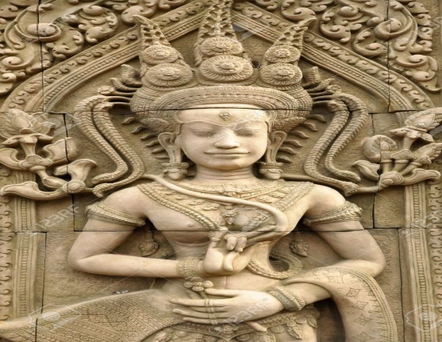
INTRODUCTION
According to the divine epic Ramayana, Tara is the Queen of Kishkindha and the consort of the Vanara King Vali. It is believed that after the death of Vali, she remarried Sugriva, and also become one of his queens. Tara has got great powers, and she had foresighted the future of her husband Vali, and hence prevented him from fighting with Sugriva. But Vali didn’t listened to her advice, and hence fought with Sugriva, and finally he was killed by Lord Rama.
Tara is the daughter of the Vanara physician Sushena, and in her previous birth, she was the celestial Apsara in the Indra Loka, and due to a curse, she was born in the earth in the family of Vanaras. After getting married with Vali, she served as a dutiful wife, and considered as a chaste and a holy women, and they had a noble son whose name was Angada. She remained as a chaste woman till the death of her husband Vali, and only in order to get proper protection, she got remarried with her brother-in-law Sugriva.
When Vali abducts Sugriva’s wife Ruma, Tara had objected his wrong act, and asked him to act in a friendly manner with his brother Sugriva.
When Sugriva delayed in searching for Sita, it was Tara, who had advised him to make a quick search for Mata Sita in order to make her to join with her consort Lord Srirama.
After the end of her life, she regained her original Apsara form and went to the abode of Lord Indra, the Swarka Loka, and continued her duties as a celestial dancer.
Let us worship the divine mother and be blessed.
“OM MATA TARA DEVIYE NAMAHA”
“JAI HANUMAN”
“JAI SRIRAM”
WRITTEN BY
R.HARISHANKAR

THIRU.V.KALYANASUNDARAM
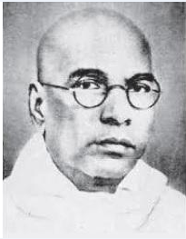
INTRODUCTION
Thiruvarur Viruttachala Kalyanasundaram (1883-1953) also called as Thiru.Vi.Ka was a Tamil scholar, poet and a great freedom fighter. His writings covers a wide range of topics and mentions the sufferings of the under privileged and down trodden poor people, and also wrote about women empowerment in the country. His works, are considered as an all-time favourite for the Tamil people, and was treated as a great treasure by the Tamil lovers.
Thiru Vi. Ka was born in Thandalam in Chengalpet district, in the year 1883. After finishing his school education, for some time, he worked as a teacher, and after a few years, he began to work for a Tamil daily newspaper. He also fought for the rights of the workers, and took part in the freedom fighting movement, along with other freedom fighters.
Due to his interest in journalism, he himself started a magazine, known as Navasakthi. Through that magazine, he expressed his views based on political and social issues. He also wrote lot of Hindu religious books including the life history and teachings of the great saint Sri Ramalinga Swamigal, and he published lot of books. A place near Perambur, was named as Thiru Vi. Ka Nagar.
After serving the society for many years, Sri Thiru Vi.Ka had died in the year 1953 at the age of 71.
Let us praise the great man.
“JAI SRI THIRU.VI.KA”
WRITTEN BY
R.HARISHANKAR

TRIDANDI SWAMI
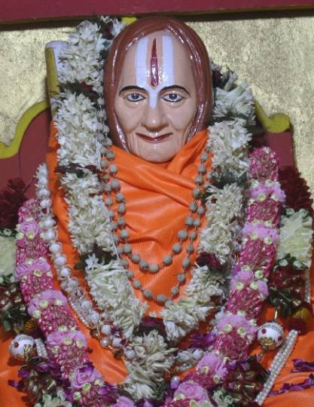
INTRODUCTION
Shri Tridandi Swami (1905–1999) was a famous Vaishnava saint and one of the celebrated spiritual discourser in the North India, and he was one of the main disciples of Sri Prativadibhayankar Swamiji of Kanchi, and he spread the importance of “NARAYANA BHAKTI SPIRIT” throughout India. He was considered as one amongst the most famous Sri Vaishnava Acharyas, and he was a sincere devotee of Guru Ramanuja and Lord Vishnu.
He was born in the year 1905 A.D in a pious Brahmin family in a village, in Bihar.
He went to Lakshmi Narayan Temple, Charitravan, Buxar and studied Vedas and Shastras. He also passed in the ‘Vyakarnacharya’ examination.
Tridandi Swamiji Maharaj became the disciple of Swami Ram Krishnacharya ji, and served him sincerely in the Lakshmi Narayan Temple situated in the Charitravan, Buxar in Bihar.
He started chanting the sacred ‘Narayana Mantra’ with utmost faith and devotion, and asked others also to do so. He attained mastery over the Vishnu Purana, and travelled to holy places like Badrinath, Muktinath and Gangotri etc. He constructed and renovated temples, founded Vedic schools, wrote lot of divine books and published it.
Through meditation, he has obtained great spiritual powers. He also educated in Yoga and became a Yoga Guru.
In course of time, he used to take only simple food, and lot of people became his followers. At his old age, Tridandi Swami gave the responsibilities of the mutt to his disciple named Vedmartand Shri Rama Narayanacharya ji. He died in the year 1999 AD and reached the abode of Lord Narayana. A beautiful Samadhi temple was built for him.
Let us worship the great saint and be blessed.
“OM SRI TRIDANDI SWAMIGALE NAMAHA”
“OM SRI RAMUNUJARE NAMAHA”
“OM NAMO NARAYANAYA NAMAHA”
WRITTEN BY
R.HARISHANKAR

UPAPANDAVAS
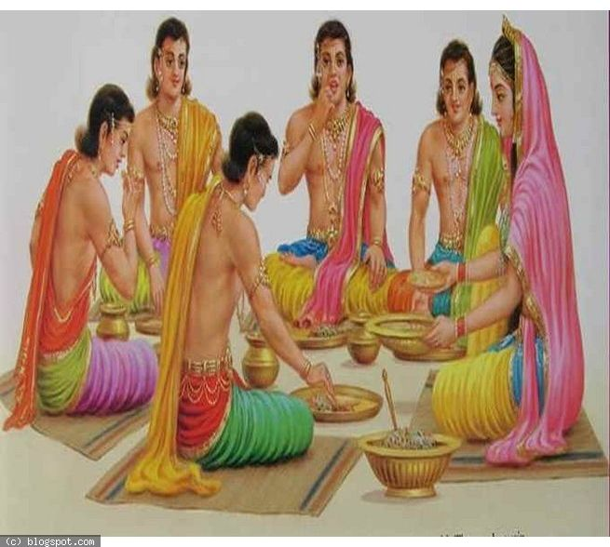
INTRODUCTION
According to the great epic Mahabharata, Upapandavas are the five sons who were born to Queen Draupadi from the Pandavas. During the Kurukshetra war, they fought bravely on the side of the Pandavas, but they were killed by Ashwathama, during the time of their sleep on the last day night of the war.
- Prativindhya was born to Yudhishthira and Draupadi.
- Shatanika was born to Nakula and Draupadi.
- Sutasoma was born to Bhima and Draupadi.
- Shrutsena was born to Sahadeva and Draupadi.
- Shrutakarma was born to Arjuna and Draupadi.
All the five sons were compared similar to their father Pandavas, and contains great strength and energy in their mind and body. They were talented in all kinds of arts, and considered as brave brothers. They contain very good qualities, and were blessed by Lord Krishna Bhagavan. But due to their bad fate, they died at their younger age itself.
Let us praise the glory of Upapandavas and be blessed.
“OM SRI KRISHNA BHAGAVANE NAMAHA”
“OM MATA DRAUPATHI DEVIYE NAMAHA”
“OM SRI UPAPANDAVARGALE NAMAHA”
WRITTEN BY
R.HARISHANKAR

VANARAS
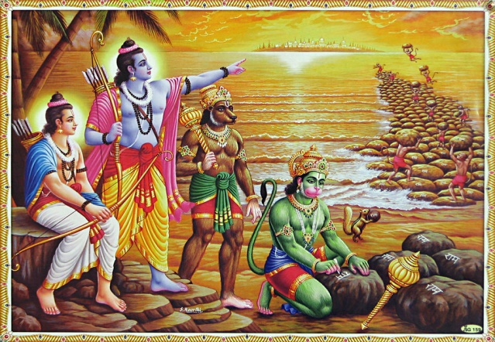
INTRODUCTION
Vanaras are well known from the great epic Ramayana, and they were lived during the Treta Yuga. They helped Lord Rama for building the Bridge to reach Lanka. Among the Vanaras, Lord Hanuman, Sugriva and Angadan are considered as most powerful warriors. Vanaras are specifically created by Lord Brahma in order to help Lord Rama. They maintained strict discipline while making conversation with Rama, and they considered Rama as the divine avatar of Lord Vishnu, and showed great respects to him.
Though Vanaras do mischievous acts, they have been controlled by the great Hanuman, and due to that, they controlled their mischievous doings to certain extent. Vanaras contain great powers, and they can take the shape of any form, whether demons, humans or devas etc.
They fought bravely during the Ramayana War, and killed many fierce demons during the battle. Among the Vanaras, Hanuman, Sugriva, Angadan, Nilan, Nalan and Jambavan are considered as the divine AMSHAS of the demi gods in the heaven.
Initially the Vanaras have been controlled by Vali, and after his death, they were controlled by Vali’s brother Sugriva, and they showed obedience to their prince Angadan also. The bear king JAMBAVAN contains great powers, and got several boons from Lord Brahma. Even till today, those who are expertise in a particular field would be compared with JAMBAVAN. He contains good knowledge, wisdom, courage and boldness. He contains the strength equivalent to 1000 elephants, and killed many demons during the Ramayana War. He lived till the end of the Dwapara Yuga, and after his death, he reached his father Lord Brahma’s divine world, “THE SATYA LOKA”.
Vanaras life span is several thousands of years, and they lived with good health and wealth, and lead a happy and peaceful life, through the grace of Lord Rama. They got the blessings from Rama and Lakshmana, and after Rama’s departure from the world, they also accompanied with him, and went to the VAIKUNTA.
Let us worship the great Vanara, Lord Hanuman and be blessed.
“JAI SRIRAM”
“JAI SITA MATA”
“JAI HANUMAN”
WRITTEN BY
R.HARISHANKAR

VEERAMANIDASAN
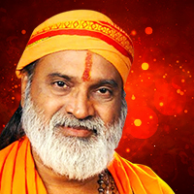
INTRODUCTION
Veeramani Dasan is a famous singer and he is popular in singing Lord Ayyappan songs. According to him, Lord Ayyappan is everything to him.
Previously he was running a light music troupe, Sruti Laya. But now he is concentrating his entire attention in singing devotional songs on the deities, and he has sung some famous songs on Guru Raghavendra Swamy and Amman, and he has sung for some feature films also. He has introduced many Bhakti Audio and Video cassettes. He has sung more than 1000 songs, and used to travel to foreign countries also, in order to provide his spiritual service among the foreigners also. Apart from singing, he used to visit many holy temples, and visited Lord Ayyappan temple for many times. He is ever remembered for his high pitch Ayyappan songs.
Let us praise the great person.
“SWAMIYE SARANAM AYYAPPA”
WRITTEN BY
R.HARISHANKAR

VELUKKUDI KRISHNAN SWAMIGAL
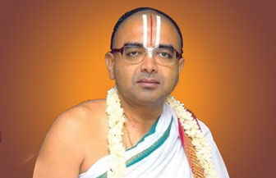
INTRODUCTION
Velukkudi Krishnan, also known as Velukkudi Krishnan Swamigal, is a Hindu religious scholar and a devotional preacher. His Guru is Sri Doddacharyan Swamigal. He delivers lectures in various temples, and his speeches are telecast on Vijay TV, Sri Venkateswara bhakthi channal and Podhigai TV. His divine lectures would melt the hearts, and would provide a rich feast to the ears of the viewers, and he makes his viewers to watch his programs regularly in the television channels through his simple approach. He is running the Kinchitkaram Trust, which exclusively functions for spiritual activities. He has got very good knowledge in Vedas, Shastras, Upanishads and other holy texts, and used to narrate the stories from the Puranas in an interesting manner.
His father, Velukkudi Varadachariar, is also a great Vedic scholar. Velukkudi Swamigal is a qualified chartered accountant, and due to his spiritual thirst, he left his job in the year 1996, and fully dedicated his attention on spirituality. His lectures are simple to hear, and even the layman can understand his lectures. He is an ardent devotee of Lord Vishnu, and concentrating his entire attention towards spreading the spirit of “VAISHNAVISM” among the people.
Swamy could fluently speak in Sanskrit, Tamil and English, and he lectured in foreign countries, like the United States, Canada, Singapore and Australia. He lives in Srirangam.
Swamy is a living legend, who helps the people by his lectures, and makes their mind to focus on spirituality. He is considered as a great Vaishnavite guru, and a well-known multifaceted personality.
Let the great Lord Bhagavan Vishnu give him a good health, wealth and a long life.
“JAI KRISHNA”
WRITTEN BY
R.HARISHANKAR
WARKARIS
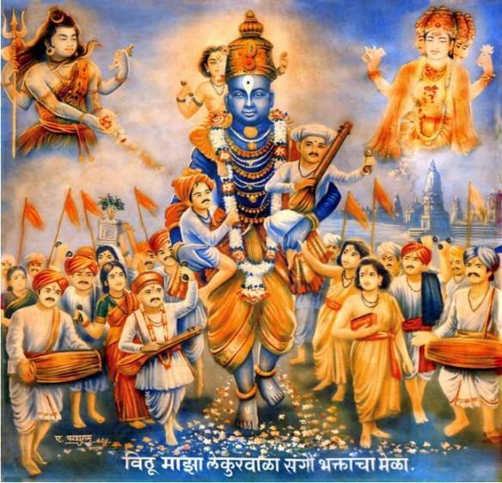
INTRODUCTION
Warkari is the bhakti tradition of Vaishnavite Hinduism, followed in the state of Maharashtra. Warkaris worship Vittal, who is the main deity of Pandharpur, a form of Lord Krishna. Warkari saints include Dnyaneshwar, Namdev, Chokhamela, Eknath, and Tukaram and they are called as Sants, and they had the direct darshan of Lord Vittal during their life time, and their songs are very melodious.
The Warkari tradition is followed in Maharashtra before a few hundred years, which was formed by a certain community of people, who are the ardent devotees of Lord Vittal Mahaprabhu. Warkaris include saints and poets, whose thoughts would focus on Lord Vittal only. Their famous works were recorded in manuscripts by the great poet Mahipati during the 18th century AD.
Warkari people undertake an annual pilgrimage to Pandharpur, during Ekadashi in the month of Ashadha, between June and July, and during their travels, bad habits such as smoking and drinking is strictly prohibited, and they have to eat only vegetarian food (without onion and garlic), and must strictly observe fasting during Ekadashi days, and during their pilgrimage they would cheerfully sings the bhakti songs of Lord Vittal. Varkaris look upon God as their saviour, and considers as their ultimate friend, guru, guide and god, and they also consider Vittal Mahaprabhu as their Kula Deva and Ishta Deva. The Varkaris used to apply the sandal-paste in their forehead. We can see the Pandharpur Vittal Darshan Videos in the Internet.
Let us visit Pandharpur once in a year, and have the darshan of Lord Vittal Mahaprabhu.
“PANDURANGA VITTALA JAI JAI”
“JAI RUKMANI MATA KI JAI”
WRITTEN BY
R.HARISHANKAR
YASOBANTA DAS
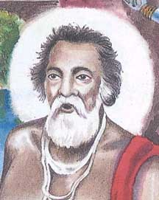
INTRODUCTION
Yasobanta Das was born in the year 1482 in a village, at Cuttack district, Odisha, in a pious Hindu family. He used to frequently visit the Jegannath temple at Puri at his younger age itself. At his teenage he was married with a charming and noble lady Anjana Devi and she served as a dutiful wife to him. After some time, he was disinterested in leading the family life, and became a saint, and travelled to many holy places in India, and worshipped the deities in the temples. He performed meditation on Lord Krishna and through that, he got great spiritual powers. He also spread the “KRISHNA BHAKTI SPIRIT” throughout Odisha, and insisted the people to worship Lord Krishna, in order to get relieved from their miseries and sorrows.
He wrote many divine texts and performed several bhajans, and composed beautiful songs on Lord Krishna, and used to sing in the temples in his sweet voice, which attracts large number of followers. His main disciples were Lohi Das and Salabega, and after performing spiritual service for many years, through the grace of Lord Krishna, he has attained SALVATION.
Let us worship the great saint and be blessed.
“OM SRI YASOBANTA DAS NAMAHA”
“JAI KRISHNA”
WRITTEN BY
R.HARISHANKAR

YOGI GOPI KRISHNA
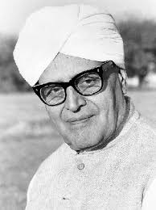
INTRODUCTION
Gopi Krishna (1903–1984) was a yogi and a writer. He was born in a village in Kashmir. At his young age, he moved along with his family to Lahore. He was an expert in awakening the Kundalini Shakti of the people. He was very good at yoga and meditation, and wrote many spiritual and useful books to the mankind. He toured to foreign countries for teaching Yoga, and he was a popular figure among the foreign people.
At his teenage he got a job in the state government, and he was married and become a family man. Through his income, he has done lot of social service works and fought for the rights of the women. Gopi Krishna was an ardent devotee of Lord Krishna, and used to frequently visit the temples of Krishna. He has rendered lot of service in spiritual, social and Yoga fields.
He died in the year 1984.
TEACHINGS
- Enter the spiritual path in order to get enlightenment.
- Your Life would be blossomed by learning yoga and meditation.
- Take care of your physical body, and apart from filling normal food, fill it up with the divine Prasad of Lord Krishna.
- Constant Prayers only would change the way of your life.
- Always be active, and don’t think about useless things.
- Show your sympathy on others, and help the depressed and supressed people.
- Never lose your faith on god, since he is the master of the entire universe.
Let us praise the noble man and be blessed.
“JAI KRISHNA”
WRITTEN BY
R.HARISHANKAR
YOGI NARAHARINATH
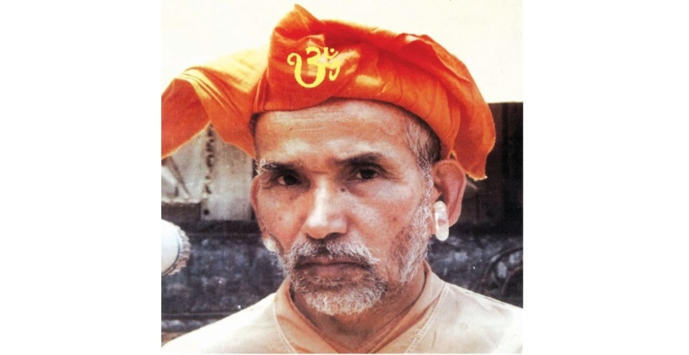
INTRODUCTION
Yogi Naraharinath (1915–2003) was a Nepalese saint and an ardent devotee of Lord Gorakhnath. He has written lot of spiritual books and also published many spiritual books, and spread the “GORAKHNATH BHAKTI SPIRIT” throughout Nepal. His birth name was Balbir Singh Hriksen Thapa.
He was born in the year 1915 to a pious napalese Hindu family, and he belonged to Rishi Bhardwaj Gotra. He went to India at his younger age, and learnt all the Vedic Subjects, and become a great Sanskrit pundit. At his teenage, he returned back to Nepal, and become a follower of Gorakhnath and resided at Kathmandu near Pashupatinath temple.
He also became a disciple of the great saints like Gorkha Bansawali, Yogi Bansawali and Devmala Banshawali. He was an admirer of the great King Sri Vikramaditya, who was a great Kali Devotee. He has taught Sanskrit language to the people of Nepal at Sanskrit University at Dang. He was a regular visitor of Pashupatinath Temple, and used to perform Pujas to the Shivalingam, and he has done many social welfare activities for the welfare of the people in Nepal.
WORKS
1. Hamro desa-darshana
2. Sivadharmamahasastram
3. Pashupatinathadarshanam
4. Divya Upadesa
5. Aitihasika yatra
6. Arthika Sahayog
He died aged at the age of 88 in Kathmandu, Nepal in the year 2003.
Let us worship the great saint and be blessed.
“OM SRI YOGI NARAHARINATH NAMAHA”
WRITTEN BY
R.HARISHANKAR

