HINDU SPIRITUAL DETAILS BY R.HARISHANKAR
ARAVAN
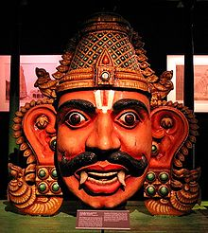
INTRODUCTION
Aravan is a noble character from Mahabharata. He is the son of Arjuna and the Naga princess Ulupi. Aravan is the deity and worshipped in the Kuthandavar Temple. He is also worshipped as a village deity and he is the main god for the transgender communities.
The Mahabharata mentions the greatness of Aravan towards self-sacrificing his life. Aravan had done self-sacrifice before Goddess Kali for the victory of the Pandavas. It is also mentioned in ancient texts, that Aravan was killed by Alambusha, one of the kaurava warrior by cutting off Aravan’s head in the kurukshetra war.
As per Aravan’s wish,
Sri Krishna takes the form of Mohini and marries Aravan. He also has got the boon from Lord Krishna, to witness the kurukshetra war from his severed head. This marriage festival is celebrated as the Transgender Festival at Koovagam village in Tamil Nadu. Aravan is also worshipped in this temple as Koothandavara.
In Koovagam, Tamil Nadu, an 18-day festival is celebrated every year. Lot of Aravanis from tamil nadu and even from other states of india would participate in the festival. This festival is usually observed on Tuesday before Chitirai pournami of every year.
Aravan is also popularly worshipped in Indonesia. He is called as Aravan, since he is the son of Ulupi, a naga princess.
Aravan is worshipped in the temples with his severed head, in order to mark his great sacrifice, which cannot be imagined in this today’s tough world.
Most of the Kuttantavar devotees reside in the Tamil Nadu districts of Cuddalore, Thiruvannamalai, Vellore and Villupuram.
IMPORTANCE
A great warrior, who has lost his life for the victory of the pandavas, cannot be forgotten by the people. Since he has willingly sacrificed his own life, his name and fame was spread across the country, even after several thousands of years. As per puranic reference, it is believed that he would have sacrificed his life before 5000 plus years. He is considered as the guardian and the protector for the aravanis and they worship him with much faith and devotion in their mind. He has got great powers through the blessings of Lord Krishna and is the BEST SAVIOUR for the ARAVANIS.
Let us worship the great ARAVAN and be blessed.
“OM SREE ARAVANE NAMAHA”
“OM SREE ULUPI ANNAIYE NAMAHA”
“JAI KRISHNA”
WRITTEN BY
R.HARISHANKAR

BHAVANI
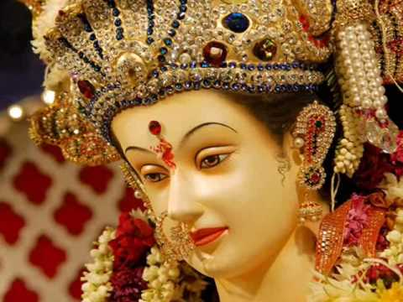
INTRODUCTION
Bhavani also known as Tulaja, Amba and Jagadamba is an incarnation of Mata Parvati. She is also worshipped in North india as Mata Durga. Once she killed the demon Matanga who created lot of problems to the people in the earth and also troubled the gods in the heaven. Due to the worship of the gods and humans, Mata Parvati took the form of “BHAVANI” and destroyed the terrible demon.
Mata Bhavani was worshipped by the Maratha King Shivaji and by his mother. The king, his relatives and his region’s people were very much devoted to Mata Bhavani and their main deity was Bhavani. They will used to worship Tuljapur Bhavani Temple in Maharashtra, and also King Shivaji had introduced many puja schemes and it is also believed that he had offered food to the devotees in the Tuljapur Bhavani Temple. Every year during Navaratri (September to October), lot of devotees would throng to the Tuljapur Bhavani temple and worship their beloved goddess with much delight and devotion in their mind. The Bhavani temple in Tuljapur of Maharashtra is considered as one of the 51 Shakti Pithas.
The goddess Bhavani is worshipped by the people throughout Maharashtra. Many families from Maharashtra consider her as their Kuladevi. The idol of Tulja Bhavani is made of black stone. The appearance of the goddess is described as very beautiful and shining. She protects her devotees, and takes care of them throughout their life. Temples for Mata Bhavani is situated throughout india. She is also worshipped as “BHAVANI AMMAN” and “BHAVANI THULUKANATHAMMAN” in tamil nadu. Out of the Bhavani Amman temples, Periyapalayam Bhavani Amman temple is a very famous temple. And devotees would worship the holy mother during Tuesdays and Fridays and they will offer “PONGAL” and “MIXED RICE” as naivedyam to the goddess and will distribute it among the devotees. Koozh offering also takes place in most of the amman temples in tamil nadu during the tamil month of Aadi. Bhavani Thulukanathamman temple in agaram is also a famous temple. Fire walking ceremony (Thimithi) would take place in the months of Aadi – Aavani of every year in this temple.
IMPORTANCE
By worshipping Mata Bhavani, we will get spiritual energy in our mind and body, and we will get her divine touch. She is the protector of the entire universe, and she is always ready to safeguard us from all the ill effects occurring in our life. We can worship her by going to her temples, chant her names and slokas and must concentrate our mind on praying to her. She will remove all the difficulties in our life and gives all the necessities to us.
Let us worship the holy mother, MA BHAVANI and be blessed.
“JAI MA BHAVANI”
“JAI CHATRAPATHI SHIVAJI MAHARAJ”
“OM NAMAH SHIVAYA”
WRITTEN BY
R.HARISHANKAR
AMBARISHA
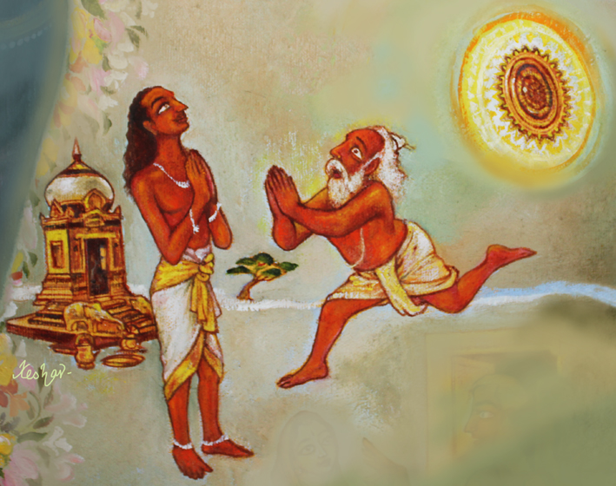
INTRODUCTION
Ambarisha was an Ikshvaku king and the son of Mandhatri. He lived in Treta Yuga. He was a great devotee of Vishnu and through his great bhakti, lord Vishnu had offered him with Sudarshana Chakra. Once, Ambarisha performed the Ekadashi Vrata, and at the time of completion of Ekadashi, Sage Durvasa visited his place, and agreed to be his guest, and also accepted to take food with him, and he went for bathing in the river and returned after a long time. Meanwhile the king broke the fast on account of offering food to the guests. After, a long time Sage Durvasa returned, and he came to know that Amabrisha had taken food without his presence, and got angry and created a demon to kill him. But, since, he is being protected by the Sudharshana Chakra, Lord Narayana's Sudarshana intervened, and it tried to kill Rishi Durvasa himself. Durvasa approached Ambarisha, and asked him to save from the Sudarsana Chakra, and the mighty king also saved the sage from the Sudarsana Chakra.
Let us worship the great king and be blessed.
“OM SREE AMBARISHARE NAMAHA”
“OM NAMO NARAYANAYA NAMAHA”
WRITTEN BY
R.HARISHANKAR

ANARANYA
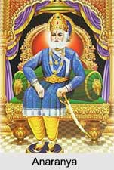
INTRODUCTION
Anaranya was a descendant of Ikshwaku, and a great king of Ayodhya. He was a great devotee of Lord Vishnu. He was also a great scholar and a master in all kinds of arts. He was good at handling weapons during the battle field.
According to the great epic Ramayana, once he was challenged by Ravana and bravely fought with him, but he was defeated by him. Even though he was wounded in the battle field, he cursed Ravana that he will die in the hands of the avatar of Lord Vishnu. Due to that Ravana was killed by Lord Rama. He was such a brave and a courageous person. And he would never afraid of any one. He contains great wisdom, knowledge and kindness. Lord Rama was his descendant, and he ruled his country in a proper manner. Due to his great rule, he was praised by the people, by the kings in other regions, and by the demi gods in the heaven.
Let us worship the great king and be blessed.
“OM SREE ANARANAYARE NAMAHA”
“JAI SREE RAM”
WRITTEN BY
R.HARISHANKAR

ARTHA NAREESWARAR TEMPLE
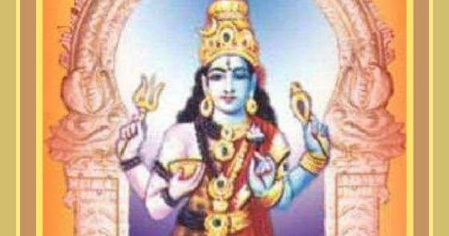
INTRODUCTION
Artha Nareeswarar temple in vasudevanallur at Tirunelveli Destrict is a famous temple, and it is several centuries old temple. The main deity of the temple is Lord Arthanareeswara also called as Chinathamaninathar, and the name of Devi is Idapaga Valli. There are also other shrines for Lord Nataraja, Bairava and Chandikeswara. Apart from these shrines, the following shrines are also found in this temple:
- Lord Surya
- Dakshinamurthy
- Juradevar
- Veerabadra
- Mahalakshmi
- Dharma Sastha
- Lord Vinayaka
- Sani Bhagavan
- Nagaraja and his consort Nagarani
The temple timing is: From 6.00 am to 11.30 am and from 4.30 pm to 8.30 pm. Devotees can approach the temple management and can perform puja and abhishekham to the deities.
Mostly married couples would visit this temple, in order to get a blessed married life, and to get relieved from various problems in their life.
Once, the great sage Bhringi, worshipped Lord Shiva alone, and ignored Mata Parvati. And due to that, in order to show him, that both of them are similar with each other in all aspects, both Lord Shiva and Parvati merged with each other and took the form of Sri Artha Nareeswarar, and appeared before the sage Bhringi. The sage immediately realized his mistake and sought apology to Mata Parvati.
FESTIVALS
- Aani Brahmotsavam
- Aipasi Skandashasti
- Margazhi Thiruvadirai
IMPORTANCE
Both the divine father and mother contains mercy on the human beings and will used to shower their grace, especially to the sinful persons, and will remove their sins, and make them purified. By visiting this temple, we can get peace of mind, good health and sufficient wealth.
Let us visit this holy temple, and worship the divine deities at least once in a year and be blessed.
“OM NAMAH SHIVAYA”
“OM SAKTHI PARASAKTHI”
WRITTEN BY
R.HARISHANKAR

ARUNDAI SIVACHARIAR AND MARAI GNANA SAMBANDAR
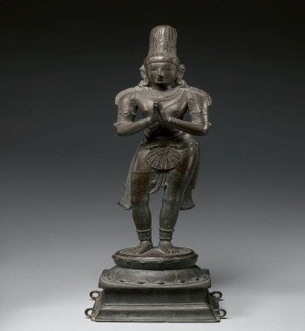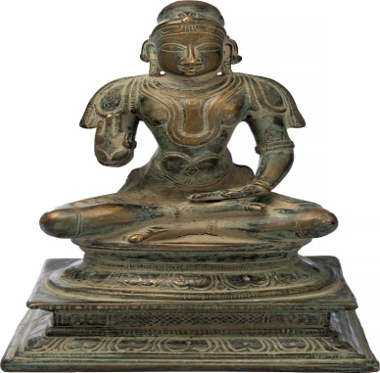
INTRODUCTION
Arundai Sivachariar was born in a village in tamil nadu during 13th century AD. He was a great devotee of Lord Shiva from this childhood, and he will used to regularly visit shiva temples, and worship him sincerely. He also completed his education without much difficulty and learned all the divine scriptures from his Guru “SRI MEYKANDAR”, a great shaivite saint. Through his guidance, he learnt the bhakti path and about surrendering the soul to the god. He composed a famous work “SIVA-JNANA-SIDDHIYAR”. This famous text, explains the importance of Lord Shiva, and also the ways to obtain SALVATION through his grace. It is considered as one of the popular Shaivite text. Arundai Sivachariar was the guru of Marai-Jnanasambandar and made him to spread the importance of Shaivism.
Marai Jnanasambandar, though born in a lower class family, was very intelligent and good in penning devotional poems on Lord Shiva. He will used to write songs and sing in front of Lord Shiva in Chidambaram Nataraja Temple. He also motivated the people by telling the importance of shaivism and conducted various spiritual lectures among the people. He helped the people through his spiritual powers, and reduced their sufferings in their life. He will used to recite the shiva mantra “OM NAMAH SHIVAYA” regularly and perform pujas on Lord Shiva. Both of them, helped the people by insisting them to worship the god in the temples, and also provided free food to the poor devotees.
Let us praise the glory of the shaivite saints and be blessed.
“OM SREE ARUNDAI SIVACHARIARE NAMAHA”
“OM SREE MARAI JNANASAMBANDARE NAMAHA”
“OM NAMAH SHIVAYA”
WRITTEN BY
R.HARISHANKAR

BABA LOKENATH
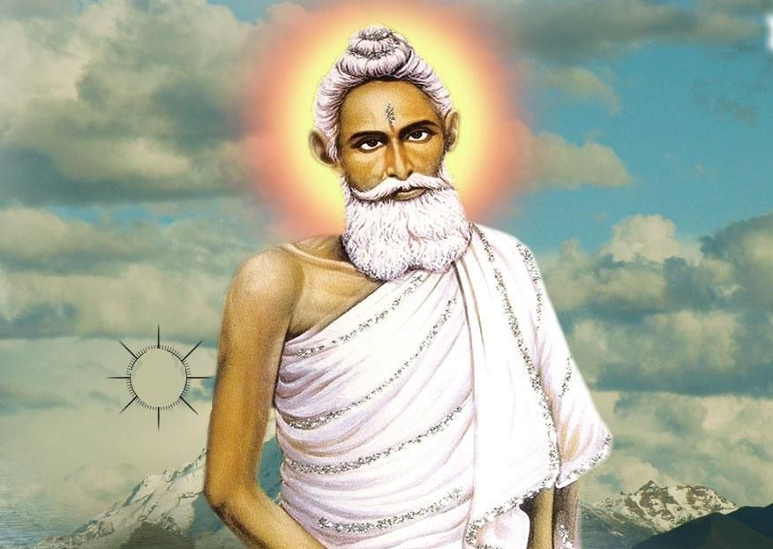
INTRODUCTION
Baba Lokenath was born in the year 1730 in a Brahmin family in the village at Kolkata. As per the wish of his father, he has entered in the spiritual path.
He learnt the Vedas, Shastras and other divine scriptures under a great scholar. At his younger age, he left home and stayed at the Kalighat Temple, and then for several years he stayed in the forest area, and learnt Yoga and Meditation, and got great spiritual powers through that.
Baba Lokenath stayed in the holy Himalayan Mountains and involved himself in deep meditation for several years. After some time, he got enlightenment. He also went on pilgrimages to many holy temples and worshipped the great gods and goddesses and received their blessings.
He also travelled to many foreign countries, and spread the bhakti spirit among the people, and also given divine lectures on spirituality. With the help of his well-wishers, he built a small ashram for him in Dhaka, Bangladesh, at his ripe old age of 100 years. He performed many miracles in the life of his devotees, and gave wisdom, happiness and peacefulness in their life, through his spiritual powers. He also conducted spiritual lectures, and made them to realize the god in their hearts.
TEACHINGS
- Try to control your senses, and live a noble life, then you can attain SALVATION.
- Always be calm and never speak angrily over others.
- Believe in god, without his help, you cannot do anything in your life.
- Consume simple and nutritious food, since we are eating food only for running our life, and not living for eating food alone.
- Don’t make others to suffer, since the same will get repeated in your case also.
- Don’t show enmity with others, since it will never make you to eat and sleep properly.
- Do charity activities in order to increase your good karma and to decrease your bad karma.
- Our main god is our parents, take care of them properly.
- Don’t be selfish, be selfless.
It is believed that he had attained SALVATION on 1890, at the age of 160 years. And his final words are:
"I will always be with you. Do not worry, and in problematic situations, remember me, and call my name, Immediately, I will protect you”.
Lokenath Baba is worshipped as a great saint and guru by millions of Bengali families in West Bengal.
IMPORTANCE
He was a kind hearted and a noble saint and guru who protects us from dangers and from our enemies, and makes us to live a peaceful and prosperous life. He will also give good strength in our mind and body, and makes us to move towards the spiritual path. Still he is hearing our voices, and blessing us from the heaven.
Let us worship the great saint and guru and be blessed.
“OM SREE BABA LOKENATH JI NAMAHA”
WRITTEN BY
R.HARISHANKAR

BHAKTA GOMA BAI
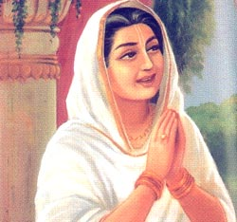
INTRODUCTION
Several centuries ago, there lived a pious and a noble lady in a village in Maharashtra. She was a sincere devotee of Lord Vital of Pandarpur. She lived her life, by cooking food at her home, and selling it to the local villagers. Once she was very much interested to visit the Lord at his temple, and she reached Pandarpur by walk, and she has to cross the holy river Chandrabhaga in order reach the Vital Rukmani Temple, and worship Lord Vital.
Since that time, she didn’t have money, so she has asked the boat man to freely drop her at the Temple, but he refused doing so, and demanded money. Finally she was frustrated and was praying to the Lord at the banks of the river, to take her to his temple and to get to have his divine darshan.
Suddenly, the boatman who was previously refused to take her for a free ride had accepted to take her to the temple without fee. The lady got delighted and joyful tears were fell down from her eyes, and went along with him and reached the temple.
After worshipping the Lord at the temple, she met the boatman again and thanked him for taking her in his boat for a free ride. The boat man was shocked and told to her, that he didn’t take her in his boat at all. Then the lady realized that the boat man who took her through the boat to the temple, was none other than her beloved Lord Vital and thanked him, and permanently stayed nearby the temple by singing songs on the lord, and ate the food given by the devotees of Lord Vital, and built a small hut for her nearby the temple, with the money given by the vital devotees and after her death, she has attained SALVATION through the grace of Lord Vital.
IMPORTANCE
Lot of people were got admired by her beautiful songs on Lord Vital, and they forget their worries and eagerly listened to her songs on the Lord. She also prayed to the god, for the well-being of the devotees, and for those who approached her with their problems. She lived a simple and saintly life, and had thought only about Lord Vital, and chanted his names and glories, and doesn’t enjoyed any other worldly pleasures, which is unimaginable in this today’s world.
Let us worship the great saint and be blessed.
“OM SREE MATA GOMA BAI NAMAHA”
“JAI, JAI VITTALA, VITTALA PANDURANGA VITTALA, JAI, JAI”
WRITTEN BY
R.HARISHANKAR

DAMAJI
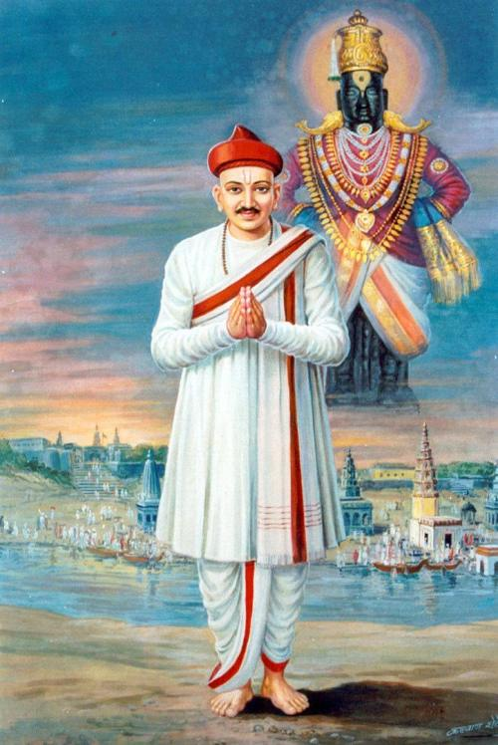
INTRODUCTION
Damaji (15th century), was a great saint belonged to the Varkari sect. He worked under the Bahamani king of Bidar. He is an ardent devotee of Lord Vithoba. He had done many social services for the welfare of the people. He was rescued by the Lord when he faced troubles. He has safeguarded the poor people from the famine which occurred during the year 1460 and lot of people were benefitted through his noble deeds.
His details are available in the famous text “Bhaktavijaya” which was written by Mahapati during 18th century. He was worked under the sultan as a revenue officer and also as a store keeper. A great famine was occurred in the region. At that time, Damaji had distributed plenty of food grains from the government godown to the people at Pandharpur.
His act was reported to the sultan in Bidar. The sultan has sent soldiers to recover the food grains or in the form of money from Damaji. On hearing about this, Damaji met sultan and asked his soldiers to wait for some time in the holy pandharpur. He prayed to Lord Vithoba and asked him to save from the Sultan king.
Vithoba transforms himself into a small boy and approached the sultan and informs himself as the servant of Damaji and settled him with gold coins. The sultan was very much pleased, and in the next day, he met Damaji, and narrated about the incident. Damaji was astonished and realised that god himself had come in the form of his servant and paid his debts, and told about the matter to the king, and asked him to give permission to leave from his job, in order to stay at pandharpur and serve the god whole heartedly at pandharpur. The sultan immediately relieved him from his job, and gave lot of food grains and gold coins as a gift and sent him along with his family to pandharpur with great honours.
Damaji spent many years at Pandharpur by composing and singing songs on Lord Vithoba, and finally attained SALVATION through the grace of Lord Vithoba. He was also praised by the great saint and Vithoba devotee Sri Eknath.
A temple is dedicated to him at his home town at Mangalvedha. Lot of people are visiting the holy shrine and worshipping him.
Let us worship the great saint and be blessed.
“OM SREE BHAKTA DAMAJI NAMAHA”
“JAI VITAL PRABHU MAHARAJ JAI”
WRITTEN BY
R.HARISHANKAR

FAMOUS SAINTS OF KERALA

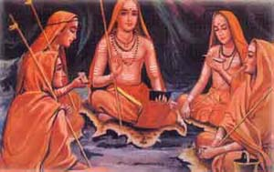

1. Alathur Brahmananda Swami Shivayogi
Alathur Sidhashramam was founded by Brahmananda Swami Sivayogi (1852-1929). He advocated the spirituality through his speeches. It is situated in Palakkad in the state of Kerala and this ashram attracts thousands of visitors every day. This place preaches the importance of doing yoga regularly in our life in order to eliminate our bad habits. According to him, control of mind can be achieved only by regularly worshipping the god.
2.Sree Neelakanta Theerthapada Swamikal
He was born at Muvattupuza. Sri Neelakanta Theerthapada Swamikal was one of the chief disciples of Sree Chattambi Swamikal. He was a great scholar in Sanskrit and Hindu scriptures, and also a great poet. Initially he served as a teacher, and later he accepted saintly life. He wrote good divine works such as Acharapadhathi, Devarchapadhathi and Brahmanjali. He attained samadhi in Karkidakom, Kerala.
3.Sree Theerthapada Paramahamsa Swamikal
Sree Theerthapada Paramahamsa Swamikal was also one of the chief disciples of Sree Chattambi Swamikal. He has started the Hindu Maha Mandalam, in the year 1912. He was born at Thathamangalam in Palakkad. His birth name was Ramanathan. After completing his schooling, he served in few private institutions, and after some time, he travelled to holy places throughout india, and he has become a saint with the name Sree Sadananda Swamy. He has done meditation and yoga. He established an Ashrama at Sadanandapuram. He was a famous ayurvedic and siddha physician.
4.Shubhananda Gurudevan
Subhananda Guru was born in the year 1882 in a village at Pathanamthitta District, Kerala to a pious family. After his parents performed several pujas to the gods, he was born. His birth name was Paappan. At his younger age itself, he was very much interested in spirituality and eagerly listen spiritual discourses held at the temples. From the year 1888 onwards, the child has got great spiritual energy from the god, and has become more spiritual. He discovered the inner self, and realized the god from his soul. After his mother’s death, he was very much depressed, and went to various religious pilgrimages. During the year 1914, He realized the divine appearance of god, and from then onwards, his entire worries and problems has come to an end. Subhananda Gurudev interacted with the untouchables, and provided food and educated them.
After some time, he went to all parts of Kerala, and conducted various spiritual discourses and motivated the people towards doing good things and worshipping the god sincerely and regularly, in order to get rid from their problems. Through his divine touch, more number of people were healed and relieved from their miseries and sorrows.
5. Sree Neelakanta Gurupadar
Sree Neelakanta Gurupadar realized the god at his younger age, and after his basic education, he settled at an ashram in Chenkottukonam and done severe meditation on Lord Shiva for several years, and attained enlightenment through that. He got great yogic powers, through his meditation, and he used his powers for providing welfare to the poor, and relieved them from their diseases and invoked them in the bhakti path, and made them to realize the importance of worshipping the god. He lived a simple and a saintly life, and used to take only simple food, and blessed others.
Gurupadar established Sree Rama Dasa Mutt at Chenkottukonam and renovated a Rama temple and introduced new puja schemes. He appointed his disciplined disciple Swami Sathyananda Saraswathi as a chief of the Mutt in 1965. He attained SAMADHI in the year 1965.
6.Swamy Abhedananda
Swamy Abhedananda was a great saint and the preacher of the Hindu Dharma. He was a disciple of Chattambi Swamikal. He established the Abhedananda Ashram at Thiruvananthapuram in the year 1954. He conducted regular pujas at his ashram and also performed several yagnas. Swamy has attained SALVATION in the year 1983.
7.Swami Aagamananda
Swami Agamananda was a chief pontiff of the Sri Ramakrishna Mission in Kerala, and he established the Sree Ramakrishna Advaita Ashram at Kalady in the year 1936. He was a great scholar and good at all the subjects. He was a kind and a wise saint, who dedicated his entire life for the sake of spirituality and doing social service to the people. He lived a holistic life, through the grace of Bhagawan Ramakrishna.
8. Thapovana Swamikal
Thapovana Swamikal was born in the year 1889 in a pious family in the Palakkad district, kerala. Through his treachings, Swami Chinmayananda has got the knowledge of Vedanta. From his younger age, he was not interested in the worldly life. He went to the Himalayas for meditation. He lived in sacred Uttarakasi by spending his time in meditation.
Swami Tapovan was a great Sanyasi and an intelligent man.
Swami Tapovan was a master in Hindu Scriptures, vedas and sacred texts. He guided others in the spiritual path. In the year 1957, he attained Mahasamadhi.
9. Nataraja Guru
Nataraja Guru was a disciple of Sree Narayana Guru. Natarajan was properly guided by Sree Narayana Guru and he was trained in all the subjects. He served as a teacher in Geneva, Switzerland. Later he established various educational centres in India.
He wrote many commentaries on the works of Narayana Guru, and translated it into english. He was well versed in divine subjects, and contains great wisdom and spiritual knowledge. Nataraja Guru reached heavenly abode in the year 1973.
10. Guru Nitya Chaithanya Yathi
Nitya was born in the year 1923, in a pious family. After finishing his schooling, he went on many spiritual journeys and met various kinds of people, and got spiritual knowledge from the great saints and siddhas. He also met G andhi and Ramana Maharshi and interacted with them.
After the death of his guru, he has become the Head of Narayana Gurukula.
Guru Nitya published many spiritual books. He attained the Samadhi in the year 1999.
11. Swami Ranganathananda
Swami served as a president of Ramakrishna Mission and was one of the spiritual leader hailed from Kerala. He was born in the village near Thrissur in Kerala in the year 1908. He joined the Ramakrishna Mission at Mysore at the age of 18. He attained sainthood in the year 1933. He spent several years in Mysore and Bangalore branches and served as a disciple to Swami Siddheswaranandaji. He also served at the Rangoon branch of Ramakrishna Mission for three years. He was a great scholar and gave spiritual lectures in western countries.
Ranganathananda at his final stage of his life has spent in the Ramakrishna Mission at Belur in West Bengal. Swami Ranganathananda, attained Mahasamadhi during the year 2005.
12. Swami Mridananda
Swami Mridananda was born in the year 1916 in a village in Palakkad in a pious family. His birth name was Kutta Guptan. He completed his education in the year 1934. He served as teacher in various schools and joined in the Sri Ramakrishna Ashram School during the year 1944, and there, he became a disciple of Swami Eswarananda. In 1946 he attained sainthood and went to Beloor. He was also a disciple of Shankaranantha Swami and he named him as Swami Mridananda.
Swami Mridananda contains great wisdom. His life was pure and simple. He spread the message of Sree Ramakrishna and Swami Vivekananda throughout the country. His books are easily understandable even to the layman. He attained Mahasamadhi in the year 2005.
13. Swami Sathyananda Saraswathi
Swami was born in the year 1933, at a village in Thiruvananthapuram. His birth name was Shekaran Pillai and for some time, he served as a teacher in Kerala. After some time, he has become the chief of the Ramadasa Ashram. He realised the god at his younger age itself. He was a good natured person, and also interacted with others in a kind manner. He performed severe penance on the god, and got great spiritual powers through that. .
Swami Sathyananda Saraswathi, has reached the heavenly abode during the year 2006.
Let us worship the great saints of Kerala and be blessed.
“OM SREE VINAYAGAYA NAMAHA”
“OM SREE GURUVAYURAPPANE NAMAHA”
“OM SWAMIYE SARANAM AYYAPPA”
WRITTEN BY
R.HARISHANKAR
GANGAMMA
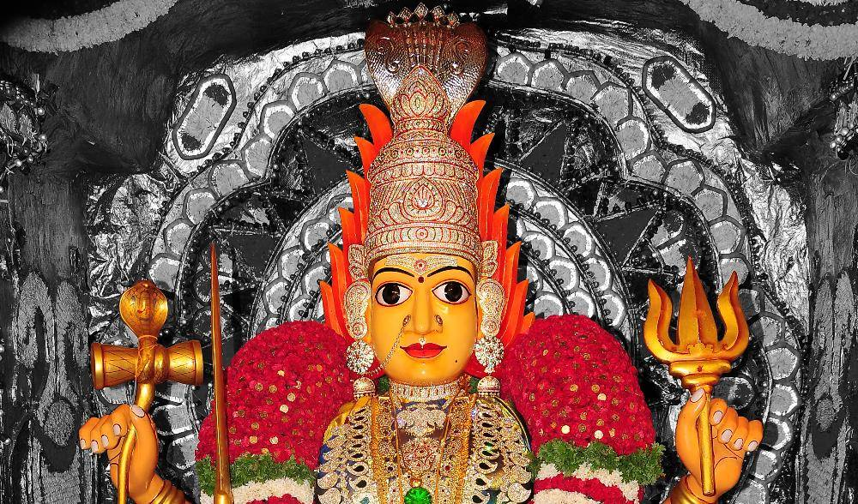
INTRODUCTION
Gangamma Devi Temple is situated at Boyakonda, Andhra Pradesh 517257. This is a holy temple dedicated to Mata Gangamma Devi, who is considered as an incarnation of Mata Parvati Devi.
Hundreds of years ago, the tribal community people known as Boyas were lived in the forest located near the hills. They were against the rule of the Sultan kings and started fighting with them. But they couldn’t withstand the army of the Sultan and escaped into the forest and prayed to the holy mother to save them. Due to the divine grace of Gangamma, the nawab’s army were fled away from that place. In order to celebrate the victory, the Boyas constructed the Gangamma temple, and worshipping her since several centuries.
The temple is an ancient temple situated on the top of a mountain. This goddess is known for destroying the enemies for those who sincerely worship her.
Devotees used to come again to this temple, once their wishes were fulfilled and perform various pujas along with animal sacrifices, though she doesn’t prefer it.
There is a well in the temple, which is believed to cure skin diseases and leprosy. Apart from that by using the water in the wall, our all sorts of diseases will be cured, through the grace of the holy divine mother.
During the annual Navratri festival, lakhs of people would come from various parts of india and worship “MATA GANGAMMA DEVI” in this temple.
IMPORTANCE
Gangamma also called as Gangaiamman is a divine mother, who will used to answer our urgent calls, and appear before us immediately. She expects only the pure bhakti from us and nothing more else. Even there is no need to tell our problems to her, since she is having the power to study our mind, and finds out the problems, and gives proper solutions for that. Even if we contribute a little amount for performing a puja for her, that will be sufficient for her, and gives all the prosperities in our life. By doing charity to the poor, she will be very much pleased with us and offer various boons to us.
Let us worship the holy mother and be blessed.
“OM MATA GANGAMMAVE NAMAHA”
“OM NAMAH SHIVAYA”
WRITTEN BY
R.HARISHANKAR

JAABAALI
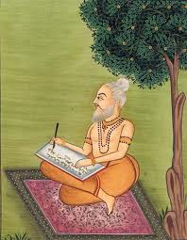
INTRODUCTION
Jaabaali Maharshi was an ancient rishi. He was mentioned in puranas and in several hindu texts, and his importance is also mentioned. He was an expert in vedas and other hindu literature and contains good knowledge, wisdom and high meditative powers. He was good at doing yoga and meditation. He has also written lot of sacred texts. Through his spiritual powers, he had done good things for the welfare of the people, and invoked them in the spiritual path, and asked them to recite the names of the gods and goddesses in order to fulfil their desires.
Jaabaali will used to meditate in the Holy Mata Narmada River. He has also constructed an ashram and lived nearby the river. He also performed penance on Tirumala, the place which is known as "Jabali Theertham", near Tirupati. Several devotees are visiting this place to solve their problems and to get peace of mind.
TEACHINGS
- You are getting energy only through the blessings of the god, without him, nothing is possible in this world.
- Understand the true sense of the god, by reading the scriptures, and get yourself surrendered with him, and put your burdens on his shoulders, and he will take care of you.
- Consider yourself as the attendant of god, and do proper service to him in the temples and in your home, by performing homams, pujas and abhishekhams to him.
- Daily allocate some time to pray to the god, and chant his names and glories.
- Understand that god is residing within you and within your soul, and consider all the living beings, even the small insects as the aspect of the god, and don’t harm them.
- Respect your parents and take care of them properly, since doing that act will please the god.
- Show kindness and respect everybody, don’t think badly about others even to your enemies.
- Our fate has already decided and finalized by the god, hence there is no need to worry about anything in this world, try to do good things in your life, rest of it, god will take care of.
- Perform meditation and avoid unnecessary talks with others, since this will lead you in troubles.
Due to his fine teachings, he has become famous, and got lot of followers. He lived his life in a righteousness manner. He never caused harm to others, and also never cursed others, even if they committed mistakes to him. He was such a kind of good rishi, and lived a saintly life throughout in his life. People were lived happily by following his teachings. He was praised by the people in the earth and by the demi gods in the heaven for his great service to the entire mankind and to the divine gods.
Let us worship the great rishi and be blessed.
“OM SREE JAABALI MAHARISHIYE NAMAHA”
WRITTEN BY
R.HARISHANKAR
KARMAMELA
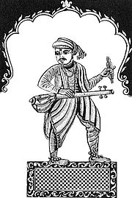
INTRODUCTION
Saint Karmamela (14th century) was a great saint from Maharashtra. He was the son of Chokhamela and Soyarabai and belonged to Mahar caste, and they were considered as untouchables and treated badly by the upper class people during those days. He was against caste discrimination. He deeply expresses in his songs, about his birth in lower class family, and the sufferings which he faces in his daily life. Karmamela was deeply attached with Lord Vital and concentrated his attention only on him. His songs are so divine, and it was praised even by the upper class people.
He will used to sing the glories of the Lord and dance with full of joy and forget about the entire things around him. He has got such a great bhakti on Lord Vital, which is very difficult to practice in this today’s modern era of lifestyle.
FAMOUS QUOTES
- According to the god, all the creations are equal, and they must be treated with great respect.
- Everybody’s blood is red only, then why caste discrimination is there in this world?
- Show mercy on lower class people, and give proper respect to them.
- We are all the slaves and servants only to the divine god, and no one is the permanent master in this world, except the great god.
- All the divine scriptures, teaches only good things to us. Then why there is such a great differentiation between us.
IMPORTANCE
He expressed his feelings in his poems, and he wants the females to be treated with good respect, and must be given all the rights similar to the males. He was very much interested in social responsibility, and took keen interest on promoting the bhakti spirit of Lord Vital among others. Though he was born from a lower class family, he got great knowledge in all the subjects, and got the talent to compose songs on the god, within a short time. He lived a noble life, and attained SALVATION after his death.
Let us praise the great saint and be blessed.
“OM SREE BHAKTA KARMAMELA NAMAHA”
“OM SREE VITAL PRABHUVE NAMAHA”
“OM MATA RUKMANI DEVIYE NAMAHA”
WRITTEN BY
R.HARISHANKAR

KARUNAKARA GURU
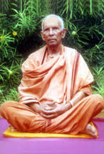
INTRODUCTION
Karunakara Guru (1927–1999) is the founder of the Santhigiri Ashram in Pothencode, Kerala, India.
Karunakara was born into a pious family in a village in the Alappuzha district of Kerala. Even from his childhood, he lived a holy life, and done regular prayers on god, and went to temples and performed pujas. At his younger age, he left home to lead a saintly life, and joined in the Advaita Ashram near Kochi, which was founded by the great spiritual saint and social reformer Sri Narayana Guru.
He spent several years in the ashram and he went to Santhigiri hill and performed meditation. After some time, he built the Santhigiri Ashram with the donations given by his well-wishers.
The Santhigiri Ashram is located nearby Trivandrum, Kerala. Birthday Celebrations of Sree Karunakara Guru would be made at this Ashram during August–September, and special prayers will be held. The ashram is surrounded with full of greenery, and is located nearby the town. People belonging to all the religions are allowed to enter into the ashram and to worship the great guru Sree Karunakara.
TEACHINGS
- Worship god sincerely, in order to get peace of mind, and to get proper support from the god.
- Read devotional books, for not getting diverted from other unnecessary activities.
- Don’t get worried about anything in your life. Your life is only in your hands. Plan properly and work accordingly.
- Respect all the living beings in the earth.
- Regularly do yoga and meditation.
- Do charity works and make the poor people to smile, and get their blessings.
- Realize your inner energy and worship the god within yourself, since god is dwelling in all of our hearts. This can be achieved only by constant prayers and meditation on the god.
- Don’t allow bad thoughts to enter into your mind, since that will spoil your life.
- Don’t show enmity over others. Move with others in a friendly manner, even with your enemies.
IMPORTANCE
He was a kind hearted and noble saint, who lived throughout his life by doing divine service and social welfare activities. Through his holy touch, he had removed the diseases of his devotees, invoked them in the spiritual path, removed the thorns from their path, and made them to live happily and peacefully. He changed the hearts of several people, through his good lectures.
Let us worship the great saint and be blessed.
“OM SREE KARUNAKARA GURUVE NAMAHA”
WRITTEN BY
R.HARISHANKAR

KATAMARAJU
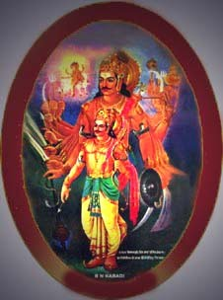
INTRODUCTION
Katamaraju and Potharaju are considered as an incarnation of Lord Shiva, who had taken the avatars to protect the village people, and especially the women from dangers and difficulties. Both of them done lot of good activities during their life time, and considered as demi gods and worshipped by the village people.
Katamaraju was born in the Yadava community, and served as a king in a village at Andhra Pradesh, and captured his nearby regions due to his great warfare and braveness. He ruled his region in a proper manner, and provided all the facilities to the people, and his people were worshipped him as their god. During his reign, there were no drought, no famine and no dry situation prevailed in his region. All the people were lived happily and peacefully throughout their life. It is believed that he lived during the 13th century and given a golden rule to the people. He constructed Annadan shelters and resting places for the travellers, and also provided free food to the poor and the needy.
He took care of the women in a proper manner, and given much respect to them, and treated them as an aspect of Mata Kali. He also provided proper training to them in agriculture and given them work in agriculture fields and looked after them properly. Apart from his people, he was praised by kings in other states, and also by the demi gods in the heaven, for his good nature.
He contains good knowledge in all kinds of art, and learned the Hindu scriptures and other sacred texts and lived as per the guidelines of the divine texts. During his reign, no one has suffered from poverty, diseases, miseries and sorrows, since he is considered be an incarnation of Lord Shiva.
Let us worship the great gods and be blessed.
“OM SREE POTHARAJUVE NAMAHA”
“OM SREE KATAMARAJUVE NAMAHA”
“OM NAMAH SHIVAYA NAMAHA”
WRITTEN BY
R.HARISHANKAR

KAVINDRA THEERTHA
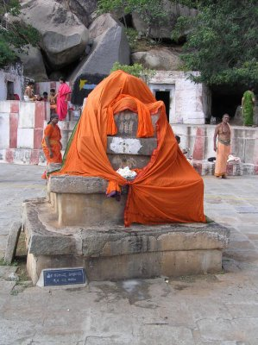
INTRODUCTION
Kavindra Tirtha (1333-1398) was a dvaita saint and the pontiff of Uttaradi Mutt. He was a great scholar and talented in all vedas, shastras, Upanishads and other holy texts. He was the chief of the Uttaradi mutt during his last six years, before attaining Samadhi in the Nava Brindavan, which is situated in Hampi, Anegunde, karnataka. Devotees from all sects of Hinduism would visit this holy place, and worship the great Saint Kavindra Tirtha along with the eight other saints.
The nine saint names are as follows:
- Shri Padmanabha Tirtha
- Shri Kavindra Tirtha
- Shri Vagisha Tirtha
- Shri Raghuvarya Tirtha
- Shri Vyasatirtha
- Shri Sudhindra Tirtha
- Shri Srinivaasa Tirtha
- Shri Raama Tirtha
- Shri Govinda Vodeyaru

LIFE
It is believed that he was born in a village at Karnataka, and he was very intelligent in his studies, and got good grasping power. He also rendered several social welfare activities during his period, and distributed food and clothes to the poor people. His guru was Shri Vidyadhiraja Teertha.
Shri Kavindra Teertha was also known as "Vedanta Samrat" due to his great knowledge in vedas. He took charge of the mutt and administered it properly. Everyone has appreciated his service and towards his dedication to the god. He used to perform puja to Sri Ram and other deities and then only would take his morning breakfast. He lived a saintly life, and dedicated himself to the welfare of the people and to the god. Through his great spiritual powers, he has also solved the problems of the people, and removed the diseases from their body, and invoked them into the spiritual path, in order to live a pleasant and a happy life.
Let us visit the holy mutt of Kavindra Teertha along with other saints at Nava brindavana at least once in a year. Since by visiting the holy place, we would get the divine blessings of the saints as well as the gods and goddesses, and we would get a sense of satisfaction and our mind and body would be relaxed and we would get spiritual energy, which we will not get anywhere else, even if we make foreign trips. Apart from luxurious entertainment travels, we can allocate some time, to travel to this holy place, in order to get pleasantness in our life.
Let us worship the holy saint and be blessed.
“OM SREE KAVINDRA TEERTHARE NAMAHA”
“OM NAMO NARAYANAYA NAMAHA”
WRITTEN BY
R.HARISHANKAR

MANIRAM BABA
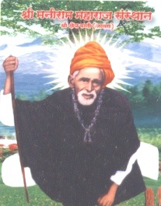
INTRODUCTION
Maniram Baba was a great saint and a yogi who was involved in deep spirituality and done many good things to others. It is believed that he was born in a village at Maharashtra, in a pious Brahmin family. He was an intelligent and a good natured yogi, who performed many miracles even at his younger age.
Once, he met the great saint Shri Gajanan Maharaj, of Shegaon, an incarnation of Lord Vinayaka, and discussed spiritual matters with him. He lived in Baggi and spent several years in meditation and doing noble deeds to others, such as healing their health by his divine touch, and reduced their sins, by touching their heads in his hands, and asked them to chant the Holy names of the gods and goddesses in order to get good fortunes in their life. His disciple was Sri Ramji, who has provided food and accommodation to the great Maniram Baba. And after some time, he has become a saint.
In the initial stages of his life, he worked under a wealthy man and looked after his cows, but instead of taking care of the cows, he was reading Hindu Puranas. And after seeing his activity, his boss has thrown the book into a river.
Maniram casually went near the river and took the book. By seeing this miracle, his employer has become the disciple of Baba.
Maniram will used to perform meditation in the river for several hours, even without bothering about the chillness, and the sea creatures bite. He will used to worship the Sun God, and chant various mantras in praise of him. He was very good at yoga and meditation.
IMPORTANCE
He cured many dreaded diseases of the people, and also solved the personal problems of the people. He also brought back the life of the dead animals. And he regularly used to provide food to crows, cats and dogs. He lived throughout his life for doing goodness to others, and lived a holistic and a simple life, and never enjoyed any comforts and luxuries in his life.
Let us praise the great saint and be blessed.
“OM SREE MANIRAM BABA NAMAHA”
WRITTEN BY
R.HARISHANKAR

MANU
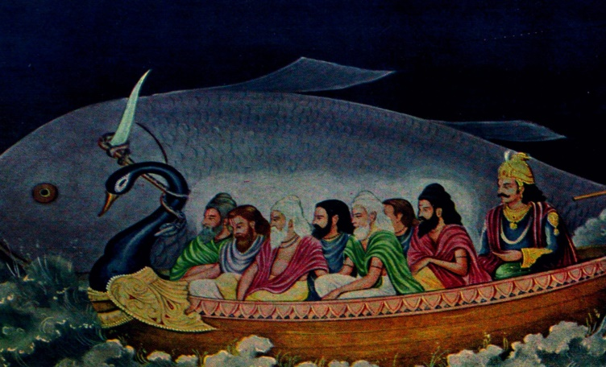
INTRODUCTION
According to ancient puranas, Shraddhadeva Manu is the current Manu and considered as the father of the entire people in the earth. He is mentioned in all the puranas, vedic texts and in divine texts. His grand-father was Lord Brahma. And through his blessings he has got great power. Shraddhadeva was ruling the Dravida Kingdom before the Pralaya, the great flood. According to the Matsya Purana, Matsya, the avatar of Lord Vishnu, informed the king to safeguard himself and his family along with the Saptharishis from the great flood. Lord Matsya was tied with the boat and he carried all of them to the Himalayan Mountains.
After the deluge, Manu's family and the seven sages created the living beings in the earth. Shraddhadeva married Shraddha and had ten children, and from them the Lunar and Solar Dynasties were formed.
IMPORTANCE
He is considered to be the main origin for the entire creation in this world. By the grace of Lord Vishnu, he has produced numerous creations in this world, through his descendants. He contains the power similar to that of Lord Brahma, and helps us in discharging our duties in a proper manner. Though he was a king, he was very much interested in spirituality and lived his life by conducting yagnas and doing pujas to Lord Vishnu. Though there are no specific temples dedicated for him, he is mentioned in almost all the ancient Hindu texts, and also is considered as an incarnation of Lord Brahma. He has given a set of valuable teachings which is very useful for the mankind also known as the “MANU DHARMA SHASTRA” and “MANUSMRITI” and it is considered as a sacred ancient text. He ruled in a dharmic path and done many good things to the humans and to the divine demi gods and used to offer regular prayers to the Trimurties and Tridevis.
Let us worship the great Manu and be blessed.
“OM SREE MANU DEVARE NAMAHA”
“OM NAMO NARAYANAYA NAMAHA”
WRITTEN BY
R.HARISHANKAR

MATA POCHAMMA
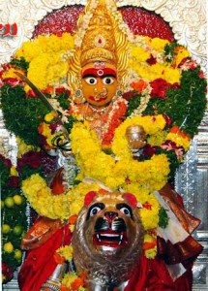
INTRODUCTION
Goddess Pochamma is a mother goddess who is mainly worshipped by the Telangana and Andhra Pradesh people. She protects people from all kinds of diseases, and also she safeguards them from their enemies and gives all the prosperity in their life. Goddess Pochamma is a guardian deity and is considered as a Village Devata. The most important festival dedicated to Goddess Pochamma is the Bonalu festival which is celebrated in the month of July – August. Pochamma is also considered as an aspect of Goddess Kali. It is told that she will create problems for the people if they reject or dislikes her, and gives various diseases to her dis-obedient. But the holy mother, will never do like that. In fact, she will correct the mistakes of the people and make them to realize that she is their divine mother. In Adilabad district, Pochamma is called as Gajjelamma. The idol of pochamma is made out of fine wood and is placed near a neem tree. Usually she will be dressed with yellow coloured dress. The devotees make small idols of her and place them in the temple. Her husband Mahamuni is the guardian deity of all the animals, birds, small insects, ants and trees in the forest. The festival of Bonala panduga and Pochamma panduga are performed in villages. Generally people worship her on Sundays. The devotees perform puja and 'Abhishekham' and decorate her with flowers and offer fruits and food items like sundal, mixed rice to the deity, and distribute it to the participants of the puja after the performance of the puja. Though she doesn’t prefers, animal sacrifice is also done in this temple, in order to please the divine mother.
IMPORTANCE
Mata Pochamma will come with us in our every walk of life, and will be our permanent protector. From our birth, till our death, she will be with us in our every moment of life, and gives more courage, strength, enthusiasm, knowledge and wisdom to us. She will immensely cure our dreaded diseases and reduce our sins committed in past births and makes us to walk freely in the outside world, and finally will also give SALVATION to us based on our pure bhakti on her.
Let us worship the holy mother and be blessed.
“OM SREE MATA POCHAMMAVE NAMAHA”
“OM SWAMY MAHA MUNIYE NAMAHA”
“OM NAMAH SHIVAYA NAMAHA”
WRITTEN BY
R.HARISHANKAR

NAMASU
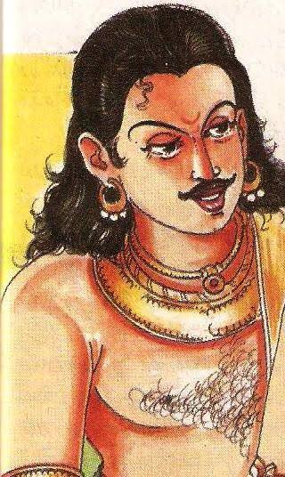
INTRODUCTION
Prince Namasu was the son of the great king Mahabali, and the great grandson of Sri Bhakt Prahalad. He was one among the 100 children of Sri Mahabali. His elder brother is Banasura, a great devotee of Lord Shiva, and become a divine attendant of Lord Shiva in Kailash, the abode of Lord Shiva. He was also present during the time of Vamana Avatar of Lord Vishnu, and went along with his father to the Nether World (Pathala Loka). He was a great devotee of Lord Vishnu, similar to his father and his great grandfather Sri Bhakt Prahalad.
Since Prahalad had got the boon for his 27 generations for becoming Chiranjeevis from Lord Vishnu, he is still able to live in the Pathala Loka, along with Mahabali. It is believed that his descendants are also living with him, with the blessings of Lord Vishnu, who stand as a guardian outside the Pathala Loka, in order to protect them from their enemies.
According to the boon given by Lord Vamana, an avatar of Lord Vishnu, King Mahabali would be the next Indra in the next Krita Yuga, that is after the end of Kali Yuga, which is supposed to end after 4,26,000 years ( approximately). At that time, the great Namasu will occupy a main place in the Swarka Loka, next to his father Mahabali. He will also get the divine blessings of his ancestor Prahalada, and live in a glorious manner.
As per the legend, Namasu is considered as one of the obedient and disciplined son of Mahabali, who always obeys his orders and instructions and carry out the duties according to his wish. He is considered as a GEM among the 100 sons of the king Mahabali. During the regime of Mahabali, he also participated in his rule, and won the hearts of the people, by properly taking care of them. Though, he is not that much familiar similar to his father and great grand–father, some details about him were mentioned in the ancient scripts. It is mentioned that during the food donation organized by Mahabali, he will used to patiently serve food to a minimum of 1000 people at his palace in a whole heartedly manner. Due to that he was admired and praised by the people and also by the kings, gods and demi gods in the heaven.
Let us worship the great prince Namasu and be blessed.
“OM SREE NAMASUVE NAMAHA”
“OM SREE MAHABALIYE NAMAHA”
“OM SREE BHAKTA PRAHALADARE NAMAHA”
WRITTEN BY
R.HARISHANKAR

NARAHARI SONAR
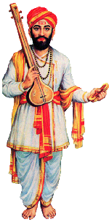
INTRODUCTION
Narahari(13th century AD) is the famous saint of the Varkari sect and a goldsmith from Maharashtra. He lived in Pandharpur, where the sacred temple of Lord Vithoba is located. Previously, he was a staunch shiva devotee, and after some time, Lord Vithoba had made him to realize that both Shiva and Vishnu are similar gods, and thereafter, he has become a staunch Vithoba devotee.
Once, a merchant had approached Narahari Sonar to make the waistband for the deity Vithoba. Narahari doesn’t want to look the idol of Vithoba, since he believes only on Lord Shiva, and he went to the temple of Vithoba by tying his both of the eyes in a cloth. But when he touched the idol, he felt as if he was touching the idol of Lord Shiva, since he felt that the idol was wearing serpent ornaments and contained matted hair on its head. He tested it for one more time, and realized that both Lord Hari and Lord Haran are one and the same, and immediately sang a song in praise of Lord Vithoba.
Afterwards he has become a staunch devotee of Lord Vithoba and penned beautiful songs and sung in front of him in the temple. He has also become a friend of Eknath, a great devotee of Lord Vithoba.
The Sonar community people are worshipping him at his shrine in Pandharpur.
IMPORTANCE
After becoming a Vithoba devotee, he has praised the glory of Lord Vithoba, and used to sing his songs in a mesmerising manner. Many people were admired him towards singing beautiful songs on Lord Vithoba, and praised him for his bhakti on the god. It is believed that Lord Vithoba had once given darshan and blessed him. He was also praised by other vithoba devotees and was honoured by them. Even at the time of his death, he was singing the glories of Lord Krishna, and after his death, he has reached the abode of Lord Vishnu, the Vaikunta.
In this present scenario, we cannot find such a great devotee, who has melted the hearts of thousands of people through his melodious songs.
Let us worship the great saint and be blessed.
“JAI NARAHARI SONAR JAI”
“JAI VITTAL MAHA PRABHU JAI”
WRITTEN BY
R.HARISHANKAR

NATARAJA
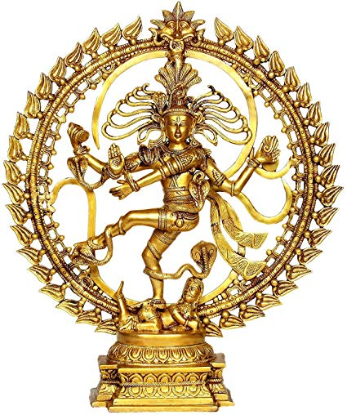
INTRODUCTION
Nataraja is a form of Lord Shiva and he is the cosmic dancer. His dance is called as Tandavam and the details about his dance are mentioned in various sacred texts, and usually a Nataraja Idol would be found in most of the Shiva Temples. It is believed that he is dancing in order to protect the people and to maintain peace and prosperity in the earth. During Pradosham days, Lord Shiva in the form of Nataraja would dance between the horns of Lord Nandi, the divine bull and attendant of Lord Shiva. Once Lord Adisesha, the divine serpent bed of Lord Vishnu, prayed to Lord Shiva, and got his darshan in the form of Nataraja.
The various dance postures in the form of stone inscriptions are found in the Ellora Caves and Badami Caves. Nataraja is also worshipped in Hindu temples of Asian countries. Thiruvadirai Festival also known as Arudra Darisanam is celebrated in Chidambaram, Madurai, Tiruvalangadu, Tirunelveli and Kutralam temples. Lord Nataraja is a well-known form of Shiva and is praised as the dance god. He is mainly worshipped by the dancers and art related people in order to get better results in their career. Most of the people belonging to music and dance field will be having a statue of Nataraja at their home, both for worship as well as for display purpose. Nataraja is the main deity in the Chidambaram Temple, and the temple is considered as one of the Mukti Stalams.
IMPORTANCE
Being worshipping Lord Nataraja at any of the shiva temples, or at Chidambaram during Thiruvathidarai festival day, will bring better prospects in our life, and our sins will be wiped out, and all of our sorrows and miseries will come to an end. It is also advisable to worship Nataraja during pradosham days, for getting better fortunes in our life.
Let us worship the holy Nataraja and be blessed.
“OM NAMAH SHIVAYA NAMAHA”
WRITTEN BY
R.HARISHANKAR
PALLIKONDESWARA TEMPLE
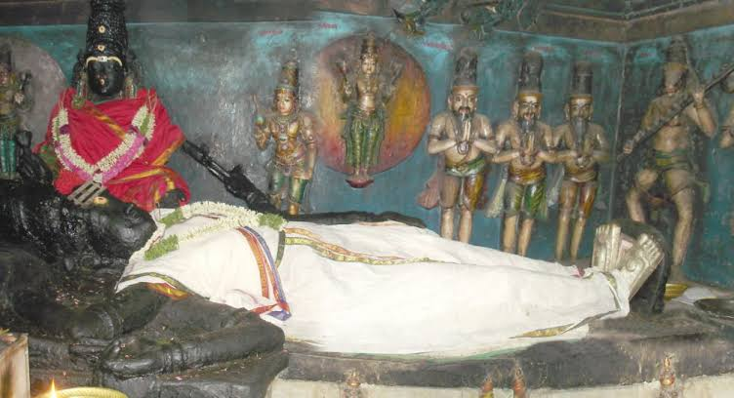
INTRODUCTION
Pallikondeswara Temple is a famous temple dedicated to Lord Shiva and it is situated in Surutapalli, a village in Chittoor district of Andhra Pradesh. The main deity Pallikondeswara, unlike in other Siva Temples, will be in the form of resting posture, and such a kind of form is not found anywhere else.
Palli Kondeswarar is found along with Mata Parvati who is called as Sarva Mangalambika, who gives all kinds of prosperity to us. The temple was built by the Vijayanagara kings. Here Lord Shiva is not worshipped in the form of Lingam. The divine idols of Ganesha, Muruga, Surya, Chandra, Indra, Brahma, Vishnu, Kubera, Adisankara and Rishis are also found in the temple. Navagraha shrine is also separately present in this temple. The Pradosha kala puja is performed here in a well versed manner.
As per the puranas, during the churning of the divine ocean by the gods and demons, along with various things, the poison Halahala also found in the ocean, which Lord Shiva had drank it, in order to safeguard the entire universe from destruction. While on his way to Mount Kailash, he was not well and for some time he took rest in the place of Suruttapalli. In order to honour the great god, who has protected the entire universe through his divine grace, a temple was constructed at this place.
FESTIVALS
Pradosham and Sivarathiri festivals are considered as most auspicious festivals in this temple. During these days, thousands of devotees would throng in the temple and will get the darshan of their beloved god and goddess, and get relieved from their sins and also from their various problems.
Let us try to visit this holy and rare temple of Lord Shiva at least once in a year, and get his great blessings.
“OM NAMAH SHIVAYA”
“OM SAKTHI PARASAKTHI”
WRITTEN BY
R.HARISHANKAR

PANCHAJANYA
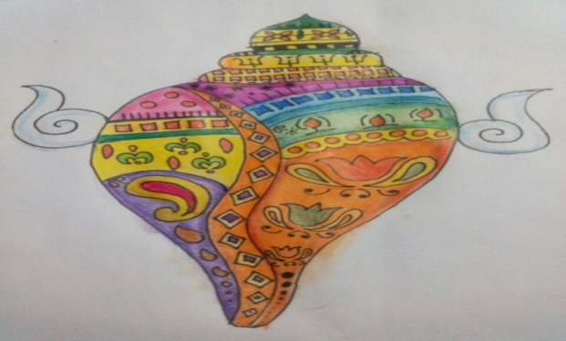
INTRODUCTION
Panchajanya is the holy conch of Lord Vishnu. According to the famous legend, Mahabharata, the great demon Panchajanya also called as Shankhasur was lived in the Ocean Prabhasa and he kidnapped the son of Sandipani, the guru of Shri Krishna and imprisoned him in his place. The guru was very much worried about the condition of his son, and asked Lord Krishna to find and bring back to him. Immediately Lord Krishna went inside the sea and fought with the powerful demon, killed him and rescued the son of his guru, and took the conch shell along with him in order to use it during the kurukshetra war. He then went to the ashram of his guru Sandipani and returned his son to him. The image of Lord Vishnu in the temples is depicted with having the Conch and Chakra in his hands.
According to Ramayana, Rama’s brother Bharata is considered to be an avatar of Conch also known as Shankha. The conch is considered as a holiest one and can be kept in the puja room. It gives great prospects in our life, and will heal our various diseases and gives great mental satisfaction to us. Our unwanted thoughts will be avoided in our mind, by keeping the conch in our puja room.
The main benefits are as follows:
- Improves mental and physical strength.
- Career growth will be there.
- Unnecessary tensions and angriness will be avoided.
- Positive approach in our life.
- Fulfilment of our desires.
- Gives more spiritual energy.
- Ma Lakshmi’s presence will be there.
- Relief from various problems in our life.
- We will attain SALVATION, after our death.
Hence, by keeping the above factors into consideration, let us worship the Lord Panchajanya and be blessed.
“OM SREE PANCHAJANYARE NAMAHA”
“OM NAMO NARAYANAYA NAMAHA”
WRITTEN BY
R.HARISHANKAR
PURURUVAS
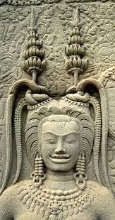
INTRODUCTION
Pururavas was the king of the chandravamsha. His father was the Planet Budha, and Kauravas and Pandavas were his descendants.
He was also mentioned in Rig Veda, Puranas, Mahabharata and the Bhagavat Purana.
The great King Pururavas got married with the heaven dancer Urvashi , and the details were mentioned in the famous text written by Kalidasa.
LIFE
Pururavas was born in Treta Yuga and since he was born on the holy Mountain Puru, he was called as Pururavas.
Through his severe penance on Lord Brahma, he has become the king of the entire earth. He also performed several yagnas for maintaining peace and prosperity in his kingdom. He had seven sons. His greatness is mentioned in various sacred texts, and he was considered as an efficient and an eminent warrior, and no one was equivalent to him with regard to his great powers. He was a friend of devas and helped them in fighting with the demons.
IMPORTANCE
Being the mighty son of Lord Budha, he got sufficient powers to bless and safeguard us from all sorts of problems in our life. He is considered as a demi god, and is equivalent to Lord Surya and Chandra. He was also good at meditation and got great spiritual powers. It is believed that he is living with his father “Lord Budha” in the Budha Loka, and doing his duties in the capacity of the DEMI GOD. He is also a friend of Lord Indra, and regularly visits him in his Indra Lok.
Let us worship the great pururavas and be blessed.
“OM SREE PURURAVAS DEVAYA NAMAHA”
WRITTEN BY
R.HARISHANKAR
RANG AVADHOOT
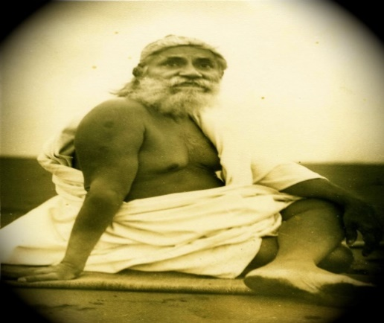
INTRODUCTION
Rang Avadhoot, (1898-1968) was a great saint, poet and a great Dattatreya Devotee. He was involved in social welfare activities before becoming a saint. He has spread the Datta Bhakti Spirit among the people in Gujarat, and he contains the features of Guru Dattatreya. He has written lot of devotional works. His birth name was Pandurang. He was a great scholar and an expert in Vedas and Hindu Scriptures and was thorough in all the regional languages.
Rang Avadhoot was born in the year 1898, in Godhra in a pious Brahmin family, at Sangameshwar taluka of Ratnagiri district in Maharashtra. His father worked as a priest in the Vittal temple. He has become the disciple of Sri Vasudevanand Saraswati in 1905. After completing his schooling in 1920, he joined in the freedom fighters movement. And he also worked as a teacher in a school, and he lived as a strict bachelor throughout his life.
Due to his spiritual thirst, he left his job and accepted sainthood. He lived at Nareshwar on the banks of the Holy River Mata Narmada, by establishing an ashram for him. Daily he used to chant Lord Dattatreya’s name for several thousands of times. He was also good at meditation and yoga. He was a great devotee of Mata Narmada and used to worship her regularly at the banks of the River Narmada.
He died in the year 1968 at Haridwar on the banks of the Holy River Mata Ganga. The devotees and his followers worship him as an avatar of Lord Dattatreya, who has taken birth in this earth for propagating the teachings of Lord Datta, and also to protect the people from their sufferings.
WORKS
- Upanishadni Vato
- Vishnupuranni Varta
- Girvahbhasha Pravesh
- Sadbodhshatakam-Balbodhini
- Rentiyanu Rahasya
- Swaraj-Kirtan
- Dattabavani
- Rangtarang
- Amar Adesh
IMPORTANCE
He was a great saint and scholar and done many good things and blessed his devotees, and also removed the fear from their minds, given suggestion for leading a noble life, and protected them during the difficult situations in their life. His teachings are simple and straight forward in nature. He rendered spiritual as well as socially related activities, and won the hearts of the people. And his works are easily readable by others, and written in a simple manner. He was highly praised by the people for his good activities, and they regarded him as a great saint and saviour.
Let us worship the great saint and be blessed.
“OM SREE GANESAYA NAMAHA”
“OM SREE AVADHOOT SWAMI NAMAHA”
“OM SREE DATTA BHAGAWANE NAMAHA”
WRITTEN BY
R.HARISHANKAR
SAINT BANKA
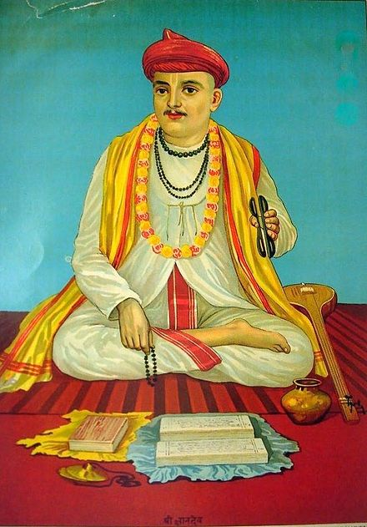
INTRODUCTION
Saint Banka (14th century) was a famous saint of Maharashtra. His wife was the great saint Nirmala, and his brother-in-law was Sri Chokhamela, who was also a great vital devotee. He was born in Mehenpuri into the lower class family, who were considered as Untouchables in those days. He was a great poet and wrote several songs on Lord Vital and also used to sing in praise of him. He dedicated his entire life, towards praying to Lord Vital, and lived a pious life.
In his song also, he expresses the difficulties being faced as an untouchable, which includes for not permitting him inside the Vital temple, and also avoiding him from participating in religious festivals, and treating him like a servant by the upper class people. He further expresses his true love on the Lord Vital, and says that according to the holy Vital Prabu, all the people created by him are equal, and the people born in lower class communities must be given all the rights similar to the higher class people.
IMPORTANCE
In order to appreciate his true bhakti, Lord Vital himself appeared before him several times along with Ma Rukmani and blessed him. He also got a good health and a sound mind, due to the divine touch of the Lord. Through the grace of Lord Vital, he was able to write several songs on him, and lived a holistic life. Through his miraculous powers, Lot of Vital devotees were got relieved from their diseases, and also received the bhakti spirit from him. He along with Choka Mela conducted regular bhajans on Lord Vital at their homes, since they were not allowed to enter into the temples. After his death, similar to his brother-in-law Choka Mela, he has also attained SALVATION.
Let us worship the great saint and be blessed.
“OM SREE BHAKTA BANKA NAMAHA”
“JAI VITAL, JAI, JAI VITAL”
“OM SREE MATA RUKMANI DEVIYE NAMAHA”
WRITTEN BY
R.HARISHANKAR

SANKARA NARAYANAR TEMPLE
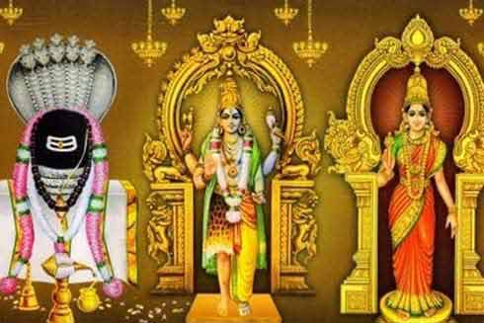
INTRODUCTION
Sankarankovil is a place where the famous Sankara Narayanan temple is located. In order to make the devotees of Vishnu and Shiva to realize that both of these gods are one and the same, Lord Shiva and Vishnu were appeared in this place as Sankaranarayanar.
It was built by the great Pandiyan king Sri Ukkira Pandiyan during the 9th century AD. The main deity of the temple is Swamy Sankara Narayanan, consisting of the appearance of both Vishnu and Shiva.
The deities found in the temple are Sri Sankareswarar, Sri Gomathi Amman and Sri Sankara Narayanar.
The holy sand of this temple cures the diseases of the devotees, and those who bath in the sacred tank of this temple, will be relieved from their past birth sins and from dreaded diseases.
The Daily Annadhanam scheme is implemented in this temple, and wholesome meals are being provided in a pleasing manner for a minimum of 100 devotees. Various puja schemes are also available in this temple. Devotees can check with the temple management and perform it as per their convenience.
It is believed, that by worshipping the divine deities in this temple, we will get better prospects in our life, and our problems will come to an end.
According to ancient legend, once, a demi god "Manikkeerivan" was cursed by Mata Parvathi. Due to that, he reached earth, and served as a gardener in a garden. One day he found a beautiful Sivalingam nearby the snake burrow. He immediately informed about this to Ukkira Pandiyan. The king with great devotion built the temple, and from then onwards large number of devotees are worshipping the divine deities and getting peace and prosperity in their life.
FESTIVALS
- Chithhirai Bramotsava
- Adi Thapasu festival
- Iyppasi Thirukkalyanam festival
- Theppam floating festival
IMPORTANCE
Being the temple dedicated for both shiva and Vishnu, here both vaishnavites and shaivites are worshipping the deities. The devotees are visiting this temple, in order to get good fortunes, good career prospects, marriage, good health and wealth and for peacefulness and pleasantness in life, and to attain SALVATION.
Let us visit this holy temple of Vishnu and Shiva at least once in a year and be blessed.
“OM NAMAH SHIVAYA”
“OM NAMO NARAYANA”
“OM SRI ADIPARASAKTHIYE NAMAHA”
WRITTEN BY
R.HARISHANKAR
SENA NHAVI
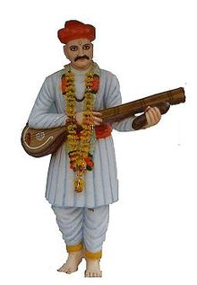
INTRODUCTION
Sena Nhavi is a famous saint of the Varkari sect and is a great devotee of Lord Vithoba, a form of Lord Krishna.
Sena worked as a barbar under the king of Bandhavgarh, Madhya Pradesh. After some time, he left his job, and started writing poems and singing the glories of Lord Vithoba.
In the famous text, Bhaktavijaya written by Mahipati during the 18th century, Sena Nhavi was mentioned as an ardent devotee of Lord Vithoba, and dedicated his entire life on praising him. And, further mentioned about the greatness of Lord Vithoba rescuing him during his difficult situations. It is believed that due to his previous birth sins, he was born in a lower caste. Once, the Muslim king of the region called him for doing service to him through a messenger. Since, Sena was worshipping the god, he hesitated to go, and through his wife, he informed to the messenger of the king, that he was not available at his home. The king has become very angry and decided to punish him. Then Lord Vithoba took the form of Sena and massaged the king with the oil. The king suddenly saw the reflection of the image of Lord Krishna, in the oil cup, and was very much surprised, and praised and rewarded him a bagful of gold coins. Lord Vithoba in the form of Sena, placed the gold coin bag in the house of Sena and disappeared.
The next day, when Sena arrived at the court, the king has asked to again show him the image of Lord Krishna. This act of the king made Sena to get surprised and explained to the king that he had got the divine darshan of Lord Vithoba himself. He further explained to him, that Lord Vithoba had taken his form, and visited the palace and massaged him. Due to that, the king respected him and treated kindly. Sena distributed the gold coins to the poor and the Brahmin scholars, which was kept by Vithoba at his home. And he immediately left his profession, and become a full time devotee of Lord Vithoba and lived his life in a saintly manner, by writing divine poems on Lord Vithoba and singing his glories in his melodious and mesmerising voice. The Muslim king has become a staunch devotee of Lord Vithoba, and lived in a pious manner.
He was praised by the great saints and Vithoba devotees Janabai, Tukaram and Ravidas.
A temple known as “SHRI SANT SENA HARI MANDIR” is dedicated to him in Hubli.
IMPORTANCE
Though he has born in a lower class, he was very much dedicated to the Lord, and he worshipped him at every moment of his life, with sincerity, dedication and utmost faith on him. He made other people to become the devotees of Lord Vithoba, through his beautiful songs, which is similar to the songs sung by THUMBURU and NARADA in the Swarka Loka. All of them enjoyed themselves in his company, and listened to his devotional lectures on the great god Vithoba. He also healed the people from their diseases and removed their mental problems, and insisted them to keep on worshipping the Divine Lord Vithoba, in order to live a prosperous and a peaceful life, and also to attain SALVATION after their death.
Let us worship the great saint and be blessed.
“OM SREE SENA NHAVI NAMAHA”
“JAI VITHOBA”
“JAI RUKMANI MATA”
WRITTEN BY
R.HARISHANKAR

SIDDHARUDHA SWAMI
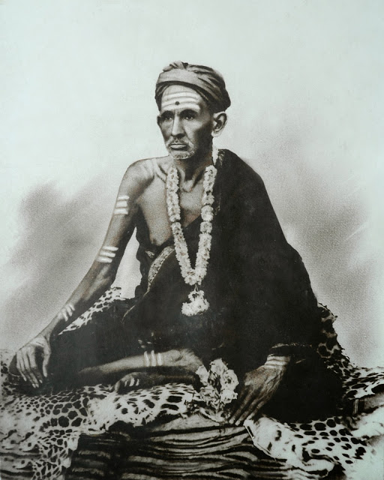
INTRODUCTION
Siddharudha Swami (1836-1929) was a spiritual guru and also a social reformer, who had done many good things for the poor people like offering food, clothes and shelter.
Sadguru Siddharudha Maharaj lived a saintly life throughout his life. He was against caste discrimination, and according to him, all are equal before god, and there must not be any partiality between the castes, and all the castes must be equally treated. He is also believed to be an incarnation of Lord Shiva. He left home at a very younger age, in search of seeking a spiritual guru. He met Shri Gajanandaswami, and become his sincere disciple and served at his ashram.
As per the wishes of his guru, he had undertaken a holy temple pilgrimage and worshipped the divine deities. He travelled throughout India, and spread the spirituality among the masses, and after some time, he settled down at Hubli. Lot of people met him and listened to his spiritual lectures and got enlightenment.
He died at Hubli in the year 1929 at his ashram. It is believed that he is still answering to the prayers of his sincere devotees from his ashram, blessing them, and giving all sorts of prosperity and peacefulness in their life. In his ashram, whole some food is served to the devotees, with great attention and kindness.
His important disciple Shri Kalavati Devi samadhi is found at Shri Harimandir at Angol near Belgaum. And his chief disciples, Gurunatharudha Samadhi and Sri Shivaputra appaji Samadhi is found nearby the samadhi of Sri Siddharudha Swami in Hubli Ashram.

FAMOUS TEACHINGS
- God is the supreme force and he is the boss, and we are all his slaves and servants of him.
- All people must be equally treated and each and every one must be given respect.
- First do your duty properly. Then start doing service to the god.
- Take care of your parents, and never leave them alone at their old age.
- God is created us only for helping others.
- Realize the inner spirit, and try to know that god is dwelling within you.
- Don’t do bad things, since that will give lot of troubles to you.
- Cultivate the habit of listening spiritual lectures, and reading spiritual books, and take note of it, and live as per the guidelines of the spirituality.
- Don’t enjoy too much of comforts and luxuries, since that will not last too long. Live a simple and a noble life.
IMPORTANCE
He has become very popular through his simplistic and kind approach. People were gathered in large numbers to eagerly listen to his speech. He also removed the fear from the minds of the people, and asked them to chant the holy Rama Mantra on a continuous basis, in order to live a peaceful and prosperous life.
Let us worship the holy saint and be blessed.
“OM SREE SIIDDHARUDA SWAMIGALE NAMAHA”
“JAI SREE RAM”
“OM NAMAH SHIVAYA NAMAHA”
WRITTEN BY
R.HARISHANKAR

SIVA PRAKASAR
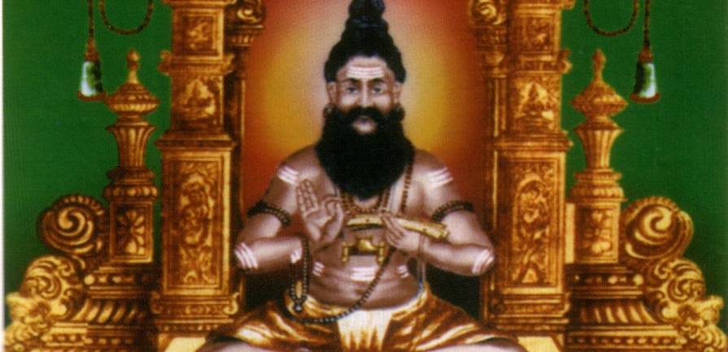
INTRODUCTION
Siva Prakasar was a poet, shiva devotee and a shaivite saint who lived during the 17th century AD. He was also known as 'Thurai mangalam Sivaprakasar'. He had contributed lot of texts in tamil, among them is the greatest text Nanneri, a work which contains teachings. He is a great poet and translated other language texts into tamil texts. He wrote a tamil poem “Neerotta Yamaha Anthathi”, which is considered as a best poem among the scholars and the common people.
LIFE
Sivaprakasar was born in Kanchipuram into a Shaivite Tamil Desikar family. He learnt Tamil under Valliyur Thambiran at Thirunelveli. Sivaprakasa Swamigal travelled throughout Tamil Nadu and during his travel he met Santhalinga Swamigal, and visited Mailam Murugan Temple along with him. Siva prakasa Swamigal met his guru Sivagnaana Balaya Swamigal at mailam and became his best disciple. And he was given the name of ‘Sivanuputhichelvar’ by his guru, due to his great efficiency in tamil literature and in penning beautiful poems on Lord Shiva. He had written a poem in praise of his guru “Sivagnaana Balaya Swamigal”, along with the poems on Lord Shiva.
Then he travelled to Thurai mangalam and met a pious shiva devotee Annamalai reddiyar and stayed with him. With his help, he built mutts in many areas of Thurai mangalam, for worshipping Lord Shiva and also for providing food to the poor devotees of Lord Shiva. He worshipped the most famous Virudhagireeshwarar Temple, at Virudhachalam.
He attained SALVATION in Nallathur nearby Pondicherry at the age of 32. He is still remembered for his contribution to the shaivism and for his greatest tamil works, and for his social service to the people.
IMPORTANT WORKS
- Tiruchendil Neerotta Yamaha Anthathi
- Nanneri
- Thiruvengai Kalambagam
- Thiruvengai Kovai
- Thriuvengai Ula
- Thiruvengai Alangaram
- Thirukoova Puranam
- Seekalathi Puranam
- Periyanayaki Ammai Kalithurai
IMPORTANCE
He lived a pious and a noble life, and dedicated his entire life towards spreading the principles of shaivism, and also done lot of welfare activities to the poor people and to the shiva devotees. He had performed many miracles in the life of his devotees through his meditative powers, and was worshipped by the people for his high spiritual power and kindness. He contains great wisdom, courage and boldness and was an expert in hindu scriptures, and was a well-versed poet. He got great knowledge in tamil, and wrote lot of tamil devotional texts, and also gave devotional lectures to the people.
Let us worship the great saint and be blessed.
“OM SREE SIVA PRAKASA SWAMIGALE NAMAHA”
“OM NAMAH SHIVAYA”
“OM SAKTHI PARASAKTHI”
WRITTEN BY
R.HARISHANKAR

SRI DANAMMA DEVI
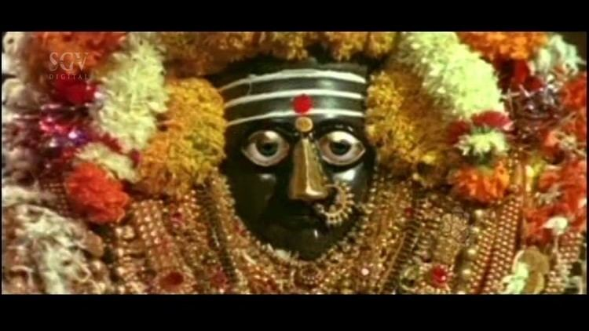
INTRODUCTION
Sharane Sri Danamma Devi was a follower of Basavanna and she is considered as an avatar of Ma Parvati and she is called as "LINGAMMA". She was born in jatta taluk of bijapur district at Maharashtra. She is worshipped by Lingayats and by the people of Karnataka. She is also called as "DANAMMA", since she is very interested in doing (Danam) charity activities. She is also worshipped as a Universal Mother. During her younger age, she learnt the basic education, and was very active, intelligent, and gave respect to everyone. She was a great devotee of Lord Shiva and through his grace she solved the problems of the people. She considered Lord Basavanna as her guru and god, and worshipped him similar to Lord Shiva, and got the divine blessings of Sri Basavanna.
LIFE
She got married with a pious shiva devotee Sri Sangamanatha nearby her village. After their marriage, both of them helped the people by donating food, and giving necessities to them. They used to worship Lord Someswara at guddapura and performed puja and abhishekham to the shiva lingam. In course of time, after knowing about her greatness, she has got many followers. She has performed lot of miracles in the life of her devotees, and even still she is performing miracles to her true devotees, and getting their problems solved.
She is also known as Annapurna Devi, since she is very much interested in feeding food to the hungry people. She also asked the people to lend their helping hand to the poor people. She advised the people to recite the "OM NAMAH SHIVAYA" mantra on a continuous basis in order to live peacefully and happily. She went on religious pilgrimages to many holy temples including Kasi and rameshwara and spread the importance of bhakti and shaivism. She and her husband were welcomed by many kings and holy people, and got blessings from her. After serving for many years to the god and to the people, she finally merged with Lord Shiva.
A temple was constructed, in Guddapur, Sangli District in Maharashtra. Sri Danamma Devi is popularly worshipped in Guddapur, and devotees from all parts of the world, are visiting this temple, in order to get her grace. She is also having temples in many parts of Karnataka, which attract thousands of pilgrims.
IMPORTANCE
Being the avatar of holy mother Ma Parvati, she will definitely solve our problems, and safeguards us in our life, reduce our sins, and show us the way of living a peaceful and a prosperous life. She will be with us in our every moment of life. Several slokas are meant for her, and by reciting the slokas, our problems and worries will be miraculously solved, and we will get her immense help.
Still now, she is curing the diseases of her devotees, and hearing their problems and rescuing the people from their enemies and gives courage, mental and physical strength, wisdom and spiritual energy.
Let us worship the divine mother and be blessed.
“OM SRI DANAMMA DEVIYE SARANAM”
“OM SREE BASAVANNARE NAMAHA”
“OM NAMAH SHIVAYA”
WRITTEN BY
R.HARISHANKAR

SRI KULANDAI ANANDA SWAMIGAL
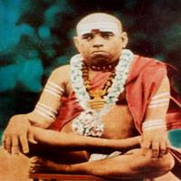
INTRODUCTION
Sri Kulandai Ananda Swamigal was a great saint, and he was lived during the 17th century AD. He was considered as the son of Mata Meenakshi, a form of Parvati Devi. He was born in Samayanallur, near Madurai, and his parents were very holy and pious and were the devotees of Meenakshi, and he was born with the blessings of Madurai Meenakshi Amman. As per Meenakshi amman’s instructions, his parents were offered him to meenakshi amman temple.
The divine child was completely taken care of by Mata Meenakshi, and he lived by drinking the milk offered to the goddess for abhishekham. The child remained in the temple by eating the temple prasadam and milk. Once the child was tested by the great king Tirumala Nayaka at Madurai, and he has asked the child to walk on the water of the holy tank. The child easily walked without any difficulty in the temple tank. By seeing that, the king was astonished and asked the divine child to apologize him.
After few years, Sri Kulandai Ananda Swamigal travelled to Kashi. In Kashi, he worshipped the Kashi Viswanath and Bhairav temples. He was believed to be an avatar of Trilanga Swami, who lived for more than hundred years and died at Kashi. He meditated at kashi for a few months, and he then travelled to Mount Kaliash, Badrinath, Kedarnath, Nepal and to many other holy places. Throughout his pilgrimage, he was greatly honoured by the kings and the people and worshipped by them. He also met the great saint Sri Ramakrishna Paramahamsa, and discussed with him about the spiritual matters.
He attained Samadhi in Sittalangudi near Madurai, and daily Pujas are being performed. One of the disciples of Swamiji was Mayamma, and her mahasamadhi is located in Salem. She was also a great yogini similar to his guru, and done many miracles in the life of her devotees, and saved them from many problems in their life.
IMPORTANCE
He has done a lot of wonders in the life of his disciples, and cured their diseases and relived them from their sins, and given them a new life. He also cured the mental illness of his devotees, and invoked them in the spiritual path, and asked them to repeatedly chant the names and mantras of Lord Shiva and Mata Parvati.
He contained great knowledge, wisdom and was well versed in religious texts and vedas through the divine grace of Ma Meenakshi. He also shared his knowledge with his disciples. He has also given lot of lectures about Hinduism and on Mata Meenakshi. People were used to gather in front of him to eagerly listen to his divine lectures. Being the son of divine mother, Meenakshi, he has got the capability to do goodness to us.
Let us worship the great saint and be blessed.
“OM SRI KULANDAI ANANDA SWAMIGALE NAMAHA”
“OM MATA MEENAKSHI DEVIYE NAMAHA”
“OM NAMAH SHIVAYA”
WRITTEN BY
R.HARISHANKAR

SRI PARASARA BHATTAR
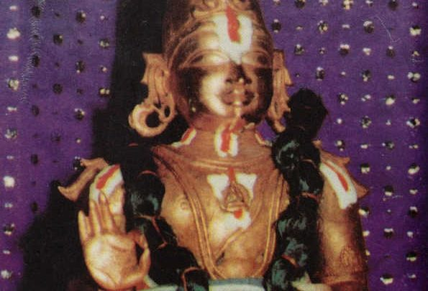
INTRODUCTION
Sri Parasara Bhattar, is the son of Sri Kurattazhwan and Andal, and considered as an important person among the Vaishnavites. It is believed that he was born due to the grace of Sri Ranganatha, a form of Lord Vishnu, and Sri Ramanuja. He was affectionately named as Parasara Bhattar by Sri Ramanuja himself.
Parasara Bhattar was a born genius. Even at his younger age, he won in the debate with the famous scholar Sarvajnya Bhattar. He was guided and educated under his father Sri Kurattazhwan and Swami Embar.
After he grown up, he has become the chief priest of the Sri Ranganathaswamy Temple, Srirangam, and he administered the temple in a proper manner, and conducted regular pujas and offered naivedyam (Holy Prasad) to the god, and distributed it to the devotees. He was affectionate and kind with all others. He also helped the poor people, and provided free food to them. Everyone has praised about his great devotion on the god, and worshipped him as a divine boy. He won several scholars in the debates. His main disciple is Ranganatha who was also known as Nanjiyar and is considered as an obedient and a perfect disciple of Sri Parasara Bhattar. He also made a commentary of Thiruvaymozhi, the divine songs of Lord Ranganatha.
Parasara Bhattar travelled to Thirukkottiyur, and worshipped Lord Sowmya Narayana Perumal, and after some time he returned to srirangam.
Parasara Bhattar was a great writer and written several divine works.
WORKS
- Astasloki
- BhagavadGunaDarpanam
- SriGunaRatnakosam
- SriRanganathaStotram
- Sri Ranganatha Stavam
- Commentary on the Kaisika puranam
Sri Parasara Bhattar has dedicated his entire life towards doing service to Lord Ranganatha and to Sri Ramanuja.
The great king Veerasikhamani Pallavaraya has also become the disciple of Sri Parasara Bhattar. And due to the request of the king, who was in a state of confusion, Sri Parasara Bhattar, has asked to chant the Rama Mantra “JAI SRIRAM” frequently, in order to get relieved from mental tensions and worries and to get peacefulness and prosperity in his life. And the king has done as per the words of Sri Parasara Bhattar, and got enlightenment.
Parasara Bhattar is the spiritual successor of Sri Ramanuja, and lived a pious and a noble life. He occupies an important part in the lives of the Vaishnavites, who are considering him as their guru, next to Sri Ramanuja.
IMPORTANCE
He was a great saint, poet and an ardent devotee of Lord Ranganatha, who got great spiritual powers, and used his powers for healing the sinful people, and he removed the bad thoughts in their mind, gives great spiritual energy, wisdom and washed out their sins, through his great divine power. Similar to his father Kurattazhwan, he was a humble and a calm person, who always used to do goodness to others. He was praised by the kings and by the common people.
Let us worship the great saint and be blessed.
“OM SRI PARASARA BHATTARE NAMAHA”
“OM SREE RAMANUJAYA NAMAHA”
“OM NAMO NARAYANAYA NAMAHA”
WRITTEN BY
R.HARISHANKAR

SRINIVASA TIRTHA
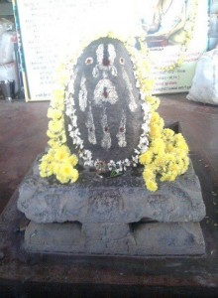
INTRODUCTION
Sri Srinivasa (1590-1640) belonged to Brahmin-Madhwa family, and was a great scholar and also an expert in sanskrit language. He was born in Bidarahalli. He also written many divine books, and lived a pious life. He was a great devotee of Sri Guru Raghavendra Swamy and lived during his period. His guru was Sri Yadavaaryaru. He lived in Honnali, Karnataka, and spread the importance of Dvaita philosophy of Sri Madhwacharya.
Since he was born in an orthodox family, he followed the Brahmin customs and traditions strictly and he will never take food from the outside, and will eat his food only after taking bath and worshipping Lord Rama and performing puja to him. He also performed annadana to Brahmin scholars and poor Brahmin students and also properly educated them.
Once he met Guru Raghavendra during Chaturmasya. After performing the Moola Rama pooja, Raghavendra Swamy has asked him to take food in the mutt, but he didn’t take food, since Sri Swamigal had mixed mustard seeds in the food, which was given by a devotee. But as per the repeated request of the holy guru, he took food by neglecting the mustard seeds. And after he went home, he found that the holy rice prasad given by Sri Swamigal has turned into black colour. Next day he went back to Sri Swamigal and apologized for his mistake, and again received the holy rice prasad. Sri Swamigal also read the works of Srinivasa and appreciated him for his great knowledge. Sri Swamigal renamed him as Srinivasa Thirtha.
FAMOUS WORKS
- Commentary on Srimanyaayasudha
- Commentary on Tatvaprakashika
- Commentary on Dashaprakaranateeka
- Commentary on Pramanapaddati
- Commentary on Bhagavatha
- Commentary on Rugbhashya
IMPORTANCE
Though he was a great scholar, he didn’t get any pride, and lived a holy life. He dedicated his life towards performing puja on Lord Vishnu, and learning and reading Vedas, and conducting lectures in the Vishnu temples, and spread the dwaita philosophy among the people. Through the grace of Guru Raghavendra, he has become a great scholar, and a famous pundit. He also advised the people to chant the Narayana Mantra “OM NAMO NARAYANAYA NAMAHA” on a continuous basis, in order to get relieved from their sins and also to get relieved from their various problems and diseases. Through his wisdom and knowledge, he was admired by the kings and the common man.
Let us worship the holy guru and be blessed.
“OM SRI SRINIVASA TIRTHARE NAMAHA”
“OM SREE RAGHAVENDRAYA NAMAHA”
“JAI SREE RAM”
WRITTEN BY
R.HARISHANKAR
SUDARSHANA CHAKRA
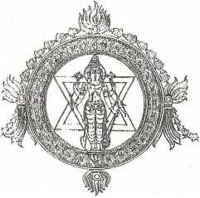
INTRODUCTION
The Sudarshana Chakra is a divine weapon of Lord Vishnu. The Sudarshana Chakra is used for destroying the enemies and to maintain peace and prosperity in the universe. The Sudarshana Chakra is worshipped as Chakkrath Azhwar. He is considered as an incarnation of Lord Vishnu, and contains the features of Lord Vishnu.
The details about Sudarshana Chakra, is mentioned in the Rigveda as well as in ancient sacred scripts and in Puranas. Once, Lord Krishna used this weapon for killing Shishupala during the dwaparka yuga. Lord Vishnu also killed several demons using this Sudarshana Chakra.
According to the ancient Puranas, the Sudarshana Chakra was made by the divine architect, Sri Vishvakarma. Also, in the Mahabharata, Lord Krishna invoked the sacred Chakra on Sisupala in order to kill him.
Once, Lord Vishnu grants Sudarshana Chakra to King Ambarisha, in order to maintain peace and prosperity to his kingdom.
Chakkrath Azhwar shrines are found inside Vishnu's temples, and there are only few temples dedicated to Lord Chakkrath Azhwar alone. They are as follows:
- Sri Sudarshana Swamy Temple, Nagamangala
- Chakrapani Temple, Kumbakonam
Sudarshana Homam
This homam is performed for getting better prospects in our life, to get relieved from various diseases, for mental satisfaction and for getting rid from enemy related problems, black magic problems etc. By doing this homam, we can experience a good change in our life immediately. It will bring good fortunes in our life and build up a strong career path for us, and make us to live happily and peacefully in our life. This homam is very popular in South India.

IMPORTANCE
Sudarshana is an aspect of Lord Vishnu, and by worshipping him, we will get the same results similar to worshipping Lord Vishnu, since both of them are considered as one and the same. In most of the Vishnu temples, Sudarshana Shrine will be there in the backside of the Narasimha shrine. By worshipping him in the Vishnu temples, our body and soul will be purified, our past sins will be wiped out, and we will get fresh energy in our mind and body, and can live a blessed life. He will follow us in our every step and will act as our guide. Being the divine weapon of Lord Vishnu, he will kill our bad thoughts, and remove the evil from our body and makes us holy and perfect in our life.
Let us worship the great Sudarshana Chakra and be blessed.
“OM SREE SUDARSHANA CHAKRATHAZHVARE NAMAHA”
“OM SREE YOGA NARASIMHARE NAMAHA”
“OM NAMO NARAYANAYA NAMAHA”
WRITTEN BY
R.HARISHANKAR
SWAMI SADANANDA
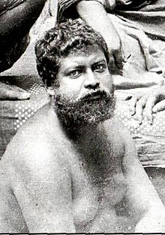
INTRODUCTION
Swami Sadananda (1865-1911), also known as Gupta Maharaj was a direct disciple of Swami Vivekananda, and he was born in Kolkata. He was considered as one of the most important disciple among the several disciples of Swami Vivekananda. He has become a saint in the Baranagar Math, Kolkata and later joined in the Belur Math. He also undertook lot of social welfare activities along with the disciples of Swami Vivekananda. He travelled throughout India and to foreign countries to spread the teachings of Sri Ramakrishna and Swami Vivekanda. He also took care of Sister Nivedita as her own brother. He had also given lot of lectures in India about the importance of Hinduism.
He spent his childhood near Varanasi. He got great proficiency in regional languages and also was specialized in ancient scriptures and other divine Hindu texts. For some time he worked in the Indian Railways. And after some time, he left his job, and joined with Swami Vivekananda and started his spiritual journey with him.
He served to the several disciples of Swami Vivekananda and took care of them during their illness, and showed motherly affection on them. For a long period of time, he lived together with Swami Vivekananda, and served him properly.
He was praised by Swami Vivekananda and described him as a Sweet and a Gentle person. He also travelled with Swami Vivekananda to many spiritual places.
Swami Sadananda died in the year 1911, in Kolkata.
IMPORTANCE
He is considered as a holiest disciple of Sri Vivekananda and acted like his right hand, and fulfilled all of his wishes and served him in a pleasing manner. He considered Swami Vivekananda and Sri Ramakrishna as the avatars of god. He lived a pious life and done lot of welfare activities to the poor, and given a helping hand to the sick people at the ashram, and also provided food and clothes to the poor people, and considered all the human beings as the incarnations of Lord Rama.
Let us worship the great saint and be blessed.
“OM SREE SWAMI SADANANDARE NAMAHA”
“JAI SREE RAM”
WRITTEN BY
R.HARISHANKAR

SWAMI VIMALANANDA
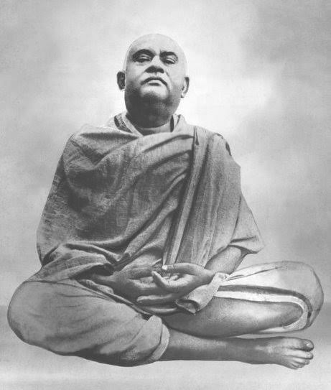
INTRODUCTION
Vimalananda (1872–1908) was one of the main disciples of Swami Vivekananda. He was also called as Khagen Maharaj, and his birth name was Khagendranath Chatterjee. He published the great text Prabuddha Bharata. He was the chief of the Advaita Ashrama at Mayavati. And he founded the Ramakrishna Math at Ulsoor in Bangalore in 1906. Throughout his life, he concentrated his attention on spiritual matters, and read many holy books of saints and gods, and got good spiritual knowledge through that. He died in 1908 at the Mayavati Ashrama, and attained SALVATION due to the grace of Bhagavan Ramakrishna and Swami Vivekananda.

LIFE

He was born in a Brahmin family in the year 1872. His relative Bodhananda, was also a disciple of Swami Vivekananda. He was interested in spirituality from his younger age, and spent his time by doing meditation and going to the temples, and got peace of mind through that. He was good at studies and completed his graduation in a college. Khagen read the teachings of Ramakrishna and got attracted with him. He visited the disciples of Ramakrishna in Baranagar Math, and also went to Jayrambati and met Mata Sarada Devi. And through her blessings, he started his spiritual journey. He also moved in a friendly manner with the disciples of Sri Ramakrishna, and he was regarded as a humble, soft spoken and a good natured saint by the people and also by his followers.
In 1897, he met Swami Vivekananda and became his disciple. He also constructed a small temple for Sri Ramakrishna and performed regular pujas and offered him, fruits, flowers and other food items as naivedyam (Holy Prasad). He also gave devotional lectures along with the disciples of Vivekananda, and spread the teachings of Sri Ramakrishna throughout india.
After suffering from fever, he died in the year 1908. Due to his death, all the disciples of Ramakrishna and Vivekananda were very much worried, and recollected the sweet memories which they have previously shared with him, and also they have praised about his great qualities such as showing kindness and affection among others. His main teachings covered the topics of spirituality, love, sincerity, respect and doing good things in others.
IMPORTANCE
Swami Vimalananda had lived a disciplined life, by showing full of love and compassion over others. He obeyed the orders of Swami Vivekananda and discharged his duties in a proper manner. He had given many divine lectures in various parts of india, and lot of people were got attracted on hearing about his divine speech. Though, now physically he is not available in this world, his lectures and the details about the great saint can be studied through the life history books, which is available in the Ramakrishna Mutt. He also invoked the people in the bhakti path, and moved with them in a friendly manner, and prayed to the god for removing their difficulties and sorrows. He contains great knowledge, wisdom, courage and boldness.
Let us worship the great saint and be blessed.
“OM SREE SWAMI VIMALANANDARE NAMAHA”
“JAI SREE RAM”
WRITTEN BY
R.HARISHANKAR

TUKDOJI MAHARAJ
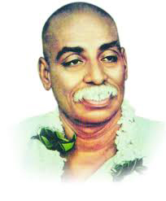
INTRODUCTION
Tukadoji Maharaj (1909–1968) was a spiritual saint and a social reformer and he was born in a poor family in a village in Amravati District of Maharashtra. He was a disciple of Aadkoji Maharaj. He was involved in various social welfare activities of Maharashtra and offered free food, clothes and provided shelters to the poor villagers. He dedicated his life towards providing service to the mankind.
Even from his childhood, he used to perform severe penance and worshipped the god at the temples. He also written various poems, and sang many songs on Lord Krishna, and also written several spiritual articles.
In 1941, Tukdoji Maharaj also participated with the freedom fighters for getting freedom for India. He was arrested several times by the British soldiers, and got punished. He has established Seva Mandals in many parts of Maharashtra, and done lot of social welfare activities for the welfare of the people. He got support from the then political personalities and was also appreciated by the general public.
He was one of the founders of the Great Movement “Vishwa Hindu Parishad”. He also went to foreign countries for attending meetings. His main motto is “First do your service to the man and then to the god”, since people are having urgent needs. He was also interested in spirituality and an ardent devotee of Lord Krishna, and went to many holy temples. He died in the year 1968.
WORKS
- Gramgeeta
- Sartha Anandamrut
- Sartha Atmaprabhav
- Geeta Prasad
- Bodhamrut
- Laharki Barkha
- Anubhav Prakash
IMPORTANCE
He was a great human, who dedicated his life for the social welfare. He was also good at meditation and yoga. His main aim was to improve the living standards of the people in India, and to remove the poverty from the life of the poor people, and he tried his level best to achieve his aim. For his dedicated service to the society, he will be permanently remembered by the Indian people, and let us salute and honour him for his great service to the society.
“JAI TUKDOJI MAHARAJ KI JAI”
“JAI KRISHNA”
WRITTEN BY
R.HARISHANKAR

UMAPATHI SIVAM
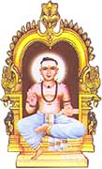
INTRODUCTION
The great shavite saint, Sri Umapathi Sivam was born in Chidambaram, near Thillai Natarajar Temple during 13th century AD in the Dikshithar family. He has studied all the vedic scriptures and also written several sacred books on shaivism. He was a great devotee of Lord Shiva from his younger age itself, and used to visit Chidambaram Natarajar temple, and worship the Lord regularly.
LIFE
At the age of 16, he got married with a pious and a noble girl, and lived a peaceful life. He also got the opportunity to serve in the Natarajar Temple, Chidamabaram as a priest, and done his duties in an efficient manner. He will used to decorate the lord with flowers, and performed pujas regularly and also done abhishekham to the deity. Without performing the temple puja, he will never take food. He also got saint hood under the great shaivite saint and nayanmar “SRI THIRUGNANA SAMBANDAR”, and also become his sincere disciple. After some time, he also established a mutt near chidambaram for spreading the importance of shaivism. He well educated his disciples, and also taught vedas, shastras and other divine scriptures and involved them in the “SHIVA BHAKTI PATH”. At his mutt, he will used to provide free food to the shaivite saints and to the poor people. After doing religious and social service for a long time, he attained SALVATION at his mutt situated at Kotravangudi, Chidamabaram. Still now, lot of devotees are visiting his ashram at Chidambaram and worshipping him, and they are getting his divine blessings.
IMPORTANCE
He was a noble and a kind hearted saint, who dedicated his life for doing service to the god, and also done social welfare activities, like providing food and giving free education to the poor children. He will used to chant Sri Rudram and Sri Chamakam regularly, and asked others also to chant it in order to get all the prospects in their life. He also relieved the people from their various dreaded diseases, through the sacred ash of Lord Nataraja, and also cured their mental diseases and gave them more power, strength and spiritual energy.
Let us worship the great saint and be blessed.
“OM SREE VINAYAKAYA NAMAHA”
“OM SREE UMAPATHI SIVAM SWAMIGALE NAMAHA”
“OM NAMAH SHIVAYA”
WRITTEN BY
R.HARISHANKAR

VAIKAM SHIVA TEMPLE
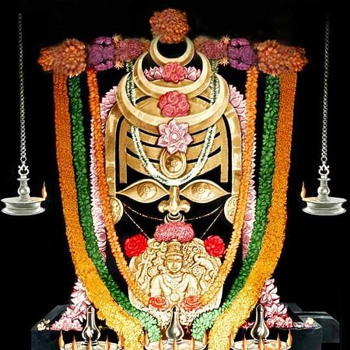
INTRODUCTION
The Vaikom Mahadeva Temple is a famous shiva temple situated in Vaikom, Kerala. The temple is a popular temple similar to Ettumanoor Siva Temple and Kaduthuruthy Thaliyil Mahadeva Temple. By visiting these kerala temples altogether, our various wishes and needs will be fulfilled. Devotees can approach the temple officers, and can pay the prescribed amount of puja fee and perform the puja to the deities. In this temple, daily annadanam is provided to hundreds of devotees, which they consider it as very delicious.
The Vaikom Mahadeva temple is worshipped by Shaivaites and the Vaishnavaites. In this temple, Lord Shiva’s name is also known as Vaikkathappan. The temple is considered as one of the ancient temples in Kerala and the shiva lingam was installed before several lakhs of years.
Once the great demon, Kharasura performed severe penance on Lord Shiva, in order to attain SALVATION. Lord Siva appeared before him and gave three Siva Lingams to him. When Kara took rest for some time in this sacred place, he couldn’t lift the lingam, and it was permanently installed in that place due to the wish of Lord Shiva. Khara got SALVATION and asked sage Vyaghrapada to stay there and worship the Shiva lingams.
Sage Vyaghrapada also got the darshan of Lord Shiva along with Mata Parvati and they blessed him and vanished. After some time, he went on holy pilgrimages. Then after several years, Lord Parasurama, found these lingams, and also got the divine darshan of Lord Shiva with Mata Parvati, and performed pujas and also constructed a temple, which is known as Vaikom Mahadev Temple.
The Vaikom temple is famous for the most important festival Vaikathashtami, one of the main annual festivals, which will be celebrated during November–December. Vaikathashtami is celebrated on the day of Krishna Ashtami. Once, Lord Shiva had given his divine darshan to the great sage Vyaghrapada along with Mata Parvati Devi in the day of Krishna Ashtami. In order to recognize the incident, the great festival Vaikathashtami is celebrated.
IMPORTANCE
Devotees from all parts of India are visiting this sacred temple, in order to get the glimpse of their favourite god and goddess. After getting the darshan of the deities, our mind would be filled with immeasurable happiness, and we would get spiritual energy and attain great prosperity in our life. Our several mind related and health related problems also would be solved, and we would be able to find solutions for our most difficult problems, through the divine grace of Mahadeva and Mahadevi.
Let us pray to the divine god and goddess and be blessed.
“OM SREE GANESAYA NAMAHA”
“OM NAMAH SHIVAYA”
“OM SAKTHI PARASAKTHI”
WRITTEN BY
R.HARISHANKAR

VASUDEVANAND SARASWATI
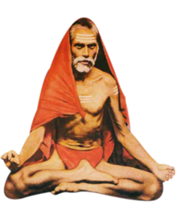
INTRODUCTION
Vasudevanand Saraswati (1854–1914), is a great saint and lived a simple and pious life throughout his life. He is also considered as an avatar of Lord Dattareya, and also known as Tembe Swami.
His father was a noble Brahmin scholar who worked as a priest in the Gangapur temple in Karnataka. His mother also helped his father in doing puja at their home and provided wholesome meals to the devotees of Lord Dattatreya on a daily basis. After some time, due to the instructions of Lord Dattatreya, his father returned to Mangaon and soon after that the great Vasudev was born at Mangaon, Maharashtra.
He attended the village schooling and completed his basic education. He was also mastered in all regional languages, and an expert in Vedas, Puranas and other divine scriptures. At his teenage, he got married to Annapurna from Ranjangad, who was a good natured lady, and helped her husband in his regular activities. He constructed a Datta Temple in Mangaon in the year 1883, due to the grace of Lord Dattatreya.
He travelled throughout the country for several years, and spread the “DATTA BHAKTI SPIRIT” among the masses. He was against caste discrimination. He conducted devotional lectures in many parts of India, and relieved the diseases and problems of the people, through his holy touch.
HOLY WORKS
- Dwisahastri Gurucharitra
- Datta Puran
- Datta Mahatmya
- Saptashati Gurucharitra Saar
After the death of his wife 1891, he has become a saint at the banks of the Holy River Mata Godavari, and thereafter the great Guru and saint, Sri Narayanand Saraswati met him and blessed him.
In 1905, he met Sri Gajanan Maharaj at Shegaon, and discussed about religious matters with great cheerfulness and happiness, since both of them are considered as divine avatars. It is said, that he also met Swami Samarth and Shirbi Sai Baba, avatars of Dattatreya, and discussed about spiritual matters with them.
He also used to worship and interact with Holy river goddesses, Lord Krishna and with Chiranjeevi and Shiva Devotee Mahabharat Ashvatthama. He was also praised by all other saints for his great power, during his period.
SPIRITUAL ADVICES
- Try to take bath in the holy rivers.
- Offer regular prayers to the god.
- Perform puja and abhishekham to the gods and goddess.
- Regularly conduct Yagnas (Fire Sacrifice) for the welfare of the entire nation.
- Provide proper food to the poor and the needy.
- Take care of cows and feed them properly.
- Attend religious discourses on Ramayan, Gita and Bhagavatham.
- Move with others in a gentle and kind manner, and don’t harm others either by physically or mentally.
- Give respect and take care of your parents properly.
He died in the year 1914, and a shrine was built at his Samadhi at Garudeshwar, Gujarat, nearby a popular Datta Temple.
IMPORTANCE
A great saint, who contains all the good qualities and relieved the people from their sins, and invoked them in chanting the names of Lord Datta. He lived a noble life, and worshipped by thousands of his devotees and followers, and properly guided the people, and gave various suggestions to come out from their family and enemy related problems, and won their hearts.
Let us worship the holy saint and be blessed.
“OM SREE VASUDEVANAND SARASWATI SWAMIGALE NAMAHA”
“JAI DATTATREYA”
WRITTEN BY
R.HARISHANKAR

YAYATI
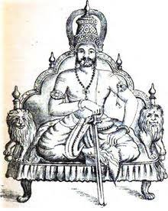
INTRODUCTION
As per Hindu Puranas, Yayati was a noble king, and he was the son of King Nahusha and Ashokasundari, also known as “SREE BALA TIRIPURA SUNDARI” who was the daughter of Shiva and Parvati. His descendants were the Pandavas. Due to his great power, Yayati had conquered the entire world and was considered as the great emperor of the world. He also ruled his kingdom in a well-versed manner treating the people in a proper manner, and he had given a GOLDEN RULE during his period, similar to Lord Sri Rama and Bhakt Prahalad. His son was puru, and King Bharata, son of Dushyanta and Shakuntala, was also the descendent of puru.
He married Devayani who was the daughter of Shukracharya, the guru of the demons. He also got an affair with Sharmishtha, the maid of his wife Devayani. Due to that he was cursed by Sri Shukracharya to become an old aged man. After repeated requests by Yayati, he slightly changed his curse, and allowed him to exchange his curse with someone. Yayati exchanged his curse with his son, Puru, who was a very holy and a noble son, and readily accepted his curse, and has become an old man. After spending several years of his life as a young man, Yayati got interested in seeking spirituality, and took back the curse from his son, and he became an old man, and lived in the form of a sage by establishing an ashram in the forest, and after his death, he attained SALVATION, and merged with his mother, ASHOKA SUNDARI.
IMPORTANCE
Being the son of Mata Ashoka Sundari, he contains superior powers, and is able to grant boons to us. He will relieve us from our sins, diseases and gives more confidence and courage towards running our life in a proper manner. He gives great wisdom, knowledge and spiritual power. By worshipping him with great bhakti, his mother Devi Ashoka Sundari will become happy, and will bless us and gives a peaceful, prosperous and a happy life.
Let us worship the great king Yayati and be blessed.
“OM SREE YAYATI MAHARAJAVE NAMAHA”
“OM SREE ASHOKA SUNDARI ANNAIYE NAMAHA”
“OM NAMAH SHIVAYA”
WRITTEN BY
R.HARISHANKAR

