NARSI MEHTA
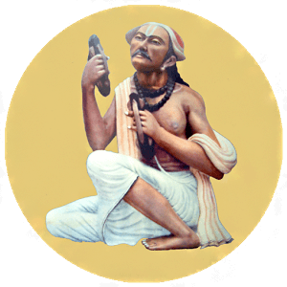
INTRODUCTION
Narsi Mehta, (15th-century) was a great poet and saint of Gujarat, India. He was talented in writing divine poems on Lord Krishna. He was an ardent devotee of Lord Krishna.
LIFE
Narsi Mehta was born in a Brahmin family at Gujarat. He lost his parents at his younger age. He was raised by his grandmother.
After his marriage, he stayed at his brother’s house with his wife. Since he was ill treated by his sister in law for his great devotion on Lord Krishna, he left the house and went to a forest and meditated for several days. And after getting the divine grace of Lord Krishna, he sung in praise of him, and composed many divine songs.
In Gujarat, Mehta lived in poverty with his wife and two children, but worshipped the god with full of faith throughout his life time.
At Mangrol, Gujarat he died at the age of 79. He will never be forgotten for his great works and devotion to Lord Krishna.
DEVOTIONAL WORKS
- Chaturis
- Sudama Charit
- Dana Leela
- Srimad Bhagwatam
- Dana Leela
- Govinda Gamana
- Surata Sangrama
IMPORTANCE
Narsi Mehta was a great poet and a devotee of Lord Krishna, has born in this earth in order to spread the bhakti of Lord Krishna among the devotees. He was an honest and a noble person, but suffered from poverty. Though he was poor, he has got the habit of providing food to others. He was interested in doing charitable activities to others and also spread the devotion on Lord Krishna to the people. He was a great scholar and studied the devotional texts of Hinduism.
He was worried about the problems of the people in this kali yuga, and asked the people to chant the names of Lord Krishna and to sing in praise of him, in order to get relieved from their problems. It is believed that he has chanted Lord Krishna’s names for several lakhs of times during his life time. He also prayed to Lord Krishna, to reduce the problems of the people, and to make them as his devotees. He wants all the people in the world to live happily and peacefully, and he insisted the people to have bhakti on Lord Krishna, in order to attain SALVATION.
Let us worship him and be blessed.
“OM SREE NARSI MEHTA MAMAHA”
“JAI KRISHNA”
WRITTEN BY
R.HARISHANKAR

NIMBARKA
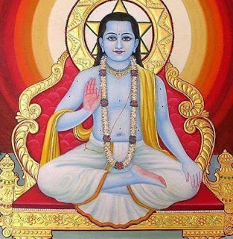
INTRODUCTION
The Nimbarka Sampradaya was founded by Nimbarka (7th century), and teaches the Vaishnava philosophy.
The philosophy of Nimbarka Sampradaya was learned from Sage Narada by Sri Nimbarka.
The Nimbarka Sampradaya is based on Nimbarka's Dvaita - Advaita philosophy, duality and nonduality.
Sage Narada introduced him to the devotional worship of the divine couple Sri Radha Rani and Lord Krishna.
Sri Nimbarkacharya was well versed in the Vedas, Puranas and Upanishads. And he was a great scholar and a master in all kinds of art.

LIFE
Nimbarka was born in a Village, in Maharashtra. And after some time their family got settled at Madhura.
IMPORTANCE
According to Nimbarka, Lord Krishna is the God, and he is the Controller of the entire universe. He insisted his followers to worship Lord Krishna in order to attain MUKTHI.
He has given lectures about the bhakti to the people. He has also relieved the sins of his devotees through his spiritual power, and he has cured many diseases of his devotees, and took them to the spiritual path, in order to attain salvation.
DEVOTIONAL WRITINGS
1. Vedanta Parijat Saurabh
2. Sadachar Prakasha
3. Rahasya Shodasi
4. Prapanna Kalpa Valli
5. Prapatti Chintamani
6. Pratah Smarana Stotram
7. Dasa Shloki
8. Savisesh Nirvisesh
9. Sri Krishna Stavam
CONCLUSION
Sri Nimbarka is also considered as an AMSA (Features) of Lord Vishnu. He has born in this earth to spread the philosophy of Dvaita-Advaita. He was a great saint who reduces the problems of his devotees, and helped them to concentrate their attention towards devotion to god. Let us pray to him and be blessed.
“OM SREE NIMBARKACHARYAVE NAMAHA”
“JAI RADHE KRISHNA NAMO NAMAHA”
WRITTEN BY
R.HARISHANKAR

NIRANJANANANDA
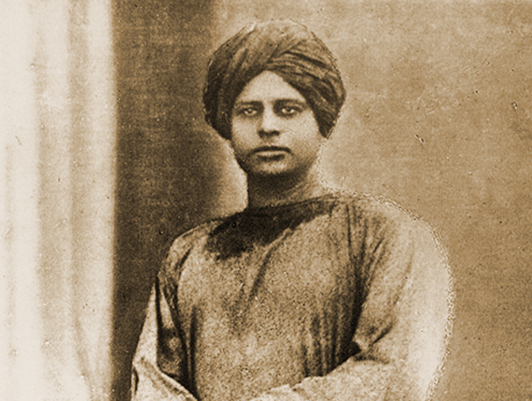
INTRODUCTION
Niranjanananda (1862-1904) was one of the main saint of Ramakrishna Mission, and the direct disciple of Ramakrishna. His birth name was Nityaniranjan ghosh.
LIFE
He was born in a village of West Bengal. He lived in Kolkata with his uncle. Even at his younger age, he was very much interested in learning the vedas and other sacred texts and grasps them immediately. He was appreciated by Ramakrishna for his high talent in hindu scriptures. Though he was married, he was interested in seeking spirituality. For some time, he worked in a private firm in west Bengal, in order to take care of his family.
He was the fond disciple of Sri Ramakrishna and they had discussed about spiritual matters and about the greatness of the divine mother ‘KALI’.
Niranjan left his family and attained sainthood in the year 1887 and stayed in Kolkata Math. From then onwards he was known as Swami Niranjanananda. He also maintained friendly relationship with Sri Ramakrishna’s another famous disciple Swami Vivekananda. He travelled to many holy places and visited the holy shrines of the divine gods. He also travelled with Swami Vivekananda throughout India towards spreading spiritualism and also visited holy temples.
He took care of Swami Vivekananda during his last days.
He died during the year 1904 due to sickness.
IMPORTANCE
Niranjanananda, was deeply impressed with mother Sarada Devi and called her as the holy mother to all. Mother Sarada devi was very fond of him for his good behaviour and for maintaining patience and discipline.
According to Sri Ramakrishna, Niranjananda was a kind hearted person and contains pure soul, who was a helpful person to everybody, and realized the god at his younger age. Niranjan was well known for his simplicity and purity. He was very much interested in doing charitable activities and later formed the Ramakrishna Mission Home of Service at Varanasi. He provided medical facilities to many poor people and also provided food and clothes to them.
CONCLUSION
Sri Niranjananda was a great man, and good in all kinds of activities like doing social welfare activities, helping others and spreading the spirituality amongst the people and showing kindness to others. He was the person who contains wisdom, courage and boldness.
Let us worship him and be blessed.
“OM SREE NIRANJANANDARE NAMAHA”
“OM SREE RAMAKRISHNA PARAMAHAMSARE NAMAHA”
WRITTEN BY
R.HARISHANKAR

PRANAVANANDA SARASWATHI
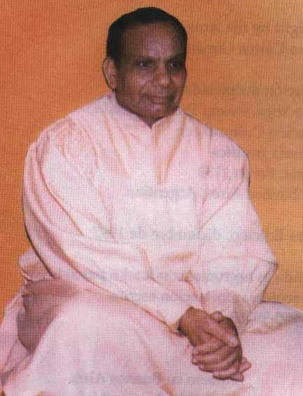
INTRODUCTION
Pranavananda Saraswati (1908–1982) was the founder of the Divine Life Society in Malaysia. His birth name was N.Ponniah.

LIFE
N. Ponniah was born in the year 1908 in Sri Lanka. His parents were strong followers of Hindu faith, and worshippers of hindu gods. He has served as a disciple to Yogaswami, who showed him the spiritual path.
Initially he worked in some places, and afterwards he undertook his first pilgrimage to India in 1948, and had darshan and blessings of Bhagawan Ramana Maharshi and Sri Aurobindo. He also met Ramadas, Paramahamsa Nityananda, Gnanananda Giri and Ananda Mai Ma. He also learnt yoga and meditation and become a great master in that.
During the year 1950, he served in Divine Life Society, which was founded by swami sivananda saraswati. In 1953, Ponniah met Sivananda and became his disciple. He became a saint by Sivananda in 1959 and was called as Pranavananda Saraswati.
He visited several places in india and in abroad to spread yoga and meditation, and also to inculcate the bhakti spirit among the people.
He published the spiritual magazine “Divine Messenger”, which covers the details about Sivananda Saraswati and other saints and rishis.
Pranavananda also published the book Bhajananjali for the Malaysian people.
IMPORTANCE
Sri Pranavananda Saraswati has dedicated his life for religious purpose. He joined with Swami Sivananda Saraswati and done many welfare activities, and also published several articles on Hinduism in their magazine. He had done his level best to spread the bhakti spirit among the people, and also taught yoga and meditation to the Indians and as well as to the foreigners.
He was a humble and a kind man and was liked by the Indians and by the foreigners for his soft approach on them. He also gave teachings on spiritualism and explained about the importance of Hinduism and hindu gods to the Indians and foreigners. He was a noble and a soft spoken person, and never hated others. He has rendered the divine service, in order to make others happy and to live a peaceful and a blessed life.
Let us worship him and be blessed.
“OM SREE PRANAVANANDA SARASWATHI SWAMIGALE NAMAHA”
“OM SIVANANADA SARASWATHI SWAMIGALE NAMAHA”
WRITTEN BY
R.HARISHANKAR

RAMA TIRTHA
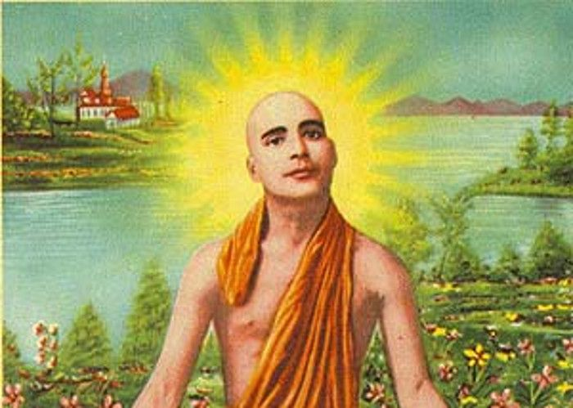
INTRODUCTION
Rama Tirtha (1873–1906) was a Hindu Saint. He was born in Pakistan. He was considered as a famous personality for giving various lectures in the United States, similar to Swami Vivekananda and Paramahansa Yogananda about the importance of Hindu religion.
LIFE
Rama Tirtha was born in a village in pakistan. After the death of his parents, he was brought up by his elder brother Gurudas. He has studied well and become a professor of Mathematics at a college in Pakistan.
After meeting Swami Vivekananda at Lahore,he has become a saint, and left his family and his profession.
He travelled all over the world and taught the sacred texts of Hinduism to the hindus in the foreign countries, and has given many lectures about Hinduism, and spread the bhakti spirit among the people, and asked them to chant the holy names of Lord Rama and Lord Krishna. He wants everyone to be educated, without any difference in status, caste, creed, gender and religion.
After some time he went to the Himalayan mountain ranges and has done deep penance.
He died at the age of 33 in Tehri,Uttarkhand.
His disciples were written his biographies.
Paramahansa Yogananda translated his poems from Bengali into English.
His Ashram is located in Uttarakhand, India.

IMPORTANCE
He was a great scholar and got great knowledge in ancient vedas, Upanishads, puranas and other divine texts. He occupied a prominent role towards spreading the importance of Hinduism in other countries, and also has conducted many meetings, and was attracted by the Indians and as well as other foreign nationals due to his attractive speech. He was also interested in bringing up the down trodden people to a higher level, and was against caste discrimination.
CONCLUSION
A great saint, who was well known for his great devotion on Lord Rama and Lord Krishna, has come to this earth for giving his teachings to the people, and has solved the problems of his followers in a simple manner. He has also done many social welfare activities to the people. The lectures which he delivered in foreign countries, has gained an international recognition. He stressed the importance of education and asked the people to educate themselves by showing attention on their career along with spirituality. According to him, for reaching higher in the career, spirituality is a must, and to be adopted by everyone.
Let us pray to him and be blessed.
“OM SREE RAMA THIRTHARE NAMAHA”
“JAI SREE RAM”
“JAI KRISHNA”
WRITTEN BY
R.HARISHANKAR

RAMAKRISHNA PARAMAHAMSA
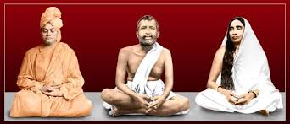
INTRODUCTION
Ramakrishna Paramahansa (1836–1886), was a great Hindu saint. Ramakrishna has experienced spiritual feeling from a young age, and he has devoted his attention towards goddess Kali. Swami Vivekananda who was the disciple of Ramakrishna Paramahamsa, followed his foot steps towards leading the spiritual path.
Birth and childhood
Ramakrishna was born in the village of Kamarpukur of West Bengal, in a Brahmin family. Before his birth, Ramakrishna's parents experienced supernatural incidents and visions. His father had a dream in that Lord Vishnu’s another form Gadadhara, would be born as his son. His mother is said to have had a vision of light entering her womb from Shiva's temple.
Although Ramakrishna attended a village school for 12 years, but he was not that much interested in school education. But he became well-versed in the Puranas, the Ramayana, the Mahabharata, and the Bhagavata Purana.
Priest
In 1856, Ramakrishna was appointed as the priest of the Dakshineswar Kali temple.
He was worshipping goddess Kali as his mother and had a vision of the goddess Kali.
Marriage Life
Sarada Devi(1853–1920),was the wife of Ramakrishna. After his marriage, Ramakrishna returned to Kolkata and took charge of temple activities. Sarada stayed at her native place, since her age was only 5, and later she joined Ramakrishna in Dakshineswar at the age of 18. They led a very simple life. Ramakrishna worshipped her wife as Goddess, and he treated her with love, and took much attention and care on her. Both of them have not lived like a normal husband and wife. There were no physical union between them. Both of them were considered as divine beings in this case. They have totally avoided lust, and concentrated only on bhakti towards goddess Kali Devi.
Disciples
1.Trigunatitananda
2.Shivananda
3.Vivekananda
4.Turiyananda
5.Brahmananda
6.Sadananda
Death
In the beginning of 1885, Ramakrishna suffered from throat cancer. During his last days, he was looked after by his disciples, and by his wife Sarada Devi. Ramakrishna died in the early morning hours on 16 August 1886. According to his disciples, this was mahasamadhi. After his death, Swami Vivekananda along with other disciples formed a Math.
Ramakrishna Math
The Ramakrishna Math was founded by Swami Vivekananda in 1897. The Mission concentrates on all social welfare activities.
CONCLUSION
A great saint, and a Kali devotee, who has conquered all the bad habits in his life, and initiated a true bhakti towards god. He along with his wife Sarada Devi, and his principle disciple,Swami Vivenkanda is still actively engaged in the welfare of the poor class people through “Sri Ramakrishna Math”. He is still listening to our prayers and answering to our problems. In Ramakrishna Mutt, and its branches all over india, lot of social welfare activities are being taken care of by the Mutt’s authorities. Let us pray to the divine avatar “SRI RAMAKRISHNA” and be blessed.
“OM SREE RAMAKRISHNAYA NAMAHA”
“OM SREE SARADA DEVIYE NAMAHA”
“OM SWAMI VIVEKANANDARE NAMAHA”
WRITTEN BY
R.HARISHANKAR

RAMANANDA
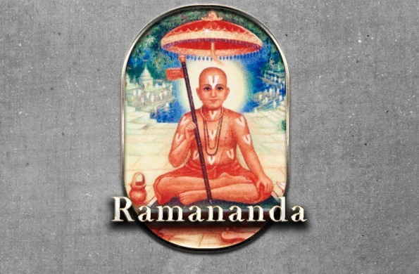
INTRODUCTION
Ramananda(1400-1476) was a Vaishnava saint. He was born in Allahabad. He was the founder of the Ramanandi Sampradaya.
LIFE
He was born in a Brahmin family. He lived in the holy city of Varanasi.
Ramananda was known for composing his works in Hindi language. His writings are very simple and understandable by everyone.
Ramananda studied under Raghavananda. He learnt all the vedas and sacred texts and grasped them immediately. He was well versed in all forms of art. He was talented in spiritual aspects of Hinduism. He was an intelligent and eminent person and says that everyone is equal before god and he has also treated his followers in a proper manner and showed kindness to them.
Spiritual Works
Ramananda has written many devotional poems,out of which two main writings are:
- Gyan-lila
- Yog-cintamani
He accepted disciples without any discrimination by caste,gender and religion.
His main disciples are as follows:
- Anantananda
- Sursurananda
- Sukhanand
- Naraharidāsa
- Bhavanand
- Bhagat Pipa
- Kabirdas
- Sen
- Dhanna
10. Ravidas
11. Sursuri
12. Padyawati

Ramananda was a great social reformer of Northern India.
According to him, there is no need to visit a temple because God is dwelling in the hearts of everyone, and it is not compulsory to worship gods in the temples. He also insisted his followers to do yoga and meditation regularly.
DEATH
He died at the age of 76 at Varanasi.
IMPORTANCE
Ramananda was a great saint, has got great disciples such as kabirdas and contains high spiritual knowledge and wisdom. He was a simple and noble scholar and a staunch devotee of Lord Rama. He invoked the bhakti spirit among the people. His teachings are very simple and straight forward in nature.
CONCLUSION
Ramananda was well known for his Ram Bhakti. He was deeply involved in meditating Lord Rama and singing in praise of him. He has dedicated his life towards spirituality. Let us worship this great guru and be blessed.
“OM SREE RAMANANDA SWAMIGALE NAMAHA”
“JAI SREE RAM”
WRITTEN BY
R.HARISHANKAR

SAINT CHARAN DAS
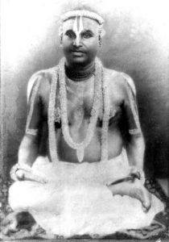
INTRODUCTION
Saint Charandas(18th century) was a great Hindu saint in Delhi. His birth name was Ranjit Singh.
LIFE
Charandas was born in a village in Rajasthan in 1706. His family belonged to the Merchant community.
At his younger age, he had a vision of Sage Sukha, and was blessed by him.
He lived with his relatives in delhi.
At his teenage, he meditated in the forest, and met Sage Sukha and become a saint through his blessings, and from then onwards he was called as “SHYAM CHARANDAS”.
Charandas practiced yoga and meditation and lived as a saint in a small cave in delhi.
In 1738, he has become famous by his teachings and taught the importance of spirituality among his followers.
Charandas had written many devotional works. Mostly tells about the importance of Lord Krishna. Once he had a vision of Lord Krishna while on the pilgrimage to holy temples.
He was well versed in vedas, Upanishads and other spiritual texts.
Charandas died in the year 1782.

TEACHINGS
- Try to concentrate your attention on Krishna, Krishna, Krishna and nothing more else. That will do wonders for you.
- Always give respect to others. And don’t hate others.
- Provide food to all the living beings in the earth, since all are the creations of the god.
- God is there in every one’s heart. And hence do good things to others.
- Forgive others, even when they caused any harm to you.
- Work hard and earn money through honest ways.
- Don’t keep lot of savings with you. Do some kind of charitable activities, since that will please the divine god.
- Read spiritual books and discuss with others, since it will boost up our spiritual energy and will get a better understanding about the god.
- Worship your spiritual guru and serve to him, since through him only, you can reach the god.

His two famous women disciples were entirely dedicated to Lord Krishna and they have also written many songs in praise of Lord Krishna. Their names are:
- Sahjo Bai
- Daya Bai
IMPORTANCE
He was famous for his teachings on the bhakti of Lord Krishna. He was a great poet and sung songs in praise of Lord Krishna. He was a pious and a noble saint, who dedicated his life towards devoting Lord Krishna. He got the habit of daily uttering Lord Krishna’s name for several thousands of times. Let us cultivate the bhakti spirit from him, and do good things in our life.
Let us praise him and be blessed.
“OM SWAMY CHARAN DAS NAMAHA”
“JAI KRISHNA”
WRITTEN BY
R.HARISHANKAR

SAINT MATA BAHINABAI
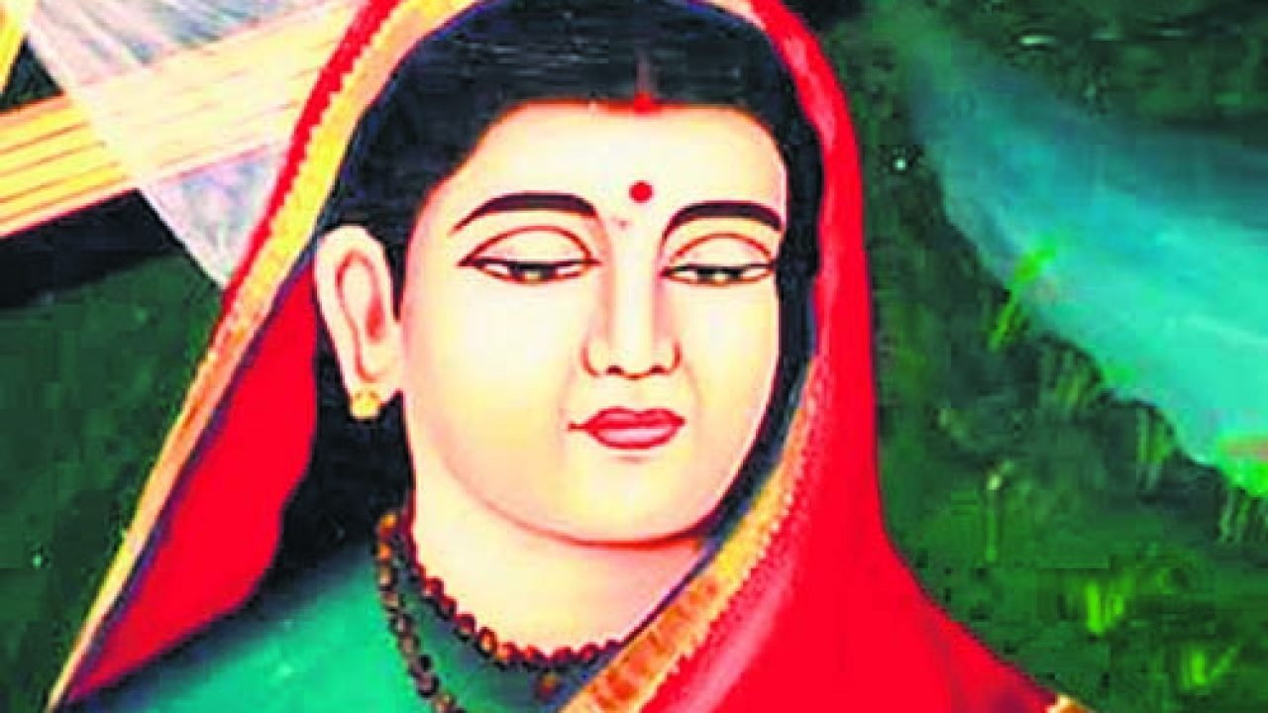
INTRODUCTION
Bahinabai (1628–1700AD) is a female saint from Maharashtra, India. She is considered as a disciple of Tukaram. She was born into a brahmin family.
LIFE
She was born in northern Maharashtra, and there she spent her childhood. She started chanting of God’s names from an early age. Bahinabai was married at a younger age. By the age of eleven, she with her family settled in Kolhapur.
Tukaram initiated her into the path of bhakti, and instructed her to chant the name of Vithoba. Some people considered her as a mad woman, while others considered her as a saint.
According to Bahinabai, serving to husband, and serving to god must be considered equally. And she took care of her husband properly, though he has harassed her physically and verbally. She has tolerated all the sufferings and has given respect to her husband, and she was the mother of two children.
DEVOTIONAL WORKS
Apart from her biography, Bahinabai composed several poems, in praise of Lord Vithoba. She has also written Pundalika-Mahatmyam.
IMPORTANCE
She has lived a saintly life without leaving her husband. According to her, doing duty to husband is much greater than worshipping god, and she has done both of the duties in a proper manner. She was a great Vithoba devotee.
CONCLUSION
Bahinabai acts as an example to others and she lived a pious life, by chanting the names of Lord Vithoba. Though now she is not available with her physical body, we can never forget her true bhakti on Lord Vithoba. Let us worship her and be blessed.
“OM SREE BAHINABAI THAYE NAMAHA”
“OM SREE VITHOBA PRABUVE NAMAHA”
WRITTEN BY
R.HARISHANKAR

SAKHUBAI
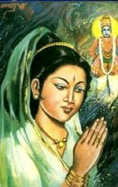
INTRODUCTION
Sakhubai was the daughter of a poor couple in Pandharpur. She was born a few hundred years ago in Pandharpur. Her parents were very humble and straight forward in nature. They were very sincere devotees of Lord Panduranga. They always worship him with pure bhakti in their mind.
LIFE
She was fully involved in a deep sense of devotion to God. At a very young age itself, she started doing puja in her home, and assisted her mother towards the daily house hold activities like cooking and maintaining the house.
Sakhubai was a kind, and a good natured girl.
Soon she was married to a rich man, who was a miser and treated her badly using harsh words.

She was ill-treated by her mother-in-law also, and was allowed to eat the left overs in their house.
IMPORTANCE
She was not worried about the troubles given to her by her husband and in laws. She has done all her house hold duties sincerely by chanting the names of Lord Krishna. Though she was not well, due to the ill-treatment caused by her mother in law, yet she didn’t lost hope and showed more attention on worshipping Lord Krishna.
One day she has asked permission to go to Pandarphar along with a group of devotees to her husband and her in laws. But she was not permitted to go, but instead she was beaten up badly by her husband. But Lord Krishna came to her house in her appearance and asked her to join with the troupe of devotees who are going to pandharpur.
She went to Pandharpur and had the darshan of Lord Vittal with much happiness and enjoyment. Lord Krishna, who was in the appearance of sakhubai, served her husband and her mother in law in a proper manner. And the Lord in the form of Sakhubai has done all the house hold chores properly similar to that of Sakhubai.
Finally, after knowing about all the incidents, her husband and her mother in law were realized about their mistakes, and were known about the greatness of Sakhubai and Lord Krishna.
The Lord blessed her entire family and they attained Moksha after their death.
CONCLUSION
Sakhubai is an incomparable woman, who forgives the problems given by her husband and in laws, and who prays for their wellbeing to Lord Krishna. She maintained a very great patience and showed respect to all the people. She was soft spoken and a very good woman, who considers Lord Krishna as everything. And she finds Lord Krishna in everybody, and was very much delighted in worshipping him. Let us develop such kind of habit similar to that of Sakhubai, in order to attain “SALVATION”. Let us worship her and be blessed.
“OM SREE MATA SAKHUBAYE NAMAHA”
“VITTALA, VITTALA PANDURANGA VITTALA NAMO NAMAHA”
WRITTEN BY
R.HARISHANKAR

SAMARTH RAMDAS
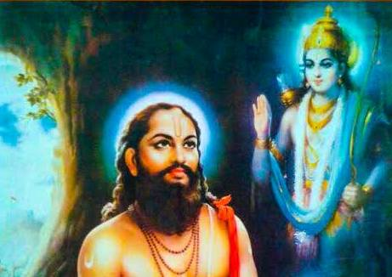
INTRODUCTION
Samarth Ramdas (1608-1681) was a saint and a famous poet of Maharashtra. He has written various famous poems. Ramdas was an ardent devotee of Lord Rama and Lord Hanuman.
His birth name was Narayan Suryaji Thosar. He was born in a village in Jalna district, Maharashtra in a Brahmin family.
It is believed that due to his sincere devotion, Lord Rama has appeared before him and blessed him. From then onwards he was called as “RAMDAS”.
At a younger age, he went to the holy city, Nasik, and started worshipping Lord Rama for many years.
He travelled throughout India and spread Ram Bhakti, and inculcated the chanting of the holy Rama Mantra “JAI SREE RAM” amongst the people.
He has established Hanuman temples all over India.
He started the Shree Samarth religious sect for spiritual purpose.
It is believed that Ramdas met the Sikh Guru Hargobind at Srinagar.
He got the Darshan of Shree Dattatreya in Mahurgad.
SOME OF HIS FAMOUS WRITINGS ARE AS FOLLOWS:
- Dasbodha
- Karunashtakas
- Sunderkand
- Poorvarambh
- Antarbhav
- Atmaram
- Chaturthman
His writings were very simple and it was well appreciated by the people.

TEACHINGS
He has asked the people to be active in their work, and to work hard, and to be honest among others.
He asked the people to be strong in their mind and in their body, in order to run their life in a proper manner. He asked the men to treat the women in a good manner, and to give them their own rights in order to live their life independently. According to his saying, women must be considered as holy, and they must be treated with respect, since all the women contains the feature of Mother Parashakthi.
DISCIPLES
- Kalyan
- Udhhav
- Venna
- Akka
- Bheem
- Divakar
- Dinkar
- Anant Buwa
- Anant Kavi
- Anant Mauni
- Gopaldas
- Dattaray
- Vasudev
- Shreedhar
- Sethuram
He died at the age of 73 in Gajawadi district, Maharashtra.
CONCLUSION
Ramdas was a great saint and a ram devotee who has spent his life towards doing good things to others, and spreading the bhakti spirit amongst the people. He lived a simple and a pious life, and was well educated in all the Hindu subjects and a master in all kinds of art. He was remembered for his good spiritual works, which was read by the people even today. He was a remarkable Rama Bhakta and chanted the names of Lord Rama throughout in his life. Let us worship this great Guru, and be blessed.
“OM SREE SAMARTHA RAMADASARE NAMAHA”
“JAI SREE RAM”
WRITTEN BY
R.HARISHANKAR

SANATH KUMARAS
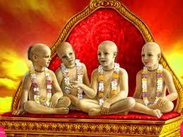
INTRODUCTION
The Sanath Kumaras are four rishis named Sanaka, Sanatana, Sanandana, and Sanatkumara. They are described as the first creations of Brahma. The four Kumaras were strict Brahmacharis(Observance of celibacy). They wander all around the entire universe. All the four brothers were talented in Vedas. They were learned Brahmins, and they were the sons of Lord Brahma. The Bhagavata Purana mentions them as an avatar of Vishnu.
IMPORTANCE
The four Kumaras learnt the Vedas at a younger age, and they became great Rishis. The Kumaras remained in the form of children due to their spiritual power. The four Kumaras are said to reside in Jana Loka. They repeatedly chant Lord Vishnu’s names and sing the glory of Lord Vishnu. Narada was regarded as the disciple of Sanath Kumaras.
According to sanath kumaras, Vishnu is the only refuge to all and he only grants MOKSHA to his devotees. His worship frees the people from their sins.
Once, the four Kumaras went to Vaikunta. And when they reached the main gate of Vaikunta, they were stopped by the Dwarapalakas, Jaya and Vijaya. The four kumaras were then got angered by their act, and punished them to take birth as demons for three consecutive births. The two guards were then born on earth, as Hiranyakashipu and Hiranyaksha in the Krita Yuga.
During the Treta Yuga, they were born as Ravana and Kumbhakarna and defeated by Lord Rama.
And in Dwapara Yuga, they were born as Sishupala and Dantavakra during the time of Lord Krishna.

CONCLUSION
The discourses given by Sanat Kumaras were found in Mahabharatha and Srimath Bhagavatha. According to them, Vishnu is everything in life. Without Lord Vishnu, we can’t sustain in this world. They further tell that when we continuously chants the name of Lord Vishnu, undoubtedly will reach the holy abode of Lord Vishnu. Lord Vishnu controls this entire universe. No one can live without the help of Lord Vishnu. Always think about Lord Vishnu to reach his abode, and to touch his lotus feet. Let us worship these four great maharishis, with sincere devotion and purity in our mind and be blessed.
Let us chant their names and live happily for ever.
“OM SREE SANAKAYA NAMAHA”
“OM SREE SANATANAYA NAMAHA”
“OM SREE SANANDANAYA NAMAHA”
“OM SREE SANAT KUMARAYA NAMAHA”
“OM NAMO NARAYANAYA NAMAHA”
WRITTEN BY
R.HARISHANKAR

SHANKAR DEV
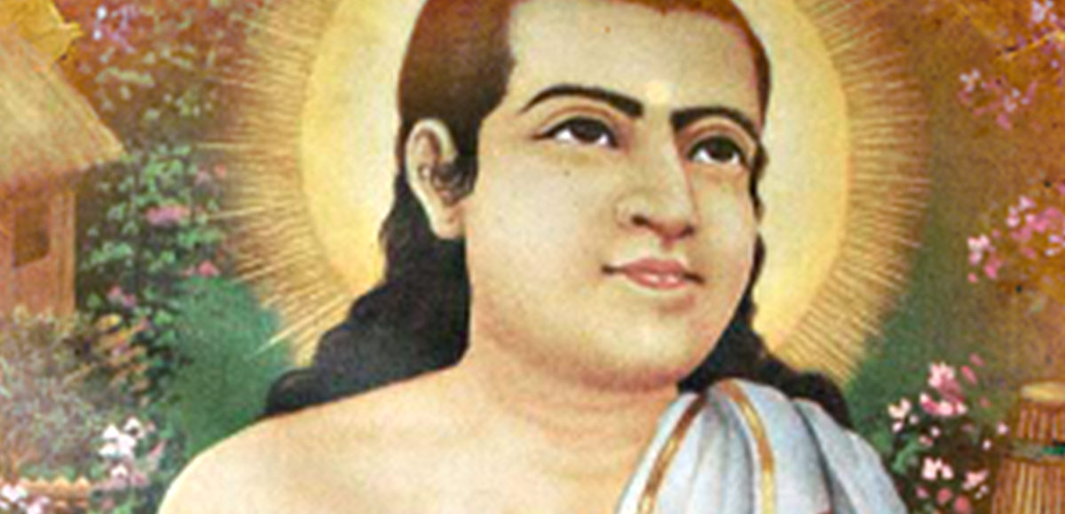
INTRODUCTION
Shankardev (1449–1568) was a saint and poet. He was born in Assam. He was well known for his music compositions and performance in dance. He was considered as an incarnation of Lord Vishnu.
He has started a new religious movement known as Ekasarana Dharma and also called Neo-Vaishnavite movement for the assamese people. He was the main person in spreading the Bhakti movement in Assam.
His literary contributions are well appreciated by the people. The religion which he developed is practised by a large population in assam.

He went to many holy places such as Puri, Mathura, Dwaraka and Ayodhya and spread the bhakti amongst the people.
DEVOTIONAL WORKS
- Bhakti pradipa
- Rukmini harana
- Harishcandra-Upakhyana
- Bhakti-pradip
- Kirtan-ghosa
- Ajamilopakhyan
- Amrta-manthan
- Kirtan-ghosa
- Patni-prasad
- Tales from the life of Child Krishna

IMPORTANCE
He has contributed a lot towards the welfare of the people. He won in the debates held at various king’s courts and has earned name and fame. He has provided food to the poor and the needy and helped them to live a peaceful life. Through his teachings, he insisted the people to worship Lord Vishnu and to consider the Lord as their Guru, Guide and God. He asked the people to accept the Lord as their protector with full faith. He was talented in all kinds of art and was a great scholar who contains great knowledge, wisdom, courage and boldness.
CONCLUSION
He was a great saint and a scholar who advocated the principle of bhakti among the people, and made them to move into the path of spirituality. He was well known for his kindness, bhakti towards god and he acts as the care taker of the people in assam. He won the hearts of millions of the people through his good speech. He was a humble and a soft spoken saint, who always worries about the sufferings of the people in this kali yuga, and removed the sorrows and miseries from the life of his devotees, and also he removed the negativity of thoughts from the mind of the people and mastered them to move their life by following a positive approach. Let us worship the great divine guru and be blessed.
“OM SREE SWAMI SHANKAR DEV MAHARAJ JAI”
“OM NAMO NARAYANA”
WRITTEN BY
R.HARISHANKAR
SHIRDI SAI BABA
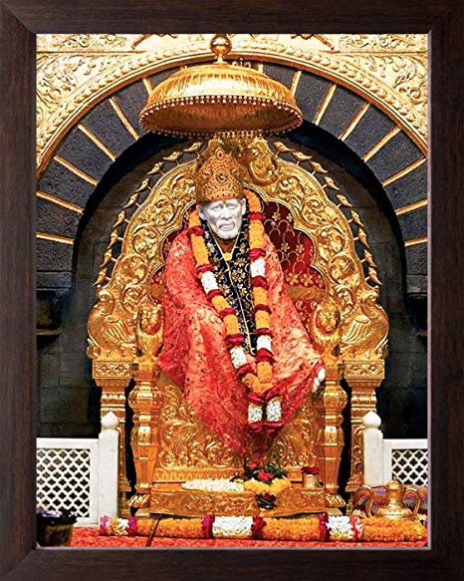
INTRODUCTION
Shirdi Sai Baba is an Indian Saint who respected both Hinduism and Islamism. He wants both Hindus and Muslims to be united and to be cooperative among each other. He is regarded as an avatar of Lord Dattatreya. He preached the importance of self-realization. He lived in Shirdi for several years and attained Mahasamadhi in Shirdi on 1918. He lived a complete life only for the sake of his Bhaktas. He has performed many miracles during his life time and even after his Mahasamadhi.
Today lot of people worship Saibaba in India as well as from all over the world. He cured many diseases of his devotees by taking the devotees wounds and diseases on him. He lived a life by begging even after people regarded him as a Sathguru. He never allowed luxuries and comforts in his life.
He was welcomed by Mahalsapathi of Shirdi who was the priest of Kandoba Temple and who regarded Baba as an incarnation of god. He lived with Baba as a disciple to him and he has done lot of duties to him.
In course of time, lot of followers were there and began praising Baba. Saibaba was also criticized by several people, and they tried to vacate him from Shirdi. Saibaba never showed any enmity with those who caused sufferings to him. Rather than, he has shown his kindness on them.
IMPORTANCE
He treated all the people alike, without distinguishing them from any caste, creed or religion. He has prepared food from his own hands and distributed among the people of Shirdi. He has touched the feet of Leprosy affected people and relieved them from their sins.
He has chanted quoran as well as Ram Naam. His origins are unknown. He is a holy and kind hearted saint. He is well known for his simplicity. He encouraged doing annadanam and explained the importance of doing annadanam to people. He himself had done it several times. He treated human beings and animals as alike.
Today, lakhs of devotees are visiting Shirdi, especially during his Mahasamadhi day which falls on Vijaya Dasami festival. He is revered as a great and a kind hearted saint. His teachings are very simple and easy. His teachings acted as a right way for his devotees. Through these, devotees are directed towards the path of salvation. Sai Baba's teaching combined elements of Hinduism and Islam. His teachings are based on love, forgiveness and devotion to god.
His life history and teaching are available in several Sai books. One famous book is Sai Sat Charitha. If we sincerely read this book for several times, our prayers will get answered and our miseries and sorrows will come to an end.
Sai baba can be worshipped by offering shawl and flowers to him. Apart from Shirdi, several temples are there for him in and around India. In Chennai, Mylapore Sai baba temple is a famous one. It can be regarded as ‘Southern Shirdi’. During Thursdays, there will be a large crowd in the temple. Saibaba will be very much pleased by offering annadanam to poor people. In most of the Sai temples, afternoon annadanam is provided to all the devotees. Mostly it will be sambar rice and curd rice and in some places it will differ. The devotees who take sai prasadam will be relieved from their diseases in course of time and will lead a happy and healthy life.
Let us chant his name and be blessed.
“JAI SAIRAM”
WRITTEN BY
R.HARISHANKAR

SIVANANDA SARASWATI
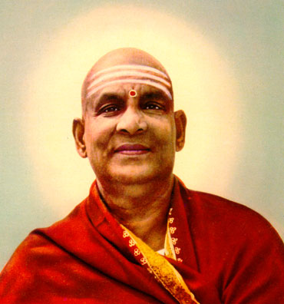
INTRODUCTION
Sivananda Saraswati (1887–1963) was a Hindu spiritual Guru and was proficient in Yoga and Vedanta. His birth name was kuppuswami. Sivananda was born in Tirunelveli district of Tamil Nadu.
LIFE
He was born in a Brahmin family, and his parents were staunch devotees of Lord Shiva. He served as a physician, and after some time he has become a Saint through the guidance of his Guru Sri Vishvananda Saraswati,and lived in Rishikesh.
He was the founder of the Divine Life Society, Yoga-Vedanta Forest Academy and has written lot of books on yoga and spirituality. He was also the founder of Sivananda Ashram, at Rishikesh.
He travelled to all parts of pilgrimage places including Rameswaram, Sri Aurobindo Ashram, Kedarnath, Badrinath and Kailash-Manasarovar.
Swami Sivananda entered Mahasamadhi in the year 1963 in Sivanandanagar,rishikesh.
IMPORTANT DISCIPLES
- Satyananda Saraswati
- Chidananda Saraswati
- Krishnananda Saraswati
- Venkatesananda Saraswati
5. Pranavanda Saraswati
6. Sivananda Radha Saraswati
7. Swami Sahajananda Saraswati
SPIRITUAL WORKS
Sivananda has written more than 100 books on yoga, vedanta and philosophy.
IMPORTANCE
He was a great spiritual guru who has travelled to many places in india, and explained the importance of hindu religion amongst the masses.
Even today, in his name, several orphanages are functioning in an efficient manner.
Let us worship this great saint and be blessed.
“OM SREE SIVANANDA SARASWATI SWAMIGALE NAMAHA”
“OM NAMAH SHIVAYA”
WRITTEN BY
R.HARISHANKAR

SRIPADA SRI VALLABHA
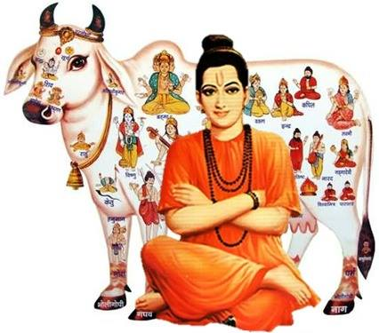
INTRODUCTION
Sripada Srivallabha was a spiritual guru of Hinduism, and he is regarded as the avatar of Lord Dattatreya. He was born in the year 1320, and lived in Pithapuram, Andhra Pradesh.
LIFE
Sripada Srivallabha was born on Ganesh Chaturti.
It is believed that Sripada Srivallabha is a 'Chiranjeevi' and he took 'Jalsamadhi' on 1351 in river Krishna near Raichur, Karnataka. It is believed that he still exists in divine form and blessing us.
Once Sripada has regained the life of Sri Vallabhesh, and then he became a sincere devotee of Sripada Srivallabha.
Sripada Srivallabha has cured the diseases of his devotees, and he is having the capacity to wash out our sins committed by us in the past and present births. He has incarnated in order to bless the people, and to relieve them from their problems, and to uphold the Hindu Dharma through his divine powers.
Sri Dattatreya and Sripada are one and the same. If we worship Sripada, we will get the same result which will be given by Sri Dattatreya.
He was a great scholar and an expert in vedas,puranas and other divine texts.
During his period, he has done lot of miracles in the life of his devotees. He removed the pain in their body, and has given the courage,boldness and wisdom in their life.
Now in the name of Sripada, Sripada Srivallabha Mahasthanam is functioning with the divine statue of Sripada. Daily they are performing various poojas and abhishekams to Lord Sripada. The address of the temple is:
Sripada Srivallabha Mahasthanam
Venugopalaswamy Temple Street,
Pithapuram – 533450
East Godavari District,
Andhra Pradesh,India.

Lot of devotees are coming from all parts of india, to have the darshan of Sripada. In the Mahasthanam, they are providing free boarding and lodging facilities to the devotees, and they are taking care of the devotees in a proper manner.

Teachings of Sripada:
- I will be present in the life of those devotees who read sincerely my “LIFE HISTORY”.
- I will protect my devotees, if they entirely believe on me, and worship me with faith.
- I am the remover of the bad karmas of my devotees.
- Give food to the poor people, so that I will be very happy.
- I will always protect the kind hearted persons, and will always remain permanently with them in their heart.
- Even if you worship other forms of god, I will bless you.
- I am the protector of the entire world. Come to me, and you will be immediately blessed.
CONCLUSION
Sripada is a great avatar of Lord Dattatreya, and is still protecting us from our problems. He is a great saint who has appeared in this KALI YUGA only for the sake of us. Let us worship him and be blessed.
“OM SRIPADA SRI VALLABHAYA NAMAHA”
“OM SRI DATTATREYARE NAMAHA”
WRITTEN BY
R.HARISHANKAR

SUDAMA
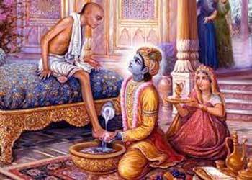
INTRODUCTION
Sudama, also known as Kuchela, was a Brahmin childhood friend of Lord Krishna. The details about him were mentioned in the Bhagavata Purana.
LIFE
Sudama was born in a poor Brahmin family. And both of them were studied under the same Gurukulam.
In course of time, Sudama had suffered from severe poverty, and his wife asked him to meet his friend Krishna, and to seek some financial help.
He went to dwaraka to visit his friend Krishna by carrying a bag of some flattened rice (AVAL) in order to give his simple offering to him, since Krishna’s favourite food item is AVAL.
Krishna welcomed his old friend in a grand manner. By seeing the Lord’s kindness, he could not speak about anything, and was thinking about the kindness and humbleness showed to him, even though he was a king.
But the Lord knows everything and fulfilled his wishes. But sudama got realized only when he reached his home. He finds a Luxury home in the place of his own hut. He also finds his wife and his children were dressed in royal clothes and waiting for him. Tears were flown from his eyes and prayed to Lord Krishna for showering his great blessings on him.
IMPORTANCE
The friendship between Krishna and Sudama was a great one. While Krishna was a divine avatar, sudama was a pious Brahmin, who also lived a noble life, and only visits his place, in case of emergency need. He thought only about krishna’s greatness and he never wants anything more than that.
He was wondering how a great king was offering a very good and kind service to him, and treating him in a good manner.
Krishna also knows about the behaviour of Sudama, that he is learned scholar and a well- mannered and a soft spoken person. He respected his gentleness and his good behaviour, and offered him all the riches in his life, even without being asked by him.
From this incident, we can know the great nature of sudama, and how he had been suitably rewarded by the god.
Even if we worship the god, without asking him for our necessities, he will suitably reward us at the appropriate time. He knows everything, but we have to wait for the right time to receive the favours from him.
Let us worship the great Sudama and be blessed.
“OM SREE SUDAMARE NAMAHA”
“OM SREE KRISHNAYA NAMAHA”
WRITTEN BY
R.HARISHANKAR

SURDAS
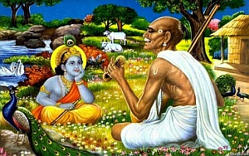
INTRODUCTION
Surdas was a 16th-century blind Hindu devotional poet and singer, who has written and sung in praise of Lord Krishna. He was a great poet and an exceptional singer. Though he was blind from his childhood, he never lost hope and always chants the glory of Lord Krishna. The book known as Sur Sagar was written by him. And it was well appreciated by many scholars.
LIFE
Since Surdas was blind child from birth, he was rejected by his family, and he lived alone on the banks of River Yamuna.
Surdas has also composed the Sur Saravali and Sahitya Lahari. Surdas's compositions are also found in the Sikhs holy book.
IMPORTANCE
Surdas has spread the spirituality of Lord Krishna among the masses.
Surdas is considered as a prominent disciple of the Great Saint Sree Vallabha Acharya.
Surdas was known for his great compositions on Lord Krishna.
He was a talented singer and always thinks about Lord Krishna, and was an ardent devotee of Lord Krishna.
It is believed that Lord Krishna himself appeared in front of him and listened to his beautiful songs.
He was born in this world for spreading the bhakti of Lord Krishna among the common people.
CONCLUSION
Surdas though lived several years ago, still remain in our hearts, due to his utmost devotion on god. Though he was a blind person, he never complained about his situation to god. He didn’t think he is a blind person, but concentrated his full attention only on writing songs and singing them, and chants the names of Lord Krishna. We also have to develop such kind of habit, and must try to learn from him. Let us chant his name and be blessed.
“OM SREE BHAKTA SURDASJI NAMAHA”
“OM SREE KRISHNA, MUKUNDA, MURARI”
WRITTEN BY
R.HARISHANKAR

SWAMI DAYANANDA SARASWATHI
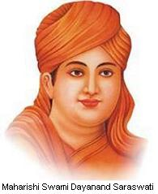
INTRODUCTION
Dayanand Saraswati (1824–1883) was an Indian Guru and founder of the Arya Samaj, for the propagation of Vedic dharma. He opposed against the british rule along with Sri Lokmanya Tilak. His birth name was Mul Shankar.
He was also the author of the great book Satyarth Prakash, which contributed to the Indian independence movement.
He was a saint from his younger age, and a great scholar. He was well versed in vedas and other divine texts. He insisted the people towards devoting god on each and every day, without forgetting him on even a single day. So that they will always be blessed by the divine gods in heaven.
He also promoted the equal rights for women, similar to men.
LIFE
Dayananda Saraswati was born on 1824 in a Brahmin family in Gujarat. He was taught the basic education at the age of eight, and was a great worshipper of Lord Shiva. He was interested in attaining spirituality and left from his home at the age of 22.
Dayananda Saraswati spent many years, as a wandering saint, and went to Himalayan Mountains, and to various pilgrimage sites in northern India. He was an expert in yoga and meditation and became a disciple of a learned scholar Sri Virajanand Dandeesha. Dayananda Saraswati devoted his entire life towards restoring the Hindu faith amongst the people.
He was a very kind saint and interested in cultivating the principle of universal brotherhood, treating all the humans with much affection and love. He wants no one to be suffered from poverty, and must not suffer from hungry. He was keen in developing the living standard of the Indians.
For this purpose, he founded the Arya Samaj.
IMPORTANCE
He travelled all over india and spread the importance of gaining knowledge in Sanskrit and Vedas.
He won in several religious debates held at various places of india.
Swami Dayananda Saraswati's creations, the Arya Samaj,was against the practices such as animal sacrifice, child marriages, and discrimination against women. He argues that these practices are against the vedic principles.
He was poisoned by his enemies on several occasions, but due to the divine grace of Lord Shiva, he was survived.
Several universities were named after him, in order to recognize his contributions made to the Hindu religion.
Swami Dayananda was a great man, who always worried about the poor people and has done many charitable activities. He wants the society to give more respect to the women and should treat them with affection and give all the basic rights to them. In his teachings, he has clearly mentioned about improving the living standard of the women in india.
FAMOUS WORKS
- Satyarth Bhumika
- Sanskarvidhi
- Rigvedadi Bhashya Bhumika
- Rigved Bhashyam
- Yajurved Bhashyam
Due to the act of enemies, he was poisoned and he died on 1883.
He was a great man, who never thought about his life, but only thought about the lives of Indians, and has done his level best towards uplifting the Indians, and to free india from the british rule. He has done many good activities in his life time, and will be remembered for ever by the indian people.
Let us worship this great social reformer, freedom fighter and saint and be blessed.
“OM SREE SWAMI DAYANANDA SARASWATHI MAHARAJ NAMAHA”
“OM NAMAH SHIVAYA”
WRITTEN BY
R.HARISHANKAR

SWAMI NARAYAN
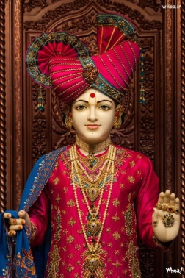
INTRODUCTION
Swaminarayan (1781 –1830), also known as Sahajanand Swami, was a yogi. He is believed by his followers as an avatar of Narayana.
BIRTH AND IMPORTANCE
Swaminarayan was born as Ghanshyam Pande into a Brahmin family at Uttar Pradesh, India in 1781. In 1792, he travelled across India, and adopted the name as Nilkanth Varni. Nilkanth Varni visited the Jagannath Temple in Puri as well as temples in Badrinath, Rameswaram, Nashik, Dwarka and Pandharpur.
During his journey, he has done lot of welfare activities to the people and he settled in the state of Gujarat around 1799.
In 1800, he was adapted into the Uddhav sampradaya by his guru, Swami Ramanand, and was given the name Sahajanand Swami. In 1802, his guru made him the leader of the Uddhav Sampraday before his death. Sahajanand Swami taught the Swaminarayan Mantra to the people. From then onwards, he was known as Swaminarayan. The Uddhav Sampraday became known as the Swaminarayan Sampraday.
Swaminarayan died on 1 June 1830, and was cremated in Gadhada, Gujarat.
Swaminarayan, established temples, as part of his philosophy of deity worship. These mandirs are known as Swaminarayan Hindu temples.
He constructed nine temples in the following cities; Ahmedabad, Bhuj, Muli, Vadtal, Junagadh, Dholera, Dholka, Gadhpur & Jetalpur. In these temples he installed images of various Hindu gods, such as NarNarayan Dev, LaxmiNarayan Dev, RadhaKrishna Dev, RadhaRaman Dev, Revti-Baldevji, Madan Mohan Dev etc.

CONCLUSION
It is believed that the sage Narayana who took birth as Lord Krishna in dwapara yuga, has again taken the avatar as “SWAMI NARAYAN” in this Kali Yuga. He is regarded as an eminent and efficient guru among his followers. He has done many miracles to the people during his life time, and is still answering to the prayers of his devotees from his mandir. His mandirs are situated all over india, and also is situated in foreign countries. Let us pray to this great saint, and an avatar of god, for our well being, and for the well being of the people of the entire universe. Let us chant his name and be blessed.
“OM SREE SWAMI NARAYANARE NAMAHA”
“JAI KRISHNA, JAI BALRAM”
WRITTEN BY
R.HARISHANKAR

SWAMI SAMARTH
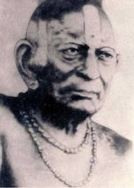
INTRODUCTION
Swami Samarth (19th century AD) also known as Akkalkot Swami, was an Indian Saint and is worshipped by his devotees in Maharashtra, Karnataka and Andhra Pradesh.
Sri Swami Samarth settled at Akkalkot village in Maharashtra, India. He stayed in Akkalkot for many years. His family details & place of birth is unknown. Sri Swami Samarth declared that he was originated from a holy tree.
It is also believed that his original name was Narasimha Bhan, and that his native place was Srisailam,Andhra pradesh.
IMPORTANCE
Sri Swami Samarth is considered as the incarnation of Shree Dattatreya. It is also believed that he is the reincarnation of Shree Narasimha Saraswati.
He has also visited sacred temples such as Kasi, Haridwar and Rameswaram.
Shri Swami Samarth is also believed to have met Saint Shri Manik Prabhu, at Manik Nagar,Karnataka.
Swami has done lot of miracles and changed the life of the depressed people. Once he changed a dull person’s life into a brighter one. He has relieved many peoples from their mental related problems. He has cured many dreaded diseases of the people, and relieved them from their past birth’s sins and showed them the spiritual path in their life. He acts as a saviour and protects us from our enemies and makes us to live happily and peacefully.
Some of his teachings are as follows:-
- God can be seen anywhere in the world.
- Read the divine texts composed by the great sages and scholars.
- Good knowledge can be obtained only through holy saints. And do your service to them in a proper manner.
- Our mind should be pure and should not think about bad things. Try to think about god and god only, and ignore all other unnecessary things in your mind.
- Work hard and earn money, don’t be lazy and suffer with poverty.
- All the religions preach only the good things which are essential for the human’s life.
- Try to behave with others in a proper manner. Don’t cheat any body and don’t commit sins.
CONCLUSION
Swami Samarth is a great guru who is also considered to be an avatara of Lord Dattatreya, will relieve us from our sins and give us a blessed life. Let us pray to him and chant his name.
“JAI SREE SWAMI SAMARTH MAHARAJ JAI”
WRITTEN BY
R.HARISHANKAR
SWAMI SRI YUKTESWAR GIRI
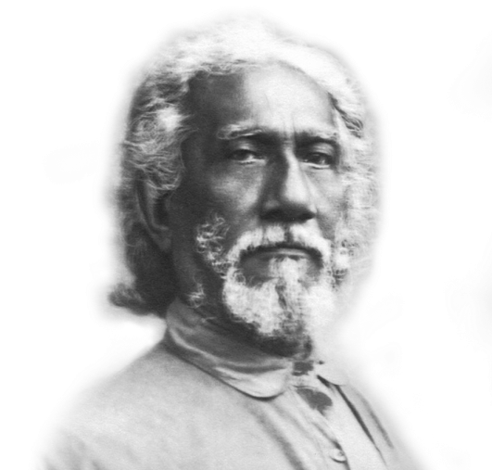
INTRODUCTION
Sri Yukteshwar(1855–1936) was an Indian Guru and yogi, and the guru of Sri Paramahansa Yogananda. Sri Yukteswar was an expert in yoga and meditation, well versed in various divine texts and a master in all kinds of art. He was the disciple of Lahiri Mahasaya of Varanasi.
LIFE
His birth name was Priya Nath Karar and born in West Bengal. After finishing his studies he got married and had a daughter. Though he was married, he was not interested in family life, but interested in attaining yogic powers.
In 1884, Yukteswar met Lahiri Mahasaya, who became his Guru and initiated him into the path of Yoga. Sri Yukteswar served his guru in Benares. As per the instructions given by Sri Maha avatar babaji in Allahabad, he wrote a book in 1894, known as The Holy Science.
He constructed an Ashram at his home town, where he stayed with his students and disciples. And he taught yoga and meditation to them along with formal education. After some time he has established another Ashram at Puri.
He also wrote a book on astrology. He wants women to be better educated, in order to stand on their own legs, without depending on men.
IMPORTANCE
Sri Yukteswar was a soft spoken and a humble person but strongly implemented his teachings to his followers. He insisted the people to do yoga and meditation along with making regular prayer to god. He attained spirituality due to the divine grace of Maha avatar Babaji, and he contains great knowledge on Kriya yoga, and spread it among the universe.
Yukteswar attained mahasamadhi at Karar Ashram, Puri, India on 1936.
FAMOUS DISCIPLES
- Paramahansa Yogananda
- Satyananda Giri
- Sailendra Bejoy Dasgupta
- Paramahansa Hariharananda
- Swami Bhabananda Giri
CONCLUSION
Sri Yukteswar Giri was a great yoga teacher and a spiritual master, who insisted his followers to follow the path of spirituality. He asked his followers to regularly practice Kriya yoga, in order get relieved from physical and mental stress and to get peace of mind. According to him, by practising the kriya yoga, one can be able to avoid unnecessary thoughts in his mind, and can concentrate on his work in a proper manner. And also it helps in attaining spiritual energy.
Let us worship the divine saint and be blessed.
“OM SREE SRI YUKTESWAR GIRI NAMAHA”
WRITTEN BY
R.HARISHANKAR
TULSIDAS
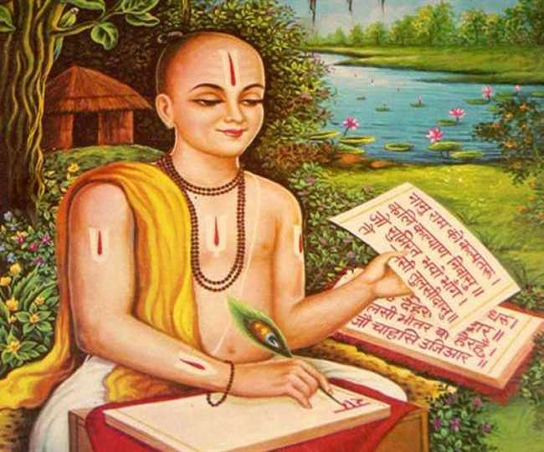
INTRODUCTION
Tulsidas (1532-1623), was a Hindu saint and poet, was well known for his devotion to Lord Rama. He was born in a village in Uttar Pradesh. His birth name was Rambola. Tulsidas has written several popular works in Sanskrit and he was the author of the great epic Ramcharitmanas, a translation of Sanskrit Ramayana into Hindi language. Ramcharitmanas is considered as one of the finest works of Hindi literature.

LIFE
Tulsidas lived in the city of Varanasi. He was the founder of Lord Hanuman Temple in Varanasi.
He has been recognized as one of the famous poets in Hindi.
It is considered that he was the incarnation of the great sage Valmiki.
At the age of five years, Rambola was adopted by Naraharidas, and became a saint, and from then onwards, he was named as “TULSIDAS”.
He travelled to many holy places like Badrinath, Dwaraka and Rameshwaram and met various saints.
During his life time he had the darshan of Lord Rama,Hanuman and the great sages Yajnavalkya and Bharadvaja.
Some of his famous works are as follows:
- Dohavali
- Ratna Ramayan
- Gitavali
- Krishna Gitavali
- Vinaya Patrika
- Barvai Ramayana
- Parvati Mangal
- Janaki Mangal
- Ramalala Nahachhu
10. Ramagya Prashna
11. Vairagya Sandipini
12. Hanuman Chalisa
13. Sankatmochan Hanumanashtak
14. Hanuman Bahuka
15. Tulsi Satsai

IMPORTANCE
Tulsidas is a famous saint in north india. He was praised for his great scholarly works. He dedicated his life towards worshipping Lord Rama and Lord Hanuman and spreading the bhakti towards the universe. He was well known for his simplicity. He treated all the people as alike and invoked them into the bhakti movement. He asked the people to chant the “RAMA MANTRA” for several lakhs of times, in order to get salvation.
Death
Tulsidas left his body on the banks of the river Ganga in Uttar Pradesh.
CONCLUSION
A great scholar and an ardent devotee of Lord Rama will give all the necessities in our life and guide us in our all walks of life. Through his great works, he will be permanently remembered by us. His works are divine in nature and help us to lead a peaceful life. He has taken the avatar in order to inculcate the importance of chanting Rama Mantra among the people. Let us worship him with pure devotion in mind and be blessed.

“JAI TULSIDAS”
“JAI SREE RAM”
“JAI HANUMAN”

WRITTEN BY

R.HARISHANKAR

UPASNI MAHARAJ
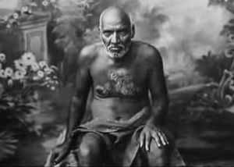
INTRODUCTION
Upasni Maharaj (1870 –1941) was considered by his devotees to be a great saint. He lived in Sakori and he has received the divine grace from Sai Baba of Shirdi. His birth name was Kashinath Govindarao Upasni.

LIFE
Upasani Maharaj born into a family of learned people at a small village in the district of Nasik.
At his younger age, he served as an ayurvedic doctor.
Once he met Sai Baba of Shirdi and he had initiated him into the path of spiritualization, and then he became his disciple.
Upasni Maharaj was the teacher of Meher Baba. Meher Baba met Upasni Maharaj in 1915 and became his disciple.
Upasni Maharaj gave him spiritual knowledge in the year 1914 and taught him the devotional texts like vedas,puranas and bhagavata. Meher baba learned it quickly and became a great scholar.
His ashram is situated near shirdi, and it contains his Samadhi. It is a beautiful ashram and maintained properly.
He died in Sakori, India during the year 1941, at the age of 71.
TEACHINGS
- Don’t give troubles to others. Instead do some good things to others.
- Always show mercy on all living creatures.
- Keep bhakti towards god, and that will lead to a peaceful life.
- Always keep yourself away from bad habits, and try to develop good habits.
- Respect others from your heart, and in turn, you will also be respected by others.
- Don’t be greedy, and don’t be miser in spending money, give money to the poor and needy.
- Work hard and earn money only through honest activities.
- Forget about past things in your life. Always think about present and future life.
- Be active at all times, and always do your work yourself and chant the names of god frequently, so that in your old age, you will not be affected by diseases.
IMPORTANCE
He was a great spiritual saint, who was blessed by Shirdi Sai Baba. He took the advice of baba and followed it, and lived as a saint and dedicated to the path of spirituality. He realized the god from his inner soul, and attained the divine bliss of god.
He has also done many miracles, similar to that of Shirdi Sai Baba. He solved the problems in the life of his followers, and removed their diseases, and inculcated the bhakti spirit to them and relieved them from their sins and asked them to chant god’s holy mantras and to do meditation.
His teachings are very simple and straight forward in nature. He was a soft spoken person, who never uttered any bad words on others.
Let us worship him and be blessed.
“OM SREE UPASNI MAHARAJ NAMAHA”
“JAI SAIRAM”
WRITTEN BY
R.HARISHANKAR

VALLABHACHARYA
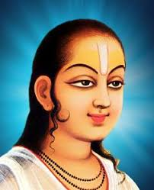
INTRODUCTION
Vallabhacharya (1479–1531), was a Telugu saint of Vaishnavism. He was born in Chhattisgarh. He was married and had two sons. It is considered that he is an incarnation of Lord Krishna.
IMPORTANCE
Vallabha studied the Vedas and the Upanishads at a younger age, and travelled extensively throughout India. He was the main person in spreading the Bhakti movement all over the country.
He suggested the people to worship God Krishna, and through him any person including the householders could attain salvation. He asked the people to continuously chant the various names of Lord Krishna in order to get peace of mind and happiness in their life.
SPIRITUAL TEXTS
- Anubhashya
- Shodash Granth
- Tattvaarth Dip Nibandh
- Commentaries on Bhagavata Purana
- Patravalamban
- Madhurashtakam
- Gayatribhashya
- Purushottam
- Sahastranaam
10. Girirajdharyashtakam
11. Nandkumarashtakam
He was well versed in all the vedas,puranas and Upanishads and also learnt the philosophies of Sankara,Ramanuja,Madhva and Nimbarka.
His writings were mainly focussed on Lord Krishna about his childhood miracles and killing of several demons and saving the people from the evil forces.
Vallabhacharya has done lot of charitable activities during his life time. He had distributed the money which he earned form the kings among the poor brahmins and to other poor people. He provided food to the people with much interest and care.
He lived a very simple life and he has also given discourses on Bhagavata and Puranas and explained the importance of Lord Krishna and insisted the people to worship him with true bhakti in order to gain all the benefits in the world, and to finally attain SALVATION. It is believed that he had met the great sage Veda Vyas in the Himalayan Mountains.
At the age of 52, he took samadhi in Kasi, Uttar Pradesh.
CONCLUSION
Saint Vallabhacharya was a great saint and also an avatar of Lord Krishna, will relieve us from our past and present birth sins and will protect us through his divine power. Let us glorify him by chanting his divine name and be blessed.
“OM SREE GURU VALLABHACHARYARE NAMAHA”
“JAI KRISHNA, GOVINDA, GOPALA, MURARI”
WRITTEN BY
R.HARISHANKAR
VIDYAPATI
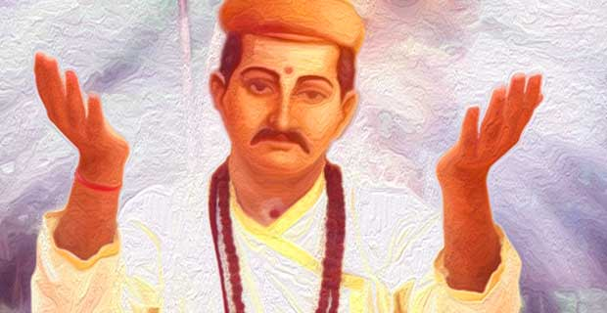
INTRODUCTION
Vidyapati (1352–1448) was a Sanskrit poet and he was born to a Shaivite Brahmin family in Bihar, India.
His father was a priest in the court of the chief of Tirhut, Bihar.
He worked as a poet in the court of several kings in Bihar.
It is also believed that he directly interacted with Lord Shiva and Goddess Ganga through his sincere devotion on them.

His famous works include:
- Purusa Pariksa Likhanabali
- Bhu-Parikrama
- Vibhagasara
- Danavakyavali
- Gangavakyavali
- Varsakrtya
- Durgabhaktitarangiṇi
- Saivasarvasvahara
- Kirttipataka
10. Kirttilata
He was praised by Sri RabindranathTagore for his great poems.
IMPORTANCE
He was a great poet and an ardent devotee of Lord Shiva. Through his famous poems, he has mesmerised the entire world. He was widely appreciated for his works by the great kings of bihar during his period. He emphasised the importance of doing various charitable activities to the poor and the needy. His poems speak about devotion on god, and it helps in developing spirituality among the common people.
He held meetings at various places and explained about the greatness of Lord Shiva and asked the people to worship him to attain MOKSHA, after their death. He also insisted them to follow the path of spirituality to avoid from the evil effects of this KALIYUGA, and to reduce our bad karmic deeds.
CONCLUSION
Vidyapathi was a great poet and a noble man who lived a pious life by worshipping lord shiva. Let us worship him and be blessed.
“OM SREE VIDYAPATIYE NAMAHA”
“OM NAMAH SHIVAYA”
WRITTEN BY
R.HARISHANKAR

VIDYARANYA
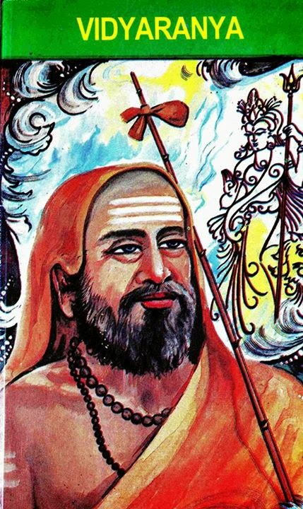
INTRODUCTION
Vidyaranya(1296-1391) was a saint and the priest to the kings of the Vijayanagara Empire.
He was the Jagadguru of the Sringeri Sarada Pitham from 1380-1386.
He served as a guide to three generations of kings who ruled over the Vijayanagara Empire.
Vidyaranya also served for some time as a prime minister in the Vijayanagara Empire and was sincerely dedicated towards administrating the kingdom.
FAMOUS WORKS
- Parasara-Madhaviya
- Sarvadarsanasangraha
- Pancadasi
- Madhaviya Shankara Vijaya
- Mimamsa Sutras
He attained Siddhi at the age of 95 at Sringeri.
IMPORTANCE
He was well versed in Sanskrit language and an expert in all kinds of art, and contains good knowledge in hindu scriptures. He was well known for his soft and gentle nature. He was a pleasing personality, and the preacher of Sanatana Dharma. He was a sincere devotee of Goddess Saradambigai and lived a blessed life through her grace. He also explained the importance of spirituality through his divine works.
CONCLUSION
Vidyaranaya was a great Jagad guru, who served in Srigeri Sarada Peetam, and attracted a huge number of followers during his period. He was appreciated by the great kings for his talent in administering the mutt and for exposing his knowledge and sharing with others, and for his spiritual power. Let us pray to him and be blessed.
“OM SREE VIDYARANYARE NAMAHA”
“OM DEVI SARADAMBIGAIYE NAMAHA”
“OM NAMAH SHIVAYA”
WRITTEN BY
R.HARISHANKAR

