Famous Temples In South India:

1. Tirupati Tirumala Temple, Lord Vishnu
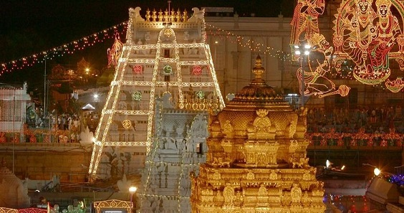
The Tirupati Temple is one of the most important temples in South India. This Temple is very much popular with all the pilgrims, and is located in Chittoor, in the state of Andhra Pradesh. Daily, lot of pilgrims are visiting this temple from all over India, and also from foreign countries. It is one of the most richest temple in India. Every year, crores of rupees are received from the devotees through hundial, and also received from various endowment donations. Nithya annadanam scheme is very much popular in Tirupati. Lot of devotees are consuming good and tasty divine food daily. Hence it is a must to visit this temple, at least once in a year and to offer our prayers, to have annadanam and to offer money based on our financial background, and to get Lord Sree Venkateswara’s divine blessings for ever.
OM NAMO SREE VENKATESAYA NAMAHA
2. Ramanatha Swamy Temple, Lord Shiva:
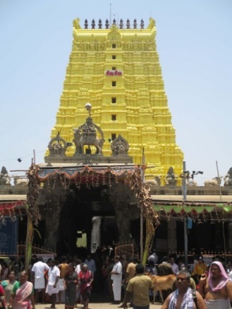
The Ramanatha Swamy temple is dedicated to Lord Shiva and it is situated at Rameswaram.
People are visiting here for doing their ancestral rituals, and it is very famous for that. This is one of ancient temples of south india. Free food is offered in the temple for more than 100 devotees. Aadi Amavasya,Thai Amavasya and Mahalaya Amavasya pitru rituals are very popular in this temple. We can take bath from the sacred wells situated inside the temple. It is a must to visit this temple, to get relieved from various sins, and also by clearing our ancestral debts by doing pitru tharpan. Many site seeing places are also there nearby rameswaram. We can visit Abdul Kalam Sir’s Memorial also in Rameswaram. Dhanushkodi is the best sight seeing place situated near Rameswaram.
‘OM SREE RAMANATHA SWAMIYE NAMAHA’

3.Virupaksha Temple of Lord Shiva
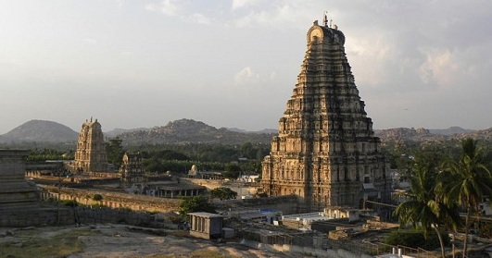
The virupaksha temple is one of the most famous temple of south india situated at Hampi, Karnataka.This is one of the sacred temple of Lord Shiva and it was established in 7th century AD and also it is one of the oldest temples in india. It is a must to visit this temple, since it is surrounded by natural beauty. The temple continues to prosper and attracts huge crowds for the marriage festivities of Virupaksha in the month of December every year.
In the month of February, the annual chariot festival is celebrated in a grand manner.

‘OM SREE VIRUPAKSHARE NAMAHA’

4. Darasuram Airavathesvara Temple,Lord Shiva
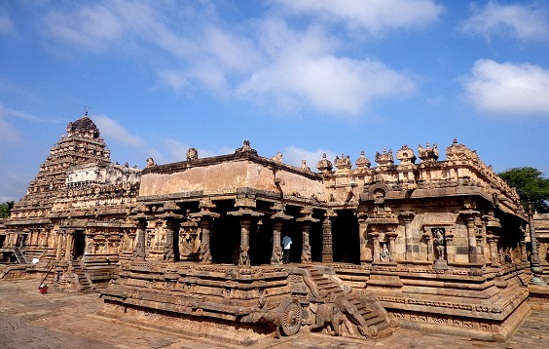
The Airavathesvara Temple was built by Rararaja Chola II. It was constructed in 12th century AD. There is a lot of art and architecture built into the temple. The front of the temple has a huge chariot which is drawn by some horses.This is also one of the powerful temples of south india. Periya Nayaki Amman temple is situated close to this temple. History says, that Lord Indra’s White Elepant, Iravata has worshipped Lord Shiva in this temple, and also Lord Yama has worshipped in this temple.
‘OM SREE AIRAVATHESWARARE NAMAHA’

5. Gangaikonda Temple of Lord Shiva and Saraswathi
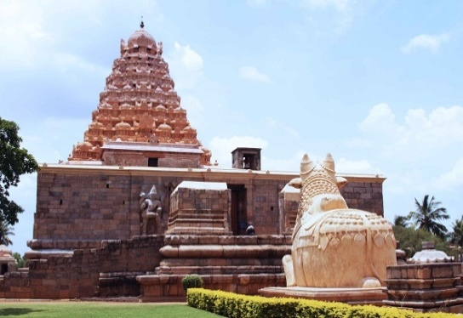
This temple architecture is very good. Apart from this, the temple art is the importance of this temple. This temple was established by the cholas to celebrate their victory.The chola kings have made various contributions for this temple. Pilgrims from all over India visit this temple throughout the year. This temple is one of the ancient and historical temples in India.
‘OM SREE GANGADEESWARARE NAMAHA’

6.Sabari Mala Lord Ayyappa Temple
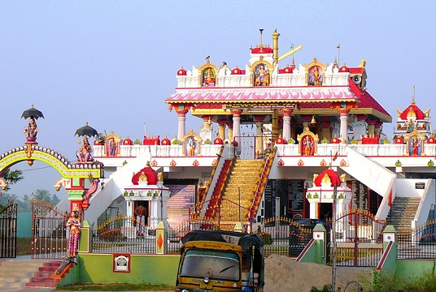
This temple is dedicted to Lord Ayyappan and it is one of the ancient temples of Kerala in India. The temple is located in the hills. The deity of Lord Ayyappan was installed by Lord Parasurama.This is the most popular temple, in which there is no caste, creed and religious discrimination among the devotees to worship Lord Ayyappa. Mostly the devotees will visit this temple during pongal season and Vishu new year day. Free annadanam is offered inside the temple premises to all the devotees. But one has to observe fasting for one mandalam ( for 48 days), and they have to be purified in their body and mind, and to chant the mantra of Lord Ayyappan and also during the fasting period, daily they have to visit some nearby temples and to offer their prayers.
‘SWAMIYE SARANAM AYYAPPA’

7. Agneeswarar Temple or Kanjanur Sukran Temple
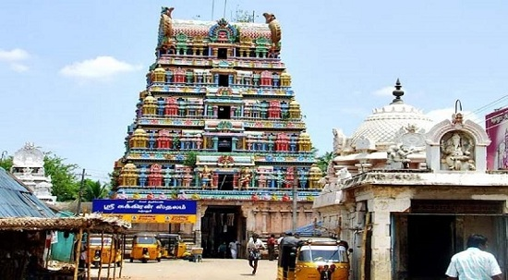
The Agneeswarar Temple is located at Kanjanur in Tamil nadu. Lord Shiva and Goddess Parvati’s marriage took place in this temple, and it was seen by Lord Brahma. Since Lord Agni worshipped Lord Shiva in this place, the temple is known from his name “Agneeswarar”. Fridays are specially celebrated in this temple. Lord Sukran occupies a most important place in this temple.
‘OM SREE AGNEESWARARE NAMAHA’

8. Kapaleeswarar Temple of Lord Shiva
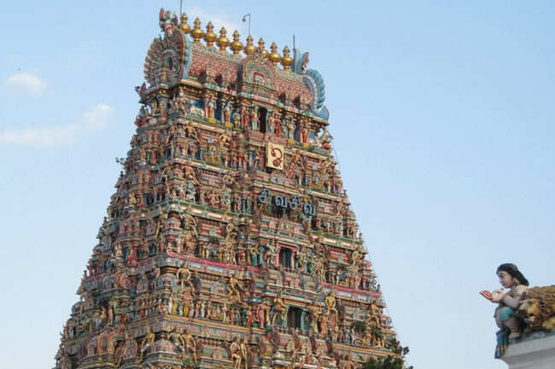
The Kapaleeswarar Temple was built in the 8th century by the pallavas.This is one of the oldest and famous temples of south india. It is located in the heart of Chennai city at Mylapore, and devotees from all parts of the Chennai visit this place. Foreigners are also visiting this temple. The 63 Nayanmars festival is considered as a very important festival in this temple, and it is celebrated in a grand manner every year. Daily free food is offered in this temple for more than 100 devotees.
‘OM SREE KAPALEESWARAYA NAMAHA’

9.Madurai Meenakshi Amman Temple
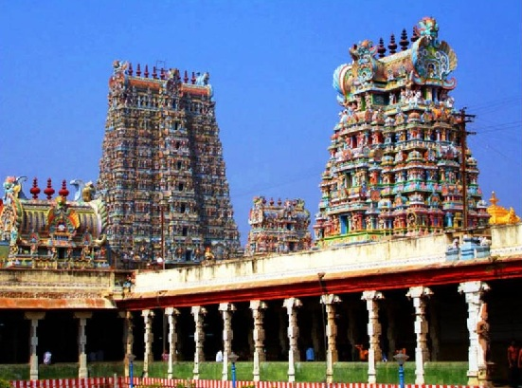

The Meenakshi Amman Temple at Madurai is a most important famous temple in south india. Lot of devotees from all parts of India are visiting this temple. Here Meenakshi Amman is the main diety in this temple. The Meenakshi temple also contains the shrines of Lakshmi, Krishna, Rukmini, Brahma, Saraswati, and also various other vedic dieties. This temple is attracted for its architecture and it is also one of the biggest temple in south india. Daily free food is offered to the devotees.
‘OM SREE MEENAKSHI THAYE NAMAHA’

10.Thiruparankundram Temple of Lord Muruga
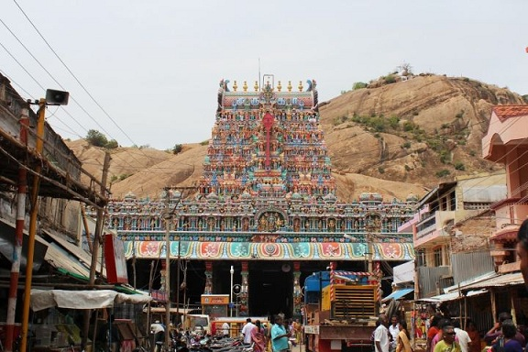
This temple is considered sacred among the Muruga temples, and it is one among the six arupadai veedus of Lord Muruga. Apart from Lord Muruga in the main shrine, deities of Shiva, Vishnu, Vinayaka and Durga are also there. The temple follows Shaivite tradition of worship. Six daily rituals and three yearly festivals are held at the temple. According to history, Lord Muruga has worshipped Lord Shiva in this place. Daily free food is offered to the devotees in this temple.
‘OM MURUGA VEL MURUGA’

11. Koodalalagar Temple of Lord Vishnu
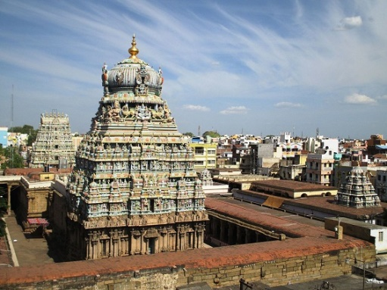

This temple is located in Madurai and is dedicated to Lord Vishnu. The temple is originally believed to be built by the Pandyas. Koodal Azhagar is believed to have appeared to kill the demon Somuka who has stolen the four Vedas from Lord Brahma. During festivals, large number of devotees visits this temple. Here Annual Alagar festival is very popular. Four daily rituals and three yearly festivals are held at the temple. It is one of the 108 Divyadesams dedicated to Vishnu. ,Here also, free food is offered to the devotees.
‘OM SREE KALAZHAGARE NAMAHA’

12. Chamundeswari Temple
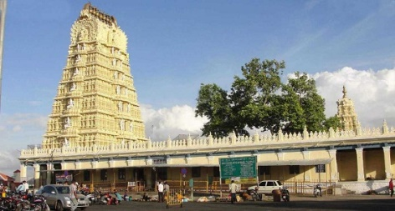
The Chamundeshwari Temple is a Hindu temple located on the top of Chamundi Hills nearby Mysore in the state of Karnataka in India.The Chamundeswari Temple is one of the famous temples in Karnataka and it is dedicated to Goddess Parvathi. Devotees from all parts of India visits this temple throughout the year. It is situated in a good natural location. The Chamundeshwari Temple is considered as a Shakti Peetha, and was the one among the 18 Maha Shakti Peethas.It was built in 11th century AD. The main idol was made up of gold.
The temple is famous for the celebrations of festivals like Navaratri. Fridays are considered particularly auspicious. Another festival celebrated is Chamundi Jayanti.

‘OM SREE CHAMUNDEESWARIYE NAMAHA’

13. Nanjundeswara Temple of Lord Shiva
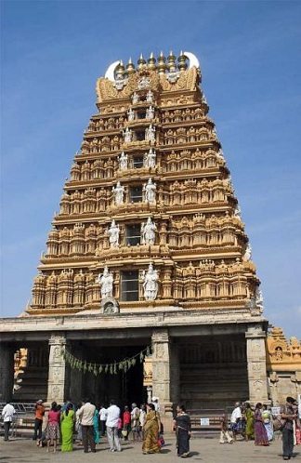

The Nanjundeswara Temple was constructed in the sides of Kabini River. Nanjanagudu is a City in the state of Karnataka. Nanjangud is famous for Srikanteshwara Temple. Nanjangud is also called "Dakshina Kashi" (southern Kashi). This city is also famous for the growth of bananas. The name of Shiva is called as Nanjundeswara, and according to history, he drank poison and kept it permanently in his throat without leaving it in the outside, in order to safeguard all the living beings in earth and heaven.
‘OM SREE NANJUNDESWARARE NAMAHA’

14. Mangadu Kamakshi Amman Temple, Mangadu
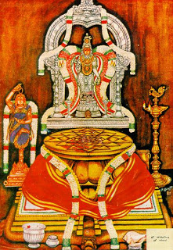
It is one of the most famous amman temples situated in mangadu, nearby poonamallee. Mangadu is known for the temple of Kamakshi performing penance. This is the place where the goddess performed her penance to marry and re-unite with Lord Shiva. All types of rituals were performed here by the goddess. Here the Srichakram was established by Adi Shankara. It is one of the ancient temples, and devotees visit this temple for solving their problems like late marriage, for getting a suitable job and for a proper life. Generally, Tuesdays, Fridays and Sundays are important days and free annadanam is offered for about 200 devotees daily inside the temple compex.
‘OM SREE MANGADU THAYE NAMAHA’

15. Kaligambal Temple
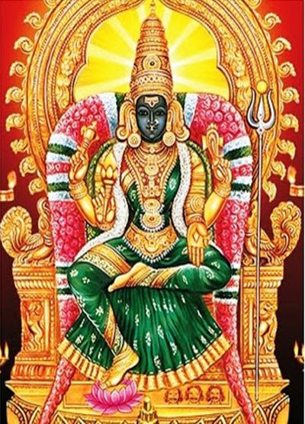
The Kalikambal Temple is a temple dedicated to Shri Kalikambal and Lord Kamadeswarar and it is located in Thambu Chetty Street, Parrys,Chennai.. This temple was ancient, and was visited by the great king Chatrapathi Sivaji. This temple contains several shrines for Vinayaka,Gayathri Devi,Durga,Muruga,Viswakarma,Veerabadrar and Navahagraha shrines.
It is also said, that the fierce form of Kali idol which was worshipped earlier, has been replaced with a gentle form.
Here also free annadanam is offered to about 200 devotees daily in the afternoon.
‘OM SREE KALIGAMBAL THAYE NAMAHA’
WRITTEN BY
R.HARISHANKAR
IMPORTANT NORTH INDIAN TEMPLES

1.Baijnath Temple
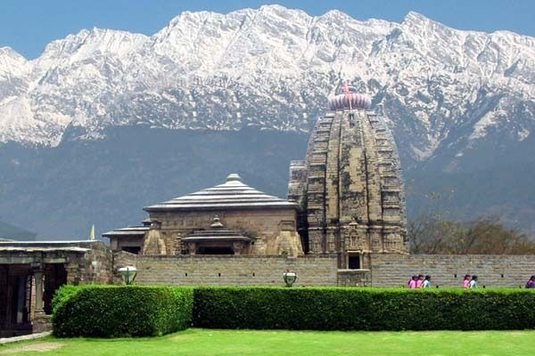
It is a famous temple dedicated to Lord Shiva. According to ancient history,the Shiva Lingam in Baijnath temple is brought by Ravana.
He worshipped Lord Shiva, and Lord Shiva got impressed with him. Hence, Lord Shiva blessed him and took the form of shiva-linga.
The temple is being built at that place called as Baijnath Temple.

2.Churdhar Temple
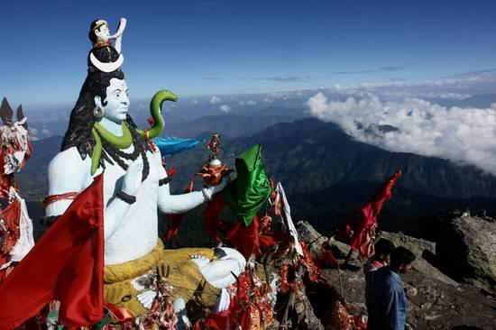
This temple is located in Himachal Pradesh. Churdhar is the highest peak and the temple at the top is dedicated to Lord Shiva. Mountain climbing can be of 18 kilometers to reach Churdhar peak.
This mountain climbing gives a natural view of Himalayas from the top. We must start climbing the mountain in the early morning, so as to reach the temple before noon.

3.Akshardham Temple
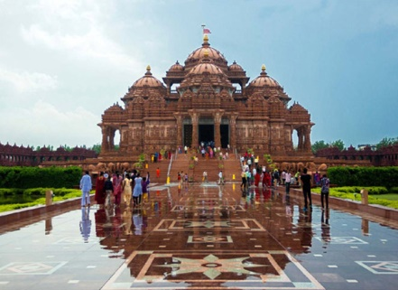
'Akshardham' is the abode of Lord Swami Narayan. Swaminarayan Temple at New Delhi is a Mandir dedicated to devotion. The mandir is a great tribute to Bhagwan Swaminarayan (1781- 1830), the great sage and an incarnation of Lord Narayanan.
This temple displays traditional Hindu culture. It is located near Yamuna bank, Delhi. It is a must for those to visit this temple when coming to New Delhi.
4.Vaishno Devi Temple
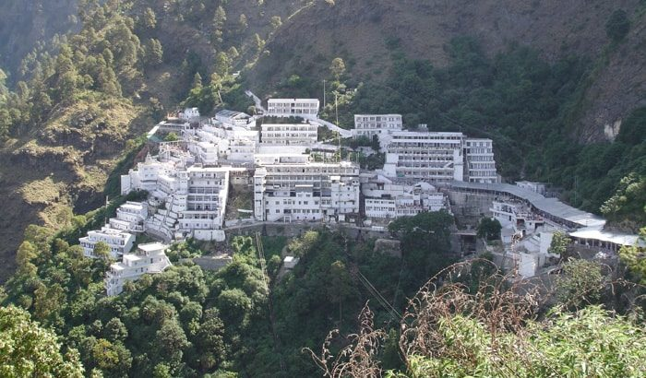
It is a famous Hindu pilgrimage site in Jammu state. Huge number of pilgrimages will visit this temple during Navaratri festival. There is another famous temple named Bairo baba temple above Vaishno Devi Temple. Snowfall will be there during winters. During summers, the temperature will be suitable for tourists.

5.Golden Temple
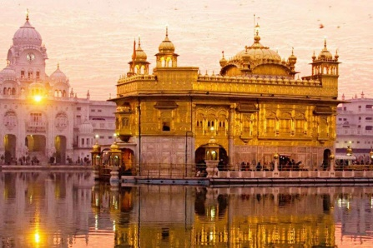

It is a holy temple, built by sikh guru, Guru Ram Das. It is located in the city- Amritsar(Punjab). The walls are covered with rich gold plates. That is why, the name is called as “ The Golden Temple”.
There is a sacred lake in Golden Temple. People will take bath in this holy lake to get rid of their sins.

6.Tera manzil Temple – Rishikesh
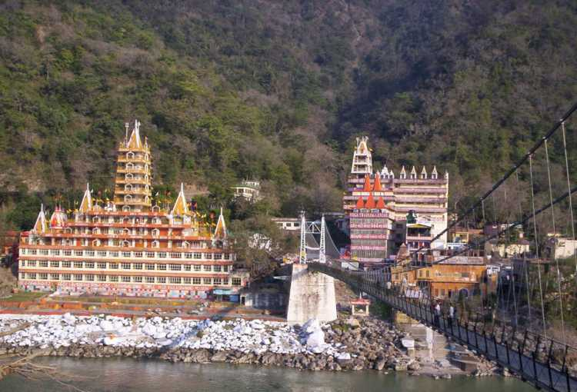
This temple is located on the banks of river Ganga. This temple is dedicated to lord Shiva and is situated at Rishikesh. There are also other famous temples in Rishekesh like Bharat Temple, Gita Bhawan and Raghunath Temple.

7.Prem Mandir
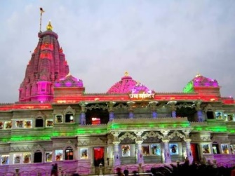
It is a popular Hindu temple dedicated to Lord Krishna. It is located in Vrindavan, Mathura. Large Number of people will gather in Prem Mandir for attending evening aarti. It took a long time to build this temple.
8.Bangla Sahib Gurudwara
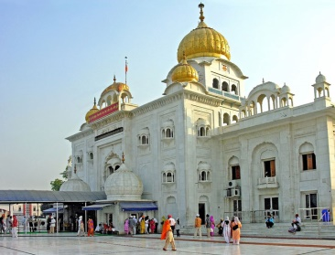
It is a famous Sikh pilgrimage site located in Delhi. This gurudwara is ranked as one of the best tourist place in Delhi. People from all over the world, visit this gurudwara to take blessings. There is a sacred lake in the Gurudwara where people will take holy bath.

9.Bhairon Temple- Delhi
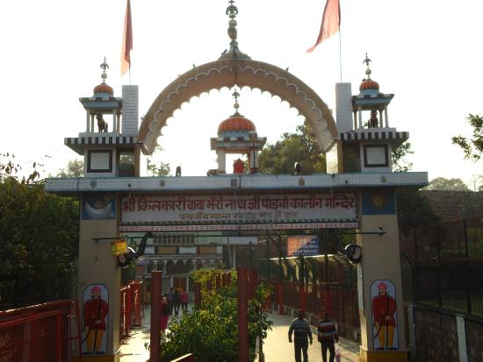
This temple is located in Delhi. In this temple devotees will usally offer liquor as a Prasad. The nearest metro station is Pragati Maidan. Bhairon baba is a form of Lord Shiva. Whenever we go to delhi,It is a must for us to visit this Bhairon baba temple and to seek his blessings.

10.Neel Kanth Mahadev Temple
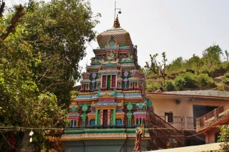
This temple is situated in Rishikesh. The Temple is dedicated to Neelkanth(another form of Lord Shiva). The temple is surrounded by the valleys like Manikoot, Vishnukoot, Brahmakoot. According to the Hindu tradition, it is a place where Lord Shiva has consumed poison, and kept it in his throat when devas and asuras have churned the ocean for getting Amudha.

11.Kashi Viswanath Mandir
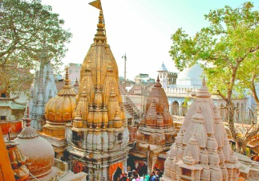
Kashi Vishvanath Temple is the famous Hindu temple dedicated to Lord Shiva. It is located in Uttar Pradesh. The temple is located on the banks of the holy river Ganga, and is one of the twelve Jyotirlingas. The deity is called by the name Vishwanath. The temple is popularly called as Kashi Vishwanath Temple.
The temple has been referred to in Hinduism. According to history, It has been destroyed and re-constructed a number of times. The current structure was built on an adjacent site by the Maratha ruler, Ahilya Bai Holkar of Indore in 1780. This temple has been managed by the government of Uttar Pradesh.

12.Badrinath Temple
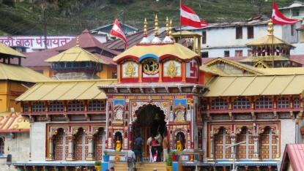
Badrinath or Badrinarayan Temple is a Hindu temple dedicated to Lord Vishnu which is situated in Badrinath at Uttarakhand, India. The temple is also considered as one of the 108 Divya Desams dedicated to Lord Vishnu. It is open for six months every year (between the end of April and the beginning of November), due to the weather conditions in the Himalayan region. The temple is located in the banks of Alaknanda River. It is one of the main pilgrimage centers of India.This temple is mentioned in ancient religious texts like Vishnu Purana and Skanda Purana.

13.Kedarnath Temple
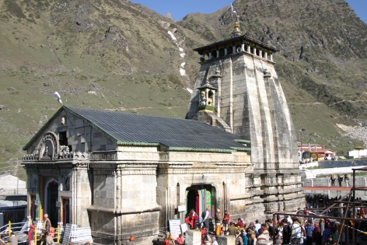
Kedarnath Temple is a Hindu temple dedicated to Lord Shiva. Kedarnath is located in the state of Uttarakhand, India. Due to weather conditions, the temple is open only between the months of April (Akshaya Tritriya) and November (Kartik Purnima). During the winters, the deities from Kedarnath temple are carried down to Ukhimath, and from there the deity is worshiped for the next six months.
According to Hindu legends, the temple was initially built by Pandavas, and is one of the twelve Jyotirlingas, the holiest Hindu shrines of Shiva. This temple is the highest among the 12 Jyotirlingas.

14.Somnath Temple
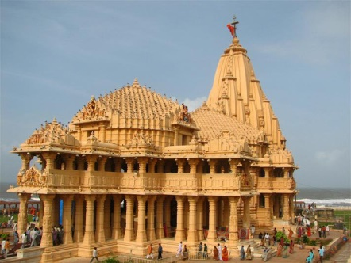
The Somnath temple is located in Gujarat, and is believed to be the first among the twelve jyotirlinga shrines of Lord Shiva. It is an important pilgrimage centre of Gujarat. It was reconstructed several times in the past after the destruction by several Muslim Kings.The present temple was reconstructed in Chaulukya style of Hindu temple architecture and completed in May 1951.According to Puranas, the temple is considered as a sacred one.

15.Pandaripur Temple
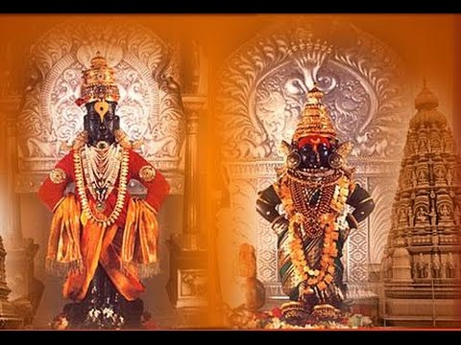
The Vithoba Temple, Pandharpur, known as Shri Vitthal-Rukmini Mandir , is a Hindu temple in Pandharpur in the state of Maharashtra. It is the main centre of worship of Lord Vithoba(A form of Lord Krishna), and his consort Rakhumai. It is the most popular temple in Maharashtra. Taking bath in the holy river Chandrabhaga, is believed to have power to wash all the sins of the devotees. All the devotees are allowed to touch the feet of the idol of Lord Vithoba. This temple appointed women and people from backward classes as priests.
WRITTEN BY
R.HARISHANKAR

OTHER HOLY TEMPLES
ARULMIGU BHAVANI THULUKANATHAMMAN TEMPLE,AGARAM
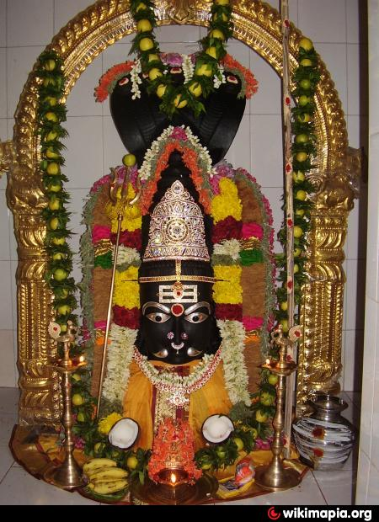
Arulmigu Bhavani Thukanathamman temple is situated at Parthasarathy Street,Agaram, Peravallur,Chennai – 600 082. I am residing next to that temple. The most important feature of that temple is, it is more than 100 years old. Every Adi month, devotees from perambur area visit the temple and offers pongal and kuzh. Devotees throng around from all parts of the city also, since their kula deivam is Bhavani Amman.

She has done lot of miracles to the devotees. Even I have been safeguarded from several accidents, which was supposed to occur nearby the temple. Those who sincerely worship her by offering flowers, will be immensely blessed. Childless couples are being blessed by child. Several diseases are cured with the blessings of Bhavani Amman. She doesn’t expect much from her devotees. What she expects is, true devotion with some flowers, and that itself will give immediate blessings from the divine mother. OM SAKTHI PARASAKTHI.

Written by

R.HARISHANKAR
SREE DEVI KANYAKUMARI AMMAN TEMPLE
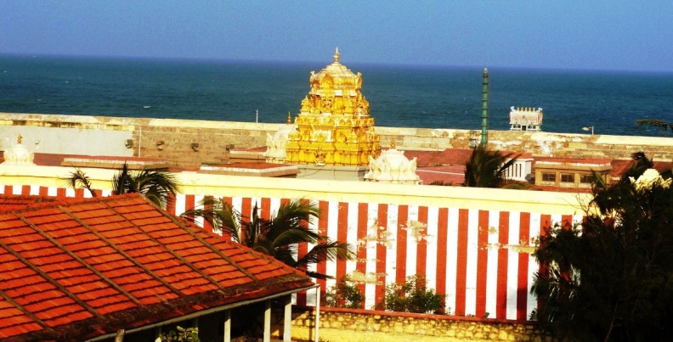
INTRODUCTION
Devi Kanya Kumari is goddess Parvati in the form of a girl child popularly known as Shakthi. The temple is dedicated to the goddess which is located in Kanya Kumari in Tamil Nadu. She is also known by several other names, including Kanya Devi and Devi Kumari. The goddess is believed to be the one who removes our mental and physical problems in our life. Kanyakumari Temple is one of the 52 Shakti Peethams.

Swami Vivekananda’s visit
As directed by his Guru Sri Ramakrishna Paramahamsa, Swami Vivekananda, came here to seek Devi's blessing in December 1892. Apart from him, various other disciples of Sri Ramakrishna Parama Hamsa, also worshiped Devi Kanyakumari.

History
Kanyakumari is situated in Tamilnadu. Kanya Kumari is a virgin goddess. Since Lord siva didn't keep his promise to marry her on one particular day, she was angry, and her anger was diverted to kill the demons. She remained a virgin and did penance.
The story dates back to the prehistoric Tamil period. Bana an asura by birth was the ruler of his land. He was a very powerful king. He did penance and got a boon from Lord Brahma that his death will occur only by an adolescent virgin girl.
With this powerful boon, he became fearless and caused several problems to devas and he was finally destroyed by Goddess Kanyakumari Amman and the place where he was killed is now known as Kanyakumari.

Attractions of the Temple
The other attractions inside the temple are the Pathala Ganga Theertham, Kalabhairava Shrine. Kalabhairava is a ferocious form of Lord Shiva who annihilates everything,
Navarathri Mandapam is a hall where devotees can display their artistic ability in music as a dedication to the goddess. Shri pada paara, the rock in the shape of Devi's foot. This is now famous as Vivekananda paara, where Vivekananda did penane in his place and got enlightenment.
Red Sarees and Ghee wick lamps are offered to the goddess by devotees.This temple has been considered as sacred by Hindus as it is the confluence of three seas. Offering Pitru Tarpan and bathing in the sea in the Kanyakumari beach is considered to be holy because of the convergence of many important Theerthams. There are a total of 11 theerthams associated with the temple in the ocean surrounding Kanyakumari.

Temple festivals

Chitra Pournima Festival: Celebrated on the Full moon day in the month of May every year.

Navarathri festival: 9 day festival in (September–October). The music artists get opportunity to perform their artistic skill to the devi in the Navarathri Mandapam.

Vaisakha festival: 10-day festival in May–June During this festival, Devi will be taken in procession both in the morning and evening.

Kalabham festival: The idol is dipped in Sandal paste in the last Friday of the month of Karkidaka or Aadi, in July–August.

Timings of the temple
The temple is opened for darshan from 6.00 a.m. to 11.00 a.m. and from 4.00 p.m. to 8.00 p.m.

CONCLUSION
It can be concluded by saying that it is a must to visit this divine amman’s temple and to seek her blessings to live a healthy and happy life with peace of mind. Let us chant the nama of Devi Kanyakumari and be blessed.
OM SREE DEVI KANYAKUMARIYE NAMAHA.

WRITTEN BY
R.HARISHANKAR

SREE MUKTHESWARA TEMPLE,BHUVANESHWAR
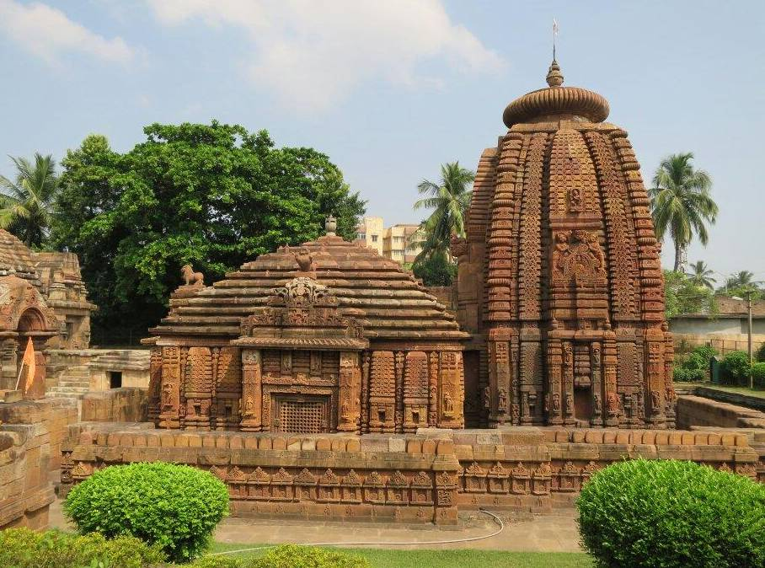
INTRODUCTION
Sree Mukteswara Temple is regarded as the 'Gem of Orissan Architecture' and is regarded as the most important and ancient temple in India and it is located in Bhubaneshwar. The temple can be reached easily from Bhubaneshwar, which is well-connected to other cities by air, rail and road. Built in 950 A.D, Mukteswara temple is really a beautiful temple which attracts lot of devotees from all over India.
Inside the complex, there are several small shrines that comprise numerous lingams of Lord Shiva. There is a holy well in the temple, and It is believed that a dip in this holy well cures various health related problems of those devotees who visits this temple.

Mukteswara Mandir is dedicated to Lord Shiva. This temple is Dedicated to Lord Shiva in the form of Mukteswara. This Shiva is regarded as Mukteswara, since he gives mukti(SALVATION) to his devotees. Those who worships this god with pure devotion, will be blessed with all the needs in this earth and also attains the glory of god in their next birth. That means, they will never take rebirth again.
Architecture
The structure of the temple shows the Kalinga School of Temple Architecture. Mukteswara Temple is a site of Indian Heritage and this holy shrine attracts many devotees & tourists to this place from india and from all over the world.
History
The Mukteshvara Temple is found to be the one of the oldest temple in india and the sanctum is engraved with beautiful paintings depicting the picture of nagas and naginis.

Other Details about the temple
The doorway to the inner sanctum houses the image of Ketu, regarded as the planet in the Hindu mythology. There is a tank in the eastern side of the temple and a well in the south-western corner. A dip in the first known as the Marichi Kunda is believed to cure infertility in women. There are also other shrines within the temple complex. The temple has sculptures both inside and outside the structure.

Significance of the Temple
Mukteshvara means "Lord of Freedom". The temple is dedicated to Hindu god Shiva. There are a number of sculptures engraved in the temple with meditation poses. The outer face of the compound wall has carvings of Hindu deities like Saraswathi, Ganesha and Lakulisha. The numerous images of Lakulisha are found in this temple, showing various mudras like yoga.

Culture
The Department of Tourism organises a three-day yearly dance function called Mukteswar Dance Festival in the temple premises. This festival celebrates the features of Odissi, the classical dance form of Odisha.
CONCLUSION
Thus It can be concluded by saying, that it is a must for every hindu, to go to this temple and to worship in order to attain salvation. Since the name itself implies, it is a temple which gives inner bliss and freedom from birth cycle. Let us chant the nama of Lord Shiva and always be happy with a healthy and peaceful life with his grace.
OM NAMASHIVAYA NAMAHA
OM SHAMBO SHIVA SHAMBO
OM SREE MUKTHESWARAYA NAMAHA

WRITTEN BY
R.HARISHANKAR

SREE SATHYA SAI BABA TEMPLE, PUTTAPARTHI
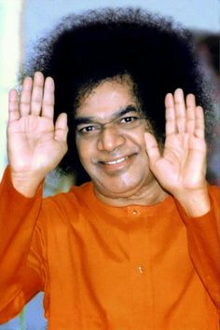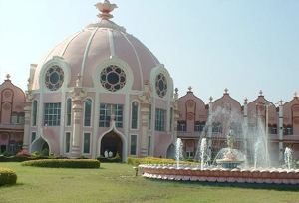
Introduction to Puttaparthi
Puttaparthi is a town in Anantapur district of Andhra Pradesh. The original name of Puttaparthi was Gollapalli. The town is located on the banks of Chitravathi River. The official language in Puttaparthi is Telugu. Other common indian languages and English are also spoken here.
Introduction to Puttaparthi Sree Sathya Sai Baba
Puttaparthi Sree Sathya Sai Baba is believed to be an reincarnation of Shirdi Sai Baba by many of his followers.
Many of the people who are the devotees of Shirdi Baba are also gets attracted with Sathya Sai Baba. They are seeing him as their Friend,Philosopher, guide and god. They are trusting him that whenever they start any new ventures, they will be blessed by him and their business will flourish well. And also for all of their problems, they are trusting him that their problems will be solved immediately by his grace.
History
This place came in to highlight only after several institutions were established here for the well being of the people, like charity hospitals and educational institutions, etc.
The story of the Sree Sathya Sai Baba tells us that he was born with intelligence and self realized fully at the age of 14 and then announcing himself as the reincarnation of Sai Baba of Shirdi. After making his contributions to the society, Sree Sathya Sai Baba died on 24 Apr' 2011, and his Samadhi is located in Prasanthi Nilayam.
Prasanthi Nilayam Ashram
Even after the death of the spiritual leader, the place continues to attract many of his devotees and his followers. The temple spreads message of spirituality, Kindness, love among each other, doing good to others and showing much attention to the poor and down trodden people.
It is one of the most popular pilgrimages in India and devotees from all over the world come to this little village to seek the blessings of the great Sree Sathya Sai Baba. Once an unknown place of Andhra Pradesh, Puttaparthi now has an airport and a super specialty hospital and also has several famous educational institutions.
His teachings are based on the principles that make the very foundation of life. These are truth, love and non-violence. The ashram has educational institutions, museums, space centers, etc.
A trip to south India is incomplete without visiting the Sai Baba ashram of Puttaparthi. There are many interesting places in Puttaparthi that should be visited like Satyabhama Temple, Shiva Temple where Sai Baba was born, Chitravati River, "Kalpavruksha" or the wish fulfilling tamarind tree from which Baba miraculously produced fruits, Sathya Sai super specialty hospital, etc.

Food
There are three canteens in Prasanthi Nilayam. Devotees are expected to eat here, since cooking is not permitted in their rooms. The food is good and tasty, offered at a nominal rate to the devotees.Only vegetarian food is served.
Breakfast, lunch, and dinner are served in a pleasing manner. Breakfast items will be usually like idlis, vadas and upma.
CONCLUSION
It can be concluded that Sree Sathya Sai Baba is still living in the hearts of his devotees and doing good to them. His true devotees feels his presence in good and bad times in their life and helping them whenever in case of need. Let us chant the name of Sree Sathya Sai Baba and live happily for ever.
OM SREE SATHYA SAI BABAVE NAMAHA
WRITTEN BY
R.HARISHANKAR

RAGHAVENDRA SWAMY MUTT AT PERAMBUR
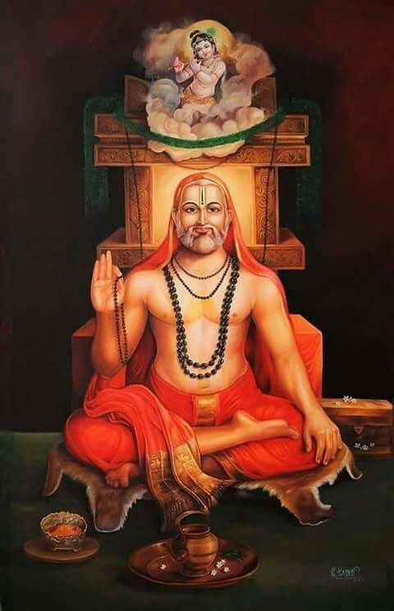
Many mutts are there for Sree Guru Raghavendra Swamy at Chennai. One such mutt is situated at Perambur Area. The address of the mutt is No.15,Srinivasan Street,Perambur,Chennai – 600 011 and the contact no.044-25518385,Raghavendra Mutt Manager Mr.P.Mohan’s Mobile No.9840818865.
Several years ago, this mutt was donated by a couple belonging to smartha Brahmin community. They have donated a major portion of their house for building the mutt and then they kept a small portion of their house for their occupation.
Every year Raghavendra Swamy Aradana will be celebrated in this mutt in a grand manner. Free food will be offered to all the devotees who visit the temple. Generally I will offer food grains as donation to the mutt on the occasion of every aradana. Raghavendra Swamy Aradana will fall during the end of August month.
People from Perambur area visit during Aradana festival. Flower decoration and various poojas will be done to Sri Raghavendra swamy. Every month during pournami, Satyanarayana pooja will be done at the temple premises by the devotees. And they will be given prasadam by the temple authorities after the completion of pooja.
LIFE MEMBERSHIP SCHEME
A Life Membership scheme is there in that, if a person donates a sum of Rs.1,000/- , till his lifetime, both he and his wife can do archana once in a year on any one day of their choice(Birthday, Marriage day etc).
Apart from yearly aradana function, the mutt is celebrating Sri Padarajar Aradana(An incarnation of Bhakta Dhuruva), Sri Vyasaraja Aradana (An incarnation of Bhakta Prahalada and our Guru Raghavendra Swamy), Sri Madhwa (An incarnation of Wind God Vayu and Hanuman) and free food is humbly offered to all the devotees those who are attending the above aradanas. Before offering food to devotees, pooja will be done for Guru Raghavendra Swamy and lord rama and hanuman names will be chanted with bhakti. After attending the above aradanas, we will get peace of mind and both our mental and physical body relaxation will be there and our body will be filled with full of fresh air.

In the first floor of the mutt, a separate shrine for Lord Perumal is there. Along with that, several dasavatharam shrines are there and also lord hanuman shrine is there.
Every Thursday, free prasadam will be offered to all the devotees in thonnai, like sakkarai pongal, venpongal and sambar rice. If the devotees wish to sponser, an amount of Rs.600/- is to be paid.
Here also lot of miracles happened in devotees life. Even I have been safeguarded from sickness, accidents, and from unhappy situations. Chennai people can visit the mutt atleast once in their life time to get the divine blessings of Guru Raghavendra Swamy. This mutt is located nearby BB Road. Devotees can get down at BB Road bus stop and can easily reach the mutt. The temple will be opened between 7 -11 in the morning hours and will be opened between 5-8 in the evening hours.
OM SREE RAGHAVENDRAYA NAMAHA.
WRITTEN BY
R.HARISHANKAR

