HOLY TEXTS BY R.HARISHANKAR
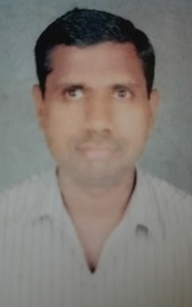
ANJANEYA SWAMY TEMPLE,NANGANALLUR
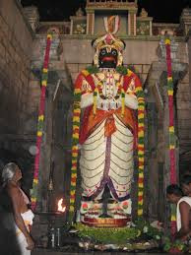
HISTORY
The temple was established by Sri Maruti Bhakta Samajan group of people. They constructed the the deity in 1989, and the idol were consecrated (KUMBABISHEKHAM) in 1995. Since then, lot of Anjaneya devotees have been visiting the temple on a daily basis. Through the grace of Sri Raghavendra Swami and Sri Kanchi Paramacharyar, the temple was formed, since both of them are staunch devotees of Lord Anjaneya.
SHRINES
The main shrine of Anjaneya is 90 feet tall, and the main idol of Hanuman is 32 feet tall and was made of a single granite stone, and is the second tallest Hanuman after Panchavatee near Puducherry.
Shrines of Lord Sri Rama along with Seetha and Lakshmana, Sree Krishna with Bhama and Rukmani, Vinayaka, Sri Raghavendra and Naga are also found inside the temple.
TEMPLE DETAILS
The temple opens at 5.00 am and closes by 9.00 pm. Temple puja timing are: 5.00 am to 12.00 pm, 4.30 pm to 9.00 pm. There are about 35 seva details are available in the temple. Devotees can perform the respective sevas for their well-being and can get the blessings of Lord Hanuman. Various Abhishekams and homams are also done here.
ARCHANAI
We can perform archanai in our name or in the name of the deity. By doing archanai, our mind will be relaxed and we will get a sense of security in our life.
ANNADANAM AND PRASADAM DISTRIBUTION
Daily free food is offered to the devotees between 11 am – 1 pm, and free prasadam is also distributed to the devotees after performing pujas to Anajaneya Swamy.
IMPORTANT SEVAS
- Kalyana Utsavam for Lord Rama on a daily basis.
- During Hanuman Jayanthi festival, Pushpavirshti seva will be performed.
- Gho paripalana seva – buying of cow and calf and producing them in the temple.
- Gho samrakshana seva – providing grass and cattle feed for cows.
- Thulabaram for Lord Krishna – Giving the items equivalent to the weight of the devotees.
- Sandhanakappu for Lord Krishna, Hanuman and Lord Rama during festivals.
- Various abhishekams can be performed to the deities and can attain all the prosperities in our life.

VADA MALAI
For getting successive results, people will generally adorn Lord Anjaneya with Vada Malai.
ABHISKHAMS AND HOMAMS
In this Anjaneya temple, various abhishekhams are done to the deities for the benefit of the devotees.
In this temple, homams for hanuman is also performed. By performing hanuman homam, we can attain all the prosperity in our life.
Benefits of performing Hanuman Homam
- Attain great courage, wisdom and knowledge.
- Develop willpower to attain our goals, and also can gain more spiritual energy.
- Get good career path.
- Overcome from various dreaded diseases.
- Free from evil effects and black magic.
- Can realize a sense of satisfaction in our life.
- Can get great strength in mind and in our body.
BENEFITS OF DOING ABHISHEKHAMS
- Curd: It gives good children and there will be good future for the children.
- Milk/water: It gives long and happy life to the person.
- Honey: Helpful in removing all mental diseases, miseries, sorrows and problems of life.
- Tender Coconut water: Gives enjoyment and pleasures in life.
- Mango: Various health ailments will be removed from the body.
- Ghee: To get rid of all illness.
- Panchamruta: This is a mixture of five ingredients ( Ripe bananas, jaggery, candy sugar, seedless dates, honey and dry fruits ) – It gives good health and wealth.
- Turmeric Abhishekham: For healing and fast recovery from diseases.
- Sugar Abhishekham: It Removes enmity.

FESTIVALS
Five major festivals are grandly celebrated in the temple. They are as follows:
1. Ramnavami
2. Hanuman Jayanti
3. Pavithrotsavam
4. Vijayadashami
5. Sri Krishna Jayanti
BENEFITS
By worshipping Lord Hanuman, we will get the following benefits:
- Completion of our duties without any trouble.
- Good health and strong mind.
- Our memory power will get increased.
- Our enemies will surrender at our feet.
- We will get great spiritual energy.
- Positive vibration will flow from top to bottom of our body.
- We get good prospects in our life.
- We will get good knowledge, wisdom, courage and boldness.
- Our sins will be reduced and we will concentrate our attention only on doing good things in our life.
CONCLUSION
By visiting the Anjaneya temple at Nanganallur, we will get great satisfaction and can get our wishes and wants fulfilled. Apart from doing all these abhishekhams and homams, by chanting the rama mantra “JAI SREE RAM”, “SREE RAM JAYA RAM JAYA JAYA RAM”, Lord Anjaneya will be immensely satisfied and grant us all of our wishes immediately in our life.
WRITTEN BY
R.HARISHANKAR

BHU VARAHA SWAMY TEMPLE
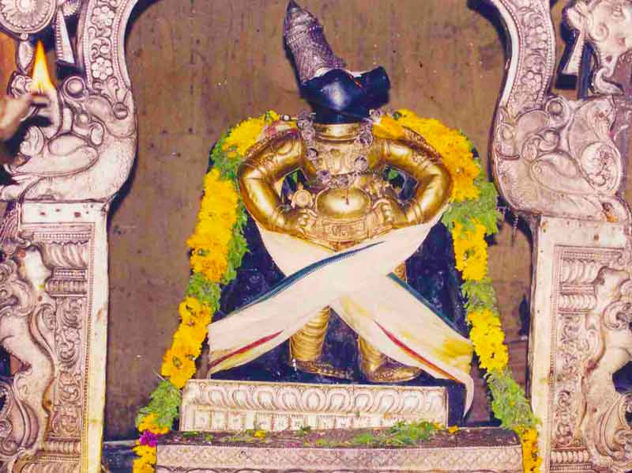
HISTORY
Bhu Varaha Swamy temple is a Hindu temple, located at Srimushnam, Tamil Nadu. The temple is dedicated to Lord Varaha popularly known as Bhu Varaha Swamy, and his consort Lakshmi is known as Ambujavalli Thayar. The temple is considered as the Sywayambu Kshetra (Self emanated) of Lord Vishnu.
The temple was constructed by the chola kings of the 10th century and was later renovated by the Thanjavur king Achuthappa Nayak. There is a seven-tiered rajagopuram.
According to the legend, the demon king Hiranyaksha had thrown the earth to the netherworld. Lord Vishnu took the form of Varaha, a boar, and killed the demon, and rescued the earth from the netherworld. It is believed that while fighting, the sweat of the demon king was dropped here, creating the temple tank.
As per another legend, a Nawab who once ruled at this place suffered from health related problems. Due to the grace of Lord Varaha he had got cured from his ailments. He was pleased with Lord Varaha, and helped in constructing the temple. Till now, every year the deity is taken to the village of the descendants of nawab, and they are making offerings to the deity.
ABHISHEKHAMS
In this temple, various kinds of abhishekhams are done to the main deities as well as to the other deities. Milk, honey, ghee, oil, fruits, panchamirtham, sandal paste abhishekhams will be done on a daily basis. Those who want to perform the abhishekhams in their name, can pay the prescribed amount in the temple office, and can perform it and get all the benefits in their life.
ARCHANAI
We can perform archanai in our name or in the name of the deity. By doing archanai, our mind will be relaxed and we will get a sense of security in our life.

HOMAMS
In this temple, we can do Vishnu homam and sudharshana homam. By doing these homams, we will get the following benefits in our life:
- Great prosperity in our life
- Wealth position will improve
- We will get peace of mind
- Good health
- Longevity
- Enemy problems will be solved
- Victory in all tasks
FESTIVALS
Among the festivals celebrated in this temple, the Chariot festival is celebrated during the Tamil month of Vaikasi (April–May) is considered as the most famous festival. In this temple, Muslims are also allowed to visit the temple.
TEMPLE RITUALS
The temple rituals are performed six times a day:
1.Ushathkalam at 7 a.m.
2.Kalasanthi at 8:00 a.m.
3.Uchikalam at 12:00 p.m.
4.Sayarakshai at 6:00 p.m.
5.Irandamkalam at 7:00 p.m.
6.Ardha Jamam at 8:30 p.m.
Along with the regular puja, alangaram , naivedyam and deepa aradanai will be peformed for both Sri Bhuvaraha Swamy Perumal and Sri Ambujavalli Thayar. There are also weekly, monthly and fortnightly rituals performed in the temple.
OTHER SHRINES IN THE TEMPLE
Apart from the main shrines, there are other shrines for Venugopala, Vishwaksena, Vedanta Desika, Thirumangai Azhvar, Manavala Mamunigal, Kuzhanthai Amman and Tirukachi Nambi. In the temple garden, a shrine is dedicated to Lord Rama.
SPECIALITY OF THE TEMPLE
In Tirumala, devotees visit the Bhu Varaha Swamy shrine before they worship Lord Srinivasa in the Tirumala temple, but in Srimushnam, devotees visit Lord Srinivasa shrine and then only they are visiting Bhu Varaha Swamy shrine.
BENEFITS
- Childless people will get the boon of conceiving noble children by visiting this temple.
- Unmarried people will get married.
- Purchase of house and land will be immediately done after visiting the temple.
- Problems from enemies will be solved.
- Black magic, all health and mental related problems will be solved.
- We will get a good position in our life.
- Wealth will accumulate and we will become prosperous.
- Long standing pending cases will be finished soon.
- We will get peace of mind.
WRITTEN BY
R.HARISHANKAR

HAYAGREEVAR TEMPLE
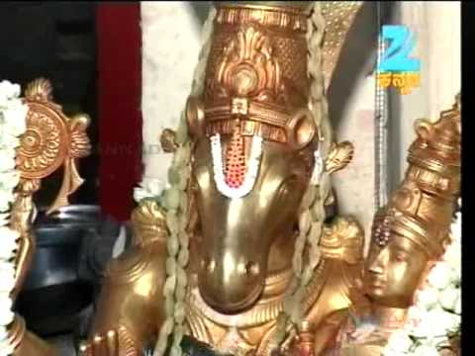
HISTORY
This temple is an ancient temple in Nanganallur and is administered by the group of Vaishnavas. Similar to Anjaneya temple this is also a famous temple at nanganallur. The idol of Lord Hayagriva is made of Salagrama stone. Here Lord and mother are embracing each other. As this idol shows both embracing each other, it is believed that worshipping the Lord and Mother in this form ensures stronger unity among couples.
Two demons born to Lord Vishnu, stole the Vedas from Lord Brahma and hidden it in the netherworld. Lord Brahma worshipped Lord Vishnu and asked him to get back the vedas from the demons.
The Lord came to Pathala Loka in the form of a horse and fought with the demons Madhu and Kaidapa. He killed the demons and returned the vedas to Brahma. Since Ma Mahalakshmi is sitting on his lap, he came to be known as Lakshmi Hayagriva.
Lord Hayagriva is worshipped as the Lord of knowledge and wisdom.
Apart from the main shrine of Hayagreevar and Lakshmi, other shrines are also found in this temple:
- Desikan
- Chakrath Alvar
- Venkatachalapathy
- Anjaneyar
- Sri Namazhwar
- Sri Emperumanar
- Sri Andal
- Sri Garudan
Every sannadhi in this temple has two idols – Moolavar and Urchchavar. Daily Vishnu Sahasranamam is chanted in this temple by the vedic scholars. It is believed that Hayagreeva being the guru of Ma Saraswathi will strengthen the learning capacity of the students and will help them in building the career path. Most of the devotees are students and the god is specially decorated with various flowers and worshipped on Thursdays. Archanai and abhishekham can be done at this temple for getting better prospects in the lives of the children. It is advisable for the students to worship the Lord in this temple at least once in a month in order to get good results in the examinations.
TIMINGS
The temple is open from 8.00 a.m. to 11.00 a.m. and from 6.00 p.m. to 9.00 p.m.
FESTIVALS
Float festival is celebrated on Avani Tiruvonam star day in August-September with flag hoisting 10 days earlier.
PUJAS
Special pujas are performed for the students who are poor in education and also for the students who are suffering from the problem of stammering.
ABHISHEKHAM
The following abhishekhams can be performed to the main idol Lord Hayagreeva and Lakshmi and also to other deities in the temple for getting better prospects in life:
- Milk Abhishekham
- Honey Abhishekham
- Ghee Abhishekham
- Fruit juice
- Panchamirtham
- Oil
- Santhanam
ARCHANAI
We can perform archanai to Lord Hayagreevar on Thursdays or Saturdays or in any other auspicious festival days, on our birth day, marriage day and get the divine blessings from the god.
HOMAMS
This temple also performs homams for the well- being of the children:
The following homams are performed in the temple:
- Sri Lakshmi Hayagreeva Homam
- Sri Sudarsana Homam
- Sri Mahalakshmi Homam
- Sri Narasimha Homam
The temple is located at: No-10, 2nd Main Road, Nanganallur, chennai 600061.
It is advisable to visit this temple not only for getting better education, but also for achieving all other good things in our life. Out entire life problems will be sorted out and we can live a blessed life through the grace of Lord Hayagreevar.
WRITTEN BY
R.HARISHANKAR

RAJARAJESWARI TEMPLE
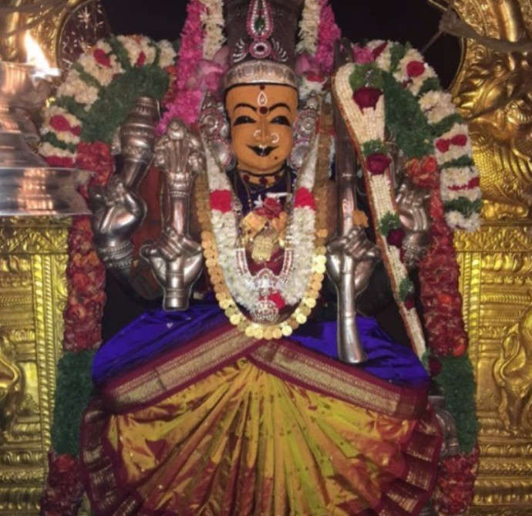
HISTORY
Sri Rajarajeswari temple is one of the oldest temples and the area is named as Nanga Nallai (place of the noble women) in honour of the great goddess Rajarajeswari which is now called as Nanganallur. This is a private temple and run by a group of people. This temple having two floors is located at 16th street at ThillaigangaNagar.
Apart from the main shrine of Sri Rajeswari, the following shrines are also present in this temple:
- Lord Dattatreya
- Lord Bhairava
- Sri Lakshmisametha Satyanarayana Swamy
- Vinayaka
- Durga
The main idol of Rajarajeswari is seen in sitting posture. She wears jewels and flower garlands and she looks very beautiful. She is surrounded by Lakshmi,Saraswati,Ganapathi and Murugan. The shrines of Matangi Devi and Vaarahi Devi are also seen on the either side of the sanctum. Fifty-one Shakti Yantras are installed in this temple.
It is believed that Rajarajeswari in this shrine was worshipped by the great Sages Agasthyar and Thirumoolar. The rays from the sun touch the holy feet of the Goddess for six days in the early morning time during the month of Masi. Special poojas are done during this time. We will experience the divinity of the holy Mother everywhere in the temple. This temple is located nearby Pazhavanthangal Railway station.
The temple is also known as Sri Rajarajeswari Ashram.
VARUNA THEERTHAM
There is a Varuna Dhanvantari theertham in the form a well within the temple. The water from this well is said to have powers to cure health problems and also various mental illness will be cured.
TEMPLE TIMINGS
The temple timings are from 6.00 a.m to 12.00 noon and 5.30 to 8.45 in the evening.
PUJAS
Kumkuma Puja. It is a famous puja in this temple. By performing Kumkuma puja, we can get all the prosperity in our life. And generally ladies will perform this puja for the well-being of their life partner.
SATHYANARAYANA PUJA
Those who are unable to do Sathyanarayana Puja at home can participate in the puja here. We have to pay a prescribed amount for the puja, and it is better to conduct sathyanarayana puja during full moon days for achieving better results in our life.
ARCHANAI
We can perform archanai to Sri Rajarajeswari Amman on Tuesdays or Fridays or in any other auspicious festival days, on our birth day, marriage day and can get the divine blessings from the goddess.
ABHISHEKHAMS
Devotees can do milk, honey, fruits, ghee and oil abhishekham to the goddess in order to live a healthy, wealthy and a happy life.
HOMAMS
In this temple, we can do Sri Rajarajeswari Homam, Ganapathy Homam and Navagraha homam for achieving goodness in our life.

IMPORTANCE
By visiting this temple, we can feel a sort of divine presence with us, and can get peacefulness in our mind. By worshipping the divine mother “Sri Rajarajeswari Amman”, our prayers will be fulfilled and our life will prosper.
BENEFITS OF WHORSHIPPING AMMAN
- Relief from physical and mental diseases.
- Relief from stress, tensions and worries.
- Relief from unwanted thoughts and confusions in our mind.
- We will be free from the birth cycle.
- Good career path.
- Good knowledge, wisdom, courage and boldness.
- Enemy related problems will be solved.
- There will not be any fear in our mind.
- We can get great spiritual energy in our life.
Hence it is advisable to worship the goddess at least once in a month and can feel the good difference in our life. Since Ma Rajeswari is dwelling in all other gods, by worshipping her with utmost faith and devotion in our mind, we will get the blessings of all other divine gods also.
WRITTEN BY
R.HARISHANKAR

THAYUMANAVAR SWAMY TEMPLE
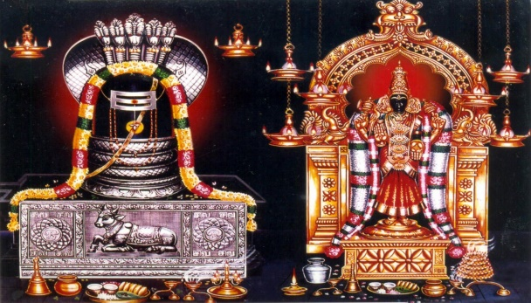
HISTORY
The Thayumanavar Temple is located in the Rockfort Complex in the city of Tiruchirappalli in tamil nadu and it is dedicated to Lord Shiva. It is believed that the temple was constructed by the Pallava king Mahendravarman in the 6th century AD. It was later renovated by the ruler of madurai and Vijayanagar. The major complex in the temple was constructed during the 8th century by the Pandyan king. .Here Lord Shiva is worshiped as Thayumanavar and Mata Parvati is worshipped as Mattuvar Kuzhali Amman.
This temple was praised by the nayanar saints and the importance of the temple is mentioned in the sacred text Tevaram, and it is also classified as Paadal Petra Sthalam. Thirugnana sambandar praises the glory of the temple in the famous text tevaram. The great saint Arunagirinathar also praised about the glory of the temple.
According to Hindu legend, Once Lord Shiva attended the delivery of a pregnant woman in the form of her mother. The pregnant woman was a staunch devotee of Lord Shiva. Since, Lord Shiva took care of his devotee with motherly affection, he was named as Thayumanaswamy.

ABHISKHEKHAMS
Various abhishekhams are done to the main deities as well as to the other deities in the temple. We can do Honey, ghee, milk, panchamirtham, oil and conconut water abhishekham for getting good results in our life.
ARCHANAI
We can perform archanai in our name or in the name of the deity. By doing archanai, our mind will get relaxed and we will get a sense of security in our life.
HOMAMS
Homams like ganapathy homam,Shri Rudra Homam and Maha Mrityunjaya homam can be performed in this temple. By doing these homams we will get good results in our life and can live happily and peacefully for a long period of time.
SHRINES
The temple complex has shrines consisting of Lord Ganesha, Thayumanavar, Amman, Arumugar, Navagrahas, Vishnu and Veerabadraswami.
THALA VRIKCHAM
Here thala vriksham is vilvam.
THEERTHAM
The temple teertham is known as Brahma Theertham.
TEMPLE RITUALS
The daily rituals are performing in the temple for six times in a day on a regular basis. The pujas will be conducted between 5.30 am to 10 pm.
- Ushathkalam at 5:30 a.m.
- Kalasanthi at 8:00 a.m.
- Uchikalam at 10:00 a.m.
- Sayarakshai at 6:00 p.m.
- Irandamkalam at 8:00 p.m.
- Ardha Jamam at 10:00 p.m.
The temple priests perform abhishekam,archanai, neivedyam and decorate the deities with flower garlands and perform deeparadanai for Thayumanaswami and Mattuvar Kuzhal Amman.
FESTIVALS
- The Chittirai festival is celebrated during the period of April - May in a grand manner for fifteen days.
- Panguni Float Festival during the month of March-April
- Aadi Puram in July – August
- Aipassi Annabhishkham in October – November
- Thirukarthigai in November – December
- Thai Pongal on January 14 or 15.
- Maha Shivarathiri in February – March.
IMPORTANCE
Since as per the legend, Lord shiva has safeguarded his devotee during pregnancy, it is advisable for pregnant women to visit this temple and worship the Lord Thayumana Swamy for safe pregnancy. Problems related to mensuration periods and all other stomach related problems pertaining to the women will be immediately cured through the divine grace of Lord Thayumanaswamy. Hence it is a must to visit this temple and to seek the blessings of Lord Shiva.
Every full moon day, especially during Chitra Pournami, thousands of pilgrims worship Lord Thayumanaswami, in order to get better prospects in their life.
SPECIAL FEATURES OF THAYUMANASWAMY
- Safeguards the helpless devotees at all times.
- If anyone in need of help, chant as “THAYUMANASWAMIYE NAMAH”, he will get immediate help from the god.
- Pregnant women will be blessed for timely and safe delivery.
- The god itself will stand in front of the pregnant women devotees during pregnancy and will reduce their sufferings and pain and will help them to conceive noble child.
- Abortion problems will not occur.
Hence it is advisable for the devotees to visit and worship thayumanavar temple at trichy and to get his divine blessings and can live peacefully with all prosperities in their life.
WRITTEN BY
R.HARISHANKAR

BIJOY KRISHNA GOSWAMI
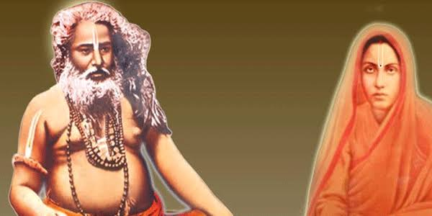
INTRODUCTION
Bijoy Krishna Goswami (1841–1899) was a great saint and an ardent devotee of Lord Krishna. During his younger age itself, he was deeply impressed with the glory of Lord Krishna and worshipped him with utmost faith and devotion till his last breath. He studied the scriptures, and also was an expert in yoga and meditation. He went to many holy places and visited Lord Krishna’s shrines and spread the bhakti spirit among others.
At his teenage, he got married to Jogmaya Devi, a pious, humble and a worshipful lady. Though he got married, he was involved in spirituality, and his noble wife also joined with him in his bhakti path. Both of them spread the importance of worshipping Lord Krishna among the masses. She also provided food to the poor devotees of Lord Krishna at her home, and treated them with much respect. She was affectionately called as MATA by her admirers, devotees and the people.
After some time, he become a disciple of “Sri Advaita Acharya”, and went to many holy places throughout india for preaching the importance of vaishnavism, and also worshipped Lord Krishna in Puri, Dwaraka and Vrindavan and become a saint. He studied the Chaitanya Charitamrita, which mentions the life and teachings of Sri Chaitanya Mahaprabhu, an incarnation of Lord Krishna and also the founder of Gaudiya Vaishnava Sampradaya. He also written some spiritual books and gave spiritual lectures throughout india.
TEACHINGS
- Consider Krishna as your god, guide, father and mother and put your burdens on his shoulders.
- Lord Krishna is everywhere and anywhere in the world. By worshipping him, you will get peace of mind and can get all the prosperity in your life.
- Don’t get fear about anything. Realize that Lord Krishna is dwelling in your heart, and don’t end up your life, due to problems, and that is not the solution for your problem. Instead of that, continue worshipping Lord Krishna and beg him for removing your problems and live your life with happiness and without any sufferings.
- Read Bhagavatham, and enjoy the everlasting pleasure in your life. Your mind will get relaxed permanently.
- Treat everyone as your friend, and give proper respect to them. Don’t talk unnecessarily to others, since that will create lot of troubles in your life.
- Enjoy each and every moment of your life by chanting the holy names of Lord Krishna.
- Don’t worry about the life after death. Live your life by doing good things to others, and by having faith on god.
IMPORTANCE
He was a blessed person, who dedicated his entire life in doing good things to others and devoting on god. He had done several social welfare activities such as providing food to the people and also educated the young children by giving them basic education, and made them to stand up on their own legs.
He removed the sickness of the people through his spiritual powers, and through his divine touch. He insisted the people and his disciples to practise yoga and meditation regularly in order to live a disease free life. Through his kind approach, he was loved by everyone and become a great personality.
Let us worship the great saint and be blessed.
“OM SREE BIJOY KRISHNA GOSWAMIYE NAMAHA”
“OM MATA JOGMAYA DEVIYE NAMAHA”
“JAI KRISHNA”
WRITTEN BY
R.HARISHANKAR

BRAHMANAND SWAMI
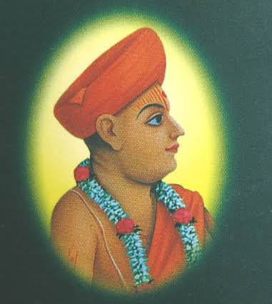
INTRODUCTION
Brahmananad Swami (1772–1832) was a famous saint of the Swaminarayan Sampraday and was served as the pontiff of Sri Swaminarayan Mandir. He was considered as an avatar of Lord Brahma. His birth name was Ladudan.
LIFE
Brahmanand Swami was born in a village in sirohi district of Rajasthan in the year 1772.
Even at his younger age, he will used to sing songs on Lord Krishna. He was well educated, and learnt the vedas, Upanishads and other divine scriptures apart from his basic education. Due to his talents, he became a poet in the court of Udaipur king. Ladudan was a great scholar and was admired by everyone. He earned name and fame and got sufficient wealth due to his efficiency, but he donated most of his wealth for social service activities. He also removed the sufferings of the people through his spiritual powers.
After some time, Ladudan met Swaminarayan in Bhuj. And he became a saint. He was given the sainthood name as Brahmanand Swami by Sri Swaminarayan. He also reconstructed and renovated several ancient hindu temples, and regularized the puja services.
WORKS
'Brahmanand Kavya' is the best spiritual work rendered by him apart from other small works.
IMPORTANCE
Being the avatar of Lord Brahma, he is having the capacity to change our fate also. He is a great guru, who occupies an important place in worshipping. If we tell our sufferings to him, he will convey it to Lord Krishna, and reduce our sufferings. Though he is not alive, it is believed that he is residing in the Brahma Loka, and carefully looking on us, and is always ready to lift us, in case of our fall.
Let us worship the noble saint and be blessed.
“OM SREE BRAHMANAND SWAMI MAHARAJ NAMAHA”
“OM SREE BRAHMA DEVARE NAMAHA”
“JAI KRISHNA”
WRITTEN BY
R.HARISHANKAR

DRONA
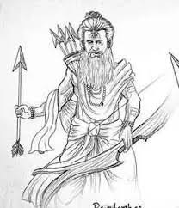
INTRODUCTION
In the epic Mahabharata, Drona also called as Dronacharya, was the divine avatar of Lord Brahma and also the teacher of the Kauravas and Pandavas. He was the son of rishi Bharadwaja. He contains great knowledge in hindu scriptures and a master in all kinds of arts including handling powerful weapons during the battle field.
Dronacharya married Kripi, the sister of Kripa, who was the guru in the kingdom of Hastinapura. Their son was Ashwathama, who contains the powers of Lord Shiva, due to the penance performed by Drona on Shiva. Drona got powerful weapons from Lord Parasurama.
Drona suffered from poverty, and approached his childhood friend King Drupada for help. But the king didn’t offer any help to him. So, Drona left that place, but got angry with him.
With the weapons he got it from Parasurama, he started a training school, and trained the pandava and kaurava princes.
Drona was very fond of Arjuna and gave him a powerful divine weapon of Brahma known as Brahmastra and asked him to use it in the battle field against his enemies. Once he got the right hand thumb of Ekalavya as a guru dakshina, since he was superior in handling weapons than that of his beloved disciple Arjuna. Finally during the time of Kurukshetra war, Drona was killed by Drupada’s son Dhrishtadyumna.
IMPORTANCE
He was a talented person who contains sufficient knowledge in all the fields. Being the incarnation of Lord Brahma dev, he was good at meditation and contains super natural powers. He is the person who cannot be defeated by any one. He was very fond of his son Ashwathama, a Chiranjeevi, and talented him in all kinds of art. It is believed that after his death, he reached the abode of Lord Brahma Dev, the satyalok.
Let us worship the divine guru and be blessed.
“OM SREE GURU DRONACHARYARE NAMAHA”
“OM SREE BRAHMA DEVARE NAMAHA”
WRITTEN BY
R.HARISHANKAR

GADGE MAHARAJ
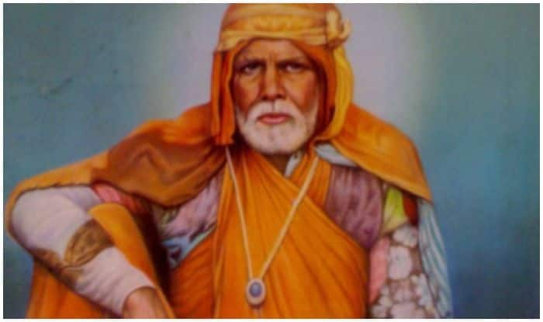
INTRODUCTION
Gadge Maharaj (1876–1956) also known as Sant Gadge Baba was a saint and a social reformer of Maharashtra. His birth name was Debuji Zhingraji Janorkar. He was born in a village in Amravati District of Maharashtra in a washerman family. From his young age, he suffered from severe poverty and travelled to many places and visited holy temples and promoted social justice and was against caste discrimination. He is still remembered by the people of Maharashtra for his sincerity and dedication on god, and for doing social welfare activities. He lived his life by cleaning the streets of the villages, and through the income which he has got he will used to give food for the poor villagers, and educated the poor girls and boys and also gave financial aid for poor girl’s marriage. Due to his good character, he was praised by the rich and the poor people, and gave proper respect to him, and treated him as their own family member. He was an admirer and a devotee of Sri Kabir Das, and was also a great ram bhaka, similar to Kabir das. He will used to tell that those people who do not utter the RAM MANTRA: “JAI SREE RAM” are wasting their life, and are not fit to live in this world. He even didn’t cared about eating food, and eats anything given by the villagers. According to him, Food is not the main thing in a person’s life, and we must have to take some food in order to live in this world, and we should not think about the quality and the quantity of the food.
He also conducted regular discourses on Lord Rama, and also composed songs and sung in front of the gathering. He asked the people to eat vegetarian food and to prevent sacrificing the animals. He has asked the people to work hard in order to earn proper money, and not to cheat others and earn money. His teachings are simple and straight forward in nature. Throughout his life, he lived a noble life, not for him, but for the sake of others. We cannot see such a kind of person in this today’s competitive world.
He left his wife and children in order to follow the social and spiritual path. He met the spiritual teacher Meher Baba several times. And both of them were involved in deep spirituality.
He died in the year 1956 on the banks of river Pedhi near Walgaon.
Let us worship the great saint and be blessed.
“OM SREE GADGE MAHARAJ KI JAI”
WRITTEN BY
R.HARISHANKAR

HARI VYASAR
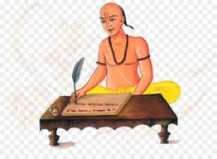
INTRODUCTION
Once in Madurai there lived a pious Brahmin who was a great devotee of Lord Hari. His name was Hari Vyasar. He used to chant the Lord’s names and recite his mantras regularly and would visit his temple in his region and offer pujas and perform abhishekhams, and then only will have his daily breakfast. Once while he was travelling on the way to the temple of Jagannathar at Puri, he come across a forest kali temple, and went there. There he has seen a farmer sacrificing his goat to Mata Kali. On seeing that, being a Brahmin, he tried to leave that place immediately.
Then, Mata Kali appeared in front of him in her true form, and asked him to have food in the temple. Hari vyasar refused to have the food, saying that he doesn’t like sacrificing the poor animal to her, and asked her to stop such kind of act. Mata Kali accepted his wish, and she appeared in the dream of the king of that region, and asked him to stop animal sacrifice, and instead of that, she has asked him to offer fruits and other vegetarian food items as a naivedyam (HOLY PRASAD) to her. The king had accepted the orders of the divine mother, and stopped sacrificing animal in her temple. On seeing the incidents, hari vyasar was very happy and stayed in the temple for some time and got the blessings from the divine mother KALI DEVI, and then he continued his journey to Jagannathar Temple, Puri.
Due to his noble act, animal sacrifice was stopped in that temple, and gradually it was stopped in other temples in the surroundings of Madurai region. Sri Hari Vyasar was such a kind, soft and a humble scholar, who lived his life by worshipping the god in the holy temples and providing welfare services to the people such as offering food, clothing for the poor people at his own cost. He was also an expert in writing poems and singing songs on Lord Hari. Due to that he got great name and fame, and he received lot of wealth from the kings. But he spent all the wealth for the welfare of the poor people.
It is believed that after his death, due to his noble acts, he has attained the divine abode of Lord Vishnu.
Let us worship the great saint and be blessed.
“OM SREE HARI VYASARE NAMAHA”
“OM NAMO NARAYANAYA NAMAHA”
WRITTEN BY
R.HARISHANKAR

HOLY MOTHER KAMADHENU
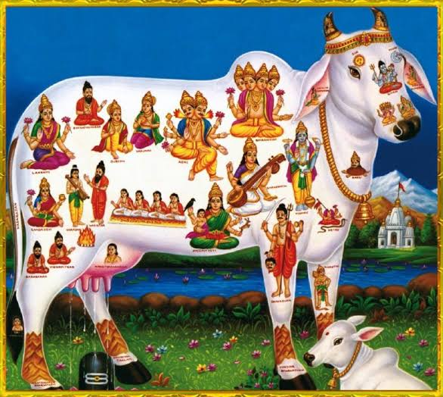
INTRODUCTION
Kamadhenu also known as Surabhi is a divine goddess known in Hinduism as Gomatha. Kamadhenu is the heavenly cow. She gives good health, wealth, happiness and all sorts of benefits in our life. Kamadhenu is not worshipped as a deity, and there are no temples dedicated to her. But she is worshipped as the divine cow and hindu’s would do poojas to the cows especially on Fridays, Festival days and on Mattu Pongal.
According to various hindu texts, it is stated that she emerged from the churning of the divine ocean, whereas some references state that she is the daughter of Lord Daksha Bhagawan. Certain texts tell that previously Kamadhenu was in the possession of either Jamadagni or Vashista , and the kings who tried to steal her from the sages had faced severe troubles for their actions. Kamadhenu gives milk and other food products equivalent to the deva loka’s divine nectar
(AMIRTHA) and it is stated that she resides in the Indra Loka, the abode of Lord Indra.
Cow's milk and its various products are used for Vedic fire sacrifices, and without that a sacrifice would not be concluded.
In Bhagavad Gita, Lord Krishna says that “Among the cows, I am the divine cow “KAMADHENU”. Hence she is considered as an aspect of Lord Krirshna, since Lord Krishna will used to graze the cattle and looked after it kindly and affectionately during the previous dwapara yuga.
In some temples and houses, the pictures of kamadhenu will be worshipped. In Hinduism, cows are considered as a sacred animal, and worshipped as an incarnation of Kamadhenu. In general, all the cow related products are used as an ayurvedic medicine. It also cures various diseases, and by worshipping cows, we will get great mental peace and relaxation in our mind and body, which we will not get anywhere else. There are also several private cow sheds and cow sheds in hindu temples throughout india, in order to protect them from slaughtering during their old age. Since, cow is considered as our affectionate mother, it is our duty to protect and safeguard them till their natural death. Once in a month we can visit the cow sheds and feed with them grass, greens and vegetables and other cow related food items.
IMPORTANCE
By worshipping the holy cow, Mata Lakshmi Devi will dwell permanently in our house as well as in our hearts, and give all the riches in our life, and protect us from various problems which we are facing in our daily life. By providing food to the divine animal, sins committed in our past births will be removed, and we will get the blessings of the gods, goddesses and the demi gods in the heaven. Since is it considered that she is a resident of Swarka Loka, by worshipping her, Lord Indra Bhagawan will shower his grace on us and we will get a chance to escape from this difficult earth, and can happily reside permanently in the swarka loka.
Let us worship the holy MATA “GOMATA” and be blessed.
“OM SREE GOMATAVE NAMAHA”
“OM SREE KRISHNA BHAGAWANE NAMAHA”
“OM NAMO NARAYANAYA NAMAHA”
WRITTEN BY
R.HARISHANKAR

KALPAVRIKSHA
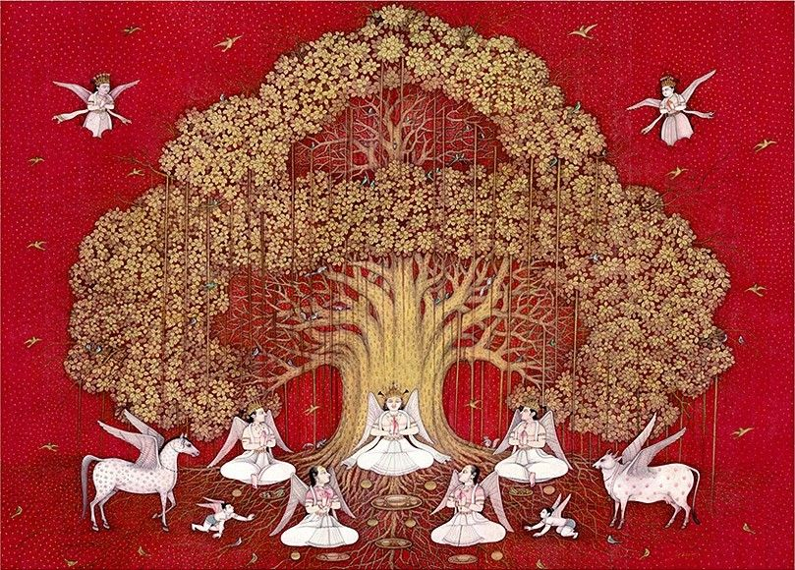
INTRODUCTION
Kalpavriksha also known as kalpataru and kalpadruma is a wish-fulfilling divine tree as mentioned in Hinduism, Jainism and Buddhism texts. The Kalpavriksha appeared during the "churning of the divine ocean" along with the Kamadhenu and other auspicious divine gods. The Holy tree is kept by Indra in his swarka loka. This tree gives whatever we ask for, and it is a very holy one.
In Hinduism, we will mention some great saints similar to Kalpavriksha and Kamadhenu, since they fulfil the wishes of their devotees. The great Madhwa saint “SREE RAGHAVENDRA SWAMY” is described as the holy tree Kalpavriksha and the Divine Cow Kamadhenu, in the famous stotra written by his ardent disciple “SREE APPANACHARYA”.
Kalpavriksha is mentioned in hindu puranas and other ancient texts. In the previous dwapara yuga, Lord Krishna fought with Lord Indra to bring the divine tree to his dwaraka from heaven towards fulfilling the wishes of his wife “MATA SATYABAMA”. And after the end of his avatar, the holy tree flew from dwaraka and reached swarka loka. This tree is guarded by the divine attendants of Lord Indra in the Swarka Loka.
It is also believed that those who keep the tree with them will not be affected from any sins, diseases and death. They will shine brightly like a sun and get all the desires fulfilled through the divine tree. But for us it is not possible, since it is kept under the custody of Devendra, the king of demi gods in the heaven. Instead of that, we can pray to the divine tree from our place, and can get all the prosperity in our life. The great poet Kalidasa also praises the tree in his famous poetry Meghaduta. The parijata tree is compared to that of the divine tree “KALPAVRIKSHA”, since it contains lot of medicinal properties and the flower of the tree is used for adorning the god’s deities.
The tree can be compared similar to Mata Lakshmi, since both of them emerged from the divine ocean. Though the tree is not specifically worshipped by the people, it is believed that through the grace of Kakpavriksha, the trees in the earth are giving more benefits to the mankind, like coconut tree and palm tree. And it is also believed that all the trees in the earth contains the features of Kalpavriksha, since each and every tree, gives some sort of benefit to us. They are giving shelter during the winter and summer season. Various birds are building their own nests in the trees only, and they are living through the grace of the divine tree “KALPAVRIKSHA”. The holy tree Kalpavriksha is considered as the king among the trees. We can chant the mantra “OM SREE KALPAVRIKSHAYA NAMAHA” regularly while doing puja in our home, and also we can recite the mantra in the temples in order to gain more fortunes in our life.
Let us worship the great divine tree and be blessed.
“OM SREE INDRA BHAGAWANE NAMAHA”
“JAI KRISHNA”
WRITTEN BY
R.HARISHANKAR
LORD BHAGA
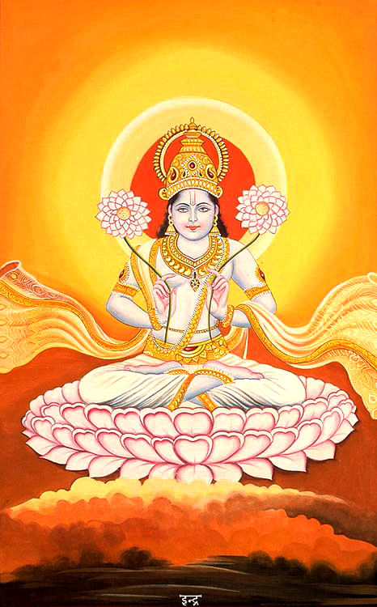
INTRODUCTION
Bhaga is a god for wealth, marriage and prosperity similar to goddess Lakshmi. He is a main deity who gives our necessities and fulfils our wishes. He is also a vedic god, and contains powers equivalent to that of Lord Indra. But generally he obeys and executes his duty as per the instructions given by Lord Indra. He is referred in various puranas and in several ancient hindu texts, and is considered as a supreme manifestation of Lord Vishnu. He is the brother of USHAS (The Dawn Goddess).
During the yagna performed by Lord Daksha, he stood by his side, and helped him to perform the fire sacrifices without any disturbance from others. He also fought with Lord Veerabadra, as aspect of Lord Shiva but finally was defeated by him. Rigveda, praises him along with Lord Agni, Indra, Chandra, Surya, Pushan and the great divine physicians Lord Ashwini Kumarars, twin sons of Lord Surya. Rigveda praises his valour, power and strength and describes him as a main demi god among the other demi gods in the heaven. He wilfully carries out his duties, and also receives his share during the performance of fire sacrifices, similar to Lord Indra, Agni, Vayu and other gods and demi gods.
Bhaga is also described as the god of the morning. As per the Rigveda, the Bhaga is one among the adityas. He is also mentioned in the Bhagavata Purana and in Buddhist texts. His appearance is mentioned in the puranas, “He contains a gigantic body with a bright and a smiling face and carries flowers in his two hands, and glitters like that of the sun and sitting in a big lotus flower”.
IMPORTANCE
While some demi gods are worshipped for getting satisfied for certain wants, Lord Bhaga can be worshipped for getting all types of benefits in our life. But he is mainly worshipped for getting married and for having good children. He also removes the obstacles caused by the nine planets (NAVAGRAHAS), based on our karmic deeds. Though there are no temples, dedicated for him, we can worship him by keeping his picture at our home, and decorate it with flowers and offer fruits and pulses as naivedyam (HOLY PRASAD) to him. After performing the puja, we can distribute the Prasad to the participants of the puja. While doing the puja, we have to chant the mantra “OM SREE BHAGAYA NAMAHA”, in order to get good fortunes in our life. He also removes the sickness from our body and makes our mind to work actively and our career path will also be improved through his grace.
Let us worship the great Demi god “BHAGA” and be blessed.
“OM SREE BHAGAYA NAMAHA”
“OM SREE INDRA BHAGAWANE NAMAHA”
WRITTEN BY
R.HARISHANKAR

PRABHUPADA
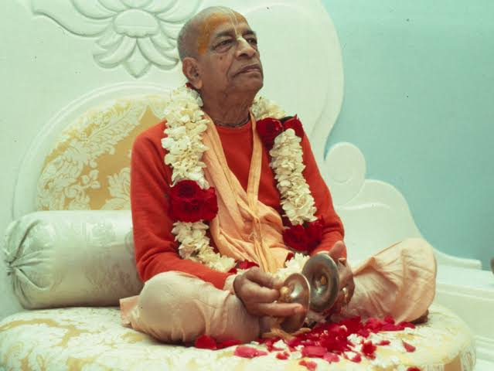
INTRODUCTION
Prabhupadha (1896 –1977) was a great spiritual leader and the founder of the International Society for Krishna Consciousness (ISKCON), commonly referred as the "Hare Rama Hare Krishna Movement". He is also considered as a messenger of Sri Chaintanya Mahaprabhu. And it is believed that he was born for the main purpose of invoking the people in the “KRISHNA BHAKTI SPIRIT”, and to make the people to live in a peaceful manner. His birth name was Abhay Charan De.
LIFE
He was born in a Bengali family and educated at Calcutta. After finishing his graduation, he got married and was running a small business. In the year 1959, he become a saint and started writing holy books on Hinduism. He spread the philosophy of Gaudiya Vaishnava throughout the universe and he founded ISKCON in the year 1966. He conducted spiritual meetings and explained the importance of following hindu religion and about worshipping Lord Krishna as the main god. He received mixed response for his activities from the foreign countries as well as in india. He started his own publication house, and begun publishing about the bhakti essence of Lord Krishna and about the performance of miracles to his sincere devotees. He also translated lot of religious books in English language.
He propagated his mission, throughout the world. His guru was Bhakti Siddhanta Saraswati. Even after his death in 1977, ISKCON continued to grow. Its main books are Bhagavat Gita and Bhagavat Purana, which deals with Lord Krishna.
A number of shrines to Bhaktivedanta Swami were constructed by the members of ISKCON and the most popular one is situated in Mayapur, Vrindavan and also in America.
IMPORTANCE
Throughout his life, his concentration was full of devotion on Lord Krishna, and he attained sainthood, and spread the principles of Chaintanya Mahaprabhu and awakened the spiritual energy of the devotees. He was the main person in establishing a big society for spreading the message of Lord Krishna. And through his divine blessings, the ISKCON movement is still going stronger, and has established several branches all over the world. They are also doing lot of charitable activities like providing food to the poor children and to the poor people. Lot of foreigners were also joined in the ISKCON movement, and taking part in their spiritual journey.
Let us worship the holy saint and be blessed.
“OM SREE PRABUPADA SWAMIGALE NAMAHA”
“JAI KRISHNA”
WRITTEN BY
R.HARISHANKAR

RAMANAND SWAMI
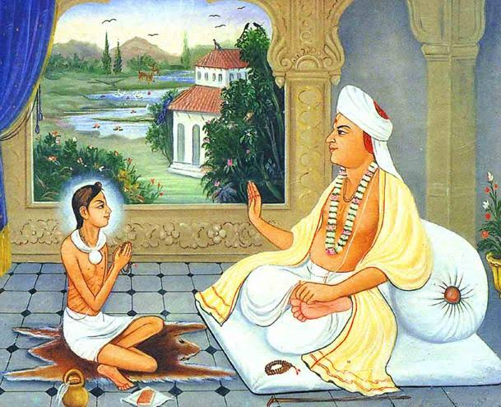
INTRODUCTION
Ramanand Swami (1738-1802) was born in a Brahmin family in Ayodhya. His birth name was Rama Sharma. He was considered to be an avatar of Uddhava, a best friend of Lord Krishna. Ramanand was the founder and the chief of the Uddhav Sampraday. Ramanand Swami adopted the Vishishta dvaita philosophy which was established by Ramanuja during the 11th century AD. Once Ramanand Swami got the divine darshan of Saint Ramanuja in his dream and was blessed by him. His main disciples were Sri Swaminarayan and Sri Muktanand Swami. He travelled to many holy places and spread the philosophy of Ramanuja and cultivated the bhakti spirit among others. He also visited dwaraka, puri and vrindavan and worshipped Lord Krishna, and got great spiritual powers.
TEACHINGS
- Have bhakti on Lord Krishna and worship him by chanting his various names.
- Visit the holy places of Lord Krishna: Puri, Vrindavan and Dwaraka.
- Your mind can be controlled only by having constant meditation on god.
- Read the hindu scriptures, Bhagavatham and Bhagavat Gita. It will teach the peaceful way of living.
- God’s blessings alone will change a person’s fate. With his help, we can achieve anything in our life.
- Respect everybody in this world. Don’t cause harm even to tiny insects in the world.
- Take care of your parents, and give your extended support during their old age, without taking care of parents, god’s worship will not at all work.
- Realize the god within yourself, and also visit the temples, to get more divine experience, and you can see his smiling face, and can get eternal bliss for ever.
- Apart from worshipping god, give respect to the great saints and worship them regularly, they will fulfil your wishes through the help of the god.
IMPORTANCE
Being the avatar of Uddhava, he will help us by reducing our sins, and show the spiritual path, and come with us in our every walk of life. Being the guru of Sri Swaminarayan, he will heal us and gives a good health and a strong mind. He will give courage, boldness, wisdom and fulfil our necessities, based on our pure devotion on him. He also relieved the people from various diseases and given various lectures to attain enlightenment. Through his lectures, lot of people were got attracted and become his devotees. He was praised by several kings and by the common man for his kindness and holiness.
Let us worship the great saint and be blessed.
“OM SREE RAMANAND SWAMIGALE NAMAHA”
“JAI SWAMINARAYAN”
“JAI KRISHNA”
WRITTEN BY
R.HARISHANKAR
RISHI KRATU
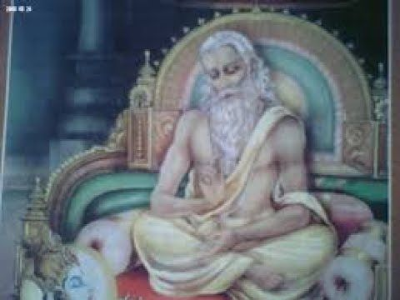
INTRODUCTION
Kratu was an ancient rishi and the son of Lord Brahma, and also the son-in-law of Lord Daksha. His wife was Santhati. And she is a very pious and a holy woman and a dutiful wife. And through her, he got thousands of children. He is also mentioned in various puranas and also in several ancient texts. It is believed that he was the foremost creation of Lord Brahma and still existing in the divine world. It is also believed that he is living in the Indralok with great respect given by Lord Indra. He got great spiritual powers, and was very affectionate to his parents: Brahma and Saraswati. Whenever if finds time, he immediately visit and worship them in the Satyalok. He is also the brother of the divine saint narada, and the sanath kumaras. Through his great meditation on Lord Vishnu, he got great super natural powers, and will always use his powers only for useful purpose. As per the instruction of his father Brahma, he got married and produced more number of children, in order to generate more number of people in the earth. While Narada and Sanath Kumaras were refused to marry and produce child, he obeys his father’s instructions and carried out his orders. He can be compared to that of Parasurama, the divine avatar of Lord Vishnu, who satisfied his father’s wishes without asking any questions to him. In the present scenario, we cannot find such kind of Avatara purushas like them. In this Kali Yuga, we may not be able to give proper respect to our parents in certain situations, and obey their orders and follow their instructions.
He is considered as a “GEM” among the sages, and was an expert in all kinds of art and contains great knowledge in hindu scriptures. He is also talented in music and composing songs on Lord Vishnu.
Let us worship the great sage and be blessed.
“OM SREE KRATU MAHARISHIYE NAMAHA”
WRITTEN BY
R.HARISHANKAR
TIBBATIBABA
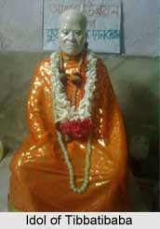
INTRODUCTION
Tibbatibaba (1820–1930) also called as Tibbetibaba was a famous saint and a yogi. He followed both the philisophies of Hinduism and Buddism. Tibbetibaba was a master in all hindu and Buddhist scriptures and was a great scholar in all the subjects, and an expert in yoga and meditation. His birth name was Nabin Chandra. He learnt education and obtained spiritual knowledge under his guru “SRI PARAMANANDA THAKKAR”. His disciple was Soham Swami. His ashram is situated in West Bengal, and his Samadhi was also built in the ashram. And lot of people from the nearby places are regularly visiting his ashram and worshipping at his Samadhi.
He was born in a Bengali Brahmin family in Bangladesh. His father was also a yogi and a great scholar. From his childhood, Nabin Chandra was very much interested in knowing about spiritual matters. He got good grasping power, and he grasped all the subjects within a few months. According to his opinion, “God is the supreme person among all the living creatures in the world, and he will do only goodness to us, and always ready to shower his grace, based on our pure devotion”.
He left his home in his teenage and went to many holy pilgrimages in search of the god. He joined with a group of pilgrims and journeyed to Ayodhya. And he finally went to Nepal. There, he met a saint and become his disciple. After performing severe meditation on the god, he attained the spiritual knowledge, and his doubts about worshipping the god was cleared from that moment.
He went to tibet and resided in a cave and began meditating on God, even without taking proper food for several days. Once, he approached a Tibetan Buddhist lama and become his disciple. Under his guidance, he learned the spiritual practices and the philosophies of Buddhism.
After some time, Nabin Chandra travelled to many foreign countries, and taught both the hindu as well as the Buddhist philosophies to the people and ask them to frequently do meditation and to chant the mantras and names of gods, in order to attain SALVATION. He also insisted the people not to cause harm to any living creatures in the earth, and not to take non vegetarian foods. He combined the teachings of Lord Buddha and the Hindu teachings. After that, he went to many holy Buddhist vihars and hindu temples like Mount Kailash, amaranth, badrinath and kedarnath and worshipped Buddha, Shiva and Vishnu.
TEACHINGS
- Love others, and do good to others, then god will help you in case of difficulty.
- Give respect to each and every one, treat them as your own brothers and sisters, and show courtesy even to your enemies.
- Give respect to the religious faith and the sentiments of others. All the religions preach only good things to be followed in our life.
- Give respect to your elders, give your full support to them, and respect your parents.
- Work and worship must be done simultaneously. Without proper worship, work cannot be done properly.
- Have faith in god, and believe that he will give pleasantness in your life.
- Never hate and curse god, in times of difficult situations. Nothing is in our hands, pray to god, and rest leave it to him. He will instantly do favours for you.
- Try to develop the habit of praying to the god from your childhood itself, because our life is not guaranteed. We don’t know for how many years we will live, and our life may come to an end at any time. Hence have sincere faith and bhakti on god.
- Control your senses by doing yoga and meditation. Do not allow bad thoughts to enter in your mind, it will collapse you entirely, and your life will become a failure.
IMPORTANCE
He got great super natural powers through his meditation on god. He lived a pious life, and acts as an example for others. He was a humble, noble and an honest saint, who never hated others, and had done his extended support to poor people. Through the money received from his supporters, he had done many good activities like providing food, clothing and shelter to the poor and the homeless people. He also cleared the mental and the physical diseases of the people through his spiritual powers.
Let us worship the great saint and be blessed.
“OM SREE TIBBATIBABAVE NAMAHA”
WRITTEN BY
R.HARISHANKAR

VYAGHRAPADA
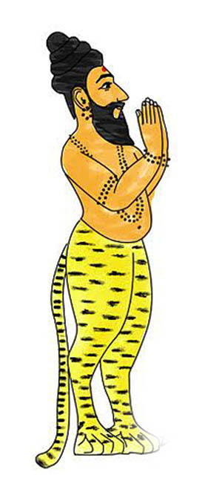
INTRODUCTION
Vyaghrapada was one of the great rishis in Hinduism. He is a sincere devotee of Lord Shiva, and used to worship him regularly, and will never take his food without worshipping him.
Vyaghrapada used to pluck flowers, in order to offer it to Lord Shiva in the temple of Chidambaram. Since, he find it difficult to pluck the powers with his human organs, he prayed to Lord Shiva, and through his grace, his legs had been changed similar to tiger’s legs. Through the tiger legs, he easily moved from one place to another place, and plucked flowers easily from the trees and offered it to Lord Shiva for his worship.
Generally, he is shown in a human form containing the legs of tigers. He worshipped Lord Shiva along with the great Pathanjali in Chitambaram Natarajar Temple. He also worshipped Lord Vishnu in the Sthalasayana Perumal Temple, Tirusirupuliyur in Tamil Nadu and got the divine darshan of Lord Vishnu.
IMPORTANCE
He got great super natural powers, and he is a great Shiva devotee and also a rishi. It is believed, that he is still doing meditation on Lord Shiva in the divine world and receiving his blessings. In this today’s fast changing world, we are not able to allot sufficient time for worshipping the god by going to temples, but the great Vyaghrapada Rishi had changed his appearance itself, in order to make proper worship on Lord Shiva. He got such a kind of great bhakti. We also have to cultivate the habit of going to temples, and worship the god with complete devotion in our mind, without concentrating on other unwanted things.
He acts as an example for others, with regard of showing great bhakti on Lord Shiva. By worshipping him, we can get his blessings as well as the blessings of Lord Shiva and Vishnu, and can live a peaceful and a prosperous life in this world, and can attain SALVATION after our death.
Let us worship the great rishi and be blessed.
“OM SREE VYAGHRAPADA MAHARISHIYE NAMAHA”
“OM NAMAH SHIVAYA”
“OM NAMO NARAYANAYA NAMAHA”
WRITTEN BY
R.HARISHANKAR

