JAIN THIRTHANKARAS
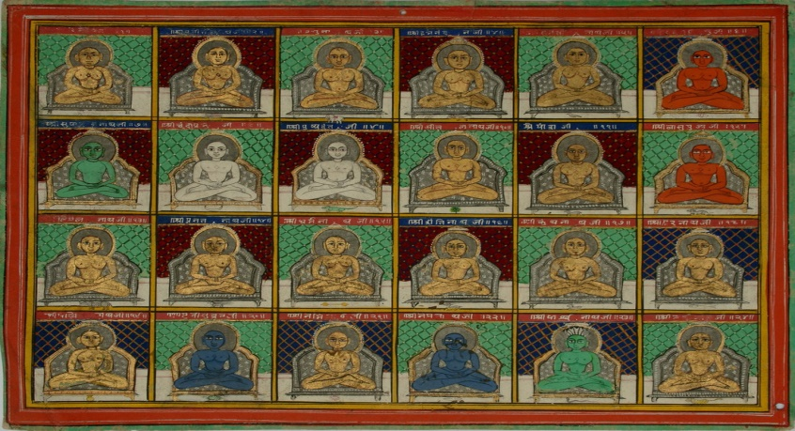
INTRODUCTION
The holy religion of Jainism preaches about living a simple and a pious life and without causing any harm to all the living beings in the earth. Jainism is mainly based on the teachings of the 24 Tirthankaras, of whom Lord Mahavira was the most important one. He was taken birth before 2600 years ago. And his teachings are considered as very important by the Jain people. The 24 Tirthankaras have taken birth in order to get rid of the sins of the people, and to make them to attain NIRVANA by following their teachings. By living a life as per their teachings, we can attain nirvana and can get liberated from the chain of life cycle. All of them taught the basic thing of avoiding luxuries and comforts in the life and to give respect and not to commit harmful activities over others. In a nutshell, they are telling us to live a sin free life, by following their principles and teachings.
The 24 Holy Jain Tirthankaras and Their Details:
Sr.No | Name | Birthplace | Colour | Age
1 | Rishabhanatha (Adinatha) | Ayodhya | Golden | 84,00,000 Purva
2 | Ajitanatha | Ayodhya | Golden | 72,00,000 Purva
3 | Sambhavanatha | Shravasti | Golden | 60,00,000 Purva
4 | Abhinandananatha | Samet Sikhar | Golden | 50,00,000 Purva
5 | Sumatinatha | Ayodhya | Golden | 40,00,000 Purva
6 | Padmaprabha | Samet Sikhar | Red | 30,00,000 Purva
7 | Suparshvanatha | Samet Sikhar | Golden | 20,00,000 Purva
8 | Chandraprabha | Chandrapuri | White | 10,00,000 Purva
9 | Pushpadanta | Kakandi | White | 2,00,000 Purva
10 | Shitalanatha | Bhadrikpuri | Golden | 1,00,000 Purva
11 | Shreyanasanatha | Samet Sikhar | Golden | 84,00,000 Years
12 | Vasupujya | Champapuri | Red | 72,00,000 Years
13 | Vimalanatha | Kampilya | Golden | 60,00,000 Years
14 | Anantanatha | Ayodhya | Golden | 30,00,000 Years
15 | Dharmanatha | Ratnapuri | Golden | 10,00,000 Years
16 | Shantinatha | Hastinapur | Golden | 1,00,000 Years
17 | Kunthunatha | Hastinapur | Golden | 95,000 Years
18 | Aranatha | Hastinapur | Golden | 84,000 Years
19 | Māllīnātha | Mithila | Blue | 55,000 Years
20 | Munisuvrata | Kusagranagar | Black | 30,000 Years
21 | Naminatha | Mithila | Golden | 10,000 Years
22 | Neminatha | Dvaraka | Black | 1,000 Years
23 | Parshvanatha | Kashi | Blue | 100 Years
24 | Mahavira | Kshatriyakund | Golden | 72 Years

DEVELOPED BY
R.HARISHANKAR

