ASHTA VASUS
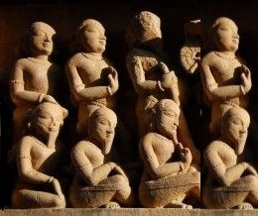
INTRODUCTION
In Hinduism, the Vasus are residing at Swarka Loka with Lord Indra and they obey his instructions. The Ashta Vasus are described in the Mahabharata as the sons of Manu or Brahma Prajapati. They are the eight gods who represents the pancha bhootas, and are also representing the
Sun, the Moon and the Stars. The name Vasu means 'Brilliance' or 'Wealth Givers'.

Names of Ashta Vasus
According to the Brihadaranyaka Upanishad, the names of the eight vasus are as follows:-
1.Prithvi
2.Agni
3.Vayu
4.Varuna
5.Aditya
6.Dyaus
7.Chandramas
8.Nakstrani
According to the Mahabharatha, the names of the eight vasus are as follows:-
1.Dhara
2.Anala
3.Anila
4.Apa
5.Pratusha
6.Prabhasa
7.Soma
8.Dhruva

Description of Ashta Vasus in Mahabharata
The Mahabharata narrates the incident of stealing a wish fulfilling cow by Prabhasa, due to the wishes of his wife. Since the cow was owned by sage Vashishta, and by his super natural powers he came to know that the Vasus had stolen it, he immediately cursed them to be born on earth as human beings. Vashishta responded to prayers of the Vasus, and promised them that seven of them would be free from his curse within a year of being born and that only Prabhasa has to suffer. The Vasus then requested goddess Ganga to be their mother. Ganga incarnated and became the wife of King Shantanu on condition that he never gains aid her in any way. As seven children were born, one after the other, Ganga drowned them in her own waters, freeing them from their punishment and the king made no opposition. Only when the eighth was born, the king finally oppose his wife, and she has left him. So the eighth son, Prabhasa took birth in human form and later became known as incarnation as Bhishma.

CONCLUSION
The Ashta vasus who are the demi gods and friends of Lord Indra, contains all the powers to protect us. They are the ones who can give us all sorts of comforts in our life. They will be pleased by the performance of yagna. Whenever an Yagna is performed, their names will be chanted, and they will be happy and give their blessings immediately.
There names are repeatedly recited while doing an yagna. Without chanting their names, an yagna cannot be completed fully. Hence let us pray to the divine gods for our well being and chant their nama and live happily and peacefully for ever.
‘OM SHREE ASHTA VASUKALE NAMAHA’
WRITTEN BY
R.HARISHANKAR

ASHWINI DEVAS
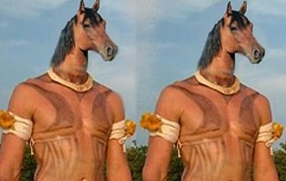
INTRODUCTION
Ashwini Kumaras , in Hindu tradition, are twin gods. Aswini Devas are Divine healers and they are the gods of Ayurvedic Medicine.They are also described in the Rigveda. in Varaha Purana and in many other puranas. They have Horse ‘s face and are reported to be very handsome and good natured devas. They heal and prevent misfortune.They are the sons of Surya and his wife shangya. They were born, when Surya and Shangya took the form of horse and coupled with each other.
IMPORTANCE
Nasatya is the god of health and Dasra is the god of medicine. They symbolise the shining of sunrise and sunset, and appears in the sky before the dawn in a golden chariot, brings treasures to men and prevents misfortune and sickness. They are the doctors of the gods and are the divine devas of Ayurvedic medicine. They are represented as humans with the horse heads.

Mention in ancient texts
The Ashwins are an instance of the European horse twins.
The Ashwins are mentioned 376 times in the Rigveda, with 57 hymns specifically dedicated to them.
Indian holy books like the Mahabharata and the Puranas, relate that the Ashwini Kumar twins, were the royal physicians to the Devas during Vedic times. In the epic Mahabharata, King Pandu's wife Madri is granted a son by each Ashvini kumar and bears the twins Nakula and Sahadeva who, are known as the Pandavas.

CONCLUSION
Let us worship the great Ashwini Kumaras, who are the sons of the bright surya bhagawan, and who are the divine healers in ayurvedic medicine. Let us pray to them for giving us a good health and a good fortune in our life.
Let us chant their nama and live a long and healthy and happy life.
“OM SHREE ASHWINI DEVAYA NAMAHA”

WRITTEN BY
R.HARISHANKAR

BRIHASPATI
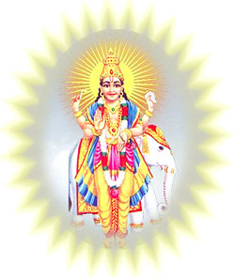
INTRODUCTION
Brihaspati is the planet jupiter, and one among the navagrahas. According to ancient texts, Brihaspati is a guru for Lord Indra, at Swarka loka. He is the god for Thursday, according to hindu calendar.
His name is mentioned in Rigveda and also in several ancient texts.
His wife name is Tara and his son is Rishi Bharadvaja.
His famous temple is situated in Jaipur, known as Brihaspati dham.
Another famous Apatsahayesvarar temple is situated in Alangudi,Thiruvarur District,Tamil nadu.
It is considered as a famous temple for Guru Brihispati and was worshipped by devotees from all parts of india.
Bengal gram dal rice can be offered as naivedyam(Prasad) to him, and can perform puja to him using jasmine flowers.
In general, people are worshipping Lord Dakshinamurthy as brahaspati. Dakshinamurthy is another form of Lord Shiva and he is the universal guru for everybody. Both are divine gods and Gurus and they are one and the same. Worshipping Dakshinamoorthy and doing abhishekham to him will also bring better prospects in our life.
If we want particularly to worship brahaspati, we can approach any of the shiva temples, and in the navagraha sannidhi, for brahaspati idol we can do abhishekham and archanai and offer prayers to him.
IMPORTANCE
Guru brahaspati is the giver of good fortunes in our life, and can be worshipped on Thursdays. We will get good grasping power and able to work properly in our office, by praying to him. He is expecting a true bhakti from us.
By worshipping Lord Brahaspati, we can get good knowledge, courage and wisdom, and we will have a bright future.
In the field of astrology, Lord Brahaspati is considered as a great person, and the giver of all prosperity in our life, based on our planetary position.
Let us worship the great guru and be blessed.
“OM SREE GURU BRAHASPATIYE NAMAHA”
“OM SREE GURU DAKSHINAMOORTHIYE NAMAHA”
WRITTEN BY
R.HARISHANKAR

DAKSHA PRAJAPATI
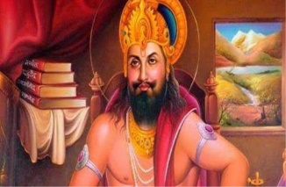
Daksha Prajapati is a great valour and a brave person. He cursed Lord Chandra to loose his powers, since he has shown more attention on one of his daughters Rohini Star than the other 26 daughters. He is considered as one of the great, honest and able Brahmin king. He has got the powers equivalent to that of Brahma and occupies equivalent status among other prajapatis like Agni, Indra, Vishvakarma, Bharata, Kapila.

Daksha was one of the Prajapati, son of Brahma, and among his foremost creations. The name Daksha means "skilled one". Daksha had two wives: Prasoothi and Panchajani (Virini). Sati (also known as ‘‘Uma’’) was his youngest daughter; born from Virini (the daughter of the Prajapati Manu), she was the pet child of Daksha and he always carried her with him. Sati (meaning truth) is also called Dakshayani as she followed Daksha’s path; this is derived from the Sanskrit words daksha and ayana (walk or path).

SATI DEVI
Sati, the youngest daughter of Daksha, was deeply in love with the god Shiva and wished to become his wife. Her worship and devotion of Shiva strengthened her immense desire to become his wife. However, Daksha did not like his daughter’s yearning for Shiva, mainly because he was a Prajapati and the son of the god Brahma; his daughter Sati was a royal princess. They were wealthy nobility and their imperial royal lifestyle was entirely different from that of Shiva. As an emperor, Daksha wanted to increase his influence and power by making marriage alliances with powerful empires and influential sages and gods.

LORD SHIVA
Shiva on the other hand led a very modest life. He lived among the downtrodden, wore a tiger skin, smeared ashes on his body, had thick locks of matted hair, and begged with a skull as bowl. His abode was Mount Kailash in the Himalayas. He embraced all kinds of living beings and did not make any distinction between good souls and bad souls. The Bhutaganas, his followers, consisted of all kinds of ghosts, demons, ghouls and goblins. He wandered though garden and graveyard alike.
As a consequence, Daksha had aversion towards Shiva being his daughter’s companion. However unlike Daksha, Sati loved Shiva as she had the revelation that Shiva was the Supreme God.^{[3][7]}
Sati won Shiva as her husband by undergoing severe austerities (tapas). Despite Daksha's disappointment, Sati married Shiva.

SREE DAKSHA YAGA
Dadhichi-Daksha argument
The Kurma Purana discusses the dialogues between the sage Dadhichi and Daksha. After the sacrifice and hymns where offered to the twelve Aditya gods; Dadhichi noticed that there was no sacrificial portion (Havvis) allotted to Shiva and his wife, and no vedic hymns were used in the yajna addressing Shiva which were part of Vedic hymns. He warned Daksha that he should not alter the Holy Vedas for personal reasons; the priests and sages supported this. Daksha replied to Dadhichi that he would not do so and insulted Shiva. Dadhichi left the yajna because of this argument.
Sati’s death
Sati came to know about the grand yajna organized by her father and asked Shiva to attend the yajna. Shiva refused her request, saying that it was inappropriate to attend a function without being invited. He reminded her that she was now his wife more than Daksha’s daughter and, after marriage, is a member of Shiva’s family rather than Daksha’s. The feeling of her bond to her parents overpowered the social etiquette she had to follow. She even had a notion that there was no need to have received an invitation in order to attend as she was Daksha’s favourite daughter and no formality existed between them. She constantly pleaded and urged Shiva to let her attend the ceremony, and became adamant in her demands without listening to the reasons Shiva provided for not attending the function. He allowed Sati to go to her parents' home, along with his followers including Nandi, and attend the ceremony, but refused to accompany with her.
Upon arriving, Sati tried to meet her parents and sisters; Daksha was arrogant and avoided interacting with Sati. He repeatedly snubbed her in front of all the dignitaries but Sati maintained her composure. Because of Sati’s persistence in trying to meet him, Daksha reacted vehemently, insulting her in front of all the other guests at the ceremony to which she had not been invited. He called Shiva an atheist and cremation ground dweller. As planned, he took advantage of the situation and continued shouting repugnant words against Shiva. Sati felt deep remorse for not listening to her beloved husband. Daksha’s insulted towards her, and especially her husband Shiva, in front of all the guests was growing each moment she stood there. The shameless insult and humiliation of her and her beloved, eventually became too much to bear.
She cursed Daksha for acting so atrociously toward her and Shiva, and reminded him that his haughty behavior had blinded his intellect. She cursed him and warned that the wrath of Shiva would destroy him and his empire. Unable to bear further humiliation, Sati committed suicide by jumping into the sacrificial fire. The onlookers tried to save her but it was too late. They were only able to retrieve the half burnt body of Sati. Daksha's pride in being a Prajapati and his prejudice against his son-in-law created a mass hatred within himself, which resulted in the death of his daughter.
The Nandi and the accompanying Bhootaganas left the yajna place after the incident. Nandi cursed the participants and Bhrigu reacted by cursing the Bhootaganas back.

Destruction of the yajna by Shiva

After knowing about the incident, Lord Shiva created Lord Veerabadra and Goddess Veeramahakali ,and they both of them went into the Yagna, and destroyed the yagna and also chopped the head of Daksha. However after hearing the prayers of Daksha’s wife, Lord Shiva has regained his life by placing a Goat’s head on to his head ,and then he allowed to continue the yagna. Daksha prayed to Lord Shiva and Lord Shiva has forgiven him.
We can attain peacefulness in our life and can attain all prospects in our life by chanting the mantra ‘OM SREE DAKSHAYA NAMAHA’
WRITTEN BY
R.HARISHANKAR

KING VIKRAMADITYA
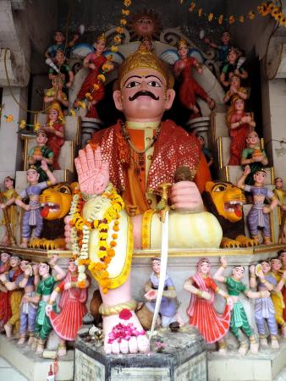
INTRODUCTION
Vikramaditya was a great emperor of ancient India. He is a great personality, and gives respect to the learned scholars in his court.
Ancient legends, praises him as a great king and a great valour, who is well known for his courage and kindness among his people. He was the ruler of Ujjain. He ruled several thousand of years before, and is still given respect by the people all over india. A temple is also dedicated to him in Ujjain.
IMPORTANCE
King Vikramaditya is well known for his skills, and he is a great devotee of Goddess Kali. He is also considered as an incarnation of Lord Vishnu.Ujjain Kali temple is very famous on account of his devotion to the goddess.
Vikramaditya was believed to have ruled during 1st century BC. Vedic books prove his existence during that period.
There were 9 important persons who were occupied in his court and they were considered as 9 important gems.
Famous poet Kalidasa, Astrologer Varaha Mihira were among the 9 gems in his court.
Bhavishya Purana states that, he ruled well and took care of his people in a good manner, and solved their problems in an effective manner. During his period, people in his kingdom, didn’t suffer. There were no sudden deaths, no death due to chronic illness, and no poverty. Their problems were sorted out by him meticulously, and he took adequate care on his people. He ruled his kingdom in a very fantastic manner.
The following are the nine Gems in court of Vikramaditya:-
1. Dhanvantari
2. Kshapanaka
3. Amarasimha
4. Sanku
5. Vetalabhatta
6. Ghatakarpara
7. Kalidasa
8. Varahamihira
9. Vararuchi
According to the great poet kalidasa, no one is comparable with king Vikrama in those days.Daily he made lot of gifts to his people and made them happy.
CONCLUSION
Let us salute to the great Emperor Vikramaditya of Ujjain, for his bravery and his talent in the arts, and for his interest in protecting the people, and for his bhakti in Kali. Let us honour him for ruling his city in a very good manner and protecting his people and his city from enemies. He is still living in the hearts of those people, who still believes him and his history. Let us pray to the great king Vikramaditya to give us a blessed life and chant his name continuously and let us live happily for ever.
“OM SREE VIKRAMADITYA MAHARAJAVE NAMAHA”
WRITTEN BY
R.HARISHANKAR
LORD AGNI
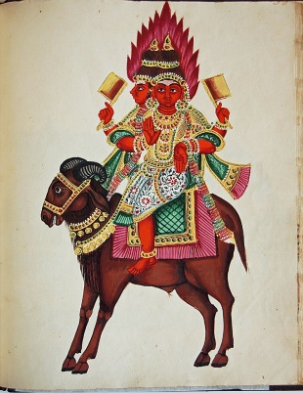
INTRODUCTION
Agni is the fire god, and considered as the Vedic god of Hinduism. He is also the guardian deity of the southeast direction. He is the son of Aditi and Kashyaba. His wife name is Svaha Devi.
IMPORTANCE
Agni is a major god along with Indra and Chandra. All the offerings of the homams will be made only through him. He resides in the agniloka. His name is mentioned in ancient Upanishads, puranas,vedas and in ancient divine texts. By conducting homams, and by chanting the names of various gods and divine devas, the fire god, carries all these powerful mantras to the respective places of the gods, and give us the benefits. His power is great and cannot be underestimated. He is very gentle and humble. He can be able to burn the entire universe into ashes, but always obeys the orders of the gods like Indra, Shiva,Brahma and Vishnu. He is mainly controlled by Lord Indra.
CONCLUSION
Lord Agni, the fire god, let us burn our bad thoughts and bad karma into ashes, and make us bright and pure. He is the god, who is present in all the temple rituals, and can be visibly seen by us in our naked eyes. His name is found in the texts of Buddhism and Jainism also. Without fire, we can’t do anything. Agni acts as the life force for a healthy body, and we are able to digest the food only with the help of Agni which is present in our body.
His image can be seen in some Hindu temples, and in Prithyanga Devi temple, Sholinganallur, a separate statue of Lord Agni is erected. In Arunachaleswarar Temple, the Shiva linga represents the element fire and is called as Agni Lingam. Fire plays an important role in celebrating Karthigai deepam festival. Various lamps are lit in every house of the devotees with much joy. Deepavali festival is also celebrated by the childrens with much interest by bursting crackers by using fire only. And our DAILY food is cooked only with the help for fire. Hence without the use of fire, we can’t sustain in this world. It is also one of the Panchabootha. Hence, let us worship “THE GREAT FIRE GOD” and be blessed.
“OM SREE AGNI BHAGAVANE NAMAHA”
WRITTEN BY
R.HARISHANKAR

LORD AYYANAR
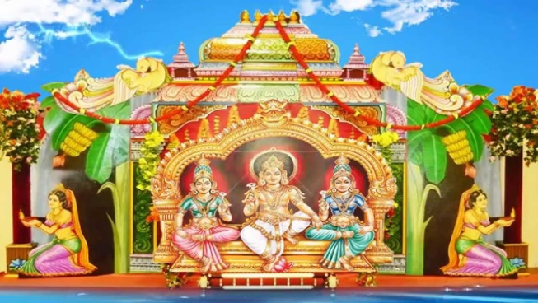
INTRODUCTION
Ayyanar or Sastha is a Hindu deity worshipped widely in South India and Sri Lanka. His worship is prevalent among Tamils, Malayalis and Sinhalese. Early history suggests that Ayyanar have also been worshipped in South east Asian countries in the past. He is mainly worshiped as one of the guardian deities of Tamil Nadu. The village temples of Ayyanar are usually found riding horses or elephants.
History of Ayyanar
Ayyanar is a Tamil adaptation of Aiyan, the chief deity of the rulers of Kerala and Tamil Nadu.
14th century Tamil version of Skanda Purana narrates the history of Aiyanar. Here Ayyanar, sends his chief commander Mahakala to protect Indrani from the demon Surapadman. Mahakala chops down the hands of Ajamukhi, sister of Surapadman, who tried to abduct Indrani for her brother.

Appearance and Importance of Ayyanar
The famous iconography of Aiyan shows him alone, carrying a crooked stick in his right hand. Sometimes a whip, stick, sword can be seen in his hand. His mount is a white elephant. The horse is another mount seen in his temples. Some people say that the tiger is also identified as the mount of Sastha.
Sastha wears black garments and reddish garlands. His body is smeared with yellow paste and he carries a sword in his hand. He is usually depicted having blue or black complexion. Although his two armed form is common, some texts describe his forms with four or eight arms. His general appearance in temples is that of carrying an arrow, bow, knife and sword.
Some records tells us that Ayyanar is accompanied by his two wives popularly known as Purana and Pushkala.

Ayyanar is regarded as the guardian of the villages, riding on either an elephant or horse. He carries a bow and arrow to save his devotees. Pavadairayan, Karuppasamy and Madurai Veeran are his attendants. Ayyanar images installed in villages are usually gigantic.
Tamil devotees did not differentiate between Ayyappan with Ayyanar and they believe that Ayyappan is the avatar of Ayyanar. It can be noted that Sri Lankan Ayyanar temples are being converted into Ayyappan temples following the outbreak of Sabarimala pilgrimage of Sri Lankan devotees in recent years.

Temple worship
Many temples are dedicated to Ayyanar and can be seen all over South India as well as Sri Lanka. Almost all villages of Tamil Nadu are having an Ayyanar Temple. Ayyanar shrines are usually located at the boundaries of rural villages and the deity is seen riding a horse with a sword. Kerala retains its Ayyanar temples as Sastha temples. Many castes of Tamil Nadu worship Ayyanar as their Kula deivam.
CONCLUSION
Lord Ayyanar is a guardian god and will protect us from all the evils. He is still riding his horse and coming to the streets to safeguard his devotees. Those who have strong faith with him, can be able to see him in their eyes and can worship him directly. If we have bhakti with him, definitely he will safeguard us from our enemies and give us a healthy and happy life. Let us pray to Lord Ayyanar and chant his nama ‘OM SREE AYYANARE NAMAHA’.
WRITTEN BY
R.HARISHANKAR

LORD BUDHA
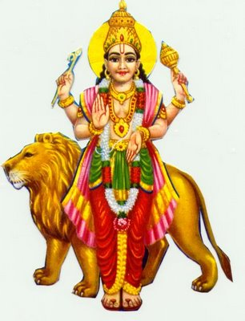
INTRODUCTION
Budha graha is the planet Mercury. Budha, is also a Hindu deity, and is one among the Navagrahas.
He is called by various names such as Soumya, Rauhineya and Tunga. He is the god of Wednesday as per the hindu calendar.
Budha is the famous navagraha and also the son of Lord Chandra and Tara (wife of Brahaspati, Jupiter planet). His wife name was Ila, and they had a son, known as Pururavas, who was the first king of the Lunar dynasty.
Budha is the great devotee of Lord Vishnu, and contains the features of Vishnu.
He looks very handsome and wears yellow clothes and considered as a great demi god.
Wednesday is considered as the auspicious day, especially for doing good things, and to start a new business, construct a new house etc.
Thiruvenkadu Sri Swetharanyeswarar Temple is a famous place for the worship of Lord Budha. It is situated in Nagapattinam district of tamilnadu. Devotees can perform archanai and abhishekham to Lord Budhan and can get better prospects in their life.
In Chennai, Sundareswarar Temple is very famous for worship of Lord Budhan and it is situated at Kovur, nearby porur.
IMPORTANCE
He is a pious and a noble demi god, who always worships Lord Vishnu and praises him. He got the status of becoming a planet through his sincere meditation on Lord Vishnu. He is an ancient god, mostly associated with Lord Vishnu, and he is also considered as a partial incarnation of Lord Vishnu.
He is the giver of peacefulness, good health and wealth to us, if we worship him sincerely and with utmost faith and bhakti. Lord Budhan will be pleased with the sincere devotees of Lord Vishnu, and he will immensely offer his blessings to them.
Let us make a regular practice to worship Lord Budhan in the respective temples meant for him, or otherwise, we can visit any shiva temple, and in the navagraha sannidhi, we can do pooja to him.
He likes green colour, and hence we can offer green moong daal, pumpkin and green fruits as naivedyam (Prasad) to him.
He is also worshipped for curing mental illness and dreaded diseases and for removing the problems caused by black magic. And he protects us from several problems and from our enemies, and makes us to live peacefully and happily in our life.
We can recite budhan slokam and also chant his name frequently for getting better results in our life.
Let us worship the great navagraha god and be blessed.
“OM SREE BUDHA BHAGAVANE NAMAHA”
“OM NAMO NARAYANAYA NAMAHA”
WRITTEN BY
R.HARISHANKAR

LORD CHANDRA
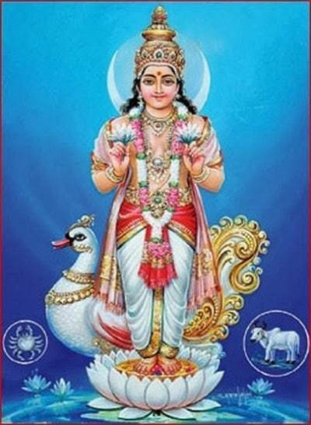
INTRODUCTION
Chandra is one of the nine planets in Hinduism. He was also called as Soma and Indu. He was the son of Atri and Anusuya. Chandra literally means the "Moon".
Chandra is described as a beautiful person. According to Hindu mythology, Chandra is the father of Budha (planet Mercury).
Chandra is the basis of Somvaar,that is Monday as per the Hindu calendar.
In Hindu mythology, there are numerous stories associating with Lord Chandra.
From the union of Chandra and Tara, Lord Budha (planet Mercury) was born. Lord Chandra married Daksha's 27 daughters, but among his 27 wives, he mainly loved Rohini only. Hence his wife’s father Daksha cursed on Chandra to lose his powers. After praying to Lord Shiva, he partially released from the curse.
According to ancient texts,it is also told, that once Chandra laughed at Ganesha by seeing his appearance. Ganesha cursed him to decrease in size. Therefore,It is advisable not to see the moon (Lord Chandra) on Ganesh Chaturthi.
IMPORTANCE
According to astrology,If a person is having Chandra Mahadasa in his planetary position, Lord Chandra will give good memory, make a person to contain good health, develops creativeness and makes him a fearless person and give him sufficient wealth. Similarly, if a person suffers from Chandra Dosham, he will give physical and mental problems to him, and also will affect his relationships between the people around him. In order to overcome from these problems, it is advisable to worship Lord Chandra, especially on Monday’s and to visit Navagraha shrines in Lord Shiva temple, and to offer abhishekham to Lord Chandra Bhagavan. Reciting various slokams in praise of Lord Chandra, also will give good remedy to the problems.

CONCLUSION
The moon god, Chandra is considered as a great god, and gives us all the requirements in our life. Daily evening, he is giving darshan to us and blessing us. We can see him directly from our naked eye without much difficulty. He controls our life, and helps us to move towards a right path. We have to chant his name continuously, so that we can be blessed.
“OM SREE CHANDRAYA NAMAHA”
WRITTEN BY
R.HARISHANKAR

LORD GARUDA
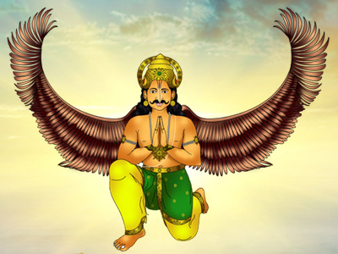
INTRODUCTION
Garuda is a powerful bird. He is the vehicle of god Vishnu, and contains all the good features, and serves Lord Vishnu in a pleasing manner in vaikunta. He always stood in front of Lord Vishnu with bowed hands. He always chants the glory of Lord Vishnu, and wilfully carries Lord Vishnu in his shoulders. His parents are Kashyapa and Vinata. His brother is Aruna, a charioteer of Lord Surya. And his wife name is Unnati.
IMPORTANCE
Garuda is the king of birds and an ardent devotee of Lord Vishnu. He freed his mother from the clutches of his step mother Kadru by bringing the divine drink (Amirtha) from heaven.

Garuda is also worshipped in Buddhism. In Vishnu temples, he is given a prominent place of worship. There is one famous temple dedicated for Lord Garuda which is situated in Mulbagal, Karnataka state.

He is mentioned in Hindu epics such as Mahabharatha, Bhagavatha purana and in Ramayana.

In Ramayana, he has helped Lord Rama from the cluthes of Nagastra. As soon as he arrived near Lord Rama, Lord Rama was freed from Nagastra. And Lord Garuda worshipped Lord Rama, circumambulated him for three times, and went back to Vaikunta.

He helped Lord Krishna towards fighting with the demon king, Narakasura. It is regarded that he is the enemy of the serpants. But he does not cause harm to anyone who are the devotees of Lord Vishnu, and who sincerely worships Lord Vishnu. He is regarded as a divine attendant of Lord Vishnu in Vaikunta.

Garuda Vahana Procession During Festivals
Garuda vahana procession is an important aspect in all vaishnava temples. During Brahmotsava, people gather in large numbers to have a glimpse of Lord Garuda and Lord Vishnu. There is a separate shrine dedicated for Lord Garuda in Sri Ranganatha swamy temple, Srirangam.
CONCLUSION
Lord Garuda a powerful bird and a devotee of Lord Vishnu will bless us for our wellbeing, and give all the prosperities in our life. Let us chant his name and be blessed.
“OM SREE GARUDAYA NAMAHA”
“OM NAMO NARAYANAYA”
WRITTEN BY
R.HARISHANKAR

LORD INDRA
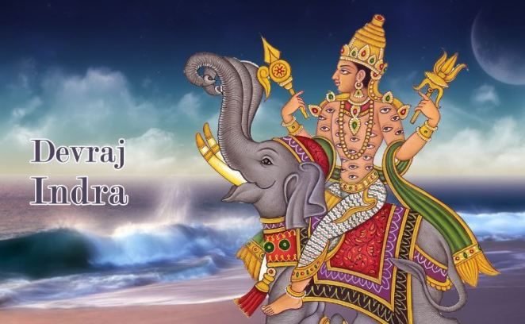
INTRODUCTION
Indra is a Vedic deity in Hinduism, and the king of the heaven. He is the son of Kashyapa and Aditi. He was mentioned in Rig veda, and described him as a most efficient warrior, and a learned scholar who contains valuable powers, and having the capacity to fight with asuras. He is guided by his guru “BRAHASPATI”.
IMPORTANCE
His wife’s name was Indrani. He rides an elephant called Iravatha, and having son and daughter, called as Jayantha and Jayanthi.
He is the god of the heavens and rains. He has got a great name in killing Vritrasura, the most fierceful asura through his Vajrayudha, and is surrounded by several crores of divine devas, who always sing in praise of him. Several rishis and saints also praised his glory and respected him. He was a great valour in the battle field, especially while fighting with the asuras. He looks very charm and gentle in nature.
He never unnecessarily fought with the asuras. Only if the asuras, gives any trouble, in that situation, he fought with them. He was a polite and a humble person. But it is also stated, that in certain situations, for keeping his position permanently, he has given some troubles for those who do severe penance on god. In order to safeguard his position, he has given some problems to those rishis who were in deep meditation.
But in general, he was a great person, and was the leader of devas, and controls the entire universe by his powers. Though, he was controlled by the Trimurthis, he acts freely for taking any decisions on waging war between asuras. Apart from this, he is a very good demi god, and is a clever person. He is interested in having pleasures like drinking divine drink, and listening to the dance of apsaras.
CONCLUSION
Devraj Indra, who was a great person, and the controller of heaven, may give us all the prosperities in our life, and help us to reach his divine place “HEAVEN” after our departure from earth. Let us pray to him, and be blessed.
“OM SREE DEVRAJ INDRANE NAMAHA”
WRITTEN BY
R.HARISHANKAR
LORD KARUPPANNA SWAMY
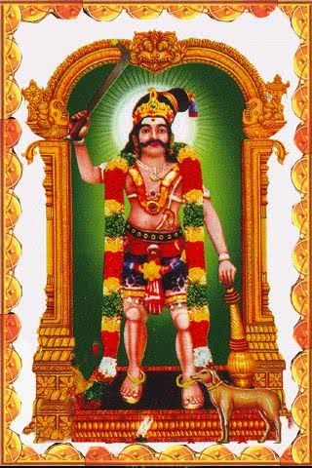
INTRODUCTION
Karuppanna Swamy or Karuppusami, is one of the Hindu deities popular among the rural social groups of Tamil Nadu and also in Kerala. Karuppannaswami is also known as Navaladian and Pattamarathaian. He is regarded as an AMSA of Ayyanar and hence he is considered to be the KAVAL DEIVAM(Demi God) as per Tamil tradition. Karuppusami is also considered as an avatar of Lord Vishnu, since he has appeared out of Vishnus right hand.
Temples
Karuppanna Swami temple is mostly found in the outskirts of the Village. Usually, the whole village contributes to the welfare of the temple. These temples do not have Gopurams and have large statues of Gods with large eyes, holding weapons like bow and arrow, swords, sickle and other weapons. The temples of Karuppanna swami is located all over tamil nadu. In Chennai, there is a famous temple for Karuppanna swami with the name ‘Sri Navaladi Karuppana Swamy Temple’ and the address of the temple is No.14,V.V.Giri Street, Meenakshi Amman Nagar, Alwarthirunagar, Chennai – 600 087. There is also a famous Pathinettampadi Raja Karuppannaswamy temple in Chenthamangalam near Salem.

Worship of Karuppannar
Karuppannar worship is a very ancient worship system. Most of the priests are non-Brahmins and they are the local villagers. The worship pattern is through folk tales, songs and arts.The midnight puja called 'Sathya Puja' is considered very important by the devotees. The local priest will offer flowers and vibuthi to the worshippers. They undertake fasting and maintain purity during the period. The devotees submit their prayers to Lord Karuppannaswami in writing.. The normal problems addressed are family problems, financial troubles and local community and social issues. Whenever the wishes of the people are granted, they give their offerings to him based on what they promised to offer.
Karuppanna Samy is also worshipped in other countries under the name Karupu or Sangili Karuppar. Offerings of cigarettes, biscuits, butter, ghee, and alcohol as well as a sacrifice of a black chicken or goat are made to him.

Festivals
The village committee would decide on when the annual festival is be conducted. The time of the year when this would fall varies from one village to another village. The commencement of the festival will be with that of a hoisting of the flag and tying the "Kaappu". After this time, villagers cannot go out of the village, but can come in from a different village. During this annual festival, a large number of goats and chicken are sacrificed for Karuppanar. He is also offered Beedis and alcohol.

CONCLUSION
Karuppana swamy is a guardian god who protects us in all times and gives us happiness in our life and he mainly removes fear from our mind. He is the one who bless us whenever we submit our prayers and make the offerings to him. Let us pray to Lord Karuppanna Swamy and chant his nama ‘OM SREE KARUPPANNA SWAMIYE NAMAHA’
WRITTEN BY
R.HARISHANKAR

LORD KUBERA
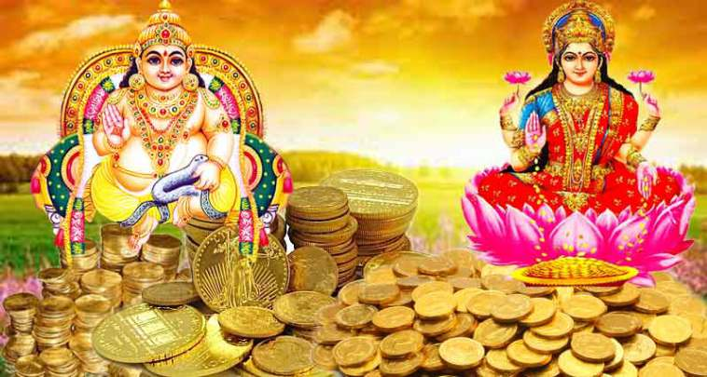
INTRODUCTION
Kubera is the Lord of Wealth and the king of Yakshas as per Hinduism. He is the son of Vishrava and Illavida. His wife name is Bhadra. And his children are Nalakuvara and Manibhadra. He is regarded as the protector of the entire world.
IMPORTANCE
Kubera was known to be as one of the powerful god as per Puranas. Previously he was the ruler of Lanka, and afterwards when he was defeated by Ravana in treta Yuga, he left Lanka and settled in Alakapuri and he is the king of that region. Kubera was praised in the Buddhism and Jainism texts. Kubera is described as the person containing "wealth, prosperity, glory", and gives it to us, when we worship him sincerely and faithfully.
Kubera was worshipped for giving good fortune as well as the giver of all the benefits in our life. Lord Kubera is the ruler of Yakshas, and his palace and his region is similar to that of Lord Indra’s ‘SWARKA LOKA’. His palace is well decorated with gold and diamonds, and fully installed with golden marbles. His glory was well praised by Narada and Tumburu, the divine sages. He is ruling his kingdom in a very generous manner, and treats all as equal.
In Venkateswara Mahathmiyam, It was stated that Lord Kubera has given a loan amount to Lord Srinivasa for performing his marriage with goddess Padmavathi. And it is told that Lord Srinivasa in Tirumala is receiving huge donations from devotees and repaying his debt to Lord Kubera. From this incident we can know the greatness and importance of Lord Kubera. He has lent money to the God himself. Mostly he is worshipped along with goddess mahalakshmi. There is one famous temple dedicated to Lord Kubera which is situated in Kuberan Koil, Anna Main Rd, Rathinamangalam, Tamil Nadu 600127.
CONCLUSION
Lord Kubera, the god of wealth and happiness, must be worshipped by us on a daily basis. We should sincerely devote him, in order to obtain all the prosperities in our life. Let us chant his name and be blessed.
“OM SREE KUBERAYA NAMAHA”
WRITTEN BY
R.HARISHANKAR

LORD MADURAI VEERAN
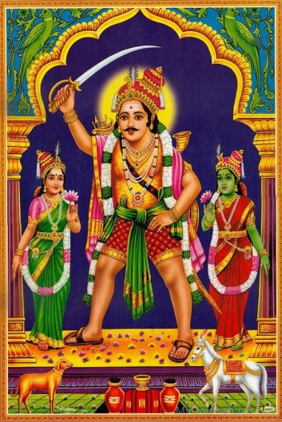
INTRODUCTION
Madurai Veeran is a Tamil folk deity popular in southern Tamil Nadu, India. His name was derived as a result of his relationship with the city of Madurai and he is the protector of Madurai. Madurai Veeran protected Madurai and Madurai Meenakshi Amman Temple and is still protecting Madurai and all of his devotees.

Worship
Madurai Veeran is commonly worshiped as a guardian deity by the Tamils. When the town of Madurai was troubled by bandits, the Pandyan king ordered Veeran to fight. Veeran then met Vellaiyammal, a royal danseuse, and both of them were attracted against each other.
The Pandyan king, who was himself attracted to Vellaiyammal, did not encourage this affair. Some people in the king’s court complained to the king that the delay in attacking the robbers was due to the fault of Madurai Veeran. This made the king to become furious, and chopped his one hand and one leg and afterwards he ordered his guards to kill him also. On hearing about this, Bommi and Vellaiyammal(both of them loved Madurai Veeran), asked the king for the injustice caused to Madurai Veeran.
History says, that Madurai Veeran is brought back to life by the effort of Bommi and Vellaiyammal. Veeran, thereafter has taken his shelter in Madurai Meenakshi Amman Temple.
A shrine was later erected at the east gate of Meenakshiamman Temple by the Pandyan king. The story persists through the singing of songs and street theatre.

Temples
Today there are several temples dedicated to Madurai Veeran across tamilnadu, kerala, Malaysia, Singapore and south africa. One famous temple dedicated to Madurai Veeran is situated in Hanumanthapuram,Chenglepet District,Chenglepet,Tamilnadu. At this temple there are shrines for 18 feet statue Maduraiveeran, Pachaiamman,Nataraja,Bhairavar and Karrupannaswamy besides seven kannimars. All of these deities are KULADEIVAM to many people and also are KAVAL DEIVANGAl for all the people who worship them. He still protects his devotees from thieves and he is worshipped by everyone, without any caste discrimination.
Nearby my home, one small road side temple is dedicated to Madurai Veeran in Agaram, Chennai. People will gather in that temple during festivals and give their offerings.

CONCLUSION
Madurai veeran who is a guardian of Madurai, will also be with us as our guardian, and will protect us from all sorts of problems, and safeguard us from our enemies. We can worship Madurai veeran by going to his temples or otherwise, we can worship him at our home with his picture. He will definitely answer to our prayers and will be with us. Let us pray to the Great and Brave Madurai Veeran for our wellness in our life and chant his nama ‘OM SREE MADURAI VEERANE NAMAHA’.
WRITTEN BY
R.HARISHANKAR

LORD MANGALA
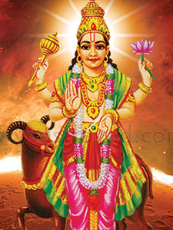
INTRODUCTION
Mangala is the name for the red planet mars, according to hindu mythology. He is the warrior god and also contains the features of Lord Murugan. According to some ancient texts, he is believed to be the son of Bhumi Devi and Lord Vishnu. Whereas in other texts, it is stated that he was born from Shiva's power. He is also mentioned in the rig veda and also in many ancient texts.
Mangala is the god of Tuesday as per the Hindu calendar. Mangala is one among the Navagrahas.
His appearance is red colour, with weapons in his hand. And his right hand shows a blessing posture. And in one hand he carries the lotus. His vehicle is a ram.
His other names are as follows:
1. Angaraka
2. Raktavarna
3. Bhauma
4. Lohitanga
5. Kuja
6. Bha
IMPORTANCE
Mangala, the god of Tuesday is worshipped by the hindus as a powerful god. Persons who are suffering from Angaraka dosham are advised to worship him at Vaitheeswaran kovil, Tamil nadu, to get rid of the evil effects caused by the planet mars. Those who are not able to visit the temple at vaitheeswaran kovil, can visit any shiva temple and worship Lord Angaraka in the navagraha sannidhi of the temple. We can worship him with red rose and also can do archanai and abhishekham to him, in order to please him. It is also better to go the amman temples and murugan temples on Tuesdays.
It is also advisable to offer food to the poor and the needy on Tuesdays at any murugan, amman or shiva temple, in order to reduce the problems caused by the planet mars (angaraka)
. We can make a simple worship to him, and that is enough in order to please him and will give all sorts of prosperity in our life. He expects only sincere bhakti from us. We can also chant various names and slokas of angaraka, in order to get better results in our life.
Let us worship him and be blessed.
“OM SREE ANGARAKA BHAGAVANE NAMAHA”
WRITTEN BY
R.HARISHANKAR

LORD MUNISWARAN
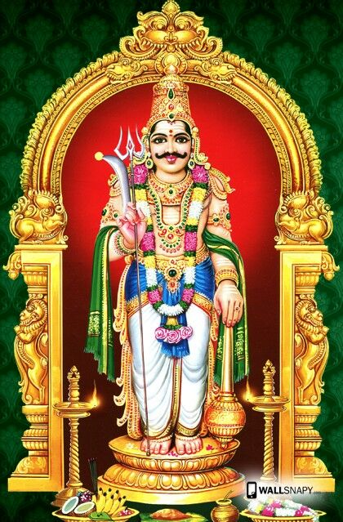
INTRODUCTION
Lord Muniswaran is a Guardian God. He is the one who protects his devotees in their life. He is having various good qualities like knowledge, power, wisdom, and affection. "Muni" means "saint" and "Ishwara" represents Shiva. He is generally worshiped as a family deity in south india. Muniswaran is also called "Muniyandi". and also as "Muniswarudu".

Daksha’s Yagna,Veerabadra and Muneeswaran
Dakshayani was the youngest daughter of Daksha, the chief of the gods. And Dakshayani got married to Lord Shiva.
One day Daksha made arrangements for a great Ashwametha Yagna, and he invited all the gods excepting Lord Shiva, since he dislike him. Dakshayani, being dishonoured by Daksha, immolated herself and fell dead. When Shiva heard about this news, he created Lord Veerabadra, who was a brave and a powerful god and carried terrible weapons. Virabhadra bowed at Shiva's feet and asked his will.
Shiva directed Virabhadra to destroy the yagna of Daksha. As per the instruction of Shiva, Virabhadra went into the place of yagna with Shiva's ganas and destroyed the participants of the yagna. In order to protect the good souls, Shiva has created Muniswara. He was a great personality and an Amsa of Lord Shiva.

Worship of Lord Muniswara
The worship of Muniswara is popular in Karnataka, Andhra Pradesh, Vellore District and North Tamil Nadu, Singapore and Malaysia, with many temples dedicated to him. There are many small temples in Sri Lanka where Indian Tamil population is largely found. During the British period, people from various places of Tamil Nadu brought the deity of Muniswaran to Sri Lanka. Since his weapon is the Trident(Soolam in tamil), Muniswara temples will contain a trident placed in the ground, and limes are placed upon the prongs of the trident. In most of the villages in India, the deity is a laid stone. When statues of Muniswara are used, they are painted, in contrast to the black granite statues in other Indian temples. Muniswara is generally worshiped either as a fierce God or a peaceful God. Those who worship his fierce form will offer him animal sacrifices.

The list of various muneeswaran temples in tamil nadu are as follows:-
- Body Guard Muneeswaran Temple,Pallavan Salai,Chennai
- Muneeswaran Temple,Kovilanchery,Chennai
- Muneeswaran Temple,Chengalpattu
- Vaipoor Sree Muneeswaran Temple,Nallamperumbedu
- Sri Muneeswaran Temple,Ranipet,Tamil nadu
- Sri Muneeswaran Temple,Melmaruvathur,Chennai
- Pal Muneeswaran Temple,Villivakkam,Chennai
- Sri Muneeswaran Temple, Senjikothamangalam.

Importance of Lord Muniswaran
Many families kula deivam is Muniswaran. He is the one who protects his devotees in case of their difficult situation. He relieves various diseases of his devotees, removes black magic and brings happiness in the families of his devotees. Pal Muniswaran, is a form of Muniswaran, who is considered as a vegetarian deity and he does not accept any animal sacrifice.

CONCLUSION
Thus it can be concluded, that by worshipping Lord Muniswaran, we can attain health, wealth and happiness in our life. He will give good prospects in the life of his devotees. If we go to his temples and worship him, we will get peace of mind and our day to day problems will vanish and also our body will become healthy. Whenever we go anywhere, he will come with us like our bodyguard and will protect us from our enemies.But only thing is that, we should have pure bhakti and faith on him.Let us chant his nama ‘OM SREE MUNISWARAYA NAMAHA’ and live happily for ever.
WRITTEN BY
R.HARISHANKAR

LORD PAVADAI RAYAN SWAMY
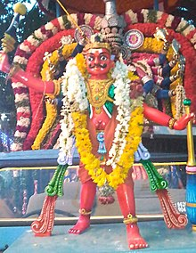
INTRODUCTION
Lord Pavadairayan is one of the Tamil male deities. He is very popular within the villages. He is one of the Kaaval Dheivams of Tamil Nadu, India. He is the son of Goddess Angala Parameswari. He is also said to be the guard for Goddess Angala Parameswari.
Once Lord Shiva destroyed the fifth head of Lord Brahma, and then afterwards he got Brahmahathi Dosha. And then, Lord Shiva came to earth and roamed everywhere.

During this period, Pethandavan was a leader for Kalvikkadu. His job was to do robbery in other places and serve his people. Pethandavan and his wife Pethandachi prayed to Lord Shiva for a child and with the blessings of Lord Shiva, they had a male child
and they named him "Kalvikaathaan" (the protector of Kalvikkadu). In course of time,Pethandavan become old and he ordered his son to take his position and to protect his region. But Kalvikaathaan was not interested in taking his father's job, and then he started to take a walk away from his region. He walked far away from his town.

As the time passed, the sun set and the darkness prevailed. Kalvikaathan saw a flame and was afraid with that, immediately the flame replied, that she was goddess Angala Parameswari.
Goddess Angalaparameswari and Pavadairayan
Angala Parameswari has asked him to construct a temple. As per the instructions given by Goddess Angala Parameswari, Kalvikaththaan constructed a temple for her.

Guardian God
Goddess Angala Parameswari was happy and her temple was built successfully with all the proper rituals. The temple was Melmalayanoor Angala Parameswari Amman Temple. She gave authority to him that he would be her Guard. Lord Pavadairayan serves as a family deity or Kula Dheivam for most of the people.
In Melmalayanoor Angala Parameswari Amman Temple, Lord Siva was sitting next to Goddess Angala Parameswari Amman inside the temple. And at outside the temple, Pavadairayan has a separate sannadhi, facing the Goddess Angala Parameswari Amman along with his two wives Aranatchi Amman and Muthunatchi Amman blessing their devotees.
Usually in the system of Kaval Dheivam, the deities will be outside the sannadhi of the main god. But Lord Pavadairayan is the only Kaaval Dheivam ,who has been given a status to sit in the lap of Goddess Angala Parameswari.

Worship of Pavadairayan
Lord Pavadairayan is worshipped mostly in the form of “stones” and "Trees". In most of the Goddess Angalaparameswari's temples, Pavadairayan has a separate Sannidhi in which people worship. There are only a few temples for Lord Pavadairayan.
Temples dedicated to him
1.Sree Paradhesiyappar Pavadairayar Temple, Vallam Padugai, Cuddalore
2.Sree Pavadairayan Temple, Madhuranthaganallur, Chidhambaram
3.Arulmigu Paavadairayar Temple, Erimedu, Budhangudi
4.Paradhesiyappar Pavadairayar Temple, Near Udayarpalayam Bus Terminus, Ariyalur
5.Angala Parameswari Amman-Pavadairayan Temple, Periyapattu, Chidambaram Taluk, Cuddalore
6.Angala Parameswari Amman - Pavadairayan Temple, Alangudi, Tiruvarur District.
Temple in Malaysia
1.Om Shree Maha Pavadairayan Aalayam, Bestari Jaya, Kuala Selangor, Selangor, Malaysia.

CONCLUSION
It can be said, that being the son of Goddess Angala Parameswari, he is having the power equivalent to that of Goddess Angala Parameswari. He is the deity who can be worshipped in all the families. Being a guard of Angala Parameswari, he also safeguards us from all sorts of difficulties in our life and eliminate our sins and causing happiness in our life. Let us pray to the great Pavadairayan and chant his nama ‘OM SREE PAVADAI RAYANE NAMAHA’.
WRITTEN BY
R.HARISHANKAR

LORD SURYA
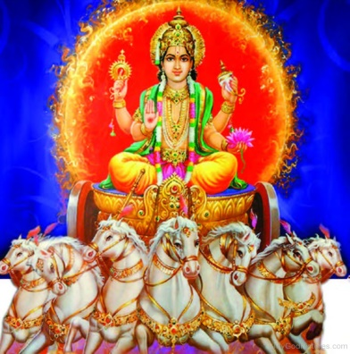
INTRODUCTION
Surya is the sun god, and he is called by various names such as Aditya, Bhanu,Ravi, and Marthanda. He was the son of Kashyapa and Aditi.
IMPORTANCE
Surya has been worshipped since ancient periods. His worship is mentioned in vedas, uphanishads,puranas and also in other ancient texts. His worship is mainly found in northern parts of India in states such as Gujarat, Bihar, Maharashtra, Uttar Pradesh and Odisha.
Major festivals related to Lord Surya include Makar Sankranti, Ratha Sapthami and Kumbh Mela.
Surya is residing at Suryaloka along with his two wives Saranyu and Chaya Devi. His children are Yama,Yamuna, Ashwin Kumaras and Lord Shani Dev. He is travelling in his chariot driven by seven horses, and his charioteer name is Aruna.
Surya is giving lot of benefit to the entire universe. Without his light, nothing can be done in this world. He is needed for giving light during the day time and also for growing up of agricultural crops, for giving rain and many more. Doing Surya Namaskaram is very good one, especially for people suffering from poor health, such as suffering from skin diseases, leprosy and mental illness. Lord Surya also gives us several benefits through his sun light, mainly by protecting us from skin related diseases. He is treated and worshipped as Lord Vishnu widely all over India. He is also called as “SURYA NARAYANAN”, the one who protects the entire universe.
Lord Surya also is considered as the Guru of Lord Hanuman. Surgriva and Karna were considered as his sons. He occupies an important place in Hinduism, and is one of the nine navagrahas(Planets).

Famous Temples
- Arasavalli sun god temple, Andhra Pradesh
- The konark sun temple, Odisha
- Suryanar Kovil, Kumbakonam,Tamil nadu
- Sun Temple, Ranchi,Jharkhand
- Sun Temple,Assam
- Sun Temple in Jammu and Kashmir
- Sun Temple, Gwalior,Madhya Pradesh
CONCLUSION
For explaining the importance of sun god in detail, we have to publish a separate book itself. He contains such as lot of valuable features within him. We should take at least a few minutes time in the early morning, and worship him sincerely, so that we can do our duties properly, and without much difficulty. We have keep it in our mind that, daily he is doing his duty without taking any rest, and we also have to follow it by worshipping him sincerely and faithfully, and can get his divine blessings.
“OM SREE SURYANARAYANARE NAMAHA”
WRITTEN BY
R.HARISHANKAR
LORD VARUNA
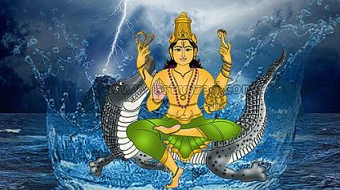
INTRODUCTION
Varuna is a Hindu deity related with the seas. He is found in the Vedic literature of Hinduism. He is the god of sea and rain. He is under the control of Lord Indra. He receives the instructions given by Lord Indra, and will do according to his favour.
In the Hindu Puranas, Varuna is the god of oceans,and his vehicle is a Makara(Sea creature), and his weapon is a rope loop. He is regarded as the guardian deity of the western direction. He is also regarded as the father of the great sage Vasishta.

IMPORTANCE
According to Rigveda, Varuna is considered as the protector of moral law. He is mentioned in many epics, and was praised by holy sages for his superior powers.
In Yajurveda, Varuna is said to be an AMSA of Lord Vishnu, it means Varuna contains the feature of Lord Vishnu. He is also considered as the main deity of physicians. His importance is mentioned in detail in various Upanishads.
In Ramayana,Lord Rama tried to cross the sea for going to Lanka, in search of his wife sita. For crossing the ocean, he sought the help of Lord Varuna. But Varuna doesn’t respond to his prayers and kept silent. Rama got angry with him and tried to punish him through his arrows. After that, Lord Varuna responded and promised Lord Rama, that he will help him for crossing the ocean, and further promised him, that the bridge will not get sink into the water.

CONCLUSION
Varuna is a great god, and is the giver of rain. In hindu temples, Varuna homam will be conducted in order to get the required rain during the rainy season. Lord Varuna is also prayed for getting relieved from water related diseases like common cold, diabetes,illness caused towards consuming bad water, and also cures all other types of dreaded diseases also. But the main thing is, we have to worship him with pure devotion in our mind with full concentration on him, and by chanting his name for several thousands of times. Let us pray to Lord Varuna and be blessed. Let us chant his name, and live peacefully for ever.
“OM SREE VARUNAYA NAMAHA”
“OM SREE INDRAYA NAMAHA”
“OM SREE VISHNUVE NAMAHA”
WRITTEN BY
R.HARISHANKAR

LORD VAYU
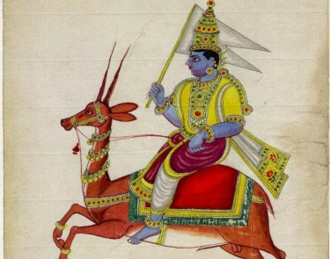
INTRODUCTION
Vayu is a Hindu deity, the wind god, and the father of Hanuman and Bheema. He is controlled by Lord Indra, the god of heavens. And he is a sincere devotee of Lord Vishnu.
IMPORTANCE
He was the father of Lord Hanuman in Tretha yuka, and has done a great service to Lord Rama. He was the father of Bheema in Dwapara yuka, and has done a great service to Lord Krishna. In Kaliyuga, he again incarnated as Madhwacharya to do service for the great Rishi Vedavyasa, and it is believed that still he is doing his divine service to Sree Vedavyasa in Bhadrikashram.
Lord Vayu contains a lot of important features. He is the base for all the living beings in the earth. Without his help, no one can survive in this world. Even by possession of his great power, he was a humble and a gentle demi god, who always worships Lord Vishnu and keep chanting his various names for ever. He is also been controlled by Lord Indra, and he acts as an assistant to him. He has to follow his instructions, and to act accordingly. Once Lord Hanuman in his childhood, tries to catch the sun god thinking that it was a fruit. By seeing his action, Lord Indra hit him with his powerful weapon Vajrayudha. Lord Hanuman could not withstand the power of the weapon, and he immediately fell on the ground and was laid in an unconscious state. By seeing his son’s condition, Lord Vayu, stopped his air circulation among the human and divine beings in the earth and heaven, and everyone was suffered by this act. After some time, the gods pacified vayu, and regained hanuman to his normal position, and offered many great boons to him. Lord Vayu became happy and again he circulated his air movement all over the heaven and the earth. With this incident, we can realize his great supreme powers.

CONCLUSION
We can’t live if we stop our breath. We are able to live only because of the Lord Vayu, who helps us for breathing in this world. Let us worship this great demi god Lord Vayu Bhagavan and be blessed.
“OM SREE VAYUDEVARE NAMAHA”
“JAI SREE RAM”
WRITTEN BY
R.HARISHANKAR

LORD VEERABAHU
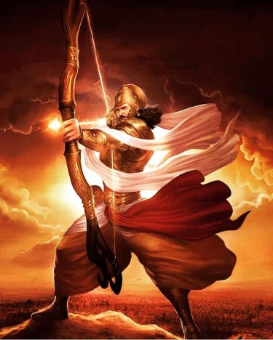
INTRODUCTION
Veerabahu is the Army Chief of Lord Muruga. Lord Muruga is the son of Lord Shiva and Goddess Parvathi. Through the power of Goddess Parvathi, nine soldiers were born to help Lord Muruga in the battle field. Among the nine commanders, Veerabaahu is the main commander of Lord Muruga’s army.
IMPORTANCE
Veerabahu acted as a mediator between Lord Muruga and the Asura King soorapadman. Veerabahu has advised soorapadman to avoid the war, and asked him to act in a friendly manner with Lord Muruga. But soorapadman arrogantly behaved with Veerabahu, and started the war with Lord Muruga. Veerabahu occupied an important role in winning the battle with soorapadman.

CONCLUSION
Veerabahu an army chief of Muruga, after winning the battle with Soorapadman, was given a permanent place in the abode of Lord Muruga. In most of the Murugan temples, a separate shrine will be there for Veerabahu. He was born from the supreme power of Maa parvathi, hence he is having all the good qualities like wisdom,courage,kindness and boldness.
He is sincerely listening to the problems of the de votees, and informing it to Lord Muruga. He removes the diseases of the devotees, and gives happiness in their life. He will be very much satisfied with those murugan devotees, who took kavadi and vel piercing in their body. He will take care of those devotees, who sincerely worship Lord Muruga. Based on their good and bad deeds, he will give the result. If a devotee cries for any help and call his name, he will be present there, and give his immense help. Let us worship this great Veerabahu, and let us chant his name and be blessed.
“OM SREE VEERABAHUVE NAMAHA”
“OM MURUGA VEL MURUGA”
WRITTEN BY
R.HARISHANKAR
LORD YAMA
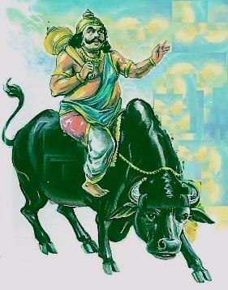
INTRODUCTION
Yama or Yama Dharma raja is the god of death. He is the son of Surya and Saranyu. His sisters are Yamuna, tapti and Bhadra, and his brother is Lord Shani Dev. By the divine grace of Lord Shiva, he became the ruler of the departed souls, and is called as the "Lord of the Pitrus".
IMPORTANCE
Lord Yamadev who was also called as dharma raja or dharma prabhu will take our souls to his place, and do his justice as per our Karmic deeds, and it is believed that persons who has done good karma will be sent to heaven, and persons who has done bad karma will be sent to hell, and will be severely punished by his attendants. He will never award injustice to the true devotees of god, and those who frequently chant the names of god, and they will be allowed to go to the suitable divine places as per their good karma. It is advisable for those who are suffering from dreaded diseases and mind related problems to do “MAHA MRITYUNJAYA HOMAM” for restoring good health, and for living a longer life without any worries in their life.
Lord Yama is also praised in Buddhism, and he is worshipped in Srilanka in the name of Dharmapala. It is also believed that the great Vidura and Yudhishtra of Mahabharatha were the incarnations of Yamadharmaraj.
In Himachal Pradesh, there is a temple dedicated to Lord Yama known as “DHARMESHVAR MAHADEV TEMPLE”. Devotees will visit this temple and offers their worship to Lord Yama Dev for maintaining a good health and for a long and peaceful life.
Lord Yamadharmaraj maintains the track of records of human beings good and bad deeds with the help of “SREE CHITHRA GUPTA”. He is a divine accountant and verifies the good and bad things done by us in this earth, and will make the correct calculations and keep it in record and show it to Lord Yamadharmaraj. They will be given the correct justice by Lord Yama as per their deeds.
There is also a famous temple for Chitragupta in Kanchipuram, and he is worshipped by a large number of devotees, especially during “CHITRA POURNAMI FESTIVAL” which falls during the English month of April.
CONCLUSION
Yama and Chitragupta are worshipped widely all over India. There is no need to get afraid of them, if we have not committed any greater sins to others. Both of them are worshipped mainly for removing our sins to some extent, and to lead a healthy and to live a sustainable life. It is advisable for those who visit Arunachaleswarar Temple at Tiruvannamalai, to worship Lord Chitragupta shirine situated inside the temple. Let us worship them and be blessed.
“OM SREE YAMADHARMA RAJAVE NAMAHA”
“OM SREE CHITRAGUPTARE NAMAHA”
“OM SREE ARUNACHALESWARAYA NAMAHA”
WRITTEN BY
R.HARISHANKAR

RAHU AND KETU
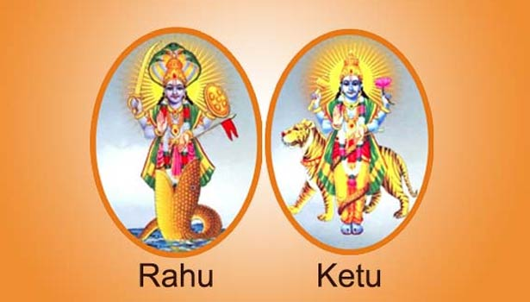
INTRODUCTION
Rahu and ketu are the powerful grahas as per hinduism. Rahu and ketu both are snake deities, who are responsible for causing eclipses of the sun and the moon, and they are also considered as the supreme among serpants.
Rahu and Ketu are interlinked with each other.
Rahu and ketu are mentioned in the ancient puranas and in various divine texts.
Once, the gods and the demons churned the Milk Ocean to get the Amrita, the immortal drink from the ocean. Rahu was available at that time and sat along with demi gods and drank the Amrita. He was watched by the demi gods, and they informed Mohini (Female form of Lord Vishnu). However, by that time Rahu, had drunk the divine drink, and become immortal. Lord Vishnu (in the form of mohini) got angry and removed Rahu’s head with his powerful weapon Sudarshan Chakra. Rahu’s head was separated from his body and his head was known as Rahu, and his body was known as Ketu. From then onwards, Rahu and Ketu were given the responsibility to influence the lives of the humans on Earth, based on their karmic deeds.
There is a famous temple for worshipping Lord Rahu, which is situated in Thirunageswaram near Kumbakonam. There is a famous temple for Ketu at Keezhaperumpallam in Nagapattinam district. It is also situated near kumbakonam.
Lot of devotees who suffer from sarpa dosha will visit the above temples and offer prayers and do pujas and perform abhishekham and archanai to them to get relieved from Sarpa dosha.
Providing water and food to the animals and birds is also considered as a good human act, and will satisfy rahu and ketu and will give better results in our life, and also our bad karmas will be reduced.
We can also reduce the ill effects caused by rahu and ketu by offering food to the poor and the needy, by giving clothes to the poor, providing shelters to the homeless people, and also by doing various social welfare activities.
IMPORTANCE
The two snake gods, rahu and ketu contains super natural powers, and are giving the good and the bad results in our life on the basis of our good and the bad deeds. There is no need of getting afraid of them. If we worship them sincerely with utmost faith and devotion in our mind, and also by doing good activities in our life, we can reduce the bad effects of rahu and ketu to some extent. There are various mantras for rahu and ketu, and if we chant the mantras properly, they will get satisfied, and we will be well protected by them.
Let us worship the great snake gods and be blessed.
“OM SREE RAHU BHAGAVANE NAMAHA”
“OM SREE KETU BHAGAVANE NAMAHA”
WRITTEN BY
R.HARISHANKAR

SHANIDEV
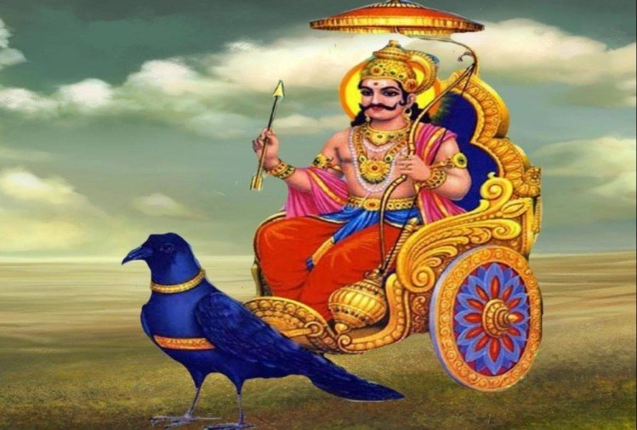
INTRODUCTION
Shanidev refers to the planet Saturn, and is one of the important Navagraha in Hinduism. He is the god for Saturday as per Hindu calendar. Shani is also referred in the Puranas and in vedic texts, and his mount is crow. He is the God of Justice in Hindu religion and will give favourable or unfavourable results to all, depending upon on our good and bad karma. He is the son of Lord Surya and goddess Chaya. His wives are Manda and Neela Devi. His sons are Maandhi and Kuligan.
The name of Shani is mentioned in ancient vedic texts and scriptures, and is praised for his great power.
Some people consider Lord Shani as highly inauspicious and for giving bad results in life. That is not correct, he is the justice god, and always will do goodness in our life, if we have sincere bhakti on god and if we do good things in our life. Based on our past and present, good and bad deeds, he will deliver positive or negative effects in our life. He is the giver of boons and blessings to us based on our pure devotion on him.
Few years ago, a tall statue of Lord Shani was installed at Medak district, nearby Hyderabad. It is worshipped by the people from all parts of india. Shani Singnapur temple is a very famous temple situated in Ahmed Nagar, Maharashtra.
In tamilnadu, thirunallar Dharbaranyeswarar temple is very famous for worshipping Lord Shani, in order to get rid of our sins, and to get prosperity in our life. Kuchanur temple at Theni district is also a famous temple where suyambu idol of Lord shani is present there, and worshipped by the people with great bhakti. In Chennai also some famous shani temples are there. Among that, Pozhichallur Shaneeswarar is very famous, which is situated nearby pallavaram.

IMPORTANCE
Shani dev is the most powerful god, among all the other navagrahas. He will be pleased by wearing black clothes on Saturday, and by doing abhiskham to him in sesame oil on Saturdays, and by worshipping him in the respective temples meant for him, or otherwise we can worship him in the navagraha shrine of the shiva temples. Blue coloured flowers are offered to him. He loves black and his favourite food item include black sesame laddus prepared with jaggery, and black pulses are also offered as naivedyam(Prasad) to him.
Feeding to the poor and hungry will please him, and will offer his immediate blessings on us. He will be very much impressed, if we do good things to the poor, by offering clothes, providing shelter, and helping the poor children in their education, building temples and by respecting our elders, and taking care of our parents in a proper manner.
There is no need to avoid him with regard to worship, since he is a god of justice, and whatever fate is placed on us, we have to suffer or live happily, based on the judgement given by Lord Shani through our good and bad deeds. He will give the correct judgement, and we cannot escape from his judgement. He is watching us in every moment of our life, by calculating our good and bad karma, and giving the good and bad results to us. Let us always do good things in our life, and worship Lord Shanidev and live happily for ever.
“OM SREE SHANI DEVAYA NAMAHA”
WRITTEN BY
R.HARISHANKAR

SHUKRA
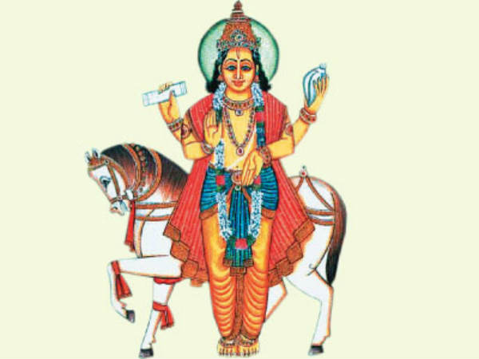
INTRODUCTION
Shukra is the planet Venus, one of the Navagrahas. He is also the god of Friday as per the Hindu calendar. He is also known as Shukracharya, and is the guru for Asuras. He is mentioned as the son of Sage Bhrigu, and Kavyamata. And his wife is Jayanti, and their daughter is Devayani.
Velleeswarar Temple, Mangadu is a famous temple for worshipping Lord Shukra. It is situated near poonamallee, Chennai.
Agneeswarar Temple situated at Kanjanur, near kumbakonam is also a famous temple for worshipping Lord Shukra. As per the great epic Mahabharata, Shukracharya was the guru of Bhishma, and taught various divine subjects to him.
Shukracharya is mentioned in most ancient hindu texts, and also in Buddhist texts.
IMPORTANCE
By worshipping Lord Shukra we can get courage, confidence, wealth and happiness in our life, based on our planetary position. He will also give a happy married life with good children in our life. He is a very ancient demi god. He likes white rice, sugar and white fruits. It is better to offer these things as naivedyam(Prasad) to him in order to get good results in our life.
We can please Lord Shukra by doing the following activities:
- Worshipping goddess Lakshmi on Fridays with white flowers.
- Doing various charity on Fridays will please Lord Shukra.
- Wearing white coloured clothes on Fridays.
- Going to the respective temples mentioned for Shukra on Fridays, or going to shiva temples, and visiting the navagraha shrine and by doing archanai and abhishekham and decorating him with flowers.
- Doing abhishekham for goddess Lakshmi will please Shukra and will give good fortunes in our life.
- By chanting the mantra meant for shukra for several thousands of times as a daily practice.
- He is also a great devotee of Lord Shiva, and worshipping him and chanting shiva mantra will also please him.
He was the guru for many famous asura kings, such as Bhakt Prahalad and his descendants such as mahabali and banasura, and guided them properly.
He removes the negativity of thoughts and suicidal thoughts from our mind, and will make us to live peacefully and happily. He will also cure various dreaded diseases and mind related problems. We will get great strength and power in our mind and body by worshipping him.
Lord Shukra is a great demi god, and possessed all good qualities and was the most powerful Navagraha. By worshipping him, with utmost faith and bhakti will benefit us in the long run.
Let us worship him, and be blessed.
“OM SREE ASURA GURU SHUKRACHARYARE NAMAHA”
WRITTEN BY
R.HARISHANKAR

ARULMIGU SUDALAI MADA SWAMY
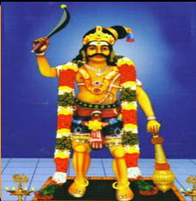
Introduction
Sudalai Madan is a divine hero known to have performed rites in temples and in graveyards who is generally worshipped by Tamil people in South India, particularly in the Tamil Nadu region. He is regarded as the ‘Shiva Amsa’. He look furious but gentle among his devotees. He is regarded as the Demi God and is the one who offers the divine blessings to his devotees and fulfil the wishes of his devotees at the right time. He is the protector of people in this Kali Yuga. Daily he is safeguarding his devotees during their daily aspects of their life. He is the one who is satisfied by the neiveidiyam offered by his devotees. And gives health, wealth and happiness in the life of his devotees. According to one ancient story, he was created by Lord Shiva, so he is considered as the son of Lord Shiva and Goddess Shakti. Madan means protector and sudalai means cemetery or burial ground. He is the eradicator of evil forces and bridles evil forces. Evil forces are believed to emanate from cemeteries and burial grounds. Sudalai reigns over evil forces, so Sri Shiva thus dubbed him as Sudalai Madan. Sudalai is also termed as the Kaval Deivam, or the protecting deity. Sudalai Madan is paramount of the protecting deities. Sudalai Madan is often termed as "Maharaja". He is worshipped by lot of people in tamil nadu, since their kula deivam is sudalai madan. He has done lot of miracles to his devotees and is still doing. He is the protector of his devotees. He fulfil the needs of his devotees at the right time. People make various offerings and worship him. He is satisfied by the true devotion of his devotees. Based on their devotion and their good behaviour, he will give good results in the life of his devotees.
There are others deities with the name Madan, but Sudalai Madan supersedes all of them. Sudalai is generally considered a rural deity. In the Tamil language, this is referred to as a Grama Devathai.
Family of Sudalai Madan
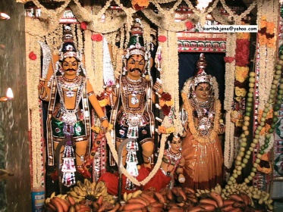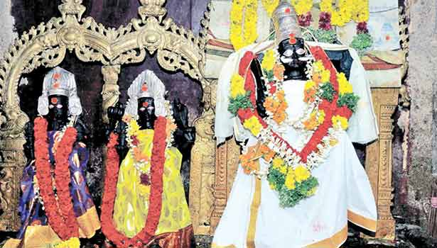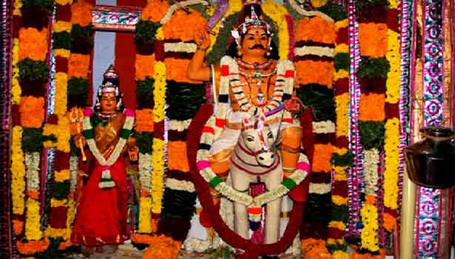

He is mostly with mother goddess Pechiamman (a form of Kaali), Brahmasakthi Amman and his brother Sudalai Mundan. Madathi is the consort of Sudalai Madan.
Protector
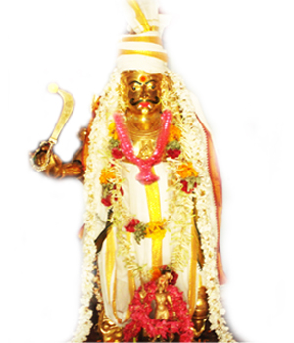
Whoever acts against dharma cannot escape from Sudalai Madan. Sudalai Madan will never forgive anyone who is harming his devotees. One has to be pure at his heart and actions to become a devotee of Sudalai Madan. There is the belief that Sudalai is the guardian of the Kodimaram (Flagstaff) in every temple.

Places of Famous and Powerful Sudalai Madan temples are:-
TEMPLE IMAGES OF SRI SUDALAI MADAN
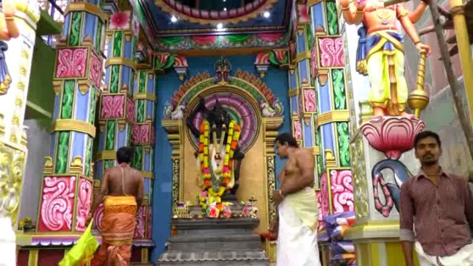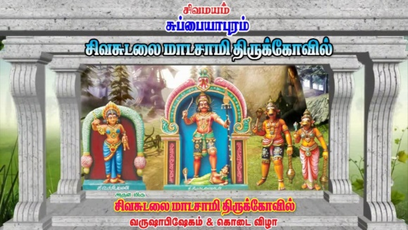
1)Kulasekara Arulmigu Sudalaimadaswamy Koil, Panchalingapuram, Mahadhanapuram, Kanyakumari, Tamil Nadu, India 629002.
2)Sri Karayadi Sudalai Madaswamy, Pechiamman Temple, Sathankulam.
3)Sudalai Andavar Alayam,Mudalai Kulam, Tirunelveli.
4)Perungalatthur Sudalai Muthu Maadaswamy Temple, (Perungalatthur, Chennai-600 063)
5)Sree Siva Sudalai Madan Swamy Temple, Sivasubramaniapuram, Radhapuram Taluk, Tirunelveli District.
6)Seevalaperi Otha Panai Sudalai Madan Swami Temple, Sirumalanchi, Thiruvenkatanathapuram, Valliyoor, Tamil Nadu 627101.
7)High Court Maharaja Temple, Arumuga Mangalam, Thenkalam Puthur (Tirunelveli).
8)Nagerkoil Sudalaimadaswamy.
9)Vijayanarayanapuram Oosikattu/Ooikattu Sudalai Madan Temple.
10)Sirumalanji Palavur, Arulmigu Sudalai Kovil.
11)Arulmigu Sri Vattrakathan Sudalaimadan Kovil, (Achioor) Valliyoor.
12)Pudupatti, Arulmigu Sri Sekkadi Sudalaimadan Kovil (Tirunelveli District).
13)Vannathankulam/ Thanumalayanputhoor Siva Sudalai, Mayana Kali Temple.
14)Vadalivilai Sudalai Madan Temple, Nagercoil.
15)Hindu Nadar Samuthaya Vagai Sudalai Madan Temple, Pattahasaliyan villai, Nagercoil, KK District.
16)Ottha Panai Veera Sudalai Madan Swamy Temple, Perumal Nager, Pattahasaliyan Villai, Nagercoil, KK District.
17)Ozhuginaseri Masana Sudalai Temple.
18)Maha SivaSudalai Temple, Colachel and All the places in the region of Tirunelveli, Tuticorin and Kanniyakumari district.
19)Vaigai Sri Sudalaimadasami Temple, Kilakkarai (Ramnanathapuram District).
20)Arulmigu SUDALAI ESWARAR SWAMY (Maaramangalam Thoothukudi District).
21)PUDUPATI ARULMIGU PERIYA OORANI SUDALAI (Alangulam Tirunelveli District).
22)Motta Kalunga Swamy Temple (Avudayanoor, Tirunelveli District).
23)Sudalai Madan Temple in Gopalasumdram.
24)SullaKarai Sudalai Madaswamy Andipatti (Alangulam Tirunelveli District).
25)Arulmigu Sri Sudalai Mada Swami Temple, Irulappapuram, Kanyakumari District.
26)Adukkupeeda Sudalai Madaswamy, Sinthamani, Tirunelveli District.
27)Adukkupeeda Sudalai Madaswamy, Tirunelveli Town, Tirunelveli District.
28)Siva Sudalai Mada Swamy Temple Kidangankaraivilai, Kanniyakumari dist.
29)Sri Sudalaimadan Swamy Temple,Navalady, Tirunelveli district.
30)Arulmigu Sri sudalai eswarar temple,pallapalayam,udumalpet.
31)Arulmigu kalathu kovil Sudalai madan swamy kovil,Vellamadam,Kanyakumari.
32)Arulmigu Puzhiyamootu Sudalai madan swamy kovil,Vellamadam,Kanyakumari.

History of Sudalai Madaswamy
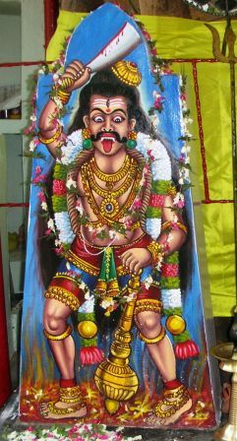
There is no written script for Sudalai Madaswamy. But the history is vocally transferred from ancient history. There are lots of stories which tells about the birth of Sudalaimadan.
Born in Kailash by penance of Parvathi is first birth.
Another story about Sudalai Madaswamy tells of his birth on Kailasa, the mountain home of Siva and Parvathi. It is said that Devi Parvathi wanted a child, but Lord Siva had sworn celibacy. He had promised to be chaste at the request of the gods since they had feared that his union with Parvathy would be so powerful it would shatter the universe. Siva suggests another way to have a child. He tells Parvathy to go and do penance in Ayiramkal Mandapam (Place having 1000 pillars in Kailash). Parvathi did penance. Shiva was happy about that. Then he plucked his hair, it started to burn as soon as he plucked and threw in that place. The fire spread on her mundanai (a part of saree). From the fire, Sudalai Madan is born.
Parvathi initially feeds the child on Amrita (the nectar of immortality), instead of on breast milk. So it is said that the child became immortal. However, the child also became desirous of solid food. He went to the cremation grounds ("sudalai") on Kailasa and began to eat the burning corpses. Since he had such a fondness for meat, it was decided that he ought not to remain in Kailash. Siva instructed him to go to Earth and to care for its people. Siva proclaimed that Sudalai Madan's protection and kindness would be re-paid with offerings of cooked food and drink, and thus he would always have a meal, as well as people who would pray to him. So Sudalai Madan came to earth, accompanied by a number of singers and dancers who were sent by Siva to see to his worship.
Worship of Sudalai Madaswamy
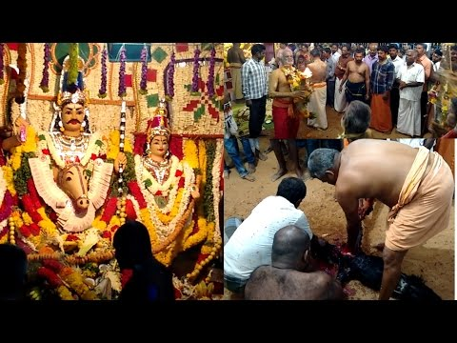
Often Sudalai Madan statues are triangular pillar-like structure and figured statues are stone carved. He is either in open or under a simple roof. The devotees serve non-vegetarian foods to him. Goats, chickens, and pigs are sacrificed and served to him. Fridays are optimum for Sudalai Madan. Special poojas are conducted every last Fridays of Tamil months and yearly once or twice main festivals are conducted for Sudalai Madan. These festivals are called "Kodai". Kodai is celebrated for one day to many days according to the devotees need. Some famous temples celebrate it for 10 days.
On these occasions, the deities are fully decorated with flowers. Some people get possessed on God and devotees talk to God through them. God goes for hunting in the cemetery through this spiritually possessed person. Art forms of Thappattai beats, Kaniyan Koothu (Maguda Kacheri) and Villupattu are main performances of Sudalai Maadan Kodai festival.
Sudalai Madan Temple function is very famously celebrated every year in Avudaiyanoor Near Pavoorchatram, Tenkasi Taluk, Tirunelveli District.

Popularity in Foreign Countries
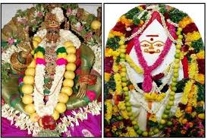
Sudalai Madan is also popular amongst certain segments of the Tamil speaking community in Sri Lanka, Singapore, Malaysia, Réunion and the French overseas territories in the Caribbean sea.
WRITTEN BY
R.HARISHANKAR

