ADVAITA ACHARYA
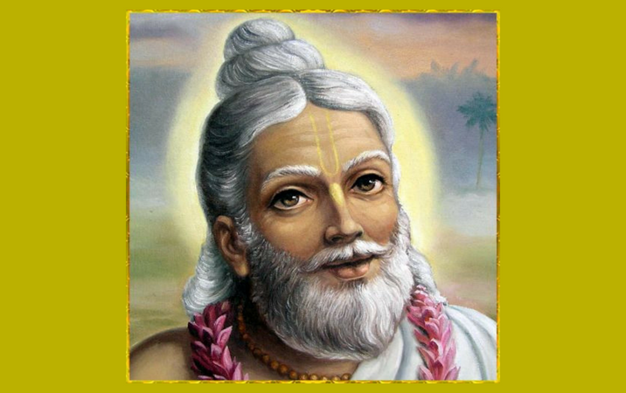
INTRODUCTION
Advaita Acharya (1434–1559), was a great Vaishnava Saint. He was a great scholar in Bhagavad Gita,Bhagavata Purana and other divine scriptures, and he promoted the Bhakti spirit amongst the devotees. His birth name was Kamalaksha Mishra.
LIFE
He was born at Bangladesh. It is believed that he was the incarnation of Lord Vishnu. He lived with his family in Nadia,West Bengal. He was the friend of Chaitanya Mahaprabhu and Nityananda. And they all together spread the “HARE RAMA HARE KRISHNA MANTRA” among the masses.
After the death of his parents, he travelled to several holy places and visited the shrines of gods. He went to Vrindavan and was deeply involved with bhakti on Lord Krishna.
Sri Advaita Acharya studied the scriptures from Santacharya in a village at Gujarat, and he was awarded the title of “ACHARYA” by his guru Sri Santacharya. And Sri Advaita Acharya was also a disciple of Madhavendra Puri.
Sri Advaita Acharya was admired by Chaitanya Mahaprabhu for his sincere devotion on god, and he was declared as an Avatar of Lord Vishnu, by Chaitanya Mahaprabhu himself.
He lived an entire life span of 125 years.
IMPORTANCE
Sri Advaita Acharya was a great devotee of Lord Krishna, and it is said that, whenever he hears any song on Krishna, tears of joy will flow from his eyes due to his great devotion on Lord Krishna. He was a great saint who devoted with full bhakti on Krishna and also prayed for the welfare of the living beings on the earth.
CONCLUSION
Sri Advaita Acharya was a great saint who has to be worshipped by us in order to redeem our sins. Worshipping him is the same as that of worshipping Lord Vishnu, since he was an avatar of Lord Vishnu.
Let us pray to him and chant his name with sincere devotion and be blessed.
“OM SREE ADVAITA ACHARYARE NAMAHA”
“JAI KRISHNA”
WRITTEN BY
R.HARISHANKAR

AKHANDANAND
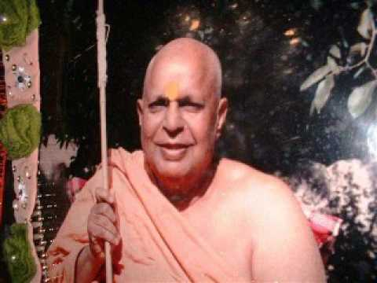
INTRODUCTION
Akhandananda(1911–1987) was a great preacher of Bhagavata Purana and was an expert scholar in Hindu Puranas, Uphanishads and other sacred texts of Hinduism. His birth name was Shantanu Behari.
LIFE
He was born in a Brahmin family in a village in the district of Varanasi. He read all the sacred texts of Hinduism at his younger age. He has also studied well in his school and was very intelligent in grasping the subjects, and got a very good name in his school.
Before becoming a saint, He published a number of spiritual books and articles. He also translated some important sacred texts from sanskrit to hindi.
He has become a saint through the instructions given by Sri Brahmanand Saraswati in 1942, and from then onwards he was called as “Swami Akhandanand”.
He served as a President of the Bharat Sadhu Samaj.
He was an honorary board member of the Bhartiya Vidya Bhavan.
He has written the following sacred texts in his own style and in a detailed manner, without disturbing the original contents.
- Bhagavata Purana
- Bhagavat Geeta
- Ram Charitra Manas
- Uphanishads
He established Anand Vrindavan Ashram in Mathura district of Uttar Pradesh, India.

IMPORTANT DISCIPLES
- Swami Prabhuddhanand Saraswati ji
- Swami Vimalanand Saraswati ji
- Swami Mahsehanand Saraswati ji
- Swami Govindanand saraswati Ji
- Swami Omkaranand saraswati ji
DEATH
He attained Mahasamadhi on 1987.
IMPORTANCE
Sri Akhandanand was a great spiritual leader and a saint, who was still living through his devotional articles. He was interested in acquiring the spiritual knowledge at his younger age itself. He has chosen the path of Sanyasi, since he was interested to enter into the “PATH OF SPIRITUALITY”.
According to him, entering into the path of spirituality is a great service to the god, and can attain salvation through that. He insists his followers to regularly read the hindu devotional books such as vedas, bhagavat gita etc. And also ask them to worship the god from their heart, and to realize the god from our inner soul (ATHMA).
He also cultivates the habit of helping others and doing charitable activities, respecting the elders, spreading the religion amongst the people and uttering the various names of Lord Krishna.
Let us worship him and be blessed.
“OM SREE SWAMI AKHANDANAND MAHARAJ NAMAHA”
“JAI MUKUNDA, “GOPALA”, MURARI”
“HARE KRISHNAM, GOVINDAM, VASUDEVAM NAMO NAMAHA”
WRITTEN BY
R.HARISHANKAR

ANANDAMAYI MA
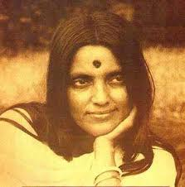
INTRODUCTION
Anandamayi Ma (1896–1982) was an Indian Saint. She was appreciated by Sivananda and Yogananda and described her as a perfect woman consisting of spiritual energy.
LIFE
Anandamayi was born in a Brahmin family in Bangladesh.
At the age of twelve years, she was married to Bholanath. Though she was married, she concentrated her attention on meditation and doing prayers to the god.
In 1926, she renovated an ancient Kali temple in the West Bengal.
She has given various lectures about spirituality and was attracted by the large crowd. Various scholars were drawn to her spiritual power and interested in listening to her lectures. She also lived during the period of the great Hindu saints like Sri Aurobindo, Ramana Maharshi and Paramahansa Yogananda.
The Anandamayi Sangha in Haridwar organizes meditation, religious discourse and devotional music.

Death
She died in Dehradun at the age of 86. And a Samadhi was built for her in Haridwar.
TEACHINGS
- She asked each one to be loved and to be respected.
- Don’t judge a person only by his wealth. There is no need to have enough wealth for a knowledgeable person.
- Give proper respect to the poor, and the underprivileged people. If possible, do some sort of help to them.
- Don’t get attracted through a person’s appearance. Get attracted by his/her personal good behaviour.
- Do social welfare activities like feeding food and providing housing and clothing facilities to the poor.
- Think about god. You will get all prosperity in your life.
- Don’t hurt anyone by physical or mental activities.
IMPORTANCE
She was a great saint and a religious philosopher who guides the people through her kindness and gentleness approach and also by her teachings. Many people were benefitted by her teachings and she was praised for her great knowledge, wisdom, courage and boldness.
CONCLUSION
She was a great divine mother who changed the life of her followers in a better manner. She was known for her capability to interact with the great spiritual gurus at her time. She contains knowledge in hindu scriptures and other divine hindu texts. She asked the people to be active and not to be lazy. She insisted her followers to work hard for their livelihood and to gain spiritual energy in their spare time.
Let us worship her and be blessed.
“OM SREE ANANDAMAYI MA NAMAHA”
WRITTEN BY
R.HARISHANKAR

BAMAKHEPA
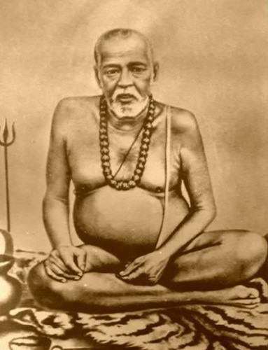
INTRODUCTION
Bamakhepa (1837–1911) was a Hindu saint, and a great devotee of goddess Tara, and a regular worshipper at Tara temple in Birbhum, west bengal. His birth name was Bamacharan Chattopadhyay. He was madly devoted to goddess tara devi, and also fondly known as the mad saint.
LIFE
He worshipped Mata Tara as a holy mother. He was born in a village of Birbhum district, West Bengal.
He lived near the temple of Tara Devi, and was good at meditation and yoga. He was also treated similarly to saint Ramakrishna, with regard to their bhakti on the holy mother.
He left his house at a younger age, and became a disciple to the great saint named Swami Makshadananda.
After some time he went Mouliksha temple, Jharkhand and continued his worship of Holy Mother.
IMPORTANCE
He was a perfect yogi who cures the illness of the people, and gives mental satisfaction to them. It is said that Bamakhepa was first fed the temple prasadam, and then only it will be offered as Naivediyam (Bhog Prasad) to Tara Devi. It is believed that once the goddess appeared to Bamakhepa and blessed him.
He was a great spiritual master who surrenders his heart and soul to the goddess with utmost devotion and faith on her. He also conducted spiritual meetings and told the importance of worshipping Tara devi, and solved the problems of the people.
He insisted his followers to chant the Devi mantra continuously in order to attain all kinds of prosperity in their life. He was considered as a holy saint by his followers. He lived a saintly life, and had taken only simple food, and never gets angry over others, and gives remedy to the problems in the life of his devotees. He reduced the sins of his devotees, by praying to the divine mother.
He also done many charitable activities, and conducted annadanam and gave clothing and shelter facilities to the poor to his level best. He also donated the wealth to the poor, which was given to him by the rich people.
He is still remembered due to his sincere bhakti on Mata Tara Devi.
He died at the age of 74 at West Bengal.
His temple is situated at Maluti village, Jharkhand.
Let us worship the great divine saint, and be blessed.
“OM SREE BAMAKHEPA PRABHUVE NAMAHA”
“OM MATA TARA DEVIYE NAMAHA”
WRITTEN BY
R.HARISHANKAR
BHAKTA TUKARAM
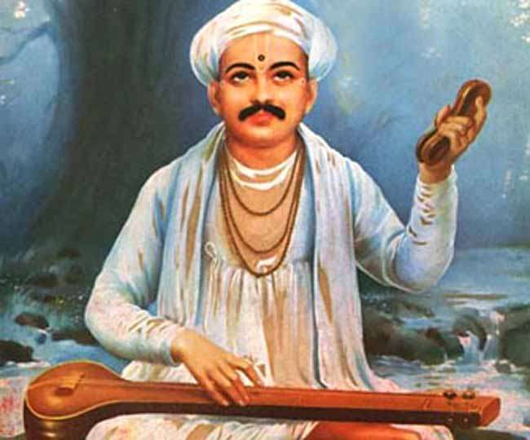
INTRODUCTION
Tukaram, also known as Sant Tukaram, Bhakta Tukaram, Tukaram Maharaj was a 17th-century Hindu poet and saint in Maharashtra, India. Tukaram is best known for his devotional poems and specialized in writing and singing spiritual songs known as kirtans. His poetry was devoted to Vitthala or Vithoba, an avatar of Hindu god Vishnu.
LIFE
He was born in the year 1608 in a village in Maharashtra, India. Tukaram was born in lower caste. His parents were devotees of Vithoba(A form of Lord Krishna).
Even after getting married, he spent most of his time in devotional worship.
It is believed that he left from this world and went to Vaikunda through garuda vahana in 1650.

Important Places
1.Tukaram Maharaj Janm Sthan Temple, Dehu.
2.Sant Tukaram Vaikunthstan Temple, Dehu.
3.Sant Tukaram Maharaj Gatha Mandir, Dehu.
Spiritual Works
Tukaram Gatha is a collection of poems, also called as Abhanga Gatha.The poems cover a wide range of human emotions, and life experiences in a spiritual manner. He analyses the difference between normal life and spiritual life. And he has chosen the spiritual life.
Songs
He considered singing songs on god is the means to learn about Bhakti. It shows a spiritual path for the devotees, as well as it helps to create a spiritual path for others.
Social reforms
Tukaram was against caste discrimination. One of his devotees was a Brahmin woman, who was tortured by her husband when she adopted the Bhakti marga and considers Tukaram as her guru.
CONCLUSION
Thukaram was a great saint, poet and a great devotee of Vithoba. His teachings are mainly focussed on worshipping god with a pure heart and with sincere devotion. Through his bhakti, he entered Vaikunta and attained eternal bliss. Let us pray to him with pure bhakti and chant his name along with Lord Vithoba and be blessed and live happily for ever.
“OM SREE THUKARAM MAHARAJ NAMAHA”
“JAI KRISHNA”,”JAI MUKUNDA” “JAI VITTHALA”
WRITTEN BY
R.HARISHANKAR

BRAHMA CHAITANYA
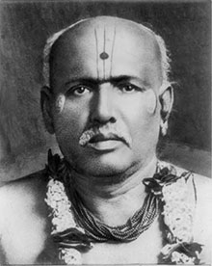
INTRODUCTION
Brahmachaitanya (1845-1913) was a Hindu saint who lived in Maharashtra, India. His birth name was Ganapati.
LIFE
He was born in a village in Satara District, Maharashtra. He left his home at a younger age and visited many saints including Shri Manik Prabhu and Shri Ramakrishna Paramahamsa. After some years, he returned to his home town Kolhapur, and again after some time he went to Yehalegaon and became the disciple of the great saint Sri Tukamai, and from then onwards he was known as Sri Brahmachaitanya.
He left his body in the year 1913 in Gondavale.
Though he left his physical body, his teachings are still alive and helping the people to lead a peaceful life.
IMPORTANCE
He spent his life in teaching the importance of worshipping lord Rama to the people. He taught to love one another and to leave the material comforts. He insisted his followers to remember the god continuously in order to get happiness and peace. According to him, all the prosperity can be achieved only by praying to Lord Rama regularly without any expectation in our mind. One should always sing in praise of him and chant his name.
He showed the path of SALVATION to his devotees in India. He insisted the people to develop good habits and good behaviour in order to attain the glory of the god. He conducted Rama Bhajans regularly for the welfare of the people and to follow the spiritual path. He taught people to chant several lakhs of Rama nama japa: 'SHRI RAM JAY RAM JAY, JAY RAM'. He told to his followers to continuously pray to the god in order to reduce the problems in our life and to reach the divine abode of the god.
He helped the poor by offering the necessities in their life, and performed annadanam, provided food to the cattle and wants the people to treat the animals with love and affection and does not harm them.
CONCLUSION
A kind hearted saint and a brilliant scholar had come to this earth for giving spiritual enlightenment to the people. He lived a holy life and treated all the people equally and helped them to his level best. He has cultivated bhakti to others, and has done a lot of social welfare activities for the people.
Let us chant his name and be blessed.
“OM SREE BRAHMA CHAITANYARE NAMAHA”
“JAI SREE RAM”
WRITTEN BY
R.HARISHANKAR

CHOKHAMELA
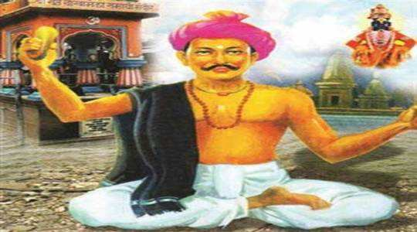
INTRODUCTION
Chokhamela was a great saint in Maharashtra, India, and lived in the 14th century. He belonged to the Mahar caste. He was a great poet, and sung in praise of Lord Vitthala, and he was a great devotee of Lord Vitthala.
LIFE
He was born at a village in Buldhana district,Maharashtra. He wrote many poems. He was one of the famous poets in India. Chokhamela lived with his family and worked in farms of wealthy people. He lived outside the town in a hut, but was fully devoted on Lord Vitthala. He never worried about his poverty, but lived the life peacefully, with his meagre earnings.
Once he got an opportunity to listen to Saint Namadev songs, and from then onwards, he became initiated into bhakti spirituality. Chokhamela followed Saint Namdev's teachings.
Once, while doing a construction work, the wall fell down, and crushed Chokhamela and he died. His tomb is situated in front of the Vitthal temple, Pandharpur, and it is believed that the bones of the dead Chokhamela were still chanting the names of Lord Krishna as Vitthala, Vitthala, Panduranga Vitthala in order to visit the Vitthal temple. The bones were buried at the footsteps of the Vitthal temple.
CONCLUSION
Chokhamela, who was a great vitthal devotee, is an unimaginable person, in connection with his devotion on Lord Krishna. His body and soul is fully filled up with the BHAKTI on Lord Krishna. After his departure from earth, he has attained SALVATION through his true bhakti. During his life time, he never aimed at anything, but only by keeping Lord Krishna in his mind, and always uttering his names, even while doing his work. We should also try to cultivate the bhakti spirit among ourselves, in order to run a peaceful life in this KALI YUGA. Let us worship Chokhamela and be blessed.
“OM SREE BHAKTA CHOKHAMELAVE NAMAHA”
“JAI KRISHNA”, JAI GOPALA”, JAI GOVINDA”,”MUKUNDA”,MURARI”
WRITTEN BY
R.HARISHANKAR

DEVI RUPA BHAWANI MATA
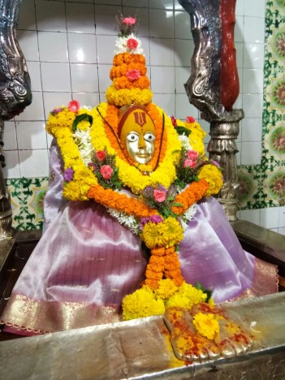
INTRODUCTION
Rupa Bhawani (1621-1721). She was a 17th-century Hindu saint of Kashmir. Her birth name was Alakheswari.
LIFE
She was an expert in yoga and meditation at a younger age. Her family was devoted towards the path of spirituality. She was very much interested in devoting god, and chanting his names. She invoked the spirituality among others, and made them to concentrate on pure bhakti towards god.
Some time, after her marriage, she left her husband and in-laws, and completely moved towards the path of spirituality.
The death day of Devi Rupa Bhawani became known as Sahib Saptami, and is observed by Kashmiri hindu people.
IMPORTANCE
She was a famous saint and a great devotee of Goddess Kali matha. During her life time, she will frequently visit Hari Parvat at Kashmir and offer prayers to Kali. She has given solutions to the problems of her devotees, and was an expert in yoga sadhana. She advised her devotees to worship the god by chanting his names, and also subsequently to do yoga and meditation.
CONCLUSION
Devi Rupa Bhawani, who was considered to be an incarnation of goddess parvati devi, was a great Divine saint. Let us worship her with sincere devotion and be blessed.
“OM SREE DEVI RUPA BHAWANI MATAVE NAMAHA”
“JAI KALI MAA”
“OM SAKTHI PARA SAKTHI”
WRITTEN BY
R.HARISHANKAR
DNYANESHWAR
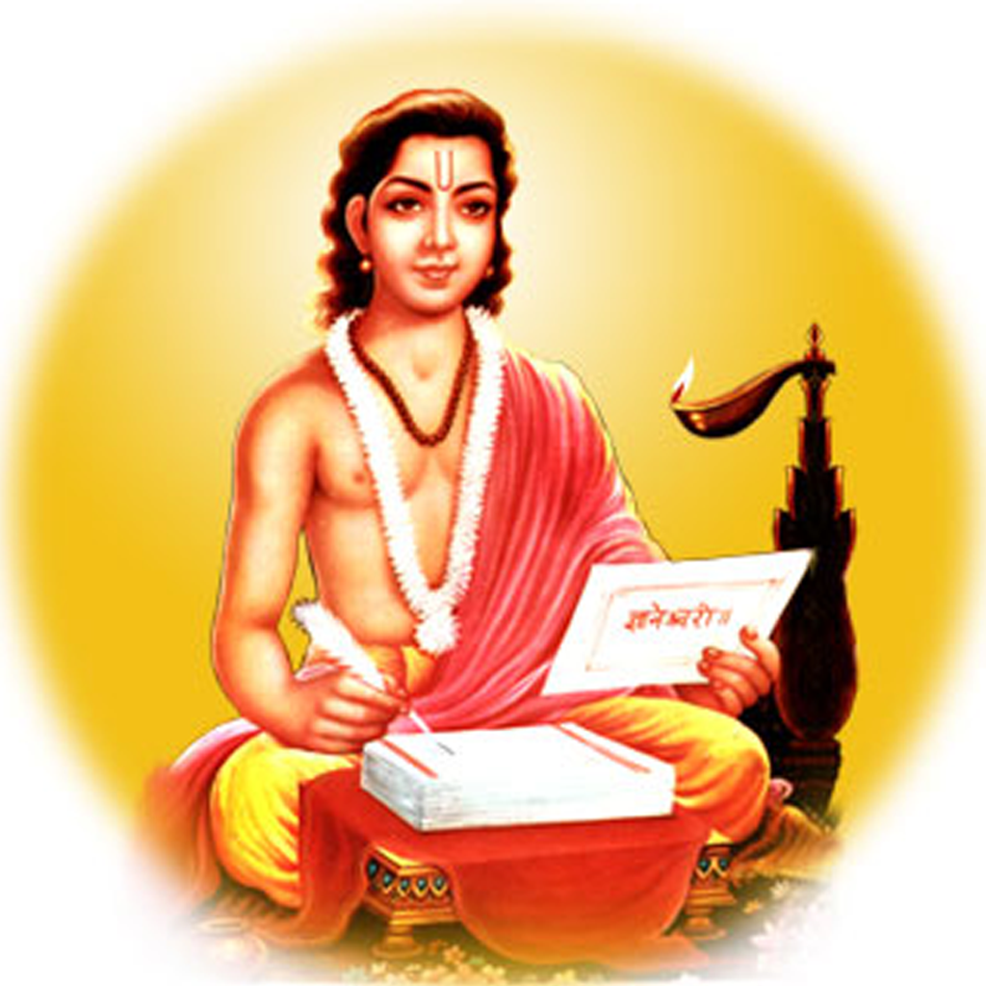
INTRODUCTION
Dnyaneshwar (1275–1296) was a Marathi saint and a poet of the Vaishnava tradition. He was the author of Dnyaneshwari (a detailed explanation on the contents of Bhagavad Gita) and also written a sacred text known as Amrutanubhav, which was widely praised by the Marathi people for its simplicity. He was regarded as the best poet during his time by the great kings and by the common people.
LIFE
Dnyaneshwar was born in a Brahmin family in a village at Maharashtra.
His father has served as an Accountant in his village.
His parents were died at his younger age, and Dhyaneshwar and his brothers and sister Muktabai become saints.
He was the close associate of Saint Namdev and together they formed the bhakti movement, and spread the spirituality among the people, and they visited many sacred places and worshipped the gods.
Dnyaneshwar was the disciple of his own brother Nivruttinath.
His samadhi lies in the Siddhesvara Temple complex in Alandi. Many people are visiting his place and getting benefitted by worshipping him.
IMPORTANCE
He has performed many miracles during his life time, such as giving back life to a dead person, and cured several dreaded diseases and given peace of mind to the people, and changed their behaviour by giving spiritual discussions, and made them to move towards the correct path of life. Once, he made a buffalo to chant the vedas, when he was challenged by the learned scholars. He took mercy on all the living creatures, and treated them in a good manner. He has advised the people to treat the animals in a kind manner and to provide them with proper food, in order to make them to live peacefully. According to his saying, “Sufferings are common to both the human beings and all the living creatures, take care of them with much care and show affection on to them, then you will be immediately blessed by the divine gods in the heaven”.
According to him, Devotion to Guru is very important than worshipping the god.
DEVOTIONAL WRITINGS
- Dnyaneshwari or Bhavarthdipika
- Amrutanubhava or Anubhavamrita
- Changdev Pasashti
- Haripath
- Abhangas
- Commentary on Yoga Vasistha
- Pavana-Vijaya
- Pancikarana
CONCLUSION
Sri Dnyaneshwar was a great saint and lived a pure life, without allowing any bad thoughts in his mind. He was admired for his knowledge, wisdom and courage, and he looks like a bright sun,who still bless us from the divine world. He lived a simple life and not interested in any material comforts and luxuries, and also taken only simple food throughout his life. Let us worship him with full of devotion in our mind, chant his glory, and be blessed.
“OM SREE DNYANESHWAR PRABHUVE NAMAHA”
WRITTEN BY
R.HARISHANKAR

EKNATH
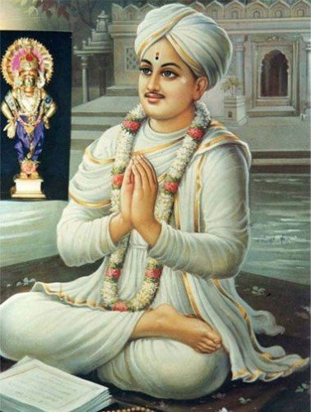
INTRODUCTION
Eknath (1533–1599) was a great saint, and Marathi poet. He was born in a village at Uttarakhand.
LIFE
He was born to a Brahmin family. And since his parents were died at his younger age, he was brought up by his grandfather. He was the disciple of the learned scholar Sri Janardhan Swami.
IMPORTANCE
He was against caste discrimination. Once he had his meal in the house of the lower caste person, even when he was opposed by the people. According to him, all people are equal before Lord Vittal, and he worried about the sufferings of the lower caste people, and prayed to Lord vittal for their welfare.
He was well known for his spirituality and for safeguarding the Sanatana Dharma. He was talented in hindu scriptures and a master in all forms of art and a great scholar.
Eknath has re-written the Ramayana in his own style which is called as Bhavarth Ramayan. He has written the epic in a simplified form, in order to understand it even by the common people.
He was the author of Eknathi Bhagavata which features the childhood miracles performed by Lord Krishna, and describes the kindness shown by Lord Krishna towards his devotees.
His other popular writings are as follows:
SPIRITUAL WRITINGS
- Shukashtak
- Swatma-Sukha
- Ananda-Lahari
- Chiranjeewa-Pad
- Geeta-Sar
- Prahlada Vijayam
He was a polite and a noble person, and he was appreciated for his works by the great scholars and the rulers of the kingdom.
He was died at the age of 66 at Uttarkhand.
Eknath's Samadhi is located near River Godavari in Uttarkhand, and devotees from the nearby villages will come regularly and visit the place and worship him.
CONCLUSION
Saint Eknath was a great devotee of Lord Vittal, similar to Bhakt Thukaram. His poems praised the glory of the god, and he has used small and simple verses for writing his poems for understanding it easily. His teachings are mainly focussed on living a worthy and a complete life. Through his teachings, he removed the sadness of the people, and eliminated the suicidal thoughts of the people, and made them to live a happy and a blessed life. His teachings are mainly based on the worship of Lord Krishna. He has advised the followers to worship lord Krishna whole heartedly in order to cleanse ourselves from bad things and to purify ourselves. He lived a pious life and helped the people towards reaching the high level of spiritual path, by giving lectures to them. Let us worship the great saint and be blessed.
“OM SREE EKNATH MAHARAJ NAMAHA”
“JAI VITTAL PRABHUVE NAMAHA”
WRITTEN BY
R.HARISHANKAR

GOPALANAND SWAMI
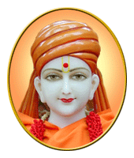
INTRODUCTION
Gopalanand Swami (1781–1852) was a follower of the Swaminarayan Sampraday, and he was the disciple of Sri Swaminarayan. He spread the Swaminarayan Sampraday through his followers. His birth name was Khushal Bhatt.
LIFE
He was born in a village at Gujarat in a Brahmin family. Gopalanand Swami studied the philosophy of Vedanta. Gopalanand Swami was a great scholar, and also a master in all kinds of art. Though he was married and had children, he has become a saint, due to the instructions of Sri Swaminarayan.
Gopalanand Swami died in 1852 in Gujarat.
Gopalanand Swami installed an Idol of Lord Hanuman in the Sarangpur temple, Gujarat.
DEVOTIONAL WORKS
- Vivekdeep
- Vishnuyaag Paddhati
- Pujavidhi
- Bhakti Siddhi
- Haribhakta Namavali
- Brahmasutrarthdeep
- Ishadi Upanishad Bhashya
- Shreemad Bhagwad Geeta Bhashya
- Commentary on Shreemad Bhagwat
IMPORTANCE
Gopalanand Swami was a sincere devotee of Sri Swaminarayan. He followed in his footsteps and attained spiritual energy through him. He was always kind towards his devotees, and has done lot of charity work like providing annadanam to the devotees of Swami Narayan Mandir etc. Till now, as per the wish of Gopalanand Swami and Sri Swaminarayan, free food is offered to thousands of devotees every day in a pleasing manner in Swami Narayan Mandir.
Let us worship the great gurus and be blessed.
“OM SREE GOPALANAND SWAMIYE NAMAHA”
“OM SREE SWAMINARAYANANE NAMAHA”
WRITTEN BY
R.HARISHANKAR

GORA KUMBHAR
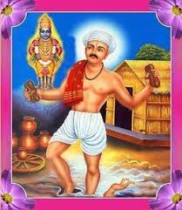
INTRODUCTION
Gora Kumbhar (1267-1317) was a Hindu saint of Maharashtra. He was a potter and a great devotee of Lord Vithal (Manifestation of Lord Krishna).
Gora Kumbhar had written and sung several songs in praise of Lord Vithal.
LIFE
Gora Kumbhar was lived in a village in Osmanabad district of Maharashtra State. He is believed to have been a close friend of Saint Namdev.
He lived with his wife and his child in his village by doing his pottery work, and also by devoting on Lord Vithal.
Once due to his great devotion on Lord Vithal, he began singing and dancing with joyful tears showering from his eyes. He forgot everything and was fully devoted to Lord Krishna. At that time, his child crawls near him, and without his attention on his child, he pressed his child with his legs, and his child got crushed from his legs and died.
After knowing the incident, he felt very bad, and prayed to Lord Vithal at Pandharpur along with his wife. To his surprise, his child was brought back alive due to the divine grace of Lord Vithal and he and his wife were very happy about the miraculous incident, and thanked to the god for saving their child.
IMPORTANCE
He was a staunch devotee of Lord Vithal, and he was unaware of the things happening near to him while devoting the Lord. His bhakti is unimaginable and unthinkable from our perspective. He acts as an example for others. We should also try to inculcate ourselves with such a bhakti spirit in our soul.
CONCLUSION
The great vithal devotee will save us from the hardships and will blossom our life. Let us pray to him with sincere devotion and be blessed.
“OM SREE GORA KUMBHARE NAMAHA”
“JAI VITHALA, VITHALA, PANDURANGA VITHALA”
WRITTEN BY
R.HARISHANKAR

GORAKHNATH
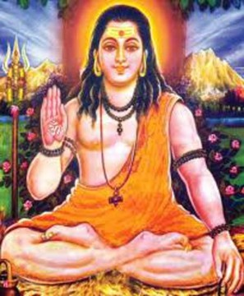
INTRODUCTION
Gorakhnath (11th century) was a saint and also the founder of the Nath tradition. He is considered as the main disciple of the great Saint Matsyendranath. His followers are mostly living at Ahmednagar in the state of Maharashtra. These followers are called as Yogis.
He was widely popular in Maharashtra, India.
Several temples are dedicated to him in many parts of India, mainly at Gorakhpur, Uttar Pradesh.
There is also a famous temple of Gorakhnath in the state of Odisha.

Many Nepali people are named as Gorakhnath.
Gorkha, a district of Nepal, is named after him.
There is a cave with his idol was found in Nepal and every year there will be great celebration in the cave which is called as Rot Mahotsav.
IMPORTANCE
Gorakhnath is an expert in yoga and meditation. He is a great shiva devotee, and is considered as an AMSHA (Features) of Lord Shiva. He has done severe penance for several years in order to attain the divine enlightenment. He contains yogic and spiritual powers and was a master in all kinds of art.
He was also a great scholar and contains a very good knowledge in hindu scriptures. He was very much attracted by his followers, due to his shiva bhakti and his kindness. He removed the problems of his devotees through his divine power. He asked his devotees to do meditation and regular prayer on god shiva. It is believed that he lived for more than 100 years with full of spiritual energy, and removed the diseases of his devotees, and lead them to the spiritual path. Let us worship him with pure bhakti and be blessed.
“OM SREE GORAKHNATHARE NAMAHA”
“OM NAMAH SHIVAYA”
WRITTEN BY
R.HARISHANKAR

HARIDASA THAKUR
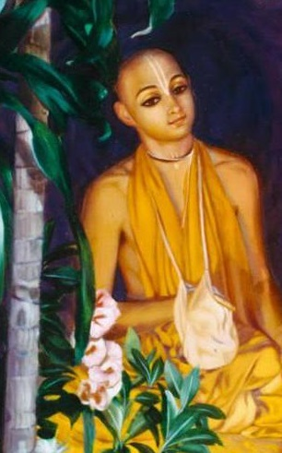
INTRODUCTION
Haridasa Thakur born on 1450 was a popular Hindu saint and also occupied a key role in establishing the Hare Krishna movement. He was the follower of Sri Chaitanya Mahaprabhu. It is believed that he has chanted the names of Lord Krishna for lakhs of times every day, throughout in his life period.
LIFE
He was born in a village in Bangladesh. Haridasa was born in a Muslim family, and then converted to Hinduism at his younger age. Haridasa Thakur was a great saint who followed the teachings of Chaintanya and worshipped Lord Krishna and also spread the bhakti spirit to others. He has seen Lord Krishna’s face in each and every thing, and he devoted his most of the time in praising and singing the glory of Lord Krishna.
He left his home at a younger age, and settled down at Puri.
IMPORTANCE
Haridasa Thakur was well known for chanting the Hare Rama Hare Krishna mantra.
He was a great spiritual guru and insisted his followers to follow the path of Lord Krishna, and not to forget him in order to attain SALVATION. He was guided by Sri Chaintanya and frequently visited him at puri and helped him to attain spiritual enlightenment.
He preached the principles of Sri Chaintanya amongst the people and showed them the spiritual path.
During his last years, Haridasa has lived in Puri and served Sri Chaitanya Mahaprabhu.
Death
Haridasa had died at puri in presence of Sri Chaitanya Mahaprabhu. Even before his death, he was chanting Sree Krishna Mantra, and has reached the divine abode of Lord Narayana.
CONCLUSION
Sri Haridasa Thakur was a great disciple of Sri Chaitanya and spread the bhakti movement across the globe. He was the one among the important spiritual leaders of Vaishnavism. He was considered as a divine incarnation of Sri Bhakt Prahalad, a great narayana devotee. Similar to him, he also chants the names of Lord Krishna, and has done good things in his life. Let us worship him and be blessed.
“OM SREE HARIDASA THAKURE NAMAHA”
“JAI KRISHNA NAMO NAMAHA”
“JAI BHAKT PRAHALAD NAMAHA”
WRITTEN BY
R.HARISHANKAR

JANABAI
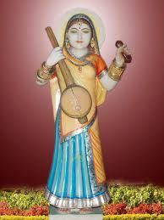
INTRODUCTION
Janabai was a Hindu poet. She was born during 13th century. Janabai was born in Maharashtra.
LIFE
At a younger age, she went to Pandharpur along with her family. And she worked as a maid in the family of the famous poet Namdev.
Her employers were very good and religious minded people. They have treated her in a kind manner. Janabai has worked very peacefully with her employers. Janabai was a staunch devotee of Lord Vittal. She composed many good poems. Still some of her poems were preserved.
IMPORTANCE
Though she has not attended formal education and belonged to a lower caste, she has written poems in a wonderful manner, and she has cultivated the bhakti towards the people on Lord Vittal. She preached the importance of worshipping Lord Vittal through her songs. She was a humble and a soft spoken lady, who was considered as a great saint by the people. She listened to the people’s problems, and sorted out it, by giving simple solutions for them. Mainly her advice is to chant the glory of god. According to her, if we sing in praise of the God, our problems will come to an end.
CONCLUSION
Janabai is a great saint and a poet, who has devoted her life towards worshipping Lord Vittal, and singing in praise of him. She was an example for others, and she lived a very blessed life. After her death in 1350, she has reached the divine abode. Let us pray to her and be blessed. Let us chant her name with bhakti and live happily for ever.
“OM SREE JANABAI THAYE NAMAHA”
“VITTALA, VITTALA PANDURANGA VITTALA”
WRITTEN BY
R.HARISHANKAR

KALIDASA
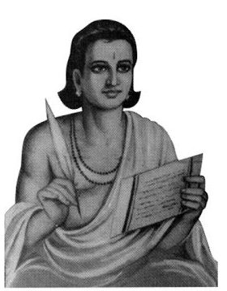
INTRODUCTION
Kalidasa (4th Century AD) was a famous poet of India. Kalidasa was believed to have lived near the Himalayas.
LIFE
According to ancient epics, he got great knowledge from goddess kali at Kali Temple, when he was insulted by a princess, who was searching for a knowledgeable man to marry her. After becoming a great scholar, he got married to that princess. From ancient texts, it was known, that during his visit to Sri Lanka, he was murdered due to some misconception.

WRITINGS
1.Abhijnanasakuntalam
2.Malavikagnimitram
3.Vikramorvasiyam
4.Raghuvamsa
5.Kumarasambhava
6.Ritusamhara
7.Meghaduta

IMPORTANCE
Kalidasa was well known for his poems and his devotion to “MAA KALI DEVI”. Through her grace, he got the knowledge. He has got great knowledge in hindu scriptures, puranas, Upanishads and vedas. He was given the title as “MAHAKAVI KALIDAS” as an honour to him. He was also a kind hearted and a noble man, who frequently conducted kali puja, and worshipped her in a grand manner.

CONCLUSION
A great poet, scholar and a kali devotee and was blessed by goddess kali. By her grace, he reached the heavenly abode. Let him give us good knowledge in all the subjects, and let us chant his name along with the name of “MAA KALI” and be blessed.
“MAHAKAVI KALIDASARE NAMAHA”
“JAI KALI MATHA”
WRITTEN BY
R.HARISHANKAR

KANHOPATRA
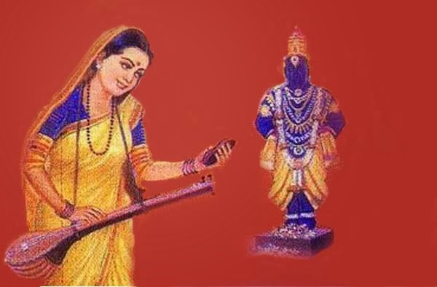
INTRODUCTION
Kanhopatra was a 15th-century saint and was born at Pandharpur. She was a great devotee of Lord Vithoba (A form of Lord Krishna).
LIFE
Kanhopatra was a dancer in the royal palace of the king of Bidar. Since she doesn’t want to attract others by means of her beauty, and to be a slave of the king, she preferred to surrender at the feet of Lord Vithoba.
IMPORTANCE
Through her poems, she tells that she wanted to be a slave for Lord Vithoba alone, and he alone is her saviour, and wants to free herself from her dancing profession. Still her poems are continued to be sung even today. She has attained sainthood without any guru, and considers Lord Vithoba as her Guru and her God.
Being a dancer, she was not interested herself to be gifted to others. Through her poems, she says, I am a devotee of Lord Vithoba, and he is my Lord. Let me completely surrender me to the Lord’s lotus feet, and let me continuously worship him for ever.

Death
According to texts, it is told that, Kanhopatra merged with the image of Vithoba, and some texts tells us, that she fell at the feet of Vithoba and died. But everybody accepts she has attained the divine abode, through the grace of Lord Vithoba.
CONCLUSION
Although a dancer by profession, she was fully devoted to Lord Vithoba. She was not attracted by money or by any other worldly pleasures. She was attracted only with Lord Vithoba. Due to her pure devotion, she reached the divine abode. Through her bhakti, she has become a saint. Let us pray to her and be blessed.
“OM SREE KANHOPATRAVE NAMAHA”
“OM SREE PANDURANGA VITTALA NAMO NAMAHA”
WRITTEN BY
R.HARISHANKAR

KRISHNANANDA SARASWATI
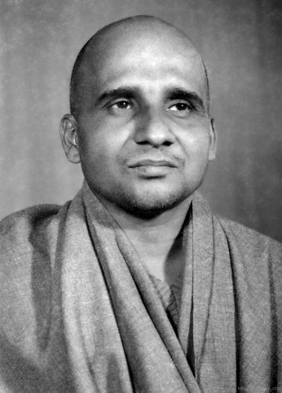
INTRODUCTION
Swami Krishnananda Saraswati (1922–2001) was a disciple of Sivananda Saraswati and he worked in the Divine Life Society in Rishikesh for a long period. He was an author of large number of texts and also interested in yoga and meditation.
He was a great saint, and interested in spirituality, and got the habit of reading divine books, and contains great knowledge in Hinduism. His birth name was Subbaraya. Krishnananda also served as a President in Sivananda Literature Research Institute.
LIFE
Swami Krishnananda was born on 1922 into a Madhva Brahmin family in Karnataka. He learnt Sanskrit and other basic education at his younger age. For some time, he worked in a government job, after that since he was interested in spirituality, in the year 1944, he left his home and went to Sivananda Ashram in Rishikesh, and served there with the blessings of Sivananda.
Swami Krishnananda was a great scholar and also contains an expert knowledge in Advaita Vedanta philosophy, vedas, puranas, Upanishads and other hindu divine texts.
He was a great Yoga Practitioner and taught various types of yoga like Karma Yoga, Bhakti Yoga, Raja Yoga, and Jnana Yoga to his followers.

SPIRITUAL WRITINGS
- Mundaka Upanishad
- The Tree of Life
IMPORTANCE
He was a humble and a noble saint, similar to his guru swami sivananda. He was interested in doing social welfare activities also, and done annadanam at his ashram. He was very much worried about the sufferings of the people, and asked them to divert their attention on spirituality and to show lesser interest in worldly pleasures and comforts. He was interested in chanting the names of god, and also interested in reciting various slokams on god.
Let us worship him and be blessed.
“OM SREE SWAMI KRISHNANANDA SARASWATIYE NAMAHA”
“OM SREE SWAMI SIVANANDARE NAMAHA”
WRITTEN BY
R.HARISHANKAR

LALLESHWARI
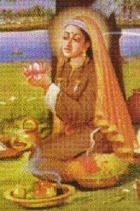
INTRODUCTION
Lalleshwari (1320–1392) was a Saint and born at Kashmir, and she belongs to the shaivite tradition. She was a great poet in the Kashmiri language.
LIFE
Lalleshwari was born near Srinagar, Kashmir in a Pundit family. She took sanyasa at a younger age, and become the disciple of Shaivite guru, Siddha Srikantha.
SPIRITUAL WRITINGS
Her poems have been translated into English. Some of the famous quotes are as follows:-
- If I do a work, that will be the worship of god.
- If I utter a word, that will become a prayer.
- My body and soul leads my path
to Lord Shiva.
IMPORTANCE
Lalleshwari was a bold and noble lady who spent his entire life towards devotion to god. She has not enjoyed any luxuries and comforts in her life. At a younger age, she has controlled her senses, and she left all her worldly pleasures, and turned into a sanyasini. She was a great devotee of Lord Shiva.
CONCLUSION
A poet and a saint, has dedicated her entire life towards worshipping god. She was well accepted by the people and respected her with devotion. She helped the people to enter into the spiritual path. She has showed the way of enlightenment. Though she is not physically available, she is still living in the hearts of her devotees through her poems. Let us worship her and chant her name and be blessed.
“OM SREE LALLESHWARI THAYE NAMAHA”
“OM NAMAH SHIVAYA”
WRITTEN BY
R.HARISHANKAR
MADHAVDEV
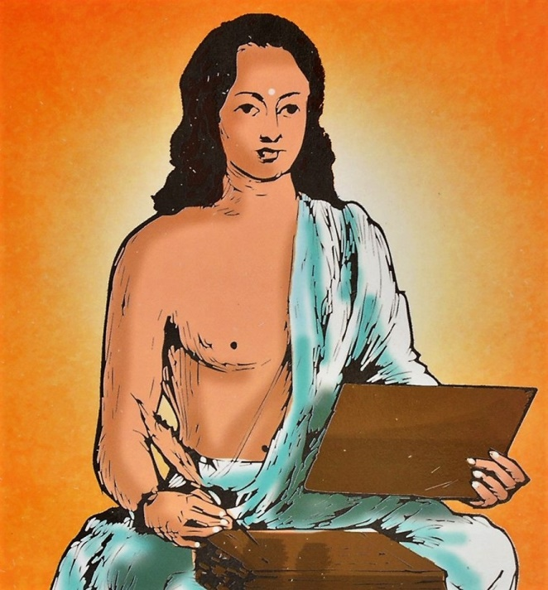
INTRODUCTION
Madhavdev (1489–1596) is an important Saint of Hindu religion and was a great disciple of Sri Sankardev. He became the successor of Sankardev after his death. He is well known for writing devotional poems.
LIFE
Madhavdev was born in the year 1489 and he was educated at Narayanpur, Assam.
He continued his education under a great scholar named Rajendra Adhyapak. He became well versed in Hindu Puranas and other ancient hindu litetature.
Madhavdev met Sankardev and became his disciple in the year 1532, and he followed his teachings and spread it among the people.
The Saint died in 1596 at West Bengal.

FAMOUS WORKS
- Naam Ghosa
- Bhakti Ratnavali
- Janma Rahasya
- Naam Maalikaa
- Srimanta Sankardev
- Dhyana Varnana
IMPORTANCE
Madhavdev was an obedient disciple of his Guru Sri Shankar Dev. He was a sincere devotee of Lord Krishna, similar to his guru. He has written several songs in praise of Lord Krishna and sung them with utmost bhakti. He has also spread the bhakti spirit among others. He insisted others in doing regular worship of Lord Krishna, in order to attain MUKTHI. According to him, the only way to escape from the evil effects of KALIYUGA, is to surrender to the lotus feet of Lord Krishna, with full of devotion and bhakti in mind. And he further says that “Lord Krishna is not expecting anything big from us. Even if we offer some basil (TULSI) leaves to him with sincere devotion, he will readily accept it and give his blessings. Hence pray for getting the divine grace of Lord Krishna”.
Let us worship this great saint and be blessed.
“OM SREE MADHAVDEV NAMAHA”
“JAI KRISHNA”
WRITTEN BY
R.HARISHANKAR

MAHAVATAR BABAJI
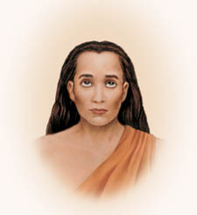
INTRODUCTION
Mahavatar Babaji was considered as an incarnation of Lord Shiva. It is also believed that, Babaji sometimes appears in the form of Lord Shiva. Babaji is believed to have still living in the Himalayas for thousands of years and blessing his devotees and was interested in spreading the kriya yoga among the universe, in order to make the people to live peacefully. It is believed that he was seen by only a small number of his disciples.

LIFE
Babaji’s birth name was Nagarajan. He was born on 203 BC in a small village at Cuddalore district of Tamil Nadu, India.
He was a disciple of Bogar. From his younger age, he loved in seeking spiritualism and was interested in doing yoga and meditation.
At his younger age he left his home, and he went to several holy places in india, studying holy scriptures like the Vedas, Ramayana and Bhagavad Gita.
Once he met Bhogar and became his disciple. Bhogar and Sage Agastya taught "Vasi Yogam" to him. Babaji has become a great yogi and got spiritual powers through his guru.
Mahavatar Babaji met Lahiri mahasaya in 1861, and initiated him into Kriya Yoga and instructed Lahiri to initiate others.
Keshabananda, a disciple of Lahiri, also met Babaji in Badrinath in the year 1935.
His sister Mataji was also living with his brother Babaji for thousands of years. She is described as a “Good looking holy lady, who appears in the form of Goddess Shakthi, and blessing her devotees”. Her details are not much known, however she also contains great yogic power, similar to that of his brother babaji.
IMPORTANCE
Paramahansa Yogananda has mentioned in his book about the features of Babaji. He tells that he is looking in the form of a divine saint with bright face and with full of smile in his face. He looks very charm and attractive with golden coloured body, and possess great spiritual power, and was a great saviour for the entire world.
He blesses his devotees and safeguards from their problems through his yogic power. It is believed that he is still living in the Himalayan cave along with his sister mathaji. Both of them are in a state of meditation, and were divine avatars.
Let us worship Babaji and his sister Mathaji and be blessed.
“OM SREE MAHAVATAR BABAJIYE NAMAHA”
“OM SREE MATHAJIYE NAMAHA”
WRITTEN BY
R.HARISHANKAR

MANIK PRABHU
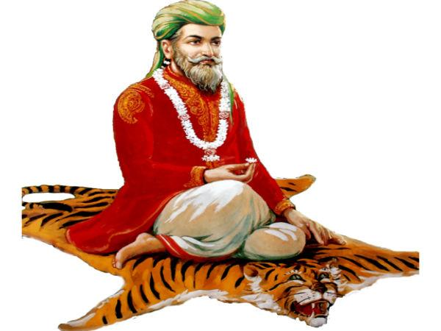
INTRODUCTION
Manik Prabhu was a Hindu saint and guru. He is also regarded as an incarnation of Lord Dattatreya. Shri Manik Prabhu composed several songs in various languages. He has interacted with the great saints like Shri Sai Baba, Shri Swami Samarth and Shri Bramhachaitanya on matters related to spirituality.
LIFE
Manik Prabhu was born in a Brahmin family, on 1817 at Bidar district of Karnataka. It is believed that Lord Dattatreya has appeared to his parents in their dream, and told that he himself would take birth as their son on Datta Jayanti. Prabhu lost his father at an early age and was brought up by his uncle at Basava Kalyan, Karnataka.
And he has performed many miracles at a younger age. He is said to have given Darshan to one person in the form of Lord Shiva, and also cured the diseases of the people. He was not interested in studying and going to school. Due to that once he was scolded badly by his uncle. Immediately he left his uncle’s place and stayed at Amrutkund - a holy place in the jungles of Karnataka for few months.
He travelled to many holy places such as Varanasi, Haridwar, Mathura,pandharpur and other major temples of India. During his travel, he composed numerous songs in praise of various gods in many languages.
Manik Prabhu settled on Maniknagar in the year 1845.
Manik Prabhu guided his devotees and removed the difficulties in their life. He has given food to the needy and the poor.
Manik Prabhu celebrated Datta Jayanti Utsav every year at Maniknagar in a grand manner.
In 1865, Prabhu took mahasamadhi at manik nagar,karnataka.
Prabhu's devotees believe that he is still answering to the prayers of his devotees from his Samadhi.
CONCLUSION
A great divine person, who has helped a lot to the people without seeing any differentiation with respect to their caste,creed and religion. He was also respected by people in other religions. He has done a lot of miracles during his lifetime and has guided the people towards moving to the right path. He was also talented in all kinds of art and a great scholar, and was well versed in vedas,puranas and other hindu texts. He is a guiding us even today, and analysing our good and bad karmas, and keep reducing our bad karmas through his great divine power. Let us worship him and chant his name with sincere devotion and be blessed.
“OM SREE MANIK PRABHU MAHARAJ JAI”
“OM SREE DATTATREYARE NAMAHA”
WRITTEN BY
R.HARISHANKAR

MATSYENDRA
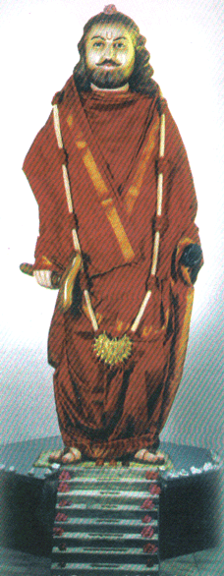
INTRODUCTION
Matsyendra (10th Century) was a saint, born in bangladesh. He was known to be an avatar of Lord Shiva. He was an expert in yoga and meditation.
LIFE
He was adopted by a fisherman who had no child. He was named as Machindranath by him. Machindranath grew up to be an active boy. He was not interested in worldly activities, and he left his home at a younger age and went to Badrinath and has done deep meditation. He was blessed by Lord Shiva and he has become a great saint through his grace. He was a devotee of Lord Vishnu also, and treated Lord Shiva and Lord Vishnu as one and the same.
SPIRITUAL WORKS
- Kaulajnananirnaya
- Matsyendrasamhita
- Akula-Viratantra
IMPORTANT DISCIPLES
- Gorakshanath
- Jalandharnath
- Kanifnath
- Gahininath
- Bhartrinath
- Revan Nath
- Charpatinath
- Naganath
He is also considered as a “RAIN GOD” and worshiped by both Hindus and Buddhists in Nepal.

TEMPLES
- Machindranath Temple at Kathmandu,Nepal.
- Machindranath Temple, Ujjain, Madhya Pradesh.
- Machindranath temple in Sangli District, Maharashtra.
- Machindranath Mandir, Aurangabad,Maharashtra.
- Machindranath Devasthan at Nagpur,Maharashtra.
- Machindranath Mandir, Amravati,Maharashtra.
- Machindranath Tapobhumi, Kudal, Maharashtra.
- Machindranath Guru Peeth Mangalore, Karnataka.
IMPORTANCE
He has taken the avatar in order to save the people from the worst effects of “KALI YUGA”. He preached the importance of uttering the Shiva mantra “OM NAMAH SHIVAYA” among the people, and removed the sins of his devotees by his spiritual power. He was a great scholar and a main person in spreading the importance of shaivism among the people. He lived his life by taking alms, and he didn’t accept the wealth given by the rich people.
CONCLUSION
Matsyendra was a great Siddha Purusha who has lived a simple life and had a soft corner on his devotees and given all the necessities in their life. He was respected by the great kings and by the common people for his gentle approach on them. His spiritual works are his best creations, and can be used as a guide for the people in the present and future generations. Let us worship him and be blessed.
“OM SREE MATSYENDRARE NAMAHA”
“OM NAMAH SHIVAYA”
WRITTEN BY
R.HARISHANKAR

MOLLA
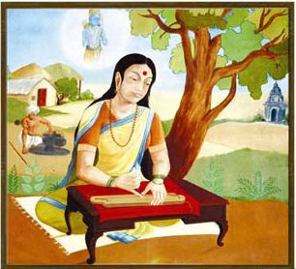
INTRODUCTION
Molla (1440–1530) was a Telugu poet and the translator of Sanskrit Ramayana in Telugu.
LIFE
She was born at a village in Kadapa District in Andhra Pradesh state. She was a Shiva devotee. Her parents were great devotees of Lord Mallikarjuna and Goddess Brahmaramba of Srisailam. She was a kind hearted and a loving lady.
DIVINE WORK
Her work is known as Molla Ramayanam and it is considered as good and simple by the readers.

IMPORTANCE
She was a humble and a soft spoken lady, who never hurts anyone through her speech.
She was awarded the title of “Kavi Ratna” for honouring her spiritual works, by the Vijayanagar emperor Sri Krishna Deva Raya.
During her old age, she visited Srisailam and stayed there, and spent the rest of her life towards devoting Lord Shiva. She has also showed the spiritual path for the people. She lived a whole life span of 90 years, and then she attained Samadhi. The way she lived a noble life, will act as an example for the future generations. Her poems are widely sung by the people even today.
CONCLUSION
Though she was a shiva devotee, she was also a Vishnu devotee, who has translated Ramayana into telugu. During her period, she was liked by everyone due to her simplicity, kindness and gentleness. After her departure from earth, she has reached the heavenly abode of god. Let us pray to her and be blessed.
“OM SREE MOLLA THAYE NAMAHA”
“OM NAMAH SHIVAYA”
“JAI SREE RAM”
WRITTEN BY
R.HARISHANKAR

MUKTABAI
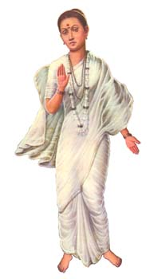
INTRODUCTION
Muktabai(1279-1297) was a popular saint. She was born at Alandi, Pune in a Brahmin family. She was the younger sister of the great saint Dnyaneshwar.
Her parents were died at her younger age.
Muktabai became the student of his elder brother Nivruttinath and she learnt the vedas, the Upanishads and other sacred hindu texts and mastered in yoga and meditation.
She has quickly learned all the subjects and was well versed in giving devotional lectures to the people.
IMPORTANT LECTURES
- A saint is always a holy man, and he always forgets the mistakes of the people and will treat them with kindness.
- Always worship god and sing in praise of him, so that you will get the everlasting bliss from him.
- Always do charity, so that god will permanently stay in your heart.
- Don’t think too much about future, since it was already decided by the god. Think about the present life and do good things to the others.
- Never hurt others using bad words. Always mingle with them in a gentle manner.
- Give proper respect to your parents, and take care of them well at their old age by providing proper food and other necessary facilities.
- Do your job properly, and rest you leave it in the hands of the god. God is always there to protect you.
- Avoid negative thoughts in your mind, since it will kill your peace of mind.
- Don’t save too much money for your life. Donate some portion to the poor and needy. After our death, money will not come with us, only our Punniyam(Good Karma) will come along with us.
IMPORTANCE
She has dedicated her entire life towards doing service to the people through her spiritualistic approach and worshipping god. She has controlled all her senses and thought only about the glory of god, and never allowed any bad thoughts to enter into her mind. She was a divine lady, and though she lived only for a short span of 18 years, she has done a great service to the god and to the people. She has removed the sufferings of the people through her devotional lectures. Though now she is not living with us, the holy life she lived will always be remembered by us through her preaching. She acts as an example for others.
DEATH
She died at the age of 18 in Alandi,Pune.
CONCLUSION
She lived a saintly life throughout her life. Though she has lost her parents at her younger age, she never lost hope, and concentrated her entire attention towards god. She has taken birth in order to safeguard us from the evil effects of this kaliyuga. Let us sincerely pray to the divine mother and be blessed.
“OM MATA MUKTABAI NAMAHA”
WRITTEN BY
R.HARISHANKAR

NAMDEV
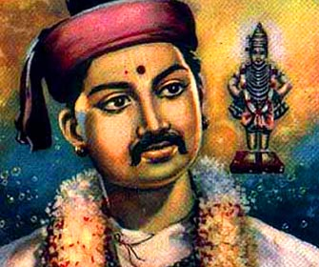
INTRODUCTION
Namdev Maharaj(1270–1350), also known as Nam Dev, was a great poet and saint from Maharashtra. His writings were also recognized by Sikhism. Namdev is a sincere devotee of lord Vitthal.
LIFE
Namdev was born due to the devotion of his parents on Lord Vitthal, and their prayers were answered by the god. He was born at their old age. He got married and had one son.
Namdev is considered as a holy man by other religious people also.
It is believed that Namdev died at the age of eighty and at Pandharpur.
He entirely devoted his life towards spreading the message of Lord Vitthal to the people, and asked them to constantly worship Lord Vitthal.
IMPORTANCE
Namdev was a great poet and written various poems and sung in praise of Lord Vitthal. He along with his family, surrendered the lotus feet of Lord Vitthal. He never took food without worshipping Lord Vitthal, and daily performed puja to Lord Vitthal, and made his food offerings to him. He has done a lot of charitable activities. Even though he was not a rich man, but he provided food to the needy, and helped the down trodden people in a generous manner. Through his bhajans, he was attracted by a large crowd, which includes rich and poor people. He never differentiated between rich and poor, good and bad people, and according to him, all the people are the servants of Lord Vitthal, and if we surrender ourselves at his feet, we will get enlightenment, and can reach the divine place after our death.

CONCLUSION
Saint Namdev was a true devotee of Lord Vitthal, and attained SALVATION after his death. Though now he is not with us, his devotion to god will never be forgotten by the people. He will be remembered for ever for his BHAKTI on Lord Vitthal. Let us worship this great holy saint and be blessed.
“OM SREE NAMDEV NAMAHA”
“JAI SREE VITTHAL MAHAPRABHU JAI”
WRITTEN BY
R.HARISHANKAR

NARASIMHA SARASWATHI
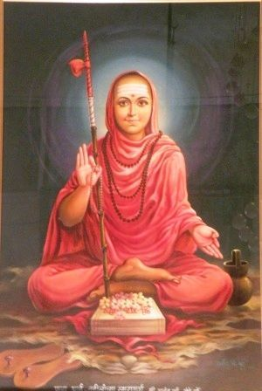
INTRODUCTION
Narasimha Saraswati (1378−1459) was an Indian saint and considered to be an avatar of Lord Dattatreya. His birth name was Narahari. His life history was written by Sri Saraswathi Gangadhar in his book Shri GuruCharitra.
LIFE
Narasimha Saraswati was born in a Brahmin family in Maharashtra.
Narasimha Saraswati was able to speak only during his Upanayanam(Thread ceremony). He started reciting the Vedas only after his Upanayanam. At a younger age itself, he was well versed in vedas and sacred texts of Hinduism.
He went on a pilgrimage to Kashi at the age of eight.
He took Sanyasa at Kashi from Shri Krishna Saraswati. From then onwards, he was called as “Narasimha Saraswathi”.
He visited several holy places and settled in Gangapur,Karnataka.
At the end of his life, he attained samadhi in Kadali vanam,near srisailam.
His famous disciples are as follows:-
- Shri Madhav Saraswati
- Bal Saraswati
- Krishna Saraswati
- Upendra Saraswati
- Sadananda Saraswati
- Dnyanajyoti Saraswati
- Siddha Saraswati
- Ramkrishna Saraswati

IMPORTANCE
Narasimha saraswathi swamiji has lived a saintly life during his period. He has helped the people through his grace, and cured the diseases of his devotees and removed the problems in their life through his spiritual powers. He was a very simple and honest saint, who always worship god and chants his name. His teachings are based on doing good things to the people, and providing food to the needy, and treating all the living beings as equal and showing kindness on them.
CONCLUSION
Sri Narasimha saraswathi being an avatar of Lord Dattatreya, has dedicated his entire life towards teaching and guiding the people in a proper manner, and taking them to the spiritual path through devotion. He was an eminent scholar and a master in all spiritual subjects. He is the saviour who has come to this earth to rescue us from our sins. It is also believed that devoting to the spiritual guru will give immediate good results, than devoting to the god. Hence let us pray to him and be blessed.
“OM SREE NARASIMHA SARASWATHI SWAMIYE NAMAHA”
“OM SREE GURU DATTATREYARE NAMAHA”
WRITTEN BY
R.HARISHANKAR
NARAYAN MAHARAJ
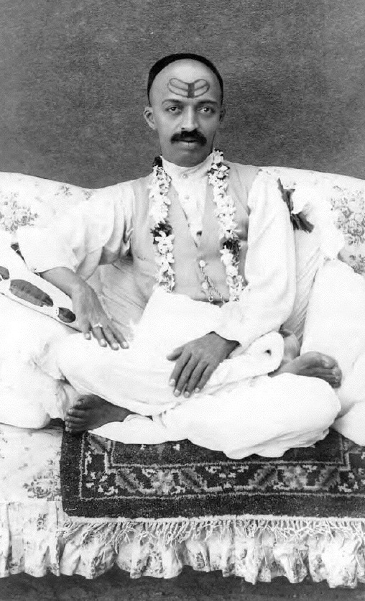
INTRODUCTION
Narayan Maharaj (1885–1945) was considered by his followers as a GREAT SAINT. He lived in Pune, India.
LIFE
Narayan was born in Nargund, Karnataka in 1885. His parents were died at his younger age. He was took care by his grandmother. At his younger age, he was deeply interested in spirituality and went to Gangapur and attained spiritual enlightenment.
He travelled to many holy religious places in india and worshipped the divine gods and received the blessings from them.
Narayan lived a comfortable life. But he was unselfish and helped the poor. He was considered as a great man by the people. He attained the divine bliss of the god, and was keen in inculcating the divine spirit amongst the people. He was a great devotee of Lord Shiva and conducted regular pujas and provided annadanam to the poor and the needy and given clothes and also offered shelter to them.
He stayed at ooty for some time, towards getting treatment for his health problems, and then moved to Bangalore and performed a grand puja to Lord Mallikarjuna. There he provided free food for more than one lakh devotees in that temple, and after some time he left his physical body, on 3 September 1945.
His Samadhi is situated at his ashram at Bangalore.
IMPORTANCE
Sri Narayan Maharaj though was a rich man, was kind enough to distribute his wealth to the poor and the down trodden people. He was interested in doing social welfare activities, and done it till his last breath. It is considered that he was a blessed devotee of Lord Shiva, and had the vision of Lord Shiva in his dream.
His regular saying is: We are all the slaves of Lord shiva, we have to do good things in our life, in order to reach his divine abode of Kailasa.
He was interested in reading spiritual books and distributed it amongst the people, in order to attain spirituality in their life. He was considered as a humble and a soft spoken Guru, who always chants the Shiva mantra “OM NAMAH SHIVAYA” and asked others to do it.
He asked the people to do shiva puja in their homes regularly, and to worship him with utmost faith in order to attain the grace of Lord Shiva.
He insisted his followers to serve others, since it is equivalent to that of serving Lord Shiva.
Let us worship this holy guru and be blessed.
“OM SREE NARAYAN MAHARAJ NAMAHA”
WRITTEN BY
R.HARISHANKAR

NAROTTAMA DASA
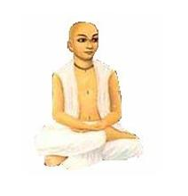
INTRODUCTION
Narottama Dasa Thakura (15th century) was a saint who was the main person towards spreading the bhakti of Lord Krishna throughout India. He was born as the son of the emperor of Bangladesh.
LIFE
Narottama Dasa Thakura lived as a bachelor throughout his life.
From his childhood he was always attracted to Shri Chaitanya. He was also trained in all the languages, and was a master in all kinds of art, and also a great learned scholar.
Even at his younger age, he was not interested in enjoying worldly comforts, but concentrated his attention towards worshipping Lord Krishna. He had his food only by taking alms.
He had preached the bhakti spirit of Lord Krishna amongst the people.
According to him, our main aim is to surrender and realize Lord Krishna, in order to attain the eternal bliss of the god.
Narottama had many thousands of disciples, in Bangladesh, and they preached his teachings throughout the world.
He travelled to Bengal and circulated his devotional writings to the general public.
He was well known for his devotional poems, which describes the love between Radha and Krishna.
SPIRITUAL WRITINGS
- Prarthana
- Premabhaktichandrika
- Hatapaltana
- Smaranamangala
IMPORTANCE
He was a great devotee of Radha and Krishna and spent his time towards devoting them. Though he was the son of a king, he left all the worldly pleasures and become a saint. He was a great yogi and contains spiritual powers. He emphasised the people towards concentrating their attention on god, in order to solve the problems in their life.
We cannot see such a person in this kaliyuga, and we have to follow his teachings and live comfortably.
Let us worship this great saint and be blessed.
“OM SREE NAROTTAMA DASARE NAMAHA”
“JAI KRISHNA”
WRITTEN BY
R.HARISHANKAR

