SACRED TEXTS WRITTEN BY R.HARISHANKAR
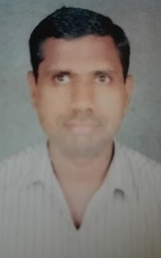
CHATTAMPI SWAMIGAL
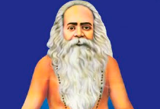
INTRODUCTION
Chattampi Swamikal (1853-1924) was a Hindu sage, philosopher and a social reformer. He was against caste discrimination. He fought for the welfare of the poor, and also given help to the poor and widowed women and provided food, clothes and shelter to the poor and the homeless people. He was interested in yoga and meditation, and taught it to the common people.
He along with his friend and a great spiritual person, Sri Narayana Guru, tried to improve the living standard of the people in kerala. He also worked for the welfare of women and given sufficient financial aid for conducting marriages for the poor girls in kerala. Swamikal was a strict vegetarian and asked others also to follow it. Swamikal treated all the religious people as one and the same. According to him, each religion contains wonderful teachings and it tells the proper way of living in the life. Hence he tells that he finds no difference between the religions, since there is only one god, and he only through his great supreme powers is protecting this entire world. Through his good lectures and teachings, he got many followers and friends from different regions of Kerala. He had written several books on spirituality and meditation. His birth name was Ayyappan.

BHASKARARAYA
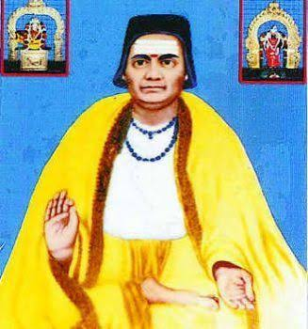
INTRODUCTION
Bhaskararaya (1690–1785) is a great devotee of mother Adhi Parasakthi. He was born in Andhra Pradesh, was patronised by the kings of South India, due to his great efficiency in all subjects and he settled down in Tamil Nadu. According to several indian and foreign scholars, Bhaskararaya was a great saint and also a great writer and an independent thinker.
Bhaskararaya had written vedic texts, poems on gods and goddesses and sanskrit documents. His major works are focussed mainly on composing poems in praise of Mata Parvati Devi. He died at the ripe age of 95, and it is believed that, after his death, he has attained SALVATION.
MAIN WORKS
- Commentary on Upanishads.
- Commentary on Devi Mahatmya.
- Varivasya Rahasya.
- Setubandha.
- Commentary on Lalita sahasranama.
- Commentary on Ganesha Sahasranama.
IMPORTANCE
Throughout his life, he wrote poems, gave lectures on vedas and Upanishads, and also served as a poet in the king’s court. He was an expert in all kinds of arts, and he was able to speak, read and write in many different languages. Apart from his regular activities, he also helped the poor and the down trodden people, and at his own cost, given sufficient necessities to them.

DAMODARDEV
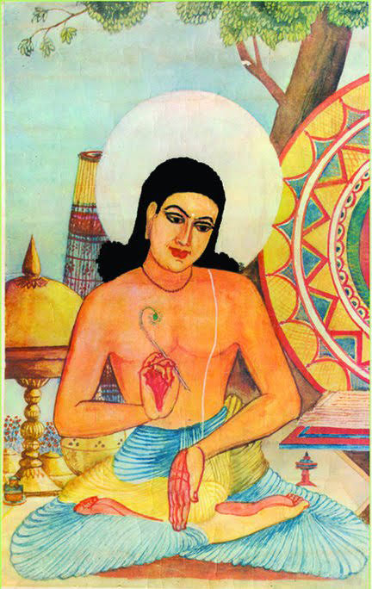
INTRODUCTION
Damodardev (1488–1598) was a great saint and a friend of Sankardev and invoked the bhakti spirit among the devotees.
LIFE
Damodardev was born in Assam. His father was a friend of Sri Sankardev, a great saint. Damodardev got educated under a guru and studied the basic education along with scriptures and other religious books. After some time, he and his family were settled in Chandravatipura. Shankardev guided him in his spiritual journey and he was his guru. He accepted the teachings of his guru and travelled to several holy places and visited the divine deities and also propagated the bhakti spirit to the common people. He lived a saintly life and he also relieved the diseases of his devotees, through his great spiritual powers.
BABA HARIDAS
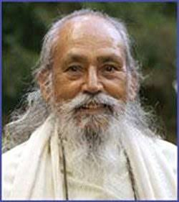
INTRODUCTION
Baba Hari Dass (1923–2018), born in Almora, Uttar Pradesh, India. He was a yoga master, a saint and a guru who has guided thousands of his followers during his life time. He was specialised in various yogas and an expert in Ayurveda and a master in all kinds of hindu, and also contains proficiency in vedas and sanskrit.
LIFE
He was born into a Brahmin Brahmin family in thhe year 1923. He was also a writer and renovated many temples in his native place. He had conducted several yoga centers throughout india and given lectures in California and in Canada. He was attracted by the people through his simplistic approach. He guided the people in the spiritual path and extended his blessings and gave them suitable solutions for their problems.
BHAKTHI SIDDHANTA SARASWATI
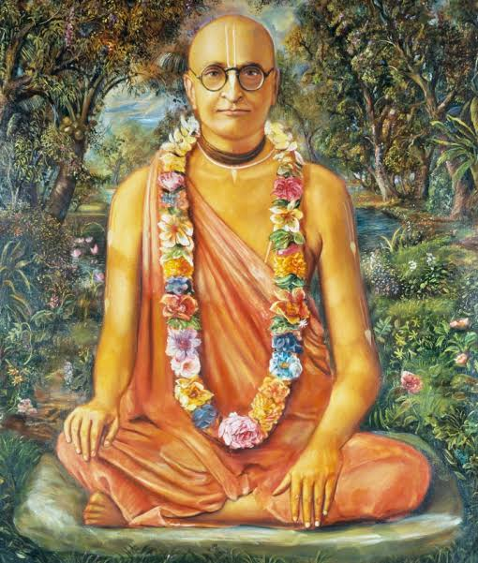
Bhaktisiddhanta Sarasvati Goswami (1874–1937), was a Gaudiya Vaisnava saint, and contained great bhakti on Lord Vishnu and promoted religious discourses in the temples and dedicated his life towards doing service to the god. His birth name was Bimla Prasad.
Bimla Prasad was born in Puri. His father was a teacher. Bimla Prasad received good education and earned the title Siddhanta Sarasvati. Under guidance of his guru, Bimla Prasad took saint hood, and dedicated himself towards doing service to Lord Krishna. He also done lot of charitable activities like providing food to the people and to the animals and showed kindness among the people and lived a saintly and a noble life. He was praised by the devotees for his great humanity. He has sorted out the problems of his devotees, and took them to the spiritual path.
BHAKTIVINODA THAKUR
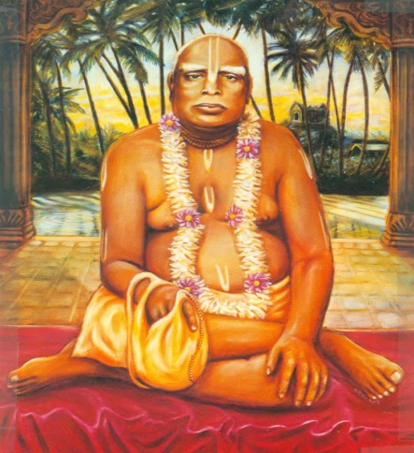
Bhaktivinoda Thakur (1838–1914), was a Hindu saint of Gaudiya Vaishnavism and considered as the most powerful Vaishnava leader of his time. His son Bhaktisiddhanta Sarasvati, made sincere efforts to spread the vaishnavism sect throughout india. His birth name was Kedarnath Datta. He was born in the year 1838 in West Bengal, in a pious land lord family. After completing his formal education in his native place, he continued his education at a college in Calcutta. There he maintained close friendship with the great persons such as Ishwar Chandra Vidyasagar, Bankim Chandra Chattopadhyay, and Sisir Kumar Ghosh. After completing his entire education, he got a teacher’s job in Orissa. After some time, he deeply involved himself in spiritualism, and got many disciples and followers. His teachings were very famous among his devotees, and he insist the people to worship the god in order to remove the obstacles in our life.
CHANDRASEKARA BHARATHI III
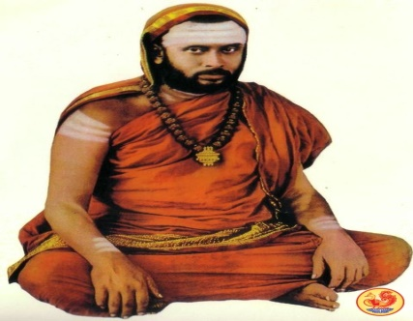
INTRODUCTION
Chandrashekara Bharati III (1892–1954) was the Jagadguru of the Sringeri Sharada Peetham during the period: 1912–1954. It is believed that he has got liberated (JEEVAN MUKTAR). His birth name was Narasimha Sastri. He was born to a holy Brahmin family in Sringeri in the year 1892. He spent his childhood days in Sringeri. He had completed formal schooling and also learnt the vedas and other divine scriptures through the guidance of an eminent guru. In 1912, he has become the successor of Acharya Sacchidananda in the Sharada Peetham. He was also efficient in yoga and meditation and after becoming a saint he conducted spiritual lectures among the devotees and the people and travelled to holy temples throughout india. Through that he got great name and fame.

GAURAKISORA DASA BABAJI
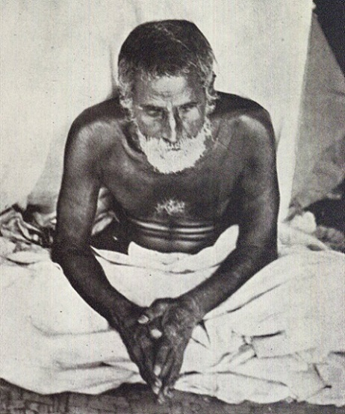
INTRODUCTION
Gaurakisora Dasa Babaji (1838–1915) is a famous guru from the Gaudiya Vaishnava tradition of Hinduism, and he is highly praised for his holiness by his followers. He had given his teachings on Bhakti Yoga, and has become very famous through that.
He was born in the year 1838 in a small village in present day Bangladesh. At the age of 30, he accepted the life of a Babaji in the Gaudiya Vaishnava tradition. He will used to visit several holy temples and stayed in the holy cities of Vrindavan and frequently used to chant the names of “RADHA” and “KRISHNA” with full of joyful tears flowing down from his eyes.
In 1900, Gaurakisora Dasa Babaji gave saint hood to his successor Sri Bhaktisiddhanta Sarasvati Thakura and guided him properly till his death.

GUNATITANAND SWAMI
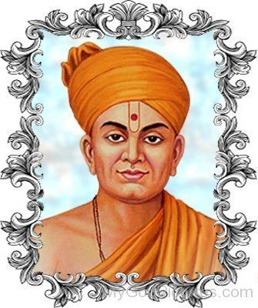
INTRODUCTION
Gunatitanand Swami (1784 –1867) was a famous saint of the Swaminarayan Sampraday who was blessed by Swaminarayan and he is the first spiritual successor of Swaminarayan. He was born into a noble family at Bhadra in Gujarat. He studied under the famous guru Sri Ramanand Swami and then become a saint at the age of 25. He was famous for his spiritual discourses and divine service. His birth name was Mulji Jani.
His important teachings on dharma, knowledge of the soul, attaining spirituality were very much attracted by the people and regularly attended his lectures. Gunatitanand Swami died in 1867, and a famous shrine was built in order to honour the great worshipful saint. People would regularly visit his shrine in order to get his blessings.
JAGANNATHA DASA BABAJI
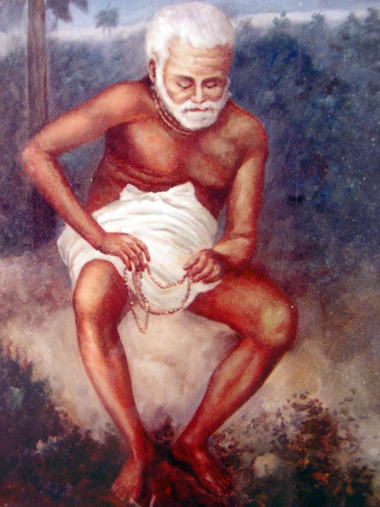
INTRODUCTION
Jagannatha Dasa Babaji (1776–1894) was a guru in the Gaudiya Vaishnava tradition of Hinduism, and is considered as a great saint by his followers. He accepted sainthood from Jagadananda Goswami of Vrindavan, and also from Madhusudana dasa Babaji. He has considered himself as a slave to Lord Krishna, and used to think about him by uttering his mantras. He will also worship him with full of devotion in his mind. Jagannatha Dasa Babaji was born in a village of Bangladesh. It is believed that he was born during the year 1776. Jagannatha Dasa Babaji spent his last days in the holy places of Vrindavan and Navadwip and worshipped Ma Radha and Krishna. He lived for more than 100 years and at the time of his death, it is believed that, he had chanted the names of Lord Krishna and Radha.
JEEVA GOSWAMI
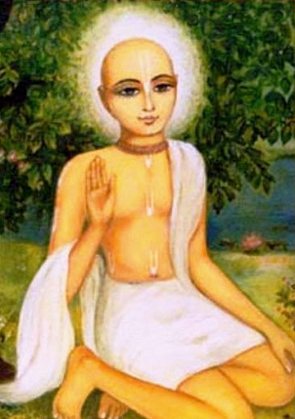
INTRODUCTION
Jiva Goswami (1513–1598) was a great saint from the Gaudiya Vaishnava sect and written lot of sacred works on yoga, veda and on Krishna Bhakti. He was the relative of Rupa Goswami and Sanatana Goswami.
He was born in a village in West Bengal into a pious family. He was a sincere devotee of Krishna even from his younger age and learnt the entire education under a spiritual guru.
He joined with Chaintanya Mahaprabhu at his younger age along with his relatives. He travelled to many places and spread the “KRISHNA BHAKTI SPIRIT” among the masses. According to him, Lord Krishna is everything. He will used to pray to him before having his food and before going to his bed. He was considered as one of the main saint in the Gaudiya Vaishnava tradition.
KHATKATE BABA
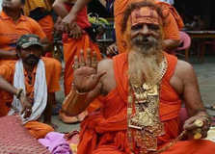
INTRODUCTION
Khatkhate Baba (1859–1930) was a Kashmiri saint and contains great spiritual powers. His birth name was Shiv Prasad.
Among the holy men in Kashmir, he is considered as an outstanding one, and performed miracles and relieved the sickness of his sincere devotees, and also protected them from their enemies. Due to his huge popularity among his large number of devotees, he was called as Baba. His samadhi is situated at Etawah, and it is a pilgrimage centre, and lot of people from the nearby areas would regularly visit his Samadhi and worship him. He was a great learned man, who was interested in spirituality, and become a great saint. His followers were considered him as their guru, guide, god and their saviour. Till his death, he provided service to the people and to the god.
KRIPALU MAHARAJ
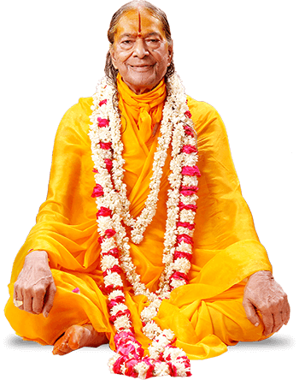
INTRODUCTION
Kripalu (1922 –2013) was a famous spiritual leader from Allahabad.
He was the founder of Jagadguru Kripalu Parishat (JKP) and Radha Madhav Dham. He was awarded the title of Jagadguru during the year 1957. His birth name was Ram Kripalu Tripathi.
Kripalu was born in the year 1922 in Allahabad. He studied his formal education in his birth place, and later he studied Ayurveda in Varanasi. After some time, He formed his own bhakti organization and was declared as a holy guru by his devotees and disciples and was affectionately known as Shri Maharaj Ji. Till his death he concentrated on bhakti path and moved the people towards it. He also helped the poor people by providing basic facilities to them.
KRISHNADASA KAVIRAJA
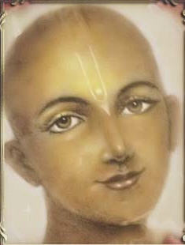
INTRODUCTION
Krishna Dasa Kaviraja Goswami was born in the year 1496 and he has written the text known as: Chaitanya Charitamrita, the life history of Sri Chaitanya Mahaprabhu, an incarnation of Lord Krishna.
He was born in the village of West Bengal. He got the bhakti spirit on Lord Krishna. It is also believed that during the previous dwapara yuga, he was the friend of Lord Krishna.
He left Bengal and travelled to Vrindavana and he took sainthood from Raghunatha Dasa Goswami, a follower of Chaitanya Mahaprabhu. He also wrote Sri Govinda Lilamrita and Saranga rangada kangada tika. He was well appreciated by the kings and the devotees for his spiritual works and also for his sincere dedication on Lord Krishna.
LAKSHMANANANDA SARASWATI
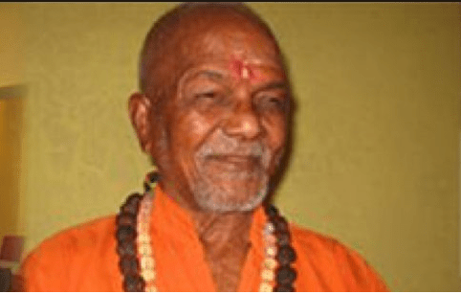
INTRODUCTION
Lakshmanananda Saraswati (1926–2008), was a Hindu monk and a social leader who had dedicated his life to the welfare of the tribal people. The Swami was a native of a village in Talcher, Odisha and was born into a pious Brahmin family. At his younger age itself, he was very much attached with spirituality, and left his family, and went to Rishikesh. In 1968, he established an ashram in Odisha, and involved in social services for promoting the tribal people welfare. He was praised by the tribal leaders and the tribal people, and treated him with much respect. His social service was not welcomed by certain set of activists, and he was killed by a group of people. The tribal people were very much worried about his death, and offered tributes to him at his native place. Inspite of several death threats, which had faced previously, he tirelessly fought for the welfare of the tribal people.
MAHARISHI MAHESH YOGI
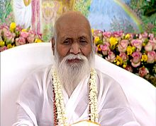
INTRODUCTION
Maharishi Mahesh Yogi (1918–2008) was an Indian guru, known for developing the special kind of meditation technique also known as “The Transcendental Meditation technique”, and formed a spiritual organisation and established throughout the world. By adopting his meditation techniques, many people were become his followers, admirers and devotees. He was also interested in spirituality. His birth name was Mahesh Prasad Varma. Maharishi Mahesh Yogi became a disciple and Swami Brahmananda Saraswati, the spiritual leader of Jyotirmath in the Himalayas. He was appreciated for his great knowledge, kindness and healing power. Many of his devotees felt that by his mere touch, the mental and physical diseases of the people will be cured. With high honour, he was called as “MAHARISHI”. And his admirers were believed that he is a blessed saint.
MAHARISHI MEHI
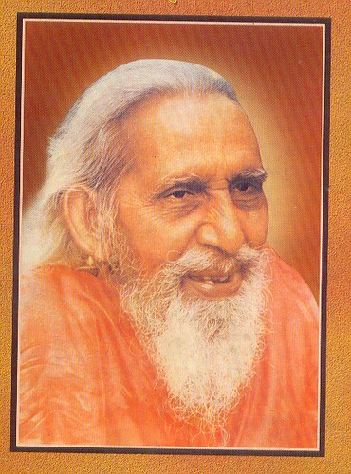
INTRODUCTION
Mehi also known as Mehi Maharishi is a saint in the tradition of Sant Mat. He was also known as 'Gurumaharaj'. He was the guru of 'Akhil Bhartiye Santmat Satsang'. He studied Vedas, and other spiritual texts. He had insisted the people to do meditation for attaining SALVATION. Mehi was a disciple of Baba Devi Sahab of Muradabad, Uttar Pradesh. Maharshi Mehi was born in the year 1885 in a small village of Bihar, India. He studied his basic education at his native place and then under the guidance of Baba Devi Sahab. As per the advice of his teacher, Mehi spent many years in deep meditation in an ashram located in Manihari of the Katihar district. He dedicated his entire life in living as a holy saint, and giving good lectures and doing yoga and meditation.
NARAYANA GURU
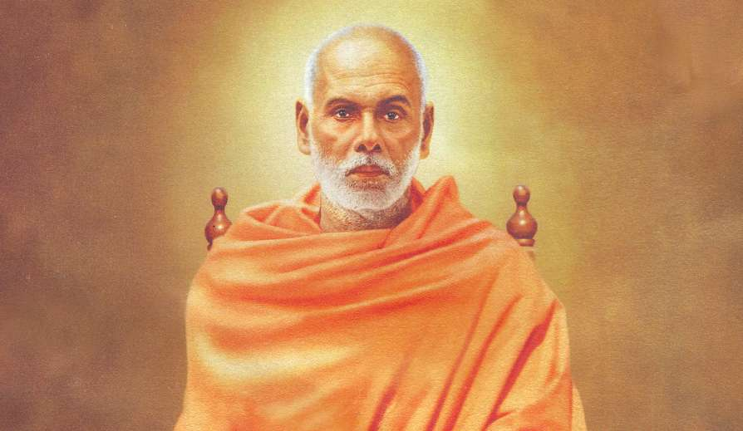
INTRODUCTION
Narayana Guru (1855–1928) was a spiritual leader and social reformer. He was born into a family of the Ezhava caste. He was against caste discrimination. He promoted spiritual enlightenment and social equality. Narayana Guru was born in the year 1855 in a village at Thiruvananthapuram. He learnt his basic education under a guru. For continuing his further studies, he went to Travancore and studied under a scholar, and learnt Vedas, Upanishads, and sanskrit language. He started a village school at his native place. He left his family, and travelled across india and learnt meditation and yoga. He meditated in a cave at Maruthwamala. He had rendered a good service to the service of the god as well as to the mankind. He died at the age of 73. He is still remembered for his valuable service to the society.
NARAYANPRASADDASJI SWAMI
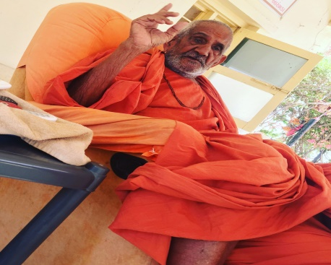
INTRODUCTION
Shri Narayanprasaddasji was one of the famous saints in the Swaminarayan Sampraday. He was a kind hearted and a noble saint. His birth name was Girdhar Radadiya. Shastri Swami Narayanprasaddasji was born in the year 1921, in the Vaishnava family in Gujarat. He was born in a poor family. Somehow he had finished his education and studied the religious scriptures. He was a very clever and nice boy, and used to grasp all the subjects immediately. He used to sing Swaminarayan songs in the Swaminarayan Temples. He left his family at his younger age and become a Saint of Swaminarayan Sampraday. Throughout his life, he spent his time in doing service at the swami Narayan temple, and he died at the age of 97. Due to his kindness and noble service, he will be always remembered by the swaminarayan devotees.
THIPPERUDRA SWAMY
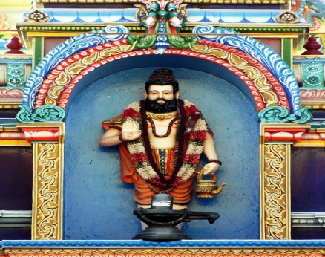
Nayakanahatti Thipperudra Swamy, (16th century), was a great Guru, saint and social reformer. Once from his jeeva Samadhi, he blessed hyder ali, and he cured the illness of his son, Tipu Sultan. Hence he is worshipped by both the Hindu and Muslim devotees. His teachings are very famous, and he insists us to do our work properly, and considered that doing work is equivalent to praying god. It is believed that he was born in Nayakanahatti, Karnataka. As per the available records, it is believed that he would have been born during the period: 1570 - 1646 AD. According to ancient texts, it is believed that Thipperudraswamy was an incarnation of Lord Shiva’s divine attendant. He had taken avatar in this earth, in order to spread the spirituality across the globe and to do service to the mankind. He also performed many miracles in the life of his devotees. It is believed that he is still living in physical form in his Jeeva Samadhi and answering to the prayers of his devotees. Daily lot of devotees from Karnataka and Andhra are visiting his Jeeva Samadhi, to get his divine blessings.
NIGAMANANDA PARAMAHANSA
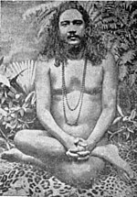
INTRODUCTION
Swami Nigamananda Paramahansa (1880 –1935) was a great saint and a guru. He is a worshipper of Mata Parvati in the form of Durga Devi and attained great powers towards meditating to her. He was also an expert in yoga and meditation, and spread the bhakti spirit across the region. Nigamananda was born into a holy Brahmin family in the Meherpur district of Bangladesh. After attaining sainthood, he was called as Swami Nigamananda Saraswati. Nigamananda helped the common people with his spiritual powers. He provided food to the poor people. He also healed many sick people and made them to talk and walk in the outside world. He died in the year 1985, and till his death, he was actively engaged in doing service to the god and to the people.
NISARGADATTA MAHARAJ
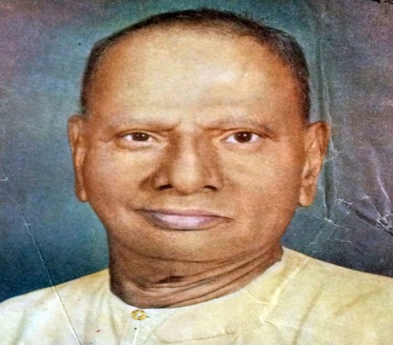
INTRODUCTION
Nisargadatta Maharaj (1897–1981), was a Hindu guru and the follower of the Lingayat Shaivism. And he also worships Lord Vithoba. His birth name was Maruti Shivrampant Kambli. He also gave lectures about the glory of Lord Shiva and delivered lectures in foreign countries also. Through that, he got great name and fame, and lot of people were got attracted with his speech. His guru was Siddharameshwar Maharaj.
He was born in the year 1897 in Mumbai. Since he was born on the Hanuman Jayanti day, his parents were named him as “MARUTI”. He was also a sincere devotee of Lord Ram, Mata Sita and Lord Hanuman. His parents were the sincere devotees of Lord Vithoba. He had done lot of good activities to the people, by teaching them spiritual subjects and also given proper necessities to the poor people for running their livelihood. Till his death at the age of 84, he concentrated his attention on devotion and social welfare activities.
NISHKULANAND SWAMI
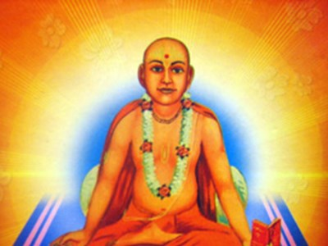
INTRODUCTION
Nishkulanand Swami (1766–1848) was a saint of the Swaminarayan Sampraday and the follower of Lord Swaminarayan. He birth name was Lalji.
He was born in the year 1766 to a noble family at a small village, in Gujarat. He learnt the basic education and studied several languages. He was an expert in the field of carpentry, and took the profession as a carpenter for some time.
He became a follower of Swaminarayan after the death of his Guru Sri Ramanand Swami. Due to his great skills, He had sculpted beautiful idols in the Dholera Temple. In Vadtal, he built a 12 door Hindola. He wrote a sacred book NishkulanandKavya. He was an expert in writing and composing music and poems. He kept on writing scriptures until his death. He died at the age of 82. Nishkulanand Swami also wrote a divine scripture named Bhaktachintamani, describing the life and the miracles performed by Sree Swami Narayan. He has also composed many sacred texts and was widely appreciated for his talent. He was regarded as a great saint by his followers.
NITYANANDA PRABHU
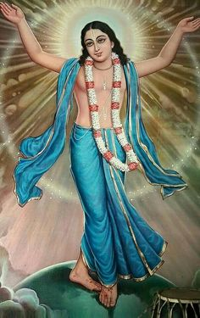
INTRODUCTION
Sri Nityananda Prabhu (15th century), was a Hindu saint, and belongs to the Gaudiya Vaishnava, and is considered as an incarnation of Lord Balarama. He was Chaitanya Mahaprabhu's close friend and disciple. Nityananda Prabhu was born to a pious Brahmin at a small village in Birbhum district of present West Bengal in the year 1474. He was talented in composting and writings songs on Lord Krishna and used to conduct bhajans and sing the divine songs of Lord Krishna along with his friends and disciples. At his younger age, he left home and become a saint and called by the people as Lakshmipati Tirtha. He travelled to Lord Krishna’s holy temples in vrindavan, vital-rukmani mandir in pandharpur, dwaraka and visited several other shrines of Lord Krishna. He learnt lot of divine studies through the guidance of Sree Chaitanya Mahaprabhu. Throughout his life, he performed miracles and solved the devotee’s problems and helped them to take the spiritual path and blessed his devotees.
PRABAT RANJAN SARKAR
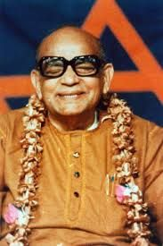
INTRODUCTION
Prabhat Ranjan Sarkar (1921–1990), is called by the name, Anandamurti and as Baba, is a Spiritual Guru, poet, writer and composer. He was the founder of Ananda Marga, a yoga and meditation centre in the year 1955. Sarkar was a best author and produced lot of spiritual works which are useful to the people for increasing their spiritual knowledge and can reduce their stress and tensions. Sarkar was born in the year 1921. He was a bright child, who was very much interested in learning puranas and vedas, and also done yoga and meditation at his younger age.
For some time, he worked as an accountant in central government. After some time, through his meditation centre, he helped the people to live freely from mental problems. He was admired by the people for his great service to the society.

PRAMUKH SWAMI MAHARAJ
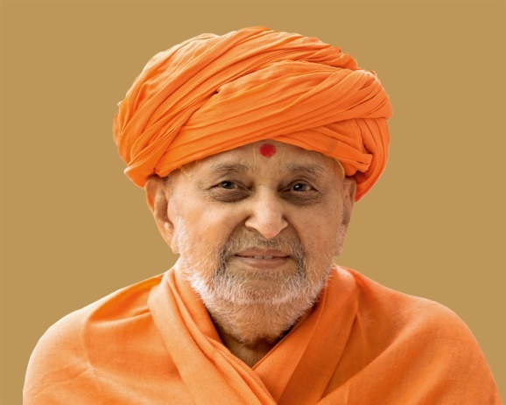
INTRODUCTION
Pramukh Swami Maharaj (1921–2016) was the guru and president, of the Swaminarayan organization. His birth name was Shantilal Patel. He used to interact with Lord Swaminarayan through his divine powers, and is also considered as an aspect of Sree Swaminarayan. He was appointed as the President of BAPS in 1950. He was the spiritual successor of Sri Yogiji Maharaj. He had constructed more than 1,000 Hindu temples, including the Swaminarayan Akshardham temples in the north india. He had also started the BAPS Charities, in order to provide wholesome food to the devotees of the Swami Narayan Mandir, and also done various charitable activities. He was praised by the devotees and the followers of the swami Narayan for his simplicity and kindness approach. His spiritual successor was Mahant Swami Maharaj.
RAGHUNATHA BHATTA GOSWAMI
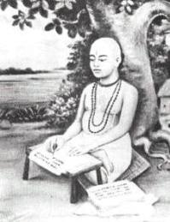
INTRODUCTION
Raghunatha Bhatta Goswami (1505–1579) was a disciple of the great saint Chaitanya Mahaprabhu. He was a sincere and a disciplined disciple of Sri Chaitanya and helped in promoting the Krishna Bhakti Movement across the globe. He was born in a noble Vaishnava family in Bengal. His parents were sincere devotees of Lord Krishna, and invited Sri Chaitanya at their home and offered delicious food to him. Gradually Raghunatha had got attached with Chaitanya and wilfully served him till his death. After finishing his education, he went to Puri and spent several months in doing service to Chaitanya. As per his guru’s advice, he had studied the Bhagavata Purana and other Vedic and Puranic scriptures and become a talented person.
SANATANA GOSWAMI
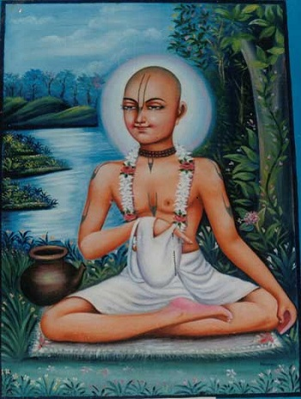
INTRODUCTION
Sanatana Goswami (1488–1558) was a main disciple of Chaitanya Mahaprabhu. Sanatana wrote lot of books about the bhakti tradition of Gaudiya Vaishnavism. Sanatana was born in Bangladesh. Sanatana and his brothers studied Vedanta and other religious subjects from a famous scholar. For some time, to took the job as a treasurer under the ruler of Bengal. After some time, Sanatana met Chaitanya at Varanasi, who initiated him in the “KRISHNA BHAKTI PATH” and asked him to spread the awareness of worshipping Lord Krishna throughout the universe. Chaitanya also taught him yoga and meditation and blessed him. He obeyed his guru’s instructions and travelled to many places and spread the bhakti spirit of Lord Krishna, and also removed the sufferings of the people by asking them to worship Lord Krishna regularly.
SANT NIRMALA
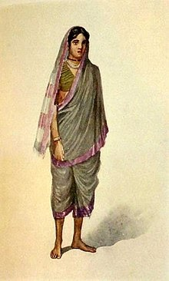
INTRODUCTION
Sant Nirmala was a poet and lived during the 14th century in Maharashtra. She was the younger sister of Chokhamela, and she was considered as a holy lady and contains bhakti on Vittal similar to her brother and is also a pious Hindu saint. Though she was married, she regretted the married life, since she was not interested in worldly pleasures, and interested only in having bhakti on Lord Krishna. Since she was born in mahar caste, she was considered as an untouchable during that period. Her writings consist largely of the partiality shown between the lower and the higher class people. She lived a saintly life and attended regular bhajans and used to sing songs in praise of Lord Krishna, and it is believed that after her death, due to her pure devotion, she was merged with Lord Krishna.
SANT SOYARABAI
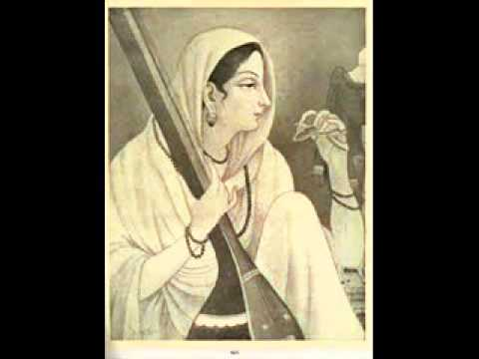
INTRODUCTION
Soyarabai was a saint from the Mahar caste in 14th century Maharashtra, India. She was the wife and disciple of her husband the great “Chokhamela”. Soyarabai had written many poems and used to sing songs on Lord Vittal. She was a pure and a pious woman who had dedicated his entire life towards worshipping Lord Vittal along with his husband Chokhamela. She was against caste discrimination, and she was worried about the caste differences which was prevalent all over india, during that period. Soyarabai will used to go for an annual pilgrimage to Pandharpur along with her husband. She was a great saint and also a dutiful wife, who always took care of her husband “CHOKHAMELA” in a proper manner. She acts as an example for others. Similar to her husband, she has also reached the divine place after her death.
SATCHIDANANDA SARASWATI
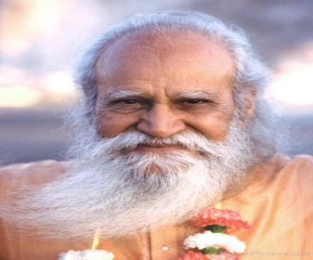
INTRODUCTION
Satchidananda Saraswati (1914–2002), also known as Swami Satchidananda, was an Indian religious saint and a yoga master, who had got more number of disciples in india and in foreign countries. He has written lot of spiritual books. His birth name was Ramaswamy.
“Satchidananda Jothi Niketan School” is located in Mettupalyam, Tamil Nadu.
Satchidananda was born in a Vellalar family in a small village in Coimbatore. He got interested in spirituality even at his younger age, and looked after the activities of the nearby village temple. He was a vegetarian and he had written books on the importance of vegetarian diet. He served in central government.
After some time Ramaswamy travelled throughout India, meditated at holy shrines and met various saints and sages and finally become the disciple of Sri Sivananda Saraswati and took sainthood and there he got the title “Sri Satchidananda Saraswati.
SATYANANDA GIRI
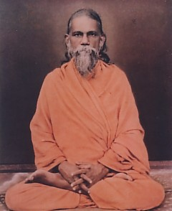
INTRODUCTION
Satyananda Giri (1896-1971), was an Indian saint and a main disciple of Sri Yukteswar Giri. He was a friend and a disciple of Sri Paramhansa Yogananda. He served as the chief in yoga training institutions in India. His birth name was Manamohan Mazumder. Acharya Swami Satyananda Giri Maharaj was born at bangladesh, in the year 1896.His father was the founder of the Calcutta Deaf and Dumb School. Satyananda studied at Calcutta and he trained in most of the indian languages while he was living at Puri with his Guru Yukteswar Giri. He also got graduated from the University of Calcutta. Throughout his life, he supported his Guru Sri Yukteswar Giri, and he was blessed by his guru and Mahavatar Babaji and got great spiritual energy in mind and helped the people towards practising kriya yoga and meditation. He got great wisdom and talent in all subjects, and was admired by the people.
SATYANANDA SARASWATI
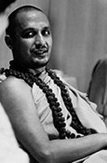
INTRODUCTION
Satyananda Saraswati (1923–2009), was a saint and a yoga guru. He was a student of Sivananda Saraswati, the founder of the Divine Life Society, and founded yoga school. He had written several books on spirituality. Satyananda Saraswati was born in 1923 at Almora, Uttaranchal, into a family of farmers. He was basically educated and studied Sanskrit, the Vedas and the Upanishads. He also met Anandamayi Ma and Sukhman Giri. After some time he met his guru Sivananda Saraswati and lived at his ashram in Rishikesh. He attained sainthood in the year 1947 on the banks of the Ganges and was given the name of Swami Satyananda Saraswati. He went to several foreign countries to spread his guru’s teachings and also given training in yoga and meditation to the indian as well as foreign people.
SHIVABALAYOGI
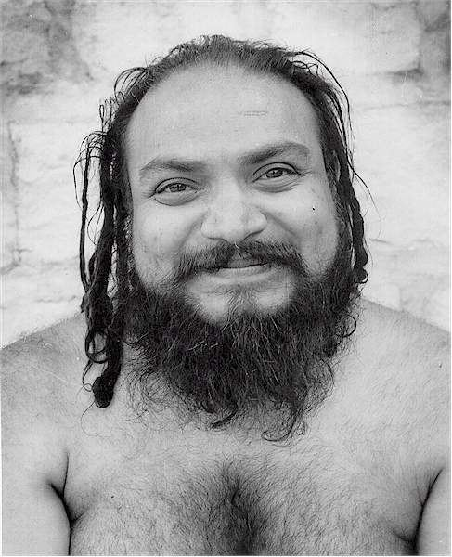
INTRODUCTION
Shri Shivabalayogi Maharaj (1935–1994) is a great yogi who attained Self-realization through his severe meditation on the god. He will used to perform meditation for several days even without taking food and water also. Due to his great penance, he was called by the name Shivabalayogi by his devotees. He travelled throughout india and srilanka, and spread the bhakti spirit and invoked the spiritual energy in them. He travelled to England and USA and taught yoga and meditation to his devotees. He was a regular worshipper of Lord Shiva and Parvati, and used to perform pujas and abhishekhams and would offer food to the poor devotees through the donations he receives from his devotees. He is a kind and a noble hearted man who lived a saintly life throughout in his life, and his teachings are simple and straight forward in nature. He will used to eat only simple food, and concentrated his entire life towards doing service to the divine and the human.
SHRIRAM SHARMA
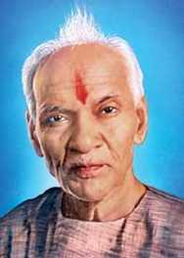
INTRODUCTION
Shriram Sharma (1911–1990) was a saint, yogi and founder of "All World Gayatri Pariwar", which is situated at Shantikunj, Haridwar, India. He realised the urgent need of spirituality to be invoked in the minds of the people, and hence preached the importance of spiritualism in the daily life throughout the universe. Pandit Shriram Sharma Acharya was born in the year 1911, in a village in Uttar Pradesh, India. His father was a scholar of the Bhagavata Purana, Vishnu purana and hindu literature, and he travelled widely to give religious discourses on the Bhagavatam. He used to accompany his father during his lectures. He also written lot of books on spirituality and also provided financial aid to the poor people.
SAINT SOPAN
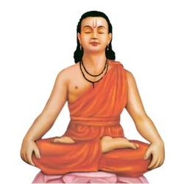
INTRODUCTION
Sopan was a sant of the Varkari sect and also the younger brother of Dyaneshwar.
Sopan(1277 A.D- 1296 A.D), attained samadhi at Saswad near Pune. He wrote a famous text, with the name “Sopandevi” based on Bhagavad Gita, and he had given simple explanation for each and every topic. He contains great knowledge in all the subjects, and was involved in deep meditation from his younger age.
SIBLINGS
- Nivruttinath.
- Gahininath.
- Dnyaneshwar.
- Mukta Bai.
All the five children were deeply attached on devotion with Lord Krishna. It is believed that Sopan along with his siblings were attained SALVATION and merged with Lord Krishna.
SWAMI ABHEDANANDA
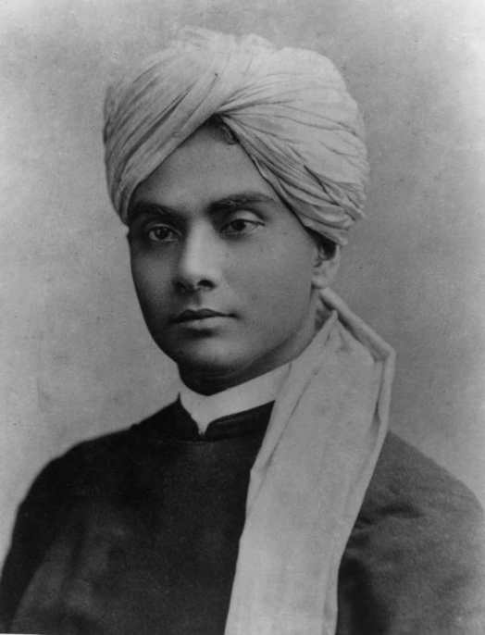
INTRODUCTION
Swami Abhedananda (1866–1939), born Kaliprasad Chandra was a direct disciple of Ramakrishna Paramahansa and the founder of Ramakrishna Vedanta Math. He headed the Vedanta Society of New York in 1897, and spread the message of Vedanta. His birth name was Kaliprasad Chandra.
He was born in Calcutta in the year 1866 and at the age of 18, while studying in the school, he went to Dakshineswar and met Sri Ramakrishna. In April 1885, he left home and stayed with him. After his Guru's death in 1886, he used to perform deep penance. After the death of Ramakrishna, he became a Saint and from then onwards he was called as "Swami Abhedananda Puri”. He travelled extensively throughout India, and meditated in the Himalayas. He also published Visvavani, the monthly magazine of the Ramakrishna Vedanta Society.
SWAMI BHOOMANANDA THEERTHA
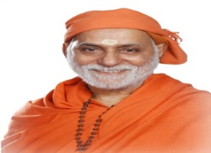
INTRODUCTION
Swami Bhoomananda Tirtha is an saint and a social reformer. He is well known for his religious discourses on Vedanta, Bhagavad Gita, Upanishads and Srimad Bhagavatam. Swami Bhoomananda Tirtha was born in 1933 in the village of Thrissur district, Kerala, India. He had educated at Parlikad and later started the Vyasa College, Parlikad. He met Baba Gangadhara Paramahamsa, who later became his Guru and both of them were very much interested in spirituality and they will used to discuss together about spiritual matters. Narayan ashrama Tapovanam, the headquarters of Swami Bhoomananda Tirtha, is located in Thrissur city. He also published lot of books based on spiritual matters. Under the guidance of Swami Bhoomananda Tirtha, the Foundation for Restoration of National Values (FRNV) was set up in June 2008 to help promote national values in the Indian society.
SWAMI CHIDBHAVANANDA
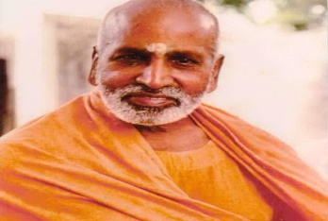
INTRODUCTION
Swami Chidbhavananda (1898-1985) was born in Coimbatore District. He studied in Stanes School, Coimbatore. His birth name was Chinnu.
After some time, he went to Ramakrishna Mission in Belur, West Bengal. His guru was Swami Shivananda who was a direct disciple of Sri Ramakrishna Paramahamsa.
As per the advice of Swami Sivananda, he established an Ashram near Ooty. He established Sri Ramakrishna Tapovanam in Tiruparaithurai, Tiruchi district. It promotes the ideals of Ramakrishna and Vivekananda through book publishing.
Swami Chidbhavananda wrote many sacred books in Tamil and English. He was a kind hearted and a noble saint, who was praised and admired for his wisdom and knowledge by the devotees. He lived a saintly and a simple life and dedicated his entire life on spreading the messages of Sri Ramakrishna and Vivekananda across the globe.
THIRUVALLUR VEERARAGHAVA SWAMY TEMPLE
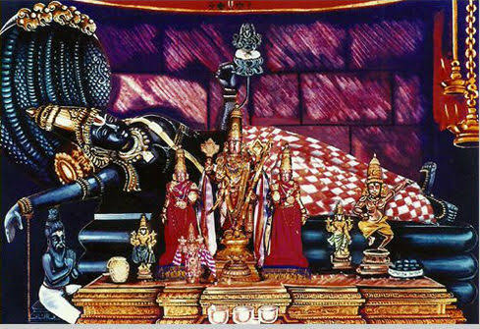
INTRODUCTION
Veeraraghava Swamy Temple is a temple dedicated to Lord Vishnu, located in Thiruvallur. It is considered as one among the 108 Divya Desams dedicated to Lord Vishnu. Vishnu is worshipped as Veeraraghava Perumal and his consort Lakshmi as Kanakavalli Thayar. He is also known as Vaidya Veera raghava perumal, since he cures the diseases of his devotees at this temple. The temple is believed to have been constructed by the Pallavas in the 8th century AD. There is a Goshala and People can offer grass and greens to the cows and can get the divine blessings of the divine cow “KAMADHENU”. Veeraraghava Perumal is believed to have appeared and married Lakshmi in this place. The temple observes six daily rituals and three yearly festivals. The most important chariot and float festival, celebrated during the Tamil month of Chittirai (March–April), is the most important festival of the temple.
KUCHANUR SANEESWARA BHAGAVAN TEMPLE
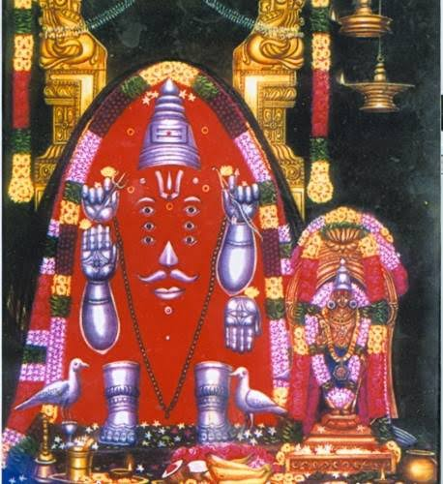
INTRODUCTION
There is a temple which is dedicated for Saneeswara Bhagawan which is situated at Kuchanoor. The Lord is seen in swayambhu (self-appeared) form. In front of this temple the holy river Surabi flows. Different religious people like Hindu,Muslim worship in Kuchanur and get the blessings from the Lord Shani Devar. There is a separate temple for guru which faces in the north direction, hence this temple is also known as vadaguru temple. There is a hanuman temple and Lord Panchamukha ganapathi’s idol is found. There is sufficient water in the River Surubi throughout the year. It is also considered as an important temple for Lord Shani similar to Thirunallaru temple and Shani Singnapur. Apart from temple lodging facilities, lot of boarding and lodging houses are available nearby the temple, and we can utilize the facility.
KOOTHANUR MAHA SARASWATHI TEMPLE
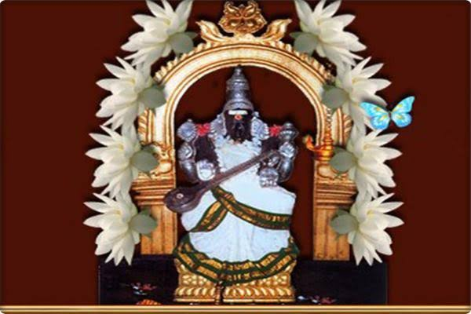
INTRODUCTION
Koothanur Maha Saraswathi Temple is a Hindu temple situated in Koothanur in the Tiruvarur district of Tamil Nadu. It is dedicated to Mata Saraswathi, the Hindu goddess of education. She is also called as “VIDYA DEVI” and “VIDYA SARASWATHI”. Individual Temples dedicated to Saraswati are rarely found in India. This is the only individual temple in Tamil Nadu with Saraswathi as the main deity. Other popular saraswathi devi temples are situated in basara and wargal at telangana state. Priests will recite the slokas in tamil. Saraswathi puja and Vijayadasami are the main festivals celebrated in the temple. Koothanur Maha Saraswathi Seva Samithi provides accommodation which is available near the temple. A/C and Non A/C and dormitory rooms are available. Devotees can utilise this facility. Private Lodging and Boarding facilities are also available nearby the temple.
ADI KUMBESWARAR TEMPLE,KUMBAKONAM
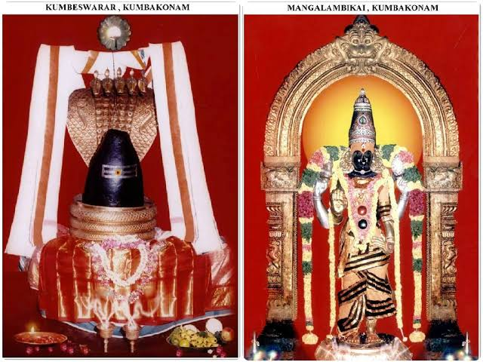
INTRODUCTION
Adi Kumbeswarar Temple, Kumbakonam is a Hindu temple dedicated to Lord Shiva, is situated in Kumbakonam in Thanjavur District Tamil Nadu, India. Here Lord Shiva is worshiped as Adi Kumbeswarar, and is represented by the lingam. His consort Parvati is worshipped as Mangalambigai Amman. This temple is praised in the sacred text Tevaram, written by the Nayanmars.
The temple has many shrines, with those of Kumbeswarar and Mangalambigai Amman being the main deities. The temple follows six daily rituals from 5:30 a.m. to 9 p.m., and twelve yearly festivals on its calendar, and the Masi Magam festival is celebrated during the Tamil month of Maasi (February - March) and lot of devotees would gather at this temple to witness the important event.
The present structure of the temple was built during the Chola period in the 9th century, and later repairs and renovation works were done by the Vijayanagar kings in the 16th century.
SRI JAMBUKESWARAR TEMPLE
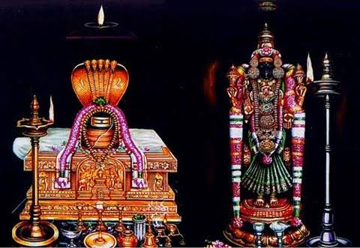
INTRODUCTION
Jambukeswarar Temple, Thiruvanaikaval is a famous Shiva temple in Trichy district. The temple was built by Kochengannan chola king, one of the Nayanar saint and an ardent devotee of Lord Shiva, who will never take his food without worshipping Lord Shiva. Thiruvanaikal is one of the Pancha Bhoota Stalam in tamil nadu. This temple represents the element of water. The sanctum of Jambukeswara has an underground water stream. It is one of the Paadal Petra Sthalams, where all the four famous Nayanar saints have sung the glories of the deity in this temple. The temple has inscriptions from the Chola period. According to legend, Once Parvati closed the eyes of Lord Shiva as a playful act. Shiva got angry with her act and asked her to do penance in the earth. Parvathi in the form of Akilandeswari worshipped Lord Shiva at this place, and after some time, she merged with Lord Shiva. This is a very holy temple, where lot of devotees would visit this temple especially for their career growth and for getting a suitable job.
PARTHASARATHY TEMPLE
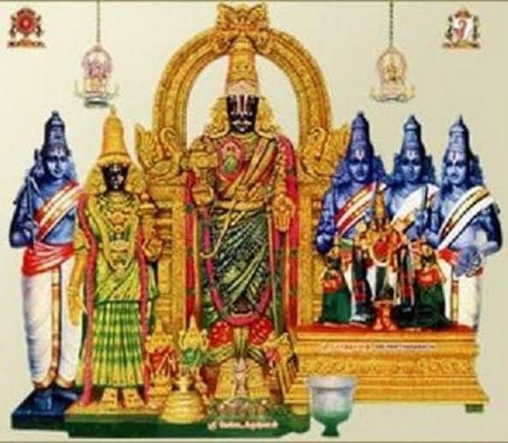
INTRODUCTION
The Parthasarathy Temple is an ancient temple which was constructed during the 8th century dedicated to Lord Krishna, located at Triplicane. The temple is glorified in the great divine text “Divya Prabandham”, and is classified as one among the 108 Divya Desams dedicated to Vishnu. The name 'Parthasarathy', in Tamil, means the 'charioteer of Arjuna', referring to Krishna's role as a charioteer to Arjuna in the epic Mahabaratha. It was originally constructed by the Pallavas in the 8th century by king Narasimhavarman I. The temple has shrines of five forms of Vishnu: Narasimha, Rama, Gajendra Varadaraja, Ranganatha and Krishna. The temple is one of the oldest temples in Chennai. There are shrines for Vedavalli Thayar, Ranganatha, Andal, Hanuman, Alvars, Ramanuja, Swami Manavala Mamunigal and Vedanthachariar. It is a very holy temple, where free food is offered daily to more than 100 devotees.
THIRUVERKADU KARUMARI AMMAN TEMPLE
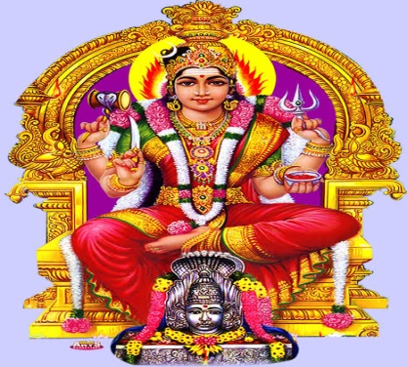
INTRODUCTION
Once, the sun god didn’t recognize Devi Karumari when she took the form of an old lady, and didn’t attend to her properly. Due to that, he has lost his brightness and begged to Mata Parvati to forgive his mistake. He further asked Karumari to celebrate Sunday as an auspicious day for worshipping her. He was forgiven for his mistake, and still Sunday is considered as an auspicious day of worshipping Devi Karumari. Once Lord Vishnu visited Thiruverkadu, and due to the request of his sister Devi Karumari, he has occupied a place in the Karumariamman Temple, Thiruverkadu. In this temple, Free Annadhanam scheme was offered to more than 100 devotees usually on sundays. Those who want to perform annadanam can donate money or otherwise, they can offer provisions and vegetables as donation, and can get the blessings of Mata Karumari, and can get relieved from various physical and mental diseases. Hence it is a must for us to visit the temple at Thiruverkadu and can get all the prosperity in our life.
SAMAYAPURAM MARIAMMAN TEMPLE
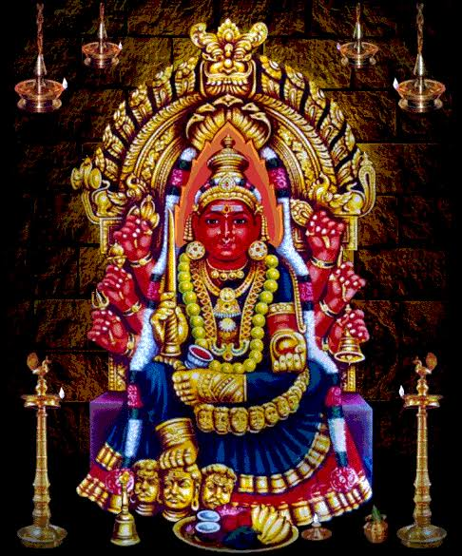
INTRODUCTION
Samayapuram Mariamman Temple is a Sakthi Devi Temple located in Samayapuram in Trichy. The main deity, Mariamman, is a form of Parvati Devi. For the main deity, no abhishekams are performed, but "abishekam" is done to the small stone statue of Devi located in front of the main deity. It is a most important temple, to get rid from various dreaded diseases and also from mental disorders. The temple attracts thousands of devotees on Sundays, Tuesdays and Fridays, and the festival days. It is believed that in the 18th century, King Vijayaraya Chakkaravarthi constructed the temple. Thai and Chittirai festivals are considered as auspicious days in this temple. In this temple, annadanam is provided daily for more than 200 devotees. Similar to Samayapuram Marriamman temple, various amman temples were constructed for worship by the tamil people living in Singapore, Srilanka and South Africa.
VAITHEESWARAN KOIL
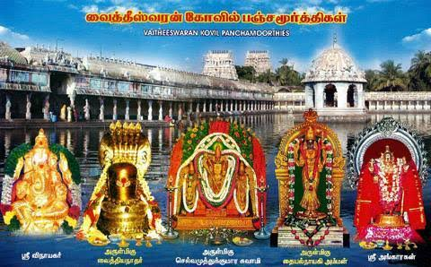
INTRODUCTION
Vaitheeswaran Kovil is a sacred temple dedicated to Lord Shiva, located in Tamil Nadu. In this temple, Lord Shiva is worshipped as Vaidyanathar or Vaitheeswaran meaning the "God of healing" and it is believed that by praying to Vaitheeswaran, our all types of physical and mental diseases will be cured. The presiding deity is Sri Vaidyanathan. It is one of the nine Navagraha temples and is associated with the planet Mars (Angaraka). The village is also specialised for reading palm leaf astrology called Naadi astrology in Tamil. By taking a holy dip in the temple tank will cure us from all types of diseases. In this temple, free annadanam is provided for more than 100 devotees on a daily basis. The temple is praised by the nayanar saints and it is also classified as a Paadal Petra Sthalam. It is believed that Lord Rama and Lakshmana also worshipped Lord Shiva in this temple.

