AGASTYA
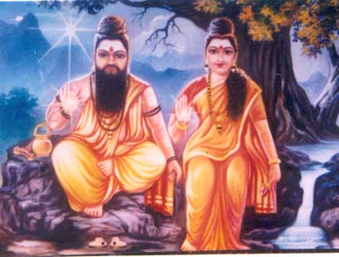
INTRODUCTION
Agastya was a famous sage of Hinduism. His wife is Lopamudra. Sage Agastya is mentioned in Ramayana and Mahabharata. He is one among the seven famous rishis, and also one among the 18 siddhars. It is believed that he has lived for over 5000 years. He is said to have lived in the pothigai hills for many years.
IMPORTANCE
It is believed that he is the author of Agastya Gita. His presence was found in ancient texts. During the time of Lord Shiva’s marriage with goddess parvathi, lord shiva asked Sage agastya to go to the pothigai hills in order to balance the earth through his spiritual powers, since most of the sages in the earth went to kailasa to attend the wedding of Lord Shiva and parvathi. And Lord Shiva has promised to him, that he will give his Wedding Darshan to Agastya whenever he needs. He possessed super natural powers through the divine grace of Lord Shiva.

Sage Agastya once due to the request of the divine gods, visit Vindyamountain, who was growing up higher and higher in order to prove its strength, and was very pride by his power. Sage Agastya made him to bow before him, since he was his guru, and asked him to remain in that condition. Hence by doing this, he has removed the pride of Vindyamountain.
He is considered as the guru for many siddhars, and provided the necessary teachings for them. He is also a master in siddha medicine,yoga and meditation. He is regarded as a “MAHARISHI” among the rishis, and he is considered as a manifestation of Lord Shiva himself. He purifies our mind, and boosts our energy by worshipping him.
CONCLUSION
Agastiya maharishi is still living in the saptha rishi mandalam and blessing us. He is created for the purpose of the upliftment of the people and to move them to spiritual path. He has cured the diseases of the people, and initiated them into the worship of Lord Shiva. He is still doing meditation and chanting the mantra of Lord Shiva. Let us worship the great divine sage with his wife MATA Lopamudra and be blessed.
“OM SREE AGASTHIYA MAHARISHIYE NAMAHA”
“OM MATA LOPAMUDRAYE NAMAHA”
“OM NAMAH SHIVAYA”
WRITTEN BY
R.HARISHANKAR

BOGAR
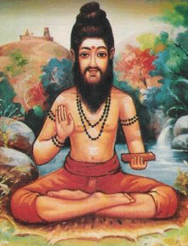
INTRODUCTION
Bogar was a Tamil siddhar who lived between 550 and 300 BC. He is one among the 18 siddhars.
IMPORTANCE
Bogar has written a book "Bogar 7000". Bogar 7000 contains 7000 songs, and it contains the details about siddha medicines.
Bogar went to China, and taught about spiritual enlightenment. Bogar is said to be in SAMADHI near Palani Murugan hill temple. He is a disciple of Agastya Maharishi. He was a master of siddha, yoga and meditation.
According to legends, it is known that Bogar created the idol of Murugan in Palani by mixing Navapashanam(Various herbs). He also established the temple for Murugan in Kodaikanal Tamilnadu, India.
CONCLUSION
A great siddhar and a Murugan devotee, and the founder of the formula for siddha medicines, is still curing the diseases of his devotees. And also he gets attracted with the devotees of Lord Muruga. He lived for a long period, and is still answering to our prayers. By worshipping him, we will get good fortune in our life, and our problems and difficulties will come to an end. He is a great SIDDHA PURUSHA, who has helped the devotees to clear their karma, by following the path of spirituality and give us the way for attaining SALVATION.
If we sincerely pray him with pure devotion, he will definitely answer to our prayers, and to some extent, he can slightly change our fate also with his “UTMOST SPIRITUAL ENERGY”, and will give withstanding power to face any problems in our life, and will give the remedy to us. Let us chant his name and be blessed.
“OM SREE BOGARE NAMAHA”
“OM MURUGA”, “VEL MURUGA”
WRITTEN BY
R.HARISHANKAR
IDAIKKADAR
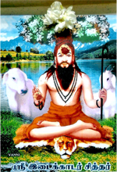
INTRODUCTION
Siddhar Idaikkadar was a great expert in the field of astrology and his writings on astrology are very useful for today’s astrologers. He was also an expert in the field of siddha. He is believed to have lived during the 3rd century BC, and he belongs to Yadava Community, and is very fond of worshipping Lord Krishna from his childhood, and praises him by singing songs on him.
He is one of the famous Siddhar among the 18 Siddhas. He was born in Idaikadu, hence he was named as idaikadar. He lived as shepherd and used to sing songs on Lord Shiva, while doing his work.
In his younger age itself, he realized the inner energy in his soul, and found that god is residing within himself. He was also a great master in yoga and meditation. He was appreciated by Bogar. He served as a disciple to Bogar and learned various subjects from him.
He also awakened the kundalini shakthi from him, and got the spiritual energy through that.
By seeing the sufferings of the people, he asked the people to leave the worldly pleasures and concentrate on bhakti in order to attain the siddhi.
He spent most of his life by helping the people in Thiruvannamalai region and attained jeeva samathi in Thiruvannamalai. He was also an ardent worshipper of Lord Arunachala.
His most important contributions are:
- Arrangement of Navagraha in temples in a proper manner.
- Introduction of Kayakalpa Medicine
He was praised by the people, since people were believed that he contained the power of Lord Shiva and Krishna.
He frequently utters the shiva mantra “Om nama shivaaya!” and asked the people to repeatedly chant it in order to remove the burdens in their life.
FAMOUS WORKS
- Idaikadar Gnyana Soothram 70
- Idaikadar Kanida Nool
IMPORTANCE
He was a great siddha who contained yogic powers, and through his power, people were treated him as god, and worshipped him. During his period, he has done lot of good things to the people. He cured various dreaded diseases of the people, and cleared their mind, by removing bad thoughts in their mind, and guided them to the spiritual path through his great divine powers.
Let us worship the great siddha and be blessed.
“OM SREE IDAIKKADARE NAMAHA”
“OM NAMAH SHIVAYA”
WRITTEN BY
R.HARISHANKAR

KALANGI NATHAR SIDDHAR
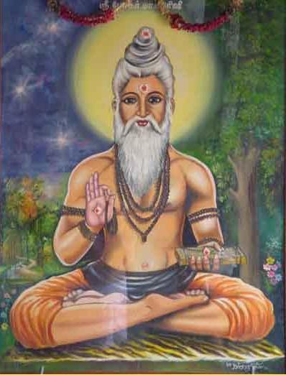
INTRODUCTION
Kalangi Nathar was a great siddhar from Benaras. And he was the guru of the great siddhar Bhogar. Kalangi Nathar and Bogar were maintained cordial relationship between each other. Both of them were deeply involved in spiritual path. Kalangi Nathar, took care of his disciple bogar, and taught him about yoga,meditation and siddha. Kalangi Nathar was the great siddhar who occupied an important role in the development of his disciple Bogar.
IMPORTANCE
He is also called as Kanjamalai Siddhar. He was the disciple of Thirumoolar.
There is a temple for Kalangi Nathar in Salem, Tamil Nadu. He has attained Samadhi at this place several hundred years ago.
He travelled to china, and attained “SALVATION” in Kanchipuram. His jeeva samadhi is found in Kanchipuram district of Tamil Nadu. His temple is situated at Salem, which is called as Sithar Koil.
Kalangi Nathar spread the knowledge of yoga to the Chinese people. It is believed that, Kalangi Nathar lived for a long time.
CONCLUSION
Kalangi Nathar was a great siddhar, and an expert in marital arts, meditation,yoga and siddha field. Through his spiritual power, he has done many miracles, and removed the diseases from the people’s health. He insisted the people to do yoga and meditation and to worship god. He was a great scholar and a master in all kinds of art. He is talented in medicinal field, and used herbs for curing the diseases of his devotees. He was a generous and a noble saint, and was very kind to the common people. He always tried to sort out of the problems in the life of his devotees, and given them peacefulness and happiness in their life. Let us pray to this great siddhar, and can receive the blessings from him.
“OM SREE KALANGI NATHARE NAMAHA”
“OM NAMA SHIVAYA”
WRITTEN BY
R.HARISHANKAR

KARUVURAR
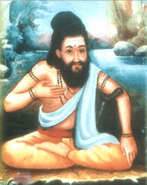
INTRODUCTION
Karuvurar Siddhar was born in Karur in Tamil nadu hence he was called as Karuvurar. It is believed that he was born thousand years ago.
Karuvurar was born in the family of Viswakarma community. His parents were doing sculpture work, by sculpting divine god’s sculptures. His parents were devotees of Lord Shiva, and they daily provided food to shiva devotees in a whole heartedly manner.
He learnt the subjects from various famous gurus, and got great knowledge by serving as a disciple to Sri Kamala Muni, and learnt the concepts of siddha from Bogar.
For some time, he also engaged in the business of doing sculpture work, and developed various god’s idol through his expert knowledge in the art of sculpting the divine idols.
Apart from his knowledge in other divine subjects, he also got great interest in doing yoga and meditation.
It is believed that he also sculpted some idols for the Brahadeeswarar Temple, Thanjavur, and was widely praised for his great work. Siddhar Karuvurar performed many miracles and safeguarded the people from various ailments.
He attained samathi in Sri Kalyana Pasupatheeswarar temple in Karur.
FAMOUS WORKS
- Vaatha kaaviyam
- Vaithiyam
- Yoga gnanam
- Pala thirattu
- Gurunool soothira
- Poorana gnanam
- Meisurukkam
- Sivagnana petham
- karppa vithi

IMPORTANCE
He was a great siddha who got good knowledge in various fields. During his period, he has done many wonders in the life of the people, and made them to lead a sin free life. Through his writings, the entire universe was benefitted. He got the skills through the divine grace of Lord Shiva.
He was loved by all the people, and was appreciated for his talents. He took care of his devotees in a proper manner, and taught the divine knowledge to them. He helped them to attain the spiritual energy through meditation and prayers.
By praying to him, we will get all the prosperity in our life, and after our death we will attain “SALVATION”.
Let us worship the great siddha and be blessed.
“OM SREE KARUVURARE NAMAHA”
“OM NAMAH SHIVAYA”
“OM SAKTHI PARA SAKTHI”
WRITTEN BY
R.HARISHANKAR
KORAKKAR
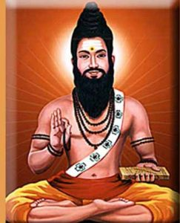
INTRODUCTION
Korakkar is one of the 18 siddhars of Tamilnadu.
His birth place is at coimbatore, tamil nadu. Agathiyar and Bogar were his gurus. His Jeeva samadhi temple is situated in Nagapattinam district of Tamil Nadu.
CAVES
His other temples are located at Perur, Thiruchendur and Triconamalli. Korakkar caves are found in Saturagiri and Kolli Hills.

SPIRITUAL WORKS
- Korakkar Malai Vagatam
- Malai Vaakadam
- Korakkar Vaippu
- Kaalamegam
- Marali Varadham
- Nilaiyodukam
- Chandhira Regai Nool

IMPORTANCE
Like other siddhas, Korakkar has written songs on Siddha Medicine. And he has occupied a major place in the field of SIDDHA. He was very famous among the siddha doctors.
Korakkar was a great siddhar, who was able to cure any diseases of the people. Through his books, the siddha doctors are able to locate the correct medicines for the diseases, and they are able to cure the diseases of the people. Korakkar has predicted the future events and written in the book which was popularly known as “CHANDRA REGAI”. This book was very much simplified and easy to understand by any one, when compared to other siddhars books. It is believed that he will again take birth and guide the people towards spirituality. A cave where he was meditated is located in Sathuragiri village at Tamil Nadu.

CONCLUSION
Korakkar was a great siddha who was born for the sake of us, and who guided us for moving towards the path of spirituality, and who has cured, and is still curing many dreaded diseases of his devotees, was a “MAHA SIDDHA PURUSHA”. His main importance is, he was very much worried about the sufferings of the people in this “KALI YUGA”, and has tried to sort out of their problems at his level best through his books. Let us pray to this great siddhar, and be blessed.
“OM SREE KORAKKARE NAMAHA”
“OM NAMAH SHIVAYA”
WRITTEN BY
R.HARISHANKAR

KUTHAMBAI
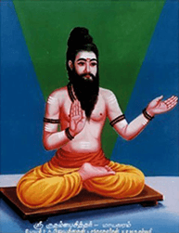
INTRODUCTION
He is one among the siddhas, and born in the Yadava community, and was greatly devoted to Lord Krishna from his childhood. He was a great siddha physician and contains an expert knowledge in the concepts of siddha medicine, and rendered great works on siddha. He learned the Siddha Science at his younger age itself from various scholars and siddhas.
He was interested to journey in the path of Siddhas and moved towards the spiritual path. His teachings are highly valuable for the entire universe. His songs are highly praised by the people, which mainly based on the yogic path.
He attained samathi at Mayiladuthurai in Tamil Nadu.
IMPORTANCE
From his childhood days, instead of playing with other boys, he concentrated his attention on praying to Lord Krishna and Shiva, and was deeply involved in meditation on them. He was highly praised for his great contributions in the field of siddha medicine. Siddha physicians are highly benefitted through his great works on siddha medicine.
He also removed the difficulties of the people, and made them to walk in the correct path. He was also well versed in all the divine subjects and contains good knowledge, wisdom, courage, boldness and devotion towards god.
During his life time, he moved with his followers and with the common people in a lovable manner. He never finds any fault with others, and always treated the people as the god’s creations, and respected everyone in a proper manner. He also cured the diseases of the people and cleared their sins and invoked them in the bhakti path. He removed the bad habits of the people, and encouraged them to develop good habits, by doing constant worship on god. He has done many miracles in the life of his devotees.
Let us worship him and be blessed.
“OM SREE KUTHAMBAI SIDDHARE NAMAHA”
“OM NAMAH SHIVAYA”
“OM SAKTHI PARASAKTHI”
WRITTEN BY
R.HARISHANKAR

MACHAMUNI
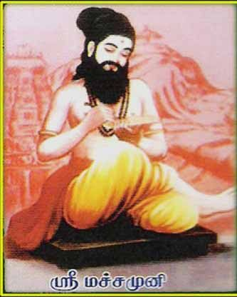
INTRODUCTION
Machamuni Siddhar is an ancient siddhar and is famous for his popular works.
He was born with the blessings of Lord Shiva and contains great bhakti and fully devoted on Lord Shiva. He was brought up by Sri Pinnakeesar and learned various subjects from him.
He took the guidance of the great sage Kakapujandar, and attained yogic powers through him.
Similar to other siddhas, he awakened his kundalini energy in order to understand the inner self and to attain great powers.
After several years of meditation, he got great spiritual energy and rendered his works in the field of Siddha medicine system.
He was also specialized in doing meditation for a long period.
He donated his entire wealth for the welfare of the poor people.
His disciple was korakkar and korakkar learned all the subjects from Machamuni.
He attained jeeva samathi in Thiruparankundram in Tamil nadu.
FAMOUS WORKS
- Meignanam
- Sothidam
- Thirumanthiram
- Perunool kaaviyam
- Vagaaram
- Yogam
- Vaithiyam
- Vethaantham
- Gnanam

IMPORTANCE
Machamuni was a great siddha who contains spiritual and yogic powers, and helped the people through his powers. He has done lot of social welfare activities, and gave all of his belongings for the welfare of the poor. He was not interested in enjoying worldly pleasures and concentrated his entire attention only on spirituality. Through his great power, he has reduced the sins of his devotees, solved their problems, removed their physical and mental diseases and made them to lead a happy life.
Let us worship him and be blessed.
“OM SREE MACHAMUNIYE NAMAHA”
“OM NAMAH SHIVAYA”
WRITTEN BY
R.HARISHANKAR

NANDIKESWARAR
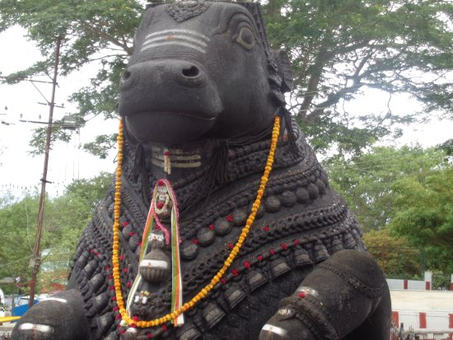
INTRODUCTION
Nandi is the guardian of Kailasa, the abode of Lord Shiva and also he serves as the mount to Lord Shiva. Almost in all Shiva temples, the statue of Lord nandi will be there, before in front of Lord Shiva’s shrine. Nandi worship exists for several thousands of years.
Nandi is the son of the sage Shilada. Shilada received Nandi as his son, after doing severe penance on Lord Shiva. By Lord Shiva’s grace, Nandi was born from a Yajna performed by Shilada. Nandi is an ardent devotee of Lord Shiva and he did severe penance, and become his mount as well as the divine gate-keeper of Kailasa.

IMPORTANCE
Nandi has got the spiritual knowledge from Lord Shiva and from goddess Parvati. He shared his spiritual knowledge to his eight disciples. Once, Nandi cursed Ravana that his kingdom would be burnt by Lord Hanuman. And it was happened as per his curse.
CONCLUSION
Lord Nandikeswarar,who was a divine attendant of Lord Shiva, taking care of kailasa as a gate keeper, and his vision will be always on Lord Shiva. His bhakti on Lord Shiva was magnificent. His statue was installed on all the shiva temples. During pradosham and shivarathri festival, abhishekham and archanai will be done for both Lord Shiva and to Lord Nandikeswarar. People will generally tell their problems into the ears of Lord Nandi’s statue, and they believe that Lord Nandi will tell our problems to Lord Shiva, and remove our problems. People who are having severe diseases, and suffering from severe mind related problems can do abhishekham to Lord Nandhikeswarar during Pradhosham, and can get relieved from their problems. Let us chant the name of Lord Nandikeswarar and be blessed.
“OM SREE NANDIKESWARAYA NAMAHA”
“OM NAMA SHIVAYA”
“OM SREE MATA PARVATI NAMAHA”
WRITTEN BY
R.HARISHANKAR

PAMBATTI SIDDHAR
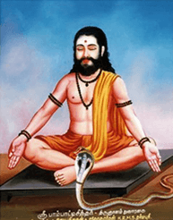
INTRODUCTION
Pambatti siddhar was one among the 18 siddhars who lived in various parts of India. Some of his poems are still available. Even his poems are addressed to snakes. He was the disciple of the great sattaimuni siddhar.
LIFE
Once the great Sattaimuni Siddhar met a snake charmer, and explained him about Kundalini Shakthi, and initiated him into the path of spirituality. The snake charmer, who has mastered the control of Kundalini, attained great powers. From then onwards, he was called as Pambatti Siddhar.

IMPORTANCE
Sri Pambatti siddhar has attained 'ASHTAMASIDDHI' through meditation at a cave, near Coimbatore in Tamil Nadu. He also lived in places like Mahalingamalai and Kollimalai. He has asked the people to love each other, and not to fight with others, and he further stated that salvation is not possible without loving each other, and giving respect to others. He also meditated in Marudamalai by praying to Lord Murugan. He is believed to have attained Samadhi in Sankaran koil. He has lived a full life span of 123 Years.
Pambatti Siddhar was an expert in Siddha Medicine and Yoga. Finally, he attained Jeeva Samathi at Sankarankoil in Tirunelveli District of Tamil Nadu.
CONCLUSION
Pambatti Siddhar is a great siddhar, and contains spiritual qualities, and guided the people towards attaining SALVATION through meditation and devotion to god. He insisted the people to show kindness to others. Let us worship this great Siddhar and be blessed.
“OM SREE PAMBATTI SIDDHARE NAMAHA”
“OM NAMAH SHIVAYA”
WRITTEN BY
R.HARISHANKAR

RAMADEVAR
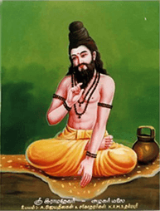
INTRODUCTION
Ramadevar is a great siddhar who occupies an important place in the Siddha Field. He was born in a Brahmin family. His guru is the great Siddhar Pulasthiyar. He attained great spiritual powers through meditation and performed many miracles.
From his younger age, he was an ardent devotee of Lord Siva and Goddess Shakthi. He lived in Nagapattinam. He regularly done pooja to Shiva Linga and worshiped the Lord daily through flowers and vilva(Bel patra) leaves and chanted shiva mantra.
He was well known for his great contribution to the Siddha Science.
He awakened his kundalini energy, and got great powers and helped the people by curing their diseases, and also relieved them from mental disorders. He performed many miracles and was praised by the people.
He attained Jeeva Samadhi at Alagar Malai in Madurai.
FAMOUS WORKS
- Sivayogam
- Vaithiya kaaviyam
- Vaithiya sinthaamani
- Sunnam
- Sunnakaandam urai
- Logaenthoora vaatha kaaviyam
- Panchamitram thandagam
- Vaithiya kalladam
- Vaithiyam 300
IMPORTANCE
He was a great siddha purusha, who used his yogic powers for the benefit of the people. He was an expert in yoga and meditation, and also a master in all forms of art and contains thorough knowledge in divine scriptures. He contains great powers through constant meditation and through his sincere devotion on the god.
Let us worship this great siddha and be blessed.
“OM SREE RAMADEVARA NAMAHA”
“OM NAMAH SHIVAYA”
“OM MATA PARVATHI DEVIYE NAMAHA”
WRITTEN BY
R.HARISHANKAR

SIVAVAKKIYAR
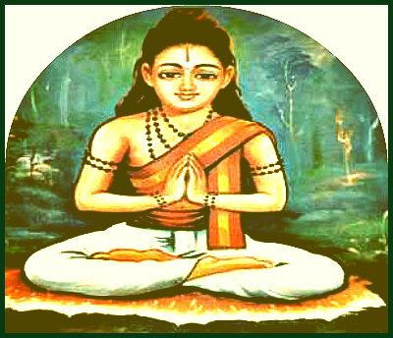
INTRODUCTION
Sivavakkiyar is one among 18 Siddhas and considered as a person who was against caste discrimination. He belonged to the family of gold smiths, and his parents were sincerely devoted to Lord Shiva. It is believed that he lived thousand years ago.
Sivavakkiyar Siddhar was born by reciting Lord Shiva’s holy name. Hence he was called by the name Sivavakkiyar. His parents were insisted him to become a great siddha, and hence he met the siddhas to learn various subjects from them.
He was an expert in Siddha medicine, Yoga and meditation.
Since Sivavakkiyar Siddhar was a great poet, he wrote lot of devotional songs on Lord Shiva.
He got the spiritual energy by worshipping goddess sakthi.
He was against caste, creed, gender and religion. He treated all the people as equal and respected everybody.
He asked the people to chant the glory of god, and by reciting his mantra and name, in order to attain spiritual enlightenment. He went to kasi and learnt vedas and other divine scriptures.
He attained Siddhi at kumbakonam. Pujas are performed regularly on Full Moon Day. Those who pray to him with sincere devotion in mind, are blessed with good health and wealth, and also give peacefulness in life. Praying him on Mondays will give good results in our life. By worshipping him all the evil effects of the Nava Grahas will be cleared immediately, and we can attain all the prosperity in our life. All problems related to black magic, mental disorder, suffering from unwanted, negative and suicidal thoughts will be removed from our mind, if we worship him and chant his name sincerely as a daily practice.
IMPORTANCE
He was a great siddha, and cured the diseases of the people through his siddha medicines. He also invoked his followers to the spiritual path and asked them to worship Lord Shiva regularly, in order attain MUKTHI. He asked the people to realize the god from their own soul, since god is dwelling in everyone’s soul.
He solved various problems of the people through his spiritual energy. He was praised and admired by the people for his good behaviour and for containing great yogic powers.
It is believed that he chanted shiva mantra for several millions of times during his life time.
Let us worship this great siddha and be blessed.
“OM SREE SIVA VAAKIYARE NAMAHA”
“OM NAMAH SHIVAYA”
“OM SAKTHI PARA SAKTHI”
WRITTEN BY
R.HARISHANKAR
THERAIYAR
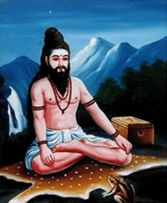
INTRODUCTION
Theraiyar is one of the 18 Siddhas. He has written lot of texts which are very useful to the mankind. His guru is Dharmasoumini. He learnt all the subjects from him, and was an expert in the field of Ayurveda and siddha, and rendered his writings on that.
FAMOUS TEXTS
- Pattartha Guna Chintamani
- Maniwenbha Medicine
- Theraiyar Venba
- Theraiyar Maruthuva Bharatham
- Theraiyar Kappiyam
- Theraiyar Paadal Thirattu
- Theraiyar Tharu
- Theran Yamaga Venba
- Theran Thaila Varkka Churukkam
- Anuboga vaidya Deva Ragasiyam
He is also a disciple of Agastiyar, and learned all the divine subjects from him, and also was blessed by him. It is believed that he lived several thousands of years ago.
He is an expert in all kinds of arts, and a scholar in all the subjects and he discovered many new effective medicines and wrote various texts on that.

He has written a very famous text known as Theraiyar karisal-300, which contains the details of preparation of various siddha medicines, which are very useful for the siddha physicians in this today’s world.

He is said to have attained Samadhi in Toranamalai,Tenkasi.
IMPORTANCE
His contribution towards the siddha and ayurveda field cannot be explained in words.
He was also praised by the great woman saint Avvaiyar for his great works.
He got talent in all the languages.
Since he removed the insect therai from a person’s head, he is called as theraiyar.
He was considered as a siddha physician and treated lot of people.
He consumed rare herbs, in order to live a long life, to provide proper service to the people.
His works are very useful to the modern rough and tough life, and through his new invention of medicines, lot of people are benefitted.
Let us worship the great siddhar and be blessed.
“OM SREE SIDDHA MAMUNI THERAIYARE NAMAHA”
WRITTEN BY
R.HARISHANKAR

THIRUMOOLAR
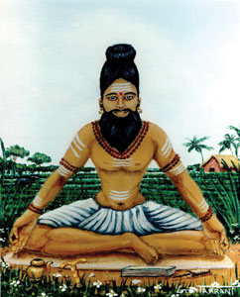
INTRODUCTION
Tirumular was a Tamil Saint, and considered as one of the sixty-three Nayanmars and also one of the 18 Siddhars. Sundaranathar was his original name. And he belonged to Madurai in Tamil nadu. According to the views of great scholars, he is believed to have taken birth during 8th century AD. And his main work, the Tirumantiram was well accepted by the tamil people.

LIFE
He travelled to Mount Kailash and was received spiritual advice from Lord Shiva. After some time, he went to tamil nadu, and met the great Maharishi Agathiyar in Pothigai mountain. While on his way, to tamil nadu, he saw a group of cows which were looked worrying due to the death of their cowherd, Moolan, who was bitten by a snake. He used his spiritual power, and transformed his soul from his body to that of the dead cowherd's body. Then the cows became happy, and so he took them to the village. His body was disappeared from the place where he left, and it was made by Lord Shiva. Lord Shiva wanted Sundara Nathar to spread his teachings from the body of Moolan, so that each and every person can understand his teachings. Since the cowherd was called as moolan, from that day onwards Sundara nathar was known by the name of Thirumoolar.
IMPORTANCE
He was a great scholar in yoga and meditation and well versed in all forms of art. He cured the diseases of the people, and made them to concentrate their attention on doing yoga and meditation. He also invoked the bhakti spirit among his followers.
CONCLUSION
Thirumoolar, a great nayanmar and also a siddhar was a devotee of Lord Shiva. Through his spiritual powers, he has helped the common people to solve their problems in a simplified manner. He taught the principles of shaivism among the common people, and insisted them to worship Lord Shiva. Let us worship this great saint, and be blessed.
“OM SREE THIRUMOOLARE NAMAHA”
“OM NAMAH SHIVAYA”
WRITTEN BY
R.HARISHANKAR
KONGANAR
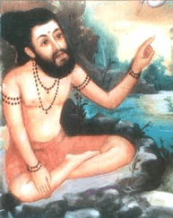
INTRODUCTION
Sri Konganar was believed to have been born during the 5th century BC, and is the disciple of Boganathar, and he is one among the 18 great siddhars. He was appreciated as the best student by Bogar himself. He was born in Erode in a goldsmith family. His main works include in the field of medicine, yoga and philosophy. He left home at his younger age in order to seek spiritualism. He got knowledge in various fields through the guidance of his guru Bogar and became a knowledgeable person. He is a great worshipper of Lord Shiva.
He was very good in doing yoga and meditation and specialized in all kinds of arts and a great scholar in all spiritual subjects.
Sri Konganar is a kind hearted Guru. He has got large number of disciples and he taught all the subjects to them with much affection and care.

Once he changed an iron into gold piece, and gifted it to his siddhar friend sivavakiyar’s wife, since sivavakiyar has gone outside. After his return to his home, his wife had narrated the incident, he immediately thrown out the gold piece into the well. He is such a great Siddha Purusha.
His Guru Boga has made his contributions in various fields.
After living a long life, he entered jeeva samathi at Thirupathi in Andhra Pradesh, nearby the Temple Complex of Lord Venkateswara.
IMPORTANCE
He shared his knowledge to his disciples, and asked them to help the common people. He also cured several health related problems of the people, and guided them in the spiritual path and told them about the greatness of Lord Shiva and asked them to worship him sincerely in order to attain all the prospects in their life.
Let us worship this great siddhar and be blessed.
“OM SREE KONGANARE NAMAHA”
“OM NAMAH SHIVAYA”
WRITTEN BY
R.HARISHANKAR

PULIPANI SIDDHAR
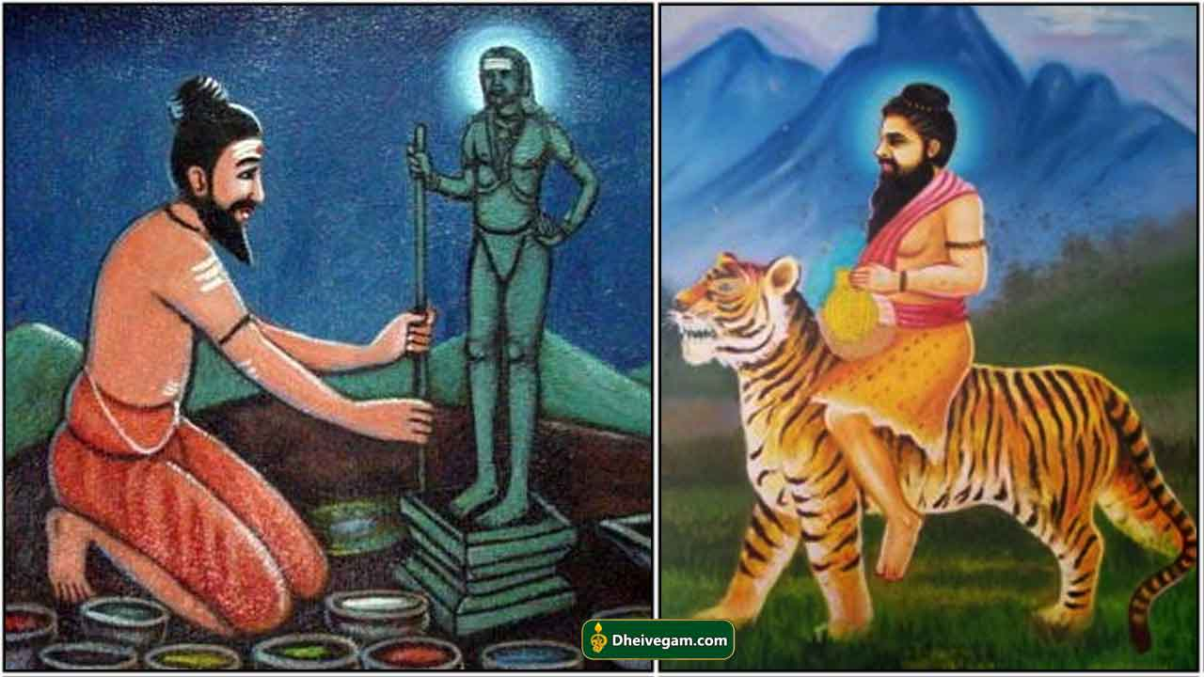
INTRODUCTION
Pulipani Siddhar is an ancient siddhar and is the disciple of Bogar. He is a staunch devotee of Lord Shiva.
Bogar installed Lord Murugan’s Navabashana idol at the Palani Hill, and daily he performed milk and panchamirtham abhishekham to the idol of Lord Murugan. After some time, his disciple Pulipani siddhar performed puja for Lord Murugan, since his guru Bogar went into a samadhi stage.
He got knowledge in vedic subjects and also an expert in all kinds of arts. He is very much interested in spirituality, and also chants the glory of Lord Shiva.
After getting the darshan of Lord Nataraja he concentrated his entire attention on devoting Lord Shiva. He worshipped Lord Siva with ‘Vilva’ leaves. He got a pair of Tiger’s paws as a boon, in order to climb the Vilva tree and for plucking the leaves for the shiva puja.
Pulipani performed yogic meditation towards Lord Siva. He has gained the status of Siddhar, through the divine grace of Lord Shiva.
IMPORTANCE
- By sincerely praying to Pulipani Siddhar, all sorts of dreaded diseases and mental disorders will be removed.
- We will get self confidence in our mind, and will be able to do our work properly.
- We can attain health, wealth and happiness in our life.
- Enemy related problems will be solved.
- We will get peace of mind.
- Unmarried people will be married soon, and they will be blessed with good children.
- We can attain spiritual energy in our mind.
- We will have a bright future.
- Bad, negative and suicidal thoughts will be removed from our mind.
Thus by worshipping Pulipani siddhar, we will get the above benefits in our life, and also after our departure from the earth, we can get SALVATION.
Let us praise his glory and be blessed.
“OM SREE PULIPANI SIDDHARE NAMAHA”
“OM NAMAH SHIVAYA”
WRITTEN BY
R.HARISHANKAR

RISHI PATANJALI
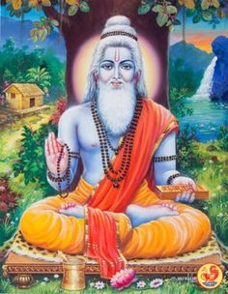
INTRODUCTION
Patanjali was a sage, siddha and a yoga guru in Hinduism, and he had written large number of sanskrit devotional texts, Ayurveda texts and yoga texts.
LIFE
He is considered to have been lived during the 2nd century BC.
He is also one among the 18 siddhars belonged to the shaiva tradition, and he is popularly worshipped by the shaivite sect of people, and he is considered as an incarnation of Lord Shiva, and contains all the features of Lord Shiva.
It is believed that he would have been lived for more than 1000 years, and attained great spiritual power through the divine grace of Lord Shiva.
He has attained Samadhi through his yogic powers at the Brahmapureeswarar Temple located at Tirupattur, Tamil Nadu, India.
Jeeva Samadhi of sage Patanjali, can be seen in Brahmapureeswarar Temple.
In the Yoga tradition, Patanjali is a popular name.
Patanjali studied Yoga from Lord Nandhi Deva.
Patanjali also writes the texts in a simple manner.
LITEREARY WORKS
- Mahabhasya
- Patanjalatantra
- Yogaratnakara
- Padarthavihnana
- Carakavarttika
- Yogaratnasamuccaya
- Cakradatta bhasya

IMPORTANCE
He is a great sage who contains knowledge in all fields. Though he was an expert scholar in various fields, he was specialized in yoga and meditation. He was also a great ayurveda physician and contains good knowledge in Ayurveda, and it is believed that he had treated several people from various diseases through his ayurvedic medicine. He also contained spiritual powers and yogic power through constant meditation. He is a great worshipper of Lord Shiva, Mata Parvati and Nandi deva. He worried about the physical sufferings of the people in the world, and introduced his medicine, several thousands of years before, through his books. It is also believed that during his period, he has seen directly the divine appearance of Lord Shiva, and he was blessed by Lord Shiva. He has got the power to meditate for several years and he attained siddhi (SALVATION) through that.
He is a great sage who lived by taking very little food and water and concentrated his entire attention on devoting Lord Shiva. He was apart from normal people, and considered as a great yogi. He is still living with us through his great divine books.
Let us worship this great sage and be blessed.
“OM SREE PATANJALI RISHIYE NAMAHA”
“OM NAMAH SHIVAYA”
WRITTEN BY
R.HARISHANKAR
SATTAIMUNI
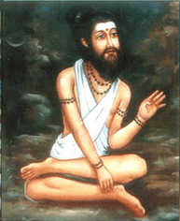
INTRODUCTION
Sattaimuni Siddhar was born in Srilanka and he lived by taking alms nearby a temple, in order to run his family. Even though he was a poor person, he was interested in the welfare of the people.
Sattaimuni Siddhar occupies a main place for his great works.
Due to the various health sufferings of the people, he made an extensive research in siddha and written medical related texts for the benefit of the mankind.
He left his family at his younger age, in order to seek spiritualism and to gain knowledge in siddha.
He was the disciple of Siddhar Agathiyar and Bogar, and learned many important subjects from them. He got the capacity to grasp the subjects quickly, and he was well appreciated for his talents by his gurus.
Being a sincere devotee of lord Shiva, it is believed, that since he was not having sufficient clothes to wear, once Lord Shiva himself appeared before him and presented him some good clothes to wear.
He was the guru of Pambatti Siddhar and Sundaranar Siddhar and he taught all the subjects to them.
He wrote the concepts of siddha secrets in a simplified manner.
Sattaimuni Siddhar is expert in Siddha medicine, and also in other fields.
After living a long life, he attained samadhi in sree rangam thiruchi.
IMPORTANCE
He was a great siddhar who was very much worried about the sufferings of the people from various diseases, and introduced new concepts in siddha medicine field through his great works. He was well versed in all divine texts, and also an expert in all forms of arts. Though he contained a great knowledge in all the subjects, he never got pride and remained as calm and a polite person throughout in his life.
Let us worship this great siddhar and be blessed.
“OM SREE SATTAIMUNI SIDDHARE NAMAHA”
“OM NAMAH SHIVAYA”
WRITTEN BY
R.HARISHANKAR

