SPIRITUAL MATTERS BY R.HARISHANKAR
ACHYUTANANDA DAS
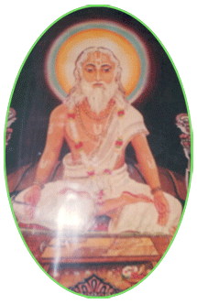
INTRODUCTION
Achyutananda (16th century AD) was a great poet and Vaishnava saint from Odisha, India. Due to his sincere meditation and devotion on god, he contains super natural powers, and utilized the power for helping the people to relieve from their diseases and problems. He was a great writer and written spiritual books and spread the Narayana Bhakti path among the people, and translated Sanskrit holy texts in the Odia Language in a simplified manner, in order to make it readable even by the common man.
Shri Achyutananda Das contains in depth knowledge in all the subjects in the field of medicine, yoga and spirituality.
LIFE
Achyutananda was born in a village at Cuttack district of Odisha. He was born due to the blessings of Lord Puri Jagannathar and was considered as an incarnation of Lord Garuda, and contains good physical and spiritual energy. He was highly honoured by the King Sri Purushottam Deva, and gifted him wealth and appreciated his talents.
In his life, he also met many great saints like Chaitanya Mahaprabhu and through their guidance he spread the bhakti spirit among the masses.
He was one among the five great vaishnavite saints who lived in puri and cultivated the bhakti spirit. All of them were translated lot of Sanskrit holy texts into Odia language, for better understanding of the people.
IMPORTANCE
He was a pious and noble man who lived a saintly life and guided the people properly and removed their sufferings and difficulties in their life. He was praised for his kindness and for his great wisdom. Being the avatar of Lord Garuda let us pray to him to have a blessed, prosperous and disease free life.
“OM SRI ACHYUTANANDA DAS NAMAHA”
“OM NAMO NARAYANAYA NAMAHA”
“OM SRI GARUDA BHAGAVANE NAMAHA”
WRITTEN BY
R.HARISHANKAR

AHOBILAM TEMPLE
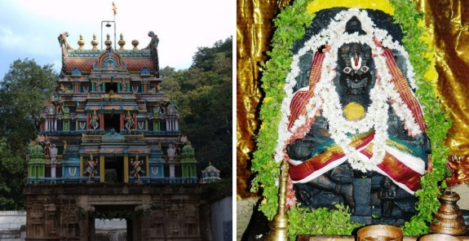
INTRODUCTION
Ahobilam is a holy site and is located in the Nallamala forests of Kurnool district in Andhra Pradesh. It is surrounded by several mountain hills and the place looks very attractive. The temple consists of nine shrines of Lord Narasimha. There is also a famous Prahalada Varadhan temple in the bottom of the mountain. Lot of devotees from all parts of India, as well as from foreign countries are visiting this holy shrine of Lord Narasimha, and getting his divine blessings. Ahobilam is the sacred place where the Lord Narasimha killed the great demon king Hiranyakasipu in this place. Lord Garuda also got the divine darshan of Narasimha after performing severe meditation on him. It is believed that by worshipping this ancient and famous temple of Narasimha, all sorts of health related problems will be solved, and we will get great spiritual energy in our mind and body, and our day to day sufferings would come to an end. Let us try to visit this temple, at least once in a year, and get the divine vision of the Lord, and also can enjoy the natural beauty at this place.
WRITTEN BY
R.HARISHANKAR
SUN GOD TEMPLE, ARASAVALLI
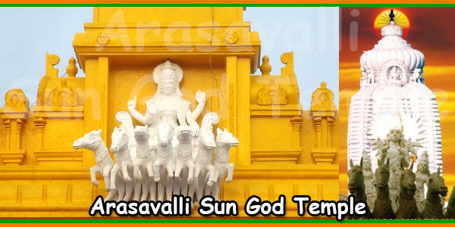
INTRODUCTION
Arasavalli Sun Temple is situated at Arasavalli Village in Andhra Pradesh, and it is a 7th century temple. It is built by the Kalinga Emperor, the great king Sri Devendra Varma. It is a popular temple, and lot of devotees are visiting this temple from all over the world. This temple is an ancient temple, and is good in architecture and art work. It is a famous temple, next to Konark Sun Temple, and is worshipped by the people, for getting relieved from their diseases and for getting bright eye sight. Here Sun God blesses us and gives all the prosperity to us. Rathasaptami festival is celebrated in a grand manner in this temple. It is advisable for those, who are suffering from severe dreaded diseases to visit and worship Lord Surya Narayana, who is protecting us through his sun rays, and can get relieved from their various ailments and can live their life peacefully and happily without any major sufferings in their life.
WRITTEN BY
R.HARISHANKAR
BAHLIKA
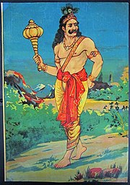
INTRODUCTION
Bahlika also called as Vahlika, was the famous king of Bahlika kingdom who lived during the previous Dwapara Yuga, that is, approximately 5,300 years back. He was the elder brother of Shantanu, who was the great king of the kingdom of Hastinapur. He was the oldest warrior who fought in the Mahabharata war. His son was Somadatta, and both of them fought together on the side of the Kaurava army in the Kurukshetra War. He was killed by Bhima in the Kutukshetra War. Even though, he stood at the side of the Kauravas, in general, he was a pious and a noble king, who loved both pandavas and kauravas, and was an ardent devotee of Lord Krishna. It is believed that he was the incarnation of Bhakt Prahalad, and due to that, he has got good qualities, and treated others in a respectable manner, and ruled his kingdom in a well-versed manner. During his reign, no one has suffered from poverty, diseases and all other sorts of problems. Due to his great spiritual power, he was highly praised by the great kings, sages and even by the demi gods in the heaven.
Since Bahlika’s elder brother Devapi has suffered from leprosy, and since bahlika doesn’t like to rule a big kingdom, and due to his generosity, he made his younger brother Shantanu as the king of Hastinapur, after the death of his father, King Pratipa. He ruled the small kingdom of Bahlika, in a proper manner, and maintained a cordial relationship between both the kauravas and the pandavas.
IMPORTANCE
According to ancient texts, it is mentioned that, in the krita yuga he was serving in the Brahma Loka to Lord Brahma Dev, as Shanku Karna, and due to a curse, he took birth as Bhakta Prahalada, and in his next birth, he took the avatar of Bahlika, the great king. He was also considered similar to Karna, in doing charitable activities. Daily he will used to provide food to thousands of poor people at his palace, and also gifted them new clothes, and constructed several annadan centres at various places of his kingdom. Being the avatar of Prahalad, he will used to chant the Narayana Mantra “OM NAMO NARAYANAYA NAMAHA” on a daily basis. Throughout his life, he never hated others, and was respected by everyone, and lived his life in a proper manner. Lord Krishna, liked him very much, and he was died in the hands of Bhima, as aspect of Lord Vayu Dev, and he wilfully accepted his defeat and died with a smiling face, and didn’t blamed anybody for the cause of his death, during the time of his death. At the time of his death, Lord Krishna blessed him to have a painless death, and due to that, without any sufferings in his body, he died in a peaceful manner. This is due to the act of his good karma, which he has done in his previous birth.
Let us worship the great king and be blessed.
“OM SRI BAHLIKA MAHARAJAVE NAMAHA”
“OM NAMO NARAYANAYA NAMAHA”
WRITTEN BY
R.HARISHANKAR
BALARAMA DASA
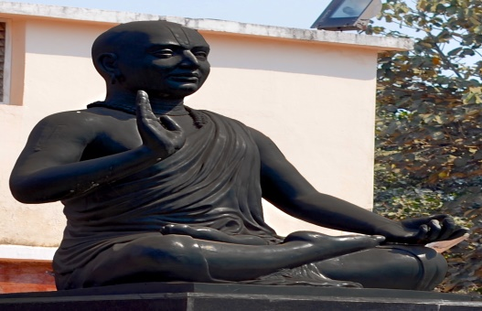
INTRODUCTION
Balarama Dasa (15th century AD) was born in odhisha and was a great saint and poet. He wrote several poems on Lord Rama and Krishna, and sung their glory in temples. His work Jagamohana Ramayana was considered as a famous text among the odhisha people, and it is written in very simple language, and even a lay man can read it. He contains great knowledge in all the subjects and an expert in vedas, and also learnt all the regional languages.
LIFE
He was born in a village at Odhisha, and his father was also a poet who served under a king of that region. He was an ardent devotee of Lord Jagannatha. He met the great saint Sri Chaitanya and he has initiated him into the bhakti path. He went on many religious pilgrimages and worshipped the gods and goddesses in the temples. He also met many great saints and discussed with them about the spiritual matters. He died at a village near Konark. And a shrine is dedicated to him near this village. Even now lot of people are visiting and worshipping him in his shrine and were got relieved from their problems.
WORKS
- Laxmi Purana
- Kanta Koili
- Baramasa Koili
- Hanuman Chautisha
- Kamalalochana Chautisha
- Gupta Gita
- Vedantasara Gita
- Udhaba Gita
- Brahma Gita
IMPORTANCE
Due to his great talents, he was praised by the kings and they rewarded him lot of money. But he distributed all the wealth to the poor, and lived a simple life. He used to worship Lord Rama and Krishna regularly, and offered food to the devotees at his home and in the temples. He was also against caste discrimination, and treated the people as the children of the god. He was a humble saint who has rendered selfless service to the mankind and the god throughout in his life. He has conducted many spiritual discourses on Lord Krishna and Rama, and spread the bhakti spirit among the people.
Let us worship the great saint and be blessed.
“OM SRI BALARAMA DASARE NAMAHA”
“JAI KRISHNA”
“JAI SRI RAM”
WRITTEN BY
R.HARISHANKAR

BHAIRAVI
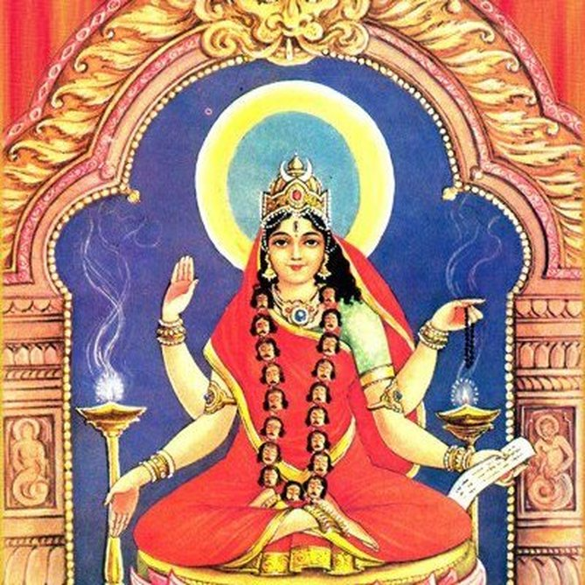
INTRODUCTION
Bhairavi is a Hindu goddess and is one among the Mahavidyas. She is the consort of the shiva avatar Kala Bhairava.
Bhairavi appears to be in fierce form and also called as Tripurabhairavi. She contains four hands and blesses us in her right hand. She is the protector of the entire universe and safeguards us from all sorts of natural calamities, evil forces and from our enemies.
By reciting the shloka meant for her, we can get rid of all the evil effects and also will realize more energy in our mind and body. We will also get spiritual energy by continuously worshipping her and chanting her various names. Mainly she removes the fear from our minds during the time of our death, and will help us to move towards the spiritual path during our life. She wears red garments and we can offer red saree to her deity in the temples meant for her.
Tripura Sundari and Tripura Bhairavi are closely related with each other, and give us better prospects in our life by worshipping them. Bhairavi is none other than our Mata Parvati, and she loves her children and guides them in all walks of their life. The only thing is that, we must sincerely worship her with utmost faith and devotion in our mind.
IMPORTANCE
Bhairavi controls the bad changes taking place in our life. And though she doesn’t change our fate, but she makes ourselves to adjust to live in this KALIYUGA, by giving more courage and confidence in our mind. She also will reduce the level of our sufferings, and remove our sins. She is the affectionate mother for us, and will try to reduce our problems, and make us to concentrate ourselves on good activities. Being the consort of Kalabhairava, by worshipping Kalabhairava in the shiva temples, she will become happy and will give us a happy and a prosperous life. She also relieves us from several dreaded diseases and gives more strength to our mind and to our body.
Bhairavi temple in Brahmapur, Siddha Bhairavi temple in odhisha, Linga Bhairavi temple in salem are the famous temples dedicated to the goddess Bhairavi.
By donating food, clothes, educating the poor children and providing shelter to the poor, will immensely satisfy her, and showers her grace on us. She can be worshipped by visiting her temples, or otherwise we can worship her with her laminated or framed photo in our puja room, and can offer flowers and fruits and can prepare some sundal (CHICKPEAS) and offer her as naivedyam (Holy Prasad - Food offering), and after the puja, we can distribute the Prasad to the people. It is advisable to chant the shiva panchakshara mantra “OM NAMAH SHIVAYA” and to chant “OM MAA TRIPURA BHARAVI DEVIYE NAMAHA” on a daily basis.
Let us pray to the divine holy mother and be blessed.
“OM SREE KALA BHAIRAVA SAMETA SREE KALA BHAIRAVIYE NAMAHA”
“OM NAMAH SHIVAYA”
“OM SAKTHI PARASAKTHI”
WRITTEN BY
R.HARISHANKAR

CHENNAKESAVA PERUMAL TEMPLE
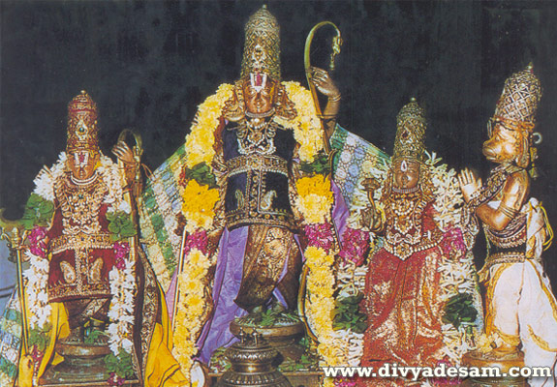
INTRODUCTION
Chennakesava Perumal Temple is a Hindu temple situated in the George Town, Chennai. It is dedicated to Lord Chenna Kesava Perumal, a form of Lord Vishnu. Chenna Malleeswarar Temple is situated nearby the Vishnu Temple. They are twin temples. Chenna pattanam is believed to have been named after the Chenna Kesava Perumal Temple. It is believed that during the 18th century, this temple has been constructed. Lot of devotees would visit these two temples, especially during the festival days. And the temple management is providing free food to a minimum of 50 people in both the temples. Both these temples are big temples, and a must to visit place, in order to get relieved from our various problems which we are facing day to day, in this Kali Yuga. Shaivites and Vaishnatives can come together and worship the deities and be blessed.
WRITTEN BY
R.HARISHANKAR

DIGAMBARBABA
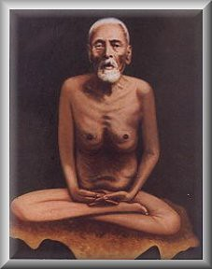
INTRODUCTION
Shree Digambarbaba was born in the year 1872 in a village at Maharashtra, and he was a great saint and was good at meditation and yoga. His birth name was Shri Ramachandra Narsimha Wahalkar.
At his younger age, he got married and had two daughters. He worked in a private firm for some time, and later found dissatisfaction with the job, and went to his native village, Chiplun Taluka, Ratnagiri District, Maharashtra. He went to the Dattatreya temple without having food for several days by chanting the mantra “OM SRI DATTATREYARE NAMAHA”.
After some time, Akkalkot Maharaj gave his darshan and blessed him. He looked nude without having proper food. Due to that he was called as Digambarbaba by the people.
All of his relatives were very much worried about his condition and asked him to be in a normal state, but he didn’t hear their words, and suddenly, left his village and met a great saint Shree Gopal Maharaj, and become his disciple.
After that he performed severe penance for several days, and he was blessed by the great saints like Shree Gondvalekar Maharaj, Shree Tembe Swami, Shree Narayan Maharaj and Shree SaiBaba.
Thereafter, he went on a long pilgrimage throughout India, and met lot of saints, and discussed with them about spiritual matters. He also went to holy temples like Pandharpur, Nashik, Banaras, Gaya, Rameshwaram etc. His wife also participated with him, in the religious temple tours, and showed much affection and love on him.
He also helped the people and cleared their personal problems by giving spiritual energy, and gave various religious lectures among the people and protected them from enemies and thieves and cured their various health ailments, and properly guided them.
He attained Mahasamadhi in the year 1951 near the temple of Shree Swami Samarth and Lord Dattatreya in Maharashtra.
Let us worship the holy saint and be blessed.
“OM SRI DIGAMBARBABAVE NAMAHA”
“OM SRI AKKALKOT SWAMIJI NAMAHA”
“OM SRI DATTATREYARE NAMAHA”
WRITTEN BY
R.HARISHANKAR

EKAMBARESWARAR TEMPLE
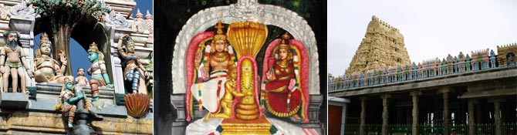
INTRODUCTION
Ekambareswarar Temple is a Shiva Temple, located in Kanchipuram. It is one of the Pancha Bhoota Stalas, Prithvi. Lord Shiva is worshiped as Prithvi lingam. Mata Parvati is worshipped as Gowridevi Amman. The greatness of the temple was praised in the 7th century sacred work, the Tevaram, written by the great nayanars and classified as Paadal Petra Sthalam. The temple is one of the largest in India. The temple has numerous shrines, and also contains many halls.
The temple follows six daily rituals from 5:30 a.m. to 10 p.m., and twelve yearly festivals are celebrated in this temple. Panguni Uthiram festival is celebrated during the period: March - April and is considered as the main festival of this temple. The temple attracts large number of tourists from all over the world.
It is believed, that Mata Parvati worshipped Lord Shiva in the form of a Prithivi Lingam in this place.
Here free food is served in the noon to a minimum of 50 persons on a daily basis.
WRITTEN BY
R.HARISHANKAR
GOUTHAMA
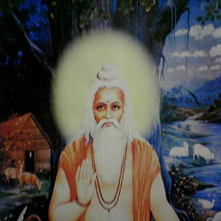
INTRODUCTION
Gautama Maharishi was a Vedic sage in Hinduism, and also was mentioned in the sacred texts of Jainism and Buddhism. He had authored some portions of Rig Veda. He was the son of Rahugana. The sons of Gautama are Vamadeva and Nodha.
His wife is Ahalya, and he cursed her to become a stone, since she was seduced by Lord Indra. And after several years, she was liberated from the curse by Lord Rama.
IMPORTANCE
He was a great sage and one among the saptharishis. Brahmins belonging to Gouthama gotra were the descendents of Sage Gouthama.
He was well versed in all the vedas,puranas and various devotional texts. He occupies a great place among the rishis. According to Devi Bhagavatham, the river Godavari is so named due to its spiritual connection with Rishi Gautama.

IMPORTANT DISCIPLES
- Praachina-yogya
- Shaandilya
- Gaargya
- Bharadwaja.
Gautama was also the author of Gautama Dharma sutra.
There is one ancient temple in Pushkar dedicated to Maharishi Gautama and his wife Mata Ahalya.
He lived a holistic life through his severe penance on gods, and by leading a spiritual life. According to ancient legends, it is believed that he is living in the Saptharishi Mandala along with Mata Ahalya.
CONCLUSION
A great maharishi who was well-known for his great spiritual powers, may bless us for our well-being. Let him guide us and protect us, and show us the way to move towards the right path in order to leave peacefully in this world, and finally to reach the divine abode of the god. Let us pray sincerely to him and be blessed.
“OM SREE GOUTHAMA MAHARISHIYE NAMAHA”
“OM SREE MATA AHALYA DEVIYE NAMAHA”
“JAI SREE RAM”
WRITTEN BY
R.HARISHANKAR

GUHA
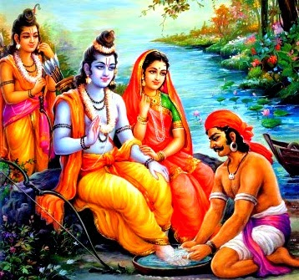
INTRODUCTION
Guha was a boat man who lived his life by taking the passengers in his boat and leave them in the other side of the river ganges. He was an honest and an efficient worker, who lived a pious and a noble life. He has already learned about Lord Rama’s exile from Ayodhya and banishment to the forest. He was very much worried about that, and didn’t eat and sleep properly. He was also aware about the incident of turning the stone into Mata Ahalya, and made her into a purified woman by the grace of Lord Rama, and he also knows that he is an avatar of Lord Vishnu, and was eagerly waiting to see his beloved Lord.
He started doing necessary arrangements to welcome Lord Rama, Sita and Lakshmana in order to take them in his boat to leave them in the other part of the shore of the river ganges.

The day also approached. He has seen that Lord Rama and Sita and Lakshmana are arriving that way. He made proper arrangements to welcome them and took the help of his friends, and gave them a warm welcome. He also kindly offered fruits and honey to them in a pleasing manner. As soon as they reached his place, he saluted them and bowed his head before them and also asked his other friends to do like that.
Rama was very much pleased with his sincere devotion on him, and accepted his prayers, and decided to get inside into his boat. Kuha has suddenly stopped him, and washed his lotus feet by his hands, and sprinkle the water into his head, and cheerfully asked them to sit into his boat. They were very much pleased and blessed him, and after reaching the shore, Mata Sita gave her ring as a payment for their trip, but he didn’t accept it, and instead of that, asked Lord Rama to give SALVATION to him. Rama immediately nodded his head and touched his hands in his head, and promised him, that after the end of his life, he along with his family and friends would reach the abode of Lord Vishnu, the VAIKUNTA, and would remain there forever.
On hearing the kind words of Lord Rama, joyful tears fell down from his eyes, and worshipped him by chanting the mantra “JAI SRI RAM”.
Due to his great devotion on the Lord, he has got salvation, and is enjoying the eternal bliss in the divine world. Similar to that, we also have to cultivate the same kind of devotion from him. We must try to chant the Rama Mantra “JAI SRIRAM” regularly, which is very simple and easy to recite.
Let us worship the great Guhan and be blessed.
“OM SREE GUHANE NAMAHA”
“JAI SRI RAM”
WRITTEN BY
R.HARISHANKAR

HANUMAN DAS BABA
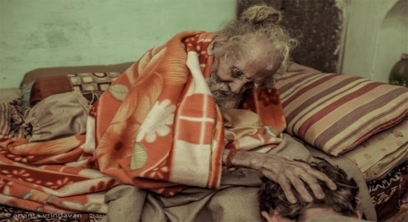
INTRODUCTION
Hanuman Das Baba was a great yogi and saint who is still living in the Vrindavan, nearby Lord Krishna Temple, at his Ashram, and blessing the visitors, and kindly listens to their talk, and finding solutions to their problems, and reduces the sufferings in their life.
He is believed to be a 170 year old saint, who was a small boy at the time of Jhansi Rani, the great woman warrior and queen who fought against the British Rule. He is doing his daily activities without anyone’s help. He was an ardent devotee of Lord Krishna, and at his younger age, he left his home, and from then onwards he is permanently staying at Vrindavan.
He is living a simple and a pious life, and regularly chants the Krishna mantra “OM NAMO BHAGAVATHE VASUDEVAYA NAMAHA”, and tells others to do so. He also accepts that he is still living at this very old age, due to the grace of Lord Krishna, and he also prays for us and for the well-being of the entire universe. So far he has not suffered from any disease or from any other health related problems due to the divine grace of Lord Krishna. He also removed the diseases of the people, and asked them to move into the spiritual path, to attain the eternal bliss of the lovely god Lord Krishna. He is a kind hearted man and never gets angry over others, and asks others to be like that. He contains deep knowledge in Srimad Bhagavatham and Bhagavat Gita. He clears the doubts of the devotees with respect to devotional matters, and helps them to reach the spiritual path.
The ashram of this Baba is located along the Vrindavan parikrama path, nearby the famous Krishna Balarama Mandir. He stays in a small room, and eagerly welcomes the visitors, and blesses them. Whenever we visit Vrindavan, let us to meet this great saint, and seek his blessings.
“OM SRI HANUMAN DAS BABA KI JAI”
“JAI SRI RAM”
“JAI HANUMAN”
WRITTEN BY
R.HARISHANKAR
HARI BABA
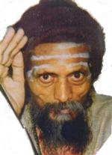
INTRODUCTION
Hari Baba was a great saint and a yogi who lives at his Ashram in a village at Jharkhand. He is very good at yoga and meditation, and those who visit him at his Ashram, he would give his divine smile, and talks about yoga, meditation and about divine matters and offer us a cup of tea. Though he is an old aged person, his appearance would be like that of a middle aged person, and this is due to his sincere devotion on the god. He is an ardent devotee of Lord Shiva and Mata Parvati.
He will used to give lectures on Gita and Bhagavatham in the nearby area, and local people and tourists would eagerly listen to his speech, and get happiness over that. Unnecessarily he will not talk to others. He has also travelled to several holy places and worshipped the divine gods, and once he has got the darshan of Kali Ma and from then onwards, he has got more spiritual powers, and helps his devotees by removing the problems in their life.
He will even sit in deep meditation for several days without sleep and food. He contains great yogic powers through that. He was also good at listening to the people’s worries and tackles them in a wonderful manner. Most of the tourists who visit Jharkhand will used to meet him in order to get his blessings.
He also met the great saints like Ramana Maharishi, Aravindar and several other sadhus during his younger age, and gained more spiritual power through that.
His teachings are as follows:
- Make a regular exercise of going to the temples and worshipping the god.
- Avoid thinking about unwanted things in your life.
- Don’t curse the god, for your sufferings in your life. Believe that he has created you for some purpose only.
- Be honest, sincere and straightforward to others.
- Don’t be arrogant over others. Always try to be a kind hearted person.
- Respect the elders, and provide proper support to them.
- Do some kind of charitable activities, since it will cool your mind and body, and there will be no unwanted tensions in your life.
- Realize the god from your soul, and worship him, and regularly do yoga and meditation.
- Be kind with all the creations of the god, and show kindness even to the small insects.
Let us worship the great saint and be blessed.
“OM SRI HARI BABAVE NAMAHA”
WRITTEN BY
R.HARISHANKAR

JAIDEV
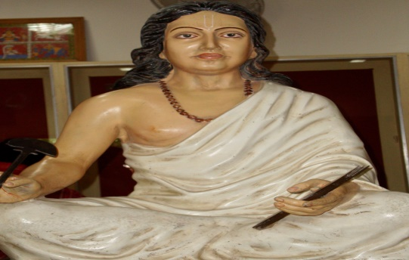
INTRODUCTION
Jayadeva (12th century) also called as Jaidev, was a famous saint and poet. He was an ardent devotee of Lord Krishna, and his famous poem was Gita Govinda which describes the love between Lord Krishna and Mata Radhe. He admires their glory and considers them as the greatest divine couple, and worships them whole heartedly. His poems were included in the Guru Granth Sahib, the important scripture of Sikhism. It is also believed that he got married with a noble lady Padmavathi, and both of them were lived peacefully with the blessings of Lord Krishna.
He was a Brahmin scholar and it is believed that he would have been born in a village in the present day Odisha. Jayadeva travelled to many holy places and worshipped in the temples of Lord Krishna with great cheerfulness and happiness, and chants his mantra, and would not stay at one place alone. He has undergone long pilgrimages and lived his life by taking alms, and was highly praised by the kings and the common people for his great talents in penning beautiful devotional poems on Lord Krishna and Radhe Mata. He was educated in his native place at Odhisha, and learned all the divine scriptures and sanskrit language, and was an expert in all kinds of art and was a born genius. Jayadeva for some time worked as a teacher in the school at Kurmapataka, Odhisha.
Jayadeva was the main person in spreading the bhakti spirit among the people through his songs on Lord Krishna.
Although Jayadeva lived in 12th century, even today his songs are very famous, and considered as divine ones.
IMPORTANCE
Though he was a great scholar, he lived a simple and a pious life, and mesmerised the people through his melodious songs on Lord Krishna. He was a humble and a kind hearted saint, who never spoke harshly over others, and interacted with others in a proper manner. He contains good knowledge and wisdom, and was a great scholar. He was one among the few poets, who wrote songs mainly based on Lord Krishna and Radhe, and propagated the Vaishnavism throughout India. His evergreen songs will always be remembered by the people, and he is still living in this world, through his beautiful songs.
Let us worship the great saint and be blessed.
“OM SRI JAIDEV NAMAHA”
“JAI KRISHNA”
“JAI RADHE MATA”
WRITTEN BY
R.HARISHANKAR

JANGALI MAHARAJ
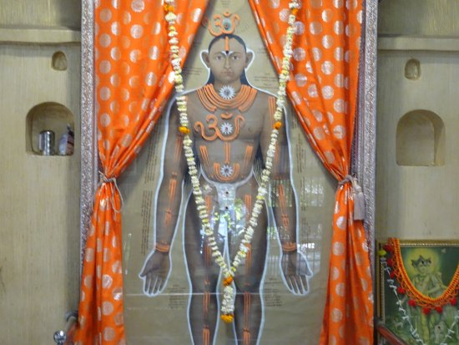
INTRODUCTION
Jangali Maharaj (1806 – 1890), was a great saint and lived in Pune, Maharashtra. He was also known as Guru Maharaj and was considered as a great saviour by the people, due to his sincerity and dedication on god, and towards showing kindness and safeguarding the people from the problems, and providing them the necessary training in the spiritual path, and makes them as good persons. It is believed that he was born in a village in Gujarat. He was a very great spiritual guru and had enlightened all the spiritual chakras.
He was a sincere devotee of Lord Krishna, and used to give lectures on bhagavatham and bhagavat gita to the people, and praises about the importance of Lord Krishna. He used to frequently tell to the people that “ Don’t keep on worrying about your problems and sufferings, instead of that, forget about your worries, and chant the glories of Lord Krishna, then automatically your problems would come to an end”. He was also a devotee of Lord Dattatreya. And he has performed regular pujas for Lord Datta and Sri Krishna.
He also insisted the people to worship the god in the temples, and to offer pujas and abhishekhams to the deities, in order to live peacefully and happily without any major sufferings in their life.
TEACHINGS
- Have faith on god, and do your duty, you will get the desired results in your life.
- Don’t cry for the pains which you have suffered in your life, god is always there to apply the medicine in your heart and body, and would relieve you from the pain.
- Show mercy on all the animals and birds, since all these are created by the god, and it is our duty to take care of them properly, and to provide them with sufficient food and water in time.
- Take care of your parents, and provide them with wholesome food and give them proper medicines during their sickness.
- Don’t think that god is not hearing your words, he is available everywhere, and he is watching your activities at every moment of your life, and will definitely shower his grace at the appropriate time. Till such time, it is your duty to wait patiently.
- Apart from god, worship the great saints, since saints are the divine incarnations of the god, and pay proper respects to them.
- Give money to the needy and the poor, then you will never become poor.
- Don’t divert your mind on unnecessary activities, instead of that, keeping thinking about the childhood plays and miracles performed by Lord Krishna at Brindavan.
- We are all the servants and slaves of the god, and we must not forget them and we should not curse them even in case of any major problems in our life.
IMPORTANCE
He was a great saint who devoted his entire life for doing goodness to others. Due to his blessings, many people were healed from their physical and mental problems, and the unhappy people were turned into joyful, unemployed people become employed, poor turned into rich, unhealthy people become healthier, and everyone’s life has changed into a meaningful manner, due the grace of Sri Jangali Maharaj.
Let us worship the great saint and be blessed.
“OM SRI JANGALI MAHARAJ JI NAMAHA”
“JAI KRISHNA”
“JAI RADHE MA”
WRITTEN BY
R.HARISHANKAR

KACHALEESWARAR TEMPLE
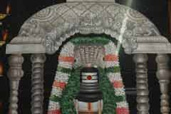
INTRODUCTION
The Kachchaleswarar Temple is a shiva temple located in Armenian Street, Parrys, chennai. It was constructed in the year 1725, and was one of the popular temples since the times of the ancient Madras City. The temple is similar to the Kachaaleshwarar temple at Kancheepuram. Here Lord Shiva is worshipped in the name of Kachaaleshwarar and Mata Parvati is worshipped in the name of Soundaraambikai. The first consecration ceremony was performed during the year 1728, and thereafter during the years: 1962, 1984 and1989. It is located in the main place of the Chennai, and surrounded by banks and business houses. It is a holy temple, where Avatars of Lord Shiva were depicted in the walls of the temple, and it will be pleasant experience by looking at that divine pictures. Chennai people can visit this temple, since lot of transportation facilities are available to reach this holy temple. Shiva Ratri and Thiruvadirai festivals are grandly celebrated and daily annadanam is offered for a minimum of 50 people. Let us visit this holy place, and be blessed.
WRITTEN BY
R.HARISHANKAR
KATYAYANI
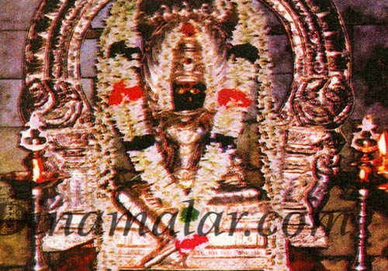
INTRODUCTION
Katyayani is one of the forms of Navadurga and worshipped during mainly during Navratri. She is also considered as an avatar of Mata Paravati, and is considered as the affectionate sister of Lord Krishna.
She is called by various names such as Bhadrakali and Chandika, and also appears similar to Mata Devi Durga.
Katyayani Temples are situated throughout India, and the most important one is situated in Bihar. Temples of Ram, Lakshman and Ma Janaki are located nearby the temple. During Mondays, Tuesdays and Fridays, large number of devotees would come to this temple, to visit and worship the holy Mata. She was brought up by Rishi Katyayan. Hence, it is believed that she is called as Katyayani. She is relieving her devotees from sins and gives them sound mind and good health.
WRITTEN BY
R.HARISHANKAR
KING DASARATHA
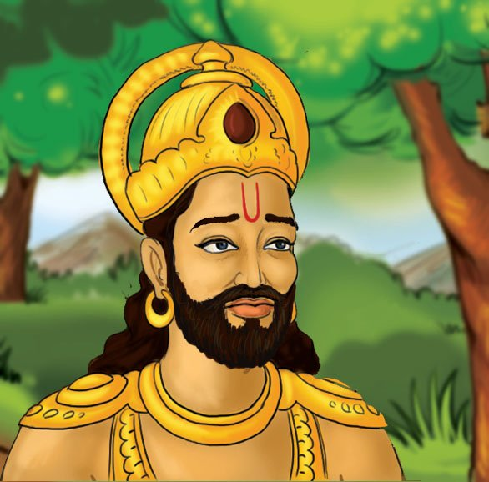
INTRODUCTION
Dasharatha was a descendant of the Ikshvaku dynasty and the king of Ayodhya who lived during the Treta Yuga. His birth name was Nemi.
Dasharatha was the son of the great King Aja and Indumati. He had three wives and his sons were Rama , Bharatha, Lakshmana and Shatrughna. Dasharatha is a talented rider of his chariot which could move in all directions, and also would go to the divine worlds and return to the earth. He also helped the demi gods and fought with several dreaded demons and killed them in the war.
Once, due to a help done by his wife Kaikeyi, towards winning in the war, Dasharatha promised her that her son would be his successor and will become the King of Ayodhya.
Dasharath has performed many yagnas with the guidance of Vasishtha, and due to that he had four great divine avatars as his sons, and he brought up them well and trained them in all kinds of arts. And after they have grown up, he conducted marriages for his children.
He was separated from his son Lord Rama, due to a curse which he got it when he accidently killed a noble person Shravan, and was cursed by his blind parents. The place where Dasharatha has accidently killed Shravan is now known as Shravan Kshetra, and even now lot of people are coming to this holy shrine and offering prayers to the noble boy “SHRAVAN”.
After the banishment of Lord Rama to the forest, the grief stricken Dasaratha died. He was cremated on the banks of the Sarayu River. This is a sacred place for Hindus.
IMPORTANCE
He was a great valour and talented in all kinds of arts, and a master in Hindu Scriptures. He was a blessed one for having Lord Rama as his own son. He ruled his kingdom in a proper manner, and treated his people in a kind manner, and provided all the necessary benefits to them. Everybody had liked him and lived peacefully and happily during his rule.
Let us worship the great king Dasaratha and be blessed.
“OM SRI DASARATHA MAHARAJAVE NAMAHA”
“JAI SRI RAM”
WRITTEN BY
R.HARISHANKAR

KUNTI
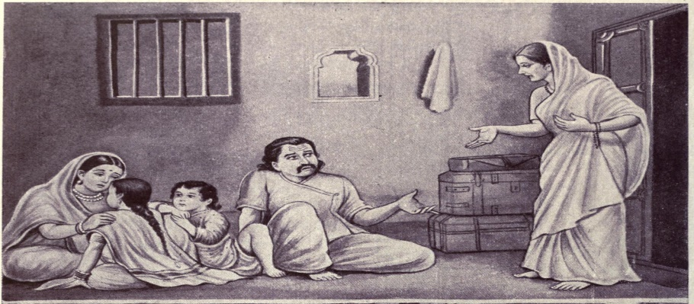
INTRODUCTION
As per the epic Mahabharata, Kunti was a pious, noble and a beautiful woman and she was the daughter of Shurasena. Her husband is King Pandu. Her brother was Vasudeva, who was the father of Lord Krishna. And she was the aunt of Lord Krishna, and the mother of Arjuna, Bheema, Dharma and Karna. Though Nakula and Sakadeva were the sons of Matri, another wife of king Pandu, after her death, she took care of Nakula and Sakadeva very well and treated them as her own sons. She occupies a main role in Mahabharata. Her birth name was Pritha.
She was adopted by Kuntibhoja. Once due to the blessings of Sage Durvasa, she got a powerful mantra from the sage, and by reciting the mantra in favour of any demi gods, she would be blessed by them with great children.
Since she was a small girl at that time, she playfully chanted the mantra in praise of Lord Surya, and due to his grace, Karna was born. Since she was a small girl, she put the child in a basket and dropped that basket into the river. After some time, she was married with King Pandu of Hastinapur, and become the Queen of Hastinapur.
After some time, Pandu married Madri, a princess of Madra in order to maintain friendly relationship with the king of Madra.
Once while Pandu was hunting in the forest, he got cursed from the Sage Kindama that whenever he maintains sexual relationship with his wife, he would die immediately. Due to that Pandu left his kingdom and went to forest along with his wives Kunti and Madri.
Due to the advice of her husband, king Pandu, Kunti used the boon granted to her by Sage Durvasa and had three sons Yudhishthira by Yama, Bhima by Vayu, and Arjuna by Indra. She also invoked the mantra in favour of Ashvins for Madri and due to the blessings of Ashvins, sons of Lord Surya, Madri gave birth to twin sons, Nakula and Sahadeva. One day, Pandu, attempted to sexually interact with his wife Madri. But, due to the curse of sage Kindama, he died. Madri had ended up her life by self-immolating herself in the fire.
After the death of Pandu and Madri, Kunti returned to Hastinapur, and took care of all the Pandavas. Due to the rivalry between pandavas and kauravas, duryodana tried his level best to destroy the pandavas in order to become a king and occupy the throne of Hastinapur.
For some time, she left Hastinapur, along with her children. During their stay at a village, due to the advice of Kunti, Bheema fought with the demon, Bakasura, who ate people, and killed him and thereby protected the villagers from him. Later Bheema married the sister of Bakasura, Hidimbi and had Kadotkacha as their son.
Later the Pancha pandavas were married with the Panchala Princess Draupati. After some time, the Pandavas and Kunti went to Hastinapura. And the Pandavas lose the kingdom in a dice game and exiled for thirteen years.
At the time of Kurukshetra war, Kunti met Karna and told about their relationship. After the end of the Kurukshetra war, Kunti went to a forest near the Himalayas with Vidura, Dhritarashtra and Gandhari, and after some time all of them were died in a forest fire, and attained SALVATION.
Let us praise the holy mother Mata Kunti Devi and be blessed.
“OM SRI KUNTI DEVIYE NAMAHA”
“OM SRI DRAUPATI AMMANE NAMAHA”
“JAI KRISHNA”
WRITTEN BY
R.HARISHANKAR

MORYA GOSAVI
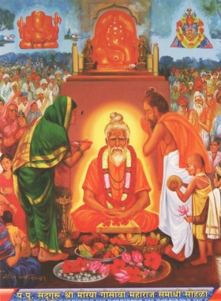
INTRODUCTION
Morya Gosavi (14th century) also called as Moroba Gosavi was a popular saint and an ardent devotee of Lord Ganesha. It is believed that he was born in Bidar, Karnataka, to a noble family, and since he was lazy at his childhood, and didn’t attend to the school properly, his father has sent him out from the home.
The young child wandered in the streets and had his food by taking alms, and travelled to many places and finally reached chinchwad, pune, maharashtra. And from there, he reached morgaon and visited the famous temple of Lord Ganesha, and for some time stayed in that place.
After some time, as per the orders of Lord Ganesha, he moved to chinchwad, and built a temple for Lord Ganesha, and stayed there permanently, and after several years, he attained Jeeva Samadhi at that place. And a shrine was built in his Jeeva Samadhi. It is believed that still he is hearing the prayers of his sincere devotees, and with the grace of Lord Ganesha, he is removing the obstacles from their life, and making them to be prosperous in their life.
Morya Gosavi is considered as the chief person of the Ganapatyas and has been described as the sincere devotee of Lord Ganesha. Morya is believed to have been born due to the grace of Lord Ganesha, in order to spread the importance of Lord Ganesha among the masses.
Morya’s son was Chintamani, and he was considered as the incarnation of Lord Ganesha. He has shown his original form of Lord Ganesha, to many of his sincere devotees. The samadhi of Morya Gosavi and the famous Ganesha temple at Chinchwad attracts lot of devotees from all over the world.
IMPORTANCE
Morya Gosavi contains the features of Lord Ganesha, and is still blessing his devotees from his shrine. During his lifetime, he has done many miracles in the life of his devotees, and removed their sins and made them to attain spirituality and holiness in their life. He also gave several spiritual discourses to cleanse the minds of the people, and to remove their bad thoughts and bad behaviours. He is considered as a saviour who still safeguards his devotees from dangers and embraces them in his golden hands.
Let us worship the great saint and be blessed.
“OM SRI MORYA GOSAVI NAMAHA”
“OM SRI CHITHAMANI NAMAHA”
“JAI GANESA”
WRITTEN BY
R.HARISHANKAR

NATHAMUNI
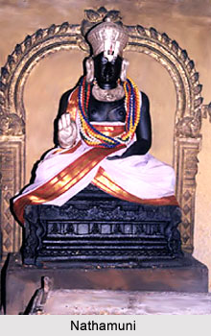
INTRODUCTION
Nathamuni (823-951) was a Vaishnavite Saint and a great scholar who compiled the Nalayira Divya Prabandham, a great collection of sacred texts praising the importance of Lord Vishnu, with the help of Nammalvar. He was the foremost person to propagate the philosophy of Vaishnavism. He has also written the holy texts Yogarahasya and Nyayatattva. His birth name was Aranganathan. But due to his devotion on god, he came to be known as Nathamuni, which means god’s servant. He was praised by the Chola kings, and admired him for his pure devotion and dedication towards Lord Vishnu. He contains good knowledge and wisdom and a master in all subjects and learnt all the regional languages.
Nathamuni was born in the village in Kattumannarkoil, Tamil nadu and died at Gangaikonda Cholapuram. His several other names were Sadamarsana Kula Tilakar, Sottai Kulaththu Arasar and Ranganatha Acharya.
His father's name was Isvara Bhatta and his son's name was Isvaramuni, and his grandson was Yamunacharya. All of them were ardent devotees of Lord Vishnu.
He travelled throughout India, to spread the bhakti spirit among the devotees. He compiled several poems in praise of Lord Ranganatha. He served as the Srirangam Temple In charge. He introduced the system of chanting the divine songs from the great text “NALAYIRA DIVYA PRAPANDAM” in the Sri Ranganathaswamy Temple, Srirangam.
Nathamuni, made a system for the recitation of Tamil Vedas during the main festivals of the Lord Ranganatha. Nammazhwar's songs are sung even now at Srirangam and several other temples of Lord Vishnu.
His main disciple was Pundarikaksha, who made his disciple Ramamisra to guide Yamunacharya, the grandson of Nathamuni. Nathamuni was against caste discrimination, and treated all castes of people equally and respected them properly. Due to his kind attitude over others, everyone has praised him for his good nature and gave much respect and worshipped him as an avatar of god.
IMPORTANCE
He was a great and a kind hearted saint, who has dedicated his life towards doing the service of Lord Vishnu. Though he remained in family life, he lived a simple and a noble life, and his thoughts were always about Sri Ranganatha, and took care of the temple management in a proper manner. He provided food to the poor people, and considered all of them as the divine incarnations of the god. He also removed the sins of his devotees, and taught them the principles of Vaishnavism, and insisted them to regularly worship the lord in the temple, and removed the diseases from their body, and inculcated the bhakti spirit into them, and made them to live happily and peacefully throughout in their life.
Let us worship the great saint and be blessed.
“OM SRI NATHAMUNI SWAMIGALE NAMAHA”
“OM NAMO NARAYANAYA NAMAHA”
WRITTEN BY
R.HARISHANKAR

NIVRUTTINATH
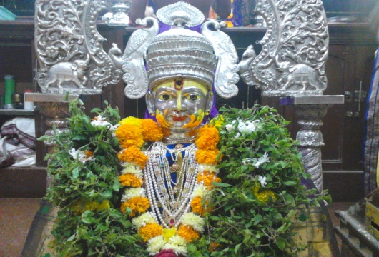
INTRODUCTION
Nivruttinath (1273–1297) was a great saint, Vittala devotee and belongs to the Vaishnava Nath tradition. He is considered as an incarnation of Lord Shiva. He was the elder brother and the guru of Saint Dyaneshwar, the popular saint. He has also written several poems in praise of Lord Krishna.
Nivruttinath was born in a village in Maharashtra into a pious Brahmin family. Nivruttinath’s father was worked as an accountant in a private firm, and his mother was a house wife. Nivruttinath went on religious pilgrimages and there he met his Guru Gahaninath, who initiated him in the bhakti path, and trained him in the Hindu scriptures and taught him various languages.
After the tragic death of his parents, he took care of his brothers Dyaneshwar and Sopan, and sister Muktabai, and trained them in studies and guided them properly. All the siblings have got the divine darshan of Lord Krishna and Mata Rukmani for several times during their life time. And they were attained SALVATION at their teenage, and they were considered as divine incarnations.
Nivruttinath has advised his brother Dyaneshwar to write a spiritual work. And that work is known as Amrutanubhav. He has conducted religious lectures among the people and invoked them into the Krishna Bhakti Spirit, and conducted regular bhajans and sung the songs in praise of Lord Krishna. He asked the people to chant the glories and the various names of Lord Krishna, in order to get relieved from their sins and diseases, and to get all sorts of prosperity in their life.
After some time, at his teenage, Saint Dyaneshwar has attained Samadhi. Very soon, Navruttinath also has attained Samadhi. And his sister Saint Muktabai has attained SALVATION after her death. Nivruttinath Samadhi is situated near Trimbakeshwar, where still now, lot of devotees are visiting this holy place and getting his blessings.
Let us worship the holy saint and be blessed.
“JAI NIVRUTTINATH MAHARAJ KI JAI”
“JAI KRISHNA”
“JAI RUKMANI MATA”
WRITTEN BY
R.HARISHANKAR

PRAHALAD CHANDRA
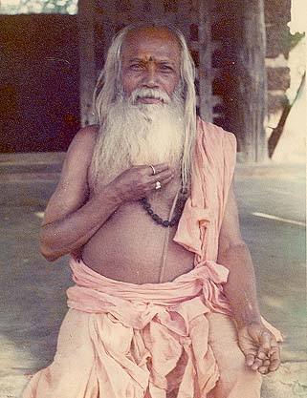
INTRODUCTION
Prahalad Chandra (1900-1982) was a renowned scholar and a great saint who lived in the Hoogly District of West Bengal. He was born in a poor family at a village in Odhisha. He has attained great spiritual knowledge at his younger age itself, and guided others towards seeking the spiritual path. He was a guru to Indian and many foreigners and they considered him as a divine saint and honoured and respected him properly.
He went to America for several times, and conducted spiritual lectures, and spread the bhakti spirit among the people and also explained about the importance of Hinduism. His main disciple was Sri Yogananda who followed him in all walks of his life. Sri Prahalad was an ardent devotee of Mata Kali and at his older age served as a priest in Kali Temple at Ramnathpur, West Bengal, and used to perform puja regularly and serve the goddess holy Prasad to the worshippers of the temple, and cured their several diseases and mind related problems. He has got the darshan of the holy mother Kali for several times, and through that he got great knowledge in spirituality, and got more spiritual powers, and used his powers for doing good things to others, such as removing the black magic of the people, and reducing their mental stress and tensions in their life and asking them to frequently chant the mantra “OM NAMAH SHIVAYA” and “JAI KALI MA” regularly.
Frequently Mata Kali would appear in his dream and give him various instructions such as insisting him to do meditation and yoga and to renovate the ancient temples, and do welfare activities to the poor such as offering them food, cloth and shelter.
He sincerely followed all the instructions given to him by the holy mother, and done divine service as well as people service.
He died at the age of 82, and attained SALVATION.
Let us worship the great saint and be blessed.
“OM SRI PRAHALAD CHADRA SWAMIJI NAMAHA”
“JAI KALI MA”
“JAI BHAKT PRAHALAD”
WRITTEN BY
R.HARISHANKAR

PUJYA SRI GURU DEVAR
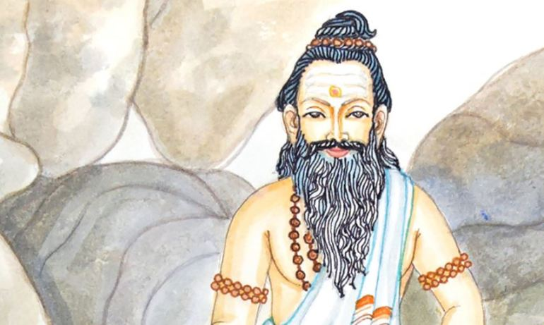
INTRODUCTION
During the 19th century there lived a great saint, in a village at Maharashtra, who was later known as Pujya Sri Guru Devar. He is an incarnation of Lord Shiva, and for his sincere devotees, he has appeared in the form of Lord Shiva. His details are not known to many people, since he doesn’t want his details to be disclosed among others. In one old Tamil book, his details were mentioned, and I got to know about him through that. He got married to a pious and a worshipful lady named as Sridevi, who is also considered to be an incarnation of Mata Parvati Devi. And they had sons and daughters. Even at the time of his daughter’s death, he didn’t prevent her from dying, and thought that the act is the desire of the god. But he has done many miracles in the life of his sincere devotees. Once he has saved a devotee from black magic, which was kept by his enemies, due to his promotion in the higher post in the Central Government. He tied a Raksha in his hand, and throughout his life, he was protected by that Raksha. Once, he tried to safeguard the life of his devotee’s wife by asking her to recite the name of Lord Shiva or his name. But due to her bad luck, she didn’t think about it seriously and not chanted the mantra, and due to that, suddenly due to fire accident, she was died. Due to that Gurudev has become very angry with the Fire God, Lord Agni Dev, and decided to punish him. But at that time, Lord Vinayaka appeared in the form of white elephant with the divine Amirtha pot in his trunk, and circumambulated Sri Gurudev, and made him to realise that everything is happening based on the fate, and there is no need to punish Lord Agnidev, and disappeared from that place. Then he has become pacified, due to the appearance of Lord Vinayaka in the form of elephant. But after her death, due to the grace of Sri Puja Sri Gurudevar, she has attained SALVATION.
Usually he will used to dwell only in the forest along with his wife and children. And he didn’t get any problem from the animals living in the forest. They will used to circumambulate and sit in front of them without giving any disturbance to them. He has got such great spiritual powers.
Once he has participated in a puja performed by his devotee, and suddenly, the devotee’s mother has called his son and said secretly, that the Guru while performing Puja has turned in the form of Lord Shiva, with snakes in his neck and wearing the tiger skin, and having a trisool in his hand. After the performance of the puja, the devotee has asked about this matter to Gurudev. And Gurudev said that his mother was a pious and a noble woman and due to that she has got his darshan in the form of Lord Shiva.
He also removed the diseases from the devotee’s body, removed black magic, and insisted them to chant the Shiva Mantra “OM NAMAH SHIVAYA” on a continuous basis, in order to get all the prospects in their life. He also changed the bad hearted souls into good ones, and made them to worship the god, and also shown his true form, and blessed them.
After his death, he has merged with Lord Shiva.
Let us worship the holy saint and be blessed.
“OM SREE PUJYA SRI GURUDEVARE NAMAHA”
“OM NAMAH SHIVAYA”
“OM SAKTHI PARASAKTHI”
WRITTEN BY
R.HARISHANKAR

RAGHAVANKA
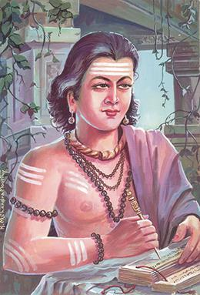
INTRODUCTION
Raghavanka (12th century) was a famous Kannada writer and a poet in the Kingdom of Hoysala. Due to his talents, he was praised by the great kings and also by the common man. Raghavanka is a great person in Kannada literature. He has written the famous text Harishchandra Kavya, based on the life history of King Harishchandra. He was the disciple of the great poet Harihara. He has also written texts on Lord Shiva and Vishnu in a simple language, which can be read even by the layman.

WORKS
- Harishchandra Kavya
- Siddharama charitra
- Somanatha charitra
- Viresvara charita
- Hariharamahatva
- Sarabha charitra
His guru has asked him to write about great saints and divine gods and goddesses, since he considers King Harishchandra as an ordinary motal. Due to that, he had written texts about Veerashaiva saints.
IMPORTANCE
Even though his guru has disliked him for writing the text of Harishchandra, he argued with his guru, that the great King Harishchandra was not an ordinary king, and he has lived a pious and a honest life throughout his life, and after his death, he has reached the divine abode of Lord Indra, the Swarka Loka, and also has become one of the demi gods in the heaven.
Raghavanka was famous for writing texts in a perfect manner, and was a great Shiva devotee. It is believed that once he has got the vision of Lord Shiva, and he got the blessings from him. After that, he has become a famous poet, and wrote lot of devotional poems and sacred texts.
He contains great wisdom, knowledge, courage and a master in all kinds of arts. He has also won in the debates with the scholars, and received price money for that. He has done several charity works, and provided food to the poor people, at his own cost.
Let us worship the great poet and a noble person and be blessed.
“OM SRI RAGHAVANKARE NAMAHA”
“OM NAMAH SHIVAYA”
WRITTEN BY
R.HARISHANKAR

RAVISHWARAR TEMPLE
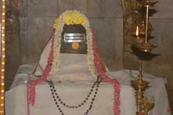
INTRODUCTION
Ravishwarar Temple is a famous Shiva temple built during Chola's period. It is located at Murthy Iyengar Street, Vyasarpadi. Vyasarpadi is situated nearby Perambur. The lord Shiva is named as Ravishwarar. It is said that the lord is worshiped by the Sun God. Once, the Sun god also took bath in the temple tank to get rid of his Bhramaharti Dosham. Mata Parvati Devi shrine is also available in this temple. The Sun god shrine is also located inside the temple. After worshiping lord Shiva, the Sun god must be worshipped. The temple has three sacred trees. Lots of people visit this temple on Sundays to get rid of various diseases and mental problems. The God is considered as powerful, and worshipped by hundreds of devotees during festival days. Here free food is offered daily to a minimum of 50 people. The place is easily accessible from various parts of the city through various modes of transport. By worshipping Lord Shiva and Lord Surya, we can get all the prosperities in our life.
WRITTEN BY
R.HARISHANKAR
RISHI LOMASA
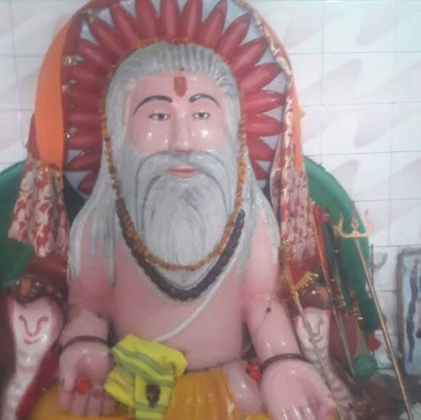
INTRODUCTION
Rishi Lomasa was considered as one of the Gem among the rishis for his sincere devotion and constant meditation on the god, and for his kind hearted behaviour. It is believed that he lived during the Treta Yuga, and met Lord Rama, and discussed about spiritual matters with him. Once he has cursed the great rishi Kakapujandar also known as Kakabhushundi to become a crow, and afterwards worried for his act, and narrated the Ramayana incidents to him. And through that, Kakapunjandar has got sincere bhakti on Lord Rama and has become a great rishi.
Once during the treta yuga, due to his great meditation, he went deeper into the earth, since he was doing meditation for several lakhs of years. By hearing his voice inside the earth, lord rama who was returning to Ayodhya after the killing of Ravana, has cleared the place where he was meditating, and took him out. The rishi after a long time opened his eyes and enquired about him. Rama told the entire incidents which was happened in his life.
He also realized that Rama is an incarnation of Lord Vishnu, and paid his respects to him. And from then onwards he has become a great devotee of Lord Rama, and used to frequently chant his mantra “JAI SRI RAM” regularly. It is believed that now he is living in the Rishi Mandala and still doing severe meditation on the god.
TEACHINGS
- Have bhakti on the god, without that nothing is possible in this world.
- Do your duty, rest leave it in the hands of the god.
- Chant the easiest Rama Mantra, which would solve all sorts of problems in this world, and also would give salvation at the end of the life.
- Give respect to everybody in this world, and take care of your parents properly.
- Work is worship.
- Do yoga and meditation regularly, in order to get good health and a sound mind.
- Nothing is permanent in this world. Hence, do charity to the poor, and get the blessings of the god.
- Nobody is our master, except the divine god, pay your regular prayers to him, and welcome him to your home.
- Realize that god is within you, and realize the inner spiritual energy and believe that god is dwelling in all the living beings in this world.
Let us praise the great rishi and be blessed.
“OM SREE RISHI LOMASARE NAMAHA”
“JAI SRI RAM”
“OM NAMO NARAYANAYA NAMAHA”
WRITTEN BY
R.HARISHANKAR

SAINT BALU
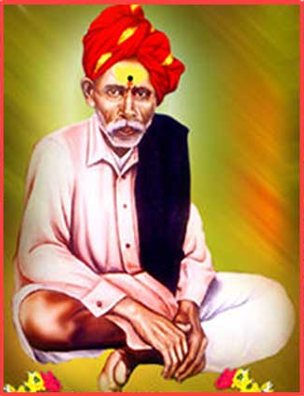
INTRODUCTION
Saint Balu also called fondly as Balumama was a great saint and considered as an incarnation of Lord Shiva. He was born in a village at Karnataka and attained Samadhi at Maharashtra. His teachings are very popular among the people. He was a simple and a humble scholar, who was thorough in ancient texts and familiar in local languages.
He was a strict vegetarian throughout his life, and asked his followers also to be like that. He was a great devotee of Lord Vithoba, a form of Lord Krishna, and used to visit his temples, and perform pujas to the Lord. He was born in a Shepherd family, but contains the knowledge of a great scholar.
He was against caste discrimination and he treated everyone in a kind manner, and considered that all are equal before god. He spent his life in doing good activities to others, and also offered free food to the poor, educated the poor children, and also given clothes to them.
LIFE
Balumama was born in 1892, in a village called Akkol in Belgaum district in Karnataka. From his childhood, he used to chant the glories of the god, and involve himself in deep meditation.
While grazing his sheep, he was said to have performed many miracles and helped the poor people. Balumama attained samadhi at the age of 74 in 1967 at a village in Kolhapur district of Maharashtra. A temple was built in his memory in Adamapur in Maharashtra. Daily lot of devotees are visiting the holy shrine and getting the blessings of the great saint.
WORKS
- Shri Sant Sadguru Devavtari Balumama Charitra
- Shri Balumama Vijaygranth
- Shri Sant Sadguru Balumama Arati Sangraha
- Sri Sant Sadguru Balumama Namanstotra
- Sri Sant Balumama Stavan

TEACHINGS
- Life is not a bed of rose flowers. You have to work hard to reach the top position in your life.
- Believe in god and worship him, without the help of the god, you cannot survive in your life.
- Cultivate the habit of reading spiritual books, and learn the important things from that, and live accordingly.
- Don’t think that god is making us to suffer in this world. Due to our past birth karmas, we are either enjoying or suffering in our life. Don’t curse the god for your sufferings, instead of that bent your head and bow your hands, and chant his mantra, then you will be blessed.
- Respect others, and don’t hate or show enmity over others.
IMPORTANCE
He relieved the diseases of the people, and removed the problems in their life, and invoked them in the bhakti path, and asked them to chant the names of god, for attaining the glory of the god. He was praised by the people for his great spiritual power and for his kind approach over them.
Let us worship the great saint and be blessed.
“OM SRI BALU MAMA NAMAHA”
“JAI VITTAL MAHARAJ KI JAI”
“JAI RUKMANI MATA KI JAI”
WRITTEN BY
R.HARISHANKAR

SARABESWARAR TEMPLE
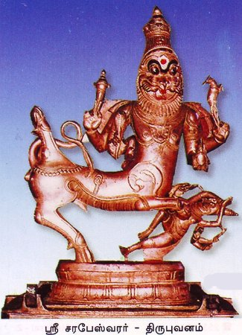
INTRODUCTION
The Sarabeshwarar Temple is a Hindu temple dedicated to Lord Shiva. It is situated in Thirubuvanam. Shiva is worshipped as "Lord Kampaheswarar ". As per ancient legend, Shiva is believed to have assumed the form of Saraba, to pacify Lord Narasimha. The temple is good in architecture. And the looks of the temple is similar to the Big Temple at Thanjavur, Airavatesvara Temple at Darasuram and Gangaikonda Cholapuram temples. There is a separate shrine for Sarabeswarar in the temple. The temple was built by the Chola king during the 13th century.
It is believed that by worshipping Lord Sarabeswara in this temple, our entire past birth sins would be wiped out, and we will get good positive thoughts in our mind, and our various diseases also will be cured. Let us try to visit this temple, at least once in a year, and be blessed.
WRITTEN BY
R.HARISHANKAR
SRI GOVINDA VODEYAR
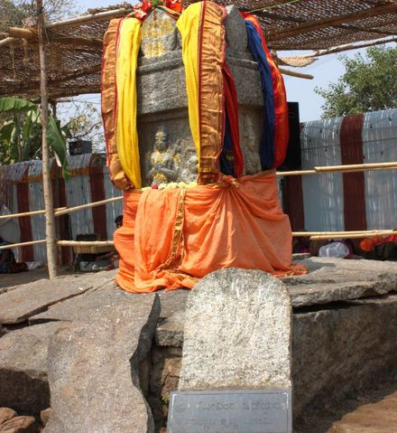
INTRODUCTION
Sri Govinda Vodeyar(16th century) previously followed Advaita philosophy, but later become a dvaita saint, with the blessings of his Guru Sri Vyasaraja. He was a great pundit and contains good knowledge in all the subjects.
He was defeated in the debate held with Sri Vyasaraja, and he has accepted his defeat, and changed into a dvaita saint. He attained Samadhi in Nava Brindavana along with eight other saints.
Nava Brindavana is situated in Anegundi, Karnataka.
He was born in a Brahmin family and followed shaivism sect and a sincere devotee of Lord Shiva. He will used to worship Shiva by chanting his mantra “OM NAMAH SHIVAYA” on a daily basis. After making spiritual discussions with the great Madhwa saint Sri Vyasaraja, he has changed his mind, and followed the principles of Dvaita.
He has attained sainthood under Sri Vyasaraja.
He attained Samadhi in 1534 AD at Navabrindavana.
IMPORTANCE
Similar to other Madhwa saints, he was also good at devotion, and done his regular activities in a proper manner. He lived a pious life, and dedicated his entire attention on Lord Krishna, and chanted his glories and offered the Lord’s holy Prasad to the devotees, and removed their sins and illness from their body. He patiently heard the problems of his devotees, and offered proper suggestions to them, and resolved the problems in their life. Through his gentle approach, he was admired and worshipped by the people, and praised him.
Let us worship the great saint and be blessed.
“OM SRI GOVINDA VODEYARE NAMAHA”
“OM SRI VYASARAJARE NAMAHA”
“JAI KRISHNA”
WRITTEN BY
R.HARISHANKAR
SRI SADGURU BABA MAHARAJ
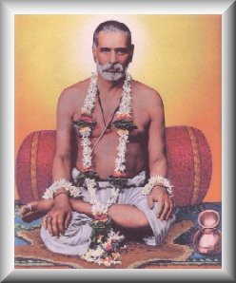
INTRODUCTION
Shree Baba Maharaj was born in an orthodox family in the year 1883 at Hubli, Karnataka. He is considered to be an avatar of Swami Samarth, who has taken rebirth in this earth to propagate the philosophies of Hinduism, and to maintain peace and prosperity in the world. He was the disciple of Shree Beedkar Maharaj. His birth name was Ramachandra.
He has finished his degree and for some time worked in a concern. In 1906, his guru Shree Beedkar Maharaj blessed him and asked him to spend his time on religious matters. Since then, Shree Baba Maharaj always remained in a state of deep meditation and was not interested in worldly matters.
Even after getting married, and while he was working, he will used to contribute his entire salary for the welfare of the poor people, and his wife was a noble woman, tolerated all of his acts, and used to cook food with the small quantity of grains available in their house, and offer food to her husband, and she has spent her several days without having proper food. Even then, she didn’t hate her husband, and took care of him properly.
In 1928, he left his job, and stayed at his guru’s ashram. He has sincerely served his guru, and took care of him properly. He also performed severe meditation on Lord Dattatreya and gained more spiritual powers through that.
After the death of his wife in 1945, he used to take only a small quantity of food offered by his devotees. He met the great saints like Shree Shankar Maharaj, Shree Meherbaba and Shree Shivaji Maharaj of Kolhapur.
He was the guru of Shree Sadguru Digambardas Maharaj and blessed him and guided him in all walks of his life.
In 1954, he left his physical body and merged with Lord Dattatreya. His disciple Shree Sadguru Digambardas Maharaj, later constructed the “Shree Sadguru Baba Maharaj Sahasrabuddhe Samadhi Mandir” at Pune, Maharashtra.
It is believed by his devotees, that still now his presence is there in his mandir and blessing his devotees, and relieving their diseases and all other problems, and makes them to prosper in their life.
Let us worship the great saint and be blessed.
“OM SRI SADGURU BABA MAHARAJ SWAMIGALE NAMAHA”
“OM SRI DATTATREYARE NAMAHA”
WRITTEN BY
R.HARISHANKAR

SRI SIVAN SAR
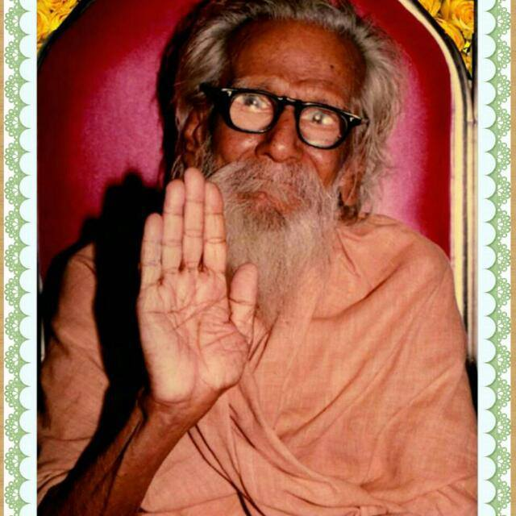
INTRODUCTION
Sri Sivan SAR was born on October 3rd 1904 as younger brother of Sri MahaPeriyava. His birth name was Sadasiva Sastri. Sri SAR attained Siddhi on March 7th 1996. Sri Sivan SAR, also called as Sri Siva Periyava. Similar to his elder brother Sri Chandra sekara saraswathi swamigal, he also performed lot of miracles in the life of his devotees. He lived a humble and noble life, and got great courage, wisdom and knowledge in all the subjects. He got great bhakti on Lord Shiva and used to worship him in the temples and chant the shiva mantra and recite the various names of Lord shiva on a daily basis.
He was born in Viluppuram, Tamil Nadu. As per the words of his brother, at his birth itself, he was a great scholar and saint. He has written a book titled Yenippadigalil Maanthargal. In this book, he has discussed on various topics, and he mentioned that people must be good and be cultured and move towards the right path, without giving any disturbances to others, and he has shown the ways to live a peaceful and a happy life, and he also mentioned the importance of Vedas, the importance of protecting cows, and methods for living a good and useful life. He recalled the stories of Karaikal Ammaiyar, Nandhanar, Badrachala Ramadas and Sadasiva Brahmendrar and explained the holiness developed by them throughout in their life. It is a must for us to read this book, in order to live a good life.
IMPORTANCE
He lived a saintly life throughout his life period. Through his blessings, many people were reached at the top level in their career. Even now, his devotees are recollecting their pleasant memories and the useful time spent along with him. He used to take simple food and lived a very pious and a noble life. Many of his devotees were got relieved from their physical and mental diseases and lived happily in their life. He was an intelligent and a kind hearted person. By seeing his picture itself, our entire problems will come to an end.
Let us worship the great saint and be blessed.
“OM SREE SIVAN SAR NAMAHA”
“OM SREE CHANDRA SEKARA SARASWATHI SWAMIGALE NAMAHA”
“OM NAMAH SHIVAYA”
WRITTEN BY
R.HARISHANKAR

SRI VAGISA TEERTHA
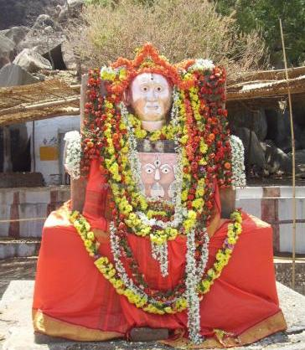
INTRODUCTION
Shri Vagisha Teertha(14th century) was a great madhwa saint who succeeded Shri Kavindra Teertha and become the pontiff of Shri Uttaradi Matha. His birth name was Raghunathacharya. He was born in an orthodox family, and it is believed that he was born and brought up in a small village at Karnataka. He has got good knowledge in all the divine texts, Vedas, Upanishads and proficient in various languages. He has got wisdom, knowledge, courage and boldness and was a sincere devotee of Lord Vishnu.
He travelled throughout India and propagated the philosophy of Dvaitha. He attained Samadhi at Nava Brindavana along with eight other holy saints. His successor was Sri Ramachandra Teertha.
Navabrindavana is located nearby Anegundi and the holy river Tungabhadra.
IMPORTANCE
He got great bhakti towards the great guru Sri Madhwacharya and worshipped Lord Rama and Lord Krishna regularly. Since from his childhood days, he will used to worship the god’s idols at his home, and perform puja and abhishekham to the divine idols. From his younger age itself, he was a kind hearted boy, who respects elders and others in a proper manner, and was brought up in a disciplined manner. He will used to have his food only after performing puja to the deities, and got great attachment on Lord Rama, and chanted his mantra “JAI SRI RAM” continuously.
He also done lot of charitable activities like providing food to the poor and feeding the cows, and educated the poor children without seeing their caste. Through his great spiritual powers, he also removed the diseases of the people, and cultivated the bhakti spirit. Due to his noble act, he was liked by the people, and they gave much respect to him.
Let us worship the great saint and be blessed.
“OM SRI VAGISA TEERTHARE NAMAHA”
“JAI SRI RAM”
“OM SRI GURU MADHWACHARYARE NAMAHA”
WRITTEN BY
R.HARISHANKAR

THIRUVALANGADU TEMPLE
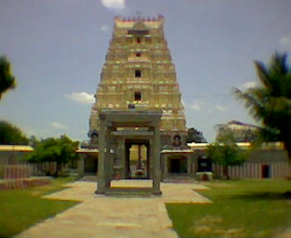
INTRODUCTION
This temple was built by the Chola Kings during the 12th century AD and is regarded as a sacred temple. According to the ancient Legend, once when Lord Shiva was deeply involved in cosmic dance, the jewels from his feet were fell into the earth and scattered in 5 places. Thiruvalangadu is one among them. It is considered as one among the 275 famous Shaivite temples. The temple is good in its architecture. The chief deity of the temple is known as "Vadaranyeswarar" and the Mata Parvati is called as, "Vandarkuzhali Amman". The temple tree is a large banyan tree. The great Karaikkal Ammaiyar visited this place and worshipped Lord Shiva.
Shivraathri and Thiruvadirai are the two important festivals which are celebrated in a grand manner in this temple, and lot of devotees from all parts of tamil nadu are visiting this holy temple, to have the glimpse of the divine father and mother. By visiting and worshipping the deities in this temple, we can get all the prosperities in our life.
WRITTEN BY
R.HARISHANKAR
UJJAIN KING BHOJARAJAN
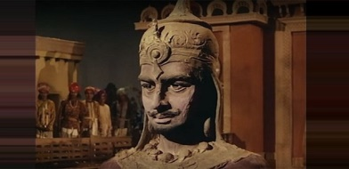
INTRODUCTION
King Bhojarajan was a great king who once ruled Ujjain, after the great king Vikramaditya, and treated all of his people in a kind manner. It is believed that he would have ruled the entire India, approximately before 3000 years. He was the successor of Vikramaditya, and ruled for several years in a well versed manner.
He has given a golden rule, and no one has suffered from any problems during his reign. He was also a great Kali Devotee similar to Sri Vikramaditya. He has also heard about the greatness of Vikramaditya, through the golden statues, which spoke about the importance of Vikramaditya, who also contains the features of Lord Vishnu. As per the advice of the golden statues, which are also considered as divine deities, he ruled the kingdom of Ujjain in a prosperous manner.
All the people in his kingdom were lived happily, without any sufferings in their life, and praised their king and compared him similar to the great king Vikramaditya and gave proper respect to him. He was also praised by the sages, holy people and by the divine gods in the heaven. After his death, he has attained SALVATION.
WRITTEN BY
R.HARISHANKAR

UPPILIAPPAN TEMPLE
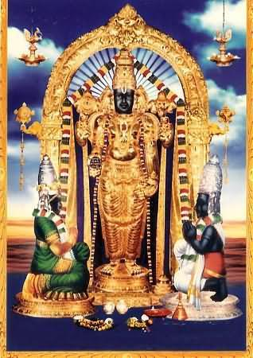
INTRODUCTION
Uppiliappan Temple, is a temple dedicated to Lord Vishnu, located in Kumbakonam of Tamil Nadu. The temple is praised in the Divya Prabandham, a sacred vaishnavite text. It is one of the 108 Divya Desams dedicated to Lord Vishnu. Here Lord Vishnu is worshiped as Uppiliappan and Mata Lakshmi as Bhumi Devi.The temple is believed to have been constructed by the Chola Kings during the 8th century AD, and after wards renovated by the great Thanjavur Nayaks. Uppiliappan is believed to have given darshan for sage Markandeya , Mata Bhoomadevi, Lord Brahma and Lord Shiva. The temple follows six daily rituals and three yearly festivals. The chariot festival, is grandly celebrated during March–April, is the most famous one. Here Naivedyam for the Lord is offered without adding salt and distributed it to the devotees. By consuming the holy Prasad, all of our mental and physical diseases will be removed from our body, and we will get spiritual energy.
WRITTEN BY
R.HARISHANKAR
VELLORE DHANVANTRI TEMPLE
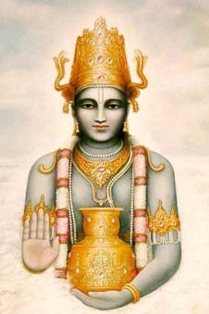
INTRODUCTION
Sri Dhanvantri Bhagavan Temple is situated in a village of Wallajapet of Vellore District of Tamil Nadu. The temple is administered by Sri Dhanvantri Arogya Peedam, and the temple is more than 500 years old.
The other shrines of the temple are Lord Vinayaka, Mahishasuramardhini, Vaastu Bhagavan, Indra, Agni, Vayu, Varuna and Kubera. Here dhanvantri homam is conducted in order to relieve the diseases of the devotees.
Lot of people from various parts of tamil nadu are visiting this sacred temple in order to get relieved from their health issues and problems related to mental disorders are also cured by consuming the temple prasadam. Hence it is advisable for us to visit this holy temple, in order to get a healthy body with a sound mind.
WRITTEN BY
R.HARISHANKAR

VEMULAWADA SHIVAN TEMPLE
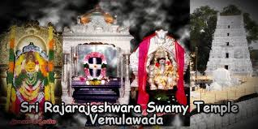
INTRODUCTION
Sri Raja Rajeshwara Temple is one of the most famous Shiva temples in Vemulawada at Telangana.
Here Lord Shiva is worshipped in the form of Raja Rajeshwara Swami. The Chief deity of the temple is Sri Raja Rajeswara Swamy appears along with Mata Sri Raja Rajeswari Devi. Vemulawada Raja rajeswara temple is situated near Karimnagar. Lot of pilgrims are visiting this holy temple during festivals and weekends. Pilgrims will used to take bath in Dharma Gundam, before worshipping the deities since the holy water in this temple tank contains medicinal properties. During Maha shivarathiri and Thiruvadhirai festivals, lot of devotees would visit this temple in order to get the darshan of the divine god and goddess. Here free food is offered to more than 100 people on a daily basis, which is considered as a tasty and delicious food by the devotees.
WRITTEN BY
R.HARISHANKAR

VENKANNA – THE ARDENT DEVOTEE OF GURU RAGHAVENDRA
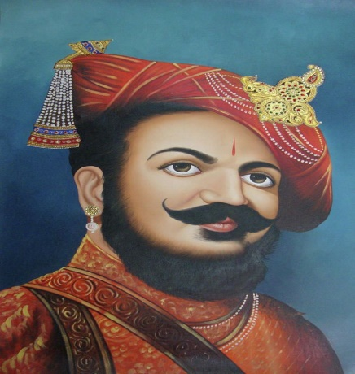
INTRODUCTION
Venkanna( 16th century) was an ardent devotee of Guru Raghavendra, who served as a minister of Adoni, under the Nawab Sidhi Masood Khan, and helped the great Guru towards building his Jeeva Samadhi at Mantralayam, Andhra Pradesh.
The young boy Venkanna lived in a village at Adoni, Andhra Pradesh, along with his uncle, since he has lost his parents. His uncle didn’t send him to school, and made him to graze the cattle. Once when he was playing with the boys in the streets, Guru Raghavendra visited Adoni, and the boy worshipped him. The great guru blessed him, and asked him to meditate him by chanting his mantra “OM SRI RAGHAVENDRAYA NAMAHA” during the time of difficult situations.
After some time, a representative of the Sultan came to Adoni and asked Venkanna to read the messages written in palm leaves. Since Venkanna was an illiterate, he was unable to read the text, and was very much worried, and prayed to Guru Raghavendra by chanting his mantra. Immediately, he could able to read the things written in the palm leaves. And he informed the details to the Sultan’s representative. Since he conveyed the message in favour of Sultan, the messenger immediately informed it to him. The next day, the Sultan has appointed Venkanna as the Diwan of Adoni. Thus by the divine grace of Guru Raghavendra, the illiterate boy became a Diwan.
Diwan Venkanna later played a very important role in obtaining the holy place Manchala, as per the wish of Guru Raghavendra, where the Guru entered Jeeva Samadhi. The place is now known as Mantralaya, situated in Andhra Pradesh, where the Moola Brindavana of Guru Raghavendra is located. Daily Lot of people visit this holy place and getting the blessings of Guru Raghavendra, and by the grace of the divine guru, they are getting relieved from their problems.
“OM SRI VENKANNAVE NAMAHA”
“OM SRI GURU RAGHAVENDRAYA NAMAHA”
“JAI SRI RAM”
WRITTEN BY
R.HARISHANKAR

VARASIDDHI VINAYAGAR TEMPLE, BESANT NAGAR
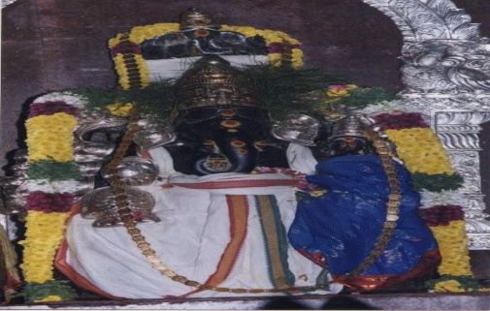
INTRODUCTION
The Varasiddhi Vinayakar Temple in Besant Nagar, Chennai, is a famous Vinayaka temple located nearby the Besant Nagar Beach. The temple provides free food to the poor and conducts regular pujas.
The first Kumbabhishekam of the temple was held in April, 1979. The Temple conducts music programs during Vinayakar Chathurthi festival and also permits other organizations to conduct programs in the temple auditorium. It is considered as a sacred temple, and Lord Vinayaka bestows various boons to his devotees, and hence called as Vara Siddhi Vinayaka, which means giving boons and fulfilling the wishes of the devotees. By visiting this temple, we will get peace of mind and a great sense of satisfaction, which we will not find it anywhere else, since Lord Vinayaka is considered as the first god, and who was worshipped first before worshipping other gods.
WRITTEN BY
R.HARISHANKAR

