SPIRITUAL WRITINGS IN ENGLISH
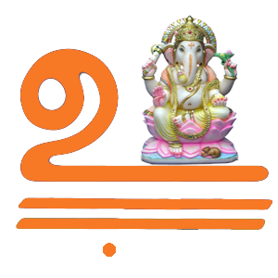
HANUMAN’S ROLE IN RAMAYANA
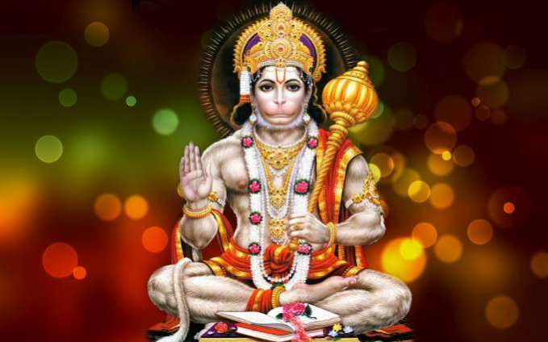

OM SREE ANJANEYAYA NAMAHA

Hanuman's role in the battle between Rama and Ravana is huge. He is the one who flies across the oceans (he is Wind's child), locates the exact place where Sita is imprisoned and brings this information back to Rama. While within the demon fort on his quest for Sita, he sets the entire place on fire and warns Ravana about an impending attack unless Sita is returned unharmed.
During the Rama-Ravana battle, Hanuman not only kills several demon generals but also brings Rama's brother back to life. How does he do that? Well, it so happens that Rama's brother is mortally wounded by Ravana's son, and the monkey-army-physician opines that the only things that can save the life of the younger prince are four specific herbs that grow on the Himalayan slopes. The catch? The battle is raging on in Lanka, across the southernmost tip of the country while the Himalayas are far up north, and the herbs are needed within the next few hours, before the new day dawns. Hanuman leaps up into the air, flies northwards at lightning speed, and alights atop the Himalayas. This is where things start to become confusing: the monkey-physician had said that medicine herbs glow in their own light and that it should be easy, therefore, to spot them. What Hanuman sees, however, is an entire mountain aglow with herbs of all kinds, each emitting its own peculiar light. Being unable to identify the exact four herbs that the physician had described, Hanuman uproots the entire mountain and carries it back to the battlefield. The physician gets his herbs, the near-dead prince is brought back his life, and, so strong is the effect of the mountain teeming with a thousand fragrant herbs that other monkeys who had fallen in battle are also healed just by inhaling the medicine-scented mountain air.
Sugriva’s role in ramayana

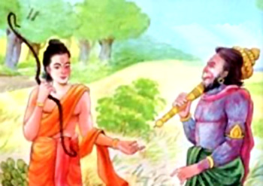
OM SREE SUGRIVAYA NAMAHA

In the Hindu epic Ramayana, Sugriva was younger brother of Vali, whom he succeeded as ruler of the vanara kingdom of Kishkindha. Rumā was his wife. He was son of Surya, the Hindu deity of sun. As the king of vanara, Sugriva aided Rama in his quest to liberate his wife Sita from captivity at the hands of the Rakshasa king Ravana. This aid is referred to as Sugrivajne.

When Rama decided to depart from the world and took samadhi in the Saryu River, Sugriva also retired from earth and went with his father Surya.

Jambavan’s role in ramayana
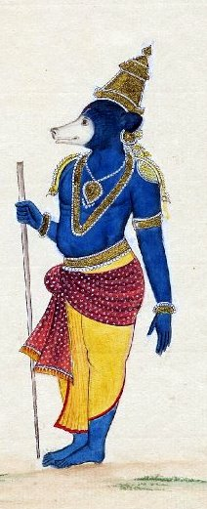
OM NAMO JAMBAVANE NAMAHA
In the epic Ramayana, Jambavantha helped Rama find His wife Sita and fight her abductor, Ravana. It is he who makes Hanuman realize his immense capabilities and encourages Him to fly across the ocean to search for Sita in Lanka. Jambavan mentions two past incidents in his life in the Ramayana.
Jambavana also known as Jambavanta is a character originating in Indian epic poetry, popularly found in Ramyana (story of Lord Rama, Bhagwan Vishnu's avatar as a human on Earth). The King of Bears, he is an asiastic or sloth bear in Indian epic tradition (though he is also described as a monkey in other scriptures), immortal to all but his father Brahma. Several times he is mentioned as Kapishreshtha (Foremost among the monkeys) and other epithets generally given to the Vanaras. He is known as Riksharaj (King of the Rikshas). Rikshas are earlier described as similar to Vanaras but in later versions of Ramayana Rikshas are described as bears. He was created by Brahma, to assist Rama in his struggle against Ravana.
Jambavana was present at the churning of the ocean, and is supposed to have circled Vamana seven times when he was acquiring the three worlds from Mahabali.

Vibhishana’s role in ramayana

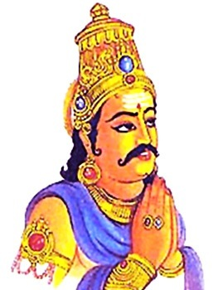
OM SREE VIBHISHANAYA NAMAHA

Vibhishana was the brother of Ravana, the king of Lanka in the legendary epic Ramayana. He was younger brother of the Rakshasa king Ravana of Lanka. Though a Rakshasa himself, Vibhishana was of a noble character and advised Ravana, who kidnapped and abducted Sita, to return her to her husband Rama in an orderly fashion and promptly which Ravana refused sternly. When Ravana did not heed his advice, Vibhishana deserted Ravana and joined Rama's army. Later, when Rama defeated Ravana, Rama crowned Vibhishana as the king of Lanka and he returned to Ayodhya.
In some period of history Sinhala people have considered Vibhishana as one of the Sathara Waram Deviyo (four guardian deities). This belief was more prominent in the Kotte period. According to the Ravana Katha of Wickramasinghe Adigar, after the defeat of Ravana, Vibhishana transferred the Yaksha capital from Alakamandawa to Kelaniya. In the 15th-century poem of Thotagamuwe Sri Rahula Thera, the sælalihini sandesaya, Myna is ordered to carry the missive to Vibhishana at his temple in Kelaniya. After the 16th century, he was replaced as a God of the four warrants by the goddess Pattini. He continues to be worshipped by a diminishing number of adherents, mainly in the Kelaniya area.

Angadan’s role in Ramayana
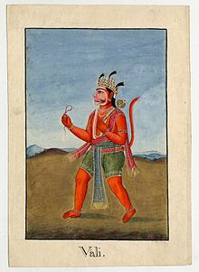
OM SREE ANGADANE NAMAHA
Angada is a vanara who helped Rama find his wife Sita and fight her abductor, Ravana, in Ramayana. He was son of Vali and Tara and nephew of Sugriva.
Angada and Tara are instrumental in reconciling Rama and his brother, Lakshmana, with Sugriva after Sugriva fails to fulfill his promise to help Rama find and rescue his wife. Together they are able to convince Sugriva to honor his pledge to Rama instead of spending his time carousing and drinking. Sugriva then arranges for Hanuman to help Rama and organises the monkey army that will battle Ravana's demonic host.
In the Ramayana war that took place, Angada killed many great warriors from Lanka, including, Ravana's son, Narantaka, and Mahaparshva, chief general of Ravana's army.

Neelan’s role in Ramayana

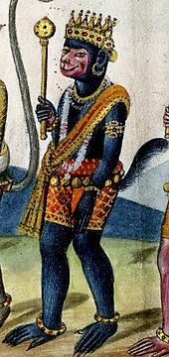
OM SREE NEELAYA NAMAHA

In the Hindu epic Ramayana, Nila is a vanara chieftain in the army of Rama, the prince of Ayodhya and avatar of the god Vishnu. He is the commander-in-chief of the monkey army under the monkey king Sugriva and is described as leading the army in Rama's battle against the rakshasa king Ravana of Lanka (identified with modern-day Sri Lanka) and as killing many rakshasas.
Though the Ramayana credits Nala as the sole builder of the Rama Setu, a bridge across the ocean between Rameswaram (India) and Lanka, enabling forces of Rama to pass over to Lanka, other adaptations of the epic attribute the bridge's construction to both Nala and Nila.

In the Ramayana, Nila is described as the son of Agni, the fire-god, and as the "foremost among the monkeys in effulgence, reputation and prowess". An important part of the epic describes the role played by the monkey army in the rescue of Sita, the wife of Rama who is kidnapped by Ravana, the rakshasa king of Lanka. The many stories forming the epic are retold in various adaptations.

Jatayu’s role in Ramayana

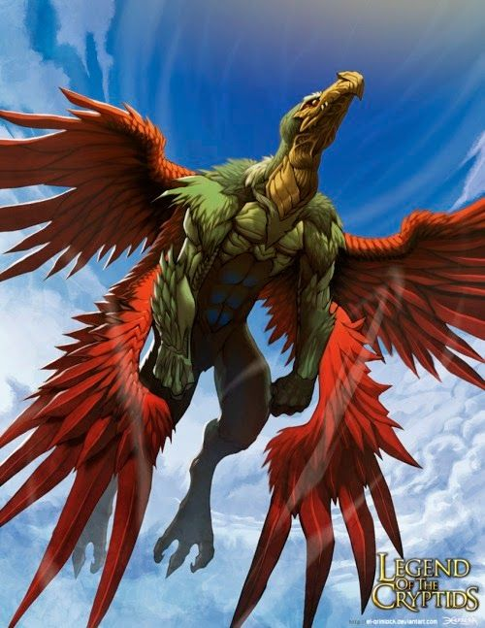
OM SREE PAKSHIRAJA JADAYUVE NAMAHA

In the Hindu epic Ramayana, Jatayu is the younger son of Aruṇa. His brother, Sampati, is a demi-god who has the form of a vultureand was an old friend of Dasharatha (Rama's father).
In the epic Ramayana when Jatayu sees Ravana abducting Sita, he tries to rescue Sita from Ravana. Jatayu fought valiantly with Ravana, but as he was very old Ravana soon got the better of him.

As Rama and Lakshmana chanced upon the stricken and dying Jatayu in their search for Sita, he informs them of the fight between him and Ravana and tells them that he had gone south.
Jatayu and his brother Sampati, when young, used to compete as to who could fly higher. On one such instance, Jatayu flew so high that he was about to get seared by the sun's flames. Sampati saved his brother by spreading his own wings and thus shielding Jatayu from the hot flames. In the process, Sampati himself got injured and lost his wings. As a result, Sampati lived wingless for the rest of his life.
While Jatayu was wounded and lying on the ground when Lord Rama arrived, Lord Rama sensed the end result and decided that Jatayu gets moksha. Jatayu consoles the distraught Rama and reassures Him that no harm will come to Sita and that very soon she will be restored to them. Rama is as much overwhelmed by grief as by a surging sense of affection and gratitude and embraces Jatayu. He asks Jatayu to be comfortable and blesses the bird. Rama says that the grief of seeing Jatayu pass away is greater than the loss of Sita. He considers Jatayu as equal to His father and proceeds to do the final rites for the bird. All along Rama had shown Himself as a human being in this avatar, but in this context He forgets Himself and by His Sankalpa and supremacy, Lord Rama then slammed an arrow into the ground so as to call all seven sacred rivers, called teertha. Six rivers' waters arrived, one river water failing to obey Lord Rama's call. Since Lord Rama was himself an incarnation of Lord Vishnu, He forced the Gaya Teertha to arrive at the spot.

Krishna's Role in Mahabharata
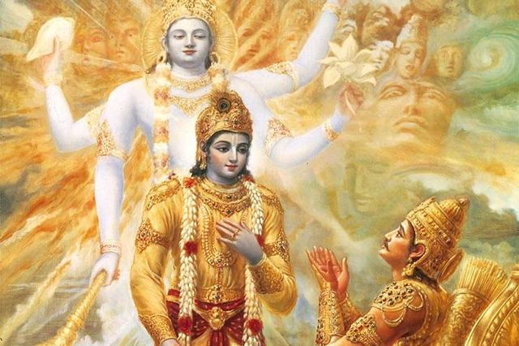
OM SRI KRISHNA BHAGAVANE NAMAHA
- When Sri krishna was having his rest or say midday sleep, both Duryodhana and Arjuna came to his place. Duryodhana came a few minutes earlier and, as he was full of pride, he stood beside Sri Krishna’s head. Arjuna, as he was full of humility and modesty, stood besideSri Krishna’s feet. Both awaited Krishna’s waking.
- After a while, Sri Krishna woke up and his eyes fell on Arjuna. When he turned around he saw Duryodhana. He wanted to know why they were there at that hour. Arjuna said, “Now you know that the battle will take place. I need you.”
- Duryodhana said, “I have also come here to take help from you, and I have come before him so you have to fulfil my desire first.” So Sri Krishna said, “It is true that you came before Arjuna, but I saw him first, and he will I be given the first chance. Besides, he is younger than you. So he will have the first choice.
- Arjuna said to Krishna with great joy. “I want you!”
- Duryodhana thought: What a stupid fellow Arjuna is. He wants Krishna alone.
- Sri Krishna said, “You want me? But I will not fight. I will only be your charioteer. One of you will have me alone and the other I will have my vast army.”
- Duryodhana felt, what could Krishna do alone and unarmed? The best thing for him was to have Krishna’s army.
- But Arjuna, being an illumined person, said to himself, “What shall I do with his army? The best thing is to have the Lord with me. The Lord will be able to protect me and the Lord will bring me the victory.” Arjuna wanted Sri Krishna and Duryodhana wanted the entire army of Sri Krishna.
- Now the promise was that Sri Krishna would never, never fight. Unfortunately, he had to break his promise; he could not keep it. Twice he ran out of the chariot. To kill whom? Bhishma. On the third and the ninth day Sri Krishna found that Arjuna was not fighting properly against his grandsire. Arjuna found it extremely difficult to use weapons against his grandsire.
- Sri Krishna said, “Arjuna, you are not fighting. Why?” So he came out of the chariot with his discus. He wanted to kill Bhishma. And what was Bhishma’s reaction? Bhishma’s joy knew no bounds. He said, “Come, O my Lord, come! If I die in your hands then immediately I will go to heaven! I am the most blessed person because you are coming to kill me!”
- But, both times, Arjuna followed Sri Krishna and said “No, you have to keep your promise. I won’t let you fight, I shall fight. I won’t allow you to eat your words. You come, you sit in the chariot and drive me on. I shall fight.
- Here we learn that the Guru, the Master, can at any moment break his own promise in order to help, to save, in order to win a victory for the disciple. Sri Krishna was the Omniscient, Omnipotent, Omnipresent, and also the Just. But when the question concerns a most intimate disciple, the Guru goes against the ordinary light of morality. This was Sri Krishna’s heart for Arjuna.
- Victory is there where there is Dharma
Gandhari’s eldest son, Duryodhana, came to her for benediction. She did not say, “I pray for your victory!” or “Yours will be the victory!” She said, “Where there is Dharma, victory will be there.” She knew perfectly well that on the other side, in the other party, was Yudhishthira, the Son of Dharma, Dharma incarnate, who would win the victory. She could not bless her son saying, “Yours will be the victory.” So she said, “Where there is Dharma, there will be the victory.”
There are seven hundred verses in the Gita. Many in India can recite the whole of the Gita in an hour and a half, from the beginning to the end. However, reciting is one thing, repeating is one thing, but following the teachings of the Gita is something else. The man who recited the whole of the Gita by heart perhaps did not follow any of the teachings of the Gita. So, reading is not enough, follow the Gita because it is necessary to ponder upon what is read.

Vidura's Role in the Mahabharata

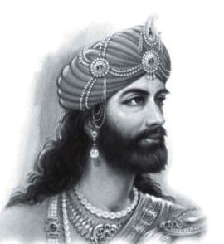

OM SREE VIDURAYA NAMAHA
Vidura was born from Niyoga- between sage Vyasa and a hand-maiden to the queens- Ambika and Ambalika. Ambika and Ambalika were wives of king Vichitravirya - the grandfather to Kauravas,Pandavas and Karna; and the father of Dhritaraashtra and Pandu. Barring Krishna, Vidura was most respected as an adviser by the Pandavas, whom he forewarned on various occasions of Duryodhana's plots to exterminate them, such as Duryodhana's plan to burn them alive in the house of wax.
Except the prince Vikarna, Vidura was the only one who protested against the humiliation of Draupadi in the Kaurava court. In that moment, Duryodhana viciously rebuked Vidura, calling him ungrateful. Dhritarashtra moved to rebuke Duryodhana for insulting Duryodhana's uncle, but, remembering Vidura saying that a blind man cannot be king, holds his tongue, and instead reprimanded Duryodhana for insulting the prime minister. It is that incident that Vidura brought up years later when he severed ties with the Kurus and sided with the Pandavas at the onset of the Kurukshetra war. Unlike Bhishma, Dronacharya, Kripacharya, Karna, etc., Vidura did not have an obligation to Hastinapur or Duryodhana, but to his family. Hearing Dhritarashtra not acknowledge that relationship, Vidura felt compelled to side with dharma and the Pandavas.
According to Krishna, Vidura was considered as Dharmaraja, which means the Lord of truth. Krishna respected Vidura for his devotion to people's welfare, and his proficiency in every sphere of knowledge.
When Krishna visited Hastinapura as a peace emissary of the Pandavas, he shunned Duryodhana's offer to stay in the royal palace, preferring instead the home of Vidura, on account of him being the only neutral man in the Kaurava court. The reason Krishna stayed in Vidura's chambers for the night instead of Duryodhana's is due to the thoughts which were running through their heads and the difference between them. Duryodhana's intention was to heave luxury upon Krishna and convince him to join the Kaurava's side. Sensing this intention, Krishna refused. Krishna knew the food that Vidura presented was presented with love and affection with no ulterior motive.
In the Sanatsujatiya section of the Mahabharata, shortly before the Kurukshetra War began, Vidura invoked the sage Sanatsujata to answer Dhritarashtra's questions about death. In protest against the Kurukshetra War, Vidura resigned from the post of minister.

Yuyutsu’s role in Mahabharatha
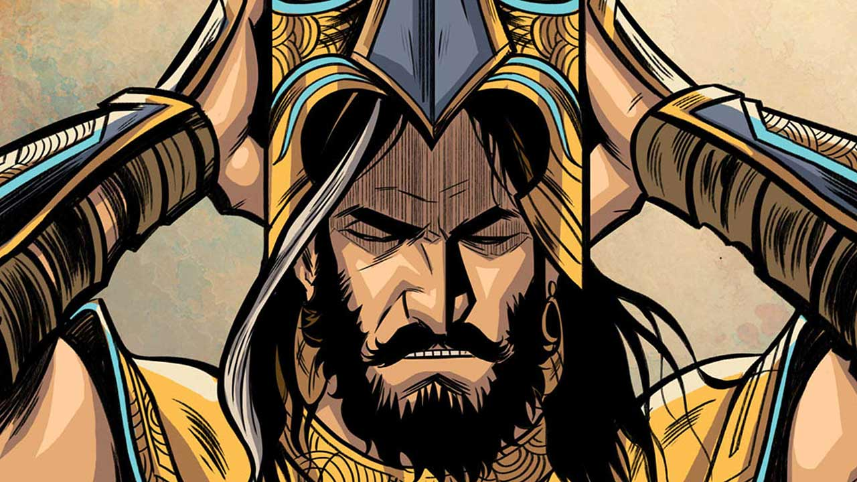
OM SREE YUYUTSUVE NAMAHA

Yuyutsu in the Hindu epic Mahabharata was a son of Dhritarashtra with Sughada/Sauvali, his wife Gandhari's maid. He was the paternal half-sibling to Gandhari's children: Duryodhana and the rest of the 99 Kaurawa brothers and their sister Dushala. Eventually, he was the only son of Dhritarashtra who survived the Kurukshetra war.

Yuyutsu is celebrated as a moral warrior who chose the path of righteousness, in spite of being born in circumstances that predisposed him to evil. He forwent his family bonds in order to side with dharma.
Also, Yuyutsu saved the life of Bheem by informing the Pandavas about Duryodhana's cunning schemes, which included poisoning water. Both Yuyutsu and Vikarna abhorred Duryodhan's conspiracies and evil schemes; however, Vikarna stays loyal to the family and perishes in the war.

Ghatotkacha's role in mahabharatha
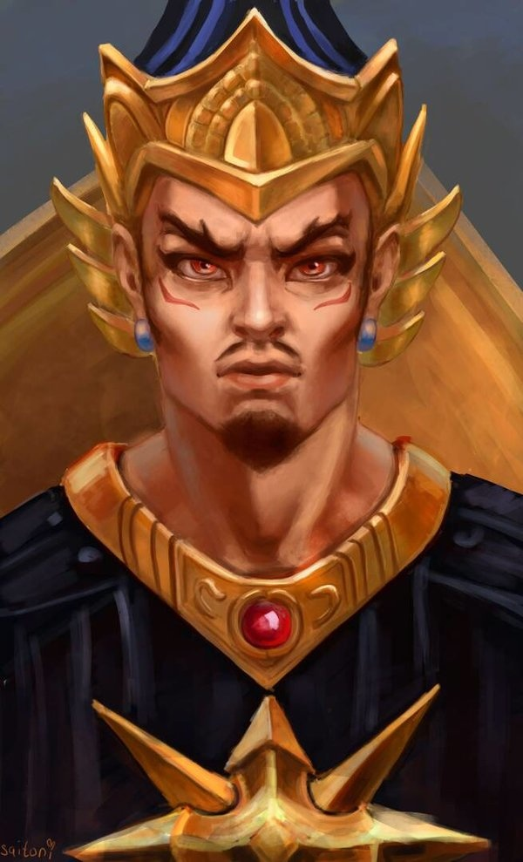

OM SREE GHATOTKACHAYA NAMAHA
Ghatotkacha is an important character in the Mahabharata. His name comes from the fact that his head was hairless (utkaca) and shaped like a ghatam. Ghatotkacha was the son of the Pandava Bhimaand the rakshasi Hidimbi.
Ghatotkacha was very powerful like his Father Bhima and it is said that his strength was equal to that of 1000 elephants. He had a powers of a rakshasa as well as magical abilities. He is also known for having been very large.
Ghatotkacha killed many rakshasas like Alambush, Alayudha, and many gigantic Asuras.
He is the father of Barbarika, Anjanaparvan, and Meghavarna. His second son Anjanaparvan participated in the war. His maternal parentage made him half-rakshasa, which granted him several magical abilities such as the ability to fly, to increase or decrease in size and to become invisible. He was an important fighter from the Pandava side in the Kurukshetra war, and caused a great deal of destruction to the Kaurava army on the fourteenth night. He is killed by Karna with Indra's missile.

Veda Vyasa’s role in Mahabaratha

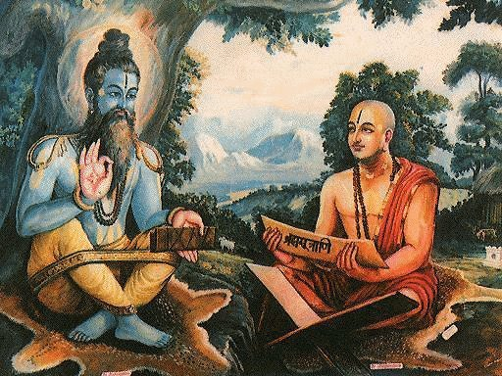
OM SREE MAHARISHI VEDA VYASAYA NAMAHA

Vyasa is considered as both, the author and a character of the Mahabharata. He plays a very critical role in the epic.
It begins with Satyavati, the fisherwoman. She was no ordinary fisherwoman. She was born when a cursed Apsara in the form of fish swallowed a kings semen. She was then raised by the fisherfolk. She was named Satyavati but teased as Matsyagandha as she smelt of fish.
Matsyagandha ferried people across river Ganga. One day she had Sage Parashar in her ferry. He expressed desire to make love to her and have children. In return he promised her a boon that she will regain virginity and will never smell of fish again. She agreed and gave birth to a child instantly with the magical powers of the sage. This child was named Krishna Dwaipayana, the dark child delivered on a river island. He was eventually known as Vyasa.
Satyavati later married king Shantanu, the father of Bhishma. From Shantanu she gave birth to two sons, Chitrangad and Vichitravirya. Chitrangad died before getting married and Vichitravirya was married to Ambalika and Ambika. However, he was unable to impregnate his wives. So Satyavati who was desperate to have her lineage as the kings of the kuru clan, calls upon her first son, Vyasa from his meditati on for years in forest. She requests him to impregnate(law of Niyoga) her daughters in law. He goes to Ambika first. Disgusted by Vyasa's looks, she closes her eyes. Then he goes to Ambalika. She goes pale looking at him. As a result, Ambika gives birth to Dhritarashtra who is blind and Ambalika gives birth to Pandu who is a pale weakling. Also Vyasa goes to a maid who fearlessly accepts him and the union gives birth to Vidur who is healthy and intelligent but not a royal lineage as per the law of Niyoga.

Role of Bahlika in mahabharat

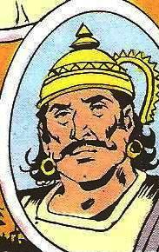
OM SREE BAHLIKAYA NAMAHA
Bahlika also spelled as Vahlika, was the king of Bahlika kingdom in the Mahabharata, the elder brother of Shantanu, who was a king of Hastinapur and the uncle of Bhishma. He was the oldest warrior to fight in the Mahabharata war. He had a son Somadatta and grandson Bhurishravas who along with him fought on the side of the Kaurava army in the Kurukshetra War. He was slain by Bhima in the 14th day of the war when it continued after sunset. According to Yudhishthira, Bahlika's only wish was that there should be peace among the Bhāratas.

Bahlika was the second of the three sons of Pratipa and his wife Sunanda, the king and queen of Hastinapur. With his eldest son Devapi set to inherit, Pratipa gifted some newly-conquered land (though in some versions of the story, this is the land Jarasandha gifted Bahlika for agreeing not to join Panchal in a war against Magdha) to his second son; the land was given the name Bahlika as a result. However, due to leprosy, Pratipa's eldest son Devapi refused to ascend the throne and retired into the woods to perform penance. Bahlika was next in line to ascend the throne, but felt that he would be an inadequate emperor, having never been raised as such. Shantanu then became the crown prince and upon Pratipa's death became the king of Hastinapur, with Bahlika's blessing.

Bhishma’s role in mahabharat
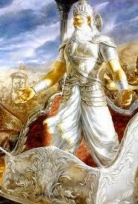
OM SREE PITHAMAK BHISMAYA NAMAHA
In the epic Mahabharata, Bhishma was well known for his pledge of Celibacy. He was the eighth son of Kuru King Shantanu and the goddess Ganga. Bhishma was blessed with wish-long life and was related to both the Pandava and the Kaurava.]He was an unparalleled archer and warrior of his time. He also handed down the Vishnu Sahasranama to Yudhishtira when he was on his death bed (of arrows) in the battle of Kurukshetra.

King Shantanu saw a beautiful woman on the banks of the river Ganges (Ganga) and asked her to marry him. She agreed but with one condition: that Shantanu would not ask any questions about her actions. They married and she later gave birth to a son. But she drowned the child. Shantanu could not ask her the reason, because of his promise, lest she would leave him. One by one, seven sons were born to them and were drowned by Ganga. When Ganga was about to drown the eighth son, Shantanu, devastated, could not restrain himself and confronted her. Finally, Ganga explained to King Shantanu about Brahma's curse given to Mahabhisha and her. Then she told him that their eight children were Eight Vasus who were cursed by Vasishtha to be born on earth as mortal humans however when they pacified him, he limited his curse and told them that they would be freed from this curse within a year of their birth as humans. So she released the seven of them from this life by drowning them all. However the eighth child Bhishma, was cursed to live a long life and to never have a wife or have children. But the sage also gave a boon to him that he would be virtuous, conversant with all the holy scriptures and will be an obedient son to his father. that she will take him to the heavens to train him properly for the King's throne and status. With these words she disappeared along with the child while Shantanu was struck with grief thinking about spending the rest of his life without her.
The history behind Bhishma's birth is as follows — once the eight Vasus ("Ashtavasus") visited Vashishta's ashram accompanied by their wives. One of the wives took a fancy to Kamadhenu, Vashishta's wish-bearing cow and asked her husband Prabhasa to steal it from Vashishta. Prabhasa then stole the cow with the help of the others who were all consequently cursed by Vashishta to be born in the world of humans. Upon the Vasus appealing to Vashishta's mercy, the seven Vasus who had assisted in stealing Kamadhenu had their curse mitigated such that they would be liberated from their human birth as soon as they were born; however, Prabhasa being protagonist of the theft, was cursed to endure a longer life on the earth. The curse, however is softened to the extent that he would be one of the most illustrious men of his time. It was this Prabhasa also called Vasu Dyaus who took the birth as Bhishma.

After Devavrata was born, his mother Ganga took him to different realms, where he was brought up and trained by many eminent sages (Mahabharata Shanti Parva, section 38).
- Brihaspati: The son of Angiras and the preceptor of the Devas taught Devavrata the duties of kings (Dandaneeti), or political science and other Shastras.
- Shukracharya: The son of Bhrigu and the preceptor of the Asuras also taught Devavrata in political science and other branches of knowledge.
- Vashishtha, the Brahmarshi and Chyavana, the son of Bhrigu taught the Vedas and the Vedangas to Devavrata.
- Sanatkumara: The eldest son of Lord Brahma taught Devavrata the mental and spiritual sciences.
- Markandeya: The immortal son of Mrikandu of Bhrigu's race who acquired everlasting youth from Lord Shiva taught Devavrata in the duties of the Yatis.
- Parashurama: The son of Jamadagni of Bhrigu's race. Parashurama trained Bhishma in warfare.
- Indra: The king of the Devas. He bestowed celestial weapons on Bhishma.

Importance of Bhagavata Purana
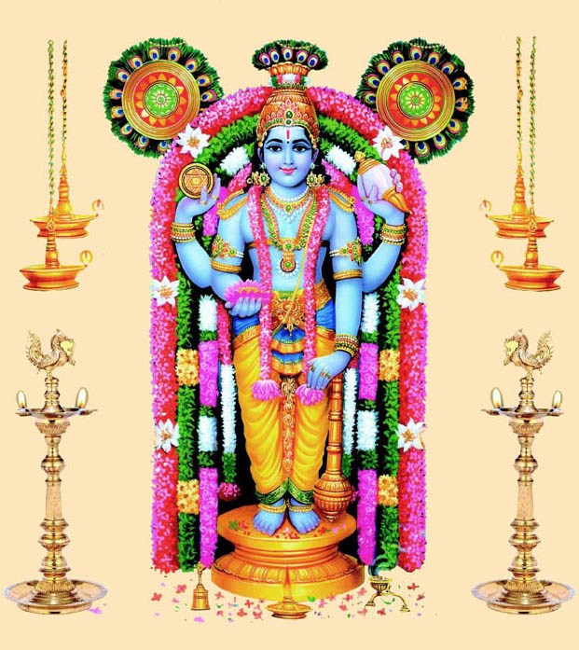

OM SREE GURUVAYUR KRISHNANE NAMAHA

Bhagavata Purana , is one of Hinduism's eighteen great Puranas (Mahapuranas, great histories). Composed in Sanskrit and available in almost all major Indian languages, it promotes bhakti (devotion) to Krishna integrating themes from the Advaita (monism) philosophy and from the Dvaita (dualism) philosophy. Srimad Bhagavatham is to be read regularly to attain the heavenly abode of Vaikunda.
The Bhagavata Purana discusses a wide range of topics including Cosmology, Genealogy, Geography, Mythology, Legend, Music, Dance, Yoga and Culture. As it begins, the forces of evil have won a war between the benevolent devas (deities) and evil asuras (demons) and now rule the universe. Truth re-emerges as Krishna, (called "Hari" and "Vasudeva (another name for Krishna)" in the text) – first makes peace with the demons, understands them and then creatively defeats them, bringing back hope, justice, freedom and happiness – a cyclic theme that appears in many legends.
The Bhagavata Purana is a revered text in Vaishnavism, a Hindu tradition that reveres Vishnu. The text presents a form of religion (dharma) that competes with that of the Vedas, wherein bhakti ultimately leads to self-knowledge, liberation (moksha) and bliss. However the Bhagavata Purana asserts that the inner nature and outer form of Krishna is identical to the Vedas and that this is what rescues the world from the forces of evil. An oft-quoted verse is used by some Krishna sects to assert that the text itself is Krishna in literary form.
The date of composition is probably between the eighth and the tenth century AD, but may be as early as the 6th century AD. Manuscripts survive in numerous inconsistent versions revised through the 18th century creating various recensions both in the same languages and across different Indian languages. The text consists of twelve books (skandhas) totalling 332 chapters (adhyayas) and between 16,000 and 18,000 verses depending on the recension. The tenth book, with about 4,000 verses, has been the most popular and widely studied. It was the first Purana that was translated into a European language, when a French translation of a Tamil version appeared in 1788 and introduced many Europeans to Hinduism and 18th-century Hindu culture during the colonial era.

The Bhagavata is among the most important texts on bhakti, presenting a fully developed teaching on bhakti that originated with the Bhagavad Gita. Bhakti is presented as a path of yoga, or "union with the divine". Many of the bhakti teachings in the Bhagavata are presented as yogic activities meditating on the lila of Krishna; hearing and singing about Vishnu as Krishna; remembering, serving, and worshiping him; dedicating all of one's actions to him—all are among nine activities of Bhakti Yoga taught in the Bhagavata. While classical yoga attempts to shut down the mind and senses, the Bhakti Yoga in the Bhagavata teaches that the focus of the mind is transformed by filling the mind with thoughts of Krishna.
There are many didactic philosophical passages, but the lengthy narrative stories are also a teaching; the book describes one of the activities that lead to liberation (moksha) as listening to, reflecting on the stories of Krishna and sharing their feelings for Krishna with others. Bhakti is depicted in the Purana, states Matchett, as both an overpowering emotion as well as a way of life that is rational and deliberately cultivated.
The Purana presents seven teachers and their hagiographic stories—describing for example Kapila, the Samkhya philosopher, as someone who was born as a full grown adult, who teaches his mother that to reach liberation, she must have bhakti, jnana (wisdom), and vairagya(dispassion), with bhakti being the most important. Other teachers such as Narada and Shukadeva described in the Purana, however, present Bhakti with less prominence, and emphasize Advaita philosophy and Jnana yoga instead but then add that adoring Hari (Krishna) has the same liberating benefits. One who repeatedly reads Bhagavatha Purana, will surely attain the divine abode of Vaikunda after their death. There should be no doubt in that. But with good faith they should keep on chanting Krishna mantra “ Om Namo Bhagavathey Vasudevaya” and should regularly read Bhagavatha Purana and also to be discussed with others by mentioning the supreme qualities of Lord Krishna. One who listens with utmost faith and devotion of Bhavatha Purana Upanyasam will be merged with Lord Vishnu and be with him forever in Vaikunda.

Importance of Guru bhakti
OM SREE GURUVE NAMAHA
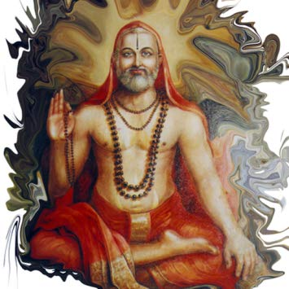
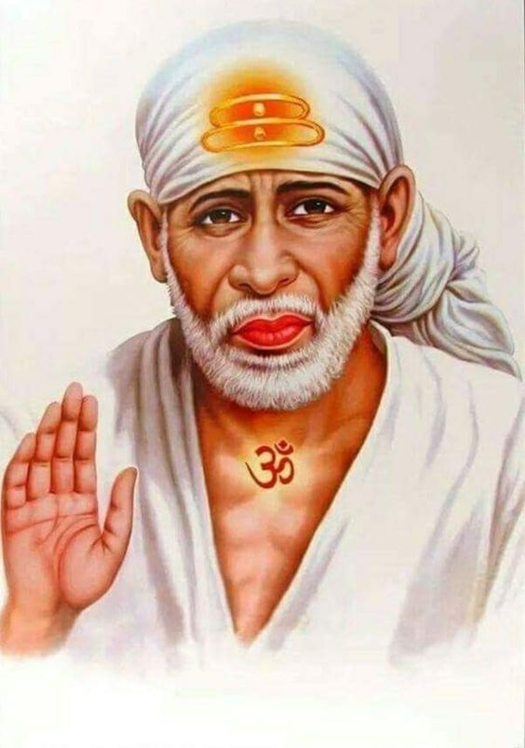
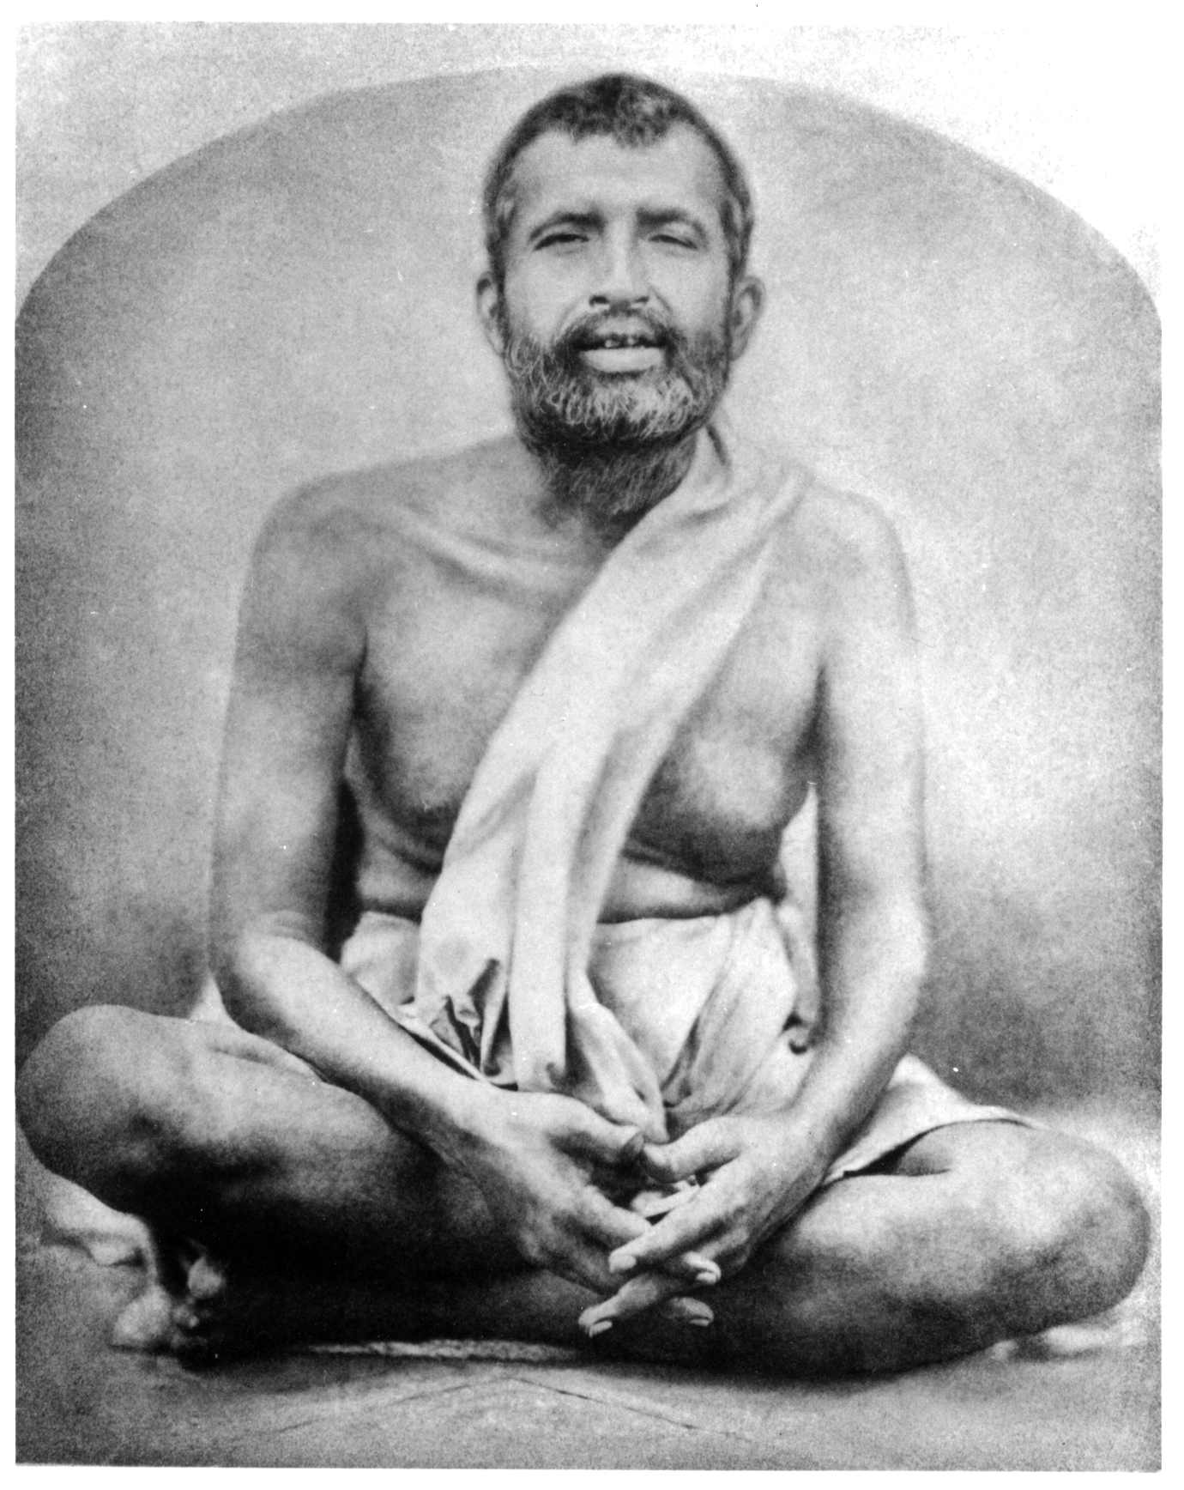
Intense devotion to one’s guru and faithful adherence to his teachings are the most essential qualifications of true discipleship. It is this shraddha, faith, and gurubhakti, devotion to guru, that bring about rapid spiritual progress and fruition of one’s sadhana. A disciple without devotion to his guru is like a flower without fragrance, a well without water, a cow without milk or a body without life. A true aspirant rejoices in the practice of guru bhakti yoga. Without taking recourse to this yoga one cannot practise the other yogas. Whatever may be acquired by asceticism, renunciation, charity, auspicious acts or by other yogas, all these are speedily acquired by practising guru bhakti yoga. It is the magic wand in the hands of the disciple to cross the ocean of samsara. Guru Bhakthi is very important in this Kali Yuga for avoiding commitment of sins. Or otherwise it is impossible for us to live in this world without commiting sins.
Guru bhakti will make possible all that is impossible; the unattainable can be attained by guru bhakti. However, this treasure is not acquired in a day. Guru bhakti is not a system that can be taught by lectures or correspondence courses. The disciple has to cultivate it gradually and painstakingly. He must increase it day by day. It develops through constant and earnest prayer in the secret chamber of the heart. The student should live under a preceptor for many years and lead a rigorous life of austerity, discipline, celibacy and deep meditation. He must make himself perfectly blind to the human aspects of the guru. Then he will develop true guru bhakti.

Importance of spirituality in daily life

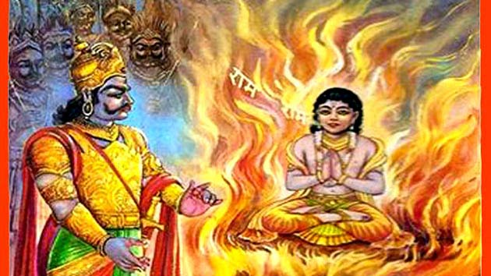
OM SREE BHAKTA PRAHALADAYA NAMAHA
To men who never rise higher than eating, drinking, begetting progeny, and dying, the only gain is in sense-enjoyments; and they must wait and go through many more births and reincarnations to learn to feel even the faintest necessity for anything higher. But those to whom the eternal interests of the soul are of much higher value than the fleeting interests of this mundane life, to whom the gratification of the senses is but like the thoughtless play of the baby, to them, God and the love of God form the highest and the only utility of human existence.
There are a number of reasons why spirituality is important to many people around the world. Unlike religion, spirituality is not built on rules, but it is based on individual choice and growth. It's usually associated with searching inward instead of finding validation of the unknown through an institution or group of people with common religious practices. This system is not limited to doctrine, does not threaten and condemn wrongdoers, or discount other faiths. Since spirituality gives you a sense of freedom that religion sometimes cannot, it usually tends to feel a lot more unrestricted. So, have you've been contemplating on what's so imperative about finding a deeper meaning to life? Well, you've come to the right place. In this article, you'll find a list detailing seven reasons why spirituality is important, either on its own, or in addition to religion.

Guardian Gods

Angala Parameswari Amman

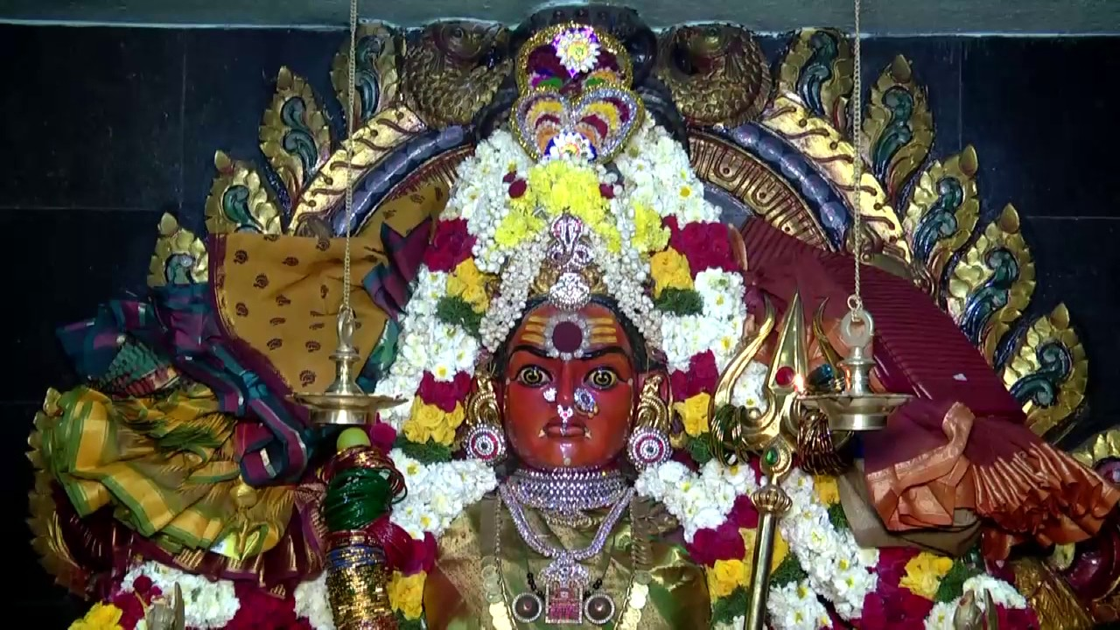

- Angala Parameswari Amman or Angalamman (Adhi Sakthi - Meaning - The First form of goddess Parvathi. The Origin is Melmalayanoor.)

Pavadairayan

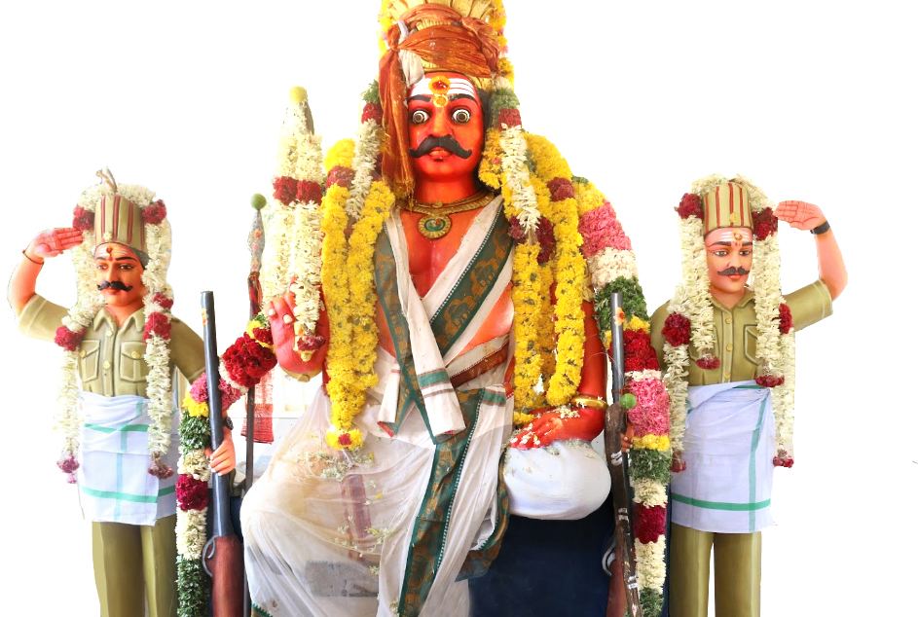

- Pavadairayan (The son of Angala Parameswari Amman) (Protector and Family Deity for many people.He has a Sannidhi in all Angala Parameswari Temples.The origin is Melmalayanoor.He is worshipped mostly in Northern parts of Tamil Nadu like Vizhuppuram,Cuddalore,Pondicherry,Thanjavur, chennai etc.)

Ayyannar

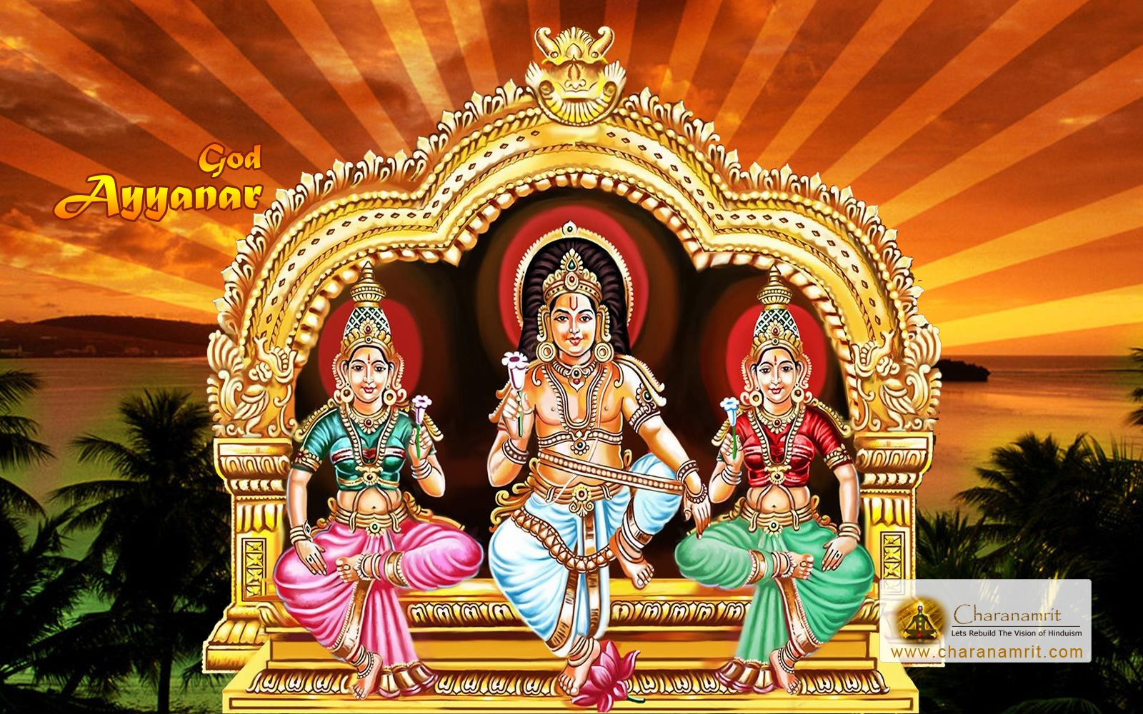

Ayyanar, Sastha or Saththan , is a Hindu deity particularly praised in South India and Sri Lanka. His worship is prevalent among Tamils, Malayalis and Sinhalese. Some studies suggest that Ayyanar may have also been worshipped in South east Asian countries in the past. He is primarily worshiped as one of the guardian folk deities of Tamil Nadu. The village temples of Ayyanar are usually flanked by gigantic and colorful statues of him and his companions riding horses or elephants. The well known shrine at Sabarimala is actually a Sastha temple though its main deity Ayyappan has now developed distinctly from Ayyanar.

Semmalaiappar

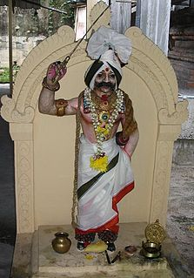

- Semmalaiappar (The father of people of the region surrounded by Red hills/soil from Unjini Village of Sendurai Taluk.He is worshiped mostly by Northern Tamil people from Ariyalur,Chennai,Cuddalore,Kanjipuram,Karaikal,Nagapattinam,Pondichery,Thanjavur, Vizhuppuram Districts etc.,)

Ayyappan

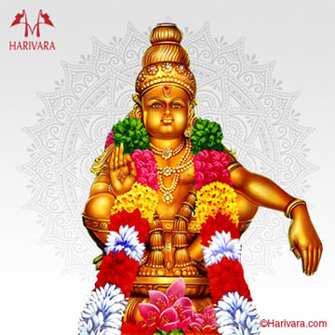

Ayyappan is the Hindu god of growth, particularly popular in Kerala. He is a syncretic deity, the son of Shiva and Mohini – the female avatar of Vishnu. Ayyappan is also referred to as Ayyappa, Sastavu, Hariharaputra, Manikanta, Shasta or Dharma Shasta.
The iconography of Ayyappan depicts him as a handsome god, who has pledged an oath of naishthika brahmacharya, in a yogic posture and as an epitome of Dharma, who wears a bell around his neck. In the Hindu pantheon, his legends are relatively recent but diverse. For some, he is also an incarnation of the Buddha. He is honored by some Muslims in Kerala, with legends wherein Ayyappan defeats and gains worship of Vavar, an Hindu. In the Hindu tradition popular in the Western Ghats of India, he was born with the powers of Shiva and Vishnu to confront and defeat the shape shifting evil Buffalo demoness Mahishasuri. He was raised by a childless royal couple, and grows up as a warrior yogi champion of ethical and dharmic living. In the South Indian version, Ayyappan images show him as riding a tiger, but in some places such as Sri Lanka he is shown as riding a white elephant.

Muniyappan
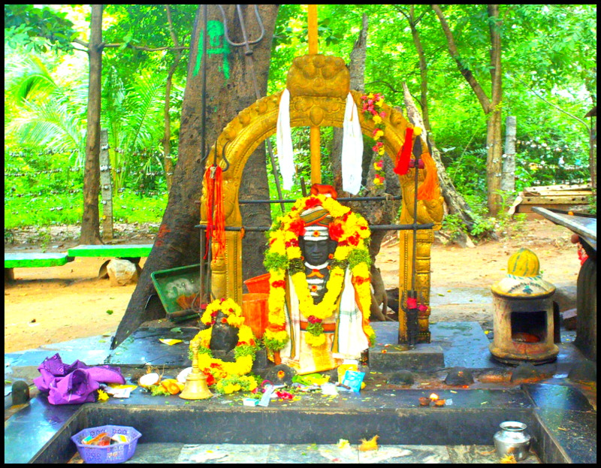

- Muniyappan (Protector of the innocent and the valiant, main deity of Ramapuram, Cuddalore).

Karkuvel Ayyanar
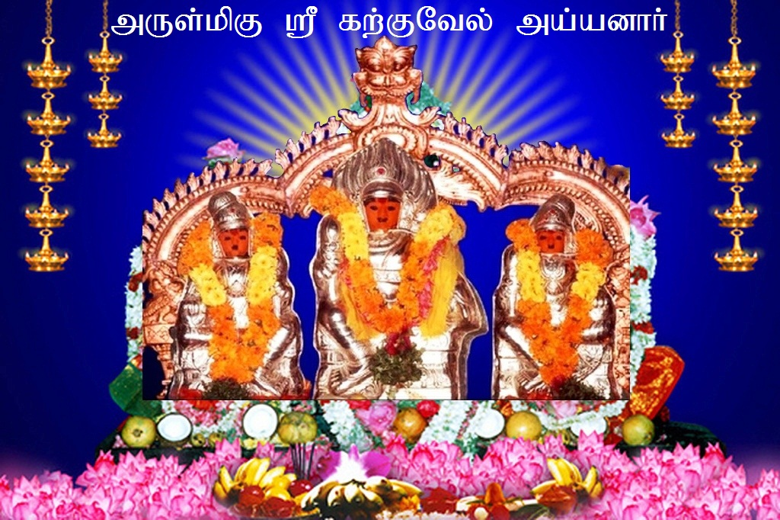
- Karkuvel Ayyanar Temple (Karkuvel Ayyanar-Therikudiyiruppu in Kayamozhi, Thoothukudi, Tamil Nadu).

Veera Maha Kali
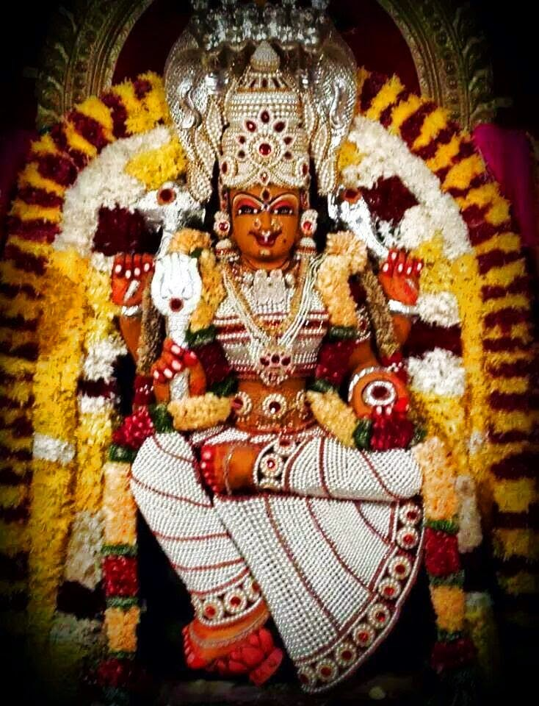

- Veera Maha Kali (Goddess of war and power)

- Madurai Veeran

Madurai Veeran ,is a Tamil folk deity popular in southern Tamil Nadu, India. His name was derived as a result of his association with the city of Madurai as a protector of the city. His worship is also popular amongst the Telugu diaspora.

Ondi Karuppanna Samy
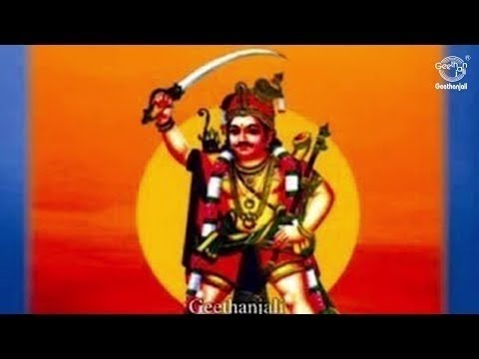

Ondi Karuppanna Samy, of Sholanganallur and Puthur village in Tiruchi District. Revered as the ‘Kaaval Deivam’ (God of Protection) across TamilNadu, He drives away the forces of evil, falsehood and treachery. He is a fierce warrior, who punishes those who harass his devotees.
Read More

Kulumayee Amman

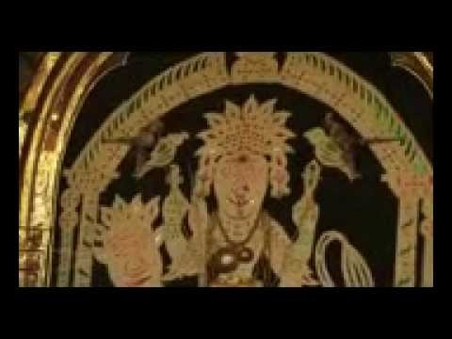

- Kulumayee Amman Ellai Pidari Amman, of Sholanganallur and Puthur Village.

Maha Kali Amman

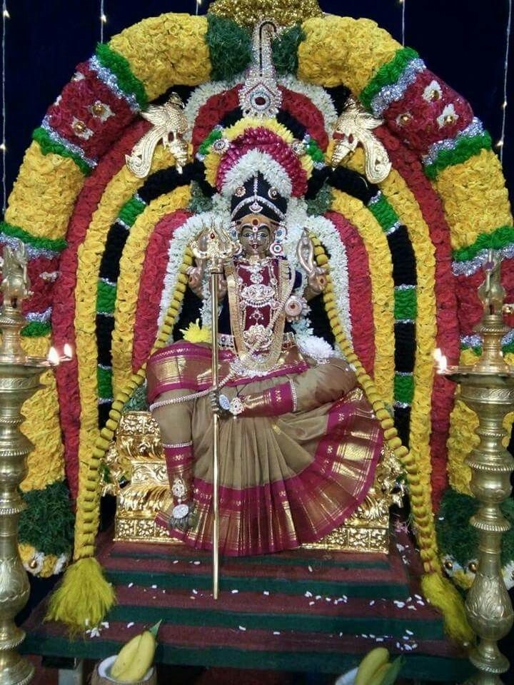
Mahakali ,considered to be the consort of Mahakala, the god of consciousness, the basis of reality and existence. Mahakali in Sanskrit is etymologically the feminized variant of Mahakala or Great Time (which is interpreted also as Death), an epithet of the god Shiva in Hinduism. Kali is the force of anger of Adi parashakti and therefore her color is black.
- Maha Kali Amman, of Sholanganallur Village.

Karuppanaar swamy

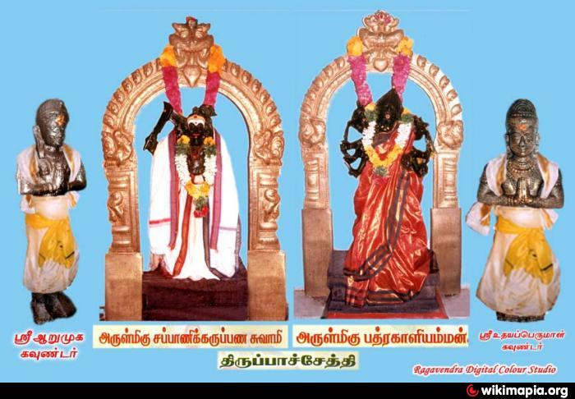

- Karuppanaar swamy (“Karuppu” means black in Tamil and is associated with dark, night, etc.). The typical variants of Karuppu or Karuppu of Eighteen Steps, Periya Karuppu, Veera Karuppanarswamy, Sanglilikarupan, Aagaya Karuppu (Thanjavur, Amaravathy), Maarnatu karuppu, Manda Karuppu, Munnadi Karuppu, Samaya Karuppu, Sinna Karuppu, Santhana Karuppu, Thundi Karuppu, Malayala Karuppu, Sappani Karuppu, Sonehkarupu etc.

Kaateri Amman

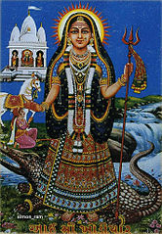

Kateri Amman , also spelt as Kaateri, is a form of Maha Devi who was created to destroy sickness and disease in the dark age of Kaliyuga. Kateri is also known as The Sister of Kali Maa and Ganga Maa by her devotees. She works alongside Ganga Maa in Caribbean Kali worship to remove diseases and to grant children to their devotees. She is believed to go within the deepest parts of a devotee's body to remove sicknesses. However, in some countries Kateri is also used in sorcery.
Kateri can be depicted in many forms with many different appearances. But her skin tone is either dark blue or black, hence sometimes calling her Kaal Kateri Maa or The Black Kateri Maa. She is seen either holding a sword, bowl, trishul, lotus or even all in her four armed form.

Sudalai Maadan Swamy

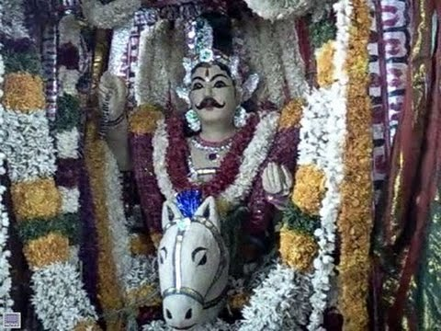

- Sudalai Madan is a deified hero known to have performed rites in temples and in graveyards who is generally venerated by Tamil people in South India, particularly in the Tamil Nadu region. But the anthropological studies show evidence of native Tamil origin of Sudalai Madan. According to one mythological story, He was created by Lord Shiva, so he is considered as the son of Lord Shiva and Goddess Shakti. In Tulunad he is usually accompanied with Therd madan means protector and sudalai means cemetery or burial ground. He is the eradicator of evil forces and bridles evil forces. Evil forces are believed to emanate from cemeteries and burial grounds. Sudalai reigns over evil forces, so Sri Shiva thus dubbed him as Sudalai Madan. Sudalai is also termed as the Kaval Deivam, or the protecting deity. Sudalai Madan is paramount of the protecting deities. Sudalai Madan is often termed as "Maharaja".
- There are others deities with the name Madan, but Sudalai Madan is the supersedes all of them. Sudalai is generally considered a rural deity. In the Tamil language, this is referred to as a Grama Devathai.
- He is mostly with mother goddess Pechiamman (a form of Kaali), Brahmasakthi Amman and his brother Sudalai Mundan. Madathi is the consort of Sudalai Madan.
- Whoever acts against dharma cannot escape from Sudalai Madan. Sudalai Madan will never forgive anyone who is harming his devotees. One has to be pure at his heart and actions to become a devotee of Sudalai Madan. There is the belief that Sudalai is the guardian of the Kodimaram (Flagstaff) in every temple.

Kali Amman
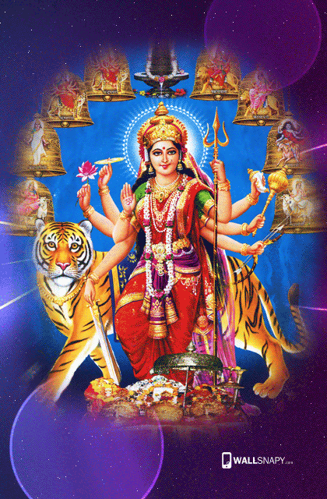

- Kali or Kali Amman was considered as the causative force for cholera.
- Kali , is a Hindu goddess. Kali is one of the ten Mahavidyas, a list which combines Sakta and Buddhist goddesses.
- Kali's earliest appearance is that of a destroyer of evil forces. She is the goddess of one of the four subcategories of the Kulamārga, a category of tantric Saivism. Over time, she has been worshipped by devotional movements and tantric sects variously as the Divine Mother, Mother of the Universe, Adi Shakti, or Adi Parashakti. Shakta Hindu and Tantric sects additionally worship her as the ultimate reality or Brahman. She is also seen as divine protector and the one who bestows moksha, or liberation. Kali is often portrayed standing or dancing on her consort, the Hindu god Shiva, who lies calm and prostrate beneath her. Kali is worshipped by Hindus throughout India especially in West Bengal.

Mariamman

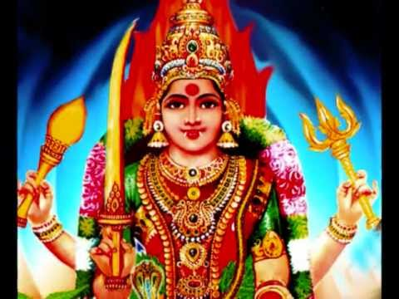

- Mari - was considered as a causative force for smallpox, chicken pox, mumps and measles (Maari in Tamil means rain. Since the rainfall cooled the otherwise hot area and protected people from summer sicknesses like viral infections, people started worshipping the rain goddess as Maari Amman).

Muniandi

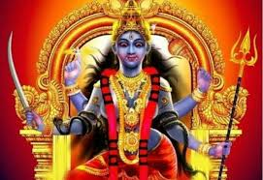

Muniandi is a regional Tamil guardian deity. The deity Muniandi refers to the Munis worshipped by the Tamil people. Muni refers to a class of guardian deities which are classified as Siva Gana. They are servants of the Supreme God Siva and his female half Shakti. The Munis could refer to former warriors, kings or sages who achieved the status of a Muni after their human death. Some of the Munis worshipped were created as Munis and did not go through the human life cycle.

Pechaiamman Amman
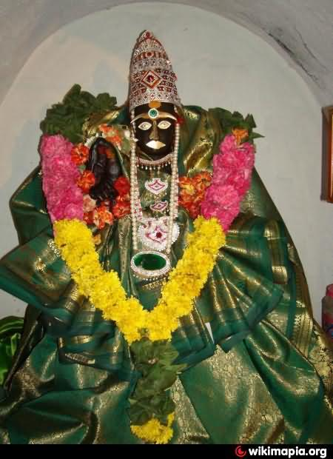
- Pechaiamman Amman - Guardian of children and mothers.

Sri Pada Muthu Swami

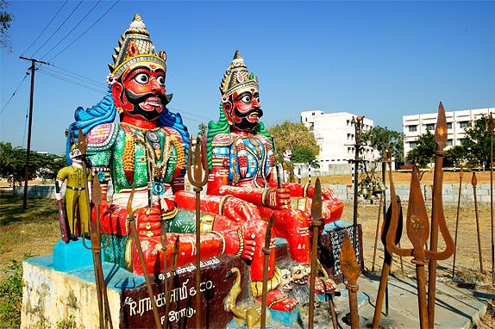

- Sri Pada Muthu Swami at Inam Karisal Kulam.There are other various Natural energy worship in the form of Muthaaramman, Muthalamman.

Sri Poovadakari Amman

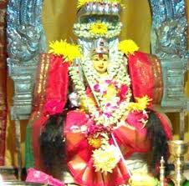

- Sri Poovadakari Amman
Sri Poovadaikari Amman Temple in Erumapalayam, Salem.

Ellai Amman

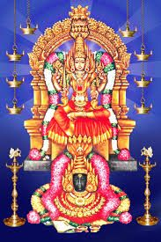

- Ellai Amman or Ellai Maari Amman - worshipped in many villages, she is represented by a milestone which demarcated the boundaries of two villages. In olden days, people when they travel from one village to another village started relaxing near these stones and in due course started praying to them for safe journey. Thus, slowly these milestones attained the position of village gods and goddesses.

Thottichiamman

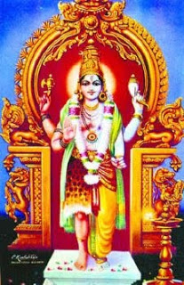

- Thottichiamman - She is believed to be the direct manifestation of Shiva himself without Shakti.
Thambran
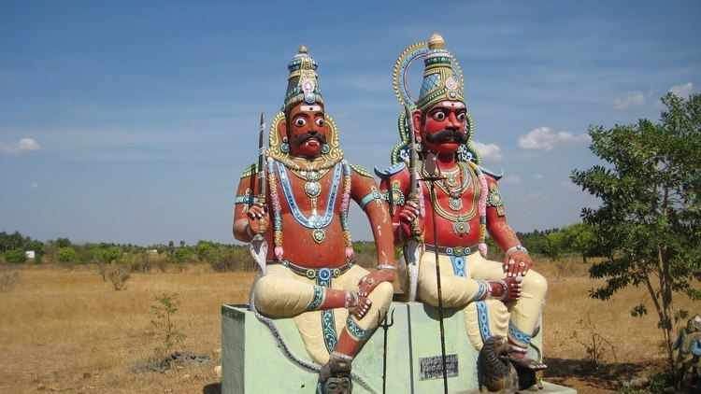
- Thambran - Protector and Family Deity for many people in Tamilnadu.

Veera Sastha & Malai Arasi Amman
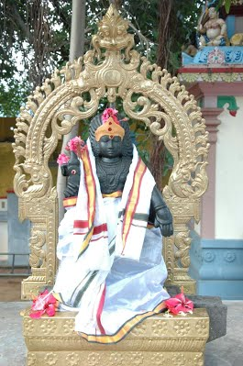

- Veera Sastha & Malai Arasi Amman; Iravu Kaathar - worshipped in villages adjoining Pattukkottai such as Aladikumulaiera Sastha & Malai Arasi Amman.

Written by
R.HARISHANKAR

