SPIRTUAL TEXTS BY R.HARISHANKAR
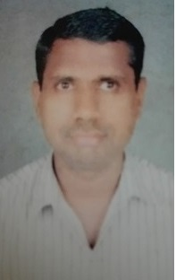
DIVYA DESAM TEMPLES
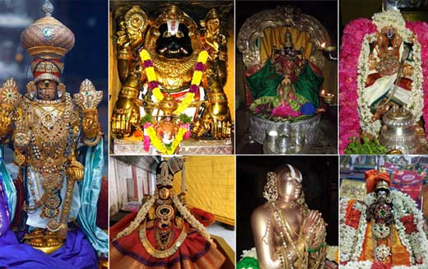
INTRODUCTION
Among the Vishnu temples which are scattered across the world, the following 108 temples are most popular and a must to visit temples at least once in our life time. In this present kali yuga, we are facing lot of difficulties and sufferings in our daily life. By visiting these temples, at a certain stage, our problems and difficulties will come to an end, and there is also a possibility of reaching the divine world, after our death. Hence let us try to visit 106 temples in our life time, since two of the temples are situated in VAIKUNTA, which we cannot go as of now.
Chennai Temples
 | - Triplicane - Sri Parthasarathy Temple
 | - Thiru Neermalai - Sri Neervanna Perumal Temple
Mahabalipuram Temples
3 | Tiruvedanthai - Sri Nithya Kalyana Perumal Temple
4 | Thiru Kadalmalai - Sri Sthala Sayana Perumal Temple
 | Vellore Temple
5 | Sholingur - Sri Yoga Narasimha Swamy Temple
Kanchipuram Temples
6 | Kanchipuram - Sri Varadharajar Temple
7 | Thiru Vekka - Sri Yathothakaari Temple
8 | Ashtabujam - Sri Aadhikesava Perumal Temple
9 | Thiru Ooragam - Sri Ulagalantha Perumal Temple
10 | Thiru Neeragam - Sri Jagadeeshwarar Temple
11 | Thiru Kaaragam - Sri Karunakara Perumal Temple
12 | Thirukkaar Vaanam - Sri Thirukkaar vaanar Temple
13 | Thiruparameshwara Vinnagaram - Sri Vaikunda Perumal Temple
14 | Thiru Pavala Vannan - Sri Pavala Vannar Temple
15 | Thiru Paadagam - Sri Pandava Thoodhar Temple
16 | Thiru Nilathingal Thundam - Sri Nilathingal Thundathan Perumal Temple
17 | ThirukKalvanoor - Sri Aadhi Varaha Perumal Temple
18 | Thiru Velukkai - Sri Azhagiya Singar Perumal Temple
19 | Thiruthanka - Sri Deepa Prakasar Perumal Temple
20 | Thiruputkuzhi - Sri Vijayaraghava Perumal Temple
21 | Tiruvallore - Sri Veeraraghava Perumal Temple
22 | Thiru Nindravoor - Sri Bhatavatsala Perumal Temple

Trichy Temples
23 | Sri Rangam - Sri Ranganathaswamy Temple
24 | Thirukkozhi - Sri Azhagiya Manavala Perumal Temple
25 | Thirukkarambanoor - Sri Purushothaman Perumal Temple
26 | Thiruvellarai - Sri Pundarikashan Perumal Temple
27 | Thiru Anbil - Sri Vadivazhagiya Nambi Perumal Temple
28 | Thirupper Nagar - Sri Appakkudathaan Perumal Temple
29 | Thirukkandiyur - Sri Hara Saabha Vimocchana Perumal Temple
Kumbakonam Temples
30 | Thiruvelliyankudi - Sri Kola Valvilli Ramar Perumal Temple
31 | Thiru Aadhanoor - Sri Aandu Alakkum Ayan Perumal Temple
32 | Thirukkudanthai - Sri Saarangapani Perumal Temple
33 | Thiruppullam Boothankudi - Sri Valvil Ramar Perumal Temple
34 | Kabisthalam - Sri Gajendra Varadha Perumal Temple
35 | Thirunandhipura Vinnagaram - Sri Jaganatha Perumal Temple
36 | Thirukkoodaloor - Sri Aaduthurai Perumal Temple
37 | Thiru Vinnagar - Sri Oppiliappa Perumal Temple
38 | Naachiyar Kovil - Sri Thirunarayoor Nambi Perumal Temple
39 | Thiruccherai - Sri Saranathan Perumal Temple
40 | Thirukkannamangai - Sri Bhaktavatsala Perumal Temple
Tanjore Temple
41 | Thiru Thanjaimaamani Koil - Sri Neelamega Perumal Temple
Mayavaram Temples
42 | Thiruvazhunthoor - Sri Devaadi Raja Perumal Temple
43 | Thiru Sirupuliyur - Sri Arulmaakadal Perumal Temple
44 | Thiru Thalaicchanga Naanmathiyam - Sri Naan Madhiya Perumal Temple
45 | Thiru Indhaloor - Sri Parimala Ranganatha Perumal Temple
Nagapattinam Temples
46 | Thirukkannapuram - Sri Neelamega Perumal Temple
47 | Thirukkannankudi - Sri Loganatha Perumal Temple
48 | Thiru Naagai - Sri Neelamega Perumal Temple
Chidambaram Temple
49 | Chidambaram - Sri Govindaraja Perumal Temple
Seergazhi Temples
 | 50. Seerkazhi - Thirivikaraman Perumal Temple
 | 51. Thiruvaali Thirunagari - Sri Lakshmi Narashima Perumal Temple
 | 52. Thiru Kavalampaadi - Sri Gopala Krishna Perumal Temple
 | 53. Thiru Arimeya Vinnagaram - Sri Kuda Maadu Koothan Perumal Temple
 | 54. Thiru Vann Purushothamam - Sri Purushothama Perumal Temple
 | 55. Thiru Sempon Sei Kovil - Sri Per Arulaalan Perumal Temple
 | 56. Thiru Manimaada Kovil - Sri Narayana Perumal Temple
 | 57. Thiru VaiKunda Vinnagaram - Sri Vaigundha Nathan Perumal Temple
 | 58. Thiru Devanaar Thogai - Sri Deiva Naayaga Perumal Temple
 | 59. Thiru Thetri Aambalam - Sri Seganmaal Ranganatha Perumal Temple
 | 60. Thiru Manikkoodam - Sri Varadharaja Perumal Temple
 | 61.Annan Kovil - Sri Srinivasa Perumal Temple
 | 62.Thiru Paarthanpalli - Sri Thamaraiyal Kelvan Perumal Temple

63.Thiruvaheendrapuram - Sri Deyva Nayaga Perumal Temple
64.Thirukkoviloor - Sri Thiruvikrama Perumal Temple

Tirunelveli Temples - Nava Tirupathis
65.Thirukkurungudi - Sri Nindra Nambi Perumal Temple
66.Vaanamaamalai - Sri Thothatrinatha Perumal Temple
67. Azhwar Thirunagari - Sri Aadhinatha Swamy Temple
68.Thirukkoloor - Sri Vaitha Maanitha Perumal Temple
69.Thirupperai - Sri Magara NedungKuzhai Kaathar Perumal Temple
70.Sri Vaikundam - Sri Vaikundanatha Perumal Temple
71.Thirukkulanthai - Sri Srinivasa Perumal Temple
72.Thiruvaragunamangai - Sri Vijayaasana Perumal Temple
73.Thiruppulingudu - Sri Kaaichina Vendha Perumal Temple
74.Thiruttholai Villimangalam - Sri Aravindha Lochana Perumal Temple
Virudhunagar Temples
75.Thiruthankaal - Sri Nindra Narayana Perumal Temple
76.Sri Villiputhoor - Sri Vadabhatra Saayi Perumal Temple
Madurai Temples
77.Thirukkoodal - Sri Koodal Azhagar Perumal Temple
78.Thirumaalirunsolai - Sri Kallazhagar Perumal Temple
79.Thiru Moghur - Sri Kaalamegha Perumal Temple
Ramanathapuram Temple
80.Thiruppullanni - Sri Kalyana Jagannatha Perumal Temple
Pudukkottai Temples
81.Thirukkotiyoor - Sri Uraga Mellanayaan Perumal Temple
82.Thirumeyyam - Sri Sathyagiri Natha Perumal Temple

Kerala Temples
83.Thiruvananthapuram - Sri Anantha Padmanabhaswamy Temple
84.Thiruvanparisaaram - Sri Kuralappa Perumal Temple
85.Thirukkaatkarai - Sri Kaatkarai Appa Perumal Temple
86.Thirumoozhikkalam - Sri Moozhikkalathaan Perumal Temple
87.Thirupuliyoor - Sri Maayapiran Perumal Temple
88.Thirucchenkundroor - Sri Imayavarappa Perumal Temple
89.Thiru Naavaay - Sri Naavaay Mugundha Perumal Temple
90.Thiruvalvaazh - Sri Kolapira Perumal Temple
91.Thiruvanvandoor - Sri Paambanaiyappa Perumal Temple
92.Thiru Vattaaru - Sri Aadhikesava Perumal Temple
93.Thiruvithuvakkodu - Sri Uyyavantha Perumal Temple
94.Thirukkadithaanam - Sri Athpudha Narayana Perumal Temple
95.Thiruvaaran Vilai - Sri Kuralappa Perumal Temple

Andhra Temples
96.Tirupathi - Tirumalai - Sri Srinivasa Perumal Temple
97.Thiru Singavel Kundram (Ahobilam) - Sri Nava Narasimhar Temple
Uttar Pradesh Temple
98.Thiru Ayodhi - Sri Ramar Temple
99.Thiru Naimisaranyam - Sri Devaraja Perumal Temple
Nepal Temple
100.Thiru Salagramam - Sri Moorthy PerumalTemple
101.Thiruvadhari Ashramam (Badrinath) - Sri Badri Narayana Perumal Temple
102.Thirukkandam - Kadi Nagar (Devaprayag) - Sri Neelamega Perumal Temple
103.Thiruppirudhi (Joshimutt) - Sri Paramapurusha Perumal Temple
104.Thiru Vadamathura (Brindhavanam) - Sri Govardhana Nesa Perumal Temple
105.Thiruvaaipadi (Aayarpadi) - Sri Navamohana Krishna Perumal Temple
106.Thiru Dwaraka (Dwaraka) - Sri Kalyana Narayana Perumal Temple

Vinnulaga Temples
107.ThirupPaarkadal (Vyugam)
108.ThirupParamapadham (Parathuvam)

DEVELOPED BY
R.HARISHANKAR

SHAKTI PEETHAS
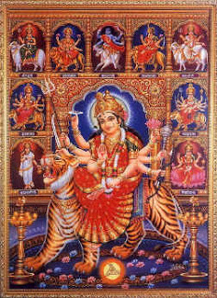
INTRODUCTION
Shakti Peetas are popular places of worship of Mata Parvati Devi. It is believed that, when Sati devi was self- immolated, her various body parts were fallen in different places. The places where her body parts were fallen are known as Shakti Peethas, and are worshipped popularly by the devotees.
The following are the 18 main Shakti peetas:
r. No. | Temple | Place | State in India/Country | Appellation | Part of the body fallen | Shakti
1 | Shankari Temple | Triconmalee | Triconmalee, SriLanka | Lankayam Shankari Peetham | Heart | Shankari
2 | Adhi Kamakshi Amman Temple behind Kamakshi Amman Temple | Kanchi | Tamil Nadu | Adi Kamakshi Devi Temple(or Kaliyambal Temple) behind Kama koti peetam | Navel | Kamakshi Amman
3 | Shrinkala | Pradmunyee (Pandua) Bengal | BavTharini Peetham | Stomach | Maa Shrinkala | -
4 | Chamundeshwari Temple | Mysuru | Karnataka | Krounja Peetham | Hair | Maa Chamundeshwari
5 | Jogulamba Devi | Alampur, Gadwal district | Telangana | Yogini Peetham | Teeth | Jogulamba Thalli (Yogamba)
6 | Bhramaramba Mallikarjuna Temple | Srisailam, | Andhra Pradesh | Srisaila Peetham | Neck | Maa Bhramarambika
7 | Mahalakshmi Temple, Kolhapur | Kolhapur | Maharashtra | Shri Peetham | Eyes | Aai Ambabai
8 | Eka Veerika Temple | Mahur, Maharashtra | Maharashtra | Moola Peetham | Left Hand | Eka Veerika
9 | Mahakaleshwar Jyotirlinga | Ujjain | Madhya Pradesh | Ujjaini Peetham | Tongue | Maa Kaali
10 | Kukkuteswara Swamy Temple | Pithapuram | Andhra Pradesh | Pushkarini Peetham | Back | Maa Puruhutika
11 | Biraja Temple | Jajpur | Odisha | Oddyana Peetham | Navel | Maa Biraja
12 | part of Kumararama Bhimeswara Temple | Draksharamam | Andhra Pradesh | Draksharama Peetham | left cheek | Maa Manikyamba
13 | Kamakhya Temple | Guwahati | Assam | Kamarupa Peetham | Genitals | Devi Kamakhya
14 | Alopi Devi Mandir | Prayagraj | Uttar Pradesh | Prayaga Peetham | Fingers | Maa Madhaveswari
15. | Jwalamukhi Temple | Kangra | Himachal Pradesh | Jwalamukhi Peetham | Head | Maa Jwalamukhi
16. | Mangla Gauri Temple | Gaya | Bihar | Gaya Peetham | Breast | Maa Sarvamangala
17. | Vishalakshi Temple | Varanasi | Uttar Pradesh | Varanasi Peetham | Noses | Maa Vishalakshi
18. | Sharada Peeth | Sharda, Kashmir | Kashmir | Sharada Peetham | Right Hand | Maa Sharada Devi
DEVELOPED BY
R.HARISHANKAR

TWELVE JYOTHIRLINGAS
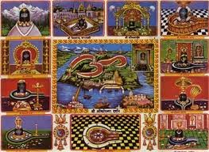
INTRODUCTION
There are twelve jyothirlingas situated in india. By worshipping these lingams, we will get great punyam(Good Karma) and get all the prosperities in our life, and also reach the divine world, after our death.
Sl No | Jyotirlinga | State | Location | Description
1 | Somnath | Gujarat | Veraval, Saurashtra | Somnath is considered as the first pilgrimage site.The temple was destroyed and re-built several times is rich in its beauty. It is situated at Gujarat.
2 | Mallikārjuna Swāmi | Andhra Pradesh | Srisailam | Srisailam, is located on a mountain in Kurnool District in Rayalaseema. It is a place where Shakti peetha and Jyotirlingam are together.
3 | Mahakaleshwar | Madhya Pradesh | Ujjain | Mahakal, Ujjain in Madhya Pradesh is the place where Mahakaleshwar Jyotirlinga temple is located. The Lingam at Mahakal is believed to be Swayambhu. It is a place where Shakti peeta and Jyotirlingam are together.
4 | Omkareshwar | Madhya Pradesh | Omkareshwar | Omkareshwar is in Madhya Pradesh and contains the Jyotirlinga shrine and the Mamaleshwar temple.
5 | Kedarnath | Uttarakhand | Kedarnath | Kedarnath in Uttarakhand forms a part of the major Shiva temple pilgrimage. Kedarnath Temple, situated in Himalayas, is accessible only for six months a year.
6 | Bhimashankar | Maharashtra | Bhimashankar | Bhimashankara temple is located near pune in Maharashtra and it is a very ancient temple and one of the holiest temple in india.
7 | Kashi Vishwanath Temple | Uttar Pradesh | Varanasi | The Kashi Vishwanath Temple in Varanasi, Uttar Pradesh is one among the Jyotirlinga shrine, and is the most sacred Temple, which is praised in Thevaaram.les. The main deity is known by the name Vishwanath. Visiting this temple, will relieve us from the curse of ancestors.
8 | Trimbakeshwar Shiva Temple | Maharashtra | Trimbakeshwar, near Nashik | The Trimbakeshwar Temple, near Nasik in Maharashtra, is a Jyotirlinga shrine.
9 | Nageshvara Jyotirlinga | Gujarat | Near Jamnagar | Nageshvara Jyotirlinga is one of the 12 Jyotirlinga shrines mentioned in the Shiva is situated in the present day Dwarka region.
10 | Baidyanath Temple | Jharkhand | Deoghar | Baidyanath Jyotirlinga temple, also known as Baba vaidyanath dham and vaidyanath dham is one of the twelve Jyotirlingas, the most sacred abodes of Shiva. It is located the state of Jharkhand.
11 | Rameshwar | Tamil Nadu | Rameswaram | Rameswaram in Tamil Nadu is home to the vast Ramalingeswarar Jyotirlinga temple and It is also one of the Padal Petra Stalam mentioned in Thevaaram.
12 | Ghrishneshwar | Maharashtra | Ellora | Ghrishneshwar Temple, is one of the 12 Jyotirlinga shrines mentioned in the Shiva Purana.

DEVELOPED BY
R.HARISHANKAR

BADRINATH TEMPLE
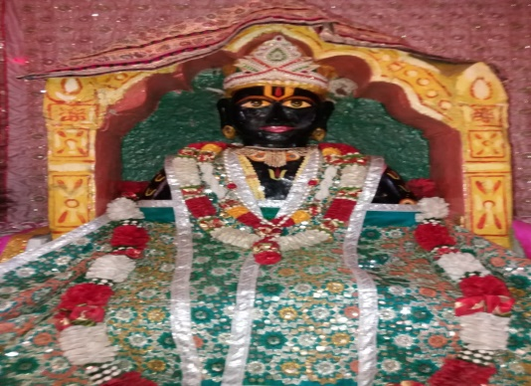
INTRODUCTION
Badrinarayan Temple is a temple dedicated to Lord Vishnu situated in Uttarakhand, India. The temple is also one of the 108 Divya Desams. It is open for six months every year (between the end of April and the beginning of November), due to the extreme weather conditions in the Himalayan region. The temple is located in Garhwal hill tracks in Chamoli district along the banks of Alaknanda River. It is one of the most ancient temples and attracts large number of pilgrims every year.
The presiding deity worshipped in the temple is known as Badrinarayan. It is a self-manifested statue of Lord Vishnu. Although Badrinath is located in North India, the head priest will be chosen from Kerala. The temple is mentioned in ancient hindu puranic texts. It is also mentioned in the sacred text “DIVYA PRABHANDHAM”.
By worshipping Lord Badri Narayan, we will get all the benefits in our life, and can get salvation after our death. Hence it is advisable to visit and worship this temple at least once in our life time.
DEVELOPED BY
R.HARISHANKAR

KAILASH MANSAROVAR
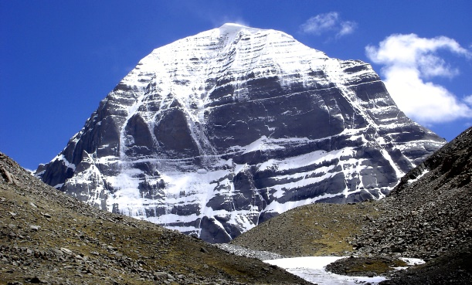
INTRODUCTION
Mount Kailash is a highest peak in the Kailash Range. The mountain is located near Lake Manasarovar and Lake Rakshastal. In Hinduism, it is believed to be the sacred abode of Lord Shiva, who resides there along with Mata Parvati, Lord Ganesha and Kartikeya.
Every year, thousands of pilgrims are visiting the holy Kailash. Pilgrims would circumambulate Mount Kailash on foot for getting better prospects in their life. The path around Mount Kailash is 52 km long. It will take a minimum of 15 hours to complete the entire trek. The mountain is located in the Tibetan Himalayas. There are a few amenities, such as resting places, refreshment drinks and snacks, are available to continue the trip in the holy mountains without much difficulty. It is believed that by visiting Mount Kailash we can attain SALVATION.
DEVELOPED BY
R.HARISHANKAR
MUKTINATH TEMPLE
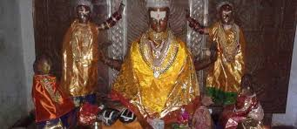
INTRODUCTION
Muktinath is a Vishnu temple, which is considered as very sacred and worshipped by both Hindus and Buddhists. It is located in Nepal. It is one of the world's highest temples. It is believed that by visiting this temple, we will get MUKTI (SALVATION) after our death. This temple is considered as one among the sacred divya desams. It is an ancient temple. It is also considered as sacred similar to the Vishnu temples in Srirangam, Srimushnam, Tirupati, Naimisharanya, Thotadri, Pushkar and Badrinath. The sacred water around the temple complex is the sacred Pushkarini. Pilgrims are expected to offer a prasad (religious offering of food) to the deity. The temple is also glorified in the sacred text: Nalayira Divya Prabandham.
DEVELOPED BY
R.HARISHANKAR
ASHTAVINAYAKA
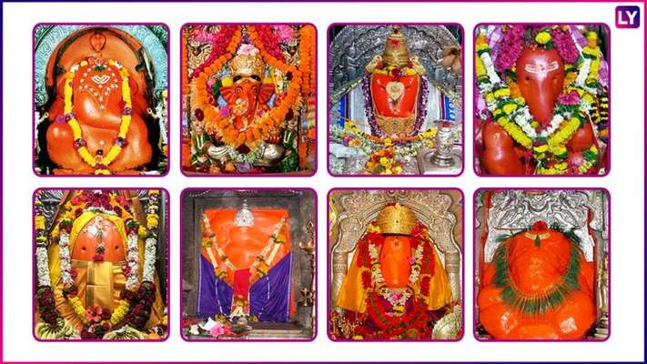
INTRODUCTION
Ashtavinayak refers to eight Ganeshas. Ashtavinayaka yatra refers to visiting the eight Ganesa temples in Maharashtra. The Ashtavinayak temples are located around Pune. Each of these temples has its own history, and all the ganesha deities are worshipped by lot of people regularly. The appearance of each idol of Ganesh differs from one another. It is believed that those who worship the Ashtavinayak temples at a single stretch can get all the prosperity in their life, and after their death, they will get liberated from the chain of re-births, and permanently attain the divine world.
The following are the Ashta Vinayak temples:
1 | Mayureshwar Temple | Morgaon, Pune district
2 | Siddhivinayak Temple | Siddhatek, Ahmednagar district
3 | Ballaleshwar Temple | Pali, Raigad district
4 | Varadavinayak Temple | Mahad, Raigad district
5 | Chintamani Temple | Theur, Pune district
6 | Girijatmaj Temple | Lenyadri, Pune district
7 | Vighneshwar Temple | Ozar, Pune district
8 | Mahaganapati Temple | Ranjangaon, Pune district

DEVELOPED BY
R.HARISHANKAR

SIX ABODES OF LORD MURUGAN
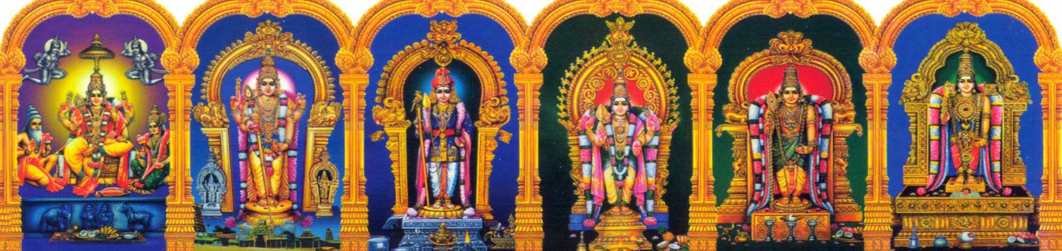
INTRODUCTION
The Six Abodes of Murugan are six temples located in Tamil Nadu. Lord Muruga is called in various names such as Kartikeya, Kanda, Vadivela and Senthil Andava at various temples. The six sacred temples of Murugan are mentioned in the sacred text "Thirumurugatrupadai", and in "Thiruppugazh. The six abodes are Palani, Thiruthani, Swamimalai, Pazhamudircholai, Thirupparankunram and Thiruchendur.
The story of Lord Murugan is mentioned in Skanda Purana. According to the legend, when the demon king Soorapadman disturbed the Devas, by Lord Shiva’s third eye spark, Lord Karthikeya was created and he killed Soorapadman and protected the devas. Muruga is worshipped for getting all sorts of benefits in our life. He will give boldness, wisdom, good physical and mental energy, and help us to get liberated from the life cycle. Lord Muruga is the god of mountainous region.
Arunagirinathar was a great poet and once he was saved from death by the grace of god Murugan. He then became an ardent devotee and composed several poems on him. The main traditions of the six temples, is the tonsuring of devotees. Devotees carry kavadi, and also pierce their mouth and body with vel, which is considered as a symbol of true bhakti expressed by the devotees on Lord Muruga.
The six abodes are as follows:
Palani Murugan Temple | Palani, Dindigul district | Located in Dindigul District, on the Palani hill bottom and was worshipped by Goddess Lakshmi. Here, the main deity is made out of Navabashanam and was established by Saint Bhogar.
Swamimalai Murugan Temple | Swamimalai, Thanjavur district | Located near Kumbakonam. The temple narrates the incident about giving explanation of chanting of the pranava “OM” Mantra by Lord Muruga to Shiva.
Thiruchendur Murugan Temple | Thiruchendur, Thoothukudi district | Located on the sea-shore near Tuticorin. In this place, Lord Murugan won a massive victory over demon Soorapadman by worshipping Lord Shiva.
Thirupparamkunram Murugan Temple | Thiruparankunram, Madurai district | Located on the outskirts of Madurai where Muruga married Indra's daughter Deivanai.
Thiruthani Murugan Temple | Thiruttani, Thiruvallur district | Located near Chennai, Murugan married Valli here.
Pazhamudircholai Murugan Temple | Pazhamudircholai, Madurai district | Located on the outskirts of Madurai and Murugan is seen with both of his consorts Deivanai and Valli.
DEVELOPED BY
R.HARISHANKAR

SABARI MALA TEMPLE
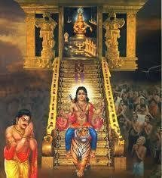
INTRODUCTION
The Sabarimala temple is a temple located at Sabarimala in Pathanamthitta district, Kerala, India. It is the famous temple where lakhs of devotees are visiting every year to have the glimpse of Lord Ayyappa after observing fasting and doing puja for 41 to 48 days. Lord Ayyappan also known as Dharma Sastha, is the son of Lord Shiva and Mohini, the feminine form of Vishnu. The temple is situated on a hilltop, and is surrounded by mountains and dense forests. Temples exist in each of the hills surrounding Sabarimala.
The worship of Sastha forms part of the very ancient history of south India. At Sabarimala, the deity is worshiped as Ayyappan. This is an ancient temple.
There are many Sastha temples throughout the world. The temple was rebuilt in 1950. The temple consists of a sanctum sanctorum with a gold-plated roof. The shrine of Kannimoola ganapathi is also found in the Sannidhanam. Ganapathi homam is the main offering. The 18 sacred steps is the main stairway to the temple. Lord Karuppu Sami and Kadutha Sami are guarding at the foot of the holy 18 sacred steps. The temple of Maalikapurathamma, is located few yards from Sannidhanam. Free annadanam is also provided in the temple for the ayyappa devotees.
DEVELOPED BY
R.HARISHANKAR

