ANAYA NAYANAR
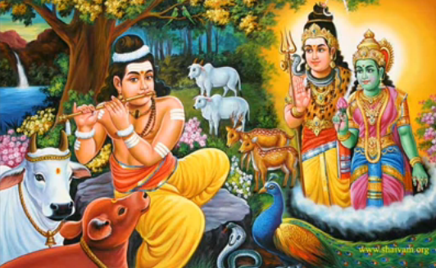
INTRODUCTION
Anaya Nayanar, is a Shaivite Saint, and is considered as one among the 63 Nayanars. He used to play Lord Shiva’s names and his mantra on his flute, and he appears similar to Lord Krishna.

LIFE
Anaya belonged to Yadava Community. Anaya was born and brought up in Trichy. Trichy contains several holy temples like Malaikottai Vinayaka Temple. And also contains Samavedeshvarar Temple, a famous Shiva temple. He used to take care of his cows and with the cow’s milk, he earned for his livelihood and he gave some milk for Lord Shiva’s abhishekham in the Samavardeshvarar Temple. Anayar used to apply sacred ash on his body, and wears Rudraksha in his neck. And he was very much interested in playing flute in praise of Lord Shiva. Due to his melodious music, people from nearby villages were also got attracted and listened to his music.
His music mesmerized even the animals and the birds, and it all surrounds him and listens to his music. It is believed that even the Demi gods from the heaven appeared in front of him to listen to his flute music. In appreciation to his sincere and pure bhakti, Lord Shiva appeared with Mata Parvati, and blessed Anayar. After his death, he reached KAILASA, the holy abode of Lord Shiva. In Shiva Temples, Anaya Nayanar idol was crafted similar to Lord Krishna, since both of them were postured in the form of playing flute.
Anaya Nayanar is specially worshipped in the Tamil month of Karthigai and also worshipped by the people in all other days in the shiva temples along with other nayanmars.
IMPORTANCE
Apart from taking care of cows and playing flute in praise of shiva, he was a good natured and soft spoken person. He was a sincere devotee of Lord Shiva and his thoughts were always on him. He never thought about unwanted things, and dedicated his entire life on devoting Lord Shiva. Let us worship the great nayanar saint and be blessed.
“OM SREE ANAYA NAYANARE NAMAHA”
“OM NAMAH SHIVAYA”
“OM SAKTHI PARASAKTHI”
WRITTEN BY
R.HARISHANKAR

APPAR
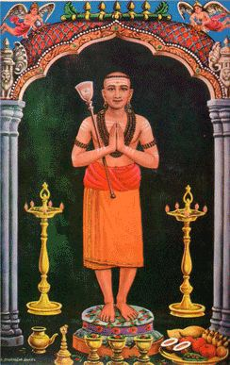
INTRODUCTION
Appar also known as Tirunavukkarasar Nayanar was one among the 63 nayanmars. His birth name was Marulneekkiyar. He was considered to be the "father" for the entire “UNIVERSE” hence he was fondly called as “APPAR”. Appar had contributed a portion of his writings in the famous writing Thiruthondar thogai. All the contributions of Appar, Sundarar and Thirugnana Sambandar are collectively called as Tevaram. All the three Nayanmars had contributed a major role in promoting the Shaivism Sect among the people.

LIFE
Appar was born in 7th century AD in Tiruvamur, Tamil Nadu. His sister Thilagavathiyar lived a saintly life and took care of him properly. He is regarded as an avatar of the holy “SIVA GANAM VAGEESAR” in KAILASA.
At his younger age, Appar was very much attracted to Jainism and converted to Jainism and stayed in the Jain Temple and was known as Darmasena.
Once he suffered from severe stomach pain, and after praying to Lord Shiva, he got cured. Then he again converted to Shaivism from Jainism. He also converted the Pallava king, Mahendravarman to Shaivaism. He was called as Tirunavukkarasu, due to his divine speech.
Navukkarasar met Thirugnana Sambandar at Sirkali and both of them travelled together by singing devotional songs on Lord Shiva. Appar is believed to have travelled to most of the shiva temples in Tamil Nadu, and preached the importance of shaivism among the people. He attained SALVATION at Tiru Pukalur Siva temple at the age of 81.
Appar’s Tevaram is very famous even in today’s world, especially among the shaivites.
One of his famous songs verses are as follows:-
Lord Shiva’s divine lotus feet are like
- The Veena,
- The Full Moon,
- The Cold breeze,
- The Early Morning Sunshine,
- The refreshing pond,
- The Holy Mountain,
- The blossomed flower
The great shaivite saint Sri Nambi Andar Nambi, recovered some of the divine scripts of tevaram through the blessings of Lord Shiva in 10 century AD.
IMPORTANCE
Appar was a great saint who removed the sins of the devotees by chanting the shiva mantra “OM NAMASHIVAYA”. He was praised for his kindness, wisdom, courage, knowledge and devotion to Lord Shiva. Though he was a great scholar in all the subjects, he never showed any pride among others. He was a humble and a soft spoken saint, who cured the dreaded diseases of the devotees by applying the holy ash (VIBUTHI) of Lord Shiva on their body. He was famous for offering food to shiva devotees. Daily he had served food for several hundreds of shiva devotees with much pleasure and joy in his mind. He will be always remembered for his “TEVARAM” and for his pure bhakti on Lord Shiva.
Even still in most of the shiva temples, his famous work “TEVARAM” is recited every day, and especially on Mondays. It is believed that by singing the verses of Thevaram, one will get relieved from their past and present birth sins and will be merged with Lord Shiva. Along with Sambandar and Sundarar, Appar is also praised for his great contribution in the shaivite siddantha and for his good nature and devotion to Lord Shiva. We must cultivate the habit of chanting the verses of Tevaram on a daily basis in order to live a peaceful life.
Let us the chant the holy name of the great saint “SRI APPAR” and be blessed.
“OM SREE APPAR SWAMIGALE NAMAHA”
“OM NAMAH SHIVAYA”
WRITTEN BY
R.HARISHANKAR

APPUTHI ADIGAL
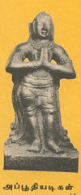
INTRODUCTION
Apputhi Adigal, also known as Apputhi Nayanmar, belonged to Shaivism. He is one among the 63 shaivite nayanmars.
LIFE
Apputhi Adigal was born in Thingalur at Thanjavur district, Tamil Nadu during 7th century AD. He was a staunch devotee of Lord Shiva and a follower of Appar.
IMPORTANCE
Once Appar went to Apputhi Adigal’s house. And Apputhi Adigal fell at his guru's feet, and worshipped him. And he arranged a grand feast for Appar. Apputhi Adigal’s son was bitten by a snake, while cutting the banana leaves for providing food to Appar. Appar prayed to Lord Shiva and sung in praise of him, and immediately the child has got back to his life.
Apputhi Adigal has got the grace of Shiva by serving Appar. The Periya Puranam also praises the devotion of Apputhi Adigal towards Lord Shiva.
Both Sundarar and Appar have praised him, for his sincere devotion to Lord Shiva. Apputhi Adigal is worshipped in the Tamil month of Thai.
CONCLUSION
Apputhi Adigal was well known for hosting feasts to the devotees of Lord Shiva. He is a great shiva devotee, and is living in the kailasa, along with other nayanmars and shiva ganas. Let us pray to him and to Lord Shiva and be blessed.
“OM SREE APPUTHI ADIGALE NAMAHA”
“OM NAMAH SHIVAYA”
WRITTEN BY
R.HARISHANKAR

ARIVATTAYA NAYANMAR
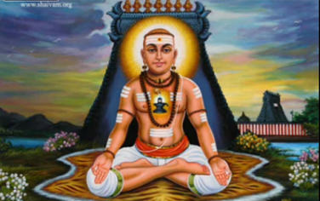
INTRODUCTION
Arivattaya Nayanmar or Thayanar was one among the 63 Nayanmars, and he is regarded as the great devotee of Lord Shiva. Nayanmars were born and lived before thousands of years ago. In the Periya Puranam, Sekkizhar had written about the life and the importance of 63 Nayanmars.
Thayanar was born in a rich family in a village located at Thanjavur district. Thayanar was an ardent devotee of Lord Shiva and lived in Thanjavur with his family.
Though he was a rich person in his village, he led a simple and a noble life. He was the owner of several farm lands. And through that, he and his noble wife cultivated the crops and provided food to the shiva devotees. Due to his continuous service, one day he had lost all of his wealth, but even then, he continued his routine service of feeding food to the devotees of Lord Shiva.
In course of time, he sold out all of his farm lands, and he and his wife were begun to work as labourers in other wealthy people’s fields. Even in that difficult situation, with his meagre income, he started feeding the poor and the devotees of Lord Shiva. His situation was further worsened due to the severe drought occurred in his village, and he and his wife were starved for several days without food.
One day, somehow the couple managed to prepare simple food and arrived towards a Shiva temple to offer the food to the Lord as Prasad and then to offer it to the devotees of Lord Shiva. Due to hunger and starvation, the couple fell down on the ground with the food and the food was wasted. Unable to tolerate the wastage of food, he took a weapon and tried to pierce it on his neck.
He was stopped from doing that act, by Lord Shiva, and he appeared along with Parvati and they appreciated the couple's sincere bhakti and their selfless service of providing food to the devotees and given them Salvation.
IMPORTANCE
He was a great nayanmar who thought only about doing food offering to the god and to his devotees, and didn’t think about himself and his wife. He had lost all his riches through his charity work, and even then, he didn’t felt bad about that. Instead of living comfortably, he lived a simple life and performed siva puja and offered fruits and flowers to shiva. His wife was an affectionate woman who always takes care of her husband, and does her duties according to his desire. She also got great bhakti on Lord Shiva similar to her husband.
Let us worship the great nayanmar saint and be blessed.
“OM SREE ARIVATTAYA NAYANMARE NAMAHA”
“OM NAMAH SHIVAYA”
WRITTEN BY
R.HARISHANKAR

CHANDESHVARA NAYANMAR
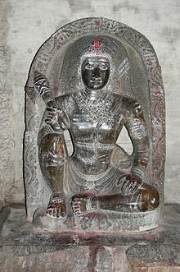
INTRODUCTION
Chandeshwara or Chandikeswara is one among the 63 Nayanmars. His idol was found in all the Shiva temples of South India. He appears in the state of deep meditation, and devotees will worship him by clapping their hands by way of appreciating his siva bhakti and for his deep meditation. It is believed that he only takes care of all the offerings made to Lord Shiva, and he passes the outcome (PALANGAL) of it to Lord Shiva. It is believed that he acts as a mediator between Lord Shiva and his devotees.
He was born into a Brahmin family. At his younger age itself, he took care of the cows and daily he will used to pour some milk on the sand lingam. Once his father saw it, and got angry and destroyed the sand lingam. Due to his father’s wrong act, chandikeswara hit his father’s leg with an axe. By seeing this incident, and in order to appreciate his shiva bhakti, Lord Shiva manifested from the sand lingam and blessed Chandesha, and appointed him as the chief among his shiva ganas, next position to Lord Nandikeswarar and also cured the injured leg of his father. Before attaining the abode of kailsa, he lived a saintly life and had took only simple food after doing shiva pooja and welcomed the devotees of Lord Shiva to his place and offered them food and water and also permitted them to take rest for some time in his home.
Chandikeswara was also involved in deep meditation from his younger age, and it is believed that even in Kailasa, after serving Lord Shiva and Parvati, he will do meditation on Lord Shiva. He is considered as a main nayanmar and occupies an important role in Kailasa.
IMPORTANCE
He was not interested in any other worldly activities expect worshipping Lord Shiva. By seeing his sincere devotion, people were attracted and started doing siva pooja. Even in his childhood, he will used to play by making siva lingam out of sand and worship it by offering fruits and flowers and ask his friends also to participate in the puja. He is such a great shiva bhakta! In this today’s world, we cannot imagine such a divine person like him!
Let us try to follow his footsteps and keep chanting the shiva mantra “OM NAMAH SHIVAYA” and be blessed.
“OM SREE CHANDIKESWARA NAYANMARE NAMAHA”
WRITTEN BY
R.HARISHANKAR

DANDIYADIGAL NAYANAR
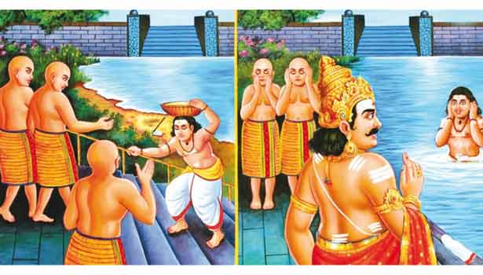
INTRODUCTION
Dandiyadigal is the Nayanar saint and a great devotee of Lord Shiva.
LIFE
He was born and lived at Tiruvarur. Daily he will used to take food only after chanting the shiva mantra “OM NAMAH SHIVAYA” and doing shiva puja. Though he was blind, he served Lord shiva and his devotees in a proper manner. Daily he will used to provide food to the devotees of Lord Shiva and worshipped Lord Shiva at the Shiva temple at Tiruvarur and sing the glory of Lord Shiva and also invoked the bhakti spirit among the people.
Due to the encroachment kept by the jain people, near the shiva temple at tiruvarur, Dandi adigal decided to renovate the temple tank and started doing his work. The jains were disliked by his act and starting disturbing his work. Since his work was interrupted, Dandi Adigal requested Lord Shiva to help him. Due to the blessings of Lord Shiva, Dandi Adigal has got his eye sight and since the Jains were gave several disturbances to him, they were become blind. Then with the help of the Chola king, the renovation of the temple tank was completed.
After his death, he attained “SALVATION” and reached Kailasa, the holy abode of Lord Shiva.
During the Tamil month of Panguni, his festival is celebrated as Guru Puja in all the shiva temples.
IMPORTANCE
Even though he was born as a blind person, he didn’t blame the god for his sufferings, but concentrated his attention only on devoting Lord Shiva. He had served both the god and his devotees in a well versed manner. He dedicated his entire life in chanting the names and reciting the slokas of Lord Shiva.
Let us worship the great nayanar saint and be blessed.
“OM SREE DANDIYADIGALE NAMAHA”
“OM NAMAH SHIVAYA”
“OM SAKTHI PARASAKTHI”
WRITTEN BY
R.HARISHANKAR

ERIPATHA NAYANAR
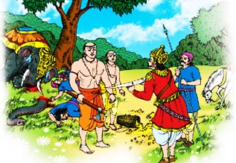
INTRODUCTION
Eripatha Nayanar, is a Shaivite saint, and considered as one among the 63 Nayanars.

LIFE
Eripatha Nayanar lived in Karur, near Sri Pasupateeswarar temple. Eripatha is a sincere devotee of Lord Shiva and a regular worshipper of Lord Pasupateeswarar. He served Lord Shiva by performing various abhishekhams and chanted his various holy names and his panchakshara mantra “OM NAMAH SHIVAYA”. He protected Shiva devotees with an axe. Once, the elephant of Chola king crushed the flowers from the flower basket of a shiva devotee. On seeing the incident Eripatha got angry with the elephant and he caught the elephant and killed it along with the elephant guard.
The news reached the ears of the Chola king. The king approached Eripatha and asked him about the reason for killing his elephant and its security. Eripatha informed about the incidents. On knowing about the incidents, the king asked the Nayanar to kill him, since the king only is ultimately responsible for the entire incidents. Eripatha was astonished on seeing the greatness of the king, and he tried to commit suicide with a sword. But the king stopped him from doing so, and Lord Shiva appeared before them and blessed them for their sincere devotion. He blessed the king and Eripatha nayanar and gave back life to the elephant and to its guard. After death, Eripatha reached the holy abode of Lord Shiva, the Kailasa and attained MUKTHI.
IMPORTANCE
Eripatha nayanar’s bhakti cannot be imagined in this today’s world. In order to safeguard shiva devotee, he murdered the elephant and its guard, and also tried to lose his life. He never thought about his life, but only thought about the life of shiva devotees, and lived a saintly life throughout in his life. He dedicated his entire life towards worshipping Lord Shiva and safeguarding his devotees.
Let us worship the great saint and be blessed.
“OM SREE ERIPATHA NAYANARE NAMAHA”
“OM NAMAH SHIVAYA”
WRITTEN BY
R.HARISHANKAR

ILAYANKUDI MARA NAYANAR
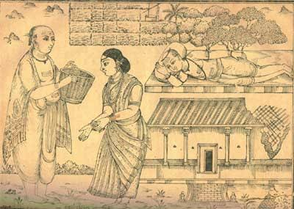
INTRODUCTION
Ilayankudi Mara Nayanar, is a follower of Shaivism and celebrated as a Nayanar and worshipped in Shiva Temples. He is a staunch devotee of Lord Shiva and lived a noble and a simple life. He regularly conducted pujas at his home and offered food to shiva devotees and then only he and his family would consume food.
INTRODUCTION
Ilayankudi Marar was born in Ilaiyangudi which is situated in Sivaganga district, tamil nadu. Since he was born in Ilayankudi he was called as Illayankudi Mara Nayanar. Marar was a farmer and got lot of agricultural lands. Though he was a rich man, he lived a simple life, and provided all the necessities to the shiva devotees and took care of them properly.
Due to his continuous food donation to the shiva devotees, his wealth was gradually diminished. Even after that, he still continued to serve the devotees by selling his agricultural lands in order to feed the devotees. In one rainy night, Lord Shiva came to his home in the form of a shiva devotee and asked for food. Mara Nayanar and his wife were starved without food for that entire day, but even then, they welcomed the devotee in a kind manner and asked him to take rest for some time. Finally the couple gathered the paddy seeds from their little farm land and also collected some greens from their field. Since they don’t have firewood to make it to burn for preparing the food, they broke a portion from their wooden roof and burnt it for preparing the food. The food was prepared and Marar delightfully went with the food to offer it to the devotee (Lord Shiva). The devotee suddenly disappeared and in his place Lord Shiva appeared with Mata Parvati and blessed them and gave all the prosperity to them. After the death of the couple, both of them reached Kailasa and attained MUKTHI.
Sundarar praises Ilayankudi Maranar for his true bhakti on Lord Shiva in his famous work Tiruthonda Thogai.
Ilayankudi Maranar is worshipped in the Tamil month of Avani in the shiva temples. He is also worshipped in the shiva temples as one among the nayanars. In the temple of Jyotishvara, a shrine is dedicated to Mara Nayanar.
IMPORTANCE
Though, he has become poor due to his noble act of providing food to the devotees, he still didn’t think about himself and his family. He thought only about rendering services to Lord Shiva and his devotees. He is such a holy and a pious man! We cannot imagine such a true shiva devotee in this today’s modern world. Let us cultivate the habit of devoting the god by going to the temples, and by providing food to the poor people and to the devotees of god.
Let us worship this great nayanar saint and be blessed.
“OM SREE ILAYANKUDI MARA NAYANARE NAMAHA”
“OM NAMAH SHIVAYA”
“OM SAKTHI PARA SAKTHI”
WRITTEN BY
R.HARISHANKAR

ISAIGNANIYAR
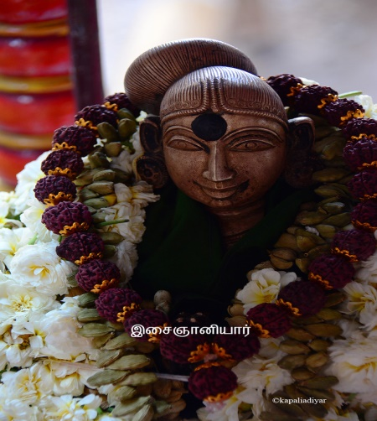
INTRODUCTION
Isaignaniyar Nayanmar was born during 12th century AD. And her son Sundara Nayanmar, her husband Sadaiya Nayanar all the three of them are Nayanmars. Isaignaniyar was born in the Brahmin caste.

LIFE
Their family lived in Tirunavalur, Tamil Nadu. Sundarar was adopted by another nayanmar known as Narasinga Muniyaraiyar.
IMPORTANCE
Being the mother of Sundarar, she was a great devotee of Lord Shiva, and was a humble and gentle woman who contains great spiritual powers. During her period, she sincerely worshipped Lord Shiva, and served food to the Shiva devotees as a daily practice. She has done lot of charitable activities, and was deeply attached with shaivism. There is a general saying about Isaignaniyar and her son Sundarar "How the thread is, so is the saree. How the mother is, so is the child". Through this, we can know about the greatness of the son and the mother. She has attained the position of Nayanmar mainly because of his son Sundarar, who was a great nayanmar saint.
CONCLUSION
A sincere devotee of Lord Shiva, who was a pure minded and pious lady, helped others towards moving to the spiritual path. Isaignaniyar is worshipped in the Tamil month of Chithirai.
She is living in Mount Kailash, the divine abode of Lord Shiva, along with her husband and son, who were also nayanmars and all the three of them were doing service to Lord Shiva. Let the Nayanmar family bless us and give us all the basic needs, and let them make us to lead a healthy, wealthy and happy life.

“OM SREE ISAIGNANIYARE NAMAHA”
“OM SREE SADAIYA NAYANARE NAMAHA”
“OM SREE SUNDARA NAYANARE NAMAHA”
WRITTEN BY
R.HARISHANKAR

IYARPAGAI NAYANAR
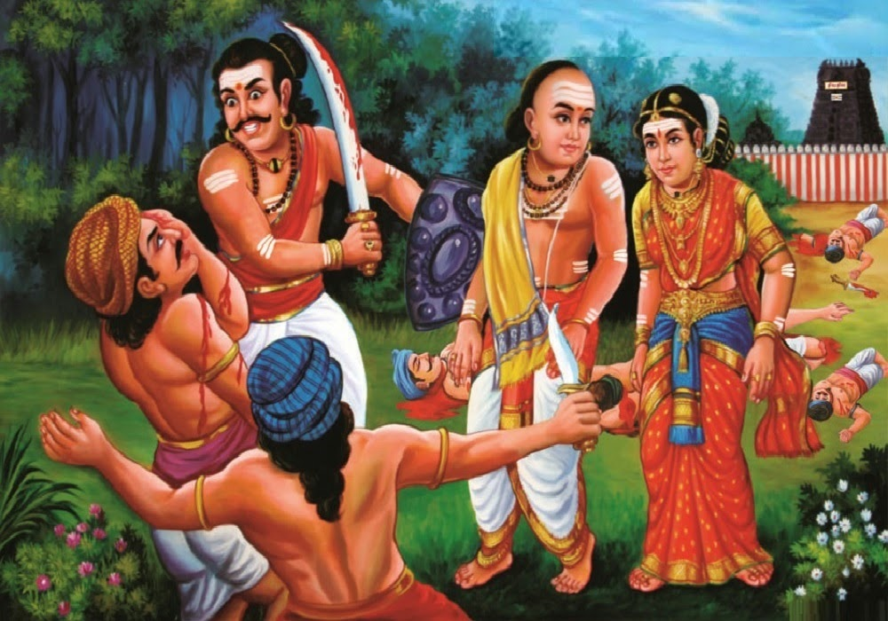
INTRODUCTION
Iyarpagai Nayanar was a great Nayanar saint, and considered as one among the 63 nayanars. His bhakti on Lord Shiva is unimaginable and unthinkable in this today’s world. It is described that his body was covered with holy ash and his each and every cell chants the shiva mantra and he shines like a precious stone.
LIFE
Iyarpagai Nayanar was born in Kaveri-poompattinam, Nagapattinam district in Tamil Nadu. Iyarpagai Nayanar belonged to the Vaishya caste and was an ardent Shiva devotee. He used to serve Lord Shiva by preparing the holy Prasad (food offering) from his home, and also provided food to his devotees, and he took care of shiva devotees in a proper manner.
Once, Lord Shiva transformed himself as an Old Shaivite saint and went to Iyarpagai's home, and he was warmly welcomed by Iyarpagai and his wife. The old Saint had asked Iyarpagai to send his wife to his house in order to serve him properly.
The great nayanar asked his wife to fulfil the wishes of the old saint (Lord Shiva). As per her husband’s command she proceeded with the divine saint. Iyarpagai protected the saint and his wife on their travel.
On knowing about the incident, the relatives of the nayanar, were got angry and tried to attack the saint with their weapons. But they could not fight and win with Iyarpagai, since he was very much skilled in handling weapons, and killed his relatives by chanting the Shiva Panchakshara mantra. Then the divine saint asked Iyarpagai Nayanar to return to his home. The Nayanar worshipped the divine saint and left from that place. After some time, he heard the crying voice of the saint, and he immediately went to the spot to safeguard the saint. On reaching the spot, the Saint had disappeared, and Lord Shiva and Mata Parvati gave their divine appearance and Lord Shiva blessed the couple for a peaceful and a prosperous life, and after their death, they attained MUKTHI.
Sundarar praises Iyarpagai Nayanar in the famous text Tiruthonda Thogai. Iyarpagai Nayanar is worshipped in the Tamil month of Margazhi, and he is also worshipped as one among the 63 Nayanars in the shiva temples.
IMPORTANCE
Iyarpagai Nayanar was a great devotee of Lord Shiva, and he devoted his entire life on worshipping Lord shiva. He provided food to the devotees of Lord Shiva and also satisfied their needs and wishes as per their requirement. In this today’s fast changing world, we cannot imagine a person with such a great bhakti on god. Let us try to develop ourselves such kind of bhakti, and live peacefully in our life.
Let us worship the nayanar saint and be blessed.
“OM SREE IYARPAGAI NAYANARE NAMAHA”
“OM NAMAH SHIVAYA”
“OM SAKTHI PARASAKTHI”
WRITTEN BY
R.HARISHANKAR

KALIYA NAYANAR
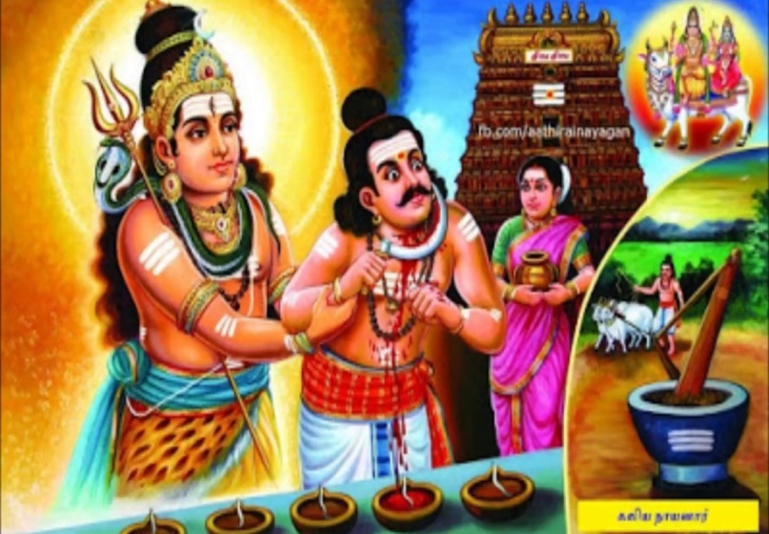
INTRODUCTION
Kaliya Nayanar, is a Nayanar saint, and belonged to Shaivism sect. He is one among the 63 Nayanars. He is an ardent devotee of Lord Shiva.

LIFE
Kaliya Nayanar was an oil merchant, and lived in Thiruvottriyur. He was a regular worshipper of Lord Shiva at the Thyagaraja Temple, Thiruvottriyur.
Kaliyan was a rich person. He used to serve Lord Shiva by lighting the lamps in the temple. Due to his continuous service, in course of time, his wealth had diminished. However, he continued his service by working as a labourer for purchasing the oil. In course of time, he has lost his job also. Finally, he decided to kill himself, since he was unable to purchase the oil for lighting the lamps in the temple. He tried to cut his throat, but he was stopped from doing that act by Lord Shiva by giving an appearance to him with Parvati and blessed him and given a permanent place in Kailash.
In the tamil month of Adi, Kaliya Nayanar is worshipped. He also worshipped as one among the 63 Nayanars.
IMPORTANCE
He tried to lose his life, since his service to Lord Shiva was interrupted. He had lost all of his richness in his life, and continued doing service to Lord Shiva. Apart from supplying oil to Shiva temple, he also performed annadanam to the shiva devotees at the Thiyagaraja Swamy Temple, Thiruvottriyur. He has done service to Lord Shiva as well as to his devotees. Though, he was a rich person, he never thought about comforts and luxuries. He thought only about doing dedicated service to Lord Shiva and to his devotees.
Let us worship the great nayanar saint and be blessed.
“OM SREE KALIYA NAYANARE NAMAHA”
“OM NAMAH SHIVAYA”
WRITTEN BY
R.HARISHANKAR
KANNAPPA NAYANAR
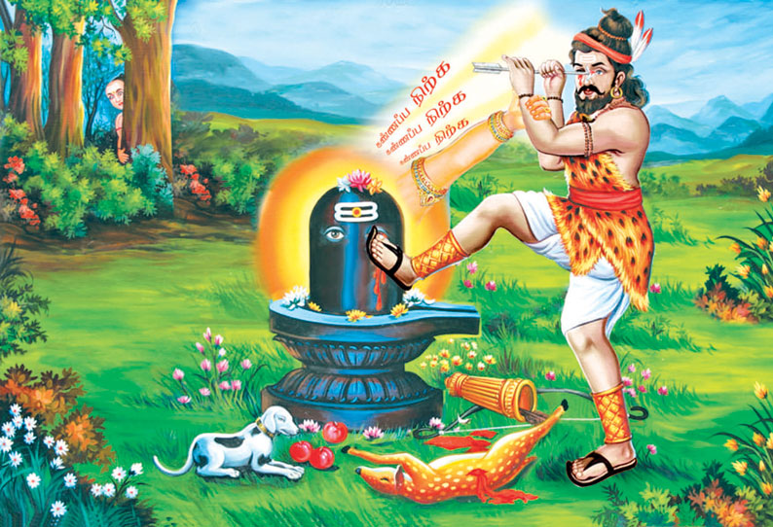
INTRODUCTION
Kannappa was a great devotee of Lord Shiva. He was born on 3102 BC in Andhra Pradesh. He is considered as one of the 63 Nayanmars. It is believed that the great warrior Arjuna took birth as Kannappa.
LIFE
Kannappa Nayanar is also known as Kannappan, was born in a hunter family, in Andhra Pradesh. His wife's name was Neela, and his birth name was Dinna.
Kannappa was a staunch devotee of Lord Shiva of SriKalahasti. Being a hunter, he worshipped in his own way. He also offered Lord Shiva the animal which he hunts. But Lord Shiva accepted his offerings in a kind manner, since Kannappan was a great devotee of Lord Shiva. Once, Lord Shiva wants to test his bhakti. Hence on one day, Lord Shiva made one of the eyes of Shiva linga to be filled with blood. On seeing that, without a second thought, Kannappa plucked his one eye out with one of his arrows, and placed it in the spot of the bleeding eye of the Shiva linga. But he noticed that again other eye of the linga has also started oozing blood. Hence, he decided to pluck, his another eye also. On seeing his great devotion, Lord Shiva appeared and restored his eyes. And he made him as one of the Nayanmars and from then onwards, he was called as Kannappa Nayanar.
IMPORTANCE
He never thought about losing his eye sight, and he immediately decided to lose his eye sight for the welfare of Lord Shiva. We can’t even imagine such a pure bhakti in this “KALI YUGA”. He acts as an example for others regarding his sincere devotion to god. We also have to try to read such great nayanmars history, and to cultivate the habit of devoting our attention towards god.
CONCLUSION
Kannappa, who was the great and mighty warrior Arjuna in his previous birth, was able to show his kindness on god to such a great extent. He has become a Nayanmar and residing in Mount Kailash and doing a great service to Lord Shiva and Goddess MAA Parvathi. Let us worship him and be blessed.
“OM SREE KANNAPPA NAYANARE NAMAHA”
“OM SREE ARJUNAYA NAMAHA”
“OM NAMA SHIVAYA”
“OM SAKTHI PARASAKTHI”
WRITTEN BY
R.HARISHANKAR

KARAIKAL AMMAIYAR
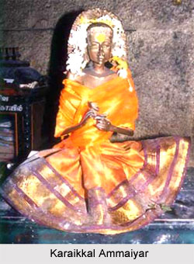
INTRODUCTION
Karaikal Ammaiyar(6th Century AD) was one of the nayanmars amongst the 63 Nayanmars. Her birth name was Punithavathiyar. She was born at Karaikal. She was a staunch devotee of Lord Shiva.
LIFE
She belonged to Chettiar Community, and she was married to a wealthy merchant from Nagapattinam.
One day her husband sent two mangoes to her, through a person, and asked her to keep it safely. After some time, a Shiva devotee asked for alms to her. She gave one of the mangoes to him, which was given by her husband. In the afternoon, his husband came to the house, and asked her to offer the two mangoes for his lunch. She prayed to Lord Shiva and by his grace, she got a mango, and she served the two mangoes to her husband. Due to its great taste, he has enquired her about the mango, and she told the truth. Without believing his wife’s words, he has asked her to produce one more mango. And due to the grace of Lord Shiva, she got one more mango and produced it to him.
He realized the greatness of his wife. And he went to the Pandiyan kingdom, and there he married a wealthy girl and lived happily, and they had one child. After knowing his whereabouts, the relatives of Punithavathi has approached him along with Punithavathi. He, with his second wife and child, fell at Punithavathy's feet, and he told to them, that she was a great divine lady.
Due to the prayer of Punithavathy, Lord Shiva transformed her body into a skeleton.
Then she went on a pilgrimage to the mount Kailash, and she finished her final part of the journey on her head. Due to that, Lord Shiva was very much satisfied with her bhakti, and made her as one of the 63 nayanmars.

CONCLUSION
Even today, every year during the tamil month of Aani on Pournami day in Karaikalammaiyar Temple, mangani thiruvizha festival will take place. Lot of Devotees will gather and celebrate the festival in a grand manner. Curd rice and mangoes are given to them as prasadam during the festival period. The festival will be celebrated in a joyful mood by the devotees for several days.
Let us pray to the great divine mother Karikal Ammaiyar and be blessed.
“OM SREE KARAIKAL AMMAIYE NAMAHA”
“OM NAMAH SHIVAYA”
WRITTEN BY
R.HARISHANKAR

KOTPULI NAYANAR
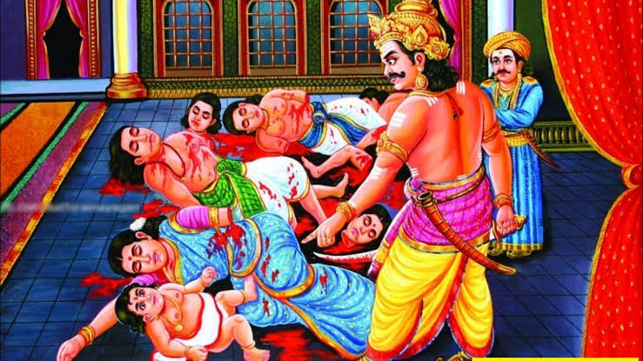
INTRODUCTION
Kotpuli Nayanar, was a great Nayanar saint, who was well known for his sincere shiva bhakti and is considered as one among the 63 Nayanars.

LIFE
Kotpuli Nayanar was born in Nattiyattankuti, in Thanjavur district of Tamil Nadu. He belongs to vellalar caste. He was an ardent devotee of Lord Shiva, and he served as Army Chief of the Chola king. He used to donate several bags of rice to Shiva temples, for preparing Naivedyam (food offering) to the god and also provided food to shiva devotees at his home. He rendered this noble act for a long period. Once he stored rice in large quantities in his house, and instructed his family to offer it as a Prasad to Lord Shiva and to feed to his devotees, and he went to other region for some time for rendering his official services.
After some time, due to severe famine, Kotpuli's family had eaten the rice in order to save themselves. After some time, Kotpuli finished his duties and returned to his home. After knowing about all the incidents, he decided to punish his family, and killed everybody, including his wife, children and parents. Though the act done by him was considered as rude and crude, he had done so, in order to punish the guilty, even though they were treated as his near and dear persons.
Due to his sincere devotion on god, Lord Shiva and Mata Parvati appeared before him and blessed him and brought back the life of his relatives again. He and his family were reached KAILASA after their death.
Sundarar praises Kotpuli Nayanar in the famous sacred text “Tiruthonda Thogai”.
Kotpuli is specially worshipped in the Shiva temple in Nattiyattankudi and he is worshipped in the Tamil month of Aadi and also worshipped along with the other nayanars in the shiva temples.
IMPORTANCE
Kotpuli Nayanar was a great shiva devotee, who always worships Lord Shiva, and considered himself as his slave. He always chants the glory of Lord Shiva and sung in praise of him. He cannot be forgotten in this world for his extreme devotion on Lord Shiva.
Let us worship the great nayanar and be blessed.
“OM SREE KOTPULI NAYANARE NAMAHA”
“OM NAMAH SHIVAYA”
“OM SAKTHI PARASAKTHI”
WRITTEN BY
R.HARISHANKAR

KUNGILIYA NAYANAR
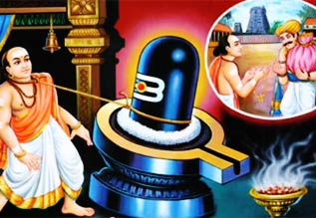
INTRODUCTION
Kungiliya Nayanar or Kalayan is a Nayanar saint, and considered as a great devotee of Lord Shiva. He is considered as one among the 63 nayanmars.

LIFE
Kalaya was born in Thirukkadaiyur,Tamil Nadu. And he was an ardent devotee of Lord Amritaghateswarar and Annai Abhirami. Kalaya worked as a temple priest and he served Lord Shiva by offering incense stick called Kungiliya( A kind of agarbathi used for shiva puja), and from then onwards he was known as Kungliya Nayanar.
Due to his divine service, in course of time, his wealth was diminished. Even after that, he continued to burn Kungiliya in Shiva's temple. Once he gave his wife’s thali (Sacred Ornament) in return for a bag of incense and went to the temple and burnt it. Shiva was pleased with the devotion of the couple and restored his wealth.
At a Shiva temple in Thiruppanandal, the shiva lingam was remained in a leaning posture. Due to the request of the chola king, he made the lingam in the straight form. The king was very happy and gave lot of wealth to Kungiliya Kalaya Nayanar. He had spent all the wealth towards doing shiva puja at his home and in the temple, and provided food to the devotees of Lord Shiva. After serving Lord Shiva and his devotees for a long time, Kungiliya Kalaya Nayanar attained Kailash, Lord Shiva's abode after his death.
IMPORTANCE
He had helped a lot for doing shiva puja, which is considered as a great sacred deed. He also provided food to the hungry people and to the devotees of Lord Shiva. He never thought about his family, but only thought about Lord Shiva and chanted his glories and his various names and recited the Shiva Mantra “OM NAMAH SHIVAYA” throughout in his life time. He also cultivated the shiva bhakti to the people. Most of the people were attracted by his speech and become the followers of Shaivism.
Let us worship the noble saint and be blessed.
“OM SREE KUNGLIYA NAYANARE NAMAHA”
“OM NAMAH SHIVAYA”
WRITTEN BY
R.HARISHANKAR

MANGAYARKKARASIYAR
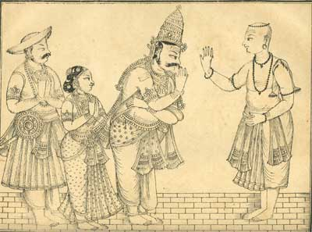
INTRODUCTION
Mangayarkkarasiyar was one of the 63 Nayanmars. She was a great devotee of Lord Shiva. Her birth name was Maani.
LIFE
She was a Chola princess. And she married the Madurai Pandiyan King, who was known as King Koon Pandiyan due to his hunch back. He had suffered from the problem of hunch back for a long time. He had converted to Jainism, and by worried about this incident, she sent the Prime Minister of the Madurai kingdom, to invite the great Saivite saints, Appar and Sambandar to Madurai.
Appar and Sambandar cured of the king’s hunchback and from then onwards, the king came to be known as Ninra Seer Nedumaara Nayanar.
By knowing the importance of Shaivism, and the importance of Appar and Sambandar, the King immediately reconverted to Shaivism.
CONCLUSION
Mangayarkkarasiyar who was a princess, and even after getting married to the pandiyan king, who was a hunch back, didn’t hate him, instead she took all efforts to cure his health, and also tried to reconvert him from Jainism to saivism. The king was cured of his health by the two nayanmars, and also by the sincere efforts put up by his wife, Mangayarkkarasiyar who was very much concerned about him. She acts as an example for others. She was a dedicated and a sincere queen, who also took care of the kingdom’s people in an affectionate manner. She has done a lot of charity works during his husband’s rule at Madurai. Due to her devotion on Lord Shiva, she has become a Nayanmar and has attained a place at Kailash, The Holy abode of Lord Shiva.
“OM SREE MANGAIYARKKARASI AMMAIYE NAMAHA”
“OM NAMAH SHIVAYA”
WRITTEN BY
R.HARISHANKAR

MEIPORUL NAYANAR
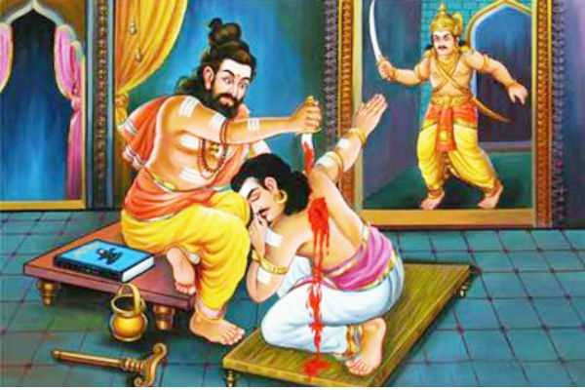
INTRODUCTION
Meiporul Nayanar is a Nayanar saint, and an ardent devotee of Lord Shiva. He is regarded as one among the 63 Nayanars.
LIFE
Meiporul Nayanar was the king of Tirukkoyilur, and a great worshipper of Lord Shiva. He was a regular visitor of Sri Veeratteswarar temple of Shiva. Meiporul Nayanar served Lord Shiva by performing regular pujas, abhishkhams and homams in the temples and served sufficient food to shiva devotees, and also took care of his people and ruled the kingdom in a proper manner. Due to his name and fame, the king of a neighbouring state, became jealous of Meiporul Nayanar and attacked his kingdom several times, but every time he was defeated by the army of Meiporul Nayanar. Finally his enemy king Muthanathan planned to kill him in various other means.
Muthanathan arrived at Tirukkoyilur, in the form of a shiva devotee. And met the king Meiporul Nayanar and attacked him with a sword, on seeing this rude act, the king’s body guard approached Muthunathan and tried to kill him. Even at his death bed, the king Meiporal Nayanar has asked his security guard to safely accompany with him and to leave him in a safety place. His security guard Dathan took muthunathan to a safety place and returned back to the king’s palace. Meiporul Nayanar called his family and his ministers to spread the glory of Shaivism and died. After his death, he reached Kailash, The holy abode of Lord Shiva and attained MUKTHI.
Meiporul Nayanar is worshipped in the Tamil month of Karthikai and appears in the form of a king and also receives worship in shiva temples similar to other nayanmars.
IMPORTANCE
Meiporul Nayanar was a great king, who sacrificed his life due to his sincere shiva bhakti. Even after attacked by his enemy king, he apologised him and let him off from his palace. During his period, he ruled his kingdom in a proper manner, and spread the shaivism sect and lived a noble life.
Let us worship this great nayanmar saint and be blessed.
“OM SREE MEIPORUL NAYANARE NAMAHA”
“OM NAMAH SHIVAYA”
“OM SREE PARVATHI ANNAIYE NAMAHA”
WRITTEN BY
R.HARISHANKAR

MURKHA NAYANAR
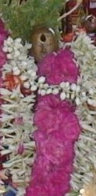
INTRODUCTION
Murkha Nayanar is a Shiva devotee, and is considered as one among the 63 Nayanars.
LIFE
Murkha Nayanar was born in Thiruverkadu in Chennai. He is an ardent devotee of Lord Shiva, and he developed shiva bhakti from his childhood. He used to serve food to the devotees of Shiva by preparing various delicious food items along with ghee and rice. Through his activity, he had spent all of his belongings and even then, he continued his practice of serving food to shiva devotees.
In order to provide proper food to the devotees of Lord Shiva, Murkha Nayanar had become a great gambler. He travelled to various places for gambling and spent the money earned through gambling by serving shiva devotees. In Kumbakonam, he won large amount of money through gambling, and spent the money towards performing temple pujas and offered Prasad to Lord Shiva in various temples at Kumbakonam and served food to the devotees of Lord Shiva. He also punished the people who had cheated the wealth earned through gambling. Through his actions, he was called as Murkha Nayanar, which means fierce and violent person. He lived a noble life by serving food to shiva devotees, and after his death, he reached Kailash, Lord Shiva's abode.
In the Tamil month of Karthikai (November–December), his festival is celebrated in a grand manner in most of the shiva temples. He will be decorated with flower garlands and various abhishekhams will be done to him. A shrine is dedicated to Murkha Nayanar in Vedapureeswarar Temple, at Tiruverkadu.
IMPORTANCE
He is a great shiva devotee, who had lost all of his wealth by providing food to shiva devotees. He never thought about his wealth. He thought only about doing pujas to Lord Shiva and feeding his devotees in a proper manner. Through his great act, he had become a nayanar and is living in Kailasa by chanting Shiva mantra “OM NAMAH SHIVAYA”.
Let us worship the great saint and be blessed.
“OM SREE MURKHA NAYANARE NAMAHA”
WRITTEN BY
R.HARISHANKAR

MURTHI NAYANAR
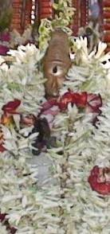
INTRODUCTION
Murthi Nayanar, is a Shiva Devotee and is one among the 63 Nayanars.

LIFE
Murthi Nayanar was born in Madurai and he was a merchant. He was an ardent devotee of Lord Shiva and he used to serve Shiva by offering sandalwood paste in order to apply it to the idol of Lord Shiva in the temple. The then ruler of Pandya kingdom was a strict follower of Jainism. He tried to convert Murthi Nayanar also to Jainism. But he remained in Shaivism and continued applying the sandalwood paste to Lord Shiva in the temple. The Jain king stopped the supply of sandalwood to his kingdom in order to stop Murthi Nayanar’s service to Lord Shiva. But, the great Murthi Nayanar used his own blood instead of sandalwood and started applying it to Lord Shiva. Pleased by his sincere devotion, Lord Shiva appeared before him and blessed him to be the Pandiyan King.
Soon after the death of the Jain king, the royal elephant garlanded Murthi Nayanar, and he became the king of Madurai. Though he was a king, he lived a simple life and ruled the kingdom in a proper manner and the spread of importance of Shaivism among the people. After his death, he reached the holy abode of Kailasa and attained MUKTHI.
IMPORTANCE
Due to his sincere bhakti, lord shiva made him as the king, and after becoming a king, he ruled Madurai in a proper manner, and during his period, all the people in his kingdom were lived happily and peacefully, and they were not suffered from mental and physical diseases and from poverty, and the people loved him very much and followed the principles of shaivism and worshipped Lord Shiva. Every day pujas were conducted in all the shiva temples in a proper manner and people were praised about his glory and greatness.
Let us worship the great nayanar saint and be blessed.
“OM SREE MURTHI NAYANARE NAMAHA”
“OM NAMAH SHIVAYA”
WRITTEN BY
R.HARISHANKAR

NESA NAYANAR
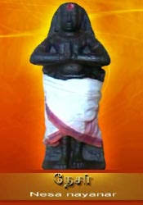
INTRODUCTION
Nesa Nayanar, also known as Sivanesa Nayanar was one among the 63 Nayanars. Nesa Nayanar was a weaver, and he got the practice of weaving the clothes and offering it to Lord Shiva and to his devotees. His life is described in the Periya Puranam by Sekkizhar and was mentioned the importance about him. Nesa Nayanar was born in Karnataka, but after some time he shifted his place to Mayiladuthurai.
He used to frequently chant the Shiva Mantra “OM NAMAH SHIVAYA” on a daily basis. Apart from donating clothes to the deity and the devotees, he used to provide food to shiva devotees at his home. He got the habit of food donation from his younger age. And according to him, donating food and clothes to the devotees of Lord Shiva, is a great good deed. Till his death, he continued the practice of giving food and the clothes to the poor and to the devotees of Lord Shiva. Due to his good deeds, and by the grace of Lord Shiva, after his death, Nesa Nayanar reached “KAILASA” the holy abode of Lord Shiva.
Swami Sivananda praises Nesa Nayanar for his sincere bhakti on Lord Shiva. He says that we must try to develop the habit of reciting shiva mantra in our life for countless number of times. By doing that act we can attain SALVATION, and can escape from this life cycle. Sundara Nayanar also praises Nesa Nayanar in the divine text Tiruthonda Thogai. Nesa Nayanar is mainly worshipped in the Tamil month of Panguni. Weavers of Mayiladuthurai worship him on this month. In shiva temples, he is worshipped by the devotees, along with the other Nayanars.
IMPORTANCE
Though he was not a rich person, he had done lot of charity works and an ardent devotee of Lord Shiva. He dedicated his entire life for doing service to Lord Shiva and to his devotees. Even today, in Kailasa, he is still worshipping Lord Shiva and Parvati and getting divine blessings from them.
Let us worship this great nayanar saint and be blessed.
“OM SREE NESA NAYANARE NAMAHA”
“OM NAMAH SHIVAYA”
“OM SAKTHI PARASAKTHI”
WRITTEN BY
R.HARISHANKAR

PARANJOTHI MUNIVAR
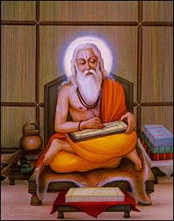
INTRODUCTION
Paranjothi Munivar, was born on 7th century AD. He was also known as Siruthondar Nayanmar, who was the army chief of the Pallava king Narasimavarman I. In course of time, Paranjothi left his job, and became a Sanyasi. LIFE
Paranjothi, was born in a village in Nagapattinam district, Tamil Nadu. Paranjothi, was specialized in various marital arts, and went to to Kanchipuram and learned tamil literature and the principles of Shaivism.

IMPORTANCE
Paranjothi was won in the battle between Narasimavarman, and the Chalukya king, Pulakeshin.
During the battle field, Paranjothi was worshipping Lord Ganesha for his victory in the battle. After his victory in the battle field, he took the statue of Vatapi Ganapathy to his birthplace Tiruchenkattankudi. Still now the statue is kept in the temple in Tiruchenkattankudi in Nagapattinam district, Tamil Nadu. “VATAPI GANAPATHY” is a famous form of Lord Ganesha, who is widely worshipped by the people, especially by the people of tamil nadu from ancient times, for their success in their life.
After winning in the battle, his mind has changed, and he moved towards the spiritual path, and became a great Saivite saint with the name as “SIRUTHONDAR”. He is one among the 63 Saivite Nayanmars.

CONCLUSION
Paranjothi was a great shiva devotee, and since he has become one of the nayanmars, he is living in the divine abode of Lord Shiva, the Kailasa. He is serving Lord Shiva in the kailasa, along with other nayanmars and shiva ganas with pure bhakti. Let him bless us, and make us a devotee of Lord Shiva. Being an ardent devotee of Lord Shiva, let him shower his grace on us, and show us the path of spirituality. Let us pray to this great saint, and be blessed.
“OM SREE SIRUTHONDA NAYANMARE NAMAHA”
“OM NAMAH SHIVAYA”
WRITTEN BY
R.HARISHANKAR

POOSALAR
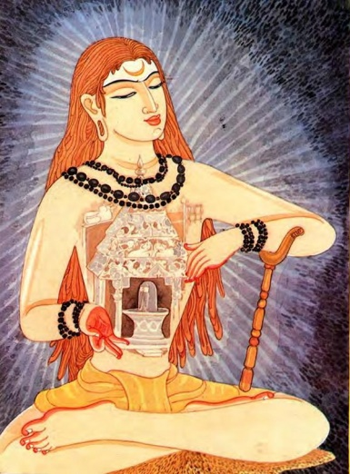
INTRODUCTION
Pusalar was born in 8th century AD. He was a saivite Nayanmar, who belonged to Shaivism sect. He is one among the 63 Nayanmars.
LIFE
Pusalar belongs to Brahmin caste. He lived in Thirunindravur,Chennai,Tamil nadu district. He spent his life towards the worship of Lord Shiva. He was a pious and a noble person.
IMPORTANCE
Pusalar was a great devotee of Lord Shiva. Once Pusalar was interested to create a big temple for Shiva, but due to lack of funds, he was unable to do so. Then, Pusalar has built a temple to Shiva in his mind. He followed all the rituals for the construction of the temple, and completed the temple, and selected a holy day for the Samprokshanam ceremony.
The Pallava king who was also a great devotee of Lord Shiva, had constructed a Shiva Temple known as Kailasanathar temple at Kanchipuram, and he also selected the same day for the Samprokshanam of his temple. And as per the instruction given by Lord Shiva in his dream, he postponed the date of consecration and went to Thirunindravur to see the temple built by Pusalar.
But the king could find any temple located at that place. Then he went to Pusalar's house and informed him about his dream. The saint informed to him that the temple was built by him in his heart. The king was amazed by Pusalar's bhakti and worshipped him. Pusalar consecrated the temple on the selected day, and continued his worship till his death, and finally attained Kailasa, the divine abode of Lord Shiva.
Hridayaleeswarar Temple, was built in Thirunindravur by the Pallavas for honouring Pusalar.

CONCLUSION
A Staunch Nayanmar who worships Lord Shiva in each and every moment, and chants his name and sings his glory, and built the temple of Lord Shiva in his heart. By reading this divine nayanmar’s history, we can get rid of all health related problems and attain peace of mind. Let us pray to this great saint, and worship him, and be blessed.
“OM SREE PUSALARE NAMAHA”
“OM NAMAH SHIVAYA”
WRITTEN BY
R.HARISHANKAR

SAMBANDAR
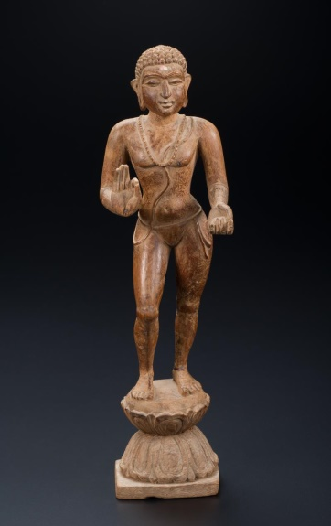
INTRODUCTION
Sambandar also known as Thirugnana Sambandar was a great shaivite saint of Tamil Nadu who lived during 7th century AD.
He is one among the 63 Nayanmars. He also contributed some portions of verses in the holy text Tirumurai.
LIFE
Sambandar was born to a holy shaivite Brahmin family in Sirkazhi at Tamil Nadu. It is believed that while he was a child and was hungry at a shiva temple, Goddess Parvati appeared before him and given him milk. He told to his father, that he was being fed with milk by Mata Parvati and started singing beaitiful song Todudaya Seviyan, the first verse of the Tevaram, describing the greatness of Lord Shiva. The song contains the details as follows:
- The Holy God Shiva who wears a beautiful ring in his ears.
- The Holy God who comes on the holy Bull, Lord Nandhideva.
- The Holy God who wears the Marvellous Moon on his head.
- The Holy God who applies the holy ash throughout in his body.
- The Holy God who is my heart and I am always thinking about him.
After his upanayanam (Sacred Thread) ceremony, he has learned all the Vedas and other divine texts. Sambandar attained MUKTHI at his younger age itself. He cured the hunchback of The Pandyan King “Koon Pandiyan”, who had converted to Jainism, and made him again to embrace Shaivism.
IMPORTANCE
He was praised for his talents and bhakti on Lord Shiva. He contributed a lot towards the upliftment of the shaivites and spread the importance of shaivism sect across the state. He was well known for his divine works, and regarded as a sincere devotee of Lord Shiva. Though he lived a short life only for 16 years, he rendered a valuable service in the spiritual field. He had reduced the bad karmic deeds of the people by praying to Lord Shiva. Through his great spiritual power, he changed the bad ones into good ones. Through his good activities, many people were relieved from their sins and became ardent devotees of Lord Shiva. He will always be remembered for his sincere bhakti and kind approach with the people. He lived a holistic life and had done many good things for the entire universe. Sambandar cured the diseases and mental illness of several people by singing songs on Lord Shiva.
Let us worship the great nayanmar saint and be blessed.
“OM SREE THIRUGNANA SAMBANDARE NAMAHA”
“OM NAMAH SHIVAYA”
“OM SREE PARVATHI THAYE NAMAHA”
WRITTEN BY
R.HARISHANKAR
SUNDARAR
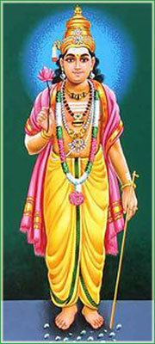
INTRODUCTION
Sundarar was an 8th century famous Shaivite Saint and is also one among the 63 Nayanmars. The Periya Puranam, tells the importance of the Nayanmars and praises the glory of Sundarar and his relation with Lord Shiva. He was also contributed a major portion in the divine tamil text Tirumurai and was widely praised by the shaivites. His birth name was Nambi Aroorar. He was born in Thirunavalur into a Shaivite Priest family. He was adopted by the king Narasingamunaiarayar, and brought him up as his own son.
Sundarar's father, Sadayan and his mother Isaignani were also nayanmars. While Sundarar was about to get married in Arulmigu Sokkantheeshwarar Temple at Puthur, Lord Shiva came in the form of an old man and asked him to sing songs on him. Sundarar began his first poem by addressing Shiva as “Pithaa pirai chudi… Perumane”. The meaning for the song is as follows:
“Lord Shiva is called by me fondly as a mad man, who was wearing the moon on his head, and controlling the entire universe, and always occupying in my mind and in the minds of several millions of his devotees. Let me always think about Lord Shiva and sing in praise of him.”
After some time, Sundarar visited several holy shiva temples of tamil nadu. And in Tiruvarur, he married a pious and noble lady Paravayar. In Thiruvottriyur, at the Vadivudaiamman Temple, he met a farmer's girl, Sangiliyar and married her also.
Sundarar is very famous for singing beautiful songs on lord Shiva and he also declares that all the living beings are equal before god, and we must give respect to each other.
At Avinashi, near Coimbatore, Sundarar prayed to lord shiva and restored the life of a dead boy who was swallowed by a crocodile.
He also taught the principles of Shaivism to his followers in a simplified manner.
Once, Sundarar took King Cheraman Peruman along with him to MOUNT KAILASH.
IMPORTANCE
Sundarar in his previous birth was one of the divine attendants of Lord Shiva with the name “ALALA SUNDARAR”. Since his attention was diverted by seeing MATA Parvati’s female attendants, he was made to be born as a human being in the earth, and to serve Lord Shiva for some time in this earth, and finally reached KAILASA, the divine abode of Lord Shiva.
He has performed many miracles in the life of the people. By chanting the names of Lord Shiva, he cured the diseases of the people, and removed their sins and given them peacefulness and happiness in their life. Through his great spiritual powers, he reduced the physical and mental sufferings of the people, and made them to chant shiva mantra and to think about Lord Shiva.
He was welcomed and given proper recognition by many kings and offered wealth. He had donated all the wealth given to him to the poor people. He daily practiced the habit of chanting shiva mantra for several lakhs of times.
He was also considered to be a friend and a devotee of Lord Shiva, and was very close to Lord Shiva while he was serving him in KAILASA. He was a fond devotee of Lord Shiva, who blessed and safe guarded him in many circumstances, and given him SALVATION at the end of his life.
Let us praise the great “SUNDARAR” and be blessed.
“OM SREE ALALA SUNDARARE NAMAHA”
“OM NAMAH SHIVAYA”
“OM PARVATHI DEVIYE NAMAHA”
WRITTEN BY
R.HARISHANKAR

THIRUMOOLAR
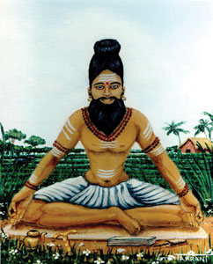
INTRODUCTION
Tirumular was a Tamil Saint, and considered as one of the sixty-three Nayanmars and also one of the 18 Siddhars. Sundaranathar was his original name. And he belonged to Madurai in Tamil nadu. According to the views of great scholars, he is believed to have taken birth during 8th century AD. And his main work, the Tirumantiram was well accepted by the tamil people.

LIFE
He travelled to Mount Kailash and was received spiritual advice from Lord Shiva. After some time, he went to tamil nadu, and met the great Maharishi Agathiyar in Pothigai mountain. While on his way, to tamil nadu, he saw a group of cows which were looked worrying due to the death of their cowherd, Moolan, who was bitten by a snake. He used his spiritual power, and transformed his soul from his body to that of the dead cowherd's body. Then the cows became happy, and so he took them to the village. His body was disappeared from the place where he left, and it was made by Lord Shiva. Lord Shiva wanted Sundara Nathar to spread his teachings from the body of Moolan, so that each and every person can understand his teachings. Since the cowherd was called as moolan, from that day onwards Sundara nathar was known by the name of Thirumoolar.
IMPORTANCE
He was a great scholar in yoga and meditation and well versed in all forms of art. He cured the diseases of the people, and made them to concentrate their attention on doing yoga and meditation. He also invoked the bhakti spirit among his followers.
CONCLUSION
Thirumoolar, a great nayanmar and also a siddhar was a devotee of Lord Shiva. Through his spiritual powers, he has helped the common people to solve their problems in a simplified manner. He taught the principles of shaivism among the common people, and insisted them to worship Lord Shiva. Let us worship this great saint, and be blessed.
“OM SREE THIRUMOOLARE NAMAHA”
“OM NAMAH SHIVAYA”
WRITTEN BY
R.HARISHANKAR

Tiru Kurippu Thonda Nayanar

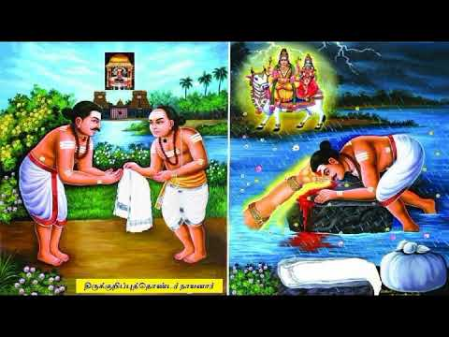

INTRODUCTION

Tiru Kurippu Thonda Nayanar is a shaivite saint and is considered as one among the 63 nayanars.

LIFE
Tiru Kurippu Thonda Nayanar was born in a Vannar(DHOBI) family at Kanchipuram.
He was a staunch devotee of Lord Shiva and served the devotees of Shiva by washing their clothes in a nice manner. He was appreciated by the people for his selfless service and considered him as a good and a noble launderer. He had done this service for the shiva devotees at a very cheap cost. And for the poor shiva devotees, he had done his washing services at free of cost. Through his good act, his name and fame were spread among the kancheepuram area and everyone was pleased by his noble act. He ate only simple food and observed fasting during Shiva rathiri and was regularly attended the prathoshala kala puja in the evenings in the shiva temple.
Lord Shiva wants to test him and appeared in the form of an old shiva devotee. The old devotee (Lord Shiva) asked to wash his clothes and to finish the work before the sunset. Due to the sudden change in the climate and also due to heavy rain, Thonda nayanar could not kept it dry before the sunset. Since he had given commitment to the old man(Lord Shiva) that he will wash his clothes before the sunset, he decided to commit suicide and tried to break his head on the washing stone. Due to his sincere devotion, Lord Shiva appeared and blessed him and granted MUKTHI after his death and made him as a nayanmar.
IMPORTANCE
Thonda Nayanar’s service to the god and to the people cannot be imaginable in today’s fast changing life. Such a good and dutiful person he is. He has born and brought up by keeping Lord Shiva in his mind. He even forgets to take food, while worshipping Lord Shiva. Apart from washing clothes to shiva devotees, he also helped them by giving good clothes and provided proper food also.
Let us worship the great nayanmar saint and be blessed.
“OM SREE TIRU KURIPPU THONDA NAYANARE NAMAHA”
“OM NAMAH SHIVAYA”
WRITTEN BY
R.HARISHANKAR

TIRUNEELANAKKA NAYANAR
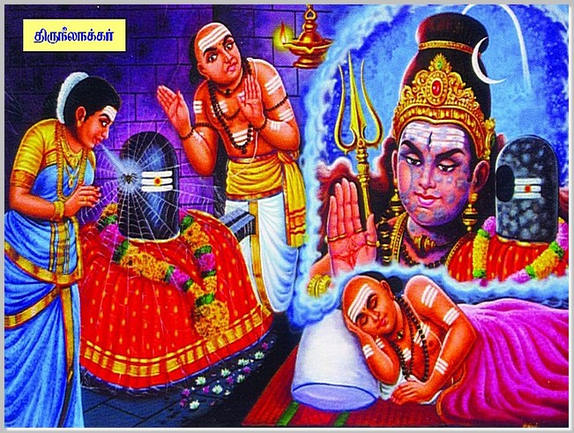
INTRODUCTION
Tiruneelanakka Nayanar was a Shaivite saint and a sincere worshipper of Lord Shiva and classified as one among the 63 Nayanars. He lived during 7th century AD and had friendly relations with the great Nayanar Thirugnana Sambandar.
LIFE
Tiruneelanakka Nayanar was born in Seeyathamangai, Nagapattinam district, Tamilnadu. He was the chief priest of the Ayavantheeswarar temple situated nearby his place, and performed various pujas and abhishekhams to the siva lingam. Tiruneelanakka belonged to the priest family, and chants mantras on Lord Shiva. He also provided food to the devotees of Lord Shiva by giving them a warm welcome to his house.
As usual when one day morning, Tiruneelanakka was performing the puja to the shiva lingam, a spider fell on the lingam. His wife attempted to remove the spider from the lingam by spitting on the lingam. She had done this act, only out of her true bhakti on Lord Shiva. But Tiruneelanakka got angry with his wife saying that she had caused impurity to the lingam by spitting on it, and then he performed various rituals to cleanse the lingam and asked for apology to the god, and he left his wife in the temple.
In the night Lord Shiva appeared in Tiruneelanakka's dream, and said that he was not got insulted by his wife’s action, and asked him to pardon his wife and to live with her. Tiruneelanakka worshipped Ayavantheeswarar, and took his wife to his home and lived happily with her.
One day, on knowing that Sambandar was passing through his place, Tiruneelanakka was very much delighted and welcomed Sambandar to his home in a grand manner. He provided rich food to Sambandar and asked him to stay for a few days in his home.
Sambandar stayed with him for few days and worshipped at the Ayavantheeswarar temple and sang beautiful songs on Lord Shiva. After some time, due to the invitation by Sambandar, Tiruneelanakka Nayanar also attended his wedding in Achalpuram.
Sundarar praises the sincere devotion of Tiruneelanakka Nayanar on Lord Shiva in the devotional text Tiruthonda Thogai. Tiruneelanakka Nayanar is worshipped by the devotees in Ayavantheeswarar temple, since he served there as a chief priest during his major part of life time. After his death, he merged with Lord Shiva.
Tiruneelanakka Nayanar is worshipped in the Tamil month of Vaikasi, and he is also worshipped as one among the 63 Nayanars in shiva temples.
IMPORTANCE
He was a great shiva devotee, who dedicated his life towards worshipping Lord Shiva. During his period, he had done several pujas to Lord Shiva and also took care of his devotees in a proper manner. He also solved the problems of the devotees of Lord Shiva according to his level best, and asked them to recite the Panchakshara Shiva Mantra “OM NAMA SHIVAYA” on a regular basis.
By consuming the temple Prasad offered by him, lot of devotees were got cured from their physical and mental diseases. He was praised for his great spiritual power.
Let us worship the divine nayanar saint and be blessed.
“OM SREE TIRUNEELANAKKA NAYANARE NAMAHA”
“OM NAMAH SHIVAYA”
“OM SAKTHI PARASAKTHI”
WRITTEN BY
R.HARISHANKAR

ADIPATHA NAYANAR
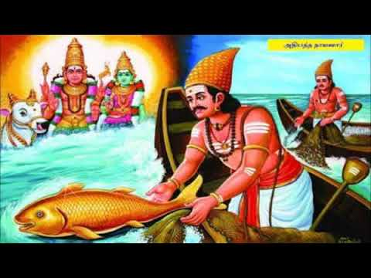
INTRODUCTION
Adipatha Nayanar was a fisher man and lived his life by catching fish in the sea. He was a great devotee of Lord Shiva and lived in Nagapattinam. He is considered as one among the 63 nayanar saints.

LIFE
He was a very good and honest person and he got his source of income by way of catching fish from the sea. As a regular practice, and through his love and devotion towards Lord Shiva, Adipatthar would dedicate the first fish he caught by throwing back into the sea. He had done this act, even if he got just one fish on a day, and he left hungry for the entire day.
Due to the divine test, Adipathar was able to catch only one fish for several consecutive days. Even then, he would throw the fish back into the sea as a sincere dedication to the god. In course of time, due to this act, he has become very poor and starved without food for several days. One day due to Lord Shiva’s grace, he caught a big golden fish, and since it was the first fish he caught, he dedicated the fish to Lord Shiva by throwing the fish back into the sea with much devotion in his mind.
The Lord immediately appeared in front of him along with Mata Parvati and blessed him for a prosperous life and granted all the riches in his life. And after his death, he reached Kailasa, and attained MUKTHI.
IMPORTANCE
Adipatha was a great nayanar who never thinks about himself and his family, but only thought about Lord Shiva and praised his glories. Though he got a rich fish, he doesn’t want to keep it for himself, and he dedicated it to Lord Shiva. He has got such a pure bhakti in his mind. Let us develop the same kind of bhakti similar to him and attain all the prosperity in our life, and finally we can attain MOKSHA.
Let us worship the great nayanar saint and be blessed.
“OM SREE ADIPATHA NAYANARE NAMAHA”
“OM NAMAH SHIVAYA”
WRITTEN BY
R.HARISHANKAR

AIYADIGAL KADAVARKON NAYANAR
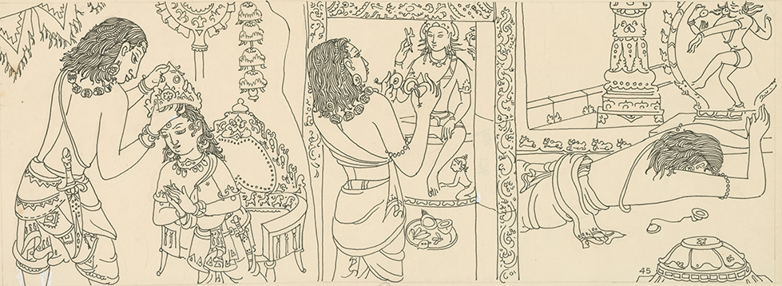
INTRODUCTION
Aiyadigal Kadavarkon(6th century AD), was a ruler of Kanchipuram. He was a stauch devotee of Lord Shiva and he was considered as one among the 63 nayanar saints.
The Pallava king Aiyadigal Kadavarkon worshiped Lord Shiva with utmost faith and sincere devotion and ruled his kingdom in a well versed manner through the blessings of Lord Shiva. He protected and renovated the Hindu temples and took care of his people and invoked the spirit of Shaivism among the people. The king was a great scholar and written many songs in praise of Lord Shiva.
The king had given a golden rule during his period. People were praised him and they were free from fear and threats. There were adequate food grains stored in the godown. He also opened many dharma shalas(Choultries) throughout his region, in order to provide proper food to the poor people. In his regime, no one had suffered from poverty and ill health. In his kingdom, the entire people lived a happy life by chanting the holy shiva mantra “OM NAMAH SHIVAYA” and gave proper respects to their king “KADAVARKON”.
After sometime, he crowned his son and helped him towards administering the kingdom. After his son has become an able administrator of the kingdom, he left his kingdom and he had undergone pilgrimage to various Shiva temples, and composed divine songs on Lord Shiva. Finally he reached Thillai Nataraja Temple, Chidambaram and stayed there permanently and worshipped Lord Shiva. After his death, he merged with Lord Nataraja.
His devotional songs are known as Kshetra Tiruvenba. He is worshipped as one among the other nayanar saints in the shiva temples.
IMPORTANCE
Even though he was a king, he was bored with enjoying the pleasures in the royal palace, but he was interested in spirituality and in his middle age he has become a saint and travelled to many holy shiva temples.
He had done many good services to the temples, and conducted temple rituals like doing homams, regular pujas and abhishekhams to the god and the goddess. He provided all the basic amenities to the people and lived a meaningful life.
Let us worship the great nayanar saint and be blessed.
WRITTEN BY
R.HARISHANKAR

AMARANEEDI NAYANAR
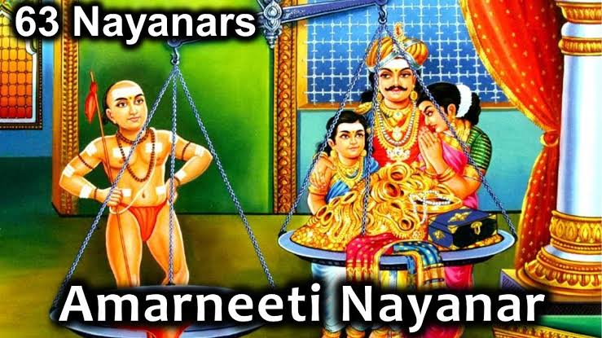
INTRODUCTION
Amaraneedi Nayanar was a Nayanar saint, and considered as one among the 63 nayanars. He is an ardent devotee of Lord Shiva.
LIFE
Amaraneedi Nayanar was born in Pazhayarai,in the chola dynasty. He belongs to Vaishya community and earned his living by doing jewellery and garments business. Amaraneedi was a sincere devotee of Lord Shiva. He served Lord Shiva in his temples, and also provided food and clothes to the devotees of Lord Shiva. He got the habit of donating the kowpeenams (UNDERWEAR) to Shiva devotees. Once, he visited the Kalyanasundaresar Temple of Tirunallur and worshipped Lord Shiva at the temple and stayed there for some time. One day, Lord Shiva transformed himself in the form of a Shaivite saint and visited Amaraneedi nayanar at his place. The saint wore a simple cloth and looked very pious and charm. The saint had asked to keep safely with him one of his Kowpeenams(UNDERWEAR) and left that place.
After some time the saint (Lord Shiva) returned, and asked for his Kowpeenam which he had given it to him. Since, Lord shiva made the kowpeenam to disappear from that place, Amaraneedi could not find the Kowpeenam and searched for it. After some time Amaraneedi asked for an apology and had offered good quality of several koupeenams to the saint.
But the saint had refused to accept it and placed his fresh koupeenam in a weighing scale and asked him to give new koupeenams according to the weight of his koupeenam. Amarneedi kept many koupeenams in the pans, but it was not balanced. Finally, Amarneedi had worshipped Lord Shiva and chanted the Panchakshara mantra, “OM NAMAH SHIVAYA” and got into the pan along with his family. Immediately, the pans were balanced. The Saint disappeared and in his place Lord Shiva appeared with Mata Parvati and blessed the family. After their death, the entire family were attained MUKTHI.
Appar praises Amaraneedi Nayanar, for his sincere devotion on Lord Shiva. Sundarar also praises him in the Divine Text “Tiruthonda Thogai”.
Amaraneedi Nayanar is worshipped in the Tamil month of Aani, and also worshipped along with other nayanars in the shiva temples.
IMPORTANCE
Though he was a wealthy person, he lived a noble and a humble life and worshipped Lord Shiva on a daily basis. He chanted shiva mantras and recited his names throughout in his life. Due to his pure bhakti on god, he attained SALVATION and reached kailasa, the holy abode of Lord Shiva.
Let us worship the great nayanar and be blessed.
“OM SREE AMARANEEDI NAYANARE NAMAHA”
“OM NAMAH SHIVAYA”
“OM SAKTHI PARA SAKTHI”
WRITTEN BY
R.HARISHANKAR

CHERAMAN PERUMAL NAYANAR
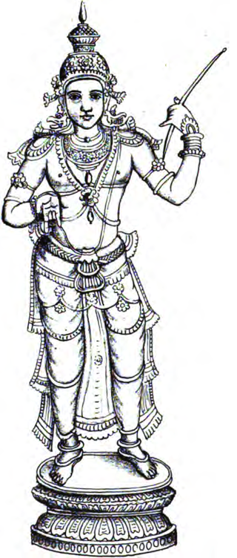
INTRODUCTION
Rajashekhara (9th century AD), was also called as Cheraman Perumal Nayanar, was a Chera ruler at Kodungallur in Kerala. He was a great ruler and got good knowledge in penning devotional poems. He was considered as one among the 63 nayanar shavite saints. He ruled his kingdom in a well versed manner with great shiva bhakti in his mind. He also renovated the temples and conducted regular puja services and performed rituals in the temples and rewarded the shaivite poets and provided food to the devotees of Lord Shiva in the shiva temples. He cultivated the bhakti spirit and developed the habit of chanting the Shiva mantra “OM NAMAH SHIVAYA” among the people.
He had contributed three sacred texts in praise of Lord Shiva. They are as follows:
- Ponvannattandadi – In praise of Lord Shiva
- Tiruvarur Mummanikkovai – In praise of Lord Thyagaraja in Thiruvarur Temple
- Tirukkailayajnana Ula – In praise of Lord Shiva
His importance was described in the tamil text Periyapuranam, written by the popular poet Chekkizhar. He was the friend of Sundara Murti Nayanar.
At his younger age itself, he was an ardent devotee of Lord Shiva and regularly worshipped him at the Tiruvanchikkulam Temple. Even he was not interested in enjoying the pleasures and comforts in his royal palace. He kept on meditating Lord Shiva and recited his mantra and chants his various names with pure bhakti. He later became the king of Kerala, and ruled his kingdom in a proper manner. He met Sundarar at Thiruvarur, and they were become good friends and went on pilgrimages to several shiva temples throughout south india. After several years, he reached the holy abode of KAILASA along with his friend SUNDARAR and attained MUKTI.

IMPORTANCE
He had gifted several lands to the temples and constructed Annadana choultries throughout his region, for providing food to the tired traveller and also to the poor people and for the shiva devotees. Due to his good activities, his name and fame was spread across the state. People began to follow shaivism and worshipped Lord Shiva with much eagerness and great devotion. He was praised by the people for his courage, knowledge, wisdom, good ruling capacity and devotion on the god. He was also mentioned in several ancient tamil texts, and describes his greatness and gentleness towards shiva devotees and to his people.
Let us worship the great nayanar and be blessed.
“OM SREE CHERAMAN PERUMAL NAYANARE NAMAHA”
“OM NAMAH SHIVAYA”
“OM SAKTHI PARASAKTHI”
WRITTEN BY
R.HARISHANKAR

EYARKON KALIKKAMA NAYANAR
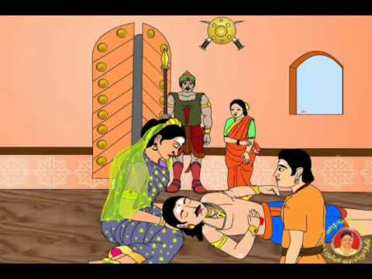
INTRODUCTION
Eyarkon Kalikkama Nayanar was a Nayanar saint, and an ardent devotee of Lord Shiva. He lived during the period of Sundarar.
LIFE
Kalikkama was born in Tiruperumangalam. He belongs to vellalar caste. He was a staunch devotee of Lord Shiva. Kalikkama served as an army chief of the Chola ruler. He was a regular visitor of the shiva temple at Thirupungur, and performed pujas and abhishekhams to Lord Shiva and also offered food to the devotees of Lord Shiva.
Once, Sundarar had asked for the help of Lord Thyagaraja(Another form of Lord Shiva), at Thiruvarur Temple to carry his message and to convey it to his wife Paravaiyar. On knowing about the incident, Kalikkama thought that sundarar had utilized the services of Lord Shiva for his personal purposes, and according to him the act done by Sundarar was not nice, and he got angry with sundarar. After some time Kalikkama suffered from severe stomach pain. Lord Shiva appeared in Kalikkama's dream and asked him to meet Sundarar in order to get relieved from his stomach pain, and Lord Shiva asked sundarar to meet Kalikkama at his place. But Kalikama doesn’t want to meet sundarar and killed himself with his sword.
On knowing about the incident, Sundarar also decided to commit suicide. But Kalikkama was given back life by Lord Shiva and he also stopped Sundarar from committing suicide. Due to Lord Shiva’s grace, Kalikkama become a friend of Sundarar and both of them worshipped Thyagaraja in Thiruvarur. Kalikkama spent rest of his life at Thirupungur and after his death he reached the holy abode of Lord Shiva, the kailasa.
Manakanchara Nayanar, had gifted the hair of his daughter to a shaivite saint (Lord Shiva) just before the marriage of his daughter to Kalikkama. Lord Shiva appeared in his true form and blessed the family. And the daughter of Manakanchara Nayanar’s hair was also grown. Kalikkama after hearing about the incident was very much worried for not getting the darshan of Lord Shiva.
Sundarar praises Eyarkon Kalikkama Nayanar in the sacred text “Tiruthonda Thogai”. Eyarkon Kalikkama Nayanar is worshipped in the Tamil month of Aani, and he is also worshipped as a nayanar in the shiva temples.
IMPORTANCE
Kalikkama Nayanar was a great shiva devotee and he spent his time in chanting the shiva mantra and reciting the shiva slokas, performing shiva pujas at his home and in the temples and visiting the shiva temples and worshipping Lord Shiva with sincere devotion in mind. He also spread the bhakti spirit throughout in his region, by giving regular discourses on shiva bhakti to the people.
He also helped the poor shiva devotees by giving them food, clothing and provided shelters to them. His service to the god and to the human cannot be described in words. He had rendered a selfless service to the god and to the people, and due to his great bhakti, he attained MUKTHI. He is still chanting the shiva mantra in kailasa and serving Lord Shiva and Mata parvati with sincere devotion.
Let us worship the great nayanar saint and be blessed.
“OM SREE EYARKON KALIKKAMA NAYANARE NAMAHA”
“OM NAMAH SHIVAYA”
“OM SAKTHI PARASAKTHI”
WRITTEN BY
R.HARISHANKAR

GANANATHA NAYANAR
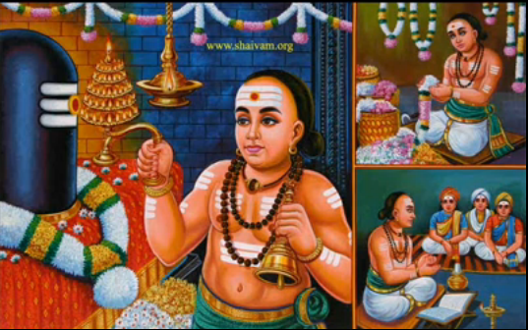
INTRODUCTION
Gananatha Nayanar is a famous nayanar saint and after his death, he has become the head of the attendants of Lord Shiva and is still living in Kailasa by serving Lord Shiva and Mata Parvati Devi. His selfless service to the god and to the devotees of Lord Shiva had made him to reach the KAILASH.
LIFE
He was born in a Brahmin family in Sirkazhi. He was an ardent devotee of Lord Shiva and a regular visitor of Brahmapureeswar Temple (Sattainathar Temple) and worships Lord Shiva, in the form of Thoniappar. He conducted pujas in the temple, and offered naivedyam (Food offering) to the Lord and also provided food to the devotees of Lord Shiva at his home.
He had given lectures on shaivism and invoked the bhakti spirit among the people. He was a great scholar in all the subjects was well versed in chanting vedas and shiva mantras. Many people were impressed by his services and contributed their portion of work with regard to plucking flowers from the flower garden and fetching the water from the well for pouring it to the shiva lingam etc. He took care of the shiva devotees in a proper manner, and apart from providing food to them, he also distributed clothes to the poor devotees and also educated their children in a proper manner.
Gananatha Nayanar was also a devotee of Sambandar, and considered him as his guru, and learned the shaivite philosophies from him.
Due to his sincere dedication on the god, and towards his great service to the people, after his death, he attained MOKSHA, and went to the divine abode of Lord Shiva, The Kailasa. In the Tamil month of Panguni, his birth day is celebrated as Guru Pooja day in all the Shiva temples.

IMPORTANCE
He had shown love and affection to everyone without any caste discrimination. He was loved by the people, and treated him with great respect. He doesn’t hate anybody, and moved with the people in a soft manner. Due to his kind behaviour, lot of people were got attracted with him, and eagerly listened to his divine lectures on Lord Shiva. He eliminated the unnecessary thoughts, and filled up with only good thoughts in his mind. During his life, he had done lot of good karmic deeds by doing service to the god and to the people.
By reading his life history, let us try to cultivate the habit of helping others and praying to the god with utmost faith in our mind.
Let us chant the name of the great nayanar saint and be blessed.
“OM SREE GANANATHA NAYANARE NAMAHA”
“OM NAMAH SHIVAYA”
“OM SAKTHI PARASAKTHI”
WRITTEN BY
R.HARISHANKAR
IDANGAZHI NAYANAR
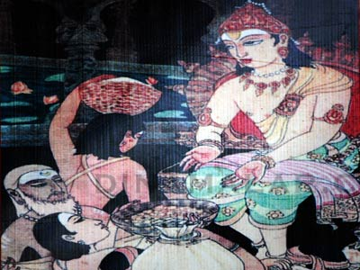
INTRODUCTION
Idangazhi Nayanar was a shaivite king, and was one among the 63 Nayanars. He was a great devotee of Lord Shiva and respected his devotees.
LIFE
Idangazhi was born and brought up in Kodumbalur in Tamil Nadu. Idangazhi was one of the small rulers who served under the Chola king. He belonged to the yadava community.
He implemented many new schemes for the worship of Lord Shiva in temples as per the Shaiva traditions. In his region, there lived a shaivite saint and daily he provided food to hundreds of shiva devotees in his home. Once he became very poor due to his noble act of food donation. In order to provide food to the shiva devotees, he entered the food treasury to steal the rice, but was noticed by the guards and he was presented to Idangazhi, and he understood the reason behind the burglary. And he immediately released the devotee. Idangazhi then announced that shiva devotees are allowed to take as much food grains in the godown. By doing that, he relieved the shiva devotees from their hungry. Idangazhi was such a humble and a noble king, who respected the shiva devotees in a proper manner.
Idangazhi Nayanar is specially worshipped in the Tamil month of Aippasi, and he is also worshipped as one among the 63 nayanars in the shiva temples. Throughout his life, he concentrated his attention on regularly visiting shiva temples, conducting proper pujas, provided food to the devotees of Lord Shiva, and ruled the kingdom properly and took care of his people in a good manner.

IMPORTANCE
He spread the importance of shaivism among the people and invoked them into shiva bhakti. Though he was a ruler of a kingdom, he lived a noble life, and followed the spiritual path in his life. People were praised him for his shiva bhakti and for being a mighty ruler of the kingdom.
Let us worship the great nayanar and be blessed.
“OM SREE IDANGAZHI NAYANARE NAMAHA”
“OM NAMAH SHIVAYA”
WRITTEN BY
R.HARISHANKAR

KALARSINGA NAYANAR
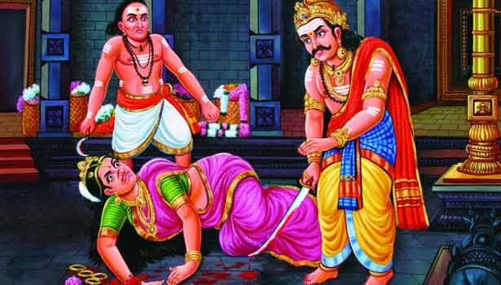
INTRODUCTION
Kalarsinga Nayanar was a Nayanar saint, and a strict follower of Shaivism sect. He ruled his pallava dynasty in a proper manner. During his period, he spread the shaivism sect throughout his region, and people in his region were lived happily and peacefully.
LIFE
Kalarsinga was a Pallava king and conquered many kingdoms and become a great emperor. He was an ardent devotee of Lord Shiva, and he went to many places to visit Shiva temples. Once, he travelled to Thiruvarur along with his queen and worshipped Lord Shiva at the Sri Achaleswarar Temple. The queen picked a flower from the flower garden in the temple and smelt it. Seruthunai Nayanar who was serving at the temple noticed the queen's actions, and got angry with the queen and punished her by severing her nose. The king Kalarsinga enquired, and Seruthunai Nayanar told about the entire incident. Kalarsinga considered that the punishment given by the nayanar to the queen was inadequate, and with his sword, he chopped off the hand of the queen also, by which she lifted the flower. Karlarsinga was blessed by Lord Shiva for his noble action, and the queen’s nose and arm was restored by the grace of Lord Shiva.
After his death, he reached the divine abode of Lord Shiva, the kailasa and is still serving Lord Shiva and Mata Parvati and chanting his shiva panchakshara mantra “OM NAMAH SHIVAYA”.
Sundarar praises Kalarsinga Nayanar in the famous text “Tiruthonda Thogai” and describes his greatness of serving the god with much loyalty and faith.
Kalarsinga Nayanar is worshipped in the Tamil month of Vaikasi, and he is also worshipped as one among the nayanars in the Shiva temples.

IMPORTANCE
Kalarsinga Nayanar was a great shiva devotee who ruled his kingdom by worshipping Lord Shiva, and performed regular pujas and other temple rituals in a proper manner in the shiva temples situated in his region. He also provided necessary services to his people and took care of the shiva devotees in a proper manner. He provided food to the poor people and to the devotees of Lord Shiva on a regular basis. His dedicated service to the god and to his devotees will always be remembered by the shiva devotees, and he will permanently reside in the hearts of the shiva devotees and bless them and give them all sorts of prosperity in their life.
Let us worship the great nayanar saint and be blessed.
“OM SREE KALARSINGA NAYANARE NAMAHA”
“OM NAMAH SHIVAYA”
“OM SAKTHI PARASAKTHI”
WRITTEN BY
R.HARISHANKAR
KALIKAMBA NAYANAR
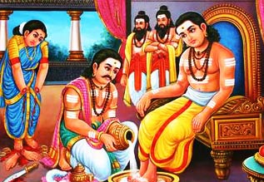
INTRODUCTION
Kalikamba Nayanar, is a Shaivite saint, and a great shiva bhakta. He is considered as one among the 63 nayanars.
LIFE
Kalikamba Nayanar was born and brought up in Virudhachalam and lived nearby Sudarkozhundeesar Temple, and he belonged to vaishya caste. He was a regular worshipper of Lord Shiva and used to go to shiva temples and served Lord Shiva by offering divine Prasad to him and also used to provide food to the shiva devotees with much pleasure and delight. As usual when once, he and his wife were offering food to shiva devotees, when his wife come across to provide food to a devotee, she recognised that the devotee was their ex servant and stopped serving food to him. Kalikamba got very angry with his wife and he chopped both of her hands with his sword. But due to the divine grace of Lord Shiva, her hands were restored. And she realized her mistake and continued providing food to all the devotees, without noticing about their caste, creed, status or community.
Kalikamba Nayanar was worshipped as one among the 63 nayanars in the shiva temples. After his death, he and his wife were reached the holy abode of Lord Shiva, the kailasa.
IMPORTANCE
Kalikamba Nayanar considers that all the shiva devotees are the manifestation of Lord Shiva. He had done his duties sincerely till his death. He was a sincere devotee of Lord Shiva, who regularly performed shiva puja in his home and took care of his devotees in a proper manner. He also recited the shiva panchakshara mantra “OM NAMAH SHIVAYA” on a daily basis. He invoked the people in the bhakti path and spread the shaivism sect throughout the region.
Let us worship this great nayanar saint and be blessed.
“OM SREE KALIKAMBA NAYANARE NAMAHA”
“OM NAMAH SHIVAYA”
WRITTEN BY
R.HARISHANKAR

KANAMPULLA NAYANAR
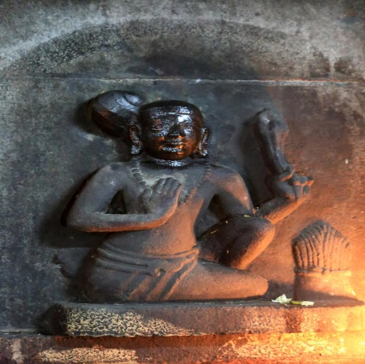
INTRODUCTION
Kanampulla Nayanar is a Nayanar and he is a great devotee of Lord Shiva. He lived his life by cutting the grass and selling it in Shiva temples in order to use it as lamp wicks. Since he was the seller of the kanampul grass, he was called as Kanampulla Nayanar.
LIFE
Kanampulla Nayanar was born in the family of farmers in a village, located at Nagapattinam District, Tamil Nadu. He was also a regular worshipper of Lord Shiva and frequently visits Vaitheeswaran Temple.
Through the income derived from farming activity, he lighted the lamps in Shiva temples. He will used to sing songs on Lord Shiva and would serve the god with food offering (Prasad) and provided food to the devotees of Lord Shiva at his home. Due to his continuous charity activities, very soon he had lost all of his wealth, and then he shifted to Chidambaram, and worked as a labourer by cutting and selling Kanampul grass. He purchased oil and ghee for lighting lamps in the Nataraja Shiva temple, and he also done various abhishekams to Lord Shiva with his meagre income.
After some time, due to severe drought, he found very difficult to earn income and unable to sell the grass, but he still continued serving Shiva by lighting lamps in the temple, by eating food only once in a day. Finally, he offered his own hair for burning the lamps in the temple. Due to his sincere bhakti, Lord Shiva appeared before him and granted MUKTHI.
In the Tamil month of Karthikai – Kirithigai star, he is honoured in the shiva temples and guru puja is performed.
IMPORTANCE
He was a great nayanar saint who offered his own hair for burning the lamps in the shiva temples. He had done services to the god as well as to his devotees. He also spread the shaivism sect among the people.
Let us worship the great nayanar and be blessed.
“OM SREE KANAMPULLA NAYANARE NAMAHA”
“OM NAMAH SHIVAYA”
WRITTEN BY
R.HARISHANKAR

KARI NAYANAR
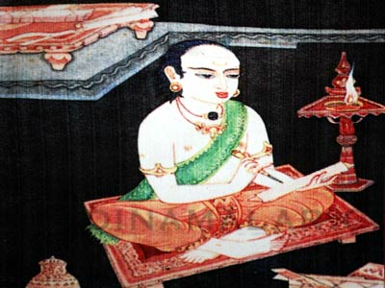
INTRODUCTION
Kari Nayanar is one of the 63 nayanar saints, and was a great worshipper of Lord Shiva. He rendered a famous Tamil text named as Karikkovai. Hence he was called as Kari Nayanar.
LIFE
Kari Nayanar was born in a Brahmin family in Thirukkadaiyur, Near Amritaghateswarar - Abirami Temple and the ancient Thirukkadaiyur Mayanam temple. He was an ardent Shiva devotee and also a learned scholar. He composed devotional songs on Lord Shiva. He spent his wealth for providing food to the devotees of Lord Shiva. He also constructed Shiva temples, and maintained the temples in a proper manner. He also regularly visited and worshipped the shiva temples in his region, and performed puja and abhishekham to Lord Shiva. He chanted the shiva panchakshara mantra on a daily basis, and he used to take food only after chanting the mantra. He also donated clothes and given shelter to the poor shiva devotees, and fulfilled all their basic amenities.
During the Tamil month of Masi his birthday is widely celebrated as Guru Puja Day in the shiva temples.
IMPORTANCE
Being a pious Brahmin, he dedicated himself to the service of Lord Shiva. He doesn’t distinguish the devotees of Shiva with regard to their caste and community. He treated everyone as the messengers of shiva, and provided good service to them. He got sufficient wealth from the kings, in appreciation to his famous poems, but utilized the entire money towards doing service to the god and to the servants of the god.
Daily he used to get up early in the morning, and worships Lord Shiva in the temples and conducted pujas in the temples and offered Prasad (food offering) to the god, and also donated food to the devotees of Lord Shiva and to the poor. He had continuously done this work till the end of his life. Through his sincere and dedicated service to the god and his devotees, after his death, he attained MOKSHA and merged with the god.
Let us worship the great nayanar saint and be blessed.
“OM SREE KARI NAYANARE NAMAHA”
“OM NAMAH SHIVAYA”
“OM SAKTHI PARASAKTHI”
WRITTEN BY
R.HARISHANKAR

KOCHCHENGANAN NAYANAR
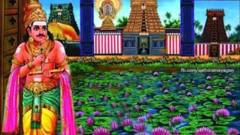
INTRODUCTION
Kochchenganan was an ancient chola king. He was supposed to have lived before several thousands of years ago. He was an ardent devotee of Lord Shiva, and spent his life towards devoting Lord Shiva in shiva temples and offering various puja services and performed abhishekhams and homams to please the god. He also ruled his kingdom in a proper manner, and provided all the amenities to his people. He had given a golden rule without causing any difficulties to the people of his kingdom.
He was mentioned in the Sangam poetry. He was praised by the great poet Poygaiyar for his efficient rule and for his sincere shiva bhakti on Lord Shiva. He was also praised by the great Nayanar Saints Thirugnana Sambanthar and Sundaramoorthy Nayanar for his skills in warfare and for his dedicated service on Lord Shiva and to his devotees. His importance was mentioned in the famous text Periyapuranam.
He built the Ayyarappan Temple in Kurumbalur. He used to worship Lord Shiva at the Ayyaarappan Temple on a daily basis. He made arrangements to perform regular pujas for Lord Shiva. He also provided food to the devotees at the temple. He built the Thiruvanaikaval temple at Trichy, and Kailayanathar Temple at Nagapattinam.
IMPORTANCE
He had done lot of good activities in his life like constructing shiva temples, renovation of various temples and conducted rituals in the temples in his region. He regularly chants the shiva panchakshara mantra “OM NAMAH SHIVAYA”, and also celebrated the festivals like Shivarathiri and Thiruvathirai in a grand manner, and established flower gardens in the temples and done various good activities to the people. He also invoked the shiva bhakti spirit among the people. And he asked the people to chant the shiva panchakshara mantra on a daily basis.
Let us worship the great nayanar and be blessed.
“OM SREE KOCHCHENGANAN NAYANARE NAMAHA”
“OM NAMAH SHIVAYA”
“OM SAKTHI PARASAKTHI”
WRITTEN BY
R.HARISHANKAR

KULACHIRAI NAYANAR
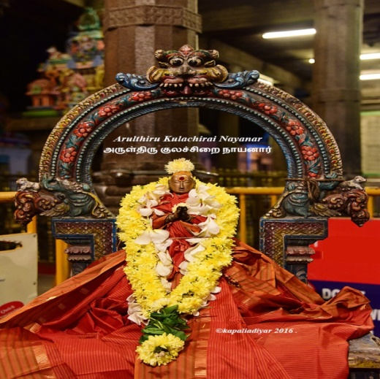
INTRODUCTION
Kulachirai Nayanar was the minister of the Pandyan king, Ninraseernedumaran, and is considered as one of the 63 Nayanars.
LIFE
Kulachirai Nayanar was born in a pious family in the Pandyan Kingdom and he served as the Minister of the Pandyan King. He was an ardent devotee of Lord Shiva.
Once, the Pandyan dynasty was dominated by the Jain Monks. The Pandyan King was converted to Jainism and compelled his people to convert into Jainism. The Jain monks got greater power in the kingdom. Hindus in the pandyan kingdom were suffered by the domination of jain monks. The Queen Mangayarkkarasiyar was very much worried about the condition of the pandyan kingdom. She consulted with the minister Kulachirai Nayanar about the wide spread of Jainism in their region.
The Queen and the Minister visited Appar and Sambandar to Madurai. They cured the hunch back of the King Koon Pandiyan, and made him to realize the importance of shaivism. Sambandar had explained the importance of shaivism and the King immediately reconverted to Shaivism. Due to his reconversion, the influence of Jainism was gradually diminished in Madurai and shaivism sect had gained top priority among the people. All the three persons, the pandiyan king, his wife Mangayarkkarasiyar and his minister Kulachirai Nayanar were considered as nayanmars and worshipped in the Shiva Temples.
IMPORTANCE
Kulachirai Nayanar was a great nayanar saint who had dedicated his entire life on worshipping Lord Shiva and also made sincere efforts to reconvert the Pandyan king from Jainism to Hinduism.
Let us worship the great nayanar and be blessed.
“OM SREE KULACHIRAI NAYANARE NAMAHA”
“OM NAMAH SHIVAYA”
WRITTEN BY
R.HARISHANKAR
KUTRUVA NAYANAR
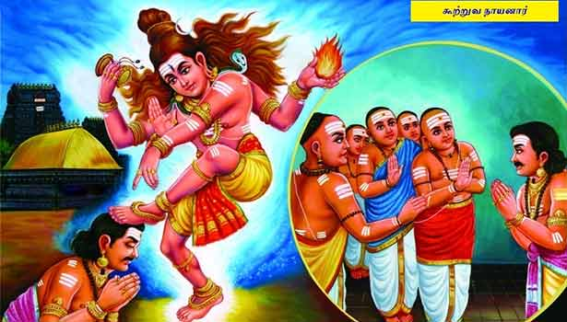
INTRODUCTION
Kutruva Nayanar was a ruler of the Kalandai region, Thiruvarur district of Tamil nadu, and a Nayanar saint and an ardent devotee of Lord Shiva. He is considered as one among the 63 nayanar saints. Though he belongs to Jain community, he was a sincere worshipper of Lord Shiva.
LIFE
Kutruva was a great ruler of his region and defeated many kings and became a wealthy person. Even though he was a great warrior, he was not crowned as the king for the other regions which he had captured through the battle. He requested the priests of the Chidambaram Nataraja temple to crown him as the king. The priests were refused to crown him stating that, he was not a king from the chola dynasty and also belongs to Jain community and left that place and took shelter in Kerala under the protection of the chera king. Finally, Kutruva approached Lord Nataraja, to crown him. Nataraja appeared in Kutruva's dream and crowned him as the king. He worshipped Lord Shiva with great devotion and done many good services to the god and also to the people. He constructed annadana mandapams across the state and provided free food to the visitors of his region and to the poor people. He also gave all the necessities to the people. Due to his good activities, after his death, he attained SALVATION, and reached the holy abode of Lord Shiva, the kailasa.
Sundarar praises Kutruva Nayanar in the famous text Tiruthonda Thogai, and he is described as the great devotee of Lord Shiva.
Kutruva Nayanar is worshipped on the Tamil month of Adi. He is worshipped as a nayanar along with the other nayanars in the shiva temples.
IMPORTANCE
Though he belongs to Jain community, he was a staunch devotee of Lord Shiva, which leads him in ruling his kingdom properly and finally attained SALVATION. During his period, he had given a golden rule, and the people were lived happily without any difficulties in their life. No one was suffered from poverty and hungry. He sorts out the problems of the people immediately and made them to live peacefully in his region.
Let us worship the great nayanar king and be blessed.
“OM SREE KUTRUVA NAYANARE NAMAHA”
“OM NAMAH SHIVAYA”
“OM SAKTHI PARASAKTHI”
WRITTEN BY
R.HARISHANKAR

MANAKANCHARA NAYANAR
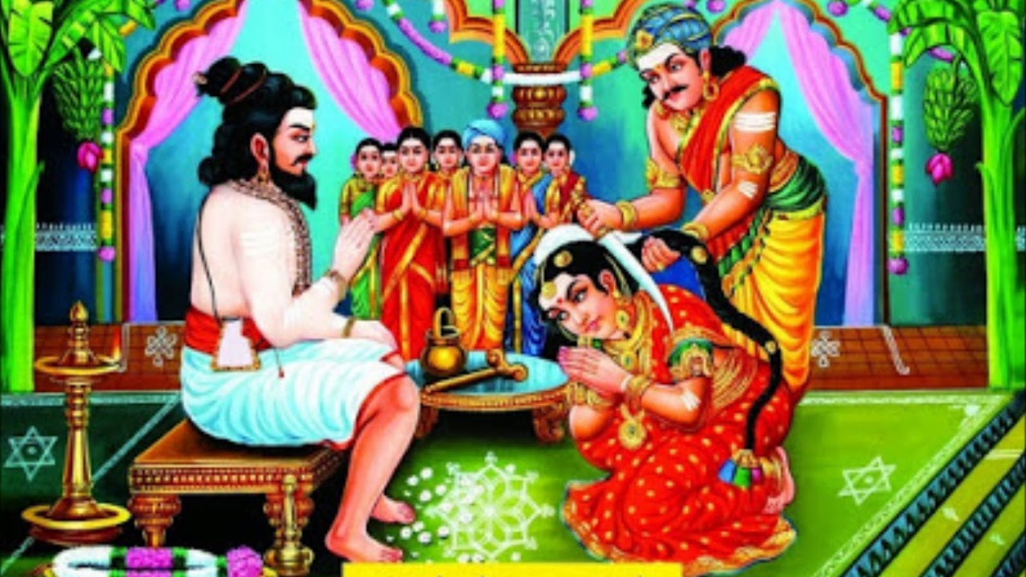
INTRODUCTION
Manakanchara Nayanar was a Nayanar saint, and he is considered as one among the 63 Nayanars. He was a staunch devotee of Lord Shiva. It is believed that he lived in the 8th century AD.
Manakanchara Nayanar was born in Kancharur, in Tamil Nadu. He served Lord Shiva and his devotees in a good manner. He was the army chief of the chola kingdom. Manakanchara was a brave and sincere person and won in several battles due to the grace of Lord Shiva. He conducted regular worship in shiva temples and donated clothes and food to the poor and the devotees of Lord Shiva.
He was blessed with a beautiful and dutiful daughter by the name Punniya Vardhini. She was sincerely devoted to Lord Shiva from her young age. As she grew up, her family members arranged her marriage to Eyarkon Kalikkama Nayanar, who was also an army chief of the Chola kingdom. He was also a sincere devotee similar to his father in law Manakanchara Nayanar.
On the day of the Punniya Vardhini’s wedding, Lord Shiva transformed himself as a shaivite saint and wore sacred thread made of human hair called as panchavati. Manakanchara Nayanar attended to him with great respect. The saint (Lord Shiva) had blessed him and his daughter, and asked to donate her long hair to him in order for making his panchavati. Immediately, Manakanchara Nayanar removed the hair of his daughter and given it to the saint. Nobody will be interested in removing their daughter’s hair and that too at the time of her wedding. Such a holy and a pious Nayanar he is. And his daughter was very pious and a good girl who had sacrificed her hair with much pleasure in her mind, and she didn’t thought about her marriage life. The saint was vanished from that place, and Lord Shiva along with his consort Parvati appeared before the family of Manakanchara Nayanar, and blessed them for a prosperous life.
Due to the grace of Lord Shiva, the bride's hair was also grown within few seconds. His son in law Kalikkama Nayanar had arrived at that wedding place and got to know about the divine incidents. Kalikkama was over joyed and married Punniya Vardhina and lived a long life with the blessings of Lord Shiva.
The temple of Sri Panchavateeswarar, highlights the appearance of Lord Shiva and his blessings to Manakanchara Nayanar. It is located in Nagapattinam district, Tamil Nadu. Manakanchara Nayanar is worshipped in the Tamil month of Margazhi, and he is also worshipped as one among the 63 Nayanars.
IMPORTANCE
Manakanchara Nayanar and his son in law Kalikkama were ardent devotees of Lord Shiva and done services to the god as well as to his devotees. But of them were very brave and contained wisdom, knowledge and courage. They spent their entire life towards devoting Lord Shiva by singing songs on him and reciting his various names and slokas and lived a simple and a noble life. They were very humble and soft spoken persons, who never allowed themselves luxuries and comforts in their life.
Let us worship the nayanmars and be blessed.
“OM SREE MANAKANCHARA NAYANMARE NAMAHA”
“OM SREE PUNNIYA VARDHINI DEVIYE NAMAHA”
“OM SREE KALIKKAMARE NAMAHA”
WRITTEN BY
R.HARISHANKAR

MUNAIYADUVAR NAYANAR
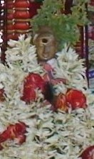
INTRODUCTION
Munaiyaduvar was a Nayanar saint, and a great devotee of Lord Shiva. He was a strict follower of the principles of shaivism. Munaiyaduvar is described as a soldier, who would fight for the weak and non-courageous kings and use the wealth received from them in service of Lord Shiva and his devotees. Munaiyaduvar also used his earnings for renovating the ancient temples and conducted regular pujas at the shiva temples.
LIFE
Munaiyaduvar was born in Needur in Nagapattinam district of Tamil Nadu. He belongs to vellalar caste. He was an ardent devotee of Lord Shiva. He was very much interested in serving Lord Shiva and his devotees, and he had done this noble act till his death. He was a great soldier and was skilled in handling all kinds of weapons during the battle. After living a peaceful and a glorious life by doing the service of Lord Shiva, after his death he attained Kailash, Lord Shiva's Holy abode.
Swami Sivananda praises the Nayanar towards his righteousness in advocating his duties and he also praises his great shiva bhakti. Sundarar praises Munaiyaduvar in the sacred text “Tiruthonda Thogai” and informs us that he is a great shiva devotee and served properly to Lord Shiva and to his devotees.
Munaiyaduvar is worshipped in the Tamil month of Panguni in the shiva temples. He also is worshipped as one among the nayanars in the shiva temples.
Munaiyaduvar is specially worshipped in the Somanathaswami temple at Needur. Lord Shiva had given his appearance to him in this temple. A shrine is dedicated to him in the temple.
IMPORTANCE
The nayanar regularly used to take his food only after worshipping Lord Shiva and after serving food to the devotees of Lord Shiva. Though he was a soldier, he ate simple food, and dedicated his entire life towards serving Lord Shiva and his devotees. He cannot be forgotten in this world for his sincere and dedicated service to the god and to his devotees.
Let us worship the great nayanar saint and be blessed.
“OM SREE MUNAIYADUVAR NAYANARE NAMAHA”
“OM NAMAH SHIVAYA”
“OM SAKTHI PARASAKTHI”
WRITTEN BY
R.HARISHANKAR

MURUGA NAYANAR
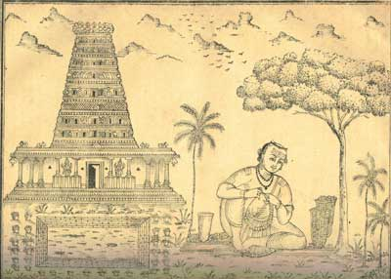
INTRODUCTION
Muruga Nayanar is a great shiva devotee and considered as one among the 63 nayanar saints. He lived a saintly life and was fully devoted to Lord Shiva. He spent his entire time in doing puja to the Shiva Lingam and decorating it with flower garlands and also done various types of abhishekhams to Lord Shiva. In addition to that, he also provided food to the devotees of Lord Shiva at his home.
LIFE
Muruga Nayanar was born in a Brahmin family in a village in Nagapattinam District, Tamil Nadu. He got the habit of leaving his home in the early morning and collecting various fragrant flowers for adorning it to Lord Shiva at the Thirupugalur Temple. He recited the Panchakshara mantra “OM NAMAH SHIVAYA” as a daily practice. He will used to visit the temple on a daily basis.
Muruga Nayanar maintained friendly relations with other Nayanars like Sambandar, Thirunavukkarasar and Sundarar. The great nayanar saints Sambandar and Thirunavukkarasar, were stayed for some time in his home and visited the Thirupugalur temple. He was appreciated by Sambandar due to his sincere devotion on Lord Shiva. The Tamil month Vaikasi, is celebrated as Muruga Nayanar's Guru pooja day in all the Shiva temples. He is also worshipped as a nayanar in the shiva temples.
IMPORTANCE
He was a great nayanar saint who dedicated his entire life towards worshipping Lord Shiva, and also done services to the devotees of Lord Shiva. He sincerely performed puja in his home and also in the temple and performed all the rituals in the temple. He was appreciated by several nayanars for his well-known service to Lord Shiva.
Let us praise the glory of Muruga Nayanar and be blessed.
“OM SREE MURUGA NAYANARE NAMAHA”
“OM NAMAH SHIVAYA”
WRITTEN BY
R.HARISHANKAR

NAMI NANDI ADIGAL NAYANAR
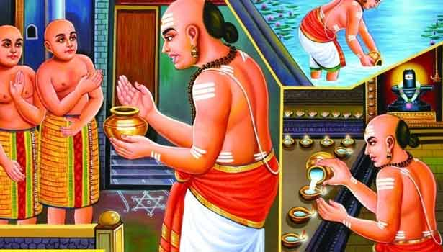
INTRODUCTION
Nami Nandi Adigal is a Nayanar saint, and the follower of Shaivism, and an ardent devotee of Lord Shiva. He is considered as one among the 63 nayanars.
LIFE
Nami Nandi Adigal was born in Thiruvarur. He belongs to Brahmin community and he got the habit of daily worshipping Lord Shiva at the Achaleswarar temple in Thiruvarur. Once, when he reached the temple, he wants to pour ghee in the lamps of the temple. Hence, he approached the residents in that area, who were belonged to Jain religion. They insulted and refused to give him ghee for lighting the lamps in the Shiva temple. Hence, he worshipped Lord Shiva and brought water from the temple tank and poured it in the lamps. Due to the divine grace of Lord Shiva, when he lit the lamps, it was burnt brightly to the surprise of the devotees of the temple. Daily he had lighted the temple lamps by pouring water. The Jains were very much astonished and were converted into Shaivites. The Chola king heard the news and appointed him as the chief priest of the Achaleswarar temple. He administered the temple in a proper manner by conducting the daily temple rituals and performed pujas and homams in the temple.
Once during the temple festival, people of all castes were participated. Nami Nandi Adigal returned home and did not worship Lord Shiva in his home since he thought that he was impure since he had mingled with the people of other castes during the temple festival. That night, Lord Shiva appeared in his dream and objected his behaviour, and asked him to treat all the living beings in the earth as the form of Lord Shiva. He realized his mistake, and interacted with everyone, without seeing their caste. Nami Nandi Adigal lived a holy life by serving Lord Shiva and his devotees.
He also provided food to the devotees of Lord Shiva at his home, and recited the shiva planchakshara mantra on a daily basis. He was also a great scholar and mastered in all the hindu scriptures, vedas and uphanishads. He chants the shiva rudram on a daily basis. Due to his sincere bhakti on Lord Shiva, he attained Kailash, Lord Shiva's holy abode, after his death.
The Airavatesvara Temple, Darasuram depicts the tale of Nami Nandi Adigal, who lightens the lamps with water. Appar praises him for performing the lamp miracle, and describes him as a magnificent gem among the nayanars. Nami Nandi Adigal receives worship similar to the other Nayanars in the shiva temples.
IMPORTANCE
He was a great devotee of Lord shiva, who keeps him in his soul, and worships him regularly in the temple also. He contains spiritual knowledge, wisdom, courage and boldness due to the divine grace. He spent his life in a peaceful manner by uttering the names and mantras of Lord Shiva. Every day he would take food, only after doing shiva puja, and after providing food to the devotees of Lord Shiva.
His bhakti is a great one, which cannot be compared with anyone in this today’s modern world. Let us try to learn from this great nayanar saint and concentrate our attention only on divine matters and eliminate our unnecessary and unwanted thoughts and be blessed.
“OM SREE NAMI NANDI ADIGALE NAMAHA”
“OM NAMAH SHIVAYA”
“OM SAKTHI PARASAKTHI”
WRITTEN BY
R.HARISHANKAR

NANDANAR NAYANAR
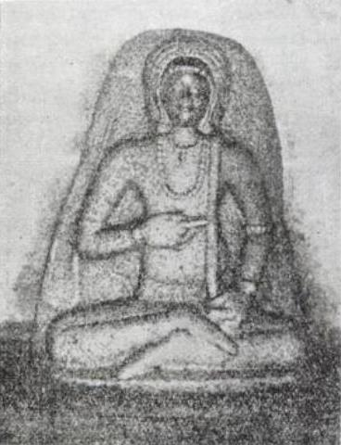
INTRODUCTION
Nandanar (7th Century AD) was a Nayanar saint, and a follower of Shaivism. He was a staunch devotee of Lord Shiva, and spent his life towards worshipping Shiva with sincere faith and devotion in his mind.
LIFE
Nandanar belonged to Adanur in Thanjavur district, Tamil Nadu. He was born in the Dalit community, and during that time, they were considered as untouchables among the people. The Dalits were lived their life by working as labourers in the agricultural fields and as singers and musicians, and they were highly regarded for their great interest in spirituality and bhakti towards the god. They lived honestly and faithfully with controlled mind, and considered themselves as the servants of the god. They are to be considered as the children of the god, for their good nature and pleasing manners.
Once, in Sivalokanathar Temple, Tirupunkur, due to his prayers a giant stone bull had moved to some distance, and still appears in the moved position in the temple. Nandanar ritually purified himself in the fire at Thillai Nataraja Temple, Chidambaram, and become a bright looking person and appeared as a holy Brahmin.
Sundarar also praises Nandanar in his sacred text. Nambiyandar Nambi also mentioned the greatness of Nandanar in his divine text “Tiruttondar Tiruvandhadhi”.
He lived his life by making leather items, and also a maker of musical instruments. Nandanar also undertook the task of cleaning the temple tanks and painting the walls of the temple, and done various repair works in the shiva temple, due to his love and affection on Lord Shiva. He also regularly provided food to the poor devotees of Lord Shiva in the shiva temples.
Nandanar is specially worshipped in the Tamil month of Purattasi and also worshipped as a nayanar in the Shiva temples.
A sculpture of Nandanar is found in the Chidambaram temple, and also in Airavatesvara Temple of Darasuram.
IMPORTANCE
Though he was born in a lower caste family, he purified himself in the fire, and come out as a holy Brahmin. His mind was fully filled up with the thoughts of Lord shiva and he attained spiritual energy through the divine grace of Lord Shiva. He chants the shiva panchakshara mantra “OM NAMAH SHIVAYA” on a daily basis, and also insisted others to recite the mantra. He was against caste discrimination, and contained good thoughts in his mind. By worshipping him, we will get great peacefulness in our life, and can eliminate our bad and unwanted thoughts in our mind, and will get more strength in our body and in our mind and our spiritual energy will get boosted.
Let us worship the great nayanar saint and be blessed.
“OM SREE NANDANAR NAYANARE NAMAHA”
“OM NAMAH SHIVAYA”
“OM SAKTHI PARASAKTHI”
WRITTEN BY
R.HARISHANKAR

NARASINGA MUNIYARAIYAR NAYANAR
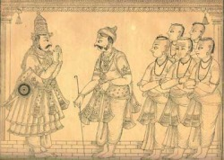
INTRODUCTION
Narasinga Muniyaraiyar Nayanar is the Nayanar saint and an ardent devotee of Lord Shiva.
LIFE
Narasinga Muniyaraiyar Nayanar was the ruler of the state Tiru Munaipadi. He adopted Sundarar as his son and brought up Sundarar by providing all sorts of comforts to him.
He was a great devotee of Lord Shiva and his people were happy during his period. He had arranged several pujas and conducted homams at the Shiva temples on Shiva rathiri and Thiruvadirai festival. He also conducted puja in the temples on a daily basis. He provided food to the devotees of Lord Shiva, and took care of them in a good manner. He chanted the shiva panchakshara mantra on a daily basis. He would take his food, only after doing puja to Lord Shiva.
Once on a Thiruvathirai festival day, Lord Shiva transformed himself as a poor shiva devotee and attended the shiva puja and wears only a small cloth in his body. On seeing his appearance, the devotees were disliked with him. But, Muniyaraiyar gave a warm welcome to the poor devotee and offered rich food to him, and also gifted him gold coins and good dresses to him. His noble act was pleased by Lord Shiva, and he appeared in his true form with Mata Parvati and blessed him for a long life. And after his death, Muniyaraiyar had reached KAILASA, the divine abode of Lord Shiva.
During the tamil month of Purattasi his birthday is grandly celebrated as Guru Puja Day.
IMPORTANCE
Due to his good karmic deeds done during his last birth, he had got an opportunity to adopt Sundarar as his son. Though he was a king, he lived a simple life, and concentrated mainly on shiva bhakti, and provided services to the god and to his devotees. He also spread the shaivism sect among the people, and explained the importance of worshipping Lord Shiva to the people.
Let us worship the great nayanar and be blessed.
“OM SREE NARASINGA MUNIYARAIYAR NAYANARE NAMAHA”
“OM NAMAH SHIVAYA”
“OM SAKTHI PARASAKTHI”
WRITTEN BY
R.HARISHANKAR

NINRA SEER NEDUMARA NAYANAR
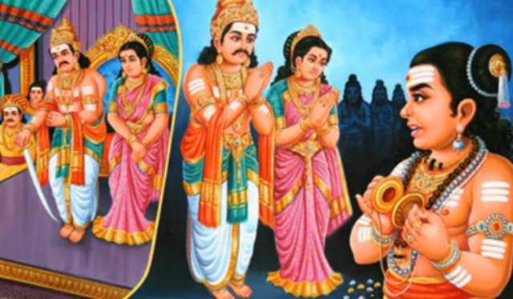
INTRODUCTION
Nedurama Pandiyan also called as Koon Pandiyan due to his hunch back was the Pandiyan king who ruled Madurai in the 7th century. He had converted from Shaivism to Jainism, due to the influence of Jain monks in his region, but then again re-converted into Shaivism through the guidance of Sambandar. After he got cured by Sambandar he was called as Sundara Pandiyan ("Handsome Pandiyan King") and Ninra Seer Nedumara Pandiyan, since he was relieved from his hunch back.
During the 7th century, Jainism was flourished throughout South India. Koon Pandiyan had embraced Jainism, but his wife, Mangaiyarkkarasiyar, and his minister, Kulachirai Nayanar, were remained as Shaivites. When the king suffered from hunch back and severe health related problems his wife and his minister were invited the Great Shaivite saint, Sambandar, to Madurai. Sambandar is said to have relieved him from his several health related problems. After getting relieved from the health problems, the king immediately embraced Shaivism, and his people were also converted to Shaivism during his rule. Sekkizhar praises the glory of the nayanars Koon Pandiyan, Kulachirai and Mangaiyarkkarasiyar and all the three of them were attained SALVATION and reached Mount Kailash after their death.
IMPORTANCE
Nedurama nayanar had ruled his kingdom in a well versed manner. He took the advice of Sundarar and reconverted into shaivism. And after getting converted into shaivism, he had renovated the ancient shiva temples, and made arrangements to conduct regular pujas in the shiva temples. He also provided food to the devotees of Lord Shiva in the Shiva Temples. During his reign, people were happily lived without any sorts of difficulties.
Let us worship the great nayanar saint and be blessed.
“OM SREE NEDUMARA NAYANARE NAMAHA”
“OM SREE SUNDARARE NAMAHA”
“OM NAMAH SHIVAYA”
WRITTEN BY
R.HARISHANKAR

PERUMIZHALAI KURUMBA NAYANAR
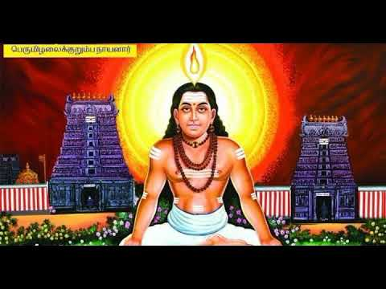
INTRODUCTION
Perumizhalai Kurumba Nayanar is one of the nayanar saints in shaivism sect. His greatness is mentioned in the divine text “Thiruthondar Thogai” and described him as an ardent devotee of Lord Shiva, and also the staunch follower of the famous nayanar saint Sundarar. He is described as a pious and a humble person, who treated others with great respect and considered the devotees of Lord Shiva as similar to that of Lord Shiva. In his free time, he will used to worship Lord Shiva with flowers and performed various pujas to Lord Shiva.
LIFE
Perumizhalai Kurumba Nayanar was born in Perumanallur village in Pudukottai district, Tamil Nadu and belongs to Kurumba sect. Every year, his birth day is celebrated during the tamil month of Aadi as guru Pooja in his village.
Kurumba Nayanar had worked under the ruler of the Perumizhalai region. Though he was not a rich person, Kurumba Nayanar supplied food packets to the poor people and to the devotees of Lord Shiva throughout the region. He got the habit of visiting Shiva temples in his locality at least once in a day. He lived a simple life and spent his life by worshipping Lord Shiva and chanting his shiva panchakshara mantra “OM NAMAH SHIVAYA” and also invoked the shiva bhakti spirit among the people. He was an honest, sincere and a straight forward person.
Kurumba Nayanar lived during the period of Sundarar and Kotpuli Nayanar. Kurumba Nayanar was considered as the disciple of Sundarar and given him proper respect, and learned the shaivite principles from him. Due to the divine blessing of Lord Shiva, he was mastered in all the subjects and attained great spiritual power. He was very much attached with his guru sundarar and worshipped him as equivalent to that of Lord Shiva.
IMPORTANCE
He was a sincere devotee of shiva and meditated him for several days even without food. He acquired divine knowledge from Sundarar, and was well known for his charity works. He was praised by the people for his simplicity and generosity, and for his kind nature.
Let us worship the great nayanar saint and be blessed.
“OM SREE KURUMBA NAYANARE NAMAHA”
“OM NAMAH SHIVAYA”
“OM SREE SUNDARARE NAMAHA”
WRITTEN BY
R.HARISHANKAR

PUGAL CHOLA NAYANAR
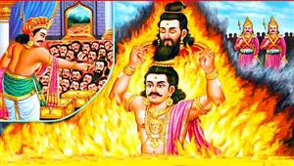
INTRODUCTION
Pugal Chola Nayanar was the king of the chola dynasty and was one among the 63 Nayanars. He was an ardent devotee of Lord Shiva, who ruled his kingdom with the blessings of Lord Shiva, and took care of his people in a well versed manner. He donated food and clothes to the poor people and to the shiva devotees. He also properly maintained the temples in his kingdom, and conducted regular pujas and performed abhishekhams to Lord Shiva.
LIFE
Pugal Chola ruled Tiruchirappalli with much devotion on Lord Shiva. Pugal Chola is described as a great king who ruled his kingdom in a proper manner. Shaivism was flourished throughout his region. Once, he visited Karur. His royal elephant seized the flower basket from the hands of a shiva devotee. On seeing the incident, a great nayanar saint, Eripatha murdered the elephant and the elephant guard. After Pugal Chola got the news about the murders, he went into the spot and enquired about the incident. Eripatha told the entire incident. Pugal Chola asked the Nayanar to kill him since he is the ultimate responsible person for that region. Eripatha got astonished with the good act of the king, and he tried to kill himself with his sword. Lord Shiva appeared before them and granted his blessings and brought back the life of elephant and the guard.
Once, Pugal Chola fought with the king Adiyaman and was won in the battle. Pugal Chola had a glimpse of the severed heads of the enemy soldiers in the battle field. Among the soldier’s head, he saw the head of a shiva devotee. Hence he decided to commit suicide, and he crowned his son as the king, and took the head of the devotee in a vessel on his head. He chanted the Shiva Panchakshara mantra and fell into the fire and was died. Immediately he reached the holy abode of Lord Shiva, the kailasa for his sincere devotion on Lord Shiva.
He is specially worshipped in the Tamil month of Aadi, and also worshipped as a nayanar in the shiva temples.
IMPORTANCE
His sincere shiva bhakti had given him to reach the holy “KAILASA”. He had given very good respect to the shiva devotees. He had sacrificed his life, towards killing an innocent shiva devotee by his soldiers. His greatness will never be forgotten by the people, and his noble act would always remain in the mind of the people.
Let us worship the great nayanar and be blessed.
“OM SREE PUGAL CHOLA NAYANARE NAMAHA”
“OM NAMAH SHIVAYA”
“OM SAKTHI PARASAKTHI”
WRITTEN BY
R.HARISHANKAR

PUGAZH THUNAI NAYANAR
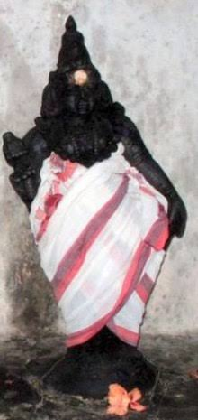
INTRODUCTION
Pugazh Thunai Nayanar was a Nayanar saint, and is considered as one among the 63 Nayanars, and is well known for his sincere devotion on Lord Shiva.
LIFE
Pugazh Thunai Nayanar was born in Alagaputhur in the Thanjavur district of Tamil Nadu. He belonged to the priest caste. The Nayanar was an ardent devotee of Lord Shiva. He worked as a temple priest at the Padikasu Nathar Temple of Alagaputhur. He used to perform abhishekham to the Lingam and performed various pujas for Lord Shiva. He also provided food to the devotees of Lord Shiva at his home.
Once, due to severe drought, he has become very poor and was unable to provide himself food and to his family. His body became very weak. One day due to severe hunger he was fainted and he could not proceed to do puja for shiva lingam. Due to the grace of Lord Shiva daily he was presented with a gold coin at the foot of the lingam in order to sustain himself and his family till the end of the famine. He continued his services till the end of his life, and after his death, he reached the holy abode of Lord Shiva, The Kailasa.
Sundarar praises Pugazh Thunai Nayanar in the divine text “Tiruthonda Thogai”.
Pugazh Thunai Nayanar is worshipped with his wife in the Padikasu Nathar Temple. His descendants were still serving as the temple priests. Pugazh Thunai Nayanar is specially worshipped in the Tamil month of Avani.
IMPORTANCE
Pugazh Thunai Nayanar was a dedicated shiva devotee who lived with the thoughts of Lord Shiva, and done his services to the god and to his devotees in a proper manner. He was well known for his utmost faith and pure devotion on god.
Let us worship the great nayanar and be blessed.
“OM SREE PUGAZH THUNAI NAYANARE NAMAHA”
“OM NAMAH SHIVAYA”
WRITTEN BY
R.HARISHANKAR

RUDRA PASUPATHI NAYANAR
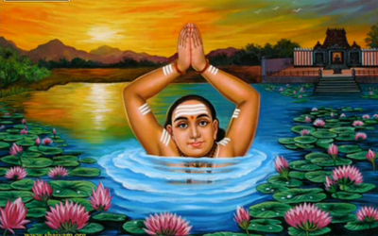
INTRODUCTION
Rudra Pasupathi Nayanar is a shaivite saint and a great shiva devotee and considered as one among the 63 nayanars. Pasupathi Nayanar belongs to Brahmin community and daily recites the Namah shivaya mantra along with the chanting of Shri Rudram. Hence, he was called by the name Rudra Pasupathi Nayanar. He also got the habit of doing shiva puja at his home and in the temple and provided food to the shiva devotees. He was a humble and a sweet natured person, who doesn’t gets angry with any one, and also spoke to others in a soft and pleasing manner.
LIFE
Rudra Pasupathi Nayanar was lived in a small village of Thiruvarur District. In his village, he lived nearby a famous shiva temple “Sri Parvati Samedha Sri Baleswarar temple”. Daily he will used to visit the temple and worship Lord Shiva and Mata Parvati and chant various shiva mantras and offers flowers and perform food offering (Prasad) to the god, and also performed various abhishekhams to the Shiva lingam and to Goddess Parvati Devi.
Rudra Pasupathi Nayanar was a sincere Shiva devotee. He used to take a dip in the nearby pond in the early morning and evening and chant Shri Shiva Rudram and “NAMAH SHIVAYA MANTRA” and offer prayers to Lord Shiva. His ardent bhakti on Lord Shiva was very much pleased by the people in his region, and they listened to his lectures on shaivism and started reciting the shiva mantra. Due to his sincere bhakti on Lord Shiva, after his death, he reached “KAILASA” the holy abode of Lord Shiva.
He is worshipped in the Tamil month Purattasi and his birthday is celebrated as Guru Puja Day. He is also worshipped as one among the nayanars in the shiva temples.
IMPORTANCE
He lived his entire life, by doing good services to the god as well as to the people. He invoked the bhakti path among the people, in order to make them to attain SALVATION. He helped the people by giving various spiritual discourses on shaivism, and also guided them to lead the spiritual path.
Let us worship the nayanar saint and be blessed.
“OM SREE RUDRA PASUPATHI NAYANARE NAMAHA”
“OM NAMAH SHIVAYA”
“OM SAKTHI PARASAKTHI”
WRITTEN BY
R.HARISHANKAR

SADAIYA NAYANAR
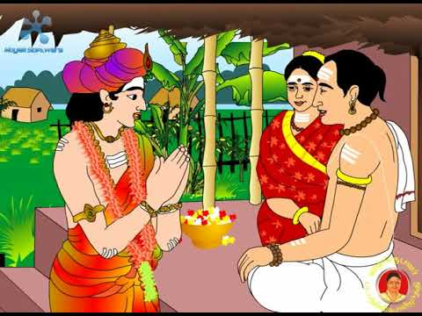
INTRODUCTION
Sadaiya Nayanar (7th century AD) is the father of Sundarar, and is one among the 63 nayanars. He is an ardent devotee of Lord Shiva, and his wife is Isaignaniyar, who is also a nayanar. Being the father of sundarar, he is widely worshipped by the shaivites along with his son sundarar and his wife Isaignaniyar.
Sadaiya Nayanar and his wife lived in Tirunavalur, of Tamil Nadu. They belonged to Brahmin caste. Sadaiya Nayanar’s son was Sundarar, who was also called as Nambi Arurar. He was adopted by Sri Narasinga Muniyaraiyar, the king of that region and also a Nayanar saint. Sundarar lived comfortably in the home of Sri Narasinga Muniyaraiyar. The entire nayanar family was praised by Swami Sivananda Saraswati and mentioned their holy life in his various devotional lectures.
Sadaiya Nayanar had done lot of good karmic deeds in his past birth. Due to that he has got Sundarar as his own son. Later his son Sundarar had got married with Sangiliyar and Paravai Nachiyar.
Sundarar mentions the importance of his father Sadaiyan in the famous text “Tiruthonda Thogai”, and informs us that his father was an ardent devotee of Lord Shiva, and he dedicated his entire life on devoting Lord Shiva.
Sadaiya Nayanar is worshipped on Thiruvathira, in the Tamil month of Margazhi. He is also worshipped in the shiva temples along with other nayanars.
IMPORTANCE
Sadaiya Nayanar lived a noble life along with his affectionate wife Isaignaniyar. He had done food offering (Holy Prasad) to Lord Shiva in the temples, and also provided food to the shiva devotees in his home along with his wife Isaignaniyar. He was a learned scholar and a master in all sacred texts. He chants the Shiva mantra on a daily basis, and also done pujas and abhishekhams to the shiva lingam.
Let us worship the great nayanar saint and be blessed.
“OM SREE SADAIYA NAYANARE NAMAHA”
“OM SREE ISAIGNANIYARE NAMAHA”
“OM SREE SUNDARARE NAMAHA”
“OM NAMAH SHIVAYA”
WRITTEN BY
R.HARISHANKAR

SAKKIYA NAYANAR
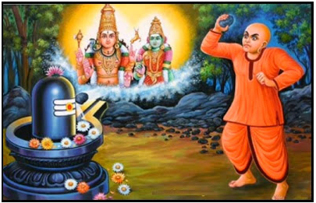
INTRODUCTION
Sakkiya Nayanar (7th century AD) was a Nayanar saint, and is considered as one among the 63 Nayanars. He was a staunch devotee of Lord Shiva, and he would never take his food, without worshipping Lord Shiva.
LIFE
Sakkiya Nayanar was born in the village Sangaramangai at Nagapattinam District, Tamil Nadu. The village was occupied with full of Buddhist monks and most of the people in that region were the followers of Buddhism. Sakkiya and his family were belonged to Vellalar community and they possessed agricultural lands. For their own safety he and his family pretended themselves as Buddhists. He became a Buddhist monk. Sakkiya was also thorough with the principles of buddhism. Hence he was called as Sakkiya. He remained in the Shaivism sect, but continued acting as a Buddhist monk in order to safeguard himself and his family. Sakkiya is interested only in shaivism, since according to him, only by following the shaivism sect and worshipping Lord Shiva, one can attain SALVATION. He secretly worshipped Lord Shiva in the temples and in his home and performed puja to the shiva lingam.
One day, he worshipped Lord Shiva by fondly throwing a stone at the lingam with great devotion. Then he continued doing that, since he thought that by throwing stone at the god will also be a kind of worship. Sakkiya’s stone worship was accepted by Lord Shiva also. He takes his morning food only after worshipping the god, and by throwing a stone at the shiva lingam. Due to his sincere devotion, Lord Shiva had given a good life to him, and after his death, he reached KAILASH, the holy abode of Lord Shiva.
Appar praises Sakkiya for his stone worship. According to Appar, the stone which he throws into the shiva lingam was converted in the form of flower and decorated the shiva lingam.
Sakkiya Nayanar was specially worshipped in the Tamil month of Margazhi, and he is also worshipped as one among the 63 Nayanars.
IMPORTANCE
Sakkiya Nayanar though was worshipped Lord Shiva in a different manner, he had done the act with pure bhakti in his mind. From his life, we can understood, that by simply offering flowers to the god, and praying to him without bhakti, will not fulfil our needs and desires. Only if we keep utmost faith and bhakti on him, our prayers will get answered by the god.
Let us worship the great nayanar saint and be blessed.
“OM SREE SAKKIYA NAYANARE NAMAHA”
“OM NAMAH SHIVAYA”
“OM SAKTHI PARASAKTHI”
WRITTEN BY
R.HARISHANKAR

SATTI NAYANAR
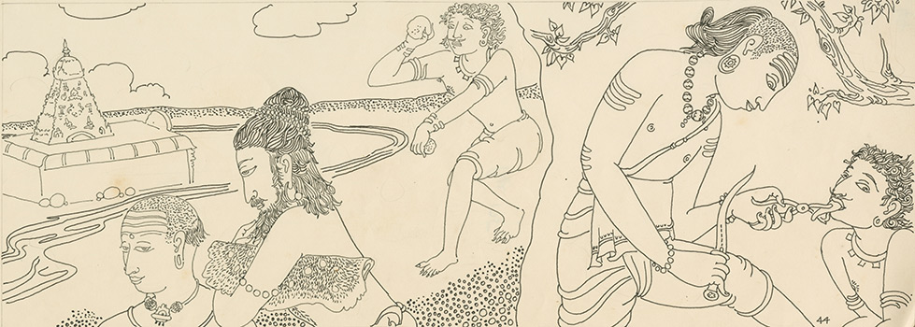
INTRODUCTION
Satti Nayanar is a great shaivite saint and an ardent devotee of Lord Shiva. And he is considered as one among the 63 Nayanars.
LIFE
Satti Nayanar belonged to Vellalar caste and born and lived in Tiruvarur District . He honoured Shaiva saints and propagated the importance of shaivism sect among the people and among the devotees of Lord Shiva. Though he lived a saintly life, he always carried a weapon in his hand, and if someone spoke ill about Lord Shiva and his devotees he will immediately remove the person's tongue with his powerful weapon. He is said to have done this act, since he wants to punish the sinners with his sharp knife also called as satti. Due to this act he was called as “SATTI NAYANAR” by the people.
Swami Sivananda, also praise the glory of Satti Nayanar for being lived as a great shiva devotee and also for being worshipped as a holy Nayanar saint. From his life, we should know that one should not speak badly about god and his devotees. Though he was violently behaved with the non-shiva devotees, his act was pardoned by the god, since he had done such an act due to his pure bhakti on Lord Shiva.
A sculpture in the Airavatesvara Temple in Darasuram depicts the nayanmar who carries a knife in his hand and cutting the tongue of a non-shaiva devotee. Satti Nayanar is mainly worshipped in the Tamil month of Aippasi, and he is worshipped similar to other nayanmars in shiva temples.
IMPORTANCE
Though he had done a violent act, it was pardoned by the god, since he had done so, in order to show his love and affection on Lord shiva. Due to his sincere bhakti, he had behaved badly with the persons who spoke rude and crude words against Lord Shiva. He could not tolerate their words, and hence he forcibly removed their tongues, in order to prevent repeating the same kind of mistake in their life again.
Let us worship the great holy nayanar saint and be blessed.
“OM SREE SATTI NAYANARE NAMAHA”
“OM NAMAH SHIVAYA”
WRITTEN BY
R.HARISHANKAR

SERUTHUNAI NAYANAR
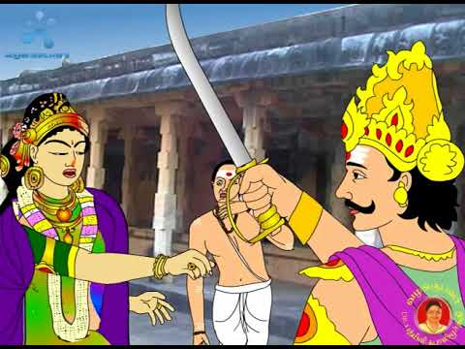
INTRODUCTION
Seruthunai Nayanar, was a Nayanar saint, and is considered as one among the 63 Nayanars.
LIFE
Seruthunai Nayanar was born and lived in Thanjavur. He belongs to Vellalar caste, and a great devotee of Lord Shiva. He will used to visit Thiruvarur to worship Lord Shiva at the Sri Achaleswarar temple. He performed many temple services and offered food to the shiva devotees.
Once, a pallava king Kazharsinga and his queen visited Achaleswarar temple to worship Lord Shiva. The queen smelled a flower from the temple garden which was kept for offering it to Lord Shiva. On seeing the queen’s act, Seruthunai Nayanar was got angry with the Pallava queen and punished her by severing her nose. Kazharsinga arrived at that place and enquired about the incident. Seruthunai Nayanar told the entire happenings. The great king, Kazharsinga decided to punish the queen by cutting the hand of the queen, since only through her hand she had lifted the flower.
Due to his noble deeds, after his death Serunthunai nayanar had attained the holy abode of Lord Shiva, The Kailasa. Sundarar praises Seruthunai Nayanar in the famous text “Tiruthonda Thogai”. Seruthunai Nayanar is specially worshipped in the Tamil month of Avani, and he is worshipped along with other Nayanars in the shiva temples.
IMPORTANCE
Serunthunai nayanar was an ardent devotee of Lord Shiva, and always praised the glory of Lord Shiva and served his devotees in a humble manner. Whenever he worships Lord Shiva, he forgets about everything in his life, including hunger and thirst. Such a great devotee he is! Let us try to develop such kind of bhakti from him by sincerely worshipping the god and always keeping him in our heart.
Let us praise the great nayanar and be blessed.
“OM SREE SERUTHUNAI NAYANARE NAMAHA”
“OM NAMAH SHIVAYA”
WRITTEN BY
R.HARISHANKAR

SIRAPPULI NAYANAR
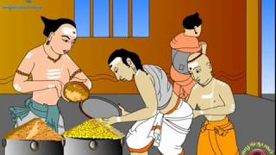
INTRODUCTION
Sirappuli Nayanar was a Nayanar saint, and is considered as one among the 63 nayanar saints. He was an ardent devotee of Lord Shiva and lived his life by worshipping him by chanting his names and by serving his devotees.
LIFE
Sirappuli Nayanar was born in Thiruvakkur, Nagapattinam district in Tamil Nadu. He was a great devotee of Lord Shiva, and was born in the Brahmin community. He was well versed in chanting the Vedas, and a master in sacred scriptures. The Nayanar saint was well known for his generosity. He invited the devotees of Shiva to his home and offered food and other necessities to them. Sirappuli Nayanar was a humble and a soft spoken person. Sirappuli used to chant the Shiva Panchakshara mantra “OM NAMAH SHIVAYA” on a daily basis. He performed yajnas (fire sacrifices) in order to please Lord Shiva. The nayanar would smear sacred ash on his body. He chanted the shiva mantra for several lakhs of time during his life time. He spent his entire life by serving Lord Shiva and his devotees, and attained SALVATION after his death.
Sivananda Saraswati, praises the greatness of Sirappuli Nayanar with regard to his sincere devotion on god, and for serving his devotees. Sundarar praises Sirappuli Nayanar in the famous text “Tiruthonda Thogai”.
Sirappuli Nayanar had got the habit of regularly visiting the Sri Thanthondreeswarar temple, at Thiruvakkur. A separate shrine is dedicated to him, in the temple. Sirappuli Nayanar is worshipped in the Tamil month of Karthikai, and also worshipped similar to other nayanars in the shiva temples.
IMPORTANCE
Though he got great wisdom, wealth and knowledge, he doesn’t get any pride over that. He remained as a humble and a gentle person, and was praised by the people through his good activities. He had done several pujas in the shiva temples and offered naivedyam (Food offering) to the god and also took care of shiva devotees in a proper manner.
Let us worship the great nayanar saint and be blessed.
“OM SREE SIRAPPULI NAYANARE NAMAHA”
“OM NAMAH SHIVAYA”
“OM SAKTHI PARASAKTHI”
WRITTEN BY
R.HARISHANKAR

SOMASI MARA NAYANAR
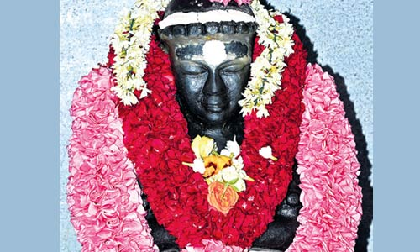
INTRODUCTION
Somasi Mara Nayanar (8th Century AD) is a Nayanar saint, and was one among the 63 Nayanars. He was an ardent devotee of Lord Shiva and also a devotee of Sundarar.
LIFE
Somasi Mara Nayanar belongs to Brahmin caste and served as a temple priest. He was born in a village in Nagapattinam district of Tamil Nadu.
He was a great devotee of Lord Shiva, and was very much interested in conducting pujas, soma-yajnas (sacrifices). Hence he was called as Somasi Mara Nayanar. He was against caste discrimination and served food to all the devotees of Lord shiva without seeing any difference with regard to their caste or community. During his period, he recited the Panchakshara mantra of Shiva for several lakhs of time. He went to Tiruvarur and met Sundarar. He became a disciple of Sundarar and served him in a proper manner. Due to his sincere service on Sundarar, he attained the grace of Lord Shiva.
Somasi Mara was living in his home town along with his wife. Once, he was interested to perform a soma-yajna and wants the divine presence of Lord Shiva in the yagna. He requested the help of Sundarar, to get the darshan of Lord Shiva in the yagna.
Shiva transformed himself and his family in the form of outcaste persons and arrived to the place where yagna is performed. Nobody was aware of the true identity of the shiva family. But Lord Ganesa had given a clue to the nayanar that the family was none other than the shiva family. Then Shiva appeared with Parvati in his true form and blessed Somasi Mara Nayanar and accepted the offerings of the yagna.
After his death, he reached KAILASA, the abode of Lord Shiva. He is specially worshipped in the shiva temples in the tamil month of Vaikasi and also worshipped as one among the 63 nayanars in the shiva temples.
IMPORTANCE
He lived a saintly life by keeping the thoughts of Lord shiva in his mind. His entire body is attached with the devotion of Lord Shiva. He considers himself to be the slave of Lord Shiva, and done his daily activities by chanting shiva mantras and names. He lived a noble life, and performed temple pujas and conducted pujas in his home, and offered food to the shiva devotees and to the poor people. He lived a sin free life and finally attained salvation. He also helped the people of all castes to reach the spiritual path, and advised them to recite the shiva mantra “OM NAMAH SHIVAYA” in order to get relieved from their problems.
Let us worship the great divine nayanar and be blessed.
“OM SREE SOMASI MARA NAYANARE NAMAHA”
“OM NAMAH SHIVAYA”
“OM SAKTHI PARASAKTHI”
WRITTEN BY
R.HARISHANKAR

TIRU NILAKANTA YAZHPANA NAYANAR
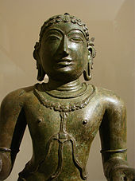
INTRODUCTION
Tiru Nilakanta Yazhpanar(7th century AD) was a Nayanar saint, and worshipped as one among the 63 nayanars in the shiva temples. He lived during the period of Sambandar and maintained friendly relations with him. Both of them travelled to many shiva temples and worshipped Lord Shiva.
LIFE
Tiru Nilakanta Yazhpanar was born in Erukattanpuliyur in the Chola kingdom. He belonged to the Tamil Panar community and was well versed in music, and composed several songs on Lord Shiva with his instrument Yazh(a lute), and sung in praise of him in his temples. He was a staunch devotee of Lord Shiva, and lived his life as per the principles of Shaivism. He got the name "Yazh-panar" since he used his instrument yazh. Due to lower caste, generally he was allowed to worship the god outside the shrine. Once, as per the instructions of Lord Shiva, the Madurai temple priests were allowed Tiru Nilakanta Yazhpanar to sung divine songs inside the shrine of Lord Shiva, and he was also given a golden seat in the temple.
Yazhpanar went to Thiruvarur Thyagaraja Temple and with his yazh, he sung many devotional songs on Lord Shiva.
Yazhpanar went on a pilgrimage to many shiva temples. He met Sambandar at the Sattainathar Temple and Sambandar accompanied him in his travels and Sambandar composed many songs on Lord Shiva and Yazhpanar played music for the songs on his yazh. Sambanar and Yazhpanar went to Thillai Nataraja Temple, Chidambaram, and several other shrines of Lord Shiva in tamil nadu.
Yazhpanar and Sambandar on his journeys met other Nayanars like Tiruneelanakka Nayanar, Siruthondar, Muruga Nayanar, Kungiliya Kalaya Nayanar, and Appar. After some time, Tiru Nilakanta Yazhpanar attended the wedding of Sambandar in Achalapuram. After the wedding ceremony, the entire marriage party went to the Shiva temple in Thirumana Nallur. Due to the grace of Lord Shiva, Sambandar, his wife, all the wedding guests, and Tiru Nilakanta Yazhpanar were merged with Lord Shiva.
Sundarar praises Tiru Nilakanta Yazhpanar in the famous text “Tiruthonda Thogai”, and describes him as a divine composer of music, and compared him with Thumburu and Narada, the divine musicians.
Tiru Nilakanta Yazhpanar is worshipped in the Tamil month of Vaikasi, and also receives worship as one among the nayanar in the shiva temples.
IMPORTANCE
Though he was born in a lower caste family, he was very much attached with Lord Shiva, and composed and sung thousands of devotional songs on Lord Shiva during his period. He would forget his food and sleep while composing divine songs on Lord Shiva. His bhakti is really appreciable by everyone and he entirely surrendered at the feet of the KAILASA NATHAR. He will always be remembered for his divine music and for his divine songs on Lord Shiva. It is believed, that even now in KAILASH, he is serving the god and the goddess by playing his instrument and singing songs on Lord Shiva.
Let us worship the great nayanar saint and be blessed.
“OM SREE TIRU NILAKANTA YAZHPANA NAYANARE NAMAHA”
“OM NAMAH SHIVAYA”
“OM SAKTHI PARASAKTHI”
WRITTEN BY
R.HARISHANKAR

TIRUNILAKANTA NAYANAR
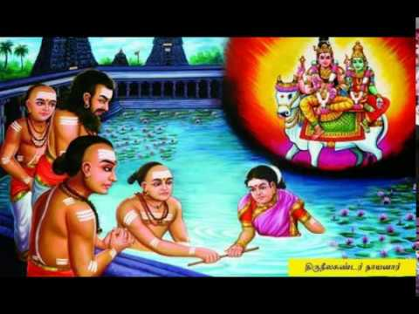
INTRODUCTION
Tirunilakanta Nayanar was a Nayanar saint, and a great devotee of Lord Shiva. He is considered as one among the 63 Nayanars.
LIFE
Tirunilakanta Nayanar lived in Chidambaram, and was a regular visitor of Thillai Nataraja Temple. He belonged to the family of potters. He lived his life by making pots and other household clay items. He was a sincere devotee of Lord Shiva and distributed pots to the devotees of Shiva, at free of cost and also provided food to them in his house.

During his young age, Tirunilakanta Nayanar had maintained affair with another woman. Due to that, his wife doesn’t allow him to touch her, but fulfilled all of her duties as a dutiful wife. In course of time, they have become old.
Once, Lord Shiva transformed himself as a Shaiva Saint and met Tirunilakanta Nayanar, and asked him to keep a costly begging bowl with him for some time. After some time, the saint (Lord Shiva) returned to his home and asked for his begging bowl. But Lord Shiva had made the begging bowl to disappear.
He has asked the nayanar to make a promise along with his wife in order to prove himself that the begging bowl was not stolen by him. Since Tirunilakanta doesn’t want to touch his wife, he and his wife entered the temple pond, each holding an end of a bamboo stick. The old couple immersed themselves in the pond and emerged as a young couple when they rose up. The entire people in that place were astonished on seeing that incident. The saint was disappeared from that place, and Lord Shiva appeared with Mata Parvati and blessed the couple. After their death, both of them were attained mukthi and reached KAILASA, the holy abode of Lord Shiva.
Sundarar praises Tirunilakanta Nayanar in the sacred text “Tiruthonda Thogai”. Tirunilakanta Nayanar is worshipped in the Tamil month of Thai, and also worshipped as a nayanar in the shiva temples.
IMPORTANCE
Tirunilakanta after committing a sin of having an affair with another woman, had realized his mistake and left all the worldly pleasures in his life, and didn’t touch his wife until his old age. But Lord Shiva had granted the boon of becoming young to both of them. He lived his entire life by worshipping Lord shiva and served his devotees in a humble manner.
Let us worship the divine saint and be blessed.
“OM SREE TIRUNILAKANTA NAYANARE NAMAHA”
“OM NAMAH SHIVAYA”
“OM SAKTHI PARA SAKTHI”
WRITTEN BY
R.HARISHANKAR

VAYILAR NAYANAR
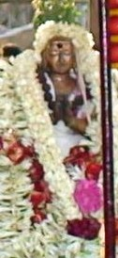
INTRODUCTION
Vayilar was a Nayanar saint, and the follower of the principles of Shaivism. He is considered as one among the 63 nayanars. He is an ardent devotee of Lord Shiva.
LIFE
Vayilar was born and brought up in Mylapore, Chennai. He belongs to vellalar caste. He was a staunch devotee of Lord Shiva. He was born as a dumb person. Vayilar was not interested in worshipping Lord Shiva by going to temples, but instead of that, he performed worship on his mind.
Vayilar constructed a temple to Shiva in his mind itself. The mind temple contained golden doors for the god and contained spacious halls. Numerous ornaments were adorned to the god and the goddess in the temple. He bathed the Lingam by waters and poured milk and honey into the lingam. He also conducted homams in his mind temple, and worshipped his mind temple day and night. He even didn’t take proper food and slept properly but always keep thinking about his mind temple and worshipping the god from his mind itself. He never physically visits any temple of Lord Shiva, but only worships Lord shiva from his mind. In his mind temple, he also provided food to the devotees of Lord Shiva, and attended them in a proper manner. Even though, he didn’t physically worship the god in the temples, and physically served food to the shiva devotees, but, due to his sincere devotion on god, after his death, he attained MUKTHI and reached the abode of Lord Shiva, the kailash.
Sundarar praises Vayilar nayanar as the precious gem among the nayanars, and tells that the nayanar saint didn’t cared about his handicap in the body, but always thinks and worships Lord Shiva from his mind.
A shrine is dedicated to Vayilar in the Kapaleeshwarar Temple in Mylapore. Vayilar is worshipped in the Tamil month of Markazi, and he is also worshipped along with the other nayanars in the shiva temples.
IMPORTANCE
Even though he was born with the problem of dumbness, he never thought about his own physical body, but filled up with full of devotional thoughts on Lord Shiva. He dedicated his entire life, in thinking and chanting the mantras of Lord Shiva from his mind. His bhakti is unimaginable. He didn’t hate the god, for his problem, but worshipped him in a pleasing manner.
We should learn the bhakti spirit from him, and instead of cursing the god for our problems, we must try to praise him with his mantras and chant his glorious names.
Let us worship the great nayanar saint and be blessed.
“OM SREE VAYILAR NAYANARE NAMAHA”
“OM NAMAH SHIVAYA”
“OM SAKTHI PARASAKTHI”
WRITTEN BY
R.HARISHANKAR

VIRALMINDA NAYANAR
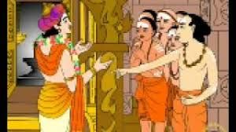
INTRODUCTION
Viralminda Nayanar is a Nayanar saint, and considered as one among the 63 Nayanars. He was a staunch devotee of Lord Shiva and gave good respect to his devotees.
LIFE
Viralminda Nayanar was born in Kerala, and he belongs to vellalar caste. He honoured the shiva devotees in a proper manner and provided food to them in his home. He visited many shiva temples and reached Thiruvarur, and went to Thyagaraja Temple, temple of Lord Shiva. According to him, shiva devotees must be worshipped before worshipping Lord Shiva in the temples. Once, Sundarar, came to the Thyagaraja shrine and worshipped Lord Shiva without giving salutation to shiva devotees. This act of Sundarar made Viralminda to get angry with Sundarar and also with Lord Thyagaraja who had allowed sundarar to worship him before worshipping his devotees. He also tried to attack sundarar with a powerful weapon, but sundarar was safeguarded by Lord Shiva.
He was also taken an oath of not entering Thiruvarur. Viralminda settled in the village near Thiruvarur. And he provided food to the devotees on a daily basis, and would check with them about their native place. He would kill them if they belonged to Thiruvarur with his weapon. Once, Lord Thyagaraja, transformed himself as a shiva devotee and came to Viralminda's house. When Viralminda heard that the devotee belonged to Thiruvarur, he tried to kill him with his weapon. The devotee crossed the limits of Thiruvarur and shown his true form as Shiva and blessed Viralminda for his sincere devotion. He was granted SALVATION after his death.
Viralminda Nayanar is worshipped in the Thiruvarur Thyagaraja temple. He is worshipped on Thiruvathirai, and also he is worshipped along with the 63 Nayanars in the shiva temples.
IMPORTANCE
Viralminda was a great nayanar who had given more respect to the shiva devotees than Lord Shiva. He spent his entire life in providing necessities for the shiva devotees and took care of them in a proper manner. He also conducted various pujas and abhishekhams in the shiva temples and worshipped him sincerely.
Let us try to cultivate such a kind of sincere bhakti from him and be blessed.
“OM SREE VIRALMINDA NAYANAMARE NAMAHA”
“OM NAMAH SHIVAYA”
“OM SAKTHI PARASAKTHI”
WRITTEN BY
R.HARISHANKAR

YENATHINATHAR NAYANAR
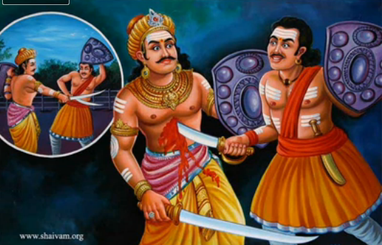
INTRODUCTION
Yenathinathar was a Nayanar saint and a great shiva bhakta and considered as one among the 63 Nayanars.
LIFE
Yenathinathar was born in Kumbakonam of Tamil Nadu. He was a brave and a good swordsman and served as an army general in the Chola kingdom. He was a rich person and provided food to the poor and to the devotees of Lord Shiva.
Atisuran also a swordsman became jealous of Yenathinathar brilliance in handling weapons and was defeated by Yenathinathar in competition. He took revenge on Yenathinathar and made a plan to kill him.
One day morning, Atisuran invited Yenathinathar to a place for competition. Atisuran applied sacred ash all over his body and appeared in front of Yenathinathar. Yenathinathar does not want to fight with him, since he applied the sacred ash in his body, and decided to die. He was attacked by Atisuran and fell down on the ground. Lord Shiva appeared before him and granted him SALVATION.
Sundarar praises Yenathinathar in the Tiruthonda Thogai and mentions his sincere shiva bhakti.
Yenathinathar is worshipped in the Tamil month of Purattasi, and also worshipped as a nayanmar along with other nayanmars in the shiva temples.
IMPORTANCE
He was an ardent devotee of Lord shiva and took his daily food only after offering naivedyam (Holy Prasad) to Lord Shiva in the temples. He also provided food, clothing and shelter to the poor and to the devotees of Lord Shiva. He had spent his major portion of income towards doing service to Lord Shiva in the temples and also to his devotees. He also performed regular pujas and abhishekhams to Lord Shiva in the temples.
Let us worship the great nayanar saint and be blessed.
“OM SREE YENATHINATHA NAYANARE NAMAHA”
“OM NAMAH SHIVAYA”
“OM SAKTHI PARASAKTHI”
WRITTEN BY
R.HARISHANKAR

