1.Gir:
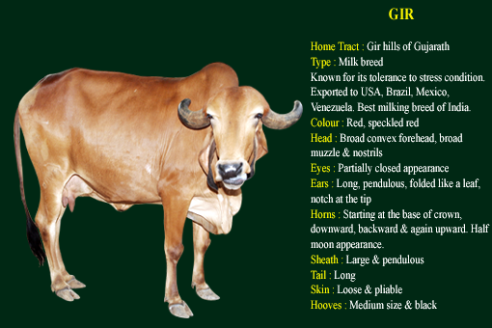
Gir cows are high milk yielder, milk yield ranging from 2000 kg to 6000 kg per lactation with fat percentage ranging from 4.5% to 5%. Bullocks are heavy and powerful draught animals. Heat and drought tolerant.

2.Sahiwal:
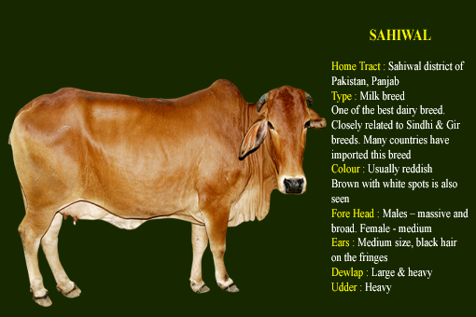
Best India dairy breed and most economic milk producer. Sahiwal cows are
well-known for their milking capacity. Milk yield varies from 2000 to 4000 kg per lactation, with fat content varying from 4% to 4.5%. Heat and drought tolerant.

3.Red Sindhi: 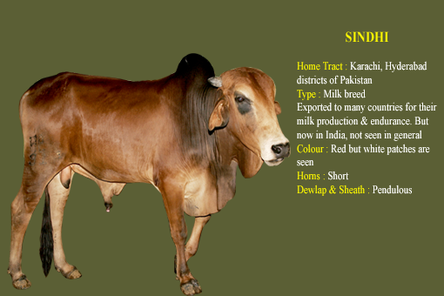
The milk yield varies from 2000 kg to 4000 kg per lactation, with fat content varying from 4% to 4.5%. Heat and drought tolerant. Resistance to many
diseases .Exported to Malaysia,Brazil and Cuba etc.

4.Tharparkar: 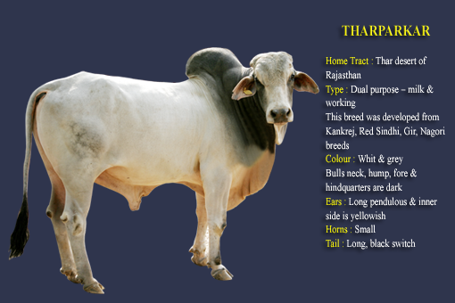
Bullocks are slow workers.Cows are good milkers, withaverage milk yields
varying from 1800 to 3500 kg per lactation. Heat and drought tolerant.

5.Rathi:
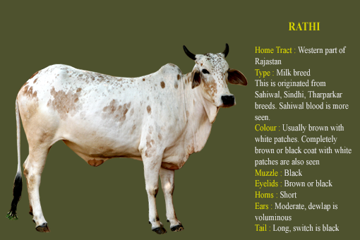 Good potential for milk production. Resistance to adverse climatic conditions of the desert area. Milk yield ranges from 1800 kg to 3500 kg per lactation.

6.Deoni:
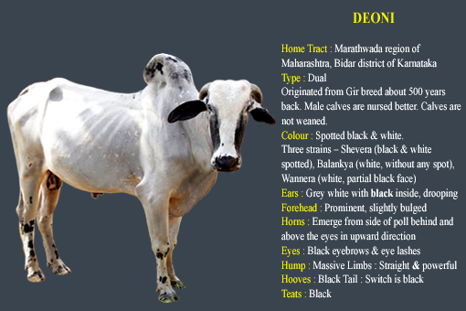 Dual purpose breed.These animals are quite popular in the tracts of former Hyderabad State which now forms the north-western part of Andhra Pradesh and adjoining districts of Karnataka and Maharashtra. Their are very good milk yielders.

7.Hariana:
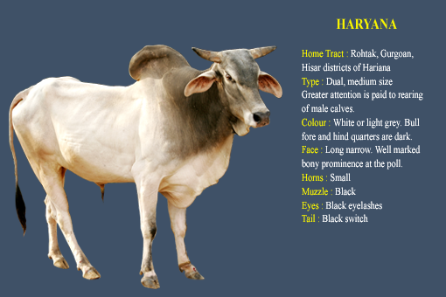Bullocks are useful for ploughing and transport.Cows are good milkers.
Milk yield is 1000 to 2000 kg per lactation.

8.Kankrej:
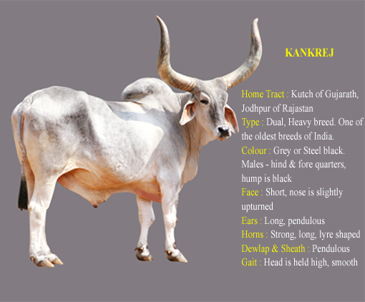
The animals of this breed are the heaviest of Indian breeds, they are fast powerful draft cattle. Male is well-known for his gait “Majestic Gait”. The animals are usually colored white to silver gray. The face is narrow with a broad and slightly dished forehead. The thick symmetrical horns curve outwards, upwards and inwards. Cows are fairly good milkers and average yield is1200 to 1500 kg . per lactation period . The age at first calving in the breed varies from 45 to 50 months and inter calving period varies from 17to 18months. Dry period varies from 8to9 months.There is a scope for improvement in milk production. Milk yield is 1500-4000 kg per lactation. Bullocks are strong and hard-working.Heaviest cattle breed of India. Impoted by central/south USA for beef
production.

9. Ongole:
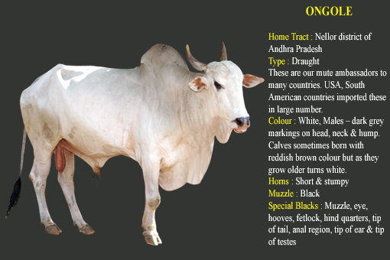
Bullocks are useful for ploughing and cart-work /transport. Cows are fair
milkers.

10. Gaolao:
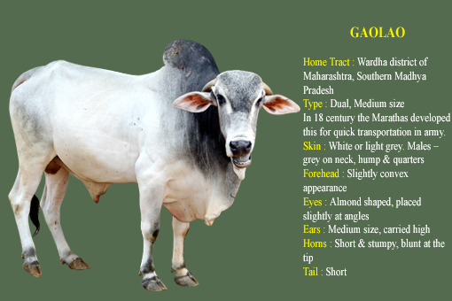
Bullocks are useful for ploughing. Cows are average milkers.

11. Krishna: 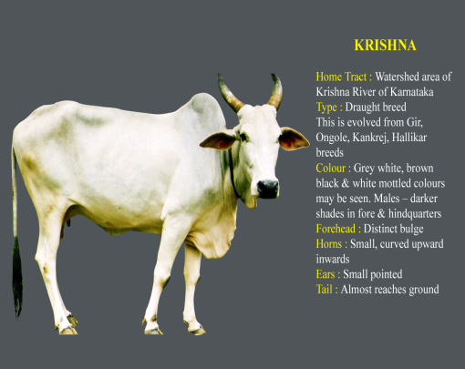
Bullocks are powerful and
good for heavy ploughing
and slower draught
purpose. Cows are fair
milkers.

12. Dangi:
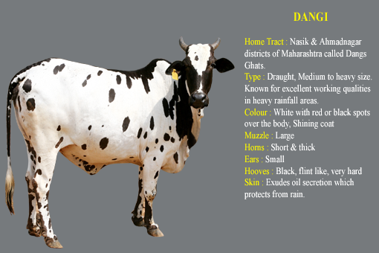
Especially good for heavy rainfall areas for draught purpose.

13. Lal Kandhari: 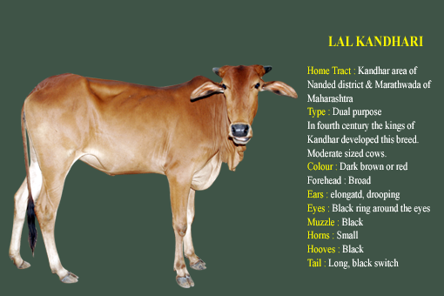
Draught purpose and hardy in nature. Bullocks are good draught animals. Cows are good milkers.

14. Nimari:
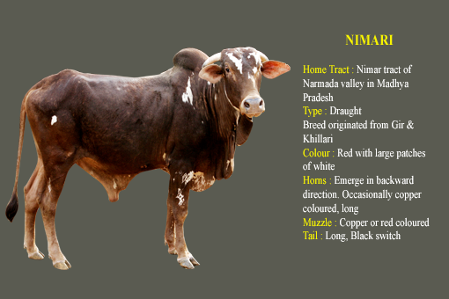
Nimari cattle show a mixture of Gir and Khillari (Tapi Valley strain) breeds. The breed has taken the coloration from the Gir as well as its massiveness of frame and the convexity of the forehead. It has acquired the hardiness, agility and temper of the Khillari with the formation of feet and occasional carroty color of the muzzle and hooves.
Draught breed.

15. Malvi:
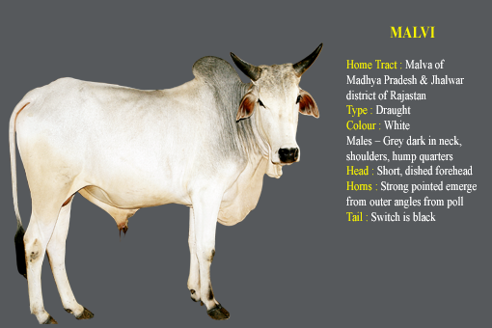
The Malvi is primarily a draft breed which has developed in to different strains which are heavy, light or medium in size, depending on soil conditions. These cattle are mainly bred in the Malwa tract of Madhyabharat State of India. In the western parts adjoining Rajputana the type bred is larger in size. In parts of Madhya Pradesh where Malvis are bred, it is smaller in size. It is also bred in the northeastern section of Hyderabad state, where it is a popular breed for medium and light draft on the roads and for cultivation. It has been said that the Malvis resembles the Kankrej in many ways. A Draught purpose breed.

16. Khillari:
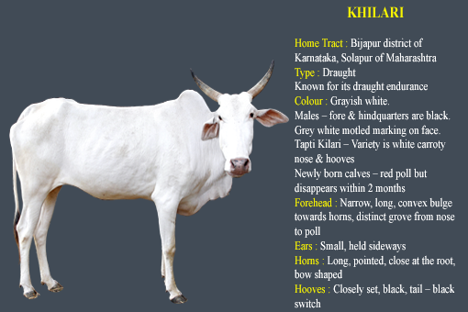
Bullocks are hardy and well-known for being fast in work. Most popular draft breed of N-Western India.

17. Amritmahal:
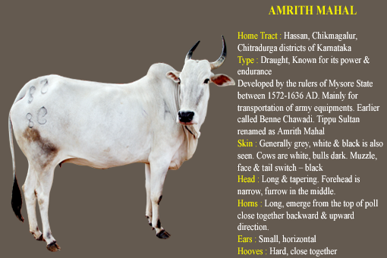
Bullocks are well-known for draught power and endurance. Average milk yield is 1000 to 1200 kg per lactation. Best draft breed of India.

18. Hallikar:
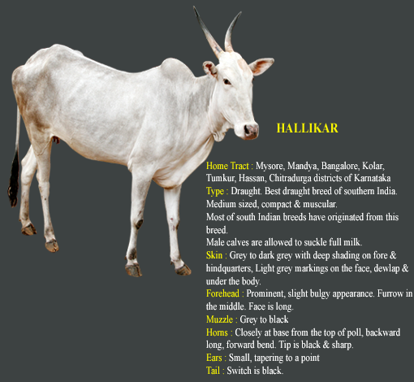
Draught breed both used for road and field agricultural operations.

19. Kangayam: 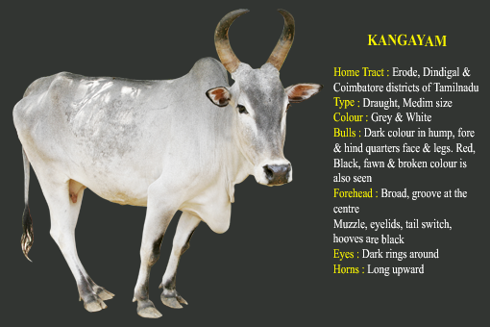
Bullocks are strong draught animals. Their skin is very strong and tight.

20. Nagore:
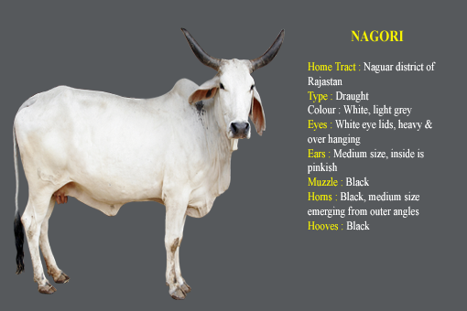
It is an excellent draught breed for hot climate. Nagori cattle are prevalent in the former Johrpur State, now a part of the State of Rajasthan in India. Nagori cattle are classified into the short-horned white or light gray cattle with a long coffin-shaped skull, orbital arches which do not prominent, and their face is slightly convex in profile. It has been suggested that probably the blood of gray lyre-horned cattle might have entered into the composition of Nagori cattle.

22. Bargur:
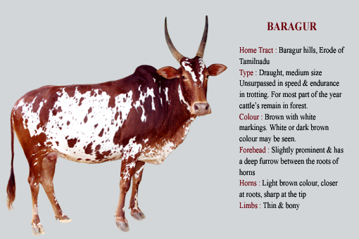
Bullocks are good work animals. It is found in Tamilnadu and Bagrur hills

23. Kenkatha:
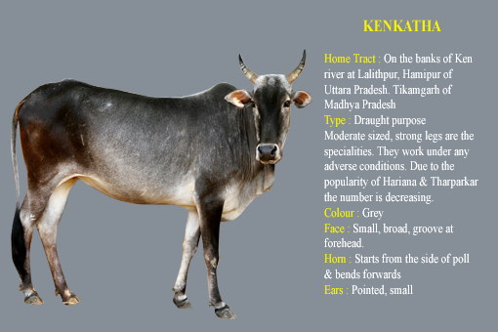
Bullocks are small but fairly sturdy animals and good for cultivation in rocky areas.

24. Bachaur:
The Bachaur appears to belong to the group of shorthorned white or light-gray cattle. The breed has very close similarity to the Hariana breed. Some think it may be a deteriorated strain of the Hariana. The breed is well-known for its draft qualities and ability to thrive with lower quality feeds. The breed is found in the Bachaur and Koilpur subdivisions of the Sitamarhi district of Bihar State, India. Bullocks are used for draught purpose. Cows are poor milkers. Best draft breed of Bihar.

25. Kherigarh:
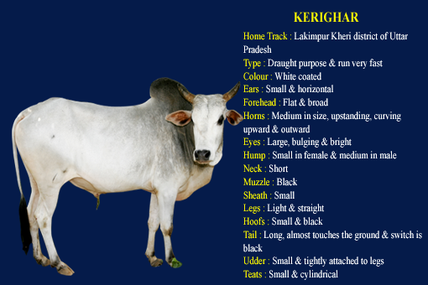
The cattle of this breed are very active and thrive on grazing only. Bullocks are
good for light draught and quick light transport. The cows are poor milkers.

26. Umblachery:
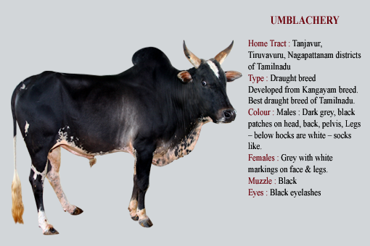
It is a draught breed of the Zebu type, similar to Kangayam but smaller. Excellent in wet ploughing.

27. Ponwar:
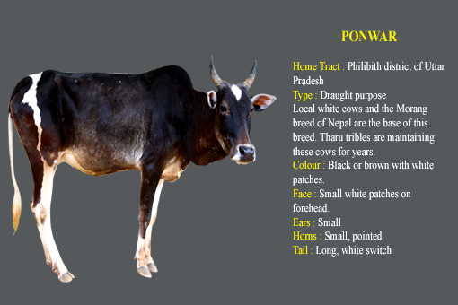
The Ponwar is small and compact with frequent white markings on the forehead, dewlap and limbs. Black and white color is often seen in the hill type of cattle and these features are also common in the Ponwar breed. However, the horns are inclined to be lyre-shaped, which may be due to some mixture of the nearby plains cattle. The breed is restricted to a small geographical area of Pilibhit district of Uttar Pradesh, India. Draught purpose. Cows are poor milkers.

28. Vechoor:
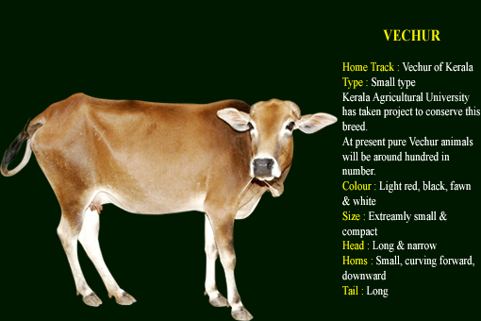
Bullocks are mainly used for draught purpose. Cows are poor milkers. Miniature cattle. The most important genetic quality of the Vechur breed is the high fat content in milk- from 6.02% to 7.86%.

29. Pungannur:
The Punganur dwarf cow, which originated in Chitoor District, Andhra Pradesh, India, is considered one of the world's smallest cows The Punganur breed's milk has a high fat content and is rich in medicinal properties. While cow milk normally has a fat content of 3 to 3.5 per cent, the Punganur breed's milk contains 8 per cent. The Punganur is found in Chittoor district situated in the south-eastern tip of the Deccan Plateau with an average rainfall of 700 mm. It is the world’s shortest, humped cattle. Animals are white and light grey in colour with a broad forehead and short horns. Its average height is 70-90 cms and its weight is 115-200 kg. The cow is an amazingly efficient milker with an average milk yield of 3-5 L/day on a daily feed intake of 5 kg. It is also highly drought resistant, and able to survive exclusively on dry fodder. Dwarf cattle.

30. Gangatiri:
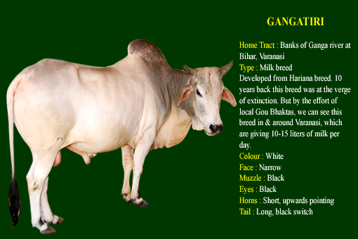
Animal of this breed are reared for milk production as well as agricultural operation. They are fit fir ploughing thrashing and power work. Average daily milk yield is 4-6 liters per day. Their lactation length is 150-250 days

31.Malenadu Gidda:
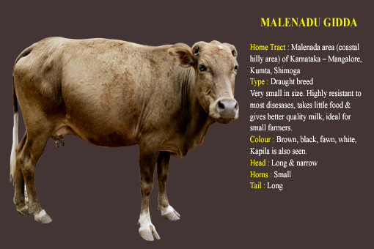
The famous dwarf variety of native cattle found throughout the Malnad region, considered rare for its strength to withstand harsh climate conditions of the hilly terrain of Western Ghats has been recognized by the National Bureau of Genetic Resources (NBGR) of the Indian Council of Agriculture Research as a registered breed variety of the country. 'Malnad Gidda', the small-sized dwarf variety in Shimoga, Chikmagalur, Udupi, Mangalore and North Canara districts, are about 10 lakh to 12 lakh in number as per the livestock census. They are smaller in size, with a compact body weight of less than 100 kg and have the ability to withstand heavy downpour and hot summers of Western Ghats, making them highly resistant to diseases.
32. Kasaragod:
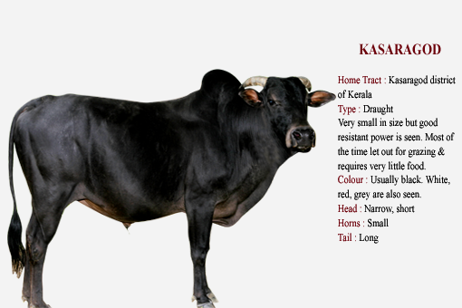
Kasaragod is the northern most district of Kerala flanked by a vast coastal area in the west and plains in the South and hilly tracts towards the North. The local cattle found in Kasaragod are of the dwarf type, with a uniform coat color black and varied shades of red. They are well adapted to the hot and humid climate of the region and possess high heat tolerance and disease resistance. Conservation efforts have already been taken up by Sosamma Iype Professor in Kerala Agricultural University with financial assistance from Indian Council of Agricultural Research, New Delhi and the work is continued by the Vechur Conservation trust to preserve this genetic resource.

